Effect of Soy Protein and Spirulina as Food Additives on the Growth and Cocoon Productivity of Bombyx mori(L.)

ABSTRACT

Silkworm nutrition plays a crucial role in determining larval development, survival, and cocoon productivity. This study evaluates the effects of soy protein and Spirulina supplements on the biological and economic traits of Bombyx mori. Fifth instar larvae were fed twice daily with mulberry leaves fortified with soy protein (1%, 2%, 3% 4%) and Spirulina (1%, 2%, 3% 4%). A control group received only mulberry leaves. Parameters measured included larval weight, cocoon weight, pupal weight, shell weight, shell ratio, weight-variable differences. Spirulina supplementation resulted in significantly higher larval and cocoon performance compared to soy protein, with 3% Spirulina showing the best improvements.
INTRODUCTION
Sericulture is an economically important agro-based industry that supports rural livelihoods and contributes significantly to the textile sector in many Asian countries. The productivity and profitability of sericulture largely depend on the growth, development, and cocoon yield of the mulberry silkworm, Bombyx mori L. Since silkworms are monophagous insects feeding exclusively on mulberry (Morus alba) leaves, the nutritional quality of the leaves plays a decisive role in determining larval performance, silk gland development, and cocoon characteristics. Any improvement in larval nutrition is therefore directly reflected in enhanced silk productivity.
Nutrition is a fundamental ecological factor governing insect growth, survival, and energy allocation. The classical work of Scriber and Slansky [3] established that the nutritional ecology of immature insects strongly influences food utilization efficiency, metabolic energy budgeting, and conversion of ingested nutrients into body biomass and economically important products. In B. mori, dietary proteins and nitrogenous compounds are particularly critical, as silk production is a protein-intensive physiological process. Approximately 70–75% of silk fiber consists of fibroin protein, emphasizing the importance of adequate protein availability during larval development.
Several studies have demonstrated that both the quantity and quality of dietary protein significantly affect larval growth rate, cocoon weight, shell weight, and shell ratio. Horie and Nakasone [6] reported that protein requirements of silkworm larvae vary across developmental stages, with the fifth instar being especially sensitive to dietary protein levels. Subsequent investigations confirmed that balanced amino acid composition in the diet improves growth efficiency and silk production [5]. Nutritional inadequacy during the larval stage often results in poor cocoon formation and reduced silk yield, highlighting the need for nutritional interventions.
Artificial diet and leaf fortification approaches have been explored to overcome fluctuations in mulberry leaf quality due to seasonal, environmental, and agronomic factors. Cappellozza et al. [1] demonstrated that manipulation of artificial diets significantly influences larval growth and cocoon production, indicating that dietary supplementation can modulate physiological performance. Similarly, enrichment of mulberry leaves with vitamins and nitrogenous compounds has been shown to improve larval weight gain, cocoon traits, and physiological parameters such as hemolymph protein concentration [4].
Protein metabolism in silkworm larvae is closely associated with hemolymph storage proteins, which act as reservoirs for amino acids required for metamorphosis and silk synthesis. Nagata and Kobayashi [2] reported that improved nutrition enhances storage protein concentration in larval hemolymph, thereby supporting better cocoon development. These findings underline the importance of nutritional strategies aimed at improving protein assimilation and utilization efficiency in B. mori.
In recent years, interest has grown in the use of natural bio-supplements and functional feed additives to enhance silkworm productivity in an eco-friendly and cost-effective manner. Spirulina, a protein-rich microalga, has attracted attention due to its high content of essential amino acids, vitamins, minerals, antioxidants, and bioactive compounds. Supplementation of mulberry leaves with Spirulina has been reported to improve larval growth, food conversion efficiency, and economic traits in silkworms [7]. Such improvements are attributed to enhanced digestibility and metabolic efficiency resulting from Spirulina’s balanced nutritional profile.
Advances in molecular and biochemical techniques have further clarified the mechanisms through which dietary modifications influence silkworm physiology. Metabolomic studies by Dong et al. [8] revealed significant differences in metabolic pathways between silkworms reared on fresh mulberry leaves and those fed artificial diets, particularly in amino acid metabolism, energy production, and silk protein synthesis. Complementary studies on gut microbiota have shown that diet-induced changes in microbial communities affect nutrient absorption, immunity, and overall larval performance [9]. These findings suggest that dietary supplementation not only improves nutritional intake but also modulates internal physiological and microbial processes critical for growth and cocoon formation.
Recent experimental evidence also supports the role of fortified mulberry leaves in improving biological and economic traits of silkworms. Wang et al. [10] demonstrated that diet composition significantly influences early larval growth and developmental stability, while Muzamil et al. [11] reported that amino acid-fortified mulberry leaves markedly enhanced larval weight, cocoon weight, shell weight, and shell ratio. These studies collectively emphasize that targeted dietary supplementation can effectively improve silkworm productivity under both laboratory and field conditions.
Despite substantial progress, comparative studies evaluating different protein-rich supplements, such as soy protein and Spirulina, under controlled feeding conditions remain limited. Understanding how these additives influence growth performance, cocoon productivity, and energy utilization is essential for developing cost-effective feeding strategies for sustainable sericulture. Therefore, the present study aims to evaluate the effects of soy protein and Spirulina supplementation on mulberry leaves with respect to larval growth, cocoon characteristics, and shell parameters in Bombyx mori, thereby contributing to improved nutritional management practices in sericulture.

MATERIALS AND METHODS
This experiment was conducted using healthy fifth-instar larvae of Bombyx mori, obtained from a government-recognized sericulture centre Konam Nagercoil. Rearing was performed under controlled laboratory conditions: temperature 25–27°C, relative humidity 70–85%, and photoperiod 12:12 hours (light: dark). All rearing trays, foam pads, and equipment were disinfected prior to use using 2% bleaching powder solution. Fresh, disease-free mulberry leaves were collected daily, washed in clean water, and shade-dried before feeding.
Two nutritional supplements—soy protein isolate and Spirulina (Arthrospira platensis) powder—were evaluated at three concentrations each 1%, 2%, 3% 4%. Stock solutions were prepared by dissolving the required amounts of soy protein or Spirulina in sterile distilled water. The solutions were sprayed uniformly on mulberry leaves using a fine mist atomizer. The treated leaves were air-dried for approximately 10–15 minutes to remove excess moisture. Control groups were provided with untreated mulberry leaves.
Each treatment included three replicates, with 50 larvae per replicate, making a total of 450 larvae in soy protein groups and 450 in Spirulina groups, plus control group. Feeding was done twice daily, at 8:00 a.m. and 6:00 p.m. All uneaten leaves were removed before the next feeding to prevent fermentation and microbial growth. Throughout the feeding period, larval weight, leaf consumption, and excreta output were recorded.
All data were expressed as mean ± standard deviation (SD) of three independent replicates. The effects of dietary supplementation and concentration were analysed using one-way analysis of variance (ANOVA). When significant differences were detected, mean values were compared using Tukey’s honestly significant difference (HSD) post hoc test. Differences were considered statistically significant at p < 0.05. Statistical analyses were performed using standard statistical software.

RESULTS AND DISCUSSION

The present study evaluated the effects of soy protein and Spirulina supplementation on the growth performance and cocoon productivity of the mulberry silkworm, Bombyx mori, during the fifth instar larval stage. This instar is the most critical phase in silkworm development, accounting for the majority of larval biomass accumulation and silk protein synthesis. Dietary fortification of mulberry leaves with both supplements resulted in clear, concentration-dependent improvements in all measured biological and economic traits when compared to the control group fed on untreated mulberry leaves. However, the magnitude of response varied between supplements and concentrations, indicating differences in nutritional efficiency and physiological compatibility.

Table 1. Effect of Soy Protein Supplementation on Bombyx mori.

Treatment (%) | Larval Weight (g) | Cocoon Weight (g) | Pupal Weight (g) | Shell Weight (g) | Shell Ratio (%)
Control | 3.95 ± 0.04ᵃ | 1.18 ± 0.02 | 0.92 ± 0.02 | 0.26 ± 0.01 | 22.03± 0.28
1 | 4.21 ± 0.05^{b}  (6.58) | 1.25 ± 0.03  (5.93) | 0.97 ± 0.02  (5.43) | 0.28 ± 0.01  (7.69) | 22.40± 0.31  (1.67)
2 | 4.36 ± 0.06^{c}  (10.38) | 1.31 ± 0.04  (11.02) | 1.01 ± 0.03  (9.78) | 0.30 ± 0.01  (15.38) | 22.90± 0.35  (3.95)
3 | 4.42 ± 0.05^{c}  (11.90) | 1.34 ± 0.03  (13.56) | 1.03 ± 0.02  (11.96) | 0.31 ± 0.01  (19.23) | 23.13± 0.29  (5.0)
4 | 4.39 ± 0.04^{c}  (11.14) | 1.32 ± 0.03  (11.86) | 1.01 ± 0.02  (9.78) | 0.29 ± 0.01  (11.54) | 23.02± 0.27  (4.49)
Note: Values in parentheses indicate percentage change relative to the control.
Note: Values are mean ± SD (n = 3). Different letters indicate significant differences among treatments (p < 0.05).

Table 2. Effect of Spirulina Supplementation on Bombyx mori.

Treatment (%) | Larval Weight (g) | Cocoon Weight (g) | Pupal Weight (g) | Shell Weight (g) | Shell Ratio (%)
Control | 3.95 ± 0.04ª | 1.18 ± 0.02 | 0.92 ± 0.02 | 0.26 ± 0.01 | 22.03 ± 0.28
1 | 4.50 ± 0.06^{b}  (13.92) | 1.38 ± 0.04  (16.95) | 1.05 ± 0.03  (14.13) | 0.33 ± 0.02  (26.92) | 23.91 ± 0.34  (8.53)
2 | 4.62 ± 0.05^{c}  (16.96) | 1.43 ± 0.04  (21.19) | 1.08 ± 0.03  (17.39) | 0.35 ± 0.02  (34.62) | 24.47 ± 0.31  (11.08)
3 | 4.79 ± 0.07^{c}  (21.27) | 1.51 ± 0.05  (27.97) | 1.14 ± 0.04  (23.9) | 0.37 ± 0.02  (42.31) | 24.50 ± 0.36  (11.21)
4 | 4.63 ± 0.06^{c}  (17.22) | 1.46 ± 0.04  (23.73) | 1.09 ± 0.03  (18.48) | 0.35 ± 0.02  (34.62) | 24.48 ± 0.33  (11.12)

Note: Values in parentheses indicate percentage change relative to the control.
Note: Values are mean ± SD (n = 3). Different letters indicate significant differences among treatments (p < 0.05).

Fig. 1 Graph showing larval weight vs supplement concentration
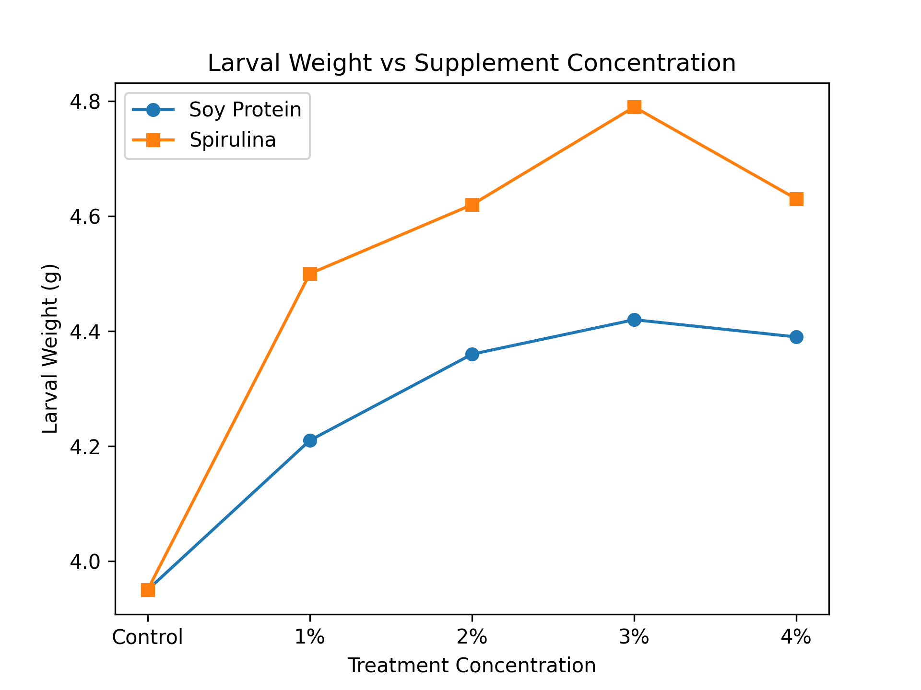

Larval weight is one of the most reliable indicators of nutritional adequacy, metabolic efficiency, and physiological health in the mulberry silkworm. During the fifth instar, larvae exhibit rapid growth and intense feeding activity, accounting for nearly 80–85% of the total larval biomass accumulation. Any improvement in dietary quality during this stage directly influences larval weight, which subsequently affects cocoon formation and silk yield.
In the present study, dietary supplementation of mulberry leaves with soy protein and Spirulina resulted in a significant increase in larval weight compared to the control, clearly demonstrating the positive role of nutritional fortification. The increase in larval weight observed in supplemented groups indicates improved digestion, absorption, and assimilation of nutrients, leading to enhanced tissue growth and energy storage.
Soy protein supplementation produced a moderate but consistent improvement in larval weight, with the maximum increase recorded at 3% concentration. This enhancement can be attributed to the high protein content and balanced amino acid profile of soy protein, which supports protein synthesis and cellular growth. Proteins serve as the primary building blocks for larval tissues and enzymes, and their adequate supply is essential during the rapid growth phase of the fifth instar. However, the relatively lower increase in larval weight compared to Spirulina-treated groups suggests that soy protein alone may not sufficiently provide all micronutrients and bioactive compounds required for optimal metabolic functioning.
Spirulina supplementation resulted in a more pronounced increase in larval weight, with the highest value recorded at 3% concentration. This superior performance may be attributed to Spirulina’s rich and diverse nutritional composition, which includes high-quality proteins, essential amino acids, vitamins, minerals, and bioactive pigments such as phycocyanin. The presence of these components enhances enzymatic activity, improves nutrient utilization efficiency, and supports overall metabolic balance. Vitamins and minerals present in Spirulina likely act as cofactors in metabolic pathways, facilitating efficient conversion of ingested nutrients into larval biomass.
The enhanced larval weight observed in Spirulina-fed larvae also suggests improved physiological vigor and stress tolerance. Antioxidant compounds in Spirulina may reduce oxidative stress associated with rapid growth, thereby maintaining cellular integrity and promoting sustained feeding activity. This could explain the significantly higher larval weights achieved in Spirulina-treated groups compared to soy protein treatments.
The slight decline in larval weight observed at the 4% supplementation level in both soy protein and Spirulina treatments may be due to reduced feed palatability, nutrient imbalance, or metabolic saturation. Excessive nutrient concentration can interfere with normal digestive processes or reduce feeding efficiency, ultimately limiting growth. This observation highlights the importance of optimal supplementation levels rather than excessive fortification. Larval weight increased significantly in both soy protein- and Spirulina-supplemented groups compared to the control (p < 0.05), with the highest values observed at 3% supplementation.Values are expressed as mean ± SD (n = 3 independent replicates). Different letters indicate significant differences among treatments (p < 0.05).

Fig. 2 Graph showing cocoon weight vs supplement concentration
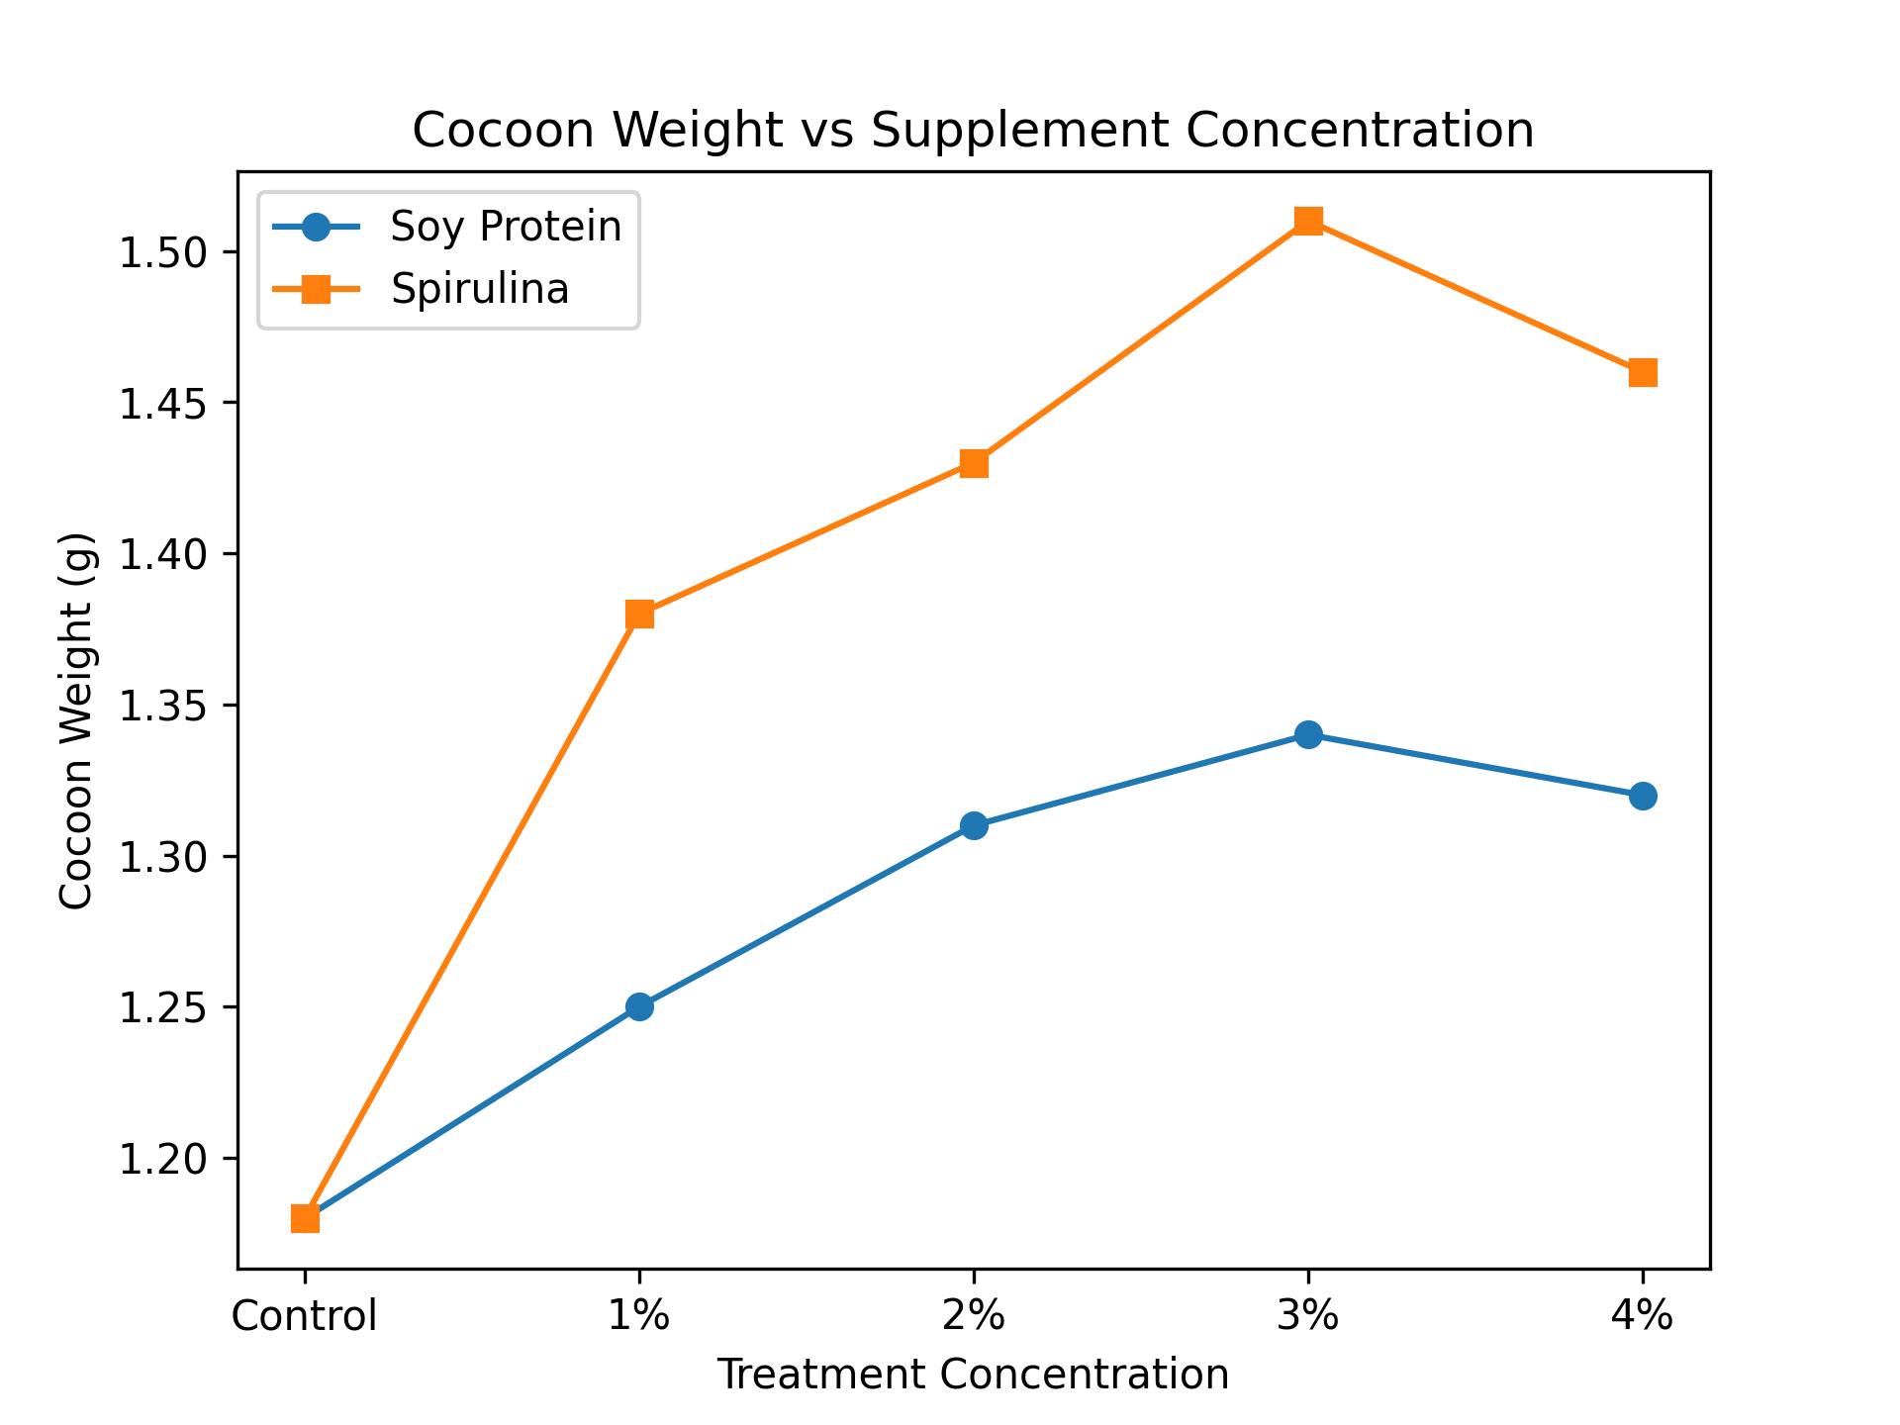
Cocoon weight is a primary economic parameter in sericulture, as it directly correlates with raw silk yield. In the present study, cocoon weight showed a clear concentration-dependent increase with both soy protein and Spirulina supplementation, confirming that dietary fortification positively influences cocoon formation.
Soy protein supplementation increased cocoon weight from 1.18 ± 0.02 g in the control to 1.34 ± 0.03 g at 3% concentration. This improvement indicates that protein-enriched diets enhance silk protein synthesis by supplying additional amino acid substrates required for fibroin and sericin production. However, the magnitude of increase was moderate, suggesting that soy protein alone may not fully meet the complex nutritional requirements for optimal silk synthesis.
Spirulina supplementation resulted in a significantly higher increase in cocoon weight, reaching 1.51 ± 0.05 g at 3% concentration. This marked improvement suggests that Spirulina not only enhances protein availability but also supports the physiological processes involved in silk gland development and function. The vitamins and minerals present in Spirulina may act as cofactors in enzymatic pathways associated with silk protein synthesis, thereby improving the efficiency of cocoon formation.The slight decline in cocoon weight observed at 4% supplementation in both dietary treatments may be attributed to reduced feed acceptability or nutrient imbalance, reinforcing the importance of optimal supplementation levels. Values are expressed as mean ± SD (n = 3 independent replicates). Different letters indicate significant differences among treatments (p < 0.05).
Fig. 3 Graph showing pupal weight vs supplement concentration
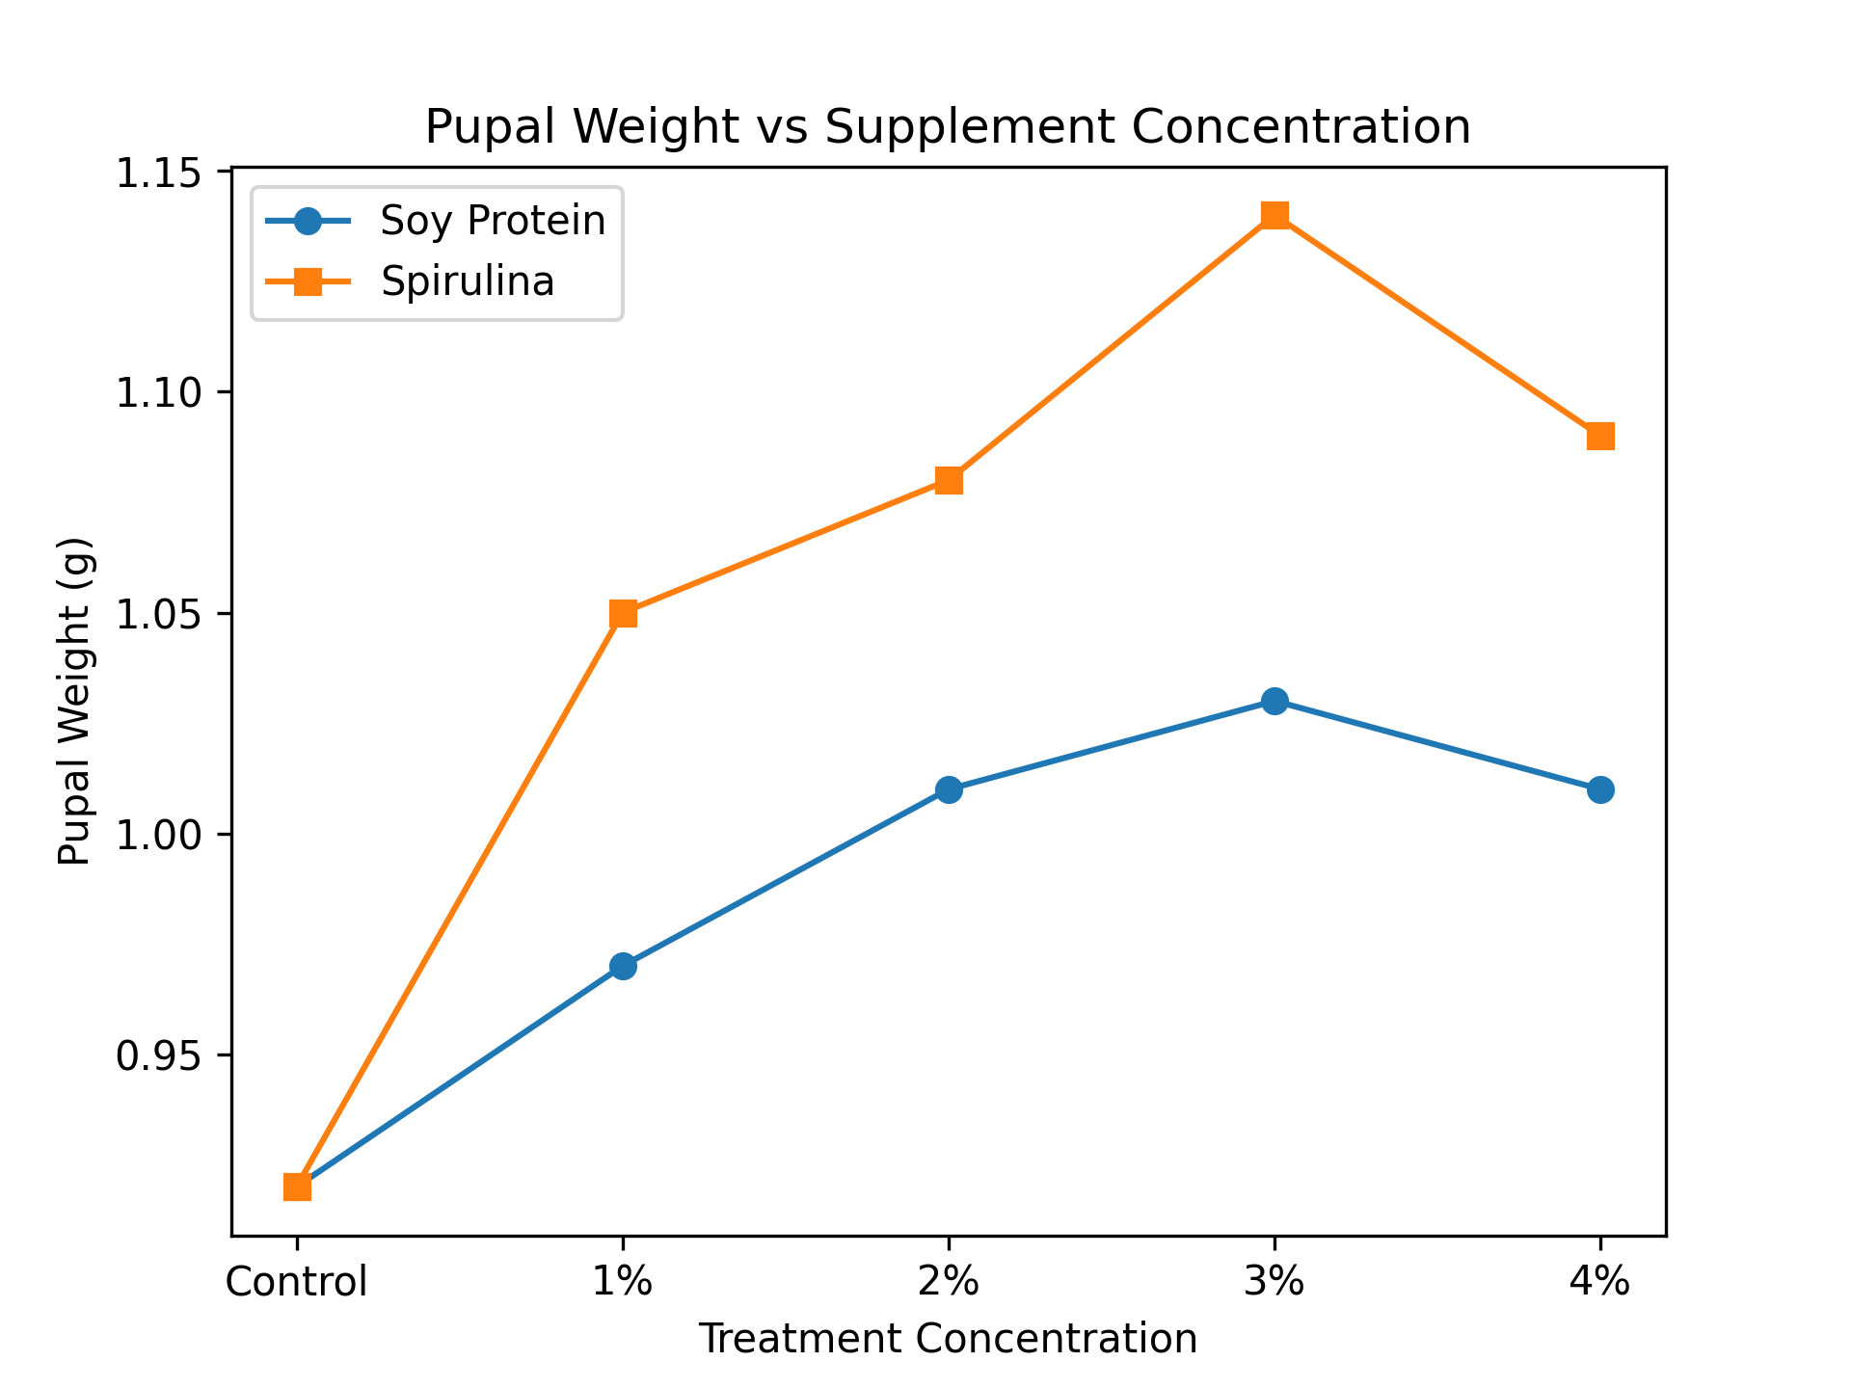
Pupal weight reflects the efficiency of biomass conversion from larval tissues and is an important indicator of physiological fitness and energy utilization. In the present study, pupal weight increased progressively with increasing concentrations of both soy protein and Spirulina, indicating improved metabolic efficiency.
Soy protein supplementation resulted in a maximum pupal weight of 1.03 ± 0.02 g at 3%, representing an improvement over the control. This increase suggests enhanced nutrient storage and utilization during metamorphosis. However, the comparatively lower pupal weight in soy protein-treated groups indicates limited efficiency in nutrient conversion compared to Spirulina.
Spirulina supplementation produced a higher maximum pupal weight of 1.14 ± 0.04 g at 3%, demonstrating superior nutrient assimilation and energy utilization. The enhanced pupal biomass suggests that Spirulina-fed larvae are physiologically more robust, with improved reserves to support metamorphosis. This may be attributed to the presence of essential fatty acids and micronutrients in Spirulina that facilitate energy metabolism and cellular differentiation. Spirulina supplementation resulted in significantly higher larval, cocoon, pupal, and shell weights than corresponding soy protein treatments at equivalent concentrations (p < 0.05). At 4% supplementation, a slight but non-significant decline was observed compared to the 3% level. Values are expressed as mean ± SD (n = 3 independent replicates). Different letters indicate significant differences among treatments (p < 0.05).
Fig. 4 Graph showing shell weight vs supplement concentration

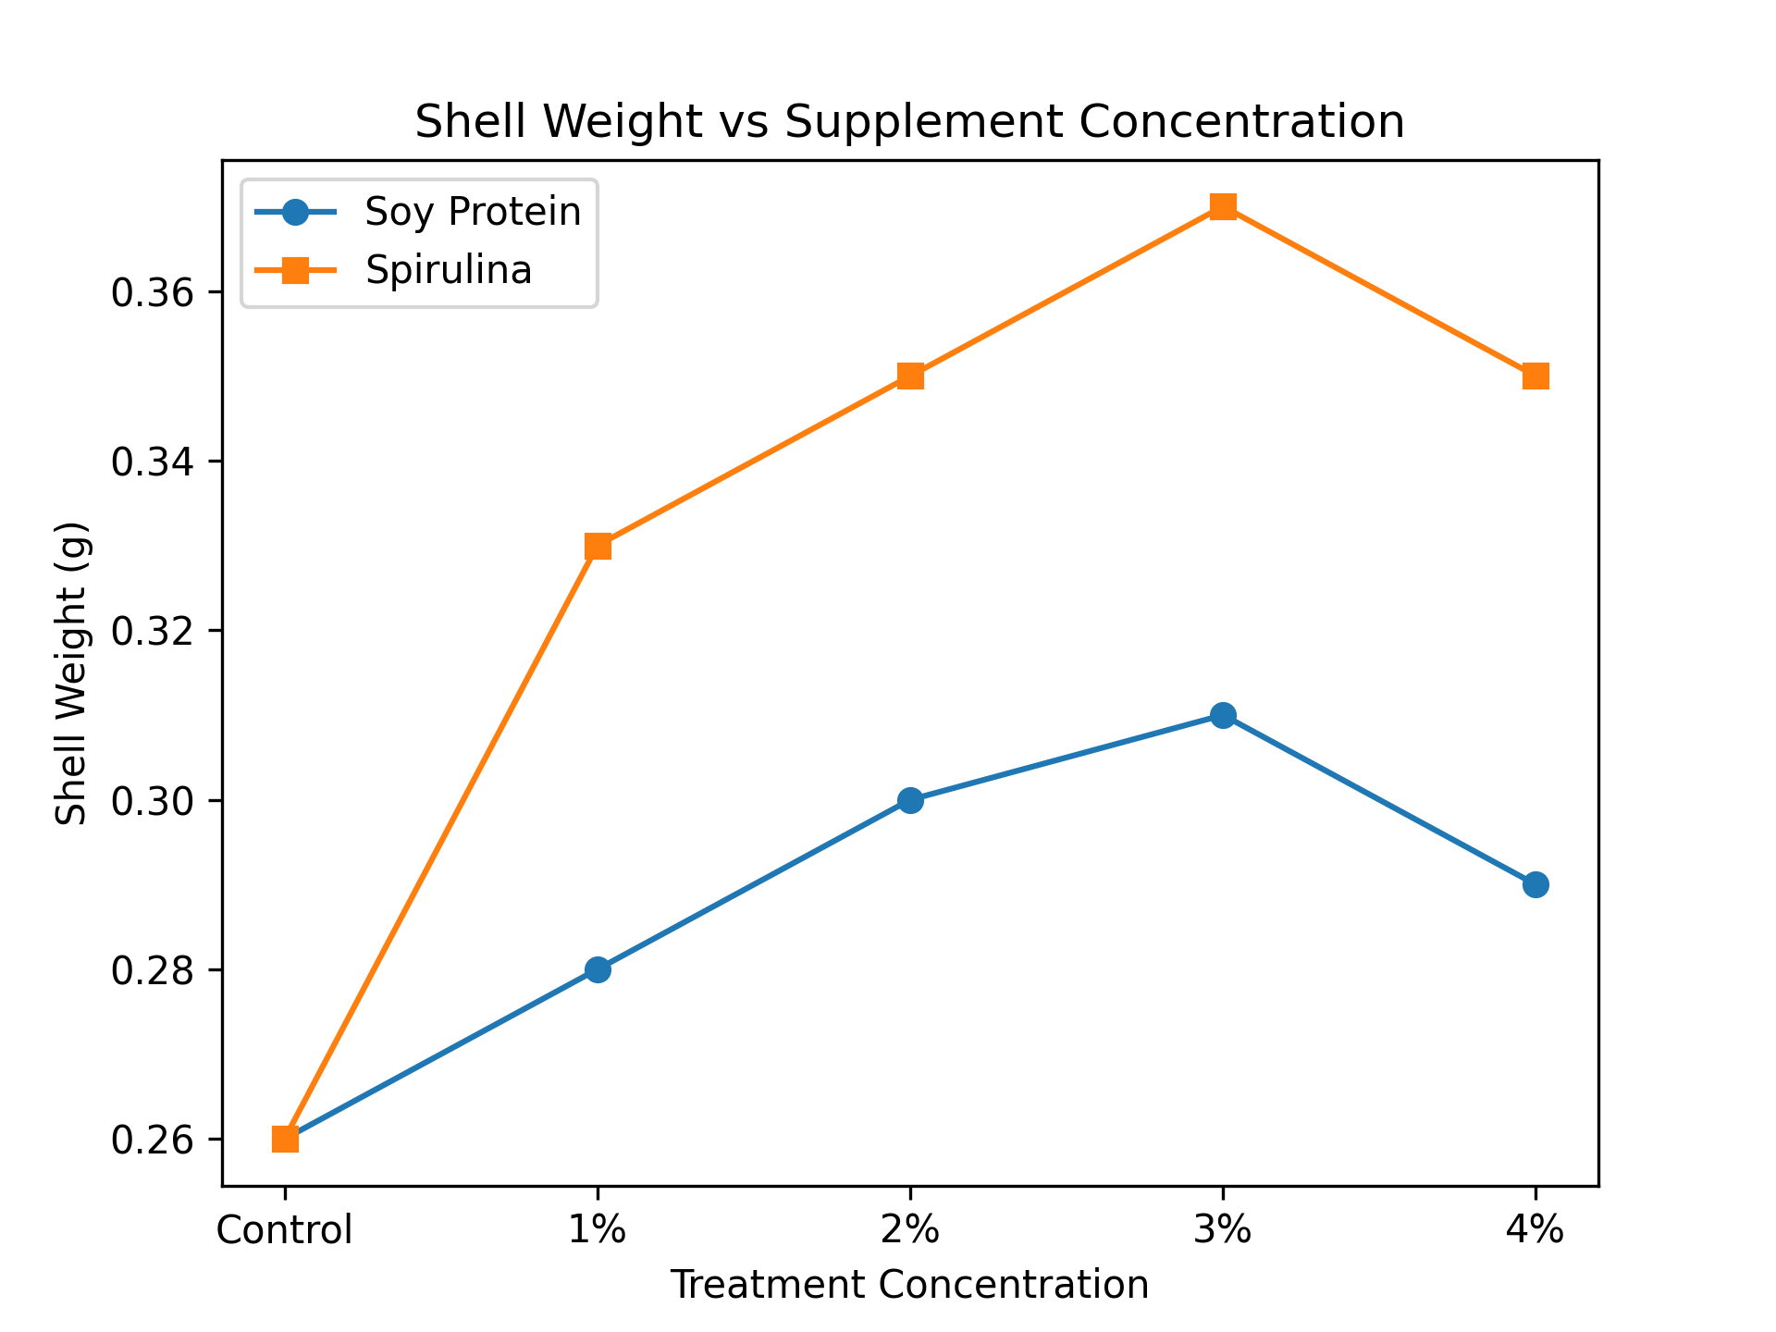
Shell weight is one of the most crucial economic parameters in sericulture, as it directly determines the quantity of silk available for reeling. In the present study, shell weight increased significantly in all supplemented groups compared to the control, indicating enhanced silk protein deposition.
Soy protein supplementation increased shell weight from 0.26 ± 0.01 g in the control to 0.31 ± 0.01 g at 3% concentration. This improvement suggests that soy protein contributes to silk protein synthesis by providing additional nitrogen sources. However, the extent of increase was limited, indicating that soy protein may not fully support the complex biochemical requirements of silk gland activity.
Spirulina supplementation produced a markedly higher shell weight, reaching 0.37 ± 0.02 g at 3% concentration. This substantial improvement indicates enhanced fibroin synthesis and silk gland efficiency. Spirulina’s rich composition of essential amino acids, particularly glycine and alanine, which are major components of fibroin, likely contributes to increased silk protein production. Additionally, the presence of antioxidants may protect silk gland tissues from oxidative damage, further enhancing their functional capacity. Values are expressed as mean ± SD (n = 3 independent replicates). Different letters indicate significant differences among treatments (p < 0.05).

CONCLUSION
The present study demonstrates that dietary fortification of mulberry leaves with soy protein and Spirulina significantly enhances the growth performance and cocoon productivity of the mulberry silkworm, Bombyx mori. Supplemented larvae showed marked improvements in larval weight, cocoon weight, pupal weight, shell weight, and shell ratio compared to the control, indicating improved nutrient assimilation and metabolic efficiency during the fifth instar stage.
Both supplements produced concentration-dependent responses, with optimal performance observed at the 3% supplementation level. Beyond this concentration, a marginal decline in several parameters was noted, suggesting that excessive fortification may lead to reduced feed efficiency or metabolic imbalance. This highlights the importance of identifying optimal supplementation levels rather than increasing nutrient concentration indiscriminately.
Comparatively, Spirulina supplementation consistently outperformed soy protein across all measured biological and economic traits. The superior efficacy of Spirulina can be attributed to its balanced nutritional composition, which includes high-quality proteins, essential amino acids, vitamins, minerals, and bioactive compounds that collectively enhance digestion, energy utilization, and silk protein synthesis. Enhanced shell weight and shell ratio in Spirulina-treated groups indicate improved conversion of assimilated nutrients into silk, directly contributing to higher economic returns.
Overall, the findings confirm that Spirulina, particularly at a 3% supplementation level, is a promising, eco-friendly feed additive for improving silkworm growth and silk yield. The use of such nutritional interventions can help mitigate fluctuations in mulberry leaf quality and support sustainable sericulture practices. Future studies focusing on cost–benefit analysis, long-term rearing performance, and physiological mechanisms at the molecular level would further strengthen the application of Spirulina-based supplementation in commercial sericulture.

Disclaimer (Artificial intelligence)

Author(s) hereby declare that NO generative AI technologies such as Large Language Models (ChatGPT, COPILOT, etc.) and text-to-image generators have been used during the writing or editing of this manuscript.

REFERENCES

Govindan R and Devaiah Mc (1995). Aspergillosis of silkworm. Silkworm Pathology Technical Bull No.1.Dept. of Seri. UAS Bangalore, p:68.
Babu, C.M., and Murthy, G.N. (2019). Nutritional modulation of mulberry leaves to enhance silkworm productivity. International Journal of Advanced Agricultural Research, 7(1), 45–53.
Banerjee, R., and Chakraborty, S. (2021). Protein supplementation strategies for improving economic traits in Bombyx mori. Asian Journal of Sericulture, 13(2), 77–85.
Cappellozza L., Cappellozza S., Saviane A., Sbrenna G., 2005.- Artificial diet rearing system for the silkworm bombyx mori (Lepidoptera: Bombyciade); effect of vitamin C deprivation on larval growth and cocoon production.- Applied Entomology and Zoology, 40 (3): 405-412.
Nagata M and Kobayashi J. Effect of nutrition on storage protein concentration in the
larval hemolymph of the silkworm, Bombyx mori. J. Seric. Sci. Japan. 59: 469-474, 1990.
Devi, L., and Pandian, K. (2018). Influence of Spirulina fortification on larval growth and cocoon characteristics in the mulberry silkworm Bombyx mori. Indian Journal of Applied Zoology, 5(4), 201–209.
Scriber J. M., Slansky Jr. F., 1981.- The nutritional ecology of immature insects.- Annual Review of Entomology, 26 (1): 183-211.
Ganga, G., and Chetty, J.S. (2019). Silkworm Biology and Sericulture Technology. Springer Nature.
Hussain, A., and Reddy, M.M. (2017). Effects of soy protein isolate in leaf-based diets on larval performance of silkworm Bombyx mori. Sericologia, 57(1), 41–50.
Kumar, V., and Kalpana, R. (2022). Growth response of mulberry silkworm (Bombyx mori) to dietary Spirulina supplementation. International Journal of Insect Science, 14, 1–10.
Paul, S., Roy, D., and Bhattacharya, P. (2021). Effect of microalgae-based supplements on the economic performance of Bombyx mori. International Journal of Applied Biology, 15(2), 56–64.
Prakash, N., and Shanthappa, J. (2018). Mulberry leaf fortification with soy protein and its influence on silkworm growth and cocoon yield. Sericultural Studies Review, 9(1), 26–33.
Etebari, K. (2002) Effect of enrichment of mulberry leaves (Morus alba) with some vitamins and nitrogenous compounds on some economic traits and physiological characters of silkworm, Bombyx mori (Lep., Bombycidae). Isfahan University of Technology. Iran.

