Original research Article
Assessment of physico-chemical characteristics of domestic sewage channels in Veraval city and Bhidiya fishing village, Gujarat, India
Abstract:
The present study finding the hydrochemical characteristics of seven domestic wastewater channels in Veraval and Bhidiya, Gujarat, over an eight-month monitoring period from August 2023 to March 2024. The discharge of untreated domestic sewage continues to be a major contributor to environmental deterioration in coastal urban areas and fishing settlements, posing serious threats to marine ecosystem health. A broad range of physicochemical parameters was assessed following standard analytical procedures, including temperature, pH, salinity, dissolved oxygen (DO), turbidity, alkalinity, total hardness, electrical conductivity, chloride, total solids (TS), total dissolved solids (TDS), total suspended solids (TSS), biological oxygen demand (BOD), nitrate, and phosphate. Results indicated relatively consistent temperature (25.05 - 25.49 °C) and pH (7.22 - 7.37) values across sites; however, pronounced spatial variations were observed in salinity (5.37 - 15.41 ppt), electrical conductivity (746.33 - 1956.41 µS cm⁻¹), and chloride concentrations (2958.81 - 10103.98 mg L⁻¹). These disparities suggest varying degrees of anthropogenic pressure and differences in wastewater composition between urban and rural discharge points. Severe organic contamination was reflected by critically low DO levels (0.024 - 0.041 mg L⁻¹) and extremely elevated BOD values (222.25 - 377.70 mg L⁻¹). Additionally, substantial particulate and dissolved matter loads were recorded, with maximum TS, TDS, and TSS concentrations reaching 19530.08 mg L⁻¹, 18083.58 mg L⁻¹, and 1455.33 mg L⁻¹, respectively. Elevated nutrient levels, particularly nitrate (11.29 - 21.87 mg L⁻¹) and phosphate (1.00 - 2.82 mg L⁻¹), indicate a high potential for eutrophication in the receiving coastal waters. Overall, the findings reveal pronounced deterioration of wastewater quality in both study areas, underscoring the urgent need for strict regulatory implementation, increased public awareness, and strengthened governmental efforts to establish effective wastewater treatment systems and sustainable management practices to protect coastal biodiversity and fisheries resources.
Keywords: Domestic sewage, Organic pollution, BOD, Spatio-temporal variation, Coastal management.

- Introduction
Water is a vital natural resource, and its degradation poses serious threats to ecological balance, public health, and socioeconomic activities. Water quality is assessed through physical, chemical, and biological parameters that collectively indicate the condition of aquatic ecosystems and their suitability for domestic, industrial, and fisheries uses. Since the Industrial Revolution, rapid industrialization, urbanization, population growth, and agricultural intensification particularly in developing countries—have significantly increased global water pollution (Taranu et al., 2015).
Domestic sewage is a major source of water contamination, originating from household activities such as bathing, cooking, washing, and sanitation. It is commonly classified into black water, grey water, and yellow water based on source and composition. Black water, mainly from toilets, contains high organic loads and pathogenic microorganisms, while grey water includes detergents and chemicals requiring treatment before reuse. Yellow water, consisting of urine, offers potential for nutrient recovery when separately collected (Friedler et al., 2013). Domestic wastewater typically contains suspended solids, nutrients, organic matter, and microbes, and is assessed using indicators such as BOD, COD, nutrient levels, and microbiological parameters.
Globally, municipal wastewater generation has reached nearly 380 billion m³ per year and is expected to rise further due to population growth and urbanization (Qadir et al., 2020). In India, inadequate treatment infrastructure results in about 72% of domestic sewage being discharged untreated into natural water bodies and coastal environments (CPCB, 2016). Similar conditions exist in Gujarat, where untreated sewage inputs into fishing harbours contribute to environmental degradation and ecological stress.
- Material and method
The present investigation was undertaken to assess the physicochemical characteristics of domestic sewage channels discharging into the Veraval Fishing Harbour from Veraval city and Bhidiya fishing village, Gujarat. The study was carried out over an eight-month period from August 2023 to March 2024, covering distinct seasonal variations. Surface water samples were collected monthly from seven selected domestic sewage channels representing the major sewage inflow points into the harbour. Of these, three channels were located in Veraval city (S1 - S3), while four channels were situated in Bhidiya fishing village (S4 - S7) (Table 1; Fig. 1 & 2). To ensure analytical accuracy, precision, and reproducibility, all samples were analysed in triplicate.
Veraval (20°53′ N, 70°26′ E), located along the north-western coastline of India, accommodates one of the largest fishing harbours in Asia and supports substantial seafood processing, export-oriented operations, and associated industries. The area is characterized by a tropical coastal climate, with temperatures ranging between 30°C and 39°C, relative humidity exceeding 55%, and an average annual rainfall of approximately 729 mm. Limited water exchange caused by siltation at the harbour entrance, reduced tidal flushing, and weak wind-induced circulation has contributed to inadequate dispersion of pollutants and the accumulation of organic matter. Earlier investigations have documented elevated nutrient levels, high ammonium concentrations, and the development of anoxic conditions within the harbour basin (NIO, 2014; 2015).
Table 1:- The selected sewage sampling sites of Veraval and Bhidiya fishing village
Site number | Geo reference Points | Description
S1 | 20°54'26.3"N 70°22'26.6"E | Bandar road  (Veraval domestic sewage)
S2 | 20°54'26.7"N 70°22'30.5"E | Bandar road  (Veraval domestic sewage)
S3 | 20°54'30.5"N 70°22'49.4"E | Bandar road  (Veraval domestic sewage)
S4 | 20°54'00.9"N 70°22'50.3"E | Bhidiya domestic sewage
S5 | 20°54'19.6"N 70°22'30.7"E | Bhidiya domestic sewage
S6 | 20°54'21.7"N 70°22'47.5"E | Bhidiya domestic sewage
S7 | 20°54'23.0"N 70°22'48.5"E | Bhidiya domestic sewage

 |  | 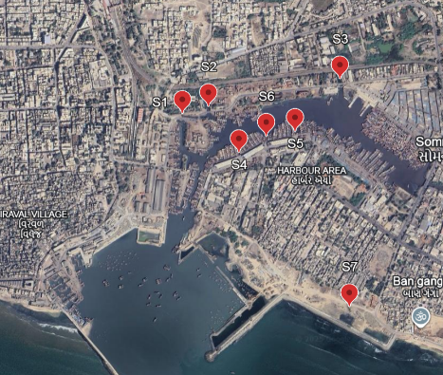
Fig 1:- Research Location (Domestic sewage channel around Veraval Fishing Harbour)
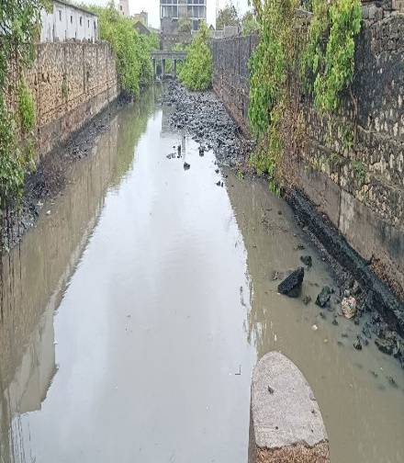 | 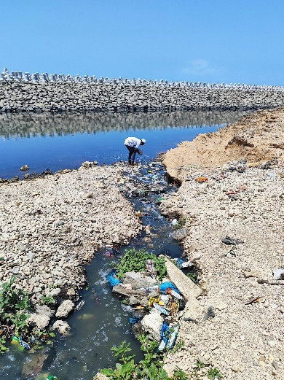 |  | 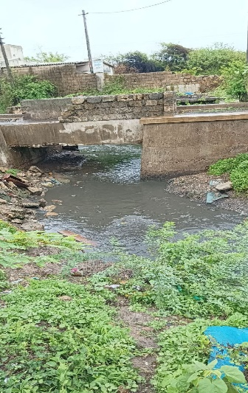
Fig 2: Selected location of Domestic sewage channel around veraval Fishing Harbour

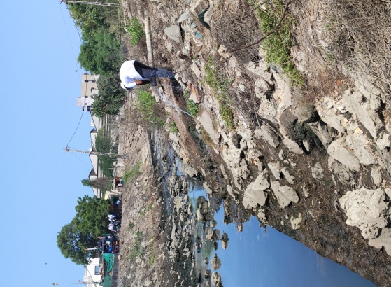 | 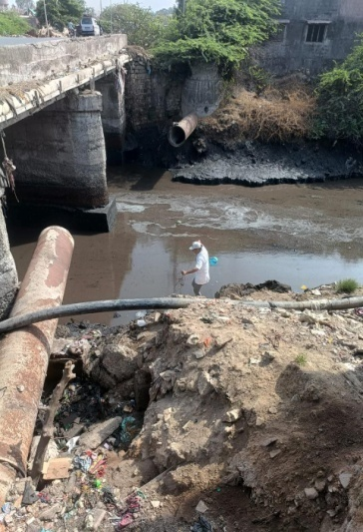 | 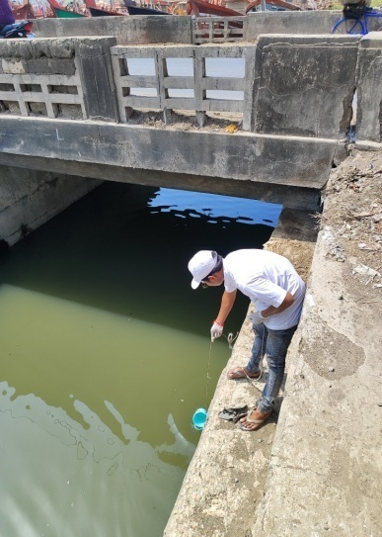
Fig 3: sampling of sewage water for analysis

Surface water samples were collected at each sampling station (fig 3), and water temperatures were recorded in situ using a mercury-in-glass thermometer. Samples intended for dissolved oxygen determination were collected separately and fixed immediately at the sampling location. All collected samples were properly preserved and transported to the laboratory for subsequent analysis. Physicochemical parameters, including water temperature, turbidity, pH, electrical conductivity, total dissolved solids, alkalinity, total hardness, dissolved oxygen, biochemical oxygen demand, nitrate, ammonia, phosphate, and chloride, were analysed in accordance with standard methodologies prescribed by APHA (2017) and Trivedi and Goel (1986). The data were analyzed using standard statistical procedures. Descriptive statistics (mean, standard deviation, and coefficient of variation) were calculated, and tests of significance were performed as per Snedecor and Cochran (2014). Duncan’s Multiple Range Test (DMRT) was applied as a post hoc test for mean separation wherever significant differences occurred.
- Result and discussion
The average values of the physicochemical parameters are summarized in Table 2. Water samples were collected from the seven selected sites over an eight-month period, with three replicates obtained during each sampling event. The results are presented as mean ± standard deviation (SD).
  - Temperature
Temperature is a key physicochemical parameter that strongly influences the chemical reactions, biological activity, and overall ecological functioning of aquatic systems. In sewage and wastewater environments, temperature affects microbial metabolism, organic matter decomposition, dissolved oxygen solubility, and nutrient transformation processes. Elevated temperatures can accelerate biochemical reactions and microbial activity, often leading to increased oxygen consumption and reduced dissolved oxygen levels, thereby exacerbating stress on receiving water bodies such as fishing harbour. Seasonal variations in temperature also reflect climatic influences and can significantly alter the impact of sewage discharge on coastal and estuarine ecosystems.
The mean sewage temperature across all monitored channels ranged from 25.05 ± 1.46 °C to 25.49 ± 1.22 °C (table 2). The lowest average temperature was observed at Bhidiya domestic sewage (Site No. 4) during the month of April. Comparable findings have been reported in earlier studies; Sivanandan et al. (2023) recorded mean temperatures of approximately 30.3 °C at the Gurunagar fish market and domestic drainage mixing zone, and 29.9 °C at the main domestic drainage outfall along the Gurunagar coastal waters. Similarly, Sarkinnoma et al. (2013) documented sewage water temperatures ranging between 23 °C and 25 °C in irrigation waters receiving sewage inputs in Bauchi Metropolis, Nigeria.
  - pH
pH is a fundamental indicator of water quality, reflecting the acid–base balance of aquatic systems and directly influencing chemical speciation, nutrient availability, and biological processes. In sewage-impacted waters, pH affects microbial activity, the toxicity and solubility of nutrients and metals, and the survival of aquatic organisms. Deviations from the normal pH range can alter biochemical reactions, impair self-purification capacity, and increase stress on receiving environments such as fishing harbour. Therefore, monitoring pH is essential for assessing the potential ecological impact of domestic sewage discharges.
The mean pH of sewage across all sampled channels ranged from 7.22 ± 0.31 to 7.37 ± 0.31, indicating slightly neutral to mildly alkaline conditions (table 2). The lowest mean pH was recorded at Veraval domestic sewage (Site No. 2), while the highest value was observed at Veraval domestic sewage (Site No. 3). The decomposition of organic matter in sewage often results in the production of ammonia and other alkaline compounds, which can contribute to elevated pH levels. In the present study, no statistically significant variation in pH was observed among the sampling sites.
Comparable pH ranges have been reported in earlier investigations. Salama et al. (2013) documented pH values ranging from 5.9 to 7.2 in sewage collectors along the El Jadida coast of Morocco. In contrast, Sarkinnoma et al. (2013) reported comparatively higher pH values (8.11–8.40) in sewage-contaminated irrigation waters in Bauchi Metropolis, Nigeria. Dashti and Haddad (2019) observed pH values between 7.9 and 8.39 in coastal seawater influenced by sewage discharges in Kuwait. Similarly, Panthi et al. (2021) recorded pH values ranging from 6.6 to 7.94 across municipal sewage channels in Veraval, which closely align with the findings of the present study.
  - Salinity
Salinity is an important parameter that reflects the concentration of dissolved salts in water and serves as an indicator of seawater intrusion, evaporation, and mixing between freshwater and marine environments. In sewage channels discharging into coastal and harbour waters, salinity influences the distribution and survival of aquatic organisms, affects osmotic regulation, and alters the behavior of nutrients and pollutants. Elevated salinity in domestic sewage may indicate marine water ingress or the contribution of saline wastes, which can intensify stress on freshwater and estuarine ecosystems and modify the physicochemical characteristics of receiving waters.
The mean salinity across all sewage channels ranged from 5.37 ± 0.29 ppt to 18.20 ± 0.62 ppt (table 2). The lowest average salinity was observed in Veraval domestic sewage (Site No. 3), whereas the highest salinity was recorded at Bhidiya domestic sewage (Site No. 7). The observed variation in salinity among the sites may be attributed to differences in freshwater inputs, domestic wastewater composition, and the degree of tidal or marine water intrusion.
Comparable observations have been reported in previous studies. Panthi et al. (2021) documented salinity values ranging between 10 and 11 ppt across municipal sewage channels in Veraval, which fall within the range observed in the present investigation.
  - Dissolved Oxygen (DO)
Dissolved oxygen is a critical indicator of water quality and ecological health, as it reflects the balance between oxygen-producing and oxygen-consuming processes in aquatic systems. In sewage-affected waters, DO levels are strongly influenced by organic pollution, microbial respiration, and temperature. Low dissolved oxygen concentrations indicate high organic loading and intense microbial activity, which can lead to hypoxic or anoxic conditions. Such conditions severely stress or eliminate sensitive aquatic organisms, disrupt biogeochemical cycles, and reduce the self-purification capacity of receiving waters, particularly in semi-enclosed environments like fishing harbour.
The mean dissolved oxygen concentrations across all sewage channels ranged from 0.024 ± 0.004 mg L⁻¹ to 0.041 ± 0.004 mg L⁻¹ (table 2). The lowest average DO was recorded at Bhidiya domestic sewage (Site No. 6), while the highest value was observed at Veraval domestic sewage (Site No. 3). The extremely low DO levels recorded in the present study reflect the high organic load typically associated with domestic sewage. The microbial decomposition of organic matter by aerobic bacteria consumes substantial amounts of dissolved oxygen, resulting in hypoxic to near-anoxic conditions within the sewage channels.
Similar observations have been reported in previous studies. Panthi et al. (2021) documented DO concentrations ranging from 0.009 to 0.014 mg L⁻¹ in municipal sewage channels of Veraval, which are comparable to the low values observed in the present investigation. In contrast, higher DO levels (0.47–1.40 mg L⁻¹) were reported in coastal seawater influenced by sewage discharges along the Kuwait coast by Dashti and Haddad (2019), indicating greater dilution and mixing in open marine environments.
  - Turbidity
Turbidity is a critical water quality parameter that reflects the concentration of suspended and colloidal particles, including organic matter, silt, and microorganisms, and serves as an indicator of pollution intensity in sewage-impacted waters. In the present study, mean turbidity values across the sewage channels ranged from 49.12 ± 10.02 NTU to 84.04 ± 10.69 NTU (table 2). The lowest average turbidity was recorded at Bhidiya domestic sewage (Site No. 3), while the highest value was observed at Bhidiya domestic sewage (Site No. 6). Elevated turbidity levels, particularly during the warmer months, can be attributed to increased evaporation, which reduces water volume and leads to the concentration of suspended particulates within the sewage channels.
Seasonal variation significantly influenced turbidity patterns. During the monsoon period, increased rainfall enhances water flow in drainage systems, resulting in the dilution of suspended solids and a subsequent decline in turbidity levels. High turbidity is of environmental concern as it reduces light penetration, interferes with photosynthetic activity, and can adversely affect aquatic organisms by clogging gills and transporting attached pollutants. Comparable turbidity ranges have been reported in earlier studies; Dashti and Haddad (2019) documented values between 20 and 74 NTU in sewage-influenced coastal waters of Kuwait, while Panthi et al. (2021) reported turbidity levels of 60–65 NTU in municipal sewage channels of Veraval, which closely correspond to the values observed in the present investigation.
  - Alkalinity
Alkalinity is an important water quality parameter that reflects the buffering capacity of water against sudden pH fluctuations and is primarily governed by the presence of bicarbonates, carbonates, and hydroxides. In the present study, mean alkalinity values across the sewage channels varied from 75.25 ± 12.39 mg L⁻¹ to 97.04 ± 28.23 mg L⁻¹ (table 2). The lowest average alkalinity was observed at Bhidiya domestic sewage (Site No. 7), whereas the highest value was recorded at the Veraval domestic sewage discharge channel (Site No. 1). Spatial variations in alkalinity may be attributed to differences in domestic wastewater composition, the extent of organic matter decomposition, and varying contributions of alkaline constituents within the sewage streams.
Elevated alkalinity in sewage-impacted waters is often associated with microbial degradation of organic matter, which releases bicarbonate ions, thereby enhancing the buffering capacity of the system. Such conditions can influence nutrient availability, microbial activity, and overall water chemistry. Similar alkalinity ranges have been reported in earlier investigations; Sarkinnoma et al. (2013) recorded alkalinity values between 63 and 95.5 mg CaCO₃ L⁻¹ in sewage-contaminated irrigation waters of Bauchi Metropolis, Nigeria, which closely align with the values observed in the present study.
  - Total hardness
Total hardness is a key physicochemical parameter that reflects the combined concentration of divalent cations, primarily calcium and magnesium, and plays an important role in influencing water chemistry, scaling potential, and the suitability of water for domestic, industrial, and ecological purposes. In the present investigation, the mean total hardness of wastewater across the sewage channels ranged from 236.79 ± 51.46 mg L⁻¹ to 281.04 ± 32.56 mg L⁻¹ (table 2). The lowest average hardness was recorded at Veraval domestic sewage (Site No. 3), while the highest value was observed at Veraval domestic sewage (Site No. 2).
Elevated hardness levels in domestic sewage are commonly linked to household water usage, detergent inputs, and the dissolution of calcium- and magnesium-bearing minerals during wastewater conveyance through pipelines and open drains. Increased hardness can influence the solubility of nutrients and metals, affect treatment efficiency, and contribute to scaling in sewage infrastructure. Comparable hardness ranges have been reported in previous studies; Sarkinnoma et al. (2013) documented total hardness values between 210 and 298 mg L⁻¹ in sewage-affected irrigation waters of Bauchi Metropolis, Nigeria, which are consistent with the findings of the present study.
  - Electrical conductivity
Electrical conductivity is an important indicator of the ionic strength of wastewater, reflecting the concentration of dissolved salts and inorganic ions that influence water quality, treatment efficiency, and potential impacts on receiving aquatic environments. In the present study, the mean electrical conductivity of sewage across all sampling sites ranged from 746.33 ± 59.42 µS cm⁻¹ to 1956.41 ± 90.73 µS cm⁻¹ (table 2). The lowest average conductivity was observed in Veraval domestic sewage, while the highest value was recorded in Bhidiya domestic sewage.
The comparatively high conductivity values observed at Bhidiya can be attributed to its coastal location and fishing activities, where seawater ingress into the sewage system increases the dissolved salt load and consequently elevates electrical conductivity. Elevated conductivity in sewage is often associated with increased salinity and mineral content, which can affect microbial activity, nutrient availability, and the performance of wastewater treatment processes. Similar conductivity ranges have been reported in earlier investigations. Panthi et al. (2021) recorded conductivity values between 1157.5 and 1286.6 µS cm⁻¹ in municipal sewage channels of Veraval, while Sarkinnoma et al. (2013) reported values ranging from 850 to 1524 µS cm⁻¹ in sewage-impacted irrigation waters of Bauchi Metropolis, Nigeria. Even higher conductivity levels (2.9–5.52 mS cm⁻¹) were documented by Salama et al. (2013) in sewage collectors along the El Jadida coast of Morocco, highlighting the influence of strong saline intrusion.
  - Chloride
Chloride is a key indicator of salinity and anthropogenic influence in sewage, as elevated concentrations often reflect seawater intrusion, domestic wastewater inputs, and activities related to food processing. High chloride levels can adversely affect freshwater ecosystems, soil quality, and the efficiency of wastewater treatment processes. In the present study, mean chloride concentrations across all sewage channels ranged from 2958.81 ± 160.78 mg L⁻¹ to 10,103.98 ± 158.89 mg L⁻¹ (table 2). The lowest average chloride content was observed in Veraval domestic sewage (Site No. 3), while the highest concentration occurred at Bhidiya domestic sewage (Site No. 7).
The markedly higher chloride concentrations recorded at Bhidiya can be attributed to its coastal setting and fishing-related activities. Seawater ingress into the sewage network, combined with the extensive use of salt for fish processing and preservation, substantially enhances chloride loading in wastewater. Comparable observations have been documented in earlier studies. Meiaraj and Jeyapriya (2019) reported chloride concentrations of approximately 17,532 mg L⁻¹ in sewage-influenced waters near the Tuticorin fishing harbour, where municipal effluents are directly discharged into the marine environment. Similarly, Sivanandan et al. (2023) recorded extremely high salinity conditions, indicative of chloride-rich waters, with mean values of about 36,517 mg L⁻¹ at the Gurunagar fish market and domestic drainage mixing zone, and 34,750 mg L⁻¹ at the main domestic drainage outfall along the Gurunagar coast.
  - Total Solids (TS), Total Dissolved Solids (TDS), and Total Suspended Solids (TSS)
Total solids and their fractions, total dissolved solids and total suspended solids are critical indicators of wastewater quality, as they collectively represent the overall load of organic and inorganic matter present in sewage. Elevated solids concentrations can impair light penetration, reduce dissolved oxygen availability, clog aquatic habitats, and negatively affect receiving water bodies as well as wastewater treatment efficiency. In domestic sewage systems, solids levels are strongly influenced by population density, household activities, flow conditions, and seasonal factors.
In the present study, mean total solids (TS) concentrations across all sewage channels ranged from 5,321.75 ± 571.44 mg L⁻¹ to 19,530.08 ± 4,907.57 mg L⁻¹ (table 2). The lowest average TS was recorded at Bhidiya domestic sewage (Site No. 4), while the highest concentration was observed at Veraval domestic sewage (Site No. 2). This pronounced spatial variation in TS can be largely attributed to differences in population density and associated domestic waste generation between the two areas. Bhidiya, characterized by a relatively lower population density, generates smaller volumes of domestic waste per unit area, resulting in comparatively lower TS levels. In contrast, the higher population density of Veraval contributes to increased domestic waste inputs into the sewage network, thereby elevating total solids concentrations. Comparable TS values have been reported by Panthi et al. (2021), who documented concentrations ranging from 6,223 to 6,511 mg L⁻¹ across municipal sewage channels in Veraval, which fall within the lower range of the present observations.
Similarly, mean total dissolved solids (TDS) concentrations varied from 4,863.41 ± 504.55 mg L⁻¹ to 18,083.58 ± 4,809.14 mg L⁻¹ across the sewage channels (table 2). The lowest TDS levels were recorded at Bhidiya domestic sewage (Site No. 4), whereas the highest values occurred at Veraval domestic sewage (Site No. 2). The spatial distribution of TDS closely followed the TS pattern, reflecting differences in population density and the intensity of domestic activities. Lower household inputs in Bhidiya resulted in reduced dissolved salt and organic loads, while higher domestic contributions in Veraval led to elevated TDS concentrations. Panthi et al. (2021) reported similar trends, with TDS values ranging from 5,836 to 6,762 mg L⁻¹ across municipal sewage channels, showing higher concentrations during the pre-monsoon season and lower values during the post-monsoon period. Substantially higher TDS levels (31,747–44,270 mg L⁻¹) have been documented in coastal seawater affected by sewage discharges along the Kuwait coast by Dashti and Haddad (2019), reflecting strong marine influence and dilution effects in open waters.
The mean concentrations of total suspended solids (TSS) across all sewage channels ranged from 458.33 ± 67.48 mg L⁻¹ to 1,455.33 ± 121.14 mg L⁻¹ (table 2). The lowest average TSS was observed at Bhidiya domestic sewage (Site No. 4), while the highest concentrations were recorded at Veraval domestic sewage (Site No. 2) and Bhidiya domestic sewage (Site No. 6). Elevated TSS levels at these sites may be attributed to increased domestic waste inputs, resuspension of particulate matter under low-flow conditions, and the accumulation of organic debris within the sewage channels. Comparable TSS ranges have been reported by Panthi et al. (2021), who observed values between 646 and 720 mg L⁻¹ in Veraval municipal sewage channels. Similarly, Salama et al. (2013) documented TSS concentrations ranging from 524.13 to 1,067.2 mg L⁻¹ in sewage collectors along the El Jadida coast of Morocco. Much higher suspended solids loads (39,812–43,156 mg L⁻¹) have been reported in seawater influenced by wadi discharges near the mouth of Wadi Gaza, Palestine (Ubeid KF and Al-Agha MR, 2016), highlighting the contrast between confined sewage channels and sediment-rich coastal receiving waters.
  - Biological Oxygen Demand (BOD)
Biological oxygen demand (BOD) is a key indicator of organic pollution in wastewater, as it represents the amount of dissolved oxygen required by microorganisms to biologically degrade organic matter. Elevated BOD levels are indicative of high organic loading, which can severely deplete oxygen concentrations in receiving water bodies and adversely affect aquatic life and overall ecosystem health.
In the present study, mean BOD values across all sewage channels ranged from 222.25 ± 57.52 mg L⁻¹ to 377.70 ± 58.83 mg L⁻¹ (table 2). The lowest average BOD was recorded in Bhidiya domestic sewage, whereas the highest values were also observed at specific Bhidiya sewage channels. Statistical analysis revealed significant monthly variations in BOD concentrations across the sewage discharge sites (one-way ANOVA followed by Duncan’s post hoc test), highlighting the influence of temporal fluctuations in organic waste inputs and degradation processes.
The elevated BOD levels observed in the sewage channels reflect the substantial accumulation of biodegradable organic matter. Microbial decomposition of this organic load consumes large amounts of dissolved oxygen, thereby increasing BOD concentrations. The comparatively higher BOD values recorded at certain Bhidiya sites may be attributed to the combined discharge of domestic sewage and organic-rich effluents from small-scale industrial and fish-processing activities in the area. Similar BOD ranges have been reported by Panthi et al. (2021), who documented values between 280 and 376 mg L⁻¹ in municipal sewage channels of Veraval. In contrast, much lower BOD concentrations were observed in coastal waters receiving sewage discharges at Gurunagar, where Sivanandan et al. (2023) reported mean BOD values of 21.3 mg L⁻¹ at the fish market and domestic drainage mixing zone and 43.5 mg L⁻¹ at the main domestic drainage mixing site, reflecting the effects of dilution and enhanced oxygen availability in open marine environments.
  - Nitrate and Phosphate
Nitrate and phosphate are key nutrient parameters in wastewater, as elevated concentrations of these compounds can stimulate eutrophication in receiving water bodies, leading to excessive algal growth, oxygen depletion, and deterioration of aquatic ecosystem health. Their concentrations in sewage are strongly influenced by domestic waste inputs, industrial discharges, and seasonal variations in wastewater flow and dilution.
In the present study, mean nitrate concentrations across all sewage channels ranged from 11.29 ± 1.01 mg L⁻¹ to 21.87 ± 1.23 mg L⁻¹ (table 2). The lowest average nitrate level was recorded at the Veraval sewage channel (Site No. 3), whereas the highest concentration occurred at Bhidiya domestic sewage (Site No. 4). Statistical analysis revealed significant monthly variations in nitrate concentrations across the sewage discharge channels, indicating temporal fluctuations in nitrogen loading. The elevated nitrate levels observed at Bhidiya may be attributed to the discharge of nitrogen-rich effluents from local industries, along with contributions from domestic wastewater, which together increase the overall nitrogen load in the sewage system.
Similarly, mean phosphate concentrations across all sewage channels ranged from 1.00 ± 0.28 mg L⁻¹ to 2.82 ± 0.36 mg L⁻¹ (table 2). The lowest average phosphate concentration was observed in Bhidiya domestic sewage, while the highest value was recorded in Veraval domestic sewage. Significant spatial differences in phosphate concentrations were detected among the sewage discharge channels, reflecting variations in domestic waste inputs, detergent use, industrial contributions, and the degree of wastewater dilution. Comparable phosphate concentrations were reported by Sarkinnoma et al. (2013), who documented values between 1.00 and 2.38 mg L⁻¹ in sewage-contaminated irrigation waters of Bauchi Metropolis, Nigeria. In contrast, substantially higher phosphate levels (18–39 mg L⁻¹) were reported by Salama et al. (2013) in sewage collectors along the El Jadida coast of Morocco, highlighting regional differences in sewage composition and anthropogenic nutrient inputs.
Table 2:- Site-wise variation of physicochemical parameters of domestic sewage water of veraval and bhidiya (Mean ± SD)
Parameter | Site 1 | Site 2 | Site 3 | Site 4 | Site 5 | Site 6 | Site 7
Temperature (°C) | 25.49 ± 1.22ᵃ | 25.33 ± 1.33ᵃ | 25.31 ± 1.48ᵃ | 25.05 ± 1.46ᵃ | 25.26 ± 1.46ᵃ | 25.29 ± 1.38ᵃ | 25.28 ± 1.40ᵃ
pH | 7.28 ± 0.33ᵃ | 7.22 ± 0.31ᵃ | 7.37 ± 0.31ᵃ | 7.33 ± 0.23ᵃ | 7.36 ± 0.29ᵃ | 7.32 ± 0.14ᵃ | 7.32 ± 0.24ᵃ
Salinity (ppt) | 5.60 ± 0.16ᶠ | 6.46 ± 0.22ᵉ | 5.37 ± 0.29ᶠ | 15.41 ± 0.17ᵇ | 14.49 ± 0.24ᶜ | 13.20 ± 0.36ᵈ | 18.20 ± 0.62ᵃ
Dissolved Oxygen (mg/L) | 0.032 ± 0.006ᵇ | 0.033 ± 0.005ᵇ | 0.041 ± 0.004ᵃ | 0.034 ± 0.006ᵇ | 0.028 ± 0.006ᵇᶜ | 0.024 ± 0.004ᶜ | 0.029 ± 0.005ᵇᶜ
Turbidity (NTU) | 72.20 ± 9.23ᵇ | 83.20 ± 8.36ᵃ | 49.95 ± 9.51ᶜ | 78.33 ± 8.03ᵃᵇ | 74.29 ± 10.72ᵃᵇ | 84.04 ± 10.69ᵃ | 49.12 ± 10.02ᶜ
Alkalinity (mg/L) | 97.04 ± 28.23ᵃ | 79.37 ± 17.43ᵃ | 80.58 ± 24.35ᵃ | 89.20 ± 19.21ᵃ | 96.45 ± 17.55ᵃ | 94.12 ± 14.03ᵃ | 75.25 ± 12.39ᵃ
Total Hardness (mg/L) | 257.87 ± 33.78ᵃ | 281.04 ± 32.56ᵃ | 236.79 ± 51.46ᵇ | 274.87 ± 31.28ᵃ | 259.66 ± 25.73ᵃ | 271.66 ± 26.24ᵃ | 243.66 ± 33.63ᵃ
Conductivity (µS/cm) | 1750.91 ± 77.86ᵇ | 1945.41 ± 67.76ᵃ | 746.33 ± 59.42ᵉ | 929.20 ± 85.43ᵈ | 1424.33 ± 56.49ᶜ | 1956.41 ± 90.73ᵃ | 859.08 ± 64.49ᵈ
Chloride (mg/L) | 3075.37 ± 92.33ᶠ | 3549.12 ± 123.10ᵉ | 2958.81 ± 160.79ᶠ | 8517.77 ± 97.21ᵇ | 7972.20 ± 143.25ᶜ | 7256.04 ± 198.06ᵈ | 10103.97 ± 158.90ᵃ
Total Solids (mg/L) | 17839.04 ± 3914.66ᵃᵇ | 19530.08 ± 4907.57ᵃ | 6305.08 ± 395.96ᶜ | 5321.75 ± 571.44ᶜ | 16199.83 ± 3950.72ᵇ | 17558.87 ± 2590.88ᵃᵇ | 7550.37 ± 620.95ᶜ
Total Dissolved Solids (mg/L) | 16501.83 ± 3809.61ᵃ | 18083.58 ± 4809.14ᵃ | 5788.37 ± 338.53ᵇ | 4863.41 ± 504.55ᵃ | 14874.91 ± 3866.78ᵃ | 16103.54 ± 2490.55ᵃ | 6979.91 ± 564.72ᵃ
Total Suspended Solids (mg/L) | 1337.20 ± 115.05ᵇ | 1446.50 ± 106.66ᵃ | 516.70 ± 59.23ᶜᵈ | 458.33 ± 67.48ᵈ | 1324.91 ± 90.86ᵇ | 1455.33 ± 121.14ᵃ | 570.45 ± 58.64ᶜ
BOD (mg/L) | 374.37 ± 59.85ᵇ | 346.29 ± 65.59ᵇ | 249.37 ± 62.96ᶜ | 377.70 ± 58.84ᵇ | 327.12 ± 57.70ᵇ | 341.16 ± 53.27ᵇ | 222.25 ± 57.52ᶜ
Nitrate (mg/L) | 14.34 ± 1.47ᵉ | 17.71 ± 1.34ᶜ | 11.29 ± 1.01ᶠ | 21.87 ± 1.23ᵃ | 19.60 ± 1.96ᵇ | 17.30 ± 1.32ᶜᵈ | 15.98 ± 0.71ᵈ
Phosphate (mg/L) | 2.56 ± 0.36ᵃ | 2.82 ± 0.36ᵃ | 1.00 ± 0.28ᵈ | 1.87 ± 0.23ᵇᶜ | 2.18 ± 0.33ᵇ | 2.05 ± 0.31ᵇᶜ | 1.81 ± 0.23ᶜ

- Conclusion
The present study provides a comprehensive assessment of the physicochemical characteristics of domestic sewage channels discharging into Veraval Fishing Harbour from Veraval town and Bhidiya fishing village along the Gujarat coast. The analysis of key water quality parameters revealed pronounced spatial and temporal variations, reflecting differences in population density, domestic activities, industrial inputs, and the influence of coastal processes such as seawater intrusion.
Sewage temperature and pH remained within relatively narrow ranges, indicating stable thermal conditions and slightly neutral to mildly alkaline nature of the wastewater. However, extremely low dissolved oxygen concentrations across all sites confirmed the presence of heavy organic loading and active microbial decomposition, resulting in hypoxic to near-anoxic conditions within the sewage channels. Elevated biological oxygen demand values further substantiated the high concentration of biodegradable organic matter, particularly at Bhidiya sites influenced by domestic and fish-processing activities.
High turbidity, total solids, total dissolved solids, and total suspended solids concentrations indicated substantial inputs of particulate and dissolved matter, with markedly higher values observed in Veraval sewage channels due to greater population density and domestic waste generation. In contrast, relatively lower values at Bhidiya reflected reduced domestic load, although localized increases in suspended solids were evident at specific sites. Electrical conductivity and chloride concentrations were significantly higher at Bhidiya, highlighting the strong influence of seawater intrusion and salt usage associated with fishing and fish-processing activities.
Nutrient enrichment was evident from elevated nitrate and phosphate concentrations across all sewage channels, with statistically significant spatial and temporal variations. The presence of nitrogen- and phosphorus-rich wastewater from domestic and localized industrial sources poses a potential risk of eutrophication in the receiving harbour waters. Overall, the combined effects of high organic load, elevated nutrients, and restricted water circulation within Veraval Fishing Harbour suggest a substantial threat to water quality, sediment condition, and aquatic biota.
The findings emphasize the urgent need for effective sewage management, pretreatment of domestic and industrial effluents, and regular monitoring of water quality in coastal fishing harbours. Implementation of appropriate wastewater treatment and pollution control strategies is essential to safeguard the ecological health of Veraval Fishing Harbour and to ensure the long-term sustainability of fisheries resources and associated livelihoods.
Acknowledgement
The authors express their sincere gratitude to Dr. D. T. Vaghela for his valuable guidance, constant support, and constructive suggestions throughout the course of this study. We are thankful to Kamdhenu University for providing the necessary platform, facilities, and academic environment to carry out this research successfully.
Disclaimer (Artificial intelligence)
Author(s) hereby declare that NO generative AI technologies such as Large Language Models (ChatGPT, COPILOT, etc.) and text-to-image generators have been used during the writing or editing of this manuscript.

Reference
- APHA (American Public Health Association) 2017. Standard methods for the examination of water and wastewater. 23rd edn. American Public Health Association, Washington, DC.
- Central Pollution Control Board (CPCB) 2016. Annual report 2015–2016. Central Pollution Control Board, New Delhi.
- Dashti F and Al-Haddad A 2019. Investigations of the physical, chemical and microbial parameters of coastal seawater near sewage outlets, Kuwait. Proceedings of the Twenty-Second International Water Technology Conference (IWTC-22): 515–524.
- Friedler E, Butler D and Alfiya Y 2013. Wastewater composition. In: Source separation and decentralization for wastewater management: 241–257.
- Meiaraj C and Jeyapriya S P 2019. Marine water quality studies at Tuticorin harbour coastal area. Indian Journal of Geo-Marine Sciences 48(6): 943–946.
- NIO 2014. Report on monitoring of environmental quality off Veraval (2014). National Institute of Oceanography, India.
- NIO 2015. Report on monitoring of environmental quality off Veraval (2015). National Institute of Oceanography, India.
- Panthi M 2021. Assessment of physio-chemical characteristics of wastewater discharge from municipal sewage channel at Veraval coast, Gujarat. M.F.Sc. Dissertation, College of Fisheries Science, Kamdhenu University, Veraval, Gujarat.
- Qadir M, Drechsel P, Jiménez Cisneros B et al. 2020. Global and regional potential of wastewater as a water, nutrient and energy source. Natural Resources Forum 44: 40–51.
- Salama Y, Chennaoui M, Mountadar M, Rihani M and Assobhei O 2013. The physicochemical and bacteriological quality and environmental risks of raw sewage rejected in the coast of the city of El Jadida (Morocco). Carpathian Journal of Earth and Environmental Sciences 8(2): 39–48.
- Sarkinnoma A, Yarkasuwa C I, Modu K A and Balewa A T 2013. Analysis of physicochemical parameters of sewage water used for irrigation in Bauchi metropolis, Nigeria. Journal of Environment and Earth Science 3(10): 37–41.
- Sivanandan A, Kuganathan S and Ketheesan B 2023. Assessment of water quality and pollution in Gurunagar fishery harbour, Jaffna, Sri Lanka. International Journal of Science and Research Archive 9(1): 213–221.
- Snedecor G W and Cochran W G 2014. Statistical methods. 8th edn. Wiley-Blackwell.
- Taranu Z E, Gregory-Eaves I, Leavitt P R, Bunting L, Buchaca T, Catalan J, Domaizon I, Guilizzoni P, Lami A, McGowan S, Moorhouse H, Morabito G, Pick F R, Stevenson M A, Thompson P L and Vinebrooke R D 2015. Acceleration of cyanobacterial dominance in north temperate–subarctic lakes during the Anthropocene. Ecology Letters 18(4): 375–384.
- Ubeid KF, Al-Agha MR. Assessment of impact sewage effluents on the coastal water quality around the mouth of Wadi Gaza (Gaza and Middle Governorates, Gaza Strip, Palestine). Journal of Environment and Earth Science. 2016;6(11):84-103.
- Trivedi R K, Goel P K and Trisal C L 1986. Practical methods in ecology and environmental science.

