Case report
CIRCUMFERENTIAL PERIAURICULAR NECROSIS WITH PARTIAL EAR SLOUGHING IN A CAPTIVE ASIAN ELEPHANT (Elephas maximus): A CASE REPORT

ABSTRACT
Periauricular necrosis and sloughing of the ear in elephants are rare but serious clinical conditions, most often associated with vascular compromise following intravenous drug administration. This case report describes the clinical presentation, diagnostic evaluation, medical management, and outcome of circumferential periauricular necrosis in a 10-year-old captive female Asian elephant (Elephas maximus). The animal was presented with anorexia and subsequently developed impaired ear flapping, peripheral ear dryness, and a septic wound on the caudal aspect of the left pinna. Clinical examination revealed circumferential dry necrosis of the ear with loss of sensation and absence of bleeding on needle puncture. Doppler ultrasonography confirmed a lack of blood flow to the affected peripheral region, while electrocardiography showed no systemic abnormalities. Histopathological examination demonstrated epithelial loss, fibrous tissue proliferation, and marked avascularity, consistent with ischemic necrosis. Conservative medical management, including systemic antimicrobial and anti-inflammatory therapy, resulted in spontaneous sloughing of the necrotic ear tissue by Day 7, followed by healthy granulation and early epithelialization by Day 15. The lesion was presumed to be of iatrogenic origin, likely secondary to auricular vascular injury following intravenous injection. This report underscores the susceptibility of the elephant ear to vascular compromise, highlights the importance of early diagnosis and appropriate management, and emphasizes the need for meticulous intravenous administration techniques to prevent such debilitating complications in captive elephants.
Keywords: Asian elephant, periauricular necrosis, ear sloughing, auricular thrombosis; intravenous injection; case report
- INTRODUCTION
Elephants are the largest extant terrestrial mammals and play a pivotal ecological role as keystone and flagship species across their native range. Through activities such as vegetation modification, seed dispersal, and water-hole creation, elephants significantly influence ecosystem structure and biodiversity. Despite their robust physical stature, elephants, particularly those maintained under captive or semi-captive conditions are vulnerable to a wide range of medical, nutritional, infectious, and management-related disorders. Unexpected morbidity and mortality have been reported even in apparently well-maintained captive elephants, often associated with infectious diseases, metabolic imbalances, musculoskeletal disorders, vascular disturbances and iatrogenic complications arising from routine veterinary interventions (Clubb et al., 2008; Mikota et al., 2016).
Captive elephants frequently require repeated handling for medical procedures, including intravenous drug administration, fluid therapy and diagnostic sampling. Due to their size and temperament, the peripheral veins of the ear are commonly selected for venous access. While auricular veins provide convenient vascular access, repeated injections or improper administration techniques can predispose elephants to vascular injury, phlebitis, thrombosis and localized ischemia (Suedmeyer, 1996; Schmidt and Schmidt, 2011). These complications may be exacerbated by the unique vascular anatomy of the elephant ear, which lacks deep muscular protection and relies heavily on superficial blood flow for tissue viability.
The ear (pinna) of elephants is a highly specialized and multifunctional organ. In addition to its role in auditory perception and balance, the elephant ear plays a critical role in thermoregulation and social communication. Heat dissipation is facilitated by rhythmic ear flapping, which enhances convective and evaporative heat loss due to the extensive vascularization of the pinna. Anatomically, the ear is supported by a thin, lattice-like cartilage framework that does not extend fully to the peripheral margin, rendering the distal pinna particularly susceptible to ischemic injury. A dense network of superficial veins and arteries courses along the caudal surface of the ear, allowing efficient thermoregulation but simultaneously increasing vulnerability to vascular compromise following trauma or iatrogenic insult (Fowler and Mikota, 2006; Weissenbock et al., 2012).
Periauricular necrosis and sloughing of the elephant ear, although infrequently reported, represent a severe and debilitating condition with significant animal welfare implications. Once vascular occlusion occurs, tissue necrosis may progress rapidly due to limited collateral circulation, ultimately leading to dry gangrene and spontaneous sloughing of the affected ear segment (Miller, 1977). Such conditions not only impair thermoregulation and communication but also predispose animals to secondary infections, chronic pain and long-term functional deficits. The present report documents a rare case of circumferential periauricular necrosis and complete sloughing of the ear in a captive Asian elephant, highlights the diagnostic approach and medical management and discusses the probable etiopathogenesis with reference to previously documented cases.
Case presentation
A 10-year-old female Asian elephant (Elephas maximus), maintained in a temple, was presented to the Large Animal Medicine Referral Clinic, Veterinary College and Research Institute, Orathanadu, Thanjavur district, Tamil Nadu, India. The animal had a reported history of anorexia for approximately one week before presentation and had received symptomatic medical treatment, including injectable medications, administered by local veterinarians. At the time of admission, the elephant appeared dull but remained responsive to external stimuli. The animal was admitted for inpatient medical care to facilitate comprehensive clinical evaluation, diagnostic investigations and supportive therapy. Within a few days of hospitalization, progressive abnormalities involving the left ear were observed. These clinical signs included diminished and impaired ear flapping and pronounced dryness of the peripheral ear margin.
Detailed physical examination revealed circumferential dry necrosis affecting the left ear, extending from the dorsal aspect of the pinna to the caudal margin (Fig.1). The necrotic zone measured approximately 8 cm in width, extending medially from the peripheral edge of the ear. The affected tissue was cold to the touch, insensate and exhibited no pain response. Exploratory needle puncture of the necrotic region failed to elicit bleeding or nociceptive response, indicating complete loss of vascular perfusion and tissue viability. Localized cellulitis was observed at the presumed site of previous intravenous injection on the posterior aspect of the ear. Doppler ultrasonographic examination of the auricular vasculature demonstrated a complete absence of blood flow to the peripheral necrotic region (Fig. 2), while the central auricular vessels remained patent. Electrocardiographic evaluation revealed no significant abnormalities. Tissue samples obtained from the necrotic margin were fixed in 10% neutral buffered formalin and submitted for histopathological examination.
Medical management
The elephant was managed conservatively with intensive clinical monitoring. Over approximately two weeks, a well-defined line of demarcation between viable and non-viable tissue became evident (Fig. 3). The loosely attached necrotic portion on the ventral aspect of the ear was excised under topical lignocaine spray. The wound was irrigated using antiseptic solutions and treated with a topical broad-spectrum antibiotic ointment. Systemic therapy included intramuscular enrofloxacin at the dose rate of 5 mg/kg, flunixine meglumine at the dose rate of 1.1 mg/kg and chlorpheniramine maleate 0.5 mg/kg and vitamin AD₃E @ 10 ml. Treatment was continued for 15 days with daily monitoring.
RESULT AND DISCUSSION
Histopathological evaluation of the affected ear tissue revealed extensive loss of the surface epithelium with replacement by proliferative fibrous connective tissue and marked avascularity. The absence of viable vascular channels, along with fibrotic tissue proliferation, is indicative of chronic ischemic injury leading to coagulative necrosis. No evidence of neoplastic transformation, vasculitis of infectious origin or primary bacterial or fungal invasion was observed. These findings strongly support a vascular etiology rather than a primary infectious or traumatic cause for the lesion. Similar histopathological features have been described in ischemic necrosis associated with vascular compromise in large mammals following iatrogenic injury (Suedmeyer, 1996; Schmidt and Schmidt, 2011) and small animals (Kar et al., 2025)
Clinically, the elephant remained systemically stable throughout the observation period, with no evidence of fever, altered behaviour or deterioration in general health status. This absence of systemic involvement suggests that the pathological process was largely localized to the ear and did not progress to septicaemia or systemic inflammatory response. By Day 7 following initiation of treatment, spontaneous and complete sloughing of the devitalized portion of the ear was observed. This event represented the final stage of tissue separation following irreversible ischemic injury, wherein necrotic tissue detached from the viable margins once inflammatory demarcation was complete. Such spontaneous sloughing is characteristic of dry gangrene resulting from arterial or venous occlusion and has been reported previously in elephants with auricular vascular thrombosis (Miller, 1977; Fowler and Mikota, 2006).
By Day 15, the wound margins exhibited healthy granulation tissue formation, accompanied by early epithelialization, indicating the initiation of reparative and regenerative processes. The favourable healing response observed in this case may be attributed to early recognition of vascular compromise, conservative wound management and appropriate systemic therapy. The elephant’s inherent capacity for wound healing, when coupled with adequate antimicrobial coverage and anti-inflammatory support, likely contributed to the satisfactory clinical outcome. Comparable healing patterns have been described in other reports of soft tissue injury in elephants when secondary infection and mechanical trauma are effectively controlled (Mikota et al., 2016).
Circumferential or periauricular necrosis of the elephant ear is an uncommon but serious condition, most frequently associated with vascular injury secondary to phlebitis or thrombophlebitis following intravenous drug administration. The auricular veins are commonly utilized for venous access in elephants due to their superficial location and relative ease of cannulation. However, accidental perivascular or intra-arterial injection of irritant drugs can precipitate acute endothelial damage, vasospasm, thrombus formation and subsequent interruption of blood flow to the distal pinna (Schmidt and Schmidt, 2011). The thin cartilage framework and limited collateral circulation of the peripheral ear further exacerbate the susceptibility of the pinna to ischemic injury.
Non-steroidal anti-inflammatory drugs, antimicrobial agents and hypertonic solutions have been implicated in previous reports of injection-related vascular complications in elephants. Suedmeyer (1996) described auricular thrombosis and circumferential necrosis in an African elephant following intravenous administration of trimethoprim-sulfadiazine and flunixin meglumine, resulting in extensive tissue loss. Similarly, Miller (1977) reported cases of segmental gangrene and sloughing of elephant ears following phenylbutazone injection. The clinical progression and severity of lesions observed in the present case closely mirror those in earlier reports, suggesting a consistent pathophysiological mechanism involving injection-induced vascular injury.
In addition to chemical irritation, mechanical factors such as repeated venipuncture, improper needle placement, and inadequate restraint may contribute to vascular trauma and subsequent thrombosis. In captive elephants, repeated therapeutic interventions over prolonged periods may further increase the risk of cumulative vascular damage. Recent studies emphasize that vascular complications in large mammals are often underrecognized during early stages, as overt clinical signs may only become apparent after significant ischemic damage has occurred (Hernandez-Divers et al., 2018).
From an animal welfare perspective, auricular necrosis has profound implications. Loss of ear tissue compromises thermoregulation, particularly in tropical climates, where elephants rely heavily on ear flapping for heat dissipation. Additionally, damage to the ear may impair social signalling and auditory perception, thereby affecting overall well-being and behaviour. Chronic pain, secondary infection, and cosmetic deformity further underscore the importance of preventing such injuries (Mason & Veasey, 2010).
Preventive strategies are therefore critical to minimize iatrogenic auricular injury in elephants. Dilution of potentially irritating injectable drugs, strict adherence to aseptic techniques and avoidance of repeated injections at the same auricular site are essential preventive measures. Recent advancements such as infrared vein finders and vein illumination devices have shown promise in improving vein visualization and reducing accidental arterial or perivascular injections in both human and veterinary medicine (Park et al., 2019). Adoption of such technologies in elephant practice may significantly reduce the incidence of catastrophic vascular complications.
Overall, this case highlights the importance of meticulous intravenous administration techniques in elephants and underscores the need for heightened awareness among veterinarians regarding potential auricular vascular complications. Early diagnosis using Doppler ultrasonography, coupled with appropriate medical management, can mitigate tissue damage and improve clinical outcomes. The present report contributes valuable clinical insight to the limited body of literature on periauricular necrosis in elephants and reinforces the necessity for preventive protocols in captive elephant healthcare.
CONCLUSION
Periauricular necrosis and subsequent sloughing of the ear represent a rare but severe iatrogenic complication in captive elephants, primarily associated with auricular vascular injury following intravenous drug administration. The present case highlights the critical role of early clinical recognition, appropriate diagnostic imaging and conservative medical management in achieving a favourable outcome despite extensive tissue loss. Histopathological findings confirmed ischemic necrosis secondary to vascular compromise, underscoring the vulnerability of the elephant ear due to its unique anatomical and vascular characteristics. This report emphasizes the importance of meticulous intravenous administration techniques, judicious drug dilution and the use of vein-localization aids to prevent catastrophic auricular injuries.
DISCLAIMER (ARTIFICIAL INTELLIGENCE)
The authors declare that generative AI tools were used only for language editing and improvement of clarity and that the authors take full responsibility for the scientific content of this manuscript.

CONFLICT OF INTEREST
The authors declare they have no conflicts of interest.
REFERENCES
Clubb, R., Rowcliffe, M., Lee, P., Mar, K.U., Moss, C. and Mason, G.J. (2008). Compromised survivorship in zoo elephants. Science, 322: 1649.
Fowler, M.E. and Mikota, S.K. (2006). Biology, Medicine, and Surgery of Elephants. Blackwell Publishing, Ames, IA.
Hernandez-Divers, S.J., Latimer, E.M. and Schumacher, J. (2018). Iatrogenic vascular injuries in zoological species: recognition, management, and prevention. Journal of Zoo and Wildlife Medicine, 49: 357–369.
Kar, M., Cingi, C., & Ferekidis, E. (2025). External Ear Tract Diseases. In Otology Updates (pp. 307-321). Cham: Springer Nature Switzerland
Mason, G.J. and Veasey, J.S. (2010). How should the psychological well-being of zoo elephants be objectively investigated? Zoo Biology, 29: 237–255.
Mikota, S.K., Sargent, E.L. and Ranglack, G.S. (2016). Health and disease management in captive elephants. Journal of Zoo and Wildlife Medicine, 47: 689–699.
Miller, R.E. (1977). Gangrene and sloughing of the ear in elephants following intravenous phenylbutazone injection. Journal of the American Veterinary Medical Association, 171: 914–916.
Park, J.H., Lee, S.H. and Kim, J.T. (2019). Clinical utility of infrared vein visualization devices for prevention of vascular injury. Journal of Clinical Monitoring and Computing, 33: 477–483.
Schmidt, M.J. and Schmidt, R.E. (2011). Vascular complications associated with intravenous drug administration in large mammals. Veterinary Clinics of North America: Exotic Animal Practice, 14: 491–507.
Suedmeyer, W.K. (1996). Auricular thrombosis and necrosis following intravenous injections in an African elephant (Loxodonta africana). Journal of Zoo and Wildlife Medicine, 27: 524–528.
Weissenböck, H., Hittmair, K.M. and Egerbacher, M. (2012). Functional anatomy of elephant skin and appendages with emphasis on thermoregulation. Journal of Anatomy, 221: 188–199.

Fig.1. Circumferential dry necrosis extending from the dorsal aspect of the pinna to the caudal margin of affected left ear
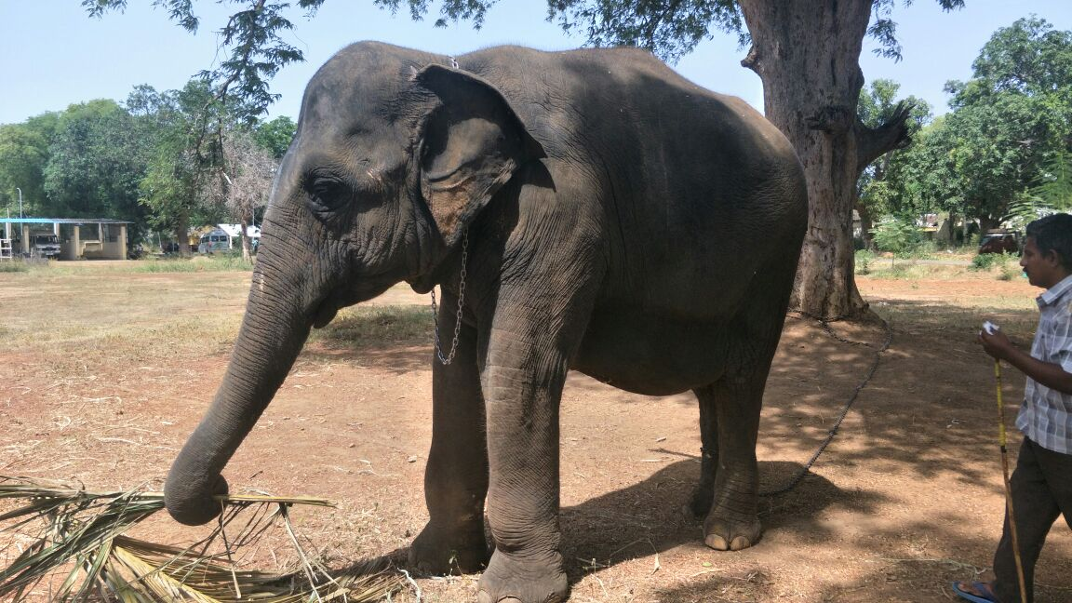 | 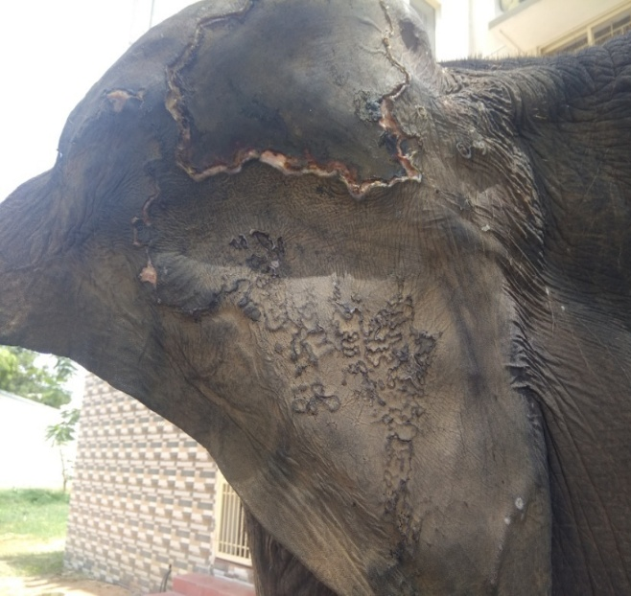

Fig. 2. Doppler ultrasonographic examination of the auricular vasculature demonstrated complete absence of blood flow to the peripheral necrotic region
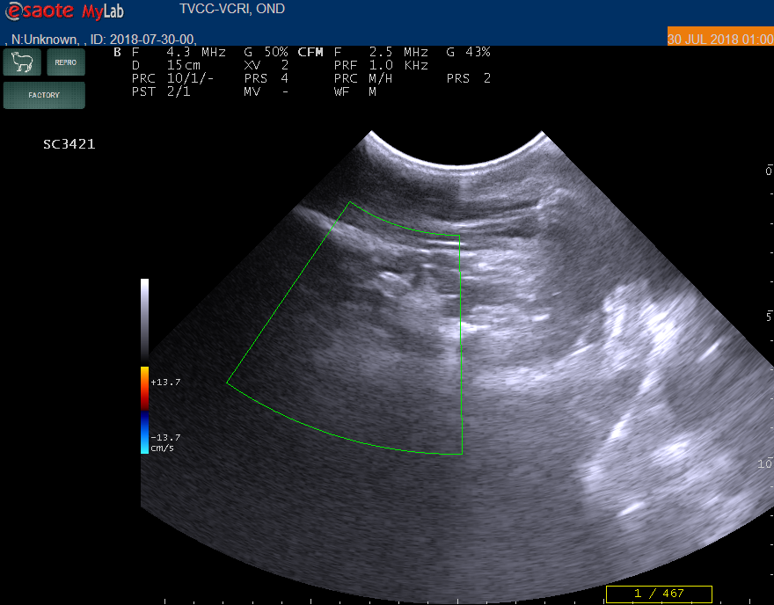

Fig. 3. Well-defined line of demarcation between viable and non-viable tissue
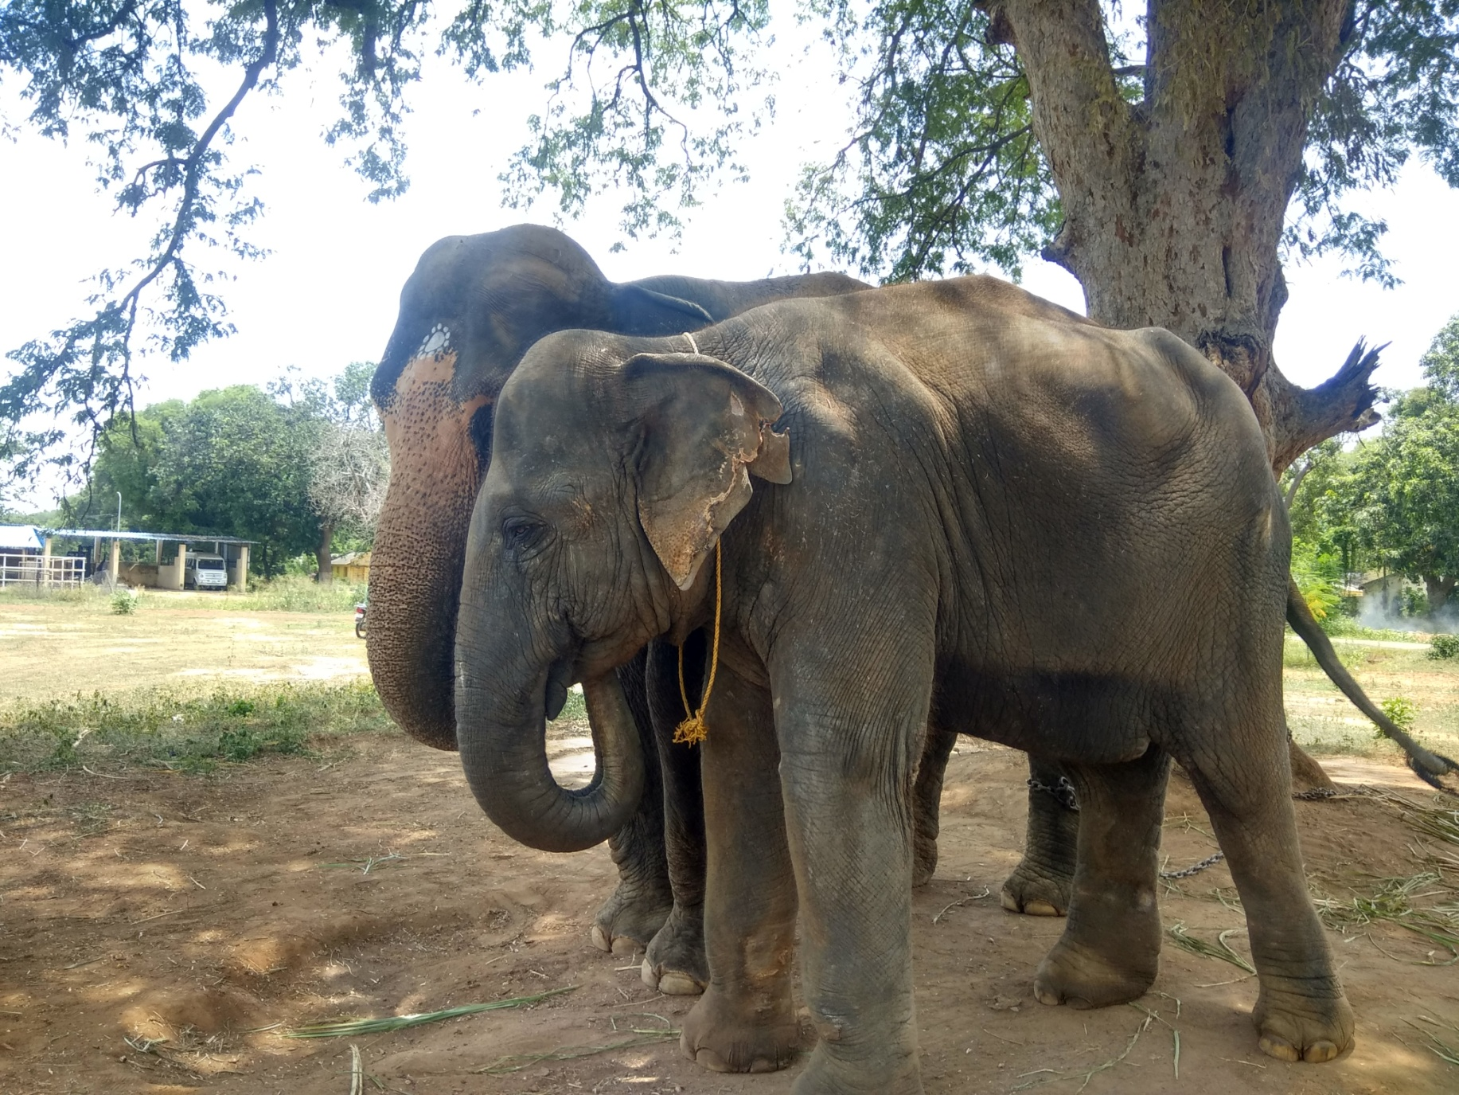 | 