Original Research Article
A New Occurrence of Ditremaster (Irregular Echinoid) from the Eocene Kapuradi Formation, Barmer Basin, Western Rajasthan, India

ABSTRACT
A previously unreported small spatangoid echinoid referable to the genus Ditremaster (Munier-Chalmas, 1885) has been identified from the Eocene Kapuradi Formation. The specimen was discovered from Kapuradi and Bhadkha localities in the Barmer Basin, Western Rajasthan, India. Thirty-eight specimens were recovered from the Fuller’s Earth horizons at Kapuradi and Bhadkha. All exhibit diagnostic characters of Ditremaster. The sample is derived from the Fuller's Earth horizon of the Kapuradi Formation, a clay-rich unit that has previously gone unrecorded for echinoids. This finding indicates a low-energy, shallow marine setting with soft clayey substrate in the Early Eocene Kapuradi Formation. This finding indicates previously unrecognised dispersal routes and environmental tolerance of spatangoids along the Western Indian margin during the Eocene. This discovery also widens Ditremaster's known paleogeographic distribution beyond the Middle Eocene of Kutch, Gujarat, where the genus was initially described.
Keywords
Spatangoida, Ditremaster, Eocene, Kapuradi Formation, Barmer Basin.

INTRODUCTION
The Indian Subcontinent is biogeographically situated between Africa, Madagascar, and Eurasia. From the Late Cretaceous through the Paleogene, this landmass assumed multiple roles in facilitating biotic exchanges across continents. At different times, it acted as a destination for incoming faunas, an intermediate dispersal platform, a centre from which taxa expanded outward, and a connective biological corridor between neighbouring regions (Prothero, 1999; Morley, 2003; Briggs, 2003; Köhler & Glaubrecht, 2007; Klaus et al., 2006; Karanth, 2006; Van Bocxlaer et al., 2006, 2009; van der Meijden et al., 2007; Datta-Roy & Karanth, 2009). The postulated geological background is crucial in biogeographic scenarios, particularly for the Indian subcontinent. It also details the breakdown of Eastern Gondwana, the northward advance of Greater India, and the Indian-Eurasian collision.
Barmer, located in the western part of Rajasthan, represents a key physiographic element of the Thar Desert. Deposits come from the Tertiary and Mesozoic eras. The Barmer Basin is a 200-kilometre-long, 40-kilometre-wide active rift basin (Farrimond et al., 2015).
The India-Africa plate separated fast between the Late Jurassic and Cretaceous periods (Dolson et al., 2015). Late Cretaceous tectonic breakup of the Indian craton resulted in the initiation of the Cambay rift system, culminating in the formation of the Barmer Basin in western Rajasthan. (Mathur & Kumar, 2003).
Echinoids have been reported from a variety of locations around India, including Meghalaya (Das & Bora, 1981; Srivastava & Garg, 2014), Mizoram (Tiwari & Jauhri, 2014), Assam (Spengler, 1923), Gujarat (Srivastava & McNamara, 2011), Himachal Pradesh (Reed, 1910), Tamil Nadu (Badve & Aziz, 1983), and Rajasthan (Srivastava & Mathur, 1996). In western Rajasthan, irregular echinoids have also reported from the Jaisalmer Basin, especially from the early Eocene Khuila Formation, where the spatangoid genus Megapneustes was discovered for the first time in India. This discovery significantly broadened the genus's palaeogeographic distribution, which was earlier known from Africa and Egypt, and highlighted faunal affinities between the Indian subcontinent and the Afro-Tethyan area during the early Eocene (Srivastava et al., 2008).
The Kapuradi Palaeocene-Eocene sedimentary ranges are situated in the south-central part of Barmer. This open-pit mine is part of the Early Eocene Fuller's Earth deposits (Dasgupta, 1977). Numerous fossils have been discovered from the Fuller’s Earth mining areas of Bhadkha and Kapuradi.
The Kapuradi Formation is widely recognised for its distinctive yellowish-white clay layers, popularly known as Fuller's Earth, which have been the subject of extensive research. The Kapuradi mine's Cenozoic succession includes siltstone, sandstone, conglomerate, fuller's earth, bentonite, bituminite shale, and lignite (Mukherjee et al. 1992; Shivanna et al. 2017). The fossil assemblage comprising gastropods, pelecypods, and crabs from the Fuller’s Earth horizons is attributed to an Eocene age. (Barooah, 1950; Glaessner and Rao, 1960; Prasad, 1961). The investigated fauna from the Kapuradi Formation chiefly represents a shallow-marine assemblage, supporting an Upper Palaeocene to Lower Eocene age assignment. (Siddiqui & Bahl, 1965).
Echinoderms are generally bottom-dwelling marine invertebrates. They are solely marine invertebrate organisms, primarily bottom dwellers. As a result, they serve as useful ecological and palaeoenvironmental indicators. (Lokho et al, 2023). The world's seas and oceans support around 800 species (Saravanan, 2024). Echinus, belonging to the family Hemisteridae, exhibits a slightly heart-shaped test with well-developed ambulacral petals on its surface (Fell and Pawson, 1966).
Irregular echinoid fossils have been discovered in numerous basins in India, including Jaisalmer (Srivastava et al. 2008). Records indicate that nearly 20 spatangoid taxa are known from stratigraphic units ranging from the Cretaceous to the Miocene within the Indian subcontinent. Their presence indicates shallow-water circumstances with normal temperature and salinity, as well as the availability of ample food supplies in the substrate (Srivastava, 2004). These echinoids existed as infaunal animals in low-energy, shallow sea habitats with fine-grained sediments. Kapuradi Fuller's Earth, located in Western Rajasthan's Barmer Basin, is a major palaeontological site that provides a single window into the Eocene era. This area holds considerable significance for reconstructing early post-Cretaceous life on the Indian subcontinent due to the presence of diverse marine fossil assemblages. (Rana et al., 2006).
The current study focuses on the systematics of early Eocene irregular echinoids from Kapuradi Fuller's Earth in the Barmer basin, Rajasthan. Through an examination of the new species’ diagnostic features and stratigraphic context, this work contributes to understanding early Eocene marine ecosystem development, climate dynamics, and biodiversity patterns. The findings of Kapuradi Fuller's Earth allow us to better understand the biodiversity and palaeogeographic conditions of this critical period in Earth's history.
MATERIAL AND METHODS
Study Area: -
In western Rajasthan, the Barmer Basin is a minor rift structure with a north–south trend, extending from the Middle Jurassic to the Lower Eocene in age. (Dasgupta, 1977; Pareek, 1981). The specimen was collected from the Fuller’s Earth mining localities of Kapuradi and Bhadkha, Barmer District, Rajasthan. (Fig. 1) In the Barmer District, the Fuller’s Earth mining horizons are collectively referred to as the Kapuradi Formation. (Siddiquie and Bahl, 1965). It is located in western Rajasthan's Barmer region, a rift region that runs north-south and has attracted geologists' attention due to its vast fossil deposits and Fuller's Earth resources.
Sampling Methods: -
The present study is based on field observations and sampling from the Kapuradi and Bhadkha sectors of the Barmer Basin in western Rajasthan, India. Systematic sampling was conducted in geological levels associated with the Fuller's Earth horizon, which is known to be rich in echinoid fossils.
The echinoid specimen was obtained from the Bhadkha open-pit mines in Bhadkha village (25°56′44″ N; 71°21′17″ E) within the Kapuradi Formation. The location lies about 30 kilometres north of Barmer in Rajasthan. A total of 38 echinoid specimens (1 completely preserved with an irregular heart-shaped test, 6 with partial imprints, and 31 in weathered condition) and impressions were found from exposed strata (Fig. 2). The collected specimens were then cleaned, labelled, and examined in the laboratory for extensive morphological study. Specimens were photographed using a Nikon D3300 DSLR camera under regulated lighting settings to document diagnostic morphological characteristics. All examined specimens have been deposited in the repository of the Palaeontology Laboratory, Department of Zoology, Jai Narain Vyas University, Jodhpur, and are catalogued under the accession number JNVU/DZ/PL/KF-24-62. The specimens are well-preserved in the yellowish Fuller's Earth and show unusual morphological characteristics. Fuller's Earth is a fine-grained, yellow and white laminated clay.
SYSTEMATIC PALAEONTOLOGY
Phylum: - Echinodermata Klein, 1778
Class: - Echinoidea Leske, 1778
Infraclass: - Irregularia Latreille, 1825
Order: - Spatangoida Claus, 1876
Family: - Hemiasteridae H. L. Clark, 1917
Genus: Ditremaster Munier-Chalmas, 1885
Diagnosis: Test medium size, irregular, subglobular to heart shaped with moderate frontal sinus; aboral surface domed shaped; oral surface flat; ambulacral petal long and petaloid, petal III is large; ambulacral plate simple (occluded plates absent); periproct and peristome not showing clearly; tubercles perforate, and a very thin peripetalous fasciole present (mostly lost throught poor preservation).
Description
Age: Eocene
Horizon: Bhadkha and Kapuradi area (Kapuradi Formation), Early Eocene (Fig. 2)
Locality: Barmer basin, Rajasthan (Fig. 1)
Repository: All of the echinoid specimens used in this work are housed in the Palaeontology Laboratory, Department of Zoology, Jai Narain Vyas University (JNVU), Jodhpur, Rajasthan, India. The specimens are identified by the catalogue number JNVU/DZ/PL/KF-24-62.
A total of 38 specimens (1 completely preserved with an irregular heart-shaped test, 6 with partial imprints, and 31 in weathered condition) were gathered and examined. Seven of these specimens are well-maintained and suitable for full morphological description, although others are slightly damaged or broken and thus preserved as supporting material. Both described and undescribed specimens are preserved in the collection, providing material for future reference and comparative studies.
Measurement (in mm) Specimen No. JNVU/DZ/PL/KF- 24
Test dimensions:
Length of the test: 15 mm
Breadth of the test: 14.3 mm
Height of the test: 9.4 mm
The test is slightly longer than wide (B/L = 0.95) and moderately low (H/L = 0.63), with height about two-thirds of the breadth (H/B ≈ 0.66). Test irregular, oval to heart-shaped, outline, consistent with the general shape described for the genus Ditremaster. Dorsal surface gently convex with a strongly developed anterior sulcus; Ventral surface moderately inflated;
Anterior Sulcus: Deep, narrow, extending from the peristome upward toward the anterior side.
Apical System: Apical disc slightly eccentric and ethmolytic, bearing two genital pores, a defining trait of Ditremaster. Genital pores are horizontal to Petal III.
Ambulacral System
Ambulacral petals are closed and symmetrical, large with elongate isopores, and are five in number; Petals I and V are the shortest and Petals II and IV are moderately long.
- Petal III longest and broadest petal.
- Petals II and IV are moderately long.
- Petals I and V shortest petals.
Interambulacral Areas: Externally, the surface is ornamented with dense, small primary tubercles (Néraudeau, David, & Madon, 1998).
Oral Surface: The oral surface is flat on the ventral side. Peristome not visible clearly (specimen is in weathered condition)
Aboral surface: The aboral surface is dome-shaped. Periproct is not visible on the aboral surface. Tuberacles are small, abundant and dense.
Fascioles: Very thin peripetalous fasciole present (Smith and Stockley, 2005).
Results and Discussion
Echinoids (sea urchins) are the only marine echinoderms (Saravanan, 2024). They are among the most common benthic invertebrates in both present and earlier oceans, spanning from arctic to equatorial regions and occupying habitats ranging from the intertidal zone to bathyal depths of over 5,000 m (Srivastava, 2012). Their vast evolutionary history and wide ecological tolerance make them valuable indicators of palaeoenvironmental conditions. The evolutionary presence of echinoderms in the Indian subcontinent is widely documented, with a probable ancestor of the Phylum Echinodermata discovered in the Ediacaran Jodhpur Sandstone (630-542 Ma) of the Marwar Supergroup in western Rajasthan (Kumar et al. 2012). Grant's 1837 pioneering work on echinoid faunas of India and Pakistan marked the beginning of systematic studies on these animals.
Although the precise age of the Kapuradi Formation is unresolved, most researchers regard it as ranging from the Palaeocene to the Eocene based on the presence of bivalves (Venricardia, Corbula, and Lucina), foraminifera (Cibicides, Rotalia, Globorotalia, Assilina, Nummulites, etc.), crabs (Penacus, Goniocypoda), and clupeoid fishes (Barooah, 1950; Glaessner and Rao, 1960; Prasad, 1961). Studies of foraminiferal and fish communities suggest that the Fuller’s Earth horizons of Rajasthan correspond to the Lower Eocene (Ypresian) (Das Gupta et al., 1975; Singh, 1969; Khosla, 1973; and Kulshreshtha et al., 1988). The current study describes the echinoderm fauna of the Kapuradi Formation, Barmer Basin, western Rajasthan, and was recovered from the Fuller's Earth sediments, where it is preserved as complete and partial test impressions. The Kapuradi material is attributed to the genus Ditremaster and dated to the Eocene period due to its close morphological similarities to genus Ditremaster specimens documented from the Middle Eocene of Kutch by Srivastava and Srivastava (1990). Specimens JNVU/DZ/PL/KF-24-62 have the diagnostic characteristics of Ditremaster, such as a subglobular to heart-shaped test, a well-developed anterior sulcus, and an ethmolytic apical system with only two genital pores (Munier-Chalmas, 1885). These characteristics closely resemble previously recorded Indian occurrences of the genus, and the specimen is thus clearly identified as Ditremaster (Srivastava & Srivastava, 1990).
Members of the Spatangoida order, to which Ditremaster belongs, are thought to be infaunal echinoids that live in soft-bottom marine environments, often in comparatively deeper marine settings with muddy to sandy substrates. The presence of Ditremaster within the Kapuradi Formation suggests that the sediments were laid down in a low-energy marine environment during the Eocene. Significant evolutionary radiation and diversification of echinoids occurred on the Indian subcontinent throughout the Cretaceous and Eocene (Srivastava, 2012). Discovery of Ditremaster in the Kapuradi Formation adds to the understanding of Eocene echinoid assemblages in western India, highlighting their stratigraphic range and palaeoecological relevance.

Conclusion
The present paper documents the discovery of the spatangoid echinoid Ditremaster Munier-Chalmas, 1885, in the Early Eocene deposits of the Kapuradi Formation, Barmer Basin, western Rajasthan. The specimen was discovered in the clay-rich Fuller's Earth deposits, indicating deposition in a low-energy, shallow marine environment with soft substrates. This situation is lined up with the infaunal life habits of spatangoid echinoids. The discovery lends confirmation to previous theories that spatangoids were well adapted to quiet-water settings during the early Paleogene. According to the Kapuradi record, Ditremaster dispersed and established itself along the western Indian margin during the Early Eocene due to favourable ecological conditions. This discovery fills a critical gap in Rajasthan's echinoid fossil record and emphasises the Barmer Basin's palaeontological relevance.

Disclaimer (Artificial intelligence)
Author(s) hereby declare that NO generative AI technologies such as Large Language Models (ChatGPT, COPILOT, etc.) and text-to-image generators have been used during the writing or editing of this manuscript.

References:
- Badve, R. M., & Aziz, S. A. (1983). Revision of Cassiduloid genus Gongrochanus Kier (Echinodermata: Echinoidea) from South Indian Cretaceous deposits. Proceedings – Animal Sciences, 92(3), 231–246. https://doi.org/10.1007/BF03186191
- Barooah, S. K. (1950). Fossil fish and crabs in Fuller’s Earth bed at Kapurdi, Jodhpur, Rajasthan. Current Science, 19, 165.
- Briggs, J. C. (2003). The biogeographic and tectonic history of India. Journal of Biogeography, 30(3), 381–388. https://doi.org/10.1046/j.1365-2699.2003.00809.x
- Das, N. K., & Bora, A. K. (1981). Studies on the variation in Stimatopygus elatus from the Mahadek Formation (Cretaceous) of Meghalaya.
- Dasgupta, S. K. (1977). Stratigraphy of western Rajasthan shelf. In Proceedings of the 4th Colloquium of Micropalaeontology and Stratigraphy (pp. 219–233). Dehradun.
- Dasgupta, S. K., Dhar, C. L., & Singh, N. P. (1975). A note on the occurrence of a bioclastic foraminiferal bed on the top of Fuller’s Earth sequence in Barmer District, Rajasthan. Science & Culture, 41(3), 127–129.
- Datta-Roy, A., & Karanth, K. P. (2009). The Out-of-India hypothesis: What do molecules suggest? Journal of Biosciences, 34(5), 687–697. https://doi.org/10.1007/s12038-009-0057-8
- Dolson, J. C., Burley, S. D., Sunder, V. R., Kothari, V., Naidu, B. S., Whiteley, N. P., Farrimond, P., Taylor, A., Direen, N. G., & Ananthakrishnan, B. (2015). The discovery of the Barmer Basin, Rajasthan, India, and its petroleum geology. AAPG Bulletin, 99(3), 433–465. https://doi.org/10.1306/10021414045
- Farrimond, P., Naidu, B. S., Burley, S. D., Dolson, J., Whiteley, N., & Kothari, V. (2015). Geochemical characterization of oils and their source rocks in the Barmer Basin, Rajasthan, India. Petroleum Geoscience, 21(4), 301–321. https://doi.org/10.1144/petgeo2014-075
- Fell, H. B., & Pawson, D. L. (1966). Systematic descriptions. In R. C. Moore (Ed.), Treatise on Invertebrate Palaeontology, Part U, Echinodermata 3 (Vol. 2, p. 695). University of Kansas & Geological Society of America.
- Glaessner, M. F., & Rao, V. R. (1960). A new species of crab from the Early Tertiary Fuller’s Earth deposits of Kapurdi, Rajasthan, western India. Records of the Geological Survey of India, 86(4), 675–683.
- Karanth, K. P. (2006). Out-of-India–Gondwanan origin of some tropical Asian biota. Current Science, 90(6), 789–792. https://www.ias.ac.in/article/fulltext_html/curr_sci/090/06/0789-0792
- Khosla, S. C. (1973). Stratigraphy and microfauna of the Eocene beds of Rajasthan. Journal of the Geological Society of India, 14(2), 142–152. https://doi.org/10.17491/jgsi/1973/140305
- Klaus, S., Schubart, C. D., & Brandis, D. (2006). Phylogeny, biogeography and a new taxonomy for the Gecarcinucoidea Rathbun, 1904 (Decapoda: Brachyura). Organisms Diversity and Evolution, 6(3), 199–217. https://doi.org/10.1016/j.ode.2005.09.006
- Köhler, F., & Glaubrecht, M. (2007). Out of Asia and into India: On the molecular phylogeny and biogeography of the endemic freshwater gastropod Paracrostoma Cossmann, 1900 (Caenogastropoda: Pachychilidae). Biological Journal of the Linnean Society, 91(4), 627–651. https://doi.org/10.1111/j.1095-8312.2007.00866.x
- Kulshreshtha, S. K., Singh, R. Y., & Sobeh, A. Y. (1989). Stratigraphy of the Lower Tertiary sediments in Bikaner, western Rajasthan. In P. Kalia (Ed.), Micropalaeontology of the Shelf Sequences of India (pp. 193–202). New Delhi: Papyrus Publishing House.
- Kumar, S., Srivastava, D. K., & Ahmad, S. (2012). Five-armed body fossil from the Ediacaran Jodhpur Sandstone, Marwar Supergroup, western Rajasthan, India: A possible precursor of Phylum Echinodermata. Current Science, 102(1), 24–26. https://www.currentscience.ac.in/Volumes/102/01/0024.pdf
- Lokho, K., Carrasco, J. F., Biswal, S., Whiso, K., & Bhandari, A. (2023). First report of Eocene echinoids from the Sylhet Limestone, Mikir Hills of Assam, India: palaeontological, palaeogeography and palaeoenvironmental significance. Journal of the Palaeontological Society of India. https://doi.org/10.1177/05529360231205313
- Mathur, S. C., & Kumar, S. K. (2003). Sedimentation in Barmer Basin, Rajasthan. Journal of the Geological Society of India, 61(3), 368–369. https://www.geosocindia.org/index.php/jgsi/issue/view/100
- Morley, R. J. (2003). Interplate dispersal paths for megathermal angiosperms. Perspectives in Plant Ecology, Evolution and Systematics, 6(1–2), 5–20. https://doi.org/10.1078/1433-8319-00039
- Mukherjee, A. K., Alam, M. M., Mazumdar, S. K., Haque, R., & Gowrisankaran, S. (1992). Physico-chemical properties and petrographic characteristics of the Kapurdi lignite deposit, Barmer Basin, Rajasthan, India. International Journal of Coal Geology, 21(1), 31–44. https://doi.org/10.1016/0166-5162(92)90034-T
- Munier-Chalmas, E. C. P. (1885). Observations sur l'appareil apical de quelques Échinides Crétacés et Tertiaires. Comptes Rendus de l'Académie des Sciences Paris, 101, 1074–1077. https://www.biodiversitylibrary.org/item/10000#page/1100/mode/1up
- Néraudeau, D., David, B., & Madon, C. (1998). Tuberculation in spatangoid fascioles: Delineating plausible homologies. Lethaia, 31, 323–334.
- Pareek, H. S. (1981). Basin configuration and sedimentary stratigraphy of western Rajasthan. Journal of the Geological Society of India, 22(11), 517–527. https://www.geosocindia.org/index.php/jgsi/article/view/65033
- Prasad, K. N. (1961). Decapod Crustacea from the Fuller’s Earth deposits of Kapurdi, Rajasthan. Indian Minerals, 15, 435.
- Prothero, D. R. (1999). Perissodactyls. In R. Singer (Ed.), Encyclopedia of Paleontology (pp. 867–871). London: Fitzroy Dearborn.
- Rana, R. S., Kumar, K., Loyal, R. S., Sahni, A., Rose, K. D., Mussell, J., Singh, H., & Kulshreshtha, S. K. (2006). Selachians from the early Eocene Kapurdi Formation (Fuller’s Earth), Barmer district, Rajasthan. Journal of the Geological Society of India, 67(4), 509–522. https://doi.org/10.17491/jgsi/2006/670411
- Reed, F. R. C. (1910). Himalayan fossils: The Cambrian fossils of Spiti. Calcutta: Government Printing.
- Saravanan, R. (2024). Echinoderm diversity and its conservation. In Training Manual on "Know Your Marine Biodiversity and Environment (MarBiE 1)" (pp. 67–72). ICAR-Central Marine Fisheries Research Institute. http://eprints.cmfri.org.in/id/eprint/18477
- Shivanna, M., Singh, A., Singh, B. D., Singh, V. P., Matthews, R. P., & Souza, P. A. (2017). Peat biomass degradation: Evidence from fungal and faunal activity in carbonized wood from the Eocene sediments of western India. Palaeoworld, 26(3), 531–542. https://doi.org/10.1016/j.palwor.2016.05.004
- Siddiqui, R. N., & Bahl, D. P. (1965). Geology of the bentonite deposits of Barmer District, Rajasthan. Memoirs of the Geological Survey of India, 96, 1–96.
- Singh, N. (1969). Stratigraphy of the Eocene of Rajasthan. Proceedings of the Indian Science Congress Association, 3, 216–217.
- Smith, A. B., & Stockley, B. (2005). Fasciole pathways in spatangoid echinoids: a new source of phylogenetically informative characters. Zoological Journal of the Linnean Society, 144, 15–35. https://doi.org/10.1111/j.1096-3642.2005.00161.x
- Spengler, E. (1926). Contributions to the palaeontology of Assam. Palaeontologia Indica (New Series), 8(1), 1–74.
- Srivastava, D. K. (2004). Fossil spatangoids (Echinodermata) from the Indian subcontinent: A review. Journal of the Palaeontological Society of India, 49, 125–149.
- Srivastava, D. K. (2012). An annotated bibliography of fossil echinoids of India and Pakistan. Journal of the Palaeontological Society of India, 57(2), 163–203.
- Srivastava, D. K., & Garg, R. (2014). Record of Eupatagus from the Siju Formation, Meghalaya, India. Journal of the Palaeontological Society of India, 59(2), 227–230.
- Srivastava, D. K., & Mathur, U. B. (1996). New fibulariid echinoid from the Middle Eocene of Rajasthan, India. Journal of the Palaeontological Society of India, 41, 53–56.
- Srivastava, D. K., & McNamara, K. J. (2011). A reappraisal of the brissid echinoid Schizobrissus insignis (Duncan & Sladen) from the middle Eocene of Kachchh, India. Alcheringa: An Australasian Journal of Palaeontology, 35(3), 345–354. https://doi.org/10.1080/03115518.2011.519639
- Srivastava, D. K., Rana, R. S., & Singh, H. (2008). Record of Megapneustes Gauthier (Brissid Echinoid) from the Khuiala Formation, Jaisalmer District, Rajasthan, India. Journal of the Palaeontological Society of India, 53(1), 31–36. https://doi.org/10.1177/0971102320080104
- Srivastava, D. K., & Srivastava, S. (1990). Record of echinoid genus Ditremaster from the Middle Eocene of Kutch, India. Current Science, 59(6), 317–318.
- Tiwari, R. P., & Jauhri, A. K. (2014). Miocene palaeobiology of Mizoram: Present status and future prospect. Special Publication of the Palaeontological Society of India, No. 5, 189–204.
- Van Bocxlaer, I., Biju, S. D., Loader, S. P., & Bossuyt, F. (2009). Toad radiation reveals into-India dispersal as a source of endemism in the Western Ghats-Sri Lanka biodiversity hotspot. BMC Evolutionary Biology. https://doi.org/10.1186/1471-2148-9-131
- Van Bocxlaer, I., Roelants, K., Biju, S. D., Nagaraju, J., & Bossuyt, F. (2006). Late Cretaceous Vicariance in Gondwanan Amphibians. PLoS ONE, 1(1), e74. https://doi.org/10.1371/journal.pone.0000074.

Table 1: Morphometric Measurements (mm) of genus Ditremaster specimen (JNVU/DZ/PL/KF- 24) from Kapuradi Area, Barmer Basin.
Parameters | Measurments (mm)
Test Length | 15
Test Breadth (Width) | 14.3
Test Thickness (Height) | 9.4

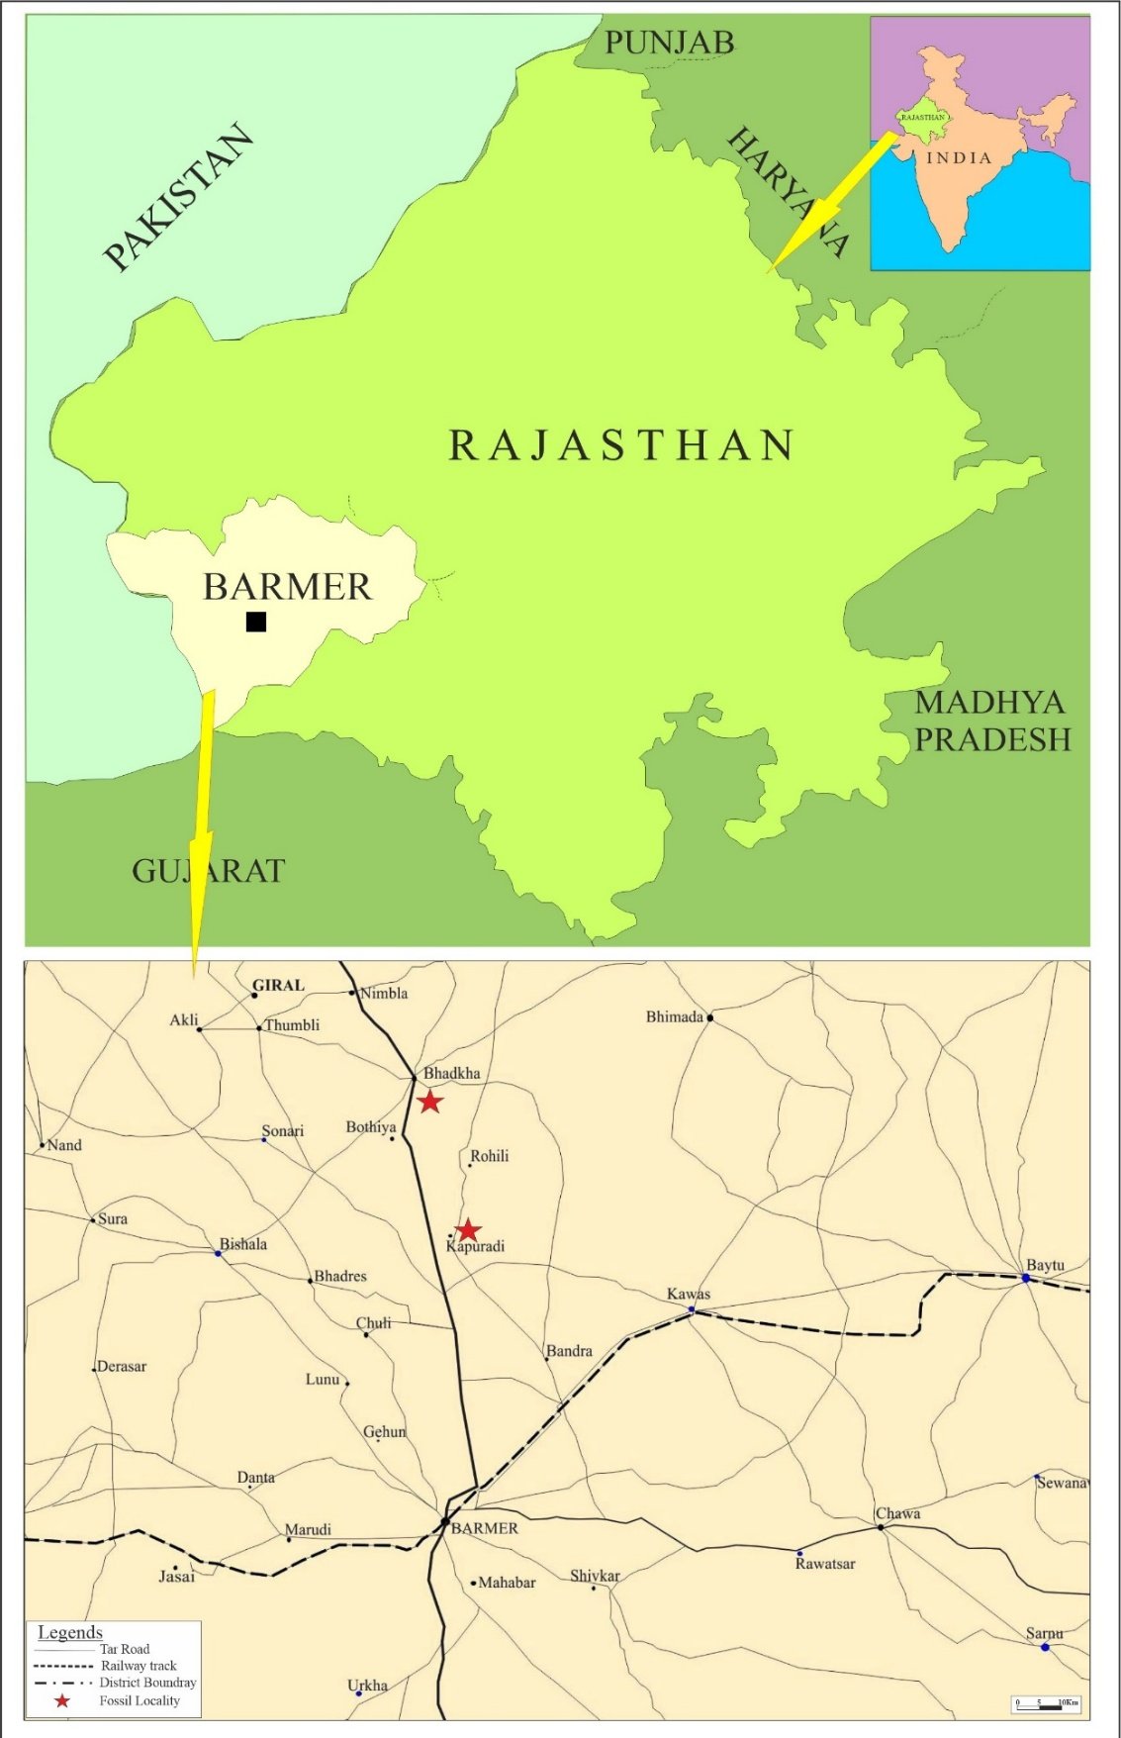
Fig. 1: Geological map showing the location of the Kapuradi area, Barmer Basin, western Rajasthan, India.

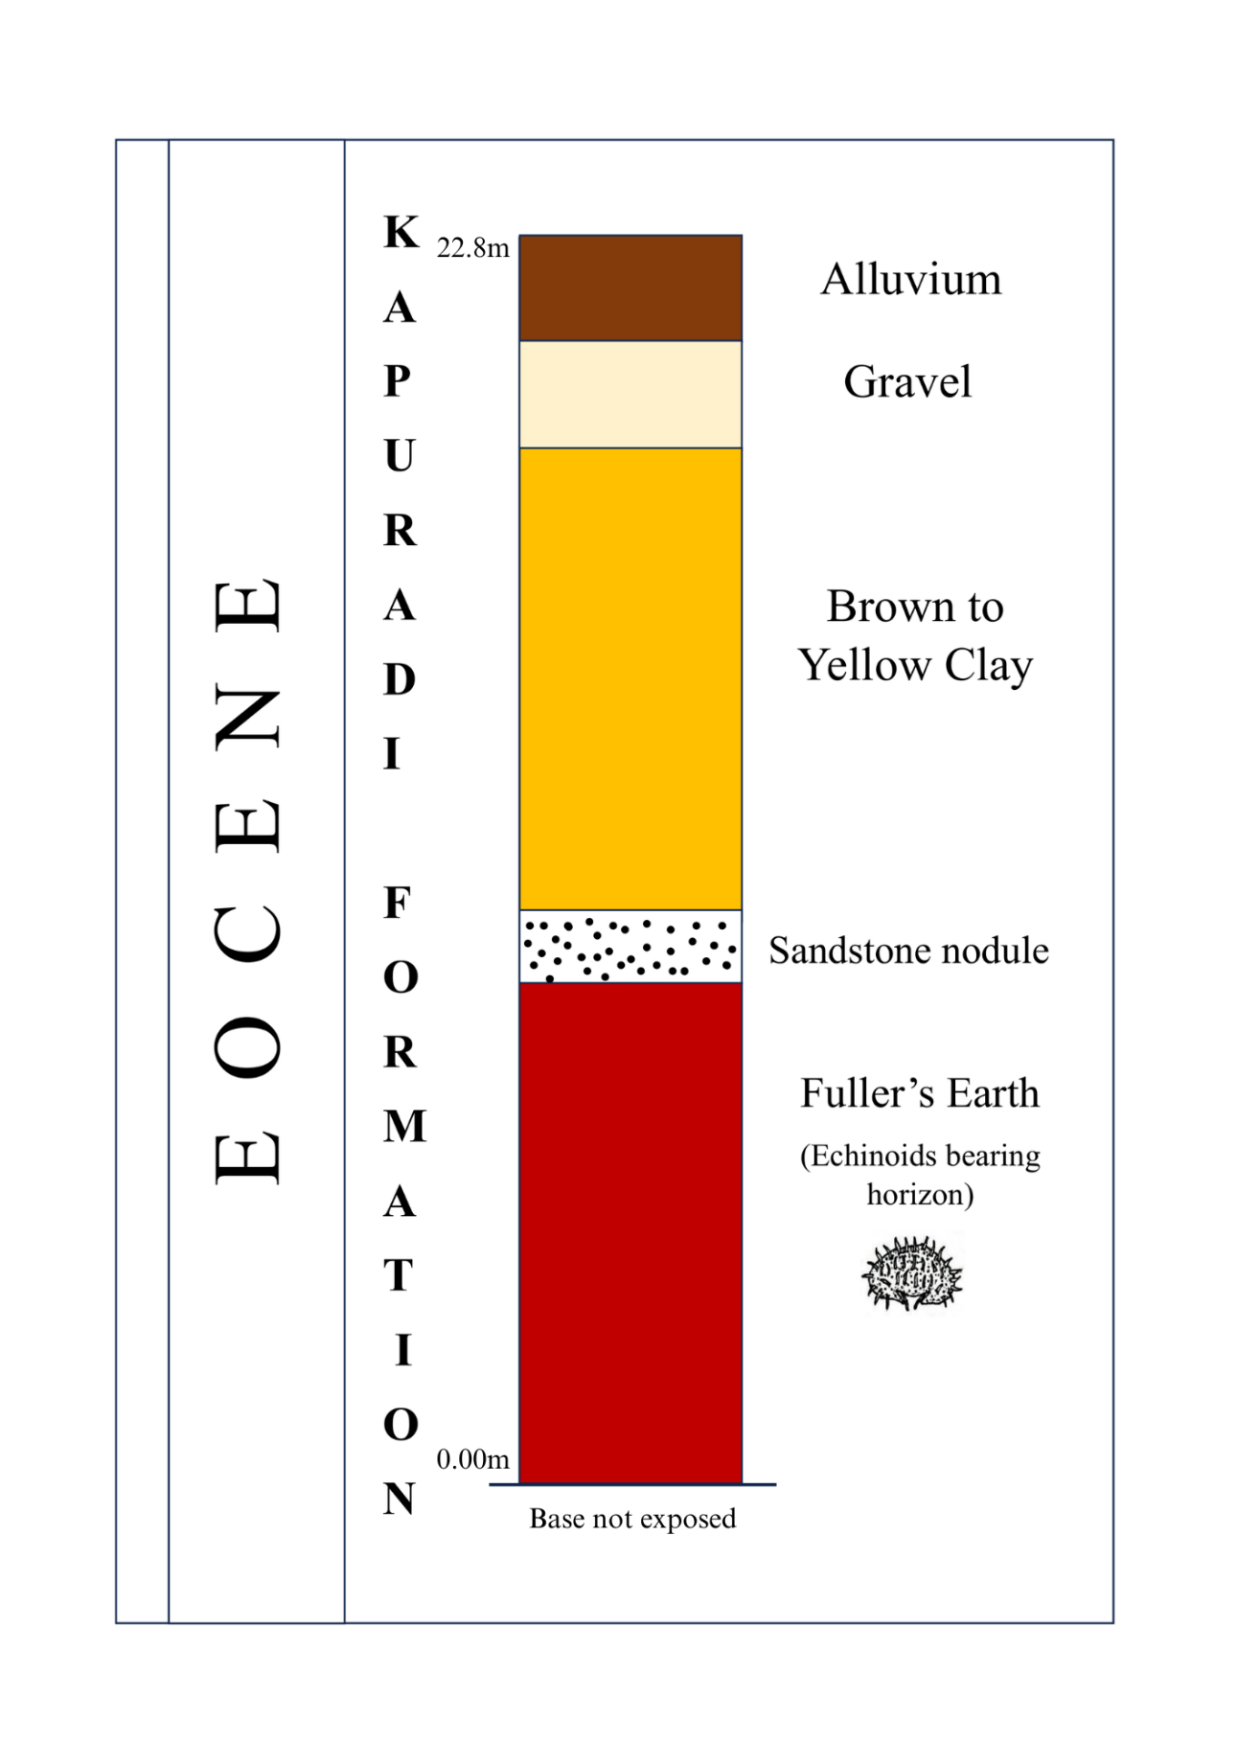
Fig. 2: Stratigraphic column of the Kapuradi Formation, Barmer Basin, Rajasthan, India, showing the lithological succession and fossil-bearing (Echinoid genus: Ditremaste) horizons.
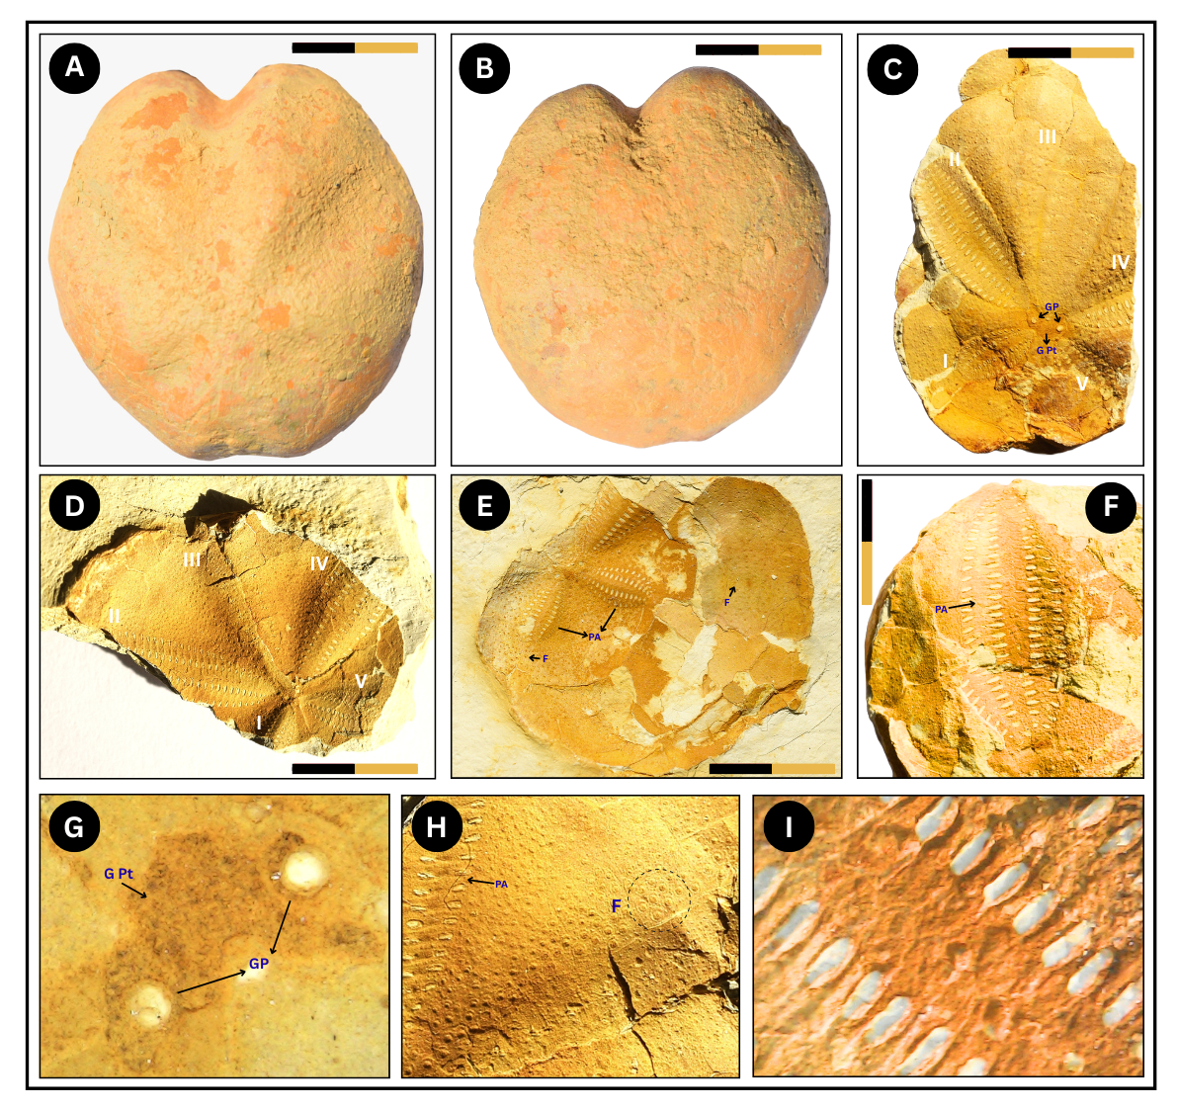
Plate 1.
A. Complete specimen showing aboral (dorsal) view of the test.
B. Complete specimen showing oral (ventral) view of the test.
C. Partially preserved specimen showing apical region with ambulacral petals I–V; genital plate (GPt) and genital pore (GP) indicated.
D. Fragmentary specimen showing well-developed ambulacral petals I–V.
E. Incomplete specimen showing petaloid ambulacra (PA) and fasciole (F).
F. Enlarged view of petaloid ambulacrum (PA) showing pore arrangement.
G. Close-up of apical system showing genital plate (G Pt) and genital pores (GP).
H. Enlarged view of fasciole (F) adjacent to petaloid ambulacrum (PA).
I. High-magnification view of petaloid pore pairs showing pore morphology.
Abbreviations: PA = Petaloid Ambulacra; F = Fasciole; G Pt = Genital Plate; GP = Genital Pore.
(Scale bar = 1 cm)

