Original Research Article
Survivability of Lepidiota mansueta (Coleoptera: Scarabaeidae) grubs under different soil orders of Assam, India

.
ABSTRACT

The survival of the third instar grubs of Lepidiota mansueta under four different soil orders of Assam was investigated in the Soil Arthropod Pests Laboratory and Bio-fertilizer Laboratory, Assam Agricultural University, Jorhat during 2012-17. A total of 30 grubs were reared for each of the soil orders in ambient laboratory conditions (temperature: 28±2º C & Humidity: 70-80%). Among the four different soil orders, grubs were successfully reared up to adult stage in both surface and subsurface soil of Entisols and Inceptisols. Survival of grubs was recorded in surface (214.46 days) and subsurface (212.20 days) soil of Entisols with adult emergence of 73.33% and 86.66% respectively, whereas in case of Inceptisols survival of grubs was found to be 210.03 and 205.67 days with adult emergence of 5.00% and 11.67%, respectively. The maximum organic carbon (0.89%), pH (6.48), soil microbial biomass carbon (289.70 mg/ kg), and sand (67.20%) were recorded in case of Entisols which exhibited a loamy sand texture. However, not a single grub could survive under Alfisols and Ultisols, indicating the strong effects of soil physicochemical properties on survival of the grubs. The findings of the present research will help developing predictive risk models and subsequent management of this pest.

Keywords: Alfisols, Entisols, Inceptisols, Scarabaeids, Ultisols, White grubs

1. INTRODUCTION

White grubs belonging to the family scarabaeidae under the order Coleoptera have become a serious constraint for production of almost all crops in the country (Mathur and Bhatnagar, 2001). They are distributed throughout the country from high altitudes of the Himalayan region to Costal Kerela, from the arid and semi-arid tracts of Rajasthan to the high rainfall, humid regions of North East. With the advancement of high yielding varieties and changing cultivation pattern, the white grubs have really become a serious threat to many cultivated crops in India. Globally, around 27000 species of scarabaeids under 1900 genera are being reported (Bouchard et al., 2017) whereas the scarabaeid fauna of Assam alone comprises of 44 species representing 21 genera and 6 subfamilies and out of 44 species, 42 species have been reported for the first time from North East India (Bhattacharyya et al., 2021). The most economically important species are Lepidiota mansueta, L. albistigma, Apogonia sp., Adoretus sp. and Anomala sp. Among these, the genus Lepidiota exhibits diversity in life history, distribution and behaviour which makes them difficult to manage. The white grub, L. mansueta was first detected in October 2005 in the farmers’ field of Majuli river island, Assam, India. Field surveys conducted during 2005-2009 revealed that L. mansueta had appeared as an extremely severe key pest and the most severely affected crops were potato, sugarcane, Colocasia and green gram and the extent of damage varied from 42-48, 15-20, 35-40 and 30-35%, respectively. L. mansueta has a biennial life cycle, which is the first of its kind from North East India (Bhattacharyya et al., 2015). It is a unique biennial species, spending its entire life cycle under the ground except for a very short period during which adults come out of the ground for mating. Grubs are voracious feeders. However, there is no evidence showing that the adults fed on any plants either in the field or laboratory and hence this species has the unique distinction as the first Indian phytophagous white grub species with nonfeeding adults (Bhattacharyya et al., 2015). These grubs can be found beneath the soil throughout the year due to their overlapping generations (Bhattacharyya et al., 2015). This white grub species spends its entire life cycle as an egg (12 to 17 days), larva (635 to 671 days) and pupa (28 to 35 days) under the soil and the adults (20-25 days) come out from the soil during the month of April each year after receiving the premonsoon shower only for mating (Bhattacharyya et al., 2013; Bhattacharyya & Dutta, 2014). Review of available literature on the genus Lepidiota reflects that most of the species are found to subsist either on the Islands or near the river valley (Allsopp, 1989; Kuniata and Young, 1992; Anonymous., 2011; Bhattacharyya et al., 2014; Bhattacharyya et al., 2023). It was already established that majority of the L. mansueta grubs (81.83 per cent in grassland and 72.73 per cent in cultivated land) were recorded within the top 20 cm of soil during summer season (April-September), however, no grubs were noticed beyond 40 cm of soil depth (Pujari and Bhattacharyya, 2016). The probable reasons of endemism/outbreak of L. mansueta in the Majuli river island of Assam might be due to the high organic carbon content of the soil (0.75-1.00%) and presence of abundant thatch zone (dead grass, stems and other organic debris) in the endemic pockets (Bhattacharyya et al., 2013; Bhattacharyya & Dutta, 2014).. It was also feared that there is every possibility of severe incidence of the grubs in other riverine areas of Assam through migration and cause a serious threat to Agriculture. Despite many ecological understanding of L. mansueta, the role of soil types in shaping the ecology and outbreak potential of this economically important white grub species remained unanswered. Hence in the present study, an attempt was made to study the survival success of L. mansueta grubs by rearing the grubs in both surface and subsurface soils belonging to four different orders (Entisols, Inceptisols, Alfisols and Ultisols) of Assam soil under controlled rearing conditions.

2. material and methods

To investigate the survival of L. mansueta grubs, four different soil orders viz., Inceptisols, Alfisols, Entisols and Ultisols prevalent in Assam were selected. Soil samples were collected from ten locations of each order during 2014-16, following standard procedures (Table 1). Jorhat subdivision (26.7509° N, 94.2037° E), Mariani (26.6521° N, 94.3255° E) and Teok (26.8337° N, 94.4285° E) of Jorhat district were selected for collection of samples under Inceptisols. Likewise, samples were collected from Titabar (26.6021° N, 94.2060° E) and nearby areas under Alfisols; Majuli (26.9466° N, 94.1658° E) and surrounding areas under Entisols; and Assam-Nagaland border areas of Mokokchung (26.3210° N, 94.5147° E) under Ultisols (Fig.1). Soil samples were collected from both surface (0-10 cm) as well as subsurface (10-20 cm) layers of each soil order, since most of the beetles were detected within Strata 2 of Majuli river island, which is an endemic site of the pest (Fig. 2). Thereafter, the surface soil and sub-surface soil samples were mixed separately to prepare two composite surface and sub-surface soil sample for each soil order. The prepared composite samples were then utilized for rearing the third instar grubs to ascertain their survivability. Grubs were collected from the farmers’ field of Bhakatchapori village (26°57' N and 94°10' E), Majuli, Assam. A total of thirty number of grubs were reared on each of the soil orders in ambient laboratory conditions where the temperature of 28±2º C and humidity of 70-80% was maintained. The grubs were reared by using plastic cups (200 ml size) containing cut pieces of potato provided as means of diet. The diets were exchanged after every seven days until the third instar grub developed to adults. The survivability of the grubs under different soil orders were recorded after every 7 days interval till the grubs successfully enters pupation and subsequently emerged as adults. Data generated from the above observations were then expressed in percentage and the days required by the grubs to emerge as adults were also recorded.
In the experiment, soil physicochemical properties of representative surface and sub-surface samples were analyzed using standard protocols. Determination of soil pH was carried out in 1:2.5 soil water suspension using glass electrode (Jackson, 1973). Organic carbon (OC) and soil microbial biomass carbon (SMBC) were determined by wet digestion method (Walkley and Black, 1934) and chloroform fumigation extraction method (Jenkinson and Powlson, 1976), respectively.
Table 1: Major characteristics of Inceptisols, Alfisols, Entisols and Ultisols
Order | Characteristics
Inceptisols | Weakly developed soils, showing initial stages of soil formation, presence of cambic (Bw) horizon, moderate texture development, moderate fertility, soil pH generally slightly acidic to neutral, moderate CEC and nutrient retention,  widely distributed in Indo-Gangetic plains and hilly regions
Alfisols | Moderately developed, productive soils, presence of argillic (Bt) horizon with clay illuviation, base saturation > 35%, dominance of 2:1 clay minerals (smectite, illite), high CEC and good nutrient-holding capacity, soil reaction slightly acidic to neutral, high natural fertility, suitable for intensive agriculture, found under deciduous forests
Entisols | Youngest soils with little or no profile development, no diagnostic subsurface horizon, strongly influenced by parent material, texture varies from sandy to clayey, low water- and nutrient-holding capacity, soil reaction ranges from acidic to alkaline, generally low fertility, occur on recent alluvium, river banks, deserts, steep slopes
Ultisols | Highly weathered and leached soils, presence of argillic or kandic horizon, base saturation < 35%, dominance of 1:1 clay minerals (kaolinite) and Fe–Al oxides, low CEC and poor nutrient retention, strongly acidic in reaction, low natural fertility, requires liming and fertilization, common in humid tropical and subtropical regions

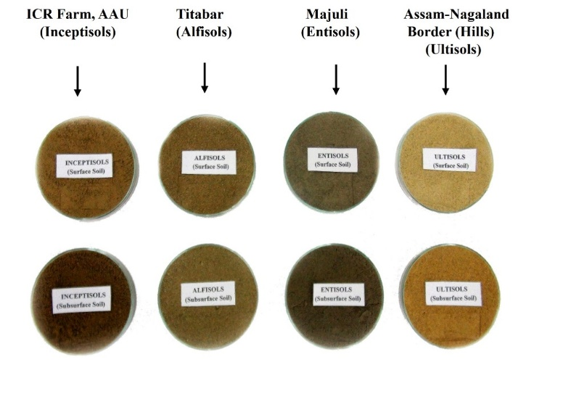
Fig.1: Representative soil samples collected from areas under four soil orders
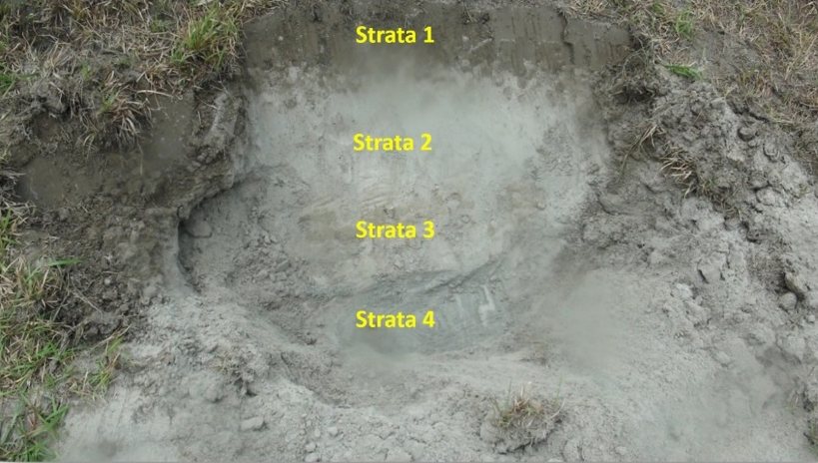
Fig.2: Different strata of Entisol in the beetle endemic sites of the Majuli river island

3. results and discussion

In the present research, the survival of L. mansueta grubs by using both surface and subsurface soils representing four different soil orders viz., Entisols, Inceptisols, Alfisols and Ultisols was investigated. The mean maximum survival of grubs was registered in the surface (214.46 days) and subsurface soil (212.20 days) under Entisols with an average of 73.33 and 86.66 per cent adult emergence, respectively (Table 2 & 3). However, Inceptisols registered a mean of 210.03 and 205.67 days grubs’ survival in both surface and subsurface soil with per cent adult emergence of 5.00 and 11.67, respectively (Table 2 & 3). Conversely, not a single grub was found to survive under Alfisols and Ultisols indicating the strong negative effects of soil physicochemical properties in those orders on survival of the grubs. Perusal of data presented in Table 4 revealed that Entisols recorded the highest per cent of OC (0.89), pH (6.48), SMBC (289.70 mg/ kg) and sand (67.20%). Ultisols recorded the lowest per cent of OC (0.55), SMBC (139.40 mg/ kg) and sand (13.70%). pH was found to be lowest in case of Alfisols (5.18). Soil texture in case of Entisols and Alfisols were found to be loamy sand and silty loam, whereas Inceptisols and Ultisols exhibited silty clay loam texture.
The results are in contrary to the findings of Cherry and Alsopp (1991) who observed that distinct soil preferences exhibited among the cane grubs and according to them, the abundance of Antritrogus parvulus was positively correlated with clay and silt content and negatively correlated with sand content. They also reported that the abundance of L. crinita showed no significant correlations with sand, silt and clay content and none of the two species showed any significant correlation with soil pH. However, the findings of the present study are partially in accordance with the research conducted by Veeresh (1974) who observed that the soil near the host trees contains relatively high organic matter which facilitates the survival of first instar grubs of scarabaeids. Pujari and Bhattacharyya (2016) also assessed the grub density of L. mansueta beetle in five ecologically different habitats and registered highest (8.0 and 6.5 nos./m³) mean density of grubs from grasslands near stream followed by open grassland (4.6 and 4.7/m³), cultivated field near stream (1.8 and 1.4/m³), open cultivated field (1.1 and 1.2/ m³) and cultivated field near tree (1.0 and 1.2/m³) during 2011 and 2012, respectively. It was also observed by Oyafuso et al. (2002) that younger grubs of Dasylepida ishigakiensis fed not only on sugarcane roots but also on the organic matter in the soil. Bhattacharyya et al. (2013) also reported that the survival of first instar grubs of L. mansueta depends on organic matter content of the soil. Therefore, maximum survival of grubs leading to adult emergence in both surface and subsurface soils of Entisols is due to the high organic carbon content (0.89) as well loamy sand texture. Unsuccessful rearing of grubs in both Ultisols and Alfisols might be due to their high silt contents because silt affects vital soil properties, such as aeration, moisture retention, and soil structure, which in turn negatively influences the ability of soil dwelling insects to move, respire, and find food.
Table 2. Mean Survival of L. mansueta grubs in surface layer (0-10 cm depth) of four different soil orders during 2014-2016*
Soil orders | Grub reared (Nos.) | Adult emerged (Nos.) | Adult emergence (%) | Survival (days)
Entisols | 30 | 22.00 | 73.33 | 214.46
Inceptisols | 30 | 1.50 | 5.00 | 210.03
Alfisols | 30 | 0 | - | 27.17
Ultisols | 30 | 0 | - | 26.47
*Pooled data of two years (2014-15 & 2015-16)

Table 3. Mean Survival of L. mansueta grubs in subsurface layer (10-20 cm depth) of four different soil orders during 2014-2016*
Soil orders | Grub reared (Nos.) | Adult emerged (Nos.) | Adult emergence (%) | Survival (days)
Entisols | 30 | 26.00 | 86.66 | 212.20
Inceptisols | 30 | 3.50 | 11.67 | 205.67
Alfisols | 30 | 0 | - | 27.76
Ultisols | 30 | 0 | - | 23.53
*Pooled data of two years (2014-15 & 2015-16)

Table 4. Physicochemical properties of different soil orders
Soil  orders | Location | Organic  Carbon  (%) | pH | Soil microbial biomass carbon  (mg/kg) | Sand  (%) | Silt  (%) | Clay  (%)
Entisols | Majuli &  surrounding  areas | 0.89 | 6.48 | 289.7 | 67.20 | 22.80 | 10.00  (Loamy Sand)
Inceptisols | Jorhat | 0.63 | 5.75 | 184.6 | 18.30 | 42.10 | 39.60  (Silty clay loam)
Alfisols | Titabar and  nearby areas | 0.67 | 5.18 | 193.5 | 33.10 | 49.00 | 17.90  (Silty loam)
Ultisols | Assam-Nagaland  border (hills) | 0.55 | 5.84 | 139.4 | 13.70 | 43.20 | 43.10  (Silty clay loam)

4. Conclusion

The present study clearly reflects that among the four soil orders, only Entisols could support the survival of L. mansueta grubs and registered high levels of adult emergence (73.33-86.66%) at both surface and subsurface layers. Inceptisols showed very negligible emergence (5.00-11.67%) of L. mansueta adults, whereas both Alfisols and Ultisols did not favour the rearing of grubs indicating minimal chance of incidence of the species. Entisols are commonly known as young soils and occupy approximately 33.6% of the total land area of Assam (Singh et al., 2009). Prominently found in the vast Brahmaputra river valley, Entisols has been considered as the primary soil type in almost nine districts of Assam. As of now, the incidence of this severe key pest has been confined to riverine areas of Majuli river island. However, there is every possibility that the pest may established in other districts of Assam where Entisols are abundant. Therefore, urgent systematic observation and monitoring on the pest species is needed to protect the crops from this notorious pest. Future research on interaction of soil moisture gradients with pupal development and the role of soil microbial communities in influencing the survival and population dynamics of L. mansueta will further help in developing predictive risk models and subsequent management of this pest.
Disclaimer (Artificial intelligence)

Author(s) hereby declare that NO generative AI technologies such as Large Language Models (ChatGPT, COPILOT, etc.) and text-to-image generators have been used during the writing or editing of this manuscript.

References
- Allsopp, P. G. (1989). Two new species of Lepidiota Kirby (Coleoptera: Scarabaeidae: Melolonthinae) from Australia with notes on Lepidiota noxia Britton. Journal of the Australian Entomological Society, 28, 39–43.
- Anonymous. (2011). Bioecology and management of phytophagous white grubs of India. Technical Bulletin No. 4, All India Network Project on White Grubs and Other Soil Arthropods. Indian Council of Agricultural Research, New Delhi, p. 16.
- Bhattacharyya, B., Sharma, A. K., Gawande, S. P., & Sreedevi, K. (2014). Occurrence of Lepidiota sp. (Coleoptera: Scarabaeidae) in western Assam. Current Biotica, 8(2), 195–196.
- Bhattacharyya, B., Bhagawati, S., Manpoong, N. S., Das, P. P. G., & Devi, E. B. (2021). Species diversity and relative abundance of scarab beetles in Jorhat district of Assam, India. Insect Environment, 24(1), 46–49.
- Bhattacharyya, B., Pujari, D., Bhuyan, U., Handique, G., Baruah, A. A. L. H., Dutta, S. K., et al. (2015). Seasonal life cycle and biology of Lepidiota mansueta (Coleoptera: Scarabaeidae): A serious root-feeding pest in India. Applied Entomology and Zoology, 50(4), 435–442.
- Bhattacharyya, B., Pujari, D., Handique, G., & Dutta, S. K. (2013). Monograph on Lepidiota mansueta Burmeister (Coleoptera: Scarabaeidae). Jorhat: Directorate of Research (Agriculture), Assam Agricultural University.
- Bhattacharyya, B., & Dutta, S. K. (2014). White grubs as emerging pests in the North Eastern Region of India and their management. In Proceedings of the National Symposium on Entomology as a Science and IPM as a Technology: The Way Forward (pp. 88–119). Pasighat, Arunachal Pradesh, India: Central Agricultural University.
- Bhattacharyya, B., Handique, G., Borkataki, S., & Boruah, R. (2023). Surviving submergence in larval stage: A strategy of Lepidiota mansueta Burmeister (Coleoptera: Scarabaeidae) living on flood plains of Majuli river island. International Journal of Tropical Insect Science, 43(2), 719–726.
- Bouchard, P., Smith, A. B., Douglas, H., Gimmel, M. L., Brunke, A. J., & Kanda, K. (2017). Biodiversity of Coleoptera: science and society. Insect biodiversity, 337-417.
- Cherry, R. H., & Allsopp, P. G. (1991). Soil texture and the distribution of Antitrogus parvulus Britton, Lepidiota crinita Brenske and L. negatoria Blackburn (Coleoptera: Scarabaeidae) in South Queensland. Journal of the Australian Entomological Society, 30, 89–92.
- Pujari, D., & Bhattacharyya, B. (2016). Grub density of Lepidiota mansueta (Coleoptera: Scarabaeidae) in different habitats of the Majuli river island of Assam, India. Acta Phytopathologica et Entomologica Hungarica, 51(1), 93–101.
- Jackson, M. L. (1973). Soil chemical analysis. New Delhi: Prentice-Hall of India Pvt. Ltd.
- Jenkinson, D. S., & Powlson, D. S. (1976). The effects of biocidal treatments on metabolism in soil—V: A method for measuring soil biomass. Soil Biology and Biochemistry, 8(3), 209–213.
- Kuniata, L., & Young, G. (1992). The biology of Lepidiota reuleauxi Brenske (Coleoptera: Scarabaeidae), a pest of sugarcane in Papua New Guinea. Journal of the Australian Entomological Society, 31, 339–343.
- Mathur, Y. S., & Bhatnagar, A. (2001). White grub and its management in the groundnut cropping system. In G. Sharma, Y. S. Mathur, & R. B. L. Gupta (Eds.), Indian phytophagous Scarabaeidae and their management (pp. 48–64). Jodhpur, India: Agrobios.
- Oyafuso, A., Arakaki, N., Sadoyama, Y., Kishita, M., Kawamura, F., Ishimine, M., et al. (2002). Life history of the white grub Dasylepida sp. (Coleoptera: Scarabaeidae), a new and severe pest on sugarcane on the Miyako Islands, Okinawa. Applied Entomology and Zoology, 37(4), 595–601.
- Singh, R. K., Rautaray, S. K., Ramakrishna, B., Sharma, R. B., Rathour, A. L., Jena, D., Mandal, B., Ram, P. C. Singh, P. N. Dubey, A. K. and Singh, A. K. (2009). Managing Soil and Water for Enhanced Agricultural Productivity. Bulletin of the Indian Society of Soil Science, 1-33.
- Veeresh, G. K. (1974). Light trap for the control of Adoretus bicolor Br. (Coleoptera: Rutelidae), a pest of grapevine. Mysore Journal of Agricultural Sciences, 8, 395–400.
- Walkley, A. J., & Black, I. A. (1934). An examination of the Degtjareff method for determining soil organic matter and a proposed modification of the chromic acid titration method. Soil Science, 37, 29–38.

