Review Article
Human-Banbakri Antelope Conflict in India: A Review of Crop Depredation, Ecological Dynamics and Mitigation Strategies

ABSTRACT
The Banbakri antelope (Boselaphus tragocamelus), commonly known as the Nilgai, is distributed across and neighbouring countries such as Nepal, Pakistan, Bangladesh, Texas, Mexico, Italy, and South Africa. Increasing human encroachment, habitat degradation, and agricultural expansion have led to a rising incidence of crop raiding by Banbakri, causing substantial economic losses to farmers, particularly in northern and central India. This review examines the human–Banbakri conflict arising from competition for agricultural resources, drawing on secondary data from scientific journals and reports. Banbakri antelope have increasingly moved from natural habitats to human-dominated landscapes in search of water, food, and crops. Bihar hosts the largest population (295,366), followed by Uttar Pradesh (254,444). The species causes significant damage to major crops, fruits, and vegetables-sometimes up to 58% yield loss-forcing farmers to alter cropping patterns. Crop depredation can be identified through direct sightings, photographs, hoof prints, plant damage, and dung traces. The review highlights ecological interactions between Banbakri antelope besides agriculture and underscores the urgent need an Integrated Banbakri Pest Management (IBPM) framework is proposed to balance conservation priorities with rural livelihoods, emphasizing evidence-based, socially acceptable, and ecologically sustainable solutions.
Keywords: Boselaphus tragocamelus; crop damage; human–wildlife conflict; IBPM; Nilgai
- INTRODUCTION
Human–wildlife conflict involving large herbivorous mammals is a global conservation and socio-economic issue, but it is particularly severe in India, where a substantial proportion of the rural population depends directly on agriculture for subsistence and income. Crop depredation by wild herbivores imposes significant economic losses on farmers and threatens food security, thereby intensifying negative perceptions toward wildlife (Treves et al., 2006; Graham et al., 2010; Mathur et al., 2015; Samson & Ramakrishnan, 2020). Rapid agricultural expansion, deforestation, and infrastructure development have led to extensive habitat loss and fragmentation, increasing spatial overlap and competition between humans and wildlife for limited food and water resources (Prasad, 2022). As a result, several native herbivore species are increasingly perceived as agricultural pests (Sridhara, 2006; Prasad et al., 2015, 2020).
Among these, the white-footed Banbakri antelope (Boselaphus tragocamelus), commonly known as the Nilgai, has emerged as one of the most contentious species in agro-ecosystems across northern and central India (Prasad et al., 2023). Historically, Banbakri were not regarded as major crop raiders (Chauhan, 2011); however, recent decades have witnessed a marked behavioural shift associated with landscape modification. The expansion of irrigated agriculture and the availability of high-nutrient crops adjacent to natural habitats have altered foraging strategies, encouraging Banbakri to exploit cultivated fields (Prasad & Prabhakar, 2020; Srivastava & Singh, 2024). In response, the species has increasingly adopted nocturnal and seasonal migratory movements, transitioning from nutrient-poor grasslands and scrublands to agriculturally productive areas that provide reliable food and water resources (Singh et al., 2017; Prasad et al., 2023).
Water availability is a key ecological driver shaping Banbakri movement patterns, particularly during prolonged dry seasons, when dependence on anthropogenic water sources increases (Sheffield et al., 1983; Bohra et al., 1992; Bagchi et al., 2004; Groves et al., 2011; Prasad et al., 2020b). The resulting proximity of Banbakri to farmlands has led to extensive crop depredation, causing substantial economic losses, especially for small and marginal farmers. Management of this conflict is further complicated by the species’ legal protection under wildlife conservation laws, which restrict lethal control and often heighten tensions between conservation priorities and rural livelihoods (Rana & Kumar, 2023). While farmers increasingly demand effective population control measures or compensation for losses, conservationists emphasize the ecological and cultural significance of the species.
In this context, a comprehensive synthesis of existing knowledge is urgently needed to inform evidence-based management strategies. This review critically examines the ecological and behavioural drivers of human–Banbakri conflict, patterns and magnitude of crop damage, economic impacts on major agricultural systems, and the effectiveness of current mitigation and management practices. By integrating ecological, socio-economic, and policy perspectives, the review aims to identify sustainable, science-based approaches for balancing Banbakri conservation with the livelihood security of farming communities in India.
- MATERIALS AND METHODS
This review is based on secondary data from peer-reviewed research articles and grey literature, including government publications, technical reports, and institutional documents, addressing the ecology, behaviour, and agricultural impacts of the Banbakri antelope (Boselaphus tragocamelus) in India. Relevant publications (2000–2025) were retrieved from Google Scholar, Scopus, and Web of Science, along with official government and institutional reports, using targeted keywords such as “Banbakri antelope crop damage,” “human-Nilgai conflict,” and “wildlife–human conflict in India.” Only studies directly related to Banbakri ecology, population trends, crop damage, and management in India were included, while non-relevant, anecdotal, or duplicate records were excluded after title and abstract screening.
Population data were compiled from national wildlife surveys, forest department records, and published census documents. Information on crop damage, economic losses, and mitigation strategies was synthesized, with emphasis on case studies from highly affected states-Bihar, Uttar Pradesh, Rajasthan, Haryana, and Madhya Pradesh-to highlight regional variation and management practices.
- DISCUSSION

  - Distribution and Ecology of Banbakri Antelope

    - Availability of Banbakri antelope in the Global Context
The Banbakri antelope (Boselaphus tragocamelus), commonly known as the Nilgai, is referred to by numerous vernacular names across regions, including Blue bull, Blue buck, White-footed antelope, and Blue cow. Historical records by Buchanan during 1810–1811 reported the name Ghoraraj from the Shahabad and Bhagalpur regions. In contemporary usage, the species is widely referred to as Banbakri in Bihar. In central and northwestern India, particularly in Madhya Pradesh and Haryana, it is locally known as “Rozer” and “Rozad,” respectively. (Prasad & Ahmad, 2016; Chandel et al., 2024). In India, the species is widely distributed across 18 states and is often regarded as an agricultural pest. Some states have permitted controlled culling to protect farmers’ livelihoods, whereas domestication trials have been initiated in Bihar to mitigate conflicts (Chauhan, 2011; Buchanan, 2013; Meena et al., 2017; Prasad, 2022; Gupta, 2024; Ghosh, 2025). Outside India, small populations occur in neighbouring countries like Nepal, Pakistan, Bangladesh. In Pakistan, the Banbakri is considered endangered and included in national conservation programmes (Laslie, 2008; IUCN, 2016; Habib, 2001). In Nepal, conservation measures have maintained a stable population (Shrestha, 2001; Aryal, 2007), while Bangladesh has recently reported reappearance of the species through targeted protection (Khan, 2001; Islam, 2024).
Globally, B. tragocamelus was introduced to the United States (Texas), Mexico, South Africa, and Italy during the early 20th century. In Texas, escaped individuals from private ranches established free-ranging populations (Sheffield et al., 1971; Ortega-Santos et al., 2016). In Mexico, they are managed under commercial wildlife enterprises (Perez-Arteaga & Vazquez, 2020), while in South Africa they are classified as a Category-2 species under the National Environmental Management: Biodiversity Act (NEMBA) (Laslie, 2008). In Italy, Banbakri populations were extirpated during World War II but later reintroduced near Rome (Don & Russel, 2011). In India, where about 65% of the population lives in rural areas overlapping with wildlife habitats, the distribution of B. tragocamelus extends across more than 17 states (Carroll et al., 2021; Gulati et al., 2021; Rana & Kumar, 2023). It is the largest Asian bovid antelope, measuring up to 200 cm in length and 150 cm in height, and typically inhabits open grasslands, consuming 13–15 kg of vegetation daily (Goyal & Rajpurohit, 2000). The predicted details are summarized in Table 1 and illustrated in Figure 1.
Table 1: Present Status of Boselaphus tragocamelus in the World:

S. N. | Country | Status | Reference
1 | India | Classified as an 'agricultural pest'; distributed across 18 states. Severe impact reported in 8 states, with government orders for culling to aid farmers. | Chauhan 2011; Meena et al. 2017; Prasad 2022; Gupta 2024; Prasad et al, 2023; Swaroop, 2024.
2 | Nepal | Population status is satisfactory and under a conservation plan. | Laslie 2008; Shreshtha 2001; Aryal 2007.
3 | Pakistan | Classified as endangered and included in a conservation plan. | Laslie 2008; IUCN 2016; Habib 2001.
4 | Bangladesh | Declared extinct in the 1930s but reappeared in 2023, marking its return to the country. | Laslie 2008; Khan 2001; Islam 2024.
5 | Texas | Managed for commercial uses under a management plan. First introduced in Southern Texas in the 1930s. | Laslie 2008; Sheffield et al. 1971, 1983; Ortega-Santos et al. 2016.
6 | Mexico | Managed for commercial uses under a management plan. | Perez-Arteaga & Vazquez 2020; Laslie 2008; Alvarez-Romero et al. 2008.
7 | South Africa | Managed under the National Environmental Management: Biodiversity Act (NEMBA). | Laslie 2008; Lever 1985.
8 | Italy | Population status is satisfactory under a management plan. | Laslie 2008; Don & Russel 2011.

    - Boselaphus tragocamelus in the Indian Context
Rapid human encroachment into forests, grazing lands, and natural habitats has intensified competition for resources between wildlife and rural communities (Manral et al., 2016; Mehta et al., 2018; Prasad et al., 2020, 2021). Over the past two to three decades, such conflicts have escalated sharply. During dry summer months, scarcity of food and water forces wild mammals to enter villages, common lands, and cultivated fields, resulting in extensive crop raiding and damage (Chauhan, 2011; Rana & Kumar, 2023; Prasad, 2022). Among the major crop-raiding species in India are the Banbakri antelope (Boselaphus tragocamelus), Wild boar (Sus scrofa), and Rhesus monkey (Macaca mulatta) (Chauhan et al., 2009; Azad, 2020; Prasad et al., 2023). These species cause substantial agricultural losses, particularly in northern India (Chauhan, 2011; Findlay & Hill, 2020). Studies across different regions report increasing crop depredation by these higher vertebrates (Sahoo et al., 2004; Meena, 2017; Kumar & Kumar, 2018). In Bihar, nearly all districts have reported serious crop damage due to the expanding Banbakri population (Prasad, 2022; Shrivastava & Singh, 2024; Prasad et al., 2023).
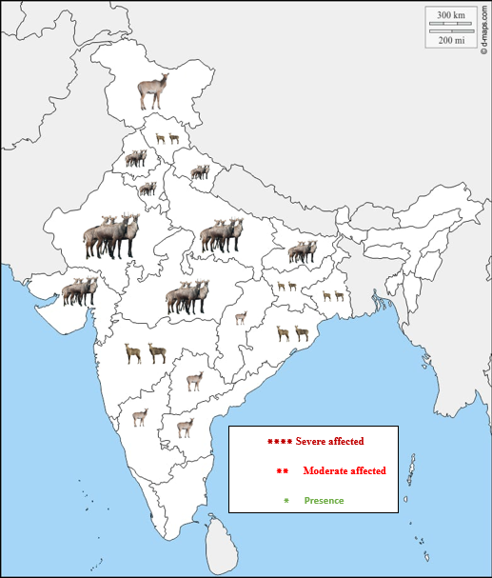
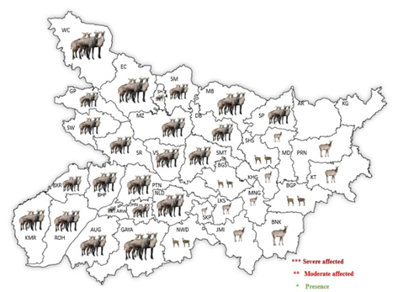
b
a
Figure. 1: Showing the classification of severe, moderate, and minimal presence of Boselaphus tragocamelus in India (a) and in Bihar (b) (Authors' analysis based on data from Chauhan 2011 & Prasad, 2022).

The Shahabad region has recorded the highest densities of Wild boar, Monkeys, and Banbakri (Prasad et al., 2018, 2019). According to the Directorate of Agriculture, Bihar, the growing Banbakri menace has forced many farmers to abandon cultivation. Annual agricultural and horticultural losses from wild mammals are estimated at ₹300–450 crore, potentially reaching ₹1,500 crore when costs for barriers and surveillance are included (Santoshi, 2017; Thakur et al., 2022). These losses translate into reduced productivity, increased labour for guarding fields, and abandonment of farmland-posing a serious livelihood threat and provoking retaliatory actions (Findlay & Hill, 2020).
Crop damage by Banbakri is particularly severe in northern India during the winter season (Chauhan, 2011). In Haryana, damage to crops such as gram, wheat seedlings, and green gram ranges from below 10% to as high as 58% of total yield (Chauhan & Singh, 1990). Similar reports from Punjab describe extensive destruction of cereals, vegetables, and orchards (Babbar et al., 2022). Banbakri typically feed during early morning and late evening hours and rest under shade during the day (Bohra et al., 1992). Though mustard is rarely consumed, it suffers significant trampling damage (Meena, 2017). The species shows strong preference for gram, wheat, and moong crops, and similar losses have been observed in Nepal-14.48% for vegetables and 10.38% for pulses (Khanal et al., 2018; Chhangani et al., 2004). The predicted details are summarized in Table 2, 3 & 4.

3.1.3 Agricultural Development and Banbakri-Related Challenges in Bihar
Bihar’s diverse agro-climatic zones support intensive cultivation of crops such as paddy, wheat, maize, and horticultural produce and the proliferation of Banbakri antelope (Prasad & Ahmad, 2016; Kumar & Kumar, 2018; Prasad et al., 2023; Srivastava & Singh, 2024). Over the past two decades, the state has achieved significant advances in agriculture and aquaculture, producing high-quality paddy, wheat, maize, and aquaculture products (Pandey, 2016; Chand & Prasad, 2021). Inland terrestrial and freshwater ecosystems provide habitats for several wild mammal species, including Banbakri, which increasingly inhabit areas outside protected zones, often near human settlements (Bagchi et al., 2003; Prasad & Prabhakar, 2020; Prasad et al., 2020, 2021). Banbakri are highly adaptable, thriving in hot summers, cold winters, flood-prone areas, and diverse land types (Prasad et al., 2021; Prasad, 2022). Prasad et al. (2025b) provided the first empirical evidence of thermoregulatory basking (sunbathing) behaviour in free-ranging Boselaphus tragocamelus, highlighting its adaptive significance as a behavioural mechanism for thermal regulation under natural environmental conditions. Free-ranging populations are present in 36 of 38 districts, with 21 districts experiencing substantial crop losses (Prasad, 2022; Srivastava & Singh, 2024). They target crops at different growth stages: mature paddy, maize, mustard, chili, cauliflower, cowpea, black gram, and cabbage; early-stage wheat, potato, radish, and pumpkin; and lentils at all stages (Prasad et al., 2023; Khanal et al., 2017).
Banbakri primarily feed in crop fields during evening and nighttime hours, returning to scrublands or thin forests by day (Bohra et al., 1992; Prajapati & Singh, 1994; Mathai, 1999; Prasad et al., 2023). Observations indicate maize is damaged during tillering to maturity stages, rice paddies at early to milky grain stages, wheat during young growth and flowering, and mustard across all stages. Crop-raiding peaks in winter, coinciding with higher activity and predation avoidance in fields (Prasad et al., 2019; Prasad et al., 2023). While Bihar’s agricultural expansion aims for self-sufficiency and improved farmer livelihoods, the widespread presence of Banbakri antelope poses a major challenge, causing direct crop losses, trampling, and increased labor demands for field protection. Effective management strategies are critical to balance conservation goals with agricultural sustainability.
Table-2. Major cultivated crops damaging and preferences by the Boselaphus tragocamelus (Prasad et al., 2023).

S. N. | Crop | Scientific name | Damaging stages
1 | Paddy | Oryza sativa | immature/ growing / milky grain
2 | Wheat | Triticum aestivum | immature/ growing/ mature
3 | Maize | Zea mays | immature/ growing/ mature
4 | Sugarcane | Saccharum officinarum | immature/ growing / mature
5 | Arhar | Cajanus cajan | immature/ growing/ mature
6 | Gram | Cicer arietinum | immature/ growing/ mature
7 | Lentil | Lens culinaris | immature/ growing/ mature
8 | Moong | Vigna radiata | immature/ growing/ mature
9 | Mustard | Brassica juncea | all stages
Major horticulture crops ( fruit & vegetables)
10 | Mango | Mangifera indica | leaves and fruits
11 | Guava | Psidium guajava | leaves and fruits
12 | Anola | Phyllanthus emblica | leaves and fruits
13 | Papaya | Carica papaya | leaves and fruits
14 | Mahua | Madhuca indica | flowers and leaves
15 | Banana | Musa paradisaic | leaves and fruits
16 | Tomato | Solanum lycopersicon | leaves and fruits
17 | Potato | Solanum tuberosum | leaves and fruits
18 | Brinjal | Solanum melongena | leaves and fruits
19 | Cabbage | Brassica oleracea | leaves and flower
20 | Kakri | Cucumis sativys | leaves, stem and fruits
21 | Guwar bean | Cyamopsis tetragonaloba | leaves, stem and fruits
Others
22 | Ber | Ziziphus mauritina | leaves, fruits and pods
23 | Semal | Bombax ceiba | flower, fruits and leaves
24 | Babul | Acacia nilotica | leaves, fruits and pods
25 | Baniyan | Ficus benghalensis | leaves and fruits
26 | Jhabar ber | Ziziphus nummalaria | leaves and fruits
26 | Peepal | Ficus religiosa | leaves/ fruits

3.1.4 Ecological and Agricultural Impacts of Banbakri antelope
In Central India, Boselaphus tragocamelus causes substantial damage to a wide range of crops, including gram, green gram, wheat seedlings, mustard, linseed, groundnut, sugarcane, soybean, ginger, and jowar (Chauhan, 2011; Meena, 2017). In some regions, the severity of damage has forced farmers to abandon cultivation altogether (Chauhan & Sawarkar, 1989). For instance, between 2009 and 2013, Madhya Pradesh reported 3,278 crop damage cases, with compensation of Rs. 1.2 crore paid to affected farmers (Babbar et al., 2022). The Blue bull’s presence has also compelled villagers to alter cropping patterns in both kharif and rabi seasons. Uttar Pradesh hosts an estimated population of 2,54,444 individuals (Chauhan, 2011; Meena, 2017), while the Shahabad region in Bihar (~4 districts) has approximately 8,000 individuals.
Table 3. Crop damage by Boselaphus tragocamelus (Foraging & Trampling)
S. N. | Crops | Low Density (In %) | High Density | Reference
1. | Wheat  (Triticum aestivum) | 20-30% | 35-60% | Chauhan, 2011
1. | Gram  (Cicer arietinum) | 40-50% | 50-70% | Chauhan, 2011
1. | Moong  (Vigna radiata) | 40-45% | 45-60% | Chauhan, 2011
1. | Mustard  (Brassica nigra) | Seldom eaten by Nilgai, but damaged by trampling |  | Chauhan, 2011
2. | Green gram  (Vigna radiata) | Less than 10% | - | Chauhan & Singh, 1990
2. | Wheat  (Triticum aestivum) | 58% | 58% | Chauhan & Singh, 1990
2. | Gram  (Cicer arietinum) | 58% | 58% | Chauhan & Singh, 1990

The overall Banbakri population in Bihar is estimated at 2,95,866 (Department of Agriculture, Government of Bihar, 2024; Swaroop, 2024). Northern Indian states have faced significant crop raiding by Banbakri since at least 1990 (Qureshi, 1991). In Rajasthan, Banbakri preferentially feed on crops such as moth (Pennisetum aconitifolium), jwar (Cyamopsis tetragonoloba), bajra (Pennisetum typhoideum), moong (Triticum vulgare), jeera (Cuminum nigrum), and dhania (Coriandrum sativum), as well as vegetables and fruits such as ber (Ziziphus mauritiana), lemon (Citrus medica), papaya (Carica papaya), guava (Psidium guajava), and pomegranate (Punica granatum). Reported crop losses vary with Banbakri density: in low-density areas, wheat 20–30%, gram 40–55%, moong 40–45%, jwar 20–35%, and cotton 25–40%; in high-density areas, losses increase to 35–60% for wheat, 50–70% for gram, and 45–60% for moong (Chauhan, 2011; Chauhan & Singh, 1990). Banbakri are ecologically adaptable, exhibiting crepuscular and nocturnal activity, particularly during summer. They rest during the day in marginal lands with sparse vegetation, scattered trees (e.g., Acacia nilotica, Ziziphus mauritiana), or sandy substrates, and actively forage in agricultural fields at dusk (Prasad et al., 2019, 2020; Prasad, 2022). Factors contributing to intensified human–Banbakri interactions include population growth, legal protection under the Wildlife Protection Act (1972), absence of natural predators, habitat degradation, overgrazing by livestock, and cultural protection by communities such as the Bishnoi. Traditional mitigation, including human vigilance and domestic dogs, imposes significant socio-economic costs. Population control measures, including culling, remain contentious due to ecological, ethical, and socio-cultural concerns. Several state governments, including Haryana and Rajasthan, have explored administrative guidelines for managing Banbakri populations. Nonetheless, long-term, ecologically sound, and socially acceptable strategies are urgently needed to balance wildlife conservation with the livelihood security of rural communities.
Table 4. An overview of Boselaphus tragocamelus as a pest in India
State | District | Pest Status | Crops Affected | Reference
Bihar | There are 295,866 Blue bulls in 34 districts of the state, the largest population in India. | Major | Paddy, Wheat, Maize, Sugarcane, Arhar, Gram, Lentil, Moong, Mustard, Fruits & Vegetables (Mango, Guava, Anola, Papaya, Mahua, Ber, Banana, Tomato, Potato, Brinjal, Cabbage, Kakri, Gavar), Others | Prasad & Ahmed 2016; Prasad et al., 2019, 2020; Prasad & Prabhakar 2021; Prasad et al. 2021; Prasad 2022; Prasad et al. 2023; Srivastava & Singh 2024; Kumar & Kumar 2018; Swaroop 2024.
Rajasthan | Inhabiting the arid regions of Rajasthan: Jaipur (Rural), Jodhpur, Rajsamand, Bikaner | Major | Moth, Gawar, Bajra, Moong, Jeera, Dhania, Several vegetable crops, Fruits (Ber, Nimbu, Papita, Amrud, Anar) | Bohra et al. 1992; Gehlot 2006; Devendra & Jaishankar 2021; Goyal & Rajpurohit 1998, 2000; Kusum 2018; Jaipal 2019; Meena et al. 2014; Gautam & Bissa 2015
Madhya Pradesh | A total of 32,728 cases of crop raids by Blue bulls were reported from 2009-2023 | Major | Gram, wheat seedlings, Mustard, Linseed, Groundnut, Sugarcane, Soybean, Gingelly (Til), Jowar | Chauhan & Sawarkar 1989; Chandel et al. 2024.
Uttar Pradesh | Aligarh | Major | U.P. population of Blue bulls (254,449) in India | Khan & Khan 2016; Chauhan 2011.
Punjab | Ludhiana & Sangrur | Major | Gram, Wheat, Green gram | Bajwa & Singh 2019.
Haryana | South western Haryana | Major | Gram, Wheat, Green gram | Singh 1995; Chauhan & Singh 1990, 2009.
Maharashtra | Hingoli & Jalna | Major | Major crops | Kalyankar et al. 2017.
Uttarakhand | Dehradun | Major | Major crops | Chauhan & Singh 1990; Azad 2020; Koshy 2021.

4. Reasons for Crop Raiding
Habitat degradation and fragmentation have disrupted natural ecological processes, forcing wild mammals to increasingly forage in human-dominated landscapes (Zedler & Kercher, 2005). In Banbakri antelope (Boselaphus tragocamelus), crop raiding is mainly driven by grassland loss, urbanization, human population pressure, agricultural expansion, land-use change, and climate variability, which reduce natural forage availability while increasing access to nutritious cultivated crops. As a result, farmlands become reliable food sources, intensifying human–Banbakri conflict (Foley et al., 2005; Srivastava & Singh, 2024).
4.1. Grassland Alteration and Population Increase
Conversion of open grasslands into crop fields has eliminated natural buffer zones, forcing Banbakri to move from low-nutrient vegetation to areas with high-quality crops (Prasad et al., 2021). The species exhibits high reproductive potential, with ~50% of births resulting in twins, though triplets are rare (Sheffield et al., 1983; Kyle, 1990; Babbar et al., 2022). Absence of predators and adaptations such as water conservation facilitate population growth, increasing crop raiding. Crop losses often result from trampling as well as direct consumption (Bayani et al., 2016; Chauhan & Rajpurohit, 1993). In Bihar, human–Banbakri conflicts are severe, affecting extensive agricultural land (Prasad, 2022; Chandel et al., 2024).
4.2. Urbanization and Agricultural Expansion
Rapid urbanization and population growth have transformed grasslands, wetlands, and uncultivated areas into farmland and settlements (Bassi et al., 2014; Zhao et al., 2006). Between 1950–51 and 2008–09, India’s cultivated land increased from ~129 to 156 million hectares, while non-agricultural land rose from 9 to 26 million hectares. Habitat degradation, declining predator populations, extended summers, and reduced rainfall have contributed to rising Banbakri populations (Dhamorikar et al., 2021; Sharma, 2020; Prasad et al., 2023; Gupta, 2024). Banbakri frequently use crops such as sugarcane, maize, paddy, and mustard for refuge, gestation, and calf protection (Chauhan, 2011; Prasad & Prabhakar, 2020; Sliwa et al., 2023).
4.3. Human Population Pressure
India’s population grew from 0.4 billion in 1951 to 1.2 billion in 2011, intensifying pressure on grazing land and wildlife habitats (Bassi & Kumar, 2012; Gehlot, 2006). Banbakri increasingly encroach upon human settlements and cultivated fields, particularly in ecological zones such as Shahabad, Bihar, where riverine forests, savannas, and agricultural landscapes offer favourable conditions (Prasad et al., 2020, 2021; Prasad & Ahmad, 2026).
4.4. Better Accessibility to Food
Advances in irrigation and year-round cultivation have concentrated high-quality crops near settlements, providing Banbakri with reliable food and water (Rao, 1994; Singh et al., 2023; Prasad, 2022). Habitat fragmentation, degraded natural forage, and proximity of irrigated fields have driven their expansion into agricultural landscapes (Prasad et al., 2023; Singh et al., 2017). Banbakri prefer high-nutrient crops-pulses, cereals, oilseeds, vegetables-and yield losses can reach 58% in some regions. Their proximity to humans also increases vehicle collision risks and zoonotic disease concerns (Bagchi et al., 2004; Gulati et al., 2021).
4.5. Legal Protection and Management Challenges
Banbakri antelope are protected under the Wildlife Protection Act, 1972, restricting unregulated culling. Temporary government permissions for population control create legal ambiguities, fueling conflicts between conservation agencies and farmers (Chauhan, 2011; Rana & Kumar, 2023).
5. Mitigation Strategies and Prudential Approaches
Human–Banbakri conflict has prompted the development of various mitigation strategies, ranging from non-lethal measures to experimental domestication and controlled culling. The effectiveness of these strategies varies with local ecological, socio-economic, and cultural contexts.
5.1. Non-Lethal Measures
Physical barriers, including solar-powered electric fences, stone walls, and trenches, have been employed but often face limitations due to high costs and maintenance challenges (Meena et al., 2017). Repellents, noise deterrents, and community vigilance patrols have shown mixed success (Meena et al., 2014). Under Bihar’s Rastriya Krishi Vikas Yojana (RKVY) scheme, trials are exploring the domestication of Banbakri antelope as a long-term conflict mitigation strategy, with potential economic benefits from milk, meat, and manure production (Gupta, 2024; Prasad & Ahmad, 2016; Prasad, 2022).
5.2. Watching and Vigilance
Traditional field watching remains the most common deterrent, with ~60% of farmers relying on elevated bamboo or wooden platforms (“Machans”) to observe crops at night (Babbar et al., 2022; Prasad et al., 2025b). Farmers employ diverse techniques to chase intruders, including drum-beating, firing licensed guns, loud noises, slingshots, dog release, and high-voltage fencing (Fig. 2).
5.3. Use of Foul Offensives
Firecrackers, reflective tapes, LED lights, and scarecrows are widely used to deter Banbakri, particularly in early crop stages (Meena et al., 2014; Khanal et al., 2018). Scarecrows equipped with LED lights simulate human presence to discourage intrusion (Babbar et al., 2022; Prasad, 2022). Sprayable repellents derived from Banbakri excreta, donkey excreta, cow urine, or decomposed vegetable matter produce odors that repel herds (Meena et al., 2012; Jain et al., 2022; Prasad et al., 2025b). Phenyl solutions are also occasionally used as a deterrent.
5.4. Fencing and Power Fencing
Banbakri can jump over six feet; thus, fences must exceed this height for effectiveness (Leslie, 2008; Babbar et al., 2024; Prasad et al., 2025). Power fencing often fails as animals develop tolerance or break through, and illegal high-voltage fencing poses serious welfare risks, occasionally causing fatalities (Sharma, 1991; Sheffield et al., 1983; Meena et al., 2014).
5.5. Habitat Protection and Sterilization
Preserving natural habitats, minimizing fragmentation, and maintaining vegetation and water sources are vital for reducing crop raids (Kasso & Bekele, 2014; Soni, 2020; Prasad et al., 2019). Sterilization, particularly castration of dominant males, is an effective population management strategy due to the species’ social herd structure (Mathur et al., 2015; Babbar et al., 2022; Prasad, 2022).
5.6. Changes in Cropping Patterns and Awareness
Farmers have altered cropping patterns, leaving some fields fallow and increasing cultivation of less-preferred crops such as okra, ginger, turmeric, and garlic (Thakur et al., 2022). Non-preferential crops, including medicinal plants such as Sarpagandha and Mentha, are recommended to reduce conflict (Gross et al., 2016; Vijayan & Pati, 2002; Aryal, 2007). Community awareness programs promoting non-lethal management and conservation education are essential.
5.7. Extent of Animal Menace
Wildlife intrusion significantly affects fragmented and scattered landholdings in northern India, including Bihar, Jharkhand, Uttarakhand, Madhya Pradesh, Rajasthan, Punjab, Haryana, and Delhi (Chauhan, 2011; Hill, 2000). Approximately 33% of cropped area is vulnerable to wild mammals, with maize (45.76%), wheat (43.07%), paddy (31.25%), and soybean (40.56%) being particularly affected (Thakur et al., 2022; Chauhan & Sawarkar, 1989; Fungo et al., 2010). The Shahabad region of Bihar is a high-conflict hotspot.
5.8. Lethal Control and Conservation
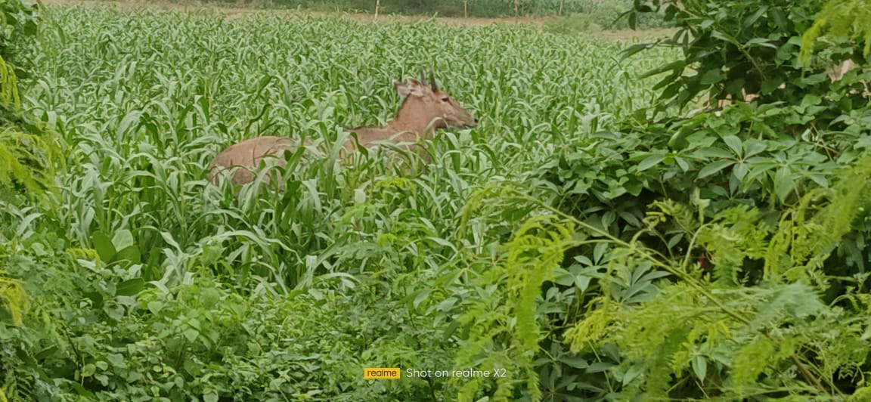
Selective culling under government notification remains controversial due to high mobility, reproductive capacity, and socio-cultural opposition (Rana & Kumar, 2023). Approximately 5,000 Banbakri were culled in Bihar between 2016–2020 (Swaroop, 2024), with isolated incidents of illegal trade in meat reported. Trapping and translocation using chemical immobilization and temporary enclosures (“Boma Capture Technique”) have been trialled successfully in Madhya Pradesh to reduce stress and relocate animals (Babbar et al., 2022; Noronha, 2018).
C
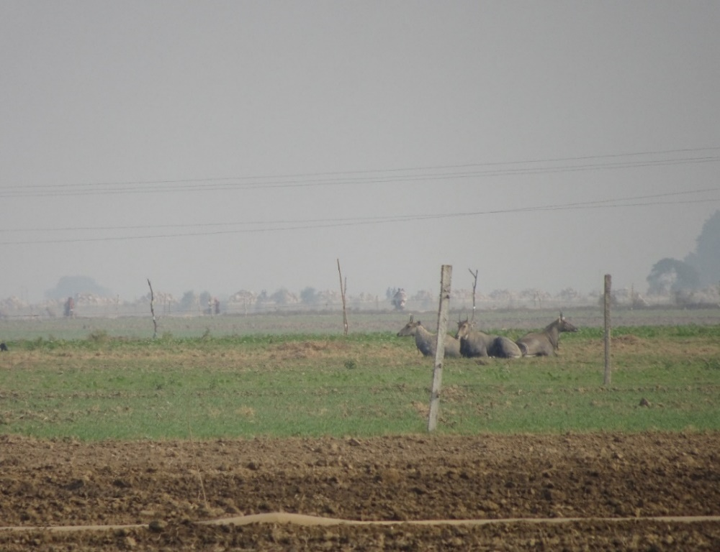
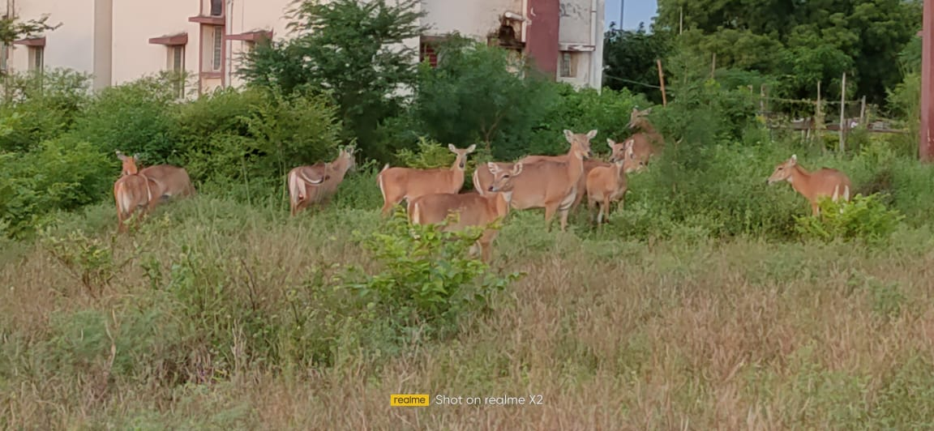
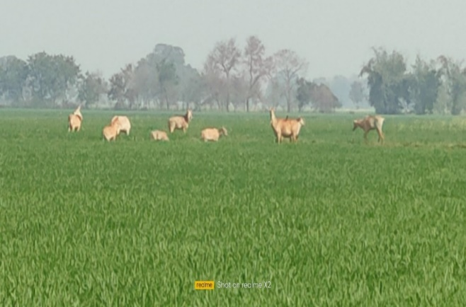
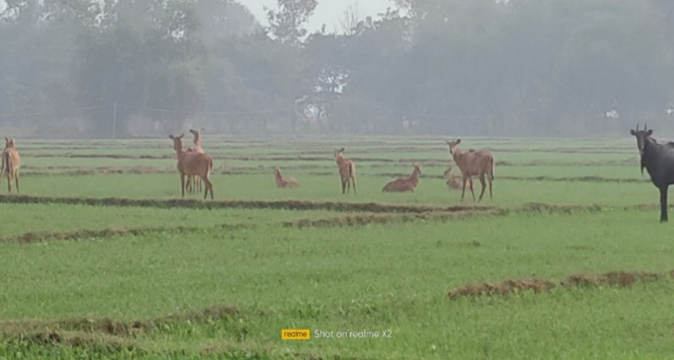
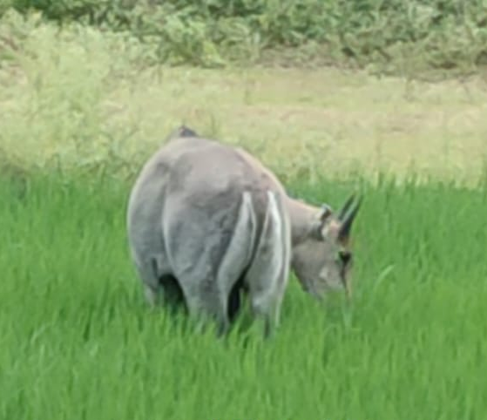
f
e
d
b
a

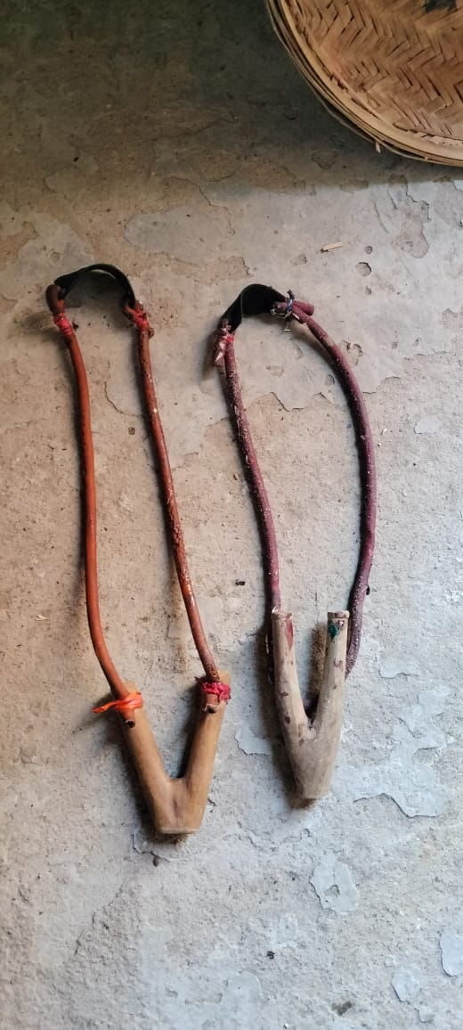
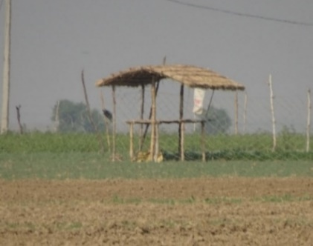
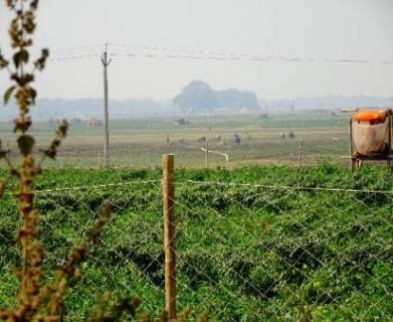
i
h
g

Fig.-2: a. Herd sitting in the pulse crop field. b. Herd eating wheat crops. c. Herd eating green fodder. d. Male eating paddy crops. e. Herd wandering near human habitation. f. Males sitting on all fours. g. Fencing with a nylon net. h. Monitoring hut (Scaffolding or Machan). i. Indigenous device (Slingshot or Gulel).

5.9. Domestication Trials
Bihar is exploring domestication as a long-term conflict mitigation strategy. Experimental efforts aim to derive economic benefits from milk, meat, hide, horns, dung, and draft use, capitalizing on the species’ adaptability to small habitats and behavioural flexibility (Prasad & Ahmad, 2016; Prasad, 2022; Gupta, 2024; Ghosh, 2025). Large-scale adoption is yet uncertain but presents potential for rural socio-economic development. Prasad et al. (2025c) provided the first report on the dung composition of the Banbakri (nilgai) antelope, demonstrating its potential as a nutrient-rich organic amendment for sustainable agriculture. The findings indicate that Banbakri dung contains essential nutrients capable of enhancing soil fertility and structure. Additionally, its multipurpose use as biofuel and natural pest deterrent highlights its value in low-input farming systems. Such applications may support improved wildlife–farming coexistence and offer an innovative pathway for mitigating human–Banbakri conflict in India.
5.10. Management in Brush Countries and Mexico
Introduced to the King Ranch in Texas (1930), Banbakri populations have grown to over 38,000 individuals across Texas and northern Mexico (Sheffield et al., 1983; Ortega-Santos et al., 2016). Managed in high-fenced enclosures for hunting, they provide significant economic value, with male harvest prices ranging from ₹125,304–₹167,068 and meat sales at ₹1,400–₹1,600/kg (Alvarez-Romero et al., 2008; Ortega-Santos et al., 2016). Management challenges include habitat improvement, population control, and ensuring sustainability (Singh et al., 2017; Prasad, 2022).
6.0. CONCLUSION
The escalating human–Banbakri (Nilgai) conflict in India represents a pressing challenge at the interface of wildlife conservation and rural livelihoods. Habitat degradation, agricultural expansion, and legal complexities have driven Banbakri antelope into farmlands, resulting in substantial economic losses for farmers. Addressing this conflict requires a balanced, evidence-based strategy grounded in robust research on population dynamics, movement ecology, and crop damage patterns. An Integrated Banbakri Pest Management (IBPM) framework—emphasizing non-lethal deterrents, community participation, fair compensation policies, and regulated management where necessary-offers a pragmatic pathway toward coexistence. By aligning conservation goals with the realities faced by farming communities, such an approach can reduce conflict while safeguarding both biodiversity and rural livelihoods.
Disclaimer (Artificial intelligence)
Author(s) hereby declare that NO generative AI technologies such as Large Language Models (ChatGPT, COPILOT, etc.) and text-to-image generators have been used during the writing or editing of this manuscript.

REFERENCES
- Alemayehu N, Tekalign W (2020) Prevalence of crop damage and crop-raiding animals in southern Ethiopia: The resolution of the conflict with the farmers. Geo Journal 1:1-15. https://doi.org/10.1007/s10708-020-10287-0
- Alvarez-Romero JG (2006) Impactos de vertebrados exo´ticos invasores en a´reas continentales. In Fundamentos para la prevencio´n y manejo de especies exo´ ticas invasoras en Me´xico (O. Sa´nchez, editor). Instituto Nacional de Ecologı´a, Mexico, D.F. 1–57.
- Aryal A (2007) Blue bull (Boselaphus tragocamelus) in Lumbini- a world heritage site of Nepal. Tiger paper, 34 (2): 4-9.
- Azad S (2020) Nilgai declared vermin in Uttarakhand, wild boar again tagged as pest that can be culled, The Times of India. Nov. 1-2. https://timesofindia.indiatimes.com › › dehradun News
- Babbar B. K, Singla N, Kaur H, Verma M, Rani K, Bala B, Jain S (2022) Bio-ecology, behaviour and management of Blue bull, Boselaphus tragocamelus. International Journal of Pest Management 1–16. https://doi.org/10.1080/09670874.2022.2104402
- Bagchi S, Goyal SP, Sankar K (2003) Niche relationships of an ungulate assemblage in a dry tropical forest. Journal of Mammalogy 84:981–988. https://doi.org/10.1644/BBa-024
- Bajwa P, Singh N (2019) Distribution of Nilgai (Boselaphus tragocamelus) and its intercalary with local communities in the Abohar wild life Sanctuary, Northwestern, India. Journal of wild life and Biodiversity 3(4): 27-35. https://doi.org/10.22120/jwb.2019.111565.1076
- Bassi N, Kumar MD (2012) Addressing the civic challenges: perspective institution of change for sustainable urban water management in India. Environ. Urban Asis 3(1): 165-183. https://doi.org/10.1177/097542531200300109
- Bassi N, Kumar MD, Sharma A, Partha-Shradhi P (2014) Status of wetlands in India: A review of extent ecosystem benefits, threats and management strategies. Journal of Hydrology Regional Studies. 2: 1-19. https://doi.org/10.1016/j.ejrh.2014.07.001
- Bayani A, Tiwade D, Dongre A, Dongre AP, Phatak R, Watve M (2016) Assessment of Crop Damage by Protected Wild Mammalian Herbivores on the Western Boundary of Tadoba-Andhari Tiger Reserve (TATR), Central India. PLoS ONE 11(4): e0153854. https://doi.org/10.1371/journal.pone.0153854
- Benton, M. 2000. "Boselaphus tragocamelus" (On-line), Animal Diversity Web. Accessed March 02, 2025 at https://animaldiversity.org/accounts/Boselaphus_tragocamelus/
- Bohra HC, Goyal SP, Ghosh PK, Prakash I (1992) Studies on the ethology and eco-physiology of the antelopes of the Indian Desert. Ann. Arid Zone, 31: 83–96. https://doi.org/10.56093/aaz.v31i2.64823
- Chand GB, Prasad S 2021. Present status potentials and future prospects of fisheries development in Bihar. Environment and Ecology 39(1): 10-15. https://environmentandecology.com/archive/volume-39-1-2021
- Chandel CS, Madan S, Jain D, Kawlni L, Kolipakam V Qureshi Q (2024) Understanding human-Nilgai negative interaction in India: a systematic review through print media report analysis. Journal of Threatened Taxa 16(6): 25318-25329. https://doi.org/10.11609/jott.8758.16.6.25318-25329
- Chauhan NPS (2011) Agricultural crop depredation by nilgai antelope (Boselaphus tragocamelus) and mitigation strategies: challenges in India. 8th European Vertebrate Pest Management Conference 432.104 pp. 190-191. https://doi.org/10.5073/jka.2011.432.104
- Chauhan NPS, Barwal SK, Kumar D (2009) Human Wild Pig Conflict in Selected States in India and Mitigation Strategies. Acta. Sylvatica Lignaria Hungarica 5: 189-197.
- Chauhan NPS, Rajpurohit KS (1993) Survey of Animal Damage Problem in and around protected areas and managed forests: Phase-I Madhaya Pradesh, Bihar and Orissa - A Report, Wildlife Institute of India, Dehradun.
- Chauhan NPS, Sawarkar VB (1989) Problems of over abundant populations of Nilgai and black buck in Haryana and Madhya Pradesh. Indian Forester 115(7): 488-493. https://doi.org/10.36808/if/1989/v115i7/9074
- Chauhan NPS, Singh R (1990) Crop damage by overabundant populations of Nilgai and black buck in Haryana (India) and its management. Proc. Vertebrate Pest Conf 14: 218-220. https://digitalcommons.unl.edu/vpc14/13
- Chhangani AK, Mohnot SM (2004) Crop raiding by wild boar (Sus scrofa) in and around Aravalli and its management in Rajasthan. Tiger paper 31(2): 1–5.
- Choudhary DN, Prasad S, Bhushan M (2023) Occurrence of Ganges River dolphin (Platanista gangetica): a cetacean mega fauna in the Mahananda river system in Purnea district, Bihar, India. International Journal of Advanced Research in Biological Science. 10(4): 46-55. DOI: http://dx.doi.org/10.22192/ijarbs.2023.10.04.004
- Devanda M, Jaishankar M (2021) Perception survey on Nilgai, Boselaphus tragocamelus (Pallas) incidence in crop land ecosystems around rural Jaipur, Rajasthan. Pest Management in Horticultural Ecosystems. 27(1):110-112. https://doi.org/10.5958/0974-4541.2021.00022.9
- Devault TL, Beasley JC, Humberg LA, Macgowan BJ, Retamosa MI, Rhodes OE (2007) Intra-field patterns of wildlife damage to corn and soybeans in Northern India. Human–Wildlife Conflicts 1(2): 205–213. https://doi.org/10.26077/0j2d-d311
- Dhami, B., Bhusal, A., Adhikari, B., Miya, SM., Maharjan, SK., Neupane, D., and Adhikari, H. (2023). Habitat Suitability and Conflict Zone Mapping for the Blue Bull (Boselaphus tragocamelus) across Nepal, Animals (Basel), 5;13(5):937. https://doi.org/10.3390/ani13050937
- Dhamorikar, A., Talegaonkar, R., Chouksey, S., Colvin, M., Salaria, S., Bhushan, A., Dubey, U., Bhatkar, A., Chanchani, P. & Dey, S. (2021). Habitat use of tigers and leopards, and habitat connectivity in the Bandhavgarh- Sanjay corridor. WWF-India. https://www.wwfindia.org/
- Don EW, Russell AM (2011) Bovidae, in Handbook of the Mammals of the World–Volume 2 Hoofed Mammals, Barcelona: Lynx Editions on page 591. https://www.lynxnaturabooks.com/product/handbook-of-the-mammals-of-the-world-volume-2/
- Findlay LJ, Hill RA (2020) Baboon and vervet monkey crop-foraging behaviors on a commercial South African farm: preliminary implications for damage mitigation. Human Wildlife Interactions 14(3): 505–18. doi.org/10.26077/5dbc-b920.
- Foley JA, Defries R, Ansor GP, Barford C, Bonon G, Carpenter SR (2005) Global Consequences of land use. Science. 309: 570-574. https://doi.org/10.1126/science.1111772
- Fortin, D., Jerod, A. C., Merkle, A., Marie Sigaud, A., Seth, A., Cherry, G., Sabrina Plante, B., Amélie Drolet, A., Myriam Labrecque, A. (2015). Temporal dynamics in the foraging decisions of large herbivores, Animal production Science, 55(3):376-383. https://doi.org/10.1071/AN14428
- Fungo B, Eilu G, Tweheyo M (2010) Patterns of crop raiding around Mabira Forest Reserve, Uganda. Research Journal of Biological Sciences 12(5): 785–92.
- Gautam R, Bissa P (2015) Population dynamics, ecology, breeding biology and pest status of Nilgai (Boselaphus tragocamelus) in Shekhawati Region of Thar Desert. Ph.D. Thesis submitted, M.G.S. University, Bikaner (Rajasthan).
- Gehlot HS (2006) Social organization, behavioural and resources selection patterns in Antelope cervicapra and Gazelle bennetti of thar Desert. PhD thesis, JN Vyas University, Jodhpur, Rajasthan. 195pp. DOI: 10.12691/aees-9-4-1.
- Ghimire SC, Chalise MK (2018) Status of crop raiding by Assamese monkeys (Macaca assamensis) along the Budhigandaki river, central Nepal. Journal of Natural History Museum 30: 294–305. https://doi.org/10.3126/jnhm.v30i0.27605
- Ghosh FK, Bhora HC, Goyal SP (1988) Crop raiding by nilgai (in press).
- Goyal SK, Rajpurohit LS (1998) Eco-behavioural study of nilgai at Beri ganga near Jodhpur (Rajasthan). Cheetal 37(1-2): 36-39.
- Goyal SK, Rajpurohit LS (1999) Mass killing of mammalian crop pest-nilgai Boselaphus tagocamelus in Village Parasala, Osian of Jodhpur, India. Advances in Ethology 34: 224.
- Goyal SK, Rajpurohit LS (2000) Nilgai (Boselaphus tragocamelus) A mammalian crop pest around Jodhpur. Utter Pradesh Journal of Zoology, 20(1): 55-59.
- Graham MD, Notter B, Adams WM, Lee PC, Ocheing, TN (2010) Patterns of crop-raiding by elephants, Loxo donta africana, in Laikipia, Kenya and the management of human-elephant conflict. Syst. Biodiversity. 8: 435-445. https://doi.org/10.1080/14772000.2010.533716
- Gross EM, Mc Robb R, Gross J (2016) Cultivating alternative crops reduces crop losses due to African elephants. Journal of Pest Science 89: 497–506. https://doi.org/10.1007/s10340-015-0699-2
- Groves CP, Leslie DM, JR, Huffman BA, Valdez R, Habibi K, Weinberg PJ, Burton JA, Jarman PJ, Robichaud WG (2011) Species accounts for Bovidae. Pages 572–779 in Handbook of the mammals of the world. Volume 2. Hoofed mammals (DE Wilson & RA Mittermeier, editors). Lynx Editions, Barcelona, Spain. https://www.lynxeds.com/product/handbook-of-the-mammals-of-the-world-volume-2/
- Gulati S, Karanth KK, Le NA, Noack F (2021) Human casualties are the dominant cost of human-wildlife conflict in India. Proc Natl Acad. Sci USA. 118: 8. https://doi.org/10.1073/pnas.1921338118
- Gupta A (2024) Domestication trails in Bihar aim to mitigate farmer-Nilgai conflict, Mongabay, India. 1-7. https://india.mongabay.com/2024/01/domestication-trials-in-bihar-aim-to-mitigate-farmer-nilgai-conflict/
- Habibi K (2001) Antelopes Global Survey and Regional Action plan’s part 4: North Africa, the middle East and Asia, compiled by DP Mallon & SC Kingswood, IUCN species survival commission. Chapter, 23, Pakistan. Page- 122-128. https://www.iucn.org/resources/publication/antelopes-global-survey-and-regional-action-plans-part-4-north-africa-middle-east-and-asia
- Halladay Patricia and Gilmour D. A.(Eds.) (1995). Conserving Biodiversity Outside Protected Areas The role of traditional agro-ecosystems. IUCN, Gland, Switzerland, and Cambridge, UK. pp.viii+229. ttps://www.iucn.org/resources/publication/conserving-biodiversity-outside-protected-areas-role-traditional-agro-ecosystems
- Hill CM (2000) Conflict of interest between people and baboons: Crop raiding in Uganda. International Journal of Primatology 21(2): 299–315. https://doi.org/10.1023/a:1005481605637
- Invasive Species South Africa, https://invasives.org.za › nemba-alien-and-invasive-species. https://invasives.org.za/nemba-alien-and-invasive-species
- Islam R (2024) Comeback on the cards for Asian antelope declared extinct in Bangladesh, Mongabay, 1-5. https://news.mongabay.com/2024/03/comeback-on-the-cards-for-asian-antelope-declared-extinct-in-bangladesh/V
- IUCN, S. S. C (2016) Antelope Specialist group, Boselaphus tragocamelus. The IUCN Red list of threatened species. https://www.iucnredlist.org/species/2893/115064758
- Jain, S., Singla, N., Karla, S., and Mahal, AK. (2022). Effectiveness of different management strategies against Nilgai population (Boselaphus tragocamelus) in Punjab Province of India, Animal Biology, 73(4):1-22. DOI: 10.1163/15707563-bja10096.
- Jaipal BR (2019) Population structure of Nilgai (Boselaphus tragocamelus) in the semi-arid region of the Thar desert, The Scientific Temper, 10(1&2): 7-10. Doc ID: https://connectjournals.com/03960.2019.10.7
- Kalyankar VB, Dhondage TB, Rahod RN (2017) Domestication of Rohi (Nilgai) a directional use of bioenergy for well - being of farmers. International Journal of Applied Research 3(f): 156 – 157. https://www.allresearchjournal.com/
- Kasso, M. and Bekele, A, (2014). Threats to Mammals on Fragmented Habitats around Asella Town, Central Ethiopia. International Journal of Biodiversity, Article ID 903898, 7 pages https://doi.org/10.1155/2014/903898
- Khan MAR (2001) Antelopes global survey and Regional Action plan’s part 4: North Africa, the middle East and Asia compiled by, DP Mallon & SC, Kingswood, IUCN species survive commission chapter 36, Bangladesh. Page- 192-193
- Khanal S, Aryal A, Morley CG, Wright W, Singh NB (2017) Challenges of conserving blue bull (Boselaphus tragocamelus) outside the protected areas of Nepal. Proceedings of the Zoological Society 71: 352-362. https://doi.org/10.1007/s12595-017-0218-y .
- Koshy VK (2021) What is and isn’t vermin, The Hindu. 1-4.
- Kumar P, Kumar A (2018) Boselaphus tagocamelus (Artiodactyla: Bovidae) in the Gangetic Plains of India WSR to North Bihar. IJSRST. Online ISSN: 2395-6011.
- Kusum (2018) Studies on, the ranging pattern and dung piles habit of Nilgai (Boselaphus tragocamelus) around Jodhpur, Rajasthan, India. IJRAR. 5; 555-559.
- Kyle R (1990) An antelope for All Seasonings: New Scientist: 126 (1711): 54-57.
- Leslie DM (2008) Boselaphus tragocamelus (Artiodactyls: Bovidae) Mammalian species American society of Mammologist. 813: 1-16. 1–16, https://doi.org/10.1644/813.1
- Lever C (1985) Naturalized mammals of the world. Longman group limited, London, United Kingdom. ISBN 10: 0582460565/ISBN 13: 9780582460560. https://www.cabidigitallibrary.org/doi/10.1079/9780851985482.0000
- Leroux SJ, Krawchuk M., Schimiegelow F, Cumming SG, Lisgo K, Anderson LG, Petkova M (2010) Global protected area and IUCN designation: Do the categories match protected area and conservation, 143(3): 609-616. https://doi.org/10.1016/j.biocon.2009.11.018
- Lohmeyer, KH., May, MA., Thomas, DB., Pérez de León, AA., (2018). Implication of Nilgai Antelope Boselaphus tragocamelus (Artiodactyla: Bovidae) in Reinfestations of Rhipicephalus (Boophilus) microplus (Acari: Ixodidae) in South Texas: A Review and Update; Journal of Medical Entomology, 55, (3):515–522. https://doi.org/10.1093/jme/tjy004
- Long H, Mojo D, Fu C, Wang G, Kanga E, Oduor AMO, Zhang L (2020) Patterns of human-wildlife conflict and management implications in Kenya: a national perspective. Human Dimensions of Wildlife 25(2): 121–35. https://doi.org/10.1080/10871209.2019.1695984
- Machado TJ, Albert CM, Schnupp MJ, Hewitt DG (2014) Characteristics of Nilgai Antelope carcasses and meat quality. The Texas J. of Agriculture and Natural Reserves 27: 73-83. https://txjanr.agintexas.org/index.php/txjanr/article/view/28
- Manral U, Sengupta S, Hussain SA, Rana S, Badola R (2016) Human wildlife conflict in India: A review of economic implication of loss and preventive measures. Indian Forester 142(10): 928–40. https://doi.org/10.36808/if/2016/v142i10/93647
- Mathai MV (1999) Habitat occupancy by tiger prey species across anthropogenic disturbance regimes in Panna National Park, Madhya Pradesh, India. M.S. thesis, Saurashtra University, Rajkot, India.
- Mathur VB, Kaushik M, Bist SS, Mungi NA, Qureshi Q (2015) Management of human-wildlife interaction and invasive alien species in India. Report no. TR 2015/004. Wildlife Institute of India. Dehradun. 1-235. https://doi.org/10.13140/RG.2.2.35522.58565
- Meena M (2017) Agriculture crop damage by antelope (Boselaphus tragocamelus) and management strategies: Challenges in India. International Journal of Zoology Studies 2(6): 157-160. ISSN: 2455-7269. https://www.zoologyjournals.com/volume-2-issue-6-november-2017-page-no-157-160/
- Meena RP, Meena BL, Nandal U, Meena CL (2014) Indigenous measures developed by farmers to curb the menace of blue bull (Boselaphus tragocamelus) in district Rajsamand, Rajasthan, India. Indian Journal of Traditional Knowledge 13(1): 208-215. http://nopr.niscair.res.in/handle/123456789/20000
- Mehta K, Thakur RK, Guleria JS (2020) Socio-economic impact of protected cultivation on tomato growers of Himachal Pradesh. Economic Affairs 65(1): 01–07. https://doi.org/10.30954/0424-2513.1.2020.1
- Mehta P, Negi A, Chaudhary R, Yasmin J, Thakur P (2018) A study on managing crop damage by wild animals in Himachal Pradesh. International Journal of Agriculture Sciences 10(12): 6438–42. https://www.bioinfopublication.org/pages.php?vol=Volume10,Issue12,2018&page=6438-6442
- Noronha R (2018) Madhya Pradesh, forest department takes up translocation for wild animal. http/www.indiatoday.in/Madhya-pradeshforest department.
- Ortega-Santos JA, Hewitt DG, Campbell TA (2016) Nilgai in south Texas: Nuisance or Asset? Society of Range Management. 1-2. . https://rangelandgateway.org/
- Panday A (2016) System of rice intensification (SRI) Methods in Bihar: A District Level study. Journal of Rural Development 35(2): 211:237. https://doi.org/10.25175/jrd/2016/v35/i2/100043
- Pandey L, Arunachalam A, Joshi N (2019) Challenges of hill farming due to crop-raiding by wild pigs in the Indian Himalayan region. Current Science 116(6): 1015–19. https://doi.org/10.18520/cs/v116/i6/1015-1019
- Perez-Arteaga A, Vazquez GS (2020) Presence of free-ranging Nilgai Boselaphus tragocamelus (Artiodactyl: Bovidae) In Nelevo Leon, Mexico. The southwestern Naturalist 64(2): 145-149. https://doi.org/10.1894/0038-4909-64-2-145
- Prajapati MC, Singh S (1994) A beneficial aspect of nilgai (Boselaphus tragocamelus) in scientifically utilised ravines—an observation. Indian Forester 120: 890–897. https://doi.org/10.36808/if/1994/v120i10/7783
- Prasad S (2022) High Time of Pacing Nilgai Antelope (Boselaphus tragocamelus) into Mainstream as Community Conservation for Influencing Macroeconomics. Asian Journal of Research in Zoology. 5(1): 21-30. DOI: 10.9734/ajriz/2022/v5i130128.
- Prasad S, Ahmad R, Thakur MB (2018) Status, Population size and conservation of Rhesus monkey (Macaca mulata) in Dumraon, Bihar. J. Env. Bio-Sci. 32(02): 199-203. https://www.connectjournals.com/
- Prasad S, Ahmed R (2016) The Indian Antelope Nilgai (Boselaphus tragocamelus) for all interests; A Now hope in Indian Farming. Progressive research. An International Journal 11(sp-x): 6638-6641.
- Prasad S, Kumar A, Ahmed R, Sah RK (2023) The Indian antelope Nilgai (Boselaphus tragocamelus): A Succeeding economic pretender of nation. (Footprints of Biodiversity in the Indian Peninsula), Edited by: Saxena VL, Jaiswal K & Mishra S. Narendra Publishing House, Delhi, India. 155-169. ISBN: 978-93-56511-98-9.
- Prasad S, Kumar S, Chaudhary S. K., Ahmed R (2015) An Observational Behaviour and threats of the Indian Blackbuck (Antelope cervicapra) in Bihar: A Heritage Site of India, Progressive Research-An International Journal 10(sp. 8): 4432-4435.
- Prasad S, Kumar S, Gorai T, Kumar A (2020b) To determine the structure and function of Bhagar oxbow lake in Dumraon, Buxar, South Bihar, India. Current Journal of Applied Science and Technology, 39(28): 145-153. https://doi.org/10.9734/cjast/2020/v39i2830948
- Prasad S, Prabhakar C. S., (2020) Docility behavioural development in Nilgai ((Boselaphus tragocamelus), a sign of Taming towards domestication. Current Journal of Applied Science and Technology 39(41): 30-39. DOI: 10.9734/cjast/2020/v39i4131117.
- Prasad S, Prabhakar C. S., Sah R. K., Kumar A (2019) Is domestication of Nilgai possible? Current science 116(7): 1045-1046. https://doi.org/10.18520/cs/v116/i7/1045-1046
- Prasad S, Prabhakar, C. S., Kumar A, Ahmed A. (2025) Banbakri Samasya Nahi, Sansadhan. Extension Bulletin No. VKSCOA/01/2025, Dikcha Art & Print, Patna. 1-6.
- Prasad S, Shohane R. K., Ahmed R (2021) The Indian Antelope Nilgai (Boselaphus tragocamelus) Appropriate contender for Domestication could add in Human society. Asian Journal of Environment and Ecology. 14(4): 1-10.
- Prasad S, Singh DK, Choudhary SK (2020) Residential population structure and abundance of Nilgai (Boselaphus tragocamelus) in Bihar, India. Current Journal of Applied Science and Technology P39(13): 110-117. https://doi.org/10.9734/cjast/2020/v39i1330687
- Prasad S, Singh DK, Kumar U, Kumar S (2020a). Biodiversity and Ecology of Wild Mammals in Dumraon, Buxar, Bihar. J. Exp. Zool. India. 23(1): 643-648. https://www.connectjournals.com/jez
- Prasad, S., Prabhakar, C.S, Kumar, A., Nath, P., & Ahmad, R. (2025). Documentation of Scent Marking with the Preorbital Gland in Banbakri Antelope (Boselaphus tragocamelus). Uttar Pradesh Journal of Zoology, 46(7), 136-143. https://mbimph.com/index.php/UPJOZ/article/view/2025-46-7-136-143
- Prasad, S., Prabhakar, C.S, Kumar, A., Nath, P., & Ahmad, R. (2025a). Communicative Role of Preorbital Gland Openings in Captive Banbakri Antelope (Boselaphus tragocamelus, Pallas 1766) in India, Book Chapter, edited by Prof. Maria Serrano Mula. Research Perspective on Biological Science Vol. 3 chapter-4;64-75. https://doi.org/10.9734/bpi/rpbs/v3/5103
- Prasad, S., Nath, P., Prabhakar, C.S, & Kumar, A., (2025b). Sunbaking behaviour and ecological significance of Banbakri Antelope (Boselaphus tragocamelus, Pallas 1766) India, J. of Adv.in Biol.& Biot., 28 (8),105-113, https://doi.org/10.9734/jabb/2025/v28i82687
- Qureshi MQ (1991) Population status and movement of nilgai around the village Ghursikaran near Aligarh University. Master’s thesis, Aligarh Muslim University, Aligarh, Uttar Pradesh, India.
- Rajpurohit LS (1988) Nilgai (Boselaphus tragocamelus) is a serious crop pest between Jodhpur and Osian (Rajasthan). Cheetal 29(2): 10-13.
- Rana AK, Kumar N (2023) Current wildlife crime (Indian scenario): major challenges and prevention approaches. Biodiversity and conservation. 32(5): 1473-1491. https://doi.org/10.1007/s10531-023-02577-z
- Rao, DSK., 1994. Farmer Management of groundwater irrigation in Asia: Community sprinkler system in Sallikere village, Bangalore Urban District South India. IWMI Conference proceedings 302112, International Water Management Institute, https://doi.org/10.22004/ag.econ.302112
- Sahoo SK, Mohnot SM (2004) A survey of crop damage by rhesus monkey (Macaca mulatta) and human langur (Semnopithecus entellus) in Himachal Pradesh, India. Tiger paper 31(4): 1-5. ISSN/ISBN: 1014-2789.
- Sahoo, S., Singha, C., Govind, A., Moghimi , A. 2025. Review of climate-resilient agriculture for ensuring food security: Sustainability opportunities and challenges of India. Environmental and Sustainability Indicators. 25, February 2025, 100544.
- Samson A, Ramakrishnan B (2020) Preliminary study on economic loss, mitigating measures and people’s perception on human wildlife conflict specially in agricultural fields in the upper reaches of the Nilgiris, Tamil Nadu, Southern India. International Journal of Pure and Applied Zoology 8(3): 19-23. https://doi.org/10.35841/2320-9585.8.19-23
- Santoshi,, N., 2017. Madhya Pradesh Govt. spends RS: 1.5 Lakh to capture relocate one Nilgai. The Hindustan Times, Bhopal, March, 23. 2017.
- Schlitz BO (1986) The management of crop damage by wild animals. Indian Forester. 112(10): 891-899.
- Sharma IK (1981) Ecological aspects of habitat preferences, feeding, daily activities and niche of the blue bull (Boselaphus tragocamelus). Tiger paper 8: 21-22.
- Sharma, M. (2020). Ecology of Blue bull, Boselaphus tragocamelus in and around Sariska Tiger Reserve, Alwar, Rajasthan, India. International Research Journal of Natural and Applied Sciences, 7, (5): 139-156. https://www.aarf.asia/
- Sheffield WJ, Ables ED, Fall DBA (1971) Geographic and ecologic distribution of nilgai antelope in Texas. Journal of Wildlife Management 25: 250-257. https://doi.org/10.2307/3799598
- Sheffield WJ, Fall BA, Brown BA (1983) The nilgai antelope in Texas. Kleberg Studies in Natural Resources, Texas A&M University, College Station. https://books.google.com/books/about/The_Nilgai_Antelope_in_Texas.html?id=2_0bAAAAYAAJ
- Shrestha TK (2001) Antelopes global survey and Regional Action plan’s part 4: North Africa, the middle East and Asia. compiled by D. P. Malloy and J.C. Kingsway, IUCN species surviving commission chapter, 35, Nepal. Page- 188-193. https://portals.iucn.org/library/node/8900
- Shridhara S (2006) An overview of vertebrate pest in India, Proc. 22nd Vertebrate pest Conference (R. M. Timm and J. M. U. Briened) University of California, Davis. Page- 510-521. DOI: 10.5070/V422110078.
- Singh D.R., Sohane R. K., Patil S, Singh R. N., Dutta S. K., Kumar S., Chaurasiya A. (2023). Climate Resilient Agriculture Programme in Bihar, Interventions & Impact, Bihar Agricultural University, Sabour, ISBN: 978-81-963064-7-2
- Singh NK, Goolsby JA, Ortega-s A, JR, Hewitt DG, Campbell TA, De leon AP (2017) Comparative daily activity patterns of Nilgai, Boselaphus tragocamelus and white-tailed deer, Odocoileus virginianus in South Texas. Subtropical Agri. and Envi. 68: 7-12.
- Singh RV, (1995) Some studies on ecology of nilgai (Boselaphus tragocamelus) with an assessment of damage to agricultural crops and development of strategy for damage control in south-western Haryana. PhD Thesis. Aligarh Muslim University, India.
- Sliwa, KM., Baumgardt, JA., DeYoung, RW., Ortega-S, JA., Hewitt, DG., Goolsby, JA., Lohmeyer, KH. (2023). Movement ecology of exotic nilgai antelope: A threat to the re-emergence of cattle fever ticks in the southern USA. Ecosphere. 14:e4401. https://doi.org/10.1002/ecs2.4401
- Soni VK (2020) Wildlife conservation in India: issue and challenges. J. Interdiscipl cycle Res. 12: 796-802. ISSN NO: 0022-1945. https://www.researchgate.net/publication/349460000_WILDLIFE_CONSERVATION_IN_INDIA_ISSUES_AND_CHALLENGES
- Srivastava A, Singh RV (2024) Study on the Docility Pattern of Nilgai (Boselaphus tragocamelus) in the Gopalganj District of Bihar. International Journal of Science and Research (IJSR) 13(5): 1456-1458. ISSN: 2319-7064. https://doi.org/10.21275/SR24523151653
- Sukumar R, Gadgil M (1988) Male-female differences in foraging on crops by Asian elephants. Animal Behaviour 36: 1233-1235. https://doi.org/10.1016/S0003-3472(88)80084-8
- Swaroop V (2024) Bihar firms up plan to deal with nilgai. Wild boars. Hindustan times (Ranchi) 9th August, 2024. Digital newspaper and magazine. www.pressreader.com.
- Tegarden CH (1988) Quality and acceptability of nilgai antelope (Boselaphus tragocamelus Pallas) meat, M.S. thesis Texas A&I University, Kings Villi.
- Thakur, RK., Walia, A., Mehta, K., Kumar, V., and Lal, H. 2022. Economic assessment of crop damages by animal menace in mid hill regions of Himachal Pradesh. Indian Journal of Animal Sciences 92 (4): 484–491. https://doi.org/10.56093/ijans.v92i4.124173
- Traves A, Wallace RB, Naughton-Treves L, Morales A (2006) Co-Managing Human-Wildlife Conflicts: A Review, Human Dimension of Wildlife, 11: 383-396. https://doi.org/10.1080/10871200600984265
- Tripathi RS, Rao VV (2016) Vertebrate pest management in agriculture. Human Animal Conflict in Agro-Pastoral Context: Issues and Policies. Indian Council of Agricultural Research, New Delhi.
- United Nations Educational Scientific and Cultural Organization-UNESCO (2007) Case studies on climate change and would Heritage. UNESCO, Centre, France. https://whc.unesco.org/document/150000000/
- Veeramani A, Easa PS, Jayson EA (2004) Socio-economic status of cultivators and their interface with wild animals: A case study of Marayur Forest Range, Kerala. Indian Forester 130(5): 513-20. ISSN/ISBN: 0019-4816. https://www.indianforester.co.in/index.php/indianforester/issue/view/130-5-2004
- Vijayan, S., and Pati, BP. (2002). Impact of Changing Cropping Patterns on Man-Animal Conflicts Around Gir Protected Area with Specific Reference to Talala Sub-District, Gujarat, India. Population and Environment, 23(6):541-559. https://doi.org/10.1023/A:1016317819552
- Zedler JB, Kercher S (2005) Wetland resources: status, trends, ecosystem services, and restorability. Annu. Rev. Environ. Resar. 30(1):39-74. https://doi.org/10.1146/annurev.energy.30.050504.144248
- Zhao S, Peng C, Jiang H, Tian D, Lei X, Zhou X (2006) Land use change in Asia and the ecological consequences. Ecol. Res. 21(6): 890-896. https://doi.org/10.1007/s11284-006-0048-2
- Ghosh, A., (2025). Farmers turn to tech to keep Nilgais at bay: The Times of India Patna Ed. August 11, 2025.
- Buchanan, F. (2013). An account of the District of Bhagalpure in 1810-1811, Department of Art, Culture & Youth (Directorate of Museums), Govt. of Bihar, Patna, reprint: 22th March, 2013, Impression Publication, Kadamkuan, Patna.
- Prasad, S., Singh, A. K., Nath, P., Prabhakar, C. S., & Kumar, A., (2025c). First Report on Dung Profile of Banbakri Antelope: Ecological Insights for Sustainable Farming, Current World Environment, 20 (03), In press

