Feeding Ecology and Seasonal Trophic Dynamics of the Spadenose Shark, Scoliodon laticaudus from Veraval, Northwest Coast of India

Abstract
The spadenose shark, Scoliodon laticaudus, is a commercially significant and Near-Threatened species that dominates shark landings along India’s northwest coast. This study investigated its feeding ecology, focusing on seasonal feeding intensity and dietary composition, to inform sustainable management. A total of 360 specimens were collected monthly from April 2024 to March 2025 at Veraval Fishing Harbour, Gujarat. Feeding intensity was assessed through the Gastro-Somatic Index (GaSI), stomach fullness categories, and the Empty Stomach Ratio (ESR). Diet composition was quantified using the Index of Relative Importance (IRI). Results revealed significant seasonal variation in feeding activity. The highest GaSI values were recorded in winter (February: 6.88), indicating peak feeding intensity, while the lowest values occurred in pre-monsoon months (May: 2.794). ESR was highest in May (85%) and November (78%), reflecting reduced feeding during these periods. Dietary analysis confirmed a generalist carnivorous diet. Crustaceans were the most important identifiable prey (IRI: 21%), followed by teleosts (IRI: 16%) and cephalopods (IRI: 14%). However, semi-digested material dominated the overall diet (IRI: 49%), highlighting challenges in precise prey identification. S. laticaudusis a mesopredatory coastal shark that feeds mainly on crustaceans, small fishes, and benthic invertebrates. It acts as an important link between lower trophic consumers and higher predators, thereby helping to maintain balance and energy flow in coastal food webs. The species exhibits seasonal, opportunistic foraging behavior, with higher feeding activity during pre- and post-monsoon periods and a shift in diet during the monsoon in response to changes in prey availability.These findings elucidate the trophic role and seasonal foraging strategy of S. laticaudus, providing critical baseline data for ecosystem-based fisheries management and conservation of this vulnerable species in the region.
Keywords: Diet Composition, Gastro-Somatic Index (GaSI), Index of Relative Importance (IRI), Seasonal Feeding, Fisheries Management
Introduction
India, situated in the Asian continent, possesses a substantial coastline of 11,098.81 km that supports extensive marine fisheries, including elasmobranch resources such as sharks. Gujarat is a pivotal coastal state with a 2,340.62 km coastline, extensive continental shelf and EEZ, making it one of the major contributors to shark landings in the country, historically accounting for a large share of India’s shark catch. Nationally, sharks form a significant component of elasmobranch fisheries, with annual landings estimated at around 1,08,000 tonnes in 2021, representing approximately 4–6% of India’s elasmobranch catch and reflecting both targeted fishing and bycatch in trawls, gillnets, and longlines. These shark resources, though smaller compared to total fish production, are important for livelihoods and local economies, underscoring the need for sustainable management alongside broader fisheries growth, which has seen India’s total fish production rise markedly over the decades.Within this national context, Gujarat emerged as the leading fish-producing state in 2023, with landings of 8.23 lakh tonnes, and accounted for 23% of India’s total shark catch. While Tamil Nadu dominated elasmobranch landings (30% of the national catch), the marine fishery composition across India in 2023 comprised 55% pelagic resources, 26% demersal fishes, 13% crustaceans, and 6% molluscs (CMFRI, 2024). Elasmobranch production accounted for 32,035 tonnes, of which sharks contributed 16,734 tonnes. Among these, the spadenose shark (Scoliodonlaticaudus) was the predominant species, constituting 57% of the national shark catch (CMFRI, 2024).
Elasmobranchs are frequently landed as bycatch in Indian fisheries and are subject to full utilization driven by domestic demand for meat and international export markets for liver oil, jaws, and skins (Kizhakudan et al., 2015; Karnad et al., 2020). Scoliodon laticaudus is a small, abundant Carcharhinid shark inhabiting shallow tropical waters of the Indian and western Pacific Oceans. It typically forms large schools in depths of 10–13 m and preys upon small fishes and invertebrates. The species exhibits advanced placental viviparity, with females breeding throughout the year and producing litters of 6–18 pups following a gestation period of 5–6 months (Sen et al., 2018). Despite its commercial importance and non-threatening nature to humans, it is currently classified as Near Threatened due to fishing pressure and habitat degradation (Dulvy et al., 2021). Like many sharks, it possesses K-selected life-history traits including slow growth, low fecundity, and late maturity that heighten its vulnerability to overexploitation and environmental changes (Gayford et al., 2024). Morphologically, it is characterized by a stout body, a broad and trowel-shaped snout, small eyes and nostrils, smooth-edged oblique teeth, and a bronzy-gray dorsal coloration. While the species commonly attains a total length of 74 cm, unverified reports suggest individuals may reach up to 1.2 m (Sukumaran et al., 2023).
Feeding ecology is a fundamental component of fish biology, directly influencing physiological processes such as growth, reproduction, and metabolic activity. Seasonal shifts in feeding intensity, often quantified through indices such as the gastro-somatic index (GaSI), can provide indirect indicators of reproductive cycles. An inverse relationship is frequently observed between GaSI and the gonadosomatic index (GSI), as energy is diverted from somatic maintenance to gonad development during spawning periods. This physiological trade-off serves as a valuable proxy for assessing reproductive phenology and breeding seasons.
Furthermore, feeding habits underpin predator–prey dynamics, shaping trophic interactions and energy flow within aquatic ecosystems (Gerking, 2014). Variability in prey availability can influence fish movement, distribution, and habitat selection, thereby affecting population structure and community assembly (Carroll et al., 2017). Detailed dietary analysis offers critical insights into species' ecological roles, niche partitioning, and resource use information essential for developing ecosystem-based fisheries management and conservation strategies (Ghosh et al., 2024). Feeding is a complex process mediated by morphological adaptations, behavioral plasticity, and physiological constraints, all of which are influenced by the population dynamics of both predators and prey (Brodeur, 2017). Condition indices, including GaSI, are widely applied in fisheries science as proxies for nutritional status, feeding intensity, and overall fish health (Kumar et al., 2021). Given the ecological and commercial significance of Scoliodon laticaudus, alongside its Near Threatened conservation status, a detailed investigation of its feeding biology is imperative. This study aims to analyze the seasonal feeding intensity, dietary composition, and trophic ecology of S. laticaudus from the Veraval coast, Gujarat, to generate baseline data that can inform sustainable harvest strategies and support the conservation of this key fishery resource.
Materials and Methods
Study Location. Specimens were obtained from commercial landings at Veraval Fishing Harbour (20°54′55″ N, 70°21′21″ E), a major fishery port on the northwestern coast of Gujarat, India.
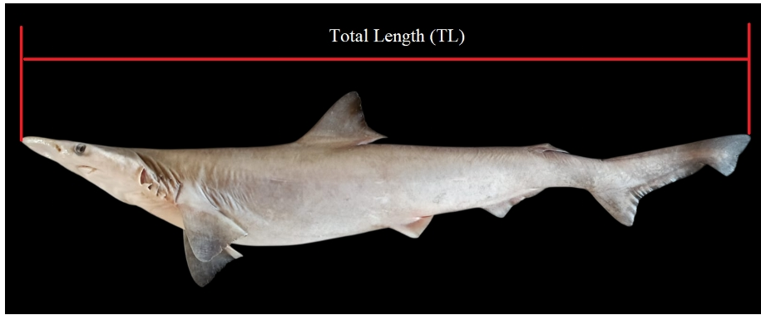
Fig 1:
Sampling Protocol. Specimens of the spadenose shark, Scoliodon laticaudus, were collected monthly over a 12-month period from April 2024 to March 2025. Each month, 30 individuals were randomly subsampled from the landings. All samples were immediately transported on ice to the Fisheries Resource Management Laboratory at the College of Fisheries Science, Veraval, for subsequent analysis.
Biological Processing. In the laboratory, individuals were subjected to standard dissection. The gonads, alimentary canal, liver, and uterus were excised for macroscopic and gravimetric examination.
Feeding Ecology Analysis. Feeding biology was assessed through a combination of gravimetric, volumetric, and frequency-based metrics.
Stomach Content Analysis. Stomachs were excised and weighed both full and empty. Contents were examined fresh, and prey items were identified to the lowest possible taxonomic level (genus or species).
Feeding Intensity. Feeding intensity was categorized based on the degree of stomach distension and volumetric fill: Gorged, Full, 3/4 Full, 1/2 Full, 1/4 Full, Trace, and Empty. Categories from Gorged to 1/2 Full were classified as "active" feeding, while 1/4 Full to Empty indicated "poor" feeding (adapted from Bapat & Bal, 1952).
Quantitative Indices. The following indices were calculated to quantify dietary patterns:
Gastro-somatic Index (GaSI): An indicator of relative gut fullness and feeding activity (Desai, 1970), calculated as
$$GaSI =\frac{Total Weight Of Gut\left(gm\right)}{Total Weight of fish\left(gm\right)}×100$$

Empty Stomach Ratio (ESR): The proportion of sampled individuals with empty stomachs:
ESR = (Number of Empty Stomachs / Total Number of Specimens) × 100 (Vinson &Angradi, 2011).
ESR= $\frac{No.of empty Stomach}{Total no.of Specimen}×100$

Index of Relative Importance (IRI): A composite measure to evaluate the contribution of each prey taxon to the diet, integrating numerical abundance, gravimetric contribution, and frequency of occurrence:
IRI = (%N + %W) × %F
where %N is the numerical percentage, %W is the gravimetric percentage, and %F is the frequency of occurrence of a prey item (Pinkas et al., 1971).
Data Analysis. All biological and ecological data were compiled and analyzed using Microsoft Office Excel. Standard statistical methodologies were applied following Snedecor and Cochran (2014).
Results and Discussion
Gastro-Somatic Index (GaSI)
Monthly GaSI values for Scoliodon laticaudus exhibited significant temporal variation (range: 2.794 – 6.88). The highest pooled GaSI was recorded in February 2025 (6.88), followed by January 2025 (5.1413). The lowest values were observed in May 2024 (2.794) and April 2024 (3.447).
Females demonstrated a pronounced peak in GaSI during February 2025 (7.275). The consistently elevated GaSI values across sexes during the winter months (December–February) indicate a seasonal increase in feeding intensity, potentially driven by heightened prey availability and favorable foraging conditions. The low GaSI values in May and March may signify periods of reduced food intake, possibly due to limited prey abundance or a physiological reallocation of energy toward reproductive investments.
Feeding Intensity
Feeding intensity, assessed via stomach distension categories, showed marked seasonal fluctuation. The Empty Stomach Ratio (ESR) was highest in May (85%), November (78%), and October (73%). Stomachs categorized as "Full" were infrequent throughout the study period, ranging from 2.44% (March 2025) to 9.52% (August 2024). Active feeding, indicated by stomach fullness categories of 1/4 to 3/4, was most prevalent during August–September 2024 and January 2025.
These patterns align with previous reports of seasonal feeding cycles in this species. The elevated ESR during late autumn and spring (October–November, May) corresponds with findings by Thomas et al. (2020), who documented peak stomach emptiness in the post-monsoon period. The observed feeding peaks in late monsoon and winter (August–September, January) are consistent with moderate feeding activity reported in other studies (Fofandi et al., 2013; Nayana et al., 2022), though the exact timing of peaks showed regional variation, likely influenced by local prey dynamics.
Dietary Composition
Stomach content analysis confirmed S. laticaudus as a carnivorous generalist, consuming teleosts, crustaceans, and cephalopods.
Prey Spectrum
Identifiable prey items included the teleosts Coilia dussumieri, Harpadon nehereus (Bombay duck), Trichiuridae (ribbon fish), and Thryssa spp. Crustacean prey were dominated by Acetes spp., penaeid shrimps, and Squilla spp. Cephalopod remains included Sepia spp. (cuttlefish), Loligo spp. (squid), and Octopus spp. However, a substantial portion of gut contents (23% by proportion) was semi-digested and unidentifiable beyond broad taxonomic categories, a common challenge in elasmobranch dietary studies due to rapid digestion.
Quantitative Diet Analysis
The Index of Relative Importance (IRI) was used to evaluate prey significance. Semi-digested material comprised the highest IRI (49%), reflecting the aforementioned identification challenge. Among identifiable prey categories, crustaceans were most important (IRI: 21%), followed by fish (IRI: 16%) and cephalopods (IRI: 14%). At the species/genus level, Acetes spp. (IRI: 11%), Thryssa spp. (9%), Trichiuridae (9%), and Sepia spp. (7%) were prominent dietary components.
Comparative Feeding Ecology. This generalist, crustacean-influenced diet aligns with the known trophic role of S. laticaudus as a mesopredator. The results show both consistency and divergence from previous regional studies: the dominance of crustaceans and teleosts matches the general dietary patterns reported by Fofandi et al. (2013) and Thomas et al. (2020), though the relative proportions of major prey groups vary. The high contribution of semi-digested material is a common finding (e.g., Raje et al., 2022 reported 31.9% digested fish), underscoring the methodological constraint in achieving precise prey identification. Regional differences in dominant prey species (e.g., Leiognathus spp. and Nemipterus spp. in Thomas et al., 2020, vs. Thryssa spp. and Acetes spp. in the present study) highlight the opportunistic feeding strategy of S. laticaudus and its adaptation to local prey assemblages.
Conclusion: Scoliodon laticaudus exhibits clear seasonal patterns in feeding intensity and a flexible, opportunistic diet. The temporal variation in GaSI and ESR suggests feeding activity is modulated by a combination of prey availability and reproductive cycles. Its generalist diet, dominated by locally abundant crustaceans and small teleosts, confirms its role as an adaptable mesopredator within the neritic ecosystem of the northwest coast of India.

Disclaimer (Artificial intelligence)
Option 1:
Author(s) hereby declare that NO generative AI technologies such as Large Language Models (ChatGPT, COPILOT, etc.) and text-to-image generators have been used during the writing or editing of this manuscript.
Option 2:
Author(s) hereby declare that generative AI technologies such as Large Language Models, etc. have been used during the writing or editing of manuscripts. This explanation will include the name, version, model, and source of the generative AI technology and as well as all input prompts provided to the generative AI technology
Details of the AI usage are given below:
1.
2.
3.

References
- Bapat, S. V., & Bal, D. V. (1952). The food of some young fishes from Bombay. Proceedings of the Indian Academy of Sciences - Section B, 35, 78–92. https://doi.org/10.1007/BF03050013
- Brodeur, R. D., Smith, B. E., McBride, R. S., Heintz, R., & Farley, E. (2017). New perspectives on the feeding ecology and trophic dynamics of fishes. Environmental Biology of Fishes, 100(3), 293–297. https://doi.org/10.1007/s10641-017-0594-1
- Carroll, G., Cox, M., Harcourt, R., Pitcher, B. J., Slip, D., & Jonsen, I. (2017). Hierarchical influences of prey distribution on patterns of prey capture by a marine predator. Functional Ecology, 31(9), 1750-1760.
- CMFRI (ICAR-Central Marine Fisheries Research Institute). (2024). Marine fish landings in India-2023 (Technical Report). Kochi, India. http://eprints.cmfri.org.in/id/eprint/18344
- Department of Fisheries (DOF), Government of India. (2023). Handbook on fisheries statistics 2022. Ministry of Fisheries, Animal Husbandry & Dairying. https://dof.gov.in/sites/default/files/2024-06/Handbook.pdf
- Desai, V. R. (1970). Studies on the fishery and biology of Tor tor (Hamilton) from river Narmada. Journal of the Inland Fisheries Society of India, 2, 101–112.
- Dulvy, N. K., Simpfendorfer, C., Akhilesh, K. V., Derrick, D., Elhassan, I., Fernando, D., Haque, A. B., Jabado, R. W., Maung, A., Valinassab, T., &VanderWright, W. J. (2021). Scoliodonlaticaudus. The IUCN Red List of Threatened Species. https://doi.org/10.2305/IUCN.UK.2021-2.RLTS.T169234201A173436322.en
- Fofandi, M., Zala, M. S., &Koya, M. (2013). Observations on selected biological aspects of the spadenose shark (Scoliodonlaticaudus Müller & Henle, 1838), landed along Saurashtra coast. Indian Journal of Fisheries, 60(1), 51–54. https://doi.org/10.21077/ijf.2013.60.1.51-54
- Gayford, J. H., Waghe, R., Sternes, P. C., & Tyabji, Z. (2024). Allometric Growth and Scaling of Body Form of the Spadenose Shark (Scoliodon laticaudus). Ecology and Evolution, 14(10), e70414.
- Gerking, S. D. (1994). Feeding ecology of fish. Academic Press. https://books.google.com/books/about/Feeding_Ecology_of_Fish.html?id=2_0_AQAAIAAJ
- Ghosh, S., Muktha, M., Satishkumar, M., Ranjan, B. P., Indira, D., Prathibha, R., ... & Gopalakrishnan, A. (2024). Trophic interactions and the diet composition of sympatric finfish predators in the tropical demersal ecosystem in the Bay of Bengal. Journal of Fish Biology, 104(1), 69-91.
- Karnad, D., Sutaria, D., &Jabado, R. W. (2020). Local drivers of declining shark fisheries in India. Ambio, 49(2), 616–627. https://doi.org/10.1007/s13280-019-01203-z
- Kizhakudan, S. J., Zacharia, P. U., Thomas, S., Vivekanandan, E., &Muktha, M. (2015). Guidance on national plan of action for sharks in India. CMFRI Marine Fisheries Policy Series No. 2. ICAR-Central Marine Fisheries Research Institute. http://eprints.cmfri.org.in/id/eprint/10403
- Kumar, A., Das, S. K., & Bhakta, D. (2021). Temporal variations in selected bio-indices (Kn, GaSI, HSI, GnSI) of Nile tilapia (Oreochromis niloticus) in East Kolkata Wetlands, India. Journal of the Inland Fisheries Society of India, 53(1–2).
- Nayana, P., Anjanayappa, H. N., Rajesh, D. P., &Pramodraj, P. (2021). Length–weight relationship and relative condition factor of Scoliodonlaticaudus along the Karnataka Coast, India. Journal of Experimental Zoology India. https://connectjournals.com/03895.2021.24.1067
- Pinkas, L., Oliphant, M. S., & Iverson, I. L. K. (1971). Food habits of albacore, bluefin tuna, and bonito in California waters. California Department of Fish and Game, Fish Bulletin 152. https://escholarship.org/uc/item/7t5868rd
- Raje, S. G., Raje, R. K., Kumar, P., & Chakraborty, S. K. (2021). Insights into the food and feeding habits of eight gestating females of elasmobrachs from Mumbai waters. Indian Journal of Geo Marine Sciences, 50(12), 1043–1051. http://nopr.niscpr.res.in/handle/123456789/58000
- Sen, S., Chakraborty, S. K., Zacharia, P. U., Dash, G., Joe Kizhakudan, S., Bharadiya, S. A., & Gohel, J. K. (2018). Reproductive strategy of spadenose shark, Scoliodon laticaudus Muller and Henle, 1839 along north‐eastern Arabian Sea. Journal of Applied Ichthyology, 34(6), 1304-1313.
- Snedecor, G. W., & Cochran, W. G. (1991). Statistical methods (8th ed.). Wiley-Blackwell. https://www.wiley.com/en-us/Statistical+Methods,+8th+Edition-p-9780813815619
- Sukumaran, S., Sebastian, W., Zacharia, P. U., Kizhakudan, S. J., Akhilesh, K. V., Thomas, S., ... & Gopalakrishnan, A. (2023). Population genetic research on the Spadenose shark, Scoliodon laticaudus (Chondrichthyes, Carcharhinidae), reveals the presence of two significantly differentiated clades along the Indian coast. Marine Biodiversity, 53(1), 16.
- Survey of India. (2024). Length of coastline of India. https://surveyofindia.gov.in/webroot/UserFiles/files/Length%20of%20Coastline%20of%20India.pdf
- Thomas, S., Purushottama, G. B., Nataraja, G. D., &Kizhakudan, S. J. (2020). Fishery and biological characteristics of the spadenose shark (Scoliodonlaticaudus Müller & Henle, 1838) from the Eastern Arabian Sea. Regional Studies in Marine Science, 34, 101085. https://doi.org/10.1016/j.rsma.2020.101085
- Vinson, M. R., &Angradi, T. R. (2011). Stomach emptiness in fishes: Sources of variation and study design implications. Reviews in Fisheries Science, 19(2), 63–73. https://doi.org/10.1080/10641262.2010.536856

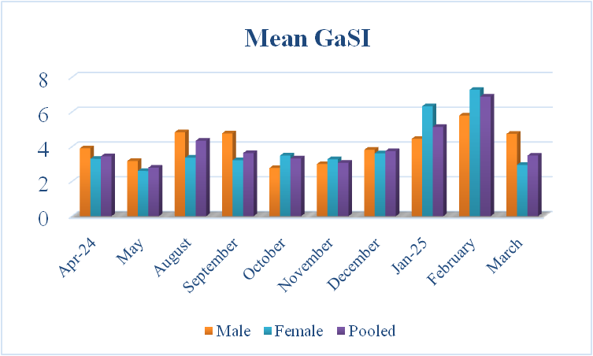
Figure 1. Monthly variation in the mean Gastro-Somatic Index (GaSI, mean ± SD) for male, female, and pooled specimens of Scoliodon laticaudus sampled from Veraval, Gujarat, from April 2024 to March 2025.

Figure 2. Overall feeding intensity of Scoliodon laticaudus expressed as percentages across stomach fullness categories.

Figure 3. Monthly variation in the frequency distribution of stomach fullness categories for Scoliodon laticaudus from Veraval, India, over the study period (April 2024–March 2025).
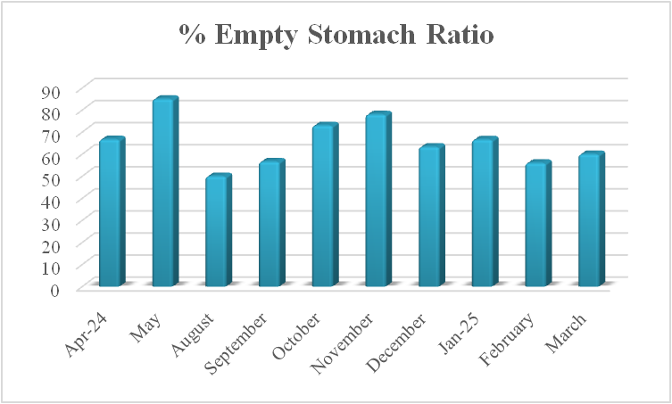
Figure 4. Monthly variation in Empty Stomach Ratio (ESR) for Scoliodon laticaudus from Veraval, India (April 2024 – March 2025).

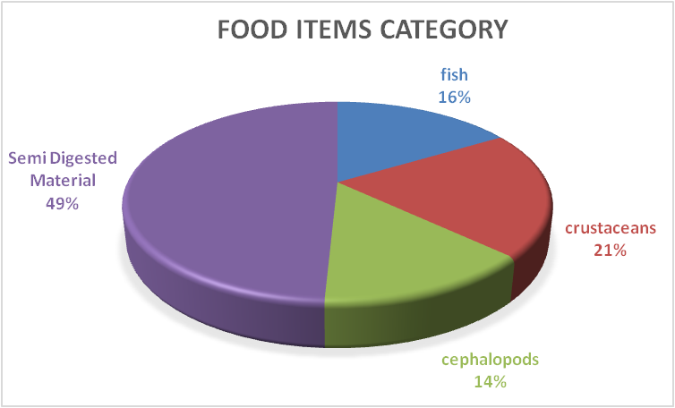
Figure 5. Dietary composition of Scoliodon laticaudus by major prey category based on the Index of Relative Importance (IRI).

Figure 6. Percentage composition of major identified prey items in the diet of Scoliodon laticaudus.

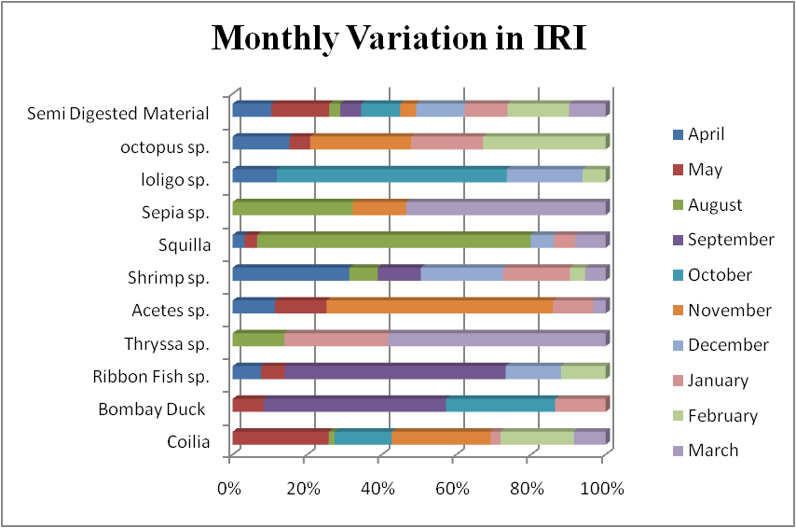

Figure 7. Monthly variation in the Index of Relative Importance (IRI) for major prey items in the diet of Scoliodon laticaudus.

