Biodiversity Exploration of Terrestrial Hemiptera in Simlipal Tiger Reserve reveals multiple new area records

ABSTRACT:
This study is the first effort to document the terrestrial Hemipteran diversity of Simlipal Tiger Reserve of Odisha, which is also famous as a biodiversity Hotspot area. The assessment of terrestrial hemipteran fauna of the Reserve area was performed across six sampling sites comprising different habitat types within the reserve area, and 141 examples of terrestrial hemiptera were collected by hand picking methods, sweep netting and light trap methods. During the study, 55 species from 50 genera belonging to 14 families have been identified. The study clearly shows the dominance of the Pentatomidae family, followed by Rhyparochromidae, Lygaeidae and Reduviidae, while some of the families are represented by a single species, which indicates variation of habitat occupancy.
The diversity analysis of the six selected sites revealed noticeable variation in species composition. Station 6 (S6), that is Ramatirtha, shows the highest number of species richness and Shannon index, while station 3 (S3) and station 4 (S4), that is Gurguria and Bundayiposi respectively, show the lowest numbers. The data shows variation in species composition, as well as species evenness and also highlights the species dominance and community structure of every station.
This study shows that Simlipal is a reservoir of various hemipteran fauna that includes not only the sap feeders but also some agriculturally significant pests and predators, which play an important role in balancing the ecosystem of the forest. As this is the first effort to document the hemipteran diversity of the protected area, it will provide a baseline for further taxonomic, ecology-oriented research works in the near future. This study also shows that a larger number of surveys and the collection of specimens from different habitats and in different seasons are needed to completely understand the hemipteran diversity of this significantly important biodiversity hotspot area.
Keywords: Hemipteran fauna, species richness, Shannon index, Simlipal Tiger Reserve, new area records.
INTRODUCTION:
Order Hemiptera represents the largest assemblage within the hemimetabolous group of insects. Members of this order are generally phytophagous, feeding chiefly on plant sap, although a minority exhibit hematophagy. They obtain nutrition from the tissue fluids of vertebrates. The size of hemiptera varies considerably, ranging from approximately 0.1 mm to 15 cm in length. The mouthparts are highly specialised and modified into a piercing–sucking type, while the forewings (hemelytra) are generally thickened basally and membranous apically. Most of the hemiptera are generally found in the terrestrial ecosystem, but some groups have adopted semi-aquatic or aquatic freshwater ecosystems as their habitat. Though most of the species are phytophagous but some of them are recognised as major pests of agricultural and forest crops that can cause substantial economic loss. Order Hemiptera is estimated to have approximately 1,03,590 species globally (Chandra et al.,2018). In India, a total of 6,058 species are reported, among which 539 species are considered endemic to India (Praveen K. et al.,2024).
Similipal derives its name from the ‘Simul’ or Silk Cotton tree, which is a National Park and Tiger Reserve located in the Mayurbhanj district, the northernmost part of Odisha. As this Park is situated within the Deccan Peninsular Biogeographic Zone, it represents a unique confluence of the Western Ghats, Eastern Ghats, and Eastern Himalayan biodiversity. It was formally declared a Tiger Reserve under Project Tiger in May 1973. Eventually, the Government of Odisha proclaimed Similipal as a Wildlife Sanctuary in 1979, covering an area of 2,750 sq. km. (Dash, M., Behera, B.,2013). The National Park is surrounded by high plateaus and hills; a few waterfalls and numerous rivers also pass through the reserve area and finally drain into the Bay of Bengal. The most important rivers that pass through the tiger reserve are Burhabalanga, Palpala, Bandan, Salandi, Kahairi, and Deo.
The vegetation of Simlipal is very diverse, which includes different forest types and also different habitats. It mainly includes Tropical Moist Dry Deciduous Forest along with some semi-evergreen patches. The floral diversity of this region shows its connection with the South Indian and North Eastern Sub-Himalayan regions. The most dominant tree species of this park is Sal (Shorea robusta), and it also has an extensive grassland area that acts as a grazing area for herbivores. The forest is also rich in aromatic and medicinal plants (Mishra, 2010).
Similipal is renowned for its population of tigers, elephants, and hill mynahs, and holds the distinction of having the highest tiger population in Odisha. Other notable mammals inhabiting the park include the leopard, sambar, barking deer, gaur, jungle cat, wild boar, four-horned antelope, giant squirrel, and common langur (Census, 2007), but no study has ever been done on the Hemipteran diversity of this tiger reserve. Despite its significance, the Hemipteran diversity of the Simlipal tiger reserve remains relatively untouched. This research is the first effort to document the heteropteran fauna of the reserved area to enrich the faunal records of Simlipal as well as the faunal record of Odisha.
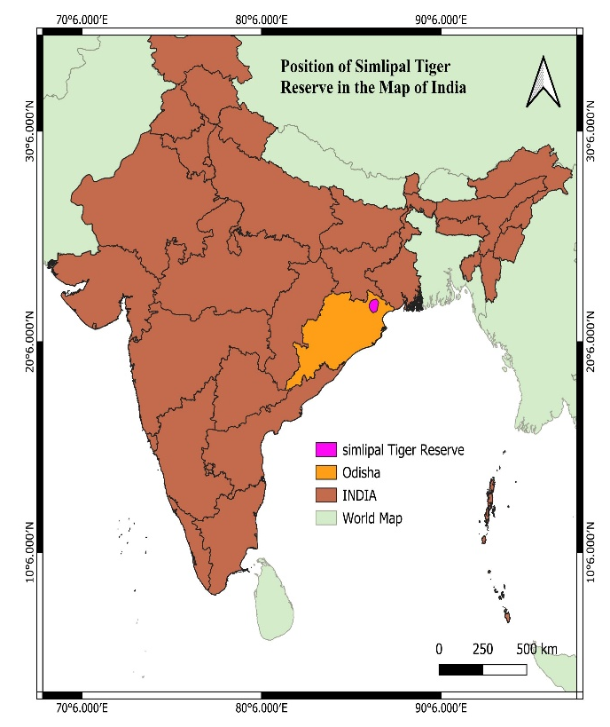 | 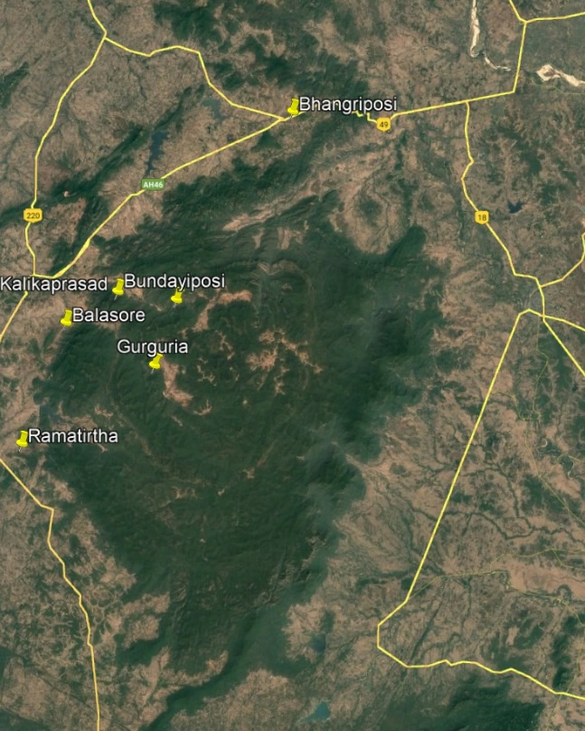  Simlipal Tiger Reserve
Map 1: Position of Simlipal Tiger Reserve

MATERIALS AND METHODS:
Specimens were collected during surveys undertaken by the scientific team of the Zoological Survey of India in the various ranges of the Simlipal Tiger Reserve. Particularly, six spots were selected for the collection of the specimens (Shown in the map no.1), and the sites are denoted as S1-S6. (S1) Bhangriposi Khairi Resort, Baripada, (S2) Kalikaprasad, (S3) Gurguria, (S4) Bundayiposi, (S5) Balasore, (S6) Ramatirtha.

Collections were made by using the light trap, net-sweep and handpicking methods. As this survey was focused on territorial hemiptera only, so bushy area in the forest where thicker patches of shrubs or dense plant growth were seen was selected as the sampling site. Family like Reduviidae was mainly found under the bark of large trees or under the stones. Collected bugs were brought to the Hemiptera section of Zoological Survey of India for further study purposes, set and pinned and preserved dry by following the standard method of preservation. Identified by using the voucher species held at NZC. The bugs were identified by using a Leica EZ4 HD stereo zoom microscope, and the identification was done based on the external characteristics. The specimens were identified with the help of taxonomic keys from available literature.
For statistical analysis, a commonly used index of biodiversity in ecology, “The Shannon Index” or
“The Shannon-Wiener Index” has been used. It helps to calculate the species diversity of an area by using species richness, i.e., the number of species, and species evenness, i.e., the distribution of individuals among species within the same given area. Here, a higher Shannon Index value ($H^{'}$) stipulates a greater diversity. The Formula for the Shannon Index is:
$$H^{'}=-\sum_{i=1}^{s}{(}p_{i}ln(p_{i}))$$
Where $H^{'}$: The Shannon Index, $p_{i}:$ Proportion of individuals belonging to species i, ln: Natural logarithm.
RESULT AND DISCUSSION:

The present study documents 55 species of hemipteran bugs, representing 50 genera and 14 families (Table 1). Analysis of the collected data indicates that the family Pentatomidae is the most diverse, with nine species recorded from the study area. Other families exhibiting considerable diversity include Reduviidae, Rhyparochromidae, Lygaeidae, Miridae, and Pyrrhocoridae. The number of species available under each family is represented by a bar graph given below (Graph 1). Table 2 indicates the summary table of biodiversity indices of the area according to the collection sites.

Table 1: Neme of species, their genus and families and number of specimens found in each site.
Sl. No. | Family | Genus | Species | S1 | S2 | S3 | S4 | S5 | S6
1 | Cicadellidae | Cofana | Cofana spectra (Distant, 1908) | 2 | 0 | 0 | 0 | 0 | 0
2 | Cicadellidae | Goniagnathus | Goniagnathus punctifer (Walker,1858) | 1 | 0 | 0 | 0 | 0 | 0
3 | Cicadellidae | Nephotettix | Nephotettix virescens (Distant,1908) | 5 | 0 | 0 | 0 | 0 | 0
4 | Cicadellidae | Exitianus | Exitianus indicus (Distant, 1908) | 1 | 0 | 0 | 0 | 0 | 0
5 | Membracidae | Otinotus | Otinotus oneratus Walker ,1858 | 0 | 0 | 0 | 0 | 0 | 1
6 | Reduviidae | Polididus | Polididus armatissimus Stal,1859 | 0 | 0 | 0 | 0 | 0 | 1
7 | Reduviidae | Rhynocoris | Rhynocoris costalis (Stal, 1866) | 0 | 0 | 0 | 0 | 0 | 1
8 | Reduviidae | Coranus | Coranus siva Kirkaldy,1891 | 0 | 0 | 0 | 0 | 0 | 1
9 | Reduviidae | Oncocephalus | Oncocephalus schioedte Reuter,1882 | 0 | 0 | 0 | 1 | 0 | 0
10 | Reduviidae | Polytoxus | Polytoxus maculates (Distant,1903) | 0 | 0 | 0 | 0 | 0 | 1
11 | Reduviidae | Endochus | Endochus inornatus Stal, 1866 | 0 | 0 | 0 | 1 | 0 | 0
12 | Miridae | Charagochilus | Charagochilus longicornis (Reuter, 1885) | 0 | 0 | 0 | 0 | 0 | 4
13 | Miridae | Apolygus | Apolygus myittae (Distant,1904) | 0 | 0 | 0 | 1 | 0 | 0
14 | Ricaniidae | Zaratus | Zaratus repandus Distant,1909 | 0 | 0 | 0 | 1 | 0 | 0
15 | Miridae | Cyrtorhinus | Cyrtorhinus lividipennis Reuter,1885 | 0 | 0 | 0 | 1 | 0 | 0
16 | Miridae | Felisacus | Felisacus magnificus Distant, 1904 | 0 | 0 | 0 | 1 | 0 | 0
17 | Miridae | Nesidiocoris | Nesidiocoris tenuis (Reuter, 1895) | 0 | 0 | 0 | 0 | 3 | 0
18 | Pentatomidae | Plautia | Plautia crossota (Fabricius, 1787) | 0 | 1 | 0 | 0 | 0 | 2
19 | Pentatomidae | Halys | Halys serrigera Westwood,1837 | 0 | 0 | 0 | 0 | 0 | 6
20 | Pentatomidae | Eysarcoris | Eysarcoris montivagus (Distant, 1902) | 0 | 1 | 0 | 0 | 0 | 0
21 | Pentatomidae | Neocarbula | Neocarbula capitata Distant, 1918 | 0 | 1 | 0 | 0 | 0 | 0
22 | Pentatomidae | Acrosternum | Acrosternum graminea Kirkaldy, 1787 | 0 | 1 | 0 | 0 | 0 | 0
23 | Pentatomidae | Nezara | Nezara viridula (Linnaeus, 1758) | 0 | 1 | 0 | 0 | 0 | 0
24 | Pentatomidae | Sciocoris | Sciocoris indicus (Dallas,1851) | 0 | 0 | 1 | 0 | 0 | 0
25 | Pentatomidae | Bagrada | Bagrada hilaris Burmeister, 1835 | 1 | 0 | 0 | 0 | 2 | 0
26 | Pentatomidae | Paracritheus | Paracritheus trimaculatus (Lep & Serv ,1825) | 0 | 0 | 1 | 0 | 0 | 0
27 | Coreidae | Cletomorpha | Cletomorpha hastata (Fabricius,1787) | 0 | 1 | 0 | 0 | 0 | 0
28 | Coreidae | Cletus | Cletus bipunctatus (Westwood, 1840) | 0 | 1 | 0 | 0 | 0 | 0
29 | Coreidae | ,, | Cletus trigonus (Thunberg,1783) | 0 | 1 | 0 | 0 | 0 | 0
30 | Coreidae | ,, | Cletus punctiger (Dallas,1852) | 0 | 2 | 4 | 0 | 0 | 0
31 | Alydidae | Leptocorisa | Leptocorisa acuta (Thunberg,1783) | 0 | 0 | 0 | 0 | 0 | 1
32 | Alydidae | Riptortus | Riptortus pedestris (Fabricius, 1775) | 0 | 0 | 0 | 0 | 0 | 1
33 | Rhopalidae | Liorhyssus | Liorhyssus hyalinus (Fabricius, 1794) | 0 | 0 | 0 | 0 | 0 | 1
34 | Rhopalidae | Leptocoris | Leptocoris augur (Fabricius, 1781) | 0 | 0 | 0 | 0 | 0 | 2
35 | Rhyparochromidae | Metochus | Metochus uniguttatus (Dohrn,1922) | 0 | 0 | 0 | 0 | 0 | 1
36 | Rhyparochromidae | Naudarensia | Naudarensia pedata Distant,1904 | 2 | 0 | 0 | 0 | 0 | 0
37 | Lygaeidae | Orieotrechus | Orieotrechus aeruginosus (Distant, 1904) | 0 | 0 | 0 | 0 | 0 | 1
38 | Rhyparochromidae | Gyndes | Gyndes pallicornis (Dallas,1852) | 0 | 0 | 0 | 0 | 0 | 1
39 | Rhyparochromidae | Horridipamera | Horridipamera nietneri (Dohrn, 1860) | 0 | 0 | 0 | 0 | 0 | 1
40 | Rhyparochromidae | Paromius | Paromius exiguus (Distant, 1883) | 0 | 0 | 0 | 0 | 0 | 1
41 | Rhyparochromidae | Dieuches | Dieuches femoralis (Distant,1904) | 0 | 0 | 0 | 0 | 0 | 1
42 | Rhyparochromidae | Primierus | Primierus indicus Distant, 1901 | 1 | 0 | 0 | 0 | 0 | 0
43 | Lygaeidae | Tropistethus | Tropistethus indicus (Dallas,1852) | 3 | 0 | 0 | 0 | 0 | 0
44 | Lygaeidae | Nysius | Nysius laucustrinus Distant, 1909 | 18 | 0 | 9 | 0 | 10 | 0
45 | Lygaeidae | ,, | Nysius ceylanicus Motschulsky,1863 | 0 | 0 | 1 | 0 | 0 | 0
46 | Lygaeidae | Spilostethu | Spilostethus hospes (Fabricius, 1794) | 0 | 0 | 0 | 0 | 0 | 1
47 | Lygaeidae | Graptostethu | Graptostethus servus (Fabricius,1787) | 6 | 0 | 0 | 0 | 0 | 5
48 | Geocoridae | Geocoris | Geocoris ochropterus Fieber, 1844 | 0 | 0 | 1 | 0 | 1 | 3
49 | Lygaeidae | Ninus | Ninus insignis Stal, 1860 | 0 | 1 | 0 | 0 | 0 | 0
50 | Largidae | Iphita | Iphita limbata(Stal,1870) | 0 | 1 | 0 | 0 | 0 | 0
51 | Pyrrhocoridae | Antilochus | Antilochus russus (Stal,1863) | 5 | 0 | 0 | 0 | 0 | 0
52 | Pyrrhocoridae | Dysdercus | Dysdercus koenigii (Fabricius,1775) | 2 | 0 | 0 | 0 | 3 | 0
53 | Pyrrhocoridae | ,, | Dysdercus olivaceous  (Fabricius,1798) | 0 | 0 | 0 | 0 | 0 | 1
54 | Pyrrhocoridae | Euscopus | Euscopus albatus (Distant,1909) | 1 | 0 | 0 | 0 | 0 | 0
55 | Pyrrhocoridae | ,, | Euscopus indecorus (Walker,1872) | 0 | 0 | 0 | 0 | 1 | 0

Table 2: summary table of biodiversity indices
Diversity Indices | S1 | S2 | S3 | S4 | S5 | S6
Species Richness | 13 | 11 | 6 | 6 | 6 | 22
Species Evenness | 0.6113 | 0.9717 | 0.6389 | 1 | 0.7074 | 0.7759
No. of individuals | 48 | 12 | 17 | 6 | 20 | 38
Diversity indices revealed noticeable differences in terrestrial hemipteran assemblages across the Simlipal Tiger Reserve. Station 6 exhibited the highest species richness (22 species), suggesting more heterogeneous or favourable habitat conditions, whereas Stations 3, 4, and 5 showed the lowest richness (6 species each; Table 2). However, richness alone does not fully characterise community structure. The Shannon–Wiener index further indicated differences in species distribution. Although Station 6 had the greatest richness while Station 2 showed higher evenness. Nonetheless, Station 6 recorded the highest Shannon diversity value (H′ = 2.837), followed by Station 2 (H′ =2.369) and Station 1(H′ =2.073), reflecting a comparatively even species distribution within the area rather than Station 4 (H′ =1.792), Station 5 (H′ =1.446) and Station 3 (H′ =1.344) which had shown decreasing value consecutively, that indicates less even species distributions.
The analysis of results shows that Pentatomidae is the most diverse family in the study area, represented by 9 species belonging to 9 genera. A total of 8042 species of Pentatomidae are known from the world, among which 786 species are available from India, and only 388 Pentatomidae species are reported till now (Biswas et al., 2014; Rider, 2018; Praveen et al., 2024). Commonly known as shield bugs or stink bugs, many species in this family are phytophagous and important pests of cultivated crops (Rider 2018). Reduviids, often referred to as assassin bugs, are aggressive terrestrial predators, some of which are capable of transmitting diseases to humans. They mainly inhabit under the bark of trees, under logs or under stones. The reduviid fauna of the study area comprises 6 species under 6 genera. For comparison, the Indian reduviid fauna includes 465 species under 144 genera across 14 subfamilies (Ambrose DP,2006).
Miridae, the most diverse family within Heteroptera, includes around 1,300 genera and over 11,000 species worldwide (Panizzi AR, Grazia J., 2015). These small to medium-sized plant bugs, usually elongated to ovoid with triangular heads and mainly found in bushy vegetation or under the leaves of green plants, are represented in this study by 5 species under 5 genera. This number is considerably lower than expected, indicating that further exploration in the region may reveal additional species. The family Lygaeidae, commonly known as seed bugs, is generally found on fruits or flowers of plants, on or under dry leaves on the forest bed, and consists of small, typically brown or black species, often exhibiting aposematic red or yellow colouration. From this area, 7 species under 5 genera have been reported this time. Among which Nysius laucustrinus Distant, 1909 was the most dominant species with 37 examples.
Pyrrhocoridae, commonly known as cotton stainers, are medium-sized bugs typically red, yellow, or black. The present study recorded 5 species belonging to 3 genera. Another significant family in the region is Rhyparochromidae, commonly referred to as “dirt-coloured seed bugs.” It is one of the largest families within Hemiptera. In this study, 7 species under 7 genera were documented from the Simlipal Tiger Reserve.
Cicadellidae, commonly known as leafhoppers, is one of the prominent insect groups recorded from the study area. The habitat of these minute sap-feeding insects is grasses, shrubs, and trees. Their hind legs are highly adapted for jumping and covered with setae. Globally, Cicadellidae is distributed across all biogeographic regions and represents the second-largest family of Hemiptera, comprising at least 20,000 described species (Stiller, 2009). 18 species of this family from four districts of Odisha have already been reported (Kushwaha, S., et.al.), but that study does not include the Mayurbhanj district, where the Simlipal Tiger Reserve is situated. However, only 4 species under 4 genera were documented from the present study area, a number significantly lower than expected, indicating the need for further systematic surveys.
A few species belonging to Alydidae and Rhopalidae were also recorded, while the families Membracidae, Ricaniidae, Geocoridae, and Largidae were each represented by a single species.
A review of the available literature on hemipteran diversity in Odisha reveals a lack of published records on the hemipteran fauna of the Simlipal Tiger Reserve. A recent study on the Eastern Ghats of India, which includes Odisha, was conducted by the Zoological Survey of India, and 408 species of Auchenorrhyncha (Saha, P.C.,2025) and 150 species of Heteroptera (Saha, P.C.,2025) were reported. Though Simlipal is situated in the easternmost part of the Eastern Ghats, but adequate study was not done and which creates a gap area. The present study addresses this gap area by providing the first comprehensive account of hemipteran diversity from the tiger reserve, thereby establishing a baseline for future research. Though the limited number of sampling sites that not cover the whole reserve area, and the single sampling effort may constrain the results of the findings and potentially overlook species that are inhabiting in different habitats or occur in other seasons. Future studies with larger sample sizes with seasonal variation are required to achieve a more comprehensive understanding of the hemipteran diversity of Simlipal.
CONCLUSION:
The present study documented a diverse Hemipteran community that includes 55 species representing 50 genera under 14 families across selected sites within the Simlipal Tiger Reserve of Mayurbhanj district, Odisha. The region with various landscapes, a huge forest area, and heterogeneous vegetation provides suitable habitats for multiple Hemipteran families. As this is the first survey-based investigation in this area, the findings only show baseline information that will serve as a valuable reference for future systematic studies. But this study has some limitations. The sampling area was smaller, and the survey was conducted for only one season. Multiple surveys in various seasons can reveal much more diversity in the faunal data.
DISCLAIMER (ARTIFICIAL INTELLIGENCE):
The authors declare that no generative Artificial Intelligence technologies, including large language models or text-to-image generators, were used in the writing or editing of this manuscript.

REFERENCES:
- Stiller, Michael. (2009). Biosystematics: Leafhoppers associated with grasslands of South Africa – Grassland Biome endemics; Plant Protection News. 82: 6.
- Panizzi, A. R., & Grazia, J. (2015). Introduction to true bugs (Heteroptera) of the neotropics. In A. R. Panizzi & J. Grazia (Eds.), True bugs (Heteroptera) of the Neotropics (pp. 3-20). Springer. https://doi.org/10.1007/978-94-017-9861-7 .
- Ambrose, D. P. (2006). A checklist of Indian Assassin Bugs (Insecta: Hemiptera: Reduviidae) with taxonomic status, distribution and diagnostic morphological characteristics. Zoos' Print Journal, 21(9), 2388-2406. https://doi.org/10.11609/JoTT.ZPJ.871.2388-406 .

- Chandra, K., Gupta, D., Gopi, K. C., Tripathy, B., & Kumar, V. (2018). *Faunal diversity of Indian Himalaya: An overview*. Zoological Survey of India. https://www.nhbs.com/faunal-diversity-of-indian-himalaya-book .

- Praveen, K., Hassan, M. E., Saha, P. C., Kushwaha, S., Dubey, A. K., Dash, S., Lyngdoh, J., Pal, A., Jehamalar, E., & Khanra, S. (2024). *Checklist of Fauna of India: Arthropoda: Insecta: Hemiptera. Version 1.0*. Zoological Survey of India. https://doi.org/10.26515/Fauna/1/2023/Arthropoda:Insecta:Hemiptera
- Distant, W. L. (1910). The fauna of British India, including Ceylon and Burma. Rhynchota. Vol. V. Taylor and Francis. https://wellcomecollection.org/works/s9222222.

- Distant, W. L. (1918). *The fauna of British India, including Ceylon and Burma. Rhynchota. Vol. 7. Homoptera: appendix. Heteroptera: addenda*. Taylor and Francis. https://www.biodiversitylibrary.org/bibliography/9193 .

- Distant, W. L. (1902). *The Fauna of British India, including Ceylon and Burma. Rhynchota. Vol. I. (Heteroptera)*. Taylor and Francis. https://doi.org/10.1080/00222930208678682.

- Distant, W. L. Fauna Brit. India, including Ceylon and Burma, Rhynchota, Taylor and Francis,
London.1904; 2:1-503.

- Distant, W.L. Fauna Brit. India, including Ceylon and Burma, Rhynchota, Taylor and Francis,
London. 1908; 4:1-501. https://www.biodiversitylibrary.org/item/10000

- Biswas, & Bal. (2010) Insecta: Hemiptera: Pentatomoidea. Fauna of Uttarakhand: State Fauna Series; Zoological Survey of India. 18 (2): 229-244

- Leston, D., Pendergrast, J. G. (1954). Southwood TRE..Classification of terrestrial Heteroptera (Geocoridae), Nature. 174: 91-92. https://doi.org/10.1038/174091b0

- Mathew, K. A., (1980) New species of Gynenica from South India (Heteroptera: Pentatomidae), Oriental Insects 14 (3): 379-382. https://doi.org/10.1080/00305316.1980.10434816

- Kushwaha, S., Khare, P., Jahan, S., Hirdesh Kumar, Dam, D., & Kusumala Suman. (2023) An account of leafhoppers (Hemiptera: Cicadellidae) from the Southern Odisha, India. Records of the Zoological Survey of India.; 123(1), 51–62. https://doi.org/10.26515/rzsi/v123/i1/2023/172403.
- Rider, D.A., Schwertner, C. F., Vilimova, J. et al (2018), Invasive Stink Bugs and Related Species (Pentatomoidea) Biology, Higher Systematics, Semiochemistry and Management. CRC Press, Tayler & Francis Group, Boca Raton. pp 25-201. https://doi.org/10.1201/9781315371221
- Saha, P.C., Dash, S., Hassan, M.E., Mukherjee, P., Khanra, S., Mandal, R., and Pal, A. (2025). Insecta: Hemiptera: Heteroptera, in Faunal Diversity of Eastern Ghats, India, Published by Director, Zoological Survey of India, Kolkata. 719-776
- Saha, P.C., Dash, S., Hassan, M.E., Mukherjee, P., Khanra, S., Mandal, R., and Pal, A. (2025). Insecta: Hemiptera: Auchenorrhyncha, in Faunal Diversity of Eastern Ghats, India, Published by Director, Zoological Survey of India, Kolkata. 666-718
- Census of India Report, (2007), Office of the Registrar General & Census Commissioner, Ministry of Home Affairs, Government of India, New Delhi.
- Mishra, B. K. (2010), Conservation and Management Effectiveness of Similipal Biosphere Reserve, Orissa, India, The Indian Forester, 136, (10), 1310-1326. https://doi.org/10.36808/if/2010/v136i10/12723
- Dash, M., Behera, B. (2013), Biodiversity conservation and local livelihoods: a study on Similipal Biosphere Reserve in India, Journal of Rural Development, 32. (4), 409-426
- Biswas B, Hassan ME, Chandra K, Kushwaha S and Mukherjee P 2014. On an account of pentatomoidea (Heteroptera: Hemiptera) from Chhattisgarh, India. Records of the Zoological Survey India .114(2). 211-231. https://doi.org/10.26515/rzsi/v114/i2/2014/121679

