Original Research Article
Effects of Dietary Supplementation with Kappaphycus alvarezii and Spirulina platensis on Growth Performance, Immunity, and Disease Resistance of Penaeus vannamei Challenged with Vibrio parahaemolyticus

ABSTRACT
This study investigated the effects of dietary supplementation with Spirulina platensis and Kappaphycus alvarezii on the growth performance, body composition, immune response, and disease resistance of Penaeus vannamei reared in HDPE-lined pond hapas. Experimental diets containing inclusion levels of 10% S. platensis (T2) and 5% K. alvarezii (T1) and control diet (without any inclusion) were evaluated over a 100 day feeding trial. Shrimp fed an S. platensis–based diet showed significantly higher final body weight (23.15 ± 0.18 g), weight gain, specific growth rate, and protein efficiency ratio, along with the lowest feed conversion ratio (1.30 ± 0.02), compared to the control group (P < 0.05).Whole-body protein, lipid, and ash contents were significantly enhanced in T1 and T2. Following Vibrio parahaemolyticus challenge, shrimp fed algal-supplemented diets showed improved survival and reduced mortality than the control diet. Immune parameters, including total haemocyte count, prophenoloxidase, respiratory burst, superoxide dismutase, and catalase activities, were significantly elevated in T1 and T2 compared to the control. These findings demonstrate that dietary inclusion of S. platensis and K. alvarezii enhances growth, immunity, and disease resistance in P. vannamei, supporting their potential as functional feed additives for sustainable shrimp aquaculture.
Keywords:
Penaeus vannamei, Spirulina platensis, Kappaphycus alvarezii, immune response, growth performance
1. INTRODUCTION
Shrimp farming is one of the most valuable sectors of global aquaculture, contributing nearly 17% of the total international aquatic export value, estimated at about US$24 billion. This growth is largely driven by the Pacific white shrimp, Penaeus vannamei, which accounts for approximately 53% of global farmed crustacean production, exceeding 6.8 million tons in 2022 (FAO, 2024). Owing to its fast growth, high survival, adaptability to intensive systems, and superior nutritional quality, P. vannamei has become the most important species in commercial shrimp aquaculture. However, feed constitutes nearly 40–65% of total farm production costs, primarily due to the rising prices and limited availability of fish meal and fish oil, highlighting the urgent need for cost-effective and sustainable feed alternatives (Junior et al., 2025; Fantatto et al., 2025).
Seaweeds and microalgae have gained increasing attention as functional feed additives due to their rich nutritional profile, bioactive compounds, and immunostimulatory properties. Global seaweed production reached nearly 35 million tons in 2022, with Asia contributing over 90% of the output (FAO, 2024; Cottier-Cook et al., 2021). Among them, Kappaphycus alvarezii is widely cultivated for carrageenan and is recognized for its bioremediation potential and safe inclusion in aquafeeds (Guillén et al., 2022). Similarly, Spirulina platensis is a protein-rich microalga (50–70%) containing essential amino acids, fatty acids, vitamins, minerals, and potent antioxidants (Musa et al., 2025). Meanwhile, bacterial diseases, particularly vibriosis caused by Vibrio parahaemolyticus, continue to pose serious threats to shrimp farming, with plasmid-mediated toxin strains responsible for Acute Hepatopancreatic Necrosis Disease (AHPND) (Munaeni et al., 2020). These challenges underscore the importance of developing natural, sustainable, and immunostimulatory feed ingredients such as seaweeds and microalgae in shrimp aquaculture.
The present study aimed to evaluate the effects of dietary supplementation with K. alvarezii and S. platensis on the growth performance, survival, and disease resistance of P. vannamei challenged with V. parahaemolyticus.
2. MATERIALS AND METHODS
2.1 Ethical Statement
The experiment was conducted following the procedures of CPCSEA (Committee for the Purpose of Control and Supervision of Experiments on Animals), Ministry of Environment and Forests (Animal Welfare Division), Govt. of India on care and use of animals in scientific research. This study was approved by the ethical committee of Tamil Nadu Dr. J. Jayalalithaa Fisheries University, Nagapattinam, Tamil Nadu, India. The experiment was conducted at Mariculture Research Farm Facility (MRFF), Tharuvaikulam, Thoothukudi, Tamil Nadu, India
2.2 Experimental Setup, Diet Preparation and stocking
The pond was drained, cleaned, sun-dried for seven days, disinfected with potassium permanganate (20 ppm), refilled with filtered seawater, and treated with calcium magnesium carbonate and calcium carbonate (10 ppm). Diets incorporating K. alvarezii (5%) and S. platensis (10%) were tested on P. vannamei using hapas installed in an HDPE-lined pond, and all experimental and control diets were prepared by sieving ingredients through a 350 µm mesh, forming a dough, extruding it through a 1 mm die, drying the pellets at 60 °C, storing them in airtight containers (Table 1). A paddle-wheel aerator-maintained aeration and water circulation and nine hapas (3 × 3 × 4 ft) with triplicates per treatment were installed for the 100 days trial. SPF PL-15 shrimp from a CAA-approved hatchery were acclimated and reared in a raceway tank until reaching an average weight of 3.05 g, after which the juveniles were stocked into the hapas. Shrimp were fed manually three times daily at 7% of body weight initially and 5% thereafter, and periodic sampling was conducted to monitor length, weight, growth performance and survival.
Table 1: Ingredient Composition and proximate analysis of the experimental diets (% on DM basis) for P. vannamei containing different inclusion levels
Ingredients | Control  (0%) | Treatment 1 (5%) | Treatment 2  (10%)
Fish Meal | 23 | 23 | 23
Shrimp Head Meal | 9 | 9 | 9
Soybean Meal | 32 | 32 | 32
K. alvarezii | 0 | 5 | 0
S. platensis | 0 | 0 | 10
Corn Flour | 15 | 10 | 5
Fish oil | 2 | 2 | 2
Wheat Flour | 6.1 | 6.1 | 6.1
Cassava powder | 5.5 | 5.5 | 5.5
DCP  (Dicalcium Phosphate) | 0.2 | 0.2 | 0.2
Vit C | 0.2 | 0.2 | 0.2
Mineral Mixª | 0.5 | 0.5 | 0.5
Vitamin Mix^{b} | 0.5 | 0.5 | 0.5
Moisture (%) | 10.45 | 10.36 | 10.46
Protein (%) | 36.36 | 36.45 | 36.66
Fat (%) | 4.91 | 4054 | 4.23
Fibre (%) | 2.64 | 2.69 | 2.47
Ash (%) | 7.81 | 7.73 | 7.29
NFE (%) | 37.83 | 38.23 | 38.89
Mineral premixª- cobalt 150mg,copper 1200 mg, iodine 325 mg,iron 1500mg,magnesium 6000mg,potassium 100mg,sodium 5.9g,manganese 1500mg,sulphur 0.72%,zinc 9600mg,DL methionine 1000mg,calcium 25.5%,phosphorus 12.75%,vitamin premix^{b}-vitamin A 5000000 I.U,Vitamin D₃ 100000 I.U,Vitamin B₃ 0.2g,Vitamin E 75 units,Vitamin K 0.1g, Pantothenate 0.25g,Nicotinamide 1g,Vitamin B12 0.6mg,Choline Chloride 15g

2.3 Tested parameters
2.3.1 Growth Performance and Nutrient Utilization Indices
Sampling was conducted every 10 days to monitor shrimp growth and adjust the feeding rate accordingly. The bio growth parameters were examined using the following formulas.
Mean weight gain (g) = Mean final weight (g) - Mean initial weight (g)
Average Daily Growth (g) (ADG) = Final weight (g) – Initial weight(g) / Days of culture
Specific growth rate (SGR) = [ln (final body weight) – ln (initial body weight) / feeding trial days] × 100
Food Conversion Ratio (FCR) = Total amount of the feed consumed (g) / Weight gained (g)
Protein Efficiency Ratio (PER) = Wet weight gain / Total protein given
Weight Gain% = [final body weight (g) – initial body weight (g)] / Initial body weight (g) × 100
Survival rate (%) = Final harvested fish X 100/ Initial stocked fish
2.3.2 Proximate analysis of experimental diets and shrimp
At the end of each trial, five shrimp were randomly collected from each replicate, homogenized, oven-dried, ground into a fine powder, and stored at –20 °C for whole-body proximate analysis. Proximate composition of both diets and shrimp samples was determined following AOAC (1995) procedures: dry matter by oven-drying at 105 °C for 24 h, crude protein by the Kjeldahl method (N × 6.25), crude lipid by Soxhlet ether extraction, and ash content by incineration at 550 °C for 6 h.
2.3.3 Water quality
Water quality parameters such as temperature, pH, dissolved oxygen, alkalinity, salinity, ammonia-N, nitrite-N, and nitrate-N were monitored on a weekly basis in the RAS throughout the feeding experiment, following the standard methods outlined by APHA (2005).
2.3.4 Preparation of Vibrio parahaemolyticus and challenge study
The Vibrio parahaemolyticus strain from CIBA, Chennai, was maintained at –80 °C in TSB+ (1.5% NaCl, 20% glycerol), revived in TSB, and incubated at 30 °C for 24 h with shaking. Pure colonies were inoculated into 50 mL TSB to obtain a suspension (OD₅₄₅ ≈ 0.6, ~5 × 10⁸ CFU/mL), pelleted, washed, and resuspended in sterile saline, with concentration confirmed by standard plate count. Following the growth trial, shrimp from all groups underwent a 15-day immersion challenge with V. parahaemolyticus, while the control group was immersed in sterile saline (Experimental control). Shrimp were fed their respective diets, and cumulative mortalities were recorded, with diseased individuals removed.
2.3.5 Immunological assays
Total haemocyte count (THC) was measured by collecting 100 μL of haemolymph mixed with an equal volume of 10% formalin in 0.45 M NaCl, staining 20 μL of the fixed suspension with 1.2% Rose Bengal in 50% ethanol, and counting haemocytes in triplicate using a Neubauer chamber (Raja et al., 2012). Prophenoloxidase (proPO) activity was determined spectrophotometrically by monitoring dopachrome formation from L-DOPA oxidation, using 100 μL haemocyte lysate incubated with laminarin or cacodylate buffer at 20 °C, with absorbance measured at 490 nm (Gollas-Galván et al., 1999). Respiratory burst activity (RBA) was evaluated by incubating 100 μL haemolymph with 0.2% NBT for 30 min, solubilizing the formazan in 1 mL DMF, centrifuging, and reading absorbance at 540 nm (Anderson and Siwiki, 1995). Superoxide dismutase (SOD) activity was assessed by diluting 40 μL haemolymph in PBS, centrifuging, heat-treating the supernatant at 65 °C for 5 min, adding 50 μL NBT reagent, incubating 2 min, and measuring absorbance at 630 nm (Campa-Córdova et al., 2002). Catalase activity was determined by mixing 0.5 mL haemolymph with 2.5 mL PBS and 1 mL H₂O₂, and monitoring the decrease in absorbance at 240 nm at 30 s intervals for 3 min (Takahara et al., 1960).
2.4 Statistical analysis
Data were analyzed using IBM SPSS version 26. Normality was assessed using the Shapiro-Wilk test (N = 40). Two-way ANOVA was applied to evaluate the effects of two variables on shrimp weight across T1, T2 and Control, with significance considered at P < 0.001, followed by Tukey’s post hoc test (P < 0.05) for multiple comparisons. One-way ANOVA was employed to assess differences in shrimp growth performance and proximate composition, with results expressed as mean ± SD.
3. RESULT
3.1 Growth performance of Penaeus vannamei
An experiment was conducted to evaluate the growth performance of P. vannamei fed with diets such as 5% K. alvarezii (Treatment 1) and 10% S. platensis (Treatment 2) in lined ponds. The growth performance of P. vannamei differed significantly (P < 0.05) among treatments was shown in Table 2. Shrimp in T2 showed the highest final body weight (23.15 ± 0.18 g), total weight gain (20.05 ± 0.16 g), percentage weight gain (646.8 ± 4.1%), and average daily growth (0.201 ± 0.002 g/day), followed by T1, while the control group recorded the lowest values. Feed conversion ratio was lowest in T2 (1.30 ± 0.02) and highest in the control (1.80 ± 0.03). Specific growth rate and protein efficiency ratio were also highest in T2 (2.01 ± 0.02 and 2.40 ± 0.05, respectively) and lowest in the control. Survival rates were high across all groups, with T2 slightly higher (96.42 ± 0.002%) than T1 (96.35 ± 0.003%) and control (94.56 ± 0.002%), showing significant differences (P < 0.05).
Table 2. Growth performance of P. vannamei fed with different experimental diets
Parameters | Control | Treatment 1 (5%) | Treatment 2 (10%)
Initial weight | 3.15 ± 0.05 | 3.20 ± 0.04 | 3.10 ± 0.03
Final weight | 12.32 ± 0.12ᶜ | 21.02 ± 0.15ᵇ | 23.15 ± 0.18ᵃ
Weight gain (g) | 9.17 ± 0.10ᶜ | 17.82 ± 0.14ᵇ | 20.05 ± 0.16ᵃ
Weight gain (%) | 291.1 ± 2.5ᶜ | 556.9 ± 3.2ᵇ | 646.8 ± 4.1ᵃ
ADG | 0.092 ± 0.001ᶜ | 0.178 ± 0.002ᵇ | 0.201 ± 0.002ᵃ
SGR | 1.36 ± 0.01ᶜ | 1.88 ± 0.02ᵇ | 2.01 ± 0.02ᵃ
FCR | 1.80 ± 0.03ᵃ | 1.50 ± 0.02ᵇ | 1.30 ± 0.02ᶜ
PER | 1.74 ± 0.03ᶜ | 2.09 ± 0.04ᵇ | 2.40 ± 0.05ᵃ
Survival rate (%) | 94.56 ±0.002ᶜ | 96.35 ±0.003ᵇ | 96.42 ±0.002ᵃ
Note: values (Mean±SD) in the same rows with different superscripts differ significantly (p<0.05)
3.2 Proximate composition of experimental shrimp
The proximate composition of P. vannamei fed different experimental diets is presented in Table 3. Significant differences (p < 0.05) were observed among the treatments. The highest dry matter content was recorded in Treatment 2 (24.34 ± 0.23%), followed by Treatment 1 (23.75 ± 0.40%) and the lowest in the control (22.15 ± 0.26%). Protein content was significantly higher in Treatment 2 (23.51 ± 0.45%), with Treatment 1 showed intermediate levels (22.64 ± 0.48%) and the lowest in the control (19.52 ± 0.55%). Fat content ranged between 7.44 ± 0.25% (control) and 8.56 ± 0.22% (T1), while ash content was highest in Treatment 2 (2.54 ± 0.75%) and Treatment 1 (2.50 ± 0.74%) compared to the control (1.82 ± 0.88%).
Table 3. Proximate composition of experimental shrimp
Experimental Diets | Dry Matter (%) | Protein (%) | Fat (%) | Ash (%)
Control | 22.15±0.26^{d} | 19.52±0.55^{d} | 7.44±0.25^{d} | 1.82±0.88^{d}
Treatment 1 | 23.75±0.4^{b} | 22.64±0.48^{b} | 8.56±0.22^{b} | 2.50±0.74^{c}
Treatment 2 | 24.34±0.23ª | 23.51±0.45ª | 8.48±0.32ª | 2.54±0.75^{b}
Values in the tables were represented as Mean±SD of triplicate groups
3.3 Water quality analysis
The water quality data collected was shown in Table 4. All measured water quality parameters, including dissolved oxygen, temperature, salinity, pH, alkalinity, nitrite, nitrate, ammonia, and hardness, were maintained within the optimal range for P. vannamei culture.
Table 4. Water quality parameters recorded in lined pond
Parameter | Mean ± SD | Range
Dissolved oxygen (mg L⁻¹) | 5.52 ± 0.29 | 5.2 – 5.8
Temperature (°C) | 30.71 ± 1.47 | 29.2 – 32.2
Salinity (ppt) | 36.85 ± 2.15 | 34.7 – 39.0
pH | 8.18 ± 0.14 | 8.0 – 8.3
Alkalinity (mg L⁻¹) | 107.34 ± 8.76 | 98.6 – 116.1
Nitrite (mg L⁻¹) | 0.0205 ± 0.071 | 0.0 – 0.092
Nitrate (mg L⁻¹) | 0.0587 ± 0.013 | 0.047 – 0.072
Ammonia (mg L⁻¹) | 0.217 ± 0.018 | 0.199 – 0.235
Hardness (mg L⁻¹) | 5652.38 ± 89.32 | 5563 – 5742

3.4 Bacterial challenge study
3.4.1 Resistance to V. paraheamolyticus challenge trials
In lined pond trials, survival of P. vannamei following V. parahaemolyticus challenge differed significantly among groups (Figure 1). The pathogen control (PC) exhibited the highest mortality (50% by day 11), while Seaweed-fed shrimp (T1) showed reduced mortality, stabilizing at 10% by day 9. Spirulina-fed shrimp (T2) demonstrated the highest resistance, with 20% mortality by day 4 that remained stable, and the experimental control (EC) showed 100% survival. Overall, T2 had the highest resistance, followed by T1, with PC showing the lowest survival.

Figure 1. The cumulative mortality of Penaeus vannamei challenged with Vibrio parahaemolyticus
3.5 Immunological assay
3.5.1 Total haemocycte count
The Total haemocyte count in the experimental shrimps challenged with V. paraheamolyticus was shown in the Figure 2. Significant differences (p < 0.05) were observed among treatments. At day 1, THC levels were significantly higher in T1 and T2 compared to EC and PC. At day 3, THC reached its peak, with T1 and T2 recording significantly higher counts (p < 0.05) than EC and PC, while no significant difference was noted between T1 and T2. By day 5, a marked reduction (p < 0.05) in THC was observed in all groups, with EC, T1, and T2 showed comparable values, whereas PC recorded the lowest count.
3.5.2 Prophenoloxidase activity
The prophenoloxidase (proPO) activity in the experimental shrimps challenged with V. paraheamolyticus was shown in the Figure 3. Significant differences (p < 0.05) were observed among treatments. At day 1, proPO activity was significantly higher in T1 and T2 compared to the experimental control (EC) and pathogen control (PC). At day 3, activity peaked, with T1 and T2 showing significantly higher levels (p < 0.05) than EC and PC, while no significant differences were observed between T1 and T2. By day 5, a significant decline (p < 0.05) in proPO activity was observed across all groups, with EC, T1, and T2 showing comparable values, whereas PC recorded the lowest activity.
3.5.3 Respiratory burst activity
The Respiratory Burst Activity in the experimental shrimps challenged with V. paraheamolyticus was shown in the Figure 4. At day 1, activity was significantly higher (p < 0.05) in T1 and T2 compared to EC and PC. The highest values were recorded at day 3, particularly in T1 and T4, while EC and PC remained lower. By day 5, activity decreased in all groups, with comparable levels in EC, T1, and T2, whereas PC showed the lowest response.
3.5.4 Superoxide dismutase activity
The Superoxide dismutase activity in the experimental shrimps challenged with V. paraheamolyticus was shown in the Figure 5. A significant difference (p < 0.05) was observed at day 1, where T1 and T2 showed higher activity than EC and PC. The highest activity occurred at day 3, with T1 and T2 maintaining significantly elevated levels compared to the other groups. By day 5, activity declined in EC and PC, while T1 and T2 remained comparatively higher, with T2 recording the strongest response.
3.5.5 Catalase activity
The Catalase activity in the experimental shrimps challenged with V. paraheamolyticus was shown in the Figure 6. A significant difference (p < 0.05) was observed at day 1, with higher activity in T1 and T2 compared to EC and PC. The highest activity occurred at day 2, where T1 and T2 maintained significantly greater levels than the control groups. By day 3, activity declined in EC and PC, while T1 and T2 remained comparatively higher, with T2 recording the strongest response.
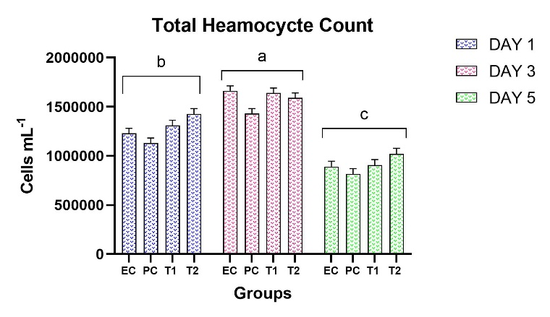
Figure 2. Effect of Dietary Treatments on Total haemocyte count of P. vannamei Challenged with V. parahaemolyticus
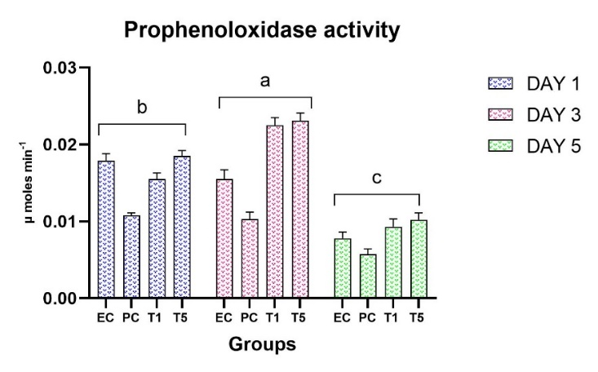
Figure 3. Effect of Dietary Treatments on Prophenoloxidase Activity of P. vannamei Challenged with V. parahaemolyticus
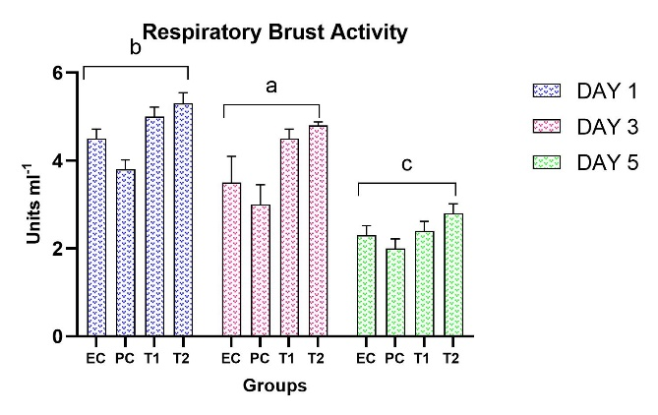
Figure 4. Effect of Dietary Treatments on Respiratory burst activity of P. vannamei Challenged with V. parahaemolyticus
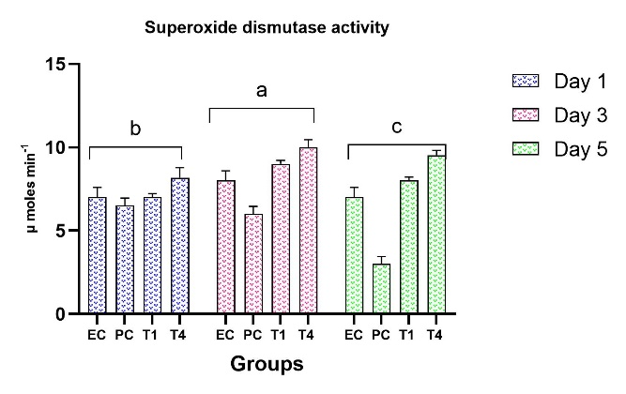
Figure 5. Effect of Dietary Treatments on Superoxide Dismutase Activity of P. vannamei Challenged with V. parahaemolyticus
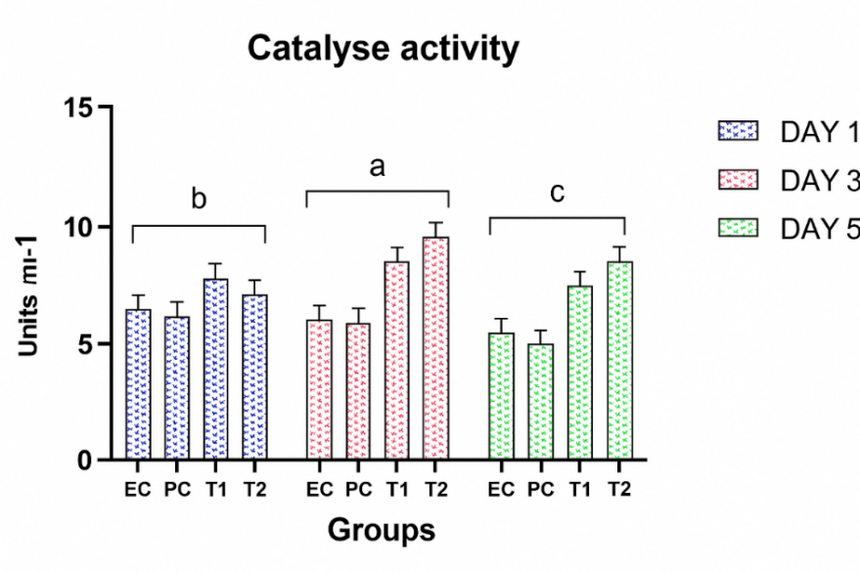
Figure 6. Effect of Dietary Treatments on Catalase Activity of P. vannamei Challenged with V. parahaemolyticus
4. DISCUSSION
An experiment was carried out to assess the growth performance of P. vannamei fed with (5% K. alvarezii (T1) and 10% S. platensis (T2)) in lined ponds.
Recently, farmers have adopted lined ponds for P. vannamei culture, enabling shrimp farming across diverse soil types. Studies indicate that pond liners are technically feasible (López et al., 2003; Pruder et al., 1992), effective in soils susceptible to disease or acidity and provide superior performance and cost-efficiency compared to earthen ponds. As a column-feeding, non-burrowing species, P. vannamei actively moves throughout the pond to forage (Wassenberg and Hill, 1994) and lined ponds allow for easier and more efficient maintenance of the pond bottom (Saraswathy et al., 2022).
Several studies have been conducted to evaluate the growth performance of P. vannamei with macroalgae and microalgae as feed supplements at various inclusion levels. Omont et al., (2019) evaluated Ulva in isoproteic diets (35 ± 0.5% protein) for P. vannamei at low, medium, and high inclusion levels over 28 days (initial weight 1.15 ± 0.08 g). Diets with high Ulva significantly improved final weight, weight gain, and SGR (p < 0.01), while all seaweed types at low inclusion enhanced digestive enzyme activity. In the present study, P. vannamei in Treatment 2 showed the highest mean body weight, followed by Treatment 1, with the lowest mean final body weight observed in the control. The total weight gain, weight gain percentage, average daily growth rate, and protein efficiency ratio were best performed in Treatment 2 followed by Treatment 1, while the control showed the lowest performance. The lowest FCR was recorded in Treatment 2, followed by Treatment 1. Specific growth rate was highest in Treatment 2, followed by Treatment 1, and lowest in the control diet.
Jasmanindar et al., (2018) showed that 2 g/kg ethyl acetate extract of Gracilaria improved growth, survival, and overall growth performance of P. vannamei. Nandeesha et al., (2001) investigated spirulina as a fishmeal substitute in Catla catla and Labeo rohita and found that it improved growth, specific growth rate, and protein efficiency in L. rohita, while having little effect on C. catla, with slight changes in digestibility and carcass composition, demonstrating its potential as a partial or full fishmeal replacement, particularly for rohu. Similarly, in the present study, treatment 2 and treatment 1 showed higher growth performance than the control (without any inclusion).
In the present study, the proximate composition of P. vannamei revealed significant differences among the treatments. The Treatment 2 had the highest levels of dry matter, protein, fat, and ash, followed by Treatment 1, and the control with the lowest levels. The significant increase in ash and protein in the algal-supplemented groups demonstrates to the beneficial effects of Kappaphycus and Spirulina on nutrition. These results are in line with previous research that found that shrimp fed diets supplemented with spirulina had higher whole-body protein and lower lipid levels (Nandeesha et al., 2001; Promya & Chitmanat, 2011; Kim et al., 2013; Velasquez et al., 2016; Cao et al., 2018; Teimouri et al., 2016).
In the present study, the total haemocyte count (THC), prophenoloxidase (proPO) activity, respiratory burst (RB) activity, superoxide dismutase (SOD) activity, and catalase (CAT) activity were elevated in T1 and T2 from day 1, peaked between days 2 and 3, and remained higher than controls throughout the study, with T2 generally showing the strongest response.
The findings of the present study are consistent with Sun et al., (2024) who reported that dietary inclusion of Spirulina at moderate levels supported the physiological condition of spiny loaches, whereas higher inclusion reduced intestinal SOD activity and elicited inflammatory responses. El-Araby et al., (2022) reported that supplementation with S. platensis strengthened immune responses in cells and tissues, alleviated stress, and increased tolerance to aquatic environmental pressures. Yousefi et al., (2022) studied dietary S. platensis (SP) and Bacillus licheniformis (BL) in goldfish and found that the SP and SP+BL significantly enhanced immune responses, antioxidant enzyme activity, and immune-related gene expression, and reduced mortality following Aeromonas hydrophila challenge. Zeraatpisheh et al., (2018) reported that dietary hot-water extract of Sargassum angustifolium improved growth, hematological and biochemical indices, and enhanced immune responses and survival in Oncorhynchus mykiss following Yersinia ruckeri challenge. Lee et al., (2020) reported that P. vannamei diets supplemented with hot-water extract of Sargassum horneri enhanced immune responses, with higher inclusion boosting hemocyte count, ROS, and phagocytic activity, while moderate inclusion improved growth and modulated immune-related gene expression. Siddik et al., (2022) found that moderate selenium-enriched Spirulina (SeE-SP) enhanced immunity, antioxidant activity, and survival in Asian seabass, while high inclusion reduced growth. The results of the present study demonstrated that dietary supplementation with Kappaphycus and Spirulina substantially enhanced immune parameters, thereby strengthening the shrimp’s resistance to pathogenic challenges.
5. CONCLUSION
Dietary supplementation of S. platensis (10%) and K. alvarezii (5%) significantly improved the growth performance, feed efficiency, body composition, immune response, and disease resistance of P. vannamei reared in lined pond systems. Algal-fed shrimp showed higher weight gain, specific growth rate, protein efficiency, enhanced immune enzyme activities, and increased survival following Vibrio parahaemolyticus challenge. Water quality remained within optimal ranges throughout the trial. These findings confirm the potential of Spirulina and Kappaphycus as effective, natural functional feed additives for improving shrimp health and productivity in sustainable aquaculture.
8. DISCLAIMER (ARTIFICIAL INTELLIGENCE)
Author(s) hereby declare that NO generative AI technologies such as Large Language Models (ChatGPT, COPILOT, etc) and text-to-image generators have been used during writing or editing of this manuscript.

9. REFERENCES
- Anderson, D. P and Siwicki, A. K. (1995). Basic hematology and serology for fish health programs. In M. Shariff, J. R. Arthur, & J. P. Subasinghe (Eds.), Diseases in Asian Aquaculture II (pp. 185-202). Fish Health Section, Asian Fisheries Society. https://pubs.er.usgs.gov/publication/96041
- Association of Official Analytical Chemists. (1990). Official methods of analysis of the Association of Official Analytical Chemists (15th ed.). Association of Official Analytical Chemists.
- Rice, E. W., Baird, R. B., Eaton, A. D., & Clesceri, L. S. (Eds.). (2012). Standard methods for the examination of water and wastewater (22nd ed.). American Public Health Association; American Water Works Association; Water Environment Federation. https://www.standardmethods.org/
- Campa-Córdova, A. I., Hernández-Saavedra, N. Y., & Ascencio, F. (2002). Superoxide dismutase as modulator of immune function in American white shrimp (Litopenaeus vannamei). Comparative Biochemistry and Physiology Part C: Toxicology & Pharmacology,133(4), 557–565. https://doi.org/10.1016/s1532-0456(02)00125-4
- Cottier-Cook, E.J., Nagabhatla, N., Asri, A., Beveridge, M., Bianchi, P., Bolton, J., Bondad-Reantaso, M.G., Brodie, J., Buschmann, A., Cabarubias, J. and Campbell, I., 2021. Ensuring the sustainable future of the rapidly expanding global seaweed aquaculture industry–a vision.
https://cris.unu.edu/gsstarpolicybrief
- El-Araby, D.A., Amer, S.A., Attia, G.A., Osman, A., Fahmy, E.M., Altohamy, D.E., Alkafafy, M., Elakkad, H.A. & Tolba, S.A., 2022. Dietary Spirulina platensis phycocyanin improves growth, tissue histoarchitecture, and immune responses, with modulating immunoexpression of CD3 and CD20 in Nile tilapia, Oreochromis niloticus. Aquaculture, 546, p.737413.
https://doi.org/10.1016/j.aquaculture.2021.737413
- Fantatto, R. R., Constantini, J. V. C., Politi, F. A. S., Sorrechia, R., Medeiros, C. C. B., Luiz, M. T., Bechara, G. H., de Souza Chagas, A. C., Chorilli, M., & Pietro, R. C. L. R. (2025). Current Tick Control Strategies and Prospects for Using Nanotechnology as an Efficient Alternative—A Review. Veterinary Sciences, 12(2), 163. https://doi.org/10.3390/vetsci12020163
- FAO. (2024). The State of Food and Agriculture 2024 – Value-driven transformation of agrifood systems. Rome: Food and Agriculture Organization of the United Nations. https://doi.org/10.4060/cd2616en
- Gollas-Galván, T., Hernández-López, J., & Vargas-Albores, F. (1999). Prophenoloxidase from brown shrimp (Penaeus californiensis) hemocytes. Comparative Biochemistry and Physiology Part B: Biochemistry and Molecular Biology, 122(1), 77-82. https://doi.org/10.1016/s0305-0491(98)10143-8
- Guillén, P. O., Motti, P., Mangelinckx, S., De Clerck, O., Bossier, P., & Van Den Hende, S. (2022). Valorization of the chemical diversity of the tropical red seaweeds Acanthophora and Kappaphycus and their applications in aquaculture:
A review. Frontiers in Marine Science, 9.
https://doi.org/10.3389/fmars.2022.957290
- Jasmanindar, Y., Sukenda, S., Alimuddin, A., Junior, M. Z., & Utomo, N. B. P. (2018). The Chemical Composition of Gracilaria verrucosa Extract and its Utilization on Survival and Growth Litopenaeus vannamei. Omni-Akuatika, 14(3), 1-9. https://doi.org/10.20884/1.oa.2018.14.3.508
- Junior, G. F. G., Wasielesky, W., Cardozo, A., Poersch, L. H. S., Brito, L. O., Krummenauer, D., & Fóes, G. K. (2025). Effect of feed restriction for Pacific white shrimp Penaeus vannamei in a semi-intensive synbiotic system: Plankton community, growth and economics. Aquaculture, 595, 741481. https://doi.org/10.1016/j.aquaculture.2023.741481
- Lee, P. T., Tran, H. T. Q., Huang, H. T., Nan, F. H., & Lee, M. C. (2020). Sargassum horneri extracts stimulate innate immunity, enhance growth performance, and upregulate immune genes in the white shrimp Litopenaeus vannamei. Fish & Shellfish Immunology, 102, 276-285. https://doi.org/10.1016/j.fsi.2020.04.049
- López, N., Cuzon, G., Gaxiola, G., Taboada, G., Valenzuela, M., Pascual, C., Sánchez, A., & Rosas, C. (2003). Physiological, nutritional, and immunological role of dietary β 1-3 glucan and ascorbic acid 2-monophosphate in Litopenaeus
vannamei juveniles. Aquaculture, 224(1-4), 223–243.
https://doi.org/10.1016/S0044-8486(03)00214-X
- Munaeni, W., Yuhana, M., Setiawati, M., & Wahyudi, A.T. (2020). Effect in white shrimp Litopenaeus vannamei of Eleutherine bulbosa (Mill.) Urb. Powder on immune genes expression and resistance against Vibrio parahaemolyticus infection. Fish & Shellfish Immunology, 102, 218-227. https://doi.org/10.1016/j.fsi.2020.03.066
- Musa, M. N., Jirgi, G. M., Zango, Z. U., Isah, M. N., Abdurrazak, M., Adamu, A. A., Wadi, I. A., Adeleke, A. A., Garba, Z. N., Bello, U., Adamu, H., Hosseini-Bandegharaei, A., & Bokov, D. O. (2025). A review on techno-economic assessment of Spirulina for sustainable nutraceutical, medicinal, environmental, and bioenergy applications. Bioresources and Bioprocessing, 12(1), 51. https://doi.org/10.1186/s40643-025-00888-3
- Nandeesha, M. C., Gangadhara, B., Manissery, J. K., & Venkataraman, L. V. (2001). Growth performance of two Indian major carps, catla (Catla catla) and rohu (Labeo rohita) fed diets containing different levels of Spirulina platensis. Bioresource Technology, 80(2), 117-120. https://doi.org/10.1016/s0960-8524(01)00085-2
- Omont, A., Quiroz-Guzman, E., Tovar-Ramirez, D., & Peña-Rodríguez, A. (2019). Effect of diets supplemented with different seaweed extracts on growth performance and digestive enzyme activities of juvenile white shrimp Litopenaeus vannamei. Journal of Applied Phycology, 31(2), 1433-1442. https://doi.org/10.1007/s10811-018-1628-6
- Pruder, G.D., Duerr, E.O., Walsh, W.A., Lawrence, A.L. and Bray, W.A., 1992. The technical feasibility of pond liners for rearing Pacific white shrimp (Penaeus vannamei) in terms of survival, growth, water exchange rate and effluent water
- Raja, R. A., Kumar, S., Sundaray, J. K., De, D., Biswas, G., & Ghoshal, T. K. (2012). Hematological parameters in relation to sex, morphometric characters and incidence of white spot syndrome virus in tiger shrimp Penaeus monodon Fabricius, 1798 from Sunderban, West Bengal. Indian Journal of Fisheries, 59(4), 169-174. https://epubs.icar.org.in/index.php/IJF/article/view/15132
- Saraswathy, R., Muralidhar, M., Thiagarajan, R., Panigrahi, A., Suvana, S., Kumararaja, P., Katneni, V. K., & Nagavel, A. (2022). Effect of lined and earthen farming practices on pond health in white leg shrimp, Penaeus vannamei culture. Aquaculture Research, 53(16), 5606-5617. https://doi.org/10.1111/are.16042
- Siddik, S. M., Howieson, J., Islam, S. M., & Fotedar, R. (2022). Synbiotic feed supplementation improves antioxidant response and innate immunity of juvenile barramundi, Lates calcarifer subjected to bacterial infection. Aquaculture, 552, 737965. https://doi.org/10.1016/j.aquaculture.2022.737965
- Sun, D., Hou, D., Zheng, Y., Xiang, W., Huang, Y., Wu, H., & Zou, J. (2024). Multi-Omics Reveals the Effects of Spirulina platensis Powder Replacement of Fish Meal on Intestinal Metabolism and Stress in Zig-Zag Eel (Mastacembelus armatus). Antioxidants, 13(7), 851. https://doi.org/10.3390/antiox13070851
- Takahara, S., Hamilton, H.B., Neel, J.V., Kobara, T.Y., Ogura, Y., & Nishimura, E.T. (1960). Hypocatalasemia: A new genetic carrier state. Journal of Clinical Investigation, 39(4), 610-619. https://doi.org/10.1172/JCI104075
- Wassenberg, T. J., & Hill, B. J. (1994). Laboratory study of the effect of light on the emergence behaviour of eight species of commercially important adult penaeid prawns. Marine and Freshwater Research, 45(1), 43-50. https://doi.org/10.1071/MF9940043
- Yousefi, M., Ahmadifar, M., Mohammadzadeh, S., Kalhor, N., Esfahani, D. E., Bagheri, A., Mashhadizadeh, N., Moghadam, M. S., & Ahmadifar, E. (2022). Individual and combined effects of the dietary Spirulina platensis and Bacillus licheniformis supplementation on growth performance, antioxidant capacity, innate immunity, relative gene expression and resistance of goldfish, Carassius auratus to Aeromonas hydrophila. Fish & Shellfish Immunology, 127, 1070-1078. https://doi.org/10.1016/j.fsi.2022.07.015
- Zeraatpisheh, F., Firouzbakhsh, F., & Khalili, K.J. (2018). Effects of the macroalga Sargassum angustifolium hot water extract on hematological parameters and immune responses in rainbow trout (Oncohrynchus mykiss) infected with Yersinia rukeri. Journal of Applied Phycology, 30(3), 2029-2037. https://doi.org/10.1007/s10811-018-1395-4

