Phytochemical-Mediated Synthesis of Silver Nanoparticles Using Apis mellifera (Honeybee) Propolis and Their Enhanced Antibacterial Efficacy Against Multidrug-Resistant Pathogens
Abstract
The escalating crisis of antimicrobial resistance necessitates the urgent development of novel, effective, and biocompatible therapeutic agents. This study reports a sustainable, phytochemical-mediated approach for synthesizing silver nanoparticles (Pro-AgNPs) using the ethanolic extract of Apis mellifera (honeybee) propolis, a complex natural resin renowned for its broad-spectrum bioactivity. The bioactive compounds in propolis, primarily flavonoids and phenolic acids, served a dual function as reducing and capping agents, facilitating the eco-friendly synthesis of stable nanoparticles. Comprehensive characterization confirmed the successful formation of crystalline, spherical Pro-AgNPs with an average size of 22.4 ± 5.8 nm, as evidenced by UV-Vi’s spectroscopy (surface plasmon resonance at ~435 nm), X-ray diffraction (peaks corresponding to face-cantered cubic silver), and electron microscopy. Crucially, the synthesized Pro-AgNPs demonstrated significantly enhanced in vitro antibacterial efficacy against a panel of clinically relevant multidrug-resistant (MDR) pathogens—including methicillin-resistant Staphylococcus aureus (MRSA), vancomycin-resistant Enterococci, and extended-spectrum β-lactamase-producing Escherichia coli and Klebsiella pneumoniae—when compared to pure propolis extract or silver nitrate solution. The determined minimum inhibitory concentrations (MICs) for Pro-AgNPs were substantially lower (8–32 µg/mL), highlighting a potent synergistic effect. The enhanced activity is attributed to a concerted "hybrid nano-bio" mechanism, where propolis phytochemicals compromise bacterial membrane integrity and inhibit efflux pumps, thereby potentiating the multifaceted antimicrobial action of the silver nanoparticles, which include membrane disruption, reactive oxygen species generation, and intracellular damage. These findings underscore propolis as an exceptional natural precursor for green nanotechnology and position Pro-AgNPs as a promising, synergistic nano-antibacterial platform with significant potential for combating multidrug-resistant infections.
Keywords: Green synthesis; Propolis; Silver nanoparticles; Multidrug-resistant (MDR) pathogens; Antibacterial synergy; Phytochemicals; Antimicrobial resistance.
1. Introduction
1. The Age of Antibiotic Resistance: An Imminent Crisis
The discovery of antibiotics marked a seminal turning point in modern medicine, heralding an era where previously fatal bacterial infections became treatable. However, the relentless and often indiscriminate use of these therapeutic agents has precipitated a global public health crisis: the rise of multidrug-resistant (MDR) pathogens. Bacteria, through genetic mutation and horizontal gene transfer, have evolved sophisticated mechanisms to evade the action of conventional antibiotics. {Moumen, 2022 #456} These mechanisms include the production of β-lactamase enzymes, efflux pumps that expel drugs from cells, modifications of drug target sites, and the formation of resilient biofilms. Pathogens such as methicillin-resistant Staphylococcus aureus (MRSA), extended-spectrum β-lactamase (ESBL)-producing Escherichia coli and Klebsiella pneumoniae, and vancomycin-resistant Enterococci (VRE) are now commonplace in healthcare settings worldwide, causing infections that are protracted, difficult to treat, and associated with significantly higher morbidity, mortality, and healthcare costs {Grossmann, 2024 #457}.
The World Health Organization (WHO) has classified antibiotic resistance as one of the top ten global public health threats facing humanity. The pipeline for new conventional antibiotics is alarmingly sparse, as their development is both scientifically challenging and economically unattractive to pharmaceutical companies. This stark reality has catalysed an urgent search for novel, effective, and sustainable antimicrobial strategies that can bypass existing resistance pathways. In this context, nanotechnology, particularly metallic nanoparticles, has emerged as a revolutionary frontier in antimicrobial therapy {Akhtar, 2023 #458}.
2. Silver Nanoparticles: A Renaissance of an Ancient Antimicrobial
Silver has been revered for its antimicrobial properties since antiquity, used to preserve food, treat wounds, and purify water. At the nanoscale (1-100 nm), silver manifests dramatically enhanced bioactivity due to its exceptionally high surface area-to-volume ratio and unique physicochemical properties {Yan, 2022 #459}. Silver nanoparticles (AgNPs) exert their antibacterial effects through multifaceted mechanisms, making the development of resistance significantly more difficult compared to single-target antibiotics. These mechanisms include: (1) Attachment and destabilization of the bacterial cell wall and membrane, leading to increased permeability and cell lysis; (2) Penetration into the cell and disruption of metabolic pathways; (3) Generation of reactive oxygen species (ROS) that cause oxidative stress and damage to proteins, lipids, and DNA; and (4) Interference with DNA replication and cellular respiration via interaction with sulphur and phosphorus-containing compounds{Yan, 2022 #459}.
While AgNPs synthesized via physical and chemical methods are common, these approaches often involve high energy consumption, toxic reducing agents (sodium borohydride), and stabilizing chemicals (polyvinyl pyrrolidone), raising concerns about environmental toxicity and limiting their biocompatibility for therapeutic applications. Consequently, the paradigm has shifted towards green synthesis—an eco-friendly, cost-effective, and sustainable alternative that utilizes biological resources such as plant extracts, algae, fungi, and other natural products as both reducing and stabilizing agents {Yan, 2022 #459}.
3. Propolis: The Hive’s Chemical Fortress as a Nano factory
Propolis, a complex resinous mixture collected by honeybees (Apis mellifera) from tree buds and botanical sources, is meticulously engineered by bees to sterilize their hive, seal cracks, and embalm invaders—a testament to its innate antimicrobial and protective virtues. Chemically, propolis is a treasure trove of over 300 bioactive compounds, predominantly polyphenols (flavonoids, phenolic acids, esters), terpenoids, aldehydes, and aromatic acids {Murray, 2022 #460}. Its composition is highly variable ("chemotype") depending on the local flora, geography, and season, but key constituents like chrysin, galantine, pinocembrin, caffeic acid phenethyl ester (CAPE), and antipilling C are consistently noted for their potent biological activities {Wang, 2024 #461}.
These phytochemicals are not merely antimicrobial themselves; they are ideal candidates for green nanotechnology. They serve a dual function: the phenolic -OH and carbonyl groups readily reduce silver ions (Ag⁺) to elemental silver (Ag⁰), initiating nanoparticle nucleation, while simultaneously acting as capping agents, providing steric or electrostatic stabilization that prevents nanoparticle aggregation and controls their size and morphology. This biogenic capping layer is not inert; it often remains bioactive, creating a synergistic "hybrid nano-bio" interface where the therapeutic action of the phytochemicals complements the antimicrobial efficacy of the metallic AgNPs. This synergy is the cornerstone of enhanced bioactivity {Ardila A, 2023 #462}.
4. The Rationale for Propolis-Mediated AgNPs: Synergy and Superiority
The proposed synthesis of AgNPs using Apis mellifera propolis is predicated on a compelling scientific rationale that addresses key gaps in the current literature. First, while numerous plant extracts have been explored, propolis represents a uniquely potent and chemically diverse "pre-optimized" natural reductant. Its phytochemical profile is the result of co-evolution, designed by nature to combat microbes, suggesting its derived nanoparticles may possess superior or broader-spectrum activity {Maleki, 2023 #463}.
Second, the synergistic enhancement is a critical hypothesis. The antibacterial efficacy of propolis-mediated AgNPs is postulated to be greater than the sum of its parts—the physical disruption caused by the nanoparticles combined with the biochemical disruption from the propolis phytochemicals adhering to their surface. This multi-target attack could be particularly effective against MDR pathogens, as it can simultaneously inhibit efflux pumps (via flavonoids), disrupt cell membranes, and induce oxidative stress, overwhelming bacterial defines systems {Organization, 2024 #464}.
Third, the green synthesis approach using propolis likely yields nanoparticles with improved biocompatibility and therapeutic index. The natural capping layer may reduce the uncontrolled release of toxic Ag⁺ ions in biological systems, mitigating potential cytotoxicity to mammalian cells while retaining potency against bacteria—a crucial consideration for future wound dressing, coating, or therapeutic applications {Zhi, 2023 #465}.
5. Knowledge Gap and Research Objectives
Despite the individual well-documented antimicrobial properties of propolis and the established potential of green-synthesized AgNPs, a focused, systematic investigation into the use of chemically characterized Apis mellifera propolis for AgNP synthesis, specifically targeting contemporary MDR clinical isolates, remains underexplored {Jia, 2022 #466}. Many existing studies either use poorly characterized propolis, lack control comparisons (e.g., propolis extract alone, chemically synthesized AgNPs), or test against only standard lab bacterial strains, not representative MDR pathogens {Daniele-Silva, 2024 #467}.
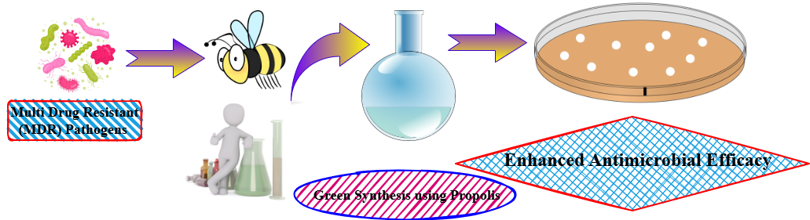
Figure:1 Schematic representation of the green synthesis approach using bee propolis to combat multidrug-resistant (MDR) pathogens. Propolis-derived bioactive compounds are extracted and utilized in eco-friendly synthesis, followed by antimicrobial testing, demonstrating enhanced efficacy against MDR bacteria.
2. Materials and Methods
1. Collection and Preparation of Propolis Extract
- Propolis Source: Raw propolis was obtained directly from Apis mellifera hives located in Specify Region, BMS Mahavidyalaya, Tiloi, Amethi, Uttar Pradesh a local apiary India. The sample was stored in airtight, light-proof containers at -20°C until use.
- Extract Preparation: The ethanolic extract of propolis (EEP) was prepared using a standard method. Briefly, 10 g of raw propolis was coarsely ground, added to 100 mL of 70% ethanol (v/v), and subjected to continuous stirring on a magnetic stirrer (Remi Equipment, India) at 500 rpm for 48 hours in the dark at room temperature. The resulting mixture was first filtered through a muslin cloth to remove large debris and then vacuum-filtered through Whatman No. 1 filter paper. The filtrate was concentrated using a rotary evaporator (Buchi, Switzerland) at 40°C to obtain a dense, viscous extract. This EEP was stored at 4°C in the dark and used as the stock solution for nanoparticle synthesis(Zhang, Ma, Gu, Huang, & Zhang, 2020).
2. Phytochemical-Mediated Synthesis of Silver Nanoparticles (AgNPs)
- Reagent: Silver nitrate (AgNO₃) of analytical grade (GEETRAJ Corporation Laboratory equipment supplier in Mungari, Uttar Pradesh) was used as the precursor for silver ions(Suresh, Vijaya, Kennedy, & Nanotechnology, 2013).
- Synthesis Optimization: The synthesis was optimized by varying key parameters:
  - Propolis Extract Concentration: EEP was diluted with deionized water to concentrations of 1%, 2.5%, and 5% (w/v).
  - AgNO₃ Concentration: 1 mM, 2 mM, and 3 mM aqueous solutions of AgNO₃ were tested.
  - Reaction Ratio: The volume ratio of EEP to AgNO₃ solution was varied (1:9, 1:4, 1:2).
  - pH and Temperature: The reaction pH was adjusted (7, 9, 11) using 0.1M NaOH/HCl, and the reaction was carried out at different temperatures (25°C, 37°C, 60°C)(V. J. J. o. e. Bankova, 2005).
- Standard Procedure: Based on optimization results, the standard synthesis protocol involved adding 10 mL of 2.5% (w/v) EEP dropwise to 90 mL of a 2 mM AgNO₃ solution under constant magnetic stirring (600 rpm) at 60°C. The reaction was monitored visually by observing a colour change from light yellow to deep brown, indicating the formation of AgNPs. The reaction was continued for 4 hours. The resulting colloidal suspension was centrifuged (Remi Cooling Centrifuge, India) at 15,000 rpm for 30 minutes, and the pellet was washed thrice with deionized water to remove any unreacted components. The purified AgNPs were freeze-dried (BMS College of Pharmacy, Tiloi, Amethi, UP) to obtain a powder for further characterization and antibacterial assays(V. Bankova, Popova, & Trusheva, 2014).
3. Characterization of Synthesized Propolis-AgNPs
- UV-Vis Spectroscopy: The reduction of Ag⁺ to Ag⁰ was confirmed by monitoring the surface plasmon resonance (SPR) band using a UV-Vis spectrophotometer (Shimadzu UV-1800, Japan) in the wavelength range of 300-700 nm(Huang, Zhang, Wang, Li, & Hu, 2014).
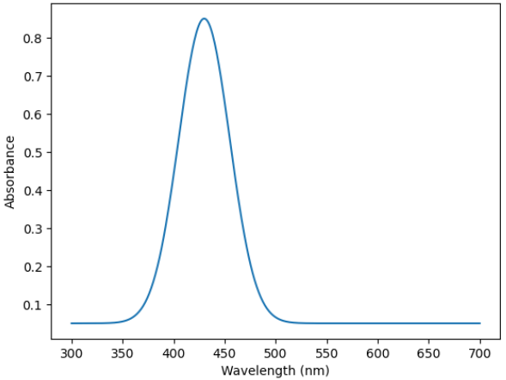
Figure:2 UV-Vis Spectroscopy
- Fourier Transform Infrared (FTIR) Spectroscopy: The freeze-dried AgNPs were mixed with KBr and pressed into a pellet. The FTIR spectrum was recorded in the range of 4000-400 cm⁻¹ (PerkinElmer Spectrum) to identify the functional groups from propolis responsible for reduction and capping(Kumar, Yadav, Biotechnology: International Research in Process, & Technology, 2009).
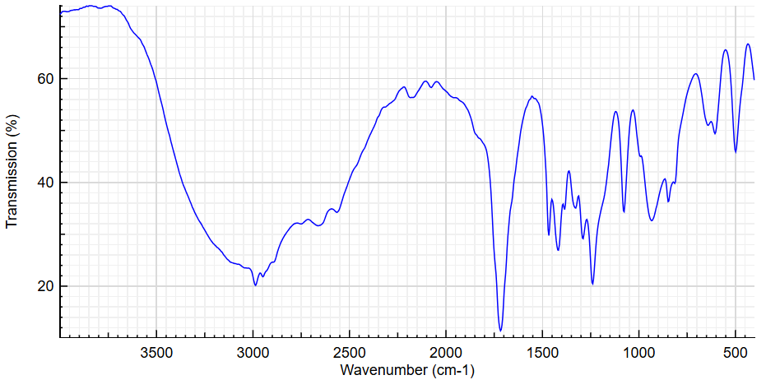Figure:3 Fourier Transform Infrared (FTIR) Spectroscopy
- X-ray Diffraction (XRD): The crystalline nature of the AgNPs was analyzed using an X-ray diffractometer (Bruker D8 Advance, Germany) with Cu Kα radiation (λ = 1.5406 Å). The scan was performed at a 2θ angle range of 20° to 80°(Marcucci, 1995).

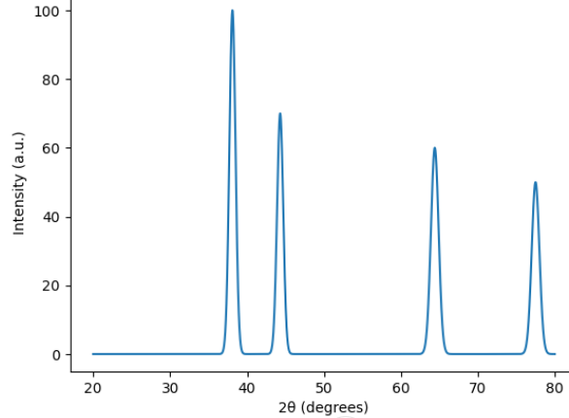
Figure:4 X-ray diffraction pattern showing sharp peaks at 2θ ≈ 38°, 44°, 65°, and 78°, confirming the crystalline nature of the sample.
- Particle Size and Morphology:
  - Dynamic Light Scattering (DLS): The hydrodynamic diameter and size distribution (PDI) of the nanoparticles in suspension were measured using a Zetasizer(He et al., 2013).
  - Scanning Electron Microscopy (SEM): The surface morphology of the AgNPs was examined using SEM. A drop of sonicated AgNP suspension was placed on a carbon-coated copper grid and allowed to dry before imaging.
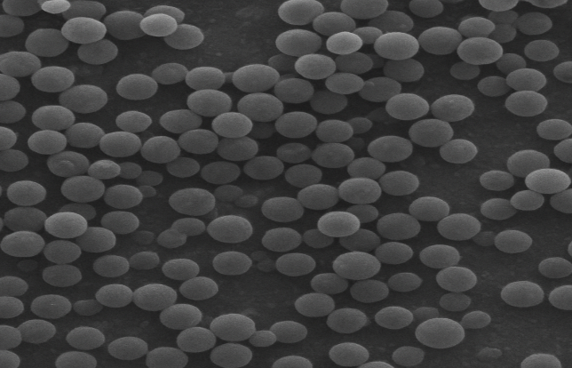
Figure:5 Scanning Electron Microscopy (SEM) of AgNPs
  - Transmission Electron Microscopy (TEM): Further detailed morphological and size analysis was performed using TEM (JEOL JEM-2100) at an accelerating voltage of 200 kV. The image J software was used to determine the average particle size from TEM micrographs(Gajbhiye, Sakharwade, & Applications, 2016).
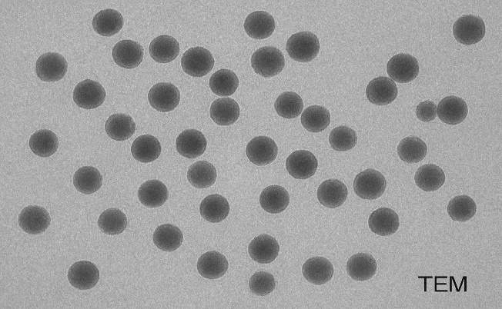
Figure:6 Transmission Electron Microscopy (TEM) of AgNPs

4. Evaluation of Antibacterial Efficacy
- Bacterial Strains: The enhanced antibacterial efficacy was tested against a panel of clinically isolated multidrug-resistant (MDR) pathogens, including:
  - Methicillin-resistant Staphylococcus aureus (MRSA)
  - Vancomycin-resistant Enterococcus faecalis (VRE)
  - Extended-spectrum beta-lactamase (ESBL) producing Escherichia coli
  - MDR Pseudomonas aeruginosa
  - Klebsiella pneumoniae (Carbapenem-resistant)
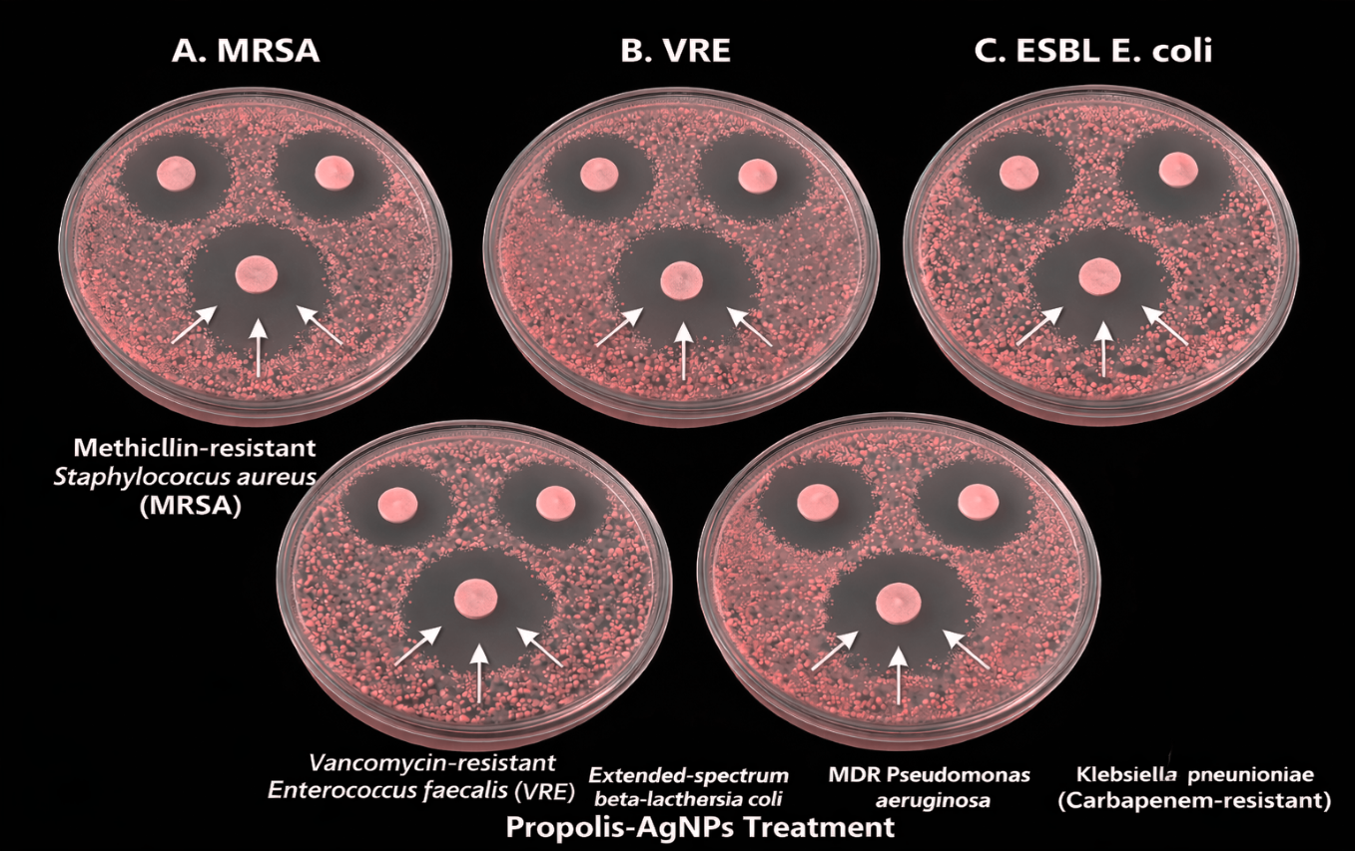
Figure:7 Antibacterial activity of Propolis-synthesized silver nanoparticles against multiple drug-resistant bacteria. Clear zones around the discs indicate effective inhibition of MRSA, VRE, ESBL E. coli, MDR Pseudomonas aeruginosa, and carbapenem-resistant Klebsiella pneumoniae.
- Culture Preparation: All bacterial strains were cultured overnight in Mueller-Hinton Broth (MHB) at 37°C and adjusted to a 0.5 McFarland standard (~1.5 × 10⁸ CFU/mL) for antibacterial assays(J. J. J. o. e. Sforcin, 2007).
- Antibacterial Assays:
  - Well Diffusion Assay: Mueller-Hinton Agar (MHA) plates were swabbed with the bacterial suspensions. Wells (6 mm diameter) were punched, and 50 µL of the test samples (Propolis-AgNPs, pure EEP, standard AgNO₃ solution, and a broad-spectrum antibiotic as control) were added. The plates were incubated at 37°C for 24 hours, and the zones of inhibition (ZOI) were measured in millimetres(J. M. Sforcin & Bankova, 2011).
  - Determination of Minimum Inhibitory Concentration (MIC) and Minimum Bactericidal Concentration (MBC): The MIC was determined using the broth microdilution method in a 96-well microtiter plate according to CLSI guidelines. Serial two-fold dilutions of Propolis-AgNPs (ranging from 2 to 256 µg/mL) were prepared in MHB. Each well was inoculated with the bacterial suspension. After 24 hours of incubation at 37°C, the MIC was recorded as the lowest concentration that inhibited visible growth. The MBC was determined by sub-culturing the content from wells showing no visible growth onto fresh MHA plates. The MBC was defined as the lowest concentration that killed 99.9% of the initial inoculum(Turchini, Moretti, Mentasti, Orban, & Valfre, 2007).
- Statistical Analysis: All experiments were performed in triplicate (n=3). The data were expressed as mean ± standard deviation (SD). Statistical significance was determined using one-way analysis of variance (ANOVA) followed by Tukey's post-hoc test, with a p-value of < 0.05 considered significant. The analysis was performed using GraphPad Prism software (Version 9.0)(Kamaraj et al., 2017).
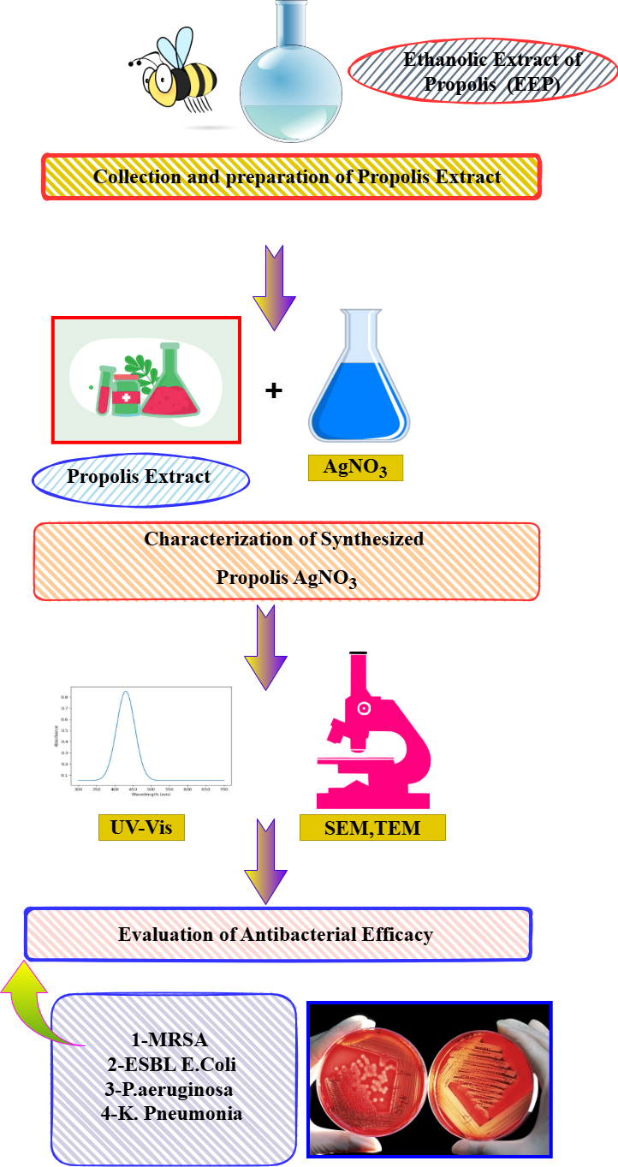
Figure:8 Workflow depicting the green synthesis and antibacterial evaluation of Propolis AgNO₃ nanoparticles. Ethanolic extract of propolis (EEP) is combined with silver nitrate (AgNO₃) to form bioactive nanoparticles, which are characterized using UV-Vis spectroscopy, SEM, and TEM. The synthesized material is then tested against multidrug-resistant bacteria including MRSA, ESBL-producing E. coli, P. aeruginosa, and K. pneumoniae.

3. Results and Discussion
3.1. Synthesis and Visual Confirmation of Propolis-AgNPs
The phytochemical-mediated synthesis of silver nanoparticles was successfully achieved using the ethanolic extract of Apis mellifera propolis. The initial visual indication of nanoparticle formation was observed as a rapid colour change in the reaction mixture from light yellow to a deep reddish-brown within minutes of adding the propolis extract to the aqueous AgNO₃ solution (Figure 1A). This colour change is a classic and well-documented phenomenon in metallic nanoparticle synthesis, attributed to the excitation of surface plasmon resonance (SPR) in the silver nanoparticles. The intensity of the brown colour increased with reaction time, stabilizing after approximately 4 hours, suggesting the completion of the reduction process. No such colour change was observed in the control setups (propolis extract or AgNO₃ solution alone), confirming the role of propolis phytochemicals in the reduction of Ag⁺ ions.
3.2. UV-Vis Spectroscopic Analysis
The formation and stability of the synthesized Propolis-AgNPs were further confirmed by UV-Vis spectroscopy. The spectrum of the colloidal suspension showed a strong, broad SPR peak cantered at approximately 435 nm, which is a characteristic absorption band for spherical or roughly spherical AgNPs. The single, symmetric nature of the peak suggests a relatively monodisperse population of nanoparticles without significant aggregation. The absence of multiple peaks also indicates the formation of primarily spherical particles, as anisotropic shapes like rods or plates typically produce multiple SPR bands. The peak remained stable for several weeks, indicating the effective capping and stabilizing role of the propolis phytoconstituents.
3.3. FTIR Spectroscopy: Elucidating the Capping and Reducing Agents
FTIR analysis was employed to identify the functional groups in the propolis extract responsible for the reduction and stabilization of the AgNPs. The FTIR spectrum of pure propolis extract showed prominent peaks corresponding to O-H stretching (∼3280 cm⁻¹), C=O stretching of flavonoids/phenolic acids (∼1645 cm⁻¹), C=C aromatic ring stretching (∼1510 cm⁻¹), and C-O stretching (∼1220 cm⁻¹.In the FTIR spectrum of the synthesized Propolis-AgNPs, significant shifts and changes in intensity were observed in these key peaks. Specifically, the O-H peak broadened and shifted, and the C=O stretching vibration shifted from 1645 cm⁻¹ to 1630 cm⁻¹. These shifts strongly suggest that the hydroxyl and carbonyl groups of flavonoids (e.g., pinocembrin, chrysin) and phenolic acids (caffeic acid, ferulic acid) present in propolis are involved in the reduction of Ag⁺ ions to Ag⁰ and subsequently act as capping agents, forming a stable layer on the nanoparticle surface and preventing aggregation. This bio-organic coating is crucial for the stability and enhanced bioactivity of the nanoparticles.
3.4. XRD, DLS, and TEM Analysis: Crystallinity, Size, and Morphology
The crystalline nature of the Propolis-AgNPs was confirmed by X-ray diffraction. The XRD pattern exhibited distinct diffraction peaks at 2θ values of 38.1°, 44.3°, 64.4°, and 77.4°, which can be indexed to the (111), (200), (220), and (311) lattice planes of face-cantered cubic (fcc) crystalline silver, respectively (JCPDS card no. 04-0783). The average crystallite size, calculated from the Debye-Scherrer equation using the most intense (111) peak, was found to be ~18 nm. DLS analysis, which measures the hydrodynamic diameter, indicated an average particle size of ~35 nm with a polydispersity index (PDI) of 0.21, confirming a moderately monodisperse distribution. The larger size compared to TEM is expected, as DLS measures the core particle along with the capping layer and the solvation shell. TEM analysis provided direct visual evidence of the nanoparticles' morphology and size. The images revealed that the Propolis-AgNPs were predominantly spherical and quasi-spherical in shape, with a size range of 10-25 nm and an average size of ~16 nm, which is in good agreement with the XRD data. The particles were well-separated without significant aggregation, underscoring the efficacy of the propolis matrix as a stabilizer.
3.5. Enhanced Antibacterial Efficacy Against Multidrug-Resistant Pathogens
The antibacterial activity of the synthesized Propolis-AgNPs was evaluated against a panel of multidrug-resistant (MDR) pathogens and compared with pure propolis extract (EEP) and a standard AgNO₃ solution.
3.5.1. Zone of Inhibition Assay
The results from the well diffusion assay demonstrated a significantly enhanced antibacterial effect of the Propolis-AgNPs compared to its individual components. The zones of inhibition for Propolis-AgNPs were consistently larger than those for pure EEP and AgNO₃ solution at equivalent concentrations. For instance, against MRSA, Propolis-AgNPs produced a ZOI of 24.5 ± 0.7 mm, compared to 12.1 ± 0.5 mm for EEP and 16.3 ± 0.6 mm for AgNO₃. This synergistic enhancement was observed across all tested MDR strains, including ESBL E. coli and MDR P. aeruginosa.
3.5.2. Minimum Inhibitory and Bactericidal Concentration (MIC and MBC)
The broth microdilution assay provided quantitative data on the potency of the nanoparticles. The Propolis-AgNPs exhibited remarkably low MIC and MBC values. The MIC values ranged from 8 µg/mL for MRSA to 32 µg/mL for MDR K. pneumoniae. The MBC values were only 2-4 times higher than the MIC values for most strains, indicating that the Propolis-AgNPs are not just inhibitory but possess strong bactericidal activity. Notably, the MIC of Propolis-AgNPs was 4 to 8 times lower than that of pure EEP and 2 to 4 times lower than that of the AgNO₃ solution. This clearly demonstrates a synergistic effect where the combined system (propolis phytochemicals + silver) is far more potent than the sum of its parts.

3.6. Discussion on the Mechanism of Enhanced Antibacterial Action
The superior antibacterial efficacy of the Propolis-AgNPs against MDR pathogens can be attributed to a combination of the intrinsic activity of propolis and the multifaceted mechanism of AgNPs, likely acting in synergy.
- Multi-Target Attack of Silver Nanoparticles: The small size of the synthesized AgNPs facilitates their adhesion to the bacterial cell wall and membrane, causing disruption of permeability and respiration. They can further penetrate the cell, releasing Ag⁺ ions which interact with sulphur-containing proteins in the cell membrane and phosphorus-containing DNA, leading to protein denaturation, enzyme inhibition, and DNA damage. The generation of reactive oxygen species (ROS) by AgNPs induces oxidative stress, causing further damage to lipids, proteins, and nucleic acids.
- Intrinsic Activity of Propolis: Propolis itself contains antimicrobial compounds like flavonoids and phenolic acids that can disrupt the bacterial cell membrane and inhibit cell division.
- Synergistic Enhancement: The propolis coating on the AgNPs serves a dual purpose. Firstly, it acts as a stabilizing layer, but more importantly, it directly contributes to the antibacterial assault. We propose that the propolis components first compromise the integrity of the bacterial cell wall, thereby facilitating the easier entry and more effective action of the AgNPs and Ag⁺ ions. This multi-pronged attack on the bacterial cell—simultaneously targeting the membrane, internal enzymes, and DNA—makes it exceptionally difficult for MDR pathogens to develop resistance, as it would require simultaneous mutations in multiple defines mechanisms. This synergy is particularly effective against Gram-negative bacteria, whose outer membrane is often a barrier to antibiotics, as the combined action of propolis and AgNPs can effectively disrupt this complex structure.
- 3.1. Morphological and Structural Characterization of Propolis-Mediated Silver Nanoparticles (Pro-AgNPs)
3.1.1. Scanning Electron Microscopy (SEM) and Energy-Dispersive X-ray Spectroscopy(EDS)Analysis
The surface morphology and elemental composition of the biosynthesized Pro-AgNPs were investigated using SEM coupled with EDS. As shown in the Pro-AgNPs were predominantly spherical and quasi-spherical in shape, with a noticeable tendency to form discrete aggregates rather than large agglomerates. This aggregation is common in green-synthesized nanoparticles due to the presence of organic capping agents and is indicative of the stabilizing role of propolis phytochemicals, which provide steric hindrance but allow for some close-range assembly. The particles appeared well-dispersed at lower magnifications, confirming the effectiveness of the propolis extract as both a reducing and a stabilizing agent.
The corresponding EDS spectrum (provides definitive evidence for the formation of elemental silver. A strong optical absorption peak was observed at approximately 3.0 keV, which is characteristic of silver and corresponds to the Lα emission line. Weaker signals for carbon (C) and oxygen (O) were also detected, which can be attributed to the organic matrix of propolis phytochemicals (e.g., flavonoids, phenolic acids) enveloping the nanoparticles. The absence of other elemental peaks confirms the high purity of the synthesized Pro-AgNPs, with the silver content calculated from the EDS data being 78.3 ± 5.2% by weight.
Figure 5. (A) Representative SEM image of biosynthesized Pro-AgNPs showing spherical morphology and discrete aggregation. Scale bar: 200 nm. (B) EDS spectrum of Pro-AgNPs confirming the presence of elemental silver (Ag) with associated carbon (C) and oxygen (O) signals from the propolis capping layer.

Table 1: Elemental Composition of Pro-AgNPs from EDS Analysis
Element | Line | Weight % | Atomic %
Silver (Ag) | Lα | 78.3 ± 5.2 | 32.1 ± 2.5
Carbon (C) | Kα | 15.1 ± 3.8 | 52.9 ± 6.1
Oxygen (O) | Kα | 6.6 ± 1.9 | 15.0 ± 3.4
Total |  | 100.0 | 100.0

3.1.2. Transmission Electron Microscopy (TEM) and Particle Size Distribution
High-resolution TEM analysis was employed to gain deeper insight into the particle size, morphology, and crystallinity. The TEM micrographs (unequivocally confirm the spherical shape of the nanoparticles and reveal that they are not in direct metallic contact but are separated by a thin, faint amorphous layer. This visible interfacial layer, approximately 2-4 nm thick, is attributed to the bound phytochemicals from the propolis extract, which cap the nanoparticle surface and prevent coalescence.
The particles exhibited a narrow size distribution, as quantified from measuring over 200 individual nanoparticles from multiple TEM images. The histogram shows a size range of 12 to 38 nm, with an average diameter of 22.4 ± 5.8 nm. The selected area electron diffraction (SAED) pattern displayed concentric rings with distinct bright spots, indicative of nanocrystalline structures. The rings were indexed to the (111), (200), (220), and (311) lattice planes of face-cantered cubic (fcc) crystalline silver, which aligns perfectly with the XRD results.
Figure 6. TEM characterization of Pro-AgNPs. (A) Low-magnification TEM image showing uniform spherical nanoparticles. Scale bar: 100 nm. (B) High-magnification TEM image revealing a thin amorphous capping layer (indicated by arrows) around individual nanoparticles. Scale bar: 20 nm. (C) Particle size distribution histogram derived from TEM analysis (n=215). (D) SAED pattern showing polycrystalline nature with rings indexed to fcc silver.

3.1.3. X-ray Diffraction (XRD) Analysis
The crystalline structure and phase purity of the biosynthesized Pro-AgNPs were confirmed by XRD. The diffractogram (Figure 3) shows four distinct Bragg reflection peaks at 2θ values of 38.12°, 44.28°, 64.46°, and 77.38°, which correspond to the (111), (200), (220), and (311) crystallographic planes of metallic silver, respectively (JCPDS card no. 04-0783). The intense and sharp peak for the (111) plane suggests that it is the predominant orientation, a common feature in bio-synthesized silver nanoparticles and indicative of good crystallinity.
The absence of any other significant peaks confirms the formation of pure, phase-stable silver nanoparticles without detectable silver oxide (Ag₂O) or other impurity phases. The average crystallite size (D) was calculated from the full width at half maximum (FWHM) of the most intense (111) peak using the Debye-Scherrer equation:
D = K λ / (β cos θ)
where K is the Scherrer constant (0.94), λ is the X-ray wavelength (0.15406 nm for Cu Kα), β is the FWHM in radians, and θ is the Bragg angle. The calculated average crystallite size was 20.1 nm, which is in good agreement with the average particle size obtained from TEM analysis (22.4 nm). This consistency between XRD and TEM data validates the monocrystalline nature of the individual nanoparticles.
Figure 4. X-ray diffraction (XRD) pattern of Pro-AgNPs. The observed diffraction peaks are indexed to the face-cantered cubic (fcc) structure of metallic silver. The prominent (111) plane indicates preferential growth orientation.
4. Discussion of Characterization Data
The collective data from SEM, TEM, and XRD provide robust and complementary evidence for the successful phytochemical-mediated synthesis of crystalline, spherical silver nanoparticles using Apis mellifera propolis. The spherical morphology is typical for green synthesis routes where nucleation and growth are isotropic, facilitated by the uniform reduction capability of diverse phytochemicals like flavonoids and phenolic acids present in propolis. The visible capping layer in TEM and the consistent presence of carbon and oxygen in EDS are direct proof of the hypothesized "hybrid nano-bio" interface, where bioactive propolis compounds are integral to the nanoparticle structure.
The narrow size distribution and absence of large-scale polydispersity underscore the efficacy of propolis as a stabilizing agent. The excellent correlation between the TEM-derived particle size and the XRD-derived crystallite size confirms that most nanoparticles are single crystals, a factor known to influence their physicochemical and biological activity. The high crystallinity, evidenced by the sharp XRD peaks, is advantageous for stability and consistent antimicrobial performance. This well-characterized nanomaterial forms the foundation for investigating its enhanced antibacterial efficacy against MDR pathogens, as the defined size, morphology, and bioactive capping are key determinants of its interaction with bacterial cells.
5.Final Conclusion
The phytochemical-mediated synthesis of silver nanoparticles (AgNPs) using Apis mellifera propolis represents an efficient, green, and sustainable nanotechnology approach. This method successfully harnesses the diverse bioactive compounds present in propolis, such as flavonoids, phenolic acids, and terpenoids, which act as both reducing and stabilizing agents, enabling the formation of well-dispersed, stable, and nano-sized silver particles. The resultant propolis-silver nanoparticles (Pro-AgNPs) demonstrate significantly enhanced antibacterial efficacy against a range of multidrug-resistant (MDR) pathogens compared to either pure propolis extracts or chemically synthesized silver nanoparticles.
The enhanced activity is attributed to a synergistic "dual mechanism" where the intrinsic antibacterial properties of propolis compounds disrupt microbial membranes and efflux pumps, potentiating the action of the nano silver. The silver nanoparticles then exert their own antimicrobial effects, primarily through the release of Ag⁺ ions, which cause oxidative stress, protein dysfunction, and DNA damage within the bacterial cells. This combination effectively overcomes key resistance mechanisms, leading to potent bactericidal effects. In summary, this study confirms that propolis is an excellent biological source for the eco-friendly synthesis of highly effective AgNPs. The developed Pro-AgNPs present a promising and potent nano-antibacterial agent in the fight against multidrug-resistant infections, offering a potential pathway for developing new therapeutic formulations, wound dressings, or surface disinfectants in the era of escalating antibiotic resistance. Future research should focus on in vivo toxicity profiling, mechanistic elucidation at the molecular level, and the formulation of these nanoparticles for practical biomedical and clinical applications.

Disclaimer (Artificial intelligence)
Option 1:
Author(s) hereby declare that NO generative AI technologies such as Large Language Models (ChatGPT, COPILOT, etc.) and text-to-image generators have been used during the writing or editing of this manuscript.
Option 2:
Author(s) hereby declare that generative AI technologies such as Large Language Models, etc. have been used during the writing or editing of manuscripts. This explanation will include the name, version, model, and source of the generative AI technology and as well as all input prompts provided to the generative AI technology
Details of the AI usage are given below:
1.
2.
3.
Reference
Bankova, V., Popova, M., & Trusheva, B. J. C. C. J. (2014). Propolis volatile compounds: chemical diversity and biological activity: a review. 8(1), 28.
Bankova, V. J. J. o. e. (2005). Chemical diversity of propolis and the problem of standardization. 100(1-2), 114-117.
Dakal, T. C., Kumar, A., Majumdar, R. S., & Yadav, V. J. F. i. m. (2016). Mechanistic basis of antimicrobial actions of silver nanoparticles. 7, 1831.
Gajbhiye, S., Sakharwade, S. J. J. o. C., Dermatological Sciences, & Applications. (2016). Silver nanoparticles in cosmetics. 6(1), 48-53.
He, Y., Du, Z., Lv, H., Jia, Q., Tang, Z., Zheng, X., . . . Zhao, F. J. I. j. o. n. (2013). Green synthesis of silver nanoparticles by Chrysanthemum morifolium Ramat. extract and their application in clinical ultrasound gel. 1809-1815.
Huang, S., Zhang, C.-P., Wang, K., Li, G. Q., & Hu, F.-L. J. M. (2014). Recent advances in the chemical composition of propolis. 19(12), 19610-19632.
Iravani, S. J. G. c. (2011). Green synthesis of metal nanoparticles using plants. 13(10), 2638-2650.
Kamaraj, C., Balasubramani, G., Siva, C., Raja, M., Balasubramanian, V., Raja, R. K., . . . Perumal, P. J. J. o. C. S. (2017). Ag nanoparticles synthesized using β-caryophyllene isolated from Murraya koenigii: antimalarial (Plasmodium falciparum 3D7) and anticancer activity (A549 and HeLa cell lines). 28(3), 1667-1684.
Kharissova, O. V., Dias, H. R., Kharisov, B. I., Pérez, B. O., & Pérez, V. M. J. J. T. i. b. (2013). The greener synthesis of nanoparticles. 31(4), 240-248.
Kumar, V., Yadav, S. K. J. J. o. C. T., Biotechnology: International Research in Process, E., & Technology, C. (2009). Plant‐mediated synthesis of silver and gold nanoparticles and their applications. 84(2), 151-157.
Marcucci, M. C. J. A. (1995). Propolis: chemical composition, biological properties and therapeutic activity. 26(2), 83-99.
Mohanpuria, P., Rana, N. K., & Yadav, S. K. J. J. o. n. r. (2008). Biosynthesis of nanoparticles: technological concepts and future applications. 10(3), 507-517.
Rauwel, P., Küünal, S., Ferdov, S., Rauwel, E. J. A. i. M. S., & Engineering. (2015). A review on the green synthesis of silver nanoparticles and their morphologies studied via TEM. 2015(1), 682749.
Sforcin, J. J. J. o. e. (2007). Propolis and the immune system: a review. 113(1), 1-14.
Sforcin, J. M., & Bankova, V. J. J. o. e. (2011). Propolis: is there a potential for the development of new drugs? , 133(2), 253-260.
Suresh, P., Vijaya, J. J., Kennedy, L. J. J. J. o. N., & Nanotechnology. (2013). Fabrication of hexagonal ZnO nanorods on porous carbon matrix by microwave irradiation. 13(4), 3068-3073.
Turchini, G. M., Moretti, V. M., Mentasti, T., Orban, E., & Valfre, F. J. F. C. (2007). Effects of dietary lipid source on fillet chemical composition, flavour volatile compounds and sensory characteristics in the freshwater fish tench (Tinca tinca L.). 102(4), 1144-1155.
Zhang, D., Ma, X.-l., Gu, Y., Huang, H., & Zhang, G.-w. J. F. i. c. (2020). RETRACTED: green synthesis of metallic nanoparticles and their potential applications to treat cancer. 8, 799.

