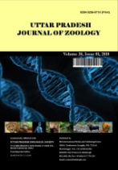
Uttar Pradesh Journal of Zoology

Volume XXX, Issue XX, Page XX-XX, 20YY; Article no.UPJOZ.5656
ISSN: 0256-971X (P)

Assessment of Citrus reticulata Powder Extract on the Control of

Sitophilus oryzae in Stored Maize Grains

Authors’ Name……………………………………………………

Affiliations……………………………………………………….………………

Authors’ contributions

This work was carried out in collaboration among all authors. All authors read and approved the final manuscript.

Article Information

DOI: 10.56557/UPJOZ/2025/XXXX

Open Peer Review History:
This journal follows the Advanced Open Peer Review policy. Identity of the Reviewers, Editor(s) and additional Reviewers, peer review comments, different versions of the manuscript, comments of the editors, etc are available here:

Received: DD/MM/20YY
Article
Published: DD/MM/20YY

Abstract

Sitophilus oryzae (rice weevil) is a severe insect pest that causes substantial post- harvest loss both qualitatively and quantitatively in stored grains. The use of plant- based insecticides offers a safer alternative for managing stored insect pests than chemical insecticides, which pose a serious health risk to both humans and the environment. This study aimed to investigate the efficacy of Citrus reticulata peel powder extract on mortality and weight loss in maize grains infested with the Sitophilus oryzae. Shade-dried orange peels were utilized for powder synthesis. Adult rice weevils were exposed to 1%, 1.5%, 2% and 2.5% (w/w) powder extract, treated 30 gm maize grains and untreated maize grains were also used as the control for a period of 21 days.

Keywords: Sitophilus oryzae; Citrus reticulata; post-harvest losses; insect pests; powder extract.

1. Introduction

Globally, maize production of 1163 million tonnes was observed over a crop area of 205 million hectares during 2022-23. In maize production, USA was the leading country with a share of 31.3% among maize-producing countries. India contributed about 2.7% share in maize production and holds the seventh rank worldwide (ANGRAU – maize outlook report, June to May 2023-24). Maize is a cereal grain that belongs to family Poaceae. After wheat and rice, maize is considered one of the most important grains for agriculture in the world (Devi et al. 2014). According to Kumari and Jha (2022) the maize contains 60% starch, 13.2% protein, 2.5% crude fibre and 1.2% sugar. Insect pests cause substantial damage during the storage of stored grain and its products. Sitophilus oryzae is one of the major harmful insect pests of stored grain (Soujanya et al. 2016). Infestation of Sitophilus oryzae caused a significant weight loss and reduction in amylose content in rice varieties (Zulaikha & Yaakop, 2021). Uneven holes on the outer layer of the corn kernels were the signs of Sitophilus oryzae infestation (Octavianti et al., 2024).

There is difficulty in managing insect pests that cause economic losses during storage. Insect pests lead to 9% storage losses in developed countries and more than 20% of storage losses in developing countries (Anandha bhairavi et al., 2022). Around 10 % loss of stored food grains is caused by unsystematic handling of the insect pests, microorganisms and mites (Chayengia et al. 2010). Storage carries around 7.5% share out of the various stages in the post-harvest losses (Mesbahm et al. 2018). Post-harvest losses take place in the middle of harvest and the time of human consumption.

The Use of synthetic pesticides is recurrent in preventing stored grains from insect pests because of their toxic action against various pests at different life stages (Akbar et al. 2022). There is a gradual limitation in the usage of commonly used insecticides due to their various detrimental effects in controlling insect pests (Soujanya et al. 2016). In managing insect pests, the use of plant products as an alternative method is a promising way to overcome the toxic effects of synthetic chemical insecticides. A powder from plant material forms a protective shield around the stored grain, helping to safeguard it (Azis et al. 2016).
Various plant species with insecticidal properties, including some with medicinal properties, are generally found in tropical areas (Ileke and Ogungbite, 2014). The insecticidal potential of orange peel has been attributed to its secondary metabolites, as observed in their study (Sharma and Gupta, 2025). Insecticidal properties of fruit peel of several Citrus species were revealed that attack insect pests (Abbas et al. 2012). Citrus reticulata peel showed both contact and fumigant activity against different insects (Diniso et al. 2024). Orange peel powder causes 66% mortality against Zabrotes subfasciatus (Zewde & Jembere, 2010). Citrus sinesis rind powder exhibited moderate toxicity against maize weevils, causing 51% mortality at 35 and 42 days post-treatment, as reported by Emeasor and Okorie (2008). Mortality and weak growth were seen in Callosobruchus maculatus after the application of orange peel powder and oil-treated cowpeas (Ekeh et al. 2013). The present study evaluates the efficacy of Citrus peel powder on the mortality of Sitophilus oryzae and grain weight loss in maize grain.

2. Materials and Methods

The present research was carried out in the laboratory of the Department of Zoology, R.B.S College, Dr. B.R. Ambedkar University, Agra-282002, Uttar Pradesh, India.

2.1 Collection, Identification and Rearing of Test Insects

The test insect was obtained from naturally infested maize grains from the Motiganj, Rawatpada market of Agra region. The insect was identified based on its morphological characteristics (Halstead, 1963). Around 200 adults were released in a 1 litre jar containing 500 grams of disinfested maize grains bought from the market (Soujanya et al. 2016) at a temperature of 29 ± 3.7 º C and 67.2 ± 15% relative humidity.

2.2 Selection of Plant Material and Preparation of Powder

The selection of plant material used in this study was based on factors like availability, effectiveness against stored insect pests and earlier research carried out on the plants. Citrus reticulata was selected for the present study.

Orange fruits were purchased from the local market of Agra. The oranges were washed with tap water, and the peel was separated, cut into small pieces, and shade-dried for 92 hrs. The dried peels were pounded with a mortar and pestle to make a coarse powder and stored it in an air-tight container for further use (Gotmare and Gade, 2018).

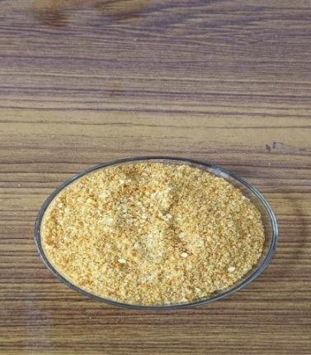

Fig. 1. Orange peel powder

2.3 Bioassay

150 gm of maize grains and glass jars were sterilized in an oven at 70º C for 1 hour (Mesbahm et al. 2018). 30 gm sterilized maize grains were mixed with the five different concentration of citrus peel powder for 1, 1.5, 2 and 2.5% (w/w = weight of powder/ weight of maize grains) in the 125 ml flask and manually shook for 30 second. The treated maize grains were carried onto the sterilized jars after which 10 pairs of adult weevils were released into each jar and the mouth of each jar was covered with muslin cloth secured by a rubber band to prevent any escape of weevils. A control treatment was also set up, in which no powder was added. The treatments were replicated three times (Asmanizar et al., 2012).

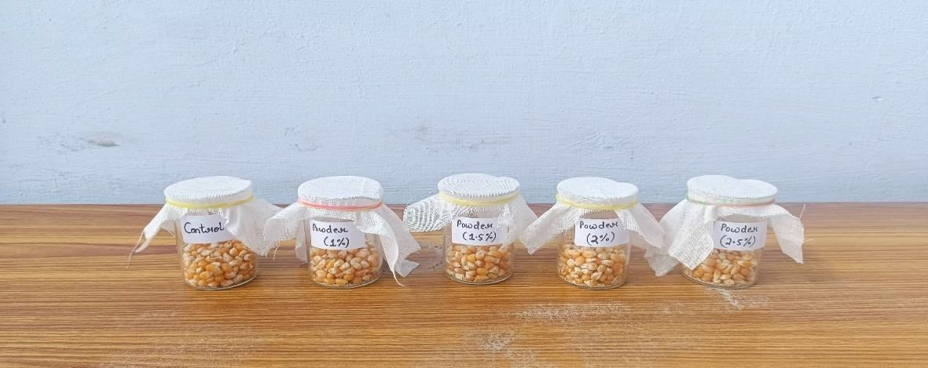

Fig. 2. Bioassay for mortality and weight loss in orange peel treated maize grains

2.4 Assessment of Mortality

For the mortality, the numbers of dead insects were counted at 1, 3, 7, 14 and 21 days after treatment. Rice weevil mortality was calculated by using Abbott’s formula (1925):

$$Percentage of corrected mortality =\frac{(Observed mortality - Control mortality)}{100 - Control mortality} × 100$$

2.5 Assessment of Weight Loss

The weight loss was estimated after 21 days of treatment and calculated as the difference between the final and initial weights of treated or untreated grain and expressed as a percentage of the initial weight of grains. The following equation was used:

$$\%WL=\frac{IW - FW}{IW}×100$$

Where,

WL = Weight Loss Index IW = Initial weight
FW = Final weight

2.6 Statistical Analysis

The experiment was statistically analyzed through one way ANOVA at value p<0.05 followed by Tukey’s Post Hoc test with p≤0.05. The percentage (%) mortality of Sitophilus oryzae and weight loss in maize grains was expressed as the mean ± SD of three replications.

3. Results and Discussion

The result presented in Table 1 revealed significantly (p<0.5) higher mortality at 21 days in powder-treated maize grains when compared to the untreated ones. The data of mortality percentage of rice weevil after 1, 3, 7, 14 and 21 days were recorded for powder-treated maize grains at 1%, 1.5%, 2% and 2.5% w/w. The results demonstrated that the mortality rate increased from 18.59% to 35.52% with the increase in dosage level of the powder extract from 1% to 2.5% at 21 days after treatment. Similar findings were observed by Tesfaye et al. (2021) in sorghum treated with orange peel powder, where the mortality rate of Sitophilus oryzae increased from 3.18% in the untreated control to 17.73% in the treated one after 21 days of treatment.

Mesbah et al. (2011) reported 67.5% mortality in rice treated with 0.5 gm orange peel powder after 21 days. Yunis (2014) also observed that the effect of orange peel powder showed the mean mortality of 63% after 3 days of exposure period on the confused beetle Tribolium confusum. Abdullahi et al. (2010) noted a 92 % mortality rate with the application of citrus peel powder after 120 hrs post-treatment against Tribolium castaneum. Iram et al. (2013) evaluated the Citrus reticulata and Psidium guajava for the control of Tribolium castaneum. In their study, Citrus reticulata peel powder showed a mortality of 63.66% after 21 days of treatment period. Rice treated with powder of Melia azedarach showed mortality of 80.54% in Sitophilus oryzae after 35 days reported by Devi et al. 2014. Emeasor and Okorie (2008) reported the 51% mortality after application of Citrus sinesis rind powder for the control of Sitophilus zeamais on maize grains. Asmanizar et al. (2012) reported the leaf powder of Azadirachta indica and Jatropa curcas showed mortality of 32.32% and 77.84%, respectively in Sitophilus zeamais. Certain plant material e.g. Catharanthus roseus and Annona squamosa showed significant mortalities of 16.67% and 13.3%, respectively in Sitophilus oryzae after a month (Radhakrishnan et al. 2025).

The data of mean percentage weight loss of maize grains treated with different doses of Citrus reticulata peel powder extract are shown in Table 2. The weight loss was observed from 10.87% to 12.96% after 21 days post- treatment indicated a noticeable reduction among the different dosages of powder extract in comparison to untreated control maize grains, in which 24.12% weight loss was recorded. These findings were supported by Chayengia et al. (2010) who reported that Citrus reticulata peel powder reduced the weight loss of stored rice caused by Sitophilus oryzae from 5.49% in the control to 4.35% in treated rice grain after 35 days of exposure period. Work of Nta et al. (2017) also showed that a significant reduction in weight loss of maize grain was found with different plant powder extracts caused by Sitophilus oryzae. In their study, the efficacy of powder of Citrus sinesis, Citrus reticulata, Citrus limon, Citrus paradisi and Citrus aurantifolia at concentrations of 2%, 4%, 8% and 10% (w/w) were tested for weight loss percentage study in maize grains. Zewde and Jembere (2010), evaluated the toxicity and repellency of orange peel as a grain damage protectant against Zabrotes subfasciatus. They recorded that the mean weight loss percentage in haricot beans was 2.33% in control (untreated) grain, while 0.00% was recorded with use of orange peel powder at 15g in 250g grain after 45 days of post-treatment. Vijay et al. (2015) studied weight loss in split pulses infested by Sitophilus oryzae and found that it depended on many factors like Variety of grain, storage conditions, species of pest and duration of storage. Similar findings were also presented by Sangma et al. (2022) by using various leaf powder to protect maize grain against Sitophilus zeamais and found Lantana leaf powder was most effective among all tested leaf powders. Weight loss of 0.87% was recorded in maize grain with lantana leaf powder while it was recorded as 12.42% in control condition.

Table 1. Effect of powder extract of orange peel on the mortality of Sitophilus oryzae on maize

S. no. | Day | Mean % mortality of powder extract (w/w %) |  |  |  | F value | P value
S. no. | Day | 1% | 1.5% | 2% | 2.5% | F value | P value
1 | 1 | 0±0ª | 6.84±2.736^{abc} | 11.936±3.33^{cd} | 20.346±5.035^{d} | 20.056 | 0.0004
2 | 3 | 5±5 ª | 11.926±7.47 ^{ab} | 18.593±5.56 ^{ab} | 23.766±3.326^{b} | 6.484 | 0.015
3 | 7 | 8.42±2.736 ª | 16.84±5.473 ^{ab} | 20.346±5.035^{b} | 23.766±3.326^{b} | 7.047 | 0.012
4 | 14 | 13.506±2.586 ª | 16.84±5.473 ^{ab} | 25.346±4.49 ^{bc} | 28.766±2.136^{c} | 9.947 | 0.004
5 | 21 | 18.593±2.436 ª | 21.926±5.323 ª | 27.013±7.19^{ab} | 35.52±4.243^{b} | 6.262 | 0.017
Note: The values of % mortality after correction of control mortality represent the mean ± SD of triplet experiments. Statistical analysis through one-way ANOVA at p<0.05 followed by Tukey’s Post Hoc test with p≤0.05 was used. The means with different alphabets are significantly different with each other as indicated by Tukey’s Post Hoc test (row by row analysis) at alpha = 0.05.

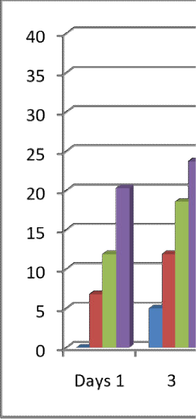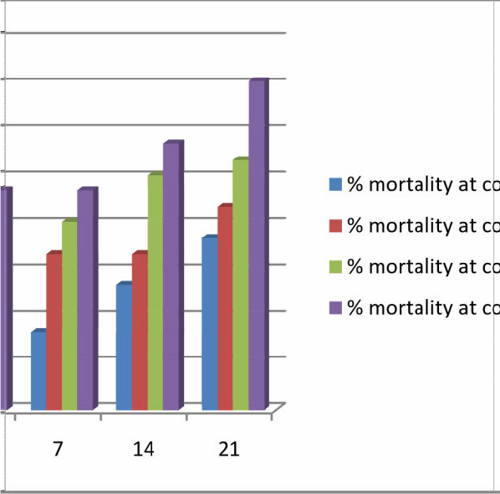

Fig. 3. Effect of powder extract of orange peel on the mortality of Sitophilus oryzae on maize

Table 2. Effect of powder extract of orange peel on the weight loss in maize caused by Sitophilus oryzae after 21 days

S. no. | Mean % wt loss in control | Mean % wt loss in maize with powder extract (w/w %) |  |  |  | F value
S. no. | Mean % wt loss in control | 1% | 1.5% | 2% | 2.5% | F value
1 | 24.12±0.27ª | 12.96±0.40 ^{b} | 12.52±0.26 ^{b} | 11.7±0.22 ^{c} | 10.87±0.40 ^{d} | 1017.6
Note: The values of % weight loss in rice represent the mean ± SD of triplet experiments. Statistical analysis through one way ANOVA at value p<0.05 followed by Tukey’s Post Hoc test with p≤0.05 was used. The means with different alphabets are significantly different with each other as indicated by Tukey’s Post Hoc test (row by row analysis) at alpha = 0.05



Fig. 4. Effect of powder extract of orange peel on the weight loss in maize caused by Sitophilus oryzae after 21 days

4. Conclusion

The results obtained from this study confirmed that Citrus reticulata possessed toxic effect against the Sitophilus oryzae. The findings of the present study supported that the Orange peel powder extract had insecticidal properties against the rice weevil (Sitophilus oryzae) and helped to reduce the post-harvest grain damage. The efficacy of orange peel powder was increased with increasing both the concentration and duration of exposure. The orange peel powder could be used for the protection of grains during storage from insect pests rather than applying synthetic pesticides due to the harmless feature of the powder towards human health (Akunne & Ononye, 2015).

Orange peel is also easily available throughout the country. Rather than letting orange peels become environmental pollutants, it can be utilised in formulating nutritious animal feed to promote sustainable development (Akinlabu et al. 2024). Therefore, orange peel powder could be used as a biopesticide for the management of insect pests in stored grains. Orange peel waste contains a bioactive compound (e.g. limonene) that possesses insecticidal activity, which can be utilized for the regulation of herbivore insects, weeds, and nematodes when applied as a foliar spray, soil additive that limits the reliance on synthetic pesticides. (Kato- Noguchi & Kato, 2025).

Disclaimer (Artificial Intelligence)

Author(s) hereby declare that NO generative AI technologies such as Large Language Models (ChatGPT, COPILOT, etc) and text-to-image generators have been used during writing or editing of this manuscript.

Acknowledgement

Authors express their sincere thanks to Prof. Vijay Shrivastav and Prof. Kamal Singh for guiding and providing help to procure materials.

Competing Interests

Authors have declared that no competing interests exist.

References

Abbas, S. K., Farooq Ahmad, F. A., Muhammad Sagheer, M. S., Mansoor-ul-Hasan, M. U. H., Muhammad Yasir, M. Y., Saeed Ahmad, S. A., & Wali Muhammad, W. M. (2012). Insecticidal and growth inhibition activities of Citrus paradisi and Citrus reticulata essential oils against lesser grain borer, Rhyzopertha dominica (F.) (Coleoptera: Bostrichidae). World Journal of Zoology, 7(4), 289–294.
Abbott, W. S. (1925). A method of computing the effectiveness of an insecticide. Journal of Economic Entomology, 18(2), 265–267. https://doi.org/10.1093/jee/18.2.265
Abdullahi, N. A., Muhammed, A., & Tukur, Z. (2010). Assessment of citrus peel powder against Tribolium castaneum (Coleoptera: Tenebionidae) infesting stored products. Bioscience Research Communications, 22(5), 283–286.
Akbar, R., Khan, I. A., Alajmi, R. A., Ali, A., Faheem, B., Usman, A., Ahmed, A. M., El-Shazly, M., Farid, A., Giesy, J. P., & Aboul-Soud, M. A. M. (2022). Evaluation of insecticidal potentials of five plant extracts against the stored grain pest, Callosobruchus maculatus (Coleoptera: Bruchidae). Insects, 13(11), 1047. https://doi.org/10.3390/insects13111047
Akinlabu, K. D., Owoeye, T. F., Emetere, M. E., Jonathan, H. O., Owoeye, D. I., & Akinlabu, P. O. (2024). Investigation of proximate analysis and phytochemical screening of dry orange waste (Citrus sinensis) extract: From agrowaste to sustainable development. IOP Conference Series: Earth and Environmental Science, 1342(1), 012016. https://doi.org/10.1088/1755-1315/1342/1/012016
Akunne, C. E., & Ononye, B. U. (2015). Entomocidal effect of a local spicy and fruit peel powders as rice grain protectant against Sitophilus oryzae (L.) (Coleoptera: Curculionidae). Journal of Entomology and Zoology Studies, 3(3), 208–211.
Anandha Bhairavi, N., Shanthi, M., Chinniah, C., Geetha, R., & Vellaikumar, S. (2022). Efficacy of hexane extracts of some plants against rice weevil Sitophilus oryzae (L.) in stored maize. Indian Journal of Entomology, 84(2), 368–372. https://doi.org/10.55446/IJE.2021.41
Asmanizar, A., Djamin, A., & Idris, A. B. (2012). Effect of four selected plant powder as rice grain protectant against Sitophilus zeamais (Coleoptera: Curculionidae). Sains Malaysiana, 41(7), 863–869.
Azis, T. M. F., Mohamad, S., & Azmi, N. M. (2016). Repellent effects of dried and powder of Citrus limon, Capsicum annum, Cinnamomum zeylanicum, and Mentha piparita on rice weevils Sitophilus oryzae in rice products. Journal of Applied Environmental and Biological Sciences, 6(10S), 79–82.
Centre for Agriculture and Rural Development Policy Research. (2023-24). ANGRAU maize outlook report – June to May 2023-24. Acharya N. G. Ranga Agricultural University. https://angrau.ac.in/downloads/AMIC/OutlookReports/2023_24/Maize%20outlook-June-july-2023-24.pdf
Chayengia, B., Patgiri, P., Rahman, Z., & Sarma, S. (2010). Efficacy of different plant products against Sitophilus oryzae (Linn.) (Coleoptera: Curculionidae) infestation on stored rice. Journal of Biopesticides, 3(3), 604–609. https://doi.org/10.57182/jbiopestic.3.3.604-609
Devi, M. B., Devi, N. V., & Singh, S. N. (2014). Effects of six botanical plant powder extracts on the control of rice weevil, Sitophilus oryzae L., in stored rice grains. International Journal of Agriculture Innovations and Research, 2(5), 683–686. https://www.ijair.org/volume-2-issue-5-march-2014/IJAIR_510_Final.pdf
Diniso, T., Oriola, A. O., Adeyemi, J. O., Miya, G. M., Hosu, Y. S., Oyedeji, O. O., Kuria, S. K., & Oyedeji, A. O. (2024). Citrus wastes: A valuable raw material for biological applications. Journal of Applied Pharmaceutical Science, 14(8), 011–026. https://doi.org/10.7324/JAPS.2024.158781
Ekeh, F. N., Oleru, K. I., Ivoke, N., Nwani, C. D., & Eyo, J. E. (2013). Effects of Citrus sinensis peel oil on the oviposition and development of cowpea beetle Callosobruchus maculatus (Coleoptera: Chrysomelidae) in some legume grains. Pakistan Journal of Zoology, 45(4).
Emeasor, K. C., & Okorie, C. C. (2008). Comparative efficacy of sweet orange, Citrus sinensis (L.) rind powder and oil for the control of maize weevil, Sitophilus zeamais (Motschulsky). Agro-Science, 7(1), 9–14.
Gotmare, S., & Gade, J. (2018). Orange peel: A potential source of phytochemical compounds. International Journal of ChemTech Research, 11(02), 240–243. https://doi.org/10.20902/IJCTR.2018.110229
Halstead, D. G. H. (1963). External sex differences in stored-products Coleoptera. Bulletin of Entomological Research, 54(1), 119–134. https://doi.org/10.1017/S0007485300048665
Ileke, K. D., & Ogungbite, O. C. (2014). Entomocidal activity of powders and extracts of four medicinal plants against Sitophilus oryzae (L.), Oryzaephilus mercator (Faur), and Rhyzopertha dominica (Fabr.). Jordan Journal of Biological Sciences, 7(1), 57–62. http://jjbs.hu.edu.jo/
Iram, N., Arshad, M., & Akhter, N. (2013). Evaluation of botanical and synthetic insecticide for the control of Tribolium castaneum (Herbst) (Coleoptera: Tenebrionidae). BioAssay. https://doi.org/10.14295/BA.v8.0.117
Kato-Noguchi, H., & Kato, M. (2025). Pesticidal activity of citrus fruits for the development of sustainable fruit-processing waste management and agricultural production. Plants, 14(5), 754. https://doi.org/10.3390/plants14050754
Kumari, A., & Jha, A. K. (2022). Study of the effect of neem leaves powder and orange peels powder on weevil growing on maize grains. Biospectra, 17(1), 17–22.
Mesbah, H. A. A., Tayeb, E. H. M., El-Sayed, N. A. A., El-Kady, M. B. A., & Greira, A. A. (2011). Biological performance of certain botanical fine dusts, ash and sulfur powders against the rice weevil Sitophilus oryzae (L.) (Coleoptera: Curculionidae). Alexandria Science Exchange Journal, 32(April–June), 173–181.
Mesbahm, H. A., Mahomed, A. A., & Aajel, M. S. (2018). Eco-friendly tools for controlling of the rice weevil Sitophilus oryzea (Coleoptera: Curculionidae). Alexandria Science Exchange Journal, 39(July–September), 482–493. https://doi.org/10.21608/asejaiqjsae.2018.15922
Nta, A. I., Okweche, S. I., & Udo, I. A. (2017). Insecticidal and insect reproductive inhibition potential of citrus peel powder on Tribolium castaneum (Herbst). Applied Tropical Agriculture, 22(2), 111–117.
Octavianti, D. F., Megasari, D., & Prasetyawati, E. T. (2024). Resistance response of five maize grain varieties to Sitophilus zeamais and Sitophilus oryzae (Coleoptera: Curculionidae). Agrovigor: Jurnal Agroekoteknologi, 17(2), 98–104. https://journal.trunojoyo.ac.id/agrovigor/
Radhakrishnan, V., Arulprakash, R., Ravi, M., Allwin, L., Vijay, S., Vijayaprabhakar, A., Karunakaran, V., Periyar Ramasamy, D., & Harisudan, C. (2025). Botanical management of Sitophilus oryzae (L.) in sorghum seeds. International Journal of Agriculture and Food Science, 7(1), 35–37. https://doi.org/10.33545/2664844X.2025.v7.i1a.235
Sangma, R. H. C., Patra, S., Thakur, N. S. A., & Baiswar, P. (2022). Management of maize weevil, Sitophilus zeamais (M.) using indigenous plant extracts at medium altitude hills of Meghalaya. Indian Journal of Hill Farming, 35, 214–223. https://ijhfonline.org/index.php/ijhf/article/view/51
Sharma, P., & Gupta, S. (2025). Phytochemical screening and thin layer chromatography of Citrus reticulata peel extract. Current Journal of Applied Science and Technology, 44(10), 80–87. https://doi.org/10.9734/cjast/2025/v44i104621
Soujanya, P. L., Sekhar, J. C., & Kumar, P. (2016). Efficacy of plant extracts against rice weevil Sitophilus oryzae (L.) in stored maize. Indian Journal of Entomology, 78(4), 342–345. https://doi.org/10.5958/0974-8172.2016.00089.4
Tesfaye, A., Jenber, A. J., & Mintesnot, M. (2021). Survey of storage insect pests and management of rice weevil, Sitophilus oryzae, using botanicals on sorghum (Sorghum bicolor L.) at Jawi District, Northwestern Ethiopia. Archives of Phytopathology and Plant Protection, 54(19–20), 2085–2100. https://doi.org/10.1080/03235408.2021.1970976
Vijay, S., Bhuvaneswari, K., & Gajendran, G. (2015). Assessment of grain damage and weight loss caused by Sitophilus oryzae (L.) feeding on split pulses. Agricultural Science Digest-A Research Journal, 35(2), 111–115. https://doi.org/10.5958/0976-0547.2015.00019.1
Yunis, M. I. (2014). Effect of orange peel (Citrus sinensis) (L.) extracts and powder on confused flour beetle Tribolium confusum (Coleoptera: Tenebrionidae). Iraqi Journal of Science, 55(3B), 1164–1169. https://ijs.uobaghdad.edu.iq/index.php/eijs/article/view/11543
Zewde, D. K., & Jembere, B. (2010). Evaluation of orange peel Citrus sinensis (L.) as a source of repellent, toxicant and protectant against Zabrotes subfasciatus (Coleoptera: Bruchidae). Momona Ethiopian Journal of Science, 2(1), 61–75. https://www.ajol.info/index.php/mejs/article/view/69030
Zulaikha, S. A. S., & Yaakop, S. (2021). Effect on Sitophilus oryzae infestation on amylose content and weight loss of eight rice varieties. Pakistan Journal of Agricultural Sciences, 58(6), 1699–1703. https://doi.org/10.21162/PAKJAS/21.480

Disclaimer/Publisher’s Note: The statements, opinions and data contained in all publications are solely those of the individual author(s) and contributor(s) and not of the publisher and/or the editor(s). This publisher and/or the editor(s) disclaim responsibility for any injury to people or property resulting from any ideas, methods, instructions or products referred to in the content.

© Copyright (2025): Author(s). The licensee is the journal publisher. This is an Open Access article distributed under the terms of the Creative Commons Attribution License (http://creativecommons.org/licenses/by/4.0), which permits unrestricted use, distribution, and reproduction in any medium, provided the original work is properly cited.

