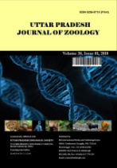
Uttar Pradesh Journal of Zoology

Volume XXX, Issue XX, Page XX-XX, 20YY; Article no.UPJOZ.5595
ISSN: 0256-971X (P)

Morphological Description

and Taxonomic Notes on

Poecilobdella tarubalaae sp. nov. from

Karnataka, India

Authors’ Name……………………………………………………

Affiliations……………………………………………………….………………

Authors’ contributions

This work was carried out in collaboration among all authors. ‘Author A’ designed the study, performed the statistical analysis, wrote the protocol, and wrote the first draft of the manuscript. ‘Author B’ and ‘Author C’ managed the analyses of the study. ‘Author C’ managed the literature searches. All authors read and approved the final manuscript.

Article Information

DOI: 10.56557/UPJOZ/2025/XXXX

Open Peer Review History:
This journal follows the Advanced Open Peer Review policy. Identity of the Reviewers, Editor(s) and additional Reviewers, peer review comments, different versions of the manuscript, comments of the editors, etc are available here:

Received: DD/MM/20YY
………… Article
Published: DD/MM/20YY

Abstract

In search of medicinal leeches, one of the author Anoop sachi found the leech and collected it by dip net from Agara lake, Bangalore, Karnataka. Identification have been done under the Binocular LEICA EZ4 HD in ZSI and compaired with the other leeches of Poecilobdella genus in the world. As a result authors came to know that it is a new leech of the genus. Structure of Vaginal duct, Vaginal sac, Position of male and female pore, pattern of stripe, number of total segments, positions of eyes, all are different from other 9 aquatic species of the genus Poecilobdella. It may be used as medicinal leech in the world. The world is having more than 721 species of leeches and India possesses 84 species of leech. Dinobdella ferox (Blanchard, 1896) and species of Poecilobdella genus are used as medicinal leech in India. There are 9 leech species of Poecilobdella genus in the world. These leeches are freshwater and used as medicinal purposes. Poecilobdella hubeiensis Yang, 1980 from China, Poecilobdella nanjingensis Nnkano & Lai (2016) from Taiwan same as Poecilobdella granulosa, Poecilobdella blanchardi (Moore, 1927) from Kerala Synonyms of Poecilobdella manillensis, Poecilobdella aligarhensis Mandal et al., 2021. Poecilobdella kananbalaae Mandal et al., 2025. Poecilobdella granulosa Savigny, 1820, Poecilobdella javanica Wahlberg, 1856, Poecilobdella manilensis Lesson, 1842, Poecilobdella viridis Moore, 1927. Here the opportunity to discover a new leech Poecilobdella tarubalaae from Agara lake, Bangalore, Karnataka, India.

Keywords: Annelida; new leech; Poecilobdella tarubalaae; Bangalore; Karnataka, India.

1. Introduction

As each and every organism has importance in this universe. Leeches are also beneficial for human beings. It cures the old wounds and skin diseases by sucking blood. Most interesting thing is paralytic patient cured by the hirudin injection. About 721 leech found in the world, and India has 84 species still now. There are 9 Poecilobdellid leeches in the world. Poecilobdella hubeiensis Yang, 1980 from China, Poecilobdella nanjingensis Nnkano & Lai (2016) from Taiwan same as Poecilobdella granulosa, Poecilobdella blanchardi (Moore, 1927) from Kerala India, Synonyms of Poecilobdella manillensis, (Lesson, 1842), Poecilobdella aligarhensis Mandal et al., 2021 from Aligarh India, Poecilobdella kananbalaae Mandal et al., 2025 from Karnataka India, Poecilobdella granulosa Savigny, 1820 from Pondichery India, Poecilobdella javanica (Wahlberg, 1856) from Java, Poecilobdella manilensis (Lesson, 1842) from Philippines, Poecilobdella viridis Moore, 1927 from Travancore Kerala India, used as medicinal leech. Leeches of the Poecilobdella genus are medium to large in size, Colour variable brown, green, reddish. Dorsal area possesses black stripes metameric spots. Eyes large, 5 pairs to 9 pairs (Poecilobdella aligarhensis). Gonopores separated by 5 to 7 annuli (Poecilobdella javanica). Recently the authors have the opportunity to record a species Poecilobdella tarubalaae from Karnataka India which is new to science. Because structure of internal organs such as, vaginal sac, duct, superficial characters such as position of genital aperatures, pattern of stripes, total segments, eyes distribution, all are different from other 9 aquatic leech species of the genus Poecilobdella in the world.

Important taxonomic work on leeches done by Harding & Moore (1927) in India. Chandra made checklist of leeches (1982). Total 60 leech species established in India up to 2003. Mandal contributed 24 leeches (2004 -2025). Ghosh (1998) provided valuable work on leech taxonomy in West Bengal, India. Soota and Ghosh (1977), Chandra (1984) and Sanjeeva Raj and Glandstone (1981) provided great contribution on classification of Indian leech. Chandra (1991) has done check list Indian leeches. Mandal (2025) worked on taxonomy of a new medicinal leech. Harding & Moore's (1924, 1927) from India. Bhatia (1940), Annandale (1913) and Kaburaki (1921) has done great job on leech taxonomy in south Asia.

Soós (1965) had done the pioneer work on leech taxonomy in the world. Sawyer, R.T. (1986), Nesemann, H. & Neubert, E. (1999), Savigny, J.C. (1820), Linnaeus (1767), Savigny (1820), Tennent's (1859), Whitman's (1886) had done excellent work on leech from abroad.

2. Materials and Methods

These leeches were collected by dip net from the lake Agara of Bangalore, Karnataka by one of the author. Collectors have to go into the water first almost 2 feet deep, then have to wave water by dip net. Due to waving, leeches come out from deep water to suck human beings. During this time the collector dips the net below and takes the leeches out from the water. After collection, leeches are cleaned in fresh water. The collected leeches are narcotized by pouring 70% alcohol into one litter bottle filled with fresh water up to one third portion. First 10 ml will be added slowly. After half an hour again we will add another 10 ml. After one hour again 10 ml is added if the leech is not narcotized fully. Following this the specimen is cleaned by fresh water because mucous and blood comes out after narcotization. This cleaned specimen is kept in 4 percent formalin for 24 hours as it facilitates for good dissection. Finally, the specimen is preserved in 70 percent alcohol. It is then dissected and its taxonomical characters are studied in detail. The specimens are deposited in ZSI Type Repository of General Non-Chordata section, for reference of future scientists.

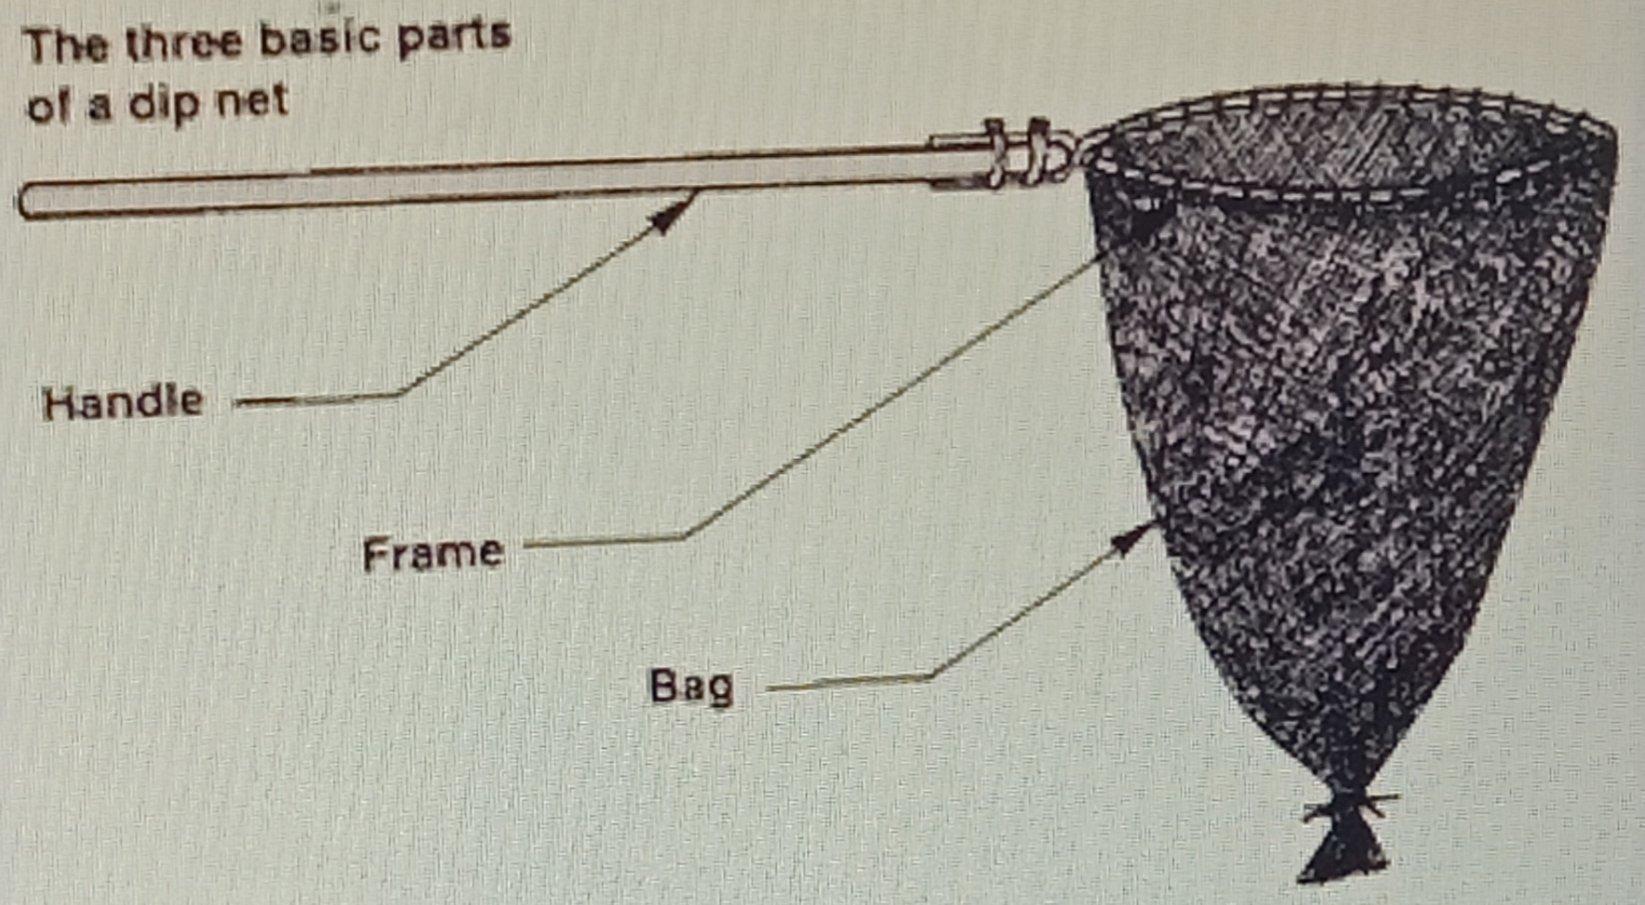

Fig.1. The three basic parts of a dip net

Material Examined: Agara lake, Bangalore, Karnataka, India. (Latitude 12̊ 55̍ 14̎ No, Longitude 77̊ 38 38 and Altitude 885metres). Holotype- 01ex. (ZSI-GNC-An 88374/2A); Paratype - 01ex. (ZSI-GNC-An 88374/2B); 18. VII. 2023. Coll. Dr. Anoop Sachi.

3. Results and Discussion

Poecilobdella genus having 9 species of leeches in the world. Poecilobdella hubeiensis Yang, 1980, Poecilobdella nanjingensis Yang, T. 1996 which is same as Poecilobdella granulosa, Poecilobdella blanchardi (Moore, 1927) Synonyms of Poecilobdella manillensis, Poecilobdella aligarhensis Mandal et al., 2021, Poecilobdella kananbalaae Mandal et al., 2025, Poecilobdella granulosa Savigny, 1820, Poecilobdella javanica Wahlberg, 1856, Poecilobdella manillensis (Lesson, 1842), Poecilobdella viridis Moore, 1927. Dr. Anoop Sachi collected medicinal leeches from Karnataka for research purpose, He brought it in ZSI for identification. 1st author identified it as Poecilobdella tarubalaae which is proposed as new leech to science. All the leeches of Poecilobdella genus are found in freshwater habitat. Due to inclusion of the species collected by Dr. Anoop Sachi, the number of species of the Genus Poecilobdella will be 8 in India and10 in the world.

3.1 Diagnostic Characters (Plate-1 & 2): Poecilobdella tarubalaae sp. nov.

The specimens of leeches were collected from Karnataka. Teeth well developed. Salivary papillae on jaws numerous. Vaginal stalk very short. Gonopores separated by 5 annuli. The leeches were originally of greyish-green colouration. But during transit, the leeches died and the sample were degraded. First two anterior segments bear 1 annulus in each. Second 2 segments also bearing 2 annuli in each segment. Other segments are composed of 4 annuli in each segment. White spoted sensillae differentiate the segments Three jaws are in the deep of the anterior sucker. The length on this specimen were about 4 cm and width approximately 5 mm. Anterior sucker 4mm. in diameter on the other hand posterior sucker 5mm. There are no species of the genus in the world as it is having. The mid dorsal stripe was ash coloured and there were two lateral stripes white in colour with 2 pair of black spots on either side of the lateral stripes. The ventral region having white coloured spots 2 pairs on black background. The gonophores were situated between 32th and 33th annuli and between 37th and 38th annuli. The annuli separation on the cranial end was obscure. Eyes were arranged on 2nd, 4th, 5th, 7th and 10th annuli. Four lines of stripes are on dorsal area. Two lines of stripes having black coloured rectangular 23 spots in each line. Another 2 lines are made of 24 white spots in each line. Two lines of each ventral area composed of 18 white spots bears nephridiopore. Each white spots bears another small white spots by the side of the same. Posterior sucker is also having black spots of multi-angular shape. Total number of annuli in the body is 113. Prostate medium in size. Vaginal stalk very little, vaginal caecum moderate in size. Crop caeca 8 pairs, crop caecum 2 almost equal in size.

Distribution: Karnataka, India.

Table 1. Showing comparison Poecilobdella Poecilobdella tarubalae sp. nov. With the other Seven species of the genus poecilobdella in the world.

Characters | Poecilobdella  manillensis | Poecilobdella granulosa | Poecilobdella viridis | Poecilobdella javanica | Poecilobdella aligarhensis | Poecilobdella kananbalaae | Poecilobdella hubeiensis | Poecilobdella tarubalae sp.nov
Stripe | Stripes-Three pairs yellow stripes. One black median broken stripe. | Two pairs yellow stripes. One black line. One pair sub marginal stripes. | Presence of marginal orange stripes and metameric spots. | Dorsal dark stripes and metameric spots. | Dorsal stripes 7. medial is paler than other six dorso-lateral stripes. | Three pairs black dorsal stripe. Most lateral one pair breaking black stripe. | Two black squired stripe | One medial black stripe. Two white spotted line and 2 black spotted line.
Colour | Colour-Dorsal is Brown in ventral is green | Dorsally olive green ventrally reddish | Dorsally olive green and ventrally greyish green | Dorsally olive green and yellow marginally | Brown coloured | Brown dorsaly yellowish ventrally | Dark brown dorsally dark green ventrally | Grayish green Dorsal, Blackish background ventral with white spots.
Body length | Length-12.2cm | 9.4cm. | 11.1cm. | 10.6cm. | 42mm. | 9.9cm | _ | 4cm.
Breadth | Breadth-2.7cm. | 2.2cm. | 2.3cm. | 2.1cm. | 8mm. | 1.4cm. | _ | 5mm.
Breadth of anterior sucker | 1.8mm. | 1.9mm. | 1.7mm. | 1.3mm. | 2mm in diameter, | 6cm | - | 3.5mm
Breadth of posterior sucker | Caudal sucker- large | Almost equal | Caudal sucker smaller than anterior sucker | Caudal suckers larger almost equal of the body | Posterior sucker third time larger than the anterior sucker. | 1.1cm | Large | 3mm
Clitellum | Clitellum-Prominent | Prominent | Not prominent | Prominent | Moderate | 33-39  7 annuli | Somite XI-XII | 32-38  7 annuli
Gonophores separated by | Gonopores- 5 annuli | 5 annuli | 5 annuli | 7 annuli | 5 annuli. | 33-39  7 annuli  5 annuli | 5 annuli | Gonopores separated by 5 annuli
Vaginal Stalk and crop caecum | Vaginal Stalk-Absent | Equal in length | Double in length | Absent | Larger | Very short | Short | absent
Breading season | Breading Season-June -July | July-August | June-July | June-August | April-July | July- September | - | August-September
Eyes | Eyes-5 pairs | 5 pairs | 5 pairs | Five pairs eyes on 2,3,4,6 and 9th annuli. | Nine pairs of eyes on rings 3, 4, 6, 8 and 11th rings. | Five pairs | Five pairs 2, 3, 4, 5, 6 | Five pairs on 2,4, 5, 7 and 10th annuli
Ring | Total segments-112 | 101 | 107 | 105 | 108(including 5 rings of posterior sucker). | 110 | Within 85- 97 | 113
Reference | References-(Lesson, 1842) | ( Sevigny, 1820) | Moore, 1927 | ( Wahlberg, 1856) | Mandal et.al., 2021 | Mandal et.al., 2025 | Yang, 1980 | Recent authors

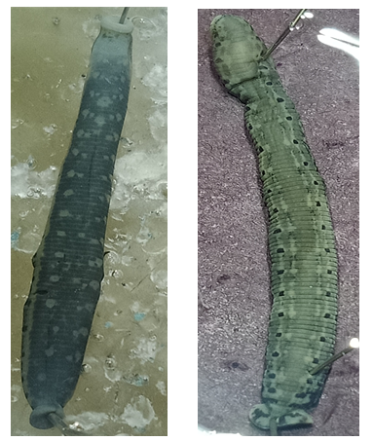

Poecilobdella tarubalaae  (Ventral view) | Poecilobdella tarubalaae  (Dorsal view)

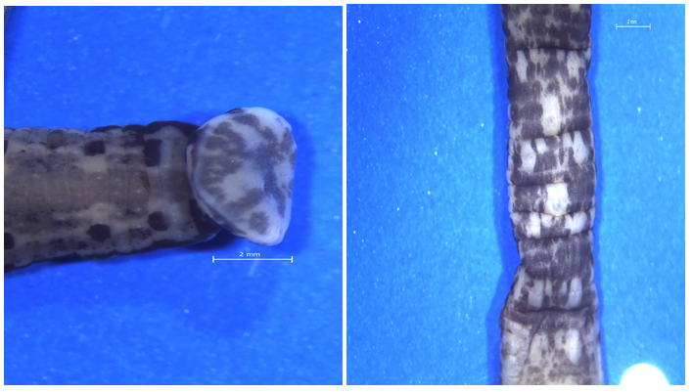

Poecilobdella tarubalaae  (Posterior sucker) | Poecilobdella tarubalaae  (Genital pores)

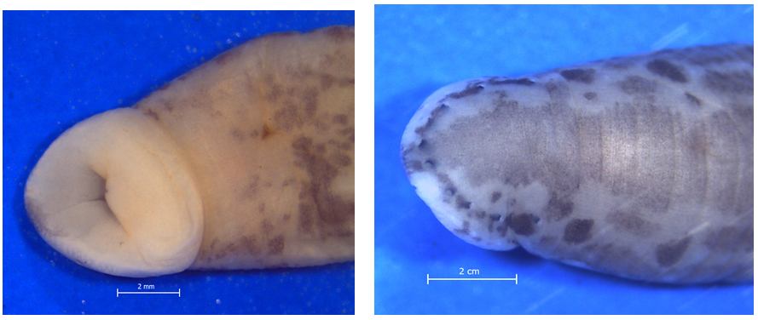

Poecilobdella tarubalaae  (Anterior sucker) | Poecilobdella tarubalaae  (Showing 5 pairs of eyes)

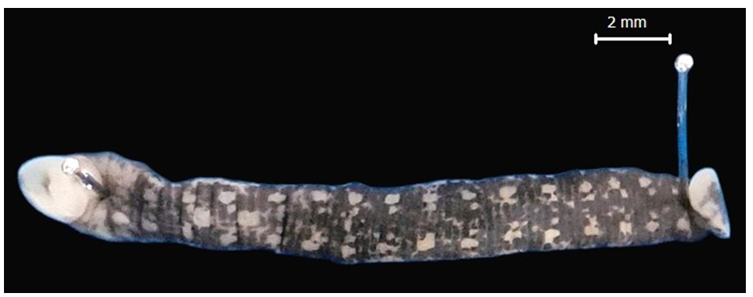

Poecilobdella tarubalaae (Ventral view)

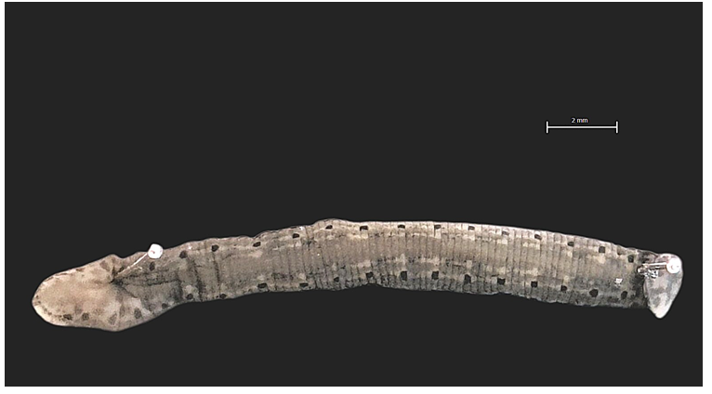

Poecilobdella tarubalaae (Dorsal view)

Plate-1. Leeches with greyish-green colouration

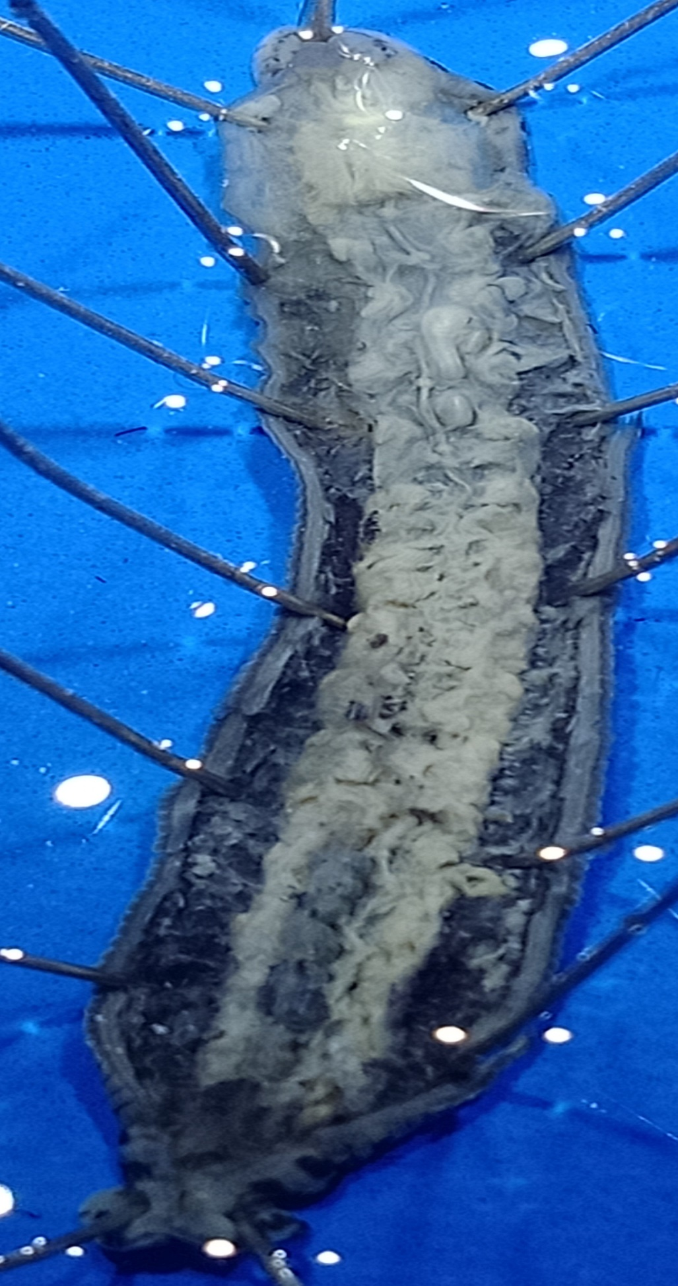

A
B

C

D

E

F

G

H

Poecilobdella tarubalaae (Dissected body showing A- Prostate, B-epididymis, C- Vaginal sac, D-8 pairs crop caeca, E-one pair caecum, F-Stomach, G- Rectum and H-Anus)

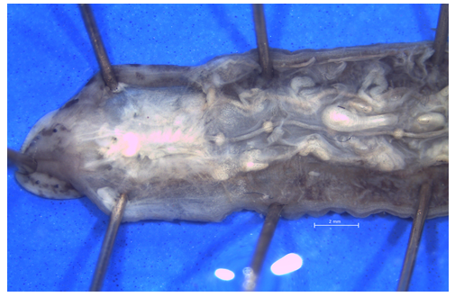

Poecilobdella tarubalaae (Anterior dissected part)

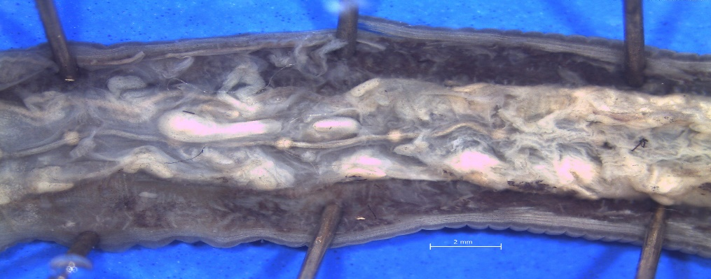

Poecilobdella tarubalaae (Middle dissected part)

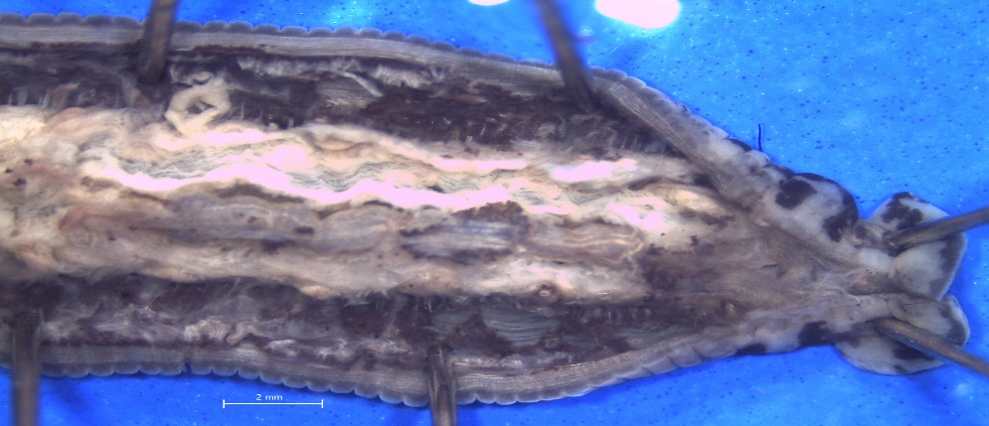

Poecilobdella tarubalaae (Posterior dissected part)

Plate 2. Morphological characteristics of leeches

Etymology: The specific name is proposed in the name of Tarubala Mandal (Birth-14.04. 1953. Mother of Dr. Chandra Kanta Mandal, Scientist C, ZSI, kind hearted, helps the needy person.

4. Conclusion

Twenty-three segments are clearly seen by the white sensillae. The length on this specimen were about 4 cm and width approximately 5 mm. Anterior sucker 4mm. in diameter on the other hand posterior sucker 5mm. There are no species of the genus in the world as it is having. The mid dorsal stripe is ash coloured and there are two lateral stripes white in colour with 2 pair of black spots on either side of the lateral stripes. The ventral region having white coloured spots 2 pairs on black background. The gonophores were situated between 32th and 33th annuli and between 37th and 38th annuli. The annuli separation on the cranial end was obscure. Eyes were arranged on 2nd, 4th, 5th, 7th and 10th annuli. Four lines of stripes are on dorsal area. Two lines of stripes having black coloured rectangular 23 spots in each line. Another 2 lines are made of 24 white spots in each line. Posterior sucker is also having black spots of multi-angular shape. Total number of annuli in the body is 113.

Disclaimer (Artificial Intelligence)

Author(s) hereby declare that NO generative AI technologies such as Large Language Models (ChatGPT, COPILOT, etc) and text-to-image generators have been used during writing or editing of this manuscript.

Acknowledgement

We are grateful to Dr. Dhriti Banerjee Director, Zoological Survey of India, for her inspiration to work hard, Dr. Marimuthu, Scientist E and O/C, General Non-Chordata Section, for his helping attitude.

Competing Interests

Authors have declared that no competing interests exist.

References

Annandale, N. (1913). The leeches of the Lake of Tiberias. Journal of the Proceedings of the Asiatic Society of Bengal (New Series), 9(6), 211–214.
Bhatia, M. L. (1940). On Haemopis indicus sp. nov., a new arhynchobdellid carnivorous leech from Kashmir. Proceedings of the National Academy of Sciences, India, 10(4), 133–144.
Blanchard, R. (1896). Whitmania ferox. Mémoires de la Société Zoologique de France, 9, 316–330.
Chandra, M. (1982). A check-list of leeches of India. Records of the Zoological Survey of India, 80(3–4), 265–290.
Chandra, M. (1984). The leech fauna of Jammu region of Jammu and Kashmir State, India. Records of the Zoological Survey of India, 81(1–2), 289–298.
Chandra, M. (1991). The leeches of India: A handbook (pp. 1–117). Zoological Survey of India.
Ghosh, G. C. (1998). Leech fauna of West Bengal. In State Fauna Series (Vol. 3, Part 10, pp. 227–249). Zoological Survey of India.
Harding, W. A., & Moore, J. P. (1927). The fauna of British India, including Ceylon and Burma: Hirudinea. Taylor & Francis.
Kaburaki, T. (1921). On some leeches from the Chilka Lake. Memoirs of the Indian Museum, 5, 661–675.
Lesson, R. P. (1842). Hirudo manillensis. Revue Zoologique par la Société Cuvierienne, 8, 1–3.
Mandal, C. K. (2004). Paraclepsis gardensis (Hirudinea: Glossiphonidae), a new species of leech from West Bengal, India. Records of the Zoological Survey of India, 103(1–2), 111–114.
Mandal, C. K., Mridha, S., Sharma, P., Bose, M., Hassan, N., Sachi, A., & Ghosh, S. (2025). Poecilobdella kananbalaae, a new species of leech from Karnataka, India. Uttar Pradesh Journal of Zoology, 46(23), 201–210.
Mandal, C. K., Mridha, S., Yasir, M., Kalam, A., Jameel, M., Anwar, M., & Ghosh, S. (2021). Poecilobdella aligarhensis, a new leech (Clitellata: Hirudinida) from Aligarh, India. Journal of Applied Zoological Research, 32(2), 145–149.
Moore, J. P. (1924). Notes on some Asiatic leeches (Hirudinea) principally from China, Kashmir and British India. Proceedings of the Academy of Natural Sciences of Philadelphia, 76, 343–388.
Moore, J. P. (1927). Hirudinaria (Poecilobdella) viridis. In The fauna of British India, including Ceylon and Burma: Hirudinea (pp. 239–243).
Moore, J. P., & Harding, W. A. (1927). The fauna of British India, including Ceylon and Burma: Hirudinea (pp. 185–189). Taylor & Francis.
Nakano, T., & Lai, Y. (2016). First record of Poecilobdella nanjingensis (Hirudinida: Arhynchobdellida: Hirudinidae) from Taiwan and its molecular phylogenetic position within the family. Species Diversity, 21(2), 127–134. https://doi.org/10.12782/sd.21.2.127
Nesemann, H., & Neubert, E. (1999). Annelida, Clitellata: Branchiobdellidae, Acanthobdellea, Hirudinea. In J. Schwoerbel & P. Zwick (Eds.), Süßwasserfauna von Mitteleuropa (Vol. 6/2). Spektrum Akademischer Verlag.
Sanjeeva Raj, P. J., & Gladstone, M. (1981). On a new species of the land-leech of the genus Haemadipsa Tennent, 1859 from peninsular India. Records of the Zoological Survey of India, 79, 1–18.
Savigny, J.-C. (1822). Système des annélides, principalement de celles des côtes de l’Égypte et de la Syrie (Vol. 1, Part 3, pp. 1–128). Description de l’Égypte.
Sawyer, R. T. (1986). Leech biology and behaviour. Clarendon Press.
Soós, Á. (1965). Identification key to the leech (Hirudinoidea) genera of the world, with a catalogue of the species. Acta Zoologica Academiae Scientiarum Hungaricae, 11(3–4), 415–464.
Soota, T. D., & Ghosh, G. C. (1977). On some Indian leeches. Newsletter of the Zoological Survey of India, 3(6), 359–360.
Tennent, J. E. (1859). Ceylon: An account of the island physical, historical and topographical, with notices of its natural history, antiquities, and productions (2 vols.). Longman, Green, Longman & Roberts.
Wahlberg, P. F. (1856). Sanguisuga javanica. Öfversigt af Kongliga Vetenskaps-Akademiens Förhandlingar, 233 –234.
Whitman, C. O. (1886). The leeches of Japan. Quarterly Journal of Microscopical Science, 26, 317–416.
Yang, T. (1980). Records of two new species of Hirudidae from China. Acta Zootaxonomica Sinica, 5(3), 267–268.
Yang, T. (1996). Fauna Sinica: Annelida Hirudinea. Science Press.

Disclaimer/Publisher’s Note: The statements, opinions and data contained in all publications are solely those of the individual author(s) and contributor(s) and not of the publisher and/or the editor(s). This publisher and/or the editor(s) disclaim responsibility for any injury to people or property resulting from any ideas, methods, instructions or products referred to in the content.

© Copyright (2025): Author(s). The licensee is the journal publisher. This is an Open Access article distributed under the terms of the Creative Commons Attribution License (http://creativecommons.org/licenses/by/4.0), which permits unrestricted use, distribution, and reproduction in any medium, provided the original work is properly cited.

