Lethal Toxicity and Effects of Chlorantraniliprole on Biomass and Gut Microbial Population of Indian Earthworm Lampito mauritii (Kinberg)
Abstract
Earthworms constitute a significant portion of the biomass in soil. They serve as appropriate bioindicators for chemical pollution. The impact of chemicals on earthworms varies based on the substances used, but regardless of their nature, both the direct and indirect effects on soil organisms must be included in the ecological risk evaluation. Chlorantraniliprole (CAP) is widely used to control agricultural pests, but also affects non-target organisms like earthworms. The present laboratory study was conducted to observe whether the insecticide is toxic or not to earthworms by carrying out the following studies: Determination of LC₀, LC₅₀ and LC₁₀₀ values; observation of biomass L. mauritii after exposure to sublethal concentration of Chlorantraniliprole and enumeration of bacterial and fungal population in gut contents. For the acute toxicity study, mortality of L. mauritii was observed after 24, 48, 72, 96 and 120 h of CAP exposure. Sub-lethal concentrations of CAP were selected from 96 hr LC50 value of 10.22 mlKg⁻¹ (5.11, 2.04, 1.46 and 1.022 mlKg⁻¹). Biomass of L. mauritii was observed once in 10 days up to 90 days. 10 aclitellate L. mauritii was introduced into each experiment (C, T1, T2, T3 and T4). Soil substrate without CAP served as control. The present study showed that CAP highly affected the biomass and gut microbial population of L. mauritii. These findings proved that CAP application in the agricultural field highly inhibited earthworm population in soil so we could lost our soil fertility in future.

Keywords: Bacteria; Biomass; Chlorantraniliprole; Earthworm; Fungi; L. mauritii; Soil.
- INTRODUCTION
“Food is essential for us to survive in the country. Nowadays, it is very difficult for farmers to get a good yield. Many are starving because of the increasing population, which is also the reason for the increasing pathogen and insects due to improper crop management. The farmers are using pesticides to kill pests and insects to get a good yield. This will cause great damage to soil beneficial organisms, including earthworms, water and crops, in addition to that it affects human health. Pesticides adversely affect soil organisms, including earthworms” (Maboeta et al., 2004).
“Earthworms play an important key role in soil fertility, and they constitute the 60% of the soil macrofauna biomass compositions. They are tremendously important in soil formation, principally by consuming organic matter, fragmenting it, and mixing it thoroughly with soil mineral particles to form water-stable aggregates. The ingestion of soil minerals and organic material by earthworms facilitates humification and mineralization of soil nutrients. Thus, it is important for the presence of earthworms in the soil to preserve its structure and function, particularly in agricultural fields. Due to their natural habitat, earthworms are exposed to a multiplicity of chemicals, such as chemical fertilizers, pesticides, and insecticides in agricultural fields and therefore are suitable indicators for the assessment of toxic effects of chemicals. Earthworms, the major biomass of soil macrofauna, are highly susceptible to chemicals so are considered a pollution-indicator soil organism” (Jouquet et al., 2010).
“Pesticides are extensively used across the globe to combat pests for higher crop production. In modern farming the use of intensive agricultural practices is mostly criticized as it adversely affects environmental health, contaminates soil and reduces biodiversity. More than 99.7% pesticides used in agriculture are persistent and accumulate in the surrounding environment” (Tejada et al., 2017). “The pesticide residues in soil inhibit the physiological function and ecological structure of earthworms and cause their mortality as well as damage higher trophic levels” (Van Gestel et al., 2011). Since Earthworms are a significant route for the uptake of soil contaminants, a toxicity study on earthworms may help in understanding the mechanism by which these pesticides affect the soil quality, especially soil biota.
“Pesticides directly affect the soil and the microorganisms that are present in the ecosystem. Some organisms, especially Bacteria obtain nutrients from pesticides to lead its life and some other are very sensitive to pesticides and easily affected. Microbes are essential for the biodegradation of pesticides and thereby make the environment clean with less accumulated pollution. Recently, more attention is paid to soil health and environmental safety issues. Pesticides are classified as insecticides, fungicides, herbicides, rodenticides, nematicides, molluscicides and plant growth regulators. Each group is specifically designed to target pests, but they have undesired toxic effects on nontarget organisms. Earthworms get exposed to different group of pesticides with different chemical nature drastically altering their physiology and morphology. Most of the farmers are using CAP in their agricultural fields in south India. Hence in this study, it was chosen for observation of adverse effect on L. mauritii” (Tejada et al., 2017).
In 2020, the Ministry of Agriculture and Rural Affairs (MARA) in China recommended using chlorantraniliprole and emamectin benzoate to prevent damage caused by FAW. These pesticides effectively control FAW (Fall armyworm, Spodoptera Frugiperda) and other pests, while being less toxic to beneficial arthropods” [Xu et al., 2008 and Raja et al., 2022]. “Chlorantraniliprole is a new generation anthranilic diamide insecticide that acts on ryanodine receptors in insects, causing disordered muscle contractions, dehydration, and the cessation of feeding on plant hosts” [Troczka et al., 2012].
The review of literature reported that many researchers found that the toxic effects of various pesticides on earthworms. They were: Hundal et al. [2016] observed that “effect of chlorofyrifos on survival, growth and reproductive performance of Eudrillus eugeniae”. Yasmin and Dsouza [2010] found that “effect of pesticide on the growth and reproduction of earthworm”. Tong Liu et al (2018) studied the toxicity of chlorantraniliprole on earthworm, Eisenia fetida. Anshu et al. [2020] observed that “individual and combined toxic effects of herbicides on growth parameters and fecundity of Eisenia fetida. Indhumathi et al. (2022) observed that the toxic effect of lambda cyhalothrin and pretilachlor on biomass and histology of the testis of L. mauritii. But, no one studied the toxic effect of chlorantraniliprole on L .mauritii. Therefore, this study was undertaken to observe the acute toxicity of chlorantraniliprole, its sublethal effect on biomass and gut microbial population of L. mauritii.
2. MATERIALS AND METHODS
Materials:
Soil and cowdung: Clay loam and cow dung were obtained from Annamalai University, Agricultural Farm and Dairy-yard.
Pesticides: Chlorantraniliprole was purchased from an agro-center in Kallakurichi, Tamil Nadu, India.
Experimental organism: L. mauritii is extensively found throughout South India. Therefore, it was chosen as the test organism for this study. The body of L. mauritii is elongated, cylindrical, and tubelike. The ventral side is light in shade while the dorsal side ranges from light brown to yellow, featuring a band-like purplish blackish hue. Mature worms measure 8-21 cm in length, have a diameter of 3-5 mm, weigh between 0.8-1.5 g, and consist of 165-190 segments. L. mauritii was obtained from Annamalai University dairy yard in Annamalai Nagar, Tamil Nadu and India. They were acclimatized to the laboratory conditions by growing in cow dung.
Experimental Setup:
Acute Toxicity Test
Acute toxicity is tested by using a static bioassay method using artificial soil according to European Economic Community (EEC) and OECD guideline No. 207, with slight modification i.e., the clay loam soil with 20% cowdung was used as soil substrate. Ten concentrations of Chlorantraniliprole were selected on the basis of an exploratory test. “Test concentrations are expressed as ml/kg of soil substrate. For assessing acute toxicity, in plastic troughs (Diameter 25 cm x Height 6 cm) each of the selected concentrations was mixed well with one kg of soil substrate using 300 ml water and 10 adult L. mauritii (clitellum well developed) were introduced into each treatment. The mortality was observed and recorded after 24, 48, 72, 96 and 120 h of exposure. The 50% lethal concentration (LC₅₀), lower confidence limit (LCL) and upper confidence limit (UCL) values were calculated by Probit analysis statistical method” (Finney, 1971).
Biomass study
Sun-dried and powdered cow dung (a nitrogen- rich natural food for earthworms) was mixed with soil (low nitrogen) in a ratio of 1:3 (vol/vol). It was termed the “soil substrate” and used throughout this study. For chronic toxicity study, sublethal concentrations were selected from 96 h LC50 value of 10.22 mlKg⁻¹ie., 1/2nd of 96 hr LC50 – 5.11 mlKg⁻¹; 1/5th of 96 hr LC50 – 2.04 mlKg⁻¹ ; 1/7th of 96 hr LC50 – 1.46 mlKg⁻¹ ; 1/10th of 96 hr LC50 – 1.022 mlKg⁻¹. The experimental setup was C, T₁, T₂, T₃ and T₄. In control (C) soil substrate was mixed only with water. Selected concentrations were mixed with 1Kg of soil substrate using 300 ml of water. After taking the initial weight ten aclitellate L.mauritii was introduced into each experimental media conducted in troughs. The troughs were covered by nylon nets and maintained at room temperature (28±2ºC) with 60-70% moisture content. Three replicates were maintained for every experiment. The wet weight of earthworms was observed once in 10 days up to 90 days.
The values are represented as mean ± SE of three replicates and were found to be statically significant at P < 0.05 and P < 0.01 (Based on one way ANOVA).
Microbial study
The sublethal concentrations of CAP were mixed with the soil substrate using 300 ml of water to ensure a homogenous mixture with the required moisture. Adult L. mauritii were introduced into each of the experiments. They were designated as C (control), T1, T2 and T3 maintained in triplicates. The control was mixed with only water.
Observation of the microbial population and species identification
“One earthworm was removed from each experiment on 5th day of the experiment and sacrificed to study their microbial composition. The dilution plate technique was used to study the population of bacteria and fungi in the gut of L. mauritii” [Waksman, 1917]. “The gut contents (3–4 cm of gut spanning 20–30 segments) were dissected out using sterile scissors and placed in sterile test tubes containing 1 ml of sterile saline (1 g NaCl2 in 100 ml distilled H2O). The tubes containing the gut contents were shaken vigorously and used as inocula. Using a micropipette, 0.01 ml of the inoculum was spread using a standard platinum loop on to MacConkey Agar plates” [Michigan, 1997] for bacterial growth and Sabouraud Dextrose Agar plates [Emmons et al., 1970] for fungal growth. “The plates were incubated for 18–24 h at 37 °C and 4–7 days at 28 °C for bacterial and fungal growth, respectively. The Colony Forming Units (CFU) on the media were estimated using a colony counter and expressed as CFU × 106 cm−1 for bacteria and CFU × 104 cm−1 for fungi as per a previously described protocol” [Baron et al., 1994].
The enumerated microbial populations are represented as mean ± standard error and percent change as compared to control values. Student's t-test was used to test the difference between means of control and experimental values. The results was statistically significant at P < 0.01.
- RESULTS AND DISCUSSION
Acute toxicity study
The acute toxicity of earthworms serves as an effective method for evaluating the ecological risks associated with contaminated soil. The mortality rate was lowest at the study's start (24 h) and rose with the duration of exposure. The median lethal concentrations (LC50) and their lower confidence limits (LCL) and upper confidence limits (UCL) for earthworm L. mauritii exposed to CAP for various durations are presented in Table 1. Tables 1 and 2 demonstrated that LC50 values declined as the exposure duration increased. The LC₅₀ values of Chlorantraniliprol was 13.53, 12.42, 11.70, 10.22 and 9.09 ml/kg-1 for 24, 48, 72, 96 and 120 hours.
“Soil toxicity is evaluated by using indicator organisms such as earthworms. The LC₅₀ values, LCL and UCL are useful measures of the acute toxicity of the insecticides. The acute toxicity results indicated that the rate of mortality was directly proportional to the concentration of pesticides. Declining trend of LC₅₀ values with an increase in exposure period, indicating the increasing toxic effect have been reported in earthworms exposed to chemicals and organic pesticides” (Bakthavathsalam and Rajaraman, 2003; Ramalingam and Kavitha, 2006). It was supported to the present study. The results showed a similar declining trend in LC₅₀ values and increasing mortality with increasing periods of exposure (24, 48, 72, 96 and 120 h) due to the high toxicity of Chlorantraniliprole on L. mauritii (Table 1 and Fig. 1).
The results are also supported by Shi et al. (2007). Many researchers carried out toxicity studies on earthworms. The effects of different doses of lindane and deltamethrin on mortality, growth, and cellulase activity of earthworms (Eisenia fetida) cultivated in artificial soil during acute (14 days) and sub-chronic (42 days) exposure were compared to laboratory tests. They observed that the toxicity order for earthworm mortality from the 14-day exposure was lindane > deltamethrin, with median lethal concentrations (LC₅₀) of 162.1 and 432.9 mg/kg, respectively.
Sublethal effect of CAP on Biomass of L. mauritii:
The effect of lower and higher sublethal concentrations of Chlorantraniliprol exposure on the biomass of L. mauritii are presented in Tables 2 and Fig.2. In control, the initial weight (52.30±0.56 mg) of L. mauritii was increased continuously up to 90th day (95.33±0.45). Instead of the results in T1, initial biomass (53.17±0.46) was decreased up to 60th day (32.47± 0.39 mg), and thereafter slowly started to gain weight at the end of the experiment (39.44 ±0.46 mg). Similarly, in T2, the initial biomass (52.42±0.32) was decreased up to 60th day (26.79± 0.48 mg), and thereafter slowly started to gain weight on 90th day (30.98±0.29 mg). Whereas inT3, the initial biomass (53.7±0.71 mg) was decreased up to 60th day (19.48±0.42 mg), thereafter it slowly started to gain weight on the day 90 (23.55 ± 0.49 mg). In T4, the initial biomass (53.22±0.51mg) was decreased up to 60th day (12.32 ± 0.74 mg) thereafter slowly started to gain weight on the day 90 (16.33±0.73 mg).T3 and T4. It was significantly decreased (P<0.01) over control in all the periods of study. The biomass was exceedingly obstructed by a higher concentration of CAP (T4 than T3). Compared with control, the growth of L.mauritii was severely affected by T4 than T3, T2 and T1 (Table 2 and Fig.2).
The present results were supported by findings of many researchers on earthworm. “The stress brought on by the presence of a contaminant, such as a pesticide, may induce the organism to redirect its energy from growth and development to survival” (Gibbs et al., 1996). “In order to evaluate any adverse effects of pesticides on earthworms, many scientists have considered the growth, development, and survival of earthworms as a crucial metric” (Yasmin and D'Souza, 2010). Several previous works have reported the adverse effect of selected pesticides on the growth, development, and reproduction of earthworms. Mosleh et al. (2002) assessed “the impact of endosulfan and aldicarb on the earthworm Lumbricus terrestris and found that the pesticide exposure has resulted in an adverse effect on the growth of the earthworms”.
According to Zhou et al. (2006), “earthworm weight was a more sensitive indicator of acetochlor and methamidophos toxicity than death”. In another study, it was reported that weight loss also appears to be a valuable indicator of physiological stress, related to the degree of intoxication and time of exposure (Frampton et al., 2006). Furthermore, Yuan et al. (2024) evaluated “the impact of Carbamates, Metolcarb, and Fenoxycarb on Eisenia fetida and reported that delayed posterior renewal of amputated earthworms compared to the control group, dwindling segments, and increased cell apoptosis in blastemal tissues.
Zhou et al. [2007] reported that “chlorpyrifos affected the growth and reproduction of earthworms, but this is dependent on pesticide concentration and exposure period”. Jordaan et al. [2012] reported that “the effect of pesticide azinphos-methyl on maturation, growth, reproduction, burrowing activity, and ChE inhibition in E. Andrei”. Zhou et al. [2011] reported that “growth and reproduction of earthworm E. fetida Andrei was decreased after exposure of 5 mg/kg of a mixture of cypermethrin and chlorpyrifos”. Kavitha et al. [2008] was observed that “organophosphorus insecticide monocrotophos highly inhibited growth and reproduction of L. mauritii”. Farrukh and Ali [2011] clearly showed that “dichlorovos insecticide caused a decrease in body weight of all groups of earthworms. Vinothini et al. [2022] observed that” sublethal concentrations of thiacloprid insecticide decreased L.mauritii biomass, gut bacterial and fungal population, digestive enzymes such as cellulase, α amylase, β amylase, protease and lipase level at 5th, 15th, and 30th day of exposure than control”.
Capowiez and Berard [2006] study supported to our result of decreased biomass of L.mauritii after exposure to CAP. They stated that the reason for reduced body weight is avoidance of feeding behaviour due to the presence of unwanted substances in the soil. Those authors noted that worms excavate less when exposed to imidacloprid, which means that they feed less. Alves et al. [2013] reported that “high concentrations of insecticides such as imidacloprid, fipronil, and thiametoxam, and fungicides captan and carboxin+ thiram affected survival, reproduction, and behavior of Eisenia Andrei”. In addition to this, Tong Liu et al (2018) reported that the weight of earthworms was significantly reduced at 5.0 and 10.0 mg/kg at 28 and 42 days after CAP application. After the 14th day, CAP induced excess production of reactive oxygen species (ROS) at 5.0 and 10.0 mg/kg, resulting in oxidative damage to biomacromolecules. Garcia-
Kavitha et al. (2020) observed that “growth of some of bacterial species such as P. mirabilis, P. aeruginosa, E. aerogenes, E. cloacae, M. morganii, and B. subtilis and fungi A. fumigatus, A. niger, and A. flavus was suppressed due to the toxic effects of monocrotophos. These species probably were not able to degrade the pesticide during the prolonged period of exposure (30 days). The findings suggested that microbes exhibit differences in their susceptibility and ability to degrade pesticides. Compared to day 15 of monocrotophos exposure, the bacterial and fungal populations increased on 30th day of the experiment, but not equally or beyond those in the control earthworms. It was corroborated to the present results ie., biomass was decreased continuously upto 60th day, thereafter slowly increased upto 90th day”. The reason is due to the presence of CAP in the soil substrate, the earthworms avoided the feeding behaviour upto 60th day. Instead of this, some of pesticide degrade bacteria and fungi in the gut contents of L.mauritii degraded CAP; therefore, biomass was increased after 60th day.
Microbial Study
Enumeration of the microbial population
The bacterial and fungal population was observed in gut contents of L.mauritii after 10th day of chlorantraniliprole exposure.
Bacterial population
At 10¹ dilution factor, the bacterial population was >10⁴ CFU/ml in control while 7.2×10³ CFU/ml (-28%) in T1; 2.8×10³ CFU/ml (-72%) in T2; 1.1×10³ CFU/ml (-89%) in T3. At 10² dilution factor, 2.3×10³ CFU/ml in control while in T1: 1.1×10³ CFU/ml (-52%); T2: 9×10² CFU/ml (-61%); T3: 8×10² CFU/ml (-65%). The results showed that very low bacterial population was observed in T3 followed by T2, T1 and control (Table 3 and Fig.3&4)
Fungal population
The Fungal population was 2.0×10² CFU/ml in control; 2×10¹ CFU/ml in T1 (-90%); 1×10¹ CFU/ml in T2 (-95%). But, no one colony was observed in T3.
Bacterial and fungal populations decreased with increasing sublethal concentrations of CAP. Fungal populations were more severely impacted than bacterial populations. Compared with control, T3 had the most significant reduction in both bacterial and fungal counts in gut contents of L.mauritii (Table 3 and Fig. 5). Plate 1 shows that bacterial and fungal cultured medium.
Earlier studies (Kalam and Mukherjee, 2001) have also reported that the total microbiota that were adversely affected at high concentrations of hexaconazole persisted in the soil for up to 21 days. Thus, it can be concluded that microbial proliferation is suppressed by chlorantraniliprole in a dose-dependent manner. Certain pesticides inhibit bacterial growth [Nawab et al., 2003]. Insecticides applied in a cotton field reduced 75% soil fungal population. The bacterial population in this treated field returned to the levels as seen in the control field after 20 days [Vig et al., 2008]. Moreover, Kavitha et al. [2020] reported that “organophosphate insecticide, monocrotophos was affected microbial population and histology of intestine upto 15 days due to the toxicity of monocrotophos. Thereafter, they were recovered by some of pesticide degrading bacteria and fungi present in gut”.
4. Conclusion and future prospects
Pesticides have demonstrated their value to farmers globally by enhancing crop yields and offering numerous societal advantages indirectly, yet the potential dangers pesticides pose to the environment and human health have sparked worries regarding their safety. The negative impacts and unwanted outcomes can be reduced through alternative cropping techniques or by utilizing well-maintained spraying tools. Paracelsus once stated that "the right dose distinguishes a poison from a cure." Intense use of pesticides can be reduced by promoting organic farming practices and searching for the bio-pesticides (or) biological agents to control agricultural pests in order to reduce the use of chemical pesticides. This is the time to act, in order to curb the utilization of pesticides to ensure the safety of our environment and ultimately health threats related with it. So, replacing the outdated management practices is the need of hour.

Disclaimer (Artificial intelligence)
Author(s) hereby declare that NO generative AI technologies such as Large Language Models (ChatGPT, COPILOT, etc.) and text-to-image generators have been used during the writing or editing of this manuscript.
REFERENCES
- Alves, P. R. L., Elke J.B.N. Cardoso, Alexandre M. Martines, José Paulo Sousa , Amarildo Pasini, (2013). Earthworm ecotoxicological assessments of pesticides used to treat seeds under tropical conditions. Chemosphere 90: 2674–2682. http://dx.doi.org/10.1016/j.chemosphere.2012.11.046

- Anshu, Singh D, Mahima and Shewatha. (2020). Individual and Combined Toxic Effects of Herbicides on Growth Parameters and Fecundity of Eisenia fetida. International Journal of Current Microbiology and Applied Sciences. 9 :12. https://www.ijcmas.com/9-12-2020/Anshu,%20et%20al.pdf.
- Bakthavathsalam, N., and Rajaraman, K. (2003). Effect of pesticide exposure on soil biota:
Earthworm studies. Environmental Pollution, 122(2), 301-308.
- Baron, J.E., Peterso, R.L., Finegold, M.S. (1994). Cultivation and isolation of viable pathogen. Diagnostic Microbiology, ninth ed., Mosbyco, London, 79–96.

- Booth, L. H., and O'Halloran, K. (2001). A comparison of biomarker responses in the earthworm Aporrectodea caliginosa to the organophosphorus insecticides diazinon and chlorpyrifos. Environmental Toxicology and Chemistry: An International Journal, 20 (11), 2494 - 2502. 10.1897/1551-5028(2001)020<2494:acobri>2.0.co;2.

Capowiez, Y. and Berard, A. (2006). Assessment of the effects of imidacloprid on the behavior of two earthworm species (Aporrectodea nocturna and Allolobophora icterica) using 2D terraria. Ecotoxicology and Environmental Safety, 64 (2):198-206. 10.1016/j.ecoenv.2005.02.013.

- EEC (European Economic Community) (1982). Directive 79/831, Annex V, Part C: Methods for the Determination of Ecotoxicity Level 1. Commission of the European Communities; DG. X1/ 127-129/82 Rev. 1.

Farrukh, S. and Ali, A. (2011). Effects of Dichlorovos Organophosphate on Growth, Reproduction, and Avoidance Behavior of Earthworm Eisenia foetida. Iranian Journal of Toxicology Volume 5, No 14, Autumn 2011. https://www.researchgate.net/publication/277097346

- Finney, D. J. (1971). Probit analysis, Cambridge University Press. Cambridge, UK. 333. https://www.sciepub.com/reference/143045
- Gibbs, M. H., Wicker, L. F., & Stewart, A. J. (1996). A method for assessing sublethal effects of contaminants in soils to the earthworm, Eisenia foeti-da. Environmental Toxicology and Chemistry, 15(3), 360-368.

Hundal, S.S, Kaur R and Kaur, V. (2016). Effect of chlorpyrifos on survival, growth and reproductive performance of Eudrilus eugeniae (Kinberg). (2016) Journal of Applied and Natural Science, 8(3), 1618-1622. https://doi.org/10.31018/jans.v8i3.1011
- Indhumathi, G., Kavitha, V., and Anandhan, R. (2022). Toxic effect of lambda cyhalothrin and pretilachlor on biomass and histology of testis of Lampito mauritii (Kinberg)
Uttar Pradesh Journal of Zoology, 43(17): 73-82,
- Jordaan, M.S., Reinecke, S.A., Reinecke, A. J. (2012). Acute and sublethal effects of sequential exposure to the pesticide azinphos-methyl on juvenile earthworms (Eisenia andrei). Ecotoxicology, 21:649–661. 10.1007/s10646-011-0821-z.
- Jouquet, P., Plumere, T., Thu, T.D., Rumpel, C., Duc, T.T. and Orange, D. (2010). The rehabilitation of tropical soils using compost and vermicompost is affected by the presence of endogenic earthworms. Applied Soil Ecology, 46: 125-133. https://www.sciencedirect.com/science/article/abs/pii/S0929139310001228.
- Kalam, Mukherjee, A.K. (2001). Influence of hexaconazole, carbofuran and ethion on soil
microflora and dehydrogenase activities in soil and intact cell, Indian J. Exp. Biol.
39, 90–94. https://europepmc.org/article/med/11349536.
- Kavitha, V. and Ramalingam, R. (2008). Comparative toxicity of four insecticides to the Indian earthworm, Lampito mauritii (Kinberg), J. Exp. Zool. India 11, 283–286.

- Kavitha, V., Anandhan, R., Alharbi, N. S., Kadaikunnan, S., Khaled, J. M., Almanaa, T. N. (2019). Impact of pesticide monocrotophos on microbial populations and histology of intestine in the Indian earthworm Lampito mauritii (Kinberg). Microb. Pathogensis.https://www.sciencedirect.com/science/article/abs/pii/S0882401019319229.
- Maboeta, M.S., Reinecke, A.J., Reinecke, S.A. (1999). Effects of low levels of lead on growth and reproduction of the Asian earthworm Perionyx excavatus (Oligochaeta). Ecotoxicology and Environmental Safety.1;44 (3): 236-40. https://www.sciencedirect.com/science/article/abs/pii/S0147651399917979

- Michigan, M.I. (1997). Difco Manual of Dehydrated Culture Media and Reagent for Microbiological and Clinical Laboratory Procedures, ninth ed., pp. 350.
- Mosleh, Y,Y., Ismail, S,M.M., Ahmed, M.T., Ahmed, Y.M. (2002). Comparative toxicity and biochemical responses of certain pesticides to the mature earthworm Aporrectodea Caliginosa under laboratory conditions. Environ Toxicol. 8: 338–346. https://onlinelibrary.wiley.com/doi/abs/10.1002/tox.10134.

- Nawab, A. Aleem, A. Malik. (2003). Determination of organochlorine pesticides in agricultural soil with special reference to gamma-HCH degradation by Pseudomonas strains, Bioresour. Technol. 88, 41–46. http://sciencedirect.com/science/article/abs/pii/S0960852402002638
- OECD (Organisation for Economic Cooperation and Development) (1984). Guidelines for testing of chemicals, earthworm acute toxicity tests (filter paper test and artificial soil test). 207: 1-9.
- Raja, R.A, Patil, P.K,Avunje, S, Kumaran, M, Solanki, H.G, Jithendran, K.P, Alavandi, S.V, Tejada, M., Morillo, E., Gómez, I., Madrid, F. and Undabeytia, T. (2017). Effect of controlled release formulations of diuron and alachlor herbicides on the biochemical activity of agricultural soils. Journal of Hazardous Material, 322 (Part B): 334-347. https://www.sciencedirect.com/science/article/abs/pii/S0044848622000540.

- Tong Liu, Xiuguo Wang, Dan Chen, Yiqiang Li, Fenglong Wang, (2018). Growth, reproduction and biochemical toxicity of chlorantraniliprole in soil on earthworms (Eisenia fetida). Ecotoxicology and Environmental Safety 150, 18–25. https://www.sciencedirect.com/science/article/abs/pii/S0147651317308382.

- Troczka, B, Zimmer, C.T., Elias, J, Schorn, C., Bass, C., Davies, T.G.E., Field, L, Williamson, M.S, Slater, R., Nauen, R. (2012). Resistance to diamide insecticides in diamondback moth, Plutella xylostella (Lepidoptera: Plutellidae) is associated with a mutation in the membrane-spanning domain of the ryanodine receptor. Insect Biochem. Mol. Biol., 42, 873–880. https://www.sciencedirect.com/science/article/abs/pii/S0965174812001245.
- Van Gestel, C.A.M., Ortiz, M.D., Borgman, E. and Verweij, R.A. (2011). The bioaccumulation of molybdenum in the earthworm Eisenia andrei: influence of soil properties and ageing. Chemosphere. 82(11), 1614-1619. https://www.sciencedirect.com/science/article/abs/pii/S0045653510013548
- Vig, K., Singh, D.K., Agarwal, H.C, Dhawan, A.K, Dureja, P. (2008). Soil microorganisms in cotton fields sequentially treated with insecticides, Ecotoxicol. Environ. Saf. 69 263–276. https://www.sciencedirect.com/science/article/abs/pii/S0147651306002636.
- Vinothini M, Kavitha V, Monisha J, Ramya, R, Anandhan, R. (2022). Toxicity of thiacloprid (Insecticide) on biomass, gut microbial population and digestive enzymes activity of an Indian Earthworm, Lampito mauritii (Kinberg) (Annelida: Oligochaeta). International Journal of Entomology Research. 7 (6), 54-62. https://www.sciencedirect.com/science/article/abs/pii/S0147651306002636.
- Waksman, S.A. (1917). Is there any fungus flora of the soil? Soil Sci. 3: 565–589. https://journals.lww.com/soilsci/citation/1917/06000/is_there_any_fungus_flora_of_the_soil_.9.aspx.
- Yasmin, S., and D’Souza, D. (2010). Pesticide impact on the growth and reproduction of earthworms: A Review. Applied and Environmental soil science. Vol.2010. 9 Pages. doi:10.1155/2010/678360.
- Yuan, Y., Teng, H., Zhang, T., Wang, D., Gu, H., and Lv, W. (2024). Toxicological effects induced by two carbamates on earthworms (Eisenia fetida): Acute toxicity, arrested regeneration and underlying mechanisms. Ecotoxicology and Environmental Safety, 269, 115824. https://www.sciencedirect.com/science/article/pii/S0147651323013283.

- Zhou, Q. X., Zhang, Q. R., and Liang, J. D. (2006). Toxic effects of acetochlor and methamidophos on earthworm Eisenia fetida in phaiozem, northeast China. Journal of Environmental Sciences, 18 (4), 741-745. https://www.cabidigitallibrary.org/doi/full/10.5555/20063202898.

- Zhou, S., Duan, C., Michelle, W.H.G., Yang, F., and Wang, X. (2011), Individual and combined toxic effects of cypermethrin and chlorpyrifos on earthworm. Journal of Environmental Sciences, 23 (4), 676-680. https://www.sciencedirect.com/science/article/abs/pii/S1001074210604627.
- Zhou, S.P., Duan, C.Q., Hui, F,U, Chen, Y.H., Wang, X.H., Yu, Z.F. (2007). Toxicity assessment for chlorpyrifos-contaminated soil with three different earthworm test methods. Journal of Environmental Sciences. 1;19 (7): 854-8. https://www.sciencedirect.com/science/article/abs/pii/S1001074207601429.

Table 1. Median lethal concentrations (LC₅₀) of CAP exposure on L.mauritii

Exposure period in hours | LCL | LC₅₀ | UCL | Log LC₅₀ | Regression Equations | Slope function(s) | Correlation coefficient square(r²) | Calculated Chi-square values (χ²)
24 | 11.20 | 13.53 | 15.87 | 1.0938 | Y= -5.76 + 0.43X | 0.172 | 0.459 | 0.227^{NS}
48 | 10.10 | 12.42 | 14.74 | 1.0170 | Y= -5.30 + 0.43X | 0.172 | 0.459 | 0.399 ^{NS}
72 | 9.15 | 11.70 | 14.24 | 0.9845 | Y= -4.44 + 0.38X | 0.152 | 0.407 | 0.512 ^{NS}
96 | 8.19 | 10.22 | 12.25 | 1.0406 | Y= -5.37 + 0.53X | 0.211 | 0.510 | 0.194 ^{NS}
120 | 6.51 | 9.09 | 11.67 | 0.9335 | Y= -3.28 + 0.36X | 0.144 | 0.370 | 0.329 ^{NS}
Values expressed as ml Number of observations = 10
NS = No Significant difference between observed and excepted mortality of 5 % level P<0.05)

Fig. 1. Lower Confidence limits (LCL), Median lethal concentrations (LC₅₀) and Upper Confidence limits (UCL) of CAP exposure on L.mauritii
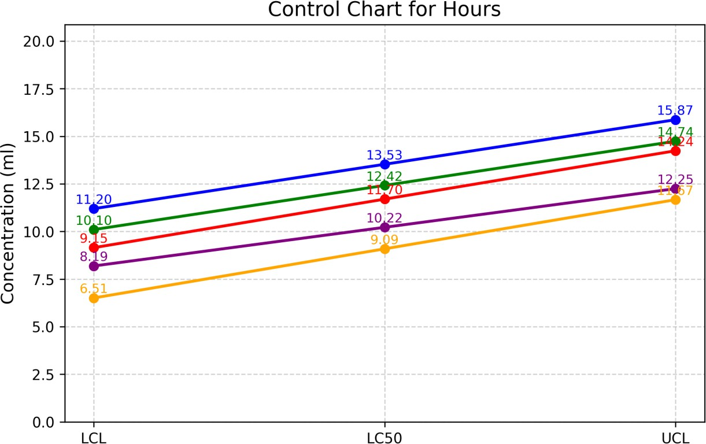
Mortality of L.mauritii

Table-2: Effect of chlorantranniliprole (CAP) on biomass of Lampito mauritii
Exposure (days) | Mean biomass per Earthworm (mg)
Exposure (days) | C | T1 | PCOC | T2 | PCOC | T3 | PCOC | T4 | PCOC
1 | 52.30±0.56 | 53.17±0.46 | - | 52.42±0.32 | - | 53.7±0.71 | - | 53.22±0.51 | -
10 | 60.11±0.67  (+14.93) | 50.12±0.54  (-5.74) | -16.62 | 47.31±0.47  (-9.75) | -21.29 | 42.31±0.44  (-21.21) | -29.61 | 37.41±0.31  (-29.71) | -37.76
20 | 64.32±0.45  (+22.98) | 46.34±0.65  (-12.85) | -27.95 | 43.12±0.51  (-17.74) | -32.96 | 35.61±0.53  (-33.69) | -44.64 | 29.37±0.47  (-44.81) | -54.34
30 | 68.34±0.66  (+30.67) | 41.72±0.55  (-21.53) | -38.95 | 38.37±0.27  (-26.80) | -43.85 | 30.72±0.61  (-42.79) | -55.05 | 22.42±0.66  (-57.87) | -67.19
40 | 73.41±0.74  (+40.36) | 37.81±0.33  (-28.89) | -48.49 | 33.41±0.51  (-36.26) | -54.49 | 22.11±0.36  (-58.83) | -69.88 | 18.37±0.34  (-65.48) | -74.98
50 | 76.31±0.57  (+45.91) | 33.42±0.76  (-37.15) | -56.20 | 28.14±0.36  (-46.32) | -63.12 | 20.37±0.33  (-62.07) | -73.31 | 15.43±0.63  (-71.0) | -79.78
60 | 81.43±0.34  (+55.70) | 32.47±0.39  (-38.93) | -60.13 | 26.79±0.48  (-48.89) | -67.10 | 19.48±0.42  (-63.72) | -76.08 | 12.32±0.74  (-76.85) | -84.87
70 | 85.61±0.45  (+63.69) | 34.47±0.67  (-35.17) | -59.74 | 27.43±0.31  (-47.67) | -67.96 | 20.33±0.71  (-62.14) | -76.25 | 13.76±0.61  (-74.15) | -83.93
80 | 92.81±0.33  (+77.46) | 36.68±0.54  (-31.01) | -60.48 | 28.37±0.71  (-45.88) | -69.43 | 21.43±0.42  (-60.09) | -76.91 | 14.53±0.54  (-72.70) | -84.34
90 | 95.33±0.45  (+82.27) | 39.44±0.46  (-25.82) | -58.63 | 30.98±0.29  (-40.90) | -67.50 | 23.55±0.49  (-56.15) | -75.29 | 16.33±0.73  (-69.32) | -82.87

Values are mean of 10 observations ± S.E C - Control (soil substrate alone)
T1 - 1/10th of 96 hr LC50 – 1.02 ml Kg-1
T2 - 1/7th of 96 hr LC50 – 1.46 ml Kg-1
T3 - 1/5th of 96 hr LC50 – 2.04 ml Kg-1
T4 - 1/2nd of 96 hr LC50 – 5.11 ml Kg-1
PCOC- Percentage change over control + Indicate Increase over initial;
- Indicate decrease over initial or control
Percent increase or decrease over initial values are given in parenthesis

Fig. 2 Effect of chlorantranniliprole (CAP) on biomass of Lampito mauritii

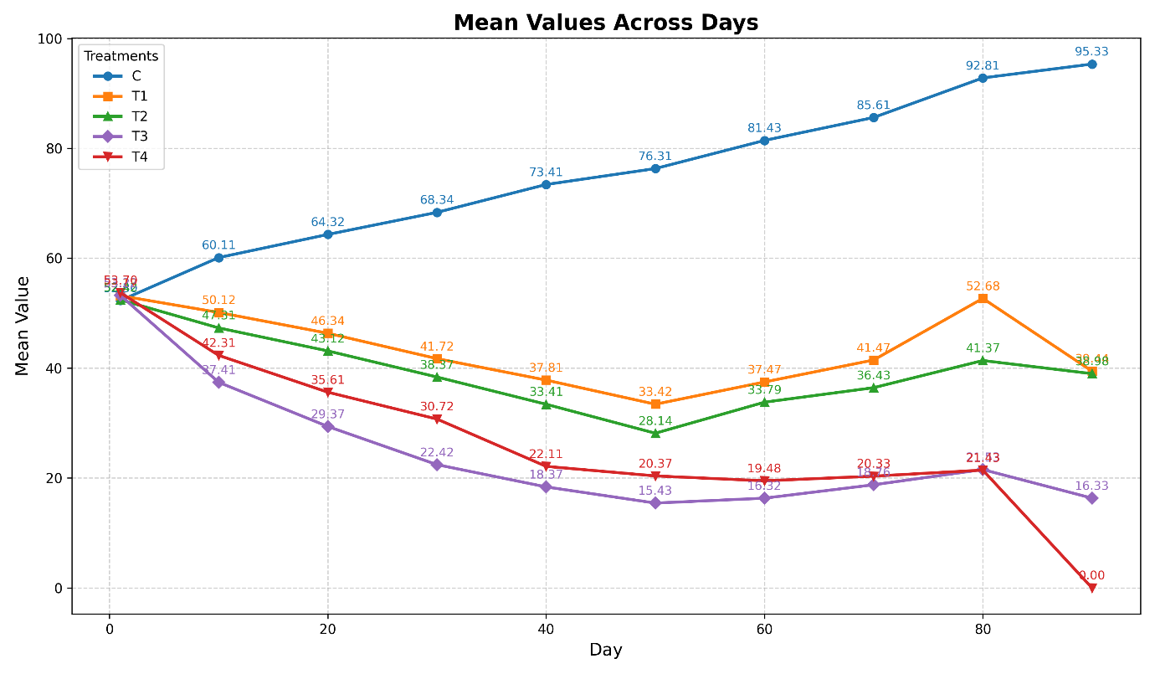

Table: 3 Effect of CAP on bacterial and fungal populations in the gut of L. mauritii on 5th day

Experiments |  |  | Bacterial Population |  |  |  |  | Fungal Population
Experiments | Sample Dilution Factor | Total Heterotrophic Count (CFU/ml)  SCDA agar |  | PCOC  (%) | Sample Dilution Factor | Total Heterotrophic Count (CFU/ml)  SCDA agar | PCOC  (%) |  | (CFU/ml Direct sample)  SDA agar | PCOC  (%)
C | 10¹ | TNTC  (>10⁴) |  | - | 10² | 2.3x10³  (2300) |  |  | 2.0x10²  (200)
T1 | 10¹ | 7.2 x10³  (7200) |  | -28 % | 10² | 1.1x10³  (1100) | -52% |  | 2x10¹  (20) | -90%
T2 | 10¹ | 2.8x10³  (2800) |  | -72% | 10² | 9x10²  (900) | -61% |  | 1x10¹  (10) | -95%
T3 | 10¹ | 1.1x10³  (1100) |  | -89% | 10² | 8x10²  (800) | -65% |  | Nil | -
CFU – Colony forming unit;
SCDA – Soyabean casein digest Agar; SDA – Sabouraud Dextrose Agar;
TNTC- Too Numerous To Count (>10⁴).
Values are mean of 3 observations ± SE C= Control (Soil substrate alone)
T1 - 1/10th of 96 hr LC50 – 1.022 ml
T2 - 1/5th of 96 hr LC50 – 2.04 ml
T3 - 1/2nd of 96 hr LC50 – 5.11 ml
% - indicates percent decrease (-) over control (C)

Fig.3 Effect of CAP on bacterial populations in the gut of L. mauritii on 5th day ( Dilution Factor 1 )
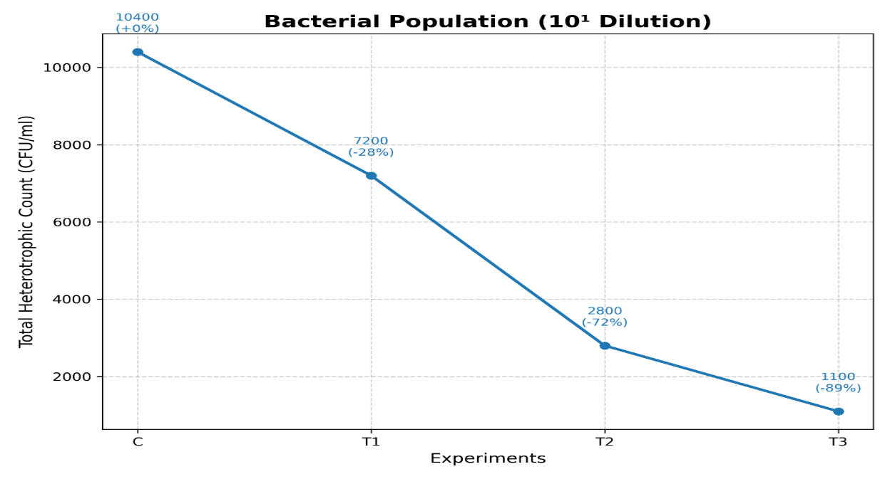

Fig.4 Effect of CAP on bacterial populations in the gut of L. mauritii on 5th day (Dilution Factor 2)
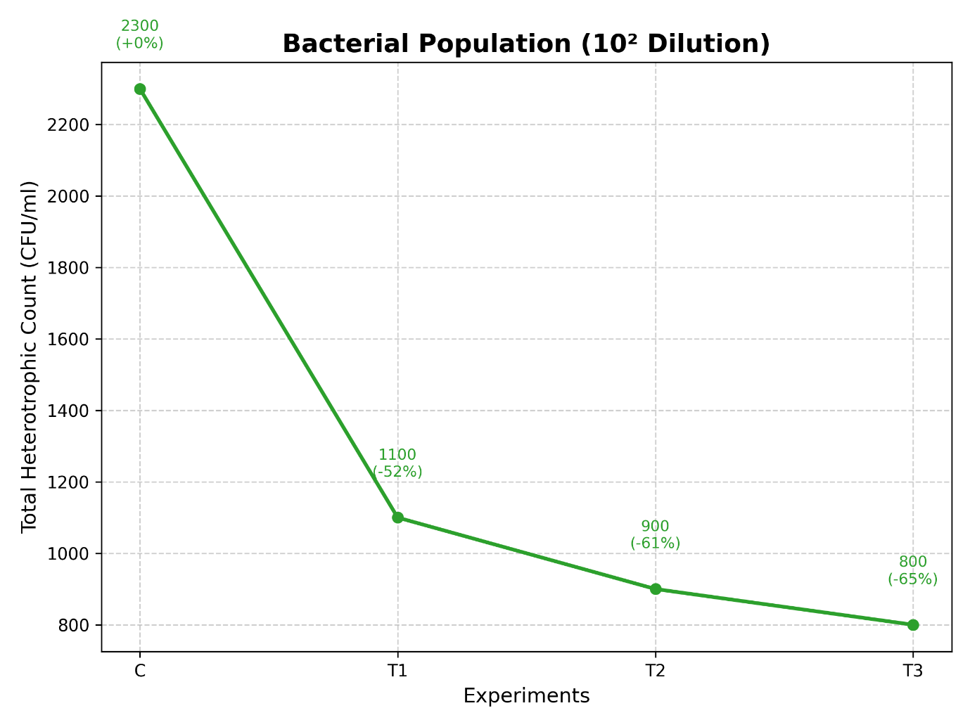

Fig.5 Effect of CAP on Fungal Population in the gut of L. mauritii on 5th day ( Direct sample and SDA agar )
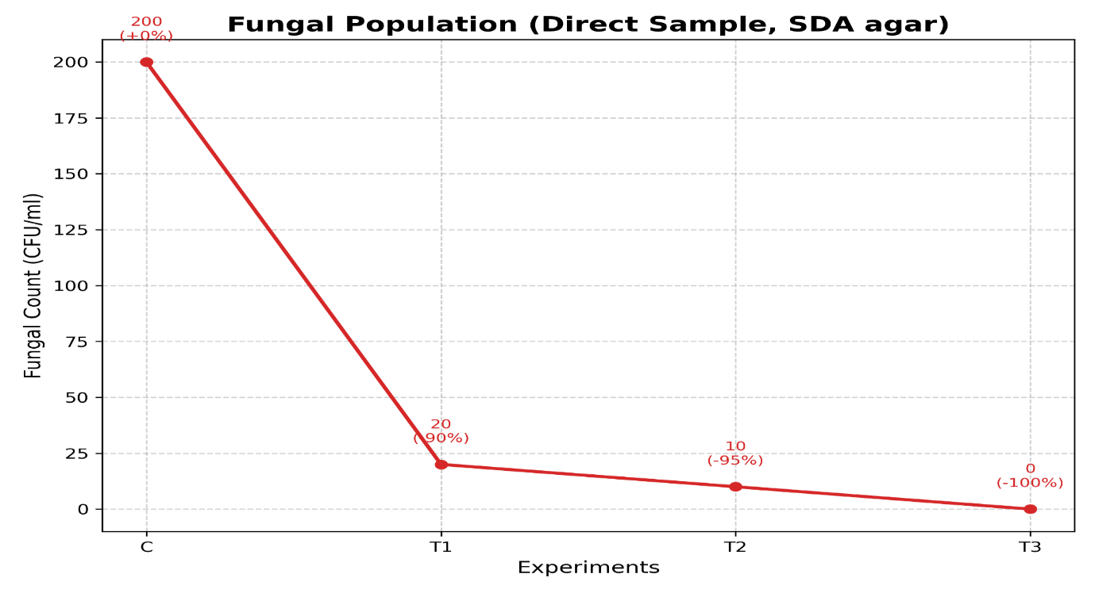

Plate 1 Effect of CAP on bacterial and fungal populations in the gut of L. mauritii on 5th day
- Bacterial Population - 10¹ Dilution Factor
Control T1 T2 T3
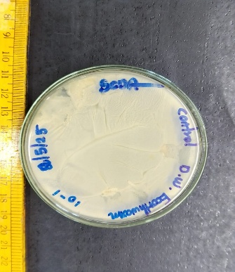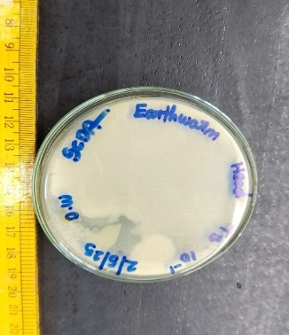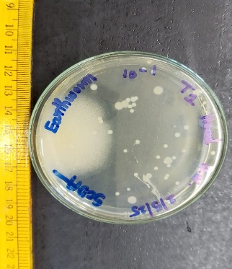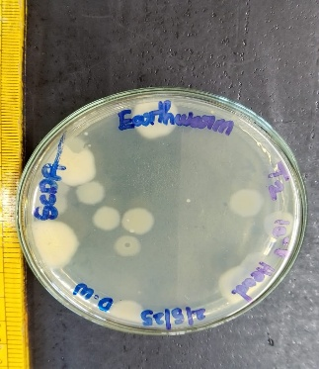
- BACTERIAL population - 10² Dilution Factor
Contol T1 T2 T3
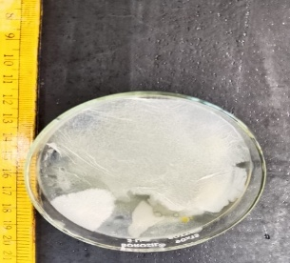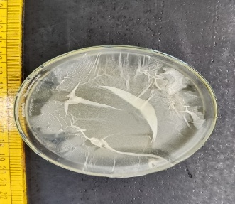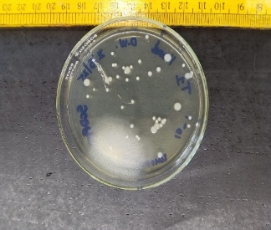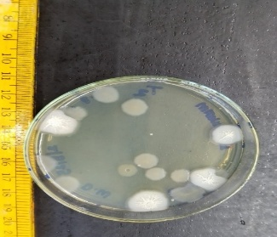
- FUNGAL population – DIRECT SAMPLE
Control T1 T2 T3
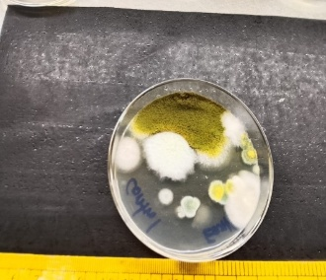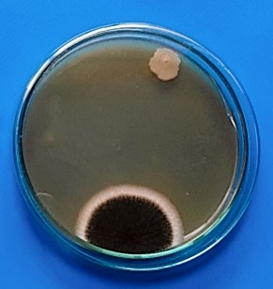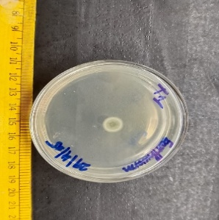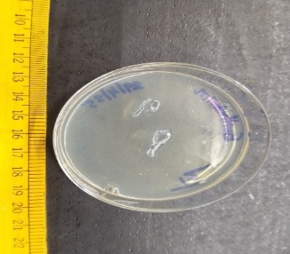
C – Soil substrate alone
T1 - 1/10th of 96 hr LC50 – 1.022 mlKg-1
T2 - 1/5th of 96 hr LC50 – 2.04 mlKg-1
T3 - 1/2nd of 96 hr LC50 – 5.11 mlKg-1

