Immunomodulatory Effect of Nigella sativa extract on Caprine Lymphocytes

------------------------------------------------------------------------------------------------------
Abstract
Background: A lymphocyte proliferation assay (LPA) is a laboratory test used to evaluate the functional capability of lymphocytes by measuring their capacity to proliferate in response to an antigen, mitogen, or foreign molecule. Nigella sativa has immunomodulatory activity, which can affect or modify goats' immune systems. Studies have shown that it may strengthen the body's defences against different infections and advance general health by improving both innate and adaptive immune responses.
Aim: The present study evaluates the immunomodulatory effect of Nigella sativa extract on Caprine Lymphocytes.

Method: The various bands of blood components in tubes were formed with plasma at the top followed by the buffy coat of lymphocytes, and the histopaque RBC of the bottom. The buffy coat was collected carefully of lymphocytes (between the upper plasma and lower RBC using a sterile serological pipette) without agitating the tube.

Results and discussion: In the present investigation, the immunomodulatory effect of the ethanolic extract of Nigella sativa was analysed by the lymphocyte proliferation assay, performed with 6.25ug/ml,12.5ug/ml & 25ug/ml of extract. The production of cytokines or nitric oxide, phagocytic and cytotoxic activities, proliferation of T cells and splenocytes, and vulnerability to necrosis and apoptosis in vitro and in vivo are all factors that support that NS affects immune cells.
Conclusion: The present study found that only 6.25ug/ml of N. sativa showed lymphoproliferation, whereas none of the higher concentrations showed proliferation. The present study indicated that the lowest dilution,6.25ug/ml has immunomodulatory activity.
Keywords: Lymphocytes, Nigella sativa, Immunomodulation, necrosis
Introduction
The long-standing interest in natural products has led to the emergence of plant substances in medicine. This branch of medicine is growing rapidly due to the increased effectiveness of new medicines of plant origin and the development of alternative therapies using plant products as support for traditional therapies for the treatment of various diseases. The use of plants as medicinal substances is culturally well-established and dates back to the earliest years of human activity (Ciesielska-Figlon et al., 2023). The long-standing interest in natural products has led to the emergence of plant substances in medicine. This branch of medicine is growing rapidly due to the increased effectiveness of new medicines of plant origin and the development of alternative therapies using plant products as support for traditional therapies for the treatment of various diseases. The use of plants as medicinal substances is culturally well-established and dates back to the earliest years of human activity. Persistent or dysregulated inflammatory responses can contribute to tissue damage, impair cellular function, and accelerate disease progression, making it a central target in understanding and managing these chronic conditions (Thakur et al., 2025). Research indicates that systemic inflammation can induce neuroinflammation, which may initiate or worsen neurological conditions such as Alzheimer’s disease (AD), Parkinson’s disease (PD), depression, anxiety, and cognitive impairment. This inflammatory crosstalk between the immune system and the central nervous system (CNS) can disrupt neural homeostasis, leading to neurodegenerative changes and altered neurotransmitter function that underpin these disorders (Mihaylova et al., 2025). A larger number of medicinal plants and their purified constituents have been shown to have beneficial therapeutic potentials, such as seeds of Nigella sativa, a dicotyledon of the Ranunculaceae family, which have been employed for thousands of years as a spice and food preservative. The numerous medicinal properties, chemical composition, and pharmacological activity of Nigella sativa, commonly known as Kalaunji or Kalonji whereas in English-speaking countries it is known as the black seed, black coriander, black cumin and black caraway was selected as an immunomodulatory agent against PPR (Elnour & Abdelsalam, 2018; Bob-Manuel et al., 2020). The therapeutic potential of the black cumin seeds is due to the pharmacologically active phytochemical thymoquinone. The oil and seed constituents, particularly thymoquinone (TQ), have shown potential medicinal properties in traditional medicine. A study found that the dietary supplementation of Nigella sativa has a role in immunomodulatory action and suppressing the pathogenicity of the PPR virus in experimentally infected goats.
In recent years, the importance of various immunomodulatory therapies has become well known, unlike conventional antibiotics used to kill particular bacteria, and such treatments exert their protective effects by acting on the host immune system. Hence, immunomodulatory drugs are more important due to their stimulatory or suppressive effect (Ghonime, 2011) many bioactive components present in Nigella sativa seeds are a-pinene, 4-terpineol, t-anethole, sesquiterpene longifolene, carvacrol, thymoquinone, p-cymene, thymol, thymohydroquinone, and dithymoquinone.
A lymphocyte proliferation assay (LPA) is a laboratory test used to evaluate the functional capability of lymphocytes by measuring their capacity to proliferate in response to an antigen, mitogen, or foreign molecule. These assays assess cell-mediated immunity, an essential component of the immune system's defence against infections, especially viruses. LPA is a key method for evaluating CD4+ cells' functional ability to react to different stimuli.
Methodology:-
- Before the procedures started, the laminar hood was cleaned with ethanol and UV prepared for 20 minutes. All the required media and chemicals were brought to room temperature. All the sterile glassware or plasticware was also kept ready to use.
- 06 mL of blood was collected in a sterile vial pretreated with EDTA or a a/Heparinized vial anti-coagulant from unvaccinated goats of age (0-4 months).
3) Diluted blood with 3 ml of sterile PBS in a 15 ml tube was kept ready.
- Fill a pre-labelled tube with 3 ml of Histopaque and cover it with 9 ml of the diluted blood sample in a 1:3 ratio.
- The diluted blood was poured carefully onto the Histopaque solution to avoid mixing and maintain a clear demarcation.
- The tube was centrifuged at 1490 rpm for 40 minutes in a swing-out rotor (REMI India).
- The various bands of blood components in tubes were formed with plasma at the top followed by the buffy coat of lymphocytes, and the histopaque RBC of the bottom.
- The buffy coat was collected carefully of lymphocytes (between the upper plasma and lower RBC using a sterile serological pipette) without agitating the tube.
9) The required volume of RPMI 1640 Media to make the given volume up to 6 ml. 10) The lymphocytes collected in the tube were centrifuged at 1600 rpm for 15 min at room temperature.
11) The supernatant was discarded, and 1 mL of RPMI-1640 Growth Media (10% FBS) was added to the tube.
12) The pellets were resuspended in RPMI-GM by pipetting in a single-cell suspension.
13) The 20 microliters of cell suspension in the microcentrifuge tube and 20 microliters of trypan blue dye were added, mixed by pipetting, and immediately loaded into the Neubauer's chamber, and the cells in the WBC counting chamber.
14) The viable cells were calculated and adjusted to 5 × 10^5 cells /ml by adding the 100 microliter cell suspension/well was added to a 96-well tissue culture plate.
The First set of triplicate wells received 100 ul RPMI-GM contains 2.5 ug of 1ml PHA. A different set of triplicate cells received the Nigella sativa extract @ 100ml/well containing 50, 25, and 10 microgram/ml prepared in RPMI. The control cells, in triplicate, were added to the placebo (PBS/Water/ethanol) in RPMI.The plate was incubated at 37 °C in a humidified chamber at 5% CO₂ for 72 hrs.After 72 hrs, 50 μL of supernatant medium was removed carefully, and 10 μL of MTT solution cat # MB186, Himedia, India (5mg/ml) was added to all wells.The plate was incubated for 4 hrs in a CO₂ incubator.Then added 150 ul of DMSO cat#TC185, Himedia, India (150ul/ml) was added to all wells.The MTT formazan was extracted from the cells, and 100 ul of the supernatant was transferred to a new plate.The OD of wells was measured at a wavelength of 492 nm and a reference wavelength of 650 nm.The stimulation data OD was normalized by calculating OD= OD 492-OD 650 nm.
The stimulation index was calculated as SI=OD stimulated/OD unstimulated.
Fig 1 : Laboratory procedure
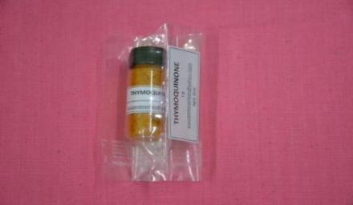 | 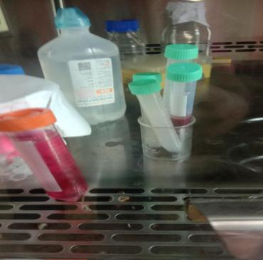
Thymoquinone -Standard for HPTLC Analysis of Nigella sativa | Goat blood sample,NS,PHA,Conc.A used for Lymphocyte Proliferation Assay
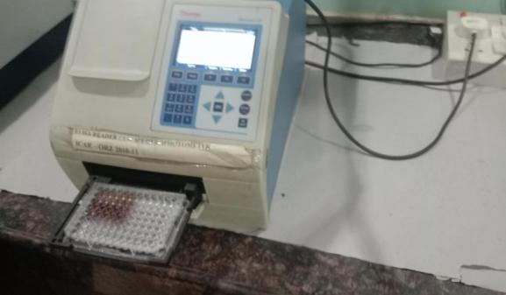 | 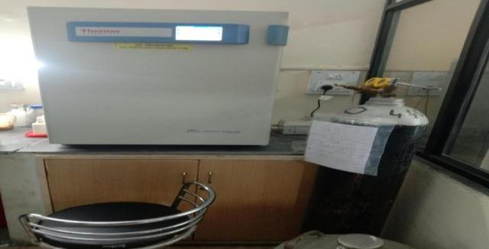
ELISA Reader used to read OD in Lymphocyte Proliferation Assay | CO₂ Incubator for proliferation of Lymphocytes
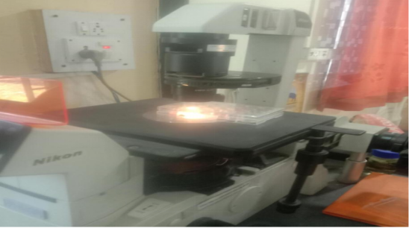 | 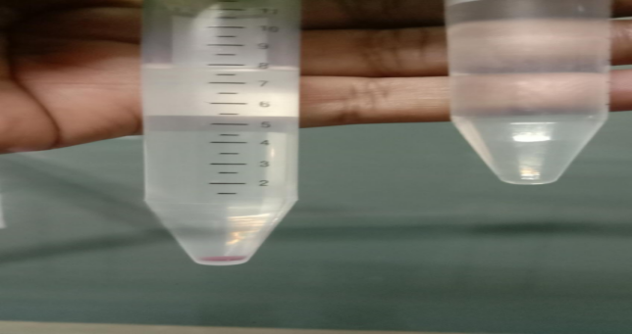
Inverted microscope for cell count | BID Formation after centrifugation

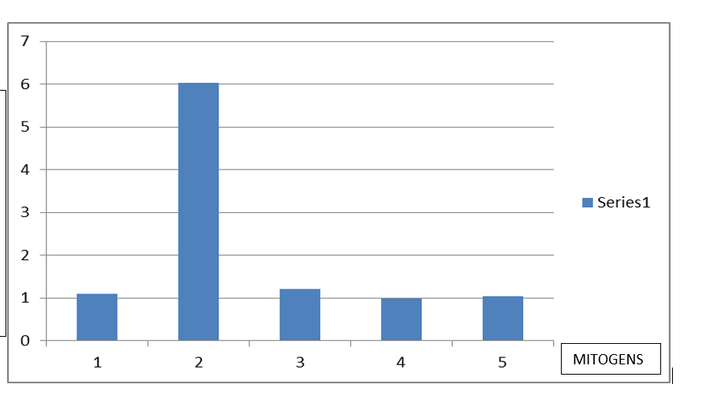
Fig 2 : Effect of different concentrations (6.25, 12.5 & 25 µg/ml) of Nigella sativa seed extract on caprine lymphocyte proliferation activity. Results expressed as a relative index.
Result and Discussion:-
Nigella sativa has immunomodulatory qualities, which can affect or modify the immune system. Studies have shown that it may strengthen the body's defences against different infections and advance general health by improving both innate and adaptive immune responses. It has been demonstrated that Nigella sativa oil and its active components increase the activity of T cells and natural killer (NK) cells, essential for cancer defence and cell-mediated immunity.
Many researchers suggest that Nigella sativa may influence the balance between T helper 1 (Th1) and T helper 2 (Th2) cells, which have distinct functions in immunological responses. Modulating various cell subsets may encourage a more balanced immune response. Nigella sativa can reduce pro-inflammatory cytokines that lead to inflammation, such as TNF-α, IL-6, and IL-1β. It can also affect the synthesis of other immunological mediators that contribute to inflammation, such as leukotrienes and prostaglandins (Alsalahi et al., 2024).
Nigella sativa has demonstrated its potential in regulating immunological responses in autoimmune conditions by increasing CD4+ CD25+ T cells and decreasing CD8+ cells (Hikmah et al., 2022). One of Nigella sativa's principal active compounds, thymoquinone (TQ), has immunomodulatory properties. Its positive qualities are also attributed to other substances, including p-cymene, α-thujene, and terpenoids. According to some research, Nigella sativa may strengthen the immune response by promoting the proliferation of lymphocytes, the white blood cells involved in the immune response, potentially leading to a stronger immune response.
It has been demonstrated that Nigella sativa proliferates lymphocyte growth in vitro. Many researchers reported that its essential oil can lower the proportion of proliferating cells and the number of cell divisions in T lymphocytes. Nigella sativa oil can effectively allow lymphocyte development and proliferation, making the cells less likely to divide; however, it will cause them to proliferate. Given its capacity to regulate lymphocyte proliferation, Nigella sativa has immunomodulatory effects, which may affect the immune system's response. Effect of different concentrations (6.25, 12.5 & 25µg/ml) of Nigella sativa seed extract on caprine lymphocyte proliferation activity. Results expressed as a relative index.
In the present study, the immunomodulatory effect of N. sativa is seen in vitro by employing a lymphocyte proliferation assay. The ethanolic extract of N. sativa at 6.25, 12.5, and 25ug/ml was used. Concavalin A and Phytohemagglutinin were used as mitogens.
Concavalin A did not show much stimulation in the present study compared to Phytohaemagglutinin's SI index of 1.02 and 6.02, respectively. The concentrations of Nigella sativa extract @ dose rate of 6.25 ug/ml have shown stimulation of PBMC as SI indices at 1.20; however, the higher concentration of N. sativa of 12.5 ug/ml did not show significant stimulation as SI indices lie at 0.99 and 1.04, respectively.
In the present investigation, the immunomodulatory effect of the ethanolic extract of Nigella sativa was analyzed by the lymphocyte proliferation assay, performed with 6.25ug/ml,12.5ug/ml, and 25ug/ml of extract. The present study found that only 6.25ug/ml of N. sativa showed lymphoproliferation, whereas none of the higher concentrations showed proliferation. The ethanolic extract was used as crude, not the HPLC purified, similar observations were reported by Haq et al., (1995) where Nigella sativa at a lower concentration (0.5ug/ml) stimulates the lymphocyte at the highest level. In contrast, Nigella sativa at a higher dose stimulates the lymphocytes at a comparatively lower level. Qureshi et al., (2017) performed an assay and observed the lowest dose of 0.5 μL of Nigella sativa, significantly different from the other doses tested. Stimulation index remained the same for different tested doses, showing minimum variation. Stimulation index was lowest with the highest dose (10 µl) and highest with the 2 µl lower dose. The lowest stimulating effect was observed at the highest dose (10ul), shift to Various doses (10ul, 2ul, 1ul, and 0.5ul) of all tested dilutions of N. sativa stimulated lymphocyte proliferation with decreasing dose. These results show findings similar to those of the present study. However, on splenocytes, another researcher, Majdalawieh et al., (2010), observed that aqueous extract of Nigella sativa at four doses (1, 10, 50, and 100 μg/ml) of Nigella sativa significantly increased splenocyte proliferation with maximal enhancement at 100 μg/ml. Swamy and Tan (2000) evaluated the immunomodulatory activity of Nigella sativa seeds extract in ethanol and demonstrated that the extract has no immunomodulatory activity. .Tutuncu (2020) studied that Black seed and its active ingredient, thymoquinone, are essential in preventing gastric mucosa damage by decreasing the increased stomach acidity. Sadarman et al., (2021) observed that supplementation on the productive performance, nutrient utilization, and blood metabolites profile of small ruminant animals. Singh et al., (2021) investigated the immunomodulatory activity of the Nigella sativa seed extract on the chicken PBMCs and suggested the potential use as an adjuvant with various vaccines in chickens.Wei et al., (2022) stated that Thymoquinone (TQ), the main active component, improves immunomodulatory qualities by acting on T cells and NK cells inside the immune system.Figlon et al., (2023) discussed the in vitro and in vivo studies the ability of Nigella sativa to modify the immune response by controlling the interactions between elements, such as T and B cells and neutrophils and macrophages, by either activating or inhibiting the immune system. The production of cytokines or nitric oxide, phagocytic and cytotoxic activities, proliferation of T cells and splenocytes, and vulnerability to necrosis and apoptosis in vitro and in vivo are all factors that support that NS affects immune cells. Alsalahi et al., (2024) observed that NSS enhances humoral but not cellular immunity in healthy animals.
As per the above discussion and various findings observed, for various researchers it indicates the Nigella sativa is having immunomodulatory activity and it either stimulates or unstimulates the lymphoctes at various concentrations i.e either at Higher concentration or either at Lower concentrations. Hence in the present study of lymphocyte immunomodulation in caprines it is clearly indicated that the lowest dilution of Nigella sativa (6.25 μg/ml),Shows has immunomodulatory activity.
Conclusion:
According to the present investigation, the immunomodulatory effect of the ethanolic extract of Nigella sativa was found higher at only 6.25ug/ml i.e at the lower concentration.

References:

Alsalahi Abdulsamad, N. N. N. Maarof, M. A. Alshawsh, M. A. Aljaberi, M. A. Qasem, Abdulaleem Mahuob, N. A. Badroon, E. A. M. Mussa, R. A. Hamat and A .M. Abdallah (2024) Immune stimulatory effect of Nigella sativa in healthy animal models: A systematic review and meta-analysis Heliyon 10. e27390.

Ciesielska-Figlon K., Lisowska K.A., Mikosik-Roczynska A., Witkowski J.M.(2021)
Nigella sativa oil inhibits proliferation and stimulates apoptosis of human
lymphocytes in vitro. Hum. Immunol. 2021;82:608
- doi:10.1016/j.humimm.2021.04.010.
Elnour S. A. and E.B. Abdelsalam (2018) Some Biological and Pharmacological Effects of the Black Cumin (Nigella sativa): A Concise Review. American Journal of Research Communication. 6(3): 10-35.
Figlon K. C., Agnieszka Daca, Adam Kokotkiewicz, Maria Łuczkiewicz, Bozena Zabiegała, J. M. Witkowski, and K. A. Lisowska (2023) The influence of Nigella sativa essential oil on proliferation, activation and apoptosis of human T lymphocytes in vitro Biomedicine & Pharmacotherapy. 153 113349.
Ghonime Mohammed, Ramadan Eldomany, Ahmed Abdelaziz and Hesham Soliman (2011) Evaluation of immunomodulatory effect of three herbal plants growing in Egypt. Immunopharmacology and Immunotoxicology, 33(1): 141–145.
Haq Afrozul, M. A. Latif, P. I. Lobo, K. S. A. Khabar, K.V. Sheth and S. T. A.Sedairy (1995) Nigella sativa: Effect on human lymphocytes and polymorphonuclear leukocyte phagocyte activity. Immuno pharmacol 30:147-55.
Heliyon. ;8:e09242.doi:10.1016/j.heliyon.2022.e09242.

Hikmah Z., Endaryanto A., Ugrasena I.D.G., Rahaju A.S., Arifin S(2022) Nigella sativa L. as immunomodulator and preventive effect on renal tissue damage of lupus mice induced by pristane.

Laily S.A., Hidayati T., Akrom A., Sofia V.(2021) The Effect of Black Cumin Seed Oil on Active Smokers Based on Interleukin-1β Activity and Neutrophil. Indones. J. Pharm. 18:476–484.

Majdalawieh A. F and M. W. Fayyad (2015) Immunomodulatory and anti-inflammatory action of Nigella sativa and thymoquinone: A comprehensive review International Immunopharmacology 28 ;295-304.

Majdalawieh A.F., Hmaidan Reem and Carr R.I.(2010) Nigella sativa modulates splenocyte proliferation, Th1/Th2 cytokine profile, macrophage function and NK anti-tumor activity. Journal of Ethnopharmacol. 131(2);268-75.

Qureshi A. S., Sarmad Rehan and Heinrich Enbergs (2017) Nigella sativa seed extract affects granulocyte phagocytosis and lymphocytes proliferation in goats. Pakistan Veterinary Journal, 37(4); 411-414.

Sadarman , Dewi Febrina , Yendraliza , M. S. Haq ,R. A. Nurfitriani , N.N. Barkah , M. M. Sholikin , Yunilas, Novia Qomariyah , Anuraga Jayanegara , Rondius Solfaine , Agung Irawan (2021) Effect of dietary black cumin seed (Nigella sativa) on performance, immunestatus, and serum metabolites of small ruminants: A meta-analysis Small Ruminant Research 204. 106521.
Singh Yogendra, N. P.Patel, Beenam Saxena and Ramakrishnan Saravanan (2021) Immunomodulatory Effects of Nigella sativa extract on Chicken Peripheral Blood Mononuclear Cells: In-vitro Journal of Animal Research 11(4) 579-586.
Swamy S. M.and B. K.Tan (2000)“Cytotoxic and Immunopotenciating Effects of Ethanolic Extract of Nigella sativa L.Seed,” Journal of Ethnopharmacology,70 (1);1-7.
Tutuncu Serife (2020) Black Seed (Nigella Sativa) and Immunomodulatory Effect International Journal of Veterinary and Animal Research 3(1): 6-9.
Wei Jinfeng, Baoguang Wang, Yixiao Chen, Qiuyi Wang, A. F. Ahmed,Yan Zhang and Wenyi Kang (2022) The Immunomodulatory Effects of Active Ingredients From Nigella sativa in RAW264.7 Cells Through NF-κB/MAPK Signaling Pathways. Front. Nutr. 9:899797.
Ciesielska-Figlon, K., Wojciechowicz, K., Wardowska, A., & Lisowska, K. A. (2023). The immunomodulatory effect of Nigella sativa. Antioxidants, 12(7), 1340. https://doi.org/10.3390/antiox12071340
Mihaylova, A., Doncheva, N., Vlasheva, M., Katsarova, M., Gardjeva, P., Dimitrova, S., & Kostadinov, I. (2025). Investigation of the immunomodulatory and neuroprotective properties of Nigella sativa oil in experimental systemic and neuroinflammation. International Journal of Molecular Sciences, 26(5), 2235. https://doi.org/10.3390/ijms26052235
Ankur Thakur, Komal Pathania, Lovish Sharma, and Deepika. 2025. “Exploring the Potential of Nigella Sativa Seeds: A Modern Perspective on an Ancient Remedy”. Journal of Advances in Medicine and Medical Research 37 (1):6–16. https://doi.org/10.9734/jammr/2025/v37i15691.

Bob-Manuel, R. Bekinwari, and Ukoroije, R. Boate. 2020. “Insecticidal Property of Black Seed (Nigella Sativa) Powder As an Eco-Friendly Management of Skin Beetle Dermestes Maculatus (Coleoptera: Dermestidae) in Atlantic Codfish Gadus Morhua (Gadiformes: Gadidae)”. Asian Journal of Advances in Agricultural Research 13 (3):47–56. https://doi.org/10.9734/ajaar/2020/v13i330108.

********************************************************************

