Light as a Chronobiological Zeitgeber in Bombyx mori: Developmental and Reproductive Outcomes under Spectral and Photoperiodic Stress
Title

Abstract
Light regime and spectral composition are pivotal in synchronising circadian and developmental processes in insects. This study systematically investigated the chronobiological effects of six wavelengths (natural, white, red, yellow, blue, green) and five photoperiod regimes (natural, 12L:12D, 16L:8D, 8L:16D, 24L:0D, 0L:24D) on Bombyx mori L. Survival rates, moulting synchronisation, and reproductive success were measured as key endpoints. Larvae raised under natural, white, or blue light completed their life cycle with high survival (87–93%), exhibited synchronised pupation, and demonstrated oviposition rates exceeding 95%. In contrast, larvae subjected to red, yellow, or green light showed pronounced developmental arrest; survival dropped below 40%, with 100% mortality by the fifth instar for green spectrum exposure. Light-dominant photoperiods (16L:8D, 24L:0D) induced fourth instar arrest with <15% survival and no adult emergence, while darkness-dominant and natural regimes enabled normal development, yielding >90% survival and full reproductive capacity. Filament length and cocoon weight were highest in larvae exposed to blue (12L:12D) and natural light (mean body length ≥1070 mm, cocoon weight ≥0.22 g). These findings underscore that prolonged illumination or long-wavelength exposure disrupts hormonal signalling and circadian entrainment, with direct implications for optimising light environments in sericulture to enhance silk yield and reproductive output.
Keywords: Bombyx mori, chronobiology, photoperiod, light spectrum, circadian entrainment, reproductive efficiency, developmental arrest, sericulture
Introduction
Light, a primary zeitgeber, entrains circadian rhythms across animal taxa, monitoring various physiological, behavioural, endocrine aspects, including development (Panda et al., 2002; Sharma, 2003). Among class Insecta, biological clocks synchronise milestones of life, including moulting, diapause, reproduction, and ecdysteroid–juvenile hormone interactions (Saunders, 2002; Helfrich-Förster, 2018). Light, through its spectral composition and photoperiod, serves as a vital ecological sign that influences the temporal organisation of developmental processes via photoreceptors. Alterations in these cues lead to altered endocrine functioning, such as altered reproductive functions, among both vertebrates and invertebrates. (K Renuka & Joshi BN, 2014; Udayakumar & Joshi BN, 1999; Foley et al., 2011). The mechanisms underlying photoreceptor modification in insects remain insufficiently characterised.
Light impacts various growth phases in the Bombyx mori life cycle (Matsumoto & Takeda, 2002; Sehadová et al., 2004). Earlier studies have revealed that L:D cycles lead to improved cocoon yield, and exposure to constant illumination or spectral imbalance may hinder developmental synchrony (Kumar et al., 2013). The effects of spectra or photoperiod at specific developmental stages on instar progression, cocooning, and fecundity remain unclear.
Research on Circadian rhythms envisages that short-wavelength illumination, acting through cryptochrome-based photoreceptors, stipulates effective entrainment of insect circadian oscillators (Stanewsky, 2002; Helfrich-Förster, 2018). Conversely, long-wavelength light may not synchronise endogenous rhythms, while continuous light or excessive photophase duration disrupts the circadian pacemaker (Sharma, 2003). Whether these mechanisms underlie instar-specific developmental success or failure in B. mori needs to be evaluated thoroughly.
The present study investigates the impact of spectral quality (natural, white, red, yellow, blue, green) and photoperiod regimes (08L:16D, 12L:12D, 16L:08D, 24L:00D, 00L:24D, natural cycle) on the B. mori life cycle. The study focused on comparative instar duration until egg formation under treatments to evaluate complete development and the impact of photic conditions on circadian entrainment in complete development. These findings have implications for both fundamental insect chronobiology and applied sericulture, where improving light environments may enhance silk yield and reproductive efficiency.
Material and methods:
Fertilised eggs of Bombyx mori (multivoltine) were obtained from the Department of Sericulture, Bangalore. Eggs were incubated at 26°C and were held in different photo regimes (fitted with chronometers for respective photoperiods) and spectra (held in a light-proof chamber with L:D 12:12)with 50 eggs in each group, as depicted in Table 1. The measurement of larvae was done through morphometric analysis (hatchlings and 1st instars), and from 2nd to 5th instars. The cocoon length and weights were also noted at regular intervals. During the experimentation period, all the animals were fed with fresh, tender chopped mulberry leaves ad libitum twice daily. The whole experimental setup was pest-free.
Table – 1: The measurement of larvae was done through morphometric analysis
Groups | Experimental condition (L:D) | Light intensity/Wavelength
1 | Natural light
2 | 12:12 | 380 - 400nm
3 | 16:08 | 380 - 400nm
4 | 08:16 | 380 - 400nm
5 | 24:00 (LL) | 380 - 400nm
6 | 00:24 (DD) | 00
7 | White light | 380 - 400nm
8 | Red | 670nm
9 | Blue | 450 - 490nm
10 | Green | 520 - 550nm
11 | Yellow | 575 - 595nm
Measurements were done for all 50 eggs, larvae from all groups, mean and standard error were calculated, and analysis was done using ANOVA.

Results:
Developmental progression varied significantly across spectral regimes. Larvae reared under natural, white, and blue light exhibited synchronised instar transitions [Figure 1(a), pupation by 26 February, adult emergence on 1 March, and oviposition by 3 March, comparable to natural controls [Figure 1(b,c)]. These conditions supported circadian entrainment, indicating that broad-spectrum and short-wavelength light serve as effective zeitgebers for growth and reproduction.
By contrast, cohorts exposed to red, yellow, or green light displayed delayed moulting, with the second instar occurring approximately one week later than in controls. Mortality was universal following the fourth instar, and no cocoon formation or reproduction occurred [Figure 1 (d)]. This suggests that longer wavelength light disrupts endocrine timing, particularly ecdysone–juvenile hormone cycles, which are critical for metamorphic commitment.
Figure 1 (a)
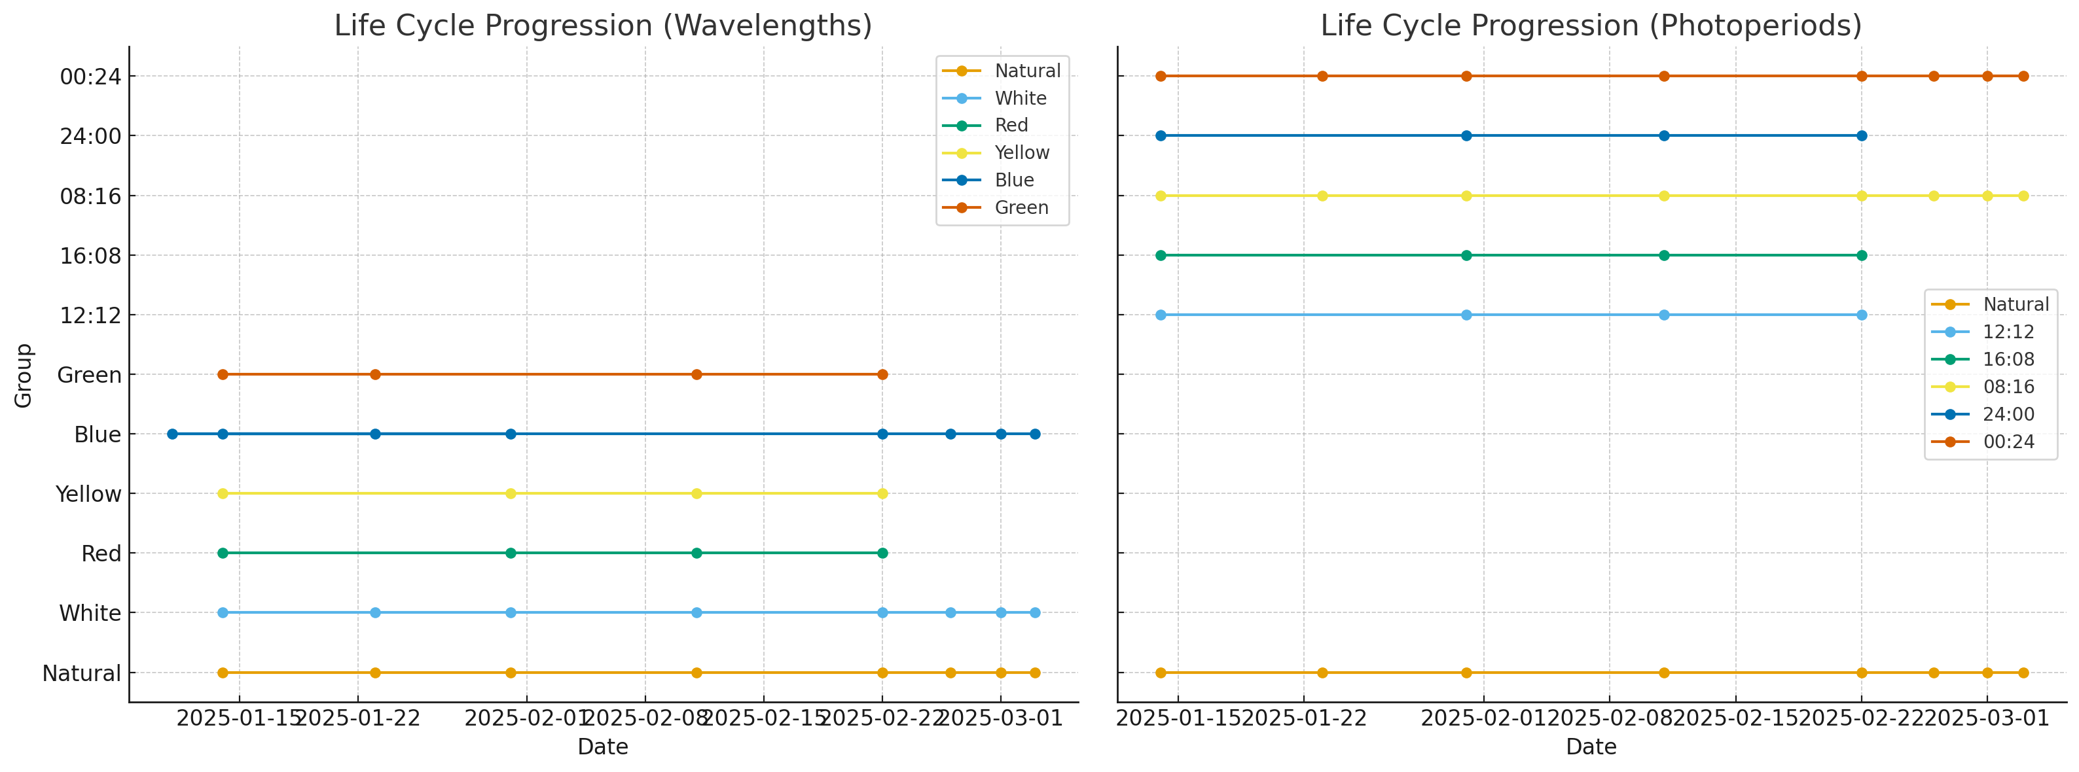
Figure 1 (b)
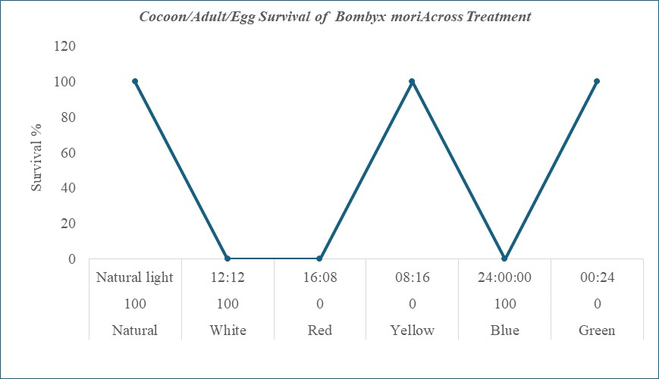

Figure 1 (c)

Figure 1 (d)

Legend to Figure 1. Composite analysis of light wavelength and photoperiod effects on Bombyx mori. (a–b) Developmental timelines demonstrate that Natural, White, Blue light, and 08L:16D, 00L:24D cycles sustain full life cycle progression, while Red, Yellow, Green, and mid-range photoperiods terminate at the 4th instar. (c) Survival percentages highlight treatment-dependent differences in cocoon formation and adult emergence. (d) The stage-specific mortality dynamics across treatments, revealing chronodisruption under non-optimal spectral and photoperiodic conditions.

Photoperiod strongly modulated developmental success. Larvae maintained under natural cycles, 08L:16D, and continuous darkness (00L:24D) completed the full life cycle, from larval growth to oviposition, which is clear through Figure 1 (a-d). These conditions preserved scotophase duration, enabling stable circadian oscillations and synchronised development.
In contrast, 12L:12D, 16L:08D, and continuous light (24L:00D) produced aberrant trajectories. Instar transitions were delayed, and all larvae succumbed by the fourth instar without pupation. Continuous light caused the most severe disruption, consistent with arrhythmicity induced by loss of dark-phase input. Although the experimental frameworks varied, both experimental data reveal that the fourth instar stage was associated with failure under maladaptive photic conditions. Successful development was consistently associated with short-wavelength illumination (blue/white) combined with darkness-dominant cycles, while long-wavelength exposure or light-dominant regimes resulted in developmental arrest and mortality.
Discussion
The present findings prove that both spectral quality and photoperiod regime function as critical zeitgebers regulating the developmental chronobiology of Bombyx mori. Successful life cycle completion was restricted to larvae reared under short-wavelength illumination (natural, white, and blue light) and darkness-dominant photoperiods (08L:16D, 00L:24D, and natural cycles). In contrast, long-wavelength exposure (red, yellow, green) and light-dominant cycles (12L:12D, 16L:08D, 24L:00D) induced developmental delays, mortality by the fourth instar, and complete reproductive failure. These outcomes highlight the interplay between photic entrainment, circadian regulation, and endocrine control of moulting.
Spectral effects on circadian entrainment are clearly visible in this set of experiments. The ability of blue light to sustain normal development suggests that short-wavelength photoreceptors mediate effective circadian entrainment in B. mori. Cryptochromes, which are maximally sensitive to blue light, function as primary circadian photoreceptors in insects (Helfrich-Förster, 2018; Stanewsky, 2002). Comparable wavelength-dependent effects have been observed in Drosophila and Manduca, where blue or broad-spectrum light supports circadian rhythmicity, while long-wavelength light does not synchronise behavioural and developmental rhythms (Foley et al., 2011). The mortality seen with red and yellow light in this study results from insufficient light input to the circadian oscillator, causing disrupted feeding cycles and ecdysone surges needed for moulting.
Photoperiodic modulation also affected the developmental aspect in this species. The photoperiod experiments confirmed that scotophase duration is a decisive factor for silkworm growth. Darkness-dominant conditions supported complete development, whereas light-dominant regimes induced mortality. Continuous light (24L:00D) was most detrimental, consistent with earlier reports that constant illumination induces arrhythmicity in circadian-controlled processes (Sharma, 2003; Panda et al., 2002). By contrast, continuous darkness (00L:24D) still allowed successful development, suggesting that the silkworm clock can free-run in darkness, guided by internal oscillators and feeding rhythms, provided that light-driven disruption is absent. This contrasts with species in which arrhythmicity occurs in both LL (constant light) and DD (constant dark) conditions, underscoring the robustness of B. mori circadian machinery under scotophase-dominant environments.

The experiments suggest the existence of a specific period of sensitivity. Across both experiments, developmental arrest consistently occurred after the fourth instar, marking this stage as a vulnerable chronobiological checkpoint. The fourth instar stands for a period of high metabolic demand, during which silk gland hypertrophy and preparatory endocrine events occur (Saunders
& Kobayashi, 2013). Failure of larvae to transition beyond this stage under maladaptive photic environments suggests a breakdown in the coupling of circadian oscillators with endocrine signalling pathways. Specifically, misaligned ecdysone and juvenile hormone pulses, both regulated by circadian clocks—likely underlie mortality in these groups (Saunders, 2002).
From a sericultural perspective, these findings indicate that optimal rearing conditions require both spectral quality and photoperiod alignment. Blue or white light under darkness-favouring photoperiods maximises developmental synchrony, cocooning efficiency, and reproductive success. Conversely, exposure to red/yellow spectra or prolonged illumination should be avoided, as they impose photic stress, desynchronize rhythms, and ultimately suppress silk yield. These results align with broader chronobiological principles emphasising the necessity of appropriate zeitgeber alignment for physiological stability across taxa (Kumar et al., 2013).
This research establishes that spectral quality and photoperiod regime are pivotal factors affecting the developmental chronobiology of Bombyx mori. Larvae reared under short-wavelength spectra (blue and white light) and darkness-dominant photoperiods (08L:16D, 00L:24D, and natural cycles) completed the life cycle, including cocooning, adult emergence, and oviposition. In contrast, exposure to long-wavelength illumination (red, yellow, green) or light-dominant cycles (12L:12D, 16L:08D, 24L:00D) resulted in delayed instar transitions, mortality at the fourth instar, and complete reproductive failure.
These findings indicate that short-wavelength input acts as an effective zeitgeber, entraining circadian oscillators that regulate ecdysone–juvenile hormone dynamics necessary for moulting and metamorphosis. Conversely, disruption of scotophase under light-dominant regimes or ineffective long-wavelength entrainment leads to arrhythmicity, endocrine desynchronization, and arrested development. From an applied perspective, the results underscore the importance of providing spectrally appropriate illumination and scotophase-preserving photoperiods in sericulture practice to improve growth, cocoon yield, and reproductive success. More broadly, the data reaffirm the role of light as a primary zeitgeber in insect chronobiology and highlight the fourth instar as a critical stage sensitive to photic disruption.

References
Foley, L. E., Gegear, R. J., & Reppert, S. M. (2011). Human cryptochrome exhibits light-dependent magnetosensitivity. Nature Communications, 2(1), 356. https://doi.org/10.1038/ncomms1364
Helfrich-Förster, C. (2018). Light input pathways to the circadian clock of insects with an emphasis on the fruit fly Drosophila melanogaster. Journal of Comparative Physiology A, 204(10), 779–792. https://doi.org/10.1007/s00359-018-1279-0
Joshi, B.N. and Udaykumar, K. (1998). Changes in ovarian follicular kinetics in intact, blinded and parietal shielded frogs exposed to different spectra of light. General and Comparative Endocrinology. 109, 310-314. https://pubmed.ncbi.nlm.nih.gov/8812387/
K Renuka, & Joshi B N. (2016). Long-days, light-spectra and melatonin alter ovarian function in the teleost fish Channa punctatus (Bloch). International Education and Research Journal (IERJ), 2(7). Retrieved from https://ierj.in/journal/index.php/ierj/article/view/330
Kumar, V., Rani, S., & Singh, S. (2013). The bird clock: A complex, multi-oscillatory and highly diversified system. Biological Rhythm Research, 44(1), 21–42. https://doi.org/10.1080/09291016.2012.708551
Matsumoto, A., & Takeda, M. (2002). Circadian rhythm of ecdysteroid secretion and its photoperiodic regulation in the silkworm. Zoological Science, 19(9), 987–997. https://doi.org/10.2108/zsj.19.987
Nagata, S., & Kobayashi, Y. (2013). Endocrine control of moulting and metamorphosis in insects. Current Opinion in Insect Science, 1(1), 1–7. https://doi.org/10.1016/j.cois.2013.02.001
Panda, S., Hogenesch, J. B., & Kay, S. A. (2002). Circadian rhythms from flies to humans. Nature, 417(6886), 329–335. https://doi.org/10.1038/417329a
Saunders, D. S. (2002). Insect Clocks (3rd ed.). Amsterdam: Elsevier.
Sehadová, H., Marková, E. P., & Takeda, M. (2004). Circadian control of development in the silkworm, Bombyx mori. Journal of Biological Rhythms, 19(2), 114–125. https://doi.org/10.1177/0748730403261807
Sharma, V. K. (2003). Adaptive significance of circadian clocks. Chronobiology International, 20(6), 901–919. https://doi.org/10.1081/CBI-120026099
Stanewsky, R. (2002). Clock mechanisms in Drosophila. Cell and Tissue Research, 309(1), 11–26. https://doi.org/10.1007/s00441-002-0572-6

