Biological control potential of Cheilomenes sulphurea (Coleoptera: Coccinellidae) against Aphids on Cashew trees in Korhogo, Côte d’Ivoire
Abstract
Cashew (Anacardium occidentale L.) cultivation is one of the main economic activities for farmers in the central and northern regions of Côte d’Ivoire. However, despite the many benefits of cashew production, it faces significant challenges caused by various factors, especially aphid infestations. This study aims to propose improved, environmentally friendly biological control strategies to manage aphids on cashew trees, protecting both the ecosystem and producers' health. The analysis showed that the predation of lady beetles Cheilomenes sulphurea on aphids (Aphis gossypii and Toxoptera aurantii) is notably effective. The beetles' voracity was observed at all aphid developmental stages, with the highest consumption recorded in fourth-instar larvae, regardless of the aphid species. However, no significant difference was found in aphid consumption by adult beetles based on their sex. Additionally, the study found that C. sulphurea showed almost no feeding preference between A. gossypii and T. aurantii across all beetle developmental stages.
Keywords : Cashew ; Cheilomenes sulphurea; Aphids; Predation; Biological control

- Introduction
Cashew (Anacardium occidentale L.) is cultivated in more than 32 countries worldwide. Production is mainly concentrated in four major regions: Southeast Asia, West Africa, East Africa, and Brazil (Wonni et al., 2017). Introduced in Côte d’Ivoire in the early 1950s, cashew was initially intended to halt desert encroachment and regenerate soils already degraded by erosion, particularly in the northern part of the country (Djaha et al., 2010). However, since the late 1990s, cashew nuts have become one of the most important export commodities in Côte d’Ivoire (Ricau, 2013). Since 2015, Côte d’Ivoire has been recognized as the world’s leading producer (Minhibo et al., 2014). Today, cashew is referred to as the ‘brown gold’ of the North and represents a source of hope for the savanna regions (Tuo, 2007).
The cashew sector is a significant source of income in rural areas, employing more than 350,000 producers and supporting approximately 2.5 million people (Ouattara, 2017). The benefits of this crop are numerous, as cashew trees provide multiple uses and products derived from the fruit, shell, nut, and apple. The wood is also used as fuel or for timber production (Lebailly, 2012). However, despite all these advantages, cashew cultivation faces major challenges due to the combination of several factors, particularly attacks by insect pests (Djaha et al., 2014).
Aphids and other pests significantly affect cashew tree production, with up to 76% of inflorescences reported as destroyed (Melo et al., 1994). Yield losses may reach 36.8% (Bleicher et al., 1992). To mitigate these damages, farmers primarily rely on chemical control methods. However, such approaches are not consistently effective and can be difficult to implement within a regulatory framework that is rapidly evolving (Tandjiekpon, 2005).
Consequently, the principal objective of this study is to identify improved strategies for managing aphid infestations in cashew orchards. Specifically, the research focuses on:“Evaluating the predatory capacity of lady beetles, Cheilomenes sulphurea (Coleoptera: Coccinellidae), as biological control agents against aphids on cashew trees.”
The specific objectives are to:
- Assess the voracity of lady beetles at different developmental stages;
- Determine their feeding preferences across developmental stages.
- Materials and Methods
2.1 Study Site
The Department of Korhogo is located in northern Côte d’Ivoire, between latitudes 8°26′ and 10°27′ N and longitudes 5°17′ and 6°19′ W (N 9.45374, W 5.63324). It covers an area of 12,500 km² (Figure 4). The study was conducted at the CNRA Fruit Research Station in Lataha, situated 22 km north of Korhogo. The station extends over 40 ha and is positioned at 9°34′ N latitude and 5°34′ W longitude, at an altitude of 350 m.
Annual rainfall averages approximately 1,400 mm in wet years and 1,000 mm in dry years. The soils are ferrallitic, typically derived from granite parent material (Djaha, 2018).
2.2 Biological Material
The biological material used consisted of Cheilomenes sulphurea. Colonies of Aphis gossypii and Toxoptera aurantii (aphids) were employed as a food source for rearing both adult and larval stages of Cheilomenes sulphurea.
Regarding plant material, in addition to cashew (Anacardium occidentale) seedlings, Commelina benghalensis plants were used both as a food source for the aphids and as a substrate for oviposition.
2.3 Technical Material
The technical equipment used consisted of the following items: a soft pig-bristle brush for handling lady beetle larvae; plastic pots with capacities of 300 ml and 10 ml, serving as rearing containers for adult and larval stages of Cheilomenes sulphurea, respectively; organza muslin with a mesh size of 0.02 mm, used to cover the rearing pots; a handheld magnifying lens and a compound optical microscope, employed to observe lady beetle eggs and larvae and to count aphids during voracity experiments; and thermometers, used to monitor laboratory ambient temperature and maintain it at 25 °C.
2.4 Experimental Design
Adult lady beetles (Cheilomenes sulphurea) were starved for 24 hours before the introduction of aphids. Following this period, aphids were placed into 400-ml vials containing the starved beetles. The vials were hermetically sealed with organza muslin (mesh size 0.02 mm) and lightly sprayed with water to maintain suitable humidity. They were then kept in an open area for 24 hours.
After 24 hours, the number of aphids not consumed by the predators was recorded. The difference between the initial and remaining aphid counts was used to estimate prey consumption by the lady beetles.
For larval stages, the experiment consisted of providing aphids daily to ensure continuous feeding, given the fragility and vulnerability of larvae when deprived of food. In this case, aphids were supplied directly to the larvae in vials without prior starvation. The vials were similarly maintained in an open area for 24 hours.
Throughout the experiment, the ambient temperature was maintained at 25 °C. Consumption was also measured according to the sex of the adult beetles.
2.5 Data Analysis
Data processing was carried out using the statistical software Excel Statistica, applying analysis of variance (ANOVA). Pairwise correlations between variables were assessed using Pearson’s correlation test, with significance determined at the 5% threshold.

- Results
3.1 Mean Consumption of Aphids (Aphis gossypii and Toxoptera aurantii) by Lady Beetles
Lady beetle larvae consumed significantly more A. gossypii aphids (135.76 ± 24.89) compared to adult beetles (77.76 ± 9.59). Statistical analysis revealed a significant difference between the two developmental stages (p = 0.0346) (Figure 1).
Similarly, for T. aurantii, larval consumption (127.2 ± 24.01) was higher than that of adults (62.2 ± 7.62). Statistical analysis again indicated a significant difference between the two stages (p = 0.0129) (Figure 2).
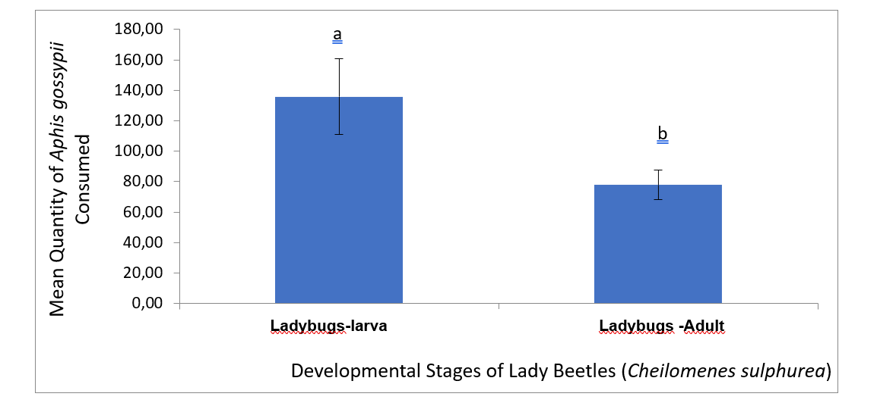
P= 0.0346
Figure 1 : Comparison of the quantities of Aphis gossypii aphids consumed by lady beetles at different developmental stages

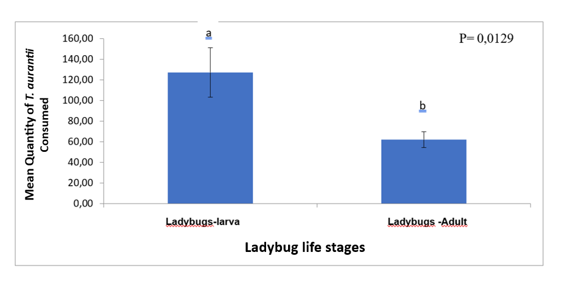

Figure 2: Comparison of the quantities of Toxoptera aurantii aphids consumed by lady beetles at different developmental stages

3.2 Average consumption of aphids (A. gossypii and T. aurantii) according to the sex of lady beetles
Male lady beetles (80.08 ± 10.51) consumed more aphids than female lady beetles (71.68 ± 9.28). However, statistical analyses revealed no significant difference (p = 0.5521) between sexes (Figure 3).
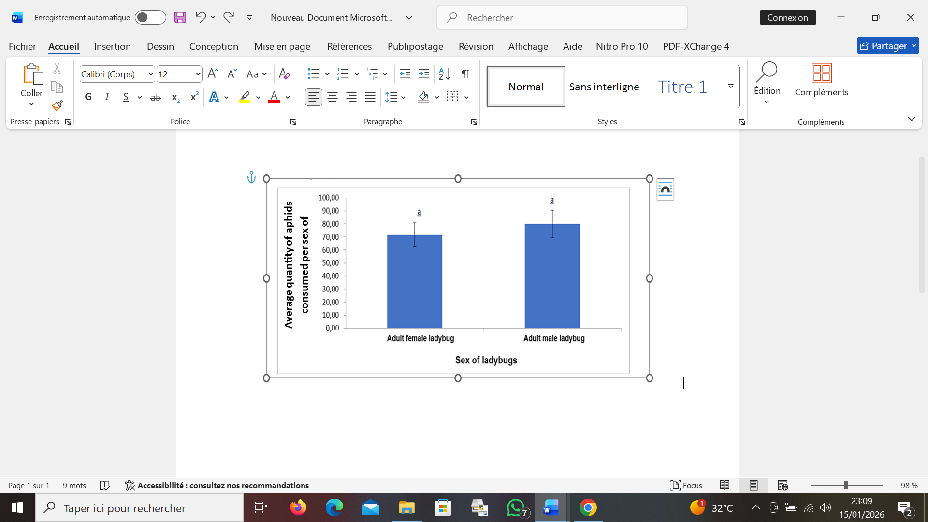

Figure 3: Comparison of Aphis gossypii aphid consumption by male and female lady beetles

3.3 Comparison of Aphis gossypii and Toxoptera aurantii aphid consumption by adult lady beetles
The quantities of Aphis gossypii consumed within 24 hours by adult lady beetles were 77.76 ± 9.59, whereas the consumption of Toxoptera aurantii by other adult lady beetles was 62.2 ± 7.62 over the same period (Figure 4). Statistical analysis showed no significant difference (p = 0.2102) between the two aphid species.
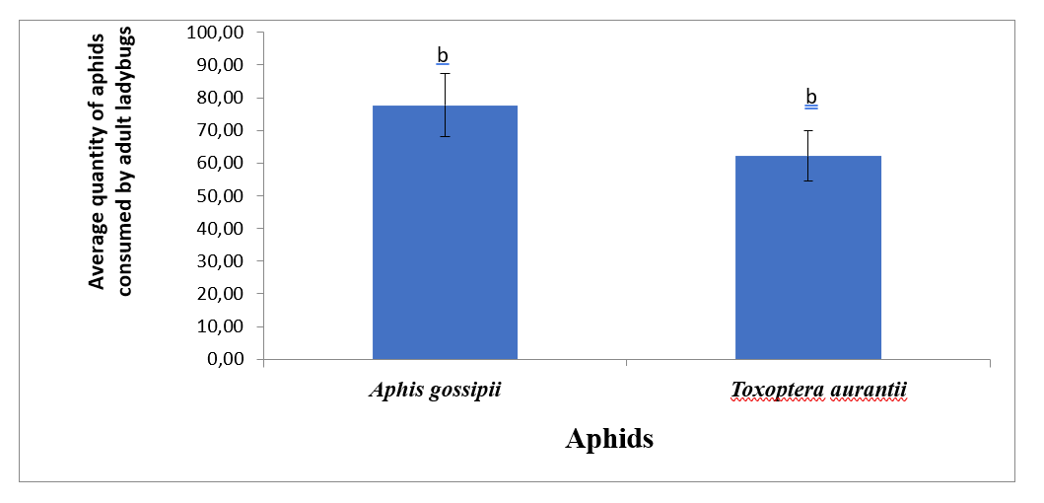
Figure 4: Comparison of Aphis gossypii and Toxoptera aurantii aphid consumption by adult lady beetles

- DISCUSSION
This study highlighted the importance of biological control in cashew cultivation areas in Côte d’Ivoire. Adults and larvae of Cheilomenes sulphurea (Coleoptera: Coccinellidae) generally feed on aphids. The predatory activity of lady beetles on aphids has been reported by several authors. In 2015, Lounes and collaborators observed that the availability of aphids enabled Coccinella septempunctata to complete its entire biological cycle. In contrast, the cycle of Hippodamia variegata was disrupted due to food scarcity. Indeed, a sharp decline in apterous populations was noted from early May, with only winged individuals persisting thereafter. Later, in 2021, Noémie and other authors obtained similar results. According to them, lady beetles provide effective control of aphid populations. However, since they appear to leave apple orchards in July, this allows for the increase of later aphid populations. Our study revealed that aphid consumption at the larval stage is markedly higher than in adults, regardless of the aphid species provided to the lady beetles. This difference may be explained by the fact that during larval development, lady beetles undergo four successive instars, increasing progressively in size until reaching the fourth instar, which represents the final larval stage. At this stage, which was used in our experiment, larvae consume large quantities of aphids both to sustain their growth and to accumulate reserves for the subsequent pupal stage. During pupation, lady beetles remain immobile and dormant for several days, relying on these reserves to complete their development. Our results are consistent with those of Michel et al. (2017), who reported that an adult lady beetle can consume approximately 100 aphids per day, whereas a larva may consume up to 600. It has been shown that lady beetles consume aphids at all developmental stages. Results concerning sex differences indicate that in Cheilomenes sulphurea, males exhibit greater voracity than females. This difference may be attributed to the fact that adult males are more active and move frequently within the rearing containers, thereby encountering aphids more often than the relatively static females. However, studies by Lucas (1994) on the voracity of lady beetles of the genus Harmonia axyridis demonstrated that in H. axyridis, females are more efficient than males in aphid predation. He also noted that females are larger in size than males. Results concerning food preference of lady beetles toward different aphid species present at the study site, namely Aphis gossypii and Toxoptera aurantii, showed that Cheilomenes sulphurea consumed more A. gossypii than T. aurantii at both adult and larval stages. The difference in food preference lies in the quantities consumed of A. gossypii and T. aurantii. Indeed, the smaller size of A. gossypii compared to T. aurantii likely explains why lady beetles tend to consume more A. gossypii. Nevertheless, this difference was not statistically significant, as it involved only a few individuals. Our results are consistent with those of Hemptinne et al. (1992), who reported that lady beetles do not exhibit a marked prey preference and highlighted their limited capacity to discriminate between prey species.
- CONCLUSION
The study conducted at the National Center for Agronomic Research of Lataha (CNRA) focused on evaluating the predatory activity of Cheilomenes sulphurea (Coleoptera: Coccinellidae) as a biological control agent against aphids on cashew trees. The findings revealed, on the one hand, that predation by C. sulphurea on Aphis gossypii and Toxoptera aurantii was quite remarkable. Indeed, lady beetles exhibited voracity at all developmental stages, with the fourth larval instar showing the highest level of consumption, regardless of the aphid species provided. However, no significant difference was observed in aphid consumption between adult males and females.
On the other hand, the study showed that C. sulphurea displayed virtually no marked food preference between A. gossypii and T. aurantii across all developmental stages. Nevertheless, consumption of A. gossypii was slightly higher than that of T. aurantii, though the difference was not statistically significant.

References
Bleicher E., Abreu A.R.M., Melo Q.M.S., Controle químico do pulgão da inflorescência do cajueiro com seletivos produtos, Embrapa-CNPAT, Bol. Almost. No. 12, Fortaleza, Brazil, 1994.
Djaha A. J. B., N’da H.A., Koffi K.E., Adopo A.N. and Ake S., 2014. Morphological diversity of cashew accessions (Anacardiumouest L.) introduced in Côte d’Ivoire, Rev. Ivory. Sci. Technol. 23:244–258.
Djaha J-B.A., N’Guessan A.K., Ballo C.K. & Aké S., 2010. Germination of seeds of two elite varieties of cashew trees (Anacardiumouest L.) intended to serve as rootstock in Ivory Coast. Journal of Applied Biosciences 32: 1995-2001
Hemptinne J.L., Dixon A.F.G., Coffin J., 1992- Biological control in orchards, Harmonia axyridis Pallas, new exotic predator to fight against Aphid outbreaks. Infos-CTIFL, pp.41-94.
Lebailly P., Lynn S., and Seri H., 2012. Study for the preparation of a strategy for the development of the cashew sector in Ivory Coast, Diagnostic report, AGRER Consortium. 92 p.
Lucas E., 1994. Evaluation of the predation efficiency of ladybugs Coccinella septempunctata L. and Harmonia axyridis Pallas (Coleoptera: Coccinellidae) as biological control aids in apple orchards. Master's thesis, University of Quebec in Montreal (Quebec). 106 pp.
Lounes S., Jean Louis H. & Alexandra M., 2015. Sharing of trophic resources among Bull ladybugs. Soc. zool. Fr., 140 (1): 5-23.
Melo Q.M.S., Bleicher E., Oliveira I.S.R., Couthinho C.I.S.B., Macul F., 1992. Efeito de deltamethrin mancozeb sobre Anthisstarcha binocularis (Lep.: Gelechiidae), Selenothrips rubrocinctus (Thysanoptera: Thripidae) and Aphis gossypii (Hom.: Aphididae) em cajueiro, Embrapa-CNPCa, Bol. Pesqu. No. 6, Fortaleza, Brazil.
Michel de L. & Aurélie M., 2017. Optimal strategies for introducing ladybugs to combat crop-ravaging aphids. 27p.
Minhibo M.Y., N’Da Adopo., Djaha A.J-B., Kouakou C. K., N’Da H. A., Evariste B. A., Kébé I., 2014. Guide to recognizing harmful insects of the cashew tree. Teaching document, 11 p.
Noémie G. L., Mirella A., Gérald C., 2021. Control of aphids by ladybugs under exclusion nets in an organically managed apple orchard in Quebec. 4p
Ouattara G. M., 2017. The determinants of the adoption of certain good cultural practices before harvesting cashew nuts in Ivory Coast. Journal of Economics and Finance (IOSR-JEF), 8(3), pp 08-15.
Ricau P., 2013. Know and understand the international cashew market. 48 p (Publication.www.rongead.org.).
Tandjiekpon A.M., 2005. Characteristics of the agroforestry system based on cashew trees (Anacardium Occidentale L.) in the savannah zone of Benin. Thesis for the Diploma of Advanced Studies (D.E.A.), Faculty of Letters, Arts and Human Sciences, University of Abomey-Calavi, Benin. 112 pages.
Tuo G., 2007. Analysis of the cashew nut sector in Côte d'Ivoire: development strategies and poverty reduction. Master's thesis in economics, University of Bouaké. 60 pages.
Wonni I, Sereme D, Ouedraogo I, Kassankagno A., & Dao I., 2017. Diseases of Cashew Nut Plants (Anacardium Occidentale L.) in Burkina Faso. Advances in Plants & Agriculture Research 6 (3): 00216.

