NEUROPHYSIOLOGICAL AND IMMUNOLOGICAL EFFECTS
OF MICROPLASTICS IN GREEN MUSSELS (Perna viridis) FROM N4 BEACH AND PULICAT LAKE, TAMIL NADU

ABSTRACT

Microplastic pollution has emerged as a pervasive environmental threat, particularly in aquatic ecosystems where filter-feeding organisms are highly susceptible to contamination. The present study investigates the sub-lethal physiological effects of environmental microplastic exposure on the neurophysiological, immunological, and biochemical responses of the green mussel Perna viridis, a commercially important and widely consumed bivalve species. Mussels were collected from two coastal locations in Tamil Nadu, India - N4 Beach, Chennai (Site-1), and Pulicat Lake, Thiruvallur (Site-2) previously reported to differ significantly in microplastic abundance. Acetylcholinesterase (AChE) activity in gill tissues, haemolymph clotting time, total haemocyte count (THC), and total protein concentrations in gill and posterior adductor muscle were assessed using standard biochemical and immunological assays. Results revealed a significant inhibition of AChE activity, prolonged haemolymph clotting time, reduced THC, and markedly decreased protein concentrations in mussels from Site-1 compared to Site-2 (p < 0.05), indicating neurotoxicity, immunosuppression, and metabolic stress associated with higher microplastic exposure. The observed physiological alterations suggest that microplastics, either directly or as vectors for associated contaminants, disrupt essential biological functions in P. viridis. These findings underscore the utility of green mussels as effective bioindicators of microplastic pollution and raise concerns regarding ecosystem health and potential human exposure through seafood consumption. The study contributes valuable insights into the sub-lethal impacts of microplastics on marine bivalves and highlights the need for continued monitoring and risk assessment of microplastic contamination in coastal environments.

KEY WORDS
Aquatic pollution, Bioindicator, Green mussel, Immunological parameters, Microplastics, Neurophysiological biomarker

GRAPHICAL ABSTRACT

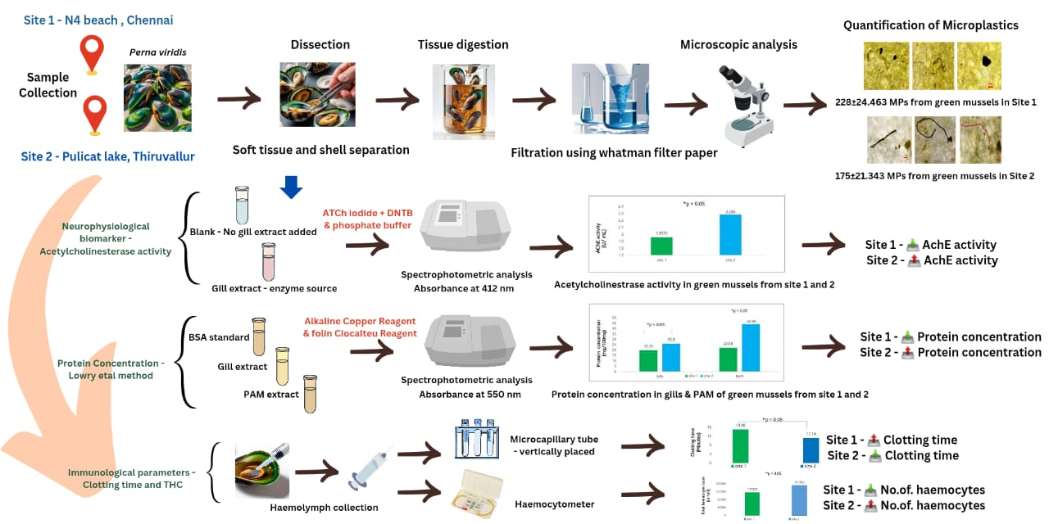

INTRODUCTION

Plastic pollution in the terrestrial and aquatic ecosystem is of serious concern which is increasing day by day globally. The earth’s surface is covered by 70% water and around 0.5% of plastic waste from 460 million metric tons of plastics generated every year end at the aquatic ecosystem (Ritchie et al., 2023). Based on their size, plastic pollutants are divided into four categories: nanoplastics (less than 1 μm), microplastics (less than 5 mm), mesoplastics (5 mm to 2.5 cm), and macroplastics (more than 2.5 cm). Microplastics (MPs) in particular are getting more attention because of their widespread presence, high durability, small size, and effects on marine life (Jeyasanta et al., 2020, Ferreira et al., 2019, Yuan et al., 2022). MPs are seen in packaging, footwear, washed off domestic waste items from ships, fishing equipments (Obebe et al., 2020) and due to anthropogenic activities. There is a serious increase in environmental microplastic concentrations exposure into the ecosystem leaving more chance for it to interact and cause hazardous effects across food webs (Horton et al., 2020).
Accumulation of microplastics in marine environment has negative impact starting from marine organisms to the whole ecology (Guzzetti et al., 2018), as they are found in the different zones of marine ecosystem either as afloat or in the marine sediment (Mani et al., 2015). When they get deposited in the marine sediments they are ingested by the deposit and filter feeders. The potential of bivalves to accumulate pollutants like microplastics, heavy metals, and persistent organic contaminants over a relatively long lifespan, as well as their extensive distribution, sedentary lifestyle, filter feeding mechanism, environmental roles, and commercial significance, have made them as appropriate bioindicators (Beyer et al., 2017; Phaksopa et al., 2022). Microplastics exposure can cause negative impact on the antioxidant enzymatic activity (superoxide dismutase, catalase, glutathione peroxidases, etc), altered haemolymph proteome, number of byssal thread, attachment strength as well as altered immune responses (Magara et al., 2019; Green et al., 2019; Pavičić-Hamer et al., 2022). Edible green mussels are a rich source of protein and are savored by humans in a healthy manner, thereby exposing them to the dangerous consequences of microplastics directly (Cherdsukjai et al., 2022). Green mussel, P. viridis was selected as the experimental organism for the current study due to their ecological significance in food web, commercial value at the fish market and widespread human consumption.
In the previous study, we detected and assessed microplastics both quantitatively and qualitatively in the soft tissues and shell of green mussel, P. viridis, from Site-1 N4 Beach, Chennai district, and Site-2 Pulicat Lake, Thiruvallur district, Tamil Nadu, India. From this, it was inferred that Site 1 exhibited a high amount of microplastics than Site 2 (Janani Kittan & Asha P., 2025). These two areas are key fish markets for green mussel, P. viridis, a commercially consumed bivalve species. The present study seeks to explore the physiological effects of microplastic exposure on neurophysiological, immunological, and total protein concentrations in green mussels obtained from the aforementioned areas. This study expands our understanding of the sub-lethal effects of microplastics on mussel health and their potential ecological consequences.

MATERIALS AND METHODS

Collection of Specimen:
Green mussels were collected from Site-1 N4 beach (13°08'02"N 80°17'56"E), Ennore, Chennai district, and Site-2 Pulicat lake (13°25'14"N 80°19'06"E), Thiruvallur district, Tamil Nadu, India (Fig. 1). During the month of September, before the onset of the Northeast monsoon, 20 samples of varied sizes were collected from each site and transferred to a container containing 2L of water collected from that site. The samples were selected at random and properly transported to the laboratory. To reduce background contamination, glassware and laboratory equipment were sterilized with distilled water throughout the course of the experiment.
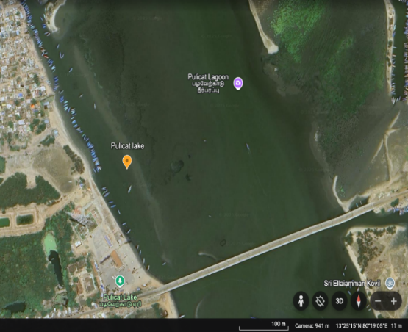
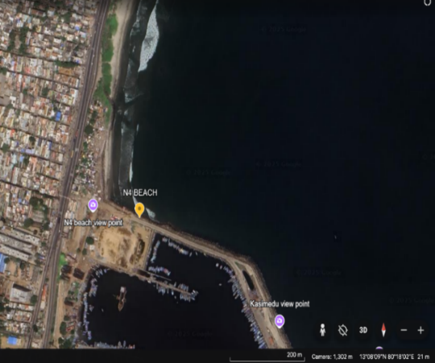
Fig 1 - Sampling sites location A) Site-1 N4 beach B) Site-2 Pulicat lake
B
A

Acetylcholinesterase activity (AChE):
AChE activity was measured using acetylthiocholine iodide (ATCh) and 5,5'-dithiobis (2-nitrobenzoic acid) (DTNB) with slight modifications of established Ellman et al method (Ellman et al.,1961). The reaction mixture was formed by adding 0.3ml of DTNB solution (0.01M) into a 3ml cuvette, followed by 0.1ml of substrate (Acetylthiocholine iodide, 0.075M) and 0.1ml of gill tissue extract (enzyme source) of the green mussels. The final volume was made up to 3ml with phosphate buffer (0.1M, pH 7.4) and incubated at 37˚C for 5-10 minutes. The total AChE enzymatic activity was then evaluated using ATCh against a blank (without adding the enzyme (gill extract) for 5 minutes at an absorbance of 412nm in a spectrophotometer to track the reaction kinetics. The enzymatic activity in the gill extract was adjusted to total protein, and AChE activity was determined using Ellman's method and reported as U/ml [enzyme activity per total reaction volume].

Haemolymph clotting time:
The haemolymph was obtained from the posterior adductor muscle of the green mussel using a 1ml syringe without anti-coagulant, where 0.2ml of haemolymph from each animal were transferred to ice-cold vials. From this 25μl of haemolymph was made to pass through the microcapillary tube. The capillary tube was turned vertical at the top end, and time was recorded. The vertical position was maintained till the haemolymph touches the bottom end of the tube. The tube was again inverted until the haemolymph clotted, and the time was noted.

Total haemocyte count [THC]:
To measure total haemocyte count, 200μl of haemolymph from each animal was collected and fixed with 4% formaldehyde at a 1:1 ratio. Cells were counted in triplicate samples in the Neubauer chamber of the haemocytometer at 40X magnification using a binocular microscope.

Estimation of protein:
Protein estimation was performed using the Lowry et al. method (Lowry et al., 1951) in the gills and posterior adductor muscle of green mussels collected from both sites. An alkaline copper reagent was prepared by adding 2% sodium carbonate (50 ml) in 0.1N sodium hydroxide with 1ml each of 0.5% copper sulphate solution and 1% sodium potassium tartrate. Before use, the Folin-Ciocalteu reagent was diluted with distilled water in 1:1. 100mg of sample was then homogenized with 10ml of 1N sodium hydroxide. It was centrifuged at 3000rpm for 10 minutes, from which 1ml of the supernatant was mixed with 5ml of alkaline copper reagent followed by incubation at 25⁰ C for 10 minutes. Subsequently, 0.5ml of the diluted Folin-Ciocalteu reagent was added, and the mixture was incubated in the dark for 30 minutes. Absorbance was measured at 550nm with a UV-Visible spectrophotometer. Protein concentration wasquantified using Bovine Serum Albumin as standard (10-100μg/mL).

Statistical analysis:
The differences in microplastics quantification and their impacts on neurophysiological biomarker, immunological parameters, and protein estimation between mussels from Sites 1 and 2 were analysed using IBM SPSS Statistical Version 30.0 (172) (IBM Corporation, 1989, 2024). One-tail t-test was used to examine the statistical difference in average microplastic accumulation in green mussels between the two sites.

RESULTS

Acetylcholinesterase (AChE) activity – Neurophysiological biomarker
Acetylcholinesterase (AChE) activity was assessed in the gill tissues of green mussels from both sites using the Ellman et al. method. A significant difference (p < 0.05) was observed between Site-1 and Site-2 mussels (Fig. 2). The AChE activity in Site-1 mussels was recorded as 1.9575 ± 0.122 U/ml, whereas Site-2 mussels exhibited a higher activity of 2.285 ± 0.40 U/ml (Table 1).

Site-1 represent N4 Beach and Site-2 Pulicat Lake
Fig. 2: Acetylcholinesterase activity (AChE) in gills of green mussels

Haemolymph Clotting Time
The clotting time of haemolymph collected from the posterior adductor muscle of green mussels showed a significant difference (p < 0.05) between the two sites (Fig. 3). Mussels from Site-1 exhibited a clotting time of 14.98 ± 1.38 minutes, while those from Site-2 showed a shorter clotting time of 11.14 ± 0.65 minutes (Table 1).

Site-1 represent N4 Beach and Site-2 Pulicat Lake
Fig. 3: Clotting time in green mussels

Total Haemocyte Count (THC)
Total haemocyte count (THC) was determined using the Neubauer chamber. Site-1 mussels showed an average THC of 1.17 × 10⁵ ± 0.087 haemocytes, whereas Site-2 mussels exhibited a higher count of 1.515 × 10⁵ ± 0.15 haemocytes. The difference between the two sites was statistically significant (p < 0.05) (Fig. 4).

Site-1 represent N4 Beach and Site-2 Pulicat Lake
Fig. 4: Total haemocytes count in green mussels

Table 1. Neurophysiological biomarker and Immunological parameters analysis in green mussels
Site | AChE activity in gill (U/mL)  (Mean ± SD) | Clotting time (minutes)  (Mean ± SD) | Total haemocyte count (THC)  (Mean ± SD)
1 | 1.9575± 0.122* | 14.98 ± 1.38* | 1.17 x 10^5 ± 0.087*
2 | 2.285 ± 0.40* | 11.14 ± 0.65* | 1.515 x 10^5 ± 0.15*

* Denotes significance, Site-1 N4 Beach and Site-2 Pulicat Lake

Protein Concentration
Protein concentration in the gill and posterior adductor muscle (PAM) was estimated using the Lowry et al. method. In gill tissues, Site-1 mussels showed a protein concentration of 19.79 ± 0.17 mg/100 mg, while Site-2 mussels showed 25.9 ± 0.58 mg/100 mg. In PAM tissues, protein concentration was 22.08 ± 0.91 mg/100 mg in Site-1 mussels and 43.95 ± 0.35 mg/100 mg in Site-2 mussels. The differences between sites were statistically significant (p < 0.05) (Fig. 5; Table 2).

Site-1 represent N4 Beach and Site-2 Pulicat Lake

Fig. 5: Protein concentration in gills and PAM of green mussels

Table 2. Protein concentration in gill and PAM of green mussels
Site | Protein levels in gill (mg/100 mg)  (Mean ± SD) | Protein levels in PAM (mg/100 mg)  (Mean ± SD)
1 | 19.79 ± 0.17* | 22.08 ± 0.91*
2 | 25.9 ± 0.58* | 43.95 ± 0.35*

* Denotes significance, Site-1 N4 Beach and Site-2 Pulicat Lake

DISCUSSION
The potential impact of microplastics on the neurophysiology, immune parameters, and protein concentration of P. viridis from Site-1 and Site-2 was reflected through notable variations observed between the two sampling locations. Acetylcholinesterase (AChE) is a key enzyme involved in the breakdown of the neurotransmitter acetylcholine and is widely recognized as an important neurophysiological biomarker. The reduced AChE activity observed in P. viridis from Site-1 suggests increased exposure to neurotoxic contaminants such as heavy metals, carbamates, organophosphates, and microplastics (Deidda et al., 2021). Recent studies indicate that microplastics can act as vectors for harmful substances, including pesticides and heavy metals, thereby impairing neuromuscular function and inhibiting AChE activity (Rafa et al., 2024). Similar reductions in AChE activity have been reported in other bivalves exposed to microplastics (Capolupo et al., 2021; Ribeiro et al., 2017). As a filter-feeding organism, P. viridis is particularly vulnerable to the bioaccumulation of microplastics and associated pollutants, which likely explains the observed enzyme inhibition.
Alterations in immunological parameters further indicate physiological stress in mussels exposed to microplastics. The prolonged haemolymph clotting time observed in mussels from Site-1 suggests an impaired immune response. This delay in clot formation may be associated with higher microplastic occurrence at Site-1, as previously reported (Janani Kittan & Asha P., 2025). Pollutants such as persistent organic pollutants, heavy metals, and microplastics have been shown to interfere with hemocyte aggregation and clotting mechanisms (Okoye et al., 2022). Extended exposure can lead to a reduction in viable haemocyte numbers, thereby diminishing clotting efficiency (Canesi et al., 2015). Additionally, oxidative damage may impair clotting protein synthesis, contributing to prolonged clotting time (Paul-Pont et al., 2016).
The reduced total haemocyte count (THC) observed in Site-1 mussels further supports the possibility of immunosuppression. THC is a sensitive indicator of immune competence in bivalves and can be influenced by environmental stressors, including pollutants. Lower THC levels may reflect haemocyte apoptosis, reduced proliferation, or impaired immune function induced by microplastic exposure (Sun et al., 2020). Similar immune suppression has been documented in bivalves such as Mytilus species exposed to phthalates and polystyrene microplastics (Gao et al., 2025). The observed reduction in THC may therefore represent an early biomarker of sublethal environmental stress.
Protein concentration plays a fundamental role in maintaining physiological, metabolic, and immune functions in bivalves. The significantly lower protein levels observed in both gill and posterior adductor muscle tissues of Site-1 mussels suggest metabolic disruption and cellular stress associated with higher microplastic exposure. Reduced protein content may result from impaired digestive efficiency and nutrient assimilation caused by microplastic ingestion (Trestrail et al., 2021). At the molecular level, exposure to polystyrene microplastics has been shown to downregulate genes involved in ribosomal function and metabolism, thereby limiting protein synthesis (Jaouani et al., 2023).
Furthermore, protein depletion may indicate increased energy expenditure to counteract stress conditions. Elevated antioxidant enzyme activity accompanied by reduced protein levels has been reported in P. viridis exposed to microplastics, suggesting protein diversion or degradation in response to oxidative stress (Li et al., 2022). Energy depletion resulting from stress responses and impaired energy allocation may also contribute to reduced protein reserves (Shang et al., 2021). Additionally, gut blockages, reduced food intake, and disrupted energy metabolism caused by microplastics have been shown to lower protein levels in bivalves (Sussarellu et al., 2016). The findings indicate that microplastics not only accumulate in mussel tissues and shells but are also associated with alterations in biological functioning.

CONCLUSION
The present study provides important insights into the sub-lethal physiological consequences of environmental microplastic exposure in the green mussel Perna viridis, a key ecological and commercially valuable bivalve species. By integrating neurophysiological, immunological, and biochemical biomarkers, this work highlights the sensitivity of P. viridis to microplastic-associated stress under natural environmental conditions. The findings collectively demonstrate that microplastic contamination poses a multifaceted threat to mussel health, affecting essential biological processes that are critical for survival, immune competence, and metabolic stability.
The observed physiological alterations emphasize the role of microplastics not only as physical stressors but also as vectors for co-contaminants capable of exacerbating toxicological impacts. The study reinforces the suitability of green mussels as effective bioindicators for monitoring microplastic pollution in coastal ecosystems, particularly in regions subjected to intense anthropogenic pressure. Given the widespread consumption of P. viridis, the bioaccumulation of microplastics in this species also raises concerns regarding potential human exposure through seafood intake.
Overall, this research contributes to a growing body of evidence underscoring the ecological risks associated with microplastic pollution and the need for comprehensive monitoring strategies. Future investigations should focus on long-term exposure effects, molecular and transgenerational impacts, and trophic transfer of microplastics (biomagnification) to better assess ecosystem level consequences and potential implications for food safety and human health.

The manuscript contains original data that hasn't been published anywhere else.
Ethical approval, Conflict of interest is not applicable.
All authors have given their consent for the manuscript to be published in the Uttar Pradesh Journal of Zoology.

REFERENCES
Beyer, J., Green, N. W., Brooks, S., Allan, I. J., Ruus, A., Gomes, T., & Schøyen, M. (2017). Blue mussels (Mytilus edulis spp.) as sentinel organisms in coastal pollution monitoring: a review. Marine Environmental Research, 130, 338-365.
Canesi, L., Ciacci, C., Bergami, E., Monopoli, M. P., Dawson, K. A., Papa, S., ... & Corsi, I. (2015). Evidence for immunomodulation and apoptotic processes induced by cationic polystyrene nanoparticles in the hemocytes of the marine bivalve Mytilus. Marine Environmental Research, 111, 34-40.
Capolupo, M., Valbonesi, P., & Fabbri, E. (2021). A comparative assessment of the chronic effects of micro-and nano-plastics on the physiology of the Mediterranean mussel Mytilus galloprovincialis. Nanomaterials, 11(3), 649.
Cherdsukjai, P., Vongpanich, V., & Akkajit, P. (2022). Preliminary study and first evidence of presence of microplastics in green mussel, P. viridis from Phuket. Applied Environmental Research, 44(1).
Deidda, I., Russo, R., Bonaventura, R., Costa, C., Zito, F., & Lampiasi, N. (2021). Neurotoxicity in marine invertebrates: An update. Biology, 10(2), 161.
Ellman, G. L., Courtney, K. D., Andres Jr, V., & Featherstone, R. M. (1961). A new and rapid colorimetric determination of acetylcholinesterase activity. Biochemical Pharmacology, 7(2), 88-95.
Ferreira, I., Venâncio, C., Lopes, I., & Oliveira, M. (2019). Nanoplastics and marine organisms: what has been studied? Environmental Toxicology and Pharmacology, 67, 1-7.
Gao, Y., Pang, X., Fang, J. K. H., Zhong, Z., Hu, M., & Wang, Y. (2025). Revealing the effects of polystyrene microplastics and di (2-ethylhexyl) phthalate on mussels: An evidence chain of gill-intestine-hemolymph. Environmental Research, 121732.
Green, D. S., Colgan, T. J., Thompson, R. C., & Carolan, J. C. (2019). Exposure to microplastics reduces attachment strength and alters the haemolymph proteome of blue mussels (Mytilus edulis). Environmental Pollution, 246, 423-434.
Guzzetti, E., Sureda, A., Tejada, S., & Faggio, C. (2018). Microplastic in marine organism: Environmental and toxicological effects. Environmental Toxicology and Pharmacology, 64, 164-171.
Horton, A. A., & Barnes, D. K. (2020). Microplastic pollution in a rapidly changing world: Implications for remote and vulnerable marine ecosystems. Science of the Total Environment, 738, 140349.
Jaouani, R., El Khatib, M., Louhichi, R., Mzoughi, N., & Ben Salem, N. (2023). Effect of aging of microplastics on gene expression levels of the marine mussel Mytilus edulis: Comparison in vitro/in vivo exposures. Marine Pollution Bulletin, 190, 114731.
Jeyasanta, K. I., Sathish, N., Patterson, J., & Edward, J. P. (2020). Macro-, meso-and microplastic debris in the beaches of Tuticorin district, Southeast coast of India. Marine Pollution Bulletin, 154, 111055.
Kittan, Janani, & Asha, P. (2025). Evaluation of microplastics in the shell and soft tissues of Green Mussel, Perna viridis from N4 Beach and Pulicat Lake, Tamil Nadu, India. Uttar Pradesh Journal of Zoology, 46(8), 174-185.
Li, Z., Chang, X., Hu, M., Fang, J. K.-H., Sokolova, I. M., Huang, W., Xu, E. G., & Wang, Y (2022). Is microplastic an oxidative stressor? Evidence from a meta-analysis on bivalves. Journal of Hazardous Materials, 423(B), 127211.
Lowry, O. H., Rosebrough, N. J., Farr, A. L., & Randall, R. J. (1951). Protein measurement with the Folin phenol reagent. The Journal of biological chemistry, 193(1), 265–275.
Magara, G., Khan, F. R., Pinti, M., Syberg, K., Inzirillo, A., & Elia, A. C. (2019). Effects of combined exposures of fluoranthene and polyethylene or polyhydroxybutyrate microplastics on oxidative stress biomarkers in the blue mussel (Mytilus edulis). Journal of Toxicology and Environmental Health, Part A, 82(10), 616-625.
Mani, T., Hauk, A., Walter, U., & Burkhardt-Holm, P. (2015). Microplastics profile along the Rhine River. Scientific Reports, 5(1), 17988.
Obebe, S. B., & Adamu, A. A. (2020). Plastic pollution: Causes, effects and preventions. International Journal of Engineering Applied Sciences and Technology, 4(12), 85-95.
Okoye, C. O., Addey, C. I., Oderinde, O., Okoro, J. O., Uwamungu, J. Y., Ikechukwu, C. K., & Odii, E. C. (2022). Toxic chemicals and persistent organic pollutants associated with micro-and nanoplastics pollution. Chemical Engineering Journal Advances, 11, 100310.
Paul-Pont, I., Lacroix, C., Fernández, C. G., Hégaret, H., Lambert, C., Le Goïc, N., & Soudant, P. (2016). Exposure of marine mussels Mytilus spp. to polystyrene microplastics: toxicity and influence on fluoranthene bioaccumulation. Environmental Pollution, 216, 724-737.
Pavičić-Hamer, D., Kovačić, I., Sović, T., Marelja, M., & Lyons, D. M. (2022). Exposure to polymethylmethacrylate microplastics induces a particle size-dependent immune response in Mediterranean mussel Mytilus galloprovincialis. Fishes, 7(6), 307.
Phaksopa, J., Sukhsangchan, R., Keawsang, R., Tanapivattanakul, K., Asvakittimakul, B., Thamrongnawasawat, T., & Worachananant, S. (2022). Assessment of microplastics in green mussel (Perna viridis) and surrounding environments around Sri Racha Bay, Thailand. Sustainability, 15(1), 9.
Rafa, N., Ahmed, B., Zohora, F., Bakya, J., Ahmed, S., Ahmed, S. F., & Almomani, F. (2024). Microplastics as carriers of toxic pollutants: Source, transport, and toxicological effects. Environmental Pollution, 343, 123190.
Ribeiro, F., Garcia, A. R., Pereira, B. P., Fonseca, M., Mestre, N. C., Fonseca, T. G., & Bebianno, M. J. (2017). Microplastics effects in Scrobicularia plana. Marine Pollution Bulletin, 122(1-2), 379-391.
Ritchie, H., Samborska, V., & Roser, M. (2023). Plastic Pollution. Our World in Data.
Shang, Y., Wang, X., Chang, X., Sokolova, I. M., Wei, S., Liu, W., & Wang, Y. (2021). The effect of microplastics on the bioenergetics of the mussel Mytilus coruscus assessed by cellular energy allocation approach. Frontiers in Marine Science, 8, 754789.
Sun, S., Shi, W., Tang, Y., Han, Y., Du, X., Zhou, W., ... & Liu, G. (2020). Immunotoxicity of petroleum hydrocarbons and microplastics alone or in combination to a bivalve species: synergic impacts and potential toxication mechanisms. Science of the Total Environment, 728, 138852.
Sussarellu, R., Suquet, M., Thomas, Y., Lambert, C., Fabioux, C., Pernet, M. E. J., & Huvet, A. (2016). Oyster reproduction is affected by exposure to polystyrene microplastics. Proceedings of the national academy of sciences, 113(9), 2430-2435.
Trestrail, C., Walpitagama, M., Miranda, A., Nugegoda, D., & Shimeta, J. (2021). Microplastics alter digestive enzyme activities in the marine bivalve, Mytilus galloprovincialis. Science of the Total Environment, 779, 146418.
Yuan, Z., Nag, R., & Cummins, E. (2022). Human health concerns regarding microplastics in the aquatic environment-From marine to food systems. Science of the Total Environment, 823, 153730.

