A Preliminary Report on Butterfly (Insecta: Lepidoptera) Diversity in Dawaipani, West Bengal, India

ABSTRACT
Butterflies are considered as bio-indicators, predicting the health of an ecosystem and its biodiversity, making their conservation crucial. Dawaipani, a tranquil village of Darjeeling district, West Bengal, India, Eastern Himalayan foothills, harbors forests, grasslands and tea gardens, that support diverse flora and fauna and is renowned for its remarkable butterfly diversity. A survey-based study was undertaken to explore the butterflies in this moderately disturbed forest area and to understand the diversity, abundance, community structure, and conservation needs of the study area. The study recorded 64 butterfly species from 49 genera and six families (Hesperiidae, Lycaenidae, Nymphalidae, Papilionidae, Pieridae, and Riodinidae), with Nymphalidae being the most dominant with 56.93% of the total number of butterflies and 51.56% of the total butterfly species. The score of Shannon diversity index, Pielou’s evenness index and Simpson's index of diversity were found 3.30, 0.95 and 0.98 respectively, indicating the area is rich in butterfly diversity with high abundance and evenness. The butterflies that showed high occurrences were Common Fivering (Ypthima baldus), Indian Cabbage White (Pieris canidia), Chocolate Pansy (Junonia iphita), Indian Tortoiseshell (Aglais caschmirensis) and Common Crow (Euploea core). Nine species protected under the Wildlife (Protection) Act (WPA), 1972, were documented. The study contributed a concise checklist along with diversity and abundance of the butterfly fauna found in the study site, accentuating the exigency of focused conservation efforts.
Keywords: Butterfly, conservation efforts, Dawaipani, Diversity, Nymphalidae.

1. INTRODUCTION
Butterflies, belonging to the order Lepidoptera of class Insecta, are one of the best taxonomically studied groups (Robbins et al., 1997), not only for their aesthetic beauty but also for their ecosystem services. Butterflies play a vital role in maintaining ecosystem’s structure and function by serving as effective pollinators, vital components of food chains and reliable bioindicators of ecosystem health. Their rapid response to microclimatic changes, habitat fragmentation and environmental degradation is helpful to determine the habitat quality of an area (Ramana, 2010). Worldwide, approximately 19 000 butterfly species are described (Westgate et al., 2016). India, a butterfly paradise, harbors more than 1500 butterfly species (Tiple, 2011) of which hundred species (15%) are endemic and twenty-six (1.8%) are globally threatened (Singh et al., 2004). High host plant specificity (Munguira et al., 2009) of butterfly species makes them an excellent marker to assess the anthropogenic annoyance and alteration of habitat and surface topography (Kocher et al., 2000). Their larvae are often very restricted to certain ecological niches (Garcia-Barros et al., 2009). Most species form meta-populations relying on habitats structure (Thomas et al., 2001; Anthes et al., 2003; Eichel et al., 2008). As a consequence, butterfly populations face threat of extinction than the coeval zoo-fauna (Thomas et al., 2004; Thomas, 2005). Hence, studies of butterfly distribution and diversity are not only considered as important models in population ecology for meta-population analyses, but also focus on adopting suitable conservation strategies to conserve and manage butterfly species effectively (Watt et al., 2003; Ehrlich et al., 2004).
Northeastern India encompasses a vast range of ecosystems, including verdant forests, grasslands and wetlands, which make the region highly biodiverse (Saha et al., 2023). The presence of a vast a diversity of flowering plants, preferable habitats, topography and climates support remarkably rich butterfly populations. About 60% of the butterfly species of the Indian sub-continent and Myanmar are documented from northeastern India alone (Evans, 1932). Few systematic studies on butterflies were carried out on butterfly distribution, diversity and abundance in the northern part of West-Bengal (from Darjeeling hills by Pradhan & Khaling, 2020, University of North Bengal campus by Saha et al., 2023, Dooars and Terai region by Pal et al., 2015).
Dawaipani, a small Himalayan village, is located at an altitude of approximately 6,500 feet in Darjeeling district, West Bengal, India. This hamlet is nestled on the opposite hill of Darjeeling Town (about 17 km away from Darjeeling town) and is surrounded by Himalayan forests. The climate of this region is subtropical highland climate. Vegetation of this area featured natural Himalayan montane temperate forests, predominating pines, oaks, deodars, and magnolias, interspersed with tea gardens, rhododendron blooms, orange orchards and grasslands. This medicinal-water-infused green landscape boasts rich biodiversity with a huge variety of trees, shrubs, herbs, and epiphytes.
No research works on diversity and abundance of butterfly community have been carried out in Dawaipani, North Bengal, India. A systematic surveys to determine the diversity and abundance of butterfly species would aid in adopting the habitat conservation strategies to effectively and sustainably protect butterflies as well as their host and nectar plants. Tthe present survey-based study was undertaken to explore the status of butterfly fauna of this area.
2. MATERIALS AND METHODS
2.1 Study area
The study was conducted at Dawaipani, situated in Darjeeling district, West Bengal, India. A survey path was established between 27.03192° N -88.30884° E and 27.02596° N - 88.31575° E, covering a distance of about 3 km (Fig. 1). The area has a cool subtropical highland climate throughout the year as it is situated at an altitude of 6500. The region receives heavy rainfall in the months of July and August when landslides are also prevalent.
2.2 Survey technique
The surveys for data collection were carried out in October, 2025, on sunny, quiet days (08:00 h to 12:00 h and 16:00 h to 17:30 h), employing a Pollard walk method (Pollard, 1977). In order to cover the entire survey path of 3000 m, a combination of 6 transects comprising 500 m each was surveyed every day. Observations were primarily made via naked eyes or binocular along with the help of photographs. The line transect method was implemented for the purpose of butterfly sampling (Hossain & Aditya, 2016). The butterfly species that were observed during the sampling period were recorded along with their abundance. Maximum butterfly species were identified by direct observation in the field or in few cases, photographs were clicked for the purpose of identification. The keys of Kunte et al. (2014), Kehimkar (2016) and Dey et al. (2017) were followed for the identification of the butterfly species recorded during the survey period, and no butterflies were collected or captured. The common English names and scientific names that were followed in the study are in accordance with Varshney and Smetacek (2015).
2.3 Statistical data Analysis
To understand the community structure of the butterfly species in the sampled site, all the recorded data were used to estimate the diversity indices with the help of Microsoft Excel 2019 software. Species richness, abundance and evenness were determined through Shannon index (Shannon & Weaver, 1963), Simpson index (Simpson, 1964) and Pielou’s index (Mulder et al., 2004) respectively. To represent species richness and evenness, a rank abundance curve was prepared (Whittaker, 1965).
Shannon diversity index (H’) = - Σ pi ln pi
Shannon H_{max}= Log₁ (N)
Dominance index (D_{BP})= ni/N (Berger & Parker, 1970)
Simpson’s diversity index (Ds)= Σ^{S}_{i-1}[ni (ni-1)/N(N-1)]
Simpson's index of diversity (D)= 1-Σ^{S}_{i-1}[ni (ni-1)/N(N-1)]
Simpson's reciprocal index (Dr)= 1/ Σ^{S}_{i} pi²
Pielou’s evenness index (J′)= H′/ln N
Here, pi is the proportion of the i^{th} species in the butterfly community. N is the number of species present in a butterfly fauna. ni is the number of individuals of i^{th} species
3. RESULTS
The satellite image of India, Darjeeling district and the study site are all represented in Fig. 1. A checklist of butterfly species that were recorded during the survey period is provided in table 1, along with their respective scientific name, their family, relative abundance and WPA Schedule (Wildlife Protection Act, 1972) status. A total number of 64 butterfly species belonging to 49 genera and 6 different families were documented from the survey site (Table 1). Among the 64 butterfly species, 33 of them belonged to family the Nymphalidae, 10 to the Pieridae, 6 to the Papilionidae and, 8 and 5 to the family Lycaenidae and Hesperiidae respectively, whereas only 2 butterfly species belonged to family Riodinidae. While considering the relative abundance of the various butterfly species observed at the study site, it was found that Common Fivering (Ypthima baldus; RA: 4.40) was the most abundant butterfly species, followed by Indian Cabbage White (Pieris canidia; RA: 4.28), Chocolate Pansy (Junonia iphita; RA: 3.80), Indian Tortoiseshell (Aglais caschmirensis; RA: 3.16), Common Crow (Euploea core; RA: 3.08), Large Cabbage White (Pieris brassicae; RA: 3.00). Relative abundance of 36 butterfly species ranged from 2 to 1, while the remaining butterfly species had relative abundance less than 1.
Analysis of percentage composition revealed that the family Nymphalidae had the maximum value constituting 56.93% of the total counted butterflies, followed by the family Pieridae (17.81%), Lycaenidae (14.13%), Papilionidae (5.72%), Hesperiidae (4.68%) and lastly the family Riodinidae (0.72%) (Fig. 2). Results of Genus proportion analysis of the studied butterfly community illustrated that the maximum number of genera were recorded from the family Nymphalidae (48.98%), followed by the family Pieridae (16.33%), family Lycaenidae (14.29%), family Hesperiidae (10.20%), family Papilionidae (6.12%), family Riodinidae (4.08%). Results of species proportion analysis revealed that the highest number of butterfly species were observed from the family Nymphalidae (51.56%), followed by the family Pieridae (15.63%), Lycaenidae (12.50%), Papilionidae (9.38%), Hesperiidae (7.81%), Riodinidae (3.13%) (Fig. 3).
While considering the family Nymphalidae, Common Fivering (Ypthima baldus) was found to be the most abundant butterfly species followed by Chocolate Pansy (Junonia iphita), whereas Broad-banded Sailer (Neptis sankara) was counted with least number. Under the family Pieridae, Indian Cabbage White (Pieris canidia) was found to be the most abundant butterfly species followed by Large Cabbage White (Pieris brassicae), while Red-base Jezebel (Delias pasithoe) was counted in minimum number. For the Papilionidae family, Common Mormon (Papilio polytes) was found in maximum number whereas Common Birdwing (Troides helena) was found in minimum number. Forget-me-not (Catochrysops strabo) of Lycaenidae family was found to be the most abundant species while Tailless Lineblue (Prosotas dubiosa) was counted with the least number. For the Hesperiidae family, Chestnut Bob (Iambrix salsala) was counted in maximum numbers, while Common Dart (Potanthus pseudomaesa) was counted in minimum number. Only 2 butterfly species were recorded for the Riodinidae family.

The butterflies that were recorded from the survey site were categorized into five different classes on the basis of their prevalence, namely very common (VC), common (C), not rare (NR), rare (R) and very rare (VR) and it was found that 51.48% of the total counted butterflies belonged to C category, followed by 33.83% to NR category, 8.69% to VC category, 5.84% to R category, 0.16% to VR category (Fig. 4).
Most of the butterfly species sampled at the study areas were ‘common’ and ‘generalist species’ and none of them were found to be universally threatened according to IUCN Red List (Ver. 3.1). Only 9 butterfly species observed at the study site, were found to be protected under various Schedules of the Wildlife Protection Act, 1972. Among these butterfly species, one of them is protected under Schedule I, namely Broad banded Sailer (Neptis sankara), six of them are protected under Schedule II, namely Himalayan Jester (Symbrenthia hypselis), Common Gull (Cepora nerissa), Common Bluebottle (Graphium sarpedon), Pea Blue (Lampides boeticus), Common Spotted Flat (Celaenorrhinus leucocera) and Lesser Punch (Dodona dipoea). Two recorded butterfly species, Blue-banded King Crow (Euploea eunice) and Brown King Crow (Euploea klugii kollari), are protected under Schedule IV.
Genus Papilio of the Papilionidae family was found to be the dominant one comprised of 4 species namely P. polytes, P. helenus, P. bianor and P. paris, followed by genus Euploea of the family Nymphalidae which was compossed of 3 species namely E. core, E. eunice, and E. klugii kollari. The family Nymphalidaegenera Ypthima, Lethe, Junonia, Vanessa, Neptis and Melanitis, Euthalia, the family Pieridae genera Pieris and Ixias, and the family Lycaenidae genus Prosotas, all comprised two species. The remaining 37 genera were all found to have only one species each. Species genus ratio was observed 1.31 from the current study (Fig. 5).
The Shannon diversity index (H') value (3.30) signifies the high species richness and diversity of the butterfly fauna at the sampled site (Table 2). The value of the Simpson’s index (Ds) was found to be more inclined towards 0, indicating the prevalence of high species abundance within the studied butterfly community. Again, the value of Simpson's index of diversity (D=0.98) depicted that the surveyed butterfly community had high abundance. The value of Pielou’s evenness index (J′=0.95) was close to 1 which stated the persistence of more evenness among the butterfly species of the studied butterfly community. Thus, all these values expressed the butterfly community was highly diverse with high abundance and high evenness.
The Shannon diversity index (H') values of the recorded six butterfly families ranged from 0.53 to 3.30 (Table 3). In this case, the family Nymphalidae was noted with the highest value as the maximum number of species were recorded from this family, followed by the family Pieridae (2.07), Lycaenidae (2.01), Hesperiidae (1.55), Papilionidae (1.35) whereas, the least value was observed from the Riodinidae family. Moreover, the highest value of Shannon H_{max} was obtained from the family Nymphalidae (3.15), followed by Pieridae (2.65), Lycaenidae (2.55), Papilionidae (2.16), Hesperiidae (2.07), Riodinidae (1.26). The values of Pielou’s evenness index (j) determine whether the species in a community is evenly distributed or not. This value was highest in case of Lycaenidae (0.97), followed by the family Hesperiidae (0.96), Nymphalidae (0.94), Pieridae (0.90), both the family Papilionidae and Riodinidae had the same value (0.76). Simpson's index of diversity (D) revealed the abundance of species in a community. Its value was recorded to be higher for the family Nymphalidae (0.96), both the families Pieridae and Lycaenidae (0.86), Hesperiidae (0.78), Papilionidae (0.69). Again, the value of Simpson's reciprocal index (Dr) indicated a higher diversity of butterfly from the family Nymphalidae (24.15) (Table 3).
The Whittaker plot’s curve showed a steep inclination up to the first four butterfly species that were recorded in the surveyed area (Figs. 6 and 7). These butterfly species occurred in high abundance and with less evenness in comparison to the remaining species. Species rank four onwards the abundance of the observed butterfly species were found to decrease accordingly with increased evenness among the sampled species of the study areas.
While considering the family-wise rank abundance curve, it was clearly observed that more evenness was exhibited by the family Lycaenidae, followed by Hesperiidae, Nymphalidae, Pieridae whereas, the families Papilionidae and Riodinidae showed relatively less evenness (Fig. 7).
4. DISCUSSION
The deforestation of vast acreage of frontier forestlands of Northeastern Himalayan region has been continued since colonial times, mainly for the purpose of timber extraction, cultivation, tea gardens establishment and construction of buildings and roads. Anthropogenic pressure due to growing population sizes and tourism pressure have further decimated the Himalayan rainforest land and lush grassland areas. These anthropogenic annoyance activities also resulted in severe soil erosion and massive biodiversity loss. In this context, impact of habitat destruction on insect livelihood is poorly surveyed (Roy et al., 2012). Thus, assessment of species diversity has become indispensable for the comprehensive understanding of forest communities and their conservation. For this, it is critically important to estimate diversity in all-inclusive way. On that account, estimation hinges on performing rapid inventoriesor by techniques that offer insight on diversity index values in a variety of habitat types (Roy et al., 2012). Moreover, habitat association of butterfly community primarily is conditional on the availability of larval host plants and ground covering nectar plants (Mitter et al., 1988; Tiple et al., 2006). Butterfly diversity in Eastern Himalayas and montane habitat of the Western Ghats, shows high endemism (Acharya & Vijayan, 2015; Sreekumar et al., 2018) and highly dependent on specific forest structures (Thakur et al., 2021). Butterfly diversity is lower in areas with high anthropogenic disturbance, such as urbanized areas or degraded forests (Bhusal et al., 2017). Lin et al. (2023) reported that butterfly diversity and abundance was reduced significantly with increasing urbanization. Landscape disturbance has an impact on butterfly communities (Cleary et al., 2025).
The results of the present study showed that the low relative abundances of a few butterfly species might be due to hostile habitat, burgeoning tourist footfall and human settlement. In contrary, high diversity of butterfly species in the study site might be related to its diversified vegetations. Similar observation documented by Bhusal and Khanal (2008) from eastern Churia mountains of Nepal and midhill region of Nepal where high diversity of butterfly was reported due to its mixed diverse vegetations (Prajapati et al., 2000).
Bhusal et al. (2018) reported that higher abundance of butterfly species was found in crop lands compared to human settlement and forest habitats due to food resources availability from the diverse flowering crops. Previous studies reported that both abiotic and biotic factors like vegetation structure, including host plants, nectar plants, temperature, wind exposure and elevation gradient, all contributed impacts on the patterns of butterfly diversity (Khan et al., 2004; Lien & Yuan, 2003; Acharya & Vijayan, 2015). Against this backdrop, Guiterrez and Memendez (1995), stated that abundance of butterflies is more related to the availability of food plants rather the physical factors like altitudes etc. Moreover, Blair and Launer (1997) affirmed that species richness and abundance of butterfly is escalated at moderately disturbed sites relative to the urban areas from the natural pristine region.
The present results demonstrate that the diversity indexes of the surveyed butterfly community were high as the surveyed area embraced both the habitat generalist and habit specialist along with favorable micro-environment and easy host plant availability, speculating that it was the ideal place for butterfly fauna. Overall butterfly diversity from study area was found higher compared to earlier studies conducted in Northeastern Himalayan region (Roy et al., 2012; Mondal et al., 2025) as the study site had the mixed vegetation with less closed canopy cover of dense forest which is suitable for only specialized butterfly species (Roy et al., 2012). A similar observation was reported by Pradhan and Khaling (2020) from human-modified tea dominated landscape of Darjeeling Hills comprising of two ecosystems of tea plantation and secondary forest. The study documented 71 species belonging to 43 genera and five families, of which seven are protected under the Wildlife (Protection) Act of India, 1972 (Pradhan & Khaling, 2020). Results of the present study revealed a similar trend in species richness and genera composition (64 species, 49 genera, six families) in the butterfly community in Dawaipani of Darjeeling district.
Greater host plant and flowering plant availability as food resources of butterfly attributes the high species richness and abundance. Likewise, increasing human settlement was found negatively correlated with butterfly species richness and their abundance (Bhusal et al., 2018; Stefanescu et al., 2011). The present study area was found to have intermediate disturbance as it is about 17 km away from busy tourist spot Darjeeling town and it is an offbeat tranquil village with lush tea estates and forest immersion. Blair and Launer (1997) noticed that butterfly diversity and abundance peaked at the areas with intermediate disturbance associated with lower urbanization. Increased urbanization affects the rare species due to habitat fragmentation, whereas common species appeared to be unaffected (Summerville & Crist, 2001). In contrary, Collinge et al. (2003) stated that grassland type and habitat quality have strong impact on butterfly diversity and abundance, but the extent of urban development was not related to species richness. However, Schulze (2004) reported that species richness of butterfly, in general is lower in natural forests, higher in disturbed forests, and highest in moderately disturbed forests. As the present study area is under the moderately disturbed forests, a high species richness with decent abundance of butterfly was obtained.
Here, only a small forest patch was studied for a shorter time span, thus, a more intensive long-term study would surely contribute more species in the checklist. Moreover, further survey-based studies in the surrounding area will provide their distribution pattern in different forest patches from the present location.
5. CONCLUSION
While a few explorative and empirical survey-based studies on butterfly fauna were undertaken in the North-eastern Himalayan region of West Bengal, long-term systematic ecological study of butterfly community in the surrounding forest patches are lacking. Additionally, understanding the responses of butterfly fauna in relation to the global climate change, habitat destruction and fragmentation, and anthropogenic annoyance activities, is urgently needed. Thereby, the most significant future strategy for biodiversity conservation would probably be further detailed investigations on the potentiality of these moderately disturbed forest areas for supporting the ecosystem structure and function.
DISCLAIMER (ARTIFICIAL INTELLIGENCE)
Authors hereby declare that NO generative AI technologies such as Large Language Models (ChatGPT, COPILOT, etc.) and text-to-image generators have been used during the writing or editing of this manuscript.
COMPETING INTERESTS
Authors have declared that no competing interests exist.
REFERENCES
Acharya, B. K., & Vijayan, L. (2015). Butterfly diversity along the elevation gradient of Eastern Himalaya, India. Ecological Research https://doi.org/10.1007/s11284-015-1292-0
Anthes, N., Fartmann, T., Hermann, G., & Kaule, G. (2003). Combining larval habitat quality and metapopulation structure – the key for successful management of pre-alpine Euphydryas aurinia colonies. Journal of Insect Conservation, 7, 175-185. https://doi.org/10.1023/a:1027330422958
Berger, W. H., & Parker, F. L. (1970). Diversity of planktonic foraminifera in deep-sea sediments. Science, 168, 1345-1347. https://doi.org/10.1126/science.168.3937.1345
Bhusal, D. R., & Khanal, B. (2009). Seasonal and Altitudinal Diversity of Butterflies in Eastern Siwalik of Nepal. Journal of Natural History Museum, 23, 82-87. https://doi.org/10.3126/jnhm.v23i0.1843
Bhusal, D. R., Rai, D., & Dahal, K. (2018). Pattern of Butterfly Response across Habitat Gradients in Midhill Mountains of Nepal. Journal of Biodiversity and Conservation, 1(2), 20-20. http://aprfjournal.org.in/wp-content/uploads/2018/01/Pattern-of-Butterfly-Response-across-Habitat-Gradients-in-Midhill-Mountains-of-Nepal.pdf
Blair, R. B., & Launer, A. E. (1997). Butterfly diversity and human land use: Species assemblages along an urban gradient. Biological Conservation, 80(1), 113–125. https://doi.org/10.1016/S0006-3207(96)00056-0
Cleary, D. F. R., Bijlmer, A. M., Wielakker, D., & Voogd, N. J. D. (2025). Impact of landscape disturbance on butterfly communities: Diversity, distance dependence, and neutral model predictions. Global Ecology and Conservation, 59(5), e03561. https://doi.org/10.1016/j.gecco.2025.e03561
Collinge, S. K., Prudic, K. L., & Oliver, J. C. (2003). Effects of Local Habitat Characteristics and Landscape Context on Grassland Butterfly Diversity. Conservation Biology, 17, 178–187. https://doi.org/10.1046/j.1523-1739.2003.01315.x
Dey, P. K., Payra, A., & Mondal, K. A. (2017). Study on butterfly diversity Singur, West Bengal, India. e-planet, 15(1), 73-77.
Ehrlich, P. R., & Hanski, I. (2004). On the wings of checkerspots: A model system for population biology. Oxford University Press. https://doi.org/10.1093/oso/9780195158274.001.0001
Eichel, S., & Fartmann, T. (2008). Management of calcareous grasslands for Nickerl’s fritillary (Melitaea aurelia) has to consider habitat requirements of the immature stages, isolation, and patch area. Journal of Insect Conservation, 12, 677-688. https://doi.org/10.1007/s10841-007-9110-9
Evans, J. H. (1932). Identification of Indian Butterflies. Mumbai: Bombay Natural History Society, 454pp.
Garcia-Barros, E., & Fartmann, T. (2009). Butterfly oviposition: sites, behaviour and modes. In J. Settele, T. G. Shreeve, M. Konvicˇka, & H. van Dyck (Eds.), Ecology of butterflies in Europe (pp. 29-42). Cambridge University Press. https://www.cambridge.org/core/books/ecology-of-butterflies-in-europe/9780521766975
Gutierrez, D., & Mendez, R. (1995). Phenology of butterflies in a mountain area in northern Iberian Peninsula. Ecography, 18, 209-216. https://doi.org/10.1111/j.1600-0587.1995.tb00123.x
Hossain, A., & Aditya, G. (2016). Avian Diversity in Agricultural Landscape: Records from Burdwan, West Bengal, India. Proceedings of the Zoological Society, 69(1), 38-51. https://doi.org/10.1007/s12595-014-0118-3
Kehimkar, I. (2016). Butterflies of India, Bombay Natural History Society. Mumbai: Oxford University Press.
Khan, M. R., Khan, M. R., Ali, K., Bashir, I., Malik, I. A., & Mir, A. (2004). Biodiversity of Butterflies from Districts Poonch and Sudhnoti, Azad Kashmir. Asian Journal of Plant Sciences, 3(5), 556-560. https://doi.org/10.3923/ajps.2004.556.560
Kocher, S. D., & Williams, E. H. (2000). The diversity and abundance of North American butterflies vary with habitat disturbance and geography. Journal of Biogeography, 27, 785-794. https://doi.org/10.1046/j.1365-2699.2000.00454.x
Kunte, K., Zhang, W., Tenger-Trolander, A., Palmer, D. H., Martin, A., Reed, R. D., Mullen, S. P., & Kronforst, M. R. (2014). doublesex is a mimicry supergene. Nature, 507, 229-232. https://doi.org/10.1038/nature13112
Lien, V. V., & Yuan, D. (2003). The differences of butterfly (Lepidoptera, Papilionoidea) communities in habitats with various degrees of disturbance and altitudes in tropical forests of Vietnam. Biodiversity and Conservation, 12(6), 1099-1111. https://doi.org/10.1023/B:BIOC.0000025300.99070.2f
Lin, Y., Huang, S., Fang, W., Zhao, Y., Huang, Z., Zheng, R., Huang, J., Dong, J., & Fu, W. (2023). Butterfly Communities Vary under Different Urbanization Types in City Parks. Animals, 13(11), 1775. https://doi.org/10.3390/ani13111775
Mitter, C., Farrell, B., & Wiegmann, B. (1988). The phylogenetic study of adaptive zones: Has phytophagy promoted insect diversification? The American Naturalist, 132, 107-128. https://doi.org/10.1086/284840
Mondal, S., Bose, A., Jamal, A., Biswas, P., & Mondal, S. (2025). Biodiversity assessment of Rongo Forest, Kalimpong, West Bengal, India: An integrated study on flora, avifauna, insects, butterflies, and moths. International Journal of Ecology and Environmental Sciences, 7(4), 44-52. https://www.ecologyjournal.in/archives
Mulder, C. P. H., Bazeley-White, E., Dimitrakopoulos, P. G., Hector, A., Scherer-Lorenzen, M., & Schmid, B. (2004). Species evenness and productivity in experimental plant communities. Oikos, 107, 50-63. https://doi.org/10.1111/j.0030-1299.2004.13110.x
Munguira, M., Garcia-Barros, E., & Cano, J. M. (2009). Butterfly herbivory and larval ecology. In J. Settele, T. Shreeve, M. Konvicˇka, & H. van Dyck (Eds.), Ecology of Butterflies in Europe (pp. 43-54). Cambridge University Press. https://www.cambridge.org/9780521766975
Pal, S., Das, D., Saha, A., & Chakraborty, K. (2015). Holistic survey on butterfly diversity at two selected regions of the Northern parts of Bengal, India. International Research Journal of Natural and Applied Sciences, 2(4), 42-57. https://www.aarf.asia/irjnas.php
Pollard, E. (1977). A method for assessing changes in the abundance of butterflies. Biological Conservation, 12(2), 115-134. https://doi.org/10.1016/0006-3207(77)90065-9
Pradhan, A., & Khaling, S. (2020). Butterfly diversity in an organic tea estate of Darjeeling Hills, eastern Himalaya, India. Journal of Threatened Taxa. 12(11), 16521–16530. https://doi.org/10.11609/jott.5716.12.11.16521-16530
Prajapati, B., Shrestha, U., & Tamrakar, A. S. (2000). Diversity of Butterfly in Daman Area of Makawanpur District, Central Nepal. Nepal Journal of Science and Technology, 2, 71-76.
Ramana, S. P. V. (2010). Biodiversity and conservation of Butterflies in the Eastern Ghats. The Ecoscan, 4, 59-67.
Tiple, A. D., Khurad, A. M., & Dennis, R. L. H. (2009). Adult butterfly feeding-nectar flower associations: constraints of taxonomic affiliation, butterfly, and nectar flower morphology. Journal of Natural History, 43(13-14), 855-884. https://doi.org/10.1080/00222930802610568
Roy, U. S., Mukherjee, M., & Mukhopadhyay, S. K. (2012). Butterfly diversity and abundance with reference to habitat heterogeneity in and around Neora Valley National Park, West Bengal, India. Our Nature, 10, 53-60. https://doi.org/10.3126/on.v10i1.7751
Saha, A., Das, S., Das, P., Raha, D., & Saha, D. (2023). Butterfly Diversity in the Campus Area of University of North Bengal, West Bengal, India. Journal of Tropical Biology and Conservation. https://doi.org/10.51200/jtbc.v20i.4520
Schulze, C. H., Steffan-Dewenter, I., & Tscharntke, T. (2004). Effects of land use on butterfly communities at the rain forest margin: A case study from Central Sulawesi. In G. Gerold, M. Fremerey, & E. Guhardja (Eds.), Land Use, Nature Conservation and the Stability of Rainforest Margins in Southeast Asia (pp. 281-297). Springer. https://doi.org/10.1007/978-3-662-08237-9_16
Shannon, C. E., & Weaver, W. (1963). The mathematical theory of communication. The University of Illinois Press. https://www.press.uillinois.edu/books/catalog/72sct725487.html
Simpson, G. G. (1964). Species density of North American recent mammals. Systematic Zoology, 13, 57–73. https://doi.org/10.2307/2411825
Singh, A. P., & Pandey, R. (2004). A model for estimating butterfly species richness of areas across the Indian subcontinent: Species proportion of family Papilionidae as an indicator. Journal of the Bombay Natural History Society, 101, 79–89. https://biostor.org/reference/48567999

Sreekumar, E. R., Nikhil, S., Ajay, K. G., & Nameer, P. O. (2018). Diversity and endemism of butterflies of montane forests of Eravikulam National Park in the Western Ghats, India. Journal of Threatened Taxa, 10(9), 12235–12246. https://doi.org/10.11609/jott.4201.10.9.12235-12246

Stefanescu, C., Carnicer, J., & Peñuelas, J. (2011). Determinants of species richness in generalist and specialist Mediterranean butterflies: the negative synergistic forces of climate and habitat change. Ecography. https://doi.org/10.1111/j.1600-0587.2010.06264.x

Summerville, K. S., & Crist, T. O. (2001). Effects of experimental habitat fragmentation on patch use by butterflies and skippers (Lepidoptera). Ecology, 82(5), 1360–1370. https://doi.org/10.2307/2679995

Thomas, C. D., Bodsworth, E. J., Wilson, R. J., Simmons, A. D., Davies, Z. G., Musche, M., & Conradt, L. (2001). Ecological and evolutionary processes at expanding range margins. Nature, 411, 577-580. https://doi.org/10.1038/35079066
Thomas, C. D., Cameron, A., Green, R. E., Bakkenes, M., Beaumont, L. J., Collingham, Y. C., Erasmus, B. F. N., de Siqueira, M. F., Grainger, A., Hannah, L., Hughes, L., Huntley, B., van Jaarsveld, A. S., Midgley, G. F., Miles, L., Ortega-Huerta, M. A., Peterson, A. T., Phillips, O. L., & Williams, S. E. (2004). Extinction risk from climate change. Nature, 427, 145-148. https://doi.org/10.1038/nature02121
Thomas, J. A. (2005). Monitoring change in the abundance and distribution of insects using butterflies and other indicator groups. Philosophical Transactions of the Royal Society B, 360(1454), 339-357. https://doi.org/10.1098/rstb.2004.1585
Tiple, A. D. (2011). Butterflies of Vidarbha region, Maharashtra State, central India. Journal of Threatened Taxa, 3(1), 1469-1477. https://doi.org/10.11609/JoTT.o2397.1469-77
Tiple, A. D., Deshmukh, V. P., & Dennis, R. L. H. (2005). Factors influencing nectar plant resource visits by butterflies on a university campus: implications for conservation. Nota Lepidopteralogica, 28, 213-224. https://www.biodiversitylibrary.org/item/145287
Varshney, R. K., Smetacek, P. (2015). A Synoptic Catalogue of the Butterflies of India. New Delhi: Indinov Publishing, 261pp.
Watt, W. B., & Boggs, C. L. (2003). Synthesis: Butterflies as model system in ecology and evolution-present and future. In C. L. Boggs, W. B. Watt, & P. R. Ehrlich (Eds.), *Butterflies: Ecology and evolution taking flight* (pp. 603-613). The University of Chicago Press. https://press.uchicago.edu/ucp/books/book/chicago/B/bo3623003.html
Westgate, M. J., Tulloch, A. I. T., Barton, P. S., Pierson, J. C., & Lindenmayer, D. B. (2017). Optimal taxonomic groups for biodiversity assessment: A meta-analytic approach. Ecography, 40(4), 539–548. https://doi.org/10.1111/ecog.02318
Whittaker, R. H. (1965). Dominance and diversity in land plant communities: Numerical relations of species express the importance of competition in community function and evolution. Science, 147(3655), 250-260. https://doi.org/10.1126/science.147.3655.250.

Table 1. Checklist of butterfly species along with their family, relative abundance, status and WPA Schedule recorded in the study site.
Sl. No. | Family | Common Name | Scientific name | Relative Abundance | Status | WPA  schedule
1 | Nymphalidae | Common Lascar | Pantoporia hordonia | 2.08 | C
2 |  | Common Sergeant | Athyma perius | 0.44 | R
3 |  | Common Fourring | Ypthima huebneri | 2.60 | C
4 |  | Common Fivering | Ypthima baldus | 4.40 | VC
5 |  | Common Bushbrown | Mycalesis perseus | 1.92 | NR
6 |  | Plain Tiger | Danaus chrysippus | 2.32 | C
7 |  | Glassy Tiger | Parantica aglea | 1.84 | NR
8 |  | Popinjay | Stibochiona nicea | 1.36 | NR
9 |  | Black Prince | Rohana parisatis | 1.56 | NR
10 |  | Common Treebrown | Lethe rohria | 1.72 | NR
11 |  | Indian Tortoiseshell | Aglais caschmirensis | 3.16 | C
12 |  | Indian Fritillary | Argynnis hyperbius | 2.72 | C
13 |  | Powdered Baron | Euthalia monina | 0.56 | R
14 |  | Yellow Coster | Acraea issoria | 0.60 | R
15 |  | Leopard Lacewing | Cethosia cyane | 2.64 | C
16 |  | Chocolate Pansy | Junonia iphita | 3.80 | C
17 |  | Lemon Pansy | Junonia lemonias | 2.64 | C
18 |  | Indian Red Admiral | Vanessa indica | 1.52 | NR
19 |  | Painted Lady | Vanessa cardui | 1.92 | NR
20 |  | Large Yeoman | Cirrochroa aoris | 1.00 | NR
21 |  | Common Crow | Euploea core | 3.08 | C
22 |  | Blue-banded King Crow | Euploea eunice | 0.08 | VR | Schedule IV
23 |  | Brown King Crow | Euploea klugii kollari | 1.28 | NR | Schedule IV
24 |  | Himalayan Sailer | Neptis mahendra | 1.04 | R
25 |  | Broad-banded Sailer | Neptis sankara | 0.04 | VR | Schedule I
26 |  | Himalayan Jester | Symbrenthia hypselis | 2.04 | C | Schedule II
27 |  | Common Evening Brown | Melanitis leda | 0.92 | NR
28 |  | Dark Evening Brown | Melanitis phedima | 0.48 | R
29 |  | Gaudy Baron | Euthalia lubentina | 1.68 | NR
30 |  | Common Maplet | Chersonesia risa | 0.72 | NR
31 |  | Great Eggfly | Hypolimnas bolina | 0.88 | NR
32 |  | Common Argus | Callerebia nirmala | 1.12 | NR
33 |  | Banded Treebrown | Lethe confusa | 2.72 | C
34 | Pieridae | Common Grass Yellow | Eurema hecabe | 2.84 | C
35 |  | Common Gull | Cepora nerissa | 0.84 | NR | Schedule II
36 |  | Indian Cabbage White | Pieris canidia | 4.28 | VC
37 |  | Large Cabbage White | Pieris brassicae | 3.00 | C
38 |  | Psyche | Leptosia nina | 2.12 | C
39 |  | Red-base Jezebel | Delias pasithoe | 0.20 | R
40 |  | Chocolate Albatross | Appias lyncida | 1.68 | NR
41 |  | Great Orange tip | Hebomoia glaucippe | 1.12 | NR
42 |  | White Orange Tip | Ixias marianne | 0.76 | NR
43 |  | Yellow Orange Tip | Ixias pyrene | 0.96 | NR
44 | Papilionidae | Common Mormon | Papilio polytes | 2.32 | C
45 |  | Red Helen | Papilio helenus | 0.56 | R
46 |  | Common Bluebottle | Graphium sarpedon | 2.04 | C | Schedule II
47 |  | Common Birdwing | Troides helena | 0.04 | VR
48 |  | Common Peacock | Papilio bianor | 0.32 | R
49 |  | Paris Peacock | Papilio paris | 0.44 | R
50 | Lycaenidae | Forget-me-not | Catochrysops strabo | 2.68 | C
51 |  | Purple Sapphire | Heliophorus epicles | 2.28 | C
52 |  | Common Cerulean | Jamides celeno | 1.48 | NR
53 |  | Pale Grass Blue | Pseudozizeeria maha | 2.32 | C
54 |  | Dark Grass Blue | Zizeeria karsandra | 2.04 | C
55 |  | Pea Blue | Lampides boeticus | 1.28 | NR | Schedule II
56 |  | Common Lineblue | Prosotas nora | 1.32 | NR
57 |  | Tailless Lineblue | Prosotas dubiosa | 0.72 | NR
58 | Hesperiidae | Common Redeye | Matapa aria | 1.00 | NR
59 |  | Common Small Flat | Sarangesa dasahara | 1.08 | NR
60 |  | Common Spotted Flat | Celaenorrhinus leucocera | 0.72 | NR | Schedule II
61 |  | Common Dart | Potanthus pseudomaesa | 0.48 | R
62 |  | Chestnut Bob | Iambrix salsala | 1.40 | NR
63 | Riodinidae | Punchinello | Zemeros flegyas | 0.56 | R
64 |  | Lesser Punch | Dodona dipoea | 0.16 | R | Schedule II
VC -very common (>100 sightings), C – common (51 to 100sightings), NR – nor rare (16 to 50 sightings), R – rare (3 to 15 sightings), VR – very rare (1 to 2) to indicate the rarest to the most common butterfly species (Tiple et al., 2006).
WPA- Species enlisted in Indian Wildlife Protection Act, 1972.
Table 2. Values of different biodiversity indices of butterfly diversity of the study area.
Shannon diversity index (H') | Pielou’s evenness index (J′) | Simpson's index (Ds) | Simpson's index of diversity (D)
3.30 | 0.95 | 0.02 | 0.98

Table 3. Values of different biodiversity indices of the six butterfly families of the study area.
Family | Shannon diversity index (H') | Shannon H_{max} | Pielou’s evenness index (J′) | Simpson's index (Ds) | Simpson's index of diversity (D) | Simpson's reciprocal index (Dr)
Nymphalidae | 3.30 | 3.15 | 0.94 | 0.04 | 0.96 | 24.15
Pieridae | 2.07 | 2.65 | 0.90 | 0.14 | 0.86 | 6.86
Papilionidae | 1.35 | 2.16 | 0.76 | 0.31 | 0.69 | 3.22
Lycaenidae | 2.01 | 2.55 | 0.97 | 0.14 | 0.86 | 7.12
Hesperiidae | 1.55 | 2.07 | 0.96 | 0.22 | 0.78 | 4.49
Riodinidae | 0.53 | 1.26 | 0.76 | 0.63 | 0.37 | 0.63

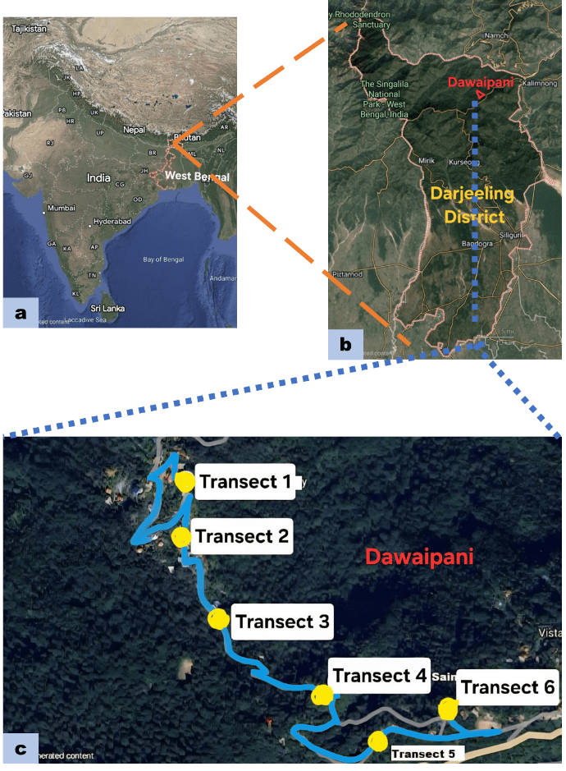
Fig. 1. Satellite image of India (a), Darjeeling district (b) and Dawaipani (c) showing the study area.
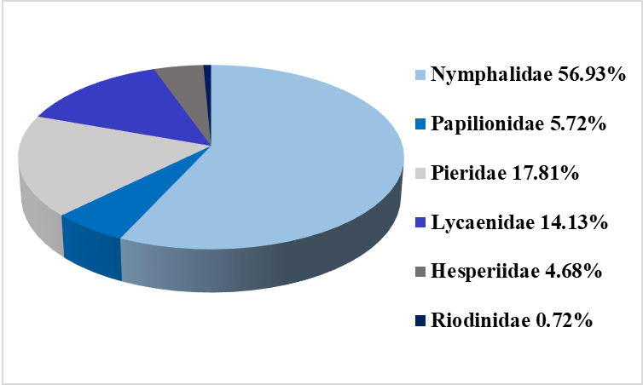
Fig. 2. Percentage composition of six families of butterflies in the study area.
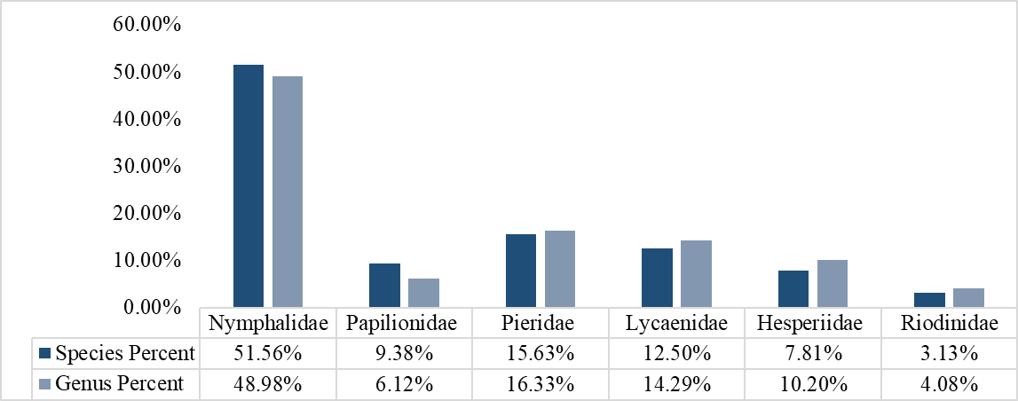
Fig. 3. Genus to species proportion of butterflies of six families.

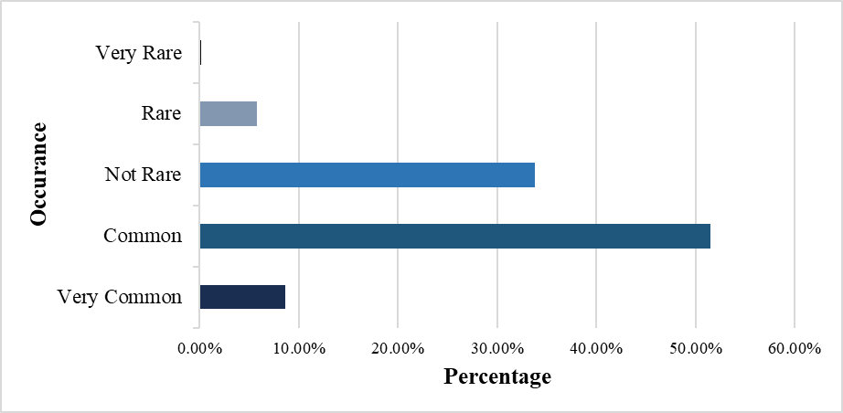
Fig. 4. Occurrence of different butterfly species in the study area.

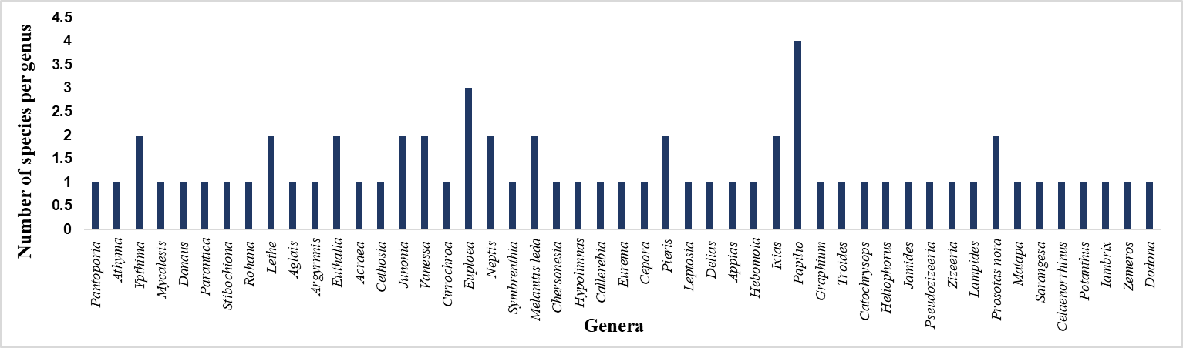
Fig. 5. Species richness of the recorded butterfly genera of the study site.

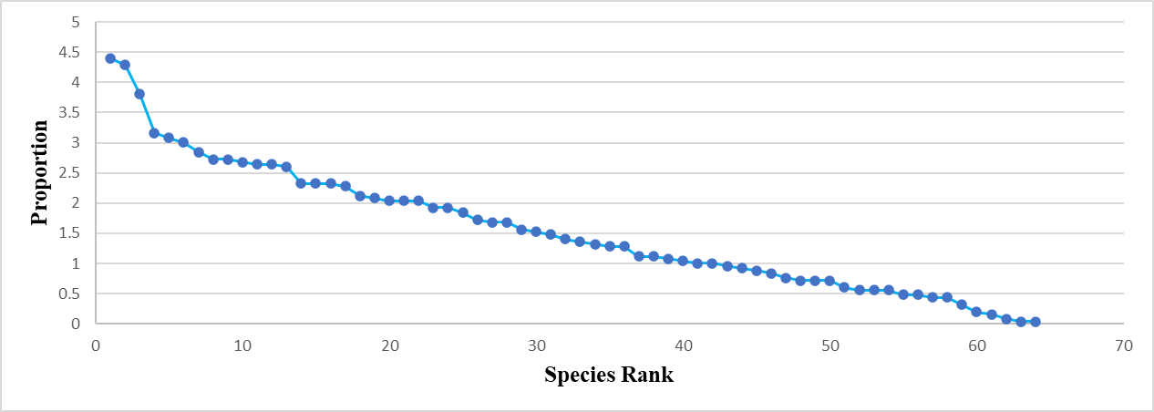
Fig. 6. Rank-abundance curve of 64 species of butterfly in the study area.

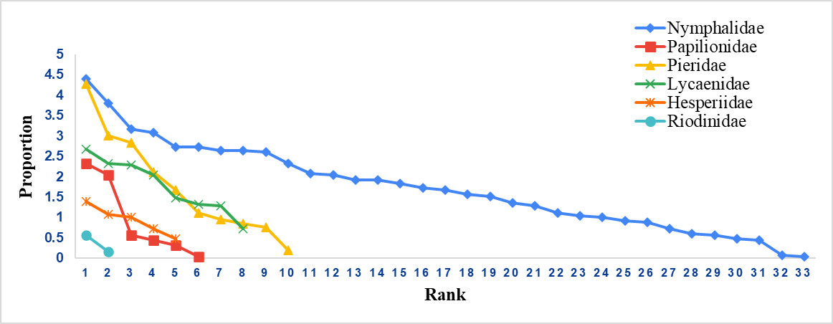
Fig. 7. Rank-abundance curve of six families of butterfly in the study area.
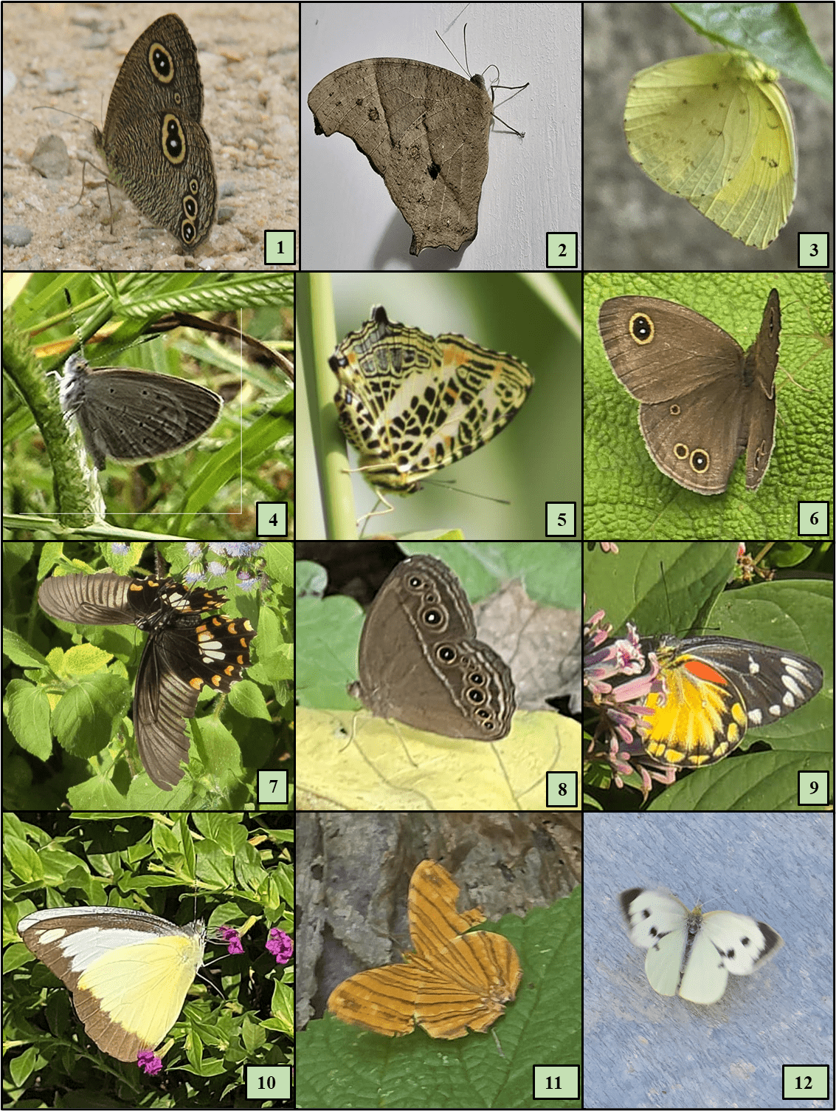
Fig. 8. Photographs of different butterfly species recorded in the study area
1) Ypthima baldus, 2) Melanitis leda, 3) Eurema hecabe 4 Pseudozizeeria maha, 5) Symbrenthia hypselis, 6) Ypthima huebneri, 7) Papilio polytes, 8) Mycalesis perseus, 9) Delias pasithoe, 10) Appias lyncida, 11) Chersonesia risa, 12) Pieris brassicae.
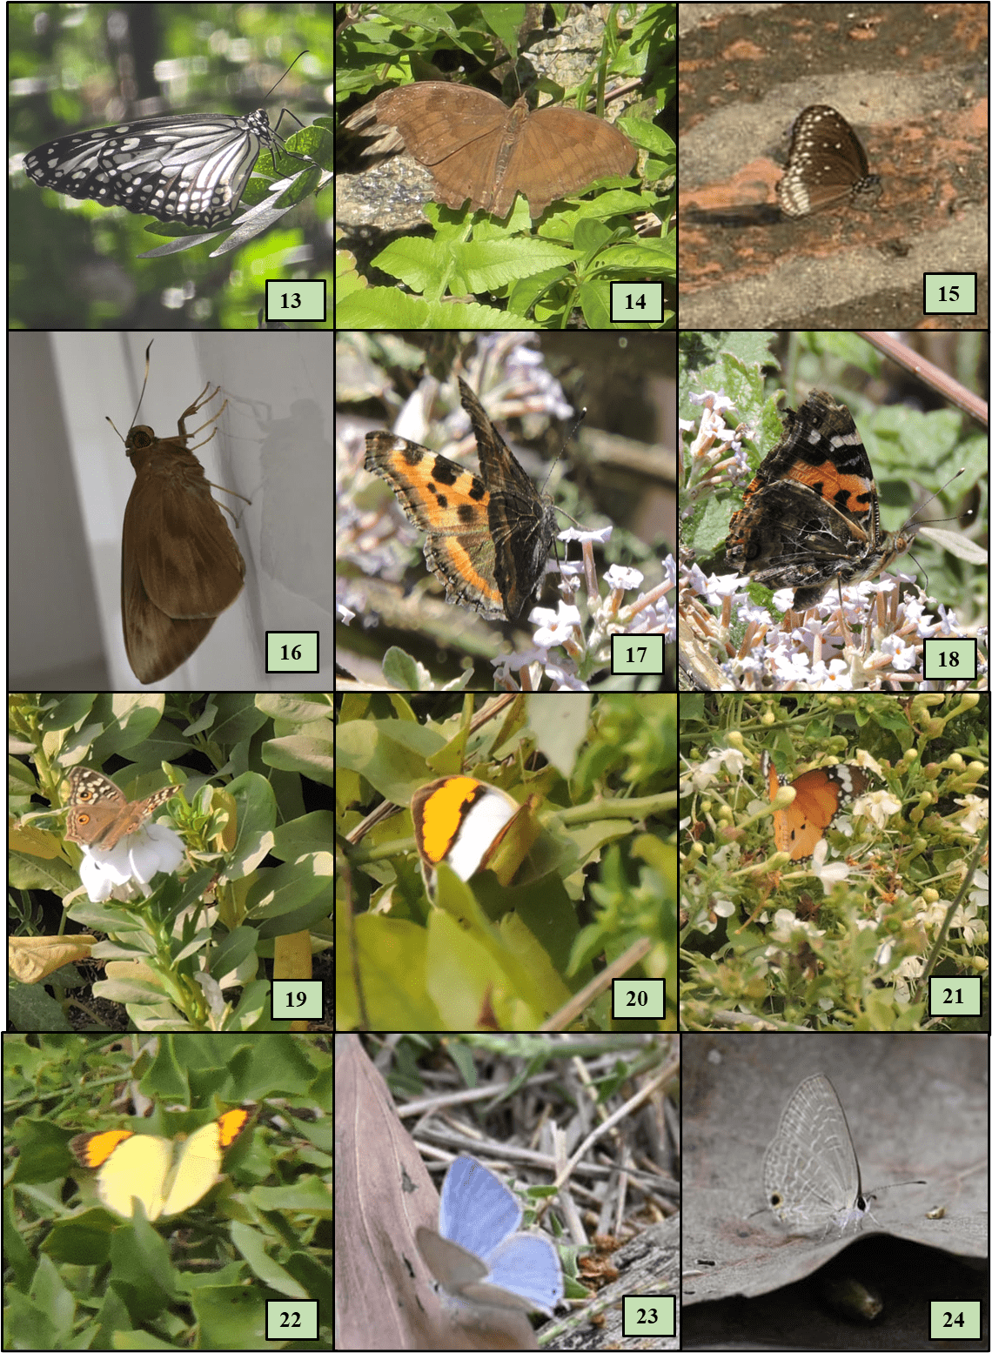
Fig. 9. Photographs of different butterfly species recorded in the study area
13) Parantica aglea, 14) Junonia iphita, 15) Euploea core, 16) Matapa aria, 17) Aglais caschmirensis, 18) Vanessa indica, 19) Junonia lemonias, 20) Ixias marianne, 21) Danaus chrysippus, 22) Ixias pyrene, 23) Catochrysops strabo, 24) Jamides celeno.

