THE AVAILABLE ZOOPLANKTON OF CHERA KULAM POND AND
THAMIRABARANI RIVER OF TIRUNELVELI CITY

ABSTRACT
Zooplankton are microscopic organism that are suspended in water and they are rich in essential amino acids and fatty acids. Rotifers are commonly called wheel organism. Rotifers are the important part of freshwater zooplankton that bring a major food source to certain freshwater organism. This work has been designed to identify the freshwater zooplankton and rotifers to analyse the inter- relationship between freshwater zooplankton and various physico- chemical parameters. Zooplankton samples were collected from Thamirabarani river and Chera Kulam Pond, Tirunelveli District respectively. These samples were collected between 9.00 to 10.00 AM during the month of Feb-Apr 2022.
Key words: Zooplankton, Rotifer, Food source, Physuco- Chemical Parameters
INTRODUCTION
Aquatic biodiversity is threatened primarily by human abuse and mismanagement of both living resources and the ecosystems that support them (Dhanapathi 2000). Nutrients like phosphorous and nitrogen from the domestic wastes and fertilizers accelerate the process of eutrophication. Natural factors like dust, storm and weathering of minerals are slow processes in causing eutrophication. Lentic water bodies have tremendous importance as they are recharging reservoirs for drinking water, domestic use and as infrastructure for pisciculture. Eutrophication has become a widely recognized problem of water quality deterioration. (Sampaio et al., 2002).
Temperature, Dissolved oxygen. Turbidity, pH and salinity are significant parameters used to study the water quality. Water quality, i.e., the physico-chemical and biological characteristics of water, play a big role in plankton productivity as the biology of the cultured organisms. Water quality determines the species optimal for culture under different environments. (Shah et al., 2015).
MATERIALS AND METHODS
STUDY AREA
The Chera kulam pond was selected for the study and it is lentic freshwater ecosystem located in Tirunelveli District. Pond occupies five-acre area. It was enriched with macrophytes like Eicchonia, Pistia, Lemna, Hydrilla and Microphytes were present. The average temperature during Feb-May 2022 ranges between 31ºC to 41ºC.
Thamirabarani river was also selected for the study and it is the lotic freshwater in Tirunelveli District. The average temperature ranges between 30-35ºC during Feb-May 2022
SAMPLE COLLECTION AND ANALYSIS
Physico-Chemical Parameters and identification of Zooplankton from the water samples collected from Thamirabarani river and Chera Kulam Pond were studied at monthly intervals from Feb-Apr 2022.
Zooplankton collection were made from littoral surface water column in different stations of each freshwater habitat. Qualitative collections were done by towing surface water column, quantitative zooplankton sample were collected by filtering 50L of water through zooplankton net made of bolding silk 100 microns mesh size. The collected water sample were transferred to a clean plastic container which is about 1L capacity.
ZOOPLANKTON IDENTIFICATION
Sorted individual samples were placed on a clean glass side with the help of fine camel air brush. Identification of Zooplankton species was done under light microscope.

PHYSICO-CHEMICAL ANALYSIS
Water Temperature – Water Temperature was determined with the help of Thermometer
pH –pH was determined by pH meter
Dissolved oxygen (DO) – DO was determined by Winkler’s Method
Chlorinity –Chlorinity was estimated by titrating against AgNO3
Salinity – Salinity was determines from Chlorinity
DIVERSITY INDEX
A Variety of indices are available to quantify the diversity of biological communities; A mathematical expression that combines species richness and eveness as a measure of diversity. The collected zooplankton species were ssubjected to diversity analysis using different indices.
OBJECTIVES
- To explore the taxonomic composition of the zooplankton from water body- Thamirabarani river, Chera kulam pond
- The work has been designed to identify the diversity, species richness of the freshwater zooplankton and rotifers
- To analyze the water quality parameters in vies of understanding the inter relationship between freshwater zooplankton and various Physico-Chemical parameters.
RESULT AND DISCUSSION
Table 1. Zooplanktonic Species Obtained from Chera Kulam Pond, Tirunelveli District

Species | February | March | April | May
Brachionus | 67 | 33 | 18 | 14
Keratells | 09 | 11 | 07 | -
Diaphonosoma | 09 | 07 | 11 | 13
Cyclops | 20 | 16 | 17 | 19
Daphnia | 11 | 09 | 13 | 27
Monia | 09 | 13 | 16 | 13
Nauplius | 10 | 15 | 13 | 12
Leptodiotonus | 09 | 09 | 07 | 10
Euchlanis | 11 | 09 | 08 | 04

Table 2. Physico-Chemical Parameter Analysis of Chera Kulam Pond, Tirunelveli District

S.NO | PARAMETER | February | March | April | May
S.NO | PARAMETER | F.N | F.N | F.N | F.N
1. | pH | 7.71 | 8.00 | 8.32 | 8.40
2. | Temperature | 30.9 | 32.4 | 31.8 | 32.6
3. | Oxygen level (mg/lit) | 7.0 | 7.1 | 6.74 | 6.60
4. | Chlorinity(ppt) | 0.41 | 0.43 | 0.46 | 0.45
5. | Salinity(ppt) | 0.77 | 0.82 | 0.86 | 0.84

Table 3. Zooplanktonic Species Obtained from Thamirabarani River, Tirunelveli District

Species | February | March | April | May
Brachionus | 2 | 3 | 4 | 5
Cyclops | 4 | 2 | 1 | -
Rotifera Neptunia | 3 | 1 | 2 | -
Moina | 1 | 2 | - | 3
Nauplius | 9 | 5 | - | 2
Copepod | 2 | - | 2 | 3
Euchlanis dilatata | 5 | - | 4 | 1
Brachinous quadridentatus | - | 1 | - | -

Table 4. Physico-Chemical Parameter Analysis of Thamirabarani River, Tirunelveli District
S.NO | PARAMETER | February | March | April | May
S.NO | PARAMETER | F.N | F.N | F.N | F.N
1. | pH | 7.58 | 7.71 | 7.8 | 7.21
2. | Temperature | 31.1 | 33.5 | 32.9 | 33.8
3. | Oxygen level (mg/lit) | 8.36 | 7.55 | 7.49 | 7.30
4. | Chlorinity(ppt) | 0.33 | 0.39 | 0.30 | 0.34
5. | Salinity(ppt) | 0.62 | 0.7 | 0.67 | 0.64

Table 5: Comparative analysis of Chera Kulam Pond and Thamirabarani River, Tirunelveli District
AREA | SHANNON DIVERSITY INDEX | EVENNESS | RICHNESS | TOTAL NO. OF INDIVIDUALS | AVERAGE POPULATION SIZE
CHERA KULAM POND | 1.96 | 0.941 | 8 | 465 | 58.1
THAMIRABARANI RIVER | 2.13 | 0.832 | 13 | 135 | 10.4

Freshwater ecosystems provide unique habitats that enhance ecological services and the survival of different life forms (Johnson and Pflugh 2008). Zooplankton are predators of phytoplankton and are very sensitive to environmental fluctuations (Eisner et ak.,2014; Xiong et ak.,2016).
Understanding the behavior of the zooplankton community under seasonal environmental conditions is necessary to support a healthy and productive aquatic ecosystem (Lacerot et al.,2013). It is debated whether nutrients, temperature are the joint interactive effect of both properties (nutrients and temperature) are responsible for shaping the abundance of Zooplankton community in the water (Iskin et al.,2000)
For instance, a study suggested that thermal conditions is capable of influencing dissolved oxygen and metabolic activities (Roman et al.,2019), consequently bringing about differences in zooplankton communities. (Carvahho et ak.,2001; Roman et al.,2019)
We collected water samples during Feb 2022-May 2022 from chera kulam pond and Thamirabarani River. During the month of Feb in the Chera kulam pond, species like Brachionus were numerous in number when compared to other species. But during the month of May the sensitive species like Brachionus, Keratell god reduced due to increase in temperature i.e,from 30.9 to 32.6ºC (Table 2)
In Thamirabarani River, water samples were collected during Feb-May of 2022, species like Branchionus quadridentatus were few in number.
Fig 1: Comparison of zooplankton abundance between Thamirabarani and Chera Kulam pond
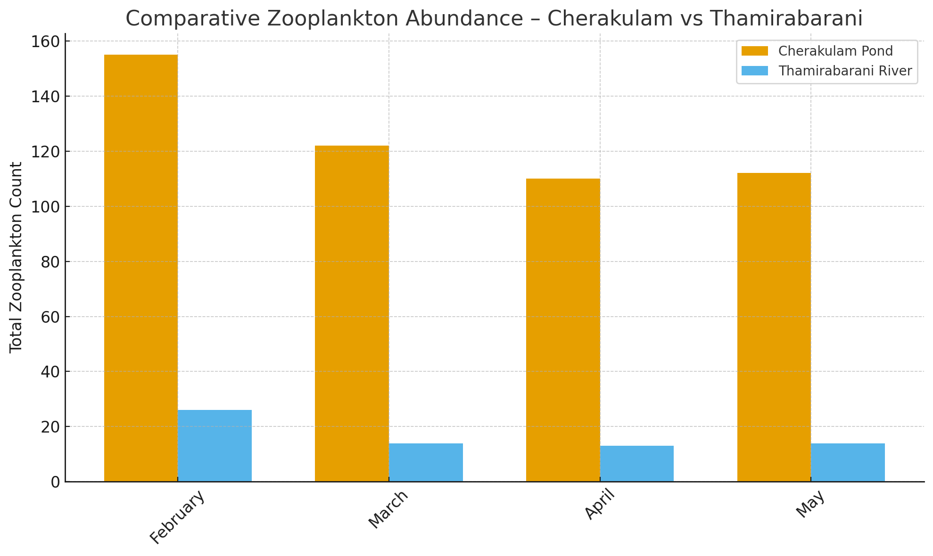 During the month of Feb 2022, the clear water is abundant and the water remained undisturned in both river and pon. But this changes in May, the turbidity is comparatively high than in Feb.
The DO in pond from Feb-May 2022 gets gradually reduced from 7 to 6 (Table 2). And the DO in River remains likely to be reduced in a smaller extent and increase in temperature i.e., around 33 also due to reduction in the molecular of water.
Fig 2: Comparison of Oxygen levels between Thamirabarani and Chera Kulam pond
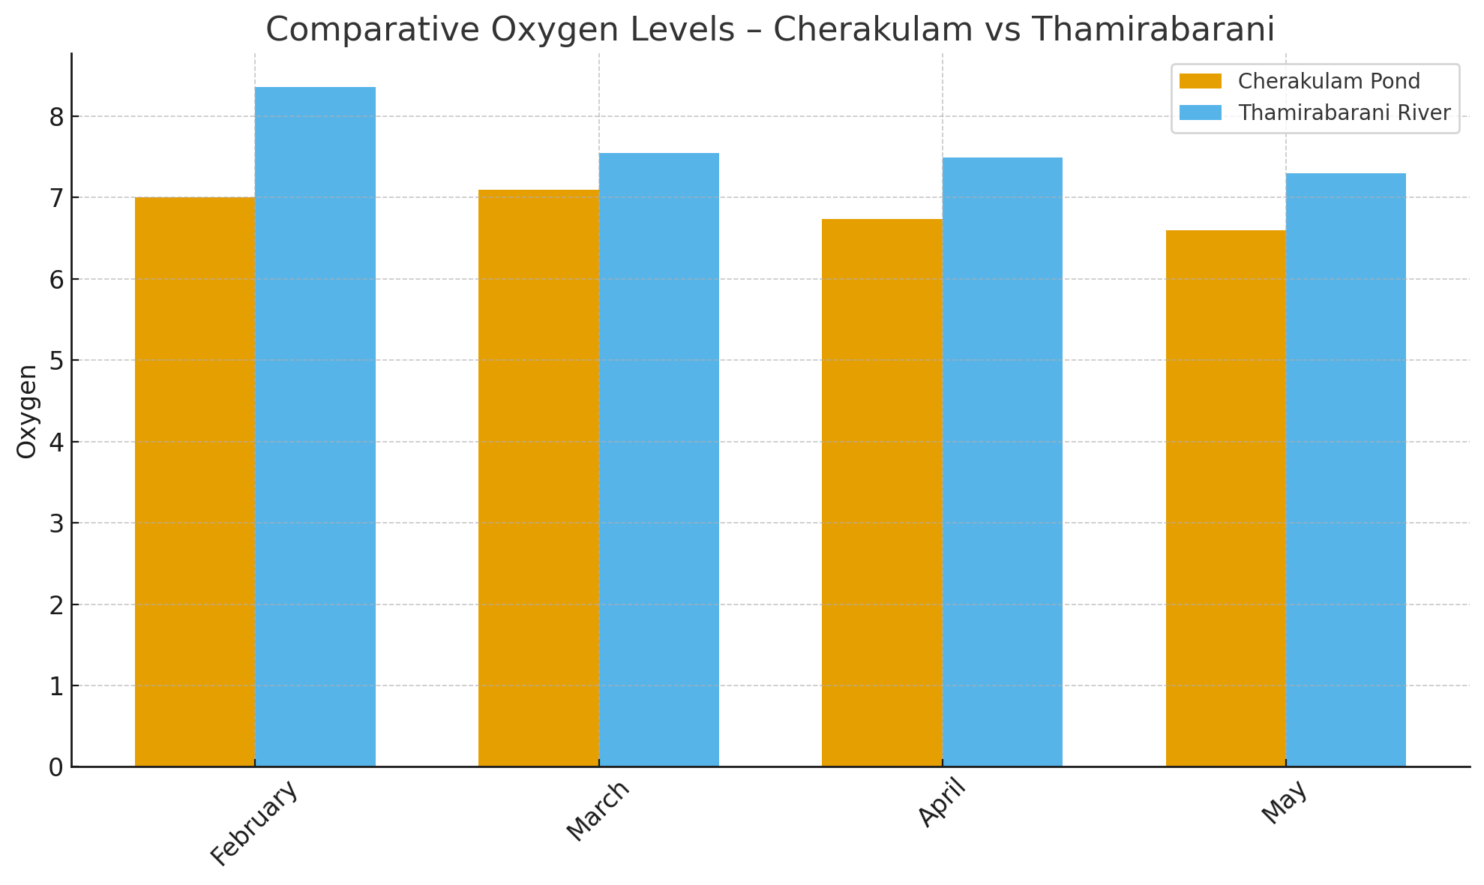
Water with higher velocity can hold more DO than slower moving water. So, the DO in River remains almost constant and the DO in pond got reduced.
Water pH can also have an impact on zooplankton; low pH causes reduced zooplankton abundance, as well as decreased biodiversity and the loss of some species (Dehui, 1995, Ivanova and Kazantseva, 2006)
The pond pH gets increased from Feb to May i.e., from 7 to 8 (Table 2). The river pH is almost 7 (Table 4) and it remains almost the same during the period of observation.
Environmental factors can also prompt organisms to migrate in order to avoid unfavorable environmental conditions, i.e., excessively high or low salinity. Variation in salinity can also contribute indirectly to food shortages and consequently, they impact zooplankton abundance (Perumal el al., 2009).
The salinity of pond gets gradually increased to a little extend i.e., 0.7 to 0.8 ppt (Table 2). So, this affects the Zooplanktonic population to an extent. The salinity of the river remains more or less constant due to running water around 0.6 ppt (Table 4).
Number of Zooplanktonic species tend to be mor or less the same in river due to stable salinity. But in pond due to increase in salinity the no. of Zooplanktonic species tends to reduced.
Food availability is another factor that may alter how Zooplankton respond to chloride. Salt regulation necessitates increased osmoprotectant and non-transporter production, both energetically costly processes (Latta et al. 2012).
In pond the chlorinity gets increases from Feb to May i.e., from 0.41 to 0.45 ppt (Table 2). Chlorinity content is increased mainly due to the man- made activity. Due to slight increase in chlorinity in pond there is fluctuation in the species population. The chlorinity of river is almost constant around 0.3 ppt due to flow of water (Table 4).
In addition, salinity has a significant impact on organisms, because it requires them to adjust the saline concentrations in their bodies to the surrounding environment changes in salinity are the direct cause of some species disappearing and others occurring (ojavee et al.,2010).
The Shannon diversity index (H) is another index that is commonly used to characterize species diversity in a community.
Different levels of disturbance have different effects on diversity. A large number of species can increase diversity. Similarly, increasing the uniformity of individual distribution among species will also increase diversity. If each individual belongs to a different species, the diversity index is the largest. In Thamirabarani river the distribution diversity index is 2.13 (Table 5). This indicates the good water quality parameters existed in river sample station. Richness of species is also higher (13) (Table 5) in River sample station but total number of individuals obtained is lowered as 135 (Table 5) in Rivers sample station though the individuals of Cherakulam Pond is noticeably higher which is 465 individuals (Table 5).
Whereas in Cherakulam Pond, because of anthropogenic activities of people the diversity value got slightly lowered as 1.96 (Table 5) though the individuals were more in numbers and the richness is also obtained as 8 (Table 5).
REFERENCES
Carvalho P.D, Bini L.M, Thomaz S.M, Oliveira L G, Robertson. B, Tavechio W. L. G Darwisch
- J. 2001, Brasil. Comparative Limnology of South America Flood plain, lakes and lagoons.
23 (2):265-273
Dehui1995,_Effects of Low pH on zooplankton in some suburban water bodies of chongqing city.
J.Environ.Sc.,7(1)(1995),pp.31-35
Dhanapathi,2000 taxonomic notes on the rotifers from India from 1989-2000. Indian association of
Aquatic BiloGists (IAAB), Hyderabad.
Eisner L.B et.al.,2014, climate-mediated changes in zooplankton community structure for the eastern
Bering Sea. Deep Sea Research Part II: Tropical Studies in Oceanogrphy 109:157-171
Iskin et al.,2020. Impact of nutrients, Temperatures and a heat wave on zooplankton community
structure: an experimental approach. Water 12(12),3416-3435
Ivanova and kazantseva,2006. Effect of water Ph and total dissolved solids on the species diversity
of pelagic zooplankton in lakes: a statistical analysis. Russ.JEcol.,37(4)(2006), pp264-270
Johnson B.B, Pflugh K.K, 2008. Local official’s and citizen’s views on fresh water wetlands.
Society and Natural Resources 21(5), 387 – 403.
Lacerot et al., 2013. The role of subtropical zooplankton as grazers of phytoplankton under different
predation levels. Fresh water Biology 58(3), 494-503
Latta, L. C., L. J. Weider, J. K. Colbourne and M. E. Pfrender. 2012. The evolution of salinity
tolerance in Daphnia. A functional genomics approach. Ecology Letters 15(8), 794-802.
Ojaveer.H, Jaanus. A, Mackenzie. B. Martin G, Olenin. S, Radziejewska. T, Telesh. I, settler.
M. L, Zaiko. A, (2010) status of biodiversity in the Baltic Sea. PLOS one 5(9), e12467.Perumal V, Rajkumar. M, Perumal. P, Rajasekar. T.K, (2009) seasonal variations of plankton
diversity in the kaduviyar estuary, Nagapattinam, Southeast coast of India. J. Environmental Biology.
2009.
Roman M.R, Brandt S.B, Houde E.D, Pierson J.J, 2019, Interactive effects of hypoxia temperature
on costal pelagic zooplankton and fish. Frontiers in Marine Science 6,139.
Sampaio E., O. Roachaa, T. Mastsumura, J. Tundisi. 2002. Compostion and abundance of
zooplankton in the limnetic zone of seven reservoirs of the Paranapanema river, Brazil. Brazilian
Journal of Biology, 62: 525-545
Shah, J. A., Pandit, A. K. and Shah, G. M. 2015. A research on Rotifers of aquatic ecosystem of
Kashmir Himalaya for Documentation and Authentication. Proc. Natl. Acad. Sci. India Sect. B Biol.
Sci. 85(1):13-19.
Xiong W. et al., 2015. Determinants of community structure of zooplankton in heavily polluted river
ecosystem. Science report 6(1): 22043-22243, [PubMed]

