Original Research Article
Ecological Associations of Weaver Ant (Oecophylla smaragdina) with Tree and Climber Species and Their Seasonal Dynamics in Mayiladuthurai and Cuddalore Districts, Tamil Nadu, India

Abstract
The Asian weaver ant Oecophylla smaragdina is an ecologically important arboreal species known for its complex nest building behaviour and role in natural pest regulation. The present study investigates the ecological associations, seasonal dynamics, and host plant preferences of O. smaragdina across Mayiladuthurai and Cuddalore districts of Tamil Nadu, India, over two consecutive years. Systematic monthly surveys were conducted to record nest presence on tree, shrub, climber, and parasitic plant species, and seasonal and inter-annual variations were analysed. A total of 41 plant species belonging to 24 families were documented as nesting substrates, with Mayiladuthurai exhibiting higher host plant diversity, while Cuddalore consistently recorded greater nest abundance, indicating higher habitat suitability. Nest presence showed marked seasonal variation, with peak occurrence during summer months (March–May) and a decline during post-monsoon and winter periods. Inter-annual comparison revealed increased nesting activity in 2024, suggesting colony stabilization under may be favourable environmental conditions. Weaver ants showed a strong preference for evergreen and broad-leaved host plants, particularly members of Anacardiaceae, Moraceae, and Menispermaceae. The findings highlight the importance of vegetation structure, seasonal climate, and floristic composition in shaping weaver ant nesting dynamics and underscore the potential of O. smaragdina as a natural biological control agent in tropical agroecosystems.
Keywords: Asian Weaver ant, Ecological associations, host plant interaction, nest construction, seasonal dynamics
- Introduction
Ants are widely spread in both tropics and temperate regions at diverse altitudes. They are both scavengers and predators, and serve as needles of climate change at micro and macro levels (Parr and Bishop, 2022). Ants are momentous components of ecosystems not only because they compose a great part of the animal biomass but also because they act as environment engineers. It can be used in monitoring environmental impacts, ecosystem functioning, and tools in ecological studies (Ramesh and Jahir Hussain, 2010; Andersen, 1990; Andersen, 1988). Weaver ants (Oecophylla sp.) are arboreal, eusocial insects and play a significant role in pest management, food, and medicines (Offenberg, 2015).
Oecophylla smaragdina is a monogynous species, meaning it has a single queen in each colony can reach an impressive size, consisting of anywhere between 100,000 and 500,000 worker ants. A mature O. smaragdina colony can consist of multiple interrelated nests with up to hundreds of thousands of workers, forming an extensive three-dimensional network across host plants (Ambika and Nalini, 2019). Because O. smaragdina is obligately arboreal, its distribution and ecological performance are strongly linked to the availability, structure, and phenology of host trees and climbers. Historically, literature suggests this ant species associates with a wide-ranging of plants with over 175 host plant species documented across 46 families indicating an elective mutualistic relationship shaped by shelter, food resources (such as honeydew from tended hemipterans), and nesting substrates in return for protection against herbivores and pest arthropods (Lim et al.,2008). This ant plant association is not merely physical but ecologically purposeful. Weaver ants interact with trophobionts (e.g., scale insects and aphids) on host trees, exploit extrafloral nectarines, and encouragement herbivore communities, thereby contributing to tri-trophic interactions that can alter herbivory and plant reproductive dynamics in tropical ecosystems (Blüthgen and Fiedler, 2002). Moreover, weaver ants are recognized as effective biological control agents, often reducing pest loads in agricultural systems where they occur on fruit trees (e.g., mango, citrus, cashew) by aggressively preying on phytophagous insects and deterring competitors (Tsuji et el., 2004).
Seasonal dynamics in O. smaragdina populations including changes in nest numbers, activity levels, and host utilization are influenced by environmental factors such as temperature, humidity, and rainfall, which in turn affect foraging behaviour, colony expansion, and reproductive cycles (Nalini & Ambika, 2019; Selvam & Nalini, 2025). Despite its ecological importance, region-specific studies, particularly in the agroforest mosaics of Mayiladuthurai and Cuddalore districts in Tamil Nadu, remain limited. These districts’ diverse vegetation comprising native trees and climber species offers an ideal setting to explore how O. smaragdina selects host plants, how these associations vary seasonally, and how they influence broader ecological processes such as pest suppression, plant defence, and canopy community structure. This study aims to fill that gap by documenting the host tree and climber species used by O. smaragdina and analysing seasonal dynamics of ant colonies across contrasting climatic periods in southern India.
- Material and Methods
  - Study area
The present study was conducted in Mayiladuthurai and Cuddalore districts of Tamil Nadu, India (Fig. 1), representing tropical coastal agro-ecosystems with mixed vegetation comprising fruit trees, avenue trees, ornamental plants, and climbers. The region experiences a tropical climate, characterized by high temperatures, moderate to high humidity, and seasonal rainfall influenced by the northeast monsoon. Such climatic conditions are favourable for arboreal ant species, particularly Oecophylla smaragdina.

Fig. 1 Map showed the study area
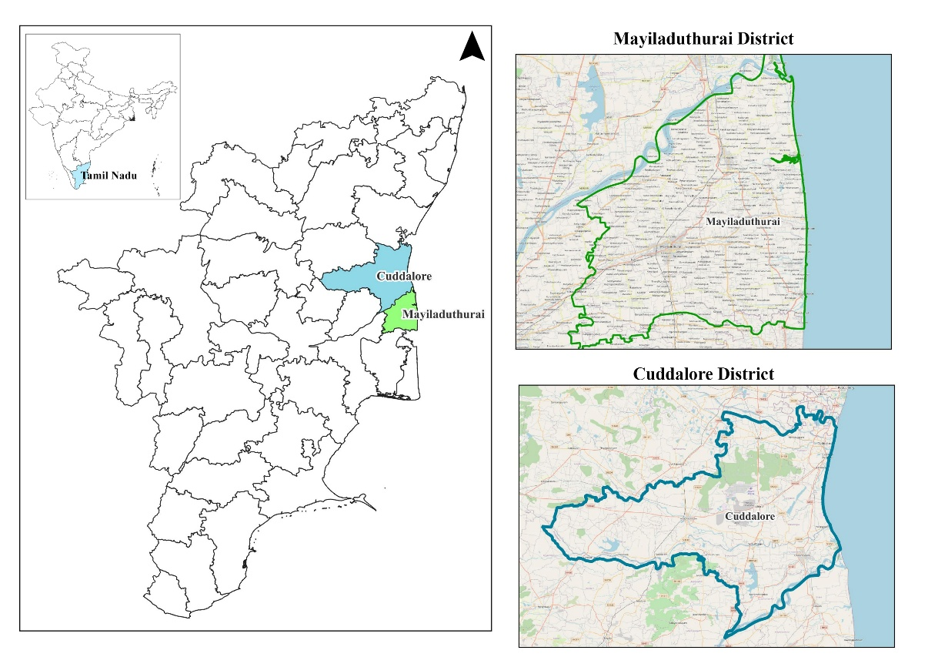

  - Selection of Host Plant Species
Field surveys were carried out on tree and climber species commonly occurring in agricultural fields, home gardens, institutional campuses, roadside plantations, and semi-natural vegetation. Plant species hosting weaver ant nests were identified using standard regional floras and verified with botanical keys. Both native and cultivated plant species were included to assess host preference and diversity.
  - Survey Design and Sampling Method
A systematic visual survey method was adopted following standard protocols used in arboreal ant studies as described by Blüthgen and Fiedler (2002). Selected sampling sites in each district were visited monthly during the study period. Each host plant was examined thoroughly for the presence or absence of O. smaragdina nests. For each plant species, the number of nests per plant was recorded and presence and absence data were documented month wise. Only active nests (with visible worker movement) were considered to avoid overestimation of colony presence. Comparative analysis between districts and seasons was performed to understand spatiotemporal patterns in host plant association. Data were analysed using descriptive statistics, and seasonal trends were illustrated graphically where necessary.
- Results
The present study documented the association of the Asian weaver ant Oecophylla smaragdina with 41 plant species belonging to 24 families across the Cuddalore and Mayiladuthurai districts of Tamil Nadu. Of these, 16 plant species were common to both districts, while 25 species showed district-specific occurrence, indicating pronounced spatial variation in host plant utilization by weaver ants (Table 1). Mayiladuthurai district supported a substantially higher diversity of host plants compared to Cuddalore. Weaver ant nests were recorded on 33 plant species in Mayiladuthurai, whereas only 19 species were observed in Cuddalore. This disparity reflects differences in vegetation composition, availability of perennial canopy cover, and habitat heterogeneity between the two districts. The families Annonaceae, Fabaceae, Combretaceae, Moraceae, Malvaceae, Meliaceae, and Rubiaceae contributed significantly to host plant diversity in Mayiladuthurai. Notably, Combretaceae was represented by three species (Terminalia arjuna, T. catappa, and T. elliptica) exclusively in Mayiladuthurai. Similarly, climbers belonging to Menispermaceae, Oleaceae, Rhamnaceae, and Cucurbitaceae were predominantly observed in Mayiladuthurai, emphasizing the importance of climbing and interconnected vegetation for nest establishment. In contrast, Cuddalore showed a relatively restricted host range, dominated by Fabaceae, Malvaceae, Moraceae, Myrtaceae, and Sapotaceae, with fewer climber species. The presence of weaver ants on economically important trees such as Mangifera indica, Artocarpus heterophyllus, Psidium guajava, Azadirachta indica, and Citrus limon in both districts highlights the species’ adaptability to managed landscapes.
Tree species constituted the dominant growth habit hosting O. smaragdina nests in both districts. However, Mayiladuthurai exhibited a greater representation of climbers and shrubs, including Artabotrys hexapetalus, Tinospora cordifolia, Cocculus hirsutus, Jasminum officinale, and Ziziphus oenoplia. The exclusive occurrence of the parasitic shrub Dendrophthoe falcata as a nesting substrate in Mayiladuthurai is noteworthy, indicating the ant’s ability to exploit structurally complex and unconventional plant forms. Cuddalore district uniquely recorded associations with Ficus carica, Morinda citrifolia, Manilkara zapota, Tectona grandis, Phyllanthus acidus, Prunus dulcis, Ixora coccinea, and the bamboo Kinabaluchloa nebulosa. The occurrence of nests on bamboo suggests behavioural flexibility in nest site selection where suitable broad-leaved trees may be comparatively limited.
Fig. 2 Month-wise percentage presence of weaver ant nests on host plant species during 2023 and 2024 in Mayiladuthurai and Cuddalore districts, Tamil Nadu.
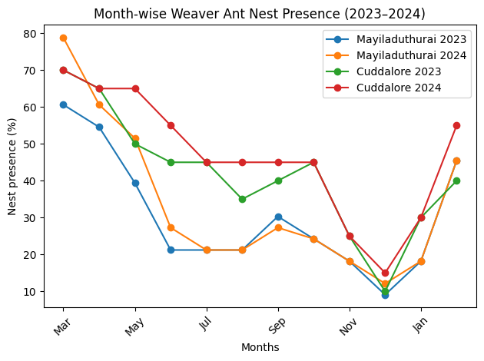

Table 1. List of trees and shrubs recorded with nests in coastal districts of Tamil Nadu during March 2023 to February 2025
S. No | Plant species | Family | Habit | Cuddalore | Mayiladuthurai
1 | Mangifera indica | Anacardiaceae | Tree | ✓ | ✓
2 | Lannea coromandelica | Anacardiaceae | Tree | – | ✓
3 | Polyalthia longifolia | Annonaceae | Tree | ✓ | ✓
4 | Artabotrys hexapetalus | Annonaceae | Climber | – | ✓
5 | Annona squamosa | Annonaceae | Tree | – | ✓
6 | Caryota urens | Arecaceae | Tree | – | ✓
7 | Tecoma stans | Bignoniaceae | Shrub/Tree | – | ✓
8 | Calophyllum inophyllum | Calophyllaceae | Tree | – | ✓
9 | Terminalia elliptica | Combretaceae | Tree | – | ✓
10 | Terminalia arjuna | Combretaceae | Tree | – | ✓
11 | Terminalia catappa | Combretaceae | Tree | – | ✓
12 | Coccinia indica | Cucurbitaceae | Climber | ✓ | ✓
13 | Pongamia pinnata | Fabaceae | Tree | ✓ | ✓
14 | Pterocarpus marsupium | Fabaceae | Tree | – | ✓
15 | Cassia fistula | Fabaceae | Tree | ✓ | ✓
16 | Couroupita guianensis | Lecythidaceae | Tree | ✓ | ✓
17 | Dendrophthoe falcata | Loranthaceae | Parasitic shrub | – | ✓
18 | Thespesia populnea | Malvaceae | Tree | ✓ | ✓
19 | Hibiscus rosa-sinensis | Malvaceae | Shrub | ✓ | ✓
20 | Azadirachta indica | Meliaceae | Tree | ✓ | ✓
21 | Swietenia mahagoni | Meliaceae | Tree | – | ✓
22 | Cocculus hirsutus | Menispermaceae | Climber | – | ✓
23 | Tinospora cordifolia | Menispermaceae | Climber | – | ✓
24 | Artocarpus heterophyllus | Moraceae | Tree | ✓ | ✓
25 | Ficus carica | Moraceae | Tree | ✓ | –
26 | Ficus amplissima | Moraceae | Tree | – | ✓
27 | Psidium guajava | Myrtaceae | Tree | ✓ | ✓
28 | Syzygium cumini | Myrtaceae | Tree | – | ✓
29 | Jasminum officinale | Oleaceae | Climber | – | ✓
30 | Ziziphus oenoplia | Rhamnaceae | Climber | – | ✓
31 | Morinda citrifolia | Rubiaceae | Tree | ✓ | –
32 | Morinda tinctoria | Rubiaceae | Tree | – | ✓
33 | Citrus limon | Rutaceae | Tree | ✓ | ✓
34 | Citrus medica | Rutaceae | Tree | – | ✓
35 | Manilkara zapota | Sapotaceae | Tree | ✓ | –
36 | Tectona grandis | Lamiaceae | Tree | ✓ | –
37 | Phyllanthus acidus | Phyllanthaceae | Tree | ✓ | –
38 | Prunus dulcis | Rosaceae | Tree | ✓ | –
39 | Ixora coccinea | Rubiaceae | Shrub | ✓ | –
40 | Kinabaluchloa nebulosa | Poaceae | Bamboo | ✓ | –
41 | Melicoccus bijugatus | Sapindaceae | Tree | – | ✓
✓- indicate presence of the nest; – indicate absence of the nest
Several plant species such as Lannea coromandelica, Annona squamosa, Caryota urens, Calophyllum inophyllum, Syzygium cumini, Swietenia mahagoni, and Ficus amplissima supported weaver ant nests only in Mayiladuthurai, underscoring its richer arboreal complexity. Conversely, Cuddalore-exclusive host plants were fewer, reflecting a more simplified canopy structure and possibly greater anthropogenic disturbance. Overall, the results clearly demonstrate that Mayiladuthurai district supports a broader and structurally more diverse range of host plants for Oecophylla smaragdina compared to Cuddalore. This enhanced plant diversity, particularly the abundance of climbers and multi-layered vegetation, appears to facilitate higher nesting opportunities and colony persistence, highlighting the importance of habitat complexity in shaping weaver ant–plant associations.
Weaver ant nest presence exhibited strong seasonal variation across both districts, with maximum occurrence during summer months (March–May) and minimum during post-monsoon and winter (November–December) (Fig. 2). Cuddalore district consistently recorded higher nest presence compared to Mayiladuthurai, suggesting greater habitat suitability. Inter-annual comparison revealed increased nesting activity in 2024, indicating colony stabilization and favourable environmental conditions (Fig. 3). Host plant analysis showed a strong preference for evergreen and broad-leaved species, particularly members of Anacardiaceae, Moraceae and Menispermaceae (Fig. 4).

Fig. 3 District-wise mean percentage presence of weaver ant nests (± SD) during 2023 and 2024.
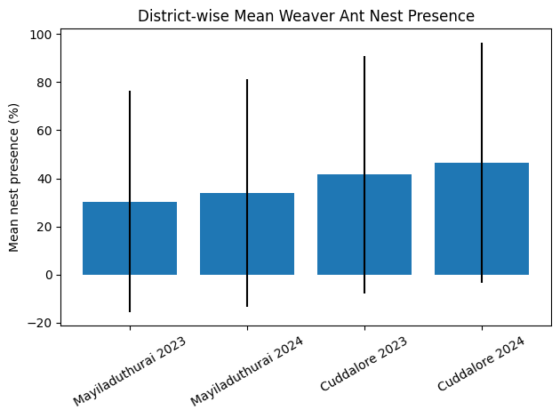

Fig. 4 Percentage occurrence of weaver ant nests across different host plant families in the study area.
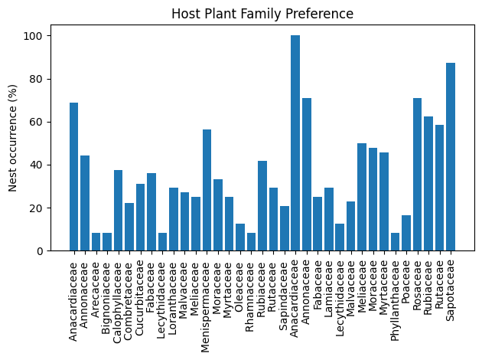
- Discussion
The present study reveals noticeable spatial variation in the association of the Asian weaver ant Oecophylla smaragdina with tree and climber species across Mayiladuthurai and Cuddalore districts of Tamil Nadu. The significantly higher number of host plant species recorded in Mayiladuthurai compared to Cuddalore clearly indicates that vegetation diversity and structural intricacy play a critical role in determining nesting opportunities and colony persistence of this obligately arboreal ant.
Mayiladuthurai district supported a richer assemblage of host plants, including a wide range of trees, climbers, shrubs, and parasitic plants, which likely provides enhanced canopy connectivity and suitable leaf construction necessary for leaf-weaving behaviour. Weaver ants favourably select plants with flexible leaves, overlapping canopies, and continuous branching patterns that facilitate nest construction and inter-nest movement. The dominance of climbers and multi-layered vegetation in Mayiladuthurai likely enhances resource accessibility and reduces the energetic costs related with nest expansion and colony maintenance, as suggested by earlier studies on Oecophylla nest site selection (Blüthgen and Fiedler, 2002; Nalini and Ambika, 2019). In contrast, the relatively lower host plant diversity in Cuddalore may reflect simplified vegetation structure, possibly due to higher levels of anthropogenic modification, monoculture practices, or coastal exposure. Such conditions can limit the availability of suitable nesting substrates and reduce canopy continuity, thereby restricting colony expansion (Offenberg, 2015).
Tree species were the primary nesting substrates in both districts, corroborating previous reports that large, perennial trees provide long-term stability for weaver ant colonies. However, the markedly higher occurrence of nests on climbers and shrubs in Mayiladuthurai suggests that O. smaragdina exploits vertically and horizontally connected plant forms to maximize nesting occasions. Climbers such as Tinospora cordifolia, Cocculus hirsutus, and Jasminum officinale may serve as linking structures between trees, enhancing foraging efficiency and territorial dominance (Philpott et al.,2006).
The utilization of the parasitic shrub Dendrophthoe falcata as a nesting substrate is particularly notable. Such unconventional host use highlights the behavioural plasticity of weaver ants and their ability to exploit structurally complex microhabitats, especially in ecosystems with high plant diversity (Yanoviak et al.,2005).
The dominance of plant families such as Fabaceae, Moraceae, Malvaceae, Meliaceae, and Annonaceae in both districts aligns with earlier studies reporting frequent weaver ant associations with these families (Way and Khoo, 1992; Lim et al.,2008). Many species within these families possess broad, pliable leaves and support trophobiont insects, which provide carbohydrate rich honeydew essential for colony nourishment. This reinforces the concept that plant morphological traits and resource availability jointly influence host plant selection by O. smaragdina.
The occurrence of several host plants exclusively in Mayiladuthurai, including Terminalia spp., Syzygium cumini, Caryota urens, and Ficus amplissima, suggests that local floristic composition strongly shapes ant plant associations (Ribas and Schoereder, 2002). Conversely, the limited number of exclusive host plants in Cuddalore, such as Prunus dulcis and Manilkara zapota, indicates constrained habitat options, though the observation of nesting on bamboo (Kinabaluchloa nebulosa) demonstrates adaptive nesting strategies under such conditions.
The wide range of economically important fruit and timber trees utilized by weaver ants in both districts underscores their potential role as natural biological control agents in agroecosystems. By establishing colonies on fruit trees such as mango, citrus, guava, and jackfruit, O. smaragdina can contribute to pest suppression, thereby reducing reliance on chemical pesticides (Peng et al.,2011; Exélis et al.,2023). The higher host plant diversity in Mayiladuthurai may thus enhance ecosystem services provided by weaver ants. Although the present analysis focuses primarily on host plant association, the observed patterns likely interact with seasonal climatic factors. Higher plant diversity and canopy cover may buffer colonies against adverse weather conditions, supporting greater colony stability across seasons, as reported in recent studies linking climate variables with weaver ant abundance (Selvam and Nalini, 2025).
- Conclusion
The present study demonstrates that the nesting ecology of the Asian weaver ant Oecophylla smaragdina is strongly influenced by seasonal variation, habitat suitability, and host plant characteristics in the agro-ecosystems of Mayiladuthurai and Cuddalore districts. Higher nest occurrence during summer months, along with increased nesting activity in 2024, reflects may be favourable climatic conditions and colony stabilization over time. The consistent preference for evergreen and broad-leaved host plants, particularly members of Anacardiaceae, Moraceae, and Menispermaceae, underscores the importance of plant structural traits and year-round canopy availability in supporting weaver ant colonies. Collectively, these findings emphasize the ecological significance of O. smaragdina as a key arboreal species and reinforce its potential as a natural biological control agent in tropical agro-ecosystems, advocating for the conservation of diverse perennial vegetation to sustain both ant populations and the ecosystem services they provide.

Reference
Andersen, A.N. 1988. Immediate and longer-term effects of fire on seed predation by ants in sclerophyllous vegetation in southeastern Australia. Australian Journal of Ecology. 13: 285–293.
Andersen, A.N. 1990. The use of ant communities to evaluate change in Australian terrestrial ecosystems: A review and a recipe. Proceedings of the Ecological Society of Australia. 16: 347–357.
Blüthgen, N. and Fiedler, K. 2002. Interactions between weaver ants Oecophylla smaragdina, homopterans, trees and lianas in an Australian rain forest canopy. Journal of Animal Ecology. 71: 793–801. https://doi.org/10.1046/j.1365-2656.2002.00647.x
Exélis, M.P., Ramli, R., Ibrahim, R.W. and Idris, A.H. 2023. Foraging behaviour and population dynamics of Asian weaver ants: Assessing its potential as biological control agent of the invasive bagworms Metisa plana (Lepidoptera: Psychidae) in oil palm plantations. Sustainability. 15: 780. https://doi.org/10.3390/su15010780
Lim, G., Kirton, L., Salom, S., Kok, L., Fell, R. and Pfeiffer, D. 2008. Host plants and associated trophobionts of the weaver ants Oecophylla spp. (Hymenoptera: Formicidae). CAB Reviews Perspectives in Agriculture Veterinary Science Nutrition and Natural Resources. 3: 1–9. 10.1079/PAVSNNR20083035.
Nalini, T. and Ambika, S. 2019. Studies on population dynamics of weaver ant, Oecophylla smaragdina Fabricius (Hymenoptera: Formicidae) nests in Prunus dulcis and Morinda citrifolia. Plant Archives. 19(2): 2018–2020.
Offenberg, J. 2015. The use of weaver ants (Oecophylla spp.) for biological control in tropical agriculture—a review. Agricultural and Forest Entomology. 17(1): 1–18.
Parr, C.L. and Bishop, T.R. 2022. The response of ants to climate change. Global Change Biology. 28: 3188–3205. https://doi.org/10.1111/gcb.16140
Peng, R., Christian, K. and Reilly, D. 2011. The effect of weaver ants Oecophylla smaragdina on the shoot borer Hypsipyla robusta on African mahoganies in Australia. Agricultural and Forest Entomology. 13: 165–171. https://doi.org/10.1111/j.1461-9563.2010.00514.x
Philpott, S.M., Perfecto, I. and Vandermeer, J. 2006. Effects of management intensity and season on arboreal ant diversity and abundance in coffee agroecosystems. In: Hawksworth, D.L. and Bull, A.T. (eds.) Arthropod Diversity and Conservation. Topics in Biodiversity and Conservation. Vol 1. Springer, Dordrecht: 147–168. https://doi.org/10.1007/978-1-4020-5204-0_9
Ramesh, T. and Jahir Hussain, K. 2010. Diversity, distribution and species composition of ant fauna at Department of Atomic Energy (DAE) Campus, Kalpakkam, South India. World Journal of Zoology. 5(1): 56–65.
Ribas, C.R. and Schoereder, J.H. 2002. Are all ant mosaics caused by competition? Oecologia. 131(4): 606–611. https://doi.org/10.1007/s00442-002-0912-x
Selvam, K. and Nalini, T. 2025. Impact of weather factors on colony inhabitation and abundance of the Asian weaver ant Oecophylla smaragdina (F). Indian Journal of Ecology. 87(2): 378–386. https://doi.org/10.55446/IJE.2024.2089
Tsuji, K., Hasyim, A., Harlion, et al. 2004. Asian weaver ants, Oecophylla smaragdina, and their repelling of pollinators. Ecological Research. 19: 669–673. https://doi.org/10.1111/j.1440-1703.2004.00682.x
Way, M.J. and Khoo, K.C. 1992. Role of ants in pest management. Annual Review of Entomology. 37: 479–503. https://doi.org/10.1146/annurev.en.37.010192.002403
Yanoviak, S., Dudley, R. and Kaspari, M. 2005. Directed aerial descent in canopy ants. Nature. 433: 624–626. https://doi.org/10.1038/nature03254

