Original Research Article
Seasonal Diversity and Feeding Guild Structure of Birds Associated with Banana and Papaya plants in Nagapattinam District, Tamil Nadu

Abstract

Birds play a crucial role in sustaining tropical agroecosystems through pollination and seed dispersal services, yet their functional associations with horticultural crops remain insufficiently explored. The present study assessed the diversity, seasonal abundance, and functional guild composition of fruit- and nectar-feeding birds associated with banana (Musa spp.) and papaya (Carica papaya) plantations in Nagapattinam District, Tamil Nadu, India, from March 2023 to February 2024. Standard visual encounter surveys were conducted across seasons, and diversity indices were computed to evaluate community structure. A total of 13 bird species belonging to nectarivorous, frugivorous, and omnivorous guilds were recorded from both crop systems. Banana plantations supported higher overall bird abundance, particularly during the monsoon and winter seasons, whereas papaya fields exhibited greater evenness and species diversity, as reflected by higher Shannon and Simpson diversity indices. Seasonal variation influenced bird assemblages, with peak richness observed during monsoon and post-monsoon periods. Statistical analysis indicated no significant seasonal differences in diversity indices (F = 0.1537, p > 0.05), suggesting relative temporal stability in avian community composition. The findings highlight that crop structure and phenology significantly shape avian assemblages, with banana acting as a high-abundance foraging habitat and papaya supporting a more balanced and diverse bird community. This study underscores the importance of diversified agroecosystems in conserving avian biodiversity and enhancing ecosystem services such as pollination and seed dispersal in agricultural landscapes.

Keywords: Pollinators, Seed Dispersal, Nagapattinam, Banana and Papaya
- Introduction
Birds play a vital role in maintaining ecological integrity through their interactions with plants, especially via pollination and seed dispersal. These mutualistic interactions not only facilitate plant reproductive success but also influence patterns of biodiversity, forest structure, and ecosystem resilience (Sekercioglu, 2006; Sekercioglu et al., 2019). In tropical and subtropical ecosystems, a significant proportion of angiosperm species depend on animal-mediated mechanisms for pollination and seed dispersal, with birds forming a major group of ecological service providers (Snow, 1981).
Avian pollination (ornithophily) involves the transfer of pollen by birds that visit flowers primarily for nectar. This is most commonly observed among nectarivorous birds such as sunbirds (Nectariniidae), flowerpeckers (Dicaeidae), and hummingbirds in the New World. These birds typically visit brightly colored, tubular flowers and inadvertently facilitate pollen movement across floral individuals (Becker et al., 2021). Bird-pollinated plants often exhibit specific traits—such as red or orange coloration, sturdy floral structures, and diurnal anthesis—that enhance bird attraction and pollination efficiency (Rodríguez-Rodríguez et al., 2013).
Similarly, birds contribute substantially to seed dispersal (ornithochory) by consuming fleshy fruits and excreting or regurgitating viable seeds at distances away from the parent plant (Howe & Miriti, 2004). Frugivorous birds, including barbets, bulbuls, pigeons, and thrushes, are key seed dispersers in many ecosystems, helping to shape plant distribution and community assembly (Susanne, 2003). Their mobility allows for long-distance dispersal across fragmented landscapes, a service critical for plant regeneration in disturbed or isolated habitats (McConkey et al., 2012; Farwig & Berens, 2012).
The Cauvery Delta in southern India presents a mosaic of ecological habitats—coastal scrublands, sacred groves, wetlands, farmlands, and urban gardens—that support a rich diversity of avifauna. Despite the recognized avian diversity in the region, the specific roles of birds in mediating pollination and seed dispersal remain understudied. This gap in knowledge is particularly pressing given the region’s vulnerability to land-use change, habitat fragmentation, and climate stressors, which threaten both plant phenology and avian behavior. Understanding bird–plant interactions in this biodiversity-rich deltaic landscape is critical for conservation planning and restoration ecology. By documenting the bird species involved in pollination and seed dispersal, and identifying the plant species that rely on these processes, it becomes possible to evaluate the ecological resilience of the system and prioritize species or habitats for protection (Kissling et al., 2009; Ghazoul, 2005).
Accordingly, this study aimed to document the diversity of avifaunal species involved in pollination and seed dispersal in Banana and Papaya. The research provides foundational data to support avian biodiversity conservation and to strengthen ecosystem-based approaches to land and vegetation management.
- Materials and Methods
  - Study Area
The study was conducted in selected plants (Banana and Papaya) within Nagapattinam District. This region comprises diverse ecosystems including coastal scrublands, mangroves, riverine patches, agricultural fields, temple groves, and urban gardens all of which provide suitable habitats for both frugivorous and nectarivores birds. The region falls under the tropical climate with distinct monsoon and dry seasons, influencing flowering and fruiting phenology.
Coordinates of selected sites (e.g., 10.77° N, 79.83° E) were recorded using a GPS device. Field surveys were conducted for one full year (e.g., March 2023 to February 2024) to account for seasonal variation in avian activity, plant phenology, and ecological interactions in Banana and Papaya trees.

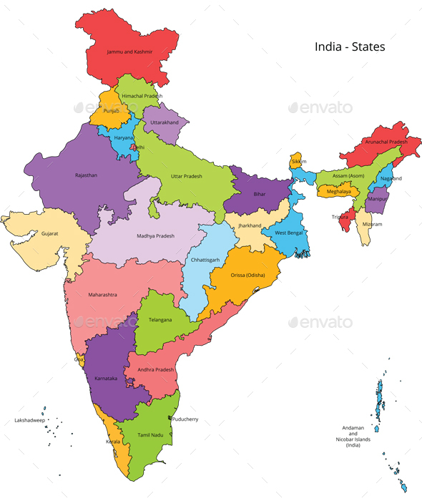
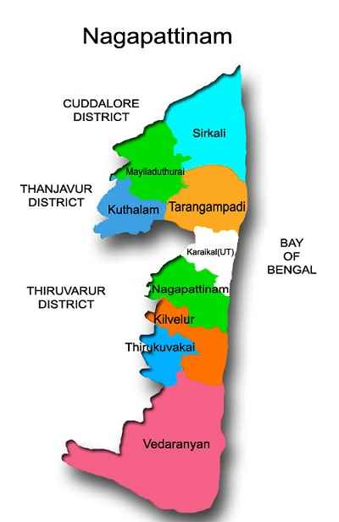
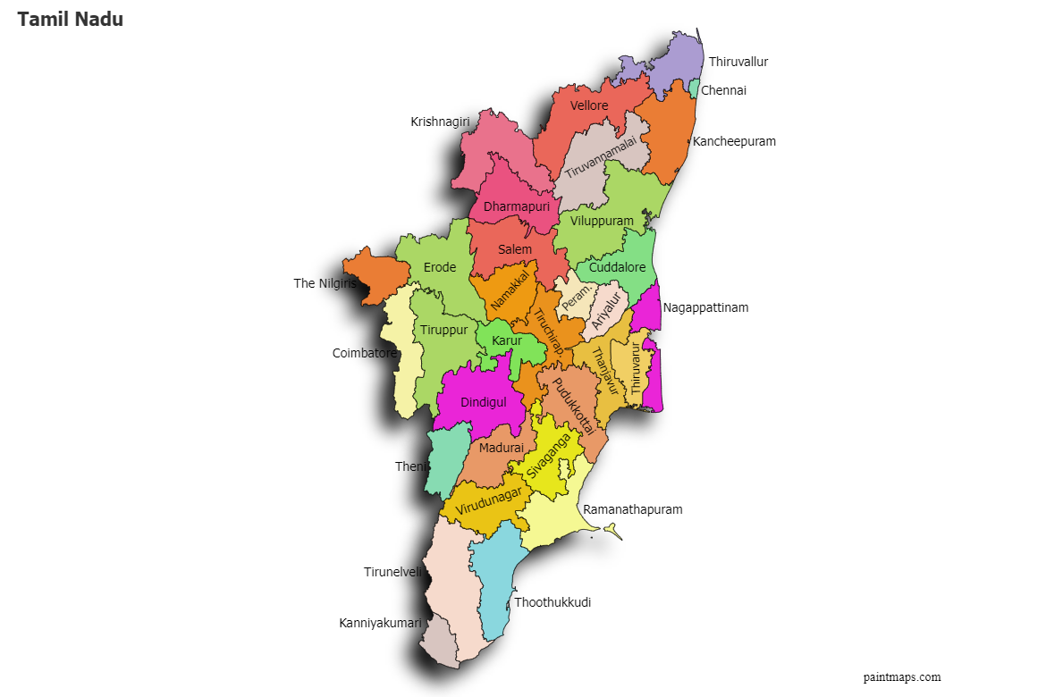
Map Showed Study area

  - Methodology
The avifaunal survey was made by Line Transect and Point Count Methods (Bibby et al., 2000; Sutherland, 2006). The transects of 500–800 meters were laid across different habitat types (Banana and Papaya). Each transect was visited eight days per month once in the morning (06:00–09:00 hrs) and once in the evening (16:00–18:00 hrs). Birds were observed visually with 8x40 binoculars and photographed using a DSLR camera with telephoto lens for later identification. Observers recorded bird species, behavior (e.g., nectar feeding, fruit consumption), plant association, foraging height, and frequency of visits. Species were identified using standard field guides (Grimmett et al., 2011) and validated with eBird or Birds of the World databases.
Focal Animal Sampling was used to monitor individual birds for a fixed period (10–15 minutes), especially when engaged in floral visitation or fruit foraging. Notes were made on the type of floral/fruit resource used. Species richness and diversity indices (Shannon-Weiner, Simpson) were calculated using PAST. Seasonal variation was assessed through ANOVA, depending on data normality. No birds or plants were harmed or manipulated beyond observation and non-invasive sampling.
- Results
The study revealed that 13 species of birds which are truly associated with Banana and Papaya plants during this survey made during March 2023 to February 2024 in Nagapattinam District (Table 1 and 2). Among the 13 species of birds visited the both plants, 11 species were under order Passeriformes and one from Cuculiformes and Psittaciformes.

Seasonal variation in the abundance of fruit- and nectar-feeding birds associated with banana plantation revealed clear differences among species and seasons (Fig. 1). Overall bird abundance was comparatively higher during the monsoon and winter seasons than in summer. House Crow (Corvus splendens) consistently showed the highest abundance across all seasons, with a pronounced peak during the monsoon, indicating its dominance as a generalist species in the study area. Common Myna (Acridotheres tristis) and Rose-ringed Parakeet (Psittacula krameri) also exhibited relatively high and stable populations throughout the year, with slight increases during the post-monsoon and winter periods. Nectar-feeding species such as Purple Sunbird (Cinnyris asiaticus) and Purple-rumped Sunbird (Leptocoma zeylonica) showed moderate seasonal fluctuations, with increased abundance during winter and monsoon, coinciding with enhanced floral availability. Frugivorous birds including Rosy Starling (Pastor roseus), Brahminy Starling (Sturnia pagodarum), and Asian Koel (Eudynamys scolopaceus) were more prominent during post-monsoon and winter, corresponding to peak fruiting of papaya. In contrast, Rufous Treepie (Dendrocitta vagabunda) and Yellow-billed Babbler (Argya affinis) were recorded in low numbers across all seasons. These results indicate that seasonal crop phenology strongly influences avian abundance, with monsoon and post-monsoon periods supporting higher diversity and abundance of fruit- and nectar-feeding birds in banana agro-ecosystems. One-way ANOVA revealed no significant difference among the groups (F = 0.1537, p = 0.992), indicating a largely uniform pattern across the compared categories.

Seasonal abundance patterns of fruit- and nectar-feeding birds in the study area showed marked interspecific and seasonal variation in Papaya tree (Fig. 2). Overall bird abundance was higher during the post-monsoon and winter seasons, while comparatively lower numbers were recorded during summer. Common Myna (Acridotheres tristis) was the most abundant species across all seasons, attaining peak numbers during the monsoon and post-monsoon periods, indicating its strong adaptability to agro-ecosystems. House Crow (Corvus splendens) also exhibited consistently high abundance, particularly during the post-monsoon season. Frugivorous species such as Red-vented Bulbul (Pycnonotus cafer), Rosy Starling (Pastor roseus), Brahminy Starling (Sturnia pagodarum), and Asian Koel (Eudynamys scolopaceus) showed moderate seasonal fluctuations, with higher abundance during post-monsoon and winter, coinciding with increased fruit availability in papaya plantations. Nectarivorous birds, including Purple Sunbird (Cinnyris asiaticus) and Purple-rumped Sunbird (Leptocoma zeylonica), were recorded in relatively low numbers but showed slight increases during monsoon and winter, reflecting seasonal flowering patterns. Species such as Large-billed Crow (Corvus macrorhynchos), Rufous Treepie (Dendrocitta vagabunda), and Yellow-billed Babbler (Argya affinis) were consistently less abundant throughout the study period. The observed seasonal trends highlight the influence of crop phenology and resource availability on avian assemblages, emphasizing the role of papaya agro-ecosystems in supporting fruit- and nectar-feeding bird communities across seasons. One-way ANOVA revealed no significant difference among the groups (F = 0.2734, p = 0.989), indicating a largely uniform pattern across the compared categories.

Table 1. List of birds recorded during the survey in Banana and Papaya plants
S. No. | Common name | Scientific name | Family | Order | Feeding habits
1 | Purple Sunbird | Cinnyris asiaticus | Nectariniidae | Passeriformes | Nectarivores, Insectivorous
2 | Purple-rumped Sunbird | Leptocoma zeylonica | Nectariniidae | Passeriformes | Nectarivores, Insectivorous
3 | Pale-billed Flowerpecker | Dicaeum erythrorhynchos | Dicaeidae | Passeriformes | Frugivorous, Nectarivores
4 | Red-vented Bulbul | Pycnonotus cafer | Pycnonotidae | Passeriformes | Frugivorous, Insectivorous
5 | Common Myna | Acridotheres tristis | Sturnidae | Passeriformes | Omnivorous (fruits, insects, refuse)
6 | Rosy Starling | Pastor roseus | Sturnidae | Passeriformes | Frugivorous, Insectivorous
7 | Brahminy Starling | Sturnia pagodarum | Sturnidae | Passeriformes | Frugivorous, Insectivorous
8 | Asian Koel | Eudynamys scolopaceus | Cuculidae | Cuculiformes | Frugivorous
9 | House Crow | Corvus splendens | Corvidae | Passeriformes | Omnivorous, Scavenger
10 | Large-billed Crow | Corvus macrorhynchos | Corvidae | Passeriformes | Omnivorous, Scavenger
11 | Rufous Treepie | Dendrocitta vagabunda | Corvidae | Passeriformes | Omnivorous (fruits, insects, small vertebrates)
12 | Rose-ringed Parakeet | Psittacula krameri | Psittaculidae | Psittaciformes | Granivorous, Frugivorous
13 | Yellow-billed Babbler | Argya affinis | Leiothrichidae | Passeriformes | Insectivorous, Omnivorous

Table 2. List of birds recorded during the survey in Banana and Papaya plants and their role

S. No. | Bird species | Association with Banana (Musa spp.) | Role in Banana | Association with Papaya (Carica papaya) | Role in Papaya
1 | Purple Sunbird | Visits flowers | Nectar feeding (indirect pollination) | Rare | Negligible
2 | Purple-rumped Sunbird | Visits flowers | Nectar feeding | Rare | Negligible
3 | Pale-billed Flowerpecker | Flower / soft pulp feeding | Nectar feeder | Occasional fruit feeding | Minor seed disperser
4 | Red-vented Bulbul | Ripe fruit feeding | Fruit consumer | Ripe fruit feeding | Primary seed disperser
5 | Common Myna | Ripe fruit feeding | Fruit consumer | Ripe fruit feeding | Primary seed disperser
6 | Rosy Starling | Ripe fruit feeding | Fruit consumer | Ripe fruit feeding | Primary seed disperser
7 | Brahminy Starling | Ripe fruit feeding | Fruit consumer | Ripe fruit feeding | Primary seed disperser
8 | Asian Koel | Ripe fruit feeding | Fruit consumer | Ripe fruit feeding | Primary seed disperser
9 | House Crow | Ripe / fallen fruits | Fruit consumer | Ripe / fallen fruits | Secondary seed disperser
10 | Large-billed Crow | Ripe / fallen fruits | Fruit consumer | Ripe / fallen fruits | Secondary seed disperser
11 | Rufous Treepie | Rare | Negligible | Ripe fruit feeding | Secondary seed disperser
12 | Rose-ringed Parakeet | Fruit damage | Crop pest | Occasional fruit feeding | Seed predator
13 | Yellow-billed Babbler | Rare | Negligible | Fallen fruits | Opportunistic feeder

Fig. 1 Frequency of Season wise bird visitation in Banana field during the study period (n=96)

Fig. 2 Frequency of Season wise bird visitation in Papaya tree during the study period (n=96)

.

Table 3. Diversity indices of birds recorded in Banana field during the study period (n=96)
Diversity indices | Summer | Monsoon | Post Monsoon | Winter
Species Richness | 12 | 13 | 13 | 13
Abundance | 128 | 148 | 135 | 142
Dominance Index | 0.15149 | 0.1398 | 0.11804 | 0.10261
Shannon H’ Index | 2.1017 | 2.1564 | 2.2633 | 2.3969
Simpson diversity Index | 0.84851 | 0.8602 | 0.88196 | 0.89739

Table 4. Diversity indices of birds recorded in Papaya during the study period (n=96)
Diversity indices | Summer | Monsoon | Post Monsoon | Winter
Species Richness | 12 | 13 | 13 | 13
Abundance | 99 | 102 | 110 | 98
Dominance Index | 0.12864 | 0.13745 | 0.12794 | 0.11552
Shannon H’ Index | 2.2256 | 2.1626 | 2.2655 | 2.3122
Simpson diversity Index | 0.87136 | 0.86255 | 0.87206 | 0.88448

A comparative assessment of diversity indices between banana fields and papaya fields revealed clear differences in avian community structure across seasons (Tables 3 & 4). In banana fields, species richness ranged from 12 species in summer to 13 species during monsoon, post-monsoon, and winter, while total abundance varied markedly, with the highest number of individuals recorded during the monsoon (148) and the lowest during summer (128). In contrast, papaya fields supported a slightly lower and more stable abundance across seasons, ranging from 98 individuals in winter to 110 individuals during the post-monsoon period, indicating comparatively uniform habitat use.

The Dominance Index was consistently higher in banana fields during summer (0.151) and monsoon (0.140), suggesting greater dominance by a few generalist species, whereas papaya fields exhibited lower dominance values across all seasons (0.116–0.137). This reduction in dominance in papaya fields indicates a more even distribution of individuals among species, particularly during the winter season, when dominance reached its lowest value (0.116).

The Shannon–Wiener diversity index (H′) showed an increasing trend from summer to winter in both crop systems; however, papaya fields consistently recorded higher H′ values than banana fields during corresponding seasons, except in the monsoon period. In banana fields, Shannon diversity increased from 2.10 in summer to 2.40 in winter, whereas in papaya fields it ranged from 2.16 (monsoon) to 2.31 (winter). Similarly, Simpson’s diversity index (1–D) values were marginally higher in papaya fields across most seasons, reaching a maximum of 0.88 during winter, compared to 0.90 in banana fields, reflecting high diversity and reduced dominance in both systems.

Overall, the comparative results indicate that banana fields support higher overall abundance, particularly during the monsoon season, while papaya fields exhibit greater community evenness and relatively higher diversity indices across seasons. These findings suggest that differences in crop structure and phenology influence avian assemblages, with banana plantations favouring higher bird abundance and papaya fields promoting a more evenly distributed and diverse fruit- and nectar-feeding bird community.
- Discussion

The present study documented 13 species of birds frequently visiting banana (Musa spp.) and papaya (Carica papaya) plants, revealing that cultivated fruit crops in tropical agro-ecosystems can support a diverse assemblage of both nectar-feeding and frugivorous birds. This pattern aligns with broader findings that agricultural landscapes offer important habitat and foraging resources for birds, particularly where structural and phenological diversity exists (e.g., mixed crops, flowering and fruiting trees) that attract multiple feeding guilds across seasons (Katuwal et al., 2025).

Our results showed that generalist omnivores such as Acridotheres tristis (Common Myna) and Corvus splendens (House Crow) maintained high abundance throughout the year, likely due to their flexible diets and ability to exploit a wide range of resources available in crop fields. Similar observations have been reported in other agricultural systems, where omnivorous bird species tend to dominate in human-modified landscapes due to their adaptability and broad foraging niches (Karjee et al., 2022).

Frugivorous and nectarivorous species, including Pycnonotus cafer (Red-vented Bulbul), Eudynamys scolopaceus (Asian Koel), and nectar feeders such as Cinnyris asiaticus (Purple Sunbird), were also frequent visitors, especially during periods of increased fruiting and flowering. Fruit consumption by birds is known to be a key driver of avian activity in agroecosystems, with many bird species consuming ripe fruits and thus potentially contributing to seed dispersal functions (e.g., movement of seeds away from the mother plant), a service recognized as important for plant regeneration and landscape dynamics in tropical environments (Balasa et al., 2023; Nicole et al., 2020).

Seasonal variation in bird assemblages observed in this study may be influenced by resource phenology—the temporal availability of flowers and fruits in banana and papaya crops—which can alter the relative attractiveness of these habitats to different guilds. Studies on plant–bird mutualisms have emphasized that fruiting phenology and fruit traits (e.g., color, abundance) significantly influence visitation rates and feeding behavior of birds in agroecosystems and natural forests, highlighting the dynamic nature of these interactions across seasons (Balasa et al., 2023).

Overall, our findings support the notion that fruit and nectar resources in agroecosystems are integral to maintaining avian diversity, providing both foraging opportunities and potential ecosystem services such as pollination and seed dispersal. These interactions demonstrate that even modified landscapes like banana and papaya fields can contribute to bird conservation and functional biodiversity if managed to maintain structural and resource heterogeneity; enhancing habitat complexity (e.g., by retaining flowering plants, fruiting trees or hedgerows) has been shown to support higher bird richness and abundance in agricultural contexts elsewhere (Hološková et al., 2025).
- Conclusion
The present study clearly documented the birds which are truly associated with Banana and Papaya plants and seasonal variation among the birds during the study period. Overall, the study demonstrates that crop-specific structural characteristics and phenological dynamics play a decisive role in structuring avian assemblages, with banana plantations functioning primarily as high-abundance foraging habitats, whereas papaya fields contribute to community stability by supporting a more evenly distributed and taxonomically diverse assemblage of fruit- and nectar-feeding birds.

References
Balasa, N. K. B., Roquero, J. O., Lidasan, A. K., Casim, L. F., Agduma, A. R., & Tanalgo, K. C. (2023). Fruit color preference of frugivorous birds in an agroecosystem in Southcentral Mindanao, Philippines. Birds, 4, 190–201. https://doi.org/10.3390/birds4020016
Becker, C. D., Loughin, M. T., Astudillo, E. S., Agreda, A., & Wethington, S. (2021). Flower abundance and defendability at two mass-blooming understory plants structure nectar-feeding bird guilds in garúa forest of western Ecuador. The Wilson Journal of Ornithology, 132. https://doi.org/10.1676/19-12
Bibby, C. J., Burgess, N. D., Hill, D. A., & Mustoe, S. (2000). Bird census techniques (2nd ed.). Academic Press.
Farwig, N., & Berens, D. G. (2012). Imagine a world without seed dispersers: A review of threats, consequences and future directions. Basic and Applied Ecology, 13(2), 109–115. https://doi.org/10.1016/j.baae.2012.02.006
Fleming, T. H., & Kress, W. J. (2013). Pollination biology and the ecology of animal pollination. Annual Review of Ecology, Evolution, and Systematics, 44, 183–206. https://doi.org/10.1146/annurev-ecolsys-110512-135802
Ghazoul, J. (2005). Pollen and seed dispersal among dispersed plants. Biological Reviews, 80, 413–443. https://doi.org/10.1017/S1464793105006731
Grimmett, R., Inskipp, C., & Inskipp, T. (2011). Birds of the Indian subcontinent. Oxford University Press.
Henry, F. H., & Miriti, M. N. (2004). When seed dispersal matters. BioScience, 54(7), 651–660. https://doi.org/10.1641/0006-3568(2004)054[0651:WSDM]2.0.CO;2
Hološková, A., Hanzelka, J., Grünwald, J., et al. (2025). Predictors of farmland bird species richness in intensively used agricultural landscapes: Habitat heterogeneity, crop type, and food supply matter. Landscape Ecology, 40, 64. https://doi.org/10.1007/s10980-025-02079-z
Karjee, R., Palei, H. S., Konwar, A., Gogoi, A., & Mishra, R. K. (2022). Bird assemblages in a peri-urban landscape in eastern India. Birds, 3, 383–401. https://doi.org/10.3390/birds3040026
Katuwal, H. B., Koirala, S., Sharma, H. P., & Quan, R. C. (2025). The agricultural landscapes of Nepal have high potential for bird conservation: An analysis of research, threats and policy gaps. Biological Conservation, 308, 111251. https://doi.org/10.1016/j.biocon.2025.111251
Kissling, D. W., Böhning-Gaese, K., & Jetz, W. (2009). The global distribution of frugivory in birds. Global Ecology and Biogeography, 18, 150–162. https://doi.org/10.1111/j.1466-8238.2008.00431.x
McConkey, K. R., Prasad, S., Corlett, R. T., Campos-Arceiz, A., Brodie, J. F., Rogers, H., & Santamaria, L. (2012). Seed dispersal in changing landscapes. Biological Conservation, 146(1), 1–13. https://doi.org/10.1016/j.biocon.2011.09.018
Nicole, L. M., Whelan, C. J., & Verutes, G. M. (2020). Ecosystem services provided by Neotropical birds. The Condor: Ornithological Applications, 122(3), duaa022. https://doi.org/10.1093/condor/duaa022
Rodríguez-Rodríguez, M. C., Jordano, P., & Valido, A. (2013). Quantity and quality components of effectiveness in insular pollinator assemblages. Oecologia, 173, 179–190. https://doi.org/10.1007/s00442-013-2606-y
Sekercioglu, C. H. (2006). Increasing awareness of avian ecological function. Trends in Ecology & Evolution, 21(8), 464–471. https://doi.org/10.1016/j.tree.2006.05.007
Sekercioglu, C. H., Wenny, D. G., & Whelan, C. J. (2019). Why birds matter: Avian ecological function and ecosystem services. University of Chicago Press. https://www.degruyter.com/document/doi/10.7208/9780226382777/html
Snow, D. W. (1981). Tropical frugivorous birds and their food plants: A world survey. Biotropica, 13(1), 1–14. https://doi.org/10.2307/2387865
Susanne, R. (2003). Plant-animal interactions: A somewhat evolutionary approach. American Journal of Botany, 90, 330–337. https://doi.org/10.3732/ajb.90.2.330

