Study on Diversity and Abundance of Butterfly (Insecta: Lepidoptera) fauna in the Vicinity of Karhandla Gate, Umred-Pauni-Karhandla Wildlife Sanctuary, Umred, Maharashtra, India

ABSTRACT
Butterflies, belonging to class Insecta, order Lepidoptera, the symbol of beauty and grace, play important role in biodiversity surveys as they are very sensitive to minute environmental fluctuations and habitat alteration. A survey-based study was conducted in the vicinity of Karhandla Gate, Umred-Pauni-Karhandla Wildlife Sanctuary of Maharashtra to explore butterflies and to estimate their diversity and abundance, and to grasp the need for conservation of the study area. Altogether 54 species of butterflies belonging to 40 genera and 5 families (Nymphalidae, Papilionidae, Pieridae, Lycaenidae and Hesperiidae) were recorded during this study, of which five species are protected under the Wildlife (Protection) Act of India, 1972. Family Nymphalidae was found dominant with 47.04% of total butterflies, 44.44% of total recorded species and 40% of total recorded genera. The calculated values of Shannon-Weiner index, Simpson's index, Pielou’s evenness index of diversity and Margalef's Richness index were found 3.74, 0.97, 0.94 and 6.68 respectively, indicating the area is rich in butterfly diversity with high abundance and evenness. The butterflies with high occurrence frequency percentage were Euploea core, Parantica aglea, Symphaedra nais, Pareronia hippia, Eurema hecabe, Papilio polytes and Pachliopta aristolochiae. This survey-based study might be an important biological tool to assess the habitat health of the study area that surrounds the wildlife sanctuary and to adopt the management strategies for sustainable conservation of this region along with similar geographical regions that ultimately ensure sustenance of butterflies and their habitat.
Keywords: Butterfly, diversity, Nymphalidae, sustainable conservation, Umred-Pauni-Karhandla Wildlife Sanctuary.

1. INTRODUCTION
Butterflies, belonging to order Lepidoptera, class Insecta, are the most beautiful and colorful insects with a great aesthetic value. It is one of the most studied groups among the insect fauna due to their large size, coloration, flying ability and role in ecosystem structure and function. The diversity of these scaly winged creatures is restricted to specific habitats as butterflies and their caterpillars are contingent on specific host plants for food resources (Bhowate & Kumar, 2020¹, 2020²). They are highly sensitive to minor environmental alterations and habitat degradation (Kunte, 2000; Padhye et al., 2006). Their occurrence and abundance indicate the health and viability of any natural terrestrial habitat (Aluri and Rao, 2002; Kunte, 2000; Barlow et al., 2007; Das & Parida, 2015; Kocher & Williams, 2000; Parmesan, 2003; Venkata-Ramana, 2010; Tiple, 2011). Hence, they are considered as an excellent bioindicators of climate and habitat health and are used by the conservation biologists to assess the conservation threat to the biodiversity (Shobana et al., 2012). Apart from this ecosystem service, they act as potential pollinating agents of many native flowerings as well as food plants.
Worldwide, more than 17000 butterfly species are reported (Kumar, 2014). India hosts about 1,504 species of butterflies which constitute 65% of total Indian fauna and about 8.74% of total world fauna (Tiple, 2011). Among them about 351 species are found in peninsular India (Tiple. 2011). Many studies have been documented on the butterflies of the southern part of Madhya Pradesh and northern part of Maharashtra since 1880s (Harsh et al., 2015). Nearly all the studies recorded the checklists of butterflies (Tiple & Khurad, 2009; Tiple, 2011; Sharma & Radhakrishnan, 2005, 2006; Chandrakar et al., 2007; Harsh et al., 2015; Gajbe, 2016; Bhowate & Kumar, 2020¹, 2020²). Due to habitat fragmentation, depletion of natural cover and anthropogenic annoyance, Indian fauna are facing threat to their existence (Harsh et al., 2015). In this scenario, for assessing the large-scale biodiversity loss and habitat degradation, it is vital to undertake systematic surveys, estimating the species richness, abundance and distribution of butterfly fauna in various locations as their diversity and distribution is affected by the modified natural habitat.
The landscape of central India is covered by lush green fields, grasslands and, teak and mixed forest. Apart from teak, saja, dhaora, lendia, salai, bija, Rohan etc. constitute the topmost storey, whereas Aonla, Tendu, Dhaman, Achar, Tinsa etc. are the important species of under storey of the forest (Rai, 2016). Bamboo trees are often found in scattered dense clusters in various parts of this region (Bhowate & Kumar, 2020¹, 2020²).
The exact status of butterflies in the vicinity of Karhandla Gate of Umred-Pauni-Karhandla Wildlife Sanctuary particularly of the Karhandla region of Maharashtra have not previously been considered. Hence, the present study aimed to ascertain the species richness, evenness and abundance of butterfly fauna of this area which will help in understanding ecology of the area and in adopting the conservation strategies for butterflies as well as habitat, if necessary.

2. MATERIALS AND METHODS
2.1 Study area
The study was conducted in the vicinity of Umred-Karhandla Wildlife Sanctuary (20.5008°N 79.3040°E), Umred Tehsil Taluka, Nagpur district, Maharashtra, India. The sanctuary is situated at a distance of about 55 km to the south-east of Nagpur (21.1466°N 79.0882°E). It covers an area of about 189 sq km in Umred, Kuhi and Bhivapur talukas of Nagpur district and is a crucial forest corridor connecting major tiger reserves of Maharashtra and Madhya Pradesh (Gajbe, 2016).
A survey path was established between 20.8457°N, 79.3745°E and 20.8460°N, 79.4005°E, covering a distance of about 3.5 km (Fig. 1). The area is covered by tropical dry deciduous type forest, grasslands and agriculture lands. It experiences a tropical climate with hot summers, monsoon season extending from June to September whereas cool winters extend up to February. Average annual temperature of the region is 26.9°C and it experiences an average annual rainfall of 1237mm.
2.2 Survey technique
All surveys and sampling were conducted from 08:30 am to 12:30 pm and 03:30 pm to 05:30 pm for eight days in the month of December, 2025, during good weather periods, employing a walk/count method (Pollard, 1997) with necessary modifications. In order to cover the entire survey path of 3500 m, a combination of 7 transects comprising 500 m each were surveyed every day. Pace was slow but constant, covering the transect line in about an hour. All the butterflies on the line as well 8 m on each side were recorded with respective number of species. Butterflies were primarily identified in the site by observation or in any difficult cases, they were photographed and identified using standard field guide (Kunte et al., 2014; Kehimkar, 2016; Dey et al., 2017). Specimen collection was strictly avoided during the present study. All common English names and scientific names followed Varshney and Smetacek (2015) guidelines.
2.3 Statistical data Analysis
Species occurrence analysis was carried out by Microsoft Excel Program with using the following formulas. Statistical analyses of alpha diversity indices were carried out by Microsoft Excel 2019 software. Shannon-Weiner diversity index (Shannon & Weaver, 1963), Simpson index of Dominance (Simpson, 1964) and Pielou’s Evenness index (Mulder et al., 2004), Margalef’s Index for Richness (Margalef, 1958) were calculated. To represent species richness and evenness a rank abundance curve was prepared (Whittaker, 1965).
Shannon-Weiner diversity index (H’) = - Σ pi ln pi
Shannon H_{max}= Log₁ (N)
Dominance index (D_{BP})= N_{max}/N (Berger and Parker, 1970)
Simpson’s diversity index (Ds)= Σ^{S}_{i-1}[ni (ni-1)/N(N-1)]
Simpson's index of diversity (D)= 1-Σ^{S}_{i-1}[ni (ni-1)/N(N-1)]
Simpson's reciprocal index (Dr)= 1/ Σ^{S}_{i} pi²
Pielou’s evenness index (J′)= H′/ln Nt
Relative abundance (RA) = ni/N (Bisht et al., 2004)
Margalef’s Richness Index (d) = [(Nt-1) / ln(N)]
Here, pi is the proportion of the i^{th} species in the butterfly community. N is the number of individuals present in a butterfly fauna. ni is the number of individuals of i^{th} species. N_{max} is the number of individuals in most abundant species. Nt is total number of all species
The frequency of occurrence of each species was calculated based on the number of occasions the species was recorded during the surveys. The butterflies, recorded from the survey site, were categorized into five different classes on the basis of their prevalence, namely very common (VC >100 sightings), common (C - 51 to 100 sightings), not rare (NR - 16 to 50 sightings), rare (R - 3 to 15 sightings) and very rare (VR -1 to 2 sightings) (Tiple et al., 2006) and denoted in Table 1 as status.
3. RESULTS
A total number of 54 species of butterflies, belonging to 40 different genera and 5 different families were recorded from the survey site (Table 1). Among the 54 butterfly species, 24 of them belonged to the family Nymphalidae, 9 to the Pieridae, 7 to the Papilionidae, 10 to the Lycaenidae and only 4 species to the family Hesperiidae. While relative abundance (RA) of the documented butterfly species was taken under consideration, it was found that Common Mormon (Papilio polytes; RA: 6.70) was the most abundant species followed by Indian Wanderer (Pareronia hippia; RA: 5.10), Common Rose (Pachliopta aristolochiae; RA: 4.78), Baronet (Symphaedra nais; RA: 4.71). Relative abundance of 33 butterfly species ranged from 3 to 1. The remaining butterfly species had the relative abundance below 1. During the study period, the occurrence frequency was found to be the highest in Euploea core, Parantica aglea, Symphaedra nais, Pareronia hippia, Eurema hecabe, Papilio polytes and Pachliopta aristolochiae (100%) (Table 1).
An analysis on percentage composition of the observed five butterfly families at the study site revealed that 47.04% of the total counted butterflies belonged to the family Nymphalidae, followed by the Pieridae (20.04%), Papilionidae (18.19%), Lycaenidae (11.23%), Hesperiidae (3.50%) (Fig. 2). While analyzing the genus proportion composition, it was found that maximum number of genera belonged to the family Nymphalidae (40.00%), followed by the Lycaenidae (25.00%), Pieridae (17.50%), Hesperiidae (10.00%), Papilionidae (7.50%). The results of species proportion analysis revealed that maximum number of butterfly species were observed from the family Nymphalidae (44.44%), followed by the Lycaenidae (18.52%), Pieridae (16.67%), Papilionidae (12.96%), Hesperiidae (7.41%) (Fig. 3).
While considering the family Nymphalidae, Baronet (Symphaedra nais) was found to be the most abundant butterfly species followed by Common Evening Brown (Melanitis leda) whereas, Blue Pansy (Junonia orithya) was counted in least number. For the family Pieridae, Indian Wanderer (Pareronia hippia) was counted in maximum numbers, while Indian Jezebel (Delias eucharis) was counted in minimum number. Common Mormon (Papilio polytes) was found to be the most abundant butterfly species for the family Papilionidae, whereas Spot Swordtail (Graphium nomius) was observed in least numbers. When the family Lycaenidae was considered, Plains Cupid (Chilades pandava) was found in maximum numbers, whereas Lesser Grass Blue (Zizina otis) was recorded with least number. Lastly, for the family Hesperiidae Rice Swift (Borbo cinnara) was found to be the most abundant butterfly species while Indian Grizzled Skipper (Spialia galba galba) was counted in minimum number.
The study revealed that 35.20% of the total counted butterflies belonged to C category, 32.77% belonged to VC category, 29.67% belonged to NR category, 2.32% belonged to R category and lastly 0.04% belonged to VR category (Fig. 4).
The butterfly species that were sampled at the study site were mostly ‘common’ and ‘generalist’ species and none of them were found to be universally threatened according to IUCN Red List (Ver. 3.1). Only five butterfly species observed at the study site, were found to be protected under various schedules of Wildlife Protection Act, 1972. Among these butterfly species, Common Pierrot (Castalius rosimon) was found to be protected under Schedule I, Common Baron (Euthalia aconthea), Common Gull (Cepora nerissa) and Crimson Rose (Pachliopta hector) were found to be protected under Schedule II, while Danaid Eggfly (Hypolimnas misippus) was found to be protected under both Schedule I and Schedule II.
For the Nymphalidae family, genus Junonia was the dominant genera, comprised of 5 species namely J. atlites, J. almana, J. lemonias, J. orithya, J. iphita. The genera Ypthima and Graphium, each composed of three species. Danaus and Hypolimnas from the Nymphalidae family, Eurema and Catopsilia from the Pieridae family and Papilio and Pachliopta from the Papilionidae family, all comprised two species. The remaining 31 genera were all found to have only one species each. Species-genus ratio was observed 1.31 from the current study (Fig. 5).
The Shannon diversity index (H') value (3.74) indicated that the species richness and diversity of the butterfly fauna at the sampled site was very high (Table 2). The value of the Simpson’s index (Ds) was found to be more inclined towards 0 thereby, indicating the persistence of high species abundance within the butterfly community. The value of Simpson's index of diversity (D=0.97) depicted that the recorded species had high abundance. The value of Pielou’s evenness index (j=0.94) was very close to 1 which described the prevalence of more evenness among the butterfly species of the studied butterfly community. The value of Margalef’s Richness index (d=6.68) indicates that the ecosystem is rich, healthy, and resilient. While the value of Simpson’s reciprocal index (Dr=35.0) emphasizes the presence of good species diversity in the surveyed butterfly comm unity. Thus, the values of various diversity indices expressed the butterfly community was highly diverse along with high abundance and high evenness.
Shannon diversity index (H') value of the recorded five butterfly families ranged from 2.99 to 1.26 (Table 3). The family Nymphalidae was recorded with the highest value (2.99) as the number of species was more in this family, followed by the Lycaenidae (2.22), Pieridae (1.96), Papilionidae (1.63), Hesperiidae (1.26). The value of Shannon H_{max} was found maximum from the family Nymphalidae (3.12) followed by the Pieridae (2.75), Papilionidae (2.71), Lycaenidae (2.50), Hesperiidae (1.99). The value of Pielou’s evenness index (j) was high for the Lycaenidae (0.96) describing in this family, species are evenly distributed. The values of Simpson's index of diversity (D) and Simpson's reciprocal index (Dr) was found highest in case of the family Nymphalidae (D=0.94 and Dr=17.64 respectively) that reveal this family is the most diverse one in the sampled fauna.
The Whittaker plot’s curve depicted a steep inclination up to the first nine butterfly species that were sampled at the study site (Figs. 6 and Figs. 7). These nine butterfly species occurred in high abundance and with less evenness in comparison to the remaining species. Species rank fifteen onwards the abundance of the observed butterfly species were found to decrease accordingly along with increased evenness among the recorded species of the study areas.
While considering the family-wise rank abundance curve, it was found that the family Lycaenidae had more evenness in species composition, followed by the Nymphalidae, Hesperiidae, Pieridae, Papilionidae (Fig. 7).
4. DISCUSSION
Butterflies are an important group of ecology and conservation as they are the major part of food chains, effective pollinators and indicators of environmental health and habitat quality (Stefanescu et al., 2004; Kehimkar, 2008). Species richness and the abundance of butterfly fauna of a specific area reflects the vegetation cover along with landscape features (Ockinger & Smith, 2006; Ockinger et al., 2006; Mutmainnah & Santosa, 2019) and biodiversity status of that area (Gangotia & Kumar, 2018). Tropical butterfly assemblages are typically dependent on canopy density of forest, disturbance level of forest (Schulze et al., 2004), intensity of land use for agriculture (Dawar et al., 2024), vegetation type (Kumar et al., 2023), climatic condition (Pywell et al., 2011) and anthropogenic annoyance activities (Woodcock et al., 2014). Keeping these points in mind, the diversity of butterflies in the Karhandla region in the vicinity of Umred- Karhandla Wildlife Sanctuary, Maharashtra, India was studied. In the recent past, several studies reported the checklists of butterflies from some districts and conservation areas of Madhya Pradesh and Maharashtra (Chandra et al., 2000¹ 2000²; 2002; Singh & Chandra, 2002; Siddiqui & Singh, 2004; Chandra, 2006; Tiple, 2011; Sharma & Radhakrishnan, 2005, 2006; Chandrakar et al., 2007; Gajbe, 2016). Consistent with the studies of Singh and Chandra (2006), carried out in Achankmar–markantak Biosphere Reserve and Tiple (2012) in Tropical Forest Research Institute, Jabalpur, the present observation recorded a similar number of butterfly species, might be due to similar landscape patterns (Roy et al., 2012; Harsh 2014; Saikia 2014; Mukherjee et al., 2015). Whereas, earlier several studies encountered relatively a greater number of butterfly species which include the reports of Chandra et al. (2007) from Madhya Pradesh and Chhattisgarh, Tiwari et al (2010) from Pench Tiger Reserve, Madhya Pradesh, Virani (2020) from Tipeshwar Wildlife Sanctuary of Maharashtra, Tiple (2012) from Tropical Forest Research Institute, Jabalpur, Madhya Pradesh, Harsh et al. (2015) from Kanha-Pench corridor, Madhya Pradesh, etc. where the recorded number of species were 174, 126, 97, 66 and 59 respectively. In contrast, butterfly species richness was recorded low from Jawaharlal Nehru Krishi Vishwavidyalaya Campus, Jabalpur Madhya Pradesh with 24 species, (Dawar et al., 2024), Chhindwara district, Madhya Pradesh with 38 species (Bhowate & Kumar, 2020¹), Betul district, Madhya Pradesh with 35 species (Bhowate & Kumar, 2020²), Barkatullah University campus, Madhya Pradesh with 36 species (Sharma, 2024) and Karhandla village, Maharashtra with 22 species (Gajbe, 2015). Variations in diversity of butterfly is closely linked to the availability of food plants of those areas (Kunte, 2000). Varieties of plant species of this dry deciduous forest and diverse flora of wild herbs of open lands and different crops of agricultural fields of this area attract a large number of butterfly species. Moreover, it is found that heterogeneity of the habitats supports the rich butterfly diversity (Kuussaari et al., 2007; Mukherjee et al., 2015). Compared to urban areas, the butterfly diversity of suburban and rural areas, were reported higher and it is increased with the availability of the green space and heterogeneity of the available plant species (Ockinger et al., 2009; Mukherjee et al., 2015). Species richness and abundance of butterfly fauna of the study area was found high might be due to presence of relatively less disturbed habitat with different herbs, shrubs and plants that provide essential food resources to the butterfly community.
In the current study, it was observed that the family Nymphalidae, composed of 16 genera and 24 species, was the most dominant family over the Lycaenidae, Pieridae, Papilionidae and Hesperiidae. Additionally, the maximum number of butterflies was recorded from this family. Dominance of the Nymphalidae family as observed in the present study remained consistent with the reports of Tiple (2011), Deokar and Shukla (2015), Harsh (2014), Gajbe (2016) and Virani (2020), recorded Nymphalidae is the dominant family in Madhya Pradesh and Maharashtra. In this context Mutmainnah and Santosa (2019) stated that Nymphalidae is the most diverse family of India. The dominance of Nymphalidae family is primarily due to their polyphagous nature, enable them to inhabit all the habitats (Parasharya, 2007). As, the Nymphalids are strong, good and active fliers, they can cover large area in search of food resources (Eswaran & Pramod 2005; Krishnakumar et al., 2008; Raut & Pendharkar 2010; Padhye et al., 2006). They avoid dense vegetation and favour open type of vegetation (Mali et al., 2014). The study area is a tropical dry deciduous forest with agricultural fields and grasslands, featuring by open canopies with teak and sal, grasses and crops, which support their high diversity and abundance. When considering the family Lycaenidae, they prefer open deciduous forest and scrub land and grasslands near the human habitations (Mali et al., 2014) that might be the cause of being the 2nd diverse and abundant family after Nymphalidae in the study area.
As the current diversity study is confined to a limited area of selected habitats, further long-term extensive studies of butterfly fauna from the other regions, surrounding the sanctuary, may include more species in the checklist in near future.
From the obtained results of species richness and abundance of the butterfly fauna, it may be assumed that the study area is rich in floral and faunal wealth that render the assemblages of a large number of butterfly species as well as the stability to the butterfly community of the study area. Although, there is no documentation regarding the values of different diversity indices till date. Thereby, it cannot be assured whether the butterfly diversity and abundance of the area is increasing or decreasing. So, there is a need of systematic surveys that will provide a significant amount of information which will be useful for sustainable development and conservation planning and management of its biodiversity along with habitats.
5. CONCLUSION
Recently, Umred-Pauni-Karhandla Wildlife Sanctuary is becoming a popular tourist place for a variety of flora and fauna, particularly for the high chances of tiger sightings along with other wild carnivores, herbivores and birds. For that, many new resorts are being established. Increased anthropogenic annoyance activities and tourism pressure would have a negative impact on butterfly community of this area as its natural habitat is slowly degrading. Moreover, the occurrence of 54 species was a key symbol of a healthy biodiversity of the present study area. In order to maintain and improve the biodiversity and habitat quality, it is essential to adopt conservation policies for sustainable development.
DISCLAIMER (ARTIFICIAL INTELLIGENCE)
Authors hereby declare that NO generative AI technologies such as Large Language Models (ChatGPT, COPILOT, etc.) and text-to-image generators have been used during the writing or editing of this manuscript.
COMPETING INTERESTS
Authors have declared that no competing interests exist.
REFERENCES
Aluri, J. S. R. & Rao, S. P. (2002). Psychophily and evolution consideration of Cadaba fructicosa (Cappa-raceae). Journal of the Bombay Natural History Society, 99(1), 59−63.
Barlow, J., Overal, W. L., Araujo, I. S., Gardner, T. A., & Carlos, A. P. (2007). The value of primary, secondary and plantation forests for fruit-feeding butterflies in the Brazilian Amazon. Journal of Applied Ecology, 44, 1001-1012.
Berger, W. H., & Parker, F. L. (1970). Diversity of planktonic foraminifera in deep sea sediments. Science, 168, 1345-1347.
Bhowate, S., & Kumar, P. (2020¹). Diversity and abundance of butterfly fauna of Chhindwara district, Madhya Pradesh. International Journal of Entomology Research, 5(6), 121-124.
Bhowate, S., & Kumar, P. (2020²). Species diversity, relative abundance and status of butterflies of Betul district, Madhya Pradesh. Journal of Entomology and Zoology Studies, 8(3), 1054-1057.
Bisht, M. S., Kukreti, M., & Shanibhusan. (2004). Relative abundance and distribution of bird fauna of Garhwal Himalaya. Ecology, Environment, and Economics, 10(4), 451-460.
Chandra, K., Singh, R. K., & Koshta, M. L. (2000¹). On a collection of butterflies (Lepidoptera: Rhopalocera) from Sidhi District, Madhya Pradesh, India. Records of Zoological Survey of India, 98(4), 11–23.
Chandra, K., Singh, R. K., & Koshta, M. L. (2000²). On a collection of Butterfly fauna from Pachmarhi Biosphere Reserve. Proceedings of National Seminar on Biodiversity Conservation 8 Management with Special Reference on Biosphere Reserve, EPCO, Bhopal. 72–77.
Chandra, K., Chaudhary, L. K., Singh, R. K., & Koshta, M. L. (2002). Butterflies of Pench Tiger Reserve, Madhya Pradesh. Zoos’ Print Journal, 17(10), 908–909.
Chandra, K. (2006). The Butterflies (Lepidoptera: Rhopalocera) of Kangerghati National Park (Chhattisgarh). Advancement in Indian Entomology: Productivity and Health, 2, 83-88.
Chandra, K., Sharma, R. M., Singh, A. & Singh, R. K. (2007). A checklist of butterflies of Madhya Pradesh and Chhattisgarh States, India. Zoos’ Print Journal, 22(8), 2790-2798.
Chandrakar, M., Palekar, S., & Chandrakar, S. (2007). Butterfly Fauna of Melghat Region, Maharashtra. Zoos’ Print Journal, 22(7), 2762-2764.
Dawar, P., Thomas, M., Nair, A., Ghosh, S., Ali, A., Vani, G. K., Bhan, M., & Tripathi, N. (2024). Diversity and Abundance of Butterfly Species Complex in Two Diverse Habitats of Jawaharlal Nehru Krishi Vishwavidyalaya, India. Uttar Pradesh Journal of Zoology, 45(12), 212-222.
Das, J., & Parida, S. P. (2015). Preliminary study of butterfly species variation in FRI Campus in accordance to its micro climatic condition. Current Life sciences, 1(3), 112- 117.
Deokar, A., & Shukla, P. N. (2015). A preliminary survey of butterfly diversity in Kolamarka Conservation Reserve, Central India. International Journal of Advanced Research, 3(8), 12-17.
Dey, P. K., Payra, A., & Mondal, K. A. (2017). Study on butterfly diversity Singur, West Bengal, India. e-planet, 15(1), 73-77.
Eswaran, R., & Pramod, P. (2005): Structure of butterfly community of Anaikatty hills, Western Ghats. Zoo’s print Journal, 20(8), 1939-1942.
Gajbe, P. U. (2015). On a single day catch of butterflies (insecta: lepidoptera) from Karhandla village of Umred Karhandla Wildlife Sanctuary, Maharashtra, Records of the Zoological Survey of India, 115(3), 313-316.
Gajbe, P. U. (2016). Diversity of Butterflies in Karhandla Region of Umred-Karhandla Wildlife Sanctuary, Maharashtra, India. Journal on New Biological Reports, 5(1) 35 – 40.
Gangotia, R., & Kumar, P. (2018). Preliminary studies on butterfly fauna of Chail Wildlife Sanctuary, Shimla, Himachal Pradesh. International Journal of Science and Research, 7(9), 1648-1651.
Harsh S. (2014). Butterfly Diversity of Indian Institute of Forest Management, Bhopal, Madhya Pradesh, India. Journal of Insects, 1-4.
Harsh, S., Jena, J., Sharma, T., & Sarkar, P. K. (2015). Diversity of butterflies and their habitat association in four different habitat types in Kanha-Pench corridor, Madhya Pradesh, India. International Journal of Advanced Research, 3(1), 779-785.
Kehimker, I. (2008). Book of Indian Butterflies. Bombay Natural History Society. Mumbai and Delhi: Oxford University Press.
Kehimkar, I. (2016). Butterflies of India. Bombay Natural History Society. Mumbai: Oxford University Press.
Kocher, S. D., & Williams, E. H. (2000). The diversity and abundance of North American butterflies vary with habitat disturbance and geography. Journal of Biogeography, 27, 785- 794.
Krishnakumar, N., Kumaraguru, A., Thiyagesan, K., & Asokan, S. (2008). Diversity of papilionid butterflies in the Indira Gandhi Wildlife Sanctuary, Western Ghats, Southern India. Tiger Paper, 35, 1-8.
Kumar, A. (2014). Butterfly abundance and species diversity in some urban habitats. International Journal of Advanced Research, 2(6), 367-374.
Kumar, P., Parmar, B., & Kumar, P. (2023). Preliminary checklist of butterfly diversity from the Himachal Pradesh University, Palampur, India. Environment Conservation Journal, 24(3), 215-221.
Kunte, K. (2000). Butterflies of Peninsular India. Indian Academy of Sciences. Bangalore: Universities Press (Hyderabad).
Kunte, K., Zhang, W., Tenger-Trolander, A., Palmer, D. H, Martin, A., Reed, R. D., Mullen, S. P., & Kronforst, M. R. (2014). Double sex is a mimicry supergene Nature, 507, 229-232.
Kuussaari, M., Heliola, J., Luoto, M., & Poyry, J. (2007). Determinants of local species richness of diurnal Lepidoptera in boreal agricultural landscapes. Agriculture. Ecosystems and Environment, 122, 366-376.
Mali, M. S., Khokhariya, B. P., & Dabgar, Y. B. (2014). Biotic interrelationship of plants and butterflies in surrounding of Gandhinagar, Gujarat. International Journal of Scientific Research, 3(4), 420-422.
Margalef, R. (1958). Temporal succession and spatial heterogeneity in phytoplankton. Perspectives in Marine Biology (Série B. Colloques), 27, 323-349.
Mukherjee, S., Banerjee, S., Saha, G., Basu, P., & Aditya, G. (2015) Butterfly diversity in Kolkata, India: an appraisal for conservation management. Journal of Asia-Pacific Biodiversity, 8, 210-221.
Mulder, C. P. H., Bazeley-White, E., Dimitrakopoulos, P. G., Hector, A., Scherer-Lorenzen, M., & Schmid, B. (2004). Species evenness and productivity in experimental plant communities. Oikos, 107, 50-63.
Mutmainnah, A. R., & Santosa, Y. (2019). Impact of oil palm plantation on the butterfly diversity: a Case study in KGP & CNG, Ketapang, West Kalimantan. IoP Conf. Series: Earth and Environmental Science, 336, 012032.
Ockinger, E., Dannestam, A., & Smith, H. G. (2009). The importance of fragmentation and habitat quality of urban grasslands for butterfly diversity. Landscape and Urban Planning, 93, 31-37.
Ockinger, E., Eriksson, A. K., & Smith, H. G. (2006). Effects of grassland management, abandonment and restoration on butterflies and vascular plants. Biological Conservation, 133, 291-300.
Ockinger, E., & Smith, H. G. (2006). Landscape composition and habitat area affect butterfly species richness. Oecologia, 149, 526-534.
Padhye, A. D., Dahanukar, N., Paingankar, M., Deshpande, M., & Deshpande, D. (2006). Season and Landscape wise distribution of butterflies in Tamhini, Northern, Western Ghats, India. Zoos’ Print Journal, 21(3), 2175-2181.
Parasharya, B. M. (2007). Butterflies of Gujarat. Anand: Anand Agricultural University, Anand, India.
Parmesan, C. (2003). Butterflies as bioindicators for climate change effects. In C. L. Boggs, W. B. Watt, & P. R. Ehrlich (Eds.), Evolution and Ecology Taking Flight: Butterflies as Model Systems (pp. 541-560). University of Chicago Press, Chicago.
Pollard, E. A. (1997). Method for assessing changes in the abundance of butterflies. Biology Conservation, 12, 115-134.
Pywell, R., Meek, W., Hulmes, L., Hulmes, S., James, K., Nowakowski, M. & Carvell, C. (2011). Management to enhance pollen and nectar resources for bumblebees and butterflies within intensively farmed landscapes. Journal of Insect Conservation, 15, 1-12.
Rai, R. (2016). Ethno-medicinal uses of promising plants in various formulations in cure of ailments in Chhindwara district, Madhya Pradesh. Pharmacy and Pharmacology International Journal, 4(7), 483-486.
Raut, N. B. & Pendharkar, A. (2010): Butterfly (Rhopalocera) fauna of Maharashtra Nature Park, Mumbai, Maharashtra, India. Journal of species lists and distribution, 6 (1), 22-25.
Roy, U. S., Mukherjee, M., & Mukhopadhyay, S. K. (2012). Butterfly diversity and abundance with reference to habitat heterogeneity in and around Neora Valley National Park, West Bengal, India. Our Nature, 10, 53-60.
Saikia, M. K. (2014). Diversity of tropical butterflies in urban altered forest at Gauhati university Campus, Jalukbari, Assam. Journal of Global Biosciences, 3, 452-463.
Schulze, C. H., Steffan-Dewenter, I., & Tscharntke, T. (2004). Effects of land use on butterfly communities at the rain forest margin: a case study from Central Sulawesi. In Land use, nature conservation and the stability of rainforest margins loss at in Southeast Asia. Springer: Heidelberg, Berlin, 281-297.
Shannon, C. E., & Weaver W. (1963). The Mathematical Theory of Communication. Urbana: The University of Illinois Press.
Sharma, R. (2024). Diversity and abundance of butterflies at Barkatullah University campus, Madhya Pradesh, India. International Journal of Entomology Research, 9(8), 226-229.
Sharma, R. M., & Radhakrishnan, C. (2005). Insecta: Lepidoptera (Rhopalocera and Grypocera). Fauna of Pench National Park. Zoological Survey of India. Conservation Area Series, 20, 251-274.
Sharma, R. M., & Radhakrishnan, C. (2006). Insecta: Lepidoptera (Rhopalocera and Grypocera). Fauna of Tadoba Andhari Tiger Reserve. Zoological Survey of India, Conservation Area Series, 25, 255-277.
Shobana, G., Gunasekaran, C., Lena, M., Agnes, D. A, & Sharmila, B. A. (2012). Diversity and abundance of butterflies in Villupuram District, Tamil Nadu, South India. International Journal of Recent Scientific Research, 3(7), 637-639.
Siddiqui, A. & Singh, S. P. (2004). A checklist of the butterfly diversity of Panna Forest (M.P). National Journal of Life Sciences, 1(2), 403–406.
Simpson, G. G. (1964). Species density in North American recent mammals. Systematic Zoology, 3, 57–73.
Singh, R. K., & Chandra, K. (2002). An inventory of butterflies of Chhattisgarh. Journal of Tropical Forestry, 18(1), 67–74.
Stefanescu, C., Herrando, S., & Paramo, F. (2004). Butterﬂy species richness in the north-west Mediterranean basin: the role of natural and human-induced factors. Journal of Biogeography, 31, 905-915.
Tiple, A. D. (2011). Butterflies of Vidarbha region, Maharashtra State, Central India. Journal of Threatened Taxa, 3(1), 1466-1474.
Tiple, A. D. (2012). Butterfly species diversity, relative abundance and status in Tropical Forest Research Institute, Jabalpur, Madhya Pradesh, Central India. Journal of Threatened Taxa, 4(7), 2713-2717.
Tiple, A. D., Deshmukh, V. P., & Dennis, R. L. H. (2006). Factors influencing nectar plant resource visits by butterflies on a university campus: implications for conservation. Nota Lepidopteralogica, 28, 213-224.
Tiple, A.D., & Khurad, A.M. (2009). Butterfly species diversity, habitats and seasonal distribution in and around Nagpur City, Central India. World Journal of Zoology, 4(3), 153-162.
Tiwari, U. U. L., Jena, J., & Dungriyal, N. S. (2010). Butterflies of Pench Tiger Reserve, Madhya Pradesh, India. Indian Forester, 1403-1409.
Venkata-Ramana, S. P. (2010). Biodiversity and Conservation of Butterflies in the Eastern Ghats. The Ecoscan, 4(1), 59-67.
Virani, R. S. (2020). Diversity of Butterflies in Tipeshwar Wildlife Sanctuary of Maharashtra, India. Bioscience Biotechnology Research Communication, 3, 1390-1402.
Varshney, R. K., & Smetacek, P. (2015). A Synoptic Catalogue of the Butterflies of India. New Delhi: Indinov Publishing, 261pp.
Whitaker, R. H. (1965). Dominance and diversity in land plant communities: numerical relations of species express the importance of competition in community function and evolution. Science, 147(3655), 250-260.
Woodcock, B. A., Savage, J., Bullock, J. M., Nowakowski, M., Orr, R., Tallowin, J. R. B., & Pywell, R. F. (2014). Enhancing floral resources for pollinators in productive agricultural grasslands. Biology Conservation, 171, 44-51.

Table 1: Checklist of butterfly species along with their family, relative abundance, status and WPA Schedule recorded in the study site.
Sl. No. | Family | Common Name | Scientific name | Relative Abundance (RA) | Occurrence frequency (%) | Status | WPA  Schedule
1 | Nymphalidae | Plain Tiger | Danaus chrysippus | 1.21 | 44.44 | NR
2 |  | Striped Tiger | Danaus genutia | 2.10 | 66.67 | C
3 |  | Common Crow | Euploea core | 3.07 | 100 | C
4 |  | Glassy Tiger | Parantica aglea | 3.25 | 100 | C
5 |  | Blue Tiger | Tirumala limniace | 1.96 | 66.67 | C
6 |  | Grey Pansy | Junonia atlites | 1.46 | 66.67 | NR
7 |  | Peacock Pansy | Junonia almana | 2.28 | 77.78 | C
8 |  | Lemon Pansy | Junonia lemonias | 1.28 | 77.78 | NR
9 |  | Blue Pansy | Junonia orithya | 0.04 | 22.22 | VR
10 |  | Chocolate Pansy | Junonia iphita | 2.78 | 88.89 | C
11 |  | Baronet | Symphaedra nais | 4.71 | 100 | VC
12 |  | Common Baron | Euthalia aconthea | 1.11 | 44.44 | NR | Schedule II
13 |  | Common Sailer | Neptis hylas | 1.71 | 66.67 | NR
14 |  | Great Eggfly | Hypolimnas bolina | 0.50 | 77.78 | R
15 |  | Danaid Eggfly | Hypolimnas misippus | 0.39 | 33.33 | R | Schedule I & II
16 |  | Common Leopard | Phalanta phalantha | 1.57 | 77.78 | NR
17 |  | Common Bushbrown | Mycalesis perseus | 3.67 | 88.89 | VC
18 |  | Tawny Coster | Acraea terpsicore | 1.36 | 66.67 | NR
19 |  | Common Sergeant | Athyma perius | 0.57 | 66.67 | NR
20 |  | Common Evening Brown | Melanitis leda | 3.99 | 77.78 | VC
21 |  | Common Three-ring | Ypthima asterope | 1.85 | 22.22 | C
22 |  | Common Four-ring | Ypthima huebneri | 2.21 | 44.44 | C
23 |  | Common Five-ring | Ypthima baldus | 3.00 | 77.78 | C
24 |  | Common Castor | Ariadne merione | 0.96 | 66.67 | NR
25 | Pieridae | Indian Jezebel | Delias eucharis | 0.43 | 55.56 | R
26 |  | Indian Wanderer | Pareronia hippia | 5.10 | 100 | VC
27 |  | Common Gull | Cepora nerissa | 2.71 | 66.67 | C | Schedule II
28 |  | White Orange-tip | Ixias marianne | 0.82 | 22.22 | NR
29 |  | Common Grass Yellow | Eurema hecabe | 3.82 | 100.00 | VC
30 |  | Spotless Grass Yellow | Eurema laeta | 1.11 | 33.33 | NR
31 |  | Lemon Emigrant | Catopsilia pomona | 3.53 | 88.89 | C
32 |  | Pioneer | Belenois aurota | 1.39 | 44.44 | NR
33 |  | Mottled Emigrant | Catopsilia pyranthe | 1.14 | 44.44 | NR
34 | Papilionidae | Lime | Papilio demoleus | 0.78 | 55.56 | NR
35 |  | Common Mormon | Papilio polytes | 6.70 | 100 | VC
36 |  | Common Rose | Pachliopta aristolochiae | 4.78 | 100 | VC
37 |  | Crimson Rose | Pachliopta hector | 0.89 | 77.78 | NR | Schedule II
38 |  | Common Jay | Graphium doson | 1.93 | 55.56 | C
39 |  | Spot Swordtail | Graphium nomius | 0.64 | 11.11 | NR
40 |  | Tailed Jay | Graphium agamemnon | 2.46 | 66.67 | C
41 | Lycaenidae | Purple Leaf Blue | Amblypodia anita | 1.03 | 44.44 | NR
42 |  | Common Silverline | Cigaritis vulcanus | 1.46 | 77.78 | NR
43 |  | Monkey Puzzle | Rathinda amor | 0.64 | 66.67 | NR
44 |  | Plains Cupid | Chilades pandava | 2.07 | 55.56 | C
45 |  | Common Cerulean | Jamides celeno | 1.32 | 44.44 | NR
46 |  | Forget-me-not | Catochrysops strabo | 1.11 | 44.44 | NR
47 |  | Lesser Grass Blue | Zizina otis | 0.50 | 44.44 | R
48 |  | Common Pierrot | Castalius rosimon | 1.50 | 77.78 | NR | Schedule I
49 |  | Striped Pierrot | Tarucus nara | 0.64 | 66.67 | NR
50 |  | Dark Grass Blue | Zizeeria karsandra | 0.96 | 55.56 | NR
51 | Hesperiidae | Small Branded-Swift | Pelopidas mathias | 0.75 | 77.78 | NR
52 |  | Common Redeye | Matapa aria | 0.57 | 66.67 | NR
53 |  | Indian Grizzled Skipper | Spialia galba galba | 0.50 | 55.56 | R
54 |  | Rice Swift | Borbo cinnara | 1.68 | 66.67 | NR
VC (very common= more than 100 sightings), C (common=51-100), NR (not rare=16-50), R (rare=3-15), VR (very rare= 1-2) to indicate the rarest to the most common butterfly species (Tiple et al., 2006).
WPA- Species enlisted in Indian Wildlife Protection Act, 1972.
Table 2: Values of different biodiversity indices of butterfly population of the study area
Shannon diversity index (H') | Pielou’s evenness index (j) | Simpson's index (Ds) | Simpson's index of diversity (D) | Margalef's Richness index  (d) | Simpson's reciprocal index (Dr)
3.74 | 0.94 | 0.03 | 0.97 | 6.68 | 35.00

Table 3: Values of different biodiversity indices of butterfly population of the study area
Family | Shannon diversity index (H') | Shannon H_{max} | Pielou’s evenness index (j) | Simpson's index (Ds) | Simpson's index of diversity (D) | Simpson's reciprocal index (Dr)
Nymphalidae | 2.99 | 3.12 | 0.94 | 0.06 | 0.94 | 17.64
Pieridae | 1.96 | 2.75 | 0.89 | 0.16 | 0.84 | 6.11
Papilionidae | 1.63 | 2.71 | 0.84 | 0.24 | 0.76 | 4.17
Lycaenidae | 2.22 | 2.50 | 0.96 | 0.11 | 0.89 | 8.59
Hesperiidae | 1.26 | 1.99 | 0.92 | 0.32 | 0.68 | 3.10

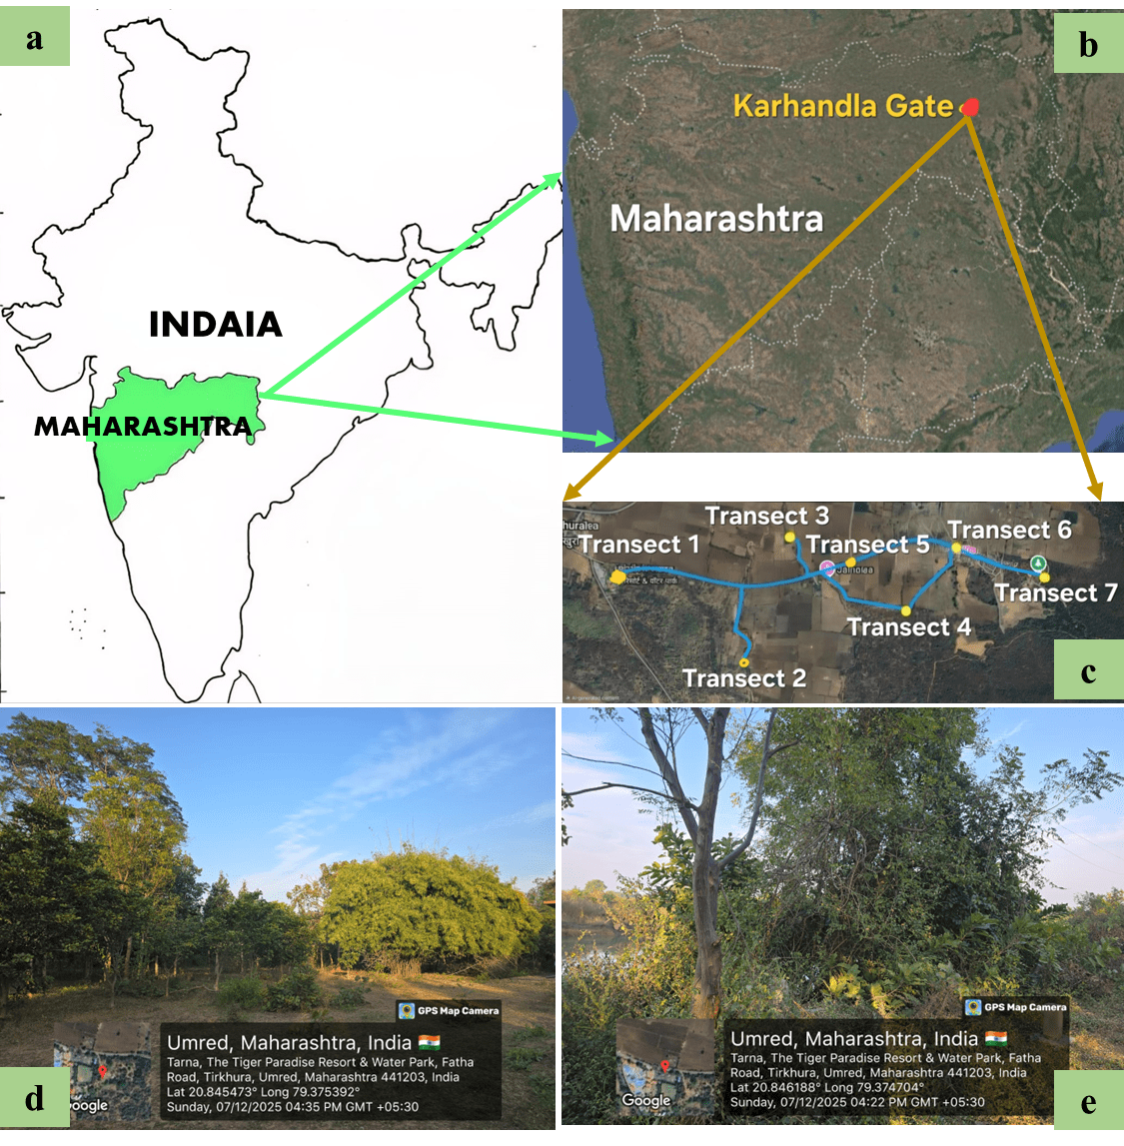
Fig 1: Map of India (a), satellite image of Maharashtra (b) and study area (c), and vegetation of study area (d, e).
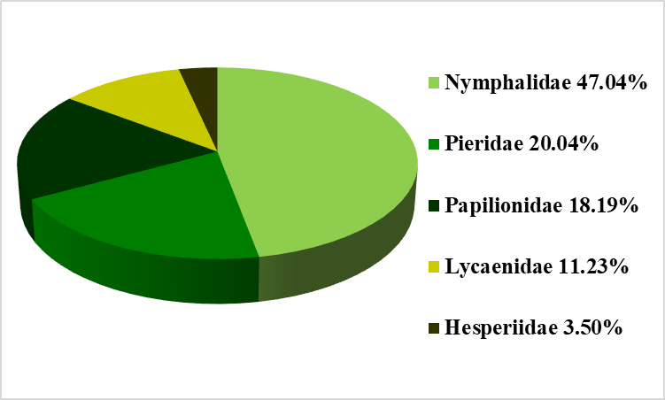
Fig 2: Percentage composition of five families of butterflies in the study area.
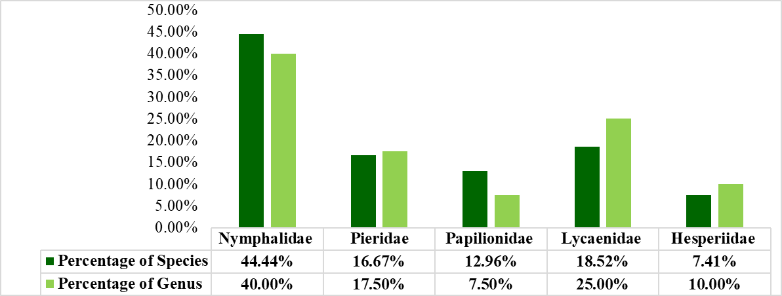
Fig 3: Genus to species proportion of butterflies of five families.
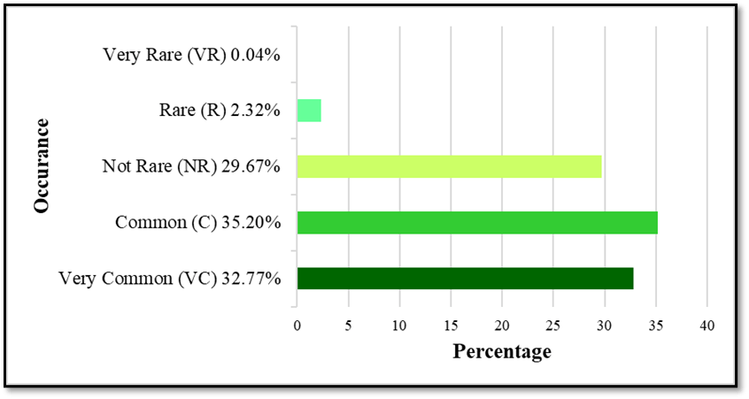
Fig. 4. Occurrence of different butterfly species in the study area.
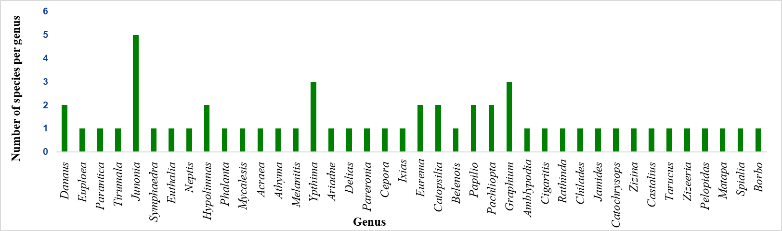
Fig 5: Species richness of the recorded butterfly genera of the study site.

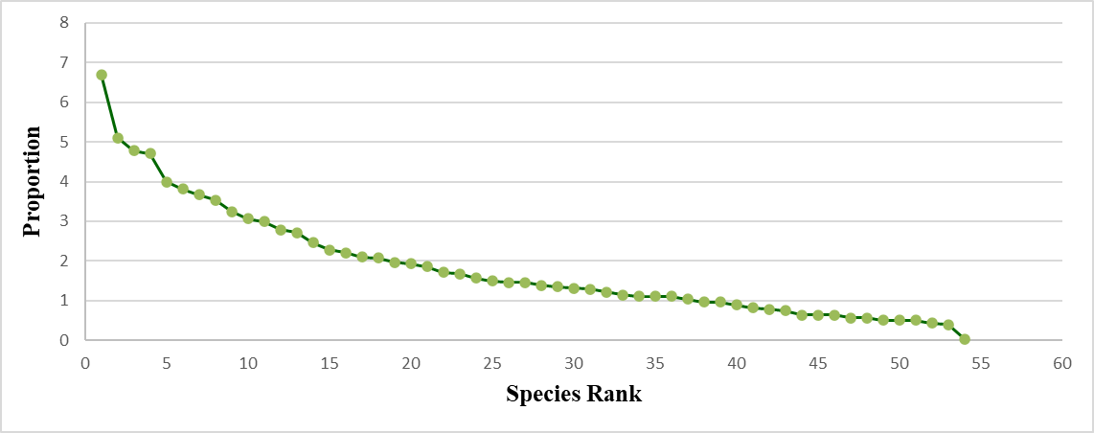
Fig 6: Rank abundance curve of 54 species of butterfly in the study area.

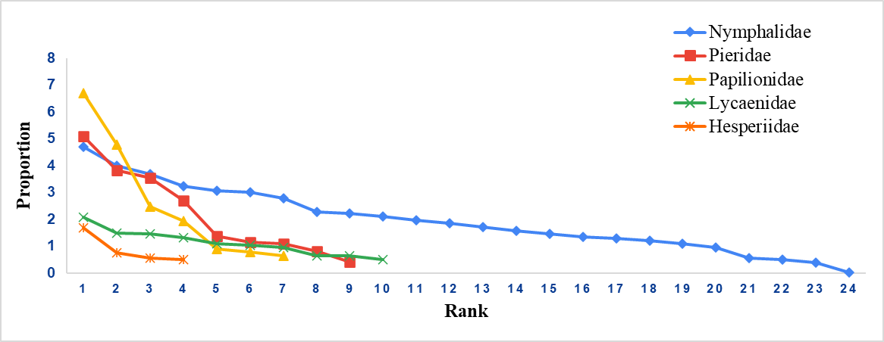
Fig 7: Rank abundance curve of five families of butterfly in the study area.

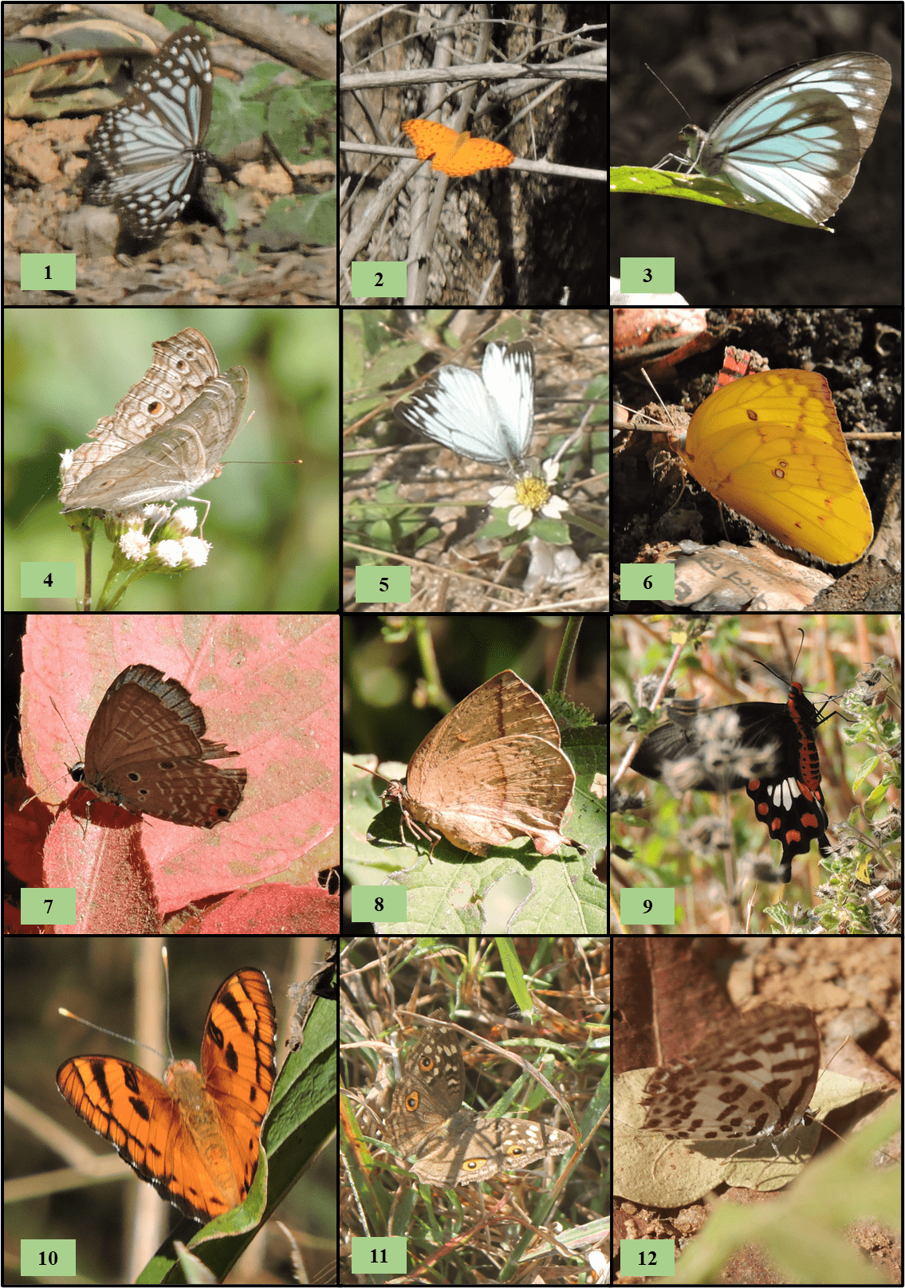
Fig 8: Photographs of different butterfly species recorded in the study area
1) Parantica aglea. 2) Phalanta phalantha, 3) Pareronia hippia, 4) Junonia atlites, 5) Cepora nerissa, 6) Catopsilia pomona, 7) Chilades pandava, 8) Amblypodia anita, 9) Pachliopta aristolochiae, 10) Symphaedra nais, 11) Junonia lemonias, 12) Castalius rosimon.
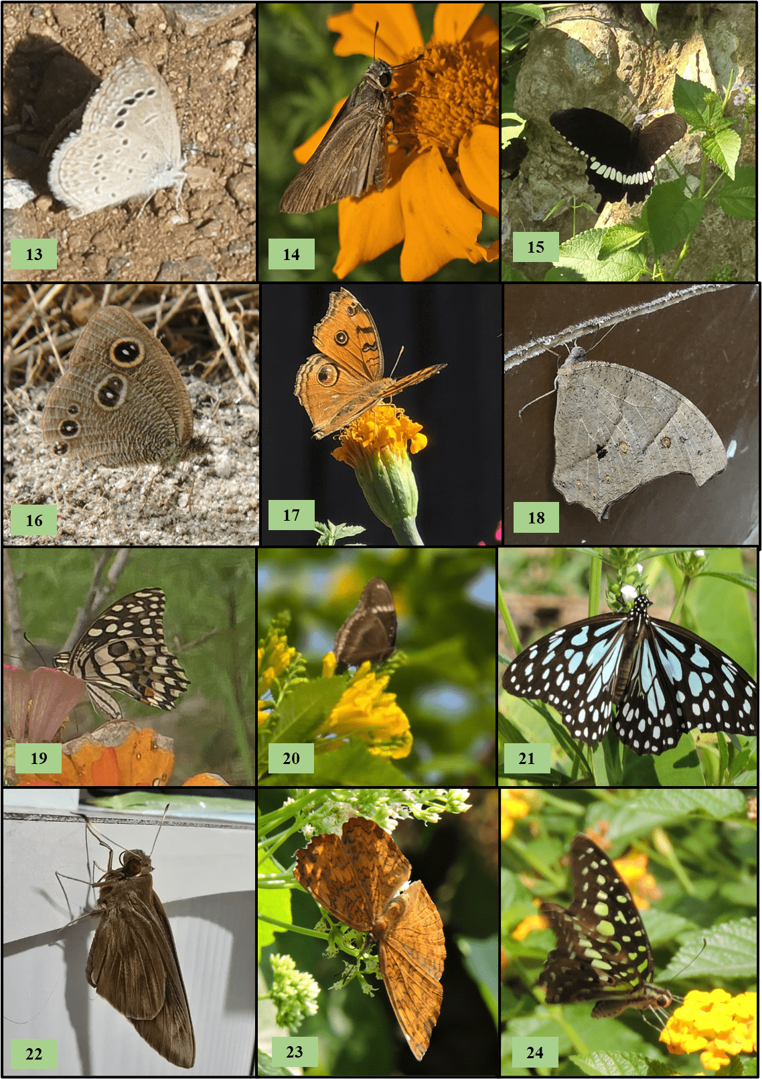
Fig 9: Photographs of different butterfly species recorded in the study area
13) Zizina Otis, 14) Borbo cinnara, 15) Papilio polytes, 16) Ypthima baldus, 17) Melanitis leda, 18) Junonia almanac, 19) Papilio demoleus, 20) Hypolimnas bolina, 21) Tirumala limniace, 22) Matapa ariaI, 23) Ariadne merione, 24) Graphium Agamemnon.

