Effect of Soy Protein and Spirulina as Food Additives on the Growth and Cocoon Productivity of Bombyx mori(L.)

ABSTRACT

Silkworm nutrition plays a crucial role in determining larval development, survival, and cocoon productivity. This study evaluates the effects of soy protein and Spirulina supplements on the biological and economic traits of Bombyx mori. Fifth instar larvae were fed twice daily with mulberry leaves fortified with soy protein (1%, 2%, 3% 4%) and Spirulina (1%, 2%, 3% 4%). A control group received only mulberry leaves. Parameters measured included larval weight, cocoon weight, pupal weight, shell weight, shell ratio, weight-variable differences. Spirulina supplementation resulted in significantly higher larval and cocoon performance compared to soy protein, with 3% Spirulina showing the best improvements.

INTRODUCTION
Sericulture is a vital agro-based industry supporting millions of families, especially in Asia. India, one of the world's largest producers of mulberry silk, relies primarily on the domesticated silkworm Bombyx mori (Ganga & Chetty, 2019). Karnataka state alone produces bulk of Indian raw silk (Govindan and Devaiah, 1995). The nutritional status of silkworm larvae determines growth, metabolism, immunity, and cocoon productivity. In 2004 an original diet receipe was developed and patented by CRA-API (Cappellozza et al., 2005). Although mulberry leaves provide the baseline diet, they often lack optimal nutrient density, prompting researchers to explore dietary supplementation (Babu & Murthy, 2019). Supplementation results in multifarious effects including increase in the concentration of hemolymph proteins (Nagata and Kobayashi, 1990;Krishnan et al., 1995).

In contrast to mulberry leaf, artificial diet does not encounter any seasonal changing in its quality (Scriber and Slansky, 1981). Protein supplementation has gained strong scientific support due to its role in tissue building, enzymatic activities, and cocoon shell formation (Banerjee & Chakraborty, 2021). Soy protein, a plant-based protein rich in essential amino acids, has been shown to improve larval weight and cocoon characteristics in several studies (Hussain & Reddy, 2017; Prakash & Shanthappa, 2018).

Spirulina (Arthrospira platensis), a microalga rich in proteins (60–70%), vitamins, minerals, and antioxidants, has recently gained attention in silkworm nutrition research. Studies report that Spirulina enhances larval growth, survival rate, cocoon weight, and immunity due to its bioactive compounds (Devi & Pandian, 2018; Raju et al., 2022; Kumar & Kalpana, 2022). Microalgae-based supplements are also known to improve stress tolerance and metabolic efficiency (Paul et al., 2021).
Despite multiple studies on individual supplements, there is limited comparative research on the effectiveness of soy protein versus Spirulina. Therefore, this study aims to evaluate the comparative effectiveness of these two additives on growth performance and cocoon traits in Bombyx mori.

MATERIALS AND METHODS
This experiment was conducted using healthy fifth-instar larvae of Bombyx mori, obtained from a government-recognized sericulture centre Konam Nagercoil. Rearing was performed under controlled laboratory conditions: temperature 25–27°C, relative humidity 70–85%, and photoperiod 12:12 hours (light: dark). All rearing trays, foam pads, and equipment were disinfected prior to use using 2% bleaching powder solution. Fresh, disease-free mulberry leaves were collected daily, washed in clean water, and shade-dried before feeding.
Two nutritional supplements—soy protein isolate and Spirulina (Arthrospira platensis) powder—were evaluated at three concentrations each 1%, 2%, 3% 4%. Stock solutions were prepared by dissolving the required amounts of soy protein or Spirulina in sterile distilled water. The solutions were sprayed uniformly on mulberry leaves using a fine mist atomizer. The treated leaves were air-dried for approximately 10–15 minutes to remove excess moisture. Control groups were provided with untreated mulberry leaves.
Each treatment included three replicates, with 50 larvae per replicate, making a total of 450 larvae in soy protein groups and 450 in Spirulina groups, plus control group. Feeding was done twice daily, at 8:00 a.m. and 6:00 p.m. All uneaten leaves were removed before the next feeding to prevent fermentation and microbial growth. Throughout the feeding period, larval weight, leaf consumption, and excreta output were recorded.

RESULTS AND DISCUSSION

The present study clearly demonstrates that dietary fortification of mulberry leaves with soy protein and Spirulina induces significant, concentration-dependent improvements in the biological and economic traits of the mulberry silkworm, Bombyx mori. All measured parameters—larval weight, cocoon weight, pupal weight, shell weight, and shell ratio—exhibited consistent enhancement in supplemented groups compared to the control, indicating improved nutrient assimilation and metabolic efficiency. Among the two dietary supplements evaluated, Spirulina supplementation consistently outperformed soy protein across all concentrations, highlighting its superior nutritional value and physiological compatibility with silkworm metabolism.

Table 1. Effect of Soy Protein Supplementation on Bombyx mori.

Treatment (%) | Larval Weight (g) | Cocoon Weight (g) | Pupal Weight (g) | Shell Weight (g) | Shell Ratio (%)
Control | 3.95 ± 0.04 | 1.18 ± 0.02 | 0.92 ± 0.02 | 0.26 ± 0.01 | 22.03± 0.28
1 | 4.21 ± 0.05  (6.58) | 1.25 ± 0.03  (5.93) | 0.97 ± 0.02  (5.43) | 0.28 ± 0.01  (7.69) | 22.40± 0.31  (1.67)
2 | 4.36 ± 0.06  (10.38) | 1.31 ± 0.04  (11.02) | 1.01 ± 0.03  (9.78) | 0.30 ± 0.01  (15.38) | 22.90± 0.35  (3.95)
3 | 4.42 ± 0.05  (11.90) | 1.34 ± 0.03  (13.56) | 1.03 ± 0.02  (11.96) | 0.31 ± 0.01  (19.23) | 23.13± 0.29  (5.0)
4 | 4.39 ± 0.04  (11.14) | 1.32 ± 0.03  (11.86) | 1.01 ± 0.02  (9.78) | 0.29 ± 0.01  (11.54) | 23.02± 0.27  (4.49)
Note: Percentage change over control values in parent thesis

The data presented in Table 1 clearly demonstrate that soy protein supplementation positively influenced the growth and cocoon characteristics of Bombyx mori. Larval weight is a critical indicator of nutritional adequacy and physiological health in Bombyx mori, as it reflects the efficiency of nutrient digestion, absorption, and assimilation during the most metabolically active larval stage. In the present study, both soy protein and Spirulina supplementation significantly enhanced larval weight compared to the control group, indicating that fortification of mulberry leaves effectively improves larval growth performance.
Soy protein supplementation resulted in a gradual increase in larval weight from 3.95 ± 0.04 g in the control to a maximum of 4.42 ± 0.05 g at 3% concentration. This increase suggests that additional dietary protein supports tissue synthesis and cellular growth during the fifth instar, a stage characterized by rapid biomass accumulation. However, the slight reduction in larval weight observed at 4% supplementation indicates that excessive protein levels may not be efficiently utilized, possibly due to metabolic saturation or reduced feed palatability.

Table 2. Effect of Spirulina Supplementation on Bombyx mori.

Treatment (%) | Larval Weight (g) | Cocoon Weight (g) | Pupal Weight (g) | Shell Weight (g) | Shell Ratio (%)
Control | 3.95 ± 0.04 | 1.18 ± 0.02 | 0.92 ± 0.02 | 0.26 ± 0.01 | 22.03 ± 0.28
1 | 4.50 ± 0.06  (13.92) | 1.38 ± 0.04  (16.95) | 1.05 ± 0.03  (14.13) | 0.33 ± 0.02  (26.92) | 23.91 ± 0.34  (8.53)
2 | 4.62 ± 0.05  (16.96) | 1.43 ± 0.04  (21.19) | 1.08 ± 0.03  (17.39) | 0.35 ± 0.02  (34.62) | 24.47 ± 0.31  (11.08)
3 | 4.79 ± 0.07  (21.27) | 1.51 ± 0.05  (27.97) | 1.14 ± 0.04  (23.9) | 0.37 ± 0.02  (42.31) | 24.50 ± 0.36  (11.21)
4 | 4.63 ± 0.06  (17.22) | 1.46 ± 0.04  (23.73) | 1.09 ± 0.03  (18.48) | 0.35 ± 0.02  (34.62) | 24.48 ± 0.33  (11.12)

Note: Percentage change over control values in parent thesis

In contrast, Spirulina supplementation produced a more pronounced increase in larval weight, reaching 4.79 ± 0.07 g at 3% concentration. This substantial improvement over both the control and soy protein-treated groups indicates that Spirulina provides a more balanced and bioavailable nutrient profile. Spirulina contains not only high-quality proteins but also essential amino acids, vitamins, minerals, and bioactive compounds that synergistically enhance digestive efficiency and metabolic activity. The presence of phycocyanin and antioxidant compounds may further support cellular metabolism by reducing oxidative stress during rapid growth phases.
The enhanced larval growth observed in Spirulina-fed larvae suggests improved enzymatic activity and nutrient conversion efficiency, which are essential for optimal development and subsequent cocoon formation.
Fig. 1
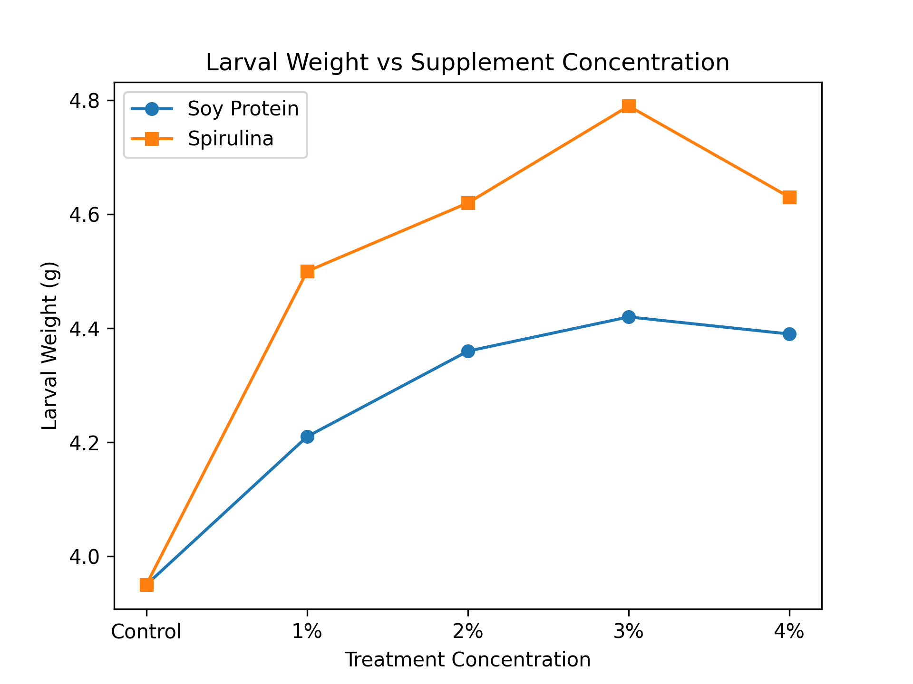
Larval weight is one of the most reliable indicators of nutritional adequacy, metabolic efficiency, and physiological health in the mulberry silkworm. During the fifth instar, larvae exhibit rapid growth and intense feeding activity, accounting for nearly 80–85% of the total larval biomass accumulation. Any improvement in dietary quality during this stage directly influences larval weight, which subsequently affects cocoon formation and silk yield.
In the present study, dietary supplementation of mulberry leaves with soy protein and Spirulina resulted in a significant increase in larval weight compared to the control, clearly demonstrating the positive role of nutritional fortification. The increase in larval weight observed in supplemented groups indicates improved digestion, absorption, and assimilation of nutrients, leading to enhanced tissue growth and energy storage.
Soy protein supplementation produced a moderate but consistent improvement in larval weight, with the maximum increase recorded at 3% concentration. This enhancement can be attributed to the high protein content and balanced amino acid profile of soy protein, which supports protein synthesis and cellular growth. Proteins serve as the primary building blocks for larval tissues and enzymes, and their adequate supply is essential during the rapid growth phase of the fifth instar. However, the relatively lower increase in larval weight compared to Spirulina-treated groups suggests that soy protein alone may not sufficiently provide all micronutrients and bioactive compounds required for optimal metabolic functioning.
Spirulina supplementation resulted in a more pronounced increase in larval weight, with the highest value recorded at 3% concentration. This superior performance may be attributed to Spirulina’s rich and diverse nutritional composition, which includes high-quality proteins, essential amino acids, vitamins, minerals, and bioactive pigments such as phycocyanin. The presence of these components enhances enzymatic activity, improves nutrient utilization efficiency, and supports overall metabolic balance. Vitamins and minerals present in Spirulina likely act as cofactors in metabolic pathways, facilitating efficient conversion of ingested nutrients into larval biomass.
The enhanced larval weight observed in Spirulina-fed larvae also suggests improved physiological vigor and stress tolerance. Antioxidant compounds in Spirulina may reduce oxidative stress associated with rapid growth, thereby maintaining cellular integrity and promoting sustained feeding activity. This could explain the significantly higher larval weights achieved in Spirulina-treated groups compared to soy protein treatments.
The slight decline in larval weight observed at the 4% supplementation level in both soy protein and Spirulina treatments may be due to reduced feed palatability, nutrient imbalance, or metabolic saturation. Excessive nutrient concentration can interfere with normal digestive processes or reduce feeding efficiency, ultimately limiting growth. This observation highlights the importance of optimal supplementation levels rather than excessive fortification.

Fig. 2
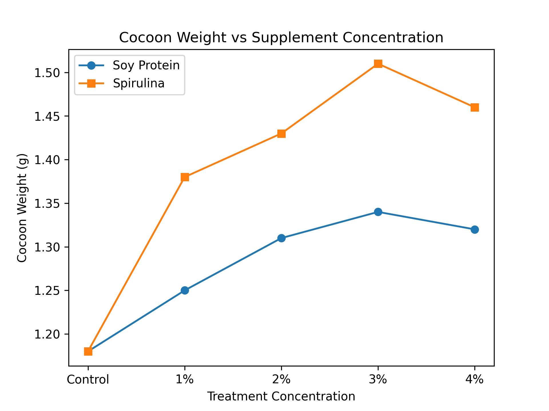
Cocoon weight is a primary economic parameter in sericulture, as it directly correlates with raw silk yield. In the present study, cocoon weight showed a clear concentration-dependent increase with both soy protein and Spirulina supplementation, confirming that dietary fortification positively influences cocoon formation.
Soy protein supplementation increased cocoon weight from 1.18 ± 0.02 g in the control to 1.34 ± 0.03 g at 3% concentration. This improvement indicates that protein-enriched diets enhance silk protein synthesis by supplying additional amino acid substrates required for fibroin and sericin production. However, the magnitude of increase was moderate, suggesting that soy protein alone may not fully meet the complex nutritional requirements for optimal silk synthesis.
Spirulina supplementation resulted in a significantly higher increase in cocoon weight, reaching 1.51 ± 0.05 g at 3% concentration. This marked improvement suggests that Spirulina not only enhances protein availability but also supports the physiological processes involved in silk gland development and function. The vitamins and minerals present in Spirulina may act as cofactors in enzymatic pathways associated with silk protein synthesis, thereby improving the efficiency of cocoon formation.The slight decline in cocoon weight observed at 4% supplementation in both dietary treatments may be attributed to reduced feed acceptability or nutrient imbalance, reinforcing the importance of optimal supplementation levels.
Fig. 3
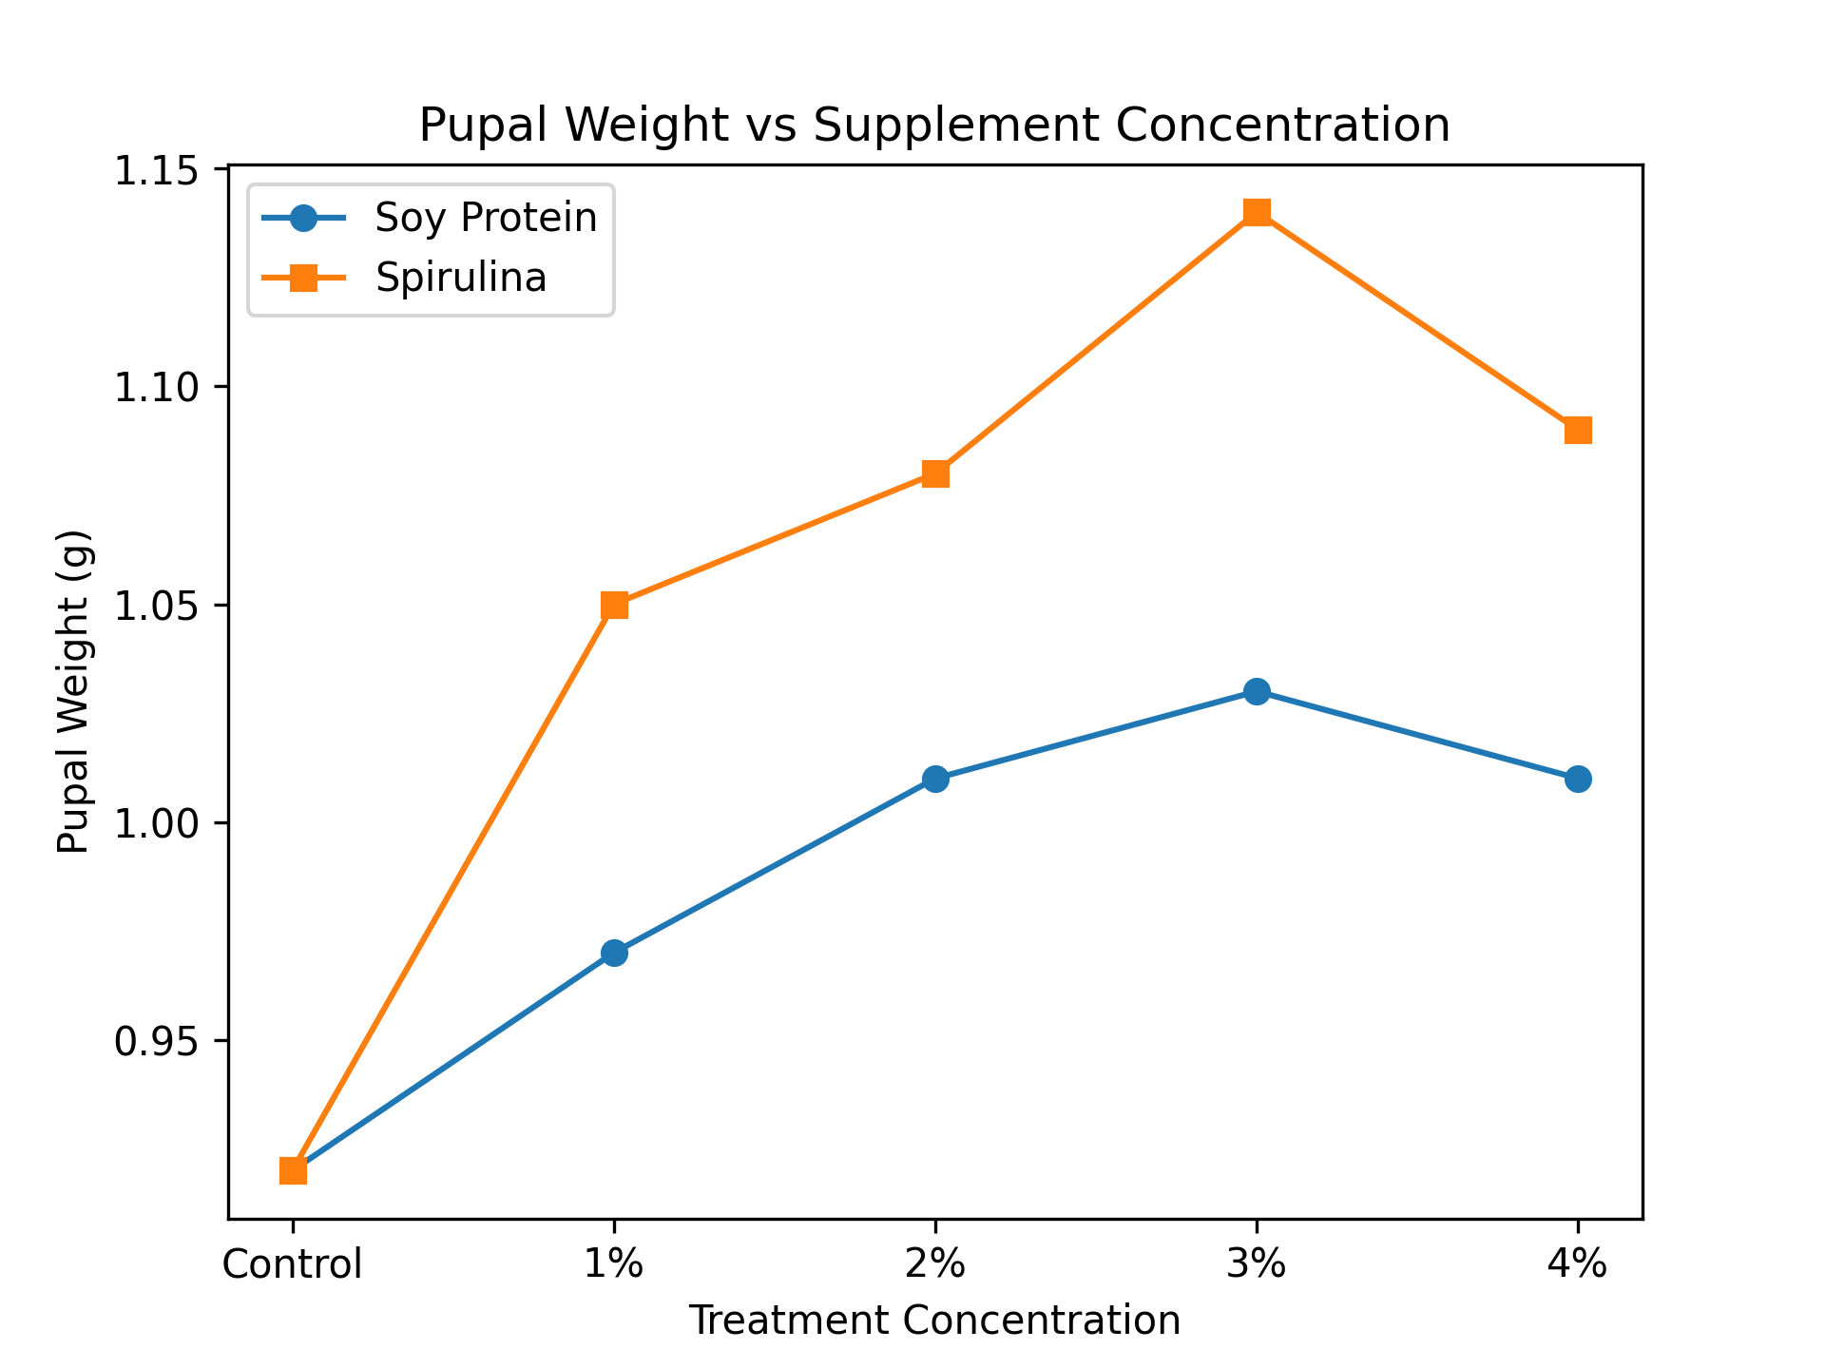
Pupal weight reflects the efficiency of biomass conversion from larval tissues and is an important indicator of physiological fitness and energy utilization. In the present study, pupal weight increased progressively with increasing concentrations of both soy protein and Spirulina, indicating improved metabolic efficiency.
Soy protein supplementation resulted in a maximum pupal weight of 1.03 ± 0.02 g at 3%, representing an improvement over the control. This increase suggests enhanced nutrient storage and utilization during metamorphosis. However, the comparatively lower pupal weight in soy protein-treated groups indicates limited efficiency in nutrient conversion compared to Spirulina.
Spirulina supplementation produced a higher maximum pupal weight of 1.14 ± 0.04 g at 3%, demonstrating superior nutrient assimilation and energy utilization. The enhanced pupal biomass suggests that Spirulina-fed larvae are physiologically more robust, with improved reserves to support metamorphosis. This may be attributed to the presence of essential fatty acids and micronutrients in Spirulina that facilitate energy metabolism and cellular differentiation.
Fig. 4

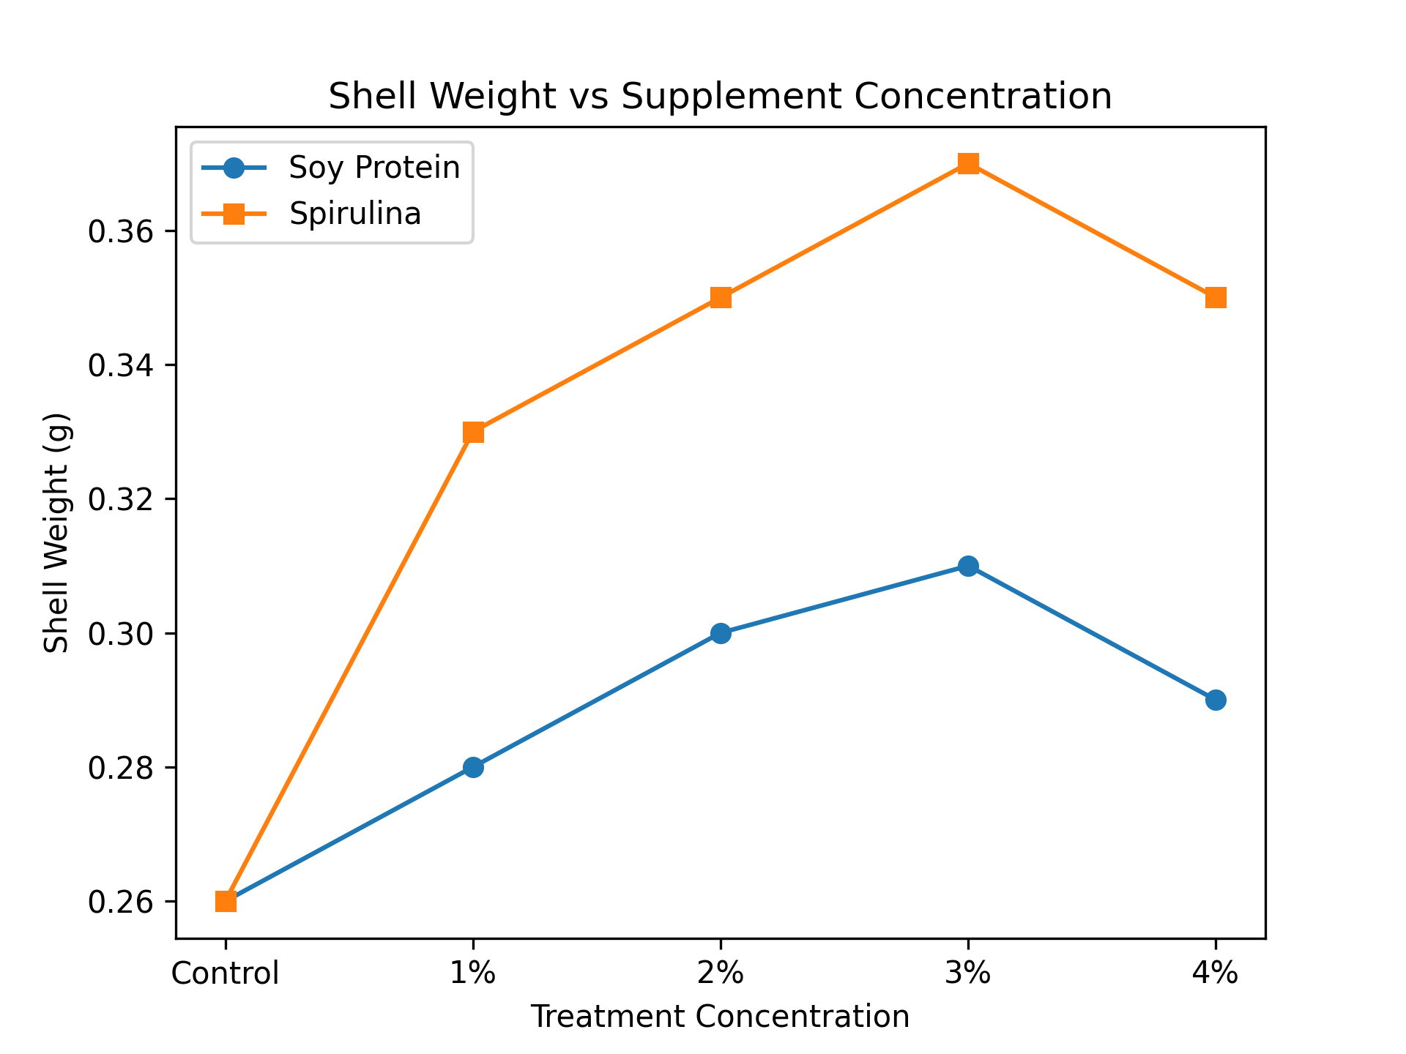
Shell weight is one of the most crucial economic parameters in sericulture, as it directly determines the quantity of silk available for reeling. In the present study, shell weight increased significantly in all supplemented groups compared to the control, indicating enhanced silk protein deposition.
Soy protein supplementation increased shell weight from 0.26 ± 0.01 g in the control to 0.31 ± 0.01 g at 3% concentration. This improvement suggests that soy protein contributes to silk protein synthesis by providing additional nitrogen sources. However, the extent of increase was limited, indicating that soy protein may not fully support the complex biochemical requirements of silk gland activity.
Spirulina supplementation produced a markedly higher shell weight, reaching 0.37 ± 0.02 g at 3% concentration. This substantial improvement indicates enhanced fibroin synthesis and silk gland efficiency. Spirulina’s rich composition of essential amino acids, particularly glycine and alanine, which are major components of fibroin, likely contributes to increased silk protein production. Additionally, the presence of antioxidants may protect silk gland tissues from oxidative damage, further enhancing their functional capacity.

REFERENCES

Govindan R and Devaiah Mc (1995). Aspergillosis of silkworm. Silkworm Pathology Technical Bull No.1.Dept. of Seri. UAS Bangalore, p:68.
Babu, C.M., and Murthy, G.N. (2019). Nutritional modulation of mulberry leaves to enhance silkworm productivity. International Journal of Advanced Agricultural Research, 7(1), 45–53.
Banerjee, R., and Chakraborty, S. (2021). Protein supplementation strategies for improving economic traits in Bombyx mori. Asian Journal of Sericulture, 13(2), 77–85.
Cappellozza L., Cappellozza S., Saviane A., Sbrenna G., 2005.- Artificial diet rearing system for the silkworm bombyx mori (Lepidoptera: Bombyciade); effect of vitamin C deprivation on larval growth and cocoon production.- Applied Entomology and Zoology, 40 (3): 405-412.
Nagata M and Kobayashi J. Effect of nutrition on storage protein concentration in the
larval hemolymph of the silkworm, Bombyx mori. J. Seric. Sci. Japan. 59: 469-474, 1990.
Devi, L., and Pandian, K. (2018). Influence of Spirulina fortification on larval growth and cocoon characteristics in the mulberry silkworm Bombyx mori. Indian Journal of Applied Zoology, 5(4), 201–209.
Scriber J. M., Slansky Jr. F., 1981.- The nutritional ecology of immature insects.- Annual Review of Entomology, 26 (1): 183-211.
Ganga, G., and Chetty, J.S. (2019). Silkworm Biology and Sericulture Technology. Springer Nature.
Hussain, A., and Reddy, M.M. (2017). Effects of soy protein isolate in leaf-based diets on larval performance of silkworm Bombyx mori. Sericologia, 57(1), 41–50.
Kumar, V., and Kalpana, R. (2022). Growth response of mulberry silkworm (Bombyx mori) to dietary Spirulina supplementation. International Journal of Insect Science, 14, 1–10.
Paul, S., Roy, D., and Bhattacharya, P. (2021). Effect of microalgae-based supplements on the economic performance of Bombyx mori. International Journal of Applied Biology, 15(2), 56–64.
Prakash, N., and Shanthappa, J. (2018). Mulberry leaf fortification with soy protein and its influence on silkworm growth and cocoon yield. Sericultural Studies Review, 9(1), 26–33.
Etebari, K. (2002) Effect of enrichment of mulberry leaves (Morus alba) with some vitamins and nitrogenous compounds on some economic traits and physiological characters of silkworm, Bombyx mori (Lep., Bombycidae). Isfahan University of Technology. Iran.

