Original Research Article
Ecology and Microhabitat Use of Varanus bengalensis in Semi-Arid Grasslands of Solapur and Dharashiv Districts, Maharashtra

______________________________________________________________________________
Abstract:
The Bengal monitor lizard (Varanus bengalensis) is a large-bodied, wide-ranging squamate that plays an important ecological role in semi-arid ecosystems. Very few ecological studies from India have examined its detailed ecology and microhabitat use. Our study has attempted to investigate the patterns of microhabitat use, spatial occupancy, and temporal variation in sighting frequency of V. bengalensis in semi-arid grassland patch from Solapur and Dharashiv Districts. The study was conducted over two years (June 2020–May 2022) using visual encounter surveys across a 10 km² area. A total of 68 sighting records representing juveniles, sub-adults, and adults were documented and analyzed as independent ecological observations reflecting habitat use rather than individual population counts. Termite mounds accounted for the highest proportion of sightings (68%), followed by rock piles (19%), cobbles (6%), rocky patches and burrows (3% each), and wells (1%) as far as microhabitat usage is concerned. Statistically significant difference in microhabitat use among life stages was detected (one-way ANOVA, F₅, ₁₂ = 4.16, p = 0.020), indicating life-stage-specific habitat associations. The appearance of juveniles coincided with the onset of the monsoon season, indicating considerable temporal pattern. Sighting frequency showed weak to moderate positive association with environmental variables such as temperature, humidity, and rainfall. Habitat variables such as termite mounds, rock piles and open rocky-grassy mosaic were found to serve as critical refuges that supported life history stages of V. bengalensis. Our study highlights the conservation significance of remaining large moderately disturbed grassland habitats (Semi-Arid Open Natural Ecosystem) outside the protected area that support threatened and critically endangered species and offer livelihood to traditional grazing community.
Keywords: Varanus bengalensis, ecology, microhabitat use, semi-arid grassland, Solapur, Dharashiv.
Introduction:
The Bengal monitor lizard, Varanus bengalensis is widely distributed across the Indian landscape (Daniel, 2002) and also ranges from South-East Iran through Pakistan, Bhutan, Nepal, Sri Lanka, Bangladesh, Myanmar, Thailand, North Vietnam, Laos, Cambodia, West Malaysia, Pulau Tioman, Indonesia (Java), and China (Yunnan) (Auffenberg, 1994; Pianka, 1995; Papenfuss et al., 2010; Koch et al. 2013; Uetz et al., 2023). A literature review on V. bengalensis in the Indian state of Maharashtra reveals mostly anecdotal sighting records in herpetofaunal inventories (Mirza & Pal, 2008; Bhandarkar et al., 2012; Kumbhar et al., 2013; Joshi et al., 2015; Joshi & Tantarpale, 2016; Sayyed, 2016; Birje & Kengar, 2017; Joshi et al., 2017; Khate & Bawaskar, 2020). With few exceptions (Chatterjee and Bhattacharyya, 2015; Subramanean, 2019), detailed ecological studies on V. bengalensis in India remain limited despite calls for such research (Choudhury and Choudhary, 2019; Subramanean, 2019). The bulk of ecological studies on V. bengalensis comes from Nepal on the impact of community forestry on the species (Ghimire & Phuyal, 2013); from Bangladesh on the consequences of habitat loss and fragmentation on the species (Mijanur & Iliazovic, 2016), from Pakistan on preferred habitat use, home range and movement patterns (Auffenberg, 1991), and from Sri Lanka on its status, distribution, habitat use and threats (Hashmi et al., 2013), its activity and thermal ecophysiology (Wikramanayake, 1995), thermal ecology of habitat and microhabitat use (Wikramanayake & Dryden, 1993), population status, diet and conservation status (Karunarathna et al., 2012), and dietary habitats and predators (Karunarathna et al., 2017). More recent observations include a range extension and a probable shift of this species to higher elevations in the Trans-Himalayan region as an adaptive response to climate change (Singh et al., 2020).
Varanus bengalensis is currently listed as Near Threatened under criteria A2d of the IUCN Red List of Threatened Species with the justification that the species is heavily hunted throughout South Asia and continental Southeast Asia along with extreme local declines of the species over the last three decades throughout most of Southeast Asia (Cota et al., 2021).
In this regard, it is vital to improve upon what is known about the ecology and current status of V. bengalensis throughout its range at both the local and regional levels. We examined current sighting frequency and habitat use patterns of the species in moderately disturbed semi-arid grassland site allocated for airport development, near Boramani Village, Solapur, Maharashtra state, India. The proposed site is potentially one of the few remaining grassland habitat that still supports the last remaining individuals of the critically endangered great Indian bustard (Ardeotis nigriceps) and other grassland adapted species including the blackbuck (Antilope cervicapra), Indian gray wolf (Canis lupus), Indian jackal (Canis aureus) and Indian fox (Vulpes bengalensis) (Mahindrakar et al., 2023). This natural habitat has high value for the conservation of many other rare, threatened and endangered species of flora and fauna that are adapted to semi-arid thorn forest and grassland ecosystems. Secondarily, ecological information on V. bengalensis has not previously been collected from the Solapur region’s Semi-arid grassland ecosystem, and little is known about their current status, distribution and ecology. The goal of this study is to shed light on Varanus bengalensis’s use of microhabitats, spatial occupancy, and temporal activity patterns in a semi-arid grassland ecosystem. Interpretations are based on patterns of sightings rather than population size or density because repeated sightings of the same individuals are likely.
Methods:
Study Area:
Field data were collected from a semi-arid grassland patch situated 25 km. from Solapur City near Boramani Village (17°46'42.06"N; 76° 2'55.76"E) (Figure 1). The study site considered of a 10 km² area of natural but partially disturbed semi-arid grassland characterized by the presence of moderate to low herbaceous ground cover with wide open grasslands with sparsely distributed Acacia trees. The landscape retains most of its original habitat features like gentle undulating plains and soil covered with various sizes of stones, rocks and boulders, termite mounds, and rock mounds (erected as boundary markers by locals and the Forest Department). However, this site and the surrounding landscape have been experiencing continuous anthropogenic pressure as part of the adjoining landscape has been allocated for the construction of Solapur Airport. The average elevation of the area is 450 m. The grassland from the study area is used extensively by the Dhangar community (traditional grazers from Maharashtra) for grazing livestock (Figure 2)
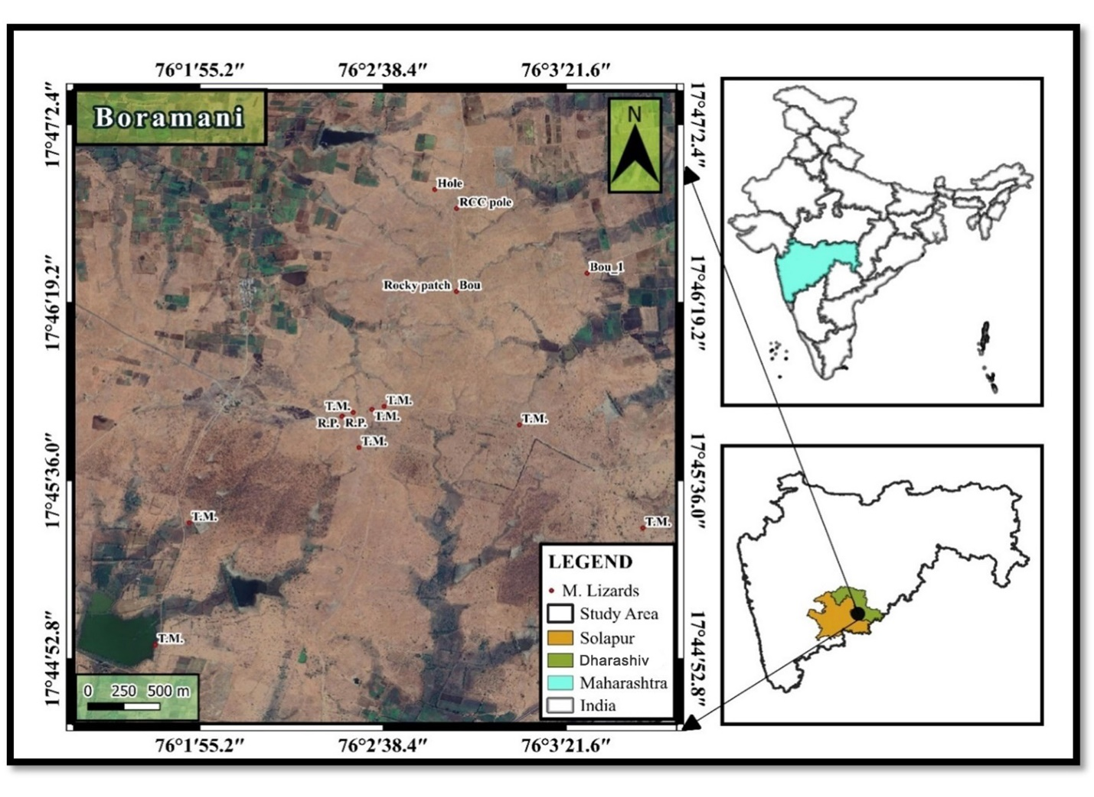
Figure 1. Study map
Microhabitats used as refuges by V. bengalensis in the study area were classified as termite mound, well, burrow, rocky Patch (weathered isolated rocks), rock pile (piled rocks as boundary marks), rocky outcrops (Large exposed rocks emanating from Earth), cobbles (rounded or angular rock fragments, measuring between 64 mm and 256 mm in diameter) and construction material (fencing RCC poles and metal wires).
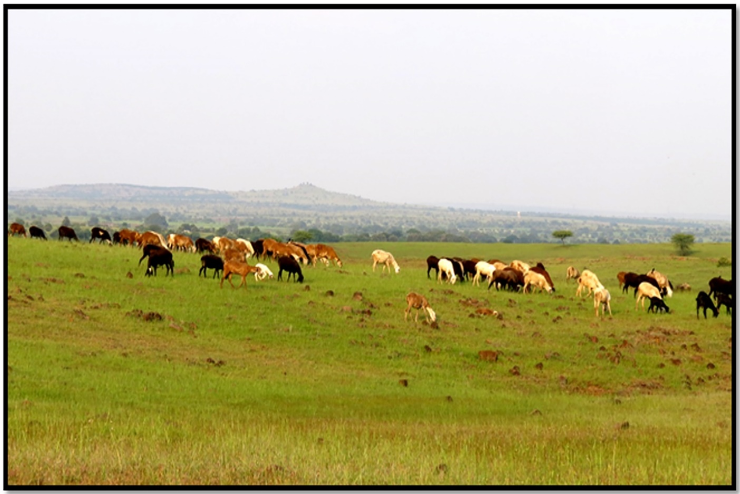
Figure 2. Typical physiognomic features of study area used by shepherds, pastorals and local farmers to graze their livestock.

Sampling and Survey Methodology:
Monthly surveys for V. bengalensis were conducted over two years from June 2020 to May 2022 and included Visual Encounter Surveys (Campbell and Christman, 1982; Magurran, 2004) carried out at randomly selected sampling units comprising quadrats of measuring 50 x 50m and belt transects of 500 m with an area limited to 20 m on each side. Surveys were performed in the morning between 07:00 and 13:00 hours and the study site were visited twice per month, with total of 48 quadrats and 48 belt transects surveyed over the two-year study period. Data relating to microhabitat use and other environmental variables (temperature, humidity) were recorded using Epicollect5-a free and easy-to-use mobile data-gathering platform.
Data Analysis:
During statistical analysis, each observation represents a sighting record, and repeated sightings of the same individual across surveys were considered ecologically meaningful indicators of habitat use rather than independent population counts. We used frequency-based indices derived from standardized sampling units for ecological analysis. Statistical analyses were performed using PAST software version 4.09 (Hammer et al. 2001). Data for two years inclusive of adults, sub-adults and juveniles were pooled to reveal sighting frequencies, microhabitat occupancy patterns and multivariate statistics to understand the overall correlation and variation. One-way ANOVA was used to evaluate statistical significance across sighting frequency across microhabitats used by each life stages. Data visualization technique such as cluster analysis was used to display specific patterns of relationship between variables. Cluster analysis was performed using a hierarchical clustering routine procedure with UPGMA (Unweighted Pair-group Average) algorithm, which joins clusters based on the average distance between all members in two groups. The distance matrix was calculated by using the Bray-Curtis measure.
Results:
Sighting Frequency and Life-stage Representation:
A total of 68 sighting records of V. bengalensis representing all life stages were documented during the two-year study period. Juveniles made up the largest percentage of these records (59 percent; n = 40), followed by adults (26 percent; n = 18) and sub-adults (15 percent; n = 10). Instead of reflecting the precise population structure, these proportions show the relative frequency of life-stage observations across surveys (Table 1)

Table 1. Sighting records of Varanus bengalensis during the study period across life stages
Category | Number of sightings | Percentage (%)
Juveniles | 40 | 58.8
Sub-adults | 10 | 14.7
Adults | 18 | 26.5
Total sightings | 68 | 100

Temporal Variation in Sightings:
Pooled monthly sighting data revealed clear temporal variation in the frequency of V. bengalensis observations. The highest proportion of sightings occurred during the monsoon season (June–September), accounting for 59% (n = 40) of all records. This was followed by the summer period (February–May), which contributed 25% (n = 17) of sightings, while the winter period (October–January) showed the lowest sighting frequency (16%; n = 11). Monthly patterns indicated increased activity and detectability during warmer and wetter months (Table 2).
Table 2. Survey-wise frequency of V. bengalensis sightings based on independent sampling units

Season | Number of surveys | Proportion of sightings | Surveys with ≥1 sighting | Sighting frequency (proportion)
Summer (Feb–May) | 16 | 25% (n=17) | 11 | 0.69
Monsoon (Jun–Sep) | 16 | 59% (n=40) | 14 | 0.88
Winter (Oct–Jan) | 16 | 16% (n=11) | 7 | 0.44

Two-way cluster analysis of monthly sighting frequencies revealed distinct temporal groupings. The March–August cluster was characterized by high frequencies of juvenile sightings, moderate adult sightings, and fewer sub-adult observations. The October–November cluster showed the presence of adults and sub-adults but an absence of juveniles, while the September and December–February cluster exhibited minimal or no sightings across life stages, suggesting seasonal inactivity or reduced surface activity during cooler months (Figure 3).
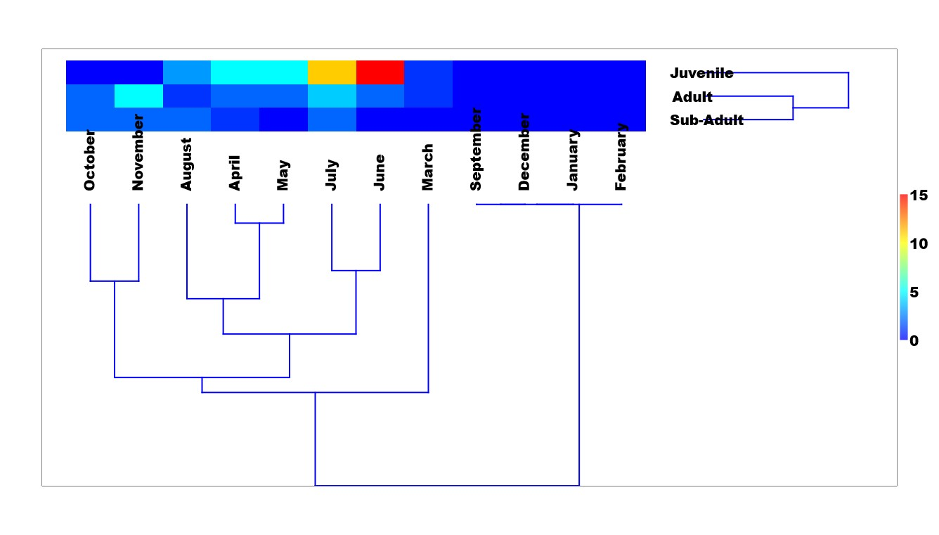
Figure 3: Two-way cluster analysis of monthly sighting frequencies
Microhabitat-Use Patterns:
Analysis of microhabitat use based on sighting frequency demonstrated strong non-random habitat associations (Table 3). Termite mounds were the most frequently used microhabitat, accounting for 68% of all sightings, followed by rock piles (19%), cobbles (6%), rocky patches and burrows (3% each), and wells (1%).
Table 3. Distribution of sighting frequency - the relative use of microhabitat types by across life stages

Microhabitat type | Number of sightings | Proportion of sightings (%)
Termite mounds | 46 | 68.0
Rock piles | 13 | 19.0
Cobbles | 4 | 6.0
Rocky patches | 2 | 3.0
Burrows | 2 | 3.0
Wells | 1 | 1.0
Total | 68 | 100

One-way ANOVA revealed statistically significant differences in microhabitat use among life stages (F₅, ₁₂ = 4.16, p = 0.020), indicating that juveniles, sub-adults, and adults differ in their microhabitat associations. These differences likely reflect variation in refuge requirements, thermoregulatory needs, and vulnerability to predation across ontogenetic stages (Table 4).
Table 4. Life-stage-wise distribution of sighting frequency across microhabitats
Microhabitat | Juvenile sightings | Sub-adult sightings | Adult sightings
Termite mounds | 28 | 7 | 11
Rock piles | 8 | 2 | 3
Cobbles | 4 | 0 | 0
Rocky patches | 0 | 1 | 1
Burrows | 0 | 0 | 2
Wells | 0 | 0 | 1

Association with Environmental Variables
Linear regression analysis revealed weak to moderate positive associations between sighting frequency and environmental variables. Sighting frequency showed a weak positive relationship with monthly average temperature (r = 0.1632, P = 0.6123), a moderate positive association with monthly average humidity (r = 0.4285, P = 0.1644), and a weak positive association with rainfall (r = 0.38, P = 0.223). Although not statistically significant, these trends indicate that climatic conditions influence surface activity and detectability of V. bengalensis (Table 5)
Table 5. Relationship between environmental variables and monthly sighting frequency (Dependent variable = number of sightings per month)

Variable | Correlation coefficient (r) | P-value
Temperature | 0.163 | 0.612
Humidity | 0.429 | 0.164
Rainfall | 0.380 | 0.223

Discussion:
The current study sheds light on V. bengalensis use of microhabitats, spatial occupancy, and temporal activity patterns throughout its life stages (juveniles, sub-adults, and adults) in semi-arid grassland ecosystem in Maharashtra based on sighting frequency because our study did not attempt individual identification.
The high frequency of juvenile sightings during the monsoon season suggests active breeding within the study area. Termite mounds and rock piles were found to be preferred by juveniles because they likely provide the best microclimatic conditions and protection from predators during the early stages of life. The close relationship between lizards and habitat structure has been widely documented (Pianka, 1966; Pianka, 1986). The widespread use of termite mounds for refuge and nesting has been documented in several prior studies on V. bengalensis, supporting the ecological importance of these structures (Traeholt, 1995; Subramanean, 2012; Karunarathna et al., 2012; Karunarathna et al., 2017). In studies from Sri Lanka, juveniles have been reported to use trees, walls and electric pillars which are 3-5 meters above the ground (Deraniyagala, 1953, Karunarathna et al., 2012). There are very few trees and shrubs that serve as refuges in the open rocky-grassy biome in our study area, hence V. bengalensis have likely shown greater preference for easily accessible termite mounds and rock piles. The lack of sightings of juveniles from August to November could be explained by the presence of grass during post-monsoon periods, which may give them more opportunities for hiding and feeding. The sightings of V. bengalensis may be suppressed between December to February due to winter induced seasonal inactivity (brumation-like behavior). Previous research on V. bengalensis have documented such low temperature induced brumations (Auffenberg, 1994). However, in Sri Lanka, V. bengalensis have been recorded as active throughout the year due to greater year-round uniformity and warmer temperatures (Karunarathna, 2017). The increase in sightings of adults and sub-adults from March onwards may correspond to the onset of the breeding season as noted in previous studies on V. bengalensis (Jacob & Ramaswamy, 1976).
Microhabitat association reveal no distinct ontogenetic niche differentiation and spatial segregation as all three life-stages were reported to coexist near each other primarily on termite mounds and rock piles situated on both sides of natural road close to water bodies spread across 10 km² intensive study area. This implies that, the observed sighting pattern of life stages in study area is determined mainly by the distribution of natural unpaved trails, termite mounds, rock piles, temporary water bodies, open foraging areas. On few occasions, during foraging it was noted that when disturbed the adults and sub-adults preferred to retreat in termite mounds, while the juveniles withdrew beneath cobbles when disturbed (Figure 4), highlighting the importance of termite mound and open-rocky-grassy habitat for their survival.
Many studies have clearly noted that V. bengalensis populations are experiencing declines across its ranges due to habitat degradation (Choudhury and Choudhary, 2019), extraction for food, meat, fat and traditional medicines (Koch et al., 2013; Auffenberg, 1994) and climate change (Singh et al., 2020). Our study area still retains heterogeneous mosaic of microhabitats within an otherwise disturbed semi-arid landscape and offers critical resources for life-history stages of V. bengalensis and facilitates its persistence in an unprotected grassland ecosystem facing increasing anthropogenic pressure due to proposed infrastructural projects such as airport, and illegal soil extraction, real estate and conversion of semi-arid grassland to agriculture. Species such as critically endangered Great Indian Bustard (Ardetois nigriceps), blackbuck (Antilope cervicapra), Indian Gray Wolf (Canis lupus), and recently uplisted grassland birds like Indian Roller (Coracias bengalensis), Indian Courser (Cursorius coromandelicus), and Rufous-tailed Lark (Ammomanes phoenicura) from their previous status as Least Concern to Near Threatened have all been documented in our study area (IUCN, 2025 Red List update), demonstrating the study area's evident significance.
Conclusion:
The importance and conservation value of Open Natural Ecosystems (ONEs) for numerous endemic species, as well as their role in supplying ecosystem services like a means of subsistence for millions of nomadic pastoralists, as well as socio-economic and cultural traditions have been widely discussed in numerous reviews (Sankaran & Ratnam, 2013; Madhusudan & Vanak, 2022). But recently, there has been much discussion about the enormous threat to these ecosystems, co-adapted species, loss of ecosystem services, and ecological, economic, and policy issues affecting these habitats, and the urgent need for conservation has been highlighted (Veldman et al., 2015; Chandran, 2015; Ratnam et al., 2016; Vanak, 2017; Nerlekar et al., 2023; Lahiri et al., 2023; Sheth et al., 2025). Many studies have shown the value of open rocky biome (Thaker & Amdekar, 2016) and habitat structure (Pianka, 1966, Taylor and Fox, 2001, Sullivan & Sullivan, 2008) to lizards and their communities (Garden et al., 2007). Habitat alteration is known to influence refuges such as loss of rocky microhabitat (Amo et al., 2007a) and rock crevices (Goode et al., 2005) and vegetation communities (Vitt et al., 1998) that serve as critical resources for many lizards. Our study here demonstrates the role of termite mounds, rock piles and rocky open habitats as critical resources for V. bengalensis. Particularly in the past ten years, the study site has undergone significant changes because of human pressures that have changed the structure of the habitat, which could be harmful to V. bengalensis, a species that requires larger patches of habitat. Lizards, being important contributors to arid ecosystems (Pianka, 1986; Reynolds, 1979) need to be given priority status in the conservation and protected area management especially in the India’s Deccan landscape that is currently experiencing severe habitat fragmentation.
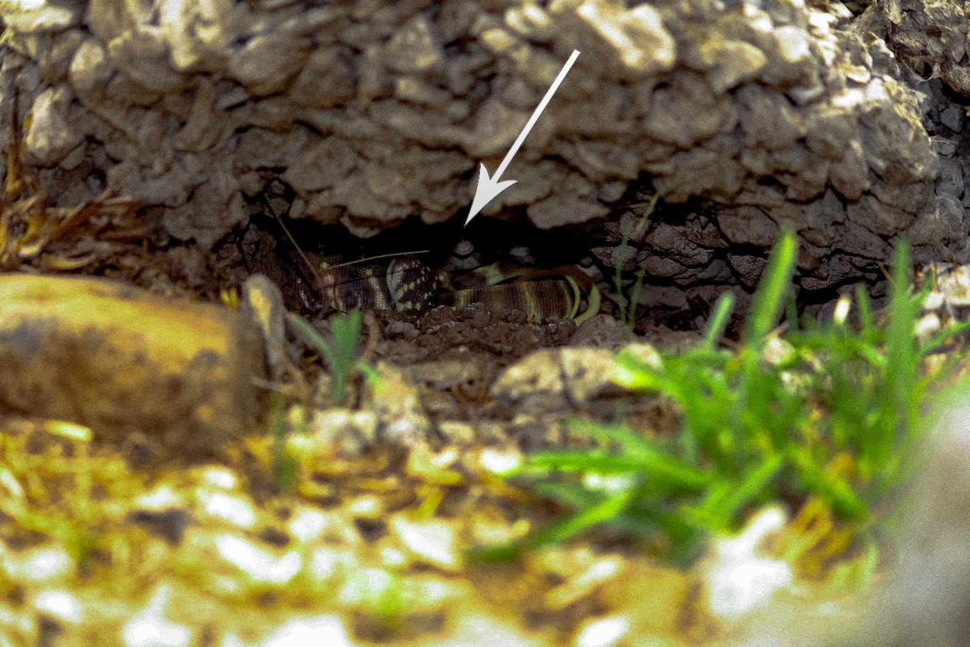Figure 4. Juveniles V. bengalensis in temporary Hollow beneath the cobble.

Reference:
- Amo, L., López, P., & Martín, J. (2007a). Refuge use: A conflict between avoiding predation and optimizing thermoregulation in lizards. Physiological and Biochemical Zoology, 80, 537–545. https://doi.org/10.1016/j.physbeh.2006.09.035
- Auffenberg, W. (1994). The Bengal Monitor. University Press of Florida, Gainesville, USA.
- Auffenberg, W., Arain, Q. N., & Khurshid, N. (1991). Preferred habitat, home range and movement patterns of Varanus bengalensis in southern Pakistan. Mertensiella (Suppl. Salamandra), 2, 7–28.
- Bhandarkar, W. R., Paliwal, G. T., Bhandarkar, S. V., & Kali, A. A. (2012). Herpetofaunal diversity at Navegaon National Park, Gondia District, Maharashtra. International Journal for Environmental Rehabilitation and Conservation, 3(1), 42–49. http://essence-journal.com/
- Birje, K. N., & Kengar, S. B. (2017). A checklist of saurian fauna from Satara District, Maharashtra, India. Indian Journal of Scientific Research, 13(1), 24–28.
- Campbell, H. W., & Christman, S. P. (1982). Field techniques for herpetofaunal community analysis. In N. J. Scott Jr. (Ed.), Herpetological Communities (pp. 193–200). U.S. Fish and Wildlife Service, Wildlife Research Report 13. https://pubs.usgs.gov/publication/wrr13
- Chandran, M. D. S. (2015). Ecology and conservation of Indian savannas and grasslands. Journal of the Indian Institute of Science, 95, 1–10.
- Chatterjee, A., & Bhattacharyya, S. (2015). Distribution and abundance of monitor lizards (Varanus spp.) in human habitations of southwest Bengal: People’s tradition of coexisting with wildlife. African Journal of Science and Research, 3(7), 1–7.
- Choudhury, A. S., & Choudhury, P. (2019). Cruelty to Varanus species in Barak Valley, Assam, India. Biawak, 13(1), 50–53.
- Cota, M., Stuart, B. L., Grismer, L., Quah, E., Panitvong, N., Neang, T., et al. (2021). Varanus bengalensis. IUCN Red List of Threatened Species 2021: e.T164579A1058949. https://doi.org/10.2305/IUCN.UK.2021-2.RLTS.T164579A1058949.en
- Daniel, J. C. (2002). The Book of Indian Reptiles and Amphibians. Bombay Natural History Society & Oxford University Press, Mumbai. https://www.nhbs.com/the-book-of-indian-reptiles-and-amphibians-book
- Deraniyagala, P. E. P. (1953). A Colored Atlas of Some Vertebrates from Ceylon: Tetrapod Reptilia (Vol. 2). Government Press, Colombo.
- Garden, J. G., McAlpine, C. A., Possingham, H. P., & Jones, D. N. (2007). Using multiple survey methods to detect terrestrial reptiles and mammals. Wildlife Research, 34, 357–366. https://doi.org/10.1071/WR06111
- Ghimire, H. R., & Phuyal, S. (2013). Impacts of community forestry on the Bengal monitor (Varanus bengalensis) in Nepal. Biawak, 7(1), 11–17. https://www.varanidae.org/biawak/images/home/Biawak_7(1)_pp11-17.pdf
- Goode, M. J., Howland, J. M., & Parker, W. S. (2005). Spatial ecology of a rock-dwelling lizard. Journal of Herpetology, 39, 469–479.
- Hammer, Ø., Harper, D. A. T., & Ryan, P. D. (2001). PAST: Paleontological statistics software package for education and data analysis. Palaeontologia Electronica, 4(1), 9. http://palaeo-electronica.org/2001_1/past/issue1_01.htm
- Hashmi, M. U. A., Khan, M. Z., & Huda, A. N. (2013). Status, distribution and threats of Varanus species in Sindh, Pakistan. International Journal of Fauna and Biological Studies, 1(1), 34–38.
- IUCN. (2025). The IUCN Red List of Threatened Species. Version 2025-2. https://www.iucnredlist.org/
- Jacob, D., & Ramaswamy, L. S. (1976). The female reproductive cycle of the Indian monitor lizard. Copeia, 256–260. https://doi.org/10.2307/1443944
- Joshi, P. S., Charjan, A. P., & Tantarpale, V. T. (2017). Herpetofaunal inventory of Vidarbha region, Maharashtra. Bioscience Discovery, 8(3), 582–587. http://jbsd.in
- Joshi, P., V.T. Tantarpale & K.M. Kulkarni. (2015). Seasonal Diversity and Population Dynamics of Ophidian Fauna in Buldhana District Maharashtra India. Indian Journal of Scientific Research 6(1):23-28.
- Joshi, P. S., & Tantarpale, V. T. (2016). Diversity of saurian fauna in the Buldhana district, Maharashtra, India. Journal of Asia-Pacific Biodiversity, 9, 306–311. . https://doi.org/10.1016/j.japb.2016.03.012
- Karunarathna, D. M. S., Amarasinghe, A. A. T., Madawala, M. B., & Kandambi, H. K. D. (2012). Population status of Varanus species in Sri Lanka. Biawak, 6(1), 22–33. http://varanidae.org/6_1.pdf
- Karunarathna, S., Surasinghe, T., Dissanayake, D., Botejue, M., Gabadage, D., & Madawala, M. (2017). Dietary habits and predators of Varanus bengalensis. Biawak, 11(1), 28–39. https://www.varanidae.org/Biawak_11(1).pdf
- Khate, D.D. & K. Bawaskar. (2020). Base-line data on herpetofaunal diversity in the Chandrapur district of Maharashtra, India. IRCF. Reptiles Amphibians 26 (3): 180-188. https://doi.org/10.17161/randa.v26i3.14399
- Koch, A., Ziegler, T., Böhme, W., Arida, E., & Auliya, M. (2013). Distribution, threats, and conservation status of m on itor lizards. Herpetological Conservation and Biology, 8, 1–62. http://www.herpconbio.org/Volume_8/monographs/Koch_etal_2013.pdf
- Kumbhar, A. S., Yele, B., & Shinde, S. (2013). Reptilian fauna of Tadoba–Andhari Tiger Reserve. World Journal of Zoology, 8(4), 397–400. https://doi.org/10.5829/idosi.wjz.2013.8.4.76131
- Lahiri, S., Roy, A., & Fleischman, F. (2023). Grassland conservation and restoration in India: A governance crisis. Restoration Ecology, 31(4), e13858. https://doi.org/10.1111/rec.13858
- Madhusudan, M. D., & Vanak, A. T. (2022). Pastoralism and conservation in Indian grasslands. Conservation Biology, 36, e13847.
- Magurran, A.E. 2004.Measuring Biological Diversity. Blackwell Publishing, Oxford. 264 pp. https://www.nhbs.com/measuring-biological-diversity-book
- Mahindrakar, Y. Y., Waghmare, A. M., & Hippargi, R. V. (2023). Ecology of lizards in a semi-arid grassland patch near Solapur. International Journal of Zoological Investigations, 9(2), 210–223. https://doi.org/10.33745/ijzi.2023.v09i02.022
- Mijanur, R. K., & Iliazovic, R. I. (2016). Consequences of habitat loss and habitat fragmentation on the survival of monitor lizard populations in Bangladesh: a review and prospectus. J Bio Env Sci, 8(2), 139-45. https://www.innspub.net/
- Mirza, Z., & Pal, S. (2008). Reptiles and amphibians of Sanjay Gandhi National Park, Mumbai. Cobra, 2(4), 14–19.
- Nerlekar, A. N., Kulkarni, A., & Watve, A. (2023). Open natural ecosystems of India. Journal of Ecology and Environment, 47, 12.
- Papenfuss, T.J., S.S. Bafti, M. Sharifi, D. Bennett & S.S. Sweet. 2010. Varanus bengalensis. The IUCN Red List of Threatened Species 2010: e.T164579A5909661. http://dx.doi.org/10.2305/IUCN.UK.2010-4.RLTS.T164579A5909661.en.
- Pianka, E. R. (1966). Convexity, desert lizards, and spatial heterogeneity. Ecology, 47(6), 1055–1059. https://doi.org/10.2307/1935656
- Pianka, E. R. (1986). Ecology and Natural History of Desert Lizards. Princeton University Press. https://doi.org/10.1515/9781400886142
- Pianka, E. R. (1995). Evolution of body size in varanid lizards. American Naturalist, 146, 398–414. https://doi.org/10.1086/285806
- Ratnam, J., Tomlinson, K. W., Rasquinha, D. N., & Sankaran, M. (2016). Savannas of Asia. Current Opinion in Environmental Sustainability, 19, 121–127. https://doi.org/10.1098/rstb.2015.0305
- Reynolds, J. F. (1979). Grazing ecology in arid systems. Journal of Arid Environments, 2, 61–76.
- Sankaran, M., & Ratnam, J. (2013). Management of Indian savannas. Journal of Biosciences, 38, 1–12.
- Sayyed, A. (2016). Faunal diversity of Satara District, Maharashtra. Journal of Threatened Taxa, 8, 9537–9561. https://doi.org/10.11609/jott.3162.8.13.9537-9561
- Sheth, A., Kohli, M., Ratnam, J., & Sankaran, M. (2025). Towards greener pastures: An overview of pastoral economics, policies and ecologies in the Indian subcontinent. Economic and Political Weekly, 60(24), 57–65. https://doi.org/10.71279/epw.v60i24.42414
- Singh, A., Rana, B. S., Thakur, M., Tripathy, B., Sharma, L. K., & Chandra, K. (2020). Range extension of the Bengal monitor. Zootaxa, 4732, 337–340. https://doi.org/10.11646/zootaxa.4732.2.10
- Subramanean, J. (2019). Sighting records of Varanus bengalensis in Tamil Nadu. Cobra, 13(1), 18–23.
- Subramanean, J. & R.M. Vikram. (2012). Monitor lizards and geckos used in traditional medicine face extinction and need protection. Current Science (Bangalore) 102(9): 1248-1249. https://www.currentscience.ac.in/Volumes/102/09/1248.pdf
- Sullivan, B. K., & Sullivan, K. O. (2008). Habitat structure and lizard assemblages. Journal of Herpetology, 42, 469–478.
- Taylor, E. N., & Fox, S. F. (2001). Thermal ecology of lizards. Oecologia, 126, 190–198.
- Thaker, M., & Amdekar, M. (2016). Urbanization and its effects on lizards: A study from a climate change perspective (Final report). Centre for Ecological Sciences, Indian Institute of Science; Environmental Management & Policy Research Institute (EMPRI), Bengaluru, India.
- Traeholt, C. (1995). Thermoregulation of free-living water monitors. Comparative Biochemistry and Physiology B, 165, 125–131.
- Uetz, P., Freed, P., Aguilar, R., Reyes, F., Kudera, J., & Hošek, J. (2023). The Reptile Database. http://www.reptile-database.org/
- Vanak, A. T., Hiremath, A. J., Krishnan, S., Ganesh, T., & Rai, N. D. (2017). Filling in the (forest) blanks: The past, present and future of India’s savanna grasslands. In Transcending Boundaries (pp. 88–93).
- Veldman, J. W., Buisson, E., Durigan, G., Fernandes, G. W., Le Stradic, S., Mahy, G., Negreiros, D., Overbeck, G. E., Veldman, R. G., Zaloumis, N. P., Putz, F. E., & Bond, W. J. (2015). Toward an old-growth concept for grasslands, savannas, and woodlands. Frontiers in Ecology and the Environment, 13(3), 154–162. https://doi.org/10.1890/140270
- Vitt, L. J., Pianka, E. R., Cooper, W. E., Jr., & Schwenk, K. (1998). Lizard ecology: Historical and experimental perspectives. Princeton University Press. https://muse.jhu.edu/book/33800
- Wikramanayake, E. D., & Dryden, G. L. (1993). Thermal ecology of Varanus species. Copeia, 709–714 https://doi.org/10.2307/1447231
- Wikramanayake, E.D. (1995). Monitors around us. Loris 20(5): 202-205.

