Original Research Article
Impact of Vegetation Structure on the Web Distribution of Cyrtophora cicatrosa (Stoliczka, 1869) In a Semi-Managed Botanical Garden

ABSTRACT
Understanding the relationship between vegetation structure and the behavioral ecology of web-building spiders is vital for predicting habitat selection and foraging efficiency. This study investigates how specific vegetation categories influence the web architecture, spatial distribution, and foraging success of the tent-web spider, Cyrtophora cicatrosa, within the botanical garden habitat of GSG Mahavidyalaya, Umarkhed, Yavatmal of Maharashtra. Over a five-month period from July 2025 to November 2025, 142 active webs were monitored across two distinct study sites. The sampling focused on five primary vegetation types: dense shrubs, medium-height bushes, small trees, ornamental garden plants, and sparse vegetation. Data collection involved quantifying web placement metrics (height, diameter, and attachment points), vegetation complexity, inter-web spacing, microclimatic variables, and prey capture rates. Statistical analysis indicates that vegetation type significantly dictates the structural characteristics and spatial arrangement of C. cicatrosa webs. The highest web densities and superior prey capture rates were recorded in dense shrubs and medium-height bushes. These findings are directly attributed to the high structural complexity of these plant types, which provide numerous stable attachment points and optimal microclimatic conditions for web maintenance and prey interception. In contrast, sparse vegetation and ornamental plants supported fewer webs with lower foraging returns. The study concludes that the physical architecture of vegetation, alongside localized microclimatic factors, serves as a primary driver for the distribution and abundance of C. cicatrosa. These results highlight the importance of maintaining structural diversity within botanical habitats to support spider populations, which play a critical role as natural pest controllers. This research provides foundational data for future ecological modeling of spider-habitat interactions in semi-arid regions of Maharashtra.

Keywords: Cyrtophora cicatrosa, web architecture, vegetation complexity, habitat selection, foraging success, botanical garden, tent-web spider.

- INTRODUCTION
As the second-largest group of arthropods, spiders (Araneomorphae: Araneae) serve as vital generalist predators that maintain trophic balance and regulate insect pest populations across terrestrial ecosystems. Their diversity, distribution, and community composition are profoundly dictated by the structural complexity of vegetation and surrounding microclimatic conditions (Uetz, 1991). For web-building species, the physical architecture of a habitat determines the availability of anchoring points and influences web orientation, which directly impacts prey interception efficiency. Research suggests that structurally complex environments support richer arthropod diversity by offering moderated, shaded microclimates and increased resource heterogeneity (MacArthur, 1972; Tews et al., 2004). Key architectural elements such as branching patterns, foliage density, and vertical layering drive microhabitat partitioning and strategic web placement (Schuepfer, 1985). This relationship is further evidenced by experimental studies in grasslands, where adding physical structures like stems significantly altered spider distribution densities (Gómez et al., 2016).
The local distribution of spider species is significantly dictated by the structural complexity of their habitat. Environmental variables such as temperature, light intensity, wind speed, and vapour pressure deficit play a crucial role in determining where these arachnids settle (Geiger, 1950). Furthermore, the overall faunal composition is shaped by biological and ecological pressures, including the availability of prey, the presence of suitable refuges, and the relative intensity of both interspecies competition and predation (Sunderland and Samu, 2000). Within this ecological context, orb-weaving spiders of the genus Cyrtophora serve as an excellent model for studying the relationship between vegetation architecture and spatial distribution. These spiders construct elaborate, three-dimensional ‘tent webs’ consisting of a horizontal sheet and an inverted dome, which necessitate stable attachment points within dense foliage. Because of these specific structural requirements, Cyrtophora species are highly sensitive to subtle changes in plant geometry, canopy density, and localized microclimates. While Cyrtophora citricola has been well-documented in various Indian gardens and plantations (Halarnkar and Pai, 2018), there remains a significant research gap regarding Cyrtophora cicatrosa, particularly concerning how vegetation influences its specific habitat selection and web placement.
The present study explores the spatial arrangement of Cyrtophora cicatrosa within the confines of a specialized botanical garden. Throughout a 0.25-hectare survey area, a total of 142 webs were documented, indicating an exceptionally high population density for this solitary orb-weaver. This research enhances the existing ecological understanding of C. cicatrosa by meticulously mapping web locations against the architectural nuances of the local flora. By situating these observations within the context of both global and regional Indian arachnology, the study demonstrates how micro-scale habitat features significantly influence the ecological patterns of large spiders in intricate tropical ecosystems.

- MATERIALS AND METHODS
  - Study Area
The present study was conducted at the GSG College Botanical Garden, a 0.25-hectare site situated south of Umarkhed along Dhanki Road (19°35'59.6"N 77°42'44.0"E). Positioned at an average elevation of 416 meters, the garden provides a stable and undisturbed environment for ecological observation. The region's biodiversity is sustained by a healthy climate, with Umarkhed recording an average annual rainfall of 715 mm over the preceding four years. The floral composition is notably diverse, dominated by Tectona grandis, with significant populations of Azadirachta indica and various ornamental shrubs. Specifically, the southern and southeastern sectors are characterized by dense plantings of Cycas revoluta, Barleria lupulina, Clitoria ternatea, and summer lilies. Furthermore, the central pathways are flanked on both sides by Euphorbia shrubs. This varied vegetation supports a robust community of fauna, particularly a wide distribution of arthropods and diverse avian species.

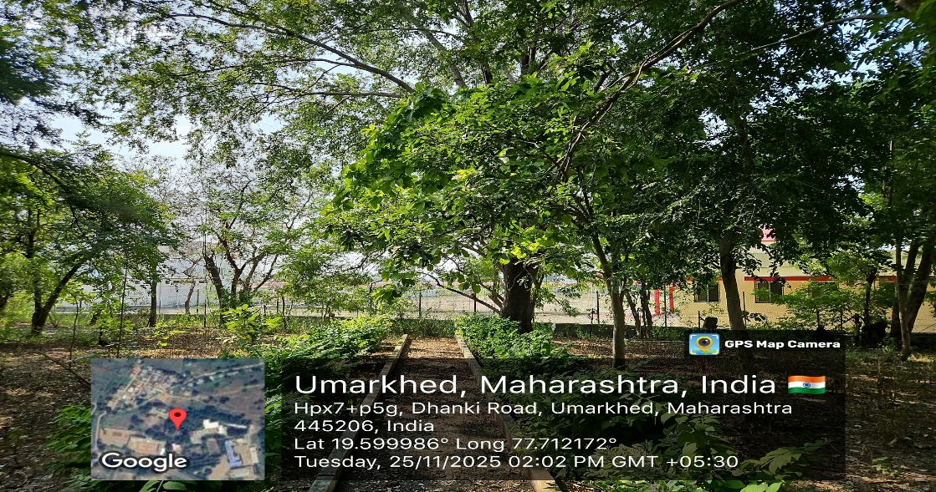
Picture 1 : Marked Quadrats
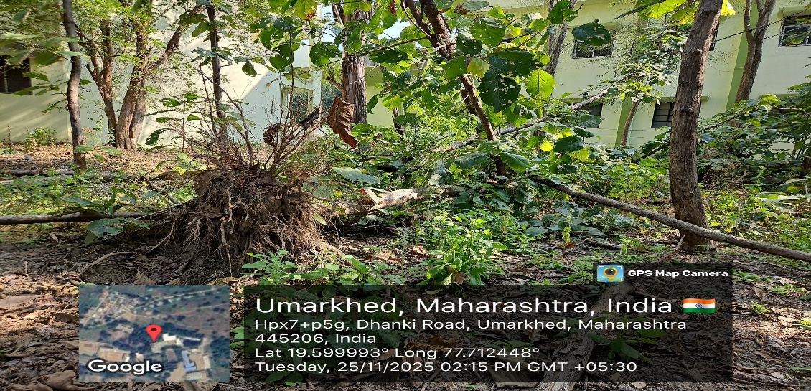
Picture 2 :Habitat formed because of cyclone
  - Sampling
During study period from July to November 2025, a structured sampling study was conducted within a botanical garden, which was partitioned into twelve 10 m×10 m quadrats (labelled Q1 - Q12). The research area was categorized into two distinct locations: Study Site-1, comprising the northern region (Q1– Q6), featured a canopy of large trees and low shrubs, including a specific area (Q4) characterized by fallen timber from prior spring storm damage. Study Site-2 (Q5– Q12) encompassed the southern portion of the garden, defined by its diverse, mixed vegetation. To analyse web architecture and its relationship to the surrounding flora, the quadrats were monitored four times weekly during morning and evening sessions. For communal spider species, various metrics including web height, positioning, support types, anchor points, and inter-web distances were recorded in centimetres. Individual webs were observed for five-minute intervals, and any debris found on the floor of tent webs was meticulously examined to determine prey composition. Furthermore, female specimens were temporarily collected for laboratory identification and promptly returned to their natural habitats (Haddad et al., 2015; Tikader, 1987).
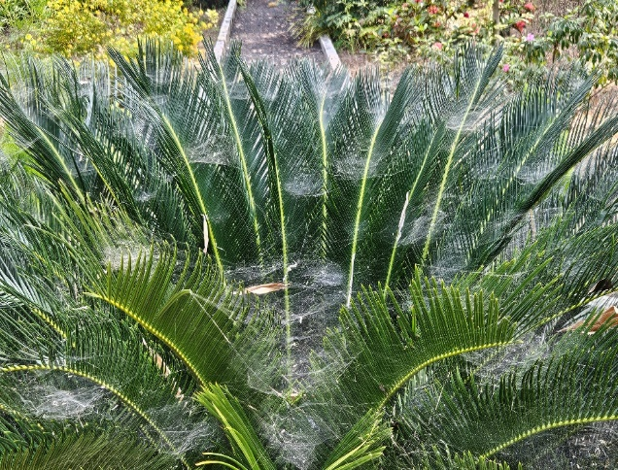
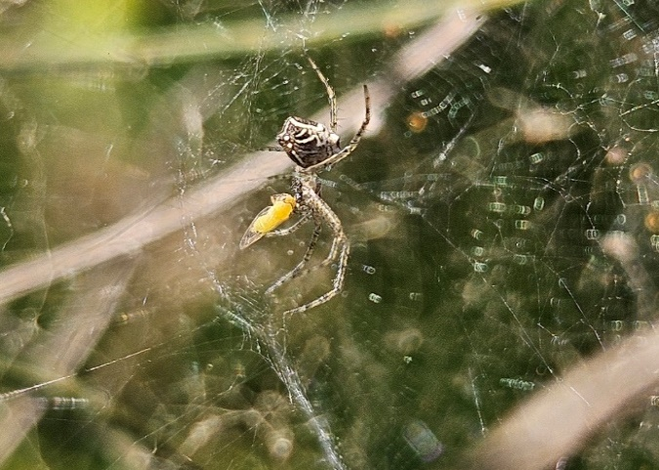

Picture 3 : Cycus plant showing abundant webs Picture 4 : C. cicatrosa feeding on insect

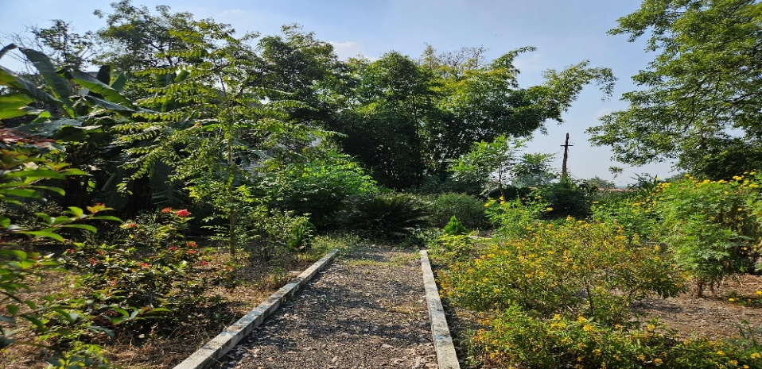

Picture 5 : Dense habitat

3. STATISTICAL ANALYASIS
The data obtained during present study was analysis by using Montgomery, et al., (2012) linear regression method.

- RESULTS AND DISCUSSION
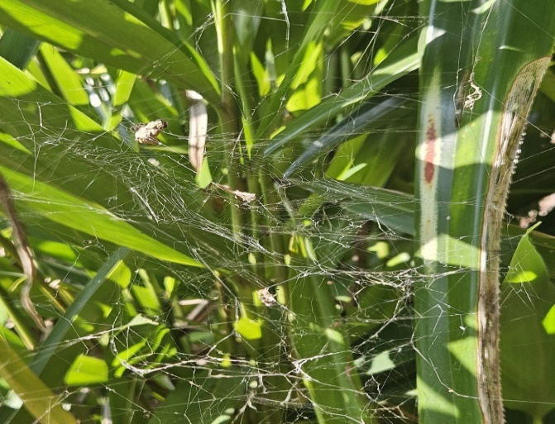
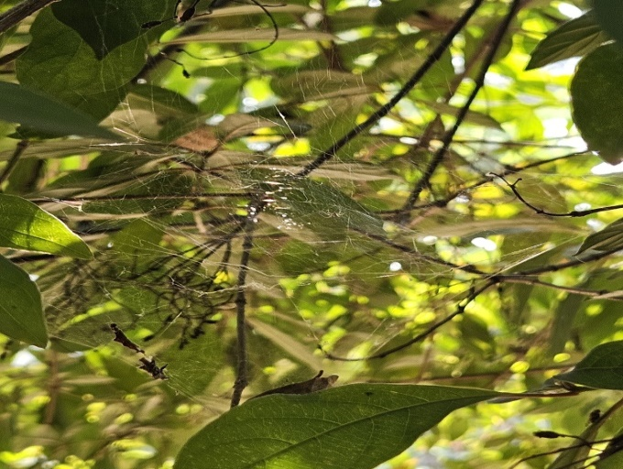
The study area of GSG College Botanical Garden in Umarkhed revealed a total population of 142 Cyrtophora cicatrosa spiders across two primary study sites. The demographic breakdown consisted of 43 adults and 99 juveniles, indicating a robust presence of immature individuals during the winter season. The botanical garden environment characterized by dense vegetation and lower humidity during the winter months serves as an ideal microhabitat for various arachnid species. Analysis of the dispersal patterns suggests that while C. cicatrosa began colonizing the area in 2024, the species achieved a garden-wide distribution within a single year. The study hypothesis regarding habitat preference was confirmed in quadrats Q4 through Q12. These areas provided the necessary structural complexity for web construction, specifically originating from Cycas plants and supported by fallen Tectona grandis (teak) trees, which offered the essential architectural framework for the species to inhabit and thrive.

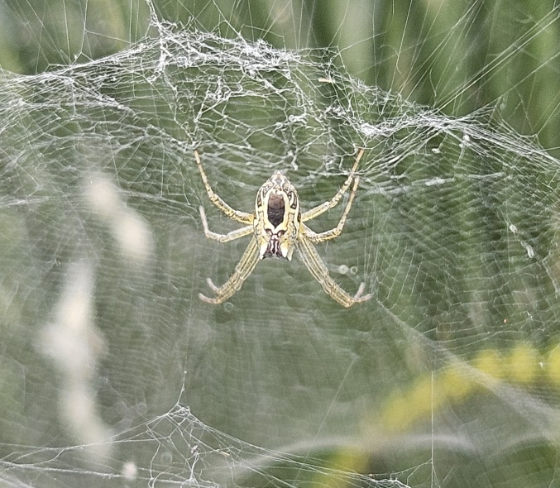
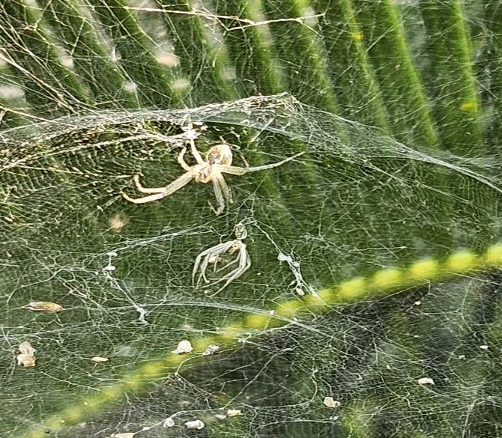

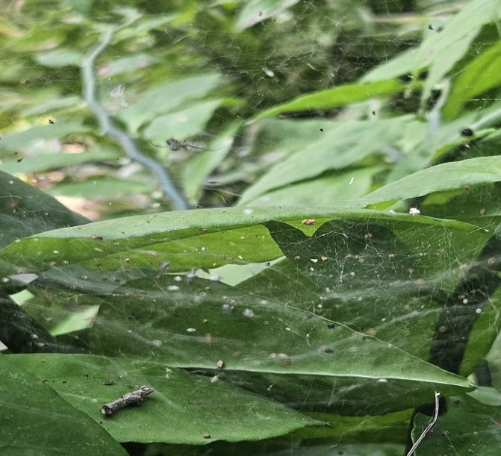
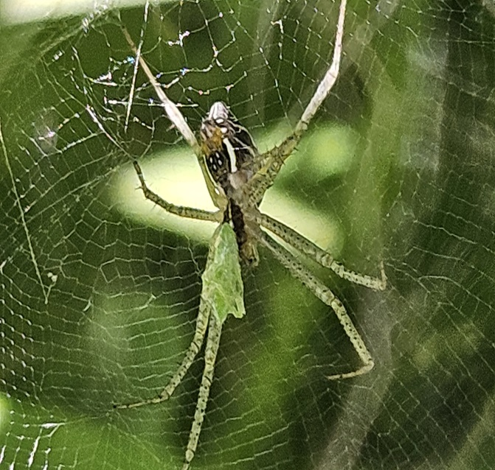

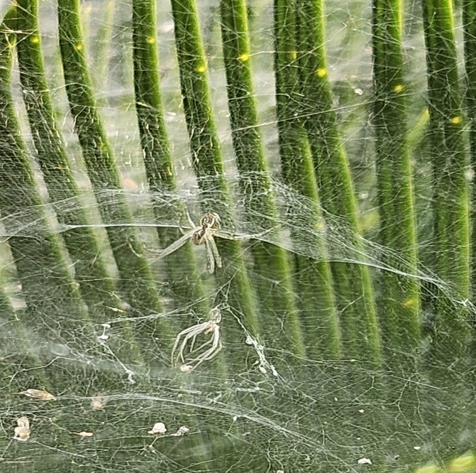
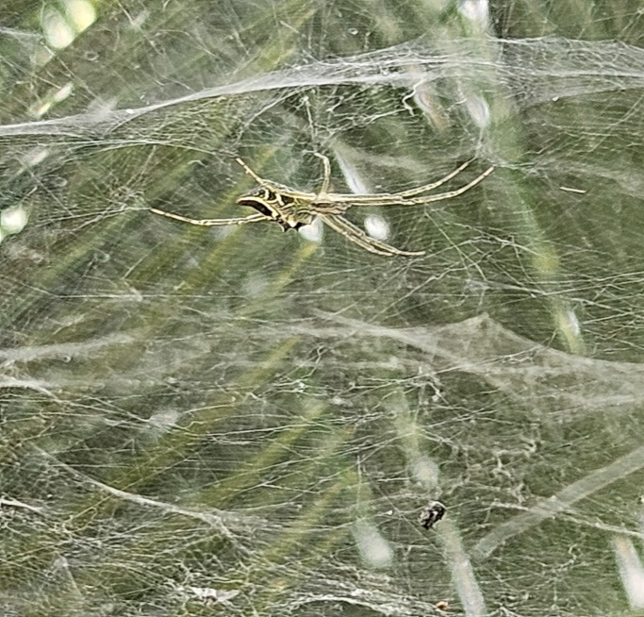

Plate 1 : Vegetation structure and web distribution of Cyrtophora cicatrosa

  - Web Placement Characteristics
The maximum recorded web height was 140 cm above the ground, typically positioned within mechanically stable regions of host vegetation, consistent with previous observations in colonial orb-weavers. Most webs were attached to small shrubs and ornamental trees, indicating a preference for mid-height vegetation strata that provide adequate support and prey interception surfaces. Webs showed strong clustering behavior, with inter-web distances of just 1- 2 cm, restricted to Cycas revoluta, reflecting colonial structuring as reported for Cyrtophora species. Web suspension required multiple anchorage points, with a mean of 96 attachment connections per web in C. revoluta, demonstrating a strong reliance on foliage complexity for structural reinforcement. The linear regression analysis (Webs = 1.71 × Anchors − 134.04) further confirmed that every one-unit increase in anchorage availability resulted in ~1.71 increase in observed webs, indicating a significant structural dependency for web deployment. Spatially, the majority of webs occurred in middle canopy zones, followed by inner and outer positions, suggesting avoidance of extreme exposure or excessively shaded understory habitats. These results indicate that colonial orb-weavers select specific vertical heights to achieve equilibrium between structural stability and foraging efficiency (Uetz, 1979). The observed preference for mid-height strata within ornamental trees aligns with the findings of Blackledge and Gillespie (2002), which identified these zones as optimal regions for prey interception. The remarkably close proximity of the webs frequently spaced only 1–2 cm apart combined with their exclusive presence on C. revoluta, underscores a sophisticated level of colonial organization (Majer et al., 2018). This dense configuration likely facilitates mutualistic advantages, including shared physical reinforcement and an enhanced capacity for capturing larger insect prey. Furthermore, the high degree of dependence on complex foliage is demonstrated by the average of 96 attachment points per web. Originally proposed by Rypstra (1983), this structural reliance is corroborated in this study through a statistically significant linear regression model.

Figure 1: Vegetation structure and web distribution of C. cicatrosa

  - Vegetation Structure Influence
The structural complexity of vegetation defined by plant height, leaf density, branching patterns, and canopy cover serves as a primary determinant for web distribution (Robinson, 1981; Lemmon, 1957; MacArthur and MacArthur, 1961; Dias et al., 2009). Our observations indicate that species-specific architectural traits significantly dictate web occurrence. High web density was strongly associated with ornamental shrubs such as Cycas revoluta and Hippeastrum sp., whose dense foliage and complex branching systems provide the essential anchor points required for communal web construction (Blackledge and Gillespie, 2002). In contrast, smaller plants with less favourable structural features supported minimal web activity. Interestingly, the orientation of structural elements proved as vital as the species itself; for instance, fallen Tectona grandis trees in Site-1 (Quadrat-4) supported multiple webs on lateral branches that had shifted to a vertical orientation, providing temporary structural complexity. Microclimatic buffering also emerged as a critical factor in site selection, particularly during the winter months. Large trees, including Tectona grandis and Azadirachta indica, create thermally stable zones characterized by temperatures between 27°C and 32°C and higher afternoon humidity. Light availability data further revealed a preference for shaded or partially covered habitats, which protect the webs from intense midday radiation. Spiders largely avoided open, patchy areas populated by species like Rauvolfia tetraphylla and Kewada, likely due to increased environmental stress and reduced prey movement (Wise, 1993).

Table1: Measured vegetation architecture used by C. cicatrosa
Plant Species | Plant Height (cm) | Leaf Density Score | Branching Complexity | Canopy Cover (%) | Observed Web Suitability
Cycus revoluta | 162 | 4 | 5 | 75 | High (majority webs recorded)
Barleria lupulina | 179 | 4 | 3 | 80 | High
Hamelia patens | 132 | 4 | 4 | 75 | Moderate-High
Gardenia sp. | 126 | 3 | 2 | 40 | Low-Moderate
Clitorea ternatea | 128 | 2 | 2 | 40 | Low
Rauvolfia tetraphylla | 132 | 3 | 3 | 40 | Moderate
Hippeastrum sp. | 40 | 4 | 2 | 60 | Very Low (height limitation)
Ravenia spectabilis | 210 | 2 | 2 | 20 | Low
Tactona grandis | 60 | 3 | 3 | 60 | Moderate

Furthermore, the vertical distribution of webs suggests a clear strategy for mechanical protection. Approximately 90% of all webs were positioned below 140 cm, a stratum where dense surrounding vegetation effectively minimizes wind force. This deliberate selection of wind-shielded, thermally buffered microhabitats represents a sophisticated adaptive strategy; by minimizing energy expenditure on web repairs and reducing damage from the elements, Cyrtophora can maximize its focus on prey interception and reproductive success.

- CONCLUSION
The present research deals with the spatial distribution and colonial establishment of Cyrtophora cicatrosa within the semi-managed botanical garden of G.S.G. College, Umarkhed, are primarily dictated by vegetation architecture and localized microclimatic variables. Cycas revoluta serves as the central hub for species dispersion, while Hippeastrum sp. and Euphorbia species offer the dense branching and high foliage density required for multiple anchorage points. These structural attributes are essential for the construction of stable, colonial orb-webs, supporting earlier assertions that habitat complexity is a primary determinant of communal behaviour in orb-weavers. Furthermore, microhabitat optimization was evident in the spiders preference for shaded, dense structures where webs were consistently positioned below 140 cm. This placement effectively minimizes thermal and mechanical stressors, thereby enhancing the stability of the communal colony.

REFERENCES
- Blackledge, T. A., & Gillespie, R. G. (2002). Estimation of capture threads and web architecture in Tetragnatha spiders: Evolution of aerial space use. Journal of Arachnology, 30 (3), 403–414.
- Dias, S. C., Carvalho, L. S., Bonaldo, A. B., & Brescovit, A. D. (2009). Spatial distribution of spiders in the Atlantic Forest of Brazil. Studies on Neotropical Fauna and Environment, 44 (3), 199–210.
- Geiger, R. (1950). The climate near the ground, Harvard University Press.
- Gómez, J. E., Lohmiller J., Joern A. (2016). Vegetation structure influences aerial arthropod communities in grassland habitats. Ecological Entomology, 41 (4), 401–411.
- Haddad, N. M., Brudvig, L. A., Clobert, J., Davies, K. F., Gonzalez, A., Holt, R. D., Lovejoy, T. E., Sexton, J. O., Austin, M. P., Collins, C. D., Cook, W. M., Damschen, E. I., Ewers, R. M., Foster, B. L., Jenkins, C. N., King, A. J., Laurance, W. F., Levey, D. J., Margules, C. R., Melbourne, B. A., Nicholls, A. O., Orrock, J. L., Song, D.-X., & Townshend, J. R. (2015). Habitat fragmentation and its lasting impact on Earth’s ecosystems. *Science Advances*, *1*(2), e1500052. https://doi.org/10.1126/sciadv.1500052
- Halarnkar, M. M., & Pai, I. K. (2018). Distribution, Diversity and Ecology of Spider Species At Two Different Habitats. International Journal of Environmental Sciences & Natural Resources. https://doi.org/10.19080/IJESNR.2018.08.555747
- Lemmon, P. E. (1957). A new instrument for measuring forest overstory density. Journal of Forestry, 55 (9), 667–668.
- MacArthur, R. H. (1972). Geographical ecology: Patterns in the distribution of species, Harper & Row.
- MacArthur, R. H., & MacArthur, J. W. (1961). On bird species diversity. Ecology, 42(3), 594–598. https://doi.org/10.2307/1932254
- Majer, M., Holm, C., & Lubin, Y. (2018). Colonial web structure and cooperation in Cyrtophora spiders. Behavioural Ecology, 29 (5), 1041–1050.
- Montgomery, D. C., Peck, E. A., & Vining, G. G. (2012). Introduction to linear regression analysis (5th ed.). Wiley. https://www.wiley.com/en-us/Introduction+to+Linear+Regression+Analysis%2C+Fifth+Edition+Set-p-9781118780572
- Robinson, J. V. (1981). The effect of architectural variation in habitat on a spider community: An experimental field study. Ecology, 62(1), 73–80. https://doi.org/10.2307/1936670
- Rypstra, A. L. (1983). The importance of food and space in limiting web-spider densities; a test using field enclosures. Oecologia, 59(2-3), 312–316. https://doi.org/10.1007/BF00378855
- Schuepfer, R. (1985). Habitat structure and web site selection in spiders. Oecologia, 67 (1), 118–125.
- Sunderland, K., & Samu, F. (2000). Effects of agricultural landscape structure on spider populations: A review. Biological Reviews, 75 (3), 243–270.
- Tews, J., Brose, U., Grimm, V., Tielbörger, K., Wichmann, M. C., Schwager, M., & Jeltsch, F. (2004). Animal species diversity driven by habitat heterogeneity/diversity: The importance of keystone structures. Journal of Biogeography, 31(1), 79–92. https://doi.org/10.1046/j.0305-0270.2003.00994.x
- Tikader, B. K. (1987). Handbook of Indian spiders. Zoological Survey of India. https://books.google.com/books/about/Indian_Spiders.html?id=2_4YAAAAIAAJ
- Uetz, G. W. (1979). The influence of variation in litter habitats on spider communities. Oecologia, 40(1), 29–42. https://doi.org/10.1007/BF00388808
- Uetz, G. W. (1991). Habitat structure and spider foraging. In S. S. Bell, E. D. McCoy, & H. R. Mushinsky (Eds.), Habitat structure: The physical arrangement of objects in space (pp. 325–348). Springer. https://doi.org/10.1007/978-94-011-3076-9_16
- Wise, D. H. (1993). Spiders in ecological webs. Cambridge University Press. https://doi.org/10.1017/CBO9780511623431

