Original Research Article
Antibacterial and Anti-biofilm activity of crude extracts of Halodule pinifolia (Hartog,1964) extracts against biofilm forming bacterial species

ABSTRACT
Marine biofouling is a serious concern in the maritime activities. Since the use of TBT and heavy metal based antifoulants were banned due to their toxic effects on non-target organisms, the hunt for eco-friendly antifoulants are still in search. Seagrasses are submerged and sessile marine angiosperms which have resistance ability against attaching epibionts. This present study focuses on the use of seagrass extracts against the marine biofouling forming bacteria.Different colonies were isolated from the collected biofilm sample of the boat hull and were tested for their biofilm producing ability by Congo Red agar method. The seagrass Halodule pinifolia (Hartog,1964) was collected from Vellar estuary and its crude extracts such as ethanol, methanol, dichloromethane and chloroform were tested against the biofilm forming bacteria Priestia megaterium (PQ012983), Bacillus licheniformis (PQ012984), Bacillus subtilis (PV460241), Vibrio alginolyticus (PV460242), Priestia flexa (PV460243) and Bacillus stercoris (PV460244) by well-diffusion assay. Among all the crude extracts of Halodule pinifolia the maximum zone of inhibition was exhibited by dichloromethane extracts against Bacillus stercoris (18.5±0.8mm). The overall minimum zone of inhibition was exhibited by chloroform extracts against Bacillus licheniformis (5 ± 0.6 mm). Followed by dichloromethane, methanol extract was most effective against these bacteria. Anti-biofilm activities of these effective extracts were performed using Tissue Culture Plate method that showed the reduction in biofilm production. The dichloromethane extracts showed more reduction of biofilm against targeted bacterial species. The secondary metabolites present in the effective extracts were further analysed using GS-MS. The compounds such as 2-Pentadecanon, 6,10,14-Trimethyl pentadecan and n-Hexadecanoic acid were abundantly found in the methanol and dichloromethane extracts respectively. This study concludes that the Halodule pinifolia extracts have effective inhibiting activity against biofilm forming microorganisms and thus can be considered as a potential source for eco-friendly marine antifoulants.
KEYWORDS: Halodule pinifolia, Anti-bacterial activity, Anti-biofilm activity, Biofilm forming bacteria, GC-MS
I. INTRODUCTION
The microbial sessile communities that are attached to a substratum, interphases, or each other which are immersed in the water are known as biofilms (Muras et al.,2021). These are embedded in self-secreted extracellular matrices containing protein, polysaccharide, nucleic acid and lipid substance that displays a different phenotype. Due to its detrimental effects on the maritime sector (biocorrosion, damage to coolant water pipes, cleaning, delays in transit, and increased fuel consumption) as well as environmental pollution (increased emissions of carbon dioxide, carbon monoxide and sulfur dioxide), biofouling control is a global economic issue (Chapman et al., 2014). The commencement of these macrobiofoulers depends on the establishment of microbial colony. These microbial communities for strong attachment towards the substratum they produce EPS (Extracellular polymeric Substances) that leads to biofilm formation. The development of biofilms and numerous other significant biological processes in bacterial populations are frequently regulated by a system of gene regulation called quorum sensing (QS), which is dependent on cell density (Fuqua et al., 1994). The biofilm matrix's exopolysaccharides, lipids, nucleic acids, and proteins can all be produced differently by the QS system. To enhance bacterial adaptation to the environment and maximize their chances of survival, this bacterial communication system is also integrated with other environmental signals, such as temperature, pH, salinity, oxidative stress, and nutrition availability (Williams et al., 2007). This is the reason that the antifouling strategies against biofilm microbes are more important than antifouling strategies against macrofoulers. Without microfoulers the association or settlement of macrofouling organisms cannot happen. The hunt has continued to find environmentally safe antifouling paint made from natural materials because the use of TBT as an antifouling has grown faint due to its toxic effects (Bitang,2011). Marine natural products and their synthetic analogs has great potential in exhibiting anaesthetic, but non-toxic to the non-target organisms and thus, preferred as potential antifouling agents (Bragadeeswaran et al., 2011). The marine angiosperms i.e. sea grasses are noted to have antifouling potential as no foulers are seen on the surface of seagrass. Metabolites with notable bioactivities have been reported from seagrasses; these metabolites differ depending on the plant component, age, season, extraction solvent, and location (Wisespongand et al.,2022). Also many findings showed that metabolites produced by seagrass are capable as antifouling agents. This present study shows the antibiofilm potential of seagrass extracts against biofilm-forming bacterial species. It also reports the phytocompounds or secondary metabolites present in effective crude methanol and dichloromethane extracts of seagrass using GC-MS analysis.
II.MATERIALS AND METHODS:
2.1 Isolation and Identification of biofilm bacteria:
The biofilm was collected from the fishing boat hull of Kasimedu Fishing Port (13°07'31"N 80°17'50"E) in a sterile tube containing nutrient broth and incubated for nearly 24 to 48 hrs. The samples were serially diluted up to 10⁻⁵. 100µl of each diluent was spread out on separate Zobell Marine Agar Plates. The density of the population noted on plates was calculated and expressed as CFU/ml. Using Bergey’s Manual of Determinative Bacteriology (Holt et al., 1994). Different and unique colonies based on their colour, shape and structure were isolated and identified by quadrant streaking on specific and differential media. Further for confirming the ability of biofilm production by selected bacteria, Congo red agar method (Freeman et al., 1989) using Brain heart infusion agar was done.
2.2 Generic level confirmation of selected biofilm bacteria using 16SrRNA Gene Fragments:
Partial 16S rRNA gene amplification of active strains of marine biofilm-forming bacteria was carried out using PCR, followed by PCR product purification and sequencing analysis (Radjasa & Sabdono, 2008). Further the determined DNA sequences of strains were compared for homology to the BLAST database. The 16S rRNA gene sequences retrieved from biofilm bacterial isolates of boat hull have been deposited into the DNA Database (NCBI) Genbank with the accession numbers. A phylogenetic tree was constructed using maximum-likelihood analysis and Phylogenetic analysis performed with MEGA11 (PAUP) software package using Neighbor-Joining method by inferring the evolutionary history. The percentage of replicate trees in which the associated taxa clustered together in the bootstrap test (1000 replicates) was shown next to the branches.
2.3 Sea grass collection and Dry Extraction:
The sea grass samples were collected from Vellar estuary (11°29'28"N 79°46'02"E) and identified as Halodule pinifolia (Family: Cymodoceaceae). The collected samples were shade dried for nearly 2 weeks. The methodology was performed using dry extraction (Mayavu et al., 2009). The shade dried samples were powdered and the compounds were extracted using Soxhalet extractor different solvents based on different polarities such as Ethanol, Methanol, Dicholoromethane and Chloroform for 36 to 48 hrs @ 50-55°C. Then the extracts collected from Soxhlet apparatus using different solvents were concentrated and dried under reduced pressure using rotary evaporator and kept in dry and dark place until further use.

2.4 Antibacterial susceptibility of sea grass extracts against biofilm bacterial strains:
Antibacterial activity was done using Muller Hinton Agar plates by well diffusion method (Perez, 1990). 100 µl of bacterial inoculum was spread plated on the agar medium. The Ethanol, Methanol, Dichloromethane. Chloroform extracts were added to each well at different volumes such as 25 µl, 50µl, 75 µl and 100 µl against the fouling bacteria and the distilled water and amoxicillin (10µg/ml) were used as negative control and positive control respectively. The inoculated plates with loaded extracts were incubated for nearly 24- 48 hrs @ 37ºC. The inhibition zone was measured from the edge of the well to the clear zone in millimeter (mm).
2.5 Anti-biofilm production activity of sea grass extracts by Tissue Culture Plate Method:
The ability of biofilm reduction potential of seagrass extracts was determined using Tissue Culture plate method in 96-well flat bottom polystyrene plates with some modifications (Christensen's et al.,1995 & Stepanovic et al.,2007). 0.2 ml of diluted microbial culture was added to the each well. The control wells were left undisturbed without adding any extracts. Amoxicillin was used as positive control. The ethanol, methanol, dichloromethane and chloroform extracts of Halodule pinifolia was added to each well at different volumes such as 100µl, 150µl and 200µl. The wells were then incubated for 24 hours @ 37°C. The contents from the wells were removed carefully then the wells were washed twice with 0.2 ml of PBS (Phosphate Saline Buffer) and were incubated for 1 hour @ 37°C. Followed by this the wells were stained using 0.1 % Crystal Violet Stain for nearly 10 minutes. Then the excess stains were removed and washed with deionized water and the wells were dried. Finally the wells were treated with 0.2 ml of 33% glacial acetic acid. The OD values of the biofilm production were determined using microELISA reader (SpectraMaxi3) @ 570nm wavelength. Interpretation of OD values for biofilm production was determined using the standard values described by Stepanovic et al., 2007 which is if the OD value is <0.17- negative biofilm production; 0.17-0.34 – weak positive biofilm production; 0.35-0.68 – moderate biofilm production; >0.68 – Strong biofilm production.

2.6 GC-MS analysis of Halodule pinifolia Extracts:
The presence of phytocompounds in two effective dried Halodule pinifolia extracts i.e. methanol and dichloromethane was identified using Shimadzu GCMS-TQ TM 8050 NX equipment. The gas chromatogram was integrated with mass spectrometer in a way that mass analyzer and detector were directly connected to capillary column (Rxi-5Sil MS GC Capillary Column, 30 m, 0.25 mm ID, 0.25 μm). While detection, electron ionization energy of 70eV was utilized and helium gas of 99.999% pure was used as a carrier gas at a constant flow rate of 1.5 ml/min. The sample was injected at 2 µl injection volume, the injector temperature and ion source temperature was set at 200°C. At 70 eV, mass spectra were carried out with a scan interval of 0.5 s at a 40–1000 m/z scan range. The total GC running time was 35 min. By comparing the average peak area to the total area, the relative percentage amount of each component was calculated. NIST 2023 library was used for detection (Pushpabharathi et al., 2018).

III. RESULTS

3.1 Identification of isolated biofilm bacterial strains using 16SrRNA:

The biofilm bacteria density observed on the Zobell Marine Agar plates were maximum of 6 x 10⁻² CFU/ml and minimum density of 1.2 x 10 ⁻⁴ CFU/ml. Further using differential and selective media the strains were observed growing on Bacillus agar medium and TCBS agar medium. The bacterial stain CASBT1A was yellowish-creamy in color with round to irregular shape. The bacterial strain CASBT2A was cream-colored, round, irregular, rough and wrinkled with hair-like growths. The bacterial strain CASBTCCEIR was circular, white to off-white, slightly raised with irregular margin. The bacterial strain CASBTCFR was smooth, convex and creamy and was yellow in colour on TCBS agar. The bacterial strain CASBTCGF was opaque, creamish and raised margin appearance. The bacterial strain CASBTALP was rough, dry and creamy white in colour. The isolated strains were confirmed for their strong biofilm production ability by Congo red agar method. The bacterial strains produced dark black colored colonies on the Brain heart infusion agar plates.

3.2 Generic level confirmation, phylogenetic tree and NCBI submission of biofilm producing bacteria:
The isolated strains were further confirmed by 16srRNA primer sequencing as Priestia megaterium, Bacillus licheniformis, Bacillus subtilis, Vibrio alginolyticus, Priestia flexa and Bacillus stercoris respectively (Table 1). Molecular phylogenetic results shows that the active isolate belonged to the families Bacillaceae and Vibrionaceae (Figure 1). In the present study, The bacteria such as Priestia megaterium, Bacillus licheniformis, Bacillus subtilis, Vibrio alginolyticus, Priestia flexa and Bacillus stercoris were sequenced and the phylogenetic tree was constructed using MEGA 11 software by inferring the evolutionary history using Neighbor-Joining Method. The analysis involved 18 nucleotide sequences for construction of phylogenetic tree was drawn to scale, with branch lengths in the same units as those of the evolutionary distances used to infer the phylogenetic tree (Figure 1).Two major clades were obtained in the tree. The first clade formed by the Bacillus subtilis (PV460241), Bacillus licheniformis, Bacillus mojavensis, Bacillus stercoris (PV460241), Bacillus velezensis, Bacillus licheniformis (PQ012984), Bacillus aerius, Bacillus subtilis, Priestia megaterium, Bacillus sp., Priestia flexa (PV460243), Bacillus aryabhatthai, Priestia megaterium (PQ012983), Lysinibacillus macrolides, Vibrio alginolyticus (PV460242), Vibrio parahaemolyticus, Vibrio neocaledonicus and the second clade was formed by Bacillus tequilensis.

TABLE 1. Molecular identification of active biofilm forming bacteria isolated from boat hull of Kasimedu port
S.No. | ISOLATE | SOURCE | CLOSEST RELATIVE | SIMILARITY(%) | ACCESSION No.
1. | CASBT1A | Biofilm samples from Boat hull | Priestia megaterium | 98.53% | PQ012983
2. | CASBT2A | Biofilm samples from Boat hull | Bacillus licheniformis | 100 % | PQ012984
3. | CASBTCCEIR | Biofilm samples from Boat hull | Bacillus subtilis | 97.88% | PV460241
4. | CASBTCFR | Biofilm samples from Boat hull | Vibrio alginolyticus | 97.94% | PV460242
5. | CASBTCGF | Biofilm samples from Boat hull | Priestia flexa | 98.57% | PV460243
6. | CASBTALP | Biofilm samples from Boat hull | Bacillus stercoris | 100% | PV460244

Figure 1. Phylogenetic tree of the 16srRNA sequence of isolated bacterial strains evolutionary relationship among other bacterial populations.

3.3 Antibacterial and Anti-biofilm production activity of Halodule pinifolia extracts against biofilm producing bacterial strains:
Among all the crude extracts of Halodule pinifolia the maximum zone of inhibition was exhibited by dichloromethane extracts against Bacillus stercoris (18.5±0.8mm). The overall minimum zone of inhibition was exhibited by chloroform extracts against Bacillus licheniformis (5 ± 0.6 mm). The positive control amoxicillin had inhibitory effects against all the six targeted bacteria. Against Priestia megaterium the maximum zone of inhibition was exhibited by dichloromethane (11.25±0.4mm) followed by methanol (13±0.7mm) and ethanol (9.25±0.8mm) extracts. Dichloromethane extracts (14.75±0.6) showed maximum zone of inhibition against Bacillus licheniformis was followed by methanol extracts (13.8±0.3mm). Minimum zone of inhibition against Bacillus licheniformis was observed in chloroform extracts (9±0.8). The bacteria Bacillus subtilis was inhibited by dichloromethane extracts which showed maximum zone of inhibition as 16.5±0.3mm. Followed by dichloromethane extracts the methanol, ethanol and chloroform extracts showed inhibition against Bacillus subtilis as 16±0.4mm, 12±0.9mm and 9±0.8mm respectively. Against Vibrio alginolyticus the maximum zone of inhibition was exhibited by dichloromethane extracts 18±0.5mm. The methanol and ethanol and chloroform extracts showed effects by the zone of 15±0.5mm, 14±0.5mm and 11±0.5mm respectively against Vibrio alginolyticus. The maximum zone of inhibition was exhibited by dichloromethane extracts (14.5±0.3mm) against Priestia flexa followed by methanol and ethanol extracts as 16±0.3mm and 14.5±0.7mm respectively. The chloroform extracts did not showed any zone of inhibition against Priestia flexa. Against Bacillus stercoris the maximum zone of inhibition was exhibited by dichloromethane (18.5±0.8mm) extracts followed by methanol (18±1 mm), ethanol (15±0.9mm) and chloroform (7±0.3mm) extracts respectively (Figure 2).
Figure 2. Inhibitory effects of the different solvents used for extracting Halodule pinifolia against biofilm forming bacteria
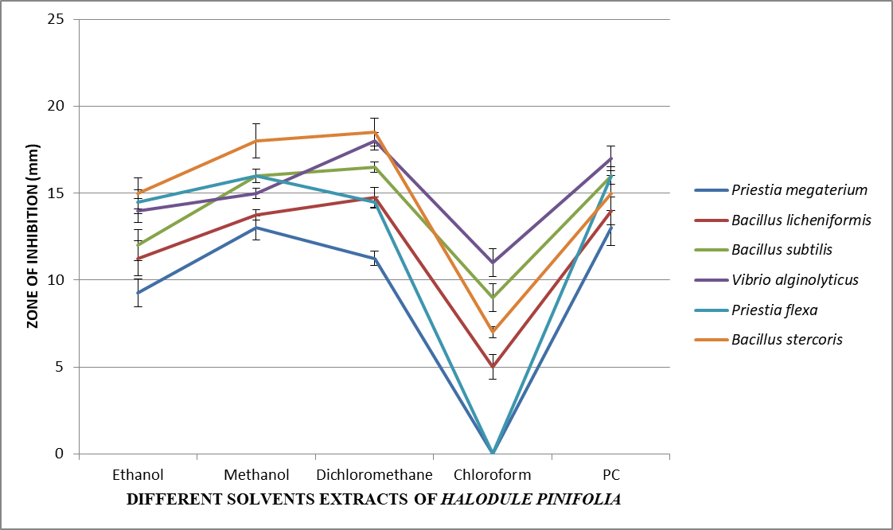

Anti-biofilm activity of the crude extracts against the biofilm forming bacteria. All the four extracts showed biofilm formation inhibition, but the maximum effects were recorded from the dichloromethane extracts followed by methanol extracts as shown in Figure 3. The increase in OD refers to the increased biofilm production and the decrease in OD value refers to weak positive or negative biofilm production. As the concentrations of the crude extracts increased the biofilm production (i.e. the value of Optical density) was reduced. The regression analysis also showed that negative regression as the concentration increases the OD value decreases, the R² value also ranged from 0.84 to 1 which shows a good negative regression of extracts against biofilm production (Figure 4).
Figure 3. Antibiofilm production activity of crude ethanol, methanol, dicholoromethane and chloroform extracts of Halodule pinifolia at different volumes against biofilm forming bacteria
PM- Priestia megaterium; BL- Bacillus licheniformis; BS – Bacillus stercoris; VA – Vibrio alginolyticus; PF- Priestia flexa; BSB – Bacillus subtilis
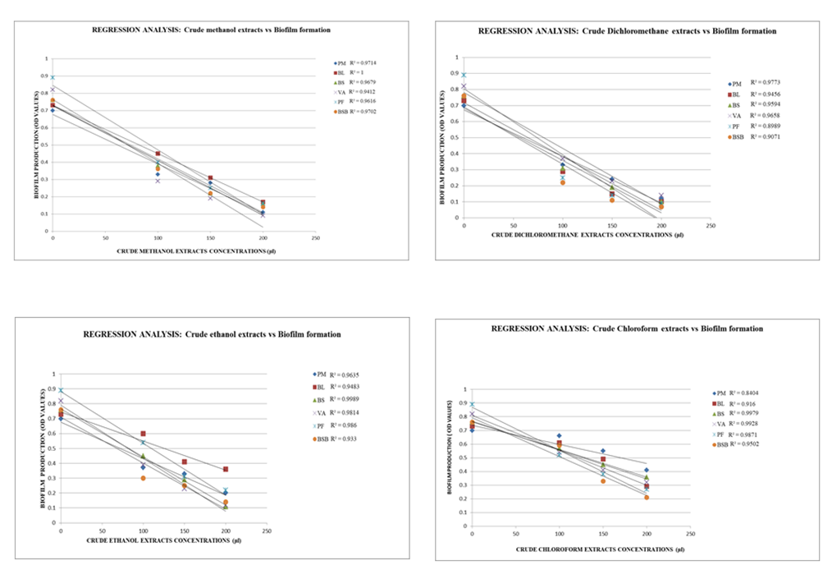
Figure 4. Regression analysis showing negative regression for the crude extracts concentrations vs the biofilm production

3.4 Identification for compounds present in effective extracts using GC-MS analysis:
GC-MS analysis was performed for the crude methanol and dichloromethane extracts of dried seagrass samples. GC-MS spectra of these two extracts were shown in Figure 5. The GC-MS spectrum peaks observed in the crude methanol extracts showed 10 compounds. The compounds identified includes 9,12-Octadecadienoic acid (Z,Z)- methyl ester (2.92%), 7,10,13-Hexadecatrienoic acid, methyl ester (1.38%), and Tetrapentacontate (42.60%).16 compounds were present in dichloromethane extracts during GC-MS analysis includes Heptadecane (4.03%), Methyl tetradecanoate (0.93%), 3,7,11,15-Tetramethyl hexadecyl acetate (0.63%), Tetradecanoic acid (3.39%), Hexadecanal (0.93%), 2-Pentadecanon, 6,10,14-Trimethyl pentadecan(10.94%), Pentadecanoic acid (0.30%), Hexadecanoic acid, methyl ester (8.72%), n-Hexadecanoic acid (62.16%), Acetic acid, 3,7,11,15-tetramethyl-hexadecyl ester (0.81%), Nonacosanal(0.68%), E,E,Z-1,3,12-Nonadecatriene-5,14-diol9 (3.56%), Heptatriacontane (0.82%) and Tetrapentacontane (0.96%). It was observed that the compound Tetrapentacone was commonly seen in both methanol and dichloromethane extracts of Halodule pinifolia.
Figure 5. Phytocompounds detected in the crude Methanol and Dichloromethane extracts of Halodule pinifolia
IV.DISCUSSION
Natural products derived from marine organisms have been widely recognized for their diverse antimicrobial activities (Faulkner, 2001). Among these, seagrasses are submerged, sessile marine angiosperms that exhibit notable resistance to biofouling, likely due to their inherent biochemical defenses against epibionts. Antibacterial compounds commonly found in seagrasses include phenolic acids, terpenoids, and flavonoids (Iyapparaj et al., 2014). In the present study, the crude methanol and dichloromethane extracts of Halodule pinifolia demonstrated significant antifouling activity against strong biofilm-forming bacteria such as Priestia megaterium and Bacillus licheniformis. These findings suggest that both polar and mid-polar compounds in H. pinifolia extracts may serve as effective natural antifouling agents.
Previous studies have similarly highlighted the bioactive potential of seagrasses. For instance, methanol and ethanol extracts of Cymodocea serrulata and Syringodium isoetifolium exhibited broad-spectrum antibacterial activity against biofilm-forming bacteria, likely due to the presence of phenolic or other bioactive metabolites (Mayavu et al., 2009). Specifically, methanol extracts of these seagrasses were more effective, reinforcing the role of polar solvents in extracting potent antifouling compounds. GC-MS analysis of methanolic extracts from S. isoetifolium identified constituents such as 2-pentadecanone, 6,10,14-trimethyl, hexadecanoic acid methyl ester, 9,12-octadecadienoic (Z,Z)-methyl ester and 1,2-benzenedicarboxylic acid diisooctyl ester. Similarly, extracts of C. serrulata revealed the presence of 2-pentadecanone, 6,10,14-trimethyl, octadecanoic acid methyl ester, oleic acid and erucic acid, which contributed to their high antifouling activity (Iyapparaj et al., 2014).
Comparable results were also reported in the case of Thalassia hemprichii, whose methanol extract exhibited antimicrofouling properties with an inhibition zone of 26 mm, closely approximating that of the positive control, chloramphenicol (28 mm) (Fahruddin et al., 2019). These findings are consistent with the current study, where methanolic extracts of H. pinifolia effectively inhibited biofilm-producing bacteria, reinforcing the antifouling potential of highly polar seagrass extracts.
Furthermore, dichloromethane extracts of H. pinifolia also showed potent antibacterial and anti-quorum sensing activity. This aligns with the findings of Wisespongpand et al. who demonstrated that both above-ground and below-ground parts of Cymodocea rotundata and C. serrulata possessed antimicrobial activity, with root-derived dichloromethane extracts exhibiting the most effective microbial inhibition among 18 tested seagrass extracts. Additional evidence comes from Bragadeeswaran et al., who showed that methanol and dichloromethane extracts of seaweeds (Cladophora clavuligera and Sargassum wightii) had antifouling effects, although the latter solvent was active only against specific strains like Pseudomonas sp.
Interestingly, while zosteric acida well-known biodegradable antifouling compound from Zostera marina has been implicated in antifouling properties (Newby et al., 2006), it was not detected in the methanol or dichloromethane extracts of H. pinifolia in the present study. Other compounds, such as 3-hydroxy-4-methoxycinnamic acid and α-cyano-4-hydroxycinnamic acid, previously reported in Halophila stipulacea, also did not show strong correlation with antifouling activity due to low mass peak intensities.
The GC-MS analysis of H. pinifolia extracts in this study revealed the presence of 9,12-octadecadienoic acid (2.92%) in methanolic extracts and n-hexadecanoic acid (62.16%) in dichloromethane extracts. The antifouling activities observed may be attributed to these compounds, as supported by previous studies on the seaweed Lobophora brandenii, where similar compounds were linked to antifouling efficacy (Manilal et al., 2010). A study done by Ganesan et al., 2022 showed that the n-hexadecanoic acid at the maximum concentration of 50 µg/ml from the Ipomoea eriocarpa’s leaves showed antibacterial activity against bacteria such as S. aureus, B. subtilis, E. coli, and K. pneumoniae was 7.96 ± 0.05 mm, 10.96 ± 0.15 mm, 11.10 ± 0.17 mm, and 11.93 ± 0.11 mm. In a similar study, using the bacterial (Bacillus licheniformes and Vibrio alginolyticus) extracts of soft coral and macroalgae from Red Sea exhibited strong effects against biofilm- forming bacteria, barnacle larval attachment and biofilm formation showed the presence of compounds such as 2,3-dihydroxypropyl ester, 2-hydroxy- 1-(hydroxymethyl) ethyl ester, 17-pentatriacontene, octadecanoic acid and tetrapentacontane were analysed using GC-MS (Tunkal et al., 2022). The GC-MS analysis of present study also showed the presence of tetrapentacontane, octadecanoic acids which prove it might contribute to the inhibitory effects of biofilm formation.
Overall, the findings confirm that the crude methanol and dichloromethane extracts of Halodule pinifolia possess significant antifouling activity against marine biofilm-forming bacteria. The QS-mediated virulence inhibition of Pseudomonas aeruginosa by 4-methoxybenzoic acid (4-MBA), a lead compound from H. pinifolia, has been previously demonstrated (Danaraj et al., 2020). Although this compound was not identified in the extracts during the current study, its known effects on virulence factors such as elastase, protease, pyocyanin and alginate underscore the seagrass's potential for anti-quorum sensing applications.
Among the three seagrasses tested, the methanol extract of H. pinifolia exhibited stronger antibacterial activity than that of Halophila stipulacea and Cymodocea serrulata (Kannan et al., 2010). This supports the present hypothesis that methanolic extracts of seagrasses, especially H. pinifolia, are rich in bioactive compounds with potent antifouling properties.
V.CONCLUSION
In conclusion, the study confirms that Halodule pinifolia exhibits substantial antifouling activity against biofilm-forming bacteria and also helps in reduction of biofilm production. The major phytocompounds identified in the methanol and dichloromethane extracts namely tetrapentacontane, 2-pentadecanone, 6,10,14-trimethylpentadecan and n-hexadecanoic acid are likely contributors to the observed bioactivity. Future work should focus on isolating and characterizing these individual compounds to validate their antifouling potential against both micro and macrofouling organisms. This study suggests that H. pinifolia could serve as a valuable, eco-friendly resource for developing antifouling paints and marine coatings.

REFERENCE:

- Muras A, Parga A, Mayer C, Otero A. 2021.Use of quorum sensing inhibition strategies to control microfouling. Marine drugs 19(2):74.doi: https://doi.org/10.3390/md19020074

- Chapman J, Hellio C, Sullivan T, Brown R, Russell S, Kiterringham E, Le Nor L, Regan F.2014. Bioinspired synthetic macroalgae: Examples from nature for antifouling applications. International Biodeterioration & Biodegradation 1(86):6-13.doi: https://doi.org/10.1016/j.ibiod.2013.03.036

- Fuqua WC, Winans SC, Greenberg EP. Quorum sensing in bacteria: the LuxR-LuxI family of cell density-responsive transcriptional regulators. 1994. Journal of bacteriology 176(2):269-75. https://doi.org/10.1128/jb.176.2.269-275.1994

- Williams P, Winzer K, Chan WC, Camara M. 2007. Look who's talking: communication and quorum sensing in the bacterial world. Philosophical Transactions of the Royal SocietyB:BiologicalSciences29;362(1483):1119-34. doi: https://doi.org/10.1098/rstb.2007.2039

- Bintang M.2011.Potential of Seagrass Symbiotic Bacteria as an Inhibitor of the Biofouling in the Sea . Dissertation, Bogor: IPB University.

- Bragadeeswaran S, Thangaraj S, Prabhu K, Rani SR. 2011. Antifouling activity by sea anemone (Heteractis magnifica and H. aurora) extracts against marine biofilm bacteria. Latin american journal of aquatic research 39(2):385-9.doi: https://doi.org/10.3856/vol39-issue2-fulltext-19

- Wisespongpand P, Khantavong A, Phothong P, Wanghom W.2022. Antimicrobial, antioxidant, and antifouling activity from extracts of aboveground and belowground parts of seagrasses Cymodocea rotundata and Cymodocea serrulata..Journal of Fisheries and Environment 46(1):37-53. doi:https://li01.tci-thaijo.org/index.php/JFE/article/view/254210

- Holt JG, Krieg NR, Sneath PH, Staley JT, Williams ST.1994. Bergey's Manual of determinate bacteriology.

- Freeman DJ, Falkiner FR, Keane CT. 1989. New method for detecting slime production by coagulase negative staphylococci. Journal of clinical pathology 1;42(8):872-4.doi: https://doi.org/10.1136/jcp.42.8.872

- Radjasa OK, Sabdono A.2008. Ecological role of a softcoral-associated bacterium Arthrobacter sp. on marine biofilm-forming bacteria. Microbiology Indonesia 2(2):84-8. https://doi.org/10.5454/mi.2.2.6

- Mayavu P, Sugesh S, Ravindran VJ.2009. Antibacterial activity of seagrass species against biofilm forming bacteria. Res J Microbiology 4(8):314-9. doi: https://doi.org/10.3923/jm.2009.314.319

- Perez C.1990. Antibiotic assay by agar-well diffusion method. Acta Biol Med Exp 15:113-5.

- Bazargani, M. M., & Rohloff, J. (2015). Antibiofilm activity of essential oils and plant extracts against Staphylococcus aureus and Escherichia coli biofilms. Food Control, 61, 156-164. https://doi.org/10.1016/j.foodcont.2015.09.036

- Pushpabharathi N, Jayalakshmi M, Amudha P, Vanitha V.2018. Identification of bioactive compounds in Cymodocea serrulata-a seagrass by gas chromatography–mass spectroscopy. Asian J. Pharm. Clin. Res 11(9):317-20.doi: http://dx.doi.org/10.22159/ajpcr.2018.v11i9.26744

- Faulkner DJ.2001. Marine natural products. Natural product reports 18(1):1R-49R. https://doi.org/10.1039/B006897G
- Iyapparaj P, Revathi P, Ramasubburayan R, Prakash S, Palavesam A, Immanuel G, Anantharaman P, Sautreau A, Hellio C.2014. Antifouling and toxic properties of the bioactive metabolites from the seagrasses Syringodium isoetifolium and Cymodocea serrulata. Ecotoxicology and environmental safety 1;103:54-60. doi: https://doi.org/10.1016/j.ecoenv.2014.02.009

- Fahruddin F, Johannes E, Dwyana Z. 2019.Antifouling potential of Thalassia hemprichii extract against growth of biofilm-forming bacteria. ScienceAsia 1;45(1). https://doi.org/10.2306/scienceasia1513-1874.2019.45.021

- Bragadeeswaran S, Prabhu K, Thangaraj S, Ganesan K, Rani S.2011. Biological activity of Seaweed extracts from Cladophora clavuligera (Kutzing, 1843) and Sargassum wightii (Greville, 1995) against marine fouling bacteria. Indian Journal of Geo-Marine Sciences 40(3):398-402. http://nopr.niscpr.res.in/11900/1/IJMS%2040(3)%20398-402.pdf

- Newby BM, Cutright T, Barrios CA, Xu Q. 2006.Zosteric acid—An effective antifoulant for reducing fresh water bacterial attachment on coatings. JCT research 3:69-76.doi: https://doi.org/10.1007/s11998-006-0007-4

- Manilal A, Sujith S, Sabarathnam B, Kiran GS, Selvin J, Shakir C, Lipton AP. 2010. Antifouling potentials of seaweeds collected from the southwest coast of India. World J. Agric. Sci. 6(3):243-8.DOI: https://idosi.org/wjas/wjas.htm
- Ganesan, T., Subban, M., Christopher Leslee, D. B., Kuppannan, S. B., & Seedevi, P. (2024). Structural characterization of n-hexadecanoic acid from the leaves of Ipomoea eriocarpa and its antioxidant and antibacterial activities. Biomass Conversion and Biorefinery, 14(13), 14547-14558. https://doi.org/10.1007/s13399-022-03576-w

- Tunkal, R. I., Jamal, M. T., Abdulrahman, I., Pugazhendi, A., & Satheesh, S. (2022). Antifouling activity of bacterial extracts associated with soft coral and macroalgae from the Red Sea. Oceanological and Hydrobiological Studies, 51(4), 325-336. https://doi.org/10.26881/oahs-2022.4.02
- Danaraj J, Mariasingarayan Y, Ayyappan S, Karuppiah V. Seagrass Halodule pinifolia active constituent 4-methoxybenzioic acid (4-MBA) inhibits quorum sensing mediated virulence production of Pseudomonas aeruginosa. 2020. Microbial Pathogenesis 147:104392.doi: https://doi.org/10.1016/j.micpath.2020.104392

- Kannan RR, Arumugam R, Anantharaman P. 2010. Antibacterial potential of three seagrasses against human pathogens. Asian Pacific Journal of Tropical Medicine 3(11):890-3.doi: https://doi.org/10.1016/S1995-7645(10)60214-3

