Synthesis and Characterization of Titanium Dioxide Nanoparticles from Ethanol Extracts of Portunus pelagicus (Linnaeus, 1758) and Their Evaluation of Brine Shrimp Lethality Assay

ABSTRACT
Aim: The present study focusses on the synthesis of titanium dioxide nanoparticles from the shell and the whole-body tissue ethanolic extracts of the blue crab Portunus pelagicus (Linnaeus, 1758). Materials and Methods: The nature and characteristics of the synthesized nanoparticles were analysed using various techniques including XRD, FTIR, SEM, EDS and UV-visible spectroscopy. The brine shrimp lethality assay of the synthesized nanoparticles was also evaluated. Results: The results revealed that the nanoparticles were spherical in shape, exhibited a tetragonal structure with an anatase phase, and were confirmed as titanium dioxide nanoparticles by EDS analysis. UV-visible spectral studies indicated a band gap energy of 3.14 eV. The brine shrimp lethality assay of the nanoparticles synthesized from ethanolic extract of shell demonstrated insignificant mortality at low doses with only a slight increase at 1500 µg/ml, while the nanoparticles synthesized from ethanolic extract of tissue exhibited dose dependent cytotoxic activity. Conclusion: Thus, the synthesized titanium dioxide nanoparticles exhibit promising potential for diverse applications.
Keywords: Brine Shrimp, Ethanolic Extract, Portunus pelagicus, Titanium Dioxide Nanoparticles.

1. INTRODUCTION
Nanoparticles are engineered materials that have been created to have at least one dimension less than 100 nm. Numerous physical, chemical and biological methods have been used to synthesize nanoparticles. Conventional methods for synthesizing nanoparticles require toxic chemicals and hazardous organic solvents, which have an adverse effect on the environment (Shahzaib et al., 2024). Green synthesis methods typically utilize natural and sustainable materials, including plant extracts, microorganisms, and other biocompatible substances. This approach minimizes the environmental impact by using less hazardous chemicals and solvents associated with conventional industrial techniques (Shakeel et al., 2025). Titanium dioxide nanoparticles are widely used by researchers worldwide in a variety of applications because of their versatility (Bhullar et al., 2021).
Portunus pelagicus (Linnaeus, 1758) often referred to as the blue swimmer crab or sand crab, is a species of commercial significance in many regions of the world (Koolkarnkhai et al., 2019). Portunus pelagicus inhabits shallow water up to a depth of 16m, with a substrate consisting of mud, sand and muddy sand. The blue swimmer crabs inhabit coastal waters that reach as far as 50 meters below the continental shelf (Susanto et al., 2022). Portunus pelagicus is a significant commercial species in the crab industry around the coasts of Thoothukudi and the Gulf of Mannar. There is a global demand for this popular seafood product, particularly in Asian nations (Liu et al., 2022). Since the shell of Portunus pelagicus contains high mineral content and the body tissue is rich in protein, vitamins and PUFA (Wilson et al., 2017) they can be employed as reducing agents in nanoparticle synthesis.
Artemia salina or Brine shrimp, is the predominant zooplankton species utilized in ecotoxicological research owing to its simplicity of cultivation, widespread availability, great adaptation to unfavourable conditions, small size and affordable expense. As a result, the toxicity of nanoparticles has been evaluated in recent years utilizing A. salina as a standard reference organism (Unal et al., 2024).
There is a paucity of knowledge in this area of research. Hence the present study aims to elucidate the synthesis and characterization of titanium dioxide nanoparticles from the shell and body tissue of Portunus pelagicus and evaluate their effects on brine shrimp lethality assay.
2. MATERIALS AND METHODS
2.1 Collection of the sample and Preparation of extract
In the present study, the Portunus pelagicus were collected from coastal region of Thoothukudi. The shell and tissue of the crabs were separated, shade dried and powdered. The extraction was carried out using the Hingmire et al., (2017) methodology with some modifications. The powdered samples were soaked in ethanol which is kept in the magnetic stirrer for about 2 hr. Then the mixture was kept in the ultra-sonicator for 30 min. Filter paper was used to filter the extracts, and the filtrate was kept in an airtight container.
2.2 Synthesis of Titanium dioxide nanoparticles
The Titanium dioxide nanoparticles were synthesised by following the method of Ahn et al., (2022) with some modifications. The ethanolic extract of shell and tissue of Portunus pelagicus were used as reducing agent. Titanium tetraisopropoxide was used as the precursor for nanoparticle synthesis. The ethanolic extract of crab shell and crab tissue were mixed separately to a mixture of titanium tetraisopropoxide (100 µl) and isopropyl alcohol (9 ml) in different beakers. It was stirred in magnetic stirrer at room temperature. The reaction produced a white precipitate. The Whatman paper was used to filter and the precipitate was collected. The precipitate was dried in the hot air oven at 100ºC. The dried powder was calcined in a muffle furnace for 4 hr at 600ºC. The white-coloured fine nanoparticles were obtained as a final product.
2.3 Characterization of Titanium dioxide nanoparticles by X-ray Diffraction analysis (XRD)
XRD analysis is used to determine the crystal structure of synthesized titanium dioxide nanoparticles. It is possible to ascertain the particle crystallinity by comparing the peak locations and intensities to reference patterns established by the Joint Committee on Power Diffraction Standards (JCPDS).
2.4 UV-vis and FTIR Spectroscopic analysis
In order to identify the characteristic peaks, the titanium dioxide nanoparticles were scanned from 200 to 800 nm in wavelength using the JASCO V-770. A spectrophotometer equipment was utilized to perform FTIR in order to identify the distinctive peaks and their functional groups in the 400-4000 cm⁻¹ range. The UV and FTIR peak values were noted.
2.5 Scanning Electron Microscopy (SEM) analysis and Energy Dispersive Spectroscopy (EDS)
Synthesized titanium dioxide nanoparticles were examined for shape and atomic weight composition using a SEM combined with an EDS analyser. The morphology and shape of the nanoparticles were investigated using the JEOL-JSM-IT 200.
2.6 Brine Shrimp Lethality Assay
The brine shrimp lethality assay was determined by following the method of Suryawanshi et al., (2020) with some modifications. The brine shrimp (Artemia salina) eggs had been purchased from pet stores. 1 litre of distilled water was used to dissolve 38 g of sea salt (without iodine), which was then filtered to produce a clear solution. Then the eggs were incubated for 48 hr in a small water tank filled with seawater in order to hatch. The required amount of light and oxygen were supplied continuously. The hatched nauplii was taken carefully using a pasteur pipette.
The titanium dioxide nanoparticles were prepared at various concentrations. Thirty nauplii were introduced into a mixture containing saline solution (25 ml) and varying concentrations of the test samples. After 24 hr, the number of survivors was counted and the Artemia salina was considered dead when they did not present internal or external movements during 1 min of observation. The negative control was saline water. Additionally, positive control, potassium dichromate, at a concentration of 1 mg/ml was included. The experiment was carried out in vitro, and the brine shrimp lethality assay does not use vertebrate models. Therefore, there was no need for Institutional Animal Ethics Committee approval. The mortality percentage was calculated by the following formula:
$$\% Mortality= \frac{No. of dead Artemia salina}{Initial no. of live Artemia salina}×100$$
2.7 Statistical Analysis
Each test was conducted in triplicate and the results were displayed as the mean ± standard deviation which was computed using Microsoft Excel spreadsheet.
3. RESULTS AND DISCUSSION
3.1 X-ray diffraction (XRD) analysis
The XRD pattern of TiO₂ nanoparticles synthesized from ethanolic extract of shell has been shown in figure 1. The diffraction angle (2θ) at 25.5118, 37.9864, 38.7687, 48.1989, 54.0983, 55.2761, 62.8496, 68.9637, 70.4567, 75.2491 which corresponds to the plane of (101), (004), (112), (200), (105), (211), (204), (116), (220), (215) respectively. It confirms that the prepared TiO₂ nanoparticles exhibited anatase phase and tetragonal structure as referenced in JCPDS-ICDD card: 21-1272.
The average crystallite size of the synthesized TiO₂ nanoparticles was calculated using Debye Scherrer's equation, D = K λ / β cosθ
where D - Crystallite size; K – Scherrer constant; λ - Wavelength of X-ray; β - Full width half maxima; θ - Bragg diffraction angle of the concerned diffraction peak. The average crystalline size of synthesized titanium dioxide nanoparticles was 32.59 nm.
The following equation can be used for calculating the lattice parameters ‘a’, ‘b’, and ‘c’ for the tetragonal structure.
$$\frac{1}{d^{2}}= \frac{h^{2}+k^{2}}{a^{2}}+ \frac{l^{2}}{c^{2}}$$
The lattice values that have been calculated were, a = b = 3.77612 Å and c = 9.47516 Å.
The XRD pattern of TiO₂ nanoparticles synthesized from ethanolic extract of tissue has been shown in figure 1. The diffraction angle (2θ) at 25.6203, 38.125, 48.3168, 54.1964, 55.3522, 62.942, 69.1202, 70.5113 and 75.3323 which corresponds to the plane of (101), (112), (200), (105), (211), (204), (116), (220), (215) respectively which also confirm anatase phase (JCPDS-ICDD card: 21-1272). The average crystallite size of synthesized titanium dioxide nanoparticles was 24.49 nm. The lattice values that have been calculated were, a = b = 3.7675 Å and c = 9.0315 Å. The results of this study aligned well with the lattice parameters a= 3.7852 Å, b=3.7852 Å and c = 9.5139 Å from JCPDS-ICDD card: 21-1272.
Similar to the present study, Rajeshkumar et al., (2021) synthesised titanium dioxide nanoparticles from Andrographis paniculata and reported that the XRD pattern showed anatase phase and the average crystallite size was around 22.97 nm. Alarif et al., (2023) also synthesized TiO₂ nanoparticles from red sea sponge Carteriospongia foliascens and the TiO₂ nanoparticles exhibited anatase phase. Furthermore, the calcination of the nanoparticles at 400℃, which is relatively low compared to elevated temperatures ranging from 1100℃ to 1500℃, promotes the formation of the anatase phase and result in small crystallite sizes (Bhullar et al., 2021) which also confirms the formation of anatase phase in the present study.
3.2 UV-vis Spectral Studies
The UV-visible spectra and Tauc plot of TiO₂ nanoparticles synthesized from ethanolic extract of shell is shown in figure 2 and 3. The peak of maximum absorption was detected at 332 nm.
The energy band gap has been calculated by using the following formula
$$E_{g}= \frac{hc}{λ} eV$$
Where, h is the Plank’s constant, E_{g} is the band gap energy (eV), c is the light velocity and λ is the wavelength (nm). The band gap energy for titanium dioxide nanoparticles synthesised using the shell of Portunus pelagicus was 3.14 eV.
The UV-visible spectra and Tauc plot of TiO₂ nanoparticles synthesized from ethanolic extract of tissue is shown in figure 2 and 3. The peak of maximum absorption was detected at 306 nm. The band gap energy was 3.14 eV. Corresponding to the current work, Anbumani et al., (2022) observed that the maximum absorption peak was at 322 nm which was a preliminary sign for the synthesis of TiO₂ nanoparticles. Bachhar et al., (2024) reported that the sharp peak was at 326nm.
3.3 FTIR analysis
The FTIR spectra of TiO₂ nanoparticles synthesized from ethanolic extract of shell is shown in figure 4. The FTIR spectrum showed peaks at 3811.34, 1743.65, 1527.62, 1095.57, 964.41, 671.23, 540.07 and 432.05 cm⁻¹. The peaks at 3811.34, 1743.65, 1527.62, 1095.57 corresponded to hydroxyl groups, aliphatic esters, nitro compounds and aliphatic amines. Anbumani et al., (2022) and Nithiyavathi et al., (2021) observed that the presence of these organic groups indicates that the organic source was responsible for reducing TiO₂. The bands of absorption that lie between the 400-700 cm⁻¹ region indicate the presence of Ti–O stretching vibrations and peaks in the range of 600-800 cm⁻¹ were consistent with Ti–O–Ti stretching movement (Nabi et al., 2024). Thus, the peaks at 964.41, 671.23, 540.07, and 432.05 in the current investigation can be attributed to the stretching vibrations of Ti–O and Ti–O–Ti. The anatase titania contribution is represented by the absorption band seen in the 400–800 cm⁻¹ region (Yihunie, 2023). Therefore, the peaks at 671.23, 540.07 and 432.05 confirmed the anatase phase of TiO₂ nanoparticles.
The FTIR spectra of TiO₂ nanoparticles synthesized from ethanolic extract of tissue is shown in figure 4. The FTIR spectrum showed peaks at 3927.07, 2353.16, 1527.62, 964.41, 725.23, 609.51, 540.07, 509.21, 462.92 and 424.34 cm⁻¹. The peak around 3927.07 cm⁻¹ corresponds to hydroxyl groups (O–H). The peak at 2353.16 corresponds to C≡N, stretching frequencies indicating the presence of biomolecules from the supernatant (Rathore et al., 2024), 1527.62 corresponds to N-O asymmetric stretching of nitro compounds. The peaks at 964.41, 725.23, 609.51, 540.07, 509.21, 462.92 and 424.34 can be attributed to Ti–O and Ti–O–Ti stretching vibration. The peaks at 725.23, 609.51, 540.07, 509.21, 462.92 and 424.34 confirmed the formation of anatase phase of TiO₂ nanoparticles. In accordance with the present study, Alarif et al., (2023) synthesized TiO₂ nanoparticles from red sea sponge Carteriospongia foliascens and noted the stretching modes of Ti–O bonds and Ti–O–Ti bridges in the 600-900 cm⁻¹ FTIR frequencies range. Rana et al., (2024) also reported that the characteristic peak at 772.5 cm⁻¹ confirms the formation of anatase phase of nanoparticles.
3.4 SEM and EDS spectral analysis
Figure 5a and 5b displays the SEM images of TiO₂ nanoparticles synthesized from ethanolic extract of shell and tissue. The SEM study of both the extracts clearly revealed that the synthesised TiO₂ nanoparticles exhibited spherical in their structures. There was significant agglomeration, in which several nanoparticles clustered to form larger structures. Strong Van der Waals forces between the nanoparticles and their high surface energy are probably the causes of these agglomerates.
The results of the EDS studies of TiO₂ nanoparticles synthesized from ethanolic extract of shell and tissue confirmed the presence of titanium and oxygen (Figure 6a & Figure 6b). The mass and atom percentage of TiO₂ nanoparticles synthesized from ethanolic extract of shell and tissue are shown in Table 1 and 2. The composition of titanium and oxygen elements are much higher compared with other elements. The carbon and zinc peak may be due to presence of minerals in the extract (Selvi et al., 2022). Aligned with the present research, Alarif et al., (2023) noted that the EDS analysis revealed the peaks for the elements Ti, O and C.
3.5 Brine Shrimp Lethality Assay
The assay findings were provided as the mortality percentage at varied titanium dioxide nanoparticles concentrations after 24 hours (figure 7). At lower concentrations, the mortality percentage of TiO₂ nanoparticles synthesized from an ethanolic extract of shell was negligible and there was not a noticeable increase in lethality between 100 and 1000 µg/ml. At the highest concentration (1500 µg/ml) there was slight increase in mortality. The TiO₂ nanoparticles synthesized from ethanolic extract of tissue revealed a direct correlation between the concentration of the nanoparticles and the degree of mortality. The negative control saline water showed zero mortality. The positive control, potassium dichromate showed maximum lethality 100% of shrimps at 1mg/ml concentration. In accordance with the present research, Natarajan Sankar et al., (2024) had synthesized TiO₂ nanoparticles through Euphorbia tirucalli and also found that the nanoparticles exhibited a lower cytotoxic effect at lower concentration, gradually increased with higher concentration. Yuvashree et al., (2020) synthesized grape seed mediated titanium dioxide nanoparticles and it was found to have negligible or extremely low cytotoxic effect on nauplii and the number of alive nauplii was directly proportional to the concentration. The results of the present study corroborate well with the above findings, showing that the concentration of TiO₂ nanoparticles was directly correlated with the extent of lethality.
4. CONCLUSION
Titanium dioxide nanoparticles were synthesized using an ethanolic extract of shell and tissue of Portunus pelagicus. X-ray Diffraction, Ultraviolet-visible Spectroscopy, Fourier Transform Infrared Spectroscopy, Scanning Electron Microscopy and Energy Dispersive Spectroscopy were used to characterize the nanoparticles. The characterisation showed that the synthesized titanium dioxide nanoparticles showed spherical shape, have a tetragonal structure and an anatase phase. The presence of titanium and oxygen has been confirmed by the EDS results. The band gap energy was found to be 3.14 eV by UV-vis studies. The brine shrimp lethality assay of the nanoparticles synthesized from the ethanolic extract of shell exhibited negligible mortality at low doses, with a slight increase observed at 1500 µg/ml, whereas the nanoparticles synthesized from the ethanolic extract of tissue displayed dose dependent cytotoxicity. This method of synthesizing nanoparticles was eco-friendly and cost-effective.

REFERENCES
- Shahzaib, A., Shaily, Ahmad, I., Hashmi, M. A., Khan, M. A., & Nishat, N. (2023). Multifunctional aspartic based MOF for reduction of methyl orange and antimicrobial activity. Catalysis Letters. https://doi.org/10.1007/s10562-023-04404-0
- Shakeel, N., Piwoński, I., Iqbal, P., & Kisielewska, A. (2025). Green synthesis of titanium dioxide nanoparticles: physicochemical characterization and applications: a review. International Journal of Molecular Sciences, 26(12), 5454. https://doi.org/10.3390/ijms26125454
- Bhullar, S., Goyal, N., & Gupta, S. (2021). Rapid green-synthesis of TiO2 nanoparticles for therapeutic applications. RSC Advances, 11(48), 30343-30352. https://doi.org/10.1039/D1RA05588G
- Koolkarnkhai, P., Intakham, C., Sangthong, P., Surat, W., & Wonnapinij, P. (2019). Portunus pelagicus mtDNA heteroplasmy inheritance and its effect on the use of mtCR and mtCOI sequence data. Mitochondrial DNA Part A, 30(8), 848–860. https://doi.org/10.1080/24701394.2019.1693549
- Susanto, A., Suuronen, P., Gorgin, S., Irnawati, R., Riyanto, M., Wahyudin, Nurdin, H. S., Hamzah, A., Supadminingsih, F. N., & Syafrie, H. (2022). Behavioral response and retinal adaptation of blue swimming crab (Portunus pelagicus) exposed to LED lights – LED light as a potential artificial attractant in trap fishing. Fisheries Research. https://doi.org/10.1016/j.fishres.2022.106274
- Liu, K., Liu, J., Zhang, Z., Ren, T., Lu, M., Lei, M., Dan, S. F., Lan, Z., Ma, Z., Fang, H., et al. (2022). Molecular characterization of three peroxiredoxin genes in Portunus pelagicus expressed in response to Vibrio alginolyticus challenge. Aquaculture Reports. https://doi.org/10.1016/j.aqrep.2022.101391
- Wilson, S., Jeyasanta, I., & Patterson, J. (2017). Nutritional status of swimming crab Portunus sanguinolentus (Herbst, 1783). Journal of Aquatic Biology & Fisheries, 5, 191–202.
- Unal, I., Erturk Gurkan, S., & Aydogdu, B. (2024). Assessment of toxicity and oxidative stress induced by rare earth oxide nanoparticles in brine shrimp (Artemia salina). Chemosphere, 367. https://doi.org/10.1016/j.chemosphere.2024.143683
- Hingmire, Y. R., Javalgikar, A. S., Mane, L. B., Kale, S. S., & Chikodi, P. B. (2017). Application of magnetic stirrer for influencing extraction method on Tectona grandis as analgesic activity. International Journal of Pharmaceutical and Clinical Research, 9(9), 634–637. https://www.ijpcr.com/volume9-issue9/
- Ahn, E.-Y., Shin, S.-W., Kim, K., & Park, Y. (2022). Facile green synthesis of titanium dioxide nanoparticles by upcycling mangosteen (Garcinia mangostana) pericarp extract. Nanoscale Research Letters. https://doi.org/10.1186/s11671-022-03678-4
- Suryawanshi, V. S., Yadav, A. R., Mohite, S. K., & Magdum, C. S. (2020). Toxicological assessment using brine shrimp lethality assay and antimicrobial activity of Capparis grandis. Journal of University of Shanghai for Science and Technology, 22(11), 746–759.
- Rajeshkumar, S., Santhoshkumar, J., Jule, L. T., & Ramaswamy, K. (2021). Phytosynthesis of Titanium Dioxide Nanoparticles Using King of Bitter Andrographis paniculata and Its Embryonic Toxicology Evaluation and Biomedical Potential. Bioinorganic Chemistry and Applications. https://doi.org/10.1155/2021/6267634
- Alarif, W. M., Shaban, Y. A., Orif, M. I., Ghandourah, M. A., Turki, A. J., Alorfi, H. S., & Tadros, H. R. Z. (2023). Green synthesis of TiO₂ nanoparticles using natural marine extracts for antifouling activity. Marine Drugs, 21(2) https://doi.org/10.3390/md21020062
- Anbumani, D., Dhandapani, K. V., Manoharan, J., Babujanarthanam, R., Bashir, A. K. H., Muthusamy, K., Alfarhan, A., & Kanimozhi, K. (2022). Green synthesis and antimicrobial efficacy of titanium dioxide nanoparticles using Luffa acutangula leaf extract. Journal of King Saud University – Science, 34. https://doi.org/10.1016/j.jksus.2022.101896
- Bachhar, V., Joshi, V., Singh, A., Mir, M. A., & Bhardwaj, A. (2025). Antibacterial, Antioxidant, and Antidiabetic Activities of TiO2 Nanoparticles Synthesized Through Ultrasonication Assisted Cold Maceration from Stem Extract of Euphorbia hirta. Letters in Applied NanoBioScience, 14(1). https://doi.org/10.33263/LIANBS141.001
- Nithiyavathi, R., Sundaram, S. J., Anand, G. T., Kumar, D. R., Raj, A. D., Al Farraj, D. A., Aljowaie, R. M., AbdelGawwad, M. R., Samson, Y., & Kaviyarasu, K. (2021). Gum mediated synthesis and characterization of CuO nanoparticles towards infectious disease-causing antimicrobial resistance microbial pathogens. Journal of Infection and Public Health, 14(12), 1893–1902. https://doi.org/10.1016/j.jiph.2021.10.022
- Nabi, G., Anjum, T., Aftab, Z. E., Rizwana, H., & Akram, W. (2024). TiO2 nanoparticles: Green synthesis and their role in lessening the damage of Colletotrichum graminicola in sorghum. Food Science & Nutrition, 12(10), 7379-7391. https://doi.org/10.1002/fsn3.4297
- Yihunie, M. T. (2023). Effect of temperature sintering on grain growth and optical properties of TiO₂ nanoparticles. Journal of Nanomaterials. https://doi.org/10.1155/2023/3098452
- Rathore, C., Yadav, V. K., Amari, A., Meena, A., Egbosiuba, T. C., Verma, R. K., Mahdhi, N., Choudhary, N., Sahoo, D. K., Chundawat, R. S., & Patel, A. (2024). Synthesis and characterization of titanium dioxide nanoparticles from Bacillus subtilis MTCC 8322 and its application for the removal of methylene blue and orange G dyes under UV light and visible light. Frontiers in Bioengineering and Biotechnology, 11. https://doi.org/10.3389/fbioe.2023.1323249 .
- Rana, A., Pathak, S., Kumar, K., and Kumari, A., Chopra, S., Kumar, M., Kamil, D., Srivastava, R., Kim, S., Verma, R., and Sharma, S. N. (2024). Multifaceted Properties of TiO₂ Nanoparticles Synthesized via Mangifera indica and Azadirachta indica Plant Extracts: Antimicrobial, Antioxidant, and Non-linear Optical Investigations for Sustainable Agriculture Applications. Materials Advances. 5. https://doi.org/10.1039/D3MA00414G.
- Selvi, J. M., Murugalakshmi, M., Sami, P., Gnanaprakash, M., & Thanalakshmi, R. (2022). Green synthesis, characterization and applications of TiO2 nanoparticles using aqueous extract of Erythrina variegata leaves. Current Science. https://doi.org/10.18520/cs/v123/i1/59-66
- Natarajan Sankar, H., Shanmugam, R., & Anandan, J. (2024). Green Synthesis of Euphorbia tirucalli-Mediated Titanium Dioxide Nanoparticles Against Wound Pathogens. Cureus. https://doi.org/10.7759/cureus.53939
- Yuvashree, C. S., Rajasekar, A., & Rajeshkumar, S. (2020). Cytotoxic effect of titanium dioxide nanoparticles synthesized using grape seed extract: An in vitro study. Plant Cell Biotechnology and Molecular Biology, 21(31-32), 120-126. https://ikprress.org/index.php/PCBMB/article/view/5361

Table 1: Mass and Atom percentage of TiO₂ nanoparticles synthesized from ethanolic extract of shell.
Element | Line | Mass% | Atom%
C | K | 4.67±0.04 | 9.04±0.08
O | K | 46.24±0.34 | 67.25±0.49
Ti | K | 48.11±0.18 | 23.37±0.09
Zn | K | 0.98±0.06 | 0.35±0.02
Total |  | 100.00 | 100.00
Table 2: Mass and Atom percentage of TiO₂ nanoparticles synthesized from ethanolic extract of tissue.
Element | Line | Mass% | Atom%
C | K | 2.63±0.03 | 5.47±0.07
O | K | 42.07±0.35 | 65.70±0.54
Ti | K | 55.12±0.20 | 28.75±0.10
Zn | K | 0.18±0.05 | 0.07±0.02
Total |  | 100.00 | 100.00

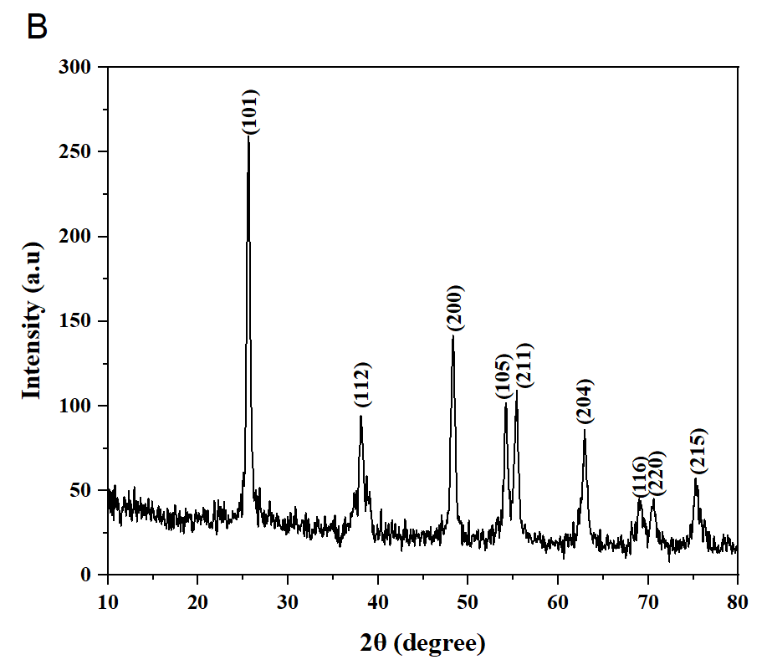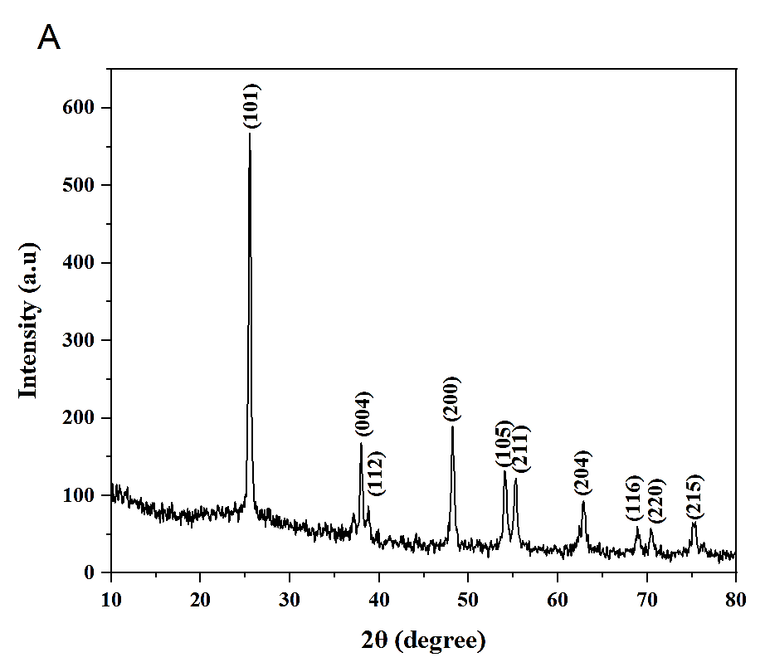
Figure 1: XRD graph of TiO₂ nanoparticles synthesized from ethanolic extract of shell and tissue (A) Shell; (B) tissue.

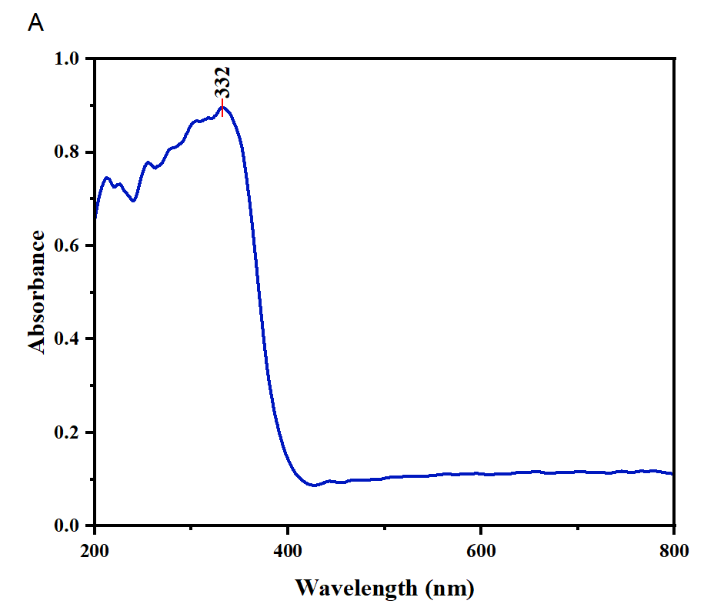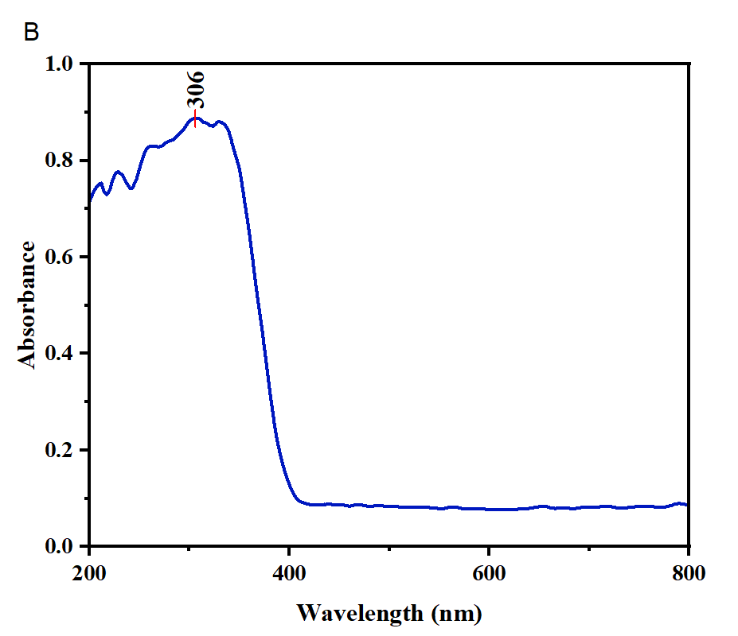
Figure 2:UV graph of TiO₂ nanoparticles synthesized from ethanolic extract of shell and tissue (A) Shell; (B) tissue.

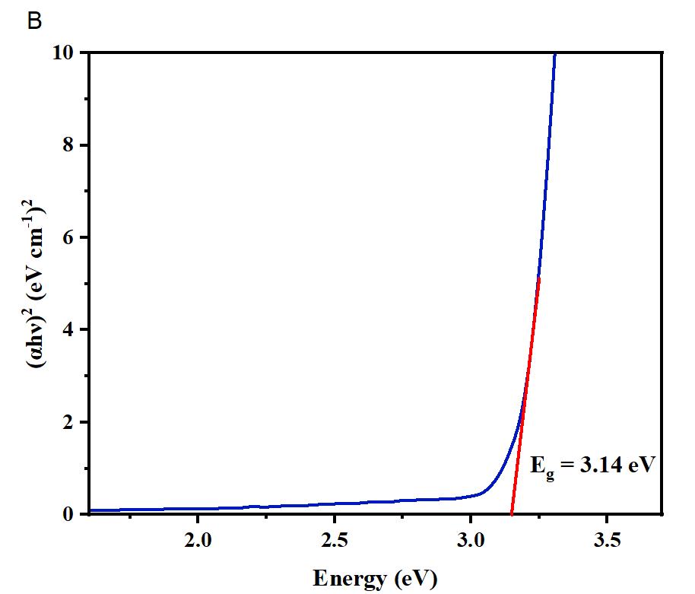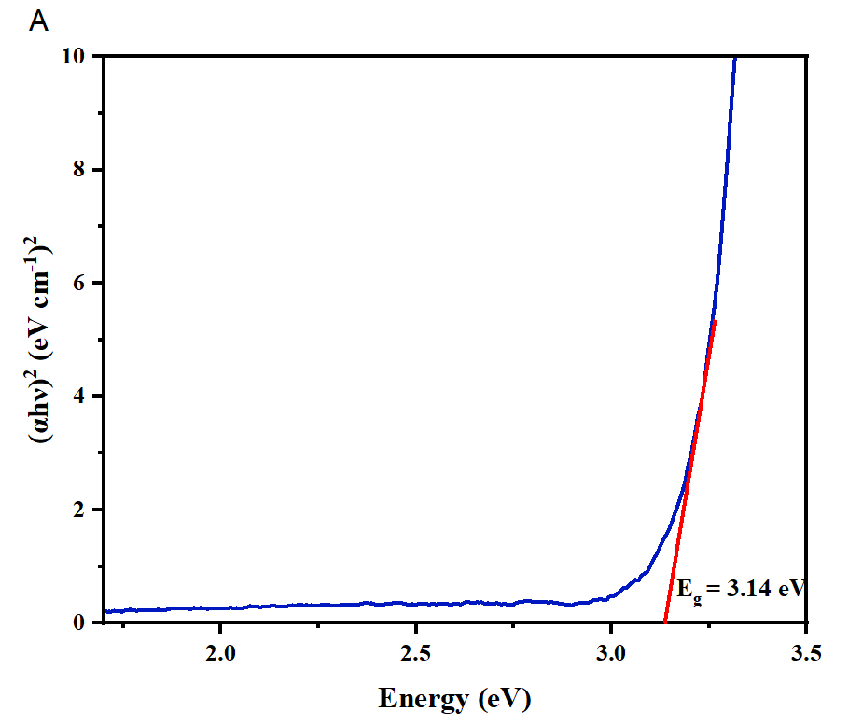
Figure 3: Tauc plot of TiO₂ nanoparticles synthesized from ethanolic extract of shell and tissue (A) Shell; (B) tissue.

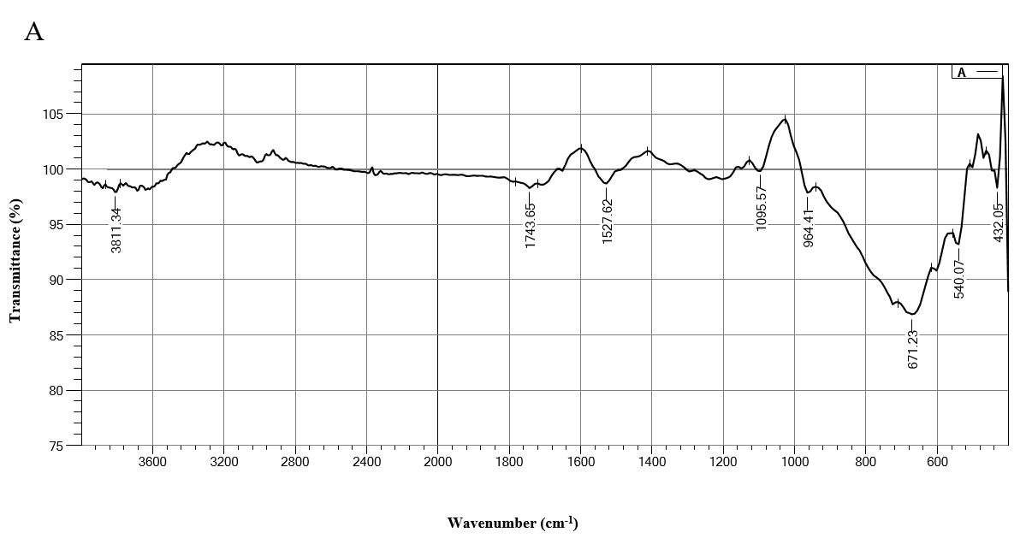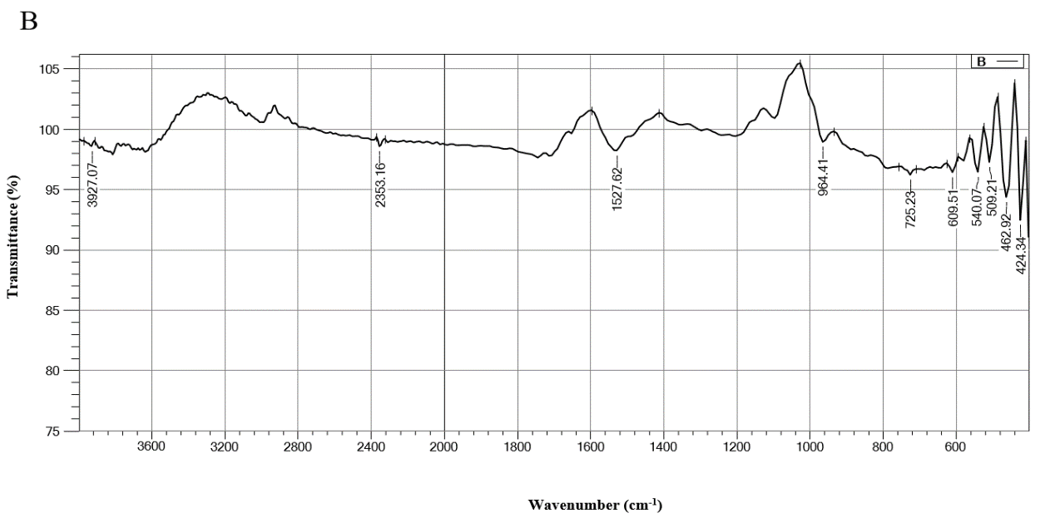
Figure 4: FTIR spectrum of TiO₂ nanoparticles synthesized from ethanolic extract of shell and tissue (A) Shell; (B) tissue.
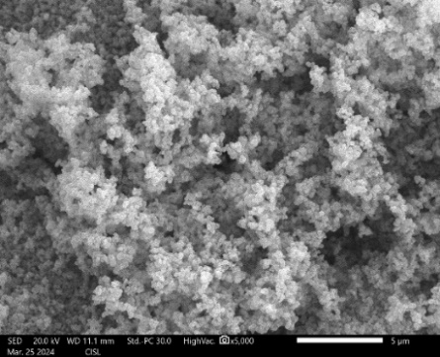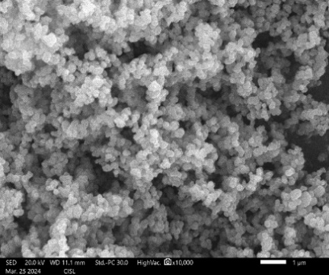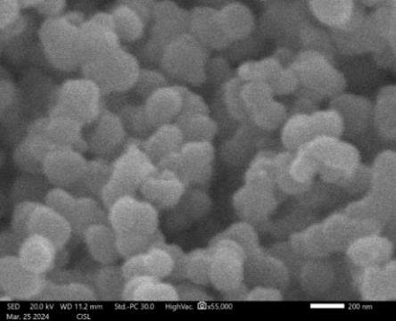
Figure 5a: SEM image of TiO₂ nanoparticles synthesized from ethanolic extract of shell.
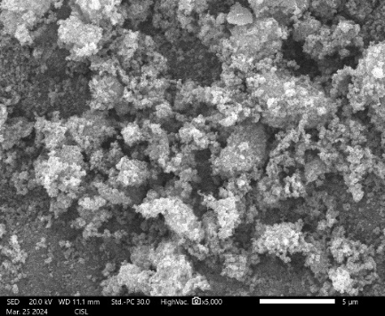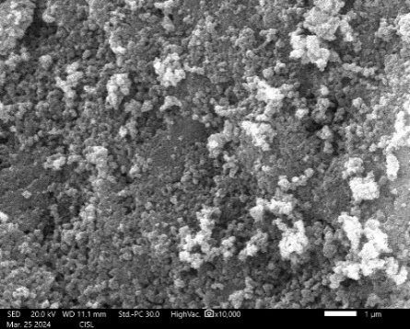
Figure 5b: SEM image of TiO₂ nanoparticles synthesized from ethanolic extract of tissue.
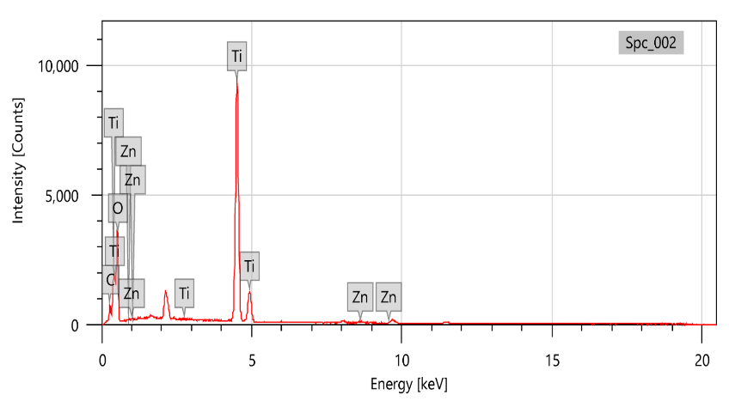
Figure 6a: EDS spectra of TiO₂ nanoparticles synthesized from ethanolic extract of shell.

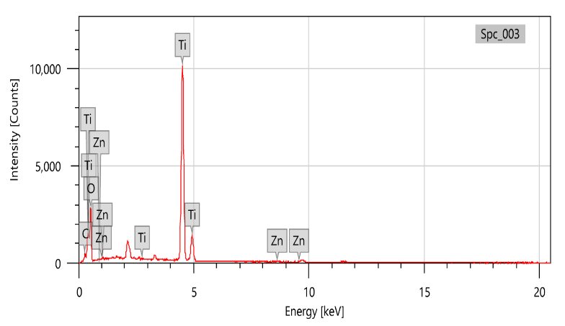
Figure 6b: EDS spectra of TiO₂ nanoparticles synthesized from ethanolic extract of tissue.

Figure 7:Mortality percentage of TiO₂ nanoparticles synthesized using crab shell and tissue extracts. Results are expressed as mean ± standard deviation.

