Feeding Ecology and Seasonal Trophic Dynamics of the Spadenose Shark, Scoliodon laticaudus from Veraval, Northwest Coast of India

Abstract
The spadenose shark, Scoliodon laticaudus, is a commercially significant and Near-Threatened species that dominates shark landings along India’s northwest coast. This study investigated its feeding ecology, focusing on seasonal feeding intensity and dietary composition, to inform sustainable management. A total of 360 specimens were collected monthly from April 2024 to March 2025 at Veraval Fishing Harbour, Gujarat. Feeding intensity was assessed through the Gastro-Somatic Index (GaSI), stomach fullness categories, and the Empty Stomach Ratio (ESR). Diet composition was quantified using the Index of Relative Importance (IRI). Results revealed significant seasonal variation in feeding activity. The highest GaSI values were recorded in winter (February: 6.88), indicating peak feeding intensity, while the lowest values occurred in pre-monsoon months (May: 2.794). ESR was highest in May (85%) and November (78%), reflecting reduced feeding during these periods. Dietary analysis confirmed a generalist carnivorous diet. Crustaceans were the most important identifiable prey (IRI: 21%), followed by teleosts (IRI: 16%) and cephalopods (IRI: 14%). However, semi-digested material dominated the overall diet (IRI: 49%), highlighting challenges in precise prey identification. The observed inverse relationship between feeding intensity and periods of potential reproductive activity suggests an energy allocation trade-off. These findings elucidate the trophic role and seasonal foraging strategy of S. laticaudus, providing critical baseline data for ecosystem-based fisheries management and conservation of this vulnerable species in the region.
Keywords: Diet Composition, Gastro-Somatic Index (GaSI), Index of Relative Importance (IRI), Seasonal Feeding, Fisheries Management

Introduction
India, situated in the Asian continent, possesses a substantial coastline of 11,098.81 km, supporting extensive marine and inland fisheries resources. Gujarat is a pivotal coastal state within this framework, featuring a 2,340.62 km coastline, a continental shelf area of 164,000 km², and an Exclusive Economic Zone (EEZ) of 214,000 km², which collectively constitute 32% of India's continental shelf and 10% of its total EEZ. Over the last four decades, advancements in fishing technology and associated industries have markedly enhanced the productivity and economic significance of Gujarat's fisheries sector, contributing substantially to regional economic growth, livelihood security, and nutritional provisioning (SOI, 2024). Nationally, India's fisheries sector has undergone rapid expansion. Total fish production increased from 24.42 lakh tonnes in 1980–81 to 175.45 lakh tonnes in 2022–23, reflecting an average annual growth rate of approximately 7.98% (DOF, 2023). Concurrently, the value of fish exports has risen significantly, reaching ₹63,969.14 crore for 17.35 lakh tonnes in 2022–23. In the fiscal year 2023–24, India contributed approximately 8% to global fish production, with exports totaling 1.78 million tonnes valued at ₹60,523.89 crore (DOF, 2023). Within this national context, Gujarat emerged as the leading fish-producing state in 2023, with landings of 8.23 lakh tonnes, and accounted for 23% of India’s total shark catch. While Tamil Nadu dominated elasmobranch landings (30% of the national catch), the marine fishery composition across India in 2023 comprised 55% pelagic resources, 26% demersal fishes, 13% crustaceans, and 6% molluscs (CMFRI, 2024). Elasmobranch production accounted for 32,035 tonnes, of which sharks contributed 16,734 tonnes. Among these, the spadenose shark (Scoliodonlaticaudus) was the predominant species, constituting 57% of the national shark catch (CMFRI, 2024).
Elasmobranchs are frequently landed as bycatch in Indian fisheries and are subject to full utilization driven by domestic demand for meat and international export markets for liver oil, jaws, and skins (Kizhakudan et al., 2015; Karnad et al., 2020). Scoliodonlaticaudus is a small, abundant Carcharhinid shark inhabiting shallow tropical waters of the Indian and western Pacific Oceans. It typically forms large schools in depths of 10–13 m and preys upon small fishes and invertebrates. The species exhibits advanced placental viviparity, with females breeding throughout the year and producing litters of 6–18 pups following a gestation period of 5–6 months (Nair, 1976; Reide, 2004). Despite its commercial importance and non-threatening nature to humans, it is currently classified as Near Threatened due to fishing pressure and habitat degradation (Dulvy et al., 2021). Like many sharks, it possesses K-selected life-history traits—including slow growth, low fecundity, and late maturity—that heighten its vulnerability to overexploitation and environmental changes (Garcia et al., 2008). Morphologically, it is characterized by a stout body, a broad and trowel-shaped snout, small eyes and nostrils, smooth-edged oblique teeth, and a bronzy-gray dorsal coloration. While the species commonly attains a total length of 74 cm, unverified reports suggest individuals may reach up to 1.2 m (Compagno, 2001).
Feeding ecology is a fundamental component of fish biology, directly influencing physiological processes such as growth, reproduction, and metabolic activity. Seasonal shifts in feeding intensity, often quantified through indices such as the gastro-somatic index (GaSI), can provide indirect indicators of reproductive cycles. An inverse relationship is frequently observed between GaSI and the gonadosomatic index (GSI), as energy is diverted from somatic maintenance to gonad development during spawning periods. This physiological trade-off serves as a valuable proxy for assessing reproductive phenology and breeding seasons.
Furthermore, feeding habits underpin predator–prey dynamics, shaping trophic interactions and energy flow within aquatic ecosystems (Gerking, 2014). Variability in prey availability can influence fish movement, distribution, and habitat selection, thereby affecting population structure and community assembly (Killen et al., 2010). Detailed dietary analysis offers critical insights into species' ecological roles, niche partitioning, and resource use—information essential for developing ecosystem-based fisheries management and conservation strategies (Cochrane, 2002; Wootton, 1998). Feeding is a complex process mediated by morphological adaptations, behavioral plasticity, and physiological constraints, all of which are influenced by the population dynamics of both predators and prey (Brodeur, 2017). Condition indices, including GaSI, are widely applied in fisheries science as proxies for nutritional status, feeding intensity, and overall fish health (Oni et al., 1983). Given the ecological and commercial significance of Scoliodonlaticaudus, alongside its Near Threatened conservation status, a detailed investigation of its feeding biology is imperative. This study aims to analyze the seasonal feeding intensity, dietary composition, and trophic ecology of S. laticaudus from the Veraval coast, Gujarat, to generate baseline data that can inform sustainable harvest strategies and support the conservation of this key fishery resource.
Materials and Methods
Study Location. Specimens were obtained from commercial landings at Veraval Fishing Harbour (20°54′55″ N, 70°21′21″ E), a major fishery port on the north western coast of Gujarat, India.
Sampling Protocol. Specimens of the spadenose shark, Scoliodon laticaudus, were collected monthly over a 12-month period from April 2024 to March 2025. Each month, 30 individuals were randomly subsampled from the landings. All samples were immediately transported on ice to the Fisheries Resource Management Laboratory at the College of Fisheries Science, Veraval, for subsequent analysis.
Biological Processing. In the laboratory, individuals were subjected to standard dissection. The gonads, alimentary canal, liver, and uterus were excised for macroscopic and gravimetric examination.
Feeding Ecology Analysis. Feeding biology was assessed through a combination of gravimetric, volumetric, and frequency-based metrics.
Stomach Content Analysis. Stomachs were excised and weighed both full and empty. Contents were examined fresh, and prey items were identified to the lowest possible taxonomic level (genus or species).
Feeding Intensity. Feeding intensity was categorized based on the degree of stomach distension and volumetric fill: Gorged, Full, 3/4 Full, 1/2 Full, 1/4 Full, Trace, and Empty. Categories from Gorged to 1/2 Full were classified as "active" feeding, while 1/4 Full to Empty indicated "poor" feeding (adapted from Bapat & Bal, 1952).
Quantitative Indices. The following indices were calculated to quantify dietary patterns:
Gastro-somatic Index (GaSI): An indicator of relative gut fullness and feeding activity (Desai, 1970), calculated as
$$GaSI =\frac{Total Weight Of Gut\left(gm\right)}{Total Weight of fish\left(gm\right)}×100$$

Empty Stomach Ratio (ESR): The proportion of sampled individuals with empty stomachs:
ESR = (Number of Empty Stomachs / Total Number of Specimens) × 100 (Vinson &Angradi, 2011).
ESR= $\frac{No.of empty Stomach}{Total no.of Specimen}×100$

Index of Relative Importance (IRI): A composite measure to evaluate the contribution of each prey taxon to the diet, integrating numerical abundance, gravimetric contribution, and frequency of occurrence:
IRI = (%N + %W) × %F
where %N is the numerical percentage, %W is the gravimetric percentage, and %F is the frequency of occurrence of a prey item (Pinkas et al., 1971).
Data Analysis. All biological and ecological data were compiled and analyzed using Microsoft Office Excel. Standard statistical methodologies were applied following Snedecor and Cochran (2014).
Results and Discussion
Gastro-Somatic Index (GaSI)
Monthly GaSI values for Scoliodon laticaudus exhibited significant temporal variation (range: 2.794 – 6.88). The highest pooled GaSI was recorded in February 2025 (6.88), followed by January 2025 (5.1413). The lowest values were observed in May 2024 (2.794) and April 2024 (3.447).
Females demonstrated a pronounced peak in GaSI during February 2025 (7.275). The consistently elevated GaSI values across sexes during the winter months (December–February) indicate a seasonal increase in feeding intensity, potentially driven by heightened prey availability and favorable foraging conditions. The low GaSI values in May and March may signify periods of reduced food intake, possibly due to limited prey abundance or a physiological reallocation of energy toward reproductive investments.
Feeding Intensity
Feeding intensity, assessed via stomach distension categories, showed marked seasonal fluctuation. The Empty Stomach Ratio (ESR) was highest in May (85%), November (78%), and October (73%). Stomachs categorized as "Full" were infrequent throughout the study period, ranging from 2.44% (March 2025) to 9.52% (August 2024). Active feeding, indicated by stomach fullness categories of 1/4 to 3/4, was most prevalent during August–September 2024 and January 2025.
These patterns align with previous reports of seasonal feeding cycles in this species. The elevated ESR during late autumn and spring (October–November, May) corresponds with findings by Thomas et al. (2020), who documented peak stomach emptiness in the post-monsoon period. The observed feeding peaks in late monsoon and winter (August–September, January) are consistent with moderate feeding activity reported in other studies (Fofandi et al., 2013; Nayana et al., 2022), though the exact timing of peaks showed regional variation, likely influenced by local prey dynamics.
Dietary Composition
Stomach content analysis confirmed S. laticaudus as a carnivorous generalist, consuming teleosts, crustaceans, and cephalopods.
Prey Spectrum
Identifiable prey items included the teleosts Coilia dussumieri, Harpadon nehereus (Bombay duck), Trichiuridae (ribbonfish), and Thryssa spp. Crustacean prey were dominated by Acetes spp., penaeid shrimps, and Squilla spp. Cephalopod remains included Sepia spp. (cuttlefish), Loligo spp. (squid), and Octopus spp. However, a substantial portion of gut contents (23% by proportion) was semi-digested and unidentifiable beyond broad taxonomic categories, a common challenge in elasmobranch dietary studies due to rapid digestion.
Quantitative Diet Analysis
The Index of Relative Importance (IRI) was used to evaluate prey significance. Semi-digested material comprised the highest IRI (49%), reflecting the aforementioned identification challenge. Among identifiable prey categories, crustaceans were most important (IRI: 21%), followed by fish (IRI: 16%) and cephalopods (IRI: 14%). At the species/genus level, Acetes spp. (IRI: 11%), Thryssa spp. (9%), Trichiuridae (9%), and Sepia spp. (7%) were prominent dietary components.
Comparative Feeding Ecology. This generalist, crustacean-influenced diet aligns with the known trophic role of S. laticaudus as a mesopredator. The results show both consistency and divergence from previous regional studies: the dominance of crustaceans and teleosts matches the general dietary patterns reported by Fofandi et al. (2013) and Thomas et al. (2020), though the relative proportions of major prey groups vary. The high contribution of semi-digested material is a common finding (e.g., Raje et al., 2022 reported 31.9% digested fish), underscoring the methodological constraint in achieving precise prey identification. Regional differences in dominant prey species (e.g., Leiognathus spp. and Nemipterus spp. in Thomas et al., 2020, vs. Thryssa spp. and Acetes spp. in the present study) highlight the opportunistic feeding strategy of S. laticaudus and its adaptation to local prey assemblages.
Conclusion : Scoliodon laticaudus exhibits clear seasonal patterns in feeding intensity and a flexible, opportunistic diet. The temporal variation in GaSI and ESR suggests feeding activity is modulated by a combination of prey availability and reproductive cycles. Its generalist diet, dominated by locally abundant crustaceans and small teleosts, confirms its role as an adaptable mesopredator within the neritic ecosystem of the northwest coast of India.
References
Bapat, S. V., & Bal, D. V. (1952). The food of some young fishes from Bombay. Proceedings of the Indian Academy of Sciences - Section B, 35, 78–92. https://doi.org/10.1007/BF03050013
Brodeur, R. D., Smith, B. E., McBride, R. S., Heintz, R., & Farley, E. (2017). New perspectives on the feeding ecology and trophic dynamics of fishes. Environmental Biology of Fishes, 100(3), 293–297. https://doi.org/10.1007/s10641-017-0594-1
CMFRI (ICAR-Central Marine Fisheries Research Institute). (2024). Marine fish landings in India-2023 (Technical Report). Kochi, India. http://eprints.cmfri.org.in/id/eprint/18344
Cochrane, K. L. (Ed.). (2002). A fishery manager's guidebook: Management measures and their application (FAO Fisheries Technical Paper No. 424). Food and Agriculture Organization of the United Nations. http://www.fao.org/docrep/005/y3427e/y3427e00.htm
Compagno, L. J. V. (2001). Sharks of the world: An annotated and illustrated catalogue of shark species known to date. Volume 2. Bullhead, mackerel and carpet sharks (Heterodontiformes, Lamniformes and Orectolobiformes). FAO Species Catalogue for Fishery Purposes No. 1, Vol. 2. Food and Agriculture Organization of the United Nations. https://www.fao.org/fishery/species/12600/en
Department of Fisheries (DOF), Government of India. (2023). Handbook on fisheries statistics 2022. Ministry of Fisheries, Animal Husbandry & Dairying. https://dof.gov.in/sites/default/files/2024-06/Handbook.pdf
Desai, V. R. (1970). Studies on the fishery and biology of Tor tor (Hamilton) from river Narmada. Journal of the Inland Fisheries Society of India, 2, 101–112.
Dulvy, N. K., Simpfendorfer, C., Akhilesh, K. V., Derrick, D., Elhassan, I., Fernando, D., Haque, A. B., Jabado, R. W., Maung, A., Valinassab, T., & VanderWright, W. J. (2021). Scoliodon laticaudus. The IUCN Red List of Threatened Species. https://doi.org/10.2305/IUCN.UK.2021-2.RLTS.T169234201A173436322.en
Fofandi, M., Zala, M. S., & Koya, M. (2013). Observations on selected biological aspects of the spadenose shark (Scoliodon laticaudus Müller & Henle, 1838), landed along Saurashtra coast. Indian Journal of Fisheries, 60(1), 51–54. https://doi.org/10.21077/ijf.2013.60.1.51-54
García, V. B., Lucifora, L. O., & Myers, R. A. (2008). The importance of habitat and life history to extinction risk in sharks, skates, rays and chimaeras. Proceedings of the Royal Society B: Biological Sciences, 275(1630), 83–89. https://doi.org/10.1098/rspb.2007.1295
Gerking, S. D. (1994). Feeding ecology of fish. Academic Press. https://books.google.com/books/about/Feeding_Ecology_of_Fish.html?id=2_0_AQAAIAAJ
Karnad, D., Sutaria, D., & Jabado, R. W. (2020). Local drivers of declining shark fisheries in India. Ambio, 49(2), 616–627. https://doi.org/10.1007/s13280-019-01203-z
Killen, S. S., Atkinson, D., & Glazier, D. S. (2010). The intraspecific scaling of metabolic rate with body mass in fishes depends on lifestyle and temperature. Ecology Letters https://doi.org/10.1111/j.1461-0248.2009.01415.x
Kizhakudan, S. J., Zacharia, P. U., Thomas, S., Vivekanandan, E., & Muktha, M. (2015). Guidance on national plan of action for sharks in India. CMFRI Marine Fisheries Policy Series No. 2. ICAR-Central Marine Fisheries Research Institute. http://eprints.cmfri.org.in/id/eprint/10403
Nair, K. P. (1976). Age and growth of the yellow dog shark Scoliodonlaticaudus Muller and Henle from Bombay waters. Journal of the Marine Biological Association of India, 18(3), 531–539.
Nayana, P., Anjanayappa, H. N., Rajesh, D. P., & Pramodraj, P. (2021). Length–weight relationship and relative condition factor of Scoliodon laticaudus along the Karnataka Coast, India. Journal of Experimental Zoology India. https://connectjournals.com/03895.2021.24.1067
Oni, S. K., Olayemi, J. Y., & Adegboye, J. D. (1983). Comparative physiology of three ecologically distinct freshwater fishes, Alestes nurse Ruppell, Synodontis schall Bloch & Schneider and Tilapia zillii Gervais. Journal of Fish Biology, 22(1), 105–109. https://doi.org/10.1111/J.1095-8649.1983.TB04730.X
Pinkas, L., Oliphant, M. S., & Iverson, I. L. K. (1971). Food habits of albacore, bluefin tuna, and bonito in California waters. California Department of Fish and Game, Fish Bulletin 152. https://escholarship.org/uc/item/7t5868rd
Raje, S. G., Raje, R. K., Kumar, P., & Chakraborty, S. K. (2021). Insights into the food and feeding habits of eight gestating females of elasmobrachs from Mumbai waters. Indian Journal of Geo Marine Sciences, 50(12), 1043–1051. http://nopr.niscpr.res.in/handle/123456789/58000
Riede, K. (2004). Global register of migratory species – from global to regional scales. Final Report of the R&D-Projekt 808 05 081. Federal Agency for Nature Conservation.
Snedecor, G. W., & Cochran, W. G. (1991). Statistical methods (8th ed.). Wiley-Blackwell. https://www.wiley.com/en-us/Statistical+Methods,+8th+Edition-p-9780813815619
Survey of India. (2024). Length of coastline of India. https://surveyofindia.gov.in/webroot/UserFiles/files/Length%20of%20Coastline%20of%20India.pdf
Thomas, S., Purushottama, G. B., Nataraja, G. D., & Kizhakudan, S. J. (2020). Fishery and biological characteristics of the spadenose shark (Scoliodon laticaudus Müller & Henle, 1838) from the Eastern Arabian Sea. Regional Studies in Marine Science, 34, 101085. https://doi.org/10.1016/j.rsma.2020.101085
Vinson, M. R., & Angradi, T. R. (2011). Stomach emptiness in fishes: Sources of variation and study design implications. Reviews in Fisheries Science, 19(2), 63–73. https://doi.org/10.1080/10641262.2010.536856
Wootton, R. J. (1998). Ecology of teleost fishes (2nd ed.). Kluwer Academic Publishers.

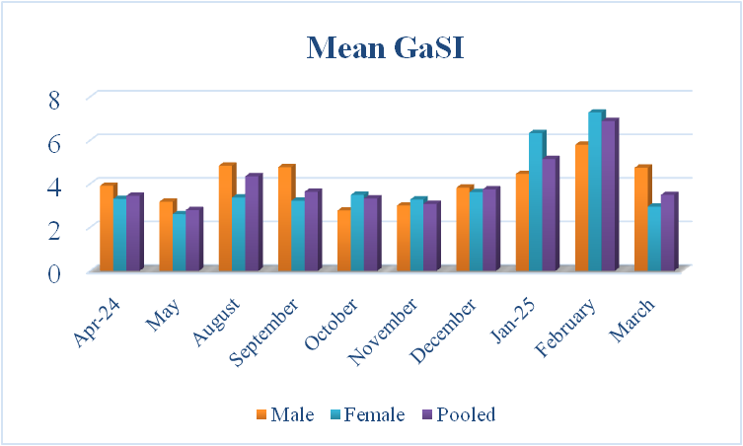
Figure 1. Monthly variation in the mean Gastro-Somatic Index (GaSI, mean ± SD) for male, female, and pooled specimens of Scoliodonlaticaudus sampled from Veraval, Gujarat, from April 2024 to March 2025.

Figure 2. Overall feeding intensity of Scoliodonlaticaudus expressed as percentages across stomach fullness categories.

Figure 3. Monthly variation in the frequency distribution of stomach fullness categories for Scoliodonlaticaudus from Veraval, India, over the study period (April 2024–March 2025).
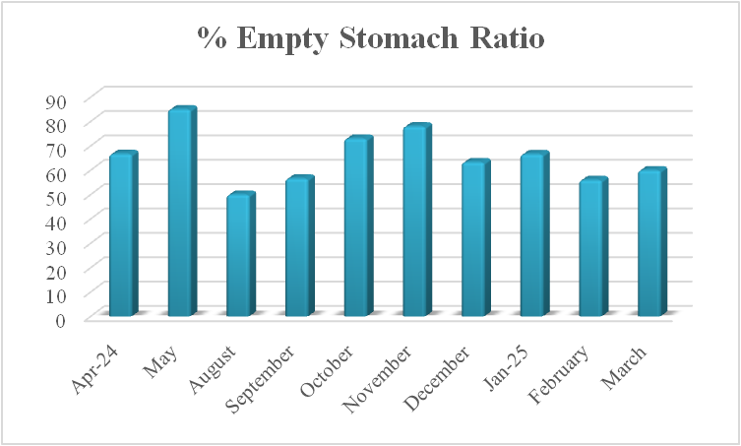
Figure 4. Monthly variation in Empty Stomach Ratio (ESR) for Scoliodonlaticaudus from Veraval, India (April 2024 – March 2025).

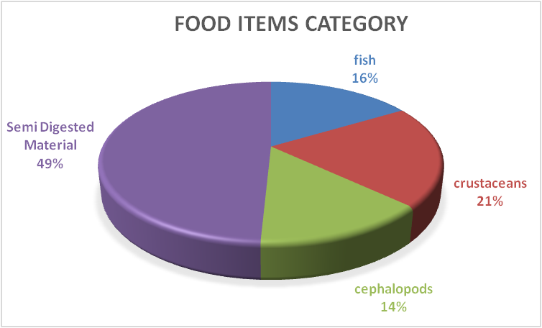
Figure 5. Dietary composition of Scoliodonlaticaudus by major prey category based on the Index of Relative Importance (IRI).

Figure 6. Percentage composition of major identified prey items in the diet of Scoliodonlaticaudus.

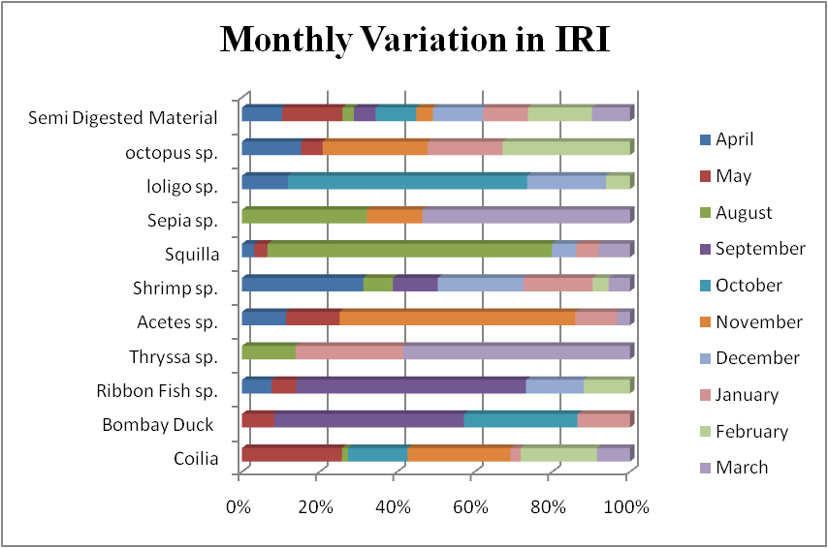

Figure 7. Monthly variation in the Index of Relative Importance (IRI) for major prey items in the diet of Scoliodonlaticaudus.

