Biodiversity Exploration of Terrestrial Hemiptera in Simlipal Tiger Reserve reveals multiple new area records

ABSTRACT:
The assessment of terrestrial hemipteran fauna of Simlipal Tiger Reserve was performed across six sampling sites within the reserved area and 141 examples of terrestrial hemiptera were collected. During the study 55 species under 50 genera pertaining to 14 families have been identified. The study clearly shows the dominance of Pentatomidae family followed by Rhyparochromidae, Lygaeidae and then other 11 families. Station 6 (S6) shows the highest number of species richness and Shannon index while station 3 (S3) and station 4 (S4) shows the lowest numbers. This research is the first effort to document the heteropteran fauna of the reserved area to enrich the faunal records of Simlipal as well as the faunal record of Odisha.
Keywords: Hemipteran fauna, species richness, Shannon index, Simlipal Tiger Reserve, new area records.
INTRODUCTION:
Order Hemiptera represents the largest assemblage within the hemimetabolous group of insects. Members of this order are predominantly adapted for phytophagy, feeding chiefly on plant sap, although a minority exhibit hematophagy, obtaining nutrition from the tissue fluids of vertebrates. The size of hemipterans varies considerably, ranging from approximately 0.1 mm to 15 cm in length. The mouthparts are highly specialized and modified into a piercing–sucking type, while the forewings (hemelytra) are characteristically thickened basally and membranous apically. The majority of hemipterans inhabit in terrestrial ecosystems, whereas certain taxa are adapted to freshwater or semi-aquatic environments. Several species are recognized as major pests of agricultural and forest crops, causing substantial economic losses. Globally, the order is estimated to comprise approximately 1,03,590 species (Chandra et al., 2018). In India, a total of 6,058 species is reported among which 539 species are considered as endemic to India (Praveen K. et al.,2024).
Similipal derives its name from the ‘Simul’ or Silk Cotton tree, is a National Park and Tiger Reserve located in the Mayurbhanj district, the northern most part of Odisha. Situated within the Deccan Peninsular Biogeographic Zone, the park represents a unique confluence of the Western Ghats, Eastern Ghats, and Eastern Himalayan biodiversity. It was formally declared a Tiger Reserve under Project Tiger in May 1973. Subsequently, the Government of Odisha proclaimed Similipal as a Wildlife Sanctuary in 1979, covering an area of 2,750 sq. km. The National Park is encircled by high plateaus and hills, adorned with spectacular waterfalls and numerous rivers that traverse the plains and ultimately drain into the Bay of Bengal, the most notable being the Burhabalanga, Palpala, Bandan, Salandi, Kahairi, and Deo.
The vegetation of Similipal is diverse, comprising various forest types and habitats, predominantly Northern Tropical Moist Deciduous Forests interspersed with semi-evergreen patches. Its floristic composition reveals a biogeographical connection between the South Indian and North-Eastern Sub-Himalayan regions. Sal (Shorea robusta) is the dominant tree species, and the park also features extensive grasslands that serve as grazing areas for herbivores. The forests are rich in medicinal and aromatic plants.
Similipal is renowned for its population of tigers, elephants, and hill mynahs, and holds the distinction of having the highest tiger population in Odisha. Other notable mammals inhabiting the park include the leopard, sambar, barking deer, gaur, jungle cat, wild boar, four-horned antelope, giant squirrel, and common langur but no study had ever done on the Hemipteran diversity of this tiger reserve. Despite its significance, the Hemipteran diversity of Simlipal tiger reserve remains relatively untouched. This study specifically conducted to shed light on the hemipteran diversity within Simlipal tiger reserve.
MATERIALS AND METHODS:
Specimens were collected during surveys undertaken by the scientific team of Zoological Survey of India in the various ranges of Simlipal Tiger Reserve. Particularly six spots were selected for collection of the specimens (Shown in the map no.2) and the sites are denoted as S1-S6. (S1) Bhangriposi Khairi Resort, Baripada, (S2) Kalikaprasad, (S3) Gurguria, (S4) Bundayiposi, (S5) Balasore, (S6) Ramatirtha.

Collections were made by using the light trap, net-sweep and handpicking methods. Collected bugs were brought to the Hemiptera section of Zoological Survey of India for further study purpose, set and pinned and preserved dry by following standard method of preservation. Identified by using the voucher species held at NZC. The bugs were identified by using Leica EZ4 HD stereo zoom microscope and the identification was done based on the external characteristics and the specimens were identified with the help of taxonomic keys from available literature.
For statistical analysis a commonly used index of biodiversity in ecology “The Shannon Index” or
“The Shannon-Wiener Index” has been used. It helps to calculate the species diversity of an area by using species richness i.e. number of species and species evenness i.e. distribution of individuals among species within the same given area. Here a higher Shannon Index value ($H^{'}$) stipulates a greater diversity. The Formula for Shannon Index is:
$$H^{'}=-\sum_{i=1}^{s}{(}p_{i}ln(p_{i}))$$
Where $H^{'}$: The Shannon Index, $p_{i}:$ Proportion of individuals belonging to species i, ln: Natural logarithm.
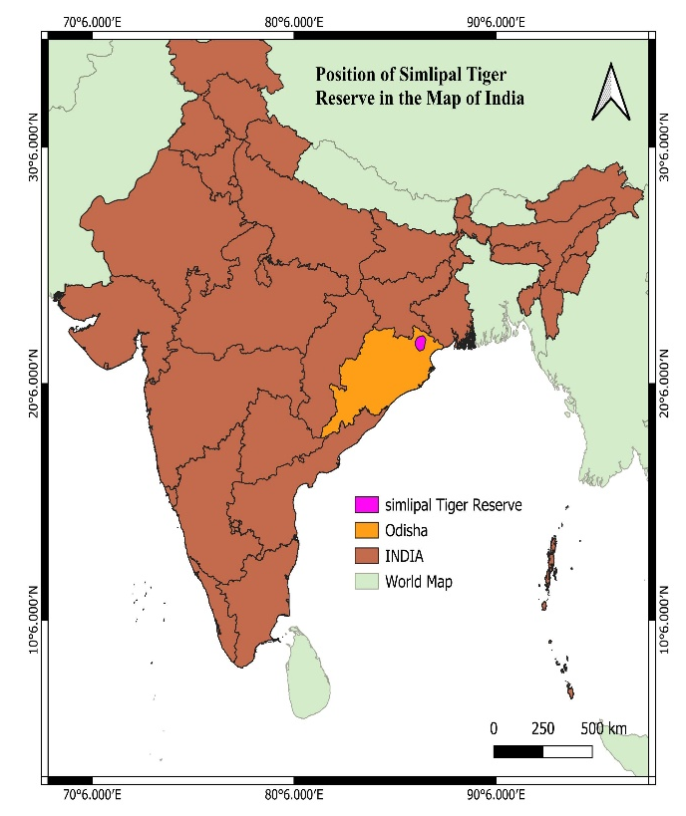 | 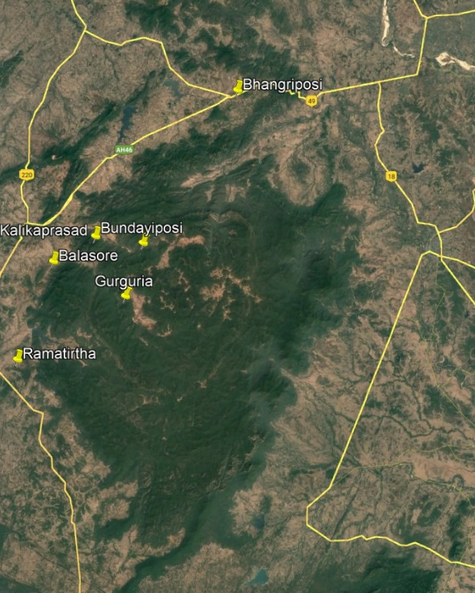  Simlipal Tiger Reserve
Map 1 : Position of Simlipal Tiger Reserve
RESULT AND DISCUSSION:

The present study documents 55 species of hemipteran bugs, representing 50 genera and 14 families (Table 1). Analysis of the collected data indicates that the family Pentatomidae is the most diverse, with nine species recorded from the study area. Other families exhibiting considerable diversity include Reduviidae, Rhyparochromidae, Lygaeidae, Miridae, and Pyrrhocoridae. The number of species available under each family is represented by a bar graph given below (Graph 1). The Table 2 indicates the summary table of biodiversity indices of the area according to the collection sites.
Table 1: Neme of species, their genus and families and number of specimens found in each site.
Sl. No. | Family | Genus | Species | S1 | S2 | S3 | S4 | S5 | S6
1 | Cicadellidae | Cofana | Cofana spectra (Distant, 1908) | 2 | 0 | 0 | 0 | 0 | 0
2 | Cicadellidae | Goniagnathus | Goniagnathus punctifer (Walker,1858) | 1 | 0 | 0 | 0 | 0 | 0
3 | Cicadellidae | Nephotettix | Nephotettix virescens (Distant,1908) | 5 | 0 | 0 | 0 | 0 | 0
4 | Cicadellidae | Exitianus | Exitianus indicus (Distant, 1908) | 1 | 0 | 0 | 0 | 0 | 0
5 | Membracidae | Otinotus | Otinotus oneratus Walker ,1858 | 0 | 0 | 0 | 0 | 0 | 1
6 | Reduviidae | Polididus | Polididus armatissimus Stal,1859 | 0 | 0 | 0 | 0 | 0 | 1
7 | Reduviidae | Rhynocoris | Rhynocoris costalis (Stal, 1866) | 0 | 0 | 0 | 0 | 0 | 1
8 | Reduviidae | Coranus | Coranus siva Kirkaldy,1891 | 0 | 0 | 0 | 0 | 0 | 1
9 | Reduviidae | Oncocephalus | Oncocephalus schioedte Reuter,1882 | 0 | 0 | 0 | 1 | 0 | 0
10 | Reduviidae | Polytoxus | Polytoxus maculates (Distant,1903) | 0 | 0 | 0 | 0 | 0 | 1
11 | Reduviidae | Endochus | Endochus inornatus Stal, 1866 | 0 | 0 | 0 | 1 | 0 | 0
12 | Miridae | Charagochilus | Charagochilus longicornis (Reuter, 1885) | 0 | 0 | 0 | 0 | 0 | 4
13 | Miridae | Apolygus | Apolygus myittae (Distant,1904) | 0 | 0 | 0 | 1 | 0 | 0
14 | Ricaniidae | Zaratus | Zaratus repandus Distant,1909 | 0 | 0 | 0 | 1 | 0 | 0
15 | Miridae | Cyrtorhinus | Cyrtorhinus lividipennis Reuter,1885 | 0 | 0 | 0 | 1 | 0 | 0
16 | Miridae | Felisacus | Felisacus magnificus Distant, 1904 | 0 | 0 | 0 | 1 | 0 | 0
17 | Miridae | Nesidiocoris | Nesidiocoris tenuis (Reuter, 1895) | 0 | 0 | 0 | 0 | 3 | 0
18 | Pentatomidae | Plautia | Plautia crossota (Fabricius, 1787) | 0 | 1 | 0 | 0 | 0 | 2
19 | Pentatomidae | Halys | Halys serrigera Westwood,1837 | 0 | 0 | 0 | 0 | 0 | 6
20 | Pentatomidae | Eysarcoris | Eysarcoris montivagus (Distant, 1902) | 0 | 1 | 0 | 0 | 0 | 0
21 | Pentatomidae | Neocarbula | Neocarbula capitata Distant, 1918 | 0 | 1 | 0 | 0 | 0 | 0
22 | Pentatomidae | Acrosternum | Acrosternum graminea Kirkaldy, 1787 | 0 | 1 | 0 | 0 | 0 | 0
23 | Pentatomidae | Nezara | Nezara viridula (Linnaeus, 1758) | 0 | 1 | 0 | 0 | 0 | 0
24 | Pentatomidae | Sciocoris | Sciocoris indicus (Dallas,1851) | 0 | 0 | 1 | 0 | 0 | 0
25 | Pentatomidae | Bagrada | Bagrada hilaris Burmeister, 1835 | 1 | 0 | 0 | 0 | 2 | 0
26 | Pentatomidae | Paracritheus | Paracritheus trimaculatus (Lep & Serv ,1825) | 0 | 0 | 1 | 0 | 0 | 0
27 | Coreidae | Cletomorpha | Cletomorpha hastata (Fabricius,1787) | 0 | 1 | 0 | 0 | 0 | 0
28 | Coreidae | Cletus | Cletus bipunctatus (Westwood, 1840) | 0 | 1 | 0 | 0 | 0 | 0
29 | Coreidae | ,, | Cletus trigonus (Thunberg,1783) | 0 | 1 | 0 | 0 | 0 | 0
30 | Coreidae | ,, | Cletus punctiger (Dallas,1852) | 0 | 2 | 4 | 0 | 0 | 0
31 | Alydidae | Leptocorisa | Leptocorisa acuta (Thunberg,1783) | 0 | 0 | 0 | 0 | 0 | 1
32 | Alydidae | Riptortus | Riptortus pedestris (Fabricius, 1775) | 0 | 0 | 0 | 0 | 0 | 1
33 | Rhopalidae | Liorhyssus | Liorhyssus hyalinus (Fabricius, 1794) | 0 | 0 | 0 | 0 | 0 | 1
34 | Rhopalidae | Leptocoris | Leptocoris augur (Fabricius, 1781) | 0 | 0 | 0 | 0 | 0 | 2
35 | Rhyparochromidae | Metochus | Metochus uniguttatus (Dohrn,1922) | 0 | 0 | 0 | 0 | 0 | 1
36 | Rhyparochromidae | Naudarensia | Naudarensia pedata Distant,1904 | 2 | 0 | 0 | 0 | 0 | 0
37 | Lygaeidae | Orieotrechus | Orieotrechus aeruginosus (Distant, 1904) | 0 | 0 | 0 | 0 | 0 | 1
38 | Rhyparochromidae | Gyndes | Gyndes pallicornis (Dallas,1852) | 0 | 0 | 0 | 0 | 0 | 1
39 | Rhyparochromidae | Horridipamera | Horridipamera nietneri (Dohrn, 1860) | 0 | 0 | 0 | 0 | 0 | 1
40 | Rhyparochromidae | Paromius | Paromius exiguus (Distant, 1883) | 0 | 0 | 0 | 0 | 0 | 1
41 | Rhyparochromidae | Dieuches | Dieuches femoralis (Distant,1904) | 0 | 0 | 0 | 0 | 0 | 1
42 | Rhyparochromidae | Primierus | Primierus indicus Distant, 1901 | 1 | 0 | 0 | 0 | 0 | 0
43 | Lygaeidae | Tropistethus | Tropistethus indicus (Dallas,1852) | 3 | 0 | 0 | 0 | 0 | 0
44 | Lygaeidae | Nysius | Nysius laucustrinus Distant, 1909 | 18 | 0 | 9 | 0 | 10 | 0
45 | Lygaeidae | ,, | Nysius ceylanicus Motschulsky,1863 | 0 | 0 | 1 | 0 | 0 | 0
46 | Lygaeidae | Spilostethu | Spilostethus hospes (Fabricius, 1794) | 0 | 0 | 0 | 0 | 0 | 1
47 | Lygaeidae | Graptostethu | Graptostethus servus (Fabricius,1787) | 6 | 0 | 0 | 0 | 0 | 5
48 | Geocoridae | Geocoris | Geocoris ochropterus Fieber, 1844 | 0 | 0 | 1 | 0 | 1 | 3
49 | Lygaeidae | Ninus | Ninus insignis Stal, 1860 | 0 | 1 | 0 | 0 | 0 | 0
50 | Largidae | Iphita | Iphita limbata(Stal,1870) | 0 | 1 | 0 | 0 | 0 | 0
51 | Pyrrhocoridae | Antilochus | Antilochus russus (Stal,1863) | 5 | 0 | 0 | 0 | 0 | 0
52 | Pyrrhocoridae | Dysdercus | Dysdercus koenigii (Fabricius,1775) | 2 | 0 | 0 | 0 | 3 | 0
53 | Pyrrhocoridae | ,, | Dysdercus olivaceous  (Fabricius,1798) | 0 | 0 | 0 | 0 | 0 | 1
54 | Pyrrhocoridae | Euscopus | Euscopus albatus (Distant,1909) | 1 | 0 | 0 | 0 | 0 | 0
55 | Pyrrhocoridae | ,, | Euscopus indecorus (Walker,1872) | 0 | 0 | 0 | 0 | 1 | 0

Table 2: summary table of biodiversity indices
Diversity Indices | S1 | S2 | S3 | S4 | S5 | S6
Species Richness | 13 | 11 | 6 | 6 | 6 | 22
Species Evenness | 0.6113 | 0.9717 | 0.6389 | 1 | 0.7074 | 0.7759
No. of individuals | 48 | 12 | 17 | 6 | 20 | 38
Diversity indices revealed pronounced spatial variation in terrestrial hemipteran assemblages across the Simlipal Tiger Reserve. Station 6 exhibited the highest species richness (22 species), suggesting more heterogeneous or favourable habitat conditions, whereas Stations 3, 4, and 5 showed the lowest richness (6 species each; Table 2). However, richness alone does not fully characterize community structure. The Shannon–Wiener index further indicated differences in species distribution. Although Station 6 had the greatest richness while Station 2 showed higher evenness. Nonetheless, Station 6 recorded the highest Shannon diversity value (H′ = 2.837), followed by Station 2 (H′ =2.369) and Station 1(H′ =2.073), reflecting a comparatively even species distribution within the area rather than Station 4 (H′ =1.792), Station 5 (H′ =1.446) and Station 3 (H′ =1.344) which had shown decreasing value consecutively, that indicates less even species distributions .
The analysis of results shows that Pentatomidae is the most diverse family in the study area, represented by 9 species belonging to 9 genera. Commonly known as shield bugs or stink bugs, many species in this family are important pests of cultivated crops.Reduviids, often referred to as assassin bugs, are aggressive terrestrial predators, some of which are capable of transmitting diseases to humans. The reduviid fauna of the study area comprises 6 species under 6 genera. For comparison, the Indian reduviid fauna includes 465 species under 144 genera across 14 subfamilies (Ambrose DP,2006).
Miridae, the most diverse family within Heteroptera, includes around 1,300 genera and over 11,000 species worldwide (Panizzi AR, Grazia J., 2015). These small to medium-sized plant bugs, usually elongated to ovoid with triangular heads, are represented in this study by 5 species under 5 genera. This number is considerably lower than expected, indicating that further exploration in the region may reveal additional species.The family Lygaeidae, commonly known as seed bugs, consists of small, typically brown or black species, often exhibiting aposematic red or yellow coloration. From this area 7 species under 5 genera have been reported this time. Among which Nysius laucustrinus Distant, 1909 was the most dominant species with 37 examples.
Pyrrhocoridae, commonly known as cotton stainers, are medium-sized bugs typically red, yellow, or black. The present study recorded 5 species belonging to 3 genera.Another significant family in the region is Rhyparochromidae, commonly referred to as “dirt-coloured seed bugs.” It is one of the largest families within Hemiptera. In this study, 7 species under 7 genera were documented from the Simlipal Tiger Reserve.
Cicadellidae, commonly known as leafhoppers, is one of the prominent insect groups recorded from the study area. These minute; sap-feeding insects inhabit grasses, shrubs, and trees. Their hind legs are highly adapted for jumping and are characteristically covered with setae. Globally, Cicadellidae is distributed across all biogeographic regions and represents the second-largest hemipteran family, comprising at least 20,000 described species (Stiller, 2009). However, only 4 species under 4 genera were documented from the present study area, a number significantly lower than expected, indicating the need for further systematic surveys.
A few species belonging to Alydidae and Rhopalidae were also recorded, while the families Membracidae, Ricaniidae, Geocoridae, and Largidae were each represented by a single species.
A review of the available literature on hemipteran diversity in Odisha reveals lack of published records on the hemipteran fauna of the Simlipal Tiger Reserve. The present study addresses this gap by providing the first comprehensive account of hemipteran diversity from the tiger reserve, thereby establishing a baseline for future research. Though, the limited number of sampling sites that not covering the whole reserve area and the single sampling effort may constrain the result of the findings and potentially overlook species inhabiting different habitats or occurring in other seasons. Future studies with larger sample sizes with seasonal coverage are required to achieve a more comprehensive understanding of the hemipteran diversity of Simlipal.
CONCLUSION:
The present study documented a diverse Hemipteran community across selected sites within the Simlipal Tiger Reserve of Mayurbhanj district, Odisha. The region’s varied landscape, extensive forested areas, and heterogeneous vegetation provide suitable habitats for multiple Hemipteran families. As one of the first survey-based investigations in this area, the findings offer baseline information that will serve as a valuable reference for future systematic studies. But this study has some limitations. Like the sampling area was less and the survey was conducted for only one season. Multiple surveys in various seasons can reveal much more diversity of the faunal data.
DISCLAIMER (ARTIFICIAL INTELLIGENCE):
The authors declare that no generative Artificial Intelligence technologies, including large language models or text-to-image generators, were used in the writing or editing of this manuscript.

REFERENCES:
- Stiller, Michael. Biosystematics: Leafhoppers associated with grasslands of South Africa – Grassland Biome endemics; Plant Protection News. 2009; 82: 6.
- Panizzi, A. R., & Grazia, J. (2015). Introduction to true bugs (Heteroptera) of the neotropics. In A. R. Panizzi & J. Grazia (Eds.), True bugs (Heteroptera) of the Neotropics (pp. 3-20). Springer. https://doi.org/10.1007/978-94-017-9861-7 .
- Ambrose, D. P. (2006). A checklist of Indian Assassin Bugs (Insecta: Hemiptera: Reduviidae) with taxonomic status, distribution and diagnostic morphological characteristics. Zoos' Print Journal, 21(9), 2388-2406. https://doi.org/10.11609/JoTT.ZPJ.871.2388-406 .

- Chandra, K., Gupta, D., Gopi, K. C., Tripathy, B., & Kumar, V. (2018). *Faunal diversity of Indian Himalaya: An overview*. Zoological Survey of India. https://www.nhbs.com/faunal-diversity-of-indian-himalaya-book .

- Praveen, K., Hassan, M. E., Saha, P. C., Kushwaha, S., Dubey, A. K., Dash, S., Lyngdoh, J., Pal, A., Jehamalar, E., & Khanra, S. (2024). *Checklist of Fauna of India: Arthropoda: Insecta: Hemiptera. Version 1.0*. Zoological Survey of India. https://doi.org/10.26515/Fauna/1/2023/Arthropoda:Insecta:Hemiptera
- Distant, W. L. (1910). The fauna of British India, including Ceylon and Burma. Rhynchota. Vol. V. Taylor and Francis. https://wellcomecollection.org/works/s9222222 .

- Distant, W. L. (1918). *The fauna of British India, including Ceylon and Burma. Rhynchota. Vol. 7. Homoptera: appendix. Heteroptera: addenda*. Taylor and Francis. https://www.biodiversitylibrary.org/bibliography/9193 .

- Distant, W. L. (1902). *The Fauna of British India, including Ceylon and Burma. Rhynchota. Vol. I. (Heteroptera)*. Taylor and Francis. https://doi.org/10.1080/00222930208678682.

- Distant WL. Fauna Brit. India, including Ceylon and Burma, Rhynchota, Taylor and Francis,
London.1904; 2:1-503.

- Distant WL. Fauna Brit. India, including Ceylon and Burma, Rhynchota, Taylor and Francis,
London.1908; 4:1-501. https://www.biodiversitylibrary.org/item/10000

- Biswas and Bal. Insecta: Hemiptera: Pentatomoidea. Fauna of Uttarakhand: State Fauna Series; Zoological Survey of India.2010; 18 (2): 229-244

- Gupta R, Singh D, Kaur H. New records of some Heteropteran bugs from North India, Bionotes, 2013; 15(3): 80-81.

- Leston D, Pendergrast J G, Southwood TRE..Classification of terrestrial Heteroptera (Geocoridae), Nature.1954; 174: 91-92. https://doi.org/10.1038/174091b0

- Mathew K. A new species of Gynenica from South India (Heteroptera: Pentatomidae), Oriental Insects.1980; 14 (3): 379-382. https://doi.org/10.1080/00305316.1980.10434816

- Mukhopadhyay A. Taxonomic study of Lygeidae (Heteroptera: Insecta) from West Bengal (India). Rec. Zool. Surv. India.1988; 107: 1-72.

