Assessing Soil transmitted Helminth infections through clinic-based survey and household survey in Darbhanga Bihar

ABSTRACT
Soil-transmitted helminths (STHs) continue to pose a significant public health concern in Bihar, India, where flooding, poverty, and inadequate sanitation facilitate endemic transmission. Few studies have concurrently evaluated clinical and community groups to ascertain the comprehensive burden. A dual-arm cross-sectional investigation was carried out in the Darbhanga district. The clinical survey looked at 2,100 stool samples from people who went to a diagnostic lab, and the community survey looked at 615 samples from randomly chosen rural and urban families. Kato-Katz processed all of the samples, and standardized questionnaires were used to look at demographic, socioeconomic, and hygienic factors. Chi-square and odds ratios (OR) were used to examine statistical connections. In the clinical arm, the prevalence of STH surpassed 80%, with infection rates inversely linked with educational attainment (χ² = 66.4, p < 0.00001). There was a substantial relationship between hookworm and anemia (OR = 3.95, 95% CI: 1.90–8.18). Effect of education and income on STH prevalence was statistically significant. In the community arm, the total prevalence was 55.1%, with roundworm (45.4%) being the most frequent, followed by hookworm (31.0%) and whipworm (23.6%). There were no major changes based on age or sex. Rural residents exhibited a considerably higher prevalence compared to their urban counterparts (61.1% vs. 49.4%; χ² = 8.62, p = 0.0033). Income was substantially linked to infection: low-income households were more vulnerable to STH infection comparison to high income groups. STH infection continues to be hyperendemic in Darbhanga, with clinical data underscoring its high incidence and anemia load, and community data revealing differences in rural and socioeconomic contexts. We need integrated control efforts right away that include deworming, sanitation, and reducing poverty.
Key words: Soil transmitted helminth, Endemic, Sanitation, Clinical survey Community survey
- INTRODUCTION
Soil-transmitted helminths (STHs) are still one of the most common neglected tropical diseases (NTDs), impacting more than 1.5 billion people around the world, especially in low- and middle-income countries (Bethony et al., 2006; Pullan et al., 2014; WHO, 2023). The main species are Ascaris lumbricoides, Trichuris trichiura, and Ancylostoma duodenale. Together, they cause anemia, malnutrition, slow cognitive development, and lower economic production (Hotez et al., 2004; Strunz et al., 2014; Jourdan et al., 2018).
India carries an unequal amount of the world's burden, with endemic hotspots in Tamil Nadu, Jharkhand, Uttar Pradesh, and Bihar (Brooker et al., 2006; Sehgal et al., 2010; WHO, 2012). Bihar, in particular, has a high frequency of disease because of poverty, overcrowding, bad sanitation, and regular floods that makes it easier for fecal matter to get into the soil and water (Greenland et al., 2015; Office of the Registrar General, 2011). Darbhanga district, located in the Mithila area, is particularly susceptible due to its alluvial soils, frequent waterlogging, and insufficient WASH infrastructure (Choudhary, 2018). Prior research in Darbhanga and adjacent districts indicates that the frequency of soil-transmitted helminths (STH) reaches its zenith during the monsoon season, disproportionately impacting children and socioeconomically disadvantaged households (Pal et al., 2017; Choudhary, 2018; Sehgal et al., 2010). Nonetheless, the majority of accessible data originates from either clinical report, which represent symptomatic patients, or community-based surveys, which document asymptomatic illnesses but infrequently evaluate clinical outcomes. This compartmentalized methodology constrains comprehension of the actual burden and transmission dynamics. This study utilized dual-approach design, amalgamating stool examination reports and questionnaires from a pathology laboratory with community-based household stool checkups and questionnaires in the Darbhanga district. By including both symptomatic and asymptomatic infections, the study gives a complete picture of the prevalence, risk factors, and public health effects, which supports the need for integrated STH management efforts in Bihar.
The objective of the present work is to ascertain the prevalence, species distribution, and risk factors of STH infections in Darbhanga district and to evaluate the influence of education, socioeconomic level, and hygiene habits.
- MATERIALS AND METHODS
Area of Study: The study took place in the Darbhanga district of Bihar, which is part of the Indo-Gangetic plain. This area gets a lot of rain, floods often, and has waterlogging problems. These circumstances foster an atmosphere conducive to STH transmission (Brooker & Clements, 2009; Hotez and Kamath, 2009). National deworming surveys and WHO mapping efforts have shown that Bihar is a STH-endemic area (Sehgal et al., 2010; National Deworming Day Report, 2020).
Plan for the Study: A cross-sectional, dual-arm epidemiological survey was executed, consisting of: Clinical arm-people who are having their stools checked at a pathology lab in Darbhanga. Community arm-people who lived in randomly chosen rural and urban homes. This mixed design facilitated the comparison of symptomatic infections (clinical cases) with asymptomatic (community), a methodology endorsed for thorough parasitological monitoring (Pullan and Brooker, 2012).
The Study Population and Sampling
Clinical Survey: Residents of Darbhanga who underwent stool examination in a pathology lab from January to December 2022 were included. Consecutive sampling was utilized. Exclusion criteria encompassed previous anti-helminthic treatment or non-residency. We looked at 2100 stool reports and the questionnaires that went with them. Earlier 2540 individuals were contacted for their participation into clinical survey but only 2100 gave permission for sample report use, rest denied.

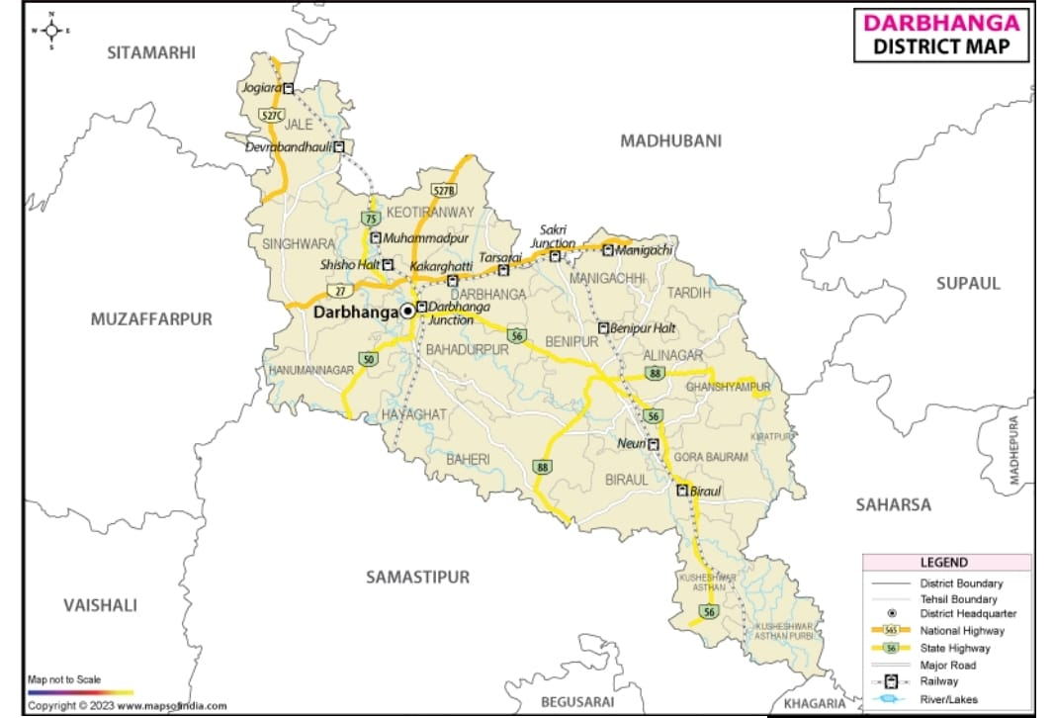

Map 1 : Darbhanga District

Community Survey: A multistage cluster design was adopted, covering both rural villages and urban wards. Households were selected systematically, and all members were invited to participate. Seasonal sampling rounds (summer, monsoon, and winter) were conducted to capture seasonal variation, consistent with WHO recommendations (WHO, 2012; Choudhary, 2018). A total of 660 stool samples were collected from participants. However, 45 samples were spoiled during transportation due to leakage and contamination and were therefore excluded. Thus, 615 stool samples were successfully processed and tested in the laboratory. This final sample size remained above the minimum requirement estimated during sample size calculation, ensuring adequate statistical power. Although sampling was performed across three different seasons, each participant contributed only a single stool sample, and no individual was followed across rounds. Therefore, the community arm also represents a cross-sectional survey.
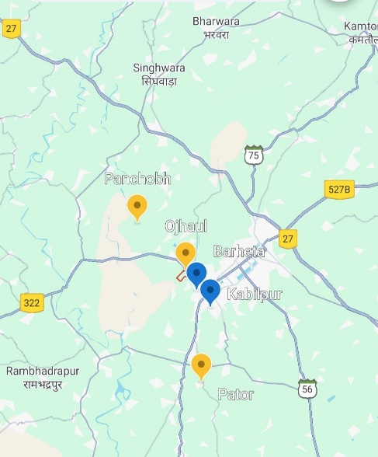
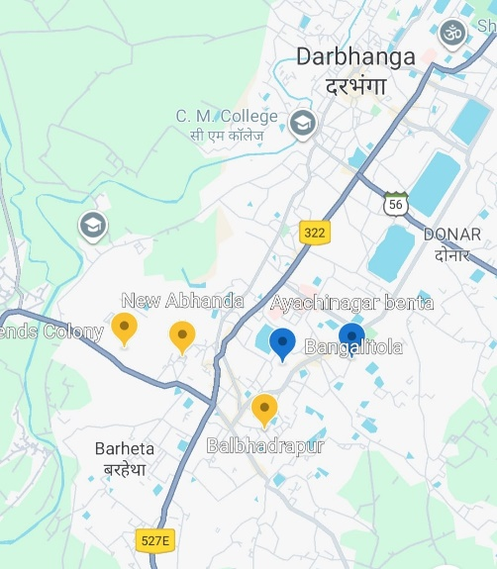

Map 2 : showing cluster location of study in urban and rural area

Collecting Data
Clinical arm: Laboratory-verified stool microscopy findings were associated with questions regarding demographics, socioeconomic status, sanitation, hygiene behaviors, and comorbidities.
Community arm: Structured surveys of households and stool sample collection were carried out. The samples were labeled, put in sterile containers, and sent to the lab for testing within two hours.
Laboratory Examination: The Kato-Katz technique, which is the WHO gold standard for STH prevalence surveys (WHO, 2006; Montresor et al., 1998), was used to look at stool samples from both arms. Eggs were discovered for Ascaris lumbricoides, Trichuris trichiura, and hookworm, and infection level was classified as light, moderate, or heavy according to WHO criteria (Bethony et al., 2006; Jourdan et al., 2018).
Ethical Considerations: The institutional ethics committee gave their support for the study. All adult participants gave their oral consent, and for minors, parental approval and child assent were sought and confidentiality was upheld.
Analysis of Statistics: Descriptive data described prevalence and intensity based on education, income, hygiene, and demographic characteristics. We used Chi-square tests to look for associations (Kirkwood and Sterne, 2003). We used SPSS to do statistical analysis. A significance criterion of p < 0.05 was employed

- RESULTS
3.1 Link between Education and STH Infection in Adults
Clinical survey: A total of 1,615 people over the age of 20 were investigated, out of which 1337were found STH infected. As shown in table 1 the overall prevalence of soil-transmitted helminth (STH) infection was 82.80%. As presented in table 8 infection rates exhibited a significant inverse correlation with educational attainment (χ² = 66.42, p < 0.001). The prevalence was highest among illiterate individuals (89.05%) and decreased steadily with increasing educational attainment, reaching 69.00% among graduates. These results highlight the possible protective function of formal education in alleviating STH burden.
Community survey: We looked at 416 adults for STH infection, and we did it by level of education. The prevalence of infection exhibited a distinct inverse correlation with educational attainment. As described in table 1, the adults who couldn't read or write, 33 of 41 (80.5%) were positive. Of the adults who had only a primary education, 65 of 89 (73.0%) were positive, and of the adults who had only a secondary education, 43 of 76 (56.6%) were positive. The prevalence was lower among higher secondary (52 of 121; 43.0%) and graduate adults (30 of 89; 33.7%). Total prevalence among adults was 53.6%. The link between education level and infection status was statistically significant (χ² = 39.42, df = 4, p < 0.0001) as shown in table 8. These findings indicate a significant protective influence of education, as the prevalence of illness diminishes progressively with higher educational attainment.
Table 1: Showing both community and clinical prevalence of STH among different groups in adults’ population based on their education

Education Level | Clinical: Examined | Clinical: Infected | Clinical: Prevalence (%) | Community: Examined | Community: Infected | Community: Prevalence (%)
Illiterate | 201 | 179 | 89.05% | 41 | 33 | 80.5%
Primary | 457 | 401 | 87.75% | 89 | 65 | 73.0%
Secondary | 375 | 333 | 88.80% | 76 | 43 | 56.6%
Higher Secondary | 382 | 286 | 74.87% | 121 | 52 | 43.0%
Graduate+ | 200 | 138 | 69.00% | 89 | 30 | 33.7%
TOTAL | 1615 | 1337 | 82.80% | 416 | 223 | 53.6%

FIGURE 1: Showing inverse relation through column chart for education and STH infection among adults in both clinical and community settings. In clinical surveys, although infection is high persistently among all education group but higher secondary and graduates show considerably low infection rate compared to secondary, primary and illiterates group.
3.2. STH Prevalence in Children and Parental Education
Clinical survey: For individuals under 20 years of age (n=485), there was no significant correlation between STH infection and paternal education (χ² = 0.15, p = 0.997) or maternal education (χ² = 1.22, p = 0.875) as shown in table 8.As described in table 2 and 3 the incidence remained continuously high (88–93%) across all levels of education. These data indicate that in endemic contexts, parental education alone may not provide substantial protection without simultaneous community-level interventions.
Community survey: The overall prevalence of STH infection among children (n=199) was 58.3%. As referred in table 2 the prevalence was greatest among kids of primary-educated mothers (69.8%) and illiterate moms (66.7%), and least among those whose mothers were graduates or above (29.4%). There was a strong inverse trend: as maternal education levels rose, the prevalence of infection fell. The chi-square test indicated a significant link between maternal education and infection status (χ² = 17.22, df = 4, p = 0.0018) presented in table 8. This data implies that maternal education is a significant protective factor, as children of educated mothers are far less likely to have STH infections.

Table 2: Showing prevalence of STH among kids and their relationship with mothers’ education
Mother’s Education | Clinical Survey Examined | Clinical Infected | Clinical Prevalence (%) | Community Survey Examined | Community Infected | Community Prevalence (%)
Illiterate | 95 | 88 | 92.63% | 21 | 14 | 66.7%
Primary | 115 | 105 | 91.30% | 63 | 44 | 69.8%
Secondary | 93 | 85 | 91.39% | 36 | 24 | 66.7%
Higher Secondary | 96 | 86 | 89.58% | 45 | 24 | 53.3%
Graduate+ | 86 | 76 | 88.37% | 34 | 10 | 29.4%
Total | 485 | 440 | 90.72% | 199 | 116 | 58.3%

A total of 199 children were assessed based on the educational levels of their fathers. As referred in table 3 the infection rate was 80.0% among children of illiterate dads (8/10), 51.0% among children of upper secondary fathers (31/51), and 73.1% among children of graduate fathers (19/26). The prevalence in the primary and secondary groups was 51.0% (25/49) and 52.4% (33/63), respectively. There was some variance in prevalence, but the chi-square test did not show a statistically significant link between the father's education and the child's STH infection (χ² = 6.15, df = 4, p = 0.189) as shown in table 8. This indicates that, in this study father education level did not influence the likelihood of STH infection in offspring. Comparison of father’s education and STH infection among kids in both community and clinical survey are shown in fig 3 through a stacked column chart.
Table -3 showing STH infection among kids and its relationship with fathers’ education

Father’s Education | Clinical Survey examined | Clinical Infected | Clinical Prevalence (%) | Community Survey examined | Community Infected | Community Prevalence (%)
Illiterate | 71 | 64 | 90.1% | 10 | 8 | 80.0%
Primary | 101 | 91 | 90.1% | 49 | 25 | 51.0%
Secondary | 144 | 131 | 91.0% | 63 | 33 | 52.4%
Higher Secondary | 103 | 94 | 91.3% | 51 | 31 | 60.8%
Graduate+ | 66 | 60 | 90.9% | 26 | 19 | 73.1%
Total | 485 | 440 | 90.7% | 199 | 116 | 58.3%

FIGURE 2: Line graph showing relation of mother’s education and STH prevalence in child in both clinical and community setting. Relationships were insignificant in clinical setting as it was throughout high among all education group but community results shows decrease in infection as mothers got more educated.

FIGURE 3: 3D stacked column chart showing relation in fathers’ education and child STH infection. No relation was found in clinical and community setting both.
3.3 Link between STH and Anemia
Clinical survey: Of the 219 subjects who’s both stool and blood samples were available were selected for studying STH anemia relationship out of 2100. 198 tested positives for STH. Anemia was present in 50.5% of STH-positive individuals, in contrast to 14.3% of STH-negative persons (χ² = 8.60, p = 0.0034) as cited in table 4. Hookworm infection was linked to the highest incidence of anemia (71.2%).As stated in table 5 Person infected with hookworm showed strongest association with anemia (OR=3.99,95%CI:2.16-7.38,p<.001) whereas roundworm also showed considerable association (OR=3.74,95%CI:1.99-7.02,p<.001).No association was found in whipworm infected person and STH infection. This shows how important it is to emphasize hookworm control to lower the risk of anemia.
Community survey: For the community survey, no blood samples were taken, and participants were not required to undergo any blood testing, biological sampling was restricted to stool for helminth diagnosis.
Table-4 Showing anemic and non-anemic among STH positive and STH negative population
Status | Helminth Type | Anemic | Not Anemic | Total | Prevalence %
STH Positive | Roundworm (RW) | 30 | 48 | 78 | 38.5
STH Positive | Hookworm (HW) | 42 | 17 | 59 | 71.2
STH Positive | Whipworm (WW) | 28 | 33 | 61 | 45.9
Total STH Positive |  | 100 | 98 | 198 | 50.5
STH Negative | None | 3 | 18 | 21 | 14.3
Total |  | 103 | 116 | 219 | 47.0

Table- 5 Association of Roundworm, Hookworm and Whipworm Infections with Anemia Based on Contingency Analysis
Helminth Type | Anemic | Not Anemic | OR | 95% CI | χ² | p-value
Roundworm (RW) | 30 | 48 | 3.74 | 1.99 – 7.02 | 14.82 | <0.001
Hookworm (HW) | 42 | 17 | 3.99 | 2.16 – 7.38 | 20.43 | <0.0001
Whipworm (WW) | 28 | 33 | 0.93 | 0.53 – 1.64 | 0.04 | 0.84

FIGURE 4: Bar chart showing STH prevalence and anemia occurrence along with STH type
3.4. Age related Trends in STH Infection
Clinical survey: There was a statistically significant link between age group and the number of people with STH infections (χ² = 38.61, p < 0.001)as stated in table 8.As shown in table 6 the infection rates were highest in children aged 0–10 years (92.06%), and they went down in older groups (for example, 75.46% in 31–40 years). This backs up the idea that deworming programs should be a top priority for school-age and preschool-age kids.
Community survey: Of the 615 people investigated, 339 (55.1%) tested positive for soil-transmitted helminth (STH) infection. The prevalence differed among age groups, with 45.1% in the 41–50-year group and 62.5% in the 11–20-year group as presented in table 6. However, chi-square analysis revealed no statistically significant correlation between age group and infection status (χ² = 7.86, df = 5, p = 0.164) referred to table 8. Effect of gender is not significant in both
clinical and community survey.
Table 6: Total prevalence percentage among variables like age and gender in both clinical and community survey
Variable | Category | Community Prevalence % | Clinical Prevalence %
Age Group | 0-10 | 53.7 | 92.1
Age Group | 11-20 | 62.5 | 90.3
Age Group | 21-30 | 59.0 | 80.6
Age Group | 31-40 | 52.1 | 75.5
Age Group | 41-50 | 45.1 | 80.9
Age Group | >50 | 55.6 | 87.1
Gender | Male | 56.8 | 84.8
Gender | Female | 53.0 | 84.4

FIGURE 5: Depicting distribution of different species of STH among different age groups in clinical and community setting through column graph
3.5. Socioeconomic Status and STH relation
Clinical survey: There was a strong negative relationship between STH prevalence and income level. The prevalence was greatest among low-income individuals (89.97%)as presented in table 7 and least among high-income groups (76.86%). χ² = 46.27, p < 0.00001. These results confirm that poverty is a significant factor influencing STH transmission as presented in table 8.
Community survey: There was a strong link between family income and STH infection (χ² = 13.9, df = 2, p = 0.00095) as shown in table 8. The highest rate of infection was among people from low-income households (63.8%)141 out of 221, followed by those from medium-income households (54.3%)133 out of 245, and the lowest rate was among those from high-income households (43.6%)65 of 149 as presented in table 8. This trend shows how socio-economic status affects the risk of STH transmission.

Figure 6: Stacked column graph comparing relation of economic state with STH infection in clinical and community survey.

3.6. STH prevalence in Rural and Urban areas
Clinical survey: As shown in table 7 and 8 People who lived in rural regions had a much greater rate of STH (88.86%) than people who lived in cities (78.98%) (χ² = 31.31, p < 0.00001). While the prevalence of roundworms was similar, hookworm infections were disproportionately higher in rural areas, indicating greater environmental exposure and inadequate sanitation.
Community survey: There were 615 people looked at, and 303 of them were from rural areas and 312 were from cities. The prevalence of STH infection was considerably greater in rural areas (61.1%) compared to urban areas (49.4%) (χ² = 8.62, df = 1, p = 0.0033) as presented in table 7 and 8. In both rural and urban areas, roundworm was the most frequent type of helminth. The relative distribution of roundworm, hookworm, and whipworm did not exhibit significant variation by area. The much higher burden in rural areas shows how exposure to the environment, sanitation procedures, and contact with soil can all increase the chance of transmission.

Fig 7: A column graph showing prevalence of Helminthiasis among rural and urban population in both clinical and community surveys. Infection is high among rural population in both categories.
Table 7: Summarizing prevalence on the basis of income and residence in community and clinical setting

Variable | Category | Community Prevalence % | Clinical Prevalence %
Income | Low | 63.8 | 90.0
Income | Middle | 54.3 | 83.4
Income | High | 43.6 | 76.9
Residence | Rural | 61.1 | 88.9
Residence | Urban | 49.4 | 79.0

TABLE 8: Statistical analysis of different variables in community and clinical settings showing their significance
Factor | Clinical χ² (p) | Community χ² (p) | Interpretation
Adult Education | 66.42, <0.001 | 39.42, <0.00001 | Significant in both
Father’s Education | 0.15, 0.997 (NS) | 6.15, 0.189 (NS) | Not significant
Mother’s Education | 1.22, 0.875 | 17.22, 0.0018 | Significant in community only
Income | 46.27, <0.001 | 13.9, 0.00095 | Significant in both
Residence | 31.31, <0.001 | 8.62, 0.0033 | Significant in both
Age Groups | 38.61, <0.001 | 7.86, 0.164 | Significant in clinical only
Gender | 0.35, 0.838 | 0.76, 0.38 | Not significant

- DISCUSSION
Our dual-arm study offers a thorough evaluation of soil-transmitted helminth (STH) epidemiology in Darbhanga, Bihar, encompassing both symptomatic patients from a clinical laboratory and asymptomatic persons from the population. The results confirm that STHs continue to be hyperendemic in this area, with a heavy impact on people of all ages and income levels In the clinical arm, prevalence surpassed 80%, aligning with the elevated infection rates commonly found in hospital-based study when symptomatic persons pursue treatment (Pullan & Brooker, 2012; Bethony et al., 2006). The negative link between education and infection in adults shows how literacy and health awareness can help keep people from getting sick (Strunz et al., 2014; Jourdan et al., 2018). Significantly, hookworm exhibited a robust correlation with anemia, consistent with previous findings indicating its disproportionate involvement in iron-deficiency anemia (Hotez et al., 2004; Brooker et al., 2006; Smith & Brooker, 2010). In the community arm, the prevalence was 55.1%, which is still far higher than the WHO's threshold for mass deworming (WHO, 2012). Infection patterns were uniformly distributed across sex and age, akin to findings from other highly endemic areas where environmental exposure facilitates transmission throughout the lifespan (Sanchez et al., 2013; Malizia et al., 2021). Roundworm was the most common type, followed by hookworm and whipworm. This is in line with what other studies in North India have found (Sehgal et al., 2010; Pal et al., 2017).
The prevalence was considerably elevated in rural regions compared to urban ones (61.1% vs. 49.4%), indicative of increased soil exposure, barefoot agriculture, and inadequate sanitary facilities (Brooker & Clements, 2009; Greenland et al., 2015). Income also had a strong negative correlation with infection. Low-income families were more than twice as likely to get infected as high-income families, showing that poverty is a major cause of STH transmission (Pullan et al., 2014; WHO, 2023). The consistently elevated prevalence must be contextualized within the framework of the COVID-19 pandemic. Lockdowns and the redirection of resources toward COVID-19 control made it hard for school-based deworming campaigns and India's National Deworming Day activities to go on from 2020 to 2022 (WHO, 2021; UNICEF, 2021). Modeling studies indicate that a mere 1–2 year cessation of mass drug administration might markedly elevate prevalence and intensity in endemic areas (Mikhailov et al., 2021; Truscott et al., 2022). Our results of consistently high infection rates, especially in school-age groups and rural communities, align with these forecasts. Prolonged school closures also made it harder to teach hygiene (Baird et al., 2021), and moving to a different place during the pandemic may have made environmental exposure worse (Choudhary, 2018). It is essential to emphasize that in our investigation, a stool sample was deemed positive if at least one egg was detected. This diagnostic threshold optimizes sensitivity and conforms to the WHO-recommended Kato-Katz approach for prevalence surveys (WHO, 2006; Montresor et al., 1998). But it might have made the prevalence estimates too high by enrolling people with extremely mild infections that aren't clinically important. On the other hand, this method makes sure that possible transmission reservoirs are not missed, especially in places with a lot of disease where even mild infections can keep the environment contaminated (Anderson et al., 2015). Consequently, our prevalence estimates probably indicate the upper limit of community burden, yet this cautious definition is warranted for directing public health initiatives. There is increasing interest in the potential modulation of host immunological responses to viral infections and vaccines, especially COVID-19, by helminth infections. Certain studies indicate that helminth-induced immune modulation may affect vaccine efficacy and COVID-19 results (Fonte et al., 2020; Wolday et al., 2021). The conjunction of elevated STH incidence with postponed COVID-19 vaccination initiatives in rural Bihar underscores the necessity of incorporating co-endemic illnesses into public health strategy formulation.
Clinical data illustrate a "worst-case" situation among symptomatic patients, whereas community studies emphasize the silent pool of asymptomatic infections that facilitate transmission. This dual perspective shows that depending on only one arm could lead to an inaccurate or incomplete picture of the true epidemiology (Anderson et al., 2015). The results confirm that mass deworming alone is inadequate. Sustainable control will necessitate the integration of preventative chemotherapy with enhancements in sanitation, health education, and poverty reduction (Strunz et al., 2014; WHO, 2012; Jourdan et al., 2018). In Darbhanga, which is prone to flooding and has a lot of standing water, treatments need to be tailored to the situation and able to handle environmental problems (Choudhary, 2018). This study was cross-sectional and did not account for reinfection dynamics. Furthermore, infection intensity was not differentiated by socioeconomic characteristics in the community arm, which could yield more profound insights. However, the amalgamation of extensive clinical and community samples provides a comprehensive and representative overview of STH epidemiology in this endemic zone.
5. CONCLUSION
This dual-arm epidemiological investigation shows that soil-transmitted helminth infections are still hyperendemic in Darbhanga, Bihar, with high rates of infection in both clinical and community groups. The clinical study showed that hookworm was strongly linked to anemia and that infection rates were very high. The community survey showed that hookworm was spreading widely among people of all ages and sexes, but it was hitting rural and low-income families the hardest. The choice of a sensitive diagnostic threshold (identifying even one egg as positive) probably led to larger prevalence estimates, but it made sure that light infections, which are critical for continued transmission, were not missed. The results should also be looked at in light of the COVID-19 disruptions, which stopped school-based deworming and public health programs. This likely made the burden seen in this study even worse. The data together show that poverty, poor sanitation, and programmatic gaps are still the main causes of transmission. To achieve sustained control and eventual eradication, strategies must extend beyond intermittent mass drug administration to encompass integrated interventions—enhanced sanitation and hygiene infrastructure, focused health education, maternal literacy advancement, and poverty reduction—specifically designed for the flood-prone and socioeconomically disadvantaged context of north Bihar. Without these kinds of broad actions, the benefits of deworming campaigns could be lost, and the disease will keep spreading from one generation to the next.
REFERENCES
- Anderson, R. M., Turner, H. C., Truscott, J. E., Hollingsworth, T. D., & Brooker, S. J. (2015). Should the goal for the treatment of soil transmitted helminth (STH) infections be changed from morbidity control in children to community-wide transmission elimination? PLoS Neglected Tropical Diseases, 9(8), e0003897. https://doi.org/10.1371/journal.pntd.0003897
- Baird, S., et al. (2021). Education loss due to COVID-19 school closures: global estimates. World Bank Policy Paper.
- Bethony, J. M., Brooker, S., Albonico, M., Geiger, S. M., Loukas, A., Diemert, D., & Hotez, P. J. (2006). Soil-transmitted helminth infections: ascariasis, trichuriasis, and hookworm. The Lancet https://doi.org/10.1016/S0140-6736(06)68653-4
- Brooker, S., & Clements, A. C. A. (2009). Spatial heterogeneity of parasite co-infection: Determinants and geostatistical prediction at regional scales. International Journal for Parasitology, 39(5), 591–597. https://doi.org/10.1016/j.ijpara.2008.10.014
- Brooker, S., Hotez, P. J., & Bundy, D. A. P. (2008). Hookworm-related anaemia among pregnant women: a systematic review. PLoS Neglected Tropical Diseases, 2(9), e291. https://doi.org/10.1371/journal.pntd.0000291
- Choudhary, A. (2018). Soil-transmitted helminthiasis in flood-prone Bihar: epidemiological considerations. Indian Journal of Parasitology, 34(2), 45–53.
- Fonte, L., Acosta, A., Sarmiento, M. E., Ginori, M., García, G., & Norazmi, M. N. (2020). COVID-19 lethality in Sub-Saharan Africa and helminth immune modulation. Frontiers in Immunology, 11, 574910. https://doi.org/10.3389/fimmu.2020.574910
- Greenland, K., Dixon, R., Khan, S. A., Gunawardena, K., Kihara, J. H., Smith, J. L., Drake, L., Makkar, P., Raman, S., Singh, S., & Kumar, S. (2015). The epidemiology of soil-transmitted helminths in Bihar State, India. PLoS Neglected Tropical Diseases https://doi.org/10.1371/journal.pntd.0003790
- Hotez, P. J., Brooker, S., Bethony, J. M., Bottazzi, M. E., Loukas, A., & Xiao, S. (2004). Hookworm infection. The New England Journal of Medicine, 351(8), 799–807. https://doi.org/10.1056/NEJMra032492
- Jourdan, P. M., Lamberton, P. H. L., Fenwick, A., & Addiss, D. G. (2018). Soil-transmitted helminth infections. The Lancet, 391(10117), 252–265. https://doi.org/10.1016/S0140-6736(17)31930-X
- Malizia, V., et al. (2021). Soil-transmitted helminths: global epidemiology and control strategies. Tropical Medicine & International Health, 26(1), 1–12. https://doi.org/10.1111/tmi.13574
- Mikhailov, A., et al. (2021). Impact of COVID-19 interruptions on preventive chemotherapy for neglected tropical diseases: a modeling analysis. The Lancet Global Health, 9(11), e1441–e1450. https://doi.org/10.1016/S2214-109X(21)00327-4
- Montresor, A., Crompton, D. W. T., Hall, A., Bundy, D. A. P., & Savioli, L. (1998). Guidelines for the evaluation of soil-transmitted helminthiasis and schistosomiasis at community level: A guide for managers of control programmes. World Health Organization. https://iris.who.int/handle/10665/63821
- Pal, R., Sehgal, R., & Choudhary, A. (2017). Seasonal variation of STH infections in North Bihar. Indian Journal of Community Medicine, 42(3), 189–193. https://doi.org/10.4103/ijcm.IJCM_135_16
- Pullan, R. L., Smith, J. L., Jasrasaria, R., & Brooker, S. J. (2014). Global numbers of infection and disease burden of soil transmitted helminth infections in 2010. Parasites & Vectors, 7, 37. https://doi.org/10.1186/1756-3305-7-37
- Pullan, R. L., & Brooker, S. J. (2012). The global limits and population at risk of soil-transmitted helminth infections in 2010. Parasites & Vectors. https://doi.org/10.1186/1756-3305-5-81
- Sanchez, A. L., Gabrie, J. A., Usuanlele, M.-T., Rueda, M. M., Canales, M., & Gyorkos, T. W. (2013). Soil-transmitted helminth infections and nutritional status in school-age children from rural communities in Honduras. PLoS Neglected Tropical Diseases, 7(8), e2378. https://doi.org/10.1371/journal.pntd.0002378
- Sehgal, R., et al. (2010). Epidemiology of intestinal parasitoses in Bihar. Indian Journal of Medical Research, 131(2), 111–117.
- Smith, J. L., & Brooker, S. (2010). Impact of hookworm infection and deworming on anaemia in non-pregnant populations: a systematic review. Tropical Medicine & International Health, 15(7), 776–795. https://doi.org/10.1111/j.1365-3156.2010.02542.x
- Strunz, E. C., Addiss, D. G., Stocks, M. E., Ogden, S., Utzinger, J., & Freeman, M. C. (2014). Water, sanitation, hygiene, and soil-transmitted helminth infection: a systematic review and meta-analysis. PLoS Medicine. https://doi.org/10.1371/journal.pmed.1001620
- Truscott, J. E., Hollingsworth, T. D., & Anderson, R. M. (2022). Delays in mass drug administration due to COVID-19: potential impact on STH control goals. Parasite Epidemiology and Control, 17, e00246. https://doi.org/10.1016/j.parepi.2022.e00246
- UNICEF. (2021). The impact of the COVID-19 pandemic on WASH and deworming programs. UNICEF Global Report.
- World Health Organization. (2006). Preventive chemotherapy in human helminthiasis: coordinated use of anthelminthic drugs in control interventions: a manual for health professionals and programme managers. Geneva: World Health Organization. https://whqlibdoc.who.int/publications/2006/9241547103_eng.pdf
- World Health Organization. (2012). Eliminating soil-transmitted helminthiases as a public health problem in children: Progress report 2001-2010 and strategic plan 2011-2020. World Health Organization. https://ntd.who.int/resources/eliminating-soil-transmitted-helminthiases-public-health-problem-children-progress-report-2001-2010-and-strategic-plan-2011-2020-sth
- WHO. (2021). COVID-19 and NTD program disruptions: interim monitoring report. Geneva: World Health Organization.
- WHO. (2023). Soil-transmitted helminth infections: key facts. Geneva: World Health Organization. https://www.who.int/news-room/fact-sheets/detail/soil-transmitted-helminth-infections
- Wolday, D., Gebrecherkos, T., Arefaine, Z. G., Kiros, Y. K., Gebreegzabher, A., Tasew, G., Abdulkader, M., Abraha, H. E., Desta, A. A., Hailu, A., Tollera, G., Abdella, S., Tesema, M., Abate, E., Endarge, K. L., Hundie, T. G., Miteku, F. K., Urban, B. C., Schallig, H. H. D. F., Harris, V. C., & Rinke de Wit, T. F. (2021). Effect of co-infection with intestinal parasites on COVID-19 severity: A prospective observational cohort study. EClinicalMedicine. https://doi.org/10.1016/j.eclinm.2021.101054

