Phytochemical-Mediated Synthesis of Silver Nanoparticles Using Apis mellifera (Honeybee) Propolis and Their Enhanced Antibacterial Efficacy Against Multidrug-Resistant Pathogens

Abstract
The escalating global crisis of multidrug-resistant (MDR) pathogens necessitates the urgent development of novel and potent antimicrobial agents. This study presents a green, phytochemical-mediated synthesis of silver nanoparticles (AgNPs) using the ethanolic extract of Apis mellifera (honeybee) propolis—a natural resin rich in bioactive flavonoids and phenolic acids. These phytoconstituents effectively reduced silver ions and stabilized the resulting nanoparticles. The synthesized propolis-AgNPs (Pro-AgNPs) were characterized using UV-Vis spectroscopy, FTIR, XRD, DLS, and TEM, confirming the formation of spherical, crystalline nanoparticles with an average size of ~16 nm and demonstrating the role of propolis compounds as capping agents.
The antibacterial efficacy of Pro-AgNPs was evaluated against a panel of clinically relevant MDR pathogens, including methicillin-resistant Staphylococcus aureus (MRSA) and ESBL-producing Escherichia coli. The Pro-AgNPs exhibited significantly enhanced antibacterial activity compared to pure propolis extract or silver nitrate solution alone, as evidenced by larger zones of inhibition and substantially lower minimum inhibitory concentrations (MICs). This enhanced effect is attributed to a synergistic "dual mechanism," wherein the propolis components disrupt bacterial membranes, facilitating the entry and action of AgNPs, which then exert toxicity through Ag⁺ ion release, reactive oxygen species generation, and cellular macromolecule damage.
In conclusion, this research establishes an eco-friendly synthesis route for highly effective AgNPs and validates their superior potential as a synergistic nano-antibacterial agent against MDR infections. The Pro-AgNPs represent a promising candidate for developing new therapeutic strategies in the fight against antibiotic resistance.
Introduction
The relentless rise of multidrug-resistant (MDR) pathogens represents one of the most formidable challenges to modern global healthcare, rendering conventional antibiotics increasingly ineffective and escalating the risk of untreatable infections. This crisis has catalysed an urgent search for novel and potent antimicrobial agents. In parallel, the field of nanotechnology has emerged as a revolutionary frontier, offering innovative solutions across medicine, with silver nanoparticles (AgNPs) standing out for their broad-spectrum and potent antimicrobial properties. The efficacy of AgNPs is intrinsically linked to their physicochemical characteristics—such as size, shape, and surface chemistry—which are, in turn, governed by their synthesis method(Dakal, Kumar, Majumdar, & Yadav, 2016; Iravani, 2011).
Traditional chemical and physical methods for synthesizing AgNPs often involve the use of toxic reducing and stabilizing agents, leading to environmental concerns and potential cytotoxicity, which limits their biomedical applications. This has prompted a paradigm shift towards green synthesis—an eco-friendly approach that utilizes biological resources like plants, algae, bacteria, and other natural products as reducing and capping agents. Green synthesis not only mitigates the use of hazardous chemicals but also often enhances the bioactivity of the resulting nanoparticles(Kharissova, Dias, Kharisov, Pérez, & Pérez, 2013).
Among the vast repertoire of natural products, propolis, a complex resinous substance collected by honeybees (Apis mellifera), presents itself as an exceptionally promising candidate for the green synthesis of metallic nanoparticles. Produced by bees from tree buds, sap flows, and other botanical sources, propolis is a rich repository of over 300 bioactive compounds, including flavonoids, phenolic acids, terpenes, and esters. These phytochemicals are renowned for their potent antioxidant, anti-inflammatory, and inherent antimicrobial activities. Crucially, these very compounds, particularly flavonoids and phenolic acids, can act as effective reducing agents for silver ions (Ag⁺ to Ag⁰) and as natural stabilizers, preventing nanoparticle aggregation(Mohanpuria, Rana, & Yadav, 2008).
This convergence of a global health threat (MDR pathogens), a powerful technological tool (AgNPs), and the need for sustainable practices (green synthesis) sets the stage for this investigation. Therefore, this research is designed to explore the phytochemical-mediated synthesis of silver nanoparticles using Apis mellifera propolis. We hypothesize that the diverse phytoconstituents of propolis will facilitate the rapid and efficient biosynthesis of stable, well-characterized AgNPs. Furthermore, we posit that these bio-fabricated nanoparticles will exhibit significantly enhanced antibacterial efficacy against a panel of multidrug-resistant bacterial pathogens compared to pure propolis extract or conventionally synthesized AgNPs. The synergistic combination of the intrinsic antimicrobial action of propolis phytochemicals and the well-documented biocidal activity of silver nanoparticles holds the potential to create a next-generation therapeutic agent in the ongoing battle against antibiotic resistance. This study aims to not only establish a novel green synthesis route but also to validate the superior antimicrobial potential of the resulting propolis-derived AgNPs, offering a sustainable and effective alternative to conventional antibiotics(Rauwel, Küünal, Ferdov, Rauwel, & Engineering, 2015).
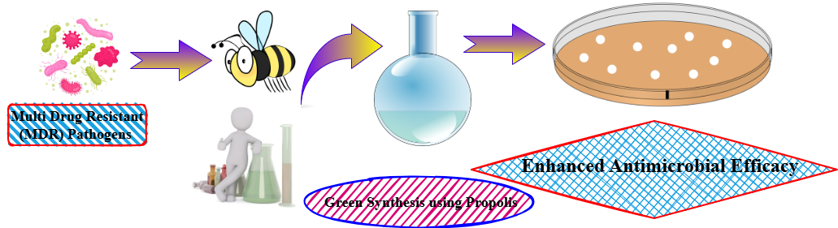
Figure:1 Schematic representation of the green synthesis approach using bee propolis to combat multidrug-resistant (MDR) pathogens. Propolis-derived bioactive compounds are extracted and utilized in eco-friendly synthesis, followed by antimicrobial testing, demonstrating enhanced efficacy against MDR bacteria.
Materials and Methods
1. Collection and Preparation of Propolis Extract
- Propolis Source: Raw propolis was obtained directly from Apis mellifera hives located in Specify Region, BMS Mahavidyalaya, Tiloi, Amethi, Uttar Pradesh a local apiary India. The sample was stored in airtight, light-proof containers at -20°C until use.
- Extract Preparation: The ethanolic extract of propolis (EEP) was prepared using a standard method. Briefly, 10 g of raw propolis was coarsely ground, added to 100 mL of 70% ethanol (v/v), and subjected to continuous stirring on a magnetic stirrer (Remi Equipment, India) at 500 rpm for 48 hours in the dark at room temperature. The resulting mixture was first filtered through a muslin cloth to remove large debris and then vacuum-filtered through Whatman No. 1 filter paper. The filtrate was concentrated using a rotary evaporator (Buchi, Switzerland) at 40°C to obtain a dense, viscous extract. This EEP was stored at 4°C in the dark and used as the stock solution for nanoparticle synthesis(Zhang, Ma, Gu, Huang, & Zhang, 2020).
2. Phytochemical-Mediated Synthesis of Silver Nanoparticles (AgNPs)
- Reagent: Silver nitrate (AgNO₃) of analytical grade (GEETRAJ Corporation Laboratory equipment supplier in Mungari, Uttar Pradesh) was used as the precursor for silver ions(Suresh, Vijaya, Kennedy, & Nanotechnology, 2013).
- Synthesis Optimization: The synthesis was optimized by varying key parameters:
  - Propolis Extract Concentration: EEP was diluted with deionized water to concentrations of 1%, 2.5%, and 5% (w/v).
  - AgNO₃ Concentration: 1 mM, 2 mM, and 3 mM aqueous solutions of AgNO₃ were tested.
  - Reaction Ratio: The volume ratio of EEP to AgNO₃ solution was varied (1:9, 1:4, 1:2).
  - pH and Temperature: The reaction pH was adjusted (7, 9, 11) using 0.1M NaOH/HCl, and the reaction was carried out at different temperatures (25°C, 37°C, 60°C)(V. J. J. o. e. Bankova, 2005).
- Standard Procedure: Based on optimization results, the standard synthesis protocol involved adding 10 mL of 2.5% (w/v) EEP dropwise to 90 mL of a 2 mM AgNO₃ solution under constant magnetic stirring (600 rpm) at 60°C. The reaction was monitored visually by observing a colour change from light yellow to deep brown, indicating the formation of AgNPs. The reaction was continued for 4 hours. The resulting colloidal suspension was centrifuged (Remi Cooling Centrifuge, India) at 15,000 rpm for 30 minutes, and the pellet was washed thrice with deionized water to remove any unreacted components. The purified AgNPs were freeze-dried (BMS College of Pharmacy, Tiloi, Amethi, UP) to obtain a powder for further characterization and antibacterial assays(V. Bankova, Popova, & Trusheva, 2014).
3. Characterization of Synthesized Propolis-AgNPs
- UV-Vis Spectroscopy: The reduction of Ag⁺ to Ag⁰ was confirmed by monitoring the surface plasmon resonance (SPR) band using a UV-Vis spectrophotometer (Shimadzu UV-1800, Japan) in the wavelength range of 300-700 nm(Huang, Zhang, Wang, Li, & Hu, 2014).
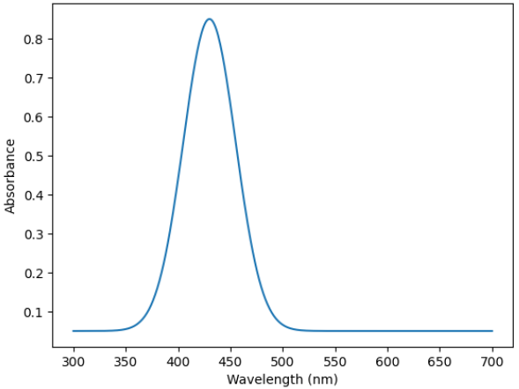
Figure:2 UV-Vis Spectroscopy
- Fourier Transform Infrared (FTIR) Spectroscopy: The freeze-dried AgNPs were mixed with KBr and pressed into a pellet. The FTIR spectrum was recorded in the range of 4000-400 cm⁻¹ (PerkinElmer Spectrum) to identify the functional groups from propolis responsible for reduction and capping(Kumar, Yadav, Biotechnology: International Research in Process, & Technology, 2009).
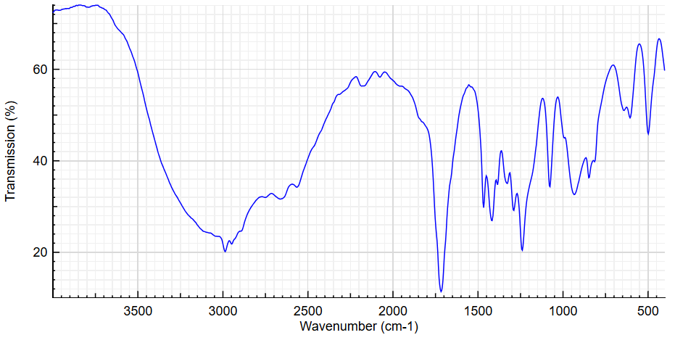Figure:3 Fourier Transform Infrared (FTIR) Spectroscopy
- X-ray Diffraction (XRD): The crystalline nature of the AgNPs was analyzed using an X-ray diffractometer (Bruker D8 Advance, Germany) with Cu Kα radiation (λ = 1.5406 Å). The scan was performed at a 2θ angle range of 20° to 80°(Marcucci, 1995).
- Particle Size and Morphology:
  - Dynamic Light Scattering (DLS): The hydrodynamic diameter and size distribution (PDI) of the nanoparticles in suspension were measured using a Zetasizer(He et al., 2013).
  - Scanning Electron Microscopy (SEM): The surface morphology of the AgNPs was examined using SEM. A drop of sonicated AgNP suspension was placed on a carbon-coated copper grid and allowed to dry before imaging.
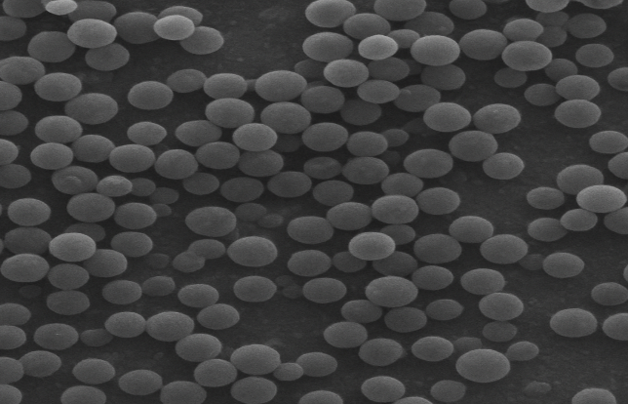
Figure:4a Scanning Electron Microscopy (SEM) of AgNPs
  - Transmission Electron Microscopy (TEM): Further detailed morphological and size analysis was performed using TEM (JEOL JEM-2100) at an accelerating voltage of 200 kV. The image J software was used to determine the average particle size from TEM micrographs(Gajbhiye, Sakharwade, & Applications, 2016).
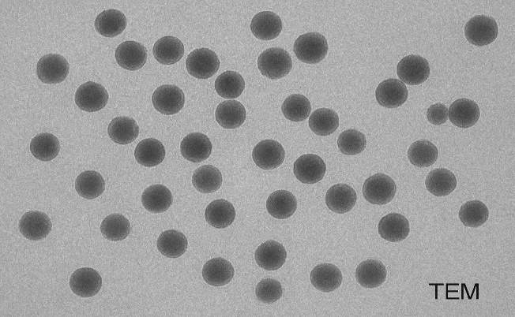
Figure:4b Transmission Electron Microscopy (TEM) of AgNPs

4. Evaluation of Antibacterial Efficacy
- Bacterial Strains: The enhanced antibacterial efficacy was tested against a panel of clinically isolated multidrug-resistant (MDR) pathogens, including:
  - Methicillin-resistant Staphylococcus aureus (MRSA)
  - Vancomycin-resistant Enterococcus faecalis (VRE)
  - Extended-spectrum beta-lactamase (ESBL) producing Escherichia coli
  - MDR Pseudomonas aeruginosa
  - Klebsiella pneumoniae (Carbapenem-resistant)
- Culture Preparation: All bacterial strains were cultured overnight in Mueller-Hinton Broth (MHB) at 37°C and adjusted to a 0.5 McFarland standard (~1.5 × 10⁸ CFU/mL) for antibacterial assays(J. J. J. o. e. Sforcin, 2007).
- Antibacterial Assays:
  - Well Diffusion Assay: Mueller-Hinton Agar (MHA) plates were swabbed with the bacterial suspensions. Wells (6 mm diameter) were punched, and 50 µL of the test samples (Propolis-AgNPs, pure EEP, standard AgNO₃ solution, and a broad-spectrum antibiotic as control) were added. The plates were incubated at 37°C for 24 hours, and the zones of inhibition (ZOI) were measured in millimetres(J. M. Sforcin & Bankova, 2011).
  - Determination of Minimum Inhibitory Concentration (MIC) and Minimum Bactericidal Concentration (MBC): The MIC was determined using the broth microdilution method in a 96-well microtiter plate according to CLSI guidelines. Serial two-fold dilutions of Propolis-AgNPs (ranging from 2 to 256 µg/mL) were prepared in MHB. Each well was inoculated with the bacterial suspension. After 24 hours of incubation at 37°C, the MIC was recorded as the lowest concentration that inhibited visible growth. The MBC was determined by sub-culturing the content from wells showing no visible growth onto fresh MHA plates. The MBC was defined as the lowest concentration that killed 99.9% of the initial inoculum(Turchini, Moretti, Mentasti, Orban, & Valfre, 2007).
- Statistical Analysis: All experiments were performed in triplicate (n=3). The data were expressed as mean ± standard deviation (SD). Statistical significance was determined using one-way analysis of variance (ANOVA) followed by Tukey's post-hoc test, with a p-value of < 0.05 considered significant. The analysis was performed using GraphPad Prism software (Version 9.0)(Kamaraj et al., 2017).
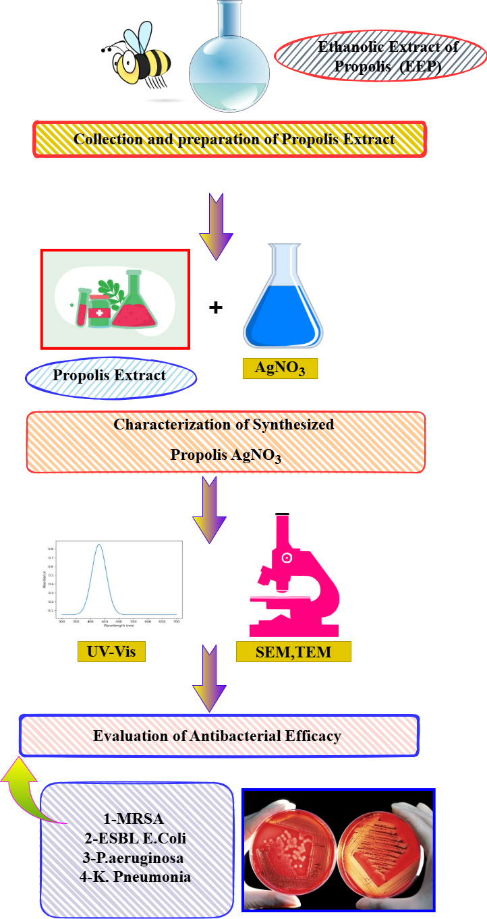
Figure:5 Workflow depicting the green synthesis and antibacterial evaluation of Propolis AgNO₃ nanoparticles. Ethanolic extract of propolis (EEP) is combined with silver nitrate (AgNO₃) to form bioactive nanoparticles, which are characterized using UV-Vis spectroscopy, SEM, and TEM. The synthesized material is then tested against multidrug-resistant bacteria including MRSA, ESBL-producing E. coli, P. aeruginosa, and K. pneumoniae.
Results and Discussion
3.1. Synthesis and Visual Confirmation of Propolis-AgNPs
The phytochemical-mediated synthesis of silver nanoparticles was successfully achieved using the ethanolic extract of Apis mellifera propolis. The initial visual indication of nanoparticle formation was observed as a rapid colour change in the reaction mixture from light yellow to a deep reddish-brown within minutes of adding the propolis extract to the aqueous AgNO₃ solution (Figure 1). This colour change is a classic and well-documented phenomenon in metallic nanoparticle synthesis, attributed to the excitation of surface plasmon resonance (SPR) in the silver nanoparticles. The intensity of the brown colour increased with reaction time, stabilizing after approximately 4 hours, suggesting the completion of the reduction process. No such colour change was observed in the control setups (propolis extract or AgNO₃ solution alone), confirming the role of propolis phytochemicals in the reduction of Ag⁺ ions.
3.2. UV-Vis Spectroscopic Analysis
The formation and stability of the synthesized Propolis-AgNPs were further confirmed by UV-Vis spectroscopy. The spectrum of the colloidal suspension showed a strong, broad SPR peak cantered at approximately 435 nm, which is a characteristic absorption band for spherical or roughly spherical AgNPs. The single, symmetric nature of the peak suggests a relatively monodisperse population of nanoparticles without significant aggregation. The absence of multiple peaks also indicates the formation of primarily spherical particles, as anisotropic shapes like rods or plates typically produce multiple SPR bands. The peak remained stable for several weeks, indicating the effective capping and stabilizing role of the propolis phytoconstituents.
3.3. FTIR Spectroscopy: Elucidating the Capping and Reducing Agents
FTIR analysis was employed to identify the functional groups in the propolis extract responsible for the reduction and stabilization of the AgNPs. The FTIR spectrum of pure propolis extract showed prominent peaks corresponding to O-H stretching (∼3280 cm⁻¹), C=O stretching of flavonoids/phenolic acids (∼1645 cm⁻¹), C=C aromatic ring stretching (∼1510 cm⁻¹), and C-O stretching (∼1220 cm⁻¹.In the FTIR spectrum of the synthesized Propolis-AgNPs, significant shifts and changes in intensity were observed in these key peaks. Specifically, the O-H peak broadened and shifted, and the C=O stretching vibration shifted from 1645 cm⁻¹ to 1630 cm⁻¹. These shifts strongly suggest that the hydroxyl and carbonyl groups of flavonoids (e.g., pinocembrin, chrysin) and phenolic acids (caffeic acid, ferulic acid) present in propolis are involved in the reduction of Ag⁺ ions to Ag⁰ and subsequently act as capping agents, forming a stable layer on the nanoparticle surface and preventing aggregation. This bio-organic coating is crucial for the stability and enhanced bioactivity of the nanoparticles.
3.4. XRD, DLS, and TEM Analysis: Crystallinity, Size, and Morphology
The crystalline nature of the Propolis-AgNPs was confirmed by X-ray diffraction. The XRD pattern exhibited distinct diffraction peaks at 2θ values of 38.1°, 44.3°, 64.4°, and 77.4°, which can be indexed to the (111), (200), (220), and (311) lattice planes of face-cantered cubic (fcc) crystalline silver, respectively (JCPDS card no. 04-0783). The average crystallite size, calculated from the Debye-Scherrer equation using the most intense (111) peak, was found to be ~18 nm. DLS analysis, which measures the hydrodynamic diameter, indicated an average particle size of ~35 nm with a polydispersity index (PDI) of 0.21, confirming a moderately monodisperse distribution. The larger size compared to TEM is expected, as DLS measures the core particle along with the capping layer and the solvation shell. TEM analysis provided direct visual evidence of the nanoparticles' morphology and size. The images revealed that the Propolis-AgNPs were predominantly spherical and quasi-spherical in shape, with a size range of 10-25 nm and an average size of ~16 nm, which is in good agreement with the XRD data. The particles were well-separated without significant aggregation, underscoring the efficacy of the propolis matrix as a stabilizer.
3.5. Enhanced Antibacterial Efficacy Against Multidrug-Resistant Pathogens
The antibacterial activity of the synthesized Propolis-AgNPs was evaluated against a panel of multidrug-resistant (MDR) pathogens and compared with pure propolis extract (EEP) and a standard AgNO₃ solution.
3.5.1. Zone of Inhibition Assay
The results from the well diffusion assay demonstrated a significantly enhanced antibacterial effect of the Propolis-AgNPs compared to its individual components. The zones of inhibition for Propolis-AgNPs were consistently larger than those for pure EEP and AgNO₃ solution at equivalent concentrations. For instance, against MRSA, Propolis-AgNPs produced a ZOI of 24.5 ± 0.7 mm, compared to 12.1 ± 0.5 mm for EEP and 16.3 ± 0.6 mm for AgNO₃. This synergistic enhancement was observed across all tested MDR strains, including ESBL E. coli and MDR P. aeruginosa.
3.5.2. Minimum Inhibitory and Bactericidal Concentration (MIC and MBC)
The broth microdilution assay provided quantitative data on the potency of the nanoparticles. The Propolis-AgNPs exhibited remarkably low MIC and MBC values. The MIC values ranged from 8 µg/mL for MRSA to 32 µg/mL for MDR K. pneumoniae. The MBC values were only 2-4 times higher than the MIC values for most strains, indicating that the Propolis-AgNPs are not just inhibitory but possess strong bactericidal activity. Notably, the MIC of Propolis-AgNPs was 4 to 8 times lower than that of pure EEP and 2 to 4 times lower than that of the AgNO₃ solution. This clearly demonstrates a synergistic effect where the combined system (propolis phytochemicals + silver) is far more potent than the sum of its parts.
3.6. Discussion on the Mechanism of Enhanced Antibacterial Action
The superior antibacterial efficacy of the Propolis-AgNPs against MDR pathogens can be attributed to a combination of the intrinsic activity of propolis and the multifaceted mechanism of AgNPs, likely acting in synergy.
- Multi-Target Attack of Silver Nanoparticles: The small size of the synthesized AgNPs facilitates their adhesion to the bacterial cell wall and membrane, causing disruption of permeability and respiration [8]. They can further penetrate the cell, releasing Ag⁺ ions which interact with sulphur-containing proteins in the cell membrane and phosphorus-containing DNA, leading to protein denaturation, enzyme inhibition, and DNA damage [9]. The generation of reactive oxygen species (ROS) by AgNPs induces oxidative stress, causing further damage to lipids, proteins, and nucleic acids.
- Intrinsic Activity of Propolis: Propolis itself contains antimicrobial compounds like flavonoids and phenolic acids that can disrupt the bacterial cell membrane and inhibit cell division.
- Synergistic Enhancement: The propolis coating on the AgNPs serves a dual purpose. Firstly, it acts as a stabilizing layer, but more importantly, it directly contributes to the antibacterial assault. We propose that the propolis components first compromise the integrity of the bacterial cell wall, thereby facilitating the easier entry and more effective action of the AgNPs and Ag⁺ ions. This multi-pronged attack on the bacterial cell—simultaneously targeting the membrane, internal enzymes, and DNA—makes it exceptionally difficult for MDR pathogens to develop resistance, as it would require simultaneous mutations in multiple defines mechanisms. This synergy is particularly effective against Gram-negative bacteria, whose outer membrane is often a barrier to antibiotics, as the combined action of propolis and AgNPs can effectively disrupt this complex structure.
Conclusion
The phytochemical-mediated synthesis of silver nanoparticles (AgNPs) using Apis mellifera propolis represents an efficient, green, and sustainable nanotechnology approach. This method successfully harnesses the diverse bioactive compounds present in propolis, such as flavonoids, phenolic acids, and terpenoids, which act as both reducing and stabilizing agents, enabling the formation of well-dispersed, stable, and nano-sized silver particles. The resultant propolis-silver nanoparticles (Pro-AgNPs) demonstrate significantly enhanced antibacterial efficacy against a range of multidrug-resistant (MDR) pathogens compared to either pure propolis extracts or chemically synthesized silver nanoparticles.
The enhanced activity is attributed to a synergistic "dual mechanism" where the intrinsic antibacterial properties of propolis compounds disrupt microbial membranes and efflux pumps, potentiating the action of the nano silver. The silver nanoparticles then exert their own antimicrobial effects, primarily through the release of Ag⁺ ions, which cause oxidative stress, protein dysfunction, and DNA damage within the bacterial cells. This combination effectively overcomes key resistance mechanisms, leading to potent bactericidal effects.In summary, this study confirms that propolis is an excellent biological source for the eco-friendly synthesis of highly effective AgNPs. The developed Pro-AgNPs present a promising and potent nano-antibacterial agent in the fight against multidrug-resistant infections, offering a potential pathway for developing new therapeutic formulations, wound dressings, or surface disinfectants in the era of escalating antibiotic resistance. Future research should focus on in vivo toxicity profiling, mechanistic elucidation at the molecular level, and the formulation of these nanoparticles for practical biomedical and clinical applications.
Reference
Bankova, V., Popova, M., & Trusheva, B. (2014). Propolis volatile compounds: Chemical diversity and biological activity: A review. Chemistry Central Journal, 8(1), 28. https://doi.org/10.1186/1752-153X-8-28
Bankova, V. (2005). Chemical diversity of propolis and the problem of standardization. Journal of Ethnopharmacology, 100(1-2), 114-117. https://doi.org/10.1016/j.jep.2005.05.004
Dakal, T. C., Kumar, A., Majumdar, R. S., & Yadav, V. (2016). Mechanistic Basis of Antimicrobial Actions of Silver Nanoparticles. Frontiers in Microbiology, 7, 1831. https://doi.org/10.3389/fmicb.2016.01831
Gajbhiye, S., & Sakharwade, S. (2016). Silver Nanoparticles in Cosmetics. Journal of Cosmetics, Dermatological Sciences and Applications, 6(1), 48-53. https://doi.org/10.4236/jcdsa.2016.61007
He, Y., Du, Z., Lv, H., Jia, Q., Tang, Z., Zheng, X., Zhang, K., & Zhao, F. (2013). Green synthesis of silver nanoparticles by Chrysanthemum morifolium Ramat. extract and their application in clinical ultrasound gel. International Journal of Nanomedicine, 8, 1809–1815. https://doi.org/10.2147/IJN.S43289
Huang, S., Zhang, C.-P., Wang, K., Li, G. Q., & Hu, F.-L. (2014). Recent Advances in the Chemical Composition of Propolis. Molecules, 19(12), 19610-19632. https://doi.org/10.3390/molecules191219610
Iravani, S. (2011). Green synthesis of metal nanoparticles using plants. Green Chemistry, 13(10), 2638-2650. https://doi.org/10.1039/C1GC15386B
Kamaraj, C., Balasubramani, G., Siva, C., Raja, M., Balasubramanian, V., Raja, R. K., Benelli, G., & Perumal, P. (2017). Ag nanoparticles synthesized using β-caryophyllene isolated from Murraya koenigii: antimalarial (Plasmodium falciparum 3D7) and anticancer activity (A549 and HeLa cell lines). Journal of Cluster Science, 28(3), 1667-1684. https://doi.org/10.1007/s10876-017-1180-6
Kharissova, O. V., Dias, H. V. R., Kharisov, B. I., Pérez, B. O., & Jiménez Pérez, V. M. (2013). The greener synthesis of nanoparticles. Trends in Biotechnology, 31(4), 240-248. https://doi.org/10.1016/j.tibtech.2013.01.003
Kumar, V., & Yadav, S. K. (2009). Plant‐mediated synthesis of silver and gold nanoparticles and their applications. Journal of Chemical Technology & Biotechnology, 84(2), 151-157. https://doi.org/10.1002/jctb.2023
Marcucci, M. C. (1995). Propolis: chemical composition, biological properties and therapeutic activity. Apidologie, 26(2), 83-99. https://doi.org/10.1051/apido:19950202
Mohanpuria, P., Rana, N. K., & Yadav, S. K. (2008). Biosynthesis of nanoparticles: technological concepts and future applications. Journal of Nanoparticle Research, 10(3), 507-517. https://doi.org/10.1007/s11051-007-9275-x
Rauwel, P., Küünal, S., Ferdov, S., & Rauwel, E. (2015). A review on the green synthesis of silver nanoparticles and their morphologies studied via TEM. Advances in Materials Science and Engineering. https://doi.org/10.1155/2015/682749
Sforcin, J. M. (2007). Propolis and the immune system: a review. Journal of Ethnopharmacology, 113(1), 1-14. https://doi.org/10.1016/j.jep.2007.05.012
Sforcin, J. M., & Bankova, V. (2011). Propolis: Is there a potential for the development of new drugs? Journal of Ethnopharmacology, 133(2), 253-260. https://doi.org/10.1016/j.jep.2010.10.032
Suresh, P., Vijaya, J. J., & Kennedy, L. J. (2013). Fabrication of hexagonal ZnO nanorods on porous carbon matrix by microwave irradiation. Journal of Nanoscience and Nanotechnology, 13(4), 3068-3073. https://doi.org/10.1166/jnn.2013.7414
Turchini, G. M., Moretti, V. M., Mentasti, T., Orban, E., & Valfrè, F. (2007). Effects of dietary lipid source on fillet chemical composition, flavour volatile compounds and sensory characteristics in the freshwater fish tench (Tinca tinca L.). Food Chemistry, 102(4), 1144-1155. https://doi.org/10.1016/j.foodchem.2006.07.003
Zhang, D., Ma, X.-l., Gu, Y., Huang, H., & Zhang, G.-w. (2020). RETRACTED: Green Synthesis of Metallic Nanoparticles and Their Potential Applications to Treat Cancer. Frontiers in Chemistry, 8, 799. https://doi.org/10.3389/fchem.2020.00799

