Original Research Article
Assessment of Citrus reticulata powder extract on the control of
Sitophilus oryzae in stored maize grains

ABSTRACT

Sitophilus oryzae (rice weevil) is a severe insect pest causes substantial post- harvest loss both qualitatively and quantitatively in stored grains. Use of plant- based insecticides offer a safer alternative for managing stored insect pests than chemical insecticides which pose a serious health risk to both human and environment. The aim of this study is to investigate the efficacy of Citrus reticulata peel powder extract on mortality and weight loss in maize grains infested with the Sitophilus oryzae. Adult rice weevil were exposed to 1%, 1.5%, 2% and 2.5% (w/w) powder extract treated 30 gm maize grains were set- up and an untreated maize grains were also set-up as control for 21 days.

Mortality was counted at 1, 3, 7, 14 and 21 day after treatment and weight loss was observed after 21 days post- treatment. Three replication of experiment was performed. The result of the study indicated the mortality increased with the exposure time and the highest mortality of 35.52% at 2.5% and lowest weight loss of 10.87% at 2.5% compared to the untreated control of 24.12% weight loss were recorded and differences was found to be significant (p<0.05). These results showed the Citrus reticulata peel powder extract could be used as botanical insecticide for the protection of stored maize from infestations of Sitophilus oryzae.

KEYWORDS

Sitophilus oryzae, Citrus reticulata, post-harvest losses, Insect pests, Powder extract

INTRODUCTION

Globally, maize production of 1163 million tonnes was observed for crop area of 205 million hectares during the time of 2022-23. In maize production, USA was the leading country with a share of 31.3% in the maize producing countries. India contributed the 2.7% share in maize production, holds the seventh rank worldwide (ANGRAU – maize outlook report, June to may 2023-24). Maize is a cereal grain belongs to family of poaceae. After wheat and rice, maize is considered the most important grain for agriculture in the world (Devi et al. 2014). According to Kumari and Jha, 2022 the maize contains 60% starch, 13.2% protein, 2.5% crude fibre and 1.2% sugar. Insect pests cause a Substantial damage during storage in stored grain and in their products. Sitophilus oryzae is one of the major harmful insect pest of stored grain (Soujanya et al. 2016). Infestation of Sitophilus oryzae caused a significant weight loss and reduction in amylose content in rice varieties ( Zulaika and Yakoop, 2021).Uneven holes on the outer layer of the corn kernels were the signs of Sitophilus oryzae infestation ( Octavianti et al.2024).

There is difficulty in managing insect pest that produces economic losses during storage. Insect pests led to 9% storage losses in developed countries and greater than 20% of storage losses in developing countries ( Anandha bhairavi et al. 2022). Around 10 % loss of storage food grains brings by the unsystematic dealing with

the insect pests, microorganisms and mites (Chayengia et al. 2010). Storage carries around 7.5% share out of the various stages in the post- harvest losses (Mesbahm et al. 2018). Post- harvest losses take place in the middle of harvest and the time of human consumption.

Usages o f s y n t h e t i c p e s t i c i d e s a r e recurrent to prevent the storage grains from insect pests because of the toxic promise to a various pests at different life stages (Akbar et al. 2022). There is a gradual limitation in the usage of generally used insecticides due to the various detrimental effects in controlling insect pests (Soujanya et al. 2016). In managing insect pests usage of plant product as an alternative method are a promising way to overcome the toxic effect of synthetic chemical insecticides. A powder from plant material forms a protective shield around the stored grain, helping to safeguard it (Azis et al. 2016).

Various plant species having insecticidal properties including a share of medicinal properties by certain ones are generally found in tropical areas (Ileke and Ogungbite, 2014).The insecticidal potential of orange peel has been attributed to its secondary metabolites, as observed in their study (Sharma and Gupta, 2025). Insecticidal properties of fruit peel of several Citrus species were revealed that attack insect pests (Yasir et al. 2012). Citrus reticulata peel showed contact and fumigant activity on different insects (Diniso et al. 2024). Orange peel powder causes 66% mortality against Zabrotes subfasciatus (Zewde and Jembere, 2010). Citrus sinesis rind powder exhibited moderate toxicity against maize weevils, causing 51% mortality at 35 and 42 days post-treatment reported by Emeasor et al. 2008. Mortality and weak growth were seen in Callosobruchus maculatus after the application of orange peel powder and oil treated cowpeas (Ekeh et al. 2013). The present study evaluates efficacy of Citrus peel powder on mortality in Sitophilus oryzae and weight loss in maize grain.

MATERIALS AND METHODS

The present research was carried out in the laboratory of the Department of Zoology, R.B.S College, Dr. B.R. Ambedkar University, Agra.

- Collection, Identification and Rearing of test insects

Test insect was obtained from naturally infested maize grains from the Motiganj, Rawatpada market of Agra region. The insect was identified based on their morphological characteristics (Halstead, 1963). Around 200 adults were released in a 1 litre jar containing 500 grams of disinfested maize grains bought from market (Soujanya et al. 2016) at temperature of 29 ± 3.7 º C and 67.2 ± 15% relative humidity.

- Selection of Plant material and preparation of powder

The selection of plant material used in this study was based on the factors like availability, effectiveness against stored insect pests and earlier research carried out on the plants. Citrus reticulata were selected for the present study.

Orange fruits were purchased from local market of Agra. The oranges were washed with tap water and the peel was separated and cut into small pieces and shade- dried for 92 hrs. The dried peels were pounded with mortar and pestle to make coarse powder and stored it in a air-tight container for further use (Gotmare and Gade, 2018).

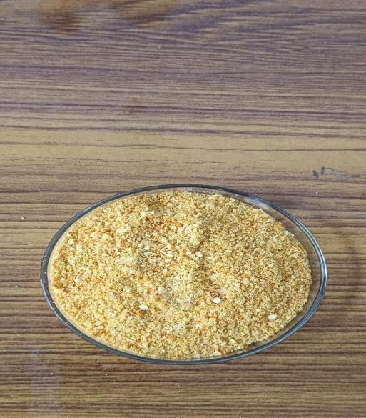

Figure 1 – Orange peel powder

3. Bioassay

150 gm of maize grains and glass jars were sterilized in the oven at 70º C for an hour (Mesbahm et al. 2018). 30 gm sterilized maize grains were mixed with the five different concentration of citrus peel powder for 1, 1.5, 2 and 2.5% (w/w = weight of powder/ weight of maize grains) in the 125 ml flask and manually shook for 30 second. The treated maize grains were carried onto the sterilized jars after which
10 pairs of adult weevil were released in the jar and then covered the mouth of jar with muslin cloth held by rubber band to prevent any escaping of weevil. A control treatment was also set- up in which no powder was added. The treatments were replicated three times (Asmanizar et al. 2012).

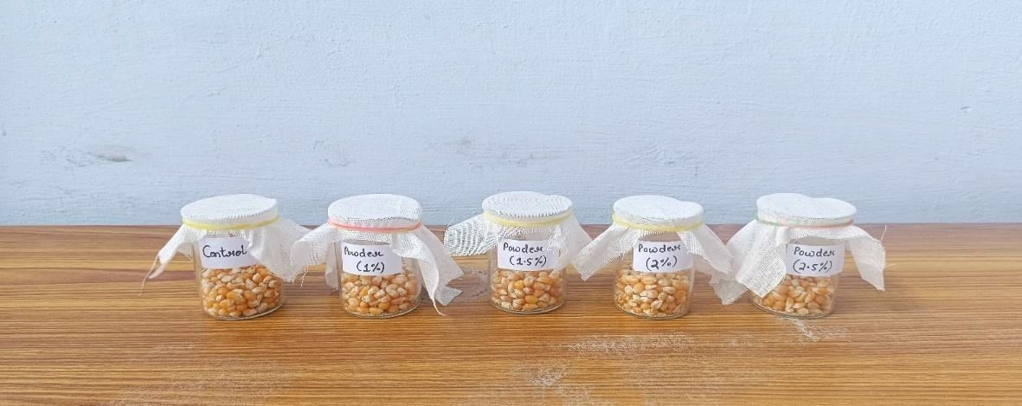

Figure -2, Bioassay for mortality and weight loss in orange peel treated maize grains

Assessment of mortality

For the mortality, the number of dead insects was counted at 1, 3, 7, 14 and 21 day after treatment. Rice weevil mortality was calculated by using Abbott’s formula (1925):

Percentage of corrected mortality =
(Observed mortality – Control mortality) 100 – Control mortality
x 100

Counting was stopped after 21 days to avoid overlapping of generation.

Assessment of weight loss

The weight loss estimated after 21 days of treatment and calculated as the difference between the final and initial weights of treated or untreated grain and expressed as a percentage of initial weight of grains. The following equation was used:

%WL =
IW − FW IW
X 100

where,WL = Weight Loss Index IW = Initial weight
FW = Final weight

Statistical analysis

The experiment was carried out by statistical analysis through one way ANOVA at value p<0.05 followed by Tukey’s Post Hoc test with p≤0.05 was used. The % mortality describe the mean ± SD of triplet experiment.

RESULTS AND DISCUSSION

The result of the experiment table 1 revealed the significantly (p<0.5) higher mortality at 21 days of powder treated maize grain when compared to untreated ones. The data on mortality of rice weevil after 1, 3, 7, 14 and 21 days after treatment at 1%, 1.5%, 2% and 2.5% were recorded. Result demonstrated the mortality rate increases from 18.59% to 35.52% with the increasing dosage level of powder extract from 1% to 2.5% at 21 days after treatment. Similar findings

observed by Tesfaye et al. 2021 in sorghum after treated with the orange peel powder, mortality rate of Sitophilus oryzae increased from 3.18% in the untreated control to 17.73% in the treated one after 21 days of treatment.

Tayeb et al. 2011 reported 67.5% mortality in rice treated with 0.5 gm orange peel powder after 21 days. Yunis, 2014 also observed the effect of orange peel powder showed the mean mortality of 63% after 3 days of exposure period on confused beetle Tribolium confusum. Abdullahi et al. 2010 noted 92 % mortality rate with the application of citrus peel powder after 120 hrs post-treatment against Tribolium castaneum. Iram et al. 2013 evaluated the Citrus reticulata and Psidium guajava for the control of Tribolium castaneum. In their study, Citrus reticulata peel powder showed the mortality of 63.66% after 21 days of treatment period. Rice treated with powder of Melia azedarach showed mortality of 80.54% in Sitophilus oryzae after 35 days reported by Devi et al. 2014. Emeasor et al. 2008 reported the 51% mortality after application of Citrus sinesis rind powder for the control of Sitophilus zeamais on maize grains. Asmanizar et al.2012 reported the leaf powder of Azadirachta indica and Jatropa curcas showed mortality of 32.32% and 77.84% respectively in Sitophilus zeamais. Certain plant material e.g. Catharanthus roseus and Annona squamosa showed significant mortalities of 16.67% and 13.3% respectively in Sitophilus oryzae after a month (Radhakrishnan et al. 2025).

The data of mean percentage weight loss of maize grains treated with different doses of Citrus reticulata peel powder extract were shown in table 2. The weight loss observed ranged from 10.87% to 12.96% after 21 days post- treatment indicated a noticeable variation among the different dosage of powder extract compared to untreated control one of 24.12% weight loss. Treatment of stored rice with Citrus reticulata peel powder reduced the weight loss caused by Sitophilus oryzae from 5.49% in the control to 4.35 % after 35 days of exposure time reported by the Chayengia et al. 2010. Work of Nta et al. 2017 also showed the significant effect in weight loss of maize grains, In their study, efficacy of powder of Citrus sinesis, Citrus reticulata, Citrus limon, Citrus paradisi and Citrus aurantifolia at 2%, 4%, 8% and 10 % were observed for weight loss in maize grains by Sitophilus oryzae. Zewde and Jembere, 2010 evaluated the orange peel for its toxicity, repellency and as grain damage protectant against Zabrotes subfasciatus.

Their study showed that the mean weight loss of 0.53% were observed with orange peel powder treated haricot beans after 45 days of post- treatment. Vijay et al. 2015 recorded 11.12% weight loss in split pulses infested by Sitophilus oryzae. Maize treated with leaf powder of tulsi showed maximum weight loss in maize recorded by Sangma et al.2022.

Table – 1, Effect of powder extract of Orange peel on the mortality of
Sitophilus oryzae on maize

S.  no. | Day | Mean % mortality of powder extract (w/w %) |  |  |  | F value | P value
S.  no. | Day | 1% | 1.5% | 2% | 2.5% | F value | P value
1 | 1 | 0±0ª | 6.84±2.736^{abc} | 11.936±3.33^{cd} | 20.346±5.035^{d} | 20.056 | 0.0004
2 | 3 | 5±5 ª | 11.926±7.47 ^{ab} | 18.593±5.56 ^{ab} | 23.766±3.326^{b} | 6.484 | 0.015
3 | 7 | 8.42±2.736 ª | 16.84±5.473 ^{ab} | 20.346±5.035^{b} | 23.766±3.326^{b} | 7.047 | 0.012
4 | 14 | 13.506±2.586 ª | 16.84±5.473 ^{ab} | 25.346±4.49 ^{bc} | 28.766±2.136^{c} | 9.947 | 0.004
5 | 21 | 18.593±2.436 ª | 21.926±5.323 ª | 27.013±7.19^{ab} | 35.52±4.243^{b} | 6.262 | 0.017

Figure – 3, Effect of powder extract of Orange peel on the mortality of Sitophilus oryzae on maize
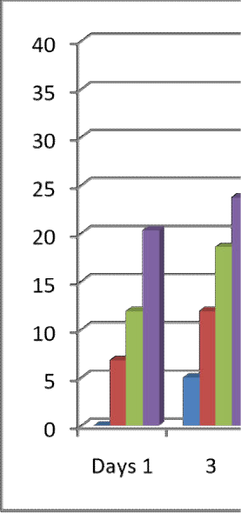
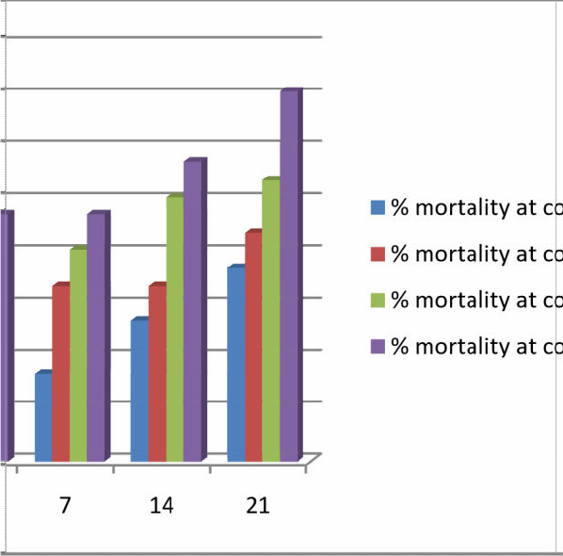


Table – 2, Effect of powder extract of Orange peel on the weight loss in maize caused by Sitophilus oryzae after 21 days

S.  no. | Mean % wt loss in control | Mean % wt loss in maize with powder extract (w/w %) |  |  |  | F value
S.  no. | Mean % wt loss in control | 1% | 1.5% | 2% | 2.5% | F value
1 | 24.12±0.27ª | 12.96±0.40 ^{b} | 12.52±0.26 ^{b} | 11.7±0.22 ^{c} | 10.87±0.40 ^{d} | 1017.6

Figure – 4 Effect of powder extract of Orange peel on the weight loss in maize caused by Sitophilus oryzae after 21 days


CONCLUSION

The result obtained from these studies confirmed that Citrus reticulata possess toxic effect on the Sitophilus oryzae. The findings of present study support the potential of Orange peel powder extract as the botanical insecticide against the rice weevil (Sitophilus oryzae) to reduce the post-harvest grain damage by causing significantly high rate of mortality and lowering the weight loss in maize. Orange peel is also easily available throughout the country. Rather than letting orange peels become environmental pollutants, they can be utilized in formulating nutritious animal feed to promote sustainable development (Akinlabu et al. 2024). Therefore, this plant powder used as a biopesticides for the management of insect pests in stored grains. After the well supported reports of insecticidal properties of orange peel powder, renders orange peel as potentially effective agent for use as an eco-friendly biopesticide. Orange peel waste contains a bioactive compound (e.g. limonene) that possesses insecticidal activity which can be utilized for the regulation of herbivore insects, weeds, nematodes when applied as a foliar spray, soil addictive that limit the reliance on synthetic pesticides. (Kato- Noguchi and Kato, 2025).

CONSENT
It is not applicable.

ETHICAL APPROVAL
It is not applicable.

REFERENCES

- Abbott, W. S. (1925). A method of computing the effectiveness of an insecticide. Journal of Economic Entomology, 18(2), 265–267. https://doi.org/10.1093/jee/18.2.265
- Abdullahi, N. A., Muhammed, A., & Tukur, Z. (2010). Assessment of citrus peel powder against Tribolium castaneum (Coleoptera: Tenebionidae) infesting stored products. Bioscience Research Communications, 22(5), 283-286.
- Akbar, R., Khan, I. A., Alajmi, R. A., Ali, A., Faheem, B., Usman, A., Ahmed, A. M., El-Shazly, M., Farid, A., Giesy, J. P., & Aboul-Soud, M. A. M. (2022). Evaluation of insecticidal potentials of five plant extracts against the stored grain pest, Callosobruchus maculatus (Coleoptera: Bruchidae). Insects, 13(11), 1047. https://doi.org/10.3390/insects13111047
- Akinlabu, K. D., Owoeye, T. F., Emetere, M. E., Jonathan, H. O., Owoeye, D. I., & Akinlabu, P. O. (2024). Investigation of Proximate Analysis and Phytochemical Screening of Dry Orange Waste (Citrus sinensis) Extract: From Agrowaste to Sustainable Development. IOP Conference Series: Earth and Environmental Science, 1342(1), 012016. https://doi.org/10.1088/1755-1315/1342/1/012016
- Anandhabhairavi, N., Shanthi, M., Chinniah, C., Geetha, R., & Vellaikumar, S. (2022). Efficacy of Hexane Extracts of Some Plants Against Rice Weevil Sitophilus Oryzae (L.) in Stored Maize. Indian Journal of Entomology, 84(2), 368-372. https://doi.org/10.55446/IJE.2021.41
- Asmanizar, A., Djamin, A., & Idris, A. B. (2012). Evaluation of Jatropha curcas and Annona muricata seed crude extracts against Sitophilus zeamais infesting stored rice. Journal of Entomology, 9, 13-22. https://doi.org/10.3923/je.2012.13.22
- Azis, T. M. F., Mohamad, S., & Azmi, N. M. (2016). Repellent Effects of Dried and Powder of Citrus Limon, Capsicum Annum, Cinnamomun Zeylanicum and Menthe Piparita on Rice Weevils Sitophilus Oryzae in Rice Products. J. Appl. Environ. Biol. Sci, 6(10S), 79-82.
- Centre for Agriculture and Rural Development Policy Research. (2023). ANGRAU Maize Outlook Report – June to May 2023-24. Acharya N. G. Ranga Agricultural University. https://angrau.ac.in/downloads/AMIC/OutlookReports/2023_24/Maize%20outlook-June-july-2023-24.pdf
- Chayengia, B., Patgiri, P., Rahman, Z., & Sarma, S. (2010). Efficacy of different plant products against Sitophilus oryzae (Linn.) (Coleoptera: Curculionidae) infestation on stored rice. Journal of Biopesticides, 3(3), 604-609. https://doi.org/10.57182/jbiopestic.3.3.604-609
- Devi, M. B., Devi, N. V., & Singh, S. N. (2014). Effects of Six Botanical Plant Powder Extracts on the Control of Rice Weevil, Sitophilus Oryzae L. in Stored Rice Grains. International Journal of Agriculture Innovations and Research, 2(5), 683-686. https://www.ijair.org/volume-2-issue-5-march-2014/IJAIR_510_Final.pdf
- Diniso, T., Oriola, A. O., Adeyemi, J. O., Miya, G. M., Hosu, Y. S., Oyedeji, O. O., Kuria, S. K., & Oyedeji, A. O. (2024). Citrus wastes: A valuable raw material for biological applications. Journal of Applied Pharmaceutical Science, 14(8), 011-026. https://doi.org/10.7324/JAPS.2024.158781
- Ekeh, F. N., Oleru, K. I., Ivoke, N., Nwani, C. D., & Eyo, J. E. (2013). Effects of Citrus sinensis peel oil on the oviposition and development of cowpea beetle Callosobruchus maculatus (Coleoptera: Chrysomelidae) in some legume grains. Pakistan Journal of Zoology, 45(4).
- Emeasor, K. C., & Okorie, C. C. (2008). Comparative efficacy of sweet orange, Citrus sinensis (l) rind powder and oil for the control of maize weevil, Sitophilus zeamais (motschulsky). Agro-Science, 7(1), 9-14.
- Gotmare, S., & Gade, J. (2018). Orange peel: A potential source of phytochemical compounds. International Journal of ChemTech Research, 11(02), 240-243. https://doi.org/10.20902/IJCTR.2018.110229
- Halstead, D. G. H. (1963). External sex differences in stored-products Coleoptera. Bulletin of Entomological Research, 54(1), 119-134. https://doi.org/10.1017/S0007485300048665
- Ileke, K. D., & Ogungbite, O. C. (2014). Entomocidal activity of powders and extracts of four medicinal plants against Sitophilus oryzae (L), Oryzaephilus mercator (Faur) and Ryzopertha dominica (Fabr.). Jordan Journal of Biological Sciences, 7(1), 57-62. http://jjbs.hu.edu.jo/
- Iram, N., Arshad, M., & Akhter, N. (2013). Evaluation of Botanical and Synthetic Insecticide for the Control of Tribolium castaneum (Herbst) (Coleoptera: Tenebrionidae). BioAssay. https://doi.org/10.14295/BA.v8.0.117
- Kato-Noguchi, H., & Kato, M. (2025). Pesticidal Activity of Citrus Fruits for the Development of Sustainable Fruit-Processing Waste Management and Agricultural Production. Plants, 14(5), 754. https://doi.org/10.3390/plants14050754
- Kumari, A., & Jha, A. K.(2022). Study of the effect of neem leaves

powder and orange peels powder on weevil growing on maize grains. Biospectra, 17(1), 17-22.
- Mesbahm, H. A., Mahomed, A. A., & Aajel, M. S. (2018). Eco-friendly tools for controlling of the rice weevil Sitophilus oryzea (Coleoptera: Curculionidae). Alexandria Science Exchange Journal, 39(July- September), 482-493. https://doi.org/10.21608/asejaiqjsae.2018.15922
- Nta, A. I., Okweche, S. I., & Udo, I. A. (2017). Insecticidal and insect reproductive inhibition potential of Citrus peel powder on Tribolium castaneum (Herbst). Applied Tropical Agriculture, 22(2), 111-117. https://journals.futa.edu.ng/ata/article/view/111
- Octavianti, D. F., Megasari, D., & Prasetyawati, E. T. (2024). Resistance response of five maize grain varieties to Sitophilus zeamais and Sitophilus oryzae (Coleoptera:Curculionidae). Agrovigor: Jurnal Agroekoteknologi, 17(2), 98-104. https://journal.trunojoyo.ac.id/agrovigor/
- Radhakrishnan, V., Arulprakash, R., Ravi, M., Allwin, L., Vijay, S., Vijayaprabhakar, A., Karunakaran, V., Periyar Ramasamy, D., & Harisudan, C. (2025). Botanical management of Sitophilus oryzae (L.) in sorghum seeds. International Journal of Agriculture and Food Science, 7(1), 35-37. https://doi.org/10.33545/2664844X.2025.v7.i1a.235
- Sangma, R. H. C., Patra, S., Thakur, N. S. A., & Baiswar, P. (2022). Management of maize weevil, Sitophilus zeamais (M.) using indigenous plant extracts at medium altitude hills of Meghalaya. Indian Journal of Hill Farming, 35, 214-223. https://ijhfonline.org/index.php/ijhf/article/view/51
- Sharma, P., & Gupta, S. (2025). Phytochemical Screening and Thin Layer Chromatography of Citrus Reticulata Peel Extract. Current Journal of Applied Science and Technology, 44(10), 80-87. https://doi.org/10.9734/cjast/2025/v44i104621
- Soujanya, P. L., Sekhar, J. C., & Kumar, P. (2016). Efficacy of plant extracts against rice weevil Sitophilus oryzae (L.) in stored maize. Indian Journal of Entomology, 78(4), 342-345. https://doi.org/10.5958/0974-8172.2016.00089.4
- Tayeb, E. H. M., HAA, M., AA El-Sayed, N., BA El-Kady, M., & Greira, A. A. (2011). Biological Performance of Certain Botanical Fine Dusts, Ash and Sulfur Powders against the Rice Weevil Sitophilus oryzae (L.)(Coleoptera: Curculionidae). Alexandria Science Exchange Journal, 32(APRIL-JUNE), 173-181.
- Tesfaye, A., Jenber, A. J., & Mintesnot, M. (2021). Survey of storage insect pests and management of rice weevil, Sitophilus oryzae, using botanicals on sorghum (Sorghum bicolor L.) at Jawi District, Northwestern Ethiopia. Archives of Phytopathology and Plant Protection, 54(19-20), 2085-2100. https://doi.org/10.1080/03235408.2021.1970976
- Vijay, S., Bhuvaneswari, K., & Gajendran, G. (2015). Assessment of grain damage and weight loss caused by Sitophilus oryzae (L.) feeding on split pulses. Agricultural Science Digest-A Research Journal, 35(2), 111-115. https://doi.org/10.5958/0976-0547.2015.00019.1
- Abbas, S. K., Ahmad, F., Sagheer, M., Hasan, M. U., Yasir, M., Ahmad, S., & Muhammad, W. (2012). Insecticidal and growth inhibition activities of Citrus paradisi and Citrus reticulata essential oils against lesser grain borer, Rhyzopertha dominica (F.) (Coleoptera: Bostrichidae). World Journal of Zoology, 7(4), 289-294. https://doi.org/10.5829/idosi.wjz.2012.7.4.62181
- Yunis, M. I. (2014). Effect of Orange Peel (Citrus sinensis) (L) extrcts and powder on confused flour beetle Tribolum confusum (Coleoptera: Teneberionidae). Iraqi Journal of Science, 55(3B), 1164-1169. https://ijs.uobaghdad.edu.iq/index.php/eijs/article/view/11543
- Zewde, D. K., & Jembere, B. (2010). Evaluation of orange peel Citrus sinensis (L) as a source of repellent, toxicant and protectant against Zabrotes subfasciatus (Coleoptera: bruchidae). Momona Ethiopian Journal of Science, 2(1), 61-75. https://www.ajol.info/index.php/mejs/article/view/69030
- Zulaikha, S. A. S., & Yaakop, S. (2021). Effect on Sitophilus oryzae infestation on amylose content and weight loss of eight rice varieties. Pak. J. Agri. Sci., 58(6), 1699-1703. https://doi.org/10.21162/PAKJAS/21.480.

