Case report
Milk Goitre In Kid: A Case Report

ABSTRACT:
A case of one week old kid was presented at Veterinary Clinical Complex, College of Veterinary Sc. & A. H., Rewa, M.P., India with a complaint of swelling under neck, gasping, anorexia and vomiting milk. Upon clinical examination the lesion revealed hard, glandular, painless, palpable swelling at cranio-ventral neck region in the throat at thyroid region. Clinical signs revealed gasping with respiratory rate 56/min, temperature as 104.3 F and pulse rate- 98/min. Ultrasonography of the neck and mediastinum revealed presence of thymus tissue. Haematological examination revealed anaemia with low RBC count and haemoglobin value. On the basis of clinical signs and laboratory findings, the case was diagnosed as milk goitre.
Key words: Goitre, thyroid swelling, kid, blood analysis.

INTRODUCTION:
Thymus is an important gland which plays a vital role in the immune system. The differentiation and development of T cells, which play an important role in immunity, takes place in this vital immune organ. The normal position of the thymus is in front of and above the great blood vessels of the mediastinum, adjacent to the thyroid gland superiorly, and close to the fourth costal cartilage inferiorly.
The thymus is a bilobed structure. Each lobe has an independent fibrous capsule. The two are connected by the isthmus and have different shapes. Development of thymus commences around the fourth week of gestation, originating from the ectoderm of the third branchial cleft and the endoderm of the third parotid pouch. By the 7-8th week of gestation, the primary thymus migrates towards the central axis. During the early period of life, the volume of the thymus increases relatively (relative to body weight). Later in life, it gradually degenerates and is replaced by adipocytes.
---------------------------------------------------------------------------------------------------------------

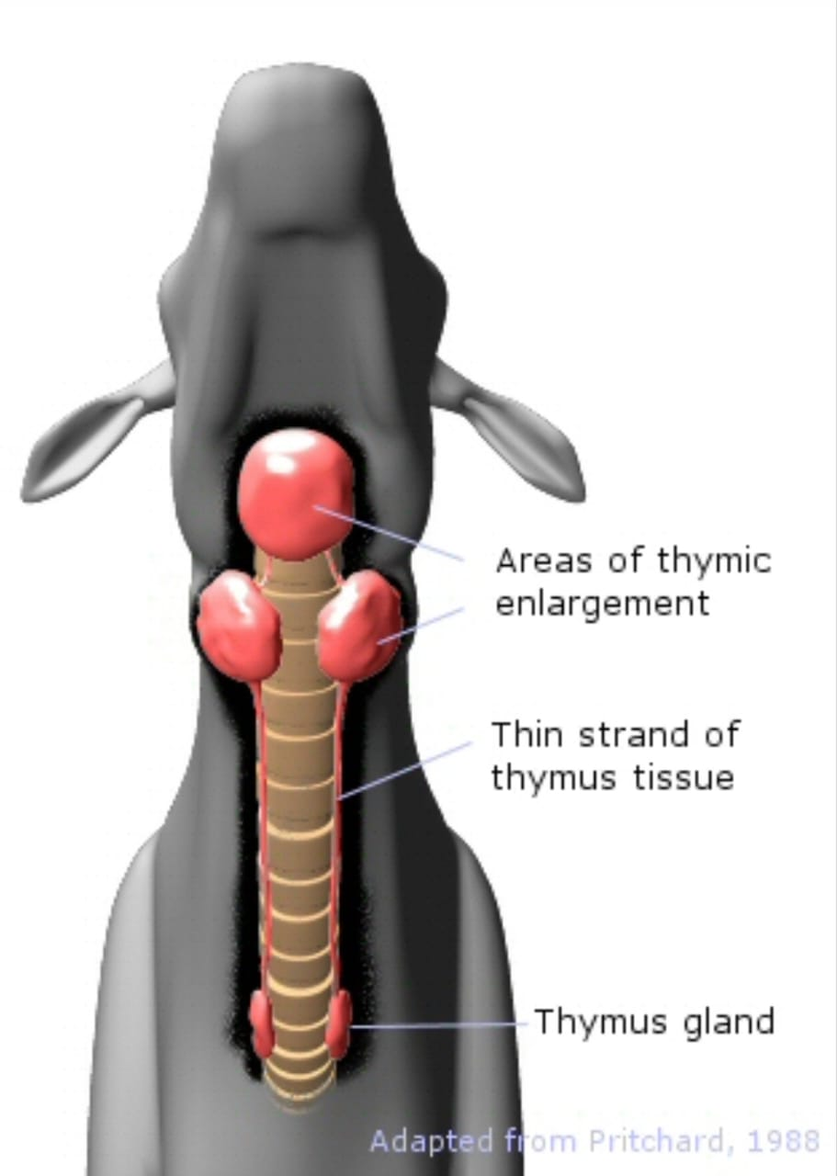

Fig-1 Showing Anatomic Representation of Milk Goitre

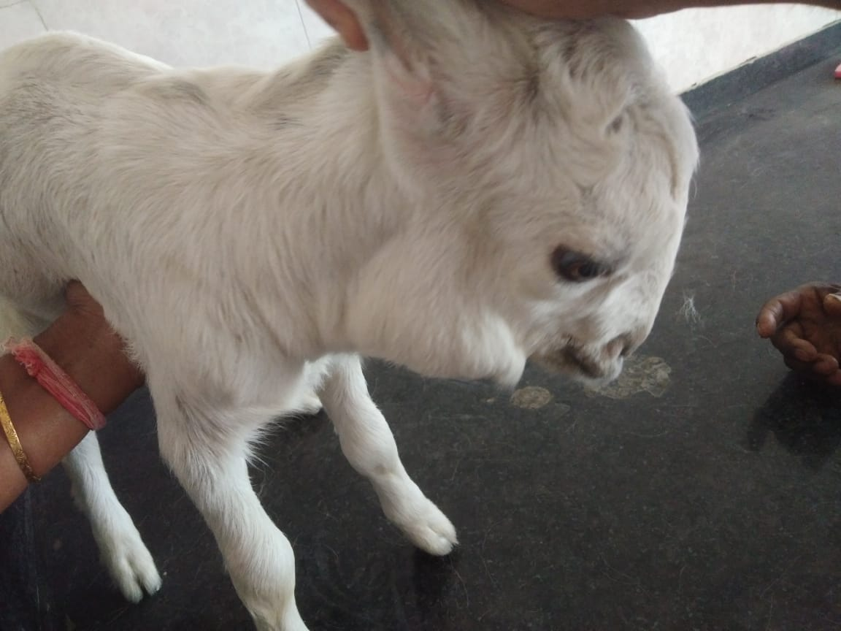
Fig-2 Showing Thymic Enlargements in goat kid

However, various factors may disrupt this process, leading to congenital anomalies such as incomplete descent and or regression of the of thymus tissue which may be regarded as a Tumors or even tumors may be mistakenly cut, causing immune deficiency in the later stages of life.
Persistence of residual thymus tissue can result in the formation of ectopic thymus predisposing the neonates to immune deficiencies (Huang, et al., 2013). Although ectopic thymus is rare in animals, sporadic cases have been reported in sheep and goat kids in the neck or mediastinum, with fewer occurrences in the pericardium, chest wall, axilla, and thyroid gland. The prevalence of this condition in goat kids is not known exactly but has been reported in few species of goats in India and abroad.
This article focuses on a neonatal goat kid with incomplete regression and descent of thymus gland.

CASE HISTORY AND OBSERVATION:
A case of one week old goat kid was presented at Veterinary Clinical Complex (VCC), College of Veterinary Sc. & A. H., Rewa, M.P., India with a complaint of difficulty in suckling, vomiting milk soon after suckling, anorexia, respiratory distress and swelling under neck which was constant in size since birth.
History revealed that the doe (female goat) had delivered two kids with the neck swelling at birth itself. One kid died two days after birth and the second kid was brought to VCC. Physical examination of the swelling revealed painless, palpable enlargement in the cranio-ventral neck region in the area of thyroid gland. Gasping and respiratory distress was noticed with hypoxia condition. Clinical examination revealed pale conjunctival and oral mucous membranes, temperature of animal was 104.3 F, pulse rate- 98/min, and respiratory rate 56/min. Ultrasonography of the neck and mediastinum revealed presence of thymus tissue.
For laboratory diagnosis, four ml blood was collected for the estimation of haematological parameters like haemoglobin, RBC count, WBC count and DLC. Haematological examination revealed anaemia with low haemoglobin (4.5 Hb gm%), PCV (20 %). Total leucocyte count was 6.170×10³ /mm³). DLC revealed 72% neutrophils, 25% lymphocytes, and 3% esinophils.
The kid was treated with parenteral anti-inflammatory injection for 2 days and oral haematinic suspension for 15 days. but it also died on the 10th day of birth. Post-mortem of the kid revealed bilaterally symmetrical enlargement of the thymus glands extending from mediastinum. No histopathology of the mass was done.
On the basis of history, physical examination, clinical and haematological findings, the case was diagnosed as milk goitre which is common in this age in certain breeds of goat kids. The kid was treated with anti-inflammatory drug (injection Melonex 0.2 lm IM) to treat the pyrexia, and oral haematinic (aRBC Rakkt @ 2.5 ml twice a day for 15days). No specific treatment for goitre was given as it is also not recommended because the condition either subsides with age or terminates in death eventually with or without treatments.
In our case, 1st kid died two days after birth and this kid (2nd kid) died on the 10th day after birth. Post-mortem of the kid revealed bilaterally symmetrical enlargement of the thymus glands extended from mediastinum. No histopathology of the mass was done.

DISCUSSION:
Milk goiter is an enlargement of the thymus gland.. The thymus gland which is part of the maturation of the immune system in nearly all juvenile mammals, is located at the base of the neck. It can extend to surround the heart, and in some goats a thin strand extends all the way up the neck enlarging in the area over the thyroid gland and can appear in the area under the lower jaw. The thymus of the goat can be quite large in young animals reaching a peak in size at about 4 months of age and then begins to regress to a small size by 6 to 7 months of age.
Neonates do not have a fully mature immune system at birth and its development begins in early fetal stages. The immune system comprises innate and adaptive immunity. The thymus serves as the primary lymphoid organ of the immune system and facilitates the development of T cells.
Incomplete descent of thymic tissue is due to various factors resulting in partial or complete ectopic thymus and is mostly found in the neck, mediastinum, or lungs, with rare occurrences in the pharynx. Due to its varied locations, ectopic thymus may be misdiagnosed as a tumor or mass, or even goitre due to iodine deficiency in the pregnant animals. Ectopic thymus has also been found in the esophagus and thyroid (Huang, et al., 2013), with fewer clinical cases identified in newborn human subjects, who often present with respiratory or swallowing difficulties (Felgentreff et al., 2009; Ashraf, et al., 2022).
The ectopic thymus in the throat under the neck region appears as a prominent swelling and is fairly common in goat kids in some breeds of goats like Sanen, Anglo-Nubians and Toggenburgs (Pritchard, 1988). Many other workers have reported swelling in the throat region in goat kids with different findings but most commonly thyroid gland swelling. Mild enlargement of glands in this region cannot be easily detected and differentiated because of the anatomical locations of thyroid and other glands in this region. Thyroid gland swelling is located behind the larynx, and slightly below and laterally. Milk goiter i.e. thymic enlargement is quite obvious, appearing in front of, and on both sides of the throat over the larynx, typically anteriorly just under the joint of mandibles as in our case. Why the thymus gland is larger in some neonates than others is not well understood. However, reducing the size at an early age could result a less efficient immune response for the life of the goat as has been shown to be the case in humans..
Pritchard (1988) studied the throat swellings in a herd of mainly Anglo-Nubians, Toggenburgs and Saanens breeds of goats. He observed that over several years most kids developed throat swellings in the area of the thyroid gland from the time they were about 7 to 10 days old which persisted until they were slaughtered at 6 to 9 months of age but usually began to reduce in size at about 4 months of age. leaving behind a loose flap of skin. Necropsy of the swellings showed that the throat swelling were due to "gross enlargement of the thymus, with most of the extra thoracic portion - weighing in excess of 200 grams - being located in the upper neck region." Histologically, the thymus tissue was normal. Screening of the goats of all ages from the entire herd for diseases including Caprine Arthritis and Encephalits (CAE) virus, enzootic bovine leucosis, border disease, infectious bovine rhinotracheitis, Toxoplasma gondii, and other bacteriology, virology, haematology, biochemistry and serology tests revealed negative test results. Analysis of feed showed an adequate amount of iodine and blood and milk samples revealed a slightly higher than normal level of iodine rather than a deficiency in the kids and dams.The symptoms of iodine deficiency in goat kids are weak with sparse hair coat, slow growth and low resistance to stress and in dams are abortion, low survival rate of kids . In his study, he reported that the kids were typical healthy, fast growing.
Symptoms like severe respiratory discomfort, change in vocalization, respiratory distress as in our case are also reported in human neonates due to thymic enlargement (Dimitriou et al., 2000; Windsor, 2018) in human subjects reported autoimmune myasthenia gravis (MG), a muscular disease mediated by autoantibodies, mainly directed against the acetylcholine receptor (AChR) due to hyperplasia of germinal centers of thymus.
Thus in our case, we conclude that the goat kid case was of Milk Goiter i.e thymus gland enlargement.

REFERENCES:
Alnosair, A. A., Alnosair, L. A., Almohammed Saleh, A. A., Al Zaid, A. R., Al Alhareth, A. S., & Alkhars, F. S. (2022). Solid Ectopic Cervical Thymus: A Case Report. Cureus, 14(5), e25142. https://doi.org/10.7759/cureus.25142
Felgentreff, K., Schupp, W., Otten, J. E., Rückauer, K. D., Uhl, M., Jüttner, E., Superti-Furga, A., & Pohl, M. (2009). Inspiratory stridor and dysphagia in two newborn infants caused by ectopic thymus tissue. European Journal of Pediatrics, 168(9), 1141-1145. https://doi.org/10.1007/s00431-008-0887-7
Dimitriou, G., Greenough, A., Rafferty, G., Rennie, J., & Karani, J. (2000). Respiratory distress in a neonate with an enlarged thymus. European Journal of Pediatrics, 159(4), 237–238. https://doi.org/10.1007/s004310050061
Huang Y, Zheng S, Xiao X. (2013). Ectopic intrathyroidal thymus in children: two case reports and review of the literature. J Pediatr Surg Case Rep. 1(11):386–90.
Pritchard, G.C. (1988) Throat swellings in goats. Goat Vet. Soc. J., 10 (1): 34-7
Windsor, P. (2018). Abnormalities of development and pregnancy. In D. E. Noakes, T. J. Parkinson, & G. C. W. England (Eds.), Veterinary Reproduction and Obstetrics (10th ed., pp. 168-194). Elsevier Health Sciences. https://doi.org/10.1016/C2014-0-04782-X

