Case Study
Clinico-Pathological and Molecular Diagnosis of Ccpp In Goats - A Case study

ABSTRACT
Contagious caprine pleuropneumonia (CCPP) is a highly contagious and economically important respiratory disease of goats caused by Mycoplasma capricolum subsp. capripneumoniae (Mccp). The present case study reports the clinico-pathological and molecular confirmation of CCPP in three goat flocks from Thotaravulapadu village, NTR district, Andhra Pradesh. Eleven goats of different age groups exhibited classical clinical signs including severe respiratory distress, sero-mucoid nasal discharge, coughing, dyspnoea, pyrexia, and general malaise. Three four-month-old kids that succumbed to the disease were subjected to detailed necropsy examination. Gross pathological findings revealed hydrothorax, bilateral fibrinous pleuritis, lung consolidation with characteristic marbling, and fibrinous pericarditis. Histopathological examination of lung tissues showed fibrin deposition, severe congestion, necrosis, sequestration, and infiltration of polymorphonuclear and mononuclear cells in alveoli and interlobular septa, along with fibrinous pleuritis. Molecular diagnosis was performed using polymerase chain reaction (PCR) targeting the arcD gene of Mccp, which yielded a specific 316 bp amplicon from lung tissue samples, confirming the presence of the pathogen. Based on the integration of clinical signs, gross and histopathological lesions, and molecular evidence, the diagnosis of CCPP was conclusively established. This case study highlights the importance of rapid clinico-pathological assessment combined with molecular diagnostics for accurate confirmation of CCPP, which is crucial for timely disease control and prevention in endemic regions.
Keywords: CCPP; Goat; Mycoplasma capricolum subsp. capripneumoniae; Marbling; PCR; Pathology
- INTRODUCTION
In India sheep and goat farming is actively promoted by the government itself as a means to enhance livelihood security and achieve food security. These forms are now playing crucial role as the backbone of the rural economy in India, playing a vital role in improving the livelihood security and socio-economic status of rural and peri-urban communities, especially in developing countries across Africa and Asia. In these regions, outbreaks of CCPP can result in morbidity rates approaching 100% and mortality ranging from 60–80%, leading to severe production losses, trade restrictions, and disruption of rural economies (Thiaucourt et al., 1996). Contagious caprine pleuropneumonia (CCPP) is a serious disease of goat with high morbidity and mortality rates. It is recognized as one of the most economically devastating mycoplasmal diseases of goats and is listed by the World Organisation for Animal Health (WOAH, formerly OIE) as a notifiable transboundary animal disease due to its rapid spread and serious socio-economic consequences (WOAH, 2022).
Diagnosis of contagious caprine pleuropneumonia is often complicated by the non-specific nature of early clinical signs and its close resemblance to other caprine respiratory diseases such as pasteurellosis, peste des petits ruminants, and contagious agalactia. Field diagnosis based solely on clinical manifestations and gross lesions may therefore lead to misdiagnosis and delayed control measures (Nicholas et al., 2008; Nicholas and Churchward, 2012). Conventional isolation of Mycoplasma capricolum subsp. capripneumoniae is laborious and time-consuming due to the fastidious growth requirements of the organism (Bölske et al., 1996; Thiaucourt and Bölske, 1996). Consequently, confirmatory diagnosis increasingly relies on the integration of pathological examination with molecular techniques. Histopathology provides valuable insights into disease pathogenesis and lesion progression, while polymerase chain reaction (PCR) targeting specific genes such as arcD enables rapid, sensitive, and specific detection of the pathogen directly from clinical samples (Woubit et al., 2004; Abraham et al., 2015). An integrated clinico-pathological and molecular diagnostic approach is therefore essential for accurate confirmation of CCPP, particularly in endemic regions where early intervention is critical to limit disease spread and economic losses (Yatoo et al., 2018; WOAH, 2022).
CCPP is caused by Mycoplasma capricolum subsp. capripneumoniae (Mccp) which was previously known as Mycoplasma F38 strain (Bascuñana et al.,1994, Bolske et al., 1996 and Abraham et al., 2015). The disease is characterized by acute fibrinous pleuropneumonia, severe respiratory distress, and high mortality, particularly in naïve goat populations (Nicholas et al., 2008). The principal lesion at necropsy is fibrinous pleuropneumonia with massive lung consolidation, accompanied by accumulation of straw-coloured pleural fluid. Affected goats are characterized by fever, coughing and severe respiratory signs with pneumonic changes causing a fatal condition (Abraham et al., 2015 and Yatoo et al., 2019). Due to the fastidious nature of the causative organism and similarities with other caprine respiratory diseases, definitive diagnosis remains challenging and requires laboratory confirmation using serological and molecular techniques such as competitive ELISA and PCR. Despite advances in diagnostic tools and vaccination strategies, control of CCPP remains difficult in endemic regions due to limited surveillance, unrestricted animal movement, and inadequate awareness among farmers. Effective prevention relies on early detection, quarantine measures, vaccination, and strengthening of disease reporting systems (WOAH, 2022). In view of the growing importance of goats in food security and poverty alleviation, a comprehensive understanding of the epidemiology, pathogenesis, diagnosis, and control measures of CCPP is essential. Hence, confirmative diagnosis of CCPP is essential and should be rapid for this devasting disease in endemic areas, to lower the morbidity and mortality rates (Yatoo et al., 2018 and Parray et al., 2019). So, the current case study will provide insights of clinic-pathological and molecular confirmation of CCPP in Goats.
HISTORY AND OBSERVATIONS
In the present study eleven goats of different age group among three goat flocks in Thotaravulapadu village, NTR district, Andhra Pradesh presented with history of clinical signs like respiratory distress, with sero-mucoid nasal discharges, coughing, dyspnoea, pyrexia and general malaise (Fig. 1). Among them, three kids of age four months died and were brought for postmortem examination. At necropsy, external examination showed muco-purulent discharges from nostrils and skin eruptions on the rim of nostrils. Internal examination revealed approximately 100ml of tan yellow coloured serous fluid in thoracic cavity and fibrinous pleural adhesions bilaterally (Fig. 2). Grossly, lungs exhibited lobes of consolidation and widened interlobular septa with jelly like material giving marbling appearance (Fig. 3). Pericardial sac contained approximately 40ml of serous fluid along with deposition of fibrin on pericardium (Fig. 4).
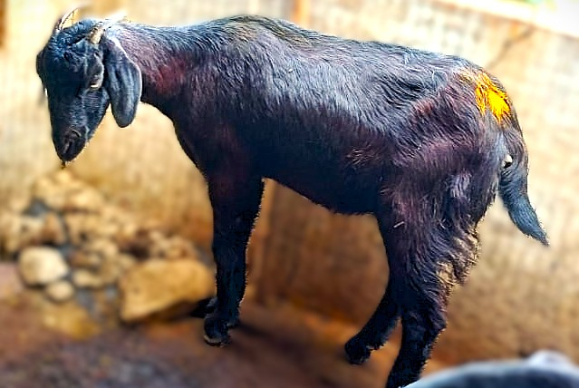 | 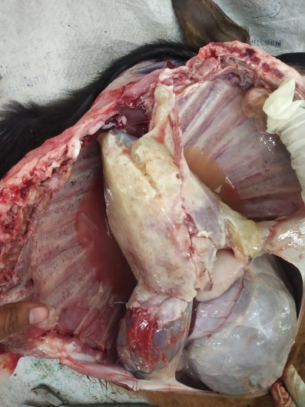
Fig 1: CCPP effected goat with sero-mucoid nasal discharges | Fig 2: Thoracic cavity: presence of yellow coloured serous fluid and bilateral fibrinous pleuritis
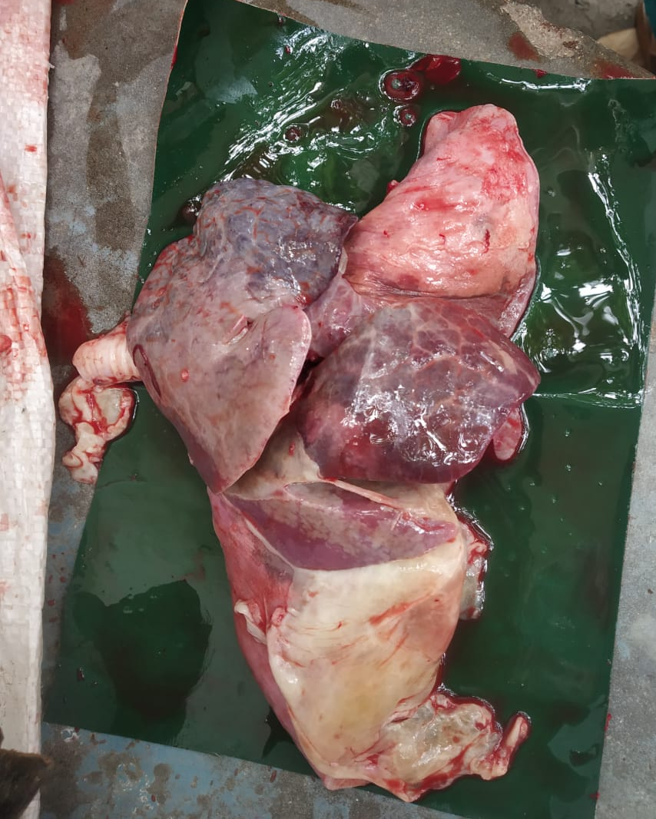 | 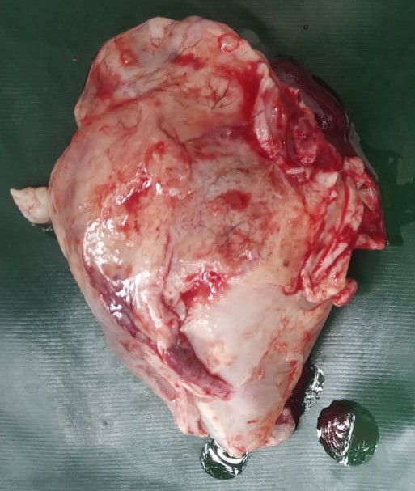
Fig 3: Marbling appearance of lungs | Fig 4: Fibrinous pericarditis
- MATERIAL AND METHODS

Study Area and Case History
The present investigation was conducted in Thotaravulapadu village, NTR district, Andhra Pradesh, India. The study involved three goat flocks where an outbreak of a severe respiratory disease was reported. A total of eleven goats of different age groups exhibited clinical signs suggestive of contagious caprine pleuropneumonia (CCPP), including respiratory distress, sero-mucoid nasal discharge, coughing, dyspnoea, pyrexia, and general malaise. Among the affected animals, three four-month-old kids succumbed to the illness and were submitted for detailed postmortem examination.

Postmortem Examination
A systematic necropsy was performed on all three deceased goats following standard veterinary necropsy procedures. External examination focused on the presence of nasal discharges, skin lesions around the nostrils, and general body condition. Internal examination emphasized the thoracic cavity, lungs, heart, and associated serosal membranes. Particular attention was given to the presence of pleural and pericardial effusions, pleural adhesions, lung consolidation, and any characteristic lesions such as marbling of lung tissue. Gross pathological findings were carefully documented and photographed for further analysis.

Collection of Tissue Samples
Representative tissue samples from lungs, heart, liver, and trachea were collected immediately after necropsy. For histopathological examination, tissue samples approximately 2–3 mm in thickness were fixed in 10% neutral buffered formalin. Separate lung tissue samples were collected aseptically and stored at −20°C for molecular analysis to avoid DNA degradation.

Histopathological Processing and Examination
Formalin-fixed tissue samples were processed following routine paraffin embedding techniques. Briefly, tissues were washed under running tap water to remove excess formalin, dehydrated through ascending grades of alcohol, cleared in xylol, and embedded in paraffin wax. Sections of 3–4 µm thickness were cut using a semi-automatic microtome. The tissue sections were mounted on glass slides and stained with hematoxylin and eosin (H&E) following standard protocols (Luna, 1968). Stained sections were examined under a light microscope for histopathological changes, including inflammatory cell infiltration, fibrin deposition, necrosis, sequestration, and involvement of pleura and pericardium.

Molecular Diagnosis

DNA Extraction
Genomic DNA was extracted from frozen lung tissue samples using the HiPurA® Mammalian Genomic DNA Purification Kit (HiMedia Laboratories, India) following the manufacturer’s instructions. The extracted DNA was quantified and assessed for purity before being used as a template for polymerase chain reaction (PCR).

Polymerase Chain Reaction (PCR)
Molecular detection of Mycoplasma capricolum subsp. capripneumoniae was carried out by PCR targeting the arcD gene, a species-specific marker. PCR amplification was performed using primers described by Abraham et al. (2015). The forward primer sequence was 5′-ATCATTTTTAATCCCTTCAAG-3′ and the reverse primer sequence was 5′-TACTATGAGTAATTATAATATATGCAA-3′.
The PCR reaction mixture contained template DNA, primers, PCR master mix, and nuclease-free water in appropriate concentrations. Amplification was carried out under optimized cycling conditions consisting of initial denaturation, followed by repeated cycles of denaturation, annealing, and extension, and a final extension step.

Agarose Gel Electrophoresis
PCR products were subjected to electrophoresis on 1.5% agarose gel containing ethidium bromide. A 100 bp DNA ladder was used as a molecular size marker. The gel was visualized under ultraviolet illumination using a gel documentation system, and the presence of a specific 316 bp amplicon was considered confirmatory for Mycoplasma capricolum subsp. capripneumoniae.

Diagnostic Criteria
The diagnosis of contagious caprine pleuropneumonia was established based on a combination of clinical history, characteristic gross pathological lesions, histopathological findings, and molecular confirmation by PCR targeting the arcD gene of Mycoplasma capricolum subsp. capripneumoniae.
- RESULTS
Histopathological lesions
Almost all the lung sections revealed presence of fibrin and mixed leucocytic infiltrates in the alveoli and bronchioles. Several sections exhibited multiple focal areas of severe necrosis of lung parenchyma and these were surrounded by numerous polymorphonuclear cells and mononuclear cells. Further these necrotic areas were encircled by one to two layers of fibroblasts in few sections (Sequestration) (Fig. 5 and Fig. 6). Few sections showed infiltration of inflammatory cells predominately macrophages within the peribronchiolar and alveolar subepithelial areas (Fig. 7). All the sections demonstrated dilated interlobular septa containing edema, fibrin and inflammatory cells and the lesions extended to pleural surface resulting in fibrinous pleuritis. Sections from heart showed fibrin deposition along with numerous PMNs in pericardium (Fig. 8). Degenerative changes in hepatocytes were also noticed in liver along with severe congestion.

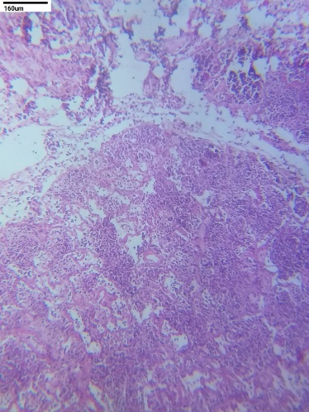 | 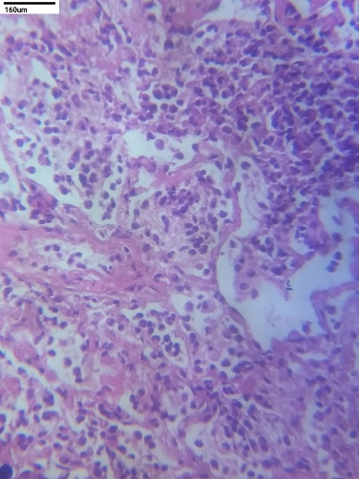
Fig. 5: Multifocal areas of necrosis and sequestration in lung parenchyma H&E,100x. | Fig. 6: Numerous PMNs and mononuclear cells in alveoli, H&E, 400x.
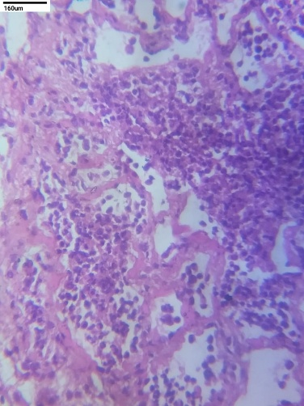 | 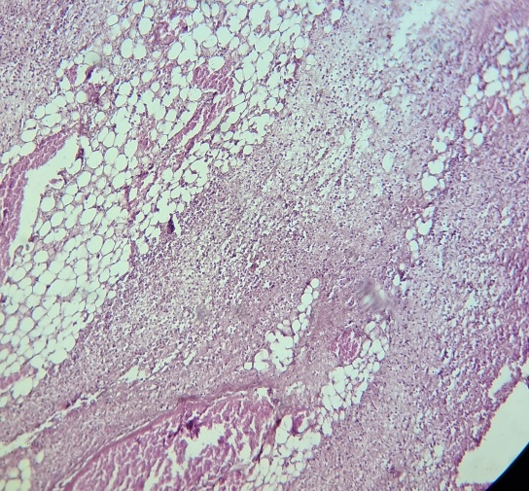
Fig. 7: Infiltration of inflammatory cells within the peribronchiolar and alveolar subepithelial regions, H&E,100x. | Fig. 8: Fibrin deposition along with numerous inflammatory cells in pericardium, H&E, 400x.

Polymerase chain reaction
In the present study, molecular diagnosis of CCPP in affected goat was carried out by amplification of arcD gene of Mccp using specific primers. The genomic DNA extracted from lung samples from dead goat were used for amplification and the positive samples yielded expected bands. On electrophoretic analysis, amplicons of 316bp size of arcD gene (Fig. 9) were obtained confirming the presence of Mccp in lung samples.
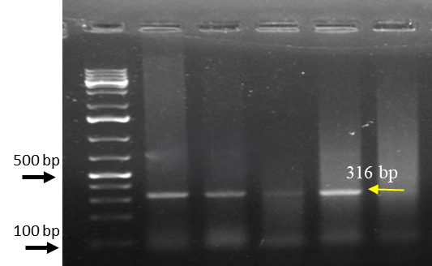
Fig. 9: Agarose gel electrophoresis showing amplified arcD gene fragment of Mccp
- DISCUSSION
The current study on an outbreak of Contagious Caprine Pleuropneumonia (CCPP) affecting eleven goats of varying age groups across three flocks in Thotaravulapadu village, NTR district, Andhra Pradesh, offers comprehensive insights. The affected animals exhibited typical clinical signs, including respiratory distress, sero-mucoid nasal discharge, coughing, dyspnea, pyrexia, and general malaise are considered as hallmark indicators of CCPP, a disease known for its high morbidity and mortality rates in goats (Kusiluka et al. 2000, Tharwat et al., 2017, Iqbal Yatoo et al., 2019, Dhaygude et al., 2023 and Esmaeili and Joghataei, 2024). These symptoms are directly linked to the pathogenesis initiated by the inhalation of Mycoplasma capricolum subsp. capripneumoniae (Mccp), the causative agent of CCPP. Upon inhalation, Mccp colonizes the respiratory tract, adhering to the ciliated epithelium of the lungs (Iqbal Yatoo et al.,2019).
Postmortem examinations of three deceased kids revealed characteristic lesions of CCPP, including muco-purulent nasal discharges, skin eruptions around the nostrils, accumulation of approximately 100 ml of tan-yellow serous fluid in the thoracic cavity, bilateral pleural adhesions with fibrin deposition, consolidated lungs with widened interlobular septa containing jelly-like material, and about 40 ml of serous fluid in the pericardial sac with fibrin deposition on the pericardium, which were also reported similarly by Dhaygude et al. (2023). The marked gross lesions like hydrothorax, pleural thickening, pleural adhesion, consolidation of lobes of the lung and characteristic marbling observed in the present case are in accordance with the previous observations (Nicholas et al., 2008; OIE, 2008, Sasikala et al., 2020). Colonization of bacteria in ciliated epithelium triggers an inflammatory response characterized by the release of cytokines such as tumour necrosis factor and interleukins, leading to vasculitis and fibrino cellular exudation. (Elhassan and Salama 2018, Iqbal Yatoo et al., 2019, Parray et al., 2019 and Sasikala et al., 2020).
In corroboration with the earlier reports, histopathology of lung sections revealed severe congestion, multifocal necrotic areas along with infiltration of numerous PMNs and mononuclear cells encircled by one to two layers of fibroblasts (Abraham et al., 2015 and Nicholas and Churchward, 2012). Further, the dilated interlobular septa containing edema, fibrin and inflammatory cells and the extended lesions to pleural surface resulting in fibrinous pleuritis were in agreement with (Parray et al., 2019 and Sasikala et al., 2020). Unilateral lung involvement and marbling are a characteristic feature of CBPP and rarely seen in CCPP but it was more prominent in the present case (Radostatis et al., 2000, Sasikala et al., 2020).
An outbreak of CCPP in a goat farm of Kerala was reported by Abraham et al. (2015) based on PCR amplification of the arcD gene and as similar report by Abdollahi et al. (2023), in the current study, the molecular diagnosis of the presence of the pathogen in lung samples was done through Polymerase Chain Reaction (PCR) targeting the arcD gene of Mccp confirmed, with the amplification of a 316 bp fragment. This gene exhibits significant sequence divergence compared to homologous regions in closely related species within the Mycoplasma mycoides cluster. Due to this high variability, the arcD gene serves as a specific and reliable target for PCR-based diagnostics, enabling accurate identification of Mccp and differentiation from other mycoplasmas that may cause similar clinical signs in goats (Woubit et al., 2004).
- CONCLUSION
The present case study conclusively confirms the occurrence of contagious caprine pleuropneumonia in goat flocks from NTR district, Andhra Pradesh, through a combination of clinical observations, gross and histopathological findings, and molecular diagnosis. The affected goats exhibited characteristic respiratory signs, while necropsy revealed hallmark lesions such as fibrinous pleuropneumonia, lung consolidation with marbling, hydrothorax, and fibrinous pericarditis. Histopathological examination further substantiated the diagnosis by demonstrating severe inflammatory responses, fibrin deposition, necrosis, and sequestration in lung tissues. Molecular confirmation by PCR amplification of the arcD gene of Mycoplasma capricolum subsp. capripneumoniae provided definitive evidence of the etiological agent. The study emphasizes that reliance solely on clinical signs may be misleading due to similarities with other caprine respiratory diseases. Therefore, an integrated diagnostic approach combining pathology and molecular techniques is essential for accurate and early detection of CCPP. Prompt diagnosis is critical to implement control measures such as quarantine, movement restriction, and vaccination to reduce morbidity, mortality, and economic losses. The findings reinforce the need for heightened disease surveillance, farmer awareness, and laboratory diagnostic capacity in endemic regions to prevent future outbreaks and safeguard goat production systems.

ACKNOWLEDGEMENTS
The authors are thankful to the NTR College of Veterinary Science, Gannavaram, SVVU and VBRI, Vijayawada.
DISCLAIMER (ARTIFICIAL INTELLIGENCE)
Author(s) hereby declare that NO generative AI technologies such as Large Language Models (ChatGPT, COPILOT, etc.) and text-to-image generators have been used during the writing or editing of this manuscript.
REFERENCES
- Abdollahi, M., Lotfollahzadeh, S., Shirazi, M. H. N., Shokrpoor, S., Moosakhani, F., & Nasr, M. P. (2023). First identification of Mycoplasma capricolum subspecies capripneumoniae in goats in Iran. Veterinary Research Forum, 14(2), 109-112. https://doi.org/10.30466/vrf.2022.555079.3496
- Abraham, S. S., Asha, T. T., Julie, B., Prathiush, P. R., Nandakumar, S., & Prasad, P. M. (2015). Pathological and molecular characterization of contagious caprine pleuropneumonia (CCPP) outbreak in Kerala. Indian Journal of Veterinary Pathology, 39, 121-124. https://doi.org/10.5958/0973-970X.2015.00028.0
- Bascuñana, C. R., Mattsson, J. G., Bölske, G., & Johansson, K. E. (1994). Characterization of the 16S rRNA genes from Mycoplasma sp. strain F38 and development of an identification system based on PCR. Journal of Bacteriology, 176(9), 2577-2586. https://doi.org/10.1128/jb.176.9.2577-2586.1994
- Bölske, G., Mattsson, J. G., Bascuñana, C. R., Bergström, K., Wesonga, H., & Johansson, K. E. (1996). Diagnosis of contagious caprine pleuropneumonia by detection and identification of Mycoplasma capricolum subsp. capripneumoniae by PCR and restriction enzyme analysis. Journal of Clinical Microbiology, 34(4), 785-791. https://doi.org/10.1128/jcm.34.4.785-791.1996
- Dhaygude, V., Kamdi, B., Barate, A., Sukare, J., Sabharwal, D., Tumlam, U., & Mote, C. (2023). Pathological and molecular diagnosis of contagious caprine pleuropneumonia (CCPP) in naturally infected goats (Capra hircus) from Maharashtra, India. Emerging Animal Species, 7, 100024. https://doi.org/10.1016/j.eas.2023.100024
- Elhassan, M. A., & Salama, A. O. (2018). Clinical and laboratory diagnosis of contagious caprine pleuropneumonia in Qassim region, Saudi Arabia: a comparative study. Tropical Biomedicine, 35(1), 67–75. https://msptm.org/files/journals/1/articles/100/public/100-299-1-PB.pdf
- Esmaeili, H., & Joghataei, S. M. (2024). Detection of Contagious Caprine Pleuropneumonia in Three Provinces of Iran: 2017-2018. Archives of Razi Institute, 79(6), 1263-1270. https://doi.org/10.32592/ARI.2024.79.6.1263
- Iqbal Yatoo M., Raffiq Parray, O., Tauseef Bashir, S., Muheet, Ahmed Bhat, R., Gopalakrishnan, A., ... & Vir Singh, S. (2019). Contagious caprine pleuropneumonia–a comprehensive review. Veterinary Quarterly, 39(1), 1-25.
- Kusiluka, L. J., Semuguruka, W. D., Kazwala, R. R., Ojeniy, B., & Friis, N. F. (2000). Demonstration of Mycoplasma capricolum subsp. Capripneumoniae and Mycoplasma mycoides subsp. mycoides, small colony type in outbreaks of caprine pleuropneumonia in eastern Tanzania. Acta Veterinaria Scandinavica, 41(3), 311-319. https://doi.org/10.1186/BF03549639
- Luna, L. G. (1968). Manual of histologic staining methods of the Armed Forces Institute of Pathology (3rd ed.). McGraw-Hill Book Co.
- Nicholas, R., & Churchward, C. (2012). Contagious caprine pleuropneumonia: new aspects of an old disease. Transboundary and Emerging Diseases, 59(3), 189-196. https://doi.org/10.1111/j.1865-1682.2011.01262.x
- Nicholas, R., Ayling, R., & McAuliffe, L. (2008). Contagious caprine pleuropneumonia. In R. Nicholas, R. Ayling, & L. McAuliffe (Eds.), Mycoplasma Diseases of Ruminants (pp. 116–129). Commonwealth Agricultural Bureaux International. https://doi.org/10.1079/9780851990125.0000
- OIE 2008: World Animal Health in 2006. World Organisation for Animal Health, Paris.
- Parray, O. R., Yatoo, M. I., Muheet, Bhat, R. A., Malik, H. U., Bashir, S. T., & Magray, S. N. (2019). Seroepidemiology and risk factor analysis of contagious caprine pleuropneumonia in Himalayan Pashmina goats. Small Ruminant Research, 171, 23–36. https://doi.org/10.1016/j.smallrumres.2018.12.004
- Radostits, O. M., Gay, C. C., Blood, D. C., & Hinchcliff, K. W. (2000). Disease caused by Mycoplasma. In O. M. Radostits, C. C. Gay, D. C. Blood, & K. W. Hinchcliff (Eds.), Veterinary Medicine: A textbook of the diseases of cattle, sheep, pigs, goats and horses (9th ed., pp. 748–785). W.B. Saunders Company Ltd.
- Sasikala, M., Selvaraj, J., Prasath, N. B., Ponnusamy, P., & Arulkumar, T. (2020). Pathology of mycoplasmal pneumonia in a goat. Ruminant Science, 9(2), 259-262.
- Tharwat, M., & Al-Sobayil, F. (2017). Ultrasonographic findings in goats with contagious caprine pleuropneumonia caused by Mycoplasma capricolum subsp. capripneumoniae. BMC Veterinary Research, 13(1), 263. https://doi.org/10.1186/s12917-017-1167-4
- Thiaucourt, F., & Bölske, G. (1996). Contagious caprine pleuropneumonia and other pulmonary mycoplasmoses. Rev. Sci. Tech. Int. Epiz, 15, 1397-1414.
- World Organisation for Animal Health. (2008). *World Animal Health in 2006*. World Organisation for Animal Health. https://www.woah.org/fr/portail-documentaire/ (Navigate to 'RAPPORTS' > 'Santé Animale Mondiale - rapports statistiques' to find archived reports)
- Woubit, S., Lorenzon, S., Peyraud, A., Manso-Silván, L., & Thiaucourt, F. (2004). A specific PCR for the identification of Mycoplasma capricolum subsp. capripneumoniae, the causative agent of contagious caprine pleuropneumonia (CCPP). Veterinary Microbiology, 104(1-2), 125-132. https://doi.org/10.1016/j.vetmic.2004.08.006
- Yatoo, M. I., Parray, O. R., Bashir, S. T., Bhat, R. A., Gopalakrishnan, A., Karthik, K., Dhama, K., & Singh, S. V. (2019). Contagious caprine pleuropneumonia–a comprehensive review. The Veterinary Quarterly, 39(1), 1-25. https://doi.org/10.1080/01652176.2019.1580826
- Yatoo, M. I., Parray, O. R., Mir, M. S., Qureshi, S., Amin, Z., Kashoo, M. N., Fazili, M. U. R., Tufani, N. A., Singh, M., Kanwar, S. C., & Dhama, K. (2018). Mycoplasmosis in small ruminants in India: A review. Journal of Experimental Biology and Agricultural Sciences, 6(2), 264–281. https://doi.org/10.18006/2018.6(2).264.281

