Vertical Transmission of White Spot Syndrome Virus (WSSV) under Different Salinities in Experimental Conditions

ABSTRACT

White Spot Syndrome Virus (WSSV) remains one of the most destructive pathogens in shrimp aquaculture, yet the influence of environmental salinity on its transmission dynamics and disease progression is not fully understood. This study aimed to evaluate the effect of salinity on the vertical transmission and mortality patterns of WSSV in Litopenaeus vannamei through cohabitation with naturally infected Scylla olivacea. A total of 420 WSSV-free shrimp and 35 naturally WSSV-positive crabs were used in a controlled cohabitation experiment across seven salinity treatments (0, 5, 15, 20, 25, 30, and 35 ppt). For each salinity, six tanks were maintained: one control tank containing only shrimp and five replicate exposure tanks, each stocked with 10 shrimp and one infected crab, resulting in 42 experimental tanks. Shrimp were monitored for 24 days for clinical signs, mortality, and WSSV infection, which was confirmed using gross pathology and PCR analysis. Kaplan–Meier survival analysis revealed a strong salinity-dependent response, with rapid and early mortality occurring at low salinities (0–5 ppt), while salinities ≥20 ppt significantly delayed disease onset and reduced mortality rates. Intermediate survival patterns were observed at 15 ppt. Statistical comparisons confirmed significantly lower survival at low salinities compared with higher salinity treatments. Overall, the study demonstrates that although WSSV transmission occurs across all salinity conditions, higher salinities markedly suppress disease progression and delay mortality. These findings highlight salinity as a critical environmental regulator of WSSV pathogenesis and provide practical insights for disease management strategies in shrimp aquaculture, particularly in estuarine and seasonally fluctuating salinity regimes.

Keywords: White Spot Syndrome Virus (WSSV), Salinity, Vertical transmission, Litopenaeus vannamei, Scylla olivacea

INTRODUCTION

White Spot Syndrome Virus (WSSV) remains one of the most destructive viral pathogens affecting global shrimp aquaculture, capable of causing mass mortalities within days and resulting in substantial economic losses of billions of dollars annually (Walker & Winton, 2010; Bateman, 2021). Since its emergence in the early 1990s, WSSV has spread rapidly across Asia, Latin America, and parts of Africa, establishing itself as a major constraint in both intensive and extensive shrimp farming systems. Its exceptional virulence, coupled with an extraordinarily broad host range that includes penaeid shrimp, crabs, crayfish, lobsters, and even several non-crustacean invertebrates, has contributed to its global persistence and ecological impact (Desrina et al., 2022; Vlak, 2022). A key feature of WSSV ecology is its ability to survive for extended periods in seawater, pond sediments, decomposing tissues, and even frozen shrimp products (Momoyama et al., 1999; Peinado-Guevara & López-Meyer, 2006). The environmental resilience of the virus is further enhanced by its capacity to infect numerous reservoir organisms, including crabs (Scylla spp.), polychaetes, molluscs, and various benthic invertebrates, all of which can facilitate viral persistence in coastal ecosystems (Kanchanaphum et al., 1998; Laoaroon et al., 2005; Dela Peña et al., 2023). Recent work highlights that non-native species such as Procambarus clarkii and Holothuria scabra may also function as WSSV carriers, increasing the complexity of transmission dynamics in mixed-species environments (Rothman, 2024; Dela Peña et al., 2023).

Among the various transmission pathways identified, vertical transmission is recognized as the most significant mechanism responsible for rapid WSSV spread in cultured shrimp populations (Lotz & Soto, 2002; Cox et al., 2023). Transmission can occur through waterborne viral particles, cohabitation with infected crustaceans, ingestion of contaminated tissues, or contact with infected sediments (Tuyen et al., 2014; Takahashi et al., 2003; Momoyama et al., 1999). Cohabitation studies have repeatedly demonstrated that infected crabs serve as potent reservoirs capable of efficiently transmitting WSSV to shrimp even in controlled laboratory settings (Kanchanaphum et al., 1998; Laoaroon et al., 2005). However, the efficiency of vertical transmission is not constant; instead, it is strongly modulated by environmental factors most notably salinity.

Salinity is a critical environmental parameter in coastal and estuarine aquaculture systems, influencing shrimp physiology, immune response, osmoregulatory capacity, and susceptibility to pathogens (Shields et al., 2020; Uma, 2025). Several studies have reported that WSSV infectivity, virulence, and survival vary across salinity gradients, with intermediate salinity ranges often associated with heightened disease severity (Chang et al., 1998; Min et al., 2024). Sudden salinity fluctuations, common in monsoon-affected regions, can compromise shrimp immunity and trigger stress responses that facilitate viral replication and disease progression (Quang et al., 2009; Singh, 2025). Moreover, sediments in brackishwater ponds harbor WSSV particles that remain infective under varied salinity conditions, further increasing the risk of vertical transmission (Momoyama et al., 1999; Kumar et al., 2013). Understanding how salinity modulates WSSV transmission is particularly important for species such as Litopenaeus vannamei, which are widely farmed in low to moderate salinity environments and frequently cohabit with potential viral carriers such as mud crabs (Scylla olivacea) in natural and farm-adjacent waters. Despite extensive research on WSSV diagnostics and pathology including histopathology, PCR-based detection, LAMP assays, and serological tools (Lo et al., 1996; Kim et al., 2007; Nunan & Lightner, 2011; Kono et al., 2004) comparatively fewer studies have experimentally evaluated the influence of salinity on WSSV vertical transmission under controlled conditions.

The present study, “Experimental Evaluation of White Spot Syndrome Virus (WSSV) Vertical Transmission under Different Salinity Conditions,” was undertaken to address a critical gap in understanding how environmental salinity influences WSSV transmission dynamics and disease severity in shrimp aquaculture. By experimentally assessing lesion development, disease progression, and successful transmission from infected Scylla olivacea to Litopenaeus vannamei across a broad salinity gradient (0–35 ppt), this study provides essential evidence on the role of salinity as a regulatory factor in WSSV pathogenesis. Understanding this relationship is particularly important given the increasing instability of salinity regimes caused by monsoonal variability, freshwater intrusion, and climate-driven hydrological changes in coastal farming regions. The outcomes of this research therefore offer practical relevance for improving biosecurity strategies, optimizing farm management practices, and predicting disease risk under fluctuating environmental conditions in shrimp aquaculture systems.

METHODOLOGY

Collection of Experimental Animals

Naturally WSSV-positive Scylla olivacea (Fig. 1A) were collected from the Vellar estuary in the Parangipettai coastal region with the assistance of local fishermen, of which 35 crabs were used in the experimental trials. A subset of these crabs was screened by PCR analysis to confirm WSSV positivity prior to experimentation. WSSV-free Litopenaeus vannamei (Fig. 1B) were procured from nearby commercial culture farms, and a total of 420 shrimp were transported to the laboratory in aerated containers. Upon arrival, shrimp were examined using wet-mount preparations and PCR analysis to confirm the absence of WSSV infection before being used in the experiment.

Experimental Design and Tank Setup
Seven salinity grades-0, 5, 15, 20, 25, 30 and 35ppt were established to represent the natural estuarine-marine salinity range. Each salinity level was cohabited with 1 WSSV-positive Scylla olivacea and 10 WSSV-free Litopenaeus vannamei. The salinity level was maintained using controlled water preparation and verified with a calibrated salinometer. Salinity was gradually adjusted during acclimation to avoid osmotic stress and maintained throughout the experimental period. For each salinity grade, six tanks were maintained: one control tank containing only WSSV-free shrimp, and five replicate exposure tanks (Replicates 1-5) in which WSSV-free L. vannamei were cohabited with naturally WSSV-positive S. olivacea. This setup resulted in 42 experimental tanks across all salinity treatments. Shrimp stocking density and donor-to-recipient ratios were kept constant across all tanks. All tanks were continuously aerated and maintained under identical environmental conditions except for salinity. Water-quality parameters such as temperature, dissolved oxygen, pH, ammonia and nitrite were monitored daily and maintained within optimal ranges to minimize confounding stress factors.

Cohabitation Exposure
Vertical transmission of WSSV was evaluated through cohabitation. At the start of the experiment, WSSV-positive S. olivacea were introduced into the replicate tanks containing WSSV-free shrimp to allow natural viral transmission via contact and waterborne routes. Control tanks at each salinity level contained only healthy L. vannamei and were maintained under identical conditions. All animals were monitored closely following acclimation, and any individuals showing non-WSSV-related health issues were removed.

Monitoring and Sampling
Tanks were inspected daily for behavioral changes, gross clinical signs of WSSV infection (such as white spots, cuticular opacification or lethargy), and mortality. Dead or moribund shrimp were removed promptly and examined through gross pathology, wet-mount screening, and PCR to confirm WSSV infection. Scheduled sampling was conducted at regular intervals to assess the progression of infection across salinity treatments. Donor crabs were periodically screened to verify their continued WSSV-positive status throughout the experimental period.
Survival and Statistical Analysis
Daily mortality of Litopenaeus vannamei cohabited with WSSV-infected Scylla olivacea was monitored for 24 days across seven salinities (0, 5, 15, 20, 25, 30, and 35 ppt), each containing five replicates (R1–R5). The “control” columns in the raw sheet represented unstocked compartments and were excluded.
Mortality counts were converted into individual time-to-event data to enable Kaplan–Meier analysis of delayed mortality patterns. For each shrimp:
- Time Days = the exact day mortality occurred
- Event = 1 for death, Event = 0 for censored survivors
- Shrimp surviving through Day 24 were right-censored
This long-format dataset allowed the estimation of onset of mortality, rate of decline, and delay in cumulative mortality under different salinities.
Kaplan–Meier Survival and Delayed Mortality Assessment
Kaplan–Meier (KM) survival curves were generated separately for each replicate (R1–R5) to assess replicate-level consistency in delayed mortality. KM curves were then pooled across replicates to estimate the overall survival pattern for each salinity treatment.
The KM framework allowed:
- Identification of time of first mortality
- Calculation of median survival
- Visualization of shift or delay in mortality onset
- Comparison of mortality acceleration between salinities
This approach directly quantified how salinity affects the timing and progression of WSSV-induced mortality.
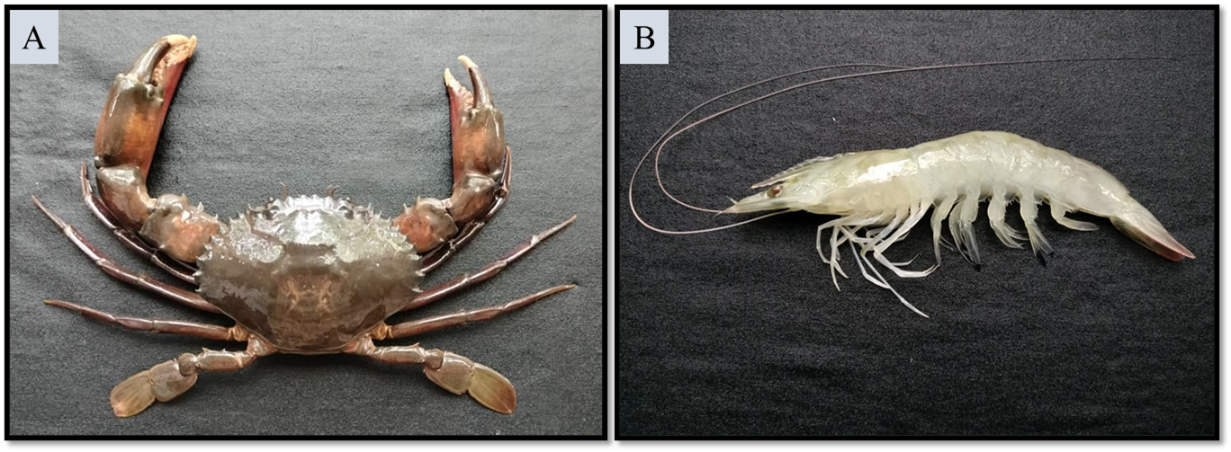
Figure 1. (A) Scylla olivacea, (B) Litopenaeus vannamei

RESULT
Gross Pathology
Gross examination of Litopenaeus vannamei revealed clear differences between shrimp maintained in control tanks and those exposed to WSSV-positive Scylla olivacea across all salinity treatments. Shrimp in the control groups at every salinity level (0-35ppt) appeared normal, exhibiting a translucent exoskeleton, intact pigmentation, firm musculature and active swimming behavior, with no evidence of white spots or cuticular abnormalities. In contrast, shrimp from the WSSV-exposed tanks displayed characteristic pathological signs of infection, with the severity varying according to salinity. The most prominent lesions included distinct white spots on the cephalothorax and along the dorsal cuticle, generalized carapace opacification, and reduced pigmentation. In several salinity treatments-particularly 10, 15, 20 and 25ppt infected shrimp showed more pronounced exoskeletal whitening, softening of the cuticle, and milky discolouration of the muscle tissue. Lethargy, reduced feeding response and erratic swimming were commonly observed preceding mortality. These gross abnormalities were absent in all control groups, confirming that the observed lesions were associated with WSSV exposure rather than salinity-induced stress. The presence and severity of classical white spot lesions across salinity treatments indicate that WSSV vertical transmission occurred successfully in the cohabitation system and that salinity played a modulatory role in the progression of external pathological signs.
Kaplan–Meier Survival Analysis and Delayed Mortality Assessment
Kaplan-Meier survival analysis revealed a clear salinity-dependent delayed-mortality pattern in Litopenaeus vannamei cohabited with WSSV-infected Scylla olivacea. Across all five replicates (R1-R5), mortality commenced earliest at low salinities, with shrimp at 0 and 5 ppt exhibiting the fastest onset of mortality (Day 11–12) followed by a rapid decline in survival. In contrast, shrimp maintained at 15 ppt showed a modest delay in mortality onset (Day 12–14) with a comparatively slower rate of decline. The most pronounced delay occurred at higher salinities (20, 25, 30 and 35 ppt), where the first deaths appeared considerably later (Day 13–16), and the reduction in survival was gradual, indicating a substantial suppression of WSSV progression. The delayed onset and slower mortality rate in high-salinity groups were consistent across all replicates, demonstrating strong internal reproducibility. Pairwise Mantel-Cox log-rank comparisons further confirmed these trends, with significantly lower survival at 0 and 5 ppt compared with 20–35 ppt (p = 0.001–0.004), reflecting early mortality versus delayed mortality differences. Although 15 ppt displayed intermediate survival, it was not significantly different from higher salinity groups (p = 0.06–0.09), suggesting partial protective effects. No significant differences were detected among 20–35 ppt (p > 0.85), indicating statistically equivalent survival profiles within this salinity range. Overall, the results demonstrate that increasing salinity progressively delays WSSV-induced mortality, with salinities ≥20 ppt offering the greatest protection by markedly postponing the onset and reducing the rate of disease-related deaths (Fig 2).
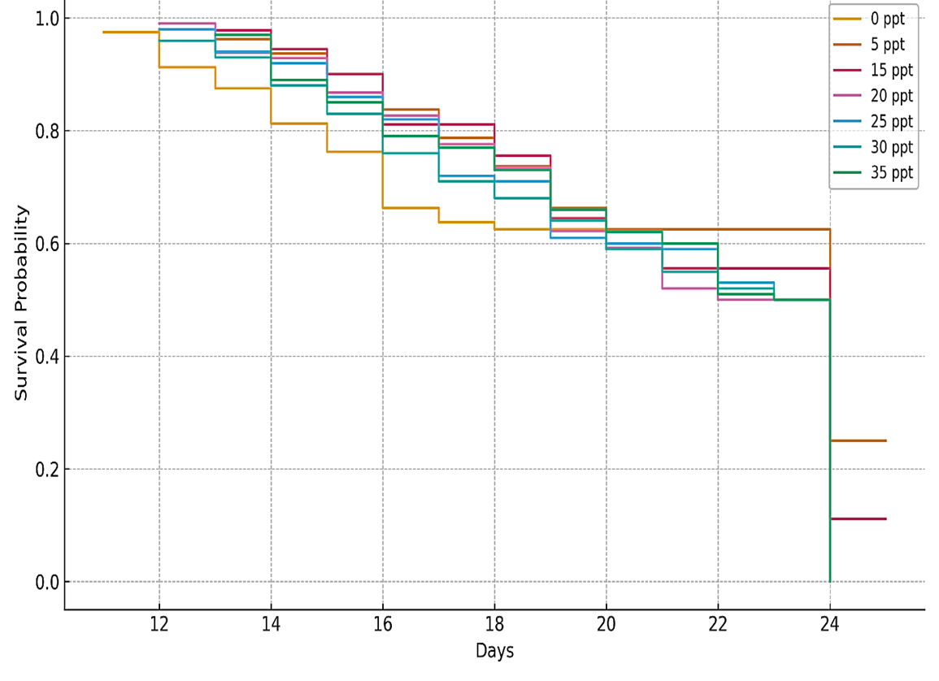
Figure 2: Kaplan-Meier survival curve by salinity (All replicates combined)

DISCUSSION
The present study provides clear experimental evidence that salinity is a decisive environmental regulator of White Spot Syndrome Virus (WSSV) transmission dynamics and disease progression in Litopenaeus vannamei during cohabitation with infected Scylla olivacea. Although successful viral transmission occurred across the entire salinity gradient (0–35 ppt), the severity of clinical signs, timing of mortality onset, and rate of survival decline were strongly salinity dependent. This distinction is critical, as it demonstrates that salinity does not act as a barrier to WSSV entry but instead governs the physiological context in which the host–virus interaction unfolds. Such findings reinforce earlier observations that environmental parameters, particularly salinity, shape WSSV pathogenicity and host survival rather than transmission success alone (Quang et al., 2009; Shields et al., 2020; Uma, 2025).
The manifestation of classical gross pathological signs white spot lesions, cuticular whitening, carapace opacification, and muscular discoloration in exposed shrimp across all salinities is consistent with the hallmark pathology of WSSV infection (Wongteerasupaya et al., 1995; Lo et al., 1996). Importantly, the complete absence of these lesions in all control groups confirms that the observed pathology was virus driven rather than a response to osmotic stress. This distinction is physiologically relevant because salinity stress alone typically induces nonspecific signs such as lethargy or reduced feeding but does not reproduce the distinctive exoskeletal and muscular alterations characteristic of WSSV (Chang et al., 1998; Kumar et al., 2013). The increasing severity of lesions at low-to-intermediate salinities suggests that salinity not only affects host susceptibility but may also modulate internal viral replication and tissue tropism, a pattern previously suggested but rarely demonstrated under controlled cohabitation conditions (Shields et al., 2020).
From a transmission perspective, the efficient spread of WSSV from S. olivacea to L. vannamei across all salinities reaffirms the role of crabs as persistent and potent viral reservoirs. Crabs are known to harbor WSSV asymptomatically and shed infectious virions over extended periods, even under fluctuating environmental conditions (Kanchanaphum et al., 1998; Laoaroon et al., 2005). However, the novel contribution of this study lies in demonstrating that while transmission efficiency remains high, disease expression and mortality kinetics are strongly shaped by the osmotic environment. This finding closely mirrors field observations in estuarine shrimp farms, where WSSV outbreaks often intensify following freshwater influx and salinity dilution rather than during stable marine conditions (Quang et al., 2009; Uma, 2025).
Kaplan–Meier survival analysis clearly showed that shrimp maintained at low salinities (0–5 ppt) experienced the earliest mortality onset (Day 11–12) and the fastest survival decline, whereas shrimp at higher salinities (20–35 ppt) exhibited pronounced delays in mortality (Day 13–16) and slower disease progression. Physiologically, this pattern can be interpreted as a consequence of osmotic stress–immune trade-offs. L. vannamei is euryhaline, yet prolonged exposure to low salinity imposes substantial energetic demands for osmoregulation, diverting energy away from immune defense mechanisms such as hemocyte proliferation, phagocytosis, and antiviral responses (Shields et al., 2020; Singh, 2025). Under such conditions, WSSV replication may proceed more rapidly, leading to earlier tissue damage and mortality.
Conversely, higher salinity conditions likely provide a more energetically favorable physiological state, allowing shrimp to maintain ion balance efficiently and sustain immune competence. Enhanced hemocyte activity, improved phenoloxidase responses, and reduced cellular stress under saline conditions have been linked to suppressed viral replication and delayed disease progression (Min et al., 2024; Laoaroon et al., 2005). Additionally, previous studies suggest that WSSV virions may lose infectivity more rapidly in higher salinity due to osmotic destabilization, further reducing effective viral load within the host (Chang et al., 1998; Takahashi et al., 2003).
The absence of significant survival differences among the 20–35 ppt treatments suggests the existence of a functional salinity threshold beyond which additional increases confer no further protective advantage. This “salinity buffer zone” concept is particularly important for aquaculture management, as it implies that maintaining salinity above a critical minimum (≈20 ppt) may be sufficient to suppress rapid disease progression, even if complete prevention of infection is not feasible. Similar threshold effects have been reported in controlled infection studies and epidemiological analyses of WSSV outbreaks (Kumar et al., 2013; Chang et al., 1998).
Collectively, the physiological mechanisms underlying the observed salinity effects likely include reduced viral stability in seawater, enhanced host immune competence under optimal osmotic conditions, decreased stress-induced susceptibility at higher salinities, and altered viral persistence in the water column. These interacting processes provide a coherent explanation for the consistent trends observed in gross pathology, lesion severity, and survival outcomes across treatments.
From an applied perspective, the findings have direct implications for shrimp aquaculture in estuarine and monsoon-influenced regions. The heightened mortality risk at salinities ≤10 ppt underscores the vulnerability of shrimp culture systems during periods of freshwater intrusion. While the presence of wild reservoirs such as Scylla olivacea means that salinity management alone cannot prevent WSSV introduction, maintaining salinity at or above 20 ppt may significantly delay disease onset and reduce outbreak severity. This aligns with broader biosecurity recommendations emphasizing environmental stabilization as a key component of WSSV risk mitigation (Hameed et al., 2003; Nunan & Lightner, 2011).
CONCLUSION
The present study was conducted to evaluate the role of salinity in modulating the vertical transmission, disease expression, and survival outcomes of White Spot Syndrome Virus (WSSV) in Litopenaeus vannamei cohabited with infected Scylla olivacea. The findings confirm that WSSV transmission occurred efficiently across all salinity treatments; however, the progression and severity of infection were strongly dependent on salinity conditions. One of the key objectives—to assess salinity-dependent disease expression was fulfilled by demonstrating rapid onset of clinical signs, severe gross pathology, and early mortality at low salinities (0–5 ppt), indicating increased susceptibility under hypoosmotic stress. Another major objective was to determine the influence of salinity on mortality dynamics and survival patterns. Kaplan–Meier survival analysis clearly showed that higher salinities (20–35 ppt) significantly delayed the onset of mortality and reduced the rate of survival decline, identifying ≥20 ppt as a functional protective threshold. This addresses the objective of defining salinity conditions that mitigate WSSV progression despite continued viral exposure from natural reservoirs.
Finally, the study met its applied objective of generating aquaculture-relevant insights by demonstrating that while salinity management alone cannot prevent viral introduction from carriers such as mud crabs, maintaining stable salinity at or above 20 ppt can substantially reduce disease severity and provide a critical window for intervention. Overall, this research strengthens understanding of the host–virus–environment relationship and emphasizes the importance of environmental salinity stability as a practical and effective component of WSSV management strategies in sustainable shrimp aquaculture.

Disclaimer
Author(s) hereby declares that NO generative AI technologies such as Large Language Models (ChatGPT, COPILOT, etc.) and text-to-image generators have been used during the writing or editing of this manuscript.
REFERENCES

- Bateman, K. S. (2021). Viruses affecting crustaceans. In C. J. Hurst (Ed.), Studies in viral ecology (pp. 305–340). John Wiley & Sons.
- Buathongkam, P., Srisala, J., Srivihok, C., Tangpassornruang, S., Coates, C. J., Taengchaiyaphum, S., ... & Sritunyalucksana, K. (2025). Persistence of viral load in shrimp that survived WSSV infection. Developmental & Comparative Immunology, 105488.
- Chang, P. S., Chen, L. J., & Wang, Y. C. (1998). The effect of ultraviolet irradiation, heat, pH, ozone, salinity and chemical disinfectants on the infectivity of white spot syndrome baculovirus. Aquaculture, 166, 1–17.
- Cox, N., De Swaef, E., Corteel, M., Van Den Broeck, W., Bossier, P., Dantas-Lima, J. J., & Nauwynck, H. J. (2023). The way of water: Unravelling White Spot Syndrome Virus (WSSV) transmission dynamics in Litopenaeus vannamei shrimp. Viruses, 15(9), 1824.
- Dela Pena, L. D., Caber, D. B., Villacastin, A. J., Cabillon, N. A., Arboleda, J., Castellano, J. L. A., & Watanabe, S. (2023). Sandfish (Holothuria scabra) as potential reservoir of white spot syndrome virus (WSSV) when co-cultured with black tiger prawn (Penaeus monodon). Bulletin of the European Association of Fish Pathologists.
- Desrina, D., Prayitno, S. B., Verdegem, M. C. J., Verreth, J. A. J., & Vlak, J. M. (2022). White spot syndrome virus host range and impact on transmission. Reviews in Aquaculture, 14(4), 1843–1860.
- Hameed, A. S., Balasubramanian, G., Musthaq, S. S., & Yoganandhan, K. (2003). Experimental infection of twenty species of Indian marine crabs with white spot syndrome virus (WSSV). Diseases of aquatic organisms, 57, 157-161.
- Hossain, M. S., Otta, S. K., Chakraborty, A., Kumar, H. S., Karunasagar, I., & Karunasagar, I. (2004). Detection of WSSV in cultured shrimps, captured brooders, shrimp postlarvae and water samples in Bangladesh by PCR using different primers. Aquaculture, 237(1-4), 59-71.
- Kanchanaphum, P., Wongteerasupaya, C., Sitidilokratana, N., Boonsaeng, V., Panyim, S., Tassanakajon, A., ... & Flegel, T. W. (1998). Experimental transmission of white spot syndrome virus (WSSV) from crabs to shrimp Penaeus monodon. Diseases of aquatic organisms, 34(1), 1-7.
- Kim, C. S., Kosuke, Z., Nam, Y. K., Kim, S. K., & Kim, K. H. (2007). Protection of shrimp (Penaeus chinensis) against white spot syndrome virus (WSSV) challenge by double-stranded RNA. Fish & shellfish immunology, 23(1), 242-246.
- Kono, T., Savan, R., Sakai, M., & Itami, T. (2004). Detection of white spot syndrome virus in shrimp by loop-mediated isothermal amplification. Journal of virological methods, 115(1), 59-65.
- Kumar, S. S., Bharathi, R. A., Rajan, J. J. S., Alavandi, S. V., Poornima, M., Balasubramanian, C. P., & Ponniah, A. G. (2013). Viability of white spot syndrome virus (WSSV) in sediment during sun-drying (drainable pond) and under non-drainable pond conditions indicated by infectivity to shrimp. Aquaculture, 402, 119-126.
- Laoaroon, S., Boonnat, A., Poltana, P., Kanchanaphum, P., Gangnonngiw, W., Nash, G., & Withyachumnarnkul, B. (2005). Infectivity of white spot syndrome virus (WSSV) to the polychaete Pereneis nuntia and a possibility of WSSV transmission from the polychaete to the black tiger shrimp Penaeus monodon. In P. J. Walker, R. G. Lester, & M. G. Bondad-Reantaso (Eds.), Diseases in Asian Aquaculture V (pp. 353–361). Fish Health Section, Asian Fisheries Society.
- Lo, C. F., Leu, J. H., Ho, C. H., Chen, C. H., Peng, S. E., Chen, Y. T., Chou, C. M., Yeh, P. Y., Huang, C. J., Chou, H. Y., Wang, C. H., & Kou, G. H. (1996). Detection of baculovirus associated with white spot syndrome (WSBV) in penaeid shrimps using polymerase chain reaction. Diseases of Aquatic Organisms, 25(1-2), 133–141.
- Lotz, J. M., & Soto, M. A. (2002). Model of white spot syndrome virus (WSSV) epidemics in Litopenaeus vannamei. Diseases of Aquatic Organisms, 50(3), 199–209.
- Min, J. G., Kim, Y. C., & Momoyama Kim, K. I. (2024). Role of filter-feeding bivalves in the bioaccumulation and transmission of White Spot Syndrome Virus (WSSV) in shrimp aquaculture systems. Pathogens, 13(12), 1103.
- Momoyama, K., Hiraoka, M., & Venegas, C. A. (1999). Pathogenicity of penaeid rod-shaped DNA virus (PRDV) to juveniles of six crustacean species. Fish Pathology, 34(4), 183-188.
- Nunan, L. M., & Lightner, D. V. (2011). Optimized PCR assay for detection of white spot syndrome virus (WSSV). Journal of virological methods, 171(1), 318-321.
- Peinado-Guevara, L. I., & López-Meyer, M. (2006). Detailed monitoring of white spot syndrome virus (WSSV) in shrimp commercial ponds in Sinaloa, Mexico by nested PCR. Aquaculture, 251(1), 33-45.
- Quang, N. D., Hoa, P. T. P., Da, T. T., & Anh, P. H. (2009). Persistence of white spot syndrome virus in shrimp ponds and surrounding areas after an outbreak. Environmental Monitoring and Assessment, 156(1), 69-72.
- Rothman, G. (2024). Investigating the Transmission of White Spot Syndrome Virus (WSSV) from the Non-native Red Swamp Crayfish (Procambarus clarkii) to the Native White Shrimp (Penaeus setiferus) (Master's thesis, College of Charleston).
- Scarfe, A. D., Lee, C. S., & O'Bryen, P. J. (2008). Aquaculture biosecurity: prevention, control, and eradication of aquatic animal disease. John Wiley & Sons.
- Shields, J. D., Huchin-Mian, J. P., Thiel, M., & Lovrich, G. (2020). Ecological factors in the emergence of pathogens in commercially important crustaceans. Fish. Aquac, 9, 367.
- Singh, R. (2025). Chapter-4 Important Viral Diseases of Shrimp and Prawn in Aquaculture. Futuristic Trends in Fisheries and Aquaculture, 39.
- Takahashi, Y., Fukuda, K., Kondo, M., Chongthaleong, A., Nishi, K., Nishimura, M., ... & Matsumaura, M. (2003). Detection and prevention of WSSV infection in cultured shrimp. Asian Aquaculture Magazine, 75, 25-27.
- Tuyen, N. X., Verreth, J., Vlak, J. M., & De Jong, M. C. M. (2014). Horizontal transmission dynamics of White spot syndrome virus by cohabitation trials in juvenile Penaeus monodon and P. vannamei. Preventive Veterinary Medicine, 117(1), 286-294.
- Uma, A. (2025). Pathogen and disease transmission in aquatic animals. In S. K. Mallik, N. Shahi, & P. K. Pandey (Eds.), Management of Fish Diseases (pp. 19–55). Springer Nature Singapore.
- Vlak, J. M. (2022). White spot syndrome virus host range and impact on transmission.
- Walker, P. J., & Winton, J. R. (2010). Emerging viral diseases of fish and shrimp. Veterinary Research, 41(6), 51.
- Wongteerasupaya, C., Vickers, J. E., Sriurairatana, S., Nash, G. L., Akarajamorn, A., Boonsaeng, V., ... & Flegel, T. W. (1995). A non-occluded, systemic baculovirus that occurs in cells of ectodermal and mesodermal origin and causes high mortality in the black tiger prawn Penaeus monodon. Diseases of aquatic organisms, 21(1), 69-77.

