Original Research Article

Assessment trends and correlation coefficient of the physicochemical parameters of Kaneri lake, Kolhapur District, Maharashtra

Abstract -
The present study evaluated the physicochemical characteristics of Kaneri lake, Kolhapur District, Maharashtra over the study period from February 2023 to January 2025, to assess its quality and suitability of water for different uses. Water samples were collected from four designated sites around the lake. The sampling was conducted between 7:00 a.m. and 9:00 a.m., with samples taken every 15 days over two years. Key parameters, including pH, temperature, dissolved oxygen, total hardness, total alkalinity, total dissolved solids, calcium, chloride, nitrate, phosphate, and sulphate, were analysed and compared with WHO and BIS standards. Correlation analysis revealed that dissolved oxygen was negatively correlated with all major parameters, indicating that increases in ionic and nutrient concentrations were associated with oxygen depletion, likely due to enhanced microbial respiration. Despite this, all recorded values remained within permissible limits, with standard deviation and coefficient of variation values indicating low temporal variability and stable water quality. The quality of water remains adequate for irrigation and domestic purposes. The findings highlight the importance of continuous monitoring of water bodies to ensure sustainability and safe utilisation.

Keywords- Coefficient of variance, Correlation analysis, Kaneri Lake, Physicochemical parameters, Standard deviation, Seasonal variation
Introduction -
In nature, freshwater bodies are crucial. They give living aquatic creatures a place to live and give nearby organisms access to drinking water. In general, wetlands and other natural, artificial, and transient water bodies are all referred to as a Lake. (Kanakiya et al, 2014). The lake serves as the sole source of drinking water and other domestic needs for the surrounding communities. (Laishram and Dey 2014). Countries are experiencing severe environmental issues as a result of their ongoing industrialisation. Soil, water, and air have been found to contain a wide range of compounds (Turgut 2003). The use of non-scientific drainage systems, uncontrolled agricultural activities, and ever-increasing human settlements all contribute to the accelerated eutrophication of urban water bodies, including lakes, ponds, and others (Grochowska and Tandyrak., 2021; Kim et al., 2021). The general health of these aquatic ecosystems is largely determined by their physicochemical characteristics, which are influenced by both natural and man-made activities. A healthy ecosystem depends on biological diversity and the physical-chemical characteristics of the water (Raju Potharaju, M. Aruna, 2021). Lakes are more vulnerable to pollution due to their comparatively lower self-regulating capacity than lotic systems (Ahamad et al., 2023). The health of the water body is directly correlated with the water quality. (Qureshimatva, 2015). In order to evaluate the quality of the water and sustainable management, several characteristics must be monitored.
The Kaneri lake is a significant water body in Kolhapur district, Maharashtra, used for irrigation and domestic needs by surrounding villages. Studying its water quality is essential to ensure public health and sustainable usage. In this context, a study was conducted to assess the water quality and its trends in Kanari Lake. Various water quality parameters were measured monthly over a period of two years to evaluate changes and identify patterns. Studying these variations in physicochemical properties provides insight into the lake’s response to climatic and hydrological shifts. Limited prior research and monitoring data exist for Kaneri Lake, presenting a significant knowledge gap. However, upsetting urbanisation, agricultural runoff and anthropogenic activities such as washing of cloths, washing of utensils, washing of buffalos, and discharge of domestic sewage have raised concerns about the quality of water in the lake. This study presents a comprehensive assessment of key physicochemical parameters to evaluate the water quality of Kaneri Lake. For instance, A mathematical relationship for comparing physico-chemical properties has been developed using statistical correlation by analysing the correlation coefficients among them. The findings are expected to contribute to developing effective strategies for the sustainable management and conservation of Kaneri Lake.
Material and Method -
Study area -
Kaneri is a village in Karveer Taluka of Kolhapur District, Maharashtra, located about 10 km south of the district headquarters, and it falls under the Paschim Maharashtra region. Nearby, Kaneri Lake (Fig. 1) is situated close to the prominent Siddha Giri Math, also known as Kaneri Math, a significant cultural and religious site in the area. Kaneri Lake is located near the coordinates 16°37'47" N latitude and 74°17'5" E longitude. It has a catchment area of about 3.60 square miles. The lake reaches a maximum depth of 14.81 meters and has a gross water storage capacity of approximately 73.624 million cubic meters of water.
Collection of water samples and physicochemical parameter analysis -
The sampling was carried out between 7:00 am and 9:00 am with samples taken every 15 days over two years, from February 2023 to January 2025. Water samples were collected from four designated sites around the lake, labelled as Site 1, Site 2, Site 3, and Site 4. At each site, water was drawn using sterilised two-litre plastic containers, submerged about 10 to 20 cm below the surface.
On-site measurements of temperature and pH were recorded immediately after sampling. For dissolved oxygen analysis, samples were fixed in BOD bottles at the location and later transported to the laboratory for detailed testing. On-site measurements were essential, as these parameters can change during transportation to the laboratory. Other parameter including total hardness, total alkalinity, total dissolved solids, calcium, chloride, nitrate, phosphate, and sulphate were analysed in the laboratory using standardized procedures as outlined by the American Public Health Association (APHA, 2023) and Trivedy and Goel (1986). Statistical analysis of the physicochemical parameters at all study sites was performed by determining the Pearson’s correlation coefficient (r) to assess the relationships between variables. Python software is used for statistical analysis. The permissible limits for various water quality parameters were adopted from the Indian Standards IS 10500:2012 (BIS, 2012) and the World Health Organisation guidelines (WHO, 2022).
The measured values of all water quality parameters were evaluated against the recommended standards to determine the quality of water with respect to each parameter. Monthly variations in each parameter were visualised through graphs to identify their respective trends. To analyse annual patterns, monthly data across different years were compared. Since certain water quality parameters exhibit interdependence, correlation coefficients were computed between each parameter and all others. These correlations help reveal relationships among the different water quality parameters.
Result
The variation in each water quality parameter is detailed in the following section. To examine the distribution pattern of the selected water quality parameters over the study period, statistical analyses were performed. These included the calculation of mean, maximum, and minimum values as shown in Table 1. Descriptive statistics such as mean, standard deviation (SD), 85th percentile, and coefficient of variation (CV) were calculated, and the results are presented in Table 2. Seasonal variation of physicochemical parameters of water is represented in Table 3. To assess the interdependence among different water quality parameters, correlation coefficients were also computed and are shown in Fig. 2.

- pH –
The pH of Kaneri Lake varies between 6.23 and 7.83 (Table 1), with a mean of 7.10 (Table 2) during the study period. pH values of samples were found below the desirable limits as per IS 10500: 2012 (6.5–8.5). pH of 85% of the samples was 7.7 during the study period (Table 2). Lower values of Standard deviation (0.52) and Coefficient of Variance (0.075) indicate there was little variance of pH among the samples (Table 2). The pH of lake water was observed slight acidic to slight alkaline range throughout the study period. The highest negative correlation between pH and Dissolved oxygen (- 0.58) was observed and the highest positive correlation with Calcium (0.87) (Fig 4). The pH values were found to be increasing gradually in summer and winter and decreasing in the monsoon season during the study period (Fig 3a, Table 3).
- Temperature -
During the study period, the temperature of Kaneri lake fluctuated between 20°C and 27.13°C (Table 1), with a mean of 22.24°C. The temperature of 85% of the samples was below 25. 63 ˚C during the study period (Table 2). Lower values of Standard Deviation (2.24), and Coefficient of Variance (0.1) indicate there was little variance of temperature among the samples (Table 2). The negative correlation between Temperature and Dissolved oxygen (- 0.74) was observed, and the highest positive correlation was with total hardness (0.88) (Fig. 2). The temperature was found to be higher in summer and decreasing in the monsoon season. (Fig. 3b, Table 3).
- Dissolved Oxygen -
During the study period, the dissolved Oxygen of Kaneri lake fluctuated between 4.7 to 8 mg/L (Table 1), with a mean of 6.35 mg/L (Table 2). As per the WHO, the dissolved oxygen values were above the desired minimum limit (6 ppm). Dissolved oxygen levels of 85% of the samples were below 7.61mg/L during the study period (Table 2). The dissolved oxygen is negatively correlated with all water quality parameters but highest negatively correlated with the water temperature (-0.74) and weakly negatively correlated with nitrate (-0.17) (Fig. 2). The Dissolved oxygen is higher in winter and lower in the summer season (Fig. 3c, Table 3).
- Total hardness -
During the study period, the total hardness of Kaneri lake fluctuated between 150.38 to 228.5 mg/L (Table 1), with a mean of 7.195 mg/L (Table 2). Total hardness values of samples were found below the desirable limits as per WHO (200-600 mg/L). The total hardness of 85% of the samples was below 216.96 mg/L during the study period (Table 2). Lower values of standard deviation (23.08), and coefficient of Variance (0.125) indicate there was little variance of total hardness among the samples (Table 2). The negative correlation between total hardness and dissolved oxygen (- 0.65) was observed, and the highest positive correlation was with total alkalinity (0.95) and calcium (0.95) (Fig. 2). The total hardness is higher in summer and lower in the monsoon season (Fig. 3d, Table 3).
- Total alkalinity –
During the study period, the total alkalinity of Kaneri lake fluctuated between 200.5 to 315.25 mg/L (Table 1), with a mean of 262.77 mg/L (Table 2). The total alkalinity represents the water's buffering ability. It is mainly controlled by the concentration of bicarbonate (HCO₃⁻) and carbonate (CO₃²⁻) ions in water. Total alkalinity values of samples were found below the permissible limits as per BIS (200- 600 mg/L). The total alkalinity of 85% of the samples was below 310.19 mg/L during the study period (Table 2). Lower values of standard deviation (37.68) and coefficient of Variance (0.145) indicate there was little variance of total hardness among the samples (Table 2). The negative correlation between total alkalinity and dissolved oxygen (- 0.60) was observed, and the highest positive correlation was with calcium (0.96), Total Hardness (0.95), chloride (0.95), and sulphate (0.95) (Fig. 2). The total alkalinity is higher in summer and lower in the monsoon season (Fig 3e, Table 3).
- Total Dissolved Solids –
During the study period, the total dissolved solids of Kaneri lake fluctuated between 220.25 to 290.38 mg/L (Table 1), with a mean of 262.77 mg/L (Table 2). Total dissolved solids values of samples were found below the desirable limits as per BIS (500- 2000 mg/L). The total dissolved solids of 85% of the samples was below 310.19 mg/L during the study period (Table 2). Lower values of standard deviation (18.44), and coefficient of variance (0.07) indicate there was little variance of total hardness among the samples (Table 2). The negative correlation between total dissolved solids and dissolved oxygen (- 0.35) was observed, and the highest positive correlation was with nitrate (0.94), and sulphate (0.90) (Fig. 2). The total dissolved solids are higher in summer and lower in the monsoon season (Fig 3f, Table 3).
- Calcium –
During the study period, the calcium of Kaneri lake fluctuated between 36.33 to 58 mg/L (Table 1), with a mean of 46.30 mg/L (Table 2). Calcium values of samples were found below the desirable limits as per BIS (75 - 200 mg/L). The Calcium of 85% of the samples were below 55.44 mg/L during the study period (Table 2). Lower values of standard deviation (6.45), and coefficient of Variance (0.14) indicate there was little variance of total hardness among the samples (Table 2). The negative correlation between calcium and dissolved oxygen (- 0.55) was observed, and the highest positive correlation was with chloride (0.89), total hardness (0.95), and sulphate (0.95) (Fig. 2). Calcium is higher in summer and lower in the monsoon season (Fig 3g, Table 3).
- Chloride -
During the study period, the Chloride of Kaneri lake fluctuated between 43.63 to 62.63 mg/L (Table 1), with a mean of 54.44 mg/L (Table 2). Chloride values of samples were found below the desirable limits as per BIS (250-1000 mg/L). The total dissolved solids of 85% of the samples were below 60.84 mg/L during the study period (Table 2). Lower values of standard deviation (5.98), and coefficient of Variance (0.11) indicate there was little variance of chloride among the samples (Table 2). The negative correlation between chloride and dissolved oxygen (- 0.49) was observed, and the highest positive correlation was with sulphate (0.89) and total hardness (0.95), (Fig. 2). Chloride is higher in summer and lower in the monsoon season (Fig 3h, Table 3)
- Nitrate –
During the study period, the nitrate of Kaneri lake fluctuated between 1.73 to 3.23 mg/L (Table 1), with a mean of 2.29 mg/L (Table 2). Nitrate values of samples were found below the desirable limits as per BIS (45 mg/L). The Nitrate of 85% of the samples were below 2.67 mg/L during the study period (Table 2). Lower values of standard deviation (0.36), and coefficient of Variance (0.15) indicate there was little variance of chloride among the samples (Table 2). The negative correlation between Nitrate and dissolved oxygen (- 0.17) was observed, and the highest positive correlation was with sulphate (0.90) and total hardness (0.95), Total Dissolved solids (0.94) (Fig. 2). Nitrate is higher in summer and lower in the monsoon season (Fig 3i, Table 3).
- Phosphate -
During the study period, the Phosphate of Kaneri lake fluctuated between 0.015 to 0.022 mg/L (Table 1), with a mean of 0.020 mg/L (Table 2). The phosphate in 85% of the samples was below 0.020 mg/L during the study period (Table 2). Lower values of standard deviation (0.01) and coefficient of Variance (0.1) indicate there was little variance of chloride among the samples (Table 2). The negative correlation between Phosphate and dissolved oxygen (- 0.17) was observed, and the highest positive correlation was with temperature (0.85) and Total hardness (0.82) (Fig. 2). Phosphate is higher in summer and lower in the monsoon season (Fig 3j, Table 3).
- Sulphate -
During the study period, the sulphate of Kaneri lake fluctuated between 5.5 to 9.14 mg/L (Table 1), with a mean of 7.84 mg/L (Table 2). The sulphate of 85% of the samples were below 8.72 mg/L during the study period (Table 2). Lower values of standard deviation (0.84) and coefficient of Variance (0.11) indicate there was little variance of chloride among the samples (Table 2). The negative correlation between sulphate and dissolved oxygen (- 0.44) was observed, and the highest positive correlation was with chloride (0.96), calcium (0.95), total alkalinity (0.95), total hardness (0.94), Total dissolved solids (0.90), and Nitrate (0.90) (Fig. 2). Sulphate is higher in summer and lower in the monsoon season (Fig 3k, Table 3).
Discussion
The pH values were found to be increasing gradually in summer and winter and decreasing in the monsoon season during the study period (Fig 3a, Table 3). In the summer season, due to high temperature, photosynthesis by algae and aquatic plants is increases, which consumes carbon dioxide (CO₂). Since CO₂ makes water acidic, and if CO₂ is reduced from water then the nature of the water is alkaline, raising the pH. In the winter season, photosynthesis is reduced due to low temperature and light, so CO₂ accumulates in water, forming carbonic acid and decreasing the pH (Roy and Majumdar, 2019). Similar results are observed by Anekar and Dongare (2021). Overall, pH values remained within a moderate range during both years, but the lower SD and lower CV in both years suggest less variability in pH levels throughout the study period.
The temperature was found to be higher in summer and decreasing in the monsoon season. (Fig. 3b, Table 3). The temperature increases, the solubility of oxygen in water decreases, so warmer water holds less dissolved oxygen (Tromans, 1998). Increased temperature increases the dissolution of calcium and magnesium salts from rocks and sediments, which raises total hardness in water. Overall, pH values remained within a moderate range during both years, but the lower SD and lower CV in both years suggest less variability in pH levels throughout the study period.
The Dissolved oxygen is higher in winter and lower in the summer season (Fig. 3c, Table 3). This is due to cold water holding more oxygen due to greater gas solubility at lower temperatures. Similar results are observed by Sun et al. (2011) and Kumari & Sharma (2018). Dissolved oxygen shows a negative correlation with other water quality parameters because higher temperature and nutrient concentrations enhance biological activity, which consumes oxygen and reduces its solubility (Wetzel, 2001). Overall, dissolved oxygen values remained within a moderate range during both years, but the moderate SD and moderate CV in both years suggest moderate variability in dissolved levels throughout the study period.
The total hardness is higher in summer and lower in the monsoon season (Fig. 3d, Table 3). Rainfall during the monsoon dilutes dissolved minerals like calcium and magnesium, lowering water hardness, while in summer, reduced water volume and increased evaporation concentrate these ions, raising hardness (Tatavarthi et al., 2025). Overall, Total hardness values remained within a moderate range during both years, but the lower SD and moderate CV in both years suggest less variability in Total hardness levels throughout the study period.
The total alkalinity is higher in summer and lower in the monsoon season (Fig. 3e, Table 3). Total alkalinity is higher in summer due to concentration from evaporation and limited recharge, while during the monsoon season, dilution from rainfall reduces alkalinity (Ramamohan and Sudhakar, 2014). Total alkalinity showed a negative correlation with dissolved oxygen due to increased microbial respiration in more alkaline waters, while its strong positive correlation with calcium, total hardness, chloride, and sulphate indicates a common source from mineral weathering and leaching (Islam and Majumder, 2020). Overall, total alkalinity values remained within a moderate range during both years, but the lower SD and moderate CV in both years suggest less variability in total alkalinity levels throughout the study period.
The total dissolved solids is higher in summer and lower in the monsoon season (Fig. 3f, Table 3). Total Dissolved Solids are higher in summer due to evaporation concentrating dissolved salts, while in the monsoon, rainfall dilutes these salts, leading to lower TDS levels (Sudarshan et al., 2019). Overall, total dissolved solids values remained within a moderate range during both years, but the lower SD and lower CV in both years suggest less variability in total dissolved solids levels throughout the study period.
Calcium is higher in summer and lower in the monsoon season (Fig. 3g, Table 3). Calcium is higher in summer not only because of evaporation but also due to increased mineral dissolution and catchment leaching under low flow, whereas in the monsoon, high rainfall and runoff dilute and flush calcium ions, lowering their levels (Singh et al., 2018). Overall, calcium values remained within a moderate range during both years, but the lower SD and moderate CV in both years suggest less variability in calcium levels throughout the study period.
Chloride is higher in summer and lower in the monsoon season (Fig. 3h, Table 3). In summer, increased human activities such as irrigation return flow and wastewater discharge add more chloride into water bodies, while in the monsoon season, heavy rainfall and high runoff dilute and flush out these inputs, reducing chloride concentration (Trivedy & Goel 1986; APHA, 2017). Overall, chloride values remained within a moderate range during both years, but the lower SD and moderate CV in both years suggest less variability in chloride levels throughout the study period.
Nitrate is higher in summer and lower in the monsoon season (Fig 3i, Table 3). The increased nitrate level may also be due to leaching of rocks, fertiliser, domestic and municipal sewage. (Dhinalama et al., 2015). Higher rates during summer were attributed to increased light availability, temperature, biomass, and nitrogenous nutrient concentrations with a reduction in water level. Lower rates during monsoon were due to the dilution of lake water caused by precipitation and runoff, resulting in limited biomass and supply of nitrogenous nutrients. (Rathi et al., 2025). Heavy rain adds large volumes of relatively nutrient-poor water and increases outflow, which dilutes nitrate in the lake and shortens water residence time so nitrate has less time to accumulate. (Beklioglu et al., 2017). Overall, Nitrate values remained within a moderate range during both years, but the lower SD and moderate CV in both years suggest less variability in Nitrate levels throughout the study period.
Phosphate is higher in summer and lower in the monsoon season (Fig. 3j, Table 3). Phosphate levels are higher in summer due to concentration from evaporation and enhanced release through decomposition, whereas in the monsoon, heavy rainfall and flushing dilute the phosphate content in lake water (Wetzel, 2001). Overall, phosphate values remained within a moderate range during both years, but the lower SD and lower CV in both years suggest less variability in phosphate levels throughout the study period.
Sulphate is higher in summer and lower in the monsoon season (Fig. 3k, Table 3). During dry seasons, sulphate introduced via weathering and anthropogenic sources isn’t flushed out effectively, allowing accumulation. But during monsoon, runoff and surface inflow tend to flush out accumulated solutes, further reducing sulphate levels (Aditya et al., 2024). Overall, sulphate values remained within a moderate range during both years, but the lower SD and moderate CV in both years suggest less variability in sulphate levels throughout the study period.
According to personal observations made during sampling, lake water is used for various purposes such as washing, bathing, irrigation, and recreation at various sampling sites. The main factor affecting the water quality parameters in the study area was point source pollution in village areas, particularly sewage from Kaneri village, and non-point sources of pollution in other areas, such as small and household waste and farmland, can affect the water quality parameters in the area. However, the physicochemical analysis showed that the concentrations of pH, total hardness, total alkalinity, total dissolved solids, calcium, chloride, nitrate, phosphate, and sulphate at all sites remained within the desirable limits.
Conclusion-
The water quality parameters such as pH, dissolved oxygen, total hardness, total alkalinity, total dissolved solids, calcium, chloride, nitrate, phosphate, and sulphate are remained within the allowable limits specified by the World Health Organization (WHO) and Bureau of Indian Standards (BIS) throughout all sampling periods, according to the seasonal water quality assessment carried out during summer, monsoon, and winter. Throughout the study period, dissolved oxygen showed a negative correlation with total hardness, total alkalinity, total dissolved solids, calcium, chloride, nitrate, phosphate, and sulphate. This indicates that as the ionic and nutrient load of the water increased, oxygen availability decreased due to enhanced microbial respiration. The standard deviation and coefficient of variation values for all water quality parameters were very low during the study period, indicating minimal temporal fluctuation and high stability of water quality. This suggests that the lake ecosystem maintained a relatively uniform physicochemical environment throughout the study duration. Overall, the water body remained under moderate stress, with signs of organic and nutrient enrichment. The water is suitable for irrigation and domestic use, and with appropriate treatment, can also be used for drinking.

Disclaimer (Artificial intelligence)
Author(s) hereby declares that NO generative AI technologies such as Large Language Models (ChatGPT, COPILOT, etc.) and text-to-image generators have been used during the writing or editing of this manuscript.

References
Aditya, S. K., Krishnakumar, A., & AnoopKrishnan, K. (2024) Analysis of seasonal spatio-temporal variations in river water quality and its influencing factors in the Periyar River Basin, Southern Western Ghats, India. Journal of Water and Climate Change, 15(9): 4434-4456 https://doi.org/10.2166/wcc.2024.136
Ahamad, F., Sharma, A. K., & Tyagi, S. K. 2023. A Study on comparative assessment of water quality of Dal and Nigeen Lakes of Jammu and Kashmir, India. AgroEnvironmental Sustain, 1(1): 48-56. https://doi.org/10.59983/s2023010107
American Public Health Association, American Water Works Association, & Water Environment Federation. (2022) Standard methods for the examination of water and wastewater Washington, DC: American Public Health Association. 24th ed., Pp 1516 . https://www.standardmethods.org/
Anekar, S., & Dongare, M. 2021. Study on the fluctuation in the physicochemical parameters of Shiroli Lake, Kolhapur. International Journal of Ecology and Environmental Sciences, 3(4): 46-50.
Beklioğlu, M., Bucak, T., Coppens, J., Bezirci, G., Tavşanoğlu, Ü. N., Çakıroğlu, A. İ., ... & Özen, A. 2017. Restoration of eutrophic lakes with fluctuating water levels: A 20-year monitoring study of two Inter-connected lakes. Water, 9 (2): 127. https://doi.org/10.3390/w9020127
Bureau of Indian Standards. (2012) Drinking water — Specification (IS 10500:2012). New Delhi, India: Bureau of Indian Standards. https://www.bsbedge.com/Search/Search_Result.aspx?Search=10500
Dhinamala, K., Pushpalatha, M., Samuel, T., & Raveen, R. (2015) Seasonal variations of nutrients in Pulicat Lake, Tamil Nadu, India. International Journal of Fisheries and Aquatic Studies, 3(2): 264-267. https://www.fisheriesjournal.com/vol3issue2/3-2-59.pdf
Grochowska, J., & Tandyrak, R. (2021) The influence of the modernization of the city sewage system on the external load and trophic state of the Kartuzy Lake complex. Applied Sciences, 11(3): 974. https://doi.org/10.3390/app11030974
Islam, M. S., & Majumder, S. M. M. H. (2020) Alkalinity and hardness of natural waters in Chittagong City of Bangladesh. International Journal of Science and Business, 4(1): 137-150. https://doi.org/10.5281/zenodo.3606945
Kanakiya, R. S., Singh, S. K., & Sharma, J. N. (2014) Determining the water quality index of an urban water body Dal Lake, Kashmir, India. IOSR Journal of Environmental Science, Toxicology and Food Technology, 8(12): 64-71. https://doi.org/10.9790/2402-081236471
Kim, D. K., Yang, C., Parsons, C. T., Bowman, J., Theÿsmeÿer, T., & Arhonditsis, G. B. (2021) Eutrophication management in a Great Lakes wetland: examination of the existence of alternative ecological states. Ecosphere, 12(2): e03339. https://doi.org/10.1002/ecs2.3339
Kumari, R., & Sharma, R. (2018) Seasonal variation in the physico-chemical variables of Western Himalayan Sacred Lake Prashar, Himachal Pradesh, India. International Research Journal of Environmental Science, 7(7): 29-36. https://www.isca.in/ENVIRONMENTAL_SCI/Vol.7/Issue.7/4.ISCA-IRJEnvS-2018-044.php
Laishram, J., & Dey, M. (2014) Water quality status of Loktak Lake, Manipur, Northeast India and need for conservation measures: a study on five selected villages. International Journal of Scientific and Research Publications, 4(6): 1-6. http://www.ijsrp.org/research-paper-0614.php?rp=P302764
Qureshimatva, U. M., Maurya, R. R., Gamit, S. B., & Solanki, H. A. (2015) Studies on the physico-chemical parameters and correlation coefficient of Sarkhej Roza lake, district Ahmedabad, Gujarat, India. Journal of Environmental & Analytical Toxicology, 5(284): 2161-0525. https://doi.org/10.4172/2161-0525.1000284
Raju Potharaju, M. A. (2021) Analysis of Physico Chemical Parameters of Medchal Lake in Telangana State. International Journal of Scientific Research in Science and Technology IJSRST218257, 8(2): 369-381. https://doi.org/10.32628/IJSRST218257
Ramamohan, H., & Sudhakar, I. (2014) Evaluation of ground water quality for the pre and post-monsoon variations in physico-chemical characteristics of North East Coast of Srikakulam District. AP, India, 3(9): 124-131. https://www.ijert.org/evaluation-of-ground-water-quality-for-the-pre-and-post-monsoon-variations-in-physico-chemical-characteristics-of-north-east-coast-of-srikakulam-district-a-p-india
Rathi, A., Sarkar, S., Rahman, A., Khan, M. A., & Kumar, S. (2025) Monsoon decline versus summertime intensification of carbon and nitrogen fixation in a shallow tropical lake. Ecohydrology & Hydrobiology, 100670. https://doi.org/10.1016/j.ecohyd.2025.100670
Roy, R., & Majumder, M. (2019) Assessment of water quality trends in Loktak Lake, Manipur, India. Environmental earth sciences, 78(13): 383. https://doi.org/10.1007/s12665-019-8383-0
Singh, A., Chaudhary, S., & Dehiya, B. S. (2018) Water quality assessment of river yamuna, with respect to its physico-chemical analysis. Journal of emerging technologies and innovative research (JETIR), 5(8): 498-504. https://www.jetir.org/papers/JETIRA006091.pdf
Sudarshan, P., Mahesh, M. K., & Ramachandra, T. V. (2019) Assessment of seasonal variation in water quality and water quality index (WQI) of Hebbal Lake, Bangalore, India. Environment and Ecology 37 (1B) : 309-317. https://environmentandecology.com/wp-content/uploads/2019/03/309-317.pdf
Sun, C. C., Wang, Y. S., Wu, M. L., Dong, J. D., Wang, Y. T., Sun, F. L., & Zhang, Y. Y. (2011) Seasonal variation of water quality and phytoplankton response patterns in Daya Bay, China. International Journal of Environmental Research and Public Health, 8(7): 2951-2966. https://doi.org/10.3390/ijerph8072951
Trivedy, R.K. & Goel, P.K. (1986) Chemical and Biological Methods for Water Pollution Studies. Environmental Publications, Karad, India
Tromans, D. (1998) Temperature and pressure dependent solubility of oxygen in water: a thermodynamic analysis. Hydrometallurgy, 48(3): 327-342 https://doi.org/10.1016/s0304-386x(98)00007-3
Turgut, C. (2003) The contamination with organochlorine pesticides and heavy metals in surface water in Küçük Menderes River in Turkey, 2000–2002. Environment international, 29(1): 29-32. https://doi.org/10.1016/S0160-4120(02)00127-7
World Health Organisation. (2022) Guidelines for drinking-water quality: Fourth edition incorporating the first and second addenda. Geneva, Switzerland: World Health Organization. Pp: 614. https://apps.who.int/iris/rest/bitstreams/1414381/retrieve
Wetzel, R. G. (2001) Limnology: Lake and River Ecosystems, 3rd ed. Elsevier science, 1006 PP.

Table 1 Range and mean of water quality parameters during February 2023 to January 2025
Parameter | 2023-24 |  |  | 2024-25
Parameter | Maximum | Minimum | Mean | Maximum | Minimum | Mean
pH | 7.83 | 6.23 | 7.1 | 7.95 | 6.5 | 7.29
Water Temperature (˚C) | 27.13 | 20 | 23.24 | 24.5 | 18.38 | 21.63
Dissolved Oxygen (mg/L) | 7.6 | 4.7 | 6.18 | 8 | 4.9 | 6.53
Total hardness (mg/L) | 228.5 | 154.13 | 185.95 | 220.75 | 150.38 | 182.47
Total alkalinity (mg/L) | 315.25 | 218.38 | 270.39 | 310.13 | 200.5 | 255.16
Total Dissolved Solids (mg/L) | 290.38 | 234.38 | 264.98 | 280.38 | 220.25 | 249.93
Calcium (mg/L) | 58 | 36.33 | 45.01 | 53.25 | 40.38 | 47.6
Chloride (mg/L) | 62.63 | 43.63 | 55.57 | 61.25 | 45.38 | 53.32
Nitrate (mg/L) | 3.23 | 1.73 | 2.45 | 2.5 | 1.73 | 2.14
Phosphate (mg/L) | 0.022 | 0.016 | 0.019 | 0.021 | 0.015 | 0.018
Sulphate (mg/L) | 9.14 | 5.5 | 7.52 | 8.78 | 7.23 | 8.16

Table 2 Descriptive statistics of the water quality parameters during February 2023 to January 2025
statistics | pH | Water Temperature (˚C) | Dissolved Oxygen (mg/L) | Total hardness (mg/L) | Total alkalinity (mg/L) | Total dissolved Solids (mg/L) | Calcium (mg/L) | Chloride (mg/L) | Nitrate  (mg/L) | Phosphate  (mg/L) | Sulphate (mg/L)
Mean | 7.19 | 22.43 | 6.35 | 184.21 | 262.77 | 257.45 | 46.30 | 54.44 | 2.29 | 0.019 | 7.84
Std. Deviation | 0.525 | 2.24 | 0.975 | 23.08 | 37.68 | 18.44 | 6.45 | 5.98 | 0.365 | 0.002 | 0.845
85th Percentile | 7.775 | 25.63 | 7.61 | 216.96 | 310.19 | 280.14 | 55.44 | 60.84 | 2.67 | 0.02 | 8.72
CV | 0.075 | 0.1 | 0.155 | 0.125 | 0.145 | 0.07 | 0.14 | 0.11 | 0.15 | 0.1 | 0.11

Table 3 Seasonal variation of the water quality parameters of Kaneri Lake during February 2023 to January 2025
Sr. No | Parameter | Summer | Monsoon | Winter
1. | pH | 7.79 ± 0.10 | 6.67 ± 0.13 | 7.13 ± 0.19
2. | Water Temperature (˚C) | 24.89 ± 1.66 | 21.22 ± 1.37 | 21.21 ± 0.39
3. | Dissolved Oxygen (mg/L) | 5.21 ± 0.25 | 6.62 ± 0.21 | 7.62 ± 0.04
4. | Total hardness (mg/L) | 209.20 ± 2.01 | 161.10 ± 2.29 | 182.33 ± 3.07
5. | Total alkalinity (mg/L) | 303.94 ± 9.55 | 217.78 ± 13.44 | 266.59 ± 9.32
6. | TDS (mg/L) | 272.59 ± 6.63 | 235.97 ± 13.12 | 263.79 ± 12.19
7. | Calcium (mg/L) | 52.77 ± 2.23 | 39.44 ± 3.00 | 46.71 ± 4.71
8. | Chloride (mg/L) | 60.00 ± 0.95 | 47.70 ± 0.46 | 55.50 ± 3.36
9. | Nitrate (mg/L) | 2.53 ± 0.44 | 1.88 ± 0.015 | 2.47 ± 0.197
10. | Phosphate (mg/L) | 0.020 ± 0.0009 | 0.017 ± 0.002 | 0.018 ± 0.0004
11. | Sulphate (mg/L) | 8.65 ± 0.22 | 6.85 ± 1.06 | 8.02 ± 0.52
mean ± standard deviation

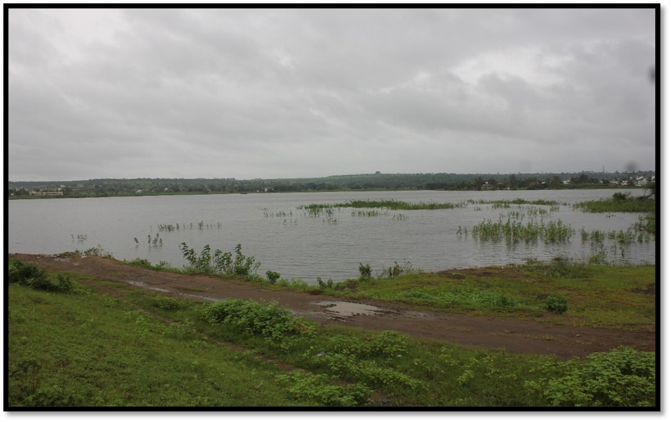
Fig 1 : Study area

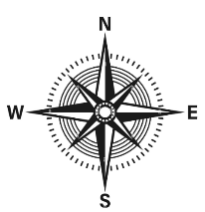
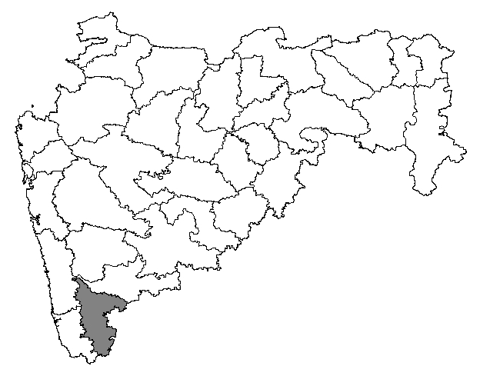
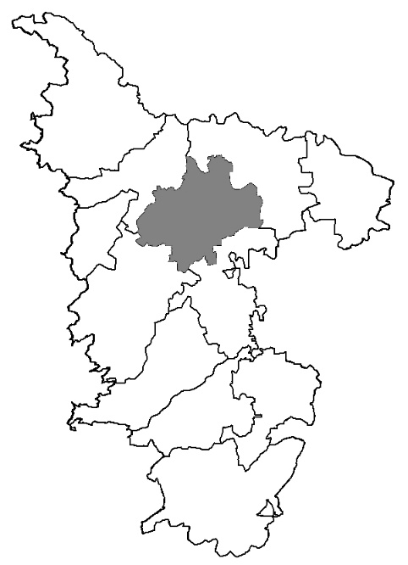
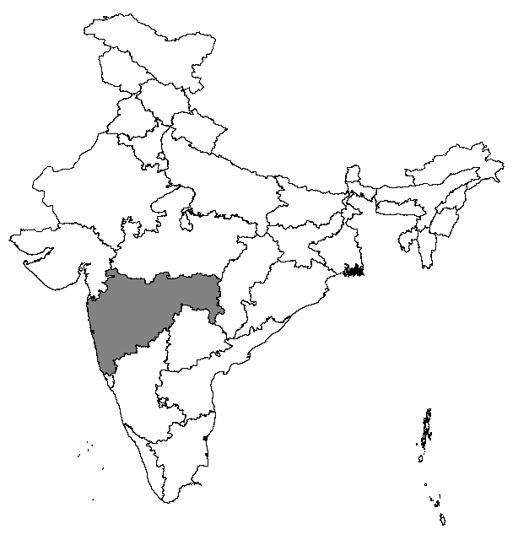
INDIA
Fig 2 Location of Kaneri Lake in India and sampling point in Kaneri Lake
MAHARASHRA
KOLHAPUR

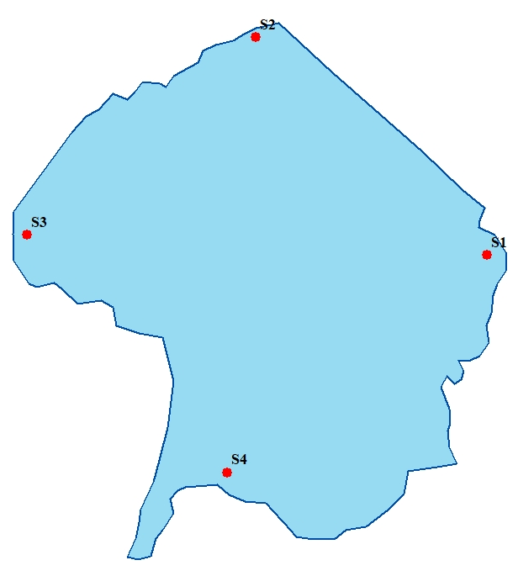

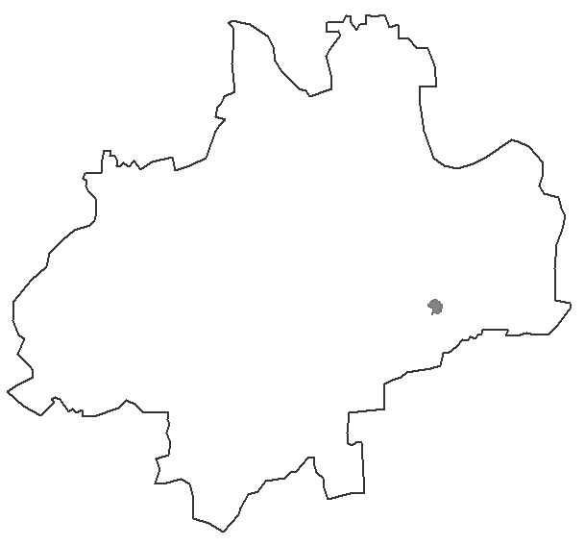
Sampling point
KANERI LAKE
KARVIR

Monthly record of water quality parameters of Kaneri from February 2023 to January 25

Figure 3a Variation of pH values in Kaneri Lake from February 2023 to January 2025

Figure 3b Variation of water temperature (˚C) in values Kaneri Lake from February 2023 to January 2025

Figure 3c Variation of Dissolved Oxygen (mg/L) values in Kaneri Lake from February 2023 to January 2025

Figure 3d Variation of Total hardness (mg/L) values in Kaneri Lake from February 2023 to January 2025

Figure3e Variation of Total alkalinity (mg/L) values in Kaneri Lake from February 2023 to January 2025

Figure3f Variation of Total dissolved solids (mg/L) values in Kaneri Lake from February 2023 to January 2025

Figure3g : Variation of Calcium (mg/L) values in Kaneri Lake from February 2023 to January 2025

Figure 3h Variation of Chloride (mg/L) values in Kaneri Lake from February 2023 to January 2025

Figure 3i Variation of Nitrate (mg/L) values in Kaneri Lake from February 2023 to January 2025

Figure 3j Variation of Phosphate (mg/L) values in Kaneri Lake from February 2023 to January 2025

Figure 3k Variation of Sulphate (mg/L) values in Kaneri Lake from February 2023 to January 2025

Figure 4 Forest plot for the correlation between water quality measure parameters of Kaneri Lake during February 2023 to January 2025
