Review Article
Next-Generation Drug Delivery Approaches in Aquaculture: A Review of Liposome, Bacterial Ghost, and Chitosan Nanocarriers

Abstract
Next-generation nanocarriers offer promising solutions to the persistent challenges of disease control, drug inefficiency, and antimicrobial resistance in aquaculture. This review synthesizes current knowledge on three key platforms liposomes, bacterial ghosts (BGs), and chitosan nanoparticles and evaluates their potential as smart drug and vaccine delivery systems for fish and shellfish. Liposomes, with their phospholipid bilayer architecture, enable the encapsulation of both hydrophilic and hydrophobic molecules, improving drug stability, uptake, and targeted delivery while reducing environmental discharge, as demonstrated for oxytetracycline delivery in Artemia franciscana and therapeutic transport in zebrafish. Chitosan nanoparticles, produced by ionic gelation with sodium tripolyphosphate, exhibit mucoadhesive, biodegradable, and intrinsically antimicrobial properties; their nanoscale size, positive surface charge, and pH-responsive release behavior enhance oral and immersion-based delivery of antibiotics, vaccines, and immunostimulants in aquaculture species. Bacterial ghosts, generated by controlled expression of bacteriophage lysis gene E in Gram-negative bacteria, retain native surface structures and form nanoscale membrane pores that support high drug-loading capacity and enzyme-responsive intracellular release, while simultaneously acting as potent immunostimulatory carriers. Collectively, these three systems address critical limitations of conventional chemotherapeutic delivery by improving bioavailability, site-specific targeting, and immune modulation. The review also highlights current methodological advances, identifies constraints related to scalability, stability, and biosafety, and outlines future research priorities for integrating these nanocarriers into practical, species-specific, and route-optimized therapeutic strategies to support sustainable aquaculture and mitigate antimicrobial resistance.
Keywords: liposomes, bacterial ghosts, chitosan nanoparticles, Drug

- Introduction
Fish aquaculture is considered an important agricultural activity capable of ending nutritional deficiencies and contributing to poverty reduction (Kaleem & Sabi, 2021). Intensive farming practices expose fish and crustaceans to a wide range of bacterial, viral, and parasitic pathogens, resulting in significant economic losses and heavy dependence on chemotherapeutic agents (FAO 2024). Conventional drug administration methods such as bath treatments, medicated feed, or direct water application often suffer from poor bioavailability, rapid dilution in water, environmental contamination, and the emergence of antimicrobial resistance (AMR) (Al-Zuhairy et al., 2025). These challenges highlight the need for smart, efficient, and environmentally safe drug delivery systems tailored for aquatic environments (Yu et al., 2025).
Smart drug delivery platforms such as liposomes, chitosan nanoparticles, and bacterial ghosts (BGs) have emerged as powerful alternatives to conventional treatment strategies. Liposomes, first introduced as phospholipid vesicles capable of entrapping both hydrophilic and hydrophobic molecules, have demonstrated substantial potential for improving drug encapsulation and targeted delivery in aquatic animals (Samad et al.,2007). For example, liposome-mediated delivery of water-soluble antibiotics like oxytetracycline significantly enhances drug uptake in Artemia franciscana larvae compared to free antibiotics added to water, thereby reducing environmental release and improving therapeutic efficiency (Touraki et al., 1995). Liposomes have also been used as in vivo delivery vehicles in model organisms such as zebrafish, where they effectively transported therapeutic molecules and released them at target tissues, demonstrating the feasibility of liposome-based systems for aquatic biomedical applications (Sivamani et al., 2013). Their biocompatibility, ability to fuse with cell membranes, and capacity for controlled drug release make them one of the most promising carriers in aquaculture (Haran et al.,1993)
Similarly, extensive research supports the versatility of chitosan-based nanoparticles, which offer mucoadhesive properties, biodegradability, and natural antimicrobial activity (Wu et al., 2020). Chitosan nanoparticles enhance oral drug and vaccine stability in the gastrointestinal tract, making them suitable for non-invasive delivery in fish and shrimp (El-Naggar, 2020). Their cationic nature facilitates interaction with negatively charged mucosal surfaces, improving drug retention and absorption, which is highly advantageous in aquatic species that exhibit rapid gut transit (Abdel Ghany & Salem, 2020).
A more recent innovation involves bacterial ghosts, which are empty, non-living envelopes of Gram-negative bacteria created through controlled lysis. These carriers maintain critical surface structures such as lipopolysaccharides and fimbriae, giving them intrinsic immunostimulatory properties and enabling them to be recognized and internalized by phagocytic cells. Bacterial ghosts display high drug-loading capacity and can release antibiotics in response to intracellular cues such as elevated lysozyme levels within macrophages, offering a targeted strategy to eliminate intracellular pathogens (Xie et al., 2020) Their ability to synergistically combine immune activation with precise antibiotic delivery represents a novel frontier for aquaculture health management.
- Materials and methods
2.1.1 Liposome Preparation
Liposomes were prepared using the reverse-phase evaporation (REV) method as described by Touraki et al. (1995) with minor modifications. Briefly, phosphatidylethanolamine and cholesterol (molar ratio 2:1) were dissolved in a 1:1 mixture of chloroform and diethyl ether. Oxytetracycline (OTC) was dissolved in artificial seawater to form the aqueous phase. The aqueous phase was added to the organic lipid solution and sonicated for 1–2 min to obtain a stable water-in-oil emulsion. Organic solvents were removed under reduced pressure using a rotary evaporator at room temperature, producing a gel-like phase that spontaneously formed liposomes. The resulting liposomes were washed three times with artificial seawater by centrifugation at 3,000 × g for 10 min to remove unencapsulated drug. The final pellet was resuspended in sterile artificial seawater and stored at 4 °C in the dark. The presence of cholesterol and α-tocopherol improved membrane stability and minimized premature leakage, consistent with earlier findings (Touraki et al., 1995).
2.1.2 Characterization of Liposomes
Particle size and polydispersity index (PDI) were measured using dynamic light scattering (DLS). Liposomal morphology was confirmed by transmission electron microscopy following standard procedures (Sivamani et al., 2013). Encapsulation efficiency (EE%) was determined by disrupting liposomes with ethanol and quantifying OTC by HPLC at 365 nm, following the analytical method of Touraki et al. (1995).
2.1.3 Stability Assessment
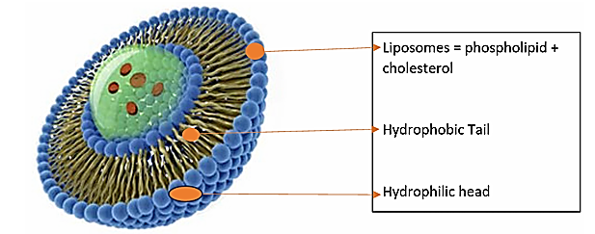
Liposome stability was evaluated by monitoring drug leakage at pH 6 and pH 8 over 24–72 h. Leakage and size changes were compared to previously reported pH-dependent destabilization patterns of OTC-loaded liposomes (Touraki et al., 1995).
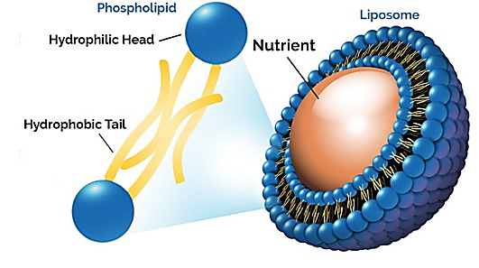

Fig. 1 Structure of Liposome (Kumar et el.,2021)
2.2 Bacterial Ghost
2.2.1 Bacterial Strain and Materials
Escherichia coli Nissle 1917 (EcN) was used for the construction of bacterial ghosts (BGs). Plasmid pVB220 carrying bacteriophage ΦX174 lysis gene E was procured from Genscript. LB media, gentamicin, PBS, and other analytical-grade reagents were used as provided (Pie at al.,2017)
2.2.2 Construction of Bacterial Ghosts (BGs)
BGs were generated following the PhiX174 lysis-gene-mediated method which is shown in fig.2. EcN cells were transformed with plasmid pVB220 using electroporation at 1.5 kV using a Bio-Rad MicroPulser. (Yoo et al., 2011). Transformed EcN were cultured in LB broth until mid-log phase (OD₆₀₀ ≈ 0.6). Expression of the lysis protein E was induced by incubating cultures at 42 °C, producing transmembrane tunnels that release cytoplasmic content. A sharp decrease in OD₆₀₀ within 30 min indicated successful lysis and BG formation. After 2 h of induction, cultures were treated with 0.05 mg/mL gentamicin for 6 h to inactivate any surviving bacteria. Viable cell counts confirmed complete lysis. BGs were harvested via centrifugation (5000 × g, 10 min), washed with sterile PBS, and lyophilized for storage (Yoo et al., 2011)
2.2.3 Verification of Ghost Formation
BG morphology was examined by scanning electron microscopy (SEM), which showed characteristic 40–100 nm lysis pores on the outer membrane (Anwer et al., 2025). The formation of BGs was also confirmed by monitoring the reduction in OD₆₀₀ during lysis and by plating assays verifying the absence of viable bacteria (Lim et al.,2019).
2.2.4 Drug Loading into Bacterial Ghosts
To load ciprofloxacin (CIP), 5 mg of lyophilized BGs were resuspended in 5 mL phosphate buffer (pH 6.0) containing CIP (0.2–0.5 mg/mL). After 30 min incubation at room temperature, BGs were centrifuged, washed (PBS, pH 7.4), and vacuum-dried to obtain BG@CIP. Drug loading content and release behavior were quantified spectrophotometrically (UV 277 nm).
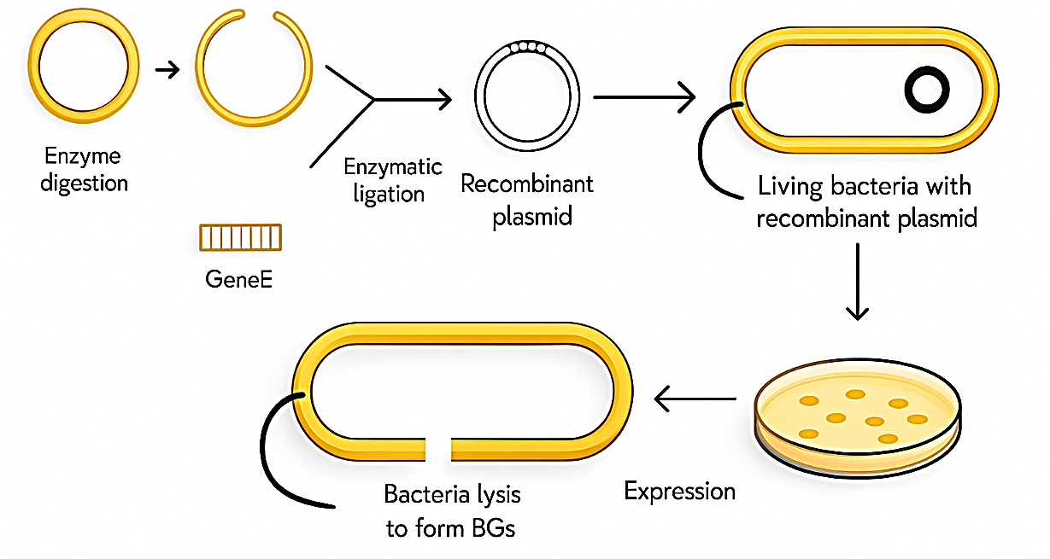

Figure 2: Bacterial Ghost (BG) Production Using Recombinant Plasmids (Chen et al., 2021)

2.3 Chitosan Nanoparticle
Chitosan nanoparticles (CSNPs) were synthesized by the ionic-gelation method using sodium tripolyphosphate (TPP) as a crosslinker (El-Naggar et al., 2022). Chitosan (low molecular weight) was dissolved in 0.5% (v/v) acetic acid to yield a 1.0 mg/mL chitosan solution; the pH was adjusted to 4.8. A TPP solution (0.5 mg/mL) was prepared in deionized water. Under constant magnetic stirring (≈ 600–900 rpm), TPP was added dropwise to the chitosan solution at room temperature, maintaining a chitosan:TPP mass ratio of 4:1. The mixture was stirred for 30 minutes, leading to the spontaneous formation of chitosan nanoparticles.
For drug or antigen loading, the therapeutic compound (e.g., antibiotic, DNA, protein, or immunostimulant) was premixed with the chitosan solution prior to TPP addition, ensuring its entrapment during nanoparticle formation (Rivas-Aravena et al., 2015). After formation, nanoparticles were collected by centrifugation (15,000 × g, 20 min), washed with deionized water or phosphate-buffered saline (PBS), and resuspended in PBS.
Nanoparticle characterization included measurement of hydrodynamic diameter, polydispersity index (PDI), and zeta potential by dynamic light scattering (DLS), and morphology by transmission electron microscopy (TEM), following standard protocols (El-Naggar et al., 2022). Encapsulation efficiency (EE%) was calculated by quantifying the unencapsulated drug/antigen in the supernatant (e.g., by UV–Vis spectrophotometry or HPLC), using the formula (Xie et al.,2022):
$$EE\%=\frac{Total drug added-Free drug in supernatant}{Total drug added}×100.$$
Stability studies were performed by incubating CSNP suspensions in aquaculture-relevant media (e.g., freshwater or brackish water) for up to 72 h, monitoring changes in size, PDI, and release of encapsulated compound.
- Results
Published studies consistently show that liposome formulations enhance drug stability, uptake, and therapeutic performance in aquaculture species. In fig.3 Liposome-encapsulated antibiotics such as oxytetracycline exhibit higher encapsulation efficiency, reduced leakage, and improved absorption compared to free drug forms. For example, Touraki et al. (1995) reported a >2-fold increase in drug retention and uptake in Artemia larvae following liposomal delivery.
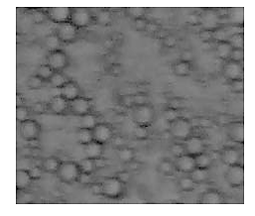
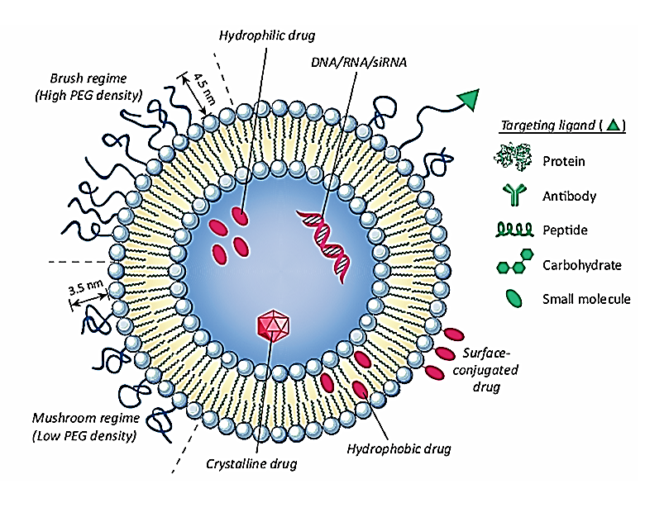
Liposomal vaccines also demonstrate superior delivery properties, with nanoscale liposomes (<200 nm) improving mucosal uptake, antigen protection, and immune activation in fish (Li, Woodle et al 1998). Studies in zebrafish show efficient intracellular delivery and controlled release of liposome-carried molecules, supporting their role in targeted therapeutic transport (Sivamani et al., 2013).

Figure 3: Visualization of liposomes in water by fluorescent microscope. (Kumar et el.,2021)
3.1 Bacterial Ghost
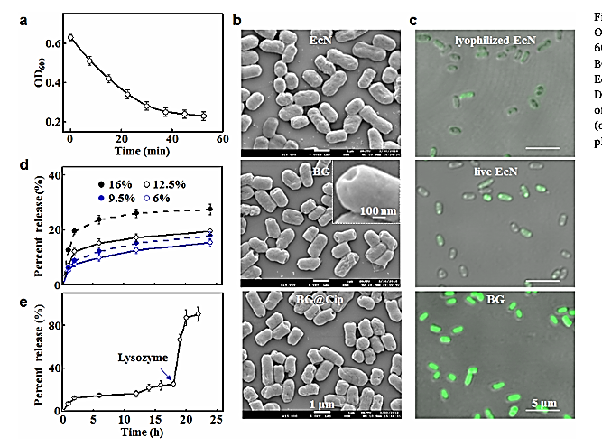
Studies demonstrate that bacterial ghosts (BGs) maintain their native cell-envelope structure while forming characteristic membrane pores (40–100 nm), enabling efficient drug loading without altering external morphology. SEM analyses consistently show intact surface features with clear transmembrane openings formed by lysis gene E, confirming successful cytoplasmic evacuation and ghost formation.
Fig. 4 Characterization and Drug-Release Behavior of Ciprofloxacin-Loaded Bacterial Ghosts (BG@Cip) (Xie et al., 2020)
Figure 4 summarizes the efficiency and structural integrity of bacterial ghost (BG) preparation. Panel (a) shows a time-dependent decrease in OD₆₀₀, confirming effective cell lysis and release of intracellular contents. Scanning electron microscopy in panel (b) demonstrates that, compared with intact E. coli (EcN), the BGs and drug-loaded BGs retain their overall cell envelope morphology, indicating controlled lysis without complete structural collapse. Fluorescence microscopy in panel (c) further confirms the non-viability of lyophilized EcN and BGs, while live EcN shows strong fluorescence, validating successful ghost formation. Panel (d) illustrates a concentration-dependent increase in the release of cellular contents, highlighting the efficiency of the method under different treatment conditions. Finally, panel (e) shows lysozyme-triggered release over time, indicating that BG membranes remain enzyme-responsive, a property advantageous for controlled release and vaccine or drug delivery applications.
BGs exhibit high drug-loading capacity, with loading efficiencies typically ranging from 36–48%, significantly higher than conventional nanoparticle carriers. In fig. 4 the characterization and drug-release behavior of ciprofloxacin-loaded bacterial ghosts (BG@Cip) has been described by Xie et al. (2020), who reported the preparation of bacterial ghost carriers, their structural features, and their ability to control ciprofloxacin release for potential antimicrobial applications. This behaviour supports their suitability for targeted intracellular delivery (Kim et al., 2026).
3.2 Chitosan Nanoparticle as drug Carrier
Studies consistently show that chitosan nanoparticles (CS-NPs) possess favorable physicochemical properties that enhance their suitability for targeted delivery in fish and shrimp. Synthesized CS-NPs typically exhibit uniform particle sizes ranging from 50–250 nm, with positive zeta potentials due to protonated amino groups, improving stability and promoting strong interaction with negatively charged mucosal surfaces. This cationic nature enhances adhesion to gills and intestinal epithelia, supporting effective oral and immersion delivery.
Encapsulation studies demonstrate high drug-loading efficiencies (40–80%) for antibiotics, vaccines, and immunostimulants. Cross-linking with sodium tripolyphosphate (TPP) results in dense polymeric matrices, allowing controlled and sustained release under aquatic conditions. Drug release is faster under acidic pH—typical of fish gastrointestinal environments—indicating pH-responsive behaviour beneficial for oral delivery.
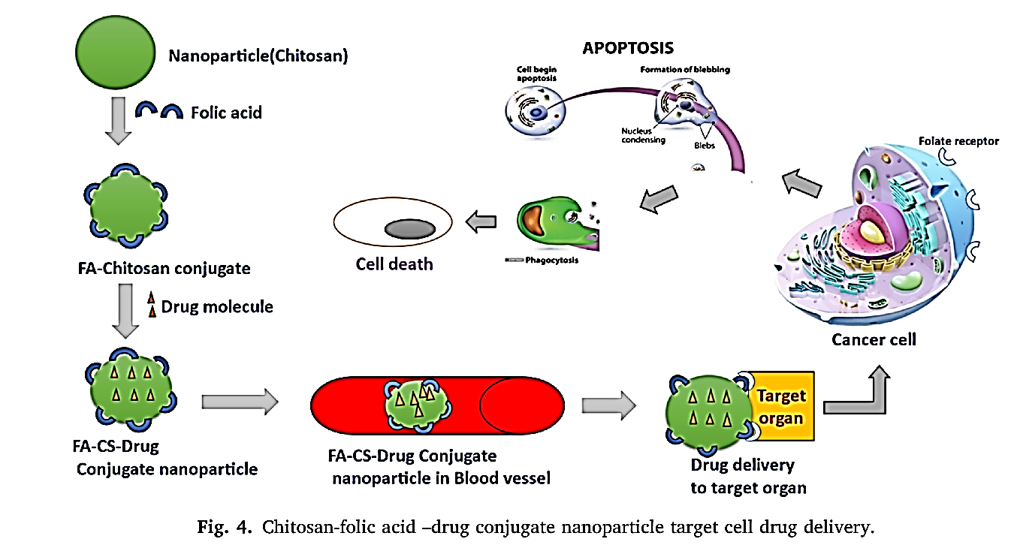
In vitro results show that CS-NPs improve cellular uptake in fish cell lines due to mucoadhesive and permeation-enhancing properties. Several studies report significantly higher antimicrobial efficacy compared to free drugs, attributed to improved stability and prolonged retention. In fig. 5 Chitosan–folic acid drug-conjugate nanoparticles were developed as a targeted drug delivery system, in which the folic acid ligand guides the nanocarriers to folate receptor–overexpressing target cells, enabling efficient cellular uptake and localized release of the conjugated therapeutic agent.

Fig. 5 Chitosan folic acid drug conjugate Nanoparticle Target cell drug delivery
- Discussion
Smart nanocarrier-based drug delivery systems represent a paradigm shift in aquaculture therapeutics, addressing key limitations of conventional medication approaches such as poor drug stability, environmental contamination, and the rise of antimicrobial resistance (AMR). Among various innovative platforms, liposomes, chitosan nanoparticles, and bacterial ghosts (BGs) have emerged as particularly promising strategies due to their target specificity, biodegradability, and sustained release capabilities.
4.1 Liposomes: Biocompatible and Efficient Carriers
Liposomes have demonstrated exceptional potential as biodegradable and biocompatible carriers capable of encapsulating both hydrophilic and lipophilic agents. Their phospholipid bilayer architecture mimics biological membranes, allowing them to interact effectively with fish epithelial and mucosal tissues. Several studies have shown enhanced drug stability and uptake when antibiotics are encapsulated within liposomes compared to their free forms. For example, oxytetracycline-loaded liposomes significantly improved absorption in Artemia franciscana larvae while minimizing environmental release (Touraki, Elaiopoulos, Kiousi, & Dotsikas, 1995). Similarly, applications in zebrafish demonstrated successful tissue-specific delivery and controlled drug release, confirming their potential as nanoscale vehicles for aquatic therapeutic transport (Sivamani, Zhang, & Collins, 2013).
Liposomal carriers also benefit vaccine formulation by supporting antigen protection and mucosal uptake. Their nanoscale size (<200 nm) promotes endocytosis and facilitates sustained antigen release, leading to enhanced immunogenicity in fish. The inclusion of stabilizing agents such as cholesterol and α-tocopherol further enhances membrane integrity under aquatic conditions, reducing drug leakage at variable pH environments (Touraki et al., 1995). Therefore, the controlled physicochemical attributes of liposomes translate into superior pharmacokinetics and therapeutic outcomes in aquaculture species.
4.2 Bacterial Ghosts
Bacterial ghosts (BGs), derived from controlled lysis of Gram-negative bacteria, represent a hybrid system merging immunological activity with drug-carrying capacity. Their unique hollow envelopes retain native membrane structures lipopolysaccharides, outer membrane proteins, and fimbriae providing intrinsic adjuvant properties that naturally stimulate host immune responses (Yoo et al., 2011). The presence of nanoscale lysis pores (40–100 nm) allows incorporation of therapeutic cargo such as antibiotics, vaccines, or peptides without altering the outer topology (Zhu et al., 2025).
A significant advantage of BGs lies in their ability to deliver drugs specifically to phagocytic cells, where intracellular fish pathogens such as Aeromonas hydrophila or Edwardsiella tarda reside. Their enzyme-sensitive release mechanisms, which respond to lysozymes and acidic conditions within macrophages, facilitate controlled intracellular drug liberation (Xie et al.,2020 & Ma et al., 2021). This targeted strategy not only increases antimicrobial bioavailability but also minimizes systemic exposure and potential toxicity. Furthermore, the dual action of BGs as immunostimulatory agents and drug carriers offers a synergistic benefit, promoting both direct pathogen clearance and immune priming.
4.3 Chitosan Nanoparticles: Mucoadhesive and Environment-Friendly Systems
Chitosan-based nanocarriers are distinguished by their natural biodegradability, mucoadhesion, and inherent antimicrobial activity (Payamifard et al., 2025). Derived from crustacean and fungal chitin, chitosan’s cationic amino groups enable electrostatic interaction with negatively charged epithelial and mucosal surfaces, improving adhesion and drug absorption in fish and shrimp (El-Naggar, Salem, Khalil, & Awad, 2022). Such interactions are particularly valuable for oral delivery systems in aquaculture species where fast gut transit times often limit bioavailability.
Chitosan nanoparticles synthesized via ionic gelation with sodium tripolyphosphate (TPP) display tunable particle sizes (50–250 nm), high encapsulation efficiencies, and pH-responsive release profiles. Drug release tends to accelerate under acidic conditions, corresponding to the gastrointestinal environment of fish, making them ideal for oral or immersion-mediated drug and vaccine administration (Rivas-Aravena et al., 2015). Moreover, chitosan nanoparticles enhance immune responses, as demonstrated by increased antibody titers and upregulated immune gene expression following administration of chitosan-based vaccines in several teleost species (El-Naggar et al., 2022). The combination of sustained release, mucoadhesion, and immunopotentiation highlights CS-NPs as environmentally benign platforms for sustainable aquaculture therapeutics (Hanafy, 2025).
4.4 Comparative Insights and Future Prospects
Collectively, liposomes, chitosan nanoparticles, and bacterial ghosts illustrate complementary strengths within aquaculture drug delivery. Liposomes excel in targeted delivery and controlled release, chitosan nanoparticles are ideal for oral and mucosal delivery with inherent antimicrobial characteristics, and bacterial ghosts integrate immune activation with site-specific therapeutic transport. However, each system faces challenges in large-scale application. Liposomal formulations may suffer from stability and cost constraints; chitosan nanoparticles require precise control of particle size and zeta potential to ensure batch reproducibility; and bacterial ghost production needs rigorous safety verification to ensure complete cell inactivation (Yoo et al., 2011).
- Conclusion
Next-generation nanocarriers such as liposomes, bacterial ghosts, and chitosan nanoparticles offer an integrated strategy to overcome the limitations of conventional chemotherapeutic delivery in aquaculture by enhancing drug stability, bioavailability, and targeting while reducing environmental discharge. Collectively, these systems improve antimicrobial efficacy and vaccine performance through controlled and often stimuli-responsive release, mucoadhesion, and intrinsic immunostimulatory properties, positioning them as key tools for sustainable disease management and for mitigating antimicrobial resistance in intensive aquaculture.​ Future research on smart nanocarriers in aquaculture should prioritize scalable, cost-effective production processes and robust stability during storage and field use, enabling commercialization beyond laboratory settings. There is also a need to develop species- and route-specific formulations (oral, immersion, injection) that integrate liposomes, bacterial ghosts, and chitosan nanoparticles as vaccine adjuvants and drug carriers, with rigorous in vivo validation of safety, efficacy, and impact on antimicrobial resistance under farm conditions.

Disclaimer (Artificial intelligence)
Option 1:
Author(s) hereby declare that NO generative AI technologies such as Large Language Models (ChatGPT, COPILOT, etc.) and text-to-image generators have been used during the writing or editing of this manuscript.
Option 2:
Author(s) hereby declare that generative AI technologies such as Large Language Models, etc. have been used during the writing or editing of manuscripts. This explanation will include the name, version, model, and source of the generative AI technology and as well as all input prompts provided to the generative AI technology
Details of the AI usage are given below:
1.
2.
3.

REFERENCES
- Kaleem, O. and Sabi, AF.B.S. 2021. Overview of aquaculture systems in Egypt and Nigeria, prospects, potentials and constrains. Aquacult. Fish., 6: 535-547. https://doi.org/10.1016/j.aaf.2020.07.017
- FAO 2024, The State of World Fisheries and Aquaculture 2024: Blue Transformation in action, FAO, Rome, Italy, viewed 8 December 2025, doi:10.4060/cd0683en. https://doi.org/10.4060/cd0683en
- Touraki, M, Rigas, P & Kastritsis, C 1995, ‘Liposome mediated delivery of water soluble antibiotics to the larvae of aquatic animals’, Aquaculture, vol. 136, no. 1–2, pp. 1–10, doi:10.1016/0044-8486(95)01039-4. https://doi.org/10.1016/0044-8486(95)01039-4
- Sivamani, S, Benin Joseph, B & Kar, B 2013, ‘Zebrafish: An in vivo model for the study of liposome mediated drug delivery’, International Journal of Molecular Genetics, vol. 3, no. 2, pp. 53–61, ISSN 2249-4227, Research India Publications, New Delhi, India. https://www.ripublication.com/ijmg/ijmgv3n1_2013/ijmgv3n1_07.pdf
- Yu C, Fan C-Q, Chen Y-X, Guo F, Rao H-H, Che P-Y, Zuo C-J & Chen H-W (2025) Global research trends and emerging hotspots in nano-drug delivery systems for lung cancer: a comprehensive bibliometric analysis (1998–2024). Discover Oncology 16, 33. https://doi.org/10.1007/s12672-025-01782-2
- Al-Zuhairy SAKS, Elhabal SF, Elrefai MFM, Hababeh S, Nelson J, Fady M, Elzohairy NA, Ewedah TM, Mousa IS & Hamdan AME (2025) Polylactic-co-glycolic acid/alginate/neem oil-reduced graphene oxide as a pH-sensitive nanocarrier for hesperidin drug delivery: antimicrobial and acute otitis media assessments. Pharmaceuticals 18(3), 381. https://doi.org/10.3390/ph18030381.​
- Anwer M, Bhaliya K, Munn A & Wei MQ (2025) Bacterial ghosts: a breakthrough approach to cancer vaccination. Biomedicine & Pharmacotherapy 182, 117766. https://doi.org/10.1016/j.biopha.2024.117766
- Kim K-s, Konwar B, Kashyap S & Cho H (2026) Probiotic bacterial ghosts: novel drug delivery platforms in biomedical applications. Journal of Drug Delivery Science and Technology 115(Part 1), 107475. https://doi.org/10.1016/j.jddst.2025.107475
- Zhu J, Na W, Dong H, Guo S, Yang Y, Yang Y, Chen W, Ding L, Tian B & Zhang X (2025) Polysaccharide‑modified liposome‑based drug delivery system for cancer targeted therapy: an updated review. International Journal of Biological Macromolecules 330(Part 4), 148236.https://doi.org/10.1016/j.ijbiomac.2025.148236.
- ​ Hanafy NAN (2025) Chitosan nanoparticles as drug carriers and gene delivery systems: advances and challenges. In: Deshmukh AB, Mishra B & Mishra S (eds) Fundamentals and Biomedical Applications of Chitosan Nanoparticles. Woodhead Publishing, Oxford, pp. 267–308. https://doi.org/10.1016/B978-0-443-14088-4.00015-0.​
- Payamifard M, Nemattalab M, Rezaie Shirmard L & Hesari Z (2025) SLN and chitosan nano-delivery systems for antibacterial effect of black seed (Nigella sativa) oil against S. aureus. International Journal of Environmental Health Research 35(4), 991–1002. https://doi.org/10.1080/09603123.2024.2378103.
- Haran, G., Cohen, R., Bar, L.K., Barenholz, Y., 1993, “Transmembrane ammonium sulfate gradients in liposomes produce efficient and stable entrapment of amphipathic weak bases”, Biochim. Biophys. Acta., 1151(2), 201-15. https://doi.org/10.1016/0005-2736(93)90105-9
- Woodle, M.C., Storm, G., 1998, “Long-circulating Liposomes: old drugs, new therapeutics”, Berlin: Springer-Verlag. https://www.ncbi.nlm.nih.gov/nlmcatalog/9712394
- Samad, A., Sultana, Y., Aqil, M., 2007, “Liposomal drug delivery systems: an update review, ” Curr. Drug Deliv., 4, pp. 297-305. https://doi.org/10.2174/156720107782151269
- Li, X., Hirsh, D.J., Cabral-Lilly, D., Zirkel, A., Gruner, S.M., Janoff, A.S., Perkins, W.R., 1998, “Doxorubicin physical state in solution and inside liposomes loaded via a pH gradient”, Biochim. Biophys. Acta., 1415(1), pp. 23-40. https://doi.org/10.1016/s0005-2736(98)00175-8
- El-Naggar, M, Medhat, F & Taha, A 2022, ‘Applications of chitosan and chitosan nanoparticles in fish aquaculture’, Egyptian Journal of Aquatic Biology & Fisheries, vol. 26, no. 1, pp. 23–43, Zoology Department, Faculty of Science, Ain Shams University, Cairo, Egypt, ISSN 1110-6131. https://www.researchgate.net/publication/357700000_Applications_of_chitosan_and_chitosan_nanoparticles_in_fish_aquaculture
- Wu, Y, Rashidpour, A, Almajano, MP & Metón, I 2020, ‘Chitosan-based drug delivery system: Applications in fish biotechnology’, [ Po;ymer], Polymers2020,12,1177 . https://doi.org/10.3390/polym12051177
- Abdel-Ghany, H.M. and Salem, M.E.S. 2020. Effects of dietary chitosan supplementation on farmed fish; a review. Rev. Aquacult., 12(1): 438-452. https://doi.org/10.1111/RAQ.12326
- Xie, S, Li, S, Zhang, Z, Chen, M, Ran, P & Li, X 2020, ‘Bacterial ghosts for targeting delivery and subsequent responsive release of ciprofloxacin to destruct intracellular bacteria’, Chemical Engineering Journal, vol. 396, 125700, https://doi.org/10.1016/j.cej.2020.125700
- Pei, Y, Mohamed, MF, Seleem, MN & Yeo, Y 2017, ‘Particle engineering for intracellular delivery of vancomycin to methicillin-resistant Staphylococcus aureus (MRSA)-infected macrophages’, Journal of Controlled Release, vol. 256, pp. 45–57, Elsevier, Amsterdam, Netherlands. https://doi.org/10.1016/j.jconrel.2017.08.007
- Yoo, CY, Seong, JS & Park, SN 2016, ‘Preparation of novel capsosome with liposomal core by layer-by-layer self-assembly of sodium hyaluronate and chitosan’, Colloids and Surfaces B: Biointerfaces, vol. 144, pp. 99–107, https://doi.org/10.1016/j.colsurfb.2016.04.010
- Lim, J, Koh, VHQ, Cho, SSL, Periaswamy, B, Choi, DPS, Vacca, M, De Sessions, PF, Kudela, P, Lubitz, W, Pastorin, G & Alonso, S 2019, ‘Harnessing the immunomodulatory properties of bacterial ghosts to boost the anti-mycobacterial protective immunity’, Frontiers in Immunology, vol. 10, 2737, https://doi.org/10.3389/fimmu.2019.02737
- Chen, H, Ji, H, Kong, X, Lei, P, Yang, Q, Wu, W, Jin, L & Sun, D 2021, ‘Bacterial ghosts-based vaccine and drug delivery systems’, Pharmaceutics, vol. 13, no. 11, 1892, https://doi.org/10.3390/pharmaceutics13111892
- Rivas-Aravena, A, Fuentes, Y, Cartagena, J, Brito, T, Poggio, V, La Torre, J, Mendoza, H, Gonzalez-Nilo, F, Sandino, AM & Spencer, E 2015, ‘Development of a nanoparticle-based oral vaccine for Atlantic salmon against ISAV using an alphavirus replicon as adjuvant’, Fish & Shellfish Immunology, vol. 45, no. 1, pp. 157–166, https://doi.org/10.1016/j.fsi.2015.03.033
- Kumar, M, Singh, A, Pandey, S, Siddiqui, MA & Kumar, N 2021, ‘Liposomes: Type, preparation, and evaluation’, International Journal of Indigenous Herbs and Drugs, vol. 6, no. 1, pp. 17–22, https://doi.org/10.46956/ijihd.vi.118
- Zhang, Qiang, Collins, Jennifer, Anastasaki, Athina, Wallis, Russell, Mitchell, Daniel Anthony, Becer, C. Remzi and Haddleton, David M.. (2013) Sequence-controlle https://doi.org/10.1002/anie.201300068d multi-block glycopolymers to inhibit DC-SIGN-gp120 binding. Angewandte Chemie International Edition, 52 (16). pp. 4435-4439.
- Ma, Y., Cui, L., Wang, M., Sun, Q., Liu, K. and Wang, J. (2021) ‘A novel and efficient high-yield method for preparing bacterial ghosts’, Toxins, 13(6), p. 420. https://doi.org/10.3390/toxins13060420
- Al Bitar, M., Khalil, M. & Awad, R., 2022. Pure and lanthanum-doped zinc oxide nanoparticles: synthesis, characterization, and antibacterial activity. Applied Physics A, 128, article no. 818. Available at: https://doi.org/10.1007/s00339-022-05942-x
- Rivas-Aravena, A., Fuentes, Y., Cartagena, J., Brito, T., Poggio, V., La Torre, J., Mendoza, H., Gonzalez-Nilo, F., Sandino, A.M. & Spencer, E., 2015. Development of a nanoparticle-based oral vaccine for Atlantic salmon against ISAV using an alphavirus replicon as adjuvant. Fish & Shellfish Immunology, 45(1), pp.157-166. Available at: https://doi.org/10.1016/j.fsi.2015.03.033

