Prevalence and Epidemiological Profiling of White Spot Syndrome Virus (WSSV) in Penaeus monodon (Fabricius, 1798) from the Parangipettai Coastal Water

ABSTRACT
White Spot Syndrome Virus (WSSV) continues to pose a serious threat to shrimp fisheries and aquaculture, yet long-term, seasonally resolved baseline data on its prevalence in wild shrimp populations remain limited, particularly in tropical coastal ecosystems where wild stocks serve as natural reservoirs for disease transmission. To address this fundamental gap, the present study assessed the seasonal prevalence and pathological features of WSSV infection in wild Penaeus monodon collected from nearshore and estuarine environments of the Parangipettai coastal waters during 2023–2025. Shrimp were sampled seasonally and screened for WSSV using a combination of wet-mount examination, histopathology, and conventional polymerase chain reaction (PCR) targeting the WSV285 gene region. A total of 4,605 shrimp specimens were analyzed, of which 948 tested positive, yielding an overall WSSV prevalence of 20.6%. Clear seasonal variation in infection levels was observed, with the highest prevalence recorded during the post-monsoon season (25.7% and 25.4%), followed by summer (21.3% and 21.1%), moderate prevalence during the monsoon (18.4% and 19.5%), and the lowest infection rates during the pre-monsoon period (15.6% and 16.3%). Histopathological and wet-mount examinations revealed characteristic WSSV-associated lesions, including hypertrophied nuclei and prominent intranuclear inclusion bodies, confirming active viral infection. These findings identify the post-monsoon period as the most critical high-risk season for WSSV occurrence in the Parangipettai region and provide essential baseline information to support regional shrimp disease surveillance, risk assessment, and the development of seasonally informed management strategies for sustainable coastal aquaculture.
Keywords: White Spot Syndrome Virus (WSSV), Penaeus monodon, Epidemiology, Seasonal prevalence

INTRODUCTION
White Spot Syndrome Virus (WSSV) is recognized as one of the most devastating viral pathogens affecting penaeid shrimp, capable of causing near-complete crop losses within days of infection (Walker & Winton, 2010; Bateman, 2021). Since its first major outbreaks in the mid-1990s, WSSV has spread across Asia, the Americas, and parts of Africa, establishing itself as a persistent threat to both aquaculture and wild crustacean populations (Vlak, 2022; Ziarati et al., 2025). The virus displays an exceptionally broad host range, infecting over 100 species of crustaceans including shrimps, crabs, crayfish, lobsters, and even several non-crustacean organisms which enhances its transmission potential in natural ecosystems (Desrina et al., 2022; Dela Peña et al., 2023).
The biological success of White Spot Syndrome Virus (WSSV) is closely linked to its environmental persistence and efficient horizontal transmission within aquatic ecosystems. Recent studies and reviews indicate that WSSV can persist in pond sediments, organic debris, biofilms, and the water column, enabling long-term environmental maintenance of the virus even in the absence of active shrimp infections (Sánchez-Paz, 2017; Flegel, 2019; Cox et al., 2023). Increasing evidence also highlights the role of multiple reservoir and carrier hosts, including crabs, polychaetes, filter-feeding bivalves, and invasive freshwater crayfish, which can harbor WSSV without showing overt disease signs and contribute to viral circulation between natural waters and aquaculture systems (Flegel, 2019; Cox et al., 2023; Min et al., 2024; Rothman, 2024). Horizontal transmission through cohabitation, cannibalism of infected or moribund individuals, and waterborne exposure is now widely recognized as the dominant pathway driving WSSV outbreaks in both Penaeus monodon and P. vannamei under field and culture conditions (Cox et al., 2023). Environmental factors further compound the epidemiology of WSSV. Seasonal fluctuations in temperature, salinity, turbidity, and nutrient loading can influence viral persistence and host susceptibility, particularly in estuarine and coastal systems where hydrological patterns shift markedly across monsoon cycles (Quang et al., 2009; Shields et al., 2020). Post-monsoon conditions, in particular, often promote viral amplification due to increased organic load, sediment resuspension, and greater interaction among carrier species (Uma, 2025; Singh, 2025). Such seasonally driven infection dynamics highlight the importance of region-specific epidemiological monitoring.
Diagnostic advancements have played a crucial role in understanding WSSV distribution and infection intensity. Early detection relied on wet-mount observation and histopathology, revealing characteristic hypertrophied nuclei and intranuclear inclusion bodies. Histopathological examination continues to be used as a supportive diagnostic approach for White Spot Syndrome Virus (WSSV), with recent studies reporting characteristic lesions such as hypertrophied nuclei and intranuclear inclusion bodies in infected shrimp tissues. However, molecular diagnostic tools have become central to WSSV detection due to their higher sensitivity and specificity. Over the past decade, techniques including conventional PCR, real-time PCR, loop-mediated isothermal amplification (LAMP), and portable microfluidic PCR platforms have significantly improved the accuracy, speed, and field applicability of WSSV surveillance in both cultured and wild shrimp populations (Sun et al., 2014; Saksmerprome et al., 2010; Otta et al., 2018; Chen et al., 2019). Among these methods, PCR-based assays targeting conserved genomic regions of WSSV, such as WSV285, remain widely employed owing to their robustness, cost-effectiveness, and suitability for large-scale epidemiological monitoring (Otta et al., 2018; Cox et al., 2023). Despite these methodological advances, epidemiological information on WSSV prevalence in wild shrimp populations remains limited, particularly along the southeast coast of India. The Parangipettai coastal waters, characterized by dynamic estuarine discharge, tidal mixing, and high biodiversity, represent an important natural habitat for Penaeus monodon. Wild shrimp inhabiting such environments may function as asymptomatic carriers or reservoirs of WSSV, facilitating pathogen transfer to adjacent aquaculture systems (Flegel, 2019; Cox et al., 2023). Understanding infection prevalence in natural shrimp populations is therefore critical for assessing outbreak risk and developing science-based disease management strategies.
Moreover, WSSV evolution and genetic variability remain active areas of research, with recent genome sequencing studies revealing considerable strain diversity and genomic features associated with virulence and host interaction (Sánchez-Paz, 2017; Li et al., 2019; Cox et al., 2023). Evidence also indicates that WSSV can persist in shrimp populations through latent or low-level infections, with surviving individuals acting as chronic carriers that may trigger outbreaks under favorable environmental conditions (Flegel, 2019; Cowley et al., 2020; Buathongkam et al., 2025). Given these challenges, comprehensive epidemiological profiling of WSSV in wild P. monodon populations is vital for regions like Parangipettai, where shrimp fisheries and aquaculture coexist closely. Seasonal monitoring provides critical insights into infection patterns, high-risk periods, and the environmental drivers of viral prevalence. Such information forms the basis for improved biosecurity measures, early-warning systems, and sustainable aquaculture planning.
The present study investigates the seasonal prevalence and epidemiological characteristics of White Spot Syndrome Virus (WSSV) in wild Penaeus monodon collected from the Parangipettai coastal waters between 2023 and 2025. Although earlier studies have largely focused on WSSV outbreaks in aquaculture systems or short-term observations in wild shrimp, comprehensive, multi-year assessments of seasonal infection dynamics in natural populations remain scarce, particularly along the southeast coast of India. By integrating wet-mount examination, histopathology, and PCR diagnostics, this study provides the most detailed and temporally resolved baseline evaluation of WSSV occurrence in the region to date. The findings significantly advance current understanding of WSSV ecology in wild shrimp reservoirs and generate critical evidence to strengthen regional disease surveillance, coastal resource management, and biosecurity strategies for sustainable aquaculture development.
METHODOLOGY
Sample collection
The sample collection for this study was carried out over a two-year period from 2023 to 2025 along the natural coastal and estuarine regions of Parangipettai on the southeast coast of India. Sampling stations were selected across nearshore marine waters, the Vellar estuary mouth, and major landing centers and auction yards where wild-caught Penaeus monodon were sold. A total of 4,605 wild shrimp specimens were collected seasonally using traditional fishing gears such as cast nets, shore seines, push nets, and trawl by-catch, with the assistance of local fishermen. Immediately after capture, the shrimp were carefully handled, placed in clean containers, and transported to the laboratory for further examination and analysis.
Wet Mount
Screening for White Spot Syndrome Virus (WSSV) was conducted using wet mount preparations of the shrimp exoskeleton. Freshly collected Penaeus monodon were rinsed with sterile seawater to remove surface debris, and small fragments of the exoskeleton-particularly from the cephalothorax or carapace-were gently dissected using a sterile scissor. The dissected exoskeletal material was placed on a clean glass slide, mixed with a drop of sterile saline, and covered with a coverslip to prepare the wet mount. The preparation was examined under a compound microscope under 100× and 400× magnifications for the detection of characteristic WSSV-associated features.
Histopathology
Normal and WSSV-infected shrimp tissues were dissected from Penaeus monodon collected from the Parangipettai coastal waters and immediately fixed in 10% neutral buffered formalin for 24-48 h. After fixation, tissues were washed, dehydrated through a graded ethanol series, cleared in xylene, and embedded in paraffin wax. Sections of 4-5 µm thickness were cut using a rotary microtome and mounted on poly-L-lysine-coated slides. Routine hematoxylin and eosin (H&E) staining was performed by deparaffinizing sections in xylene, rehydrating through descending ethanol grades, staining with hematoxylin, bluing, counterstaining with eosin, dehydrating, and clearing in xylene before mounting with DPX, following standard histopathological procedures described for shrimp tissues (Lightner, 1996; Bell & Lightner, 1988).
Molecular Analysis
Genomic DNA was extracted from normal and WSSV-infected Penaeus monodon tissues using a commercial DNA extraction kit following the manufacturer’s instructions. DNA quality and quantity were assessed spectrophotometrically, and working stocks were adjusted to approximately 50–100 ng/µL. Nested PCR was carried out using WSSV-specific primers targeting a conserved region of the viral genome as described previously (146F2/146R2 target, 941 bp) following established protocols (Lo et al., 1996; Hossain et al., 2004). Each 25 µL reaction contained 1× PCR buffer, 1.5 mM MgCl₂, 200 µM of each dNTP, 0.4 µM of each primer, 1 U of Taq DNA polymerase, and 2 µL of template DNA. Amplification was performed in a thermal cycler with an initial denaturation at 94 °C for 3 min followed by 35 cycles of denaturation at 94 °C for 30 s, annealing at 55–60 °C (depending on primer Tm) for 30 s, and extension at 72 °C for 45 s, with a final extension at 72 °C for 7 min. PCR products were resolved on a 1.5% agarose gel containing ethidium bromide, visualized under UV illumination, and samples showing a distinct diagnostic WSSV-specific band were considered positive. Representative WSSV-positive amplicons were purified and subjected to Sanger sequencing using the same primers on an ABI 3730xl DNA analyzer. Chromatograms were manually checked, and forward and reverse reads were assembled into consensus sequences. Sequence identity was confirmed by BLAST analysis against the NCBI database analysis against the NCBI database, following standard molecular confirmation procedures (Saksmerprome et al., 2009; Otta et al., 2018).
RESULT
Gross Pathology
Gross examination of Penaeus monodon revealed clear differences between healthy and WSSV-infected individuals. Normal shrimp (Fig1. A and C) showed a translucent, well-pigmented carapace, firm exoskeleton, and absence of white inclusions. In contrast, WSSV-infected shrimp (Fig1. B and D) exhibited characteristic whitish to opaque carapace discoloration, accompanied by distinct white spots on the cephalothorax and dorsal cuticle. The exoskeleton of infected shrimp appeared soft and fragile, with noticeable reduction in pigmentation and areas of milky opacification. These gross abnormalities are consistent with typical manifestations of WSSV infection in P. monodon.

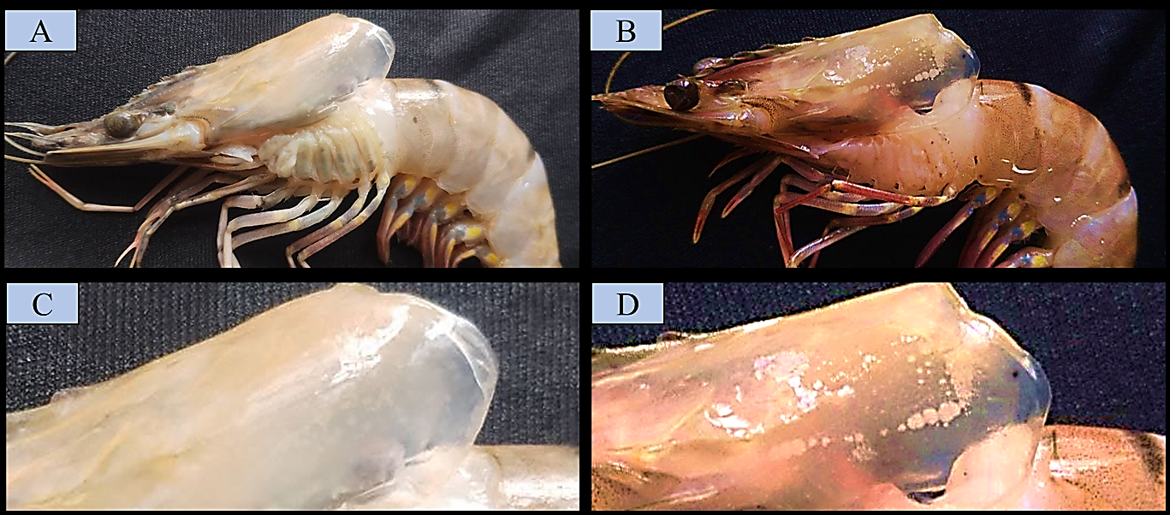
Figure 1. Gross comparison between healthy and WSSV-infected Penaeus monodon.
(A, C) Normal shrimp showing a clear, translucent carapace with no visible white spots.
(B, D) WSSV-infected shrimp displaying prominent white spots, carapace opacification, and typical gross lesions associated with white spot syndrome.

Prevalence of WSSV in Penaeus monodon
The seasonal prevalence of White Spot Syndrome Virus (WSSV) in Penaeus monodon collected along the Parangipettai coastal water from 2023 to 2025 is summarized in Table 1. A total of 4,605 shrimp samples were screened across two years, representing all four major seasons. The infection pattern showed clear and consistent seasonal fluctuations across both study years. During 2023-2024, WSSV prevalence ranged from 15.6% in the pre-monsoon season to a maximum of 25.7% in the post-monsoon period. Moderate levels of infection were observed during the summer (21.3%) and monsoon (18.4%) seasons. A similar trend was observed during 2024–2025, with lowest prevalence during pre-monsoon (16.3%) and highest during post-monsoon (25.4%). Summer and monsoon seasons recorded 21.1% and 19.5% infection levels, respectively (Graph 1).
Overall, the two-year infection trend indicates that post-monsoon consistently exhibited the highest WSSV prevalence, followed by summer, while pre-monsoon remained the least affected period. The monsoon-associated prevalence remained moderate in both years, suggesting environmental influences such as salinity fluctuations and freshwater inflow may impact viral transmission dynamics. The repeated post-monsoon peak across both years highlights this season as a critical high-risk period for WSSV emergence in the Parangipettai region.
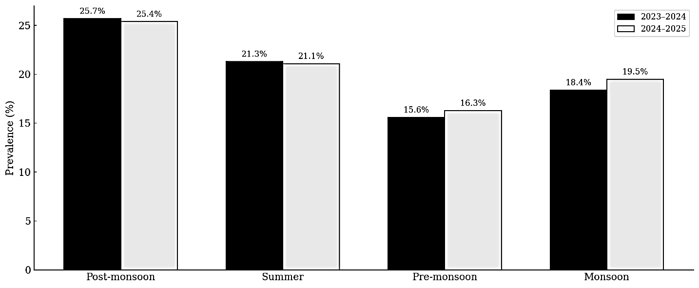
Graph 1:

Seasonal Prevalence Cochran- Armitage Trend Test
The Cochran–Armitage trend test was applied to evaluate the presence of a linear trend in WSSV prevalence across ordered seasonal categories (pre-monsoon, monsoon, summer, and post-monsoon). Data from both study years were pooled to increase statistical power. The analysis revealed a highly significant increasing trend in WSSV prevalence across seasons (Z = 5.98, p < 0.001). WSSV prevalence progressively increased from the pre-monsoon period (15.95%) through monsoon (19.00%) and summer (21.19%), reaching the highest level during the post-monsoon season (25.58%). These results indicate a strong seasonal influence on WSSV occurrence, with infection risk increasing steadily towards the post-monsoon period.
Table 2. Seasonal trend in WSSV prevalence revealed by the Cochran–Armitage trend test
Season | Positive | Total | Prevalence (%)
pre-monsoon | 177 | 1110 | 15.95
Monsoon | 228 | 1200 | 19.00
Summer | 213 | 1005 | 21.19
Post-monsoon | 330 | 1290 | 25.58

Wet Mount
Wet-mount examination of the shrimp carapace revealed the presence of characteristic White Spot Syndrome Virus (WSSV) inclusions. The epithelial surface displayed distinct circular to oval viral‐associated structures with well-defined concentric layers. These inclusions appeared refractile under light microscopy and were consistently distributed along the carapace cuticle. High-magnification observation further highlighted the radiating internal pattern and finely striated outer margins, features commonly associated with WSSV-induced cuticular abnormalities. The presence of these structures strongly supports WSSV infection in the examined specimen.
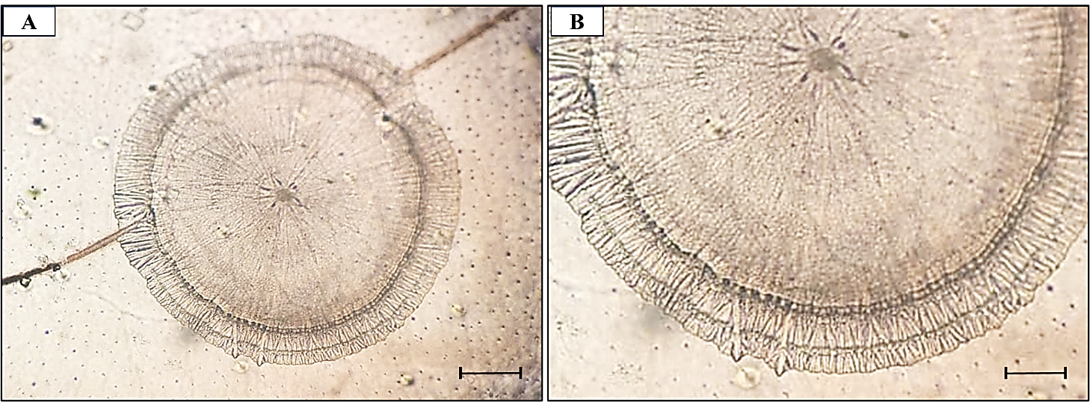
Figure 2: Wet-mount microscopy of shrimp carapace showing WSSV-associated cuticular inclusions. (A) Low-magnification view illustrating a complete circular inclusion with concentric internal radiations. (B) Higher-magnification view highlighting the fine peripheral striations typical of WSSV lesions. Scale bars: 50 µm.
Histopathology
Histological examination of the gill tissues revealed clear distinctions between normal and WSSV-infected samples. In normal gills (Fig 3A-B), the lamellae appeared well-organized with intact epithelial layers and uniform cellular architecture. Hemocytes were sparsely distributed, and no structural abnormalities or inclusion bodies were observed. The lamellar margins were smooth, and the underlying supportive tissues showed no signs of degeneration or necrosis.
In contrast, gills from WSSV-infected shrimp (Fig 3. C-F) exhibited marked pathological alterations. The lamellae were congested, with pronounced cellular hypertrophy and disorganization of the epithelial lining. Numerous hypertrophied nuclei containing eosinophilic to basophilic inclusions characteristic of WSSV infection-were evident throughout the lamellar tissue. Degenerative changes, including cell swelling, vacuolation, and focal necrosis, were also prominent. These lesions were accompanied by increased hemocytic infiltration, indicating a host inflammatory response. Collectively, these histopathological features are consistent with acute WSSV infection in shrimp gill tissue.
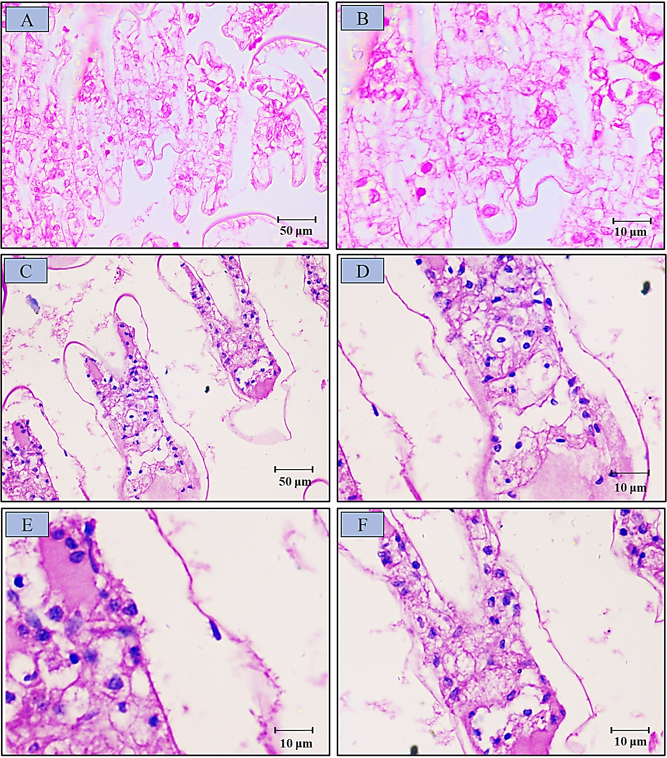
Figure 3: Histopathological sections of shrimp gill tissue stained with H&E. (A-B) Normal gill showing intact lamellae with well-organized epithelial cells and absence of degenerative changes. Scale bars: 50 µm (A), 10 µm (B). (C-F) Gill tissue from WSSV-infected shrimp displaying hypertrophied nuclei with intranuclear inclusion bodies, epithelial disorganization, vacuolation, and hemocytic infiltration.
Molecular Analysis
First- and second-step PCR assays targeting the WSSV genome yielded clear and diagnostic amplification patterns for all tested samples. In the first-step PCR, a distinct 1447 bp amplicon was observed in the positive control and in all randomly selected shrimp samples (Lanes 1–5), while the negative control showed no amplification, confirming the specificity of the reaction. To further authenticate these results, a second-step (nested) PCR was performed, producing a sharp 941 bp band in the same samples, consistent with the expected size for the internal WSSV target region. The simultaneous presence of both 1447 bp (first-step) and 941 bp (second-step) products in all samples confirms successful amplification of WSSV genomic material and validates the infection status detected through wet-mount screening and histopathology. These findings together demonstrate robust molecular confirmation of WSSV infection across the analyzed specimens. (Fig 4).
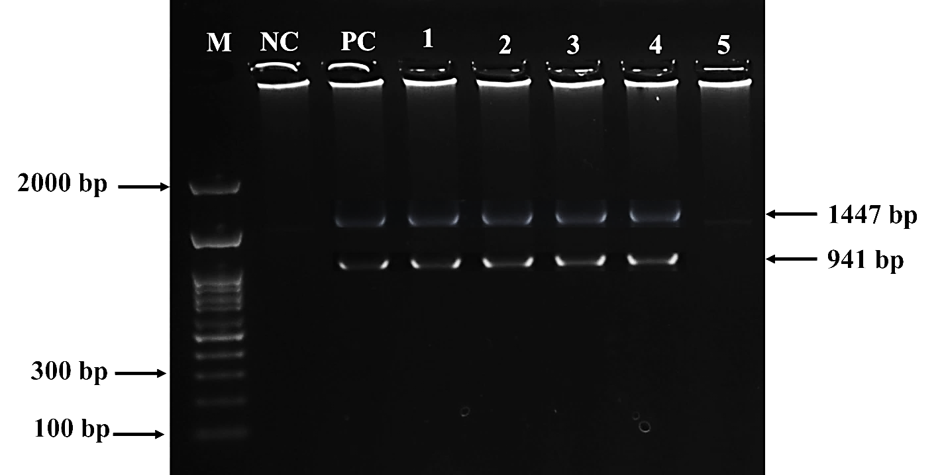
Figure 4: First-step and second-step PCR amplification of WSSV from randomly selected shrimp samples confirmed positive by wet-mount screening. Lane M: 100 bp DNA ladder; Lane NC: negative control showing no amplification; Lane PC: positive control. Lanes 1–5 represent shrimp samples. All samples show a clear band at 1447 bp, corresponding to the first-step PCR product, and a second, distinct band at 941 bp, representing the nested/second-step PCR amplification of the WSSV target region. The presence of both expected amplicons confirms successful detection and validation of WSSV infection in the tested specimens.
DISCUSSION
The present study provides a comprehensive, multi-year evaluation of the seasonal prevalence and epidemiological characteristics of White Spot Syndrome Virus (WSSV) in wild Penaeus monodon from the Parangipettai coastal waters. By integrating seasonal prevalence data with gross pathology, wet-mount screening, histopathology, and molecular confirmation, this study addresses a major gap in long-term epidemiological information on WSSV in natural shrimp populations along the southeast coast of India, where wild stocks may function as persistent viral reservoirs (Flegel, 2019; Cox et al., 2023).
One of the primary objectives of this study was to determine the seasonal prevalence of WSSV in wild P. monodon. The results demonstrated clear and consistent seasonal fluctuations across both study years, with post-monsoon periods exhibiting the highest prevalence, followed by summer, moderate prevalence during monsoon, and the lowest prevalence during pre-monsoon. This pattern strongly suggests that environmental variability plays a critical role in modulating WSSV transmission dynamics. Post-monsoon conditions in coastal and estuarine systems are typically characterized by increased freshwater inflow, fluctuating salinity, enhanced organic matter loading, and sediment resuspension, all of which can promote viral persistence and host exposure (Momoyama et al., 1998; Kumar et al., 2013; Shields et al., 2020). Similar post-monsoon or post-rainfall peaks in WSSV prevalence have been reported from Indian estuaries and other tropical shrimp-growing regions, supporting the role of hydrological disturbance in amplifying infection risk (Quang et al., 2009; Uma, 2025; Singh, 2025). The recurrence of this trend across two consecutive years identifies the post-monsoon season as a predictable high-risk period for WSSV emergence in the Parangipettai region.
Gross pathological examination revealed classical signs of white spot syndrome in infected shrimp, including whitish to opaque carapace discoloration, prominent white spots on the cephalothorax and dorsal cuticle, and exoskeletal softening. These manifestations are consistent with earlier descriptions of WSSV-induced lesions resulting from viral replication in ectodermal and mesodermal tissues, leading to epithelial hypertrophy and cuticular disorganization (Wongteerasupaya et al., 1995; Lo et al., 1996; Flegel, 2007). Although gross signs are most evident during acute infections and may not detect early or latent stages, the strong agreement between gross pathology and molecular confirmation in this study indicates that many infected shrimps were undergoing active disease progression, particularly during peak prevalence seasons.
Wet-mount microscopy of the shrimp carapace revealed characteristic WSSV-associated cuticular inclusions appearing as circular to oval refractile structures with concentric radiations and finely striated margins. These features are consistent with surface-level cuticular abnormalities associated with epithelial necrosis and viral replication (Peng et al., 1998; Chang et al., 1998). While wet-mount examination lacks the specificity of molecular diagnostics, its consistent detection of WSSV-associated structures in PCR-positive samples highlights its value as a rapid, low-cost screening tool. When used in conjunction with histopathology and PCR, wet-mount screening can enhance early detection capacity in large-scale field surveillance and routine monitoring programs (Nunan & Lightner, 2011).
Histopathological analysis of gill tissues provided definitive evidence of active WSSV infection in wild-caught shrimp. Infected specimens exhibited hypertrophied nuclei containing eosinophilic to basophilic intranuclear inclusion bodies, epithelial disorganization, vacuolation, focal necrosis, and marked hemocytic infiltration. These lesions represent hallmark features of acute WSSV infection and reflect intense viral replication coupled with host immune response (Wongteerasupaya et al., 1995; Lo et al., 1996; Bateman, 2021). The severity of tissue damage observed suggests systemic infection rather than passive viral carriage, emphasizing the epidemiological significance of wild shrimp as active contributors to viral maintenance. The clear contrast between normal and infected gill architecture reinforces histopathology as a gold-standard approach for confirming WSSV infection and assessing disease severity (Poulos et al., 1999; Nunan & Lightner, 2011).
Molecular analysis using first-step and nested PCR assays yielded consistent amplification of the expected 1447 bp and 941 bp WSSV-specific fragments in all tested samples. Nested PCR has been widely recognized for its high sensitivity in detecting low viral loads and reducing false-negative results, particularly in epidemiological studies involving wild hosts (Hossain et al., 2004; Saksmerprome et al., 2009). The complete concordance between PCR results and gross, wet-mount, and histopathological findings in this study validates the integrated diagnostic framework employed. PCR assays targeting conserved genomic regions of WSSV, such as WSV285, remain indispensable tools for reliable surveillance and large-scale monitoring of WSSV in both wild and cultured shrimp populations (Durand & Lightner, 2002; Otta et al., 2018; Cox et al., 2023).
The substantial prevalence of WSSV observed in wild P. monodon highlights the critical role of natural shrimp populations as reservoirs capable of sustaining viral circulation and facilitating spillover into aquaculture systems. Previous studies have demonstrated that wild shrimp, along with other carrier organisms such as crabs, polychaetes, molluscs, and invasive crayfish, contribute to long-term viral persistence and transmission through waterborne exposure, predation, and cannibalism (Lotz & Soto, 2002; Flegel, 2007; Min et al., 2024; Rothman, 2024). Given the close proximity of the Parangipettai coastal waters to shrimp farming areas, the high infection levels documented here particularly during post-monsoon periods underscore the need for enhanced biosecurity measures, including controlled water intake, sediment management, seasonal risk-based monitoring, and routine molecular screening of broodstock and environmental samples (Chang et al., 1998).
CONCLUSION
The present study provides a comprehensive epidemiological assessment of White Spot Syndrome Virus (WSSV) in wild Penaeus monodon inhabiting the Parangipettai coastal waters during 2023–2025. By systematically examining seasonal infection patterns, the study demonstrates pronounced temporal variability in WSSV prevalence, with consistently elevated infection levels during the post-monsoon period, followed by summer, while pre-monsoon remained the least affected season. These findings clearly identify seasonality as a key driver of WSSV dynamics in this coastal estuarine ecosystem. To achieve reliable disease confirmation, multiple diagnostic approaches were integrated, including gross pathological examination, wet-mount observations, histopathology, and molecular analysis. The concurrence of these methods verified active WSSV infection in wild shrimp, characterized by classical pathological features such as hypertrophied nuclei and intranuclear inclusion bodies, and confirmed by PCR-based detection of WSSV genomic material. This multi-tiered diagnostic framework strengthens confidence in the prevalence estimates generated in this study.
Overall, the present work establishes robust baseline data for long-term WSSV surveillance in the Parangipettai region and underscores the post-monsoon season as a critical high-risk period requiring intensified monitoring, early-warning systems, and biosecurity interventions. The insights gained from this study provide a valuable foundation for developing seasonally informed management strategies aimed at reducing WSSV transmission risks in both natural shrimp populations and adjacent aquaculture systems.
CONFLICT OF INTEREST
The authors declare that there is no conflict of interest related to the publication of this manuscript.
ETHICS STATEMENT
The manuscript does not require ethical approval.
DISCLAIMER
Authors hereby declare that NO generative AI technologies such as Large Language Models (ChatGPT, COPILOT, etc.) and text-to-image generators have been used during the writing or editing of this manuscript.

Table 1. Seasonal prevalence of White Spot Syndrome Virus (WSSV) in Penaeus monodon collected from Vellar estuary water during 2023 - 2025
Year | Seasons | No. of Samples | WSSV Positive | Prevalence (%)
2023-2024 | Post-monsoon | 630 | 162 | 25.7%
2023-2024 | Summer | 480 | 102 | 21.3%
2023-2024 | Pre-monsoon | 540 | 84 | 15.6%
2023-2024 | Monsoon | 585 | 108 | 18.4%
2024-2025 | Post-monsoon | 660 | 168 | 25.4%
2024-2025 | Summer | 525 | 111 | 21.1%
2024-2025 | Pre-monsoon | 570 | 93 | 16.3%
2024-2025 | Monsoon | 615 | 120 | 19.5%
Total |  | 4,605 | 948 | 20.6%

REFERENCE

- Armitage, P. (1955). Tests for linear trends in proportions and frequencies. Biometrics, 11(3), 375-386.
- Bateman, K. S. (2021). Viruses affecting crustaceans. In Studies in Viral Ecology (pp. 305–340).
- Bell, T. A., & Lightner, D. V. (1988). A handbook of normal penaeid shrimp histology. World Aquaculture Society, Baton Rouge, Louisiana.
- Buathongkam, P., Srisala, J., Srivihok, C., Tangphatsornruang, S., Coates, C. J., Taengchaiyaphum, S., Thitamadee, S., & Sritunyalucksana, K. (2025). Persistence of viral load in shrimp that survived WSSV infection. Developmental & Comparative Immunology.
- Cha, T., Cho, S., Kim, Y. T., & Lee, J. H. (2014). Rapid aptasensor capable of simply diagnosing prostate cancer. Biosensors and Bioelectronics, 62, 31-37.
- Chang, P. S., Chen, L. J., & Wang, Y. C. (1998). The effect of ultraviolet irradiation, heat, pH, ozone, salinity and chemical disinfectants on the infectivity of white spot syndrome baculovirus. Aquaculture, 166, 1–17.
- Cox, N., De Swaef, E., Corteel, M., Van Den Broeck, W., Bossier, P., Dantas-Lima, J. J., & Nauwynck, H. J. (2023). The way of water: Unravelling White Spot Syndrome Virus (WSSV) transmission dynamics in Litopenaeus vannamei shrimp. Viruses, 15(9), 1824.
- De la Peña, L. D., Tavárez, J. J., & Muroga, K. (2003). Rapid detection of white spot syndrome virus in shrimp by dot‐blot hybridization using a DIG‐labeled probe. Aquaculture, 218(1–4), 67–73.
- Desrina, D., Prayitno, S. B., Verdegem, M. C. J., Verreth, J. A. J., & Vlak, J. M. (2022). White spot syndrome virus host range and impact on transmission. Reviews in Aquaculture, 14(4), 1843–1860.
- Dewangan, N. K., Ayyaru, G., Kuzhanthaivel, R., Thirugnanasambandan, S. S., Martin, G. G., Daniel, K., & Ramakrishna, R. S. (2017). Incidence of simultaneous infection of infectious hypodermal and haematopoietic necrosis virus (IHHNV) and white spot syndrome virus (WSSV) in Litopenaeus vannamei. Aquaculture, 471, 1-7.
- Durand, S., & Lightner, D. V. (2002). Quantitative real‐time PCR for the measurement of white spot syndrome virus in shrimp. Journal of Fish Diseases, 25(7), 381–389.
- Flegel, T. W. (2007). Update on viral accommodation, a model for host–viral interaction in shrimp and other arthropods. Developmental & Comparative Immunology, 31(3), 217–231.
- Gopalakrishnan, A., Rajkumar, M., Sun, J., Wang, M., & Senthil Kumar, K. (2011). Mud crab, Scylla tranquebarica (Decapoda: Portunidae), a new host for the white spot syndrome virus. Aquaculture Research, 42(2).
- Gunasekaran, T., Gopalakrishnan, A., Deivasigamani, B., Seralathan, M. V., & Kathirkaman, P. (2018). Spontaneous white spot syndrome virus (WSSV) infection in mud crab (Scylla serrata Forskal 1775) fattening pens farm of south east coast of India. Comparative Clinical Pathology, 27(2), 413-419.
- He, J., Wan, X., Chen, Y., & Li, L. (2015). Comparative genomic analysis of white spot syndrome virus reveals recombination hotspots in global isolates. Virus Evolution, 1(1), vev005.
- Hossain, M. S., Chakraborty, A., Joseph, B., Otta, S. K., Karunasagar, I., & Karunasagar, I. (2001). Detection of new hosts for white spot syndrome virus of shrimp using nested polymerase chain reaction. Aquaculture, 198(1-2), 1-11.
- Hossain, M. S., Otta, S. K., Chakraborty, A., Kumar, H. S., Karunasagar, I., & Karunasagar, I. (2004). Detection of WSSV in cultured shrimps, captured brooders, shrimp postlarvae and water samples in Bangladesh by PCR using different primers. Aquaculture, 237(1-4), 59-71.
- Kanchanaphum, P., Wongteerasupaya, C., Sitidilokratana, N., Boonsaeng, V., Panyim, S., Tassanakajon, A., Withyachumnarnkul, B., & Flegel, T. W. (1998). Experimental transmission of white spot syndrome virus (WSSV) from crabs to shrimp Penaeus monodon. Diseases of Aquatic Organisms, 34(1), 1–7.
- Kim, D. K., Koo, H. J., Kim, S. W., & Park, S. C. (2007). Comparative evaluation of PCR, nested PCR and real‐time PCR assays for detection of white spot syndrome virus in shrimp. Aquaculture, 272(1–4), 31–37.
- Kono, T., Savan, R., Sakai, M., & Itami, T. (2004). Detection of white spot syndrome virus in shrimp by loop-mediated isothermal amplification. Journal of Virological Methods, 115(1), 59–65.
- Kumar, S. S., Bharathi, R. A., Rajan, J. J. S., Alavandi, S. V., Poornima, M., Balasubramanian, C. P., & Ponniah, A. G. (2013). Viability of white spot syndrome virus (WSSV) in sediment during sun-drying (drainable pond) and under non-drainable pond conditions indicated by infectivity to shrimp. Aquaculture, 402, 119–126.
- Laoaroon, S., Boonnat, A., Poltana, P., Kanchanaphum, P., Gangnonngiw, W., Nash, G., & Withyachumnarnkul, B. (2005). Infectivity of White Spot Syndrome Virus (WSSV) to the Polychaete Pereneis nuntia and a Possibility of WSSV Transmission from the Polychaete to the Black Tiger Shrimp Penaeus monodon. In P. J. Walker, R. G. Lester, & M. G. Bondad-Reantaso (Eds.), Diseases in Asian Aquaculture V (pp. 353–361). Fish Health Section, Asian Fisheries Society.
- Flegel, T. W. (2019). A future vision for disease control in shrimp aquaculture. Journal of Invertebrate Pathology, 165, 65–74. https://doi.org/10.1016/j.jip.2019.05.018
- Lightner, D. V. (1996). A handbook of shrimp pathology and diagnostic procedures for diseases of cultured penaeid shrimp. World Aquaculture Society, Baton Rouge, Louisiana.
- Lo, C. F., Leu, J. H., Ho, C. H., Chen, C. H., Peng, S. E., Chen, Y. T., Chou, C. M., Yeh, P. Y., Huang, C. J., Chou, H. Y., Wang, C. H., & Kou, G. H. (1996). Detection of baculovirus associated with white spot syndrome (WSBV) in penaeid shrimps using polymerase chain reaction. Diseases of Aquatic Organisms, 25(2), 133–141.
- Lotz, J. M., & Soto, M. A. (2002). Model of white spot syndrome virus (WSSV) epidemics in Litopenaeus vannamei. Diseases of Aquatic Organisms, 50(3), 199–209.
- Marks, H., van Duijn, E., Zuidema, D., Koerten, H. K., van Hulten, M. C. W., & Vlak, J. M. (2005). Sequence analysis and genomic organization of white spot syndrome virus reveals repeated regions and putative functional modules. Journal of Virology, 79(2), 563–567.
- Min, J. G., Kim, Y. C., & Kim, K. I. (2024). Role of Filter-Feeding Bivalves in the Bioaccumulation and Transmission of White Spot Syndrome Virus (WSSV) in Shrimp Aquaculture Systems. Pathogens, 13(12), 1103.
- Momoyama, K., Hiraoka, M., Nakano, H., Kimura, T., & Inouye, K. (1998). Residual virulence of white spot syndrome virus (WSSV) in shrimp pond sediments. Fish Pathology, 33, 17–22.
- Nunan, L. M., & Lightner, D. V. (2011). Developments in diagnostic methods for crustacean viruses, including WSSV. In B. Scarfe, A. C. Stokes, & P. R. Bowser (Eds.), Aquaculture biosecurity: Prevention, control, and eradication of aquatic animal disease (pp. 189–203).
- Otta, S. K., Shubha, G., Joseph, B., Chakraborty, A., & Karunasagar, I. (2018). Application of PCR-based diagnostics for surveillance of white spot syndrome virus in shrimp. Aquaculture International, 26(4), 1127–1139.
- P., A, G., S, M. V., T, G., & ST, S. (2020). First report of pedunculate barnacle (Octolasmis neptuni), as potential asymptomatic carrier of white spot syndrome virus (WSSV). Comparative Clinical Pathology, 29(3), 631-638.
- Peinado-Guevara, L. I., & López-Meyer, M. (2006). White spot syndrome virus persists in frozen shrimp tissue and remains infective. Diseases of Aquatic Organisms, 68, 115–120.
- Peña, L. D. de la, Caber, D. B., Villacastin, A. J. B., Cabillon, N. A. R., Arboleda, J. I., Castellano, J. L. A., Nava, J. K. P. T., & Watanabe, S. (2024). Sandfish (Holothuria scabra) as potential reservoir of white spot syndrome virus (WSSV) when co-cultured with black tiger prawn (Penaeus monodon). Bulletin of the European Association of Fish Pathologists, 44(1).
- Peng, S.-E., Lo, C.-F., & Kou, G.-H. (1998). In situ hybridization of white spot syndrome virus (WSSV) in infected penaeid shrimp. Journal of Invertebrate Pathology, 72(1), 1–7.SJ.
- Poulos, B. T., Lightner, D. V., & Redman, R. M. (1999). Non-lethal detection of white spot syndrome virus in penaeid shrimp using hemolymph PCR. Diseases of Aquatic Organisms, 39(1), 1–10.
- Quang, N. D., Hoa, P. T. P., Da, T. T., & Anh, P. H. (2009). Persistence of white spot syndrome virus in shrimp ponds and surrounding areas after an outbreak. Environmental Monitoring and Assessment, 156(1), 69-72.
- Rothman, G. (2024). Investigating the Transmission of White Spot Syndrome Virus (WSSV) from the Non-native Red Swamp Crayfish (Procambarus clarkii) to the Native White Shrimp (Penaeus setiferus) (Master's thesis, College of Charleston).
- Saksmerprome, V., Charoonnart, P., Gangnonngiw, W., & Withyachumnarnkul, B. (2009). A novel and inexpensive application of RNAi technology to protect shrimp from viral disease. Journal of Virological Methods, 162(1-2), 213-217.
- Saksmerprome, V., Puiprom, O., Noonin, C., & Flegel, T. W. (2010). Detection of infectious hypodermal and haematopoietic necrosis virus (IHHNV) in farmed Australian Penaeus monodon by PCR analysis and DNA sequencing. Aquaculture, 298(3-4), 190-193.
- Sánchez-Paz, A. (2017). White spot syndrome virus: An overview on an emergent concern. Veterinary Research, 48, 43. https://doi.org/10.1186/s13567-017-0451-3
- Shields, J. D., & Huchin-Mian, J. P. (2020). Ecological factors in the emergence of pathogens in commercially important crustaceans. In G. Lovrich & M. Thiel (Eds.), Fisheries and Aquaculture (pp. 367). Oxford University Press.
- Singh, R. (2025). Chapter-4 Important Viral Diseases of Shrimp and Prawn in Aquaculture. Futuristic Trends in Fisheries and Aquaculture, 39.
- Takahashi, Y., Itami, T., Kondo, M., Maeda, M., Fujii, R., Tomonaga, S., Supamattaya, K., & Boonyaratpalin, S. (1998). Analyses of Hemolymph Immunoparameters in Kuruma Shrimp Infected with Penaeid Rod-shaped DNA Virus. Fish Pathology, 33(4), 389-393.
- Tuyen, N. X., Verreth, J., Vlak, J. M., & De Jong, M. C. M. (2014). Horizontal transmission dynamics of White spot syndrome virus by cohabitation trials in juvenile Penaeus monodon and P. vannamei. Preventive Veterinary Medicine, 117(1), 286–294.
- Uma, A. (2025). Pathogen and disease transmission in aquatic animals. In S. K. Mallik, N. Shahi, & P. K. Pandey (Eds.), Management of fish diseases (pp. 19–55). Springer Nature Singapore.
- Van Hulten, M. C. W., Witteveldt, J., Peters, S., Kloosterboer, N., Tarchini, R., Fiers, M., Sandbrink, H., Lankhorst, R. K., & Vlak, J. M. (2001). The white spot syndrome virus DNA genome sequence. Virology, 286(1), 7–22.
- Vlak, J. M. (2022). White spot syndrome virus host range and impact on transmission. Reviews in Aquaculture, 14(4), 1843–1860.
- Walker, P. J., & Winton, J. R. (2010). Emerging viral diseases of fish and shrimp. Veterinary Research, 41(6), 51.
- Wongteerasupaya, C., Vickers, J. E., Sriurairatana, S., Nash, G. L., Akarajamorn, A., Boonsaeng, V., Panyim, S., Tassanakajon, A., Withyachumnarnkul, B., & Flegel, T. W. (1995). Yellow head virus and related viruses in penaeid shrimp in Thailand: Histopathology and ultrastructure. Diseases of Aquatic Organisms, 22(3), 145–157.
- Zhu, Y., Li, X., Zhang, J., & Xu, X. (2007). Evidence for white spot syndrome virus latency and reactivation in penaeid shrimp. Journal of General Virology, 88, 2650–2658.
- Ziarati, M., Mousavi, S. S., Zorriehzahra, M. J., Yazdanpanah Goharrizi, L., & Talebi, M. (2025). White spot disease (WSD), past, present and future: A review. International Aquatic Research, 17(1), 31–55.

