Original Research Article
Behavioural, Respiratory and Histopathological Effects of the Strobilurin Fungicide Picoxystrobin on Riverine Fish, Tilapia (Oreochromis niloticus)

ABSTRACT
In this study, the toxicity of the fungicide was assessed using behavioural and histopathological effects in freshwater cichlids, specifically tilapia (Oreochromis niloticus). Picoxystrobin is a broad-spectrum systemic cereal fungicide belonging to the strobilurin class. Its mode of action involves blocking mitochondrial electron transport at the Qo site of complex III, thereby reducing ATP production and inhibiting cellular respiration. Tilapia was selected as the target species due to its global economic significance and ecological relevance. As one of the most widely farmed freshwater fish, tilapia plays a vital role in food security, aquaculture, and rural livelihoods. To evaluate the fungicide's toxicity, healthy and active tilapia fingerlings were exposed to low and high concentrations of the fungicide for 21 days. The mortality rate among the experimental fish was zero in the control group but increased in water treated with low- and high-concentration fungicides. In this study, fish exposed to various concentrations of Picoxystrobin exhibited a consistent and significant increase in opercular movement rate. The rise in opercular beats from control to higher concentrations was statistically significant (p = 0.05). Furthermore, oxygen consumption gradually decreased as Picoxystrobin concentration increased. Histopathological analysis showed that exposure to fungicide-contaminated water caused progressive alterations in target organs, including the intestine and gills. Overall, the behavioural, respiratory, and histopathological responses observed in this research emphasise the ecological risks of fungicide contamination in aquatic environments and highlight the need for stricter regulation of agrochemical residues in water bodies.
Keywords: Tilapia, Pesticide, Picoxystrobin, Fingerlings, Histology

1. INTRODUCTION
Aquatic toxicity refers to the adverse effects of chemical substances on aquatic life, from algae and invertebrates to fish and amphibians (Kataoka et al., 2021). A multidisciplinary field that combines toxicology, ecology, and chemistry, it assesses the effects of pollutants, including heavy metals, fertilisers, pesticides, and industrial waste, on ecosystems (Landos et al., 2021). Toxicity is measured through acute and chronic tests using organisms such as Daphnia, algae, and fish, focusing on endpoints such as survival and reproduction to determine LC50 and EC50 values. Toxicants can cause behavioural changes, stress, and population decline, disrupting food webs and ecosystems. Industrial runoff and agricultural pollutants significantly affect fish behaviour and survival, underscoring the need for rigorous monitoring and pollution control.
Pesticide toxicity in fish is a major environmental issue caused by the widespread use of agricultural chemicals that often contaminate aquatic ecosystems through runoff, leaching, and atmospheric deposition (Kumari, 2020; Mangalawede, 2025). Fish are especially vulnerable to these pollutants, including insecticides such as organophosphates and pyrethroids, as well as herbicides and fungicides. These compounds can enter fish bodies via gill absorption, dermal contact, or ingestion, leading to bioaccumulation and long-term toxicity. Physiological effects include damage to the gills, liver, and kidneys, as well as disruptions in endocrine and neurological functions (Pokale & Kawade, 2021). Histopathological changes such as necrosis, haemorrhage, and cellular degeneration are typically observed. Behavioural changes, reduced reproductive success, and increased mortality rates further underscore the ecological impact. Biomarkers, such as alterations in blood parameters and enzyme activity, are used to assess toxicity levels. The decline in fish populations and biodiversity due to pesticide exposure jeopardises aquatic food webs and ecosystem stability. Strategies to mitigate these issues include promoting integrated pest management, regularly monitoring water quality, and using biopesticides. Studies by Sharma et al. (2020), Singh & Yadav (2025), and Pokale & Kawade (2021) offer comprehensive insights into the mechanisms and effects of pesticide toxicity in fish species, emphasising the need for stricter regulation and sustainable agricultural practices.
Various authors have documented the adverse effects of pesticides on fish. For instance, common carp exposed to a synthetic pyrethroid for 96 hours exhibited behavioural abnormalities, particularly in swimming (Anwar, 2023). Ajibare & Ayeku (2024) reported that Juvenile Clarias gariepinus exposed to sub-lethal glyphosate concentrations showed respiratory distress, erratic swimming, and reduced growth performance, highlighting glyphosate’s impact on fish physiology and behaviour. Exposure to organophosphates, carbamates, and organochlorines in air-breathing fish like Channa gachua led to decreased oxygen uptake and increased aerial respiration, indicating a shift in respiratory strategy (Rahman & Sadhu, 2009). Research on Labeo rohita has shown significant reductions in haemoglobin and erythrocyte counts, resulting in anaemia and reduced oxygen-carrying capacity due to heavy metal toxicity (Salve, 2023). Exposure to malathion, endosulfan, chlorpyrifos, and cartap hydrochloride in Channa marulius induced physiological stress, as indicated by decreased oxygen consumption and a reduced respiratory exchange ratio (Shah & Rani, 2025).
Picoxystrobin is a systemic and translaminar fungicide belonging to the Quinone outside Inhibitor (QoI) group. It works by inhibiting mitochondrial respiration in fungi, specifically blocking electron transfer at the Qo site of cytochrome bc1, thereby stopping energy production and fungal growth (http://www.fao.org). It is mainly used on crops such as maize, soybeans, wheat, oilseed rape, and oats, and is applied using ground equipment, aerial spraying, or chemigation. The formulated product is usually a suspension concentrate, with "Approach" being one of the registered end-use products (www.fao.org). Picoxystrobin has been identified as a high-risk compound for aquatic environments. According to the Minnesota Department of Agriculture’s Active Ingredient Review (2022), picoxystrobin is classified as “highly toxic” to fish and aquatic invertebrates. Its mobility in soil and persistence in water bodies make it particularly concerning, especially when applied near surface waters or before rainfall events. The adverse effects of strobilurins have been reported in a few nontarget organisms, including zebrafish (Jia et al., 2018), copepods (Van Wijngaarden et al., 2014), grass carp (Liu et al., 2013), and Salmon (Olsvik et al., 2010). These studies primarily focused on acute toxicity. However, little or no work has been conducted to date on sublethal effects in Indian riverine fish species. To address these gaps, this manuscript provides detailed experimental evidence on the sublethal effects of the strobilurin fungicide Picoxystrobin on Oreochromis niloticus, a freshwater fish species of global ecological and economic importance. By integrating behavioural, respiratory, and histopathological biomarkers, the study offers a comprehensive assessment of pesticide-induced stress that extends beyond conventional acute toxicity endpoints. Focusing on chronic exposure and organ-level damage, the work addresses a critical knowledge gap, particularly for riverine fish species in developing regions with intensive pesticide use. The findings of the present work provide valuable data for environmental risk assessment and biomonitoring, and support the development of safe and sustainable pesticide management strategies for aquaculture and freshwater ecosystems.
2. MATERIALS AND METHODS
2.1. EXPERIMENTAL DESIGN
Healthy and active Tilapia fingerlings were procured from local hatcheries in Kallidaikurichi, Tirunelveli. The fingerlings were maintained in a cement tank (5 x 3 x 3 feet) for 10 days prior to the experiment. Subsequently, fish were acclimatised to laboratory conditions for 5 d at 29 ± 2 °C in a circular trough containing dechlorinated tap water. Water was renewed every day, and fish were fed (ad libitum) daily with commercial dry feed pellets (Nova, Aquatic P. Feed) during the acclimatisation period. During acclimation, batches with less than 5% of mortalities were only considered for further experimentation. The experiments were conducted in small circular troughs (20 L capacity), with a nylon mosquito net covering the water surface to prevent fish from escaping. The toxic effects of Picoxystrobin were assessed by rearing fish at three concentrations for 21 days. Twelve fish in each trough, numbered 1 to 3, were maintained on a 12-hour light and dark cycle and fed commercial fish food twice daily. An aerator was used to ensure an adequate oxygen supply. The first trough served as the control. Trough 2 was dosed with 5 ml of a 1:1000-diluted Picoxystrobin (Low Concentration), and trough 3 with 9 ml (High Concentration). Fish mortality was recorded at 7-day intervals. The test medium was renewed daily with freshly prepared solutions to maintain a consistent effect of Picoxystrobin. Before the experiment began, the length and weight of each fish were measured using calibrated instruments. On the seventh day of exposure, both the control and experimental animals underwent various behavioural assays. After that, the fish were euthanised, the body was cut open, and the target organs were removed for histopathological studies.

2.2. BEHAVIOURAL AND RESPIRATORY ASSESSMENT
2.2.1. Opercular Movements
To assess the effect of Picoxystrobin on opercular movement in fish, control and experimental fish (3 individuals each) were maintained in 1 L glass beakers containing water with the respective drug dose. After a 10-minute acclimatisation period, the number of opercular movements was counted for 10 minutes using a stopwatch. The count was repeated three times to calculate the mean for each fish. The data were expressed as the number of beats per minute.

2.2.2. Rate of Oxygen Consumption
Control and experimental fish were placed in separate beakers containing 2 litres of water with the respective drug dosages. The initial oxygen level in each beaker was recorded. After 1 h, 150 mL of water was sampled from each beaker, and the oxygen content was measured using Winkler’s method. The oxygen consumed by the fish was calculated as the difference between the initial and final oxygen concentrations. The net oxygen consumption was then divided by the fish's weight to determine the oxygen consumption rate. This rate was expressed in ml/g/hr. Before each experiment, the test fish were acclimated for 20 minutes.

2.3. HISTOPATHOLOGICAL STUDIES
To study the histopathology of target organs, the method described by Humason (1972) was followed. The target organs, such as the intestine and gill, were dissected from control and parallel experimental groups and fixed in Bouin's fixative for 24 hours. After fixation, tissues were washed in running tap water for one day to remove excess colouration and dehydrated in a graded series of alcohol. The tissues were infiltrated with molten paraffin at 58–60 °C through three changes (10 min each) and finally embedded in paraffin. 7 mm-thick sections of all tissues were obtained using a rotary microtome (Weswox MT-1090A) and stained with Ehrlich's haematoxylin, with eosin as a counterstain. The slides were mounted using DPX mountant. The sections were observed under an Olympus CH20I microscope under field illumination, and selected areas were photographed at 1000x magnification using a trinocular microscope fitted with a 5-megapixel camera.

3. RESULTS
3.1. Growth Parameters
In the present study, the experimental animal, Tilapia, was reared in water at different concentrations of Picoxystrobin to investigate behavioural and biochemical changes. The present work was carried out from January 2024 to March 2024. Table 1 summarises the growth parameters of fish exposed to the drug. The mean length and mean body weight of control fish were 8.2 ± 0.92 cm and 8.02 ± 1.43 g, respectively. The mean growth parameters of fish subjected to higher concentrations of drug exposure were 7.4 ± 2.66 cm and 6.8 ± 1.16 g, respectively (Table 1).

Table 1: Mean growth parameters of juvenile tilapia at the time of exposure

S.No | Exposure | Parameters | Growth Parameters
S.No | Exposure | Parameters | Body weight (g) | Body length (mm)
1 | Control  (No treatment) | Mean | 8.02 | 8.2
1 | Control  (No treatment) | SD | 1.437 | 0.927
1 | Control  (No treatment) | Range | 6.8 – 7.8 | 7 – 9.5
1 | Control  (No treatment) | N | 12 | 12
2 | Lower concentration | Mean | 6.6 | 6.2
2 | Lower concentration | SE | 1.772 | 2.244
2 | Lower concentration | Range | 4 – 8.5 | 4 – 10
2 | Lower concentration | N | 12 | 12
3 | Higher  Concentration | Mean | 7.4 | 6.8
3 | Higher  Concentration | SE | 2.663 | 1.166
3 | Higher  Concentration | Range | 4 -12 | 5 – 8
3 | Higher  Concentration | N | 12 | 12

3.2. Mortality Rate
Aquatic toxicology is the study of the effects of environmental contaminants on aquatic organisms, such as the effect of pollutants on the health of fish or other aquatic organisms. The mortality of tilapia in different concentrations of Picoxystrobin during 21 days of exposure is presented in Table 2. In the control group, no mortality was observed. At the same time, 8% mortality was observed after the 10th day of exposure in low concentrations of Picoxystrobin treatment. In contrast, 16% of mortality was observed after the 12th day of exposure and 30% of mortality was found on the 17th day of exposure in higher concentrations of Picoxystrobin treatment.

Table 2: Effect of different concentrations of Picoxystrobin on the mortality percentage of tilapia during the exposure period

S. No | Concentration | % of Mortality
S. No | Concentration | 0 – 7 d | 8 – 14 d | 15 – 21 d
1 | Control | Nil | Nil | Nil
2 | Low concentration | Nil | 1/12  (8.0%) | Nil
3 | Higher concentration | Nil | 2/12  (16.0%) | 3/10  (30.0%)

3.3. Rate of Opercular Movement
In the present study, fish reared at different concentrations of Picoxystrobin showed a strong and stable increase in opercular movement rate. The mean opercular beats of fish reared in drug-free water were 134.11 ± 9.44 beats/minute. The rate of opercular beats of fish reared in low concentrations of Picoxystrobin ranged from 123 to 207 beats/minute (166.78 ± 9.02 beats/minute). However, the fish reared at higher concentrations had a mean opercular beat rate of 178.89 ± 12.68 beats/minute, ranging from 129 to 220. The increase of opercular beats from control to higher concentration was statistically significant (ANOVA F_{(2,5)} = 29.31, p<0.0001). The opercular movement rate for the control and treated groups is shown in Graph 1.

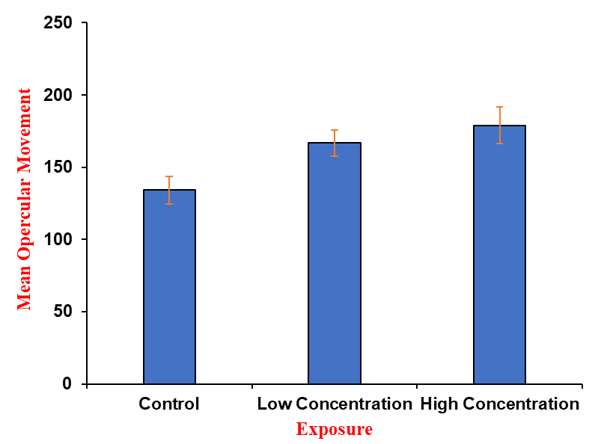
Graph 1: Rate of Opercular Movement of Control and Experimental Fish
3.4. Rate of Oxygen Consumption
Oxygen consumption is one of the most important energy pathways in all living organisms. The mean oxygen consumption in the control group of fish was 3.8 ± 0.78 ml/g/hr. There was a gradual decrease in oxygen consumption with increasing Picoxystrobin concentration. The mean oxygen consumption at low and high concentrations was observed as 3.4 ± 0.53 and 1.3 ± 0.91 ml/g/hr, respectively. The decrease in oxygen consumption may be due to gill damage and malfunctioning red blood cells. Graph 2 shows the changes in oxygen consumption in control and experimental animals reared in water containing different concentrations of fungicide.

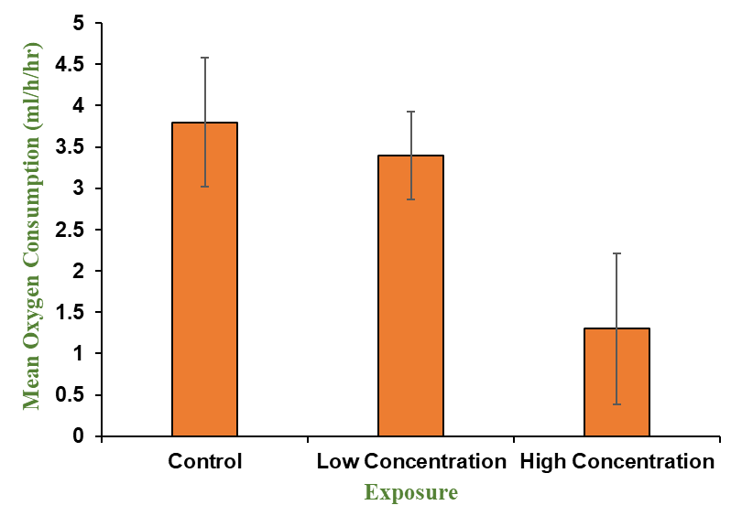
Graph 2: Mean Oxygen Consumption of Control and Experimental Fish

3.5. Histopathology

Control Intestine
The control group of fish exhibited a typical structure of the intestine with tightly packed circular muscle fibres (CMF), longitudinal muscle fibres (LMF), and long tapering villi with tightly packed sub-mucosal tissue (Plate 1: Figure A).

Treatment groups
The histological evaluation of fungicide-treated intestines showed villous broadening and flattening toward the tips. The apical surface of each villus showed cell death, with cells lacking distinct nuclei or cytoplasmic boundaries. Clear spaces were observed towards the tips of the villi due to the shrinkage of the submucosal tissue. This observation was noted in fish reared in water with low fungicide concentration (Plate 1: Figure B). However, the basement membrane was also damaged and distorted in fish exposed to higher concentrations of the fungicide. Furthermore, the fungicide-exposed intestines also showed that each villus facing the lumen demonstrated cell degeneration, with cells lacking distinct nuclei and cytoplasmic boundaries. Circular muscle fibres were loosely arranged, and degeneration of submucosal tissue was observed. There was also degeneration of the columnar epithelium of the intestine, with necrosis at the tips of the villi and distortion of goblet cells (GC) (Plate 1: Figure C).

Control Gill
The control gill has a structure very similar to a regular gill. Its surface is covered with simple squamous epithelial cells, and numerous capillaries, separated by pillar cells (PC), run parallel to it. Many semicircular secondary gill lamellae line both sides of the primary gill lamellae. The primary gill lamellae (PGL) feature a centrally located, rod-like central axis (CA) with chloride cells and blood vessels on both sides (Plate 1: Figure D). The secondary lamellae (SGL), also called respiratory lamellae, are highly vascularized and covered with a thin epithelial cell (EC) layer. Blood vessels extend into each secondary gill filament. The blood cells in the secondary lamellae have a single, flattened nucleus. The space between two adjacent secondary gill lamellae is known as the interlamellar region (ILR) (Plate 1: Figure D).

Treatment groups
Exposure to different concentrations of picoxystrobin has induced significant pathological changes in the gill architecture of fish. The changes include epithelial lifting (EL), bulging of tips of primary gill filaments (BTPG), degeneration of secondary lamella (DGSL), curling of secondary gill filaments (CSG), atrophy of secondary lamella (ASL), and fusion of secondary gill filaments (FSG) (Plate 1: Figure E). These changes increased with exposure levels. In fish exposed to higher concentrations, the gill damage was more severe (Plate 1: Figure F). Notable features included shortened and clubbed ends of the secondary gill lamellae, fusion of adjacent secondary gill lamellae, and necrosis in the primary lamellae. Additionally, nuclear hyperplasia and hypertrophy were observed. In addition to these changes, pyknosis, vacuolization, degeneration of epithelial and pillar cells, and lifting of the epithelial layer from the secondary lamellae were also significant.

Plate 1
Toxic Effect of Fungicide on Selected Organs of Tilapia

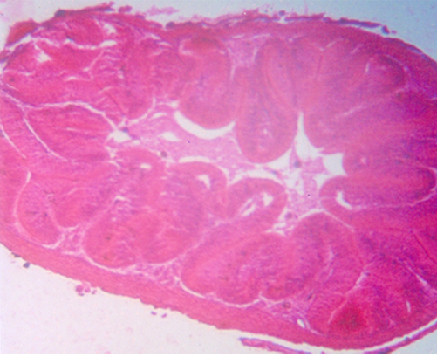
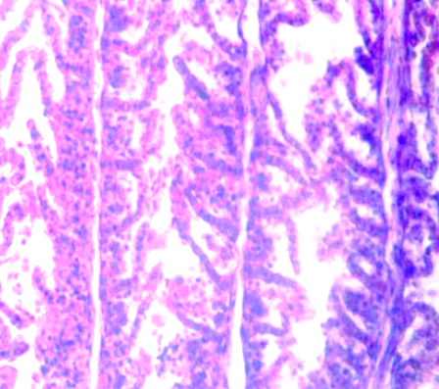
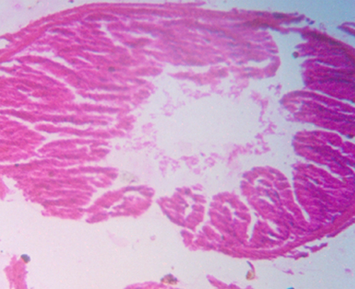
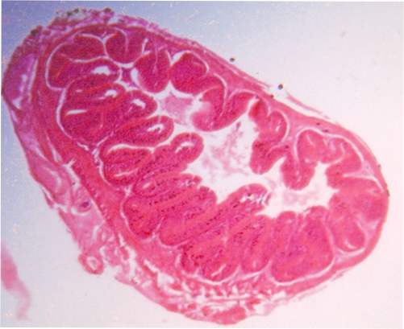
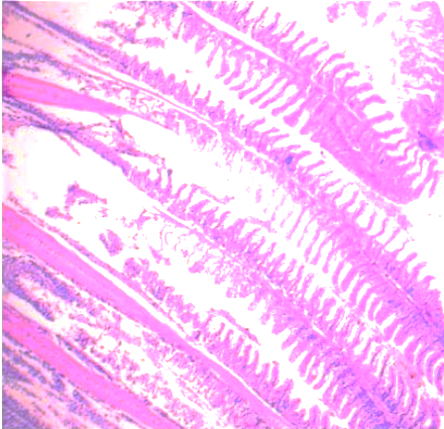

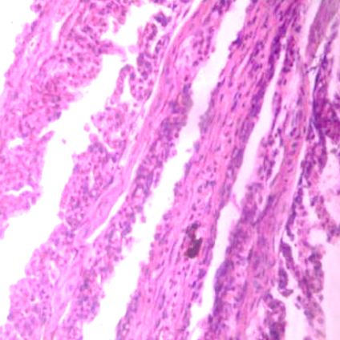
F
E
D
C
B
A

Fig D – Control Gill
Fig E – Low Conc. Fungicide-Treat Gill
Fig F – High Conc. Fungicide-Treated Gill
Fig A – Control Intestine
Fig B – Low Conc. Fungicide-Treated Intestine
Fig C – High Conc. Fungicide-Treated Intestine

DISCUSSION
In the present investigation, experimental fish were exposed to different concentrations of fungicide-treated water to evaluate behavioural changes and histopathological alterations. Under control conditions, individuals showed regular swimming, feeding, and breathing behaviour. However, as fungicide levels increased, opercular movements became irregular, indicating respiratory distress. The stress-related behaviours observed suggest impaired gill function, likely due to fungicide-induced physiological stress, supporting the findings of Ayoola (2008), and more recent studies by Agbohessi et al. (2023) and Singh et al. (2025), which reported similar respiratory issues in fish exposed to agrochemical contaminants. Hyperactivity of opercular movement in the treated groups may reflect disturbances in metabolic regulation. Elevated metabolic rates under abiotic stress (heavy metals) are consistently linked to compensatory respiratory activity that induces oxidative stress, resulting in altered oxygen consumption and metabolic imbalance, as previously described by Menon et al. (2023) and further supported by Elia et al. (2018), who associated behavioural hyperactivity in fish with oxidative stress and changes in energy metabolism under pesticide stress.
A progressive decline in oxygen consumption was observed with increasing fungicide concentration. Similar declines were reported by Haniffa and Porchelvi (1985) in Oreochromis mossambicus under sublethal exposure to industrial effluent. Comparable trends have been documented in Labeo rohita and Puntius stigma (Lonkar, 2012; Kumara et al., 2021), and recent studies continue to report decreased oxygen uptake in response to organophosphate and avermectin stress (Fırat Ö & Tutus, 2020). Neelima et al. (2016) also observed a gradual decrease in oxygen uptake in the freshwater edible fish, Cyprinus carpio, under acute exposure to the synthetic insecticide, a pattern confirmed in subsequent research on sublethal Ethion exposure (Prasanna et al., 2020). The decreased oxygen consumption may be due to gill damage, oxidative stress, metabolic suppression, enzyme inhibition, and behavioural changes. Recent studies confirm these mechanisms, demonstrating that heavy metals induce oxidative stress and histopathological changes in gills (Zahran et al., 2025; Wang et al., 2024), while organophosphate pesticides such as chlorpyrifos impair gill function and enzyme activity, leading to respiratory inhibition (Devi et al., 2024; Kumari, 2020).
Histopathological changes in fish tissues are widely recognised as early, sensitive biomarkers of toxicant exposure. They often precede more obvious endpoints, such as impaired reproduction or growth, making them a robust measure of organismal health (Shah & Parveen, 2022; Chavin, 1973). In this study, structural deformities of the gills and pathologies such as lamellar necrosis, epithelial lifting, and increased mucus production were observed at higher fungicide doses. Abdel-Moneim et al. (2012) reported that increased mucus secretion may serve as a protective response mediated by mucins, glycoproteins that bind and neutralise toxic compounds. However, lamellar fusion indicates impaired gas-exchange surfaces. These lesions are consistent with typical gill responses to chemical pollutants (Mallatt, 1985; Laurent & Perry, 1991; Au, 2004) and have been similarly reported in Channa punctatus exposed to chromium (Mishra & Mohanty, 2008) and in Danio rerio exposed to azoxystrobin (Zhao et al., 2020). Vascular dilations and hemorrhagic lesions observed in our study resemble those described by Stoyanova et al. (2015), suggesting that pillar cell breakdown and collapse of secondary lamellae occur under toxic stress.
The histoarchitecture of the intestine of control fish revealed normal tissue organisation, characterised by well-defined villi, intact epithelial linings, and compactly arranged circular and longitudinal muscle fibres. In contrast, exposure to fungicide-contaminated water led to progressive histopathological alterations that intensified with increasing concentration. The initial signs of damage included villous broadening and flattening, epithelial cell disorganisation, and localised necrosis at the villar tips. Such morphological disruptions indicate impaired absorptive capacity due to reduced epithelial surface area. Similar epithelial degenerations and villar distortions have been reported in pesticide-exposed fish, suggesting that these structures are susceptible to xenobiotic stress (Mishra & Mohanty, 2008; Abdel-Moneim et al., 2012). Similar degenerative effects of strobilurin fungicides on enteric tissues have been documented by Wang et al. (2021). Rimply and Sharma (2024) found that Tebuconazole (a broad-spectrum fungicide) induced cytotoxicity, which contributed to nuclear alterations, vacuolation, and cytoplasmic degeneration in hepatocytes and mucosal alterations in the intestine. Overall, the behavioural, respiratory, and histopathological responses observed in this investigation underscore the detrimental effects of fungicide contamination in aquatic systems. The results support the growing body of evidence emphasising gill architecture and oxygen consumption rate as reliable biomarkers for environmental toxicity evaluation in fish (Rimply & Sharma, 2024).

5. CONCLUSION
In summary, exposure of juvenile tilapia to varying concentrations of the fungicide Picoxystrobin caused significant physiological and pathological changes compared to controls. Fish exposed to treatment showed reduced growth parameters, with notable decreases in mean body weight and length, along with concentration-dependent increases in mortality. Respiratory stress was indicated by higher opercular beat rates and a sharp decline in oxygen consumption, especially at higher concentrations, suggesting impaired gill function. Histopathological analysis revealed progressive damage in both intestinal and gill tissues, including villus degeneration, necrosis, epithelial lifting, lamellar fusion, and nuclear abnormalities, all of which worsened with higher exposure levels. Overall, these results demonstrate that Picoxystrobin is toxic to tilapia, impairing growth, survival, respiration, and tissue integrity, highlighting its potential ecological risk to aquatic life.

DISCLAIMER (ARTIFICIAL INTELLIGENCE)
The author (s) hereby declare that NO generative AI technologies such as Large Language Models (ChatGPT, COPILOT, etc.) and text-to-image generators have been used during the writing or editing of this manuscript.

REFERENCES
Abdel-Moneim, A. M., Al-Kahtani, M. A., & Elmenshawy, O. M. (2012). Histopathological biomarkers in the gills and liver of Oreochromis niloticus from polluted wetland environments in Saudi Arabia. Chemosphere, 88(8), 1028–1035. https://doi.org/10.1016/j.chemosphere.2012.04.001
Agbohessi, P., Olowo, L., Degila, B., Houedjissi, G., Imorou Toko, I., Mandiki, S. N. M., & Kestemont, P. (2023). Comparative assessment of acute toxicity and histological changes in the liver of African catfish Clarias gariepinus exposed to cotton insecticides. Journal of Environmental Science and Health, Part B, 58(1), 31–44. https://doi.org/10.1080/03601234.2023.2168445.
Ajibare, A. O., & Ayeku, P. O. (2024). Glyphosate toxicity: Effects on the behavioural and growth responses of juvenile Clarias gariepinus. Polytechnica, 7(5). https://doi.org/10.1007/s41050-024-00046-2
Anwar, A. (2023). Physiological changes in common carp exposed to pyrethroid pesticides using well water. Journal of Pure and Applied Sciences, 35(6), 171–178. http://dx.doi.org/10.21271/ZJPAS.35.6.17.
Au, D. W. T. (2004). The application of histo-cytopathological biomarkers in marine pollution monitoring: A review. Marine Pollution Bulletin, 48(9–10), 817–834. https://doi.org/10.1016/j.marpolbul.2004.02.032
Ayoola, S. O. (2008). Toxicity of glyphosate herbicide on Nile tilapia (Oreochromis niloticus) juvenile. African Journal of Agricultural Research. https://doi.org/10.5897/AJAR.9000744
Chavin, W. (1973). Physiological aspects of toxicology. American Zoologist, 13(2), 451–453. https://doi.org/10.1093/icb/13.2.451
Devi, N. N., Sapana Devi, M., Thounaojam, R. S., Singh, K. B., Singh, T. B., Chanu, L. B., & Gupta, A. (2024). Toxic effects of chlorpyrifos on biochemical composition, enzyme activity and gill surface ultrastructure of three species of small fishes from India. Environmental Science and Pollution Research, 31, 35498. https://doi.org/10.1007/s11356-024-35498-7
Fırat Ö, & Tutus, R. (2020). Comparative acute toxicity assessment of organophosphate and avermectin insecticides on a freshwater fish, Oreochromis niloticus. Bulletin of Environmental Contamination and Toxicology, 105(4), 582-587. http://doi.org/10.1007/s00128-020-02990-y.
Haniffa, M. A., & Porchelvi, M. (1985). Effect of distillery effluent on oxygen consumption of freshwater fish Sarotherodon mossambicus. Journal of Environmental Biology, 6(1), 17–23.
Jia, W., Mao, L., Zhang, L., Zhang, Y., & Jiang, H. (2018). Effects of Two Strobilurins (Azoxystrobin and Picoxystrobin) on Embryonic Development and Enzyme Activities in Juveniles and Adult Fish Livers of Zebrafish (Danio Rerio). Chemosphere, 207, 573–580. https://doi.org/10.1016/j.chemosphere.2018.05.138
Kataoka, C., Yoshino, K., Kashiwada, S., & Yamamoto, M. (2021). Do Polystyrene Beads Contribute to Accumulation of Methylmercury in Oysters? Archives of Environmental Contamination and Toxicology, 81(1), 36–45. https://doi.org/10.1007/s00244-021-00848-w
Kumara, S., Salonia, S., & Sahb, L. (2021). Toxic effect of profenofos (Mardo) on bimodal oxygen uptake in Labeo rohita. Biospectra, 16(1), 215–218. http://www.https://mset-biospectra.org/wp-content/uploads/2021/09/215-218.pdf.
Kumari, K. (2020). Pesticides toxicity in fishes: A review. Journal of Entomology and Zoology Studies, 8(5), 1640–1642. https://www.entomoljournal.com/archives/2020/vol8issue5/PartZ/8-5-100-907.pdf
Kumari, S. (2020). Impacts of chlorpyrifos (an organophosphate pesticide) in fish. International Journal of Fauna and Biological Studies, 7(4), 48–54. https://www.doi.org/10.22271/23940522
Landos, M., Lloyd-Smith, M., & Immig, J. (2021). Aquatic Pollutants in Oceans and Fisheries. International Pollutants Elimination Network (IPEN). https://ipen.org/documents/aquatic-pollutants-oceans-and-fisheries
Laurent, P., & Perry, S. F. (1991). Environmental effects on fish gill morphology. Physiological Zoology, 64(1), 4–25. https://doi.org/10.1086/physzool.64.1.30158511
Liu, L., Jiang, C., Wu, Z.-Q., Gong, Y.-X., & Wang, G.-X. (2013). Toxic effects of three strobilurins (trifloxystrobin, azoxystrobin and kresoxim-methyl) on mRNA expression and antioxidant enzymes in grass carp (Ctenopharyngodon idella) juveniles. Ecotoxicology and Environmental Safety, 98, 297–302. https://doi.org/10.1016/j.ecoenv.2013.10.011.
Lonkar, A. (2012). Alteration in oxygen consumption of fresh water fish Puntius stigma exposed to sublethal concentrations of insecticide Phytofos. Environment Conservation Journal, 13(3), 131–134. https://doi.org/10.36953/ECJ.2012.130321.
Mallatt, J. (1985). Fish gill structural changes induced by toxicants and other irritants: A statistical review. Canadian Journal of Fisheries and Aquatic Sciences, 42(4), 630–648. https://doi.org/10.1139/f85-083
Mangalawede, S.S. (2025). Pesticide toxicity in some fish species: A review. International Journal of Fisheries and Aquatic Studies, 13(2), 189–194. https://doi.org/10.22271/fish.2025.v13.i2c.3063
Menon, S. V., Kumar, A., Middha, S. K., Paital, B., Mathur, S., Johnson, R., Kademan, A., Usha, T., Hemavathi, K. N., Dayal, S., Ramalingam, N., Subramanaian, U., Sahoo, D. K., & Asthana, M. (2023). Water physicochemical factors and oxidative stress physiology in fish: A review. Frontiers in Environmental Science, 11, 1240813. https://doi.org/10.3389/fenvs.2023.1240813
Mishra, A. K., & Mohanty, B. (2008). Acute toxicity impacts of hexavalent chromium on behavior and histopathology of gill, kidney and liver of the freshwater fish, Channa punctatus (Bloch). Environmental Toxicology and Pharmacology, 26(2), 136–141. https://doi.org/10.1016/j.etap.2008.02.010
Neelima, P., Rao, N. G., Rao, G. S., & Rao, J. C. S. (2016). A study on oxygen consumption in a freshwater fish Cyprinus carpio exposed to lethal and sublethal concentrations of cypermethrin (25% EC). International Journal of Current Microbiology and Applied Sciences, 5(4), 338-346. http://dx.doi.org/10.20546/ijcmas.2016.504.040.
Olsvik, P. A., Kroglund, F., Finstad, B., & Kristensen, T. (2010). Effects of the fungicide azoxystrobin on Atlantic salmon (Salmo salar L.) smolt. Ecotoxicology and Environmental Safety. https://doi.org/10.1016/j.ecoenv.2010.07.017
Pokale, S.N., & Kawade, S.A. (2021). Pesticides and heavy metals toxicity in fishes. International Journal of Entomology Research. https://www.entomologyjournals.com/archives/2021/vol6issue6/PartB/6-5-10-901.pdf
Prasanna, C., Anithasmruthi, C., & Venkatarathnamma, V. (2020). A Study on oxygen consumption in freshwater fish Labeo rohita exposed to lethal and sub-lethal concentrations of Ethion 50% Ec. Indian Journal of Forensic Medicine and Toxicology, 14(4), 122 – 127. https://doi.org/10.37506/ijfmt.v14i4.11454.
Rahman, Q., & Sadhu, D. N. (2009). Effect of pesticides on aquatic and aerial oxygen consumption in an air breathing murrel fish, Channa gachua. Nature Environment and Pollution Technology, 8(3), 603 – 608. https://www.neptjournal.com/upload-images/NL-5-34-%2834%29B-1404com.pdf
Rimply, & Sharma, S. (2024). Effects of Tebuconazole on liver and intestine of fresh water fish Cyprinus carpio. Applied Biological Research, 26(3), 323–333. http://doi.org/10.48165/abr.2024.26.01.37.
Salve, B. S. (2023). Haematological alterations in Labeo rohita due to heavy metal toxicity. Journal of Emerging Technologies and Innovative Research, 8(10), 750–753. https://doi.org/10.13140/RG.2.2.20506.62401
Shah, R., & Rani, A. (2025). Impact of pesticide exposure on respiratory physiology in Channa marulius: A study of oxygen consumption, ventilation frequency, and respiratory efficiency. Acta Entomology and Zoology, 6(2), 170–177. https://doi.org/10.33545/27080013.2025.v6.i2c.248.
Shah, Z. U., & Parveen, S. (2022). Oxidative, biochemical and histopathological alterations in fishes from pesticide-contaminated river Ganga, India. Scientific Reports, 7;12(1), 3628. https://doi.org/10.1038/s41598-022-07506-8.
Sharma, H., Kalamkar, S. S., & Swain, M. N. (2020). Assessment the Cost and Return in Marine Fish Production in Gujarat, India. International Journal of Current Microbiology and Applied Sciences. https://doi.org/10.20546/ijcmas.2020.902.021
Singh, R. R., & Yadav, M. (2025, June 13). *Inland Fisheries & Aquaculture Meet 2025*. Ministry of Fisheries, Animal Husbandry & Dairying, Government of India, Indore. https://www.drishtiias.com/daily-updates/daily-news-analysis/inland-fisheries-aquaculture-meet-2025
Stoyanova, S., Yancheva, V., Velcheva, I., Uchikova, E., & Georgieva, E. (1996). Histological alterations in Common Carp (Cyprinus carpio Linnaeus, 1758) gills as potential biomarkers of fungicide contamination. Brazillian Archives of Biology and Technology, 58(5), 757–764. https://doi.org/10.1590/S1516-89132015050151.
van Wijngaarden, R. P. A., Belgers, J. D. M., Zafar, M. I., Matser, A. M., Boerwinkel, M. C., & Arts, G. H. P. (2014). Chronic aquatic effect assessment for the fungicide azoxystrobin. Environmental Toxicology and Chemistry, 33(12), 2775–2785. https://doi.org/10.1002/etc.2739
Wang, X., Li, X., Wang, Y., Qin, Y., Yan, B., & Martyniuk, C. J. (2021). A comprehensive review of strobilurin fungicide toxicity in aquatic species: Emphasis on mode of action from the zebrafish model. Environmental Pollution, 275, 116671. https://doi.org/10.1016/j.envpol.2021.116671.
Wang, Y., Noman, A., Zhang, C., Al‑Bukhaiti, W. Q., & Abed, S. M. (2024). Effect of fish-heavy metals contamination on the generation of reactive oxygen species and its implications on human health: A review. Frontiers in Marine Science, 11, 1500870. https://doi.org/10.3389/fmars.2024.1500870.
Zahran, E., Mamdouh, A., Elbahnaswy, S., El‑Son, M. M. A., Risha, E., ElSayed, A., El Barbary, M. I., & El Sebaei, M. G. (2025). The impact of heavy metal pollution: Bioaccumulation, oxidative stress, and histopathological alterations in fish across diverse habitats. Aquaculture International, 33(3), 371. https://doi.org/10.1007/s10499-025-02045-1.

