Original Research Article
Histological Alterations and Recovery Response in Labeo rohita Exposed to Extreme Acidic and Alkaline pH Conditions

ABSTRACT
Water quality, especially pH levels, is crucial for the survival, growth, and health of fish in aquaculture environments. An experimental 30-day study was conducted to evaluate the histopathological effects of extreme pH conditions on Labeo rohita fingerlings. Sub-lethal pH treatments of 4.5, 5.0, 7.0, 9.5 and 10.0 were maintained in 500-L FRP tanks filled with 300 L of water, with pH 7.0 serving as the neutral control. Water pH was adjusted using 0.5 N HCl or 1.0 N NaOH and monitored daily with a digital meter. Fifty fingerlings were stocked per tank and fed a commercial diet (30 % protein, 3 % fat) at 4 % body weight twice daily. Water quality was managed through 20 % weekly water exchange and constant aeration. After 30 days, fish were sampled from each treatment for histopathological analysis; survivors were then transferred to tap water for a 14-day recovery period, with additional sampling at the end of recovery. Gill tissues from acidified and alkaline treatments exhibited epithelial lifting, telangiectasia, congestion, lamellar curling, aneurysms, necrosis, and vacuolation; liver tissues showed hepatocyte degeneration, necrosis, haemorrhage, blood congestion, and vacuolation. Lesions were most severe at pH 4.5 and 10.0. Fish at pH 5.0 and 9.5 showed partial restoration of tissue architecture during recovery, whereas those exposed to pH 4.5 or 10.0 displayed persistent damage. The findings underscore the importance of maintaining water pH within the optimal range of 6.5–9.0 to ensure normal physiological and metabolic functioning in Labeo rohita. Extreme pH deviations can severely damage gill and liver morphology, compromising fish health and survival. The study highlights the necessity for regular monitoring and management of pH in aquaculture ponds to prevent long-term stress and mortality. Future research should focus on molecular-level responses and the cumulative effects of pH in combination with other environmental stressors.

- Introduction
The success of aquaculture operations is inextricably linked to the physical and chemical characteristics of the aquatic environment. As the medium in which fish breathe, feed, grow, osmoregulate, and reproduce, water quality acts as the decisive factor in the health and productivity of cultured stocks. Among the myriad environmental variables, pH serves as a master control, mediating acid–base balance, ion exchange, and overall physiological stability. While a pH range of 6.5 to 9.0 is generally considered suitable for freshwater farming, levels below 4 or above 11 are lethal to most finfish. However, modern aquaculture systems increasingly face erratic pH fluctuations driven by anthropogenic factors. Industrial effluents, agricultural runoff containing fertilizers, and the decomposition of excessive feed and organic manures can shift pond water from neutral to strongly acidic or alkaline states. Labeo rohita (Hamilton, 1822), commonly known as Rohu, is one of India’s most commercially significant cultured species. Despite its economic importance, the species is vulnerable to these chemically destabilized environments. Sudden perturbations in pH can trigger a cascade of physiological stress, compromising the structural integrity of vital organs such as the gills and liver. To understand these impacts, it is necessary to examine the mechanisms of ion regulation. In acidic environments, the proliferation of hydrogen ions (H⁺) creates a hostile physiological landscape. Excess H⁺ competes with calcium (Ca⁺) and sodium (Na⁺) at the gill surface, hindering the fish’s ability to absorb these essential ions. This competition is exacerbated by the disruption of tight junctions in the gill epithelia. Research indicates that low pH exposure leads to the expansion of these junctions, increasing gill permeability and causing significant ion loss through the paracellular route (Wood, 2001; McDonald et al., 1991). Studies on rainbow trout demonstrated that reduction in tight junctions occurs within just one hour of exposure to pH 4.0 (Freda et al., 1990). Consequently, significant ion depletion often peaks within the first few hours of exposure, frequently preceding visible tissue damage (Booth et al., 1988; McDonald et al., 1991). While some species, such as sunfish, exhibit morphological adaptationstransforming gills from long and slender to short and stubby to obstruct diffusion pathwaysothers suffer severe impairment (McDonald et al., 1991). Extreme acidity (pH 3.5) has also been linked to suffocation due to excessive mucus accumulation (Packer & Dunson, 1970) and increased mucus secretion as a stress response (Ultsch & Gros, 1979; Daye & Garside, 1980). Conversely, exposure to highly alkaline waters presents a different set of physiological challenges. High pH can disturb the influx of Na⁺ and Cl⁻ ions, triggered initially by the inhibition of ion transport mechanisms within the gills (Wilkie et al., 1999). Furthermore, elevated pH at the boundary layer of the gills can reduce the trapping of ammonia (NH₃) or inhibit the Rh protein-based Na⁺/NH₄⁺ exchange complex, leading to ammonia toxicity (Wright & Wood, 2009). Physiological consequences often include respiratory and metabolic alkalosis (Wilkie & Wood, 1995), contributing to a loss of equilibrium and avoidance behaviors in various species (Falter & Cech, 1991; Serafy & Harrell, 1993). These physiological disruptions are frequently mirrored by histopathological changes. Extensive research has categorized gill structural changes into compensatory responses and cellular damage (Daye & Garside, 1976; Leino & McCormick, 1984; Teitge et al., 1988). Mallatt (1985) identified epithelial lifting as the most common injury, followed by necrosis, lamellar fusion, and swelling. Liver tissue is equally susceptible; recent studies on juvenile yellowfin tuna highlight that rising pH correlates with hepatocyte loss, vacuolation, nuclear displacement, and altered enzyme activity (GOT and GPT) (Wang et al., 2024; Nataraj et al. 2017). However, sensitivity to pH is species-specific. For instance, Lost River suckers show remarkable resilience, with no structural damage observed even at pH 10.0 (Lease et al., 2003; Meyer & Hansen, 2002). This variability highlights a critical knowledge gap regarding Labeo rohita. While the general physiological responses of freshwater fish to pH stress are documented, detailed histological assessments of L. rohita under acute and sub-lethal pH stress are limited. Little is known about the specific tissue alterations in this species or its capacity to recover once water quality improves. This knowledge gap constrains the development of evidence-based strategies for pond management and stock welfare. The present work addresses this challenge by systematically exposing L. rohita to extreme acidic (pH 4.5–5.0) and alkaline (pH 9.5–10.0) conditions. By evaluating the resulting histopathological changes in the gills and liver, and monitoring recovery upon return to neutral water, this study aims to clarify how pH disruptions impair key tissues. These insights are essential for identifying toxicity thresholds, designing early-warning indicators, and safeguarding the ecological resilience of aquaculture environments.

2. Materials and Method
2.1 Histological analysis
Histopathology was done in acute toxicity test and the last sampling of chronic toxicity test (30th day) of toxicity test and 14th day of recovery. A very minute portion of whole body was collected from the fish of each pH tank. After collection, the tissue samples were fixed into 2 ml vial with bouin’s fluid for 48-72 hours. Following fixation, samples were stored for the night in 70% ethyl alcohol. Histopathological analyses were carried out described in (Roberts, 2012).
2.2 Tissue cutting and processing
After being submerged in 70% alcohol, the various tissues were sliced into tiny pieces. Then, a sequence of ethyl alcohols with progressively higher concentrations (85%, 90%, and 100%) dehydrated them. Tissues were stored for 90 minutes in each alcoholic concentration, with two variations. The tissues were placed with xylene to become translucent after being dehydrated. To enable it to penetrate the tissues, the tissue was then left in liquid paraffin for a minimum of 2 hours and 30 minutes.
2.3 Tissue embedding
Triple-filtered matured paraffin (melting point 58˚C to 60 ˚C) was used for this purpose. The organs were preserved in molten paraffin that was placed into an L-mould and allowed to solidify.
2.4 Preparation or blocks for sectioning
In order to properly slice the tissues, the solid paraffin blocks holding the tissues were cut into small square blocks.
2.5 Sectioning
Following trimming, the blocks were placed in the microtome's block holder (Medimeas Model: MRM-RM 1191), and they were then divided into 5 µm-thick sections or ribbons. Good parts were gently moved to a glass slide that was grease-free and spotless. To help the tissues adhere to the grease-free slides, Mayer's albumin was applied in layers.
2.6 Stretching of tissue
To stretch and flatten the wrinkled tissues, the slides with the necessary lengths of ribbons were placed on a hot plate filled with warm water kept at a temperature of between 50 and 55˚C.
2.7 Preparation of slides and staining
The dried slides were stained by the haematoxylin and eosin double staining (H&E) method described by Fiedler et al., 2023. Slides were permanently mounted using DPX (Di-butyl Phthalate Xylene) mountain.
  - Microscopy and photomicrography
A microscope linked to a monitor was used to screen the sections. Using a 16 MP SCO-LUX camera mounted to the sophisticated Trinocular Research microscope (Olympus, Japan, Model: BX51), digital colour microphotographs were obtained at various magnifications from the chosen slides.

- Result and Discussion
  - Histopathological alteration
This study was aimed to analyse the possible histopathological changes in the vital organ of extremely high and low pH exposed L. rohita. The sample was taken from gill and liver of LC₅₀ test and 30th day of sub-lethal exposure. Different types of changes were occurred in the gill and liver such as fusion, necrosis, aneurisms, vacuolization etc. There were no changes occurred in the sample of control tank.
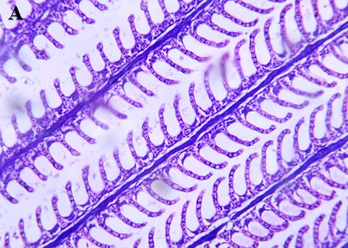

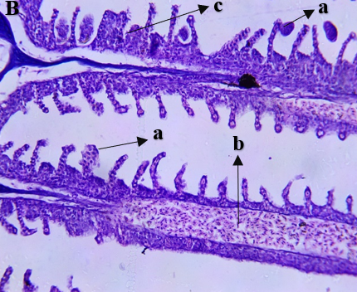 | 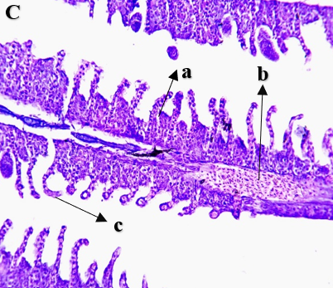
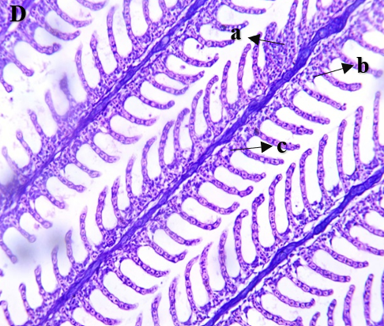 | 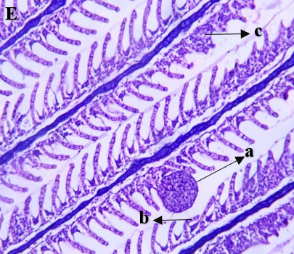
Fig.- 1 Histological alteration in gill of Labeo rohita exposed to high and low pH

Figure (1) A: Gill of control tank (pH -7), here (a) Primary gill lamella (b) indicates Secondary lamella and (c) indicates cartilaginous core. B: Gill of extreme low pH 4.5, here (a) means Telangiectasia in gill lamella (b) indicates Congestion in gills (c) Clubbing of Secondary gill lamella. C: Gill of extreme low pH 5, here (a) means Epithelial Lifting (b) indicates Congestion in gill (c) indicates Curling of SGL. D: Gill of extreme high pH 9.5, here (a) means Epithelial hyperplasia (b) indicates Necrosis in gill lamella (C) indicates Vacuolat ion in epithelial cells. E: Gill of extreme high pH 10, here (a) means Aneurysm in gill lamella (b) indicates Curling of Secondary gill lamella (c) indicates Hyperplasia and fusion of gill lamella.
3.1.1 Histological findings in gills of Labeo rohita exposed to high and low pH
Histopathological examination showed that gills were one of the major organs affected by direct exposure to different pH values. Curling of the secondary gill lamella (SGL) and epithelial lifting were seen in most of the treatment groups, except for the neutral pH 7 treatment that showed no discernible histopathological changes. In this study, lesions were found in the extreme low pH levels of 4.5 and 5, which included telangiectasia of the gill lamella, congestion, clubbing of the secondary gill lamella, epithelial lifting, and curling of the SGL. Lesions relating to the extreme high pH treatments (9.5 and 10) included epithelial hyperplasia, necrosis of the gill lamella, aneurysms within gill lamella, fusion of the gill lamella and the vacuolation of epithelial cells. The results of the current investigation seem to correspond with the report by Salleh et al. (2017) in Oryzias javanicus in which lesions on gills were implicated to cause disruption in oxygen uptake and, under extreme conditions, precipitate high mortality rates at both low and high pH levels. Wilkie et al. stated that a drastic drop in the plasma electrolyte concentrations represents the critical physiological challenge for fish living in an alkaline environment. Salleh et al. (2017) reported aneurysm, epithelial lifting, and edema lesions at pH 9, an extreme environment for fishes, and generalized severe necrosis due to the inappropriate pH levels that occurred simultaneously. Javanese medakas exposed to low (pH 5) or high (pH 9) pH showed epidermal damage with epithelial necrosis, sloughing and hyperplasia. Histological examinations suggested that the damage starts as epithelial necrosis distributed in the superficial layer and then extends deeper in a short time period, which later results in hyperplasia if the fish are not killed by chronic exposure, as reported by Salleh et al. (2017).
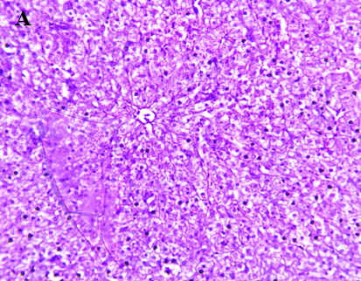
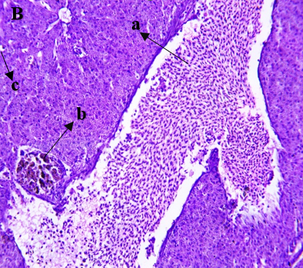 | 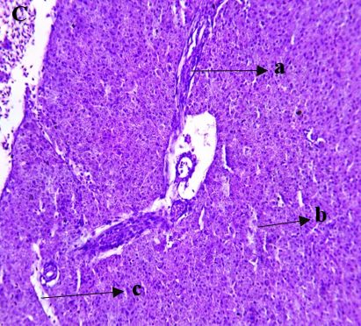
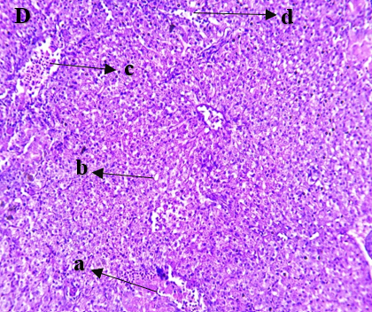 | 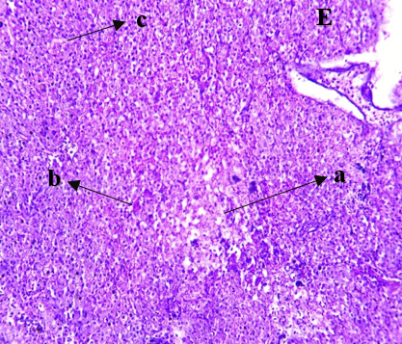
Fig.- 2 Histological alteration in liver of Labeo rohita exposed to high and low pH

Figure: (2) A: Liver of control tank pH 7. B: Liver of extreme low pH 4.5, here (a) means Blood infiltration (b) indicates Blood Congestion (c) indicates Eccentric nucleus. C: Liver of extreme low pH 5, here (a) means Blood infiltration (b) indicates Hepatocyte degeneration (c) Sinusoidal spaces. D: Liver of extreme high pH 9.5, (a) means Haemorrhage (b) indicates Vacuole (C) indicates blood infiltration (d) indicates Sinusoidal space. D: Liver of extreme high pH 10. (a) means Necrotic area (b) indicates Haemorrhage (c) indicates Hepatocyte Degeneration.
3.1.2 Histological findings in liver of Labeo rohita exposed to high and low pH
In the pH 7, there were no pathological abnormalities. The changes were found in 4.5, 5, 9.5, 10 pH levels. The sever changes occurred in the 4.5 and 10 pH levels. In general, the main changes were as follows: Necrosis, sinusoidal space, vacuolation, blood infiltration, blood congestion, hepatocyte degeneration, eccentric nucleus, haemorrhage etc. In pH 4.5 the main changes were degeneration of cells, loss of membrane structure, dilated sinusoids, inflammation etc. In this concentration changes were found more than the pH 5. Blood infiltration, hepatocyte degeneration, sinusoidal spaces were observed in the pH 5. Moderate changes found in pH 9.5. In pH 9.5 mainly observations were haemorrhage, vacuole, blood infiltration, sinusoidal space etc. High changes were found in the pH 10 concentration which is the highest pH level among all. Here main changes were necrosis, haemorrhage, hepatocyte degeneration. The present results are consistent with those that were reported by Tegemo and colleagues (2021). In the control group, healthy liver features were observed at a seawater pH of 8.10 ± 0.01. The general architecture of the liver was normal, no sign of blood congestion in any hepatopancreas was observed. No vascular congestion within the hepatopancreas and no cellular necrosis among hepatocytes were found. At a pH of 7.80 ± 0.02 of the seawater in the control group hepatocyte vacuolation was observed. Vascular congestion was not observed in the hepatopancreas but congestion within the vasculature was found. Ultimately, cellular necrosis developed. A hemorrhagic liver, characterized by strong blood coloration, was detected for a seawater pH of 7.40 ± 0.02. All hepatopancreas showed vascular congestion, with two different regions of hemorrhage being observed. It was also described the congestion in the central vein (Tegomo et al. 2021).
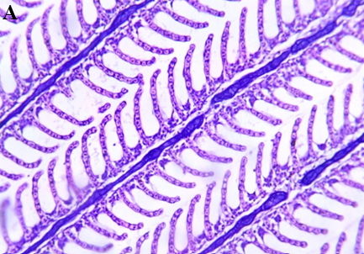
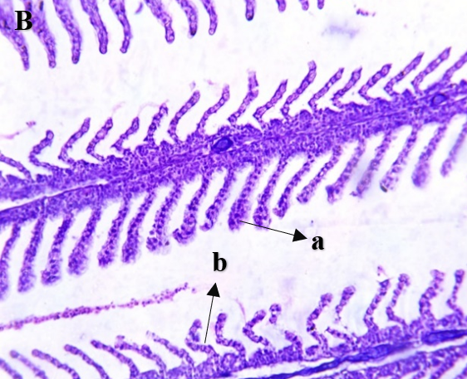 | 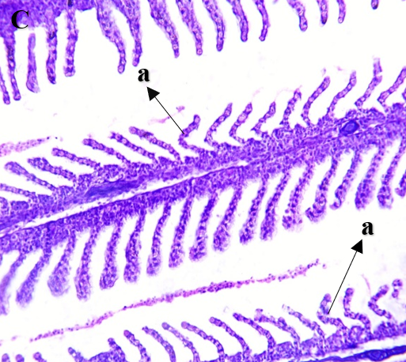
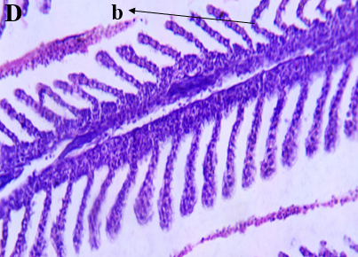 | 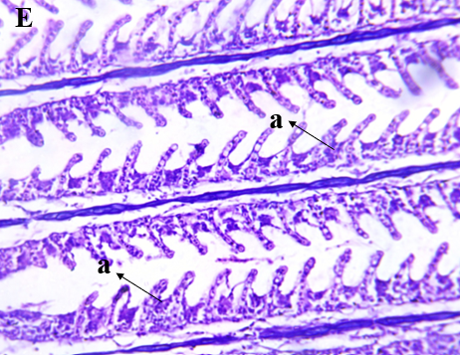
Fig.-3 Recovery of Histological alteration in gill of Labeo rohita exposed to high and low pH

Fig. (3) A: Gill of control in recovery phase B: Gill of pH 4.5 in recovery phase, here (a) means swelling of SGL tip (b) indicates curling of SGL C: Gill of pH 5 in recovery phase, here (a) means Curling of SGL D: Gill of pH 9.5 in recovery phase, here (a) indicates curling of secondary gill lamella E: Gill of pH 10 in recovery phase, here (a) indicates epithelial hyperplasia
3.1.3 Histological finding in gill of Labeo rohita exposed to high and low pH under recovery phase
The pH 7 is control pH and there is no histological alteration was found. High alteration found in pH 4.5 and 10. In the pH 4.5 and 10 histological changes are epithelial hyperplasia, swelling of SGL tip, curling of SGL were found. Highest recovery found in pH 5. In the pH 5 very less alteration found were curling of SGL. In the pH 9.5 also there was no more alteration found. In pH 9.5 alteration are The pH 5 and 9.5 very less histological alteration were found.
Improvement of the histological architecture was observed in the tissues of cypermethrin treated C. gariepinus which were transferred to fresh water systems. Individuals exposed to lower concentrations of cypermethrin recovered more quickly from histopathological damage than from individuals exposed to higher concentrations; however, complete recovery was not reached in any case. In the same investigation, histological recovery was further demonstrated by keeping the intoxicated fish in fresh water for an additional 28 days; it was this length of time that provided pronounced recuperation. The present study showed that some of the changes were reversible or attenuated after the recovery period; however, better investigation should be carried out to determine that the damages seen are non-permanent and recovery can be complete upon complete removal of pollutants from the water.
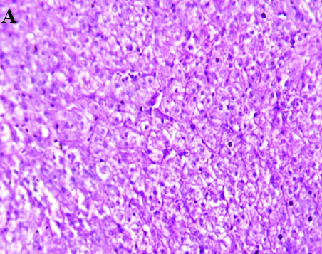
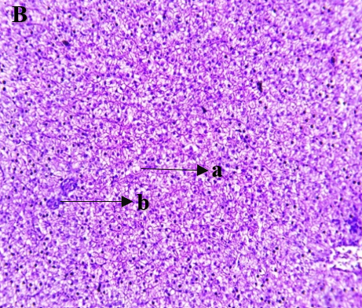 | 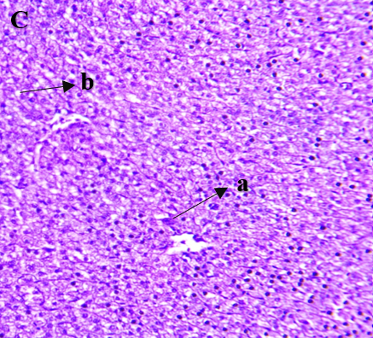
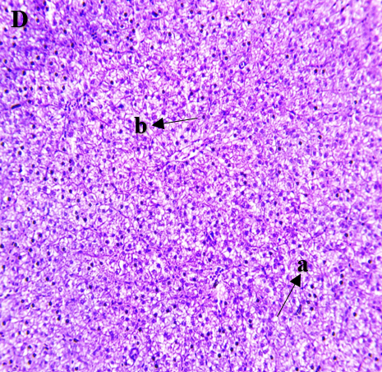 | 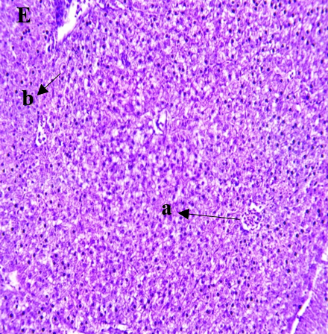
Fig.- 4 Recovery of Histological alteration in liver of Labeo rohita exposed to high and low pH

Fig (4) A: Liver of control tank pH 7 in recovery phase. B: Liver of extreme low pH 4.5 in recovery phase, here (a) means blood congestion (b) indicates vacuole C: Liver of extreme low pH 5 in recovery phase, here (a) means Haemorrhage (b) indicates vacuole D: Liver of extreme high pH 9.5 in recovery phase, (a) means vacuole (b) indicates pleomorphitic nuclei D: Liver of extreme high pH 10 in recovery phase. (a) means blood congestion (b) indicates pleomorphitic nuclei.
3.1.4 Histological finding in liver of Labeo rohita exposed to high and low pH under recovery phase
The pH 7 is most stable pH in this pH there is any histological alteration were found. In this study lesions found in pH 4.5 and 10 are blood congestion, vacuole, pleomorphitic nuclei. Less alterations were found in pH 5. Lesions found in pH 5 were vacuole, haemorrhage. Alterations in pH 9.5 were vacuole, pleomorphitic nuclei.
As per Sarkar et. al 2005 transfer of cypermethrin and carbofuran treated L. rohita to freshwater systems improvement was observed in the histological architecture of their livers. Here, fish exposed to lower concentrations of carbofuran or cypermethrin regained from damages sooner than did their counterparts exposed to higher concentrations. However, in all cases, repair was not complete (except in lower doses of carbofuran) and it was necessary to have a prolonged recovery period to return to normalcy. For pollution alleviation the fresh water acts like a therapeutic agent and also a suitable medium. Through the excretion and osmoregulation fish exposed to fresh water slowly eliminates deposition of metabolites of pesticides from the body. As the residual load will be less, the normal enzyme and cellular activity of liver will be enhanced and tissues will recover faster from the damage (Sarkar et al. 2005).
- Conclusion
The current research clearly illustrates that the pH level of water is crucial for preserving the physiological and structural health of Labeo rohita. When exposed to highly acidic (pH 4.5 and 5) and alkaline (pH 9.5 and 10) environments, significant histopathological changes were observed in the gills and liver tissues compared to the control group (pH 7). The gills showed signs of epithelial lifting, curling of secondary lamellae, necrosis, aneurysm formation, and hyperplasia, while the liver exhibited hepatocyte degeneration, necrosis, hemorrhage, blood congestion, and vacuolation. These morphological changes suggest severe stress responses that disrupt normal respiration, osmoregulation, and metabolic functions in the fish. Recovery experiments indicated that some of the histological damage could be partially reversed when the fish were returned to optimal pH conditions. Notable improvements were observed in treatments at pH 5 and 9.5, where minimal lesions were present during the recovery phase, whereas higher stress levels at pH 4.5 and 10 still showed ongoing structural deformities. This suggests that Labeo rohita has a limited capacity to recover from extreme pH exposure, which depends on both the duration and severity of the stress. Overall, the results emphasize the importance of maintaining water pH within the optimal range (6.5–9.0) to ensure the health and survival of Labeo rohita in aquaculture systems. Continuous monitoring and management of water quality parameters are crucial to prevent histological and physiological damage that could reduce growth performance and productivity. Future research should focus on the molecular and biochemical mechanisms involved in recovery processes to develop more effective strategies for mitigating pH-induced stress in cultured fish.

- Future Scope
Molecular and Biochemical Studies:
Further research should focus on identifying molecular biomarkers (e.g., stress proteins, antioxidant enzymes, and gene expression profiles) that indicate early pH-induced stress responses in Labeo rohita.
Long-term and Chronic Exposure Analysis:
Chronic exposure experiments can help determine whether sub-lethal pH fluctuations lead to cumulative histological, metabolic, or reproductive impairments.
Comparative Species Studies:
Similar studies on other economically important freshwater fish species can establish interspecies variations in tolerance and recovery to pH stress.
Water Quality Management Strategies:
Development of cost-effective buffering systems and pH stabilizers should be explored for sustainable aquaculture, particularly in regions affected by industrial or agricultural runoff.
Integration with Ecotoxicology:
Since pH changes often co-occur with pollutants such as heavy metals, pesticides, or ammonia, future research should assess combined stressor effects on fish health and recovery capacity.
Application in Aquaculture Practices:
Findings from such studies can be applied to formulate better management guidelines for pond water quality, improving fish welfare, productivity, and economic sustainability.

Disclaimer (Artificial intelligence)
Author(s) hereby declare that NO generative AI technologies such as Large Language Models (ChatGPT, COPILOT, etc.) and text-to-image generators have been used during the writing or editing of this manuscript.

- References
Booth, C. E., McDonald, D. G., Simons, B. P., & Wood, C. M. (1988). Effects of aluminum and low pH on net ion fluxes and ion balance in the brook trout (Salvelinus fontinalis). Canadian Journal of Fisheries and Aquatic Sciences, 45, 1563-1574. https://doi.org/10.1139/f88-186 .
Chevalier, G., Gauthier, L., & Moreau, G. (1985). Histopathological and electron microscopic studies of gills of brook trout, Salvelinus fontinalis, from acidified lakes. Canadian Journal of Zoology, 63(9), 2062–2070. https://doi.org/10.1139/z85-302
Daye, P. G., & Garside, E. T. (1976). Histopathologic changes in surficial tissues of brook trout, Salvelinus fontinalis (Mitchill), exposed to acute and chronic levels of pH. Canadian Journal of Zoology, 54(12), 2140–2155. https://doi.org/10.1139/z76-248
Falter, M.A., Cech Jr, J.J. (1991). Maximum pH tolerance of three Klamath Basin fishes. Copeia. 4:1109–1111.
Fiedler, S., Schrader, H., Theobalt, N., Hofmann, I., Geiger, T., Arndt, D., Wanke, R., Schwaiger, J., Blutke, A., & El Asely, A. M. (2023). Standardized tissue sampling guidelines for histopathological and molecular analyses of rainbow trout (Oncorhynchus mykiss) in ecotoxicological studies. PLoS ONE, 18(7), e0288542. https://doi.org/10.1371/journal.pone.0288542
Lang, T., Peters, G., Hoffmann, R., & Meyer, E. (1987). Experimental investigations on the toxicity of ammonia: effects on ventilation frequency, growth, epidermal mucous cells, and gill structure of rainbow trout Salmo gairdneri. Diseases of Aquatic Organisms, 3, 159–165. https://www.int-res.com/articles/dao/3/d003p159.pdf .
Lease, H. M., Hansen, J. A., Bergman, H. L., & Meyer, J. S. (2003). Structural changes in gills of Lost River suckers exposed to elevated pH and ammonia concentrations. Comparative Biochemistry and Physiology Part C: Toxicology & Pharmacology. https://doi.org/10.1016/S1532-0456(03)00044-9
Leino, R. L., & McCormick, J. H. (1984). Morphological and morphometrical changes in chloride cells of the gills of Pimephales promelas after chronic exposure to acid water. Cell and Tissue Research. https://doi.org/10.1007/BF00216521 .
Mallatt, J. (1985). Fish Gill Structural Changes Induced by Toxicants and Other Irritants: A Statistical Review. Canadian Journal of Fisheries and Aquatic Sciences, 42, 630–648. https://doi.org/10.1139/f85-083
McDonald, D. G., Freda, J., Cavdek, V., Gonzalez, R., & Zia, S. (1991). Interspecific differences in gill morphology of freshwater fish in relation to tolerance of low-pH environments. Physiological Zoology, 64(1), 124-144. https://doi.org/10.1086/physzool.64.1.30158516 .
Meyer, J. S., & Hansen, J. A. (2002). Subchronic toxicity of low dissolved oxygen concentrations, elevated pH, and elevated ammonia concentrations to lost river suckers. Transactions of the American Fisheries Society, 131, 656–666. https://doi.org/10.1577/1548-8659(2002)131<0656:STOLDO>2.0.CO;2 .
Mueller, M. E., Sanchez, D. A., Bergman, H. L., McDonald, D. G., Rhem, R. G., & Wood, C. M. (1991). Nature and time course of acclimation to aluminum in juvenile brook trout (Salvelinus fontinalis). II. Gill histology. Canadian Journal of Fisheries and Aquatic Sciences, 48(10), 2016–2027. https://doi.org/10.1139/f91-240 .
Nataraj, B., Hemalatha, D., Rangasamy, B., Maharajan, K. and Ramesh, M., 2017. Hepatic oxidative stress, genotoxicity and histopathological alteration in fresh water fish Labeo rohita exposed to organophosphorus pesticide profenofos. Biocatalysis and Agricultural Biotechnology, 12, pp.185-190. https://doi.org/10.1016/j.bcab.2017.09.006
Packer, R. K., & Dunson, W. A. (1972). Anoxia and sodium loss associated with the death of brook trout at low pH. Comparative Biochemistry and Physiology Part A: Physiology, 41(1), 17-26. https://doi.org/10.1016/0300-9629(72)90028-x
Parra, J. E. G. & B. Baldisserotto. (2007). Effect of water pH and hardness on survival and growth of freshwater teleosts. Pp.135-150. In: Baldisserotto, B., J. M. Mancera & B. G Kapoor (Eds.). Fish Osmorregulation. Enfield, Science Publishers.
Rankin, J.C., Stagg, R.M., Bolis, L. (1982). Effects of pollutants on gills. In: Houlihan, D.F., Rankin, J.C., Shuttleworth, T.J (Eds.), Gills. Cambridge University Press, New York, NY, pp. 207–219 Society for Experimental Biology, Seminar Series 16.
Roberts, R. J. (Ed.). (2012). Fish pathology (4th ed.). Wiley-Blackwell. https://doi.org/10.1002/9781118222942
Salleh, A. F. M., Azmai, M. N. A., Nasruddin, N. S., Zulkifli, S. Z., Yusuff, F. M., Ibrahim, W. N. W., & Ismail, A. (2017). Water pH effects on survival, reproductive performances, and ultrastructure of gonads, gills, and skins of the Javanese medaka (Oryzias javanicus). Turkish Journal of Veterinary & Animal Sciences, 41(4), 471-481. https://doi.org/10.3906/vet-1701-9 .
Sarkar, B., Chatterjee, A., Adhikari, S., & Ayyappan, S. (2005). Carbofuran‐and cypermethrin‐induced histopathological alterations in the liver of Labeo rohita (Hamilton) and its recovery. Journal of Applied Ichthyology, 21(2), 131-135. https://doi.org/10.1111/j.1439-0426.2004.00590.x .
Serafy, J.E., Harrell, R.M. (1993). Behavioural response of fishes to increasing pH and dissolved oxygen: field and laboratory observations. Freshwater Biology. 30: 53–61.
Smart, G. (1976). The effect of ammonia exposure on gill structure of the rainbow trout (Salmo gairdneri). Journal of Fish Biology, 8, 471–475. https://doi.org/10.1111/j.1095-8649.1976.tb03990.x .
Tegomo, F. A., Zhong, Z., Njomoue, A. P., Okon, S. U., Ullah, S., Gray, N. A., Chen, K., Sun, Y., Xiao, J., Wang, L., Ye, Y., Huang, H., & Shao, Q. (2021). Experimental studies on the impact of the projected ocean acidification on fish survival, health, growth, and meat quality; black Sea bream (Acanthopagrus schlegelii), physiological and histological studies. *Animals*, *11*(11), 3119. https://doi.org/10.3390/ani11113119 .
Tietge, J. E., Johnson, R. D., & Bergman, H. L. (1988). Morphometric changes in gill secondary lamellae of brook trout (Salvelinus fontinalis) after long-term exposure to acid and aluminum. Canadian Journal of Fisheries and Aquatic Sciences, 45(9), 1643–1648. https://doi.org/10.1139/f88-194 .
Ultsch, G. R., & Gros, G. (1979). Mucus as a diffusion barrier to oxygen: Possible role in O2 uptake at low pH in carp (Cyprinus carpio) gills. Comparative Biochemistry and Physiology. https://doi.org/10.1016/0300-9629(79)90125-7
Wang, X., Yang, R., Fu, Z., Zhao, L., & Ma, Z. (2024). Antioxidant and Metabolic Response to Acute Acidification Stress of Juvenile Yellowfin Tuna (Thunnus albacares). Journal of Marine Science and Engineering, 12(6), 970. https://doi.org/10.3390/jmse12060970
Wilkie, M. P., & Wood, C. M. (1995). Recovery from high pH exposure in the rainbow trout: White muscle ammonia storage, ammonia washout, and the restoration of blood chemistry. Physiological and Biochemical Zoology, 68(3), 379–401. https://doi.org/10.1086/physzool.68.3.30163775
Wilkie, M. P., Laurent, P., & Wood, C. M. (1999). The physiological basis for altered Na+ and Cl− movements across the gills of rainbow trout (Oncorhynchus mykiss) in alkaline (pH= 9.5) water. Physiological and Biochemical Zoology, 72(3), 360-368. https://doi.org/10.1086/316670 .
Wood, C. M. (2001). Toxic responses of the gill. In D. Schlenk & W. H. Benson (Eds.), Target organ toxicity in marine and freshwater teleosts (pp. 1–89). Taylor & Francis. https://doi.org/10.1201/9781315109244
Wright, P. A., & Wood, C. M. (2009). A new paradigm for ammonia excretion in aquatic animals: role of Rhesus (Rh) glycoproteins. Journal of Experimental Biology, 212(15), 2303-2312. https://doi.org/10.1242/jeb.023085
Yesaki, T. Y., & Iwama, G. K. (1992). Survival, acid-base regulation, ion regulation, and ammonia excretion in rainbow trout in highly alkaline hard water. Physiological Zoology, 65(4), 763–787. https://doi.org/10.1086/physzool.65.4.30163776

