Evaluating Cardiac Morphology and Heart Rate Alterations Induced by Pyrolysis Microplastics in Danio rerio

Abstract

Plastic pollution of the environment is a burgeoning worldwide issue with MPs becoming a prominent aquatic contaminant. Plastic waste pyrolysis generates fine particulate residues with the potential to serve as MPs and produce toxic effects in aquatic life. Zebrafish (Danio rerio) are commonly employed as a vertebrate model to screen environmental toxicants because they share human-like genetics, are transparent in early life stages, and are convenient to maintain. In this research, MPs collected from a pyrolysis facility were leached out and diluted in six concentrations (control, 3.12%, 6.25%, 12.5%, 25%, and 50%) to evaluate their cardiotoxicity in zebrafish larvae. Larvae were exposed for a maximum of 96 hours post fertilization (hpf), and cardiac morphology and heart rate were monitored. Counts of heartbeat significantly declined with rising MP concentrations, from 173 beats/min (control) to 112 beats/min at the highest exposure (50%). Morphological measurements indicated concentration-related cardiac malformations including pericardial edema and constricted body morphology, with most pronounced changes occurring in the 50%, 25%, and 12.5% groups. The 3.12% group showed minimal changes similar to controls. These findings show that MPs obtained by pyrolysis could produce dose-dependent bradycardia and cardiac malformations in zebrafish larvae, which highlights the cardiotoxic hazard of pyrolysis microplastics to aquatic species.

Key words: Microplastic, pyroplastic, Zebrafish, Cardiotoxicity, Pericardial edma, Heart rate alteration

Introdution
Environmental pollution is a global problem, from affecting microbes to whales via polluted air, water, and soil (Parul et al., 2025). The aquatic environment, especially freshwater habitats, is most sensitive to damage due to industrial effluents and the deposition of heavy metals, destabilizing food chains and ecosystem stability (Sharma et al., 2025). Air pollutants like PAHs, heavy metals, and sulfur dioxide induce respiratory illnesses, whereas water pollution has been responsible for millions of deaths every year, and children are the worst-hit (Satpathy et al., 2024). Pesticides, fertilizers, and mining activities contribute to land pollution, further adding to environmental and health hazards (Hossain et al., 2022). Plastic pollution is one of the biggest contributors to environmental pollution. Worldwide plastic manufacturing has increased exponentially since the 1950s, producing 381 million tons of plastic waste a year, of which half are single-use plastics (Goel., 2024, Fakayode et al., 2024, Binelli et al., 2024, Gani et al., 2024, Das, S., & Kalyani, M. I. 2024, Oraee et al., 2025). Traditional means of disposal like incineration and landfilling have toxic chemicals and reduce the quality of soil and groundwater (Siddiqua et al., 2022, Israni, et al., 2024, Kumar et al., 2025, Sutkar et al., 2025,). Pyrolysis is a promising process, turning waste plastic into useful liquid and gaseous fuels at high temperature in low-oxygen environments. Forms of pyrolysis, such as catalytic, microwave-assisted, and plasma pyrolysis, are more efficient, but high sulfur contents and low flash points among products are still challenges (Rex et al., 2023, Suman et al., 2025Multisanti et al., 2025). Environmental degradation of plastics causes microplastic (MP) formation particles less than 5 mm in size which are now ubiquitous in marine and freshwater ecosystems (Kasmuri et al., 2022). MPs are consumed by various organisms such as mollusks, corals, and fish, inducing internal obstructions, oxidative stress, and even carcinogenesis (Subaramaniyam et al., 2023). They also serve as vectors for harmful pollutants like heavy metals and persistent organic chemicals (Thakur et al., 2025, Chakraborty et al., 2025). MPs have found their way into human placentas, creating public health issues and prompting regulatory bans on their application in personal care products (de Souza Freire et al., 2023, Lang et al., 2024, Li, H. 2025). The zebrafish (Danio rerio) (Kim et al., 2025, Naïja et al., 2024, Jahedi et al., 2025, Kadac-Czapska et al., 2025) have proven (Xiao et al., 2024) to be a useful model for toxicological research based on their close genetic relationship to humans, transparency when developing early, and the simplicity of breeding them (Gautam et al., 2024). Microplastic exposure in zebrafish produces both acute and chronic responses, such as oxidative stress, inflammation, disruption of oogenesis, mitochondrial impairment, and changed behavior (Savuca et al., 2023). Of specific interest are cardiotoxic effects, since MPs build up in the yolk sac, pericardium, and heart of developing zebrafish, lowering heartbeat and impairing cardiac subcellular structures (Persiani et al., 2023). Larvae are particularly sensitive, exhibiting compromised cardiac function, locomotor defects, and changed expression of cardiac and neural genes (Du et al., 2023), (Chowdhury et al., 2024).

Materials & Methods

Extraction of Microplastic by Leaching

The microplastics were collected from pyrolysis unit located at Chennai in powdered form. Then extraction was done by leaching process. The powdered microplastic were submerged in the sterile extraction medium (physiological saline) of concentration 0.368 g/mL. The extraction was carried out at 70°C for 4 hours with regular agitation (Bučaitė et al., 2023) (Fig 1). After 24 hrs, the extract was filtered and collected in a sterile container, and stored at 4°C.
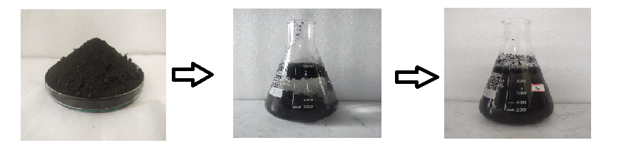
Filtered Micro plastic extract
Extraction of Micro plastics using sterile extraction medium (Physiological Saline)
Micro plastics obtained from Pyrolysis unit

Fig 1: Extraction of Microplastic by Leaching

Zebrafish line and maintenance
The strains of zebrafish (Danio rerio) used were wild type animals adapted and bred at Dynamic Megaceutics Research Lab. All fish were acclimated to constant laboratory condition (14-h light: 10-h dark photoperiod, diet, water, 28°C) for at least one week in stock aquaria before all experiments were conducted. Adult fish were fed Tetrabit flakes (A complete pet food for Tropical fish from Tetra GmbH, Herrenteich) daily, until the beginning of experiments. All fish used in these experiments were random adults from different clutches.
Groups of 60 adult fish were housed in transparent polycarbonate tanks at light dark cycle of 14/10hr with water temperature of 28 +/- 1 °C and pH between 6.8-7.5. Good Animal Practice as per Institutional Animal Ethics Committee in accordance with Committee for the Purpose of Control and Supervision of Experiments (CPCSEA), India, were followed in adherence to established protocols. Housing tanks were cleaned once in 4 days to keep the fishes clean and free from infection.

Group Setting
Adult male fishes of similar body weight totaling to 0.8 grams per fish were selected for the study and housed as 8 per group in a polycarbonate tank at a stocking density of 2 liters of water per fish. Study fishes were grouped as per the table 1.

Table 1: The Study groups and their category
Group study | Category
Group 1 | Control
Group 2 | 50% of plastics immersed water
Group 3 | 25% of plastics immersed water
Group 4 | 12.5% of plastics immersed water
Group 5 | 6.25% of plastics immersed water
Group 6 | 3.12% of plastics immersed water

Study Design
The selected adult fishes were transferred to study cups containing prepared extract and were housed in a ratio of 1 per study cup for 6 groups. The groups were fed and monitored every day. On day 7 & 14 the adult fishes screened for the toxic effect.
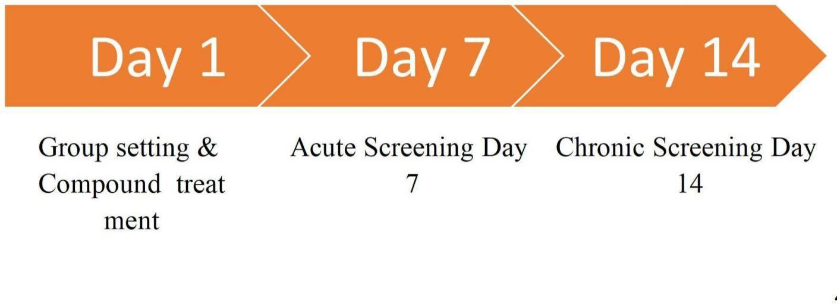
Chart 1: Steps involved in feeding and monitoring adult fishes

Dissection and histopathology
Fishes were euthanized and dissected as per ethical guidance. Fish were euthanized with 2-4°C water. The fish was dissected through an incision in the viscera and organs of interest were isolated by cutting the localized tissue with a dissection knife the caudal fin was cut by holding the fish with lateral segment parallel to the dissection table. Sectioning of the organs were made on glass slides and stained with Hematoxylin & Eosin (Pérez Díaz et al., 2025).
Results and discussion
Cardiac defects and heartbeat analysis
The cardio toxicity phenotypes, including cardiac defects, heartbeat and blood flow activity of zebrafish larvae at 24 hpf to 96 hpf were assessed under microscope. For heartbeat analysis, zebrafish larvae were mounted in 3% methylcellulose, and heart beat were counted for 10s. The heartbeat was calculated as beats per minute.

Cardiac defects and heartbeat analysis

Heart beat analysis
Table 2: Study Group of heart bear per minute
Study group | Heart beat per minute (bpm)
Control | 173
50% plastic immersed water | 112
25% plastic immersed water | 122
12.5% plastic immersed water | 130
6.25% plastic immersed water | 148
3.12% plastic immersed water | 165
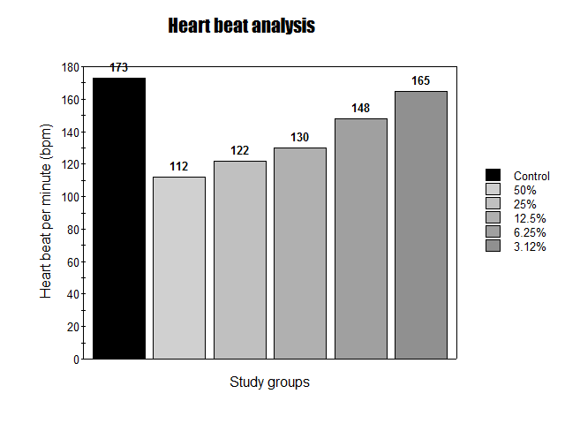
Graph 1: Heart Beat analysis of the ZebraFish
To investigate the functional defects of larvae cardiotoxicity, the heart beat rate was measured in control, 50%, 25%,12.5% 6.25% & 3.12% of microplastic immersed water at 96 hpf. The 3.12% group exhibits slightly decreased heart beat but higher heart rate than other treated groups while 6.25% group exhibit bradycardia in some larvae. The treated group at 12.5%, 25% & 50% exhibit significantly reduced cardiac heart beat with increased cardiac dysfunction induced by microplastic immersed water as the concentration of microplastic immersed in water increases the cardiac dysfuction also increases as a result (Table 2 & Graph 1)
Morphological analysis of Larvae Heart
3.12%
6.25%
12.5%
25%
50%
Control

24hrs
d

48hrs
d
c
a
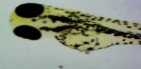
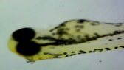
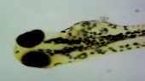
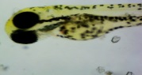
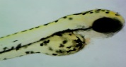
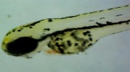
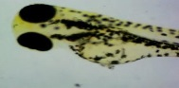
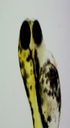
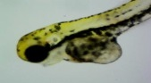
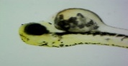
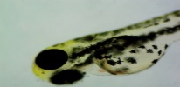
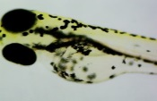
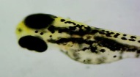
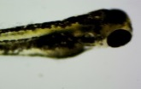
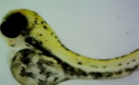
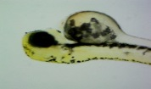
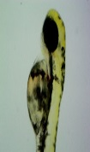
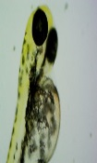
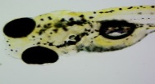
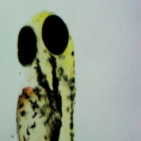
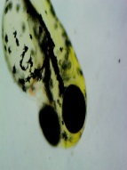
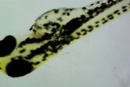
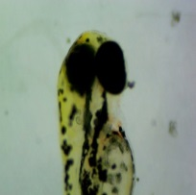
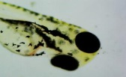
a
b
c
d
e
f
b
c
e
f
a
b
c
d
e
f
72hrs

96hrs
f
e
c
b
a
d

Fig 2: Microscopic image of zebrafish larvae Heart
The morphological phenotypes of zebrafish larvae are measured at 24, 48, 72 & 96 hpf & hpi. The larvae at 24 hpi indicates intact morphology of the heart without any abnormalities while larvae at 48 hpf indicates intact morphological phenotype at control & 3.12% treated group but at treated group 50%,25%, 12.5% & 6.25% exhibits cardiac malfunction such as pericardial edema, the edema is significantly higher in the order 50% , 25% and 12.5%. The larvae at 72 hpf indicates intact morphology at control and slight pericardial edema at treated group 3.12% while treated group 50%, 25%, 12.5% & 6.25% exhibits shrunken body morphology with pericardial edema. The larvae at 96 hpf indicates intact morphology at control and slight pericardial edema at treated group 3.12% while treated group 50%, 25%, 12.5% & 6.25% exhibits shrunken body morphology at 50% treated group and inflamed body morphology with pericardial edema is observed at 25%, 12.5% & 6.25% (Fig 2).
Conclusion
In the present study the given compound is screened to evaluate the toxicity of the microplastic in zebrafish larvae is followed by visual observations of the heart. The functional defects of larvae carditoxicty, the heart rate was measure among which 50%, 25%, 12.5% & 6.12% exhibits bradycardia, while 3.12% is slightly comparable to control. The morphological phenotypes of zebrafish larvae exhibits cardiac malfunction such as pericardial edema, the edema is significantly higher in the order 50%, 25%,12.5%, 6.12% & 3.12%. The larvae indicates intact morphology at control and slight pericardial edema at treated group 3.12% while treated group 50%, 25%, 12.5% & 6.25% exhibits shrunken body morphology with pericardial edema at 24, 48, 72 & 96 hpf.

Disclaimer (Artificial intelligence)
Option 1:
Author(s) hereby declare that NO generative AI technologies such as Large Language Models (ChatGPT, COPILOT, etc.) and text-to-image generators have been used during the writing or editing of this manuscript.
Option 2:
Author(s) hereby declare that generative AI technologies such as Large Language Models, etc. have been used during the writing or editing of manuscripts. This explanation will include the name, version, model, and source of the generative AI technology and as well as all input prompts provided to the generative AI technology
Details of the AI usage are given below:
1.
2.
3.

Reference
- Bučaitė, A., Sauliutė, G., & Stankevičiūtė, M. (2023). Effects on hematological and morphological parameters in fish after chronic exposure to microplastics. In The COINS 2023: international conference of life sciences: book of abstracts. https://www.thecoins.eu/static/resources/booksofabstracts/COINS2023.pdf
- de Souza Freire, I., Fascineli, M. L., Piau, T. B., Pereira, B. F., & Grisolia, C. K. (2023). Multilevel toxicity evaluations of polyethylene microplastics in zebrafish (Danio rerio). International Journal of Environmental Research and Public Health, 20(4), 3617. https://doi.org/10.3390/ijerph20043617
- Du, W., Wang, X., Wang, L., Wang, M., & Liu, C. (2023). Avermectin induces cardiac toxicity in early embryonic stage of zebrafish. Comparative Biochemistry and Physiology Part C: Toxicology & Pharmacology, 264, 109529. https://doi.org/10.1016/j.cbpc.2022.109529
- Gautam, M. K., Panda, P. K., Dubey, A., Kumari, M., & Ghosh, N. S. (2024). Zebrafish as a Fascinating Animal Model: A Robust Platform for in vivo Screening for Biomedical Research. International Journal of Pharmaceutical Investigation, 14(3). https://doi.org/10.5530/ijpi.14.3.696
- Goel, M. (2024). Understanding Plastic Pollution. In Plastic Pollution: Challenges and Green Solutions (pp. 3-30). Singapore: Springer Nature Singapore.
- Hossain, M. E., Shahrukh, S., & Hossain, S. A. (2022). Chemical fertilizers and pesticides: impacts on soil degradation, groundwater, and human health in Bangladesh. In Environmental degradation: challenges and strategies for mitigation (pp. 63-92). Cham: Springer International Publishing. https://doi.org/10.1007/978-3-030-95542-7_4
- Kasmuri, N., Tarmizi, N. A. A., & Mojiri, A. (2022). Occurrence, impact, toxicity, and degradation methods of microplastics in environment—a review. Environmental Science and Pollution Research, 29(21), 30820-30836. https://doi.org/10.1007/s11356-021-18268-7
- Parul, Jain, U., Sharma, B., Kumar, A., Singh, R., & Bharti, S. (2025). Environmental Pollution: Air, Water, Soil, Marine, and Thermal Pollution. Epidemiology and Environmental Hygiene in Veterinary Public Health, 385-392. https://doi.org/10.1002/9781394208180.ch33
- Pérez Díaz, M., de Azevedo Gomes, A. M., Quiroga Berdeal, M. I., & Bermúdez Pose, R. (2025). How to Dissect Zebrafish: A Standardized Sampling Protocol for Histological and Molecular Studies in Adult Zebrafish. Zebrafish, 22(3), 76-85. https://doi.org/10.1089/zeb.2024.0184
- Persiani, E., Cecchettini, A., Ceccherini, E., Gisone, I., Morales, M. A., & Vozzi, F. (2023). Microplastics: a matter of the heart (and vascular system). Biomedicines, 11(2), 264. https://doi.org/10.3390/biomedicines11020264
- Rex, P., Ganesan, V., Sivashankar, V., & Tajudeen, S. (2023). Prospective review for development of sustainable catalyst and absorbents from biomass and application on plastic waste pyrolysis. International Journal of Environmental Science and Technology, 20(7), 8141-8156. https://doi.org/10.1007/s13762-022-04292-8
- Satpathy, P., Mishra, M., Nath, J., Boopathy, R., & Das, T. (2024). The health menace of myriad air pollutants: An Indian perspective. In Air Quality and Human Health (pp. 181-202). Singapore: Springer Nature Singapore. https://doi.org/10.1007/978-981-97-1363-9_14
- Savuca, A., Nicoara, M. N., Ciobica, A., Gorgan, D. L., Ureche, D., & Balmus, I. M. (2023). Current aspects on the plastic nano-and microparticles toxicity in zebrafish—focus on the correlation between oxidative stress responses and neurodevelopment. Animals, 13(11), 1810. https://doi.org/10.3390/ani13111810
- Sharma, M., Kant, R., Sharma, A. K., & Sharma, A. K. (2025). Exploring the impact of heavy metals toxicity in the aquatic ecosystem. International Journal of Energy and Water Resources, 9(1), 267-280. https://doi.org/10.1007/s42108-024-00284-1
- Siddiqua, A., Hahladakis, J. N., & Al-Attiya, W. A. K. (2022). An overview of the environmental pollution and health effects associated with waste landfilling and open dumping. Environmental Science and Pollution Research, 29(39), 58514-58536. https://doi.org/10.1007/s11356-022-21578-z
- Subaramaniyam, U., Allimuthu, R. S., Vappu, S., Ramalingam, D., Balan, R., Paital, B., ... & Sahoo, D. K. (2023). Effects of microplastics, pesticides and nano-materials on fish health, oxidative stress and antioxidant defense mechanism. Frontiers in physiology, 14, 1217666. https://doi.org/10.3389/fphys.2023.1217666
- Thakur, S., Chandra, A., Kumar, V., & Bharti, S. (2025). Environmental pollutants: endocrine disruptors/pesticides/reactive dyes and inorganic toxic compounds metals, radionuclides, and metalloids and their impact on the ecosystem. In Biotechnology for environmental sustainability (pp. 55-100). Singapore: Springer Nature Singapore. https://doi.org/10.1007/978-981-97-7221-6_15
- Chowdhury, S. R., Dey, A., Mondal, S., & Gautam, M. K. (2024). Environmental microplastics and nanoplastics: Effects on cardiovascular system. Toxicologie Analytique et Clinique, 36(2), 145-157.
- Kim, Y., Lee, H., Kim, Y. H., & Oh, C. K. (2025). Polyethylene microplastics perforate the chorion defense, triggering developmental cardiotoxicity at zebrafish. Aquatic Toxicology, 282, 107331.
- Chakraborty, J., Shil, D., Roy, S. D., Samanta, A., Bhowmik, D., Roy, S., ... & Jodder, P. K. (2025). A Comprehensive Review on Micro and Nanoplastics-Mediated Cardiovascular Complications. Micro-Nano Plastics Exposure, Environmental Degradation and Public Health Crisis: Perspectives and Concerns for Sustainable Development, 207-216.
- Li, H. (2025). Progress in Research on Microplastics and Nano-plastics Cardiac Toxicity. Advances in Life Science for Adolescents, 1(2).
- ze Y., Hu, L., Duan, J., Che, H., Wang, W., Yuan, Y., ... & Zhao, S. (2024). Polystyrene microplastics enhance microcystin-LR-induced cardiovascular toxicity and oxidative stress in zebrafish embryos. Environmental Pollution, 352, 124022.
- Oraee, S., Alinejadfard, M., Mahdavi, S., Rajai Firouzabadi, S., Hatami, S., Mohammadi, I., ... & Khaheshi, I. (2025). The association between micro-and nano-plastics and cardiovascular outcomes: a comprehensive review. Toxicology and Environmental Health Sciences, 1-16.
- Kumar, G., Duggal, B., & Banerjee, P. (2025). Impact of Microplastics on Human Health. In Occurrence, Detection, and Fate of Microplastics in Freshwater Ecosystems (pp. 221-240). Singapore: Springer Nature Singapore.
- Multisanti, C. R., Ferrara, S., Piccione, G., & Faggio, C. (2025). Plastics and their derivatives are impacting animal ecophysiology: A review. Comparative Biochemistry and Physiology Part C: Toxicology & Pharmacology, 110149.
- Naïja, A., Horie, Y., Boughattas, S., Ismail, S., & Al-Mansouri, N. (2024). Toxicity assessment of di (2-ethylhexyl) phthalate using zebrafish embryos: Cardiotoxic potential. Comparative Biochemistry and Physiology Part C: Toxicology & Pharmacology, 283, 109956.

- Israni, D. K., Soni, J., Singh, S., & Prajapati, B. G. (2024). Revealing the Potential Effects and Risk of Microplastics from Face Mask on Human Health and Environment: A interlink Review on COVID-19 and Particulate Matter (PM2. 5). Water, Air, & Soil Pollution, 235(6), 334.
- Suman, T. Y., Rajendiran, K., & Kwak, I. S. (2025). Microplastics and nanoplastics in human health: a comprehensive review of exposure pathways, cellular mechanisms, and toxicological implications. Archives of Toxicology, 1-26.
- Jahedi, F., Frad, N. J. H., Khaksar, M. A., Rashidi, P., Safdari, F., & Mansouri, Z. (2025). Nano and microplastics: unveiling their profound impact on endocrine health. Toxicology Mechanisms and Methods, 35(8), 865-893.
- Lang, T., Jelić, F., & Wechselberger, C. (2024). From Cradle to Grave: Microplastics—A Dangerous Legacy for Future Generations. Environments, 11(12), 263.
- Kadac-Czapska, K., Ośko, J., Nowak, N., Jażdżewska, K., Kowalczyk, P., & Grembecka, M. (2025). Unseen Hazards—Toxicological Effects and Human Health Impacts of Nanoplastics and Microplastics. Applied Sciences, 15(18), 10146.
- Fakayode, S. O., Mehari, T. F., Fernand Narcisse, V. E., Grant, C., Taylor, M. E., Baker, G. A., ... & Anum, D. (2024). Microplastics: Challenges, toxicity, spectroscopic and real-time detection methods. Applied Spectroscopy Reviews, 59(9), 1183-1277.
- Binelli, A., Nigro, L., Sbarberi, R., Della Torre, C., & Magni, S. (2024). To be or not to be plastics? Protein modulation and biochemical effects in zebrafish embryos exposed to three water-soluble polymers. Science of the Total Environment, 906, 167699.
- Sutkar, P., Dhulap, V., Girigosavi, S., Deshmukh, S., & Desai, M. (2025). Microplastics in the Human Body: A Comprehensive Review of Exposure, Detection, and Health Risks. Wastewater Purification 1 (1), 20250317163738.
- Gani, A., Pathak, S., Hussain, A., Shukla, A. K., & Chand, S. (2024). Emerging pollutant in surface water bodies: a review on monitoring, analysis, mitigation measures and removal technologies of micro-plastics. Environmental Geochemistry and Health, 46(7), 214.
- Das, S., & Kalyani, M. I. (2024). An Overview of the Detrimental Effect of Microplastics on Humans. Microplastics in African and Asian Environments: The Influencers, Challenges, and Solutions, 463-498.

