Effective Management of Notoedres cati in Cats: A Comparative Study of Selamectin Spot-On and Ethnoveterinary Medicine

Abstract
A total of 4500 clinical cases of domestic cats presented to the Veterinary Clinical Complex (VCC), Rajendranagar, between 2022 and 2024 were screened for Notoedres cati infestation. Out of these, 250 cats (5.5%) were diagnosed positive based on the characteristic clinical signs, symptoms and microscopic examination of deep skin scrapings revealing Notoedres cati mites. The occurence of the disease was found to be males (54%) and females (46%), indicating a slightly higher susceptibility in males. Among the naturally infested cats, 60% were between 6 months to 1 year and 40 percent between 1 to 2 years. Affected cats exhibited typical lesions of notoedric mange including alopecia, crusting, hyperkeratosis, excoriations and intense pruritus with lesions primarily on scantily haired regions such as the ear margins, face, neck, and forelimbs. Some of the cat owners also developed pruritic skin lesions on their hands and wrists which confirms zoonotic disease transmission. The study evaluated the therapeutic efficacy of Selamectin spot-on (6 mg/kg body weight) and an Aloe vera-virgin coconut oil formulation using Z test in 250 naturally infested cats divided equally into two treatment groups (n=125 per group) irrespective of gender, age and sex with mean lesion scores evenly distributed between the 2 groups. The cats treated with Selamectin (Group I) reached their best recovery point at day 21 after treatment but the cats receiving the ethnoveterinary formulation (Group II) needed until day 28 to show substantial improvement in the reduction of mean lesion scores. Both the treatments were effective, but Selamectin provided quicker recovery than the Aloe vera - Virgin Coconut Oil (VCO) combination which offered lower costs and better environmental sustainability. The research confirms that Notoedres cati continues to affect domestic cats in Hyderabad while demonstrating the need for prompt diagnosis and standard treatment protocols to stop disease relapses and animal-to-human transmission.
Keywords: Notoedres cati, Selamectin, Aloe vera-Virgin Coconut Oil, cats, Hyderabad.

- INTRODUCTION
Dermatological disorders are among the most frequently encountered clinical conditions in domestic cats (Felis catus). Among various parasitic diseases, mange is one of the most prevalent. Mite infestations lead to skin thickening, wrinkling, and folding, eventually resulting in the formation of dense, firmly adherent crusts varying in color from yellow to gray (Sivajothi et al., 2015). Scabies in cats is an extremely contagious zoonotic disease that can be transmitted between animals and humans. It is caused by mites, Notoedres cati and Sarcoptes scabiei (Goldust et al., 2013). Notoedric mange is a comparatively uncommon infectious skin disease affecting domestic and stray cats caused by the burrowing mites belonging to the genus Notoedres (family: Sarcoptidae) (Georgiana et al., 2021). These mites burrow into the skin, leading to crusty dermatitis, particularly in scantily haired regions such as the head, neck, axillae, groin, and tail (Hardy et al., 2012). Typical scabies lesions appear at the burrowing sites as papular or vesicular eruptions, often accompanied by a generalized allergic dermatitis and severe pruritus (Mounsey et al., 2013). Hence, prompt veterinary attention for feline scabies is essential to prevent skin thickening, folding, and crust formation.
Morphologically, Notoedres mites resemble other members of the family Sarcoptidae, such as Sarcoptes species, but are smaller and possess characteristic “thumbprint” appearance with distinct dorsal striations, shorter limb stalks, dorsal legs and spines, and a dorsal anus rather than the terminal anus classsical of Sarcoptes (Ozukum et al., 2019). Common lesions in cats consist of alopecia, lichenification, crusts, scales, and intermittent scabs, commonly affecting the head, legs, and genital areas (Dangi et al., 2023) and can be further aggravated by secondary bacterial infections resulting from excoriations caused by self-trauma (Györke et al., 2022).
Although Notoedres mites primarily affects cats, the disease has also been documented in more than 15 other animal species, and humans can also acquire infection through close contact with the affected cats, resulting in intense pruritus and papular lesions on the arms and legs (Sinha et al., 2023). As notoedric mange is transmissible to human beings, prompt and appropriate treatment is crucial and the owners must be cautioned when handling cats (Chakrabarti 1986; Foil 2003). In humans, hypersensitivity reactions to Notoedres cati bites give rise to papulovesicular eruptions accompanied by intense pruritus and the condition is predominantly self-limiting and transient in human (Chakrabarti, 1986).
Despite the rapid advancements in modern medicine, the significance of natural and traditional remedies must not be neglected (Khairullah et al., 2020; Ansori, et al., 2021). Despite growing interest in plant-based therapies, there is a lack of comprehensive data on variety of plants that could function as natural medicines for specific treatment and be advanced into standardized therapeutic formulations (Pratasik et al., 2019; Solikhah et al., 2020; Khairullah et al., 2021).
Among natural remedies, Aloe barbadensis, belonging to the family Liliaceae is usually known as Aloe vera, is a promising candidate as a pharmaceutical raw material (Bashir et al., 2011) with several reports documenting its effectiveness in treating scabies in animals (Ansori et al., 2021; Zia-ud-Din Sindhu et al., 2012; Oyelami et al., 2009). Virgin Coconut Oil, obtained from the fresh and mature kernel of the coconut (Cocos nucifera L.) offers numerous advantages including health benefits of its retained vitamins and antioxidants, the antimicrobial and antiviral properties of its lauric acid component and the easy digestability of its medium-chain fatty acids (MCFAs) (Mansor et al., 2012; Solikhah & Solikhah, 2019). Additionally, VCO is a natural, pesticide-free oil with a composition that promotes skin absorption, leaving the skin soft and smooth (Abujazia et al., 2012). Topical cream formulations are particularly suitable for localized therapy (Majid & Citraningtyas, 2019).
Selamectin (Selamec™ spot on) is highly effective alternative drug for the therapeutic management of Notoedric mange in cats (Georgiana et al. 2021) and the topical recommended dose is 6 mg/kg body weight (Sadhu et al., 2024) which aligns with the present study. Selamectin has high affinity for the sebaceous glands and skin and in dogs it has an estimated half-life of 11days whereas in cats it is about 8 days (Marks, 2016). Although macrocyclic lactones such as ivermectin and selamectin demonstrate excellent effectiveness, they can be expensive and ocassionally connected with adverse effects. In contrast, traditional ethnoveterinary remedies using plant-based oils and herbal extracts have gained prominence for their safety, accessibility, and affordability, particularly in rural and resource-limited settings. Therefore, the present study was undertaken to compare the clinical efficacy of Selamectin spot-on therapy and an ethnoveterinary herbal formulation in the management of Notoedres cati infection in domestic cats.

2. MATERIALS AND METHODS
2.1 Study Animals
The present study was conducted on domestic cats presented to the Veterinary Clinical Complex and the Department of Veterinary Clinical Medicine, Rajendranagar, Hyderabad during the period between 2022 and 2024. A total of 250 cats aged between 6 months and 2 years, naturally infested with Notoedres cati, were selected based on typical lesions such as alopecia, crust formation, thickened skin and intense pruritus. Diagnosis was confirmed through microscopic examination of deep skin scrapings, which revealed the presence of Notoedres cati mites.
2.2 Experimental Design
Infested cats were randomly divided into two equal groups irrespective of gender, age and sex (n=125 per group) with mean lesion scores evenly matched between the 2 groups. Group I animals were treated with Selamectin spot-on (6 mg/kg body weight) topically applied at the infested areas on days 0, and 14 while Group II animals were treated with an ethnoveterinary formulation comprising cream base (100 g), Aloe vera gel (15%) and virgin coconut oil (20 mL) as per the study of Solikhah et al. (2021), which was applied once daily over the affected areas for 7 consecutive weeks. Owners were recommended to feed their cats with a balanced diet and vitabest derm supplement (VITABEST® DERM) throughout the 8-week study period.
2.3 Clinical Evaluation
Lesions were scored based on alopecia, crust formation, erythema, and pruritus using a 0–3 scale (0 = absent, 3 = severe) on days 0, 7, 14, 21 post treatment.
2.4 Parasitological Examination
Deep skin scrapings were examined microscopically at 7-day intervals for mite detection and assessment of parasitological cure.
2.5 Statistical Analysis
Mean lesion scores between 2 groups were analyzed using Z test and the differences were considered significant at p < 0.05.
3. RESULTS
On physical examination, affected cats exhibited characteristic signs of notoedric mange, including alopecia, thick crusty scabs and intense pruritus, most prominently on the head, ears, eyes, nose, neck, forelimbs, and tip of the tail (Fig. 1), along with moderate increase in temperature and emaciation, while no other serious systemic signs and symptoms were observed. Among the examined population, 250 cats (5.5%) were confirmed positive through clinical evaluation and microscopic detection of Notoedres cati (Fig. 2), characterized by approximately oval body, 4 pairs of legs (3rd and 4th pairs lie within the circumference of body outline) and a long, unsegmented pedicel. Such morphological features serve as diagnostic evidence for N. cati infestation in feline scabies (Ngetich et al., 2019). Both male (54%) and female (46%) cats were affected, predominantly in younger cats aged between 6 months and 2 years of age, with 60% aged between 6 months to 1 year and 40% aged between 1 to 2 years. Haematological examination revealed obvious eosinophilia, being approximately three times higher than that of normal cats, which is in accordance with the findings of Dovhiy and Melniychuk (2024).
Zoonotic transmission was observed in few owners who developed erythematous papules and crusted lesions on the exposed areas of the neck and forearm (Fig. 3), accompanied by moderate pruritus. The lesions appeared approximately one week after handling the infested cat. The owner’s condition improved following medical attention and resolution of the animal’s infestation, suggesting the zoonotic potential of Notoedres cati.
Selamectin-treated cats (Group I) showed rapid improvement with reduced pruritus by day 7, 80% hair regrowth by day 21, and complete clinical and parasitological recovery by day 28. This response followed the application of selamec spot-on as per the recommended dosage of 6mg/kg body weight (Sadhu et al., 2024) on zero day and 14th day. The Aloe vera + VCO group (Group II) showed gradual improvement from day 14, with optimum reduction in mean clinical score by day 28 and maximum recovery in 90% of cats by day 56. Since the mean lesion scores for Group I approached zero by day 21, lesion scoring was discontinued thereafter. Comparison between 2 groups was done using Z test since the sample size is more than 30. Both treatments significantly reduced mean lesion scores (p < 0.05), with faster recovery in the selamectin group and the comparison of mean lesion scores between 2 groups are presented in Table 1. Z values used for calculation were taken from standard normal distribution table (Spiege et al., 2016). Since the Z calculated value is greater than Z critical or table value (1.645 in a one-tailed test), null hypothesis is rejected and it is concluded that selamectin has greater efficiency in treating Notoedric mange than ethnoveterinary medicine. No detrimental reactions occurred, except mild transient erythema in two Aloe vera + VCO treated cats, resolved within 24 h. Supportive therapy was provided orally with Vitabest Derm supplement (VITABEST® DERM) containing omega fatty acids (2 ml twice daily for 30 days) for both the groups. Subsequent to treatment, skin scrapings examined after 8 weeks were negative for mites, and marked clinical improvement with regrowth of hair was observed (Fig. 4). The treatment response and comparative efficacy of Selamectin and the ethnoveterinary formulation are presented in Table 2. However, the herbal formulation also gave satisfactory results and can be considered a cost-effective option, especially in areas with limited access to veterinary care. Hair regrowth improved more markedly with selamectin, while smoother skin and lesser post-lesional dryness were seen with Aloe vera + VCO.
Table 1. Comparitive analysis of mean lesion scores between comparison of mean lesion scores in Group I and Group II using Z test
Days | Group I (Selamectin) | Group II (Aloe vera + VCO)
Day 0 | 2.66 ± 0.03 | 2.66 ± 0.04
Day 7 | 2.14 ± 0.04 | 2.30 ± 0.01
Day 14 | 1.12 ± 0.04 | 2.11 ± 0.01
Day 21 | 0.15 ± 0.01 | 1.84 ± 0.02

Table 2. Comparitve efficacy of Selamectin and Ethnoveterinary formulation against Notoedres cati infestation in cats
Parameter | Group I (Selamectin) | Group II (Aloe vera + VCO)
No. of cats | 125 | 125
Clinical recovery (%) by day 21 | 98 | 65
Clinical recovery (%) by day 35 | 100 | 78
Parasitological cure (%) by day 56 | 100 | 100
Mean reduction in clinical score by day 56 (%) | 100 | 97
Adverse effects | None | Mild transient erythema (2)

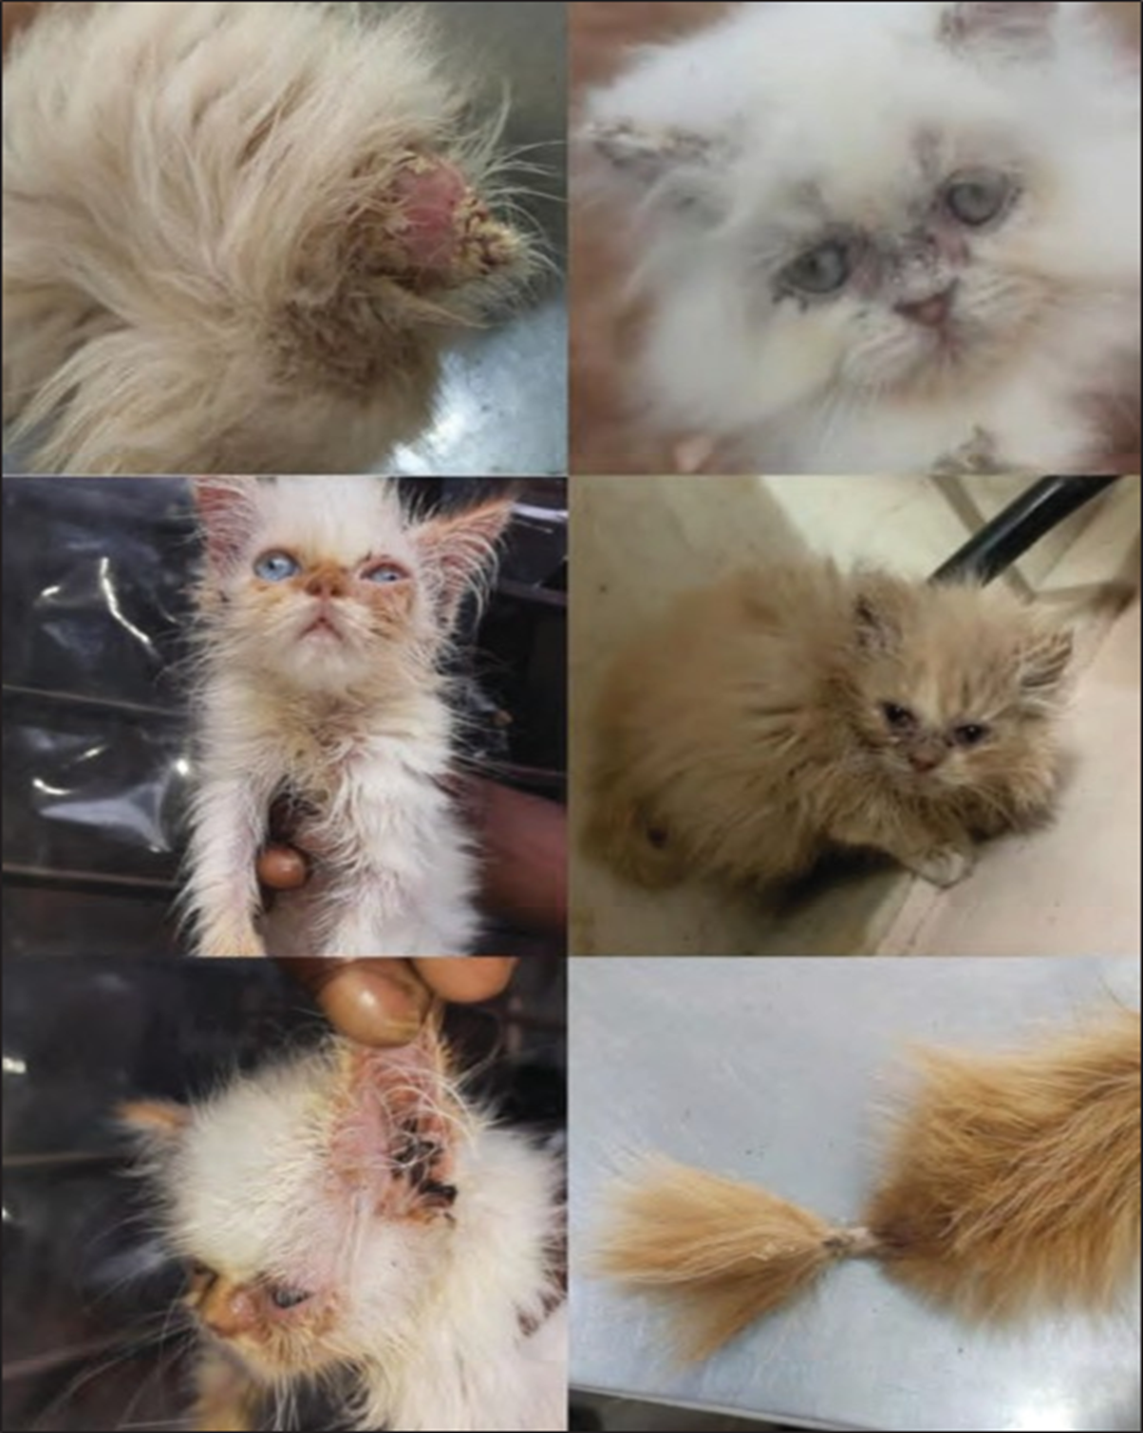
Fig. 1. Pathognomic lesions of Notoedres cati infestation in cats showing thick crusty scabs at tip of the ears, eye, nose, neck, forelimbs and tip of the tail.
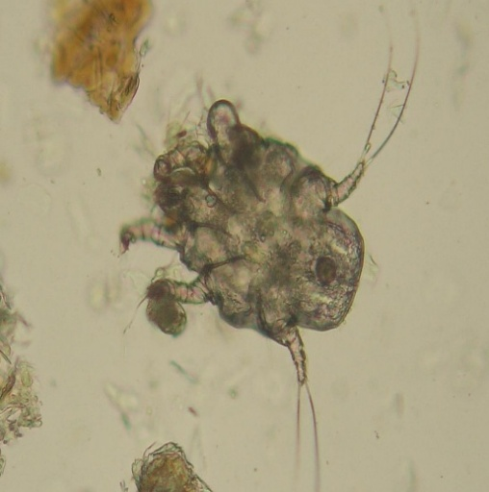
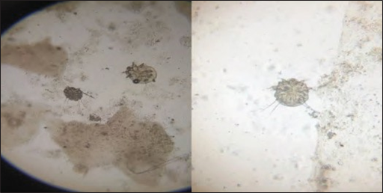
Fig. 2. Microscopic examination of skin scrapping showing mites with circular body, very short legs, pedicels unsegmented and dorsal anus confirming Notoedres cati.
This Photo by Unknown Author is licensed under CC BY-SA
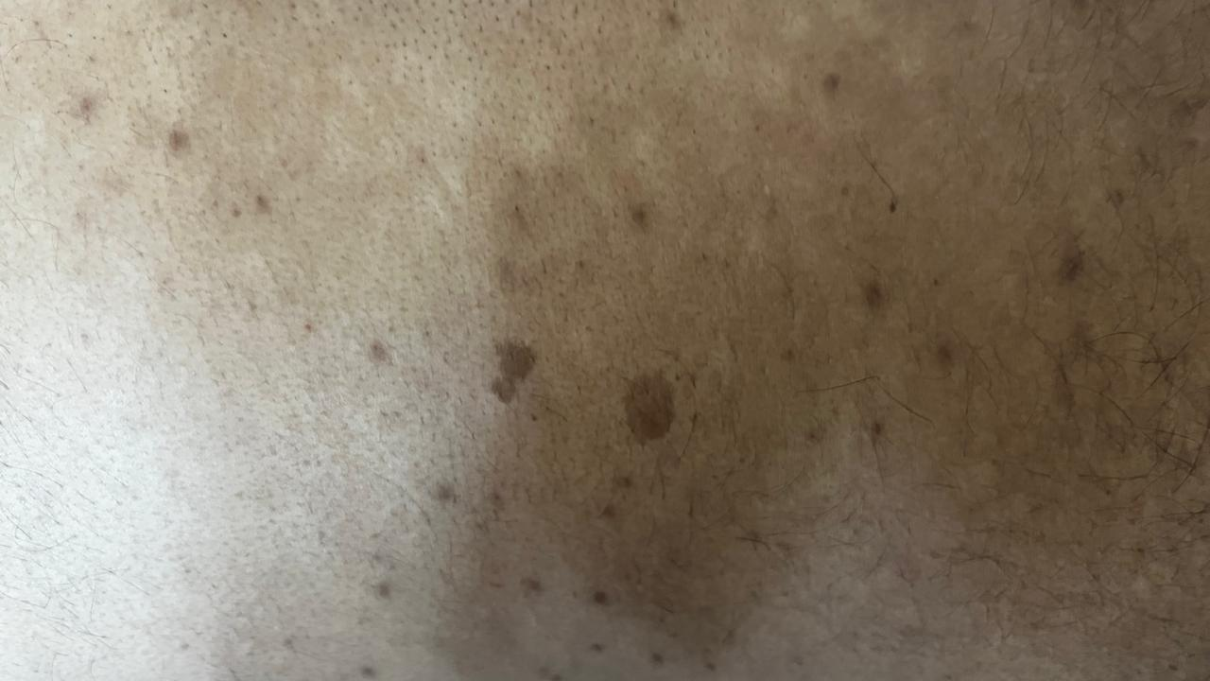
Fig. 3. Zoonotic manifestation of Notoedres cati in a cat owner showing erythematous papular lesions on the forearm region.
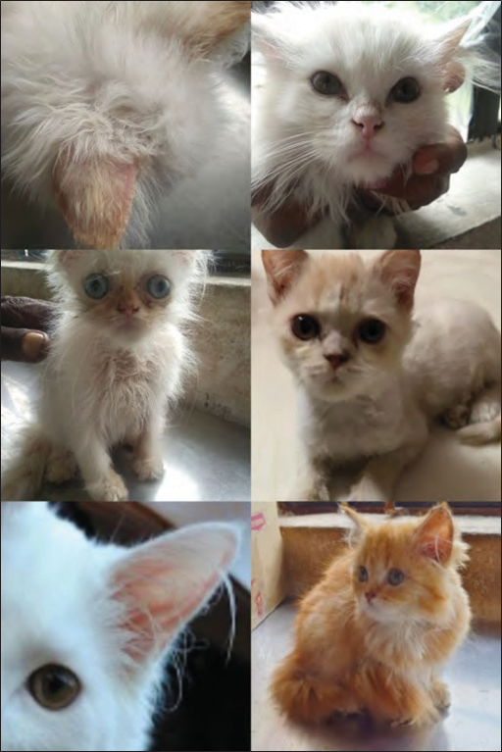
Fig. 4. Marked clinical improvement and hair regrowth in cats following treatment with Selamectin and Ethnoveterinary formulation.

4. DISCUSSION
Feline mange refers to a dermatological condition caused by Notoedres cati in domestic and stray cats. Skin scraping and microscopy are the easiest and most common diagnostic tests, but molecular diagnostics may be needed when lesions are not evident and mites are in low number (Foley et al., 2016). However, molecular approaches remain limited because it is still unclear whether N. cati is genetically similar across hosts like cats, rabbits, and lynxes (Foley et al., 2016). The typical lesions observed in this case such as alopecia, crusting, erythema, and intense pruritus localized on the eyes, nose, forelimb and auricular regions are strongly indicative of N. cati infestation and are generally acknowledged as pathognomonic (Suryaningrat et al., 2024; Handoko and Agusthusana, 2024). Frequent scratching of the body parts is quite common when a cat is attacked by scabies (Susanto et al., 2020).
The faster improvement in feline mange (Group I) aligns with previous studies that reported complete recovery within 2-3 weeks when treated with any of the Avermectin group drugs such as ivermectin, selamectin, or imidacloprid-moxidectin combinations (Hariono et al., 2021; Balamurugan et al., 2022; Ningrum et al., 2023; Putra et al., 2024). Therapeutic success was also achieved with the combination of selamectin and sarolaner against notoedric mange in cats (Sadhu et al., 2024; Georgiana et al., 2021). Eprinomectin (eprinomectin B1), 4’’-epiacetylamino4’’-deoxyavermectin B1, belongs to the macrolide class of parasiticides within the avermectin family has achieved notable therapeutic success against notoedric mange (Dangi et al., 2023).
The improvement observed in Group II is in accordance with the research carried out by Solikhah, Solikhah and Susilo (2021), which evaluated the efficacy of Aloe vera gel cream combined with VCO in accelerating the healing process of scabies in cats. VCO facilitates healing of scabies due to its rich composition of saturated fatty acids, which enhances tissue repair and regeneration (Viste et al., 2013). Furthermore, a study published in Phytotherapy Research provided report supporting the efficacy of Aloe vera in the treatment of scabies (Oyelami et al., 2009). The results of the study (Group II) revealed that Aloe vera gel and Virgin Coconut Oil (VCO) is equally successful as benzyl benzoate, a regularly prescribed treatment for scabies (Solikhah, Solikhah and Susilo, 2021). The therapeutic significance of Aloevera-VCO combination lies in the individual and synergistic properties of Aloe vera and VCO. Together, these natural substances may offer a complementary approach to managing N. cati infestations, especially in cases where conventional treatments are unavailable or less effective.
Marked eosinophilia noticed in the affected cats, nearly three times higher than that of healthy animals, supports the findings of Dovhiy and Melniychuk (2024), implying an allergic and hypersensitivity reaction to Notoedres cati infestation. Environmental and management associated risk factors such as irregular and inadequate antiparasitic drug treatments, outdoor roaming, inadequate sanitation and high animal density markedly increase susceptibility to ectoparasitic infestation (Handoko et al.,2024). In clinical settings, cats lacking antiparasitic treatment or with unrestricted outdoor access are more likely to be affected by ectoparasitic infestation (Qudsiyati et al., 2023). Health education regarding parasite biology and transmission, environmental sanitation, and avoiding home remedies like essential oils is beneficial in preventing reinfection (Handoko and Agusthusana, 2024; Dewi et al., 2022).
While the ethnoveterinary formulation demonstrates promising results, further research and controlled clinical trials are required to establish standardized treatment protocols and to evaluate its long-term efficacy and safety. Veterinarians should exercise caution and consider individual patient factors when recommending alternative therapies. Although Selamectin provides a quicker recovery, the herbal formulation represents a sustainable and cost-effective option, especially for domestic cats and in regions with limited access to veterinary care.

5. CONCLUSION
Feline notoedric mange, caused by Notoedres cati, is a highly contagious and pruritic dermatological infestation in cats, with potential zoonotic transmission to humans and other animals. The mite burrows into the epidermis, resulting in alopecia, crust formation, and intense pruritus, predominantly affecting the head and ears. Diagnosis is confirmed through deep skin scraping examination and identification of characteristic lesions in the affected areas. Therapeutic intervention with Selamectin spot-on has demonstrated rapid clinical recovery, while an ethnoveterinary formulation comprising herbal components achieved comparable end resluts over an extended period without observable adverse effects. Integrating early diagnosis with both modern and ethnoveterinary treatment strategies presents a sustainable and accessible approach to feline mange management. Moreover, controlling N. cati infestations carries significant zoonotic importance, as effective treatment not only enhances feline health and welfare but also mitigates the risk of zoonoses, underscoring the necessity for clinical vigilance and heightened public awareness

ACKNOWLEDGEMENTS
The authors thank the Dean, Faculty of Veterinary Medicine, College of Veterinary Science, Rajendranagar for providing necessary facilities and support during the study.

COMPETING INTERESTS
The authors hereby declare that they have no competing interests.

Ethical Approval
Animal Ethic committee approval has been collected and preserved by the author(s)

DISCLAIMER
Authors hereby declare that no thatno generative AI technologies including large language models (e.g., ChatGpt, COPILOT) or text to image tools were used in the writing or editing manuscript.

REFERENCES:

- Abujazia, M.A., Muhammad, N., Shuid, A.N. and Soelaiman, I.N., 2012. The effects of virgin coconut oil on bone oxidative status in ovariectomised rat. Evidence‐Based Complementary and Alternative Medicine, 2012(1), p.525079. DOI: 10.1155/2012/525079
- Ansori, A.N.M., Kharisma, V.D. and Solikhah, T.I., 2021. Medicinal properties of Muntingia calabura L.: A Review. Research Journal of Pharmacy and Technology, 14(8), pp.4509-4512. DOI: 10.52711/0974-360X.2021.00784 DOI: 10.52711/0974-360X.2021.00784DOI: 10.52711/0974-360X.2021.00784
- Balamurugan, N., Devadevi, N., Vijayalakshmi, P., Rajkumar, K. and Abiramy Prabavathy, A., 2022. Effect of Selamectin spot on in the treatment of Notoedres cati in a Persian kitten. J Res Chem, 3(1), pp.15-16.
- Bashir, A., Saeed, B., Mujahid, T.Y. and Jehan, N., 2011. Comparative study of antimicrobial activities of Aloe vera extracts and antibiotics against isolates from skin infections. African Journal of Biotechnology, 10(19), pp.3835-3840.

- Chakrabarti, A., 1986. Human notoedric scabies from contact with cats infested with Notoedres cati. International journal of dermatology, 25(10), pp.646-648.
- Dangi, R., Mehta, H.K., Choudhary, N.S., Agrawal, V., Singh, T. and Bhagherwal, R., 2023. Therapeutic management of notoedric mange in cat. Indian Journal of Veterinary Sciences and Biotechnology, 19(3), pp.102-104.
- Dewi, A.H.K., Prihastuti, A.E., Wisesa, I.B.G.R. and Adrenaline, S.L., 2022. Penanganan skabies pada kucing di Yourdaily Petshop and Vet Jakarta Timur. ARSHI Veterinary Letters, 6(4), pp.65-66. https://doi.org/10.29244/avl.6.4.65-66
- Dovhiy, Y.Y. and Melniychuk, I.V., (2024). Pathogenesis of notohedrosis in cats. Scientific Messenger of LNU of Veterinary Medicine and Biotechnologies. Series: Veterinary Sciences, 26(113), pp.145-149.
- Foil, C.S., 2003. An approach to feline alopecia. BSAVA Manual of small animal dermatology, 2nd edn. BSAVA, Gloucestor.
- Foley, J., Serieys, L.E.K., Stephenson, N., Riley, S., Foley, C., Jennings, M., Wengert, G., Vickers, W., Boydston, E., Lyren, L. and Moriarty, J., 2016. A synthetic review of notoedres species mites and mange. Parasitology, 143(14), pp.1847-1861.
- Georgiana, D.E.A.K. and Dumitrache, M.O., 2021. Therapeutic efficacy of topical treatment with selamectin and sarolaner against notoedric mange in a domestic cat: A case report. Revista Română de Medicină Veterinară, 31(4), pp.41-44.
- Goldust, M., Rezaee, E., Raghifar, R., & Naghavi-Behzad, M. (2013). Ivermectin vs. lindane in the treatment of scabies. Annals of parasitology, 59(1), 37–41. DOI: 10.3109/09546634.2012.723122
- Györke, A., Dumitrache, M.O., Ursache, A.L., D'Amico, G. and Mircean, V., 2022. Notoedric mange and aelurostrongylidosis in two domestic cats from rural environment in Romania.
- Handoko, J. and Agusthusana, I.G.A.E., 2024. Risk Factors Associated with Feline Scabies at a Veterinary Clinic in Municipal Pekanbaru. JURNAL KAJIAN VETERINER, 12(2), pp.182-189.
- Hardy, J.I., Fox, M.T., Loeffler, A. and Sinclair, G., 2012. Feline sarcoptic mange in the UK: a case report. The Veterinary Record, 171(14), p.351. https://doi.org/10.1136/vr.101001https://doi.org/10.1136/vr.101001
- Hariono, A.P.F., Haskito, A.E.P., Yessica, R., Wisesa, I.B.G.R. and Fadli, M., 2021. Penanganan scabies pada kucing mix-persia di Rafa Pet’s Care. ARSHI Veterinary Letters, 5(3), pp.45-46. https://doi.org/10.29244/avl.5.3.45-46.
- Khairullah, A.R., Solikhah, T.I., Ansori, A.N.M., Hidayatullah, A.R., Hartadi, E.B., Ramandinianto, S.C. and Fadholly, A., 2021. Review on the pharmacological and health aspects of apium graveolens or celery: An update. Systematic Reviews in Pharmacy, 12(1), pp.606-612.
- Khairullah, A.R., Solikhah, T.I., Ansori, A.N.M., Fadholly, A., Ramandinianto, S.C., Ansharieta, R., Widodo, A., Riwu, K.H.P., Putri, N., Proboningrat, A. and Kusala, M.K.J., 2020. A review of an important medicinal plant: Alpinia galanga (L.) willd. Systematic Reviews in Pharmacy, 11(10), pp.387-395
- Majid, N.S., Yamlean, P.V. and Citraningtyas, G., 2019. Formulasi dan uji efektivitas krim antibakteri ekstrak daun nangka (Artocarpus heterophyllus Lam.) terhadap bakteri Staphylococcus aureus. Pharmacon, 8(1), pp.225-233. https://doi.org/10.35799/pha.8.2019.29257
- Mansor, T.S.T., Che Man, Y.B., Shuhaimi, M., Abdul Afiq, M.J. and Ku Nurul, F.K.M., 2012. Physicochemical properties of Virgin Coconut Oil extracted from different processing methods. International Food Research Journal, 19(3).
- Mark G, Papich DVM. Handbook of Veterinary Drugs. Edn 4, MS DACVCP, Saunders, North Carolina, USA, 2016, 720-721
- Mounsey, K.E., McCarthy, J.S. and Walton, S.F., 2013. Scratching the itch: new tools to advance understanding of scabies. Trends in parasitology, 29(1), pp.35-42.
- Ngetich, W., 2019. Mange in an adult domestic short haired catcase report. Archives of Animal Husbandry & Dairy Science, 1, pp.1-3. https://doi.org/10.33552/AAHDS.2019.01.000520
- Ningrum, N. M. A., Soma, I. G., & Batan, I. W. (2023). Penanganan skabiosis pada kucing domestik dengan terapi kombinasi ivermectin dan sabun sulfur (Treatment of scabiosis in domestic cat with combination therapy of ivermectin and sulphur soap: A case report). Indonesia Medicus Veterinus, 12(5), 657–667. https://doi.org/10.19087/imv.2023.12.5.657
- OA, O., A, O., OA, O. and LA, A., 2009. Preliminary study of effectiveness of Aloe vera in scabies treatment. Phytotherapy Research: An International Journal Devoted to Pharmacological and Toxicological Evaluation of Natural Product Derivatives, 23(10), pp.1482-1484. DOI: 10.1002/ptr.2614
- Ozukum, S., Reihii, J. and Monsang, S.W., 2019. Clinical management of Notoedric mange (Feline scabies) in domestic cats: A case report. The Pharma Innovation Journal, 8(3), pp.306-308.
- Pratasik, M. C. M., Yamlean, P. V. Y. and Wiyono, W. I. (2019) “FORMULASI DAN UJI STABILITAS FISIK SEDIAAN KRIM EKSTRAK ETANOL DAUN SESEWANUA (Clerodendron squamatum Vahl.)”, PHARMACON, 8(2), pp. 261–267. https://doi.org/10.35799/pha.8.2019.29289 doi.org/10.35799/pha.8.2019.29289
- Putra, M.D.D., Soma, I.G. and Widyastuti, S.K., 2024. SCABIOSIS AND TOXOCARIOSIS IN DOMESTIC CAT. Veterinary Science and Medicine Journal, pp.472-481. doi.org/10.24843/vsmj.2024.v06.i05.p08.
- Sadhu, D.B., Rao, N.M., Patel, B.R., Joseph, J.P., Shah, A.I., Hadiya, K.K. and Patel, H.D., 2024. Therapeutic management of notoedric mange in domestic cats.
- Sinha, S., Maiti, S.K., Ratre, H.K., Raj, L. and Bante, N., 2023. Notoedric mange in cats: It’s treatment and zoonotic importance. The Pharma Innovation Journal, SP, 12(7), pp.2061-2062
- Sivajothi, S., Sudhakara Reddy, B., Rayulu, V.C. and Sreedevi, C., 2015. Notoedres cati in cats and its management. Journal of Parasitic Diseases, 39(2), pp.303-305.
- Solikhah, T., Solikhah, G.P. and Susilo, R.J.K., 2021. Aloe vera and virgin coconut oil (VCO) accelerate healing process in domestic cat (Felis domesticus) suffering from scabies. DOI: 10.33899/ijvs.2020.127884.153
- Solikhah, T.I., Setiawan, B. and Ismukada, D.R., 2020. Antidiabetic activity of papaya leaf extract (Carica Papaya L.) isolated with maceration method in alloxan-induces diabetic mice. Systematic Reviews in Pharmacy, 11(9), pp.774-778.
- Solikhah, T.I. and Solikhah, G.P., 2019. The effect of virgin coconut oil waste in the ration against broiler chicken growth (Gallus sp.). Ecology, Environment and Conservation, 25(September Suppl. Issue), pp.S55-S60.
- Spiegel, M.R., Schiller, J.J. and Srinivasan, R.A., 2016. Probabilidade e Estatística-: Coleção Schaum. Bookman Editora.
- Suryaningrat, I.M.A., Soma, I.G. and Suartha, I.N., 2024. SCABIOSIS BY SARCOPTES SCABIEI AND NOTOEDRES CATI IN DOMESTIC CATS. Veterinary Science and Medicine Journal, pp.340-350. doi.org/10.24843/vsmj.2024.v06.i04.p07.
- Susanto, H., Kartikaningrum, M., Wahjuni, R.S., Warsito, S.H. and Yuliani, M.G.A., 2020. Kasus scabies (Sarcoptes scabiei) pada kucing di klinik Intimedipet Surabaya. Jurnal Biosains Pascasarjana, 22(1), pp.37-45.
- Viste, G.B., Silvestre, R.C., Tabije, N.B. and Silvestre, J.Q., 2013. Efficacy of Virgin Coconut (Cocos nucifera) oilsoap against mange in dogs. Int Sci Res J, 5(2), pp.227-241.
- Qudsiyati, N., Khirqah, A., Muntolip, A., Priyowidodo, D., Indarjulianto, S. and Nurcahyo, R.W., 2023. Cat Scabies Prevalence at Animal Health Center Pemalang. Jurnal Sain Veteriner, 41(3), pp.354-360. https://doi.org/10.22146/jsv.79996.
- Zia-ud-Din Sindhu, Z.U.D.S., Shafiq Ullah, S.U., Abbas, R.Z., Zafar Iqbal, Z.I. and Mansoor Hameed, M.H., 2012. Inventory of ethno-veterinary practices used for the control of parasitic infections in District Jhang, Pakistan. Int J Agric Biol. 2012;14(6):922-928.

