Bubble Test: A Prognostic Indicator To Identify The Lung Maturity In Neonatal Pups

Abstract:
The present investigation was carried out in P.V.Narasimha raoTelangana Veterinary University, Veterinary Clinical complex, C.V.Sc, Rajendranagar. A total of 12 dogs belonging to five different breeds were selected for the study and was divided into two groups (Group I and II) of six each. The first samples of amniotic fluid from 6 pregnant dogs were collected through amniocentesis on day 63 or the last day of pregnancy. Amniotic fluid samples were analysed for the presence of lung surfactant, using bubble test. Bubble test prognostic indicator in newborns diagnosing death due to Respiratory Disstress Syndrome.
Keywords: Amniotic fluid, Bubble test, RDS, Neonatal pups, pregnant bitches, Amniocentesis
Introduction
Dystocia is one of the major obstetrical emergencies encountered in pregnant bitches, and in a large proportion of these cases, an emergency caesarean section becomes the only effective option to safeguard the dam as well as the neonates (Bergström et al., 2006). Although this intervention is often life-saving, emergency caesarean procedures carry a comparatively higher risk for both the mother and offspring due to prolonged labour, foetal distress and delayed surgical decision-making (Moon et al., 2000). Elective caesarean section has been proposed as an alternative; however, it also involves the possibility of delivering immature foetuses if the exact timing of gestation is not accurately determined.

During the terminal stage of pregnancy, several complex physiological and endocrine changes occur in the bitch that prepare the foetus for successful extra-uterine adaptation. Even though the complete molecular mechanism behind these events remains unclear, these late-gestation adjustments are considered essential for neonatal survival. A marked rise in foetal adrenocorticosteroids and a concurrent decline in progesterone levels have been reported during this period, and these hormonal fluctuations are closely associated with the final maturation of vital organs, most importantly the lungs (Bonte et al., 2017).

Pulmonary surfactant production represents a critical stage in lung development, as it lowers alveolar surface tension and prevents pulmonary collapse immediately after birth. Inadequate surfactant levels are known to predispose neonates to respiratory distress syndrome, which is a major neonatal morbidity in dogs (Vannucchi et al., 2012). Surfactant is synthesised by Type II pneumocytes during the saccular phase of lung maturation, and normal foetal breathing movements, along with ciliated respiratory epithelium, aid in the movement of surfactant into the surrounding amniotic fluid (Castagnetti et al., 2007). This natural process provides the scientific basis for assessing foetal lung maturity by analysing amniotic fluid collected during late pregnancy or at parturition.

Despite its clinical relevance, studies assessing surfactant concentration or lung maturity indicators in canine amniotic fluid remain scarce. Simple diagnostic tools such as the bubble test have not been extensively validated for use in dogs. Therefore, the present investigation was undertaken to evaluate the presence of lung surfactant using the bubble test in amniotic fluids collected at two distinct stages of canine pregnancy. The findings of this study may contribute to a better understanding of foetal lung maturity and support clinicians in determining the appropriate timing for caesarean section in bitches
Materials and methods
The present investigation was carried out in P.V.Narasimha rao Telangana Veterinary University, Veterinary Clinical complex, C.V.Sc, Rajendranagar. A total of 12 dogs belonging to five different breeds were selected for the study and was divided into two groups (Group I and II) of six each. The first samples of amniotic fluid from 6 pregnant dogs were collected through amniocentesis on day 63 or the last day of pregnancy. Abdomen of the pregnant bitch was shaved, and samples were collected after a surgical scrub and under ultrasonographic guidance using sterile techniques (Fig.1). The puncture was performed preferably on the midline of the abdomen, avoiding the mammary tissue. Continuous ultrasound guidance was performed by positioning the probe transversely and manually driving the needle progression into the middle of the field of view. The needle (22 G) was placed in the cranial portion of the amnios, close to the head of the foetus and approximately 1 ml of sample was collected. The second set of amniotic fluid samples was collected from 6 dogs during the C-section, after the extraction of the neonates and before opening the foetal bags (Fig.2). The sampling was done from every foetal bag, by needle puncture of amniotic sac between the foetal legs, before opening the foetal bags. The amniotic fluid samples were collected with 1-4 samples per bitch with a median of 2 amples per bitch and transferred into a sterile glass tube. Amniotic fluid samples were analysed for the presence of lung surfactant, using bubble test (Bonte et al. 2017). About, 1 mL of amniotic fluid sample was pipetted into a clean glass test tube and to which 1 mL of 95 per cent of ethanol was added. Test tube was shaken vigorously for 30 sec and allowed to stand for 15 to 30 sec at room temperature and examined for the presence of bubbles at the meniscus. Grading of results was done by counting the number of layers of stable bubble (Bonte et al. 2017).
Bubble test grading system used in the study Observation Grades Inference No bubbles 0 Negative A single layer of bubbles 1+ Two layers of bubbles 2+ Positive (Sufficient surfactant for extra-uterine life) Three layers of bubbles 3+ Whole surface of the tube covered with bubbles 4+.

Results and Discussion:
Table:1 Indicating Group- 1(Eutocia):
S.no | Breed | Total no. of. Pups
1 | Labrador | 3
2 | GSD | 4
3 | Chow chow | 1
4 | Beagle | 3
5 | Shitzu | 2
6 | CB | 1
Total |  | 14
Out of 14 samples from group 1 dogs, 5 amniotic fluid samples showed a positive bubble test (Fig 3) as there two- three layers of bubbles. while the remaining 9 samples were shown negative for bubble test (Fig.4) as there were a single layer (among 3) and no bubbles (among 6)
Table :2 indicating Group-II ( C-section)
s.no | Breed | Total no.of.pups
1 | Rottweiler | 5
2 | Dashund | 2
3 | Beagle | 4
4 | Pug | 3
5 | Mini pom | 3
6 | Cross breed | 1
Total |  | 18
Similarly group 2 of the 18 samples that was collected during C-section revealed a positive bubble test (Fig 5) with presence of multiple layers of bubbles and whereas 5 samples did not showed any bubbles, thus confirming negative bubble test (Fig.6).
Table 3: Total no. of. pups. showing different layers of bubble test in group -I
s.no | Breed | No. of. pups | 0 layer | 1 layer | 2 layer | 3 layer | 4 layer
1 | Labrador | 3 | 1 | 1 |  |  | 1
2 | GSD | 4 | 1 | 1 |  | 2
3. | Chow chow | 1 | 1
3 | Beagle | 3 | 1 |  |  |  | 1
4 | Shitzu | 2 |  | 1 |  | 1
5 | Cross breed | 1 | 1

Similarly group 2 of the 18 samples that was collected during C-section revealed a positive bubble test (Fig 5) with presence of multiple layers of bubbles and whereas 5 samples did not showed any bubbles, thus confirming negative bubble test (Fig.6) .
Table 4 Total no. of. pups. showing different layers of bubble test in group -II
s.no | Breed | No. of. pups | 0 layer | 1 layer | 2 layers | 3 layers | 4 layers
1 | Rottweiler | 5 | 1 |  | 1 | 1 | 2
2 | Dashund | 2 | 1 |  | 1
2 | Beagle | 4 |  |  |  | 2 | 2
3 | Pug | 3 | 1 |  |  | 2
4 | Mini pom | 3 | 1 | 1 |  | 1
5 | Cross breed | 1 |  |  |  |  | 1
In the present study, we initially examined the influence of sample contamination during ultrasound-guided amniocentesis, as contamination is known to interfere with foam-stability or bubble test outcomes. Only non-contaminated samples were included in the comparative analysis. We specifically evaluated bitches that underwent both amniocentesis and later caesarean section, allowing us to assess the pattern of change in bubble scores between the two procedures. The results showed that bubble scores obtained during amniocentesis were consistently lower than those obtained from samples collected directly during caesarean section. This difference suggests that the progression of surfactant production continues until the final days of gestation, and the lung maturity of the fetuses improves significantly closer to parturition.
Among the 14 pups that were born dead or that died shortly after birth, detailed postmortem and histopathological examinations were performed. All these neonates showed evidence of severe atelectasis, indicating surfactant deficiency commonly associated with respiratory distress syndrome (RDS). The lungs of these pups were dark red to purple in colour, failed to float on water, and showed extensive alveolar collapse. Histological sections revealed complete collapse of alveoli along with distension of respiratory bronchioles, consistent with classical descriptions of atelectasis reported earlier (Manktelow & Baskerville, 1972). Out of the remaining neonates, two apparently healthy pups died within two hours of birth, while the remaining sixteen pups survived and remained clinically normal during the observation period. These findings indicate that a negative bubble test result is strongly associated with neonatal death due to RDS and can therefore serve as a valuable prognostic indicator.
Caesarean sections are frequently performed in small animal veterinary practice, and when timed appropriately, elective C-sections can yield excellent maternal and neonatal outcomes while reducing stress for the dam, pups, and veterinarian. Foam-stability or bubble tests, also referred to as Clements’ tests or shake tests, have long been used in human obstetrics to predict the risk of neonatal respiratory distress syndrome and to guide decisions regarding the timing of early or medically indicated deliveries (Bates et al., 2010). During high-risk pregnancies, this test assists clinicians in determining pulmonary maturity and in preventing maternal complications associated with delayed delivery. A similar diagnostic approach could be beneficial in veterinary obstetrics as well. If uncertainty exists regarding the expected date of whelping, bubble testing of amniotic fluid in dogs may offer a rapid and reliable means to assess the maturity of the fetal lungs prior to performing a C-section. In human medicine, the bubble test demonstrates high sensitivity and has proven to be an effective screening method (Varner et al., 2013).
Previous canine studies, such as those conducted by Kutzler and Volkmann, demonstrated that bubble testing can successfully detect foetal surfactant in amniotic fluid collected during ovariohysterectomy in term bitches (Kutzler & Volkmann, 2008). However, the accuracy and reliability of this test for samples obtained through amniocentesis had not been evaluated. In the present study, no complications were observed following the amniocentesis procedure, and the overall mortality rate did not differ from that reported in earlier studies with elective caesarean section protocols (Levy et al., 2009). These findings indicate that amniocentesis can be safely performed in late gestation without posing additional risk to the dam or fetuses, and that it provides a useful opportunity to assess foetal lung maturity before surgical intervention.
Nonetheless, the procedure may be technically challenging. Achieving proper dorsal recumbency in heavily pregnant bitches can be difficult, and during the final day of pregnancy the volume of amniotic fluid may be insufficient to allow safe aspiration. Moreover, our study confirmed that contamination—particularly by blood or meconium—can significantly affect bubble test outcomes, frequently producing false-negative results. A large proportion of contaminated samples (33.2%) were obtained during surgery, highlighting the need for meticulous sample handling and the collection of multiple aliquots whenever possible. Clear, uncontaminated samples consistently produced positive bubble test scores within the same bitch, reinforcing the importance of pre-evaluation before testing.
In our investigation, all pups associated with negative bubble test results died either immediately or within a few hours after birth. Necropsy findings revealed complete or near-complete collapse of lung lobes, absence of flotation in water, and no detectable abnormalities in other organs. Histopathology confirmed extensive alveolar collapse and bronchiolar distension, reaffirming surfactant deficiency as the primary cause of mortality (Manktelow & Baskerville, 1972). These results strengthen the association between negative bubble tests and fatal neonatal respiratory distress syndrome in puppies.

Conclusion
The findings of the present study suggest that ultrasound-guided amniocentesis can be safely performed at term in pregnant bitches without increasing the risk to the dam or fetuses. The amniotic fluid collected through this method is suitable for conducting the bubble test to assess the final stage of fetal lung maturation. The absence of complications and the similarity in mortality rates to previous studies support the clinical feasibility of the procedure. Our results highlight that contamination of amniotic fluid is a major contributor to false-negative bubble test results; therefore, all contaminated samples should be excluded to ensure accuracy. The bubble test serves as an effective prognostic marker for evaluating pulmonary surfactant status in newborn puppies and may help predict neonatal survival, particularly in cases where respiratory distress syndrome is suspected. Overall, this technique offers a practical and rapid tool for aiding clinical decision-making regarding the timing of caesarean section in canine obstetrics.
Ethical Approval
Animal Ethic committee approval has been collected and preserved by the author(s)

Disclaimer (Artificial intelligence)
Option 1: No generative AI technologies it is a original ph.d research work
Author(s) hereby declare that NO generative AI technologies such as Large Language Models (ChatGPT, COPILOT, etc.) and text-to-image generators have been used during the writing or editing of this manuscript.
Option 2:
Author(s) hereby declare that generative AI technologies such as Large Language Models, etc. have been used during the writing or editing of manuscripts. This explanation will include the name, version, model, and source of the generative AI technology and as well as all input prompts provided to the generative AI technology
Details of the AI usage are given below:
1.
2.
3.
.
References
Bates, E., Rouse, D. J., Mann, M. L., Chapman, V., Carlo, W. A., & Tita, A. T. (2010). Neonatal outcomes after demonstrated fetal lung maturity prior to 39 weeks of gestation. Obstetrics and Gynecology, 116(6), 1288–1295.
Bergstrom, A., Nodtvedt, A. N. E., Lagerstedt, A. S. and Egenvall, A. 2006. Incidence and breed predilection for dystocia and risk factors for caesarean section in a Swedish population of insured dogs. Vet. Surg. 35: 786-791.
Bonte, T., Del Carro, A., Paquette, J., CharlotValdieu, A., Buff, S. and Rosset, E. 2017. Foetal pulmonary maturity in dogs: Estimated from bubble tests in amniotic fluid obtained via amniocentesis. Reprod. Dom. Anim. 52: 1025-1029.
B. W. manktelow and A. Baskerville 1972 respiratory distress syndrome in newborn puppies 3. small Anim. Pract. (1972) 13, 329-332.
Castagnetti, C., Mariella, J., Serrazanetti, G. P., Grandis, A., Merlo, B., Fabbri, M. and Mari, G. 2007. Evaluation of lung maturity by amniotic fluid analysis in equine neonate. Theriogenology. 67: 1455-1462.
Gil, E. M., Garcia, D. A., & Froes, T. R. (2015). In utero development of the fetal intestine: Sonographic evaluation and correlation with gestational age and fetal maturity in dogs. Theriogenology, 84(5), 681-686.
Kutzler, M. A., & Volkmann, D. (2008). Fetal lung development and surfactant production in the dog. In Proc 6th International Symposium on Canine and Feline Reproduction. Vienna, Austria.
Moon, P.F., Erb, H.N., Ludders, J.W., Gleed, R.D. and Pascoe, P.J. 2000. Perioperative risk factors for puppies delivered by cesarean section in the United States and Canada. J. Am. Anim. Hosp. Assoc. 36: 359-368.
Sipriani, T. M., Grandi, F., Da Silva, L. C. G., Maiorka, P. C. and Vannucchi, C. I. 2009. Pulmonary maturation in canine foetuses from early pregnancy to parturition. Reprod. Dom. Anim. 44:137- 140.
Vannucchi, C.I., Silva, L.C. G., Lucio, C.F., Regazzi, F.M., Veiga, G.A.L. and Angrimani, D.S. 2012. Prenatal and Neonatal Adaptations with a Focus on the Respiratory System. Reprod. Dom. Anim. 47: 177-181

Fig-1: Collection of amniotic fluid from a pregnant bitch after abdominal shaving and surgical scrub, using ultrasonographic guidance and sterile technique
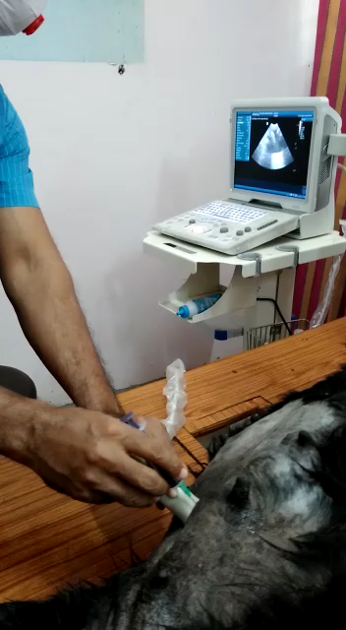
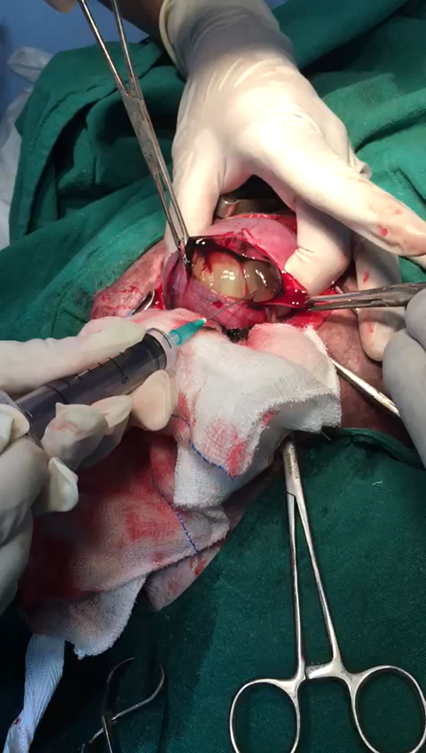
Fig-2: Collection of amniotic fluid during C-section from six dogs, after neonatal extraction and prior to opening the fetal membranes

Fig-3: Positive bubble test in amniotic fluid samples from Group 1 dogs
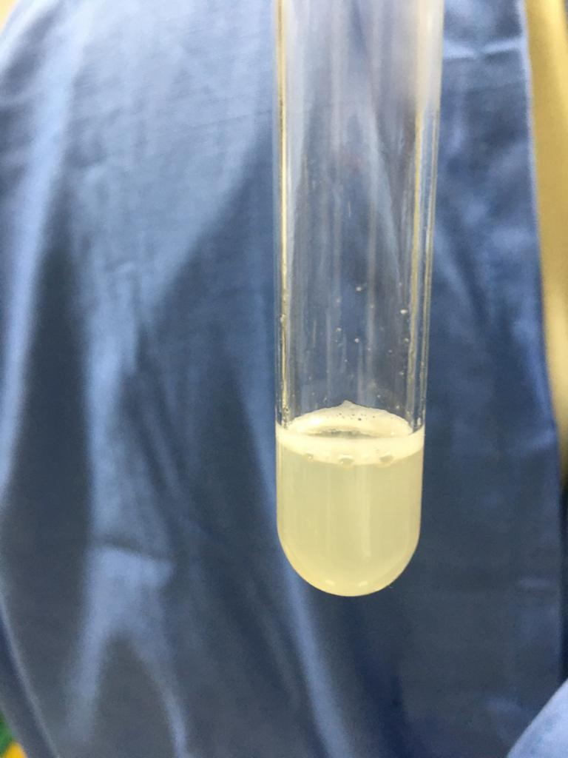

Fig 4: Negative bubble test in amniotic fluid samples from Group 1 dogs

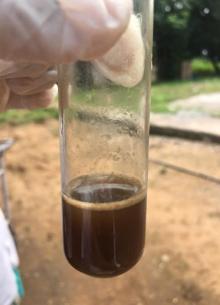

Fig-5: Positive bubble test in amniotic fluid samples collected from Group 2 dogs
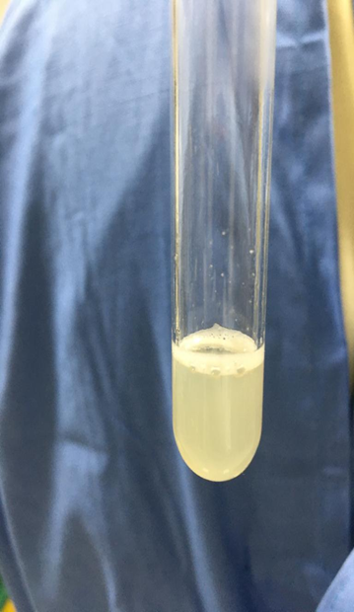

Fig-6: Negative bubble test in amniotic fluid samples from Group 2 dogs
