ANTIBACTERIAL ACTIVITY OF PERIONYX EXCAVATUS COELOMIC FLUID AND ETHANOLIC BODY EXTRACT AGAINST ESCHERICHIA COLI AND GC-MS PROFILING OF THE EXTRACT

ABSTRACT
Earthworms are soil-dwelling organisms that interact with a wide range of microbes and have evolved an effective innate immune response. Their immune system is enriched with leukocytes and humoral immune components. The coelomic fluid of earthworms contains lysozyme and antimicrobial peptides that act as antibacterial agents. Earthworms are inexpensive, non-ethical model organisms that can be used as potential sources of antimicrobial agents.
In the present investigation, the antibacterial effects of earthworm extract and coelomic fluid from Perionyx excavatus against Escherichia coli were determined by measuring the diameter of the zone of inhibition. Escherichia coli showed a high level of resistance to both the coelomic fluid and the earthworm extract. However, P. excavatus earthworm extract was found to be more effective than its coelomic fluid. Therefore, the bioactive compounds present in the earthworm extract were identified using GC–MS analysis. The results revealed putative compounds responsible for its antibacterial activity. From this study, it is evident that earthworm extracts possess antibacterial properties against Escherichia coli.
Keywords. Coelomic fluid, Earthworm extract, Perionyx excavates, Escherichia coli.

INTRODUCTION
“Perionyx excavatus is an earthworm found commonly over a large area of tropical Asia although it has been transported to Europe and North America. This is an epigeic species which lives in organic wastes, and high moisture contents and adequate amounts of suitable organic material are required for populations to become fully established and for them to process organic wastes efficiently” (Edwards et al., 1998).
They are negatively phototactic, soft bodied, true coelomates and saprophytic organisms. They have also been living with the aid of their defensive mechanism since long time during the course of evolution and always face the invasion of microorganisms in their environment. Such studies have been continued for more than 50 years and then confirmed that earthworms have developed both humoral and cellular immunity mechanisms to fight against pathogenic microorganisms. “Many invertebrates exhibit various immune mechanisms against different pathogens. Likewise, earthworm also prevails coelomocytes located in the coelomic fluid is responsible for both innate cellular immune functions such as phagocytosis and encapsulation against pathogenic microorganisms and humoral components includes lectin, preforming proteins, phenoloxidases and proteases nullifies antigenic material by agglutination and cytotoxicity etc” (Patil and Biradar, 2017).
“Earthworms have been used in medicine for various remedies since 1340 AD. They have been recognized in oriental medicine as anti-inflammatory, analgesic and antipyretic agent. It shows anticancer effect by preventing excess glucose uptake. Microorganisms are known to play a major role in soil characteristics, invertebrates are believed to act as regulators of antimicrobial activity. They live in an environment filled with various kinds of pathogens that have favoured the development of efficient defence mechanisms against various environmental pathogens during the course of evolution, including the production of certain microbiological substances, especially active proteins and enzymes. Their surface excreta were found to have potent antimicrobial activity. It is also having anti-coagulator or fibrinolytic activity which results in the facilitation of blood circulation” (Vasanthi et al., 2013). “Earthworm surface excreta were found to have potent antimicrobial activity. Their successful survival is supported by efficient innate immune mechanisms based on cellular activities of coelomocytes and humoral immune proteins, both components of the earthworm coelomic fluid. The bacteriolytic substances include fetidins (which have serine proteases and promote clots), lysenins, lumbric, coelomic cytolytic factor (CCF-1) and erythrocytolytic proteins. Some of these agents have been tested for antineoplastic potential. One substance like eisenin destroys human neoplastic cells from several human cancer cell lines” (Bhorginand Uma, 2014). “Many tribes and people in remote villages in India are known to use earthworms to treat various kinds of ailments. Traditional medicine practitioners in Tamilnadu (India) use the earthworm, in its decoction form, to treat fever, stomach pain, neck pain, neural disorders and digestive disorders” (Bansal et al., 2015).
The present study is aimed to determine the antibacterial effect of earthworm extract and coelomic fluid from Perionyx excavatus against Escherichia coli. Bioactive compounds present in Perionyx excavates earthworm extract were also detected using GC-MS analysis.
MATERIALS AND METHODS
Sample collection
Earthworms are collected by digging up soil with the help of shovel from banana and coconut plantation at Muhavoor village of Rajapalayam town, Virudhunagar district, Tamilnadu. Earthworms were sampled following the method suggested by (Jaikishun et al.,2015). The soil cores from the sampling site were dug to a depth of 25 cm and were manually screened for the presence of earthworms. The earthworms were hand-sorted and pooled separately along with some native soil. The collected earthworms were purplish dorsally and reddish-brown ventrally, and were identified as Perionyx excavatus.
Figure 1 - Periyonx excavates
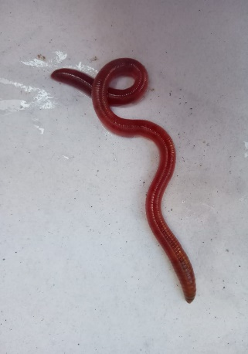
Bacterial strains
For antibacterial activity, Escherichia coli is obtained from microbiology laboratory, Department of Microbiology, Ayya Nadar Janaki Ammal College, Sivakasi. Escherichia coli ATCC 25922 was used as the reference strain for antibacterial assays. The strain’s antibiotic resistance profile was verified according to CLSI guidelines. Prior to testing, the bacterial inoculum was standardized to a 0.5 McFarland turbidity standard (approximately 1.5 × 10⁸ CFU/mL) using a spectrophotometer. All assays were performed using this standardized inoculum.
Coelomic fluid collection
In order to prepare coelomic fluid, earthworms are rinsed and cleaned with sterile water to remove dirt from the body surface. They were allowed to clear their guts for 24 hours on moist filter paper in wide and deep plastic tray, covered with polythene paper having pin holes. Earthworms were given cold shock treatment for the collection of coelomic fluid. In this method, a pack of ice cube was put over some worms to give cold shock. The ice cube lowered the temperature of earthworm body surface from 10-15°C that agitated the worm to discharge coelomic fluid which is collected in a beaker. The collected coelomic fluid is then transferred to sterilized test tubes. Collected coelomic fluid is centrifuged at 4500-5000 rpm for 10 minutes to remove debris and impurities. Supernatant is filtered and stored in sterile eppendorf at -18°C (Hussain et al.,2023). Various concentration of coelomic fluid (62.5µl,125µl,250µl,500 µl) were dissolved in 1 ml of ethanol and the inhibitory activity against bacterial isolates is measured. 500µl/ml is represented as 50% concentrated coelomic fluid. 25% concentrated coelomic fluid was prepared by mixing 250µl of coelomic fluid in 1ml of ethanol.125µl coelomic fluid mixed with 1ml of ethanol as 12.5% concentrated coelomic fluid. 62.5µl/ml is represented as 6.25% concentrated coelomic fluid.
Figure 2 - Coelomic fluid collection
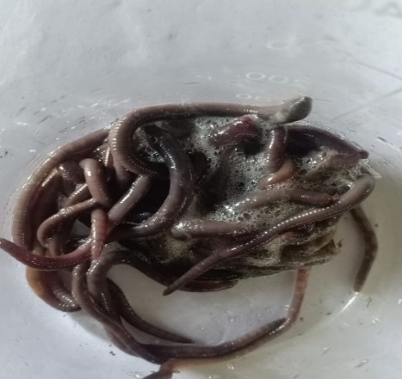
Preparation of earthworm extract
Earthworm extracts were made by selecting healthy and mature earthworms. After cleaning with distilled water and placed on moist blotting paper to remove undigested matter from gut for 24 h. The earthworms were placed in plastic container which was firmly covered with polythene sheet. After covering, container was exposed to sunlight to kill worms for 3 days. During this period, released coelomic fluid and mucous digested the dead body of worms and formed earthworm body paste having brown colour (Hussain et al.,2023). Taken different concentration of earthworm paste as 19.5 mg, 37.5 mg, 75 mg and 150 mg dissolve them in 10ml of ethanol and mix them thoroughly by using mortar and pestle. Then placed them in the shaker for 4 hours in a place that was protected by light. Extract was then kept in beaker for one day for evaporation of ethanol. After that it was centrifuged and the supernatant was used for antibacterial activity. 150mg/10ml is represented as 50% concentrated coelomic fluid. 25% concentrated coelomic fluid was prepared by mixing 75mg of coelomic fluid in 10ml of ethanol. 37.5mg coelomic fluid mixed with 10ml of ethanol as 12.5% concentrated coelomic fluid. 19.5mg/10ml is represented as 6.25% concentrated coelomic fluid.

Antibacterial assay
Antibacterial activity of earthworm extract was carried out by using disk diffusion method. Nutrient agar medium was used. Four disks were filled with different concentrated ethanol extract of earthworm and one disk was filled with ethanol as control (Mathur et al., 2010). The plates were incubated at 37⁰ C for 18 hrs. The antibacterial activity was determined by measuring the diameter of zone of inhibition using measuring scale.
Sample preparation for GC-MS analysis
Earthworms are dried in the sun for 3 days and then, placed in the oven for about 10 minutes. 300mg of dried earthworm was taken in mortar and 10ml ethanol solution was added into it. Mix them thoroughly by using mortar and pestle. Extract was placed in the shaker for 4 hours. Extract was then kept in beaker for one day for evaporation of ethanol. After that it was centrifuged and the supernatant was used for GC-MS analysis.
RESULTS AND DISCUSSION
Antibacterial effect of ethanolic body extract from Perionyx excavatus
50% concentrated ethanolic earthworm extract showed the highest antibacterial activity against Escherichia coli with a zone of inhibition measured as 22mm and 21.65mm. 25% concentrated ethanolic earthworm extract formed inhibitory zone of about 16.5mm and 17.2mm. 13.8mm and 15mm zone of inhibition was formed against 12.5% concentrated earthworm extract. Escherichia coli was not inhibited by 6.25% concentrated ethanolic earthworm extract. The mean extract inhibition zone diameter of Escherichia coli in the treatment group was tested using One-Way ANOVA as in Table 1.
Figure 3 - Inhibitory zone of ethanolic earthworm extract against Escherichia coli
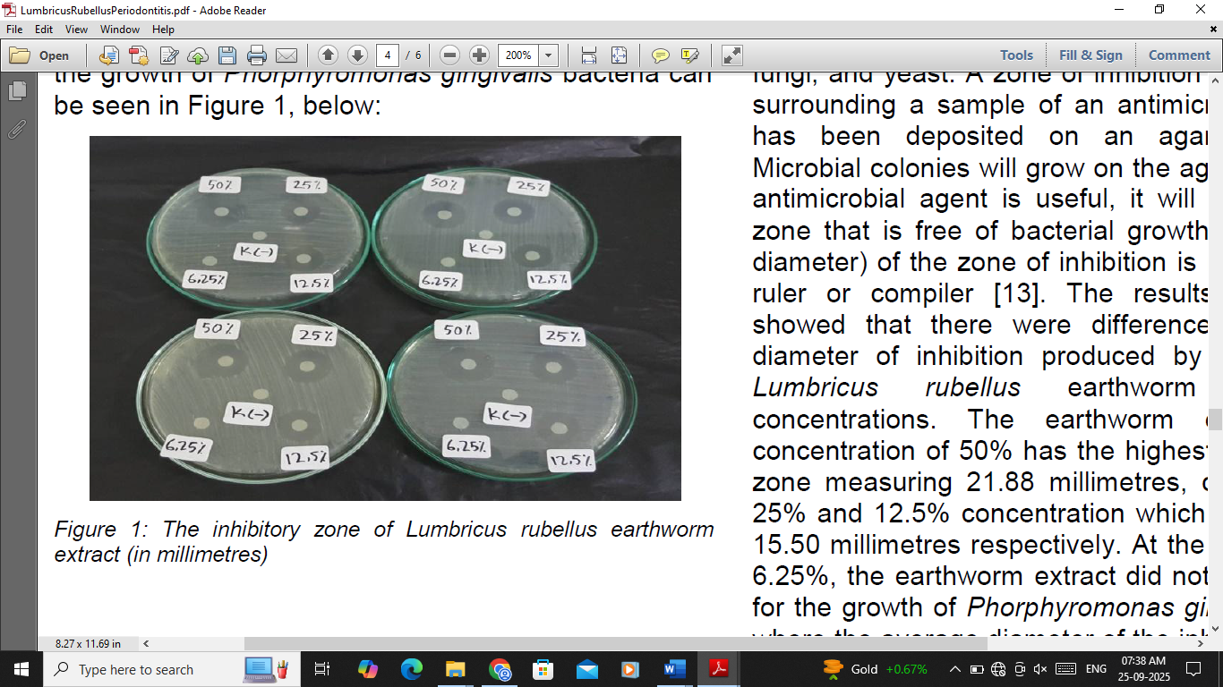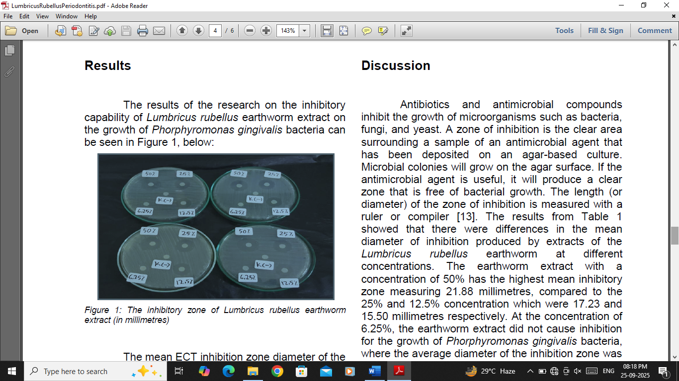

Table 1 - Inhibitory zone of various concentration of Ethanolic earthworm extract and Analysis with One-Way ANOVA Test; * significant if p < 0.05.
Concentration of Earthworm extract | Inhibitory zone of Plate 1 (mm) | Inhibitory zone of Plate2(mm) | n | Mean ± SD | P*
Control | 0 | 0 | 2 | 0 | 0.017
50% | 22 | 21.3 | 2 | 21.65± 0.49 | 0.017
25% | 16.5 | 17.2 | 2 | 16.85± 0.49 | 0.017
12.5% | 13.8 | 15 | 2 | 14.40± 0.85 | 0.017
6.25% | 0 | 0 | 2 | 0 | 0.017
Antibacterial effect of earthworm coelomic fluid from Perionyx excavatus
50% concentrated coelomic fluid showed maximum inhibition against Escherichia coli and formed zone of 20.5mm and 21mm. Escherichia coli was found to be unaffected by 6.25% concentrated coelomic fluid. 25% concentrated coelomic fluid shows inhibition zone of 15.6mm and 16.2 mm. 12.5% concentrated coelomic fluid formed inhibitory zone of about 14.2 mm and 15 mm against Escherichia coli. The mean extract inhibition zone diameter of Escherichia coli in the treatment group was tested using One-Way ANOVA as in Table 2.
Figure 4 - Inhibitory zone of earthworm coelomic fluid against Escherichia coli
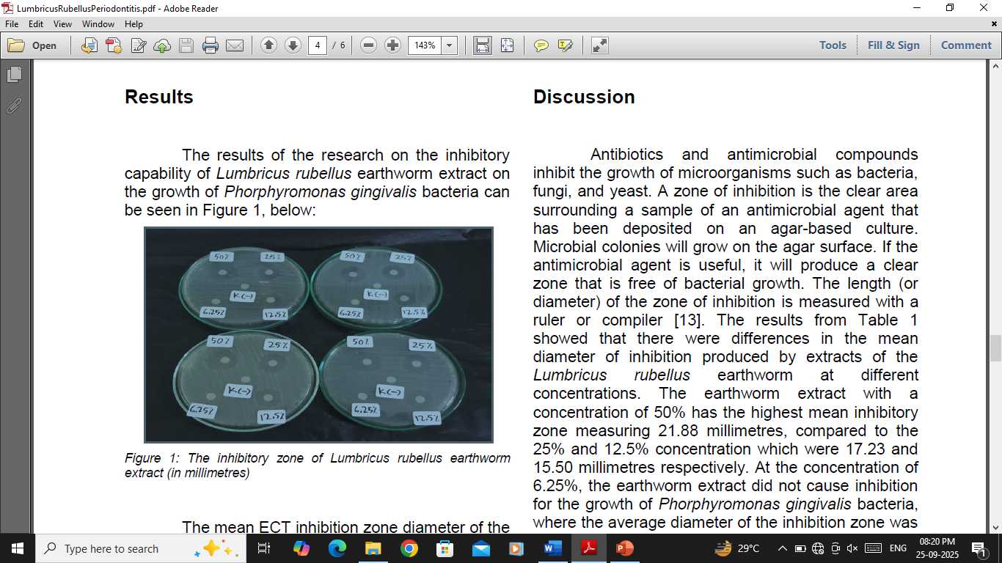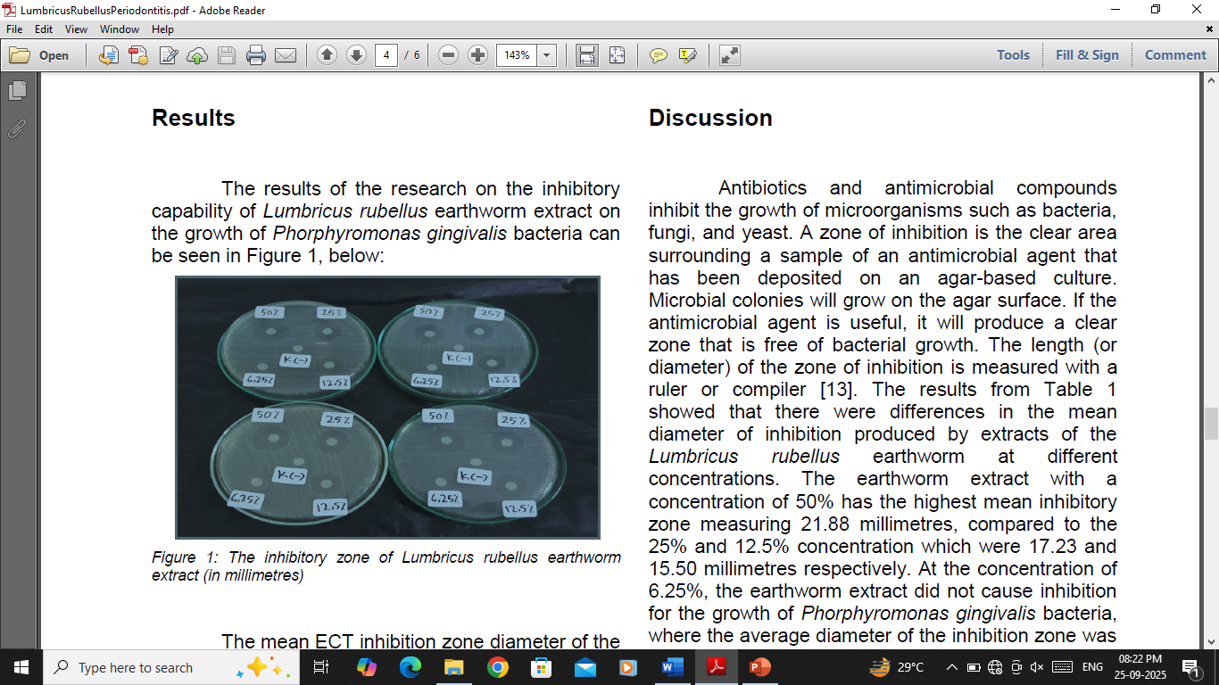
Table 2 - Inhibitory zone of various concentration of Coelomic fluid extract and Analysis with One-Way ANOVA Test; * significant if p < 0.05.
Concentrations of Coelomic fluid extract | Inhibitory zone of Plate 1 (mm) | Inhibitory zone of Plate 2(mm) | n | Mean ± SD | P*
Control | 0 | 0 | 2 | 0 | 0.0002
50% | 20.5 | 21 | 2 | 20.75± 0.35 | 0.0002
25% | 15.6 | 16.2 | 2 | 15.9± 0.42 | 0.0002
12.5% | 14.2 | 15 | 2 | 14.6± 0.57 | 0.0002
6.25% | 0 | 0 | 2 | 0 | 0.0002

Analysis of bioactive compounds in earthworm extract from Perionyx excavatus
The GC-MS chromatogram operated on the principle that the sample was injected into the injector, and it was converted to gaseous form. Helium served as the carrier gas. Gaseous form of sample carried along with helium to the separating column. The stationary phase is the separating column, while the mobile phase is the carrier gas. Chemicals over coated on the stationary phase can interact with the gaseous sample and absorb the compounds in the sample at different points in the column depending on their chemical characteristics. Peak intensity and retention time are only provided by GC. This information was not only sufficient for identifying unfamiliar chemicals. Molecular weight of the sample was provided by Mass Spectrometry. In this way, compounds in the sample were identified. GC-MS analysis of Perionyx excavates extract with peak intensity and retention time was given in Figure 5.
Fig.5. The GC-MS chromatogram for ethanolic earthworm extract
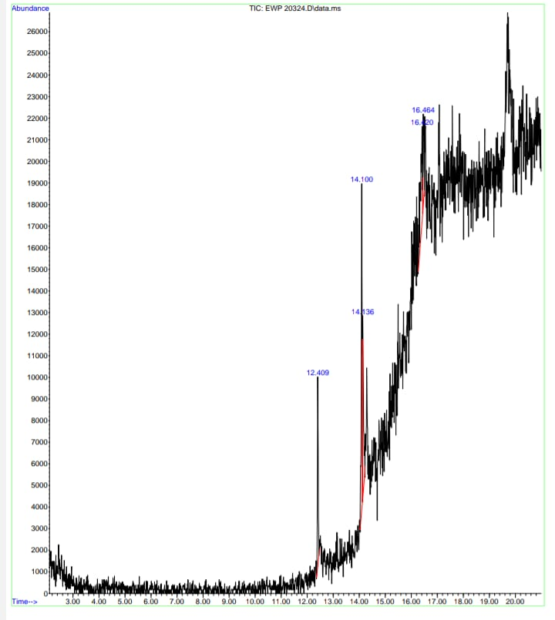
There are 14 physiologically significant compounds identified in the earthworm extract from Perionyx excavates. Among these five of them are having antibacterial activity and tabulated in Table 3.

Table 3 - Analysis of bio active compounds found in earthworm extract from Perionyx excavatus.
S. No | Name of the compound | Chemical formula | Retention time and Peak area(%) | Molecular weight (g/mol) | Function
1 | n-Hexadecanoic acid | CH3  (CH2)14COOH | 12.412 and 17.10 | 256.43 | Antioxidant  And antimicrobial
2 | Tetradecanoic acid | C14H28O2 | 12.412 and 17.10 | 228.37 | Flavouring agent
3 | Cyclohexane1-(cyclohexylmethyl)-4-ethyl- trans- | C14H26 | 14.096 and 30.39 | 208.38 | Antioxidant and anticancer
4 | Oleic Acid | C18H34O2 | 14.096 and 30.39 | 282.46 | Antibacterial
5 | Decane4,5-dibromo-  (R*,R*)- | C10H20  Br2 | 14.096 and 30.39 | 300.07 | No activity reported
6 | 2- Myristynoyl-glycinamide | C16H28  N2O2 | 14.133 and 21.69 | 280.41 | Antioxidant
7 | 10-Octadecenoic acid, methyl ester | C19H3602 | 14.133 and 21.69 | 296.4879 | Antibacterial, antioxidant and antifungal
8 | 1-Cyclohexylnonene | C15H28 | 14.133 and 21.69 | 208.38 | No activity reported
9 | 1H-Pyrazole, 1-(3-methylbutyl)-4-(4,4,5,5-tetramethyl-1,3,2-dioxaborolan-2-yl) | C10H17BN2O2 | 16.422 and 21.17 | 208.07 | Anti inflammatory
10 | Heptamethyl  trisiloxane | C7H21O2  Si3 | 16.422 and 21.17 | 221.50 | Antimicrobial
11 | 1-Benzazirene-1-carboxylic acid, 2,2,5a-trimethyl-1a-[3-oxo-1-butenyl] perhydro-, methyl ester | C15H23  NO3 | 16.422 and 21.17 | 265.35 | Antioxidant
12 | Silicic acid diethylbis  (trimethylsilyl)ester | C1OH28  O4Si3 | 16.459 and 9.66 | 296.58 | Lowers bad cholesterol.
13 | 2(Acetoxymethyl)-3-(methoxy carbonyl)  biphenylene | C17H14  O4 | 16.459 and 9.66 | 282.29 | Antibacterial agent
14 | 4-Dehydroxy-N-(4,5-methylenedioxy-2-nitrobenzylidene)tyramine | C16H14  N2O4 | 16.459 and 9.66 | 298.29 | Interact with serotonin and Control depression

CONCLUSION
Antibacterial compounds are ubiquitous in nature. However, there is a need to discover eminent, novel and alternative antibacterial compounds is essential to combat the increasing proliferation of drug-resistant microorganisms. The present study showed the antibacterial effect of ethanolic body extract and coelomic fluid from Perionyx excavatus against Escherichia coli. Antibacterial compounds present in ethanolic body extract of Perionyx excavates were also determined using GC-MS analysis. Thus, P. excavatus is a good source of antibacterial agents that are in need to be identified and extracted as source of cheap medicines to control serious infections.

Disclaimer (Artificial intelligence)
Option 1:
Author(s) hereby declare that NO generative AI technologies such as Large Language Models (ChatGPT, COPILOT, etc.) and text-to-image generators have been used during the writing or editing of this manuscript.
Option 2:
Author(s) hereby declare that generative AI technologies such as Large Language Models, etc. have been used during the writing or editing of manuscripts. This explanation will include the name, version, model, and source of the generative AI technology and as well as all input prompts provided to the generative AI technology
Details of the AI usage are given below:
1.
2.
3.
REFERENCES

Bae Y S., Kim J., Yi J., Park S C., Lee H Y. & S J Cho. (2020). Characterization of Perionyx excavatus development and its head regeneration. Biology (Basel). 9(9): 273. https://doi.org/10.3390/biology9090273
Bansal N., Gupta R K., Singh D. & Shashank. (2015). Comparative study of antibacterial activity of two different earthworm species, Perionyx excavates and Pheretima posthuma against pathogenic bacteria. Journal of Applied and Natural Science 7(2): 666-671. https://journals.ansfoundation.org/index.php/jans/article/view/664
Bartlett M D., Briones J I M., Neilson R., Schmidt O., Spurgeon D. & R E Creamer. (2010). A critical review of current methods in earthworm ecology: From individuals to populations. European Journal of Soil Biology. 46: 67-73.
https://doi.org/10.1016/j.ejsobi.2009.11.006
Bhorgin A J. & Uma K. 2014. Antimicrobial activity of Earthworm Powder (Lampito mauritii). International Journal of Current Microbiology and Applied Sciences 3: 437–443. https://doi.org/10.7324/japs.2013.30316
Budayatin, B., Waluyo, J., Wahyuni, D., & Dafik, D. (2021). Antibacterial effects of Pheretima javanica extract and bioactive chemical analysis using Gas Chromatography Mass Spectrum. Journal of Physics: Conference Series, 1751(1), 012055. https://doi.org/10.1088/1742-6596/1751/1/012055
Bui, P. T., Pham, K. T., & Vo, T. D. L. (2023). Earthworm (Perionyx excavatus) Protein Hydrolysate: Hypoglycemic Activity and Its Stability for the Hydrolysate and Its Peptide Fractions. Processes journal. https://doi.org/10.3390/pr11082490

Chauhan P S., Tomar J., Prasad G B K S & P Agrawal. (2014). Evaluation of antimicrobial activity of earthworm Eudriluseugeniae tissue extract. Journal of Chemical and Pharmaceutical Research. 6(8): 28-38. https://share.google/ColPcrvKoYzG249Fb

Devi R. & P Serfoji. (2018). GCMS analysis of bioactive compounds in ethyl acetate extract of earthworm gut Streptomyces fulvissimus. International Journal of Pharmacy and Biological Sciences. 8(4): 200-205.
https://share.google/uCEc3CqGBuf5jecFG

Debnath S. & P S Chaudhuri. (2020). Growth and reproduction of Perionyx excavatus during vermicomposting of different plant residues. An International Quarterly Scientific Journal. 19: 1937-1943.
https://doi.org/10.46488/nept.2020.v19i05.018

Dharmawati G A A., Mahadewa T G B. & P K. Widyadharma. (2019). Antibacterial activity of LumbricusRubellus earthworm extract against PorphyromonasGingivalis as the bacterial cause of periodontitis. Open Access Macedonian Journal of Medical Sciences. 7(6): 1032–1036
https://doi.org/10.3889/oamjms.2019.222.

Dinesh M S., Sridhar S., Chandana P G., Pai V., Geetha K S. & R N Hegdge. (2013). Anticancer potentials of peptides of coelomic fluid of earthworm Eudriluseugeniae. Biosciences biotechnology research asia. 10(2): 601-606.
https://doi.org/10.13005/bbra/1170

Ecimovic, S., Vrandecic, K., Kujavec, M., Zulj, M., Cosic, J., & Velki, M. (2021). Antifungal activity of earthworm coelomic fluid obtained from Eisenia andrei, Dendrobaena veneta and Allolobophora chlorotica on six species of phytopathogenic fungi. Environments, 8(102) https://doi.org/10.3390/environments8100102
Edwards C.A., Dominguez J. & Neuhauser E F. (1998). Growth and reproduction of Perionyx excavatus (Megascolecidae) as factors in organic waste management. Biology and Fertility of Soils. 27: 155–161. https://doi.org/10.1007/s003740050414
Enami Y., Okano S., Yada H. & Y Nakamura. (2001). Influence of earthworm activity and rice straw application on the soil microbial community structure analyzed by PLFA pattern. European Journal of Soil Biology. 37(4): 269-272.
https://doi.org/10.1016/s1164-5563(01)01096-2
Ghosh S. & Chatterjee S. (2020). Isolation and characterization of Bacillustequilensis from gut content of Perionyx excavatus and evaluation of its starch hydrolyzing property. Bioscience Biotechnology Research Communications. 13(2): 670-675. https://doi.org/10.21786/bbrc/13.2/45
Grdisa M. (2013). Therapeutic properties of earthworms. bioremediation, biodiversity and bioavailability (Global Science Books). 7 (1): 1-5. https://share.google/ZfjBMMLoCepxZVZRY

Hang V T., Anh T M H. & P Khanh. (2022). Potential of Earthworm (Perionyx Excavatus) in food treatment in Ho Chi Minh City. IOP Conf. Ser.: Earth Environ. Sci. 964.
https://doi.org/10.1088/1755-1315/964/1/012031
Hatti S S. (2014). Extraction of Coelomic Fluid from the Earthworm DichogasterBolaui for the Antibacterial Activities. Indian journal of applied research. 4(1): 545-548.
https://doi.org/10.15373/2249555x/jan2014/166

Husain D R., Wardhani R. & E Erviani. (2022). Antibacterial activity of bacteria isolated from earthworm (Pheretimasp) gut against salmonella typhi and staphylococcus aureus. Biodiversitas. 23: 1125-1131.
https://doi.org/10.13057/biodiv/d230257
Hussain M., Liaqat I., Ali N.M., Arshad N., Hanif U., Sajjad S., Sardar A A. & Awan U F. (2023). Antibacterial and bacteriostatic potential of coelomic fluid and body paste of Pheretima posthuma against ampicillin-resistant clinical bacterial isolates. Brazilian Journal of Biology. 83: 1–10. https://doi.org/10.1590/1519-6984.247016

Jaikishun S., Ansari A., Punu G., Seecharran D. (2015). Taxonomy of Earthworm Species Collected from East Coast of Guyana. Annual Research & Review in Biology 8(6):1-7. https://share.google/UxbVYvGWpJubjUq9H
John A S. & Packialakshmi N. (2007). Studies on antimicrobial activity of Perionyx excavatus. Pakistan Journal of Biological Sciences. 10(19): 3482–3484. https://doi.org/10.3923/pjbs.2007.3482.3484
Kathireswari P., Alakesan A., Abirami P. & Sangeetha P. (2014). Antimicrobial activity of earthworm coelomic fluid against disease-causing microorganisms. International Journal of Current Microbiology and Applied Science. 3(8): 608–613.
https://share.google/NsBHFNPX1qZTDSk5z

Kauschke E., Mohrig W. & E L Cooper. (2007). Coelomic fluid proteins as basic components of innate immunity in earthworms. European Journal of Soil Biology. 43: 110-115. https://doi.org/10.1016/j.ejsobi.2007.08.043

Mathur A., Verma S K., Bhat R., Singh S K., Prakash A., Prasad G B K S. & Dua V K. (2010). Antimicrobial activity of earthworm extracts. Journal of Chemical and Pharmaceutical Research. 2(4): 364–370. https://share.google/csdCogk40USVIzsK0

Mustafa, R. G., Ali, S., Domínguez, J., Jamil, M., Manzoor, S., Wazir, S., Shaheen, B., Parveen, A., Khan, R., Ali, S., Ali, N. M., Jalal, F., & Raja, S. A. (2022). Therapeutic values of earthworm species extract from Azad Kashmir as anticoagulant, antibacterial, and antioxidant agents. Canadian Journal of Infectious Diseases and Medical Microbiology, 2022, Article 6949117. https://doi.org/10.1155/2022/6949117
Punu G P., Ansari A., Jaikishun S. & D Seecharran. (2016). Effect of earthworm (Perionyx excavatus) powder on selected bacteria and fungi. Journal of Advances in Biology & Biotechnology. 5(2): 1-15.
https://doi.org/10.9734/jabb/2016/22572
Ramasamy P K., Murthy C., Gokula V., Govindaraj K. & Manikandan T. (2017). Comparative study on antibacterial activity in coelomic fluid of Eudrilus eugeniae and Polypheretima elongata. Elixir Journal. 104: 45989–45995. https://share.google/NXjBt3DocNp9CBRqR

Sethulakshmi K C., Ranilakshmi K. C., Thomas A P. 2018. Antibacterial and antifungal potentialities of Earthworm Eudrilus eugeniae Paste and Coelomic Fluid. Asian Journal of Biology. 5: 1-7. https://share.google/KkzaHNwqecJf8Q6IK
Shrefy H S A l. & Mahmood S M. (2023). Effect of Lumbricus terrestris earthworm extract and coelomic fluid on some pathogenic bacteria. Bionatura. 8: 1-11.
https://doi.org/10.21931/rb/css/2023.08.02.38

Udayakumar S., Purushothaman M. & S Jayalakshmi. (2022). Culture of Earthworm, Perionyx excavatus (Perrier) and Nutrient analysis using municipal solid waste. Journal of Research in Agriculture and Animal Science. 9: 81-87. https://share.google/4ogD0CwS3eH7RkAih
Vasanthi K., Chairman K. & Singh A J A. (2013). Antimicrobial activity of earthworm (Eudrilus eugeniae) paste. Academic Journal. 7(8): 789–793. https://doi.org/10.5897/ajest2013.1455
Wang C., Sun Z., Liu Y., Zheng D., Liu X. & S Li. (2007). Earthworm polysaccharide and its antibacterial function on plant-pathogen microbes in vitro. European Journal of Soil Biology. 43: 135-142.
https://doi.org/10.1016/j.ejsobi.2007.08.035

Yakkou L., Houida S., Domínguez J., Raouane M., Amghar S., & A E Harti. (2021). Identification and characterization of microbial community in the coelomic fluid of earthworm (Aporrectodeamolleri). Microbiol Biotechnol Lett. 49(3): 391-402.
https://doi.org/10.48022/mbl.2104.04013

