Enzymatic Remediation of Poultry Waste: Using a Klebsiella pneumoniae β-Lactamase to Degrade Antibiotics and Reduce AMR Risks

Abstract
Aim: This study aimed to isolate and evaluate β-lactamase-producing bacteria from poultry fecal matter for their potential to degrade β-lactam antibiotics, particularly Penicillin G, thereby reducing residual antibiotic contamination in farm waste.Methods: Fecal-contaminated soil samples were collected from five poultry farms in Namakkal, Tamil Nadu. Thirty bacterial isolates were screened for β-lactamase activity using the iodometric method. Enzyme activity was quantified via spectrophotometry, and the most potent isolate was identified through 16S rRNA sequencing. Degradation of Penicillin G, Amoxicillin, and Ampicillin was assessed using agar well diffusion with E. faecalis as an indicator strain. Molecular docking (AutoDockVina) was used to evaluate the interaction between Penicillin G and β-lactamase (PDB ID: 1XPB).Results: Out of 30 isolates, 11 (37%) were β-lactamase-positive. Isolate 23 (KlebsiellaKlebsiella pneumoniae) showed the highest enzyme activity (46.60 U/mL). Enzyme-treated samples exhibited reduced inhibition zones, confirming antibiotic degradation. Docking revealed a binding affinity of –4.45 kcal/mol and an inhibition constant (Ki) of 542.67 µM, indicating effective interaction and hydrolytic potential.Conclusion: These findings highlight the enzyme’s role in reducing antibiotic pollution and antimicrobial resistance risks, while biologically controlling the prevalence of resistant isolates. Microbial degradation offers a cost-effective and eco-friendly solution for poultry waste management and the safe reuse of biofertilizers.
Keywords: β-lactamase, Klebsiella pneumonia, Antibiotic biodegradation, Poultry waste, Molecular docking, β-lactam antibiotics.
1. Introduction
Our environment is facing a growing crisis, with pollution worsening over time and causing severe, often irreversible damage. Pollution takes many forms—air, water, soil, noise, and light—and is driven by urbanization, overpopulation, and technological development. Hazardous waste from factories, fossil fuel combustion, acid rain, oil spills, and industrial toxins degrades essential resources like air, water, and soil ^{[1]}. Agro-waste and the waste discharged from cattle, goat, pig, and poultry farms significantly pollute the air, soil, and water.
In 2010, global antimicrobial use in food-animal production was estimated at 63,151 ± 1,560 tons, and this figure is projected to increase by 67%, reaching approximately 105,596 ± 3,605 tons by 2030. This surge is largely driven by shifts in production systems in Asia, where antimicrobial consumption is expected to rise by about 46% by 2030. In India alone, areas of high antimicrobial use in poultry farming (30 kg/km²) are expected to increase by 132% by 2030, driven by the expansion of the poultry sector. As a result, with the intensification of animal farming, antimicrobial use is rising rapidly. This contributes to the growth of antimicrobial resistance (AMR) and increases the risk of its transmission to humans through the food chain ^{[2]}.
Many classes of antimicrobials, such as β-lactams, tetracyclines, and aminoglycosides, which are commonly used in human medicine, are also extensively used in food animals. The use of antibiotics in food animals is not limited to therapeutic purposes; they are often employed for disease prevention and growth promotion as well. In developed countries, the responsibility for diagnosing, prescribing, and administering antibiotics to farm animals lies solely with licensed veterinarians^{[3]}. However, in developing countries, antibiotics are frequently administered directly by livestock producers or farmers, largely due to easy, unregulated access to these drugs.”
The discharge of antibiotics and other residues from poultry waste contaminates both terrestrial and aquatic environments. When such contaminated waste is used as fertilizer, rainfall can wash it into nearby water bodies, leading to water pollution. This type of contamination can further spread to various locations through human contact, causing widespread environmental and health impacts. Moreover, the continuous use of the same antibiotic can lead to the development of high levels of resistance in exposed microbes. Farm animals and humans are often infected by the same bacterial species, indicating that transmission between the two occurs to some extent. Evidence also suggests that antimicrobial-resistant (AMR) bacteria are shared between humans and animals^{[4]}.
Among the various antibiotics used in animal farms, Penicillin V potassium (PVK), a commonly used slow-onset antibiotic, is more acid-resistant than natural penicillin, allowing for oral administration without degradation in the stomach. Its stability enhances its effectiveness in treating bacterial infections. However, extensive use has led to high PVK concentrations in soil, wastewater, and animal waste, posing risks to the environment and human health by promoting resistant strains^{[5 and 6]}. In this context, using poultry waste containing antibiotics without proper treatment or removal of the antibiotics can lead to serious environmental and health problems.
Various traditional bacterial residue treatment methods, including incineration, landfilling, anaerobic digestion^{[7 and 8]}, ionizing radiation (Salem), UV/TiO2 photocatalytic ^{[9]} have also been used for antibiotic degradation. However, these methods are costly, the processing conditions are harsh, and scaling up is difficult. Microbiological degradation has emerged as an effective approach to remove antibiotic contamination. Reports indicate that certain bacteria can biodegrade penicillin antibiotics^{[10, 11, and 12]}. However, most studies focus on strain screening and cell-level degradation, with limited research at the enzymatic and molecular levels. This gap hinders the development of more efficient and eco-friendly enzymatic degradation methods.
Previous studies, such as those by Gao et al. ^{[13]} and Yang et al. ^{[14]}, have investigated the degradation of β-lactam antibiotics using β-lactamase enzymes. Similarly, another study reported the degradation of Penicillin V potassium by bacteria producing β-lactamase enzymes ^{[6]}. Based on sequence similarities, β-lactamases are categorized into four main classes: A, B, C, and D. For example, class A β-lactamases predominantly degrade penicillins and cephalosporins^{[15]}, while class B β-lactamases exhibit broad activity against penicillins, cephalosporins, and carbapenems^{[16,17]}. Class C and D β-lactamases are primarily active against cephalosporins and certain carbapenems ^{[18, 19]}. Recently, Fatima et al. demonstrated the use of a class C enzyme to degrade β-lactam antibiotics ^{[20]}. However, there is a lack of systematic studies that screen and compare enzymes across all β-lactamase classes. Moreover, investigations into the molecular mechanisms of antibiotic degradation, particularly using molecular docking approaches, remain scarce.
Based on the above perspective, the present study was conducted to prevent pollution caused by antibiotic use in poultry farms in Namakkal, Tamil Nadu, and across India. Furthermore, the study not only examined whether the antibiotic compounds released through waste are degraded by β-lactamase enzymes produced by bacteria, but also investigated the underlying degradation mechanisms using molecular docking analysis.
2. Materials and methods
Between June and July 2024, fecal-contaminated soil samples were aseptically collected from five layer poultry farms, each housing approximately 20,000 to 50,000 birds, located in and around Namakkal, Tamil Nadu, India. Bi-monthly visits were conducted to monitor farm conditions and poultry health. Birds exhibiting symptoms such as respiratory distress, diarrhea, poor gut health, and stunted growth were commonly treated with antimicrobials, including penicillin, streptomycin, doxycycline, gentamicin, and ciprofloxacin. The samples were placed in sterile plastic bags and immediately transported to the laboratory for further analysis.

2.1 Isolation of Bacterial Isolates
The collected soil samples were first enriched in Buffered Peptone Water (HiMedia, India) by incubating at 37 °C for 18–24 hours. Following enrichment, a loopful of the incubated broth was aseptically spread onto nutrient agar plates and incubated at 37 °C for an additional 18–24 hours. From each sample, at least three morphologically distinct colonies were selected and streaked onto nutrient agar slants. These slants were then incubated at 37 °C for 18–24 hours to obtain well-grown pure cultures. The resulting slants were stored at 4 °C for further analysis.

2.2 Screening of β-Lactamase-Producing Isolates
Penicillin solution was dispensed into sterile test tubes in 0.5 mL volumes. Test bacterial isolates were taken from overnight cultures grown on solid media and suspended in the penicillin solution to achieve a final concentration of approximately 10⁴ CFU/mL. The suspension was incubated at room temperature for 1 hour. After incubation, two drops of starch indicator were added to each tube, then one drop of iodine reagent. A positive β-lactamase reaction was indicated by the immediate disappearance of the blue color. If the dark blue color persisted for more than 10 minutes, the test was considered negative, indicating the absence of β-lactamase activity ^{[21]}.
2.3 Isolation of potential isolates
β‑Lactamase‑positive isolates were inoculated into nutrient broth supplemented with 20 μg/mL penicillin. Following incubation, the bacterial cells were harvested by centrifugation at 4,000×g for 15 minutes at 4 °C and washed twice with 0.01 M phosphate buffer (pH 7.0). The washed cells were then lysed using an ultrasonic disintegrator for 3 minutes at 4 °C. The resulting lysate was centrifuged at 12,000 rpm for 40 minutes at 4 °C to remove cell debris. The clear supernatant was collected and used as the crude enzyme extract. A control solution was prepared by replacing the enzyme extract with phosphate buffer. Enzyme activity was assessed by measuring absorbance at 620 nm using a spectrophotometer ^{[22]}. Protein concentration was estimated using the method described by Lowry et al. ^{[23]}. An International Unit (IU) is defined as the amount of enzyme required to hydrolyze 1 μmol of penicillin G per minute at 25 °C and pH 7.0.
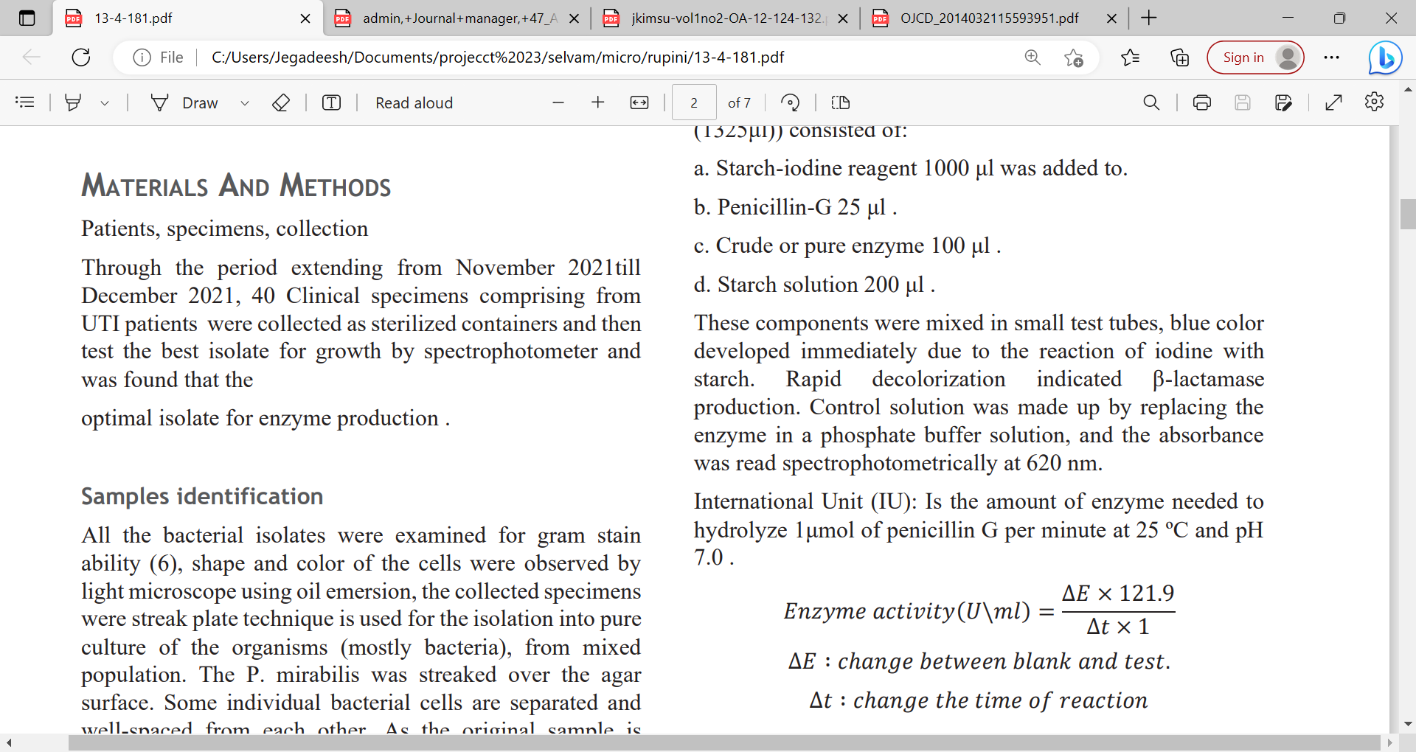

2.4 Assessment of Degradation Activity of β-Lactamase Against β-Lactam Antimicrobials
The β-lactamase degradation activity against selected β-lactam antibiotics was evaluated by incubating the enzyme solution (25 U/mL) with antimicrobial agents. Three β-lactam antibiotics—Penicillin G, Ampicillin, and Amoxicillin (10 µg/mL each)—and Cefotaxime were incubated with β-lactamase in 50 mM sodium phosphate buffer (pH 7.0) at 25 °C for 30 minutes. All antibiotics were procured from HiMedia, India. Following incubation, a semi-quantitative bioassay was performed using the agar well diffusion method. A volume of 100 µL of each incubated sample was loaded into wells on nutrient agar plates pre-inoculated with E. faecalis (β-lactam-sensitive test strain). A control was included for each antibiotic, prepared in the same manner but without enzyme treatment. The plates were incubated at 36 °C for 12 hours, after which the zones of inhibition around each well were measured. A reduction or absence of inhibition zones in the enzyme-treated samples compared to the control indicated degradation of the antibiotics ^{[24].}
2.5 Molecular docking study

2.5.1 Protein Preparation and Visualization
The three-dimensional (3D) structure of the β-lactamase enzyme (PDB ID: 1XPB) was obtained from the Protein Data Bank (PDB) in .pdb file format. The protein structure was prepared using AutoDock Tools (ADT) by adding polar hydrogens, assigning Gasteiger charges, and removing water molecules. The prepared protein was saved as Model.pdb and used as the receptor for docking studies. Visualization and inspection of the protein structure were performed using AutoDockVina and Chimera 1.16.

2.5.2 Ligand Preparation
Two primary ligands, Penicillin G and Linezolid, were selected for docking. The 2D chemical structures of these ligands were drawn using BIOVIA Draw 2019 and saved in .mol file format. The ligands were then converted into 3D structures using Chimera 1.16, energy-minimized, and prepared for docking.

2.5.3 Molecular Docking Procedure
Molecular docking was carried out using AutoDockVina 2.0. The receptor (β-lactamase enzyme, PDB ID: 1XPB) and ligand structures were converted into .pdbqt format using AutoDock Tools. A grid box was defined to cover the receptor’s active site region. Each ligand was docked separately, and multiple docking poses were generated. The best docking pose was selected based on the lowest binding affinity (kcal/mol). The following interaction parameters were recorded: binding affinity, inhibition constant (Ki), van der Waals (vdW) energy, and intermolecular energy.
3. Results and discussion
A total of 30 isolates were obtained from poultry fecal samples and were screened for β-lactamase production using the iodometric method. Among them, 11 isolates (37%) tested positive for β-lactamase. These findings are consistent with patterns reported in similar regions of India. For instance, in Namakkal, β-lactamase-producing isolates were detected in poultry fecal samples using the iodometric method ^{[25]}. In Odisha, ESBL-producing E. coli were detected in approximately 5% of poultry fecal isolates, indicating a relatively low prevalence in commercial poultry settings ^{[26]}. Such variability underscores regional differences in poultry management, antibiotic usage, and microbial ecology.
The relatively higher proportion of β-lactamase-producing isolates in our Namakkal cohort may reflect more intensive antibiotic usage, particularly penicillins and cephalosporins, for treating respiratory and gastrointestinal illnesses in birds. Frequent antimicrobial administration is a known driver of selection and proliferation of resistant bacteria in poultry farms. The iodometric method used to detecte β-lactamase is consistent with the phenotypic screening techniques employed in previous studies. These methods often combine disc diffusion and indicator-based assays for initial screening. Although these approaches are less specific than gene-based identification (genotyping) methods, they provide reliable preliminary results, especially in resource-limited settings.
Out of 30 bacterial isolates obtained from poultry fecal samples, 11 demonstrated β-lactamase activity as determined by the enzyme assay. The specific activities of these enzyme preparations ranged from 13.52 U/mL to 46.60 U/mL. Notably, Isolate 23 exhibited the highest specific activity (46.60 U/mL), followed by Isolate 30 (37.80 U/mL), Isolate 25 (31.25 U/mL), and Isolate 6 (29.86 U/mL) (Table 1).
Table.1 screening of potential isolate of betalactamase producing isolates

S. No | Isolates name | Enzyme (U) | Protein (mg) | Specific activity (U/ml)
 | Isolate 5 | 14.01 | 0.49 | 13.52
 | Isolate 6 | 14.21 | 0.53 | 13.68
 | Isolate 7 | 18.5 | 0.65 | 28.4
 | Isolate 12 | 18.28 | 0.59 | 17.69
 | Isolate 15 | 15.84 | 0.69 | 22.95
 | Isolate 18 | 20.31 | 0.74 | 27.44
 | Isolate 19 | 15.23 | 0.51 | 29.86
 | Isolate 21 | 18.28 | 0.61 | 29.96
 | Isolate 23 | 31.69 | 0.68 | 46.60
 | Isolate 25 | 24.38 | 0.78 | 31.25
 | Isolate 30 | 27.22 | 0.72 | 37.80

These findings are consistent with previously reported data. For instance, Pradeepa et al. [25] reported that crude β-lactamase extracts from poultry fecal isolates exhibited specific activity values of 43.0 ± 1.2 U/mL during early-stage purification. The results also align with broader studies reporting the presence of β-lactamase-producing bacteria in diverse environmental sources, including animal waste and soil ecosystems ^{[27]}.
In the present study, the highest β-lactamase-producing isolate, Isolate 23, was subjected to molecular characterization using 16S rRNA gene sequencing. Sequence analysis revealed 99.7% similarity with KlebsiellaKlebsiella pneumoniae (GenBank Accession No. NR_117683.1). Phylogenetic analysis further confirmed the taxonomic placement of the isolate within the K.Klebsiella pneumoniae clade (Figure 1).

Figure.1 Molecular phylogenetic analysis by maximum likelihood method
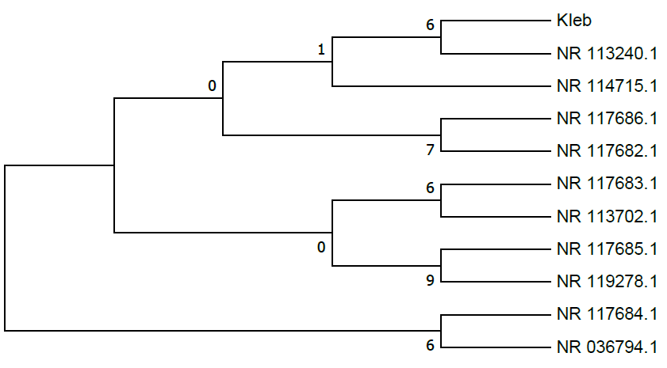

Several previous studies have reported the isolation of K.Klebsiella pneumoniae from poultry fecal matter. For instance, Tigabieet al. ^{[28]} found K.Klebsiella pneumoniae in 7.7% of Enterobacteriaceae isolated from chicken droppings, identifying at least one strain as ESBL-producing. Similarly, Hayati et al. ^{[29]} reported ESBL-positive K.Klebsiella pneumoniae from poultry farms in East Java, and Hou et al. ^{[30]} detected K.Klebsiella pneumoniae strains carrying multiple resistance genes across poultry and livestock farms in China. However, the main focus of these studies was to assess the resistance potential of the isolates and their implications for public health.
In contrast, the objective of the present study was not to determine resistance capability, but to identify and isolate β-lactamase-producing bacteria from poultry fecal samples for the biodegradation of β-lactam antibiotics, thereby reducing their residual activity in the environment. This approach highlights the bioremediation potential of such isolates, particularly in mitigating antibiotic pollution from poultry waste. To date, only a limited number of studies have explored this perspective. Notably, Pradeepa et al. ^{[25]} investigated bacterial isolates from poultry droppings for their ability to produce β-lactamase enzymes capable of degrading antibiotic residues. Their findings align with the current study’s goal which emphasizes antibiotic suppression rather than resistance profiling.
Antibiotic residues in the environment pose risks to both ecosystems and human health by contaminating food and water, promoting the spread of antibiotic resistance bacteria, and disrupting plant growth and physiology. Safe and eco-friendly removal of these residues is therefore critical. Enzyme-based degradation, particularly using β-lactamase, offers a promising approach despite certain environmental concerns ^{[6, 31]}. In this study, a poultry fecal isolate producing β-lactamase was used to degrade antibiotics in vitro. Of the four antibiotics tested, enzyme treatment altered susceptibility patterns in E. faecalis. The potential K.Klebsiella pneumoniae isolate producing β-lactamase shifted from susceptible to resistant to penicillin G, Ampicillin, Amoxicillin, and Cefotaxime, confirming the hydrolytic activity of the β-lactamase (Table 2).

Table 2.Degradation of antibiotics with betalactamase enzyme

S.No | Name of the antibiotics | Zone of inhibition in mm
S.No | Name of the antibiotics | Before treatment with enzyme | After treatment with enzyme
1. | Penicillin G | 16 | 10
2. | Ampicillin | 17 | 09
3. | Amoxicillin | 15 | 09
4. | Cefotaxime | 20 | 11

Previous studies have demonstrated enzyme-mediated environmental degradation of antibiotics. For example, β-lactamase encapsulated within metal–organic frameworks (e.g., penicillinase-8) significantly enhanced catalytic degradation of penicillins in aqueous environments ^{[14]}. Similarly, OtLac, a class C β-lactamase from Ochrobactrum tritici, exhibited high activity against Penicillin V and was successfully used to remove fermentation residues under laboratory conditions ^{[6]}. While many earlier studies focused on isolating environmental β-lactamase carriers or mapping resistance profiles, only a few have evaluated their capacity to actively degrade antibiotic residues. Pradeepa et al. ^{[25]} investigated poultry fecal isolates specifically for β-lactamase production aimed at antibiotic suppression and environmental detoxification, closely aligning with the degradation-focused objective of the present study.
Biological degradation of antibiotics in the environment is a critical process; however, it first requires a comprehensive understanding of the properties and mechanisms of the antibiotics involved. While numerous detection techniques exist, molecular docking is considered one of the most efficient approaches due to its cost-effectiveness and time-saving advantages. In the present study, penicillin was effectively degraded by the β-lactamase enzyme, resulting in a significant reduction in antibiotic concentrations. A detailed understanding of the underlying degradation mechanisms remains essential. Martinez et al. ^{[32]} emphasized the diversity of enzymatic pathways responsible for antibiotic degradation, particularly highlighting the role of microbial enzymes such as β-lactamases in hydrolyzing β-lactam antibiotics. Similarly, Nesmeet al. ^{[33]} explored the ecological and evolutionary consequences of these degradation pathways, underscoring the importance of understanding enzyme-substrate interactions to improve environmental management strategies.
The molecular docking study was conducted using AutoDockVina 2.0 to evaluate the interaction between Penicillin G and the β-lactamase enzyme (PDB ID: 1XPB). The docking simulation revealed a binding affinity of –4.45 kcal/mol and an estimated inhibition constant (Ki) of 542.67 µM, indicating a moderate interaction strength. The van der Waals (vdW) energy was calculated to be–3.86 kcal/mol, and the overall intermolecular energy was –5.95 kcal/mol, reflecting the nature of interactions within the active site.
Examination of the docking pose identified key amino acid residues involved in the interaction between Penicillin G and the β-lactamase enzyme. These active site residues include VAL108, LYS111, HIS112, GLU121, SER124, ALA125, and MET129. These residues are associated with the hydrolysis and resistance mechanisms typically observed in β-lactam antibiotics. Their involvement in the interaction suggests the presence of enzymatic activity that convert resistance to Penicillin G.
Figures 2 depict the 2D structure of Penicillin G and the 3D structure of the β-lactamase receptor (1XPB), respectively. Figure 2 also illustrates the docking interaction between Penicillin G and the β-lactamase enzyme. The visualization highlights how the ligand is accommodated within the active site and identifies the specific amino acid residues contributing to resistance against Penicillin G. These findings suggest that although Penicillin G interacts with the β-lactamase enzyme, the nature of this interaction—particularly involving resistance-associated residues—may reduce the antibiotic’s efficacy, consistent with the observed enzymatic degradation by β-lactamase.
Figures 2. Molecular docking study of β-lactam antibiotic degradation by β-lactamase
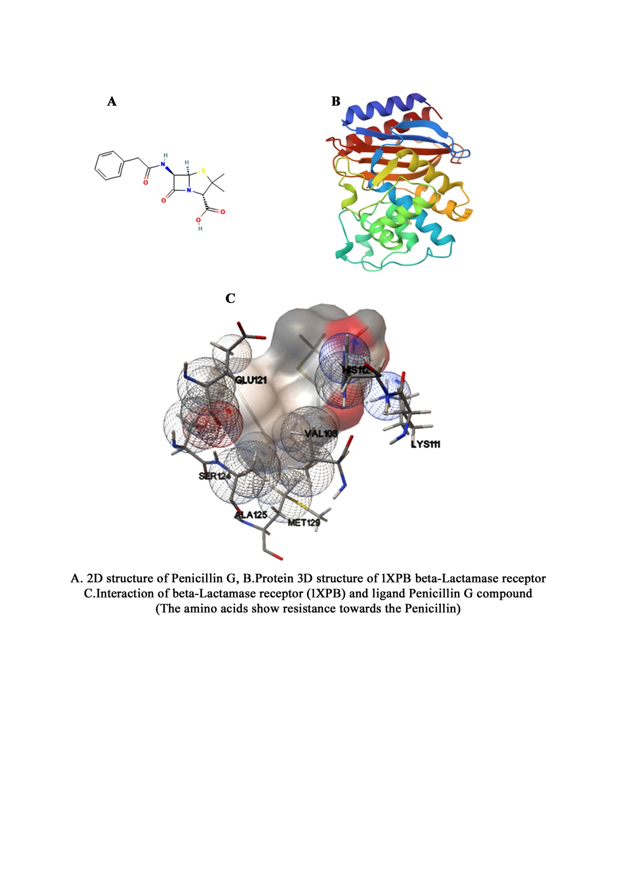
Similarly, He et al. ^{[34]} demonstrated that β-lactam antibiotics, including Penicillin G, exhibit appreciable binding affinities to class A β-lactamases and penicillin-binding proteins, reinforcing the functional relationship between these enzyme families. Additionally, recent study of Thillainayagi and Bharathidasan, ^{[35]} also determined the mechanism of antibiotic resistance though docking study. They were determined the interaction between the β-lactamases and penicillin-binding proteins through docking (AutoDockVina 2.0). Mechanistically, class A β‑lactamase enzymes inactivate β‑lactam antibiotics such as penicillins by hydrolysing the β‑lactam ring through a catalytic serine residue in the active site, forming a transient acyl–enzyme intermediate that subsequently breaks down into an inactive product while regenerating the free enzyme. In bacteria‑rich environments like poultry litter or manure, these β‑lactamases can degrade antibiotics such as penicillin and amoxicillin, disrupting their active molecular structures and thereby reducing their antimicrobial activity. Effective enzymatic breakdown of antibiotics in fecal matter lowers residual drug levels and helps curb the environmental spread of antibiotic resistance. As a result, properly treated waste has greater potential to be reused safely as fertilizer, supporting more sustainable agricultural practices while mitigating ecological and public health risks ^{[36] and [37]}.
This study highlights the potential of β-lactamase-producing bacteria, particularly KlebsiellaKlebsiella pneumoniae, to biodegrade β-lactam antibiotics, such as Penicillin G, present in poultry waste. Enzymatic degradation effectively reduces antibiotic residues, thereby minimizing environmental contamination and the risk of antimicrobial resistance. Pre-treating poultry litter with such microbes allows the safe reuse of waste as fertilizer. Overall, β-lactamase-mediated remediation is a sustainable eco-friendly strategy for managing antibiotic pollution in poultry farming.
Conclusion
This study highlights the potential of β-lactamase-producing microbes, such as KlebsiellaKlebsiella pneumoniae, to degrade β-lactam antibiotics (e.g., Penicillin G) from poultry waste collected in Namakkal, Tamil Nadu, and an area characterized by intensive poultry farming and related environmental concerns. These enzymes effectively reduce antibiotic activity and minimize the persistence of drug residues in the environment, thereby lowering the risk of antimicrobial resistance (AMR). In addition to environmental detoxification, this approach facilitates the reuse of treated waste as biofertilizer, supporting circular agriculture and promoting antibiotic stewardship in intensive animal farming systems. Further research on enzyme optimization, large-scale application, and long-term ecological impacts will be essential to fully realize the potential of this biological control strategy.
Disclaimer (Artificial intelligence)
Option 1:
Author(s) hereby declare that NO generative AI technologies such as Large Language Models (ChatGPT, COPILOT, etc.) and text-to-image generators have been used during the writing or editing of this manuscript.
Option 2:
Author(s) hereby declare that generative AI technologies such as Large Language Models, etc. have been used during the writing or editing of manuscripts. This explanation will include the name, version, model, and source of the generative AI technology and as well as all input prompts provided to the generative AI technology
Details of the AI usage are given below:
1.
2.
3.

4. Reference
- Gaur, N., Sharma, S., & Yadav, N. (2024). Environmental pollution. Advances in Green and Sustainable Chemistry, Green Chemistry Approaches to Environmental Sustainability, 23-41.
- Tasmim, S. T., Hasan, M. M., Talukder, S., Mandal, A. K., Parvin, M. S., Ali, M. Y., Ehsan, M. A., & Islam, M. T. (2023). Socio demographic determinants of use and misuse of antibiotics in commercial poultry farms in Bangladesh. IJID Regions, 7, 146-158. https://doi.org/10.1016/j.ijregi.2023.01.001
- Mainda, G., Bessell, P. R., Muma, J. B., McAteer, S. P., Chase-Topping, M. E., Gibbons, J., et al. (2015). Prevalence and patterns of antimicrobial resistance among Escherichia coli isolated from Zambian dairy cattle across different production systems. Scientific Reports, 5, 12439. https://doi.org/10.1038/srep12439
- Mankhomwa, J., Tolhurst, R., M’biya, E., Chikowe, I., Banda, P., Mussa, J., Mwasikakata, H., Simpson, V., Feasey, N., & MacPherson, E. E. (2022). A qualitative study of antibiotic use practices in intensive small-scale farming in urban and peri-urban Blantyre, Malawi: Implications for antimicrobial resistance. Frontiers in Veterinary Science, 9, 876513. https://doi.org/10.3389/fvets.2022.876513
- Wang, P., Shen, C., Xu, K., Cong, Q., Dong, Z., Li, L., Guo, J., Lu, J., & Liu, S. (2020). Isolation and characterization of Ochrobactrumtritici for penicillin V potassium degradation. mSphere, 5, e00058-20. https://doi.org/10.1128/mSphere.00058-20
- Wang, P., Shen, C., Cong, Q., Xu, K., & Lu, J. (2021). Enzyme‑catalyzed biodegradation of penicillin fermentation residues by β‑lactamase OtLac from Ochrobactrumtritici. Microbial Cell Factories, 20, 117.
- Yu, Z., He, P., Shao, L., Zhang, H., & Lu, F. (2016). Co-occurrence of mobile genetic elements and antibiotic resistance genes in municipal solid waste landfill leachates: A preliminary insight into the role of landfill age. Water Research, 106, 583-592.
- Wallace, J. S., Garner, E., Pruden, A., & Aga, D. S. (2018). Occurrence and transformation of veterinary antibiotics and antibiotic resistance genes in dairy manure treated by advanced anaerobic digestion and conventional treatment methods. Environmental Pollution, 236, 764-772.
- Tran, M. L., Fu, C. C., & Juang, R. S. (2019). Removal of metronidazole and amoxicillin mixtures by UV/TiO2 photocatalysis: An insight into degradation pathways and performance improvement. Environmental Science and Pollution Research International, 26, 11846-11855.
- Lin, B., Lyu, J., Lyu, X. J., Yu, H. Q., Hu, Z., Lam, J. C., & Lam, P. K. (2015). Characterization of cefalexin degradation capabilities of two Pseudomonas strains isolated from activated sludge. Journal of Hazardous Materials, 282, 158-164.
- Yang, X., Li, M., Guo, P., Li, H., Hu, Z., Liu, X., & Zhang, Q. (2019). Isolation, screening, and characterization of antibiotic-degrading bacteria for penicillin V potassium (PVK) from soil on a pig farm. International Journal of Environmental Research and Public Health, 16, 2166.
- Wang, P., Liu, H., Fu, H., Cheng, X., Wang, B., Cheng, Q., Zhang, J., & Zou, P. (2015). Characterization and mechanism analysis of penicillin G biodegradation with KlebsiellaKlebsiella pneumoniae Z1 isolated from waste penicillin bacterial residue. Journal of Industrial and Engineering Chemistry, 27, 50-58.
- Gao, X., Fan, X., Chen, X., & Ge, Z. (2017). Immobilized β-lactamase on Fe3O4 magnetic nanoparticles for degradation of β-lactam antibiotics in wastewater. International Journal of Environmental Science and Technology, 15, 1-10.
- Yang, L., Hu, D., Liu, H., Wang, X., Liu, Y., Xia, Q., Deng, S., Hao, Y., Jin, Y., & Xie, M. (2021). Biodegradation pathway of penicillins by β-lactamase encapsulated in metal-organic frameworks. Journal of Hazardous Materials, 414, 125549. https://doi.org/10.1016/j.jhazmat.2021.125549
- Tooke, C. L., Hinchliffe, P., Bragginton, E. C., Colenso, C. K., Hirvonen, V. H. A., Takebayashi, Y., & Spencer, J. (2019). Beta-lactamases and beta-lactamase inhibitors in the 21st century. Journal of Molecular Biology, 431(18), 3472-3500. https://doi.org/10.1016/j.jmb.2019.04.002
- Gottig, S., Hamprecht, A. G., Christ, S., Kempf, V. A., &Wichelhaus, T. A. (2013). Detection of NDM-7 in Germany, a new variant of the New Delhi metallo-beta-lactamase with increased carbapenemase activity. Journal of Antimicrobial Chemotherapy, 68(8), 1737-1740. https://doi.org/10.1093/jac/dkt088
- Lohans, C. T., Freeman, E. I., Groesen, E. V., et al. (2019). Mechanistic insights into β-lactamase-catalysedcarbapenem degradation through product characterisation. Scientific Reports, 9, 13608. https://doi.org/10.1038/s41598-019-49264-0
- Manageiro, V., Ferreira, E., Canica, M., & Manaia, C. M. (2014). GES-5 among the beta-lactamases detected in ubiquitous bacteria isolated from aquatic environment samples. FEMS Microbiology Letters, 351(1), 64-69. https://doi.org/10.1111/1574-6968.12340
- Evans, B. A., & Amyes, S. G. (2014). OXA β-lactamases. Clinical Microbiology Reviews, 27(2), 241-263. https://doi.org/10.1128/CMR.00117-13
- Fatima, H., Bhattacharya, A., & Khare, S. K. (2023). Efficient remediation of meropenem using Bacillus tropicus EMB20 beta-lactamase immobilized on magnetic nanoparticles. Journal of Environmental Management, 329, 117054. https://doi.org/10.1016/j.jenvman.2022.117054
- Devapriya, C., Kumar, S., & Kumar, S. (2013). In vitro study on determination of beta-lactamase producing isolates among clinical bacterial isolates from tertiary care hospital, North Karnataka, India. International Journal of Pharmaceutical and Biological Sciences, 4(4), 788-795.
- Hasan, T. H., & Ali, E. H. (2022). Extraction and purification of intracellular beta-lactamase from Proteus mirabilis. Journal of Pharmaceutical Negative Results, 13(4), 1-7.
- Bradford, M. M. (1976). A rapid and sensitive method for the quantitation of microgram quantities of protein utilizing the principle of protein-dye binding. Analytical Biochemistry, 72, 248-254.
- Choe, Y. S., Lee, J. H., Jo, S. G., & Park, K. H. (2017). A novel method to depurate β-lactam antibiotic residues by administration of a broad-spectrum β-lactamase enzyme in fish tissues. Fisheries and Aquatic Sciences, 19(1), 45. https://doi.org/10.1186/s41240-016-0045-5.
- Pratibha, T., Balu, P., Wong, L. S., Krishnan, K., Abirami, G., Jayanthi, M., Suganthi, M., Kumar, K. A., & Manjunathan, J. (2023). Bioremediation of penicillin-contaminated poultry faecal waste using beta-lactamase-producing bacteria. Journal of Advanced Zoology, 44(3), 687-693.
- Giri, S., Kumar, S. H., Girisha, S. K., & Shetty, A. V. (2022). Characterization of virulence gene distribution and antibiotic susceptibility profiles of diarrheagenic Escherichia coli from chicken faeces. Journal of Advanced Biotechnology and Experimental Therapeutics, 5(1), 148-162.
- Martinez, J. L., Coque, T. M., & Baquero, F. (2013). What is a resistance gene? Ranking risk in resistomes. Nature Reviews Microbiology, 13(2), 116-123.
- Tigabie, M., Biset, S., Belachew, T., Amare, A., Moges, F. (2023). Multidrug-resistant and extended-spectrum beta-lactamase-producing Enterobacteriaceae isolated from chicken droppings in poultry farms at Gondar City, Northwest Ethiopia. PLOS ONE, 18(6), e0287043. https://doi.org/10.1371/journal.pone.0287043
- Hayati, M., Indrawati, A., Mayasari, N. L. P. I., Istiyaningsih, I., & Atikah, N. (2019). Molecular detection of extended-spectrum β-lactamase-producing KlebsiellaKlebsiella pneumoniae isolates of chicken origin from East Java, Indonesia. Veterinary World, 12(4), 578-583. https://doi.org/10.14202/vetworld.2019.578-583.
- Hou, G., Ahmad, S., Li, Y., Yan, D., Yang, S., Chen, S., Qiu, Z., Yu, X., Li, N., Li, Y., Liang, Y., Leng, Q., & Qu, Y. (2024). Epidemiological, virulence, and antibiotic resistance analysis of KlebsiellaKlebsiella pneumoniae, a major source of threat to livestock and poultry in some regions of Xinjiang, China. Animals, 14(10), 1433. https://doi.org/10.3390/ani14101433.
- Choe, Y. S., Lee, J. H., Jo, S. G., & Park, K. H. (2017). A novel method to depurate β-lactam antibiotic residues by administration of a broad-spectrum β-lactamase enzyme in fish tissues. Fisheries and Aquatic Sciences, 19(1), 45. https://doi.org/10.1186/s41240-016-0045-5
- Martinez, J. L. (2009). The role of natural environments in the evolution of resistance traits in pathogenic bacteria. Proceedings of the Biological Sciences, 276(1667), 2521-2530. https://doi.org/10.1098/rspb.2009.0320
- Nesme, J., Cecillon, S., Delmont, T. O., Monier, J. M., Vogel, T. M., & Simonet, P. (2014). Large-scale metagenomic-based study of antibiotic resistance in the environment. Current Biology, 24, 1096-1100. https://doi.org/10.1016/j.cub.2014.03.036
- He, Y., Lei, J., Pan, X., et al. (2020). The hydrolytic water molecule of Class A β-lactamase relies on the acyl-enzyme intermediate ES for proper coordination and catalysis. Scientific Reports, 10, 10205. https://doi.org/10.1038/s41598-020-66431-w.
- Thillainayagi, M., & Bharathidasan, R. (2025). Exploring antibiotic resistance mechanisms and β-lactamase interactions with ceftriaxone and linezolid. Uttar Pradesh Journal of Zoology, 46(19), 358–369.
- Lin, J., Wang, T., Zhou, Y., et al. (2025). One-step degradation of 4 classes of β-lactam using β-lactamase enzyme cocktail. Scientific Reports, 15, 34701. https://doi.org/10.1038/s41598-025-16947-w
- Fisher, J. F., & Mobashery, S. (2009). Three decades of the class A beta-lactamase acyl-enzyme. Current Protein & Peptide Science, 10(5), 401–407. https://doi.org/10.2174/138920309789351967.

