DIVERSITY, UTILISATION AND CONSERVATION OF FISHMEAL RESOURCES ALONG THE BAKKHALI–FRASERGANJ COAST, WEST BENGAL, INDIA

ABSTRACT
The composition of the fish meal fishery resources along the Bakkhali -Fraserganj coast of West Bengal, India has been represented in the study. Besides the highly priced food fishes, some low valued fishes including some prawns, crabs, squids etc. are sun dried to be used as fish meal for cattle and poultry feed purposes and also for manure. A small portion of fishmeal from the by-catch of other fisheries are also used for human consumption. Fishmeal is generally manufactured from wild-caught, small marine fishes, prawns and crabs. The present study was carried out twice a year for almost 3 consecutive years (February, 2022 to December,2024). Different fish samples were collected from the fishermen during early morning hours (5 am to 8am). Questionnaire and interview were done with the people of the khutis connected with fish drying. At least hundred khutis were visited each year for interviewing. Items used for the fish meal purpose included 36 fishes, 7 prawns, 7 crabs, 3 stomatopods and 3 cephalopod species. Among the finfishes, the species Harpodon nehereus under the order Aulopiformes was the most common one and the major contributor population. In the study area, the local inhabitants are entirely dependent on the natural resources for their livelihood. The present paper aims in studying the diversity of fish meal resources, to understand various anthropogenic pressure on the system and to highlight the management options for ecosystem sustainability.
Keywords: fish meal, marine fishes, prawns, crabs.

- INTRODUCTION
The shoreline of West Bengal is divided into western and eastern regions and is bestowed with natural resources upon which the rural economy depends. The Bakkhali - Fraserganj coast is located in the eastern region of Southern Bengal serving as a tourist spot and the port here supports mainly the fishing industry (Mallik,2020). These two beaches lie adjacent to the Hooghly River mouth and are part of the Gangetic Delta. Many of the local populations of this area depend on marine fisheries for their livelihood. These coastal regions of Bakkhali- Fraserganj harbour a significant number of such fishing-based community where fishing has developed on a commercial scale. The fishing include a wide variety of fishes, prawns and crabs. Besides the highly priced food fishes, some low valued fishes including some prawns, crabs, squids etc. are sun dried to be used as fish meal for cattle and poultry feed purposes and also for manure. Fishmeal can be used in the diet of domestic animals as it is very rich in nutrient and it also finds its application as an organic fertilizer. Presence of fishmeal in animal foodstuffs increases dietary efficiency and improvement in growth through healthier food appetizing, and increases nutrient consumption, digestion, and assimilation (Miles & Chapman,2006). Fishmeal is generally manufactured from wild-caught, small marine fishes, prawns and crabs. A small portion of fishmeal from the by-catch of other fisheries are also used for human consumption. So small fishes which can be a source for fish meal will also be in great demand from both animal feed industry and fisheries and can be widely used in cosmetic and nutraceutical industries (Remesan et al.,2019) The production of fish meal depends on the number of fish landings. The more the landings, the more will be the production of fish meal. The place where the drying activity of the catch takes place is called Khuti (Samanta et al., 2016). In the Khutis, fishes etc. are dried in bamboo poles in the coastal areas under bright sunlight. Sun-drying can prevent the growth of the microorganisms and spoilage. Also it preserves the fish for a considerable period of time (Doe & Olley, 2020). After drying they are then subjected to further processing and marketing. Fishermen depend on fishing whole year round which is their primary source of income. (Das et al., 2019).So for the sustainable development of these fishery resources proper scientific study is crucial. Moreover, maintenance of biological diversity is pivotal for environmental protection and conservation and understanding the real worth of every species on the earth (Ehrlich & Wilson 1991).
Talwar et al., 1992 observed 402 species harbouring both marine and estuarine waterbodies of West Bengal. The fishery resources of Southern west Bengal comprising Hooghly-Matlah estuarine system have been documented by Nandi & Pramanik, 1994., Sinha et al., 1996, Mitra et al., 1997, Bhakta et al.,2018; Thapa et al., 2025; etc. in different times. However, time to time inventories on fish meal resources are also equally required to find out the existing problems and thereby outline the conservation strategies. The present paper aims in studying the diversity of fish meal resources, to understand various anthropogenic pressure on the system and to highlight the management options towards conservation issues.

2. MATERIALS AND METHODS
2.1. Study site
Bakkhali (21° 56’ 31” N; 88° 25’ 95” E) and Fraserganj (21° 37’ 2” N; 88° 16’ 3” E) are under the Namkhana Community Development Block in South 24 Parganas district (Map 1) in West Bengal, India.
Bakkhali is one of the popular beaches of West Bengal with a coastal length of only about 1.3km. The beach is not crowded usually. Fraserganj is a busy fishing village where the beach is hard, muddy and uneven. The present study was carried out two times a year for almost 3 consecutive years (February, 2022 to December,2024).

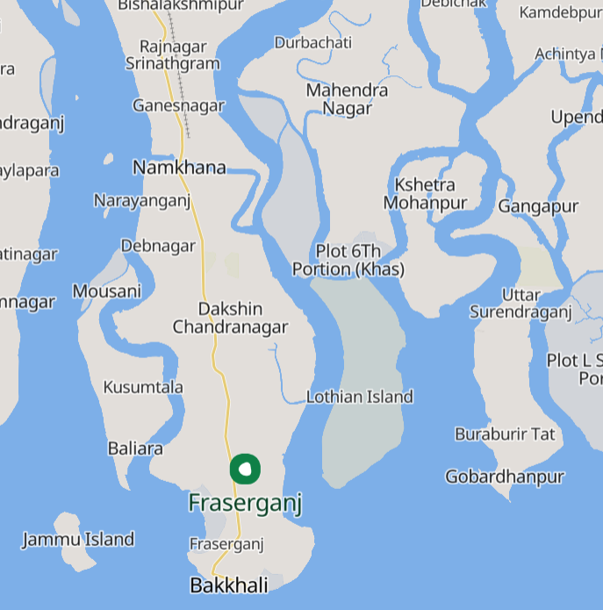
Map.1 showing the study sites.
2.2. Specimen collection and preservation

Commercial fishermen as well as other individuals collect commercial catch in a large scale round the year. Local fishermen use small boats made up of bamboo for fishing of smaller fishes, shrimps and crabs in the the near-shore waters. Some fishermen use big trawlers, mechanized boats to go far away into the sea for large-scale fishing. Gill and bag nets are also in use. Different fish samples were collected from these fishermen. The specimens were collected during early morning hours (5 am to 8am). The collected species were preserved in a 10% formalin Solution.
Questionnaire and interview were done with the people of the khutis connected with fish drying. The khutis included five, seven or upto nine individuals usually with a ratio of one or two men with three or four women. At least hundred khutis were visited each year for interviewing.
2.3. Identification of species
The species were identified following Jayaram (2002), Talwar & Kacker (1994), Talwar & Jhingran (1991), and www. fishbase.org.

3.RESULTS AND DISCUSSION

In the present study, items used for the fish meal purpose included 36 fishes, 7 prawns, 7 crabs, 3 stomatopods and 3 cephalopod species (Table – 1). Among the finfishes, the species under Aulopiformes was the most common and was the major contributor species called Bombay duck- Harpodon nehereus. Harpodon nehereus was the most preferred one for the drying activity as observed from the khutis followed by Lepturacanthus savala, Pama pama, Leognathus spp., Setipina phasa, etc.
Shellfish species comprised of the orders Decapoda, Stomatopoda, Myopsida and Sepiida of which most of the species of crabs were represented by ovigerous females of mostly Charybdis rostrata species. The Acetes sp. of prawns have considerable commercial value in dried form as they are also a major component of fishmeal manufacture.
The working of the khutis started early in the morning from 7AM when they begin to spread the species for drying, to 5 or 6PM when they again collect the species back. In the study area, species were dried both by spreading and then covering by net to safeguard it (fig.1A, 1B) and by hanging in the bamboo poles (fig.2).
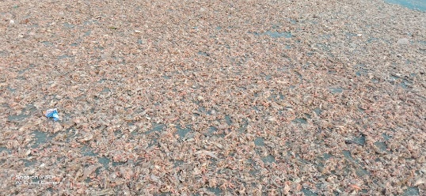
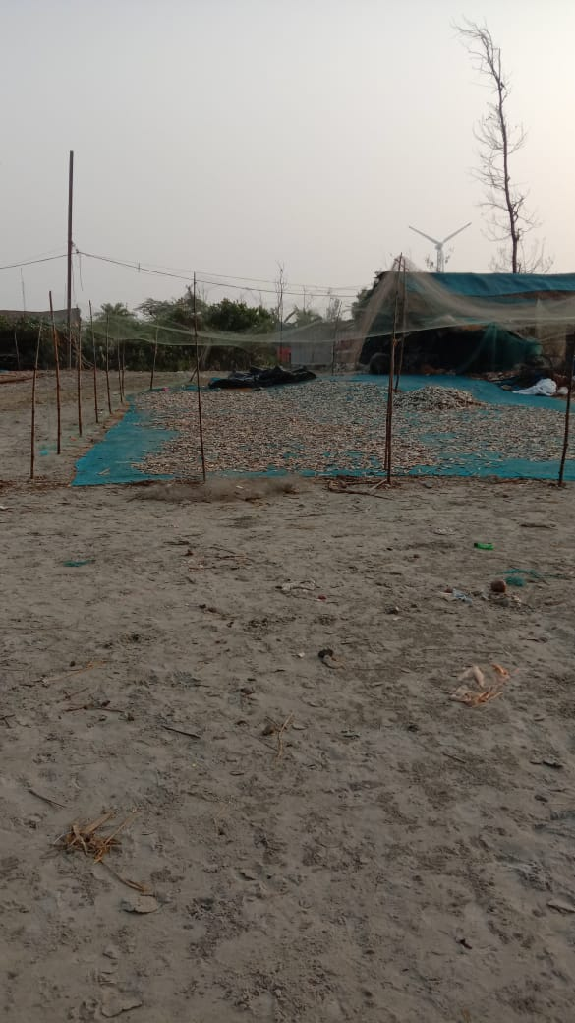

Fig.1A. Drying of the aquatic species Fig.1B. Protective net over the drying species.
through spreading.

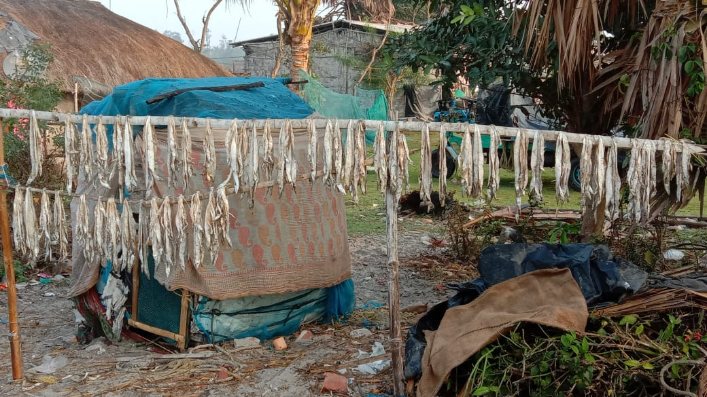
Fig.2. Drying of the fishes in bamboo poles.

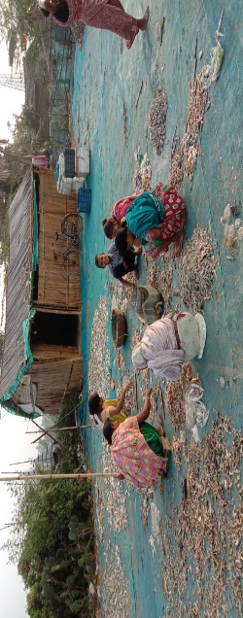
Fig.3. Individuals involved in sorting and drying.

Dominant fishes like Bombay duck and ribbon fish requires at least four to five days for drying. Fatty fishes take more time for drying depending upon its body flesh. The shrimps on the other hand gets dried up within two days depending on the sunlight. However there is no fixed duration of drying as it depends on the weather condition. Some fleshy big size fishes may take upto ten days for drying. The dry fish processors connected with fish drying may include five, seven or upto nine individuals. Among them there may be one or two males along with five or six females. Females were always greater in number than males in the khutis. The work on shore at the small size fishing camps is done mainly by women and children of the dry fish unit owners making it a household industry (Fig.3). The present survey revealed that these drying activities are in peak during the months of November to February indicating higher productions. After drying, the dried products are packed in plastic packets. However, spoilage of dry fishes can cause a huge financial loss which may happen due to poor environmental conditions, unscientific handling, attack of pests, etc.
The IUCN status (as per IUCN, 2022) of the recorded species (Table 1) reflected that most of the species had status of LC (Least Concern), some of the species belong to NE (Not Evaluated) category and some to DD (Data Deficient) category in the present study. Only the species- Harpodon nehereus was found to be under the category of near threatened. All the shellfishes belong to either NE (Not Evaluated) or DD (Data Deficient) category. Many like Bland et al., 2012 are of the opinion that in the sustainability programmes species under IUCN-DD status often remain unnoticed.

Table – 1. List of major species contributing to the fish meal

 | Fishes- Class: Actinopterigii
Order |  | Family | Scientific name/common name | Local  name | IUCN status
Carangiformes |  | Carangidae | Alepes djedaba (Forsskal, 1775) -Shrimp scad | Chingrichanda machh | LC
 |  | Carangidae | Atropus atropos(Bloch & Schneider 1801)-Cleftbelly trevally | Tek chanda machh | LC
 |  | Carangidae | Megalaspis cordyla(Linnaeus,1758) - Torpedo scad | Kajol Gouri machh | LC
 |  | Cynoglossidae | Cynoglossus arel (Bloch & Schneider, 1801) - Largescale tonguesole | Banspata machh | DD
 |  | Cynoglossidae | Cynoglossus cynoglossus (Hamilton, 1822) - Bengal tongue sole | Pata bata or bhangon machh | LC
 |  | Cynoglossidae | Cynoglossus lingua Hamilton, 1822 - Long tongue sole | Lamba pata machh | LC
 |  | Soleidae | Brachirus pan (Hamilton, 1822) - Pan sole | Pata machh | LC
Cichliformes |  | Ambassidae | Ambassis ambassis Lacepede,1802 - glassies or common glassfishes | Kanchali machh | LC
Gadiformes |  | Bregmacerotidae | Bregmaceros mcclellandi Thompson,1840-Unicorn cod | Puia machh | NE
Clupeiformes |  | Engraulidae | Coilia ramcarati (Hamilton, 1822) - Ramcarat grenadier anchovy | Boiragi machh | DD
 |  |  | Setipinna brevifilis (Valenciennes, 1848) - Short-hairfin anchovy | Gangeyo Phasa | DD
 |  |  | Setipinna phasa (Hamilton, 1822) - Gangetic hairfin anchovy | Phasa machh | LC
 |  |  | Stolephorus baganensis Hardenberg, 1933 - Bagan anchovy | Amodi machh | LC
 |  |  | Thryssa purava (Hamilton, 1822) - Oblique-jaw thryssa | Phansa machh | DD
 |  |  | Thryssa mystax (Bloch & Schneider, 1801) - Moustached thryssa | Phasa machh | LC
 |  | Dorosomatidae | Herklotsichthys quadrimaculatus (Rüppell, 1837) - Bluestripe herring | Nildora hering | LC
 |  | Pristigasteridae | Pellona ditchela Valenciennes, 1847 - Indian pellona | Choukka mach | LC
 |  |  | Raconda russeliana Gray, 1831 – Russell’s smooth back herring | Patia machh | LC
Acanthuriformes |  | Sciaenidae | Daysciaena albida (Cuvier, 1830) - Bengal corvina | Bhola machh | NE
 |  | Sciaenidae | Johnius belangerii (Cuvier, 1830) - Belanger's croaker | Poa machh | LC
 |  | Sciaenidae | Johnius dussumieri (Cuvier, 1830) - Sin croaker | Bhol mach | LC
 |  | Sciaenidae | Otolithes ruber (Bloch & Schneider, 1801) - Tigertooth croaker | Nero Bhola | LC
 |  | Sciaenidae | Pama pama (Hamilton, 1822) - Pama croaker | Koi bhola | NE
 |  | Leiognathidae | Nuchequula blochii (Valenciennes, 1835) - Twoblotch ponyfish | Dui dagola chand machh | NE
 |  | Leiognathidae | Leiognathus equula (Forsskål, 1775) - Common ponyfish | Tak chanda machh | LC
 |  | Leiognathidae | Leiognathus brevirostris (Valenciennes,1835)-short nose pony fish | Komola chanda | NE
 |  | Leiognathidae | Gazza minuta (Bloch, 1795) - Toothpony | Deto chanda | LC
 |  | Leiognathidae | Secutor ruconis (Hamilton ,1822)-deep pugnose pony fish | Thutuni chanda | NE
Aulopiformes |  | Synodontidae | Harpodon nehereus (Hamilton, 1822) - Bombay-duck | Lote machh | NT
Kurtiformes |  | Kurtidae | Kurtus indicus Bloch,1786-Indian humphead | Gank chanda | NE
Scombriformes |  | Trichiuridae | Lepturacanthus savala (Cuvier, 1829) – silver ribbon fish | Churimach | NE
Mugiliformes |  | Mugilidae | Planiliza planiceps (Valenciennes, 1836) - Tade gray mullet | Bangon machh | LC
Gobiiformes |  | Gobiidae | Odontamblyopus rubicundus  ( Hamilton,1822)-eel goby | Lal chewa | NE
Anguilliformes |  | Ophichthidae | Pisodonophis boro (Hamilton, 1822) - Rice-paddy eel | Kharu or dhankhet eel | LC
Centrarchiformes |  | Terapontidae | Terapon jarbua(Forsskal,1775) - Jarbua terapon | Borguni machh | LC
Tetraodontiformes |  | Triacanthidae | Triacanthus brevirostris Temminck and Schlegel,1850-  Short-nosed tripodfish | Tekathi machh | LC
Crabs
Decapoda |  | Portunidae | Charybdis feriata (Linnaeus,1758)-crucifix crab | Shil kankra | NE
 |  | Portunidae | Charybdis hellerii (A.Milne Edwards,1867)-IndoPacific swimming crab | Shantaru Kankra | NE
 |  | Portunidae | Charybdis merguiensis (De Man,1887) - swimming crab | Jogi kankra | NE
 |  | Portunidae | Charybdis orientalis Dana,1852 | kankra | NE
 |  | Portunidae | Charybdis rostrata (A.Milne Edwards,1861 ) | Thoto kankra | NE
 |  | Matutidae | Matuta lunaris (Forskal,1775)-spotted moon crab | Chand kankra | NE
 |  | Matutidae | Matuta planipes Fabricius,1798- flower moon crab | Fulchand kakra | NE
Prawns
Decapoda |  | Sergestidae | Acetes erythraeus Nobili,1906 – Tsivakhini paste shrimp | Ghora chingri | NE
 |  | Sergestidae | Acetes indicus H.Milne Edwards,1830 – Indian white shrimp | Desi sada chingri | NE
 |  | Palaemonidae | Palaemon styliferus H.Milne Edwards,1840 – roshna prawn | Roshna chingri | NE
 |  | Penaeidae | Metapenaeus brevicornis (H. Milne Edwards,1837)– yellow shrimp | Chamni chingri | NE
 |  | Penaeidae | Metapenaeus lysianassa (De Man,1888) -bird shrimp | Gusha chingri | NE
 |  | Penaeidae | Parapenaeopsis sculptilis (Heller,1862) – rainbow shrimp | Baghatara chingri | NE
 |  | Penaeidae | Penaeus merguiensis De Man,1888 – banana prawn | Bagda chingri | NE
Stomatopoda |  | Squillidae | Clorida decorata Wood Mason,1875- Mantis shrimp | Gotal chingri | NE
 |  | Squillidae | Harpiosquilla raphidea (Fabricius,1798) – giant Mantis shrimp | Icha | NE
 |  | Squillidae | Oratosquillina interrupta (Kemp,1911) – black spot Mantis shrimp | Kalo dagola gotal /icha | NE
Cephalopods
Myopsida |  | Loliginidae | Loligo duvaucelii Ad’Orbigny,1835-Indian squid | calamari | DD
Sepiida |  | Sepiidae | Sepia aculeata Ad’Orbigny,1835- Needle cuttle fish | Lagra/suchola cuttlemach | DD
 |  | Sepiidae | Sepiella inermis Ad’Orbigny,1835- spineless cuttle fish | Kantabihin cuttle mach | DD
(LC - Least Concern; NT – Near threatened;DD - Data Deficient; NE - Not Evaluated)

This study has revealed that most of the local populations are entirely dependent on the natural resources for their livelihood and some unscientific practices of fishing are also there. An over pressure of the surrounding population in terms of fishing was noticed. There were about 150 dry fish production units of Fraserganj and Bakkhali. Both fishermen and fish workers are local inhabitants of coastal villages under Namkhana police station. The dry fish unit owners lament over the declining trend of production.
The gravid female of a number of species are so indiscriminately exploited commercially that they need urgent protection and conservation. Use of unscientific gears like mosquito nets to collect spawns of prawns were done by many local inhabitants. Many fish juveniles caught in net play a prominent role in the depletion of fish landings in commercial catches. It is felt that the various fish juveniles caught by fishmeal and shrimp harvesters, if allowed to grow in nature might have raised the production level.
Use of improper mesh nets and gear for fishing upraise serious concerns in the area studied. These methods haphazardly catch mature as well as juveniles, leading to decreasing yield rates and menacing sustainability for a prolonged period (Remesan et al., 2019). Key species of fishmeal like Bombay ducks, ribbonfishes, anchovies and croakers, have suffered declining catches due to different types of cyclones causing soil erosion as well as habitat destruction, overharvesting of juveniles, excessive bycatch and disastrous fishing techniques (Bhakta et al., 2018). Increased trawling services may destroy the bottom habitats of many organisms and thereby disturb the ecosystem. Besides these, coastal hazards such as cyclones, storm surges, coastal erosion, nonpoint pollution, degrade the coastal water quality.
So from the aspects of ecology and socio economy, it is of no doubt that conservation of this coastal area is essential. Various conservation measures have been put from and by many workers in different areas (Ando & Getzner, 2005; Nyakaana, 2008; Islam & Shamsuddoha,2018; Ayyam
et al.,2019; Jayaraj et al.,2021;). The following measures are however suggested in case of this coastal region.
- More people are exploiting the living resources of the ecosystem in a manner that will be difficult to sustain over the long term. So over exploitation of natural resources should be stopped by promulgation of laws.
- Fishing should be done in such a way that the maximum profit can be gained as well as the population of fishes is maintained in proper level.
- To make an inventory of the commercially important species available and noting their seasonal abundance.
- Size limit of each fish species to be harvested is to be made to relieve the pressure on juvenile fishes.
- To employ strict vigilance about exploitation and harvesting of endangered marine species.
- Mesh size should also be regulated to prevent juvenile fish catching.
- To promote research on ecological conservation, breeding biology and integrity restoration relation between plants and animals.
- Various income generating activities should be arranged around the coast so that people need not depend on exploitation of natural resources only.
So, in general we can conclude that a holistic approach is required for conservation of coastal fishery resources.
4. CONCLUSION
It is evident from the study that aquatic resources contribute to the economy of the country. Bakkhali Fraserganj coastal regions are one of the most significant areas of West Bengal. These regions are bestowed with enormous biological wealth. The need for fish meal is rapidly increasing and India can minister to this need by augmenting fishmeal export. The anticipated growth in fish landings and the rise of requirements in the inside and offshore retail indicate a promising future for this sector. However exploration of such economically resourceful area should be assured with proper conservationary measures including judicial use of aquatic resources to attain ecological sustainability.

Disclaimer (Artificial intelligence)
Author(s) hereby declare that NO generative AI technologies such as Large Language Models (ChatGPT, COPILOT, etc.) and text-to-image generators have been used during the writing or editing of this manuscript.

REFERENCES

Ando, A. W., & Getzner, M. (2005). The roles of ownership, ecology and economics in public wetland conservation decision. Ecological Economics, 58, 287-303.
Ayyam, V., Palanivel, S., & Chandrakasan, S. (2019). Strategies and Collaborations for Management of Coastal Areas. In: Coastal Ecosystems of the Tropics - Adaptive Management. Springer, Singapore. https://doi.org/10.1007/978-981-13-8926-9_13
Bhakta, D., Das, S., Nagesh, T., Behera, S., Chirwatkar, B.B., Das, A., &Samanta, R. (2018). Winter migratory bag net fishery of Hooghly-Matlah estuary, West Bengal: an overview National Seminar on “Advancement in Green Technology for Controlling and Managing Current Environmental Pollution,” 10.13140/RG.2.2.35402.88006
Bhakta, D., Das, S., Behera, S., & Talagunda Srinivasan, N. (2018). Length composition of commercially important fin fishes during monsoon period at Hooghly-Matlah estuarine system, West Bengal, India. Inno.Farm,3(2), 77-81.

Bland, L. M., Collen, B., Orme, C. D. L. & Bielby, J. (2012). Data uncertainty and the selectivity of extinction risks in freshwater invertebrates. Diversity and distributions, 18, 1211-1220.
https://doi.org/10.1111/j.1472-4642.2012.00914.x
Das, M., Zaman, S., Biswas, S.K., & Mitra, A. (2019). Fish faunal diversity of Hooghly river near Diamond Harbour. Technology, 4, 12-21.
Doe, P., & Olley, J. (2020). Drying and dried fish products. In Seafood (pp. 125-145). CRC Press.
Ehrlich, P. R., & Wilson, E. O. (1991). Biodiversity Studies:Science and Policy. Science, 253, 758-762.
Islam, M.M., & Shamsuddoha, M. (2018). Coastal and marine conservation strategy for Bangladesh in the context of achieving blue growth and sustainable development goals (sdgs)
Environ. Sci. Policy, 87, 45-54.
IUCN (2022). The IUCN Red List of Threatened Species. Version 2017.3. IUCN, Gland, Switzerland and Cambridge, UK. Accessed in December, 2022.
Jayaraj, R., Krishnakumar, P. K., & Manjusha, U. (2021). Marine biodiversity conservation in India: Status, challenges, and opportunities. Ocean & Coastal Management, 208, 105612
Jayaram, K.C. (2002). Fundamentals of fish taxonomy. New Delhi: Narendra Publishing House.
Mallik, T.K. (2020). Salient features of West Bengal coastal ecosystem and effective management of environment. MOJ Eco Environ Sci.,5(3),124-127.
DOI: 10.15406/mojes.2020.05.00184
Miles, R., & Chapman, F. (2006). Benefits of Fish Meal in Aquaculture Diets: FA122/FA122, 5/2006. EDIS. 2006. 10.32473/edis-fa122-2006
Mitra, P.M., Karmakar, H.C., Sinha, M., Ghosh, A., & Saigal, B. N. (1997). Fisheries of the Hooghly – Matla estuarine system – an appraisal, Bull, Cent Ind. Fish Res. Inst. No. 67, 49.
Nandi, N. C., & Pramanik, S. K. (1994). Crabs and crab fisheries of Sunderban, Hindustan Publishing Corporation (India), Delhi, 192p.
Nyakaana, J. B. (2008). Sustainable wetland resource utilization of Sango Bay through eco-Tourism development. African Journal of Environmental Science and Technology, 2(10),326-335.
Remesan, M.P., Raghu Prakash, R., Prajith, K.K., Jha, P.N., Renjith, R.K., & Boopendranath, M.R. (2019). A Review on Techniques and Challenges in the Harvest of Mesopelagics. Fishery Technology,56, 243 – 253.
Samanta, C., Bhaumik, U., & Patra, B.C. (2016). Socio-Economic Status of the Fish Curers of the Dry Fish Industry of the Coastal Areas of West Bengal, India. International Journal of Current Research and Academic Review, 4(5), 84-100.
10.20546/ijcrar.2016.405.009.
Sinha, M., Mukhopadhyay, M. K., Mitra, P.M., Bagchi, M. M., & Karmakar, H.C. (1996). Impact of Farakka Barrage on hydrology and fishery of Hooghly estuaries. Estuary,19 (3); 710-722.
Talwar, P. K., & Jhingran, A. G. (1991). Inland fishes of India and adjacent countries. IBH Publishing, Co., Pvt,Ltd. New Delhi.
Talwar, P. K. & Kacker, R. K. (1994). Handbook of commercial Sea Fishes of India. Zool. Surv. India, 1- 997.
Talwar, P.K., Mukherjee, P., Saha, D., Paul, S. N., & Kar, S. (1992): Marine and estuarine fishes. State Fauna Series -3, Fauna of West Bengal, Part 2, Zoological Survey qf India: 243 – 342.
Thapa, A., Qureshi, N.W., Ananthan, P.S., Bhakta, D., & Debroy, P. (2025). Multidimensional assessment of fisheries sustainability in India's largest estuarine system,Cleaner Environmental Systems, 19, 100325, ISSN 2666-7894.
https://doi.org/10.1016/j.cesys.2025.100325.

