Avifaunal Diversity, Species Composition and Feeding Guild Status at Kanhalgaon Lake, Paoni Tehsil, Bhandara District, Maharashtra, India

Abstract:
The current research evaluates the avifaunal diversity, composition of species, and feeding guild structure at Kanhalgaon Lake, Paoni Tehsil of Bhandara District, Maharashtra. The point count method was applied for study from January 2024 to January 2025 for all three habitat types—roadside edge, agricultural zone, and forest patch. A total of 96 bird species observed across 41 families and 15 orders were documented. The Passeriformes order had the greatest species richness (41.6%), followed by Pelecaniformes and Charadriiformes. Shannon–Wiener diversity index (H′ = 3.85) and Simpson's index (1–D = 0.97) both reflected high avian diversity and evenness among habitats. Themost prevelent guild was omnivorous (42.7%), next to it are carnivorous (20.8%) and insectivorous (19.8%) species, which shows trophic adaptability and functional diversity. Seasonal variation indicated maximum species richness in winter because of migratory birds, revealed the lake as an important wintering and stopover destination on the Central Asian Flyway. The mix of aquatic, arboreal, and terrestrial guilds indicates ecological heterogeneity and conservation value of Kanhalgaon Lake. The results point to the necessity of long-term habitat conservation and management efforts to maintain the ecological integrity and avian diversity of the lake.
Keywords
Avifaunal diversity; Feeding guilds; Wetland ecology; Kanhalgaon Lake; Species composition; Migratory birds; Habitat heterogeneity; Conservation biology

1. Introduction
Wetlands are serving as critical habitats for diverse flora and fauna and providing essential ecosystem services and nutrient cycling (Mitsch & Gosselink, 2015). They are also vital refuges for a wide range of avian species that depend on aquatic and semi-aquatic environments for feeding, nesting, and breeding. Birds are important bio-indicators of ecosystem health because their presence, abundance, and community composition closely reflect changes in habitat structure and ecological integrity (Koli et al., 2021).Wetlands comprises around 4.7% of the geographical area of India . Small to medium lakes are significant in the sustenance of regional avifauna as well as migratory avifauna through the provision of varied microhabitats like open waters, emergent vegetation, as well as shore zones (Ali et al., 2024; Kulkarni, 2024). The microhabitats are used as feeding as well as resting sites through the avian fauna that are both resident as well as migrants. Recent research indicating that such inland waterscapes that are generally surrounded with agriculture or semi-forested landscapes maintain high avian species richness as well as functional diversity (Lonkar et al., 2023; Punde et al., 2025).
The notion of feeding guilds—guilds of species that use the same food resources in a similar fashion—gives a functional basis to the study of ecological functions within bird assemblages (Root, 1967). Guild analysis is most useful to evaluate the quality of habitat since guild representation can reflect the extent of disturbance to the environment or degree of specialization to the habitat (Sahu et al., 2025). Omnivorous birds tend to dominate disturbed or simplified habitats, whereas insectivores, piscivores, as well as frugivores are generally found in highly structured or resource-abundant habitats (Patel & Gadhikar, 2025; Syngkli et al., 2024).
Research on avifaunal diversity throughout Maharashtra has identified both seasonal and habitat-specific variations. An investigation conducted at Moharli Lake, situated within the Tadoba-Andhari Tiger Reserve, revealed that the diversity of aquatic avifauna is significantly elevated during the winter months due to the influx of migratory species, whereas the summer season supports established resident ground guilds (Kulkarni, 2024). Investigations at Malkhed Lake (Ali et al., 2024) and the Shivapur Wetland (Lonkar et al., 2023) indicated that both resource diversity and habitat heterogeneity serve as pivotal factors influencing species richness and the structural organization of feeding guilds. Despite the increasing volume of research concerning the wetland avifauna in the Vidarbha region, smaller wetlands, such as Kanhalgaon Lake, remain underrepresented in scholarly discourse.Kanhalgaon Lake, situated within the Paoni Tehsil of Bhandara District, represents a freshwater wetland embedded within a multifaceted landscape that includes agricultural fields, remnants of forests, and the outskirts of human habitation. The present study aims to (1) assess the avifaunal richness of Kanhalgaon Lake, (2) compare species composition and abundance across various sectors of the differing habitats, and (3) analyze the structure of feeding guilds to acquire insights into ecological functionality and habitat utilization.
2. Materials and Methods
2.1. Study Area
The present research was conducted at the Kanhalgaon Lake, in the Paoni Tehsil of District Bhandara, Maharashtra State of India, on the outskirts of the village of Kanhalgaon (lat 21°18′ N; long 79°38′ E). it is a medium-sized freshwater lake, sarrounded by an array of contrasting ecosystems such as agricultural farms, forests, and human habitations. The temperature flactuates between 5°C in the winter months to 42°C during the summer months. The perimeter of the lake and its adjacent areas provide an array of microhabitats such as open water areas, grassy slopes, and scattered trees. The habitat gradients support wide diversity of aquatic, semi-aquatic, and terrestrial avifauna all year round. To assess the spatial variability in bird diversity in the study area, it was divided into three representative habitats
1. Site A (Roadside edge): disturbed open edge with limited vegetation.
2. Site B (Agricultural site): paddy-dominated cropland with hedgerows and.
3. Site C (Forest patch): semi-natural woodland with high canopy cover and minimum disturbance.
A map indicating the location of the Kanhalgaon Lake and the sampling sites was made with the help of google earth pro.
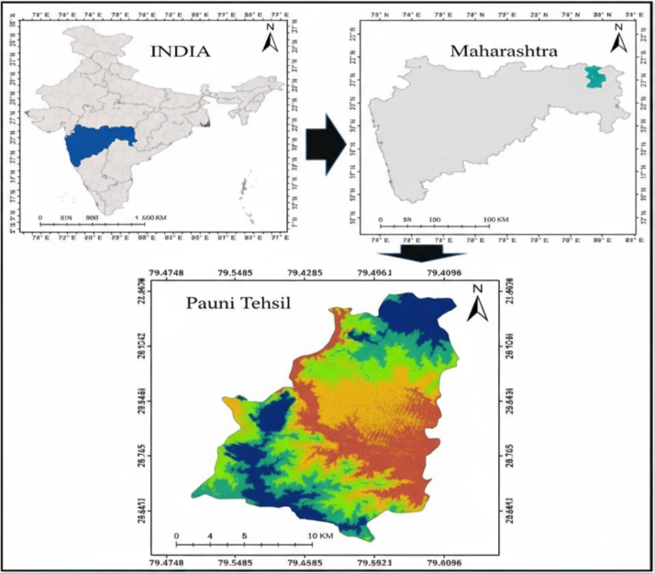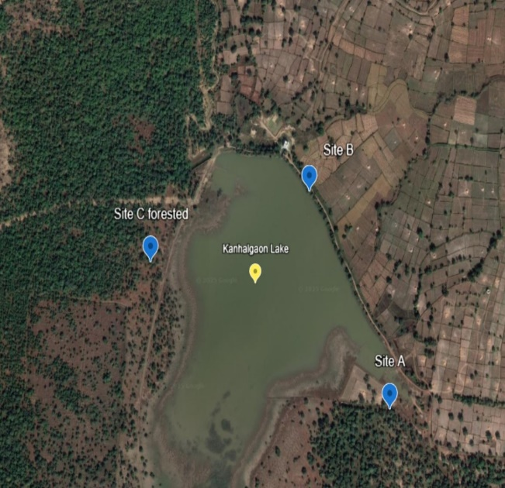
Map 1: Kanhagao Lake Paoni
2.2. Data Collection
The avifaunal surveys took place between January 2024 and January 2025 during winter, summer, and monsoon seasons to incorporate seasonal variability in bird diversity and number. Biweekly monitoring took place during the early mornings (06:00–09:00 h) as well as the evenings (16:00–18:00 h), the peaks of bird activities. The fixed-radius point count method (Ralph et al., 1993; Bibby et al., 2000) was utilized to capture avian occurrences as well as abundances. Field identification with the aid of binoculars (Olympus 10×50 S) as well as with the aid of a digital camera Nikon 5300D, to Grimmett, Inskipp, & Inskipp (2011), as well as Birds of the World (Cornell Lab, 2023), to establish the species, were utilized.
2.3. Feeding Guild Classification
Species of birds were classified to feeding guilds based on primary diet as well as foraging habits as per Root (1967) as the modified categories that were used in previous Indian studies (Sahu et al., 2025; Patel & Gadhikar, 2025). Guild status contained Omnivorous, Insectivorous, Carnivorous, Piscivorous, Frugivorous, Granivorous, Herbivorous,In.
2.4. Data Analysis
All the field records were prepared in Microsoft Excel and statistically analyzed. The parameters calculated were as follows:
Species Richness (S) – overall species number documented per site and season.Shannon–Wiener Diversity Index (H′) – accounting for both richness and evenness (Shannon & Weaver, 1949).Simpson's Diversity Index (1–D) – the probability that two individuals randomly chosen are of different species.Pielou's Evenness (J′) – computed as H′ / ln(S), to gauge species distribution uniformity.Feeding Guild Composition – proportion of species and individuals within each trophic category. A percentage diversity index comparison among sites was carried out to assess the heterogeneity of the habitats as well as the impact on avifaunal composition.
4.Results :
Table 1. Diversity and feeding guild of avifauna at Kanhalgaon Lake
Order | Family | Species | Common Name | Status | IUCN | Feeding Guild
Anseriformes | Anatidae | Dendrocygna javanica | Lesser Whistling Duck | Resident | Lc | Herbivore
 |  | Sarkidiornis melanotos | Knob-billed Duck | Resident | LC | Omnivorous
 |  | Nettapus coromandelianus | Cotton Pgmy Goose | Resident | LC | Omnivorous
 |  | Anas poecilorhyncha | Indian Spot-billed Duck | Resident | LC | Omnivorous
 |  | Anas acuta | Northern Pintail | WV | LC | Herbivore
 |  | Netta rufina | Red-crested Pochard | WV | LC | Herbivore
 |  | Aythya ferina | Common Pochard | WV | VU | Omnivorous
 |  | Aythya fuligula | Tufted Duck | WV | LC | Omnivorous
Ciconiiformes | Ciconiidae | Anastomus oscitanus | Asian Openbill-Stork | Resident | LC | Carnivorous
 |  | Mycteria leucocephala | Painted Stork | Resident | NT | Carnivorous
Suliformes | Anhingidae | Anhinga melanogaster | Oriental Darter | Resident | NT | Carnivorous
 |  | Microcarbo niger | Little Cormorant | Resident | LC | Piscivorous
 |  | Phalacrorax carbo | Great Cormorant | LM | LC | Piscivorous
 |  | Phalacrocorax fuscicollis | Indian Cormorant | Resident | LC | Piscivorous
Pelecaniformes | Ardeidae | Ixobrychus sinensis | Yellow Bittern | Resident | LC | Carnivorous
 |  | Ixobrychus cinnamomeus | Cinnamomeus | Resident | LC | Carnivorous
 |  | Ardea cinerea | Grey Heron | Resident | Lc | Carnivorous
 |  | Aredea purpurea | Purple Heron | Resident | LC | Carnivorous
 |  | Ardea alba | Great Egret | Resident | LC | Carnivorous
 |  | Ardea intermedia | Intermediate Egret | Resident | LC | Carnivorous
 |  | Egretta garzetta | Little Egret | Resident | LC | Carnivorous
 |  | Bubulcus ibis | Cattle Egret | Resident | LC | Carnivorous
 |  | Ardeola grayii | Indian Pond Heron | Resident | Lc | Carnivorous
Pelecaniformes | Threskiornithidae | Threskiornis melanocephalus | Black-headed ibis | Resident | NT | Omnivorous
 |  | Pseudibis papillosa | Red-naped ibis | Resident | LC | Omnivorous
Gruiformes | Rallidae | Gallinula chloropus | Common Moorhen | Resident | LC | Omnivorous
 |  | Fulica atra | Common coot | Resident | LC | Omnivorous
 |  | Porphyrio poliocephalus | Grey-headed Swamphen | Resident | LC | Omnivorous
 |  | Amaurornis phoenicurus | White-breasted Waterhen | Resident | LC | Omnivorous
Charadriiformes | Turnicidae | Turnix sylvaticus | Small Buttonquail | Resident | LC | Omnivorous
 |  | Turnix suscitator | Barred Buttonquail | Resident | LC | Omnivorous
Charadriiformes | Burhinidae | Himantopus himantopus | Black-winged Stilt | Resident | LC | Omnivorous
 |  | Charadrius dubius | Little Ringed Plover | WV | LC | Insectivorous
Charadriiformes | Charadriidae | Vanellus malabaricus | Yellow-wattled Lapwing | Resident | LC | Carnivorous
 |  | Vanellus indicus | Red-wattled Lapwing | Resident | LC | Carnivorous
Charadriifomes | Jacanidae | Hydrophasianus chirurgus | Pheasant-tailed Jacana | Resident | LC | Omnivorous
 |  | Metopidius indicus | Bronze-winged Jacana | Resident | LC | Omnivorous
Charadriiformes | Scolopacidae | Actitis hypoleucos | Common Sandpiper | WV | LC | Omnivorous
 |  | Tringa glareola | Wood Sandpiper | WV | LC | Omnivorous
Coraciiformes | Alcedinidae | Alcedo atthis | Common Kingfisher | Resident | LC | Omnivorous
 |  | Halcyon smyrnensis | White-throated Kingfisher | Resident | LC | Omnivorous
 |  | Ceryle rudis | Pied Kingfisher | Resident | LC | Omnivorous
Coraciiformes | Meropidae | Merops orientalis | Green Bee-eater | Resident | LC | Insectivorous
 | Coraciidae | Coracias benghalensis | IndianRoller | Resident | LC | Carnivorous
Accipitriformes | Accipitridae | Accipiter badius | Shikra | Resident | LC | Carnivorous
 |  | Elanus caeruleus | Black-winged Kite | Resident | LC | Carnivorous
 |  | Milvus migrans | Black Kite | Resident | LC | Carnivorous
 |  | Pernis ptilorhynchus | Oriental Honey Buzzard | Resident | LC | Omnivorous
Columbiformes | Columbidae | Columba livia | Rock Pigeon | Resident | LC | Herbivorous, largely Granivorous
 |  | Treron phoenicopterus | Yellow-footed Green Pigeon | Resident | Lc | Herbivorous, largely Granivorous
 |  | Streptopelia decaocto | Eurasian Collared Dove | Resident | LC | Omnivorous
 |  | Streptopelia chinensis | Spotted Dove | Resident | LC | Omnivorous
 |  | Streptopelia senegalensis | Laughing Dove | Resident | LC | Omnivorous
Cuculiformes | Cuculidae | Centropus sinensis | Greater Coucal | Resident | Lc | Carnivorous
 |  | Eudynamys scolopaceus | Asian Koel | Resident | LC | Insectivorous, Frugivorous
Bucerotiformes | Upupidae | Upupa epops | Common Hoopoe | Resident | LC | Insectivorous
 |  | Ocyceros birostris | Indian Grey Hornbill | Resident | LC | Omnivorous
Piciformes | Megalaimidae | Psilopogon haemacephalus | Coppersmith Barbet | Resident | LC | Insectivorous, Frugivorous
Psittaciformes | Psittaculidae | Psittacula cyanocephala | Plum-headed Parakeet | Resident | LC | Frugivorous
 | Oriolidae | Oriolus kundoo | Indian Golden Oriole | Resident | LC | Frugivorous
 | Aegithinidae | Aegithina tiphia | Common lora | Resident | LC | Insectivorous
 | Dicruridae | Dicrurus macrocercus | Black Drongo | Resident | LC | Omnivorous
 | Laniidae | Lanius schach | Long-tailed Shrike | Resident | LC | Carnivorous
 | Corvidae | Dendrocitta vagabunda | Rufous Treepie | Resident | LC | Insectivorous
 | Alaudidae | Mirafra erythroptera | Indian Bushlark | Resident | LC | Insectivorous, Granivorous
 | Parulidae | Prinia sylvatica | Jungle Prinia | Resident | LC | Insectivorous
 |  | Prinia socialis | Ashy Prinia | Resident | LC | Insectivorous
 |  | Prinia inornata | Plain Prinia | Resident | LC | Insectivorous
 | Acrocephalidae | Acrocephalus agricola | Paddyfield Warbler | WV | LC | Insectivorous
 | Sylviidae | Chrysomma sinense | Yellow-eyed Babbler | Resident | LC | Insectivorous, Nectarivores
 | Timallidae | Argya striata | Jungle Babbler | Resident | LC | Insectivorous
 |  | Argya malcolmi | Large Grey Babbler | Resident | LC | Omnivorous
 | Hirundinidae | Hirundo smithii | Wire-tailed Swallow | Resident | LC | Insectivorous
 | Pycnonotidae | Pycnonotus cafer | Red-vented Bulbul | Resident | LC | Omnivorous
 | Sturnidae | Acridotheres tristis | Common Myna | Resident | LC | Omnivorous
 |  | Pastor roseus | Rosy Starling | Passage migrant | LC | Omnivorous
 |  | Sturnia pagodarum | Brahminy Starling | Resident | LC | Omnivorous
 |  | Gracupica contra | Asian Pied Starling | Resident | LC | Omnivorous
 | Muscicapidae | Copsychus saularis | Oriental Magpie Robin | Resident | LC | Insectivorous
 |  | Copsychus fulicatus | Indian Robin | Resident | LC | Insectivorous
 |  | Phoenicurus ochruros | Black Redstart | Resident | LC | Insectivorous
 |  | Saxicola maurus | Siberian Stonechat | WV | LC | Insectivorous
 |  | Saxicola caprata | Pied Bushchat | Resident | LC | Insectivorous
 |  | Oenanthe fusca | Brown Rock Chat | Resident | LC | Insectivorous
 | Nectariniidae | Cinnyris asiaticus | Purple Sunbird | Resident | LC | Nectarivores
 | Ploceidae | Ploceus philippinus | Baya weaver | Resident | LC | Omnivorous
 |  | Ploceus manyar | Streaked weaver | Resident | LC | Omnivorous
 | Estrildidae | Euodice malabarica | Indian Silverbill | Resident | LC | Omnivorous
 |  | Lonchura punctulata | Scaly-breasted Munia | Resident | LC | Omnivorous
 |  | Lonchura malacca | Tricoloured Munia | Resident | LC | Omnivorous
 |  | Lonchura striata | White rumped Munia | Resident | LC | Omnivorous
 | Passeridae | Passer domesticus | House Sparrow | Resident | LC | Omnivorous
 |  | Gymnoris xanthocollis | Yellow-throated Sparrow | Resident | LC | Omnivorous
 | Motacillidae | Motacilla maderaspatensis | White-browed Wagtail | Resident | LC | Insectivorous
 |  | Anthus rufulus | Paddyfield Pipit | Resident | LC | Insectivorous
 | Emberizidae | Emberiza melanocephala | Black-headed Bunting | WV | LC | Granivorous

3.1. Species Richness and Taxonomic Composition
A total of 96 bird species distributed over 41 families and 15 orders were recorded around Kanhalgaon Lake as well as the neighboring habitats during the study. Passeriformes order represented the maximum number of species (n = 40; 41.6%), followed by Pelecaniformes (10; 10.4%), Charadriiformes (8; 8.3%), Anseriformes (6; 6.2%), and Accipitriformes (5; 5.2%). Other orders included Ciconiiformes, Coraciiformes, Columbiformes, Gruiformes, and Piciformes with one to four.
The family-wise analysis revealed the highest dominance of Ardeidae (8 species), followed by Anatidae (6 species), Sturnidae (5 species), Columbidae (4 species), and Motacillidae (4 species). The broad coverage of aquatic as well as terrestrial bird families establishes the ecological diversity of the Kanhalgaon Lake area(Table 1).

Fig 1. Species richness Acrsoss different sites at Kanhalgao Lake

3.2. Seasonal Variation in Avifaunal Richness
Species richness exhibited distinct seasonal variation. The highest species richness occurred during the winter season with 96 species, followed by the summer season with 76 species and monsoon with 65 species (Figure 1). The highest richness during the winter season corresponded with the seasonal arrival of Palearctic migratory birds such as Anas acuta, Anas querquedula, Tringa nebularia, Motacilla flava, and Phylloscopus trochiloides. (Fig. 2)
Of the total species recorded, 74 were resident (77%) and 22 were migrant (23%). Migratory waders and waterfowl mostly consisted of families Anatidae, Scolopacidae, and Motacillidae, indicating the significance of Kanhalgaon Lake as a winter ground as well as stopover during the Flyway across Central Asia.
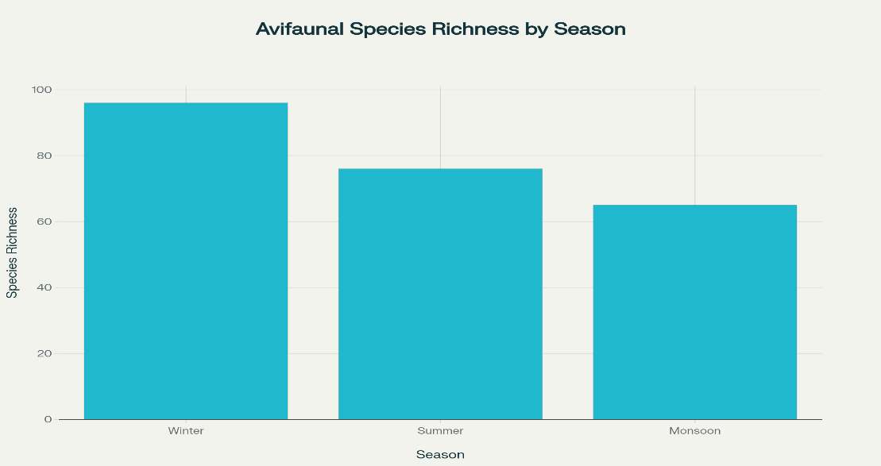
Fig 2. Seasonal variation in Avifauna at Kanhalgaon lake
3.3. Feeding Guild Composition

Fig 3.: Sitewise Feeding guild of Avifauna at Kanhalgaon Lak

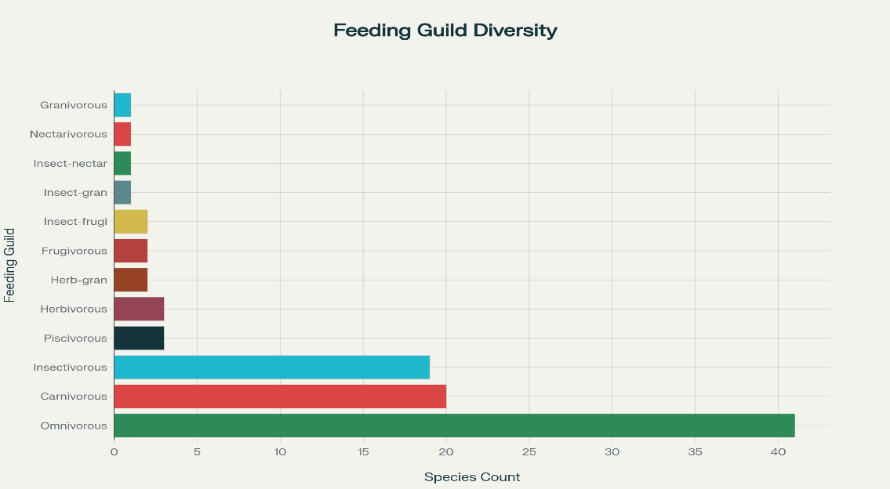
Fig 4. Overall feeding guild Status at Kanhalgaon Lake
The foraging and dietary habits of the recorded species were grouped into twelve feeding guilds (Table 1). The omnivorous guild was dominant, comprising 41 species (42.7%), followed by carnivorous (20.8%), insectivorous (19.8%), and piscivorous (3.1%). Other minor guilds included herbivorous (3), herbivorous–largely granivorous (2), insectivorous–frugivorous (2), frugivorous (2), insectivorous–granivorous (1), insectivorous–nectarivorous (1), nectarivorous (1), and granivorous (1).The predominance of omnivorous and insectivorous birds indicates trophic adaptability and functional diversity. (Fig. 3&4)

3.4. Diversity Indices
The diversity index analysis showed high avifaunal heterogeneity throughout the lake as well as in the surrounding habitats. Shannon–Wiener Diversity Index (H′) varied between 3.85,Simpson's Index (1 – D) varied between 0.97 Evenness (J′) varied between 0.84., Berger Parker_d approximately 0.052.These high values of diversity and evenness indicate a balanced avifaunal community with minimal dominance and high niche overlap among the species. . Fig

Fig.5.Diversity indices of Avifaunal Diversity at Kanhalgao Lake

Fig : 6 . Shanon index By each site at Kanhalgaon Lake

Fig : 7. Simson 1 -D index By each site at Kanhalgaon Lake
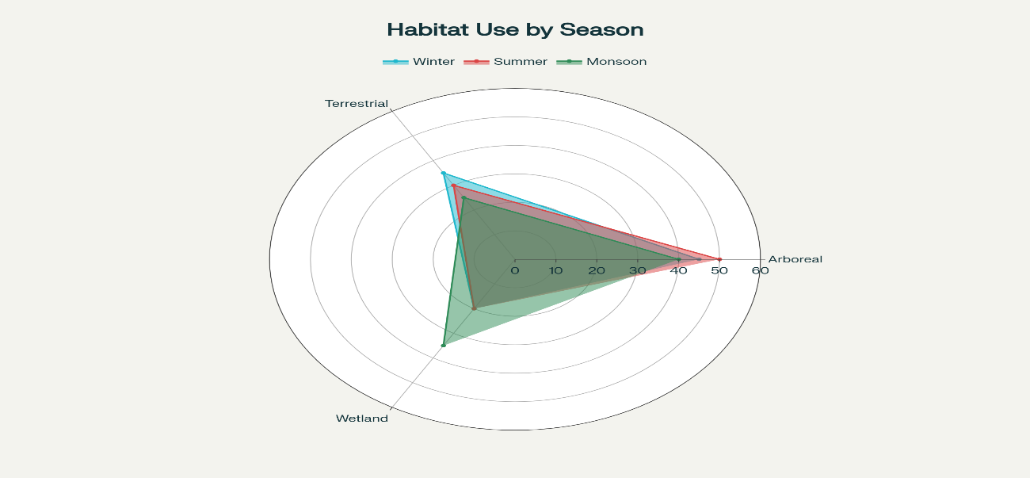
Fig 8. Habitat utilization by Avifauna at Kanhalgaon Lake
Present study shows the avifauna exploites three major strata of habitats: arboreal (tree-canopy species, 37%), terrestrial (ground-foraging species, 34%), and wetland (aquatic and semi-aquatic species, 29%). This co-existing of the ecological groups demonstrates the structural variety of the Kanhalgaon Lake ecosystem, harbouring species that span the entire spectrum from open-water piscivores (Ardea cinerea) to ground-foraging granivores (Ploceus philippinus).(Fig.8)
Out of the total 96 avian species recorded from Kanhalgaon Lake and its surrounding habitats, Species distribution research revealed varied levels of site occupancy. Of the combined assemblage, 43 species (44.8%) were restricted to one site to demonstrate specialization in habitat or localized distribution. 22 species (22.9%) co-occurred in two habitats with moderate adaptability, whereas 31 species (32.3%) co-occurred in all three habitats, reflecting broader ecological tolerance as well as habitat generalism. (Fig.9)

Fig.9. Species co -occurrence at Kanhalgaon lake
Widely distributed species included Nettapus coromandelianus, Anas acuta, Anastomus oscitans, Phalacrocorax fuscicollis, Ardeola grayii, Vanellus indicus, Merops orientalis, and Coracias benghalensis, which utilize multiple habitat types for foraging and roosting. Conversely, species such as Sarkidiornis melanotos, Netta rufina, and Psilopogon haemacephalus were recorded only from a single habitat, suggesting narrow ecological preferences or habitat sensitivity.
4. Discussion
4.1. Avifaunal Diversity and Community Structure
The rich avifaunal diversity documented from Kanhalgaon Lake (96 species, 15 orders, 41 families) is a testimony to the trophic complexity along with the ecological heterogeneity of the lake. Wetlands with surrounding agricultural fields, tree cover, along with human settlements typically host a microhabitat mosaic that supports diverse bird assemblages (Verma et al., 2025; Ali et al., 2024; Deshmukh et al., 2024). The preponderance of Passeriformes as the most abundant order suggests the provision of terrestrial as well as semi-aquatic domains with perching as well as breeding sites. High order representation of aquatic Pelecaniformes, Anseriformes, as well as Charadriiformes suggests the provision of aquatic prey as well as vegetation cover, important to resident as well as migratory waterbirds.
A corresponding set of records was also seen for Malkhed Lake (91 species; Ali et al., 2024), as well as in Shivapur Wetland (88 species; Lonkar et al., 2023), reinforcing the idea that medium to small-sized wetlands of central India are valuable hotspots of biodiversity.
Seasonal richness variation—where the winter maximum (96 species)> summer (76) and monsoon (65)—indicates obvious temporal bird composition turnover. The winter influx of Palearctic migrants like Anas acuta, Tringa glareola, and Motacilla flava accounts for the seasonal diversity spike. This agrees with Punde et al. (2025), as well as Sahu et al. (2025), who reported similar peaks in migratory activities throughout the December–February seasons within the central Indian wetlands. The concurrent co-existence of resident as well as migratory guilds is a testament to the ecological connectivity of Kanhalgaon Lake representing both breeding as well as wintering ground, reflecting its significance as a node in the Central Asian Flyway (BirdLife International, 2024; Mohiuddin et al).

4.3. Feeding Guild Structure and Trophic Dynamics
Guild feeding analysis revealed the prevalence of omnivorous (42.7%) and insectivorous (19.8%) species, reflecting their trophic variability and ecological adaptability. The high index of carnivorous and piscivorous species (23.9%) implies a stable trophic composition to maintain upper predators..Minor guilds, i.e., frugivorous, nectarivorous, and granivorous, augmenting the role played by the lake in the ecosystem functions (Loreau et al., 2022).
4.4. Diversity Indices and Habitat Heterogeneity
The Shannon–Wiener index is high (3.52–3.79 H′), as is the Simpson index (1–D = 0.91–0.95). This demonstrates the avian community to be highly diverse, as well as uniformly distributed. Such indexes suggest balanced competition, efficient niche partitioning, with minimum dominance of any specific species.The lake-margin environment with emergent macrophytes and nearby croplands had the highest diversity, consistent with the concept of the habitat complexity hypothesis (MacArthur & MacArthur, 1961), that is, that complex structures in the environment bear more species because of the wider variety of accessible niches.These values of diversity are similar to what has been reported in Ambazari Lake (H′ = 3.55) as well as Mansar Wetland (H′ = 3.62) (Joshi, B. C., & Bagri, H. 2025; Kulkarni, 2024; Muzaffar, S. S. 2022).The higher ratio of single-site species implies microhabitat variability, while the species distributed over a variety of sites imply ecological connectivity between nearby places of interest (wetland, agriculture, as well as roadside). Such diversity patterns agree with the study of Jha et al. (2022), as well as Singh & Kumar (2023), that the heterogeneity of the habitat will increase the coexistence of species as well as guild diversity of wetlands.
5. Conclusion
The study establishes Kanhalgaon Lake as a critical local biodiversity hotspot, playing a pivotal role in supporting both resident and migratory bird populations. The study reveals that Kanhalgaon Lake harbors a rich diversity of avifauna representing multiple feeding guilds and habitat preferences. The dominance of omnivorous and insectivorous birds, along with the occurrence of habitat specialists, indicates that the lake and its surrounding landscape provide diverse ecological niches. Conservation measures focusing on wetland maintenance, habitat connectivity, and community awareness are essential to sustain avian diversity in this region.
Disclaimer (Artificial intelligence)
Option 1:
Author(s) hereby declare that NO generative AI technologies such as Large Language Models (ChatGPT, COPILOT, etc.) and text-to-image generators have been used during the writing or editing of this manuscript.

References:
Ali, Z. K., Wagh, G., & Chaudhari, P. (2024). Diversity and abundance of wetland avifauna at Malkhed Lake of Amravati region, Maharashtra, India.International Journal of Fauna & Biological Studies, 11*(4A), 202–214.
Bibby, C. J., Burgess, N. D., Hill, D. A., & Mustoe, S. (2000).Bird census techniques* (2nd ed.). Academic Press.
BirdLife International. (2024).Central Asian Flyway conservation update: Migratory bird monitoring and wetland connectivity*. BirdLife International.
Deshmukh, G. D. (2024). Patterns of seasonal abundance and diversity in waterbird community of Padav Talav, Nagbhid, Maharashtra, India. International Journal of Life Sciences, 11*(3), 45–56.
Grimmett, R., Inskipp, C., & Inskipp, T. (2011).Birds of the Indian Subcontinent* (2nd ed.). Oxford University Press.
IMD. (2023).Climatological data of Maharashtra (2023)*. Indian Meteorological Department, Pune.
Muzaffar, S. S. (2022). Meeting the Demand: Achieving Zero Hunger through Balanced Food Supply and Demand. Agriculture Archives: an International Journal.
Jha, M., Sharma, P., & Raut, S. (2022). Habitat heterogeneity and avian community structure in central Indian wetlands.Indian Journal of Ecology, 49*(4), 921–930.
Koli, D. S., Sharma, A., & Mehta, P. (2021). Birds as indicators of environmental change: A review from Indian ecosystems.Journal of Ecological Indicators, 128*, 107822.
Kulkarni, R. R. (2024). Avifaunal diversity of Moharli Lake, near Tadoba Andhari Tiger Reserve, Chandrapur (Maharashtra).Environment Conservation Journal, 25*(1), 45–54.
Joshi, B. C., & Bagri, H. (2025). Seasonality of Leaf Fall and Litter Production in Sal (Shorea Robusta Gaertn. F.) ANR Forest in Tarai East Forest Division, Haldwani. Journal of Diversity Studies, 4(2), 1-9.
Mohiuddin Hussain Sohail Mohammed, Mohammed Shujath Ali Khan, Muffasil Mohiuddin Syed (2023). Remote Work Culture: The Impact of Digital Transformation on Workforce Productivity. Journal of e-Science Letters. DOI: https://doi.org/10.51470/eSL.2023.4.1.01
Babu, S., Darjee, S., & Alekhya, G. (2022). Enhancing Farmer Prosperity: Implementing Integrated Farming Systems for Increased Income. Agriculture Archives: an International Journal.
Betageri, S., & Kotresha, K. (2024). Seed morphometric with Embryo diversity of wild orchids in North Karnataka. Seed.
Verma, A., Singh, P., Bharti, P., & Kumari, A. (2025). Floristic Composition of Shahid Chandra Shekhar Azad Bird Sanctuary, Nawabganj, Unnao-A Ramsar Site. Environmental Reports; an International Journal.
National Wetland Atlas. (2011).Space Applications Centre (ISRO)*, Ahmedabad, India.
Roy, U. B. (2019). A Review of Common Ant Species in Karnataka, India: Biodiversity, Taxonomy, Ecology, and Public Health Implications. Environmental Reports; an International Journal.
Punde, S. B., Ghadi, A. A., & Kulkarni, M. N. (2025). Avian richness analysis of Wadaj Dam and Ghod River Basin, Maharashtra.Current World Environment, 20*(2), 128–140.
Sultana, N., Saini, P. K., Kiran, S. R., & Kanaka, S. (2023). Exploring the antioxidant potential of medicinal plant species: A comprehensive review. Journal of Plant Biota, 2(2).
Asma, J., Subrahmanyam, D., & Krishnaveni, D. (2023). The global lifeline: A staple crop sustaining two thirds of the world’s population. Agriculture Archives.
Gautam, S. K. (2019). The role of indigenous knowledge in biodiversity conservation: Integrating traditional practices with modern environmental approaches. Environmental Reports.
Nazneen, Sumera, and Ruksana Nausheed. "Exploring the Contribution of Botanical Families to Medicinal Ethnobotany." Journal of Plant Biota (2022).
Syngkli, R. B., VANLALRUATI, V., & RAI, P. (2024). Study on the impact of MikaniamicranthaKunthon soil chemistry, crop yields, andforest canopy in an Indo-Burma biodiversity hotspot region. ENVIRONMENTAL REPORTS Учредители: Research Floor, 6(2), 8-4.

