Microbial pollution in the muscle tissue of Siganus rivulatus from the Syrian Coast

Abstract
The marine environment plays an essential role in providing food resources, yet it is highly vulnerable to microbial contamination. This study aimed to evaluate the microbial load in the muscle tissue of Siganus rivulatus collected from two coastal sites in Tartous, Syria, and to identify the dominant microbial species. Fish samples were collected seasonally from September 2023 to August 2024. Total aerobic plate count (TAPC) and selective culture media were used for microbial identification. Results showed that the microbial load, ranged between (0.7×10² - 3×10²) cfu/g. It was higher at Tartous Corniche site, with the highest values recorded during summer. Detected microorganisms included Escherichia coli, Salmonella spp., Shigella sp., and Pseudomonas spp., all within the permissible limits of the Syrian Standard (10⁵–10⁶ cfu/g). These findings indicate that the fish are generally safe for human consumption, although continuous monitoring is recommended.
Keywords: Microbial load, Siganus rivulatus, Syrian coast, TAPC, fecal indicator bacteria, marine pollution.
1- Introduction:
Fish constitute an essential component of marine ecosystems and serve as a major source of protein for humans. In Syria, marine fish represent a significant portion of annual fish production, compared to 54% from freshwater fish (Syrian Agricultural Statistical Abstract, 2020). However, increasing pollution from industrial, domestic, and tourism activities threatens marine biodiversity and fish quality (FAO, 2012; Oehlenschlager, 2014), which has led to a decline in fish production and, in some cases, even its complete deterioration. Some fish species have disappeared due to food scarcity (Al-Shiwi, 2013; Sulaiman and Mohammad, 2017). Microbial contamination is particularly concerning due to its ability to affect fish health and pose risks to consumers (Garcia et al., 2015; Chong et al., 2023).
Fish is a highly perishable food source, susceptible to any change. Bacterial activity, coupled with autolysis by enzymes naturally present in fish flesh, accelerates spoilage and causes visible deterioration, rendering it unacceptable to consumers (Elbaz and Mohammad, 2022).
Microbes are in balance in healthy, live fish, but they can cause disease under stressful conditions (De Bruijn et al., 2018; Medina et al., 2023). After fish die, microbes attack and damage fish tissues (Sikorski et al., 2020). The autolysis of fish, due to the enzymes present, facilitates microbial attack on fish tissues through internal organs (Ghali, 2010), causing the emission of putrid odors and sometimes affecting the overall appearance of the fish species (Beverly, 2011). Some microbes produce toxins or byproducts called biotoxins, rendering fish unfit for human consumption without any visible spoilage. These toxins accumulate in fish tissues, leading to a condition known as histamine fish poisoning (Austin, 2006). This poisoning results from improper fish storage at unsuitable temperatures and an increase in amino acids like histamine, a phenomenon known as biological contamination (Begona et al., 1998). Fish tissue deterioration is attributed mainly to autolytic processes (due to the activity of the inherent tissue and digestive enzymes), bacterial activity (due to microbial enzymes), spontaneous chemical reactions (the oxidation of lipids/discoloration) and the loss of flesh compounds (Maria, 2019). It is important to note that some microbes may not be pathogenic to fish, but they can be transmitted directly to humans, causing disease. Microbial spoilage can lead to significant economic losses. It's estimated that approximately one-third of the annual global fish production is lost (Lund et al., 2000). Microbial activity is the primary cause of spoilage in most fresh foods and seafood. The total aerobic plate count in fish can indicate their storage suitability and expected shelf life (Huss et al., 1974; Al-Sharifi, 2014).
Siganus rivulatus, a herbivorous species with ecological and economic importance, serves as a suitable indicator of environmental pollution. This study investigates microbial contamination in its muscle tissue to assess the safety of fish harvested along the Tartous coast.
2- Materials and Methods:
A total of 48 specimens of Siganus rivulatus were collected seasonally from September 2023 to August 2024 from two coastal sites in Tartous: Basira (lower pollution impact) and Tartous Corniche (proximal to a sewage outlet). Fish samples were transported on ice and processed immediately (to minimize post-catch microbial proliferation) to determine some of bacteria species and the total aerobic plate count (TAPC).
Table 1: Sample Collection Sites
Site name | Site Coordinates
Basira | (35°53’21» N, 34°59’46» E)
Tartous Corniche | (35°52’57» N, 34°53’09» E)

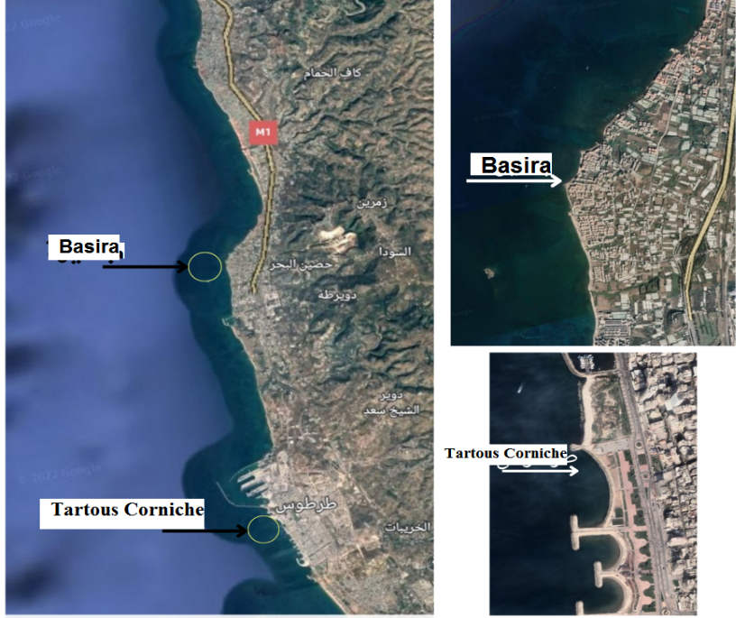
Figure 1: Study sites on the Tartus city coast (Google Earth):
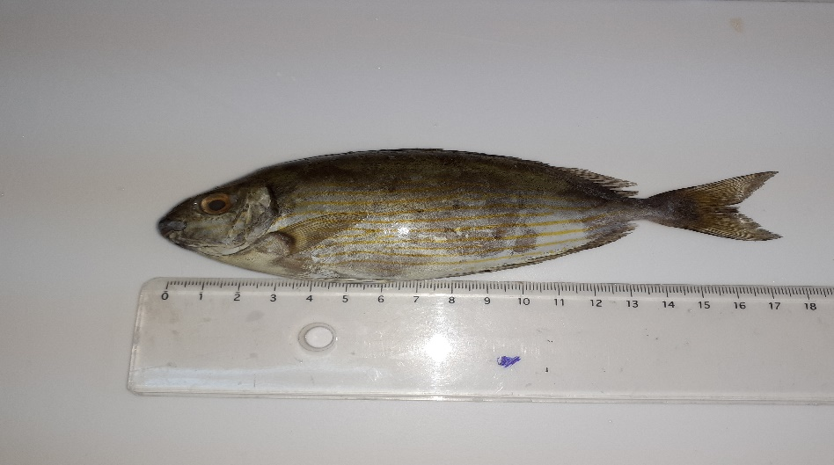
Figure 2: The Marbled spinefoot species Siganus rivulatus (Forsskål, 1775)
Five grams of muscle tissue were homogenized in sterile distilled water (Figures 3), and serial dilutions (10⁻¹–10⁻⁵) were prepared (Figures 4 & 5). One milliliter from each dilution was plated on nutrient agar and incubated at 37°C for 48 hours to determine total aerobic plate count (Figures 6 & 7). Selective media including MacConkey, Hektoen, SS agar, and XLD agar were used for microbial identification. Colonies were classified based on morphological characteristics. Microbial counts were expressed in cfu/g.

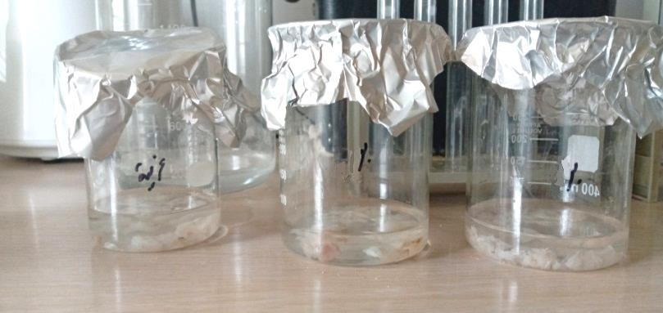
Figure 3: Solutions of the fish samples.
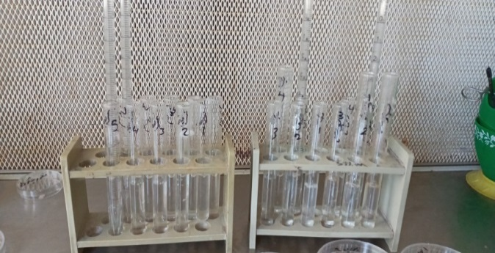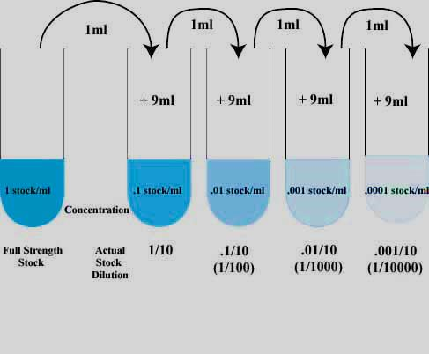
Figure 4: Dilutions of the solution (⅟10, ⅟100, ⅟1000, ⅟10000, ⅟100000).
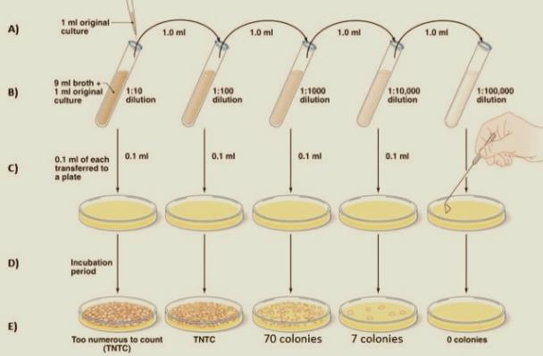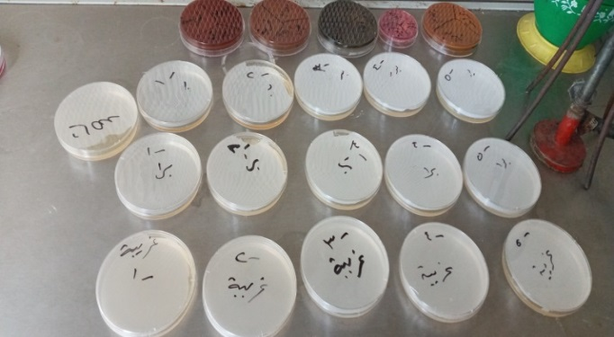

Figure 5: Distributing the solution dilutions in Petri dishes.

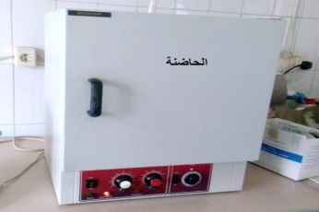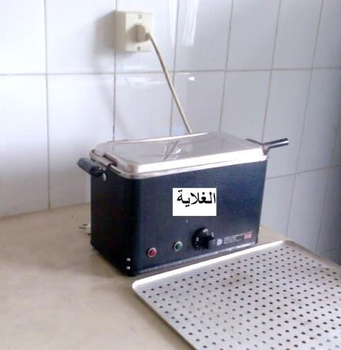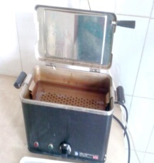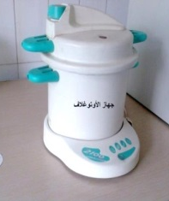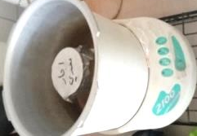
Figure 6: Preparation of nutrient media (agates) and incubation of Petri dishes.
Identification of some microbial species and genera:

The observed colony growth were counted using Coulter Colony counter according to plate count method. Identification of the organisms was done using the phenotypic and biochemical characteristics (Slaby et al., 1981; Cheesbrough, 1984). Six solid nutrient media were used in this study: Nutrient agar, McConkey agar, Hektoen agar, Shigella Salmonella (SS) agar, and Xylose Lysine Deoxycholate agar (Figure 7 & Table 4).

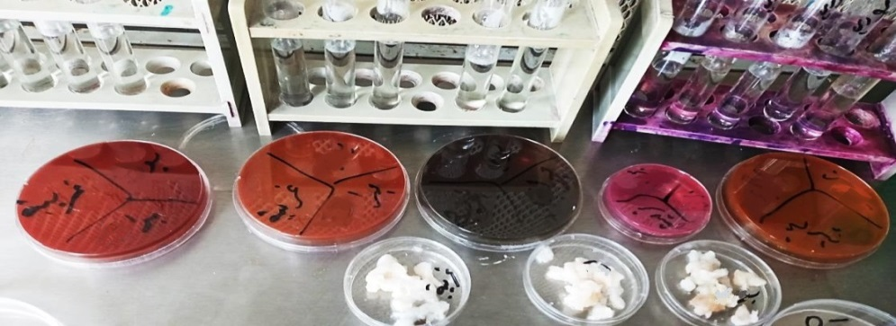

Figure 7: Growth of isolates bacterial on Nutrient Agar.

3- Results and Discussion
In this study, the total aerobic plate count (TAPC) for all the fish samples ranged between 0.7×10² and 3×10² cfu/g as shown in Table 2. Higher counts were observed at Tartous Corniche site, with the peak recorded during summer in both sites. Basira showed the lowest microbial counts throughout the year ranged between (0.7 -2.8) ×10² cfu/g. The TAPC values showed a significant spatial difference (p < 0.05) between Basira and Tartous Corniche, while no significant seasonal effect was detected (p > 0.05).
Identified microbes included Escherichia coli, Salmonella spp., Shigella sp., and Pseudomonas spp. All recorded values were within permissible limits according to the Syrian Standard (10⁵–10⁶ cfu/g). (Table 2 & Figure 9).

Table 2: Developments in total aerobic plate count during the study period:
Tartus Corniche | Basira | Season | Year
1.97 | 1.87 | Spring | 2023
2.33 | 2.50 | Summer | 2023
1.83 | 1.70 | Autumn | 2023
1.63 | 1.30 | Winter | 2023
2.37 | 0.80 | Spring | 2024
3.00 | 0.87 | Summer | 2024
2.10 | 0.73 | Autumn | 2024
1.90 | 0.70 | Winter | 2024
3.00 | 2.50 | Max
1.63 | 0.70 | Min
2.14±0.43 | 1.31±0.66 | Ave.± SD
The statistical analysis of the results show weak correlations. (r=0.05) between TAPC and stages of collecting samples. This might be related to the randomness of collected samples and the unknown variations in handling conditions that these fish were exposed to during the harvest.

.
Figure (8) Total aerobic plate count during the study period:
Identification of the Isolated Bacteria:
The isolates were identified following previously described methods (Fish and Service, 2010;
MacFaddin, 2000). In brief, colony morphology including shape, color, pigmentation, size, edges and elevation were determined and isolates grouped accordingly.
The culture results (Figures 9-10-11-12-13) showed the presence of microbial species on these media.

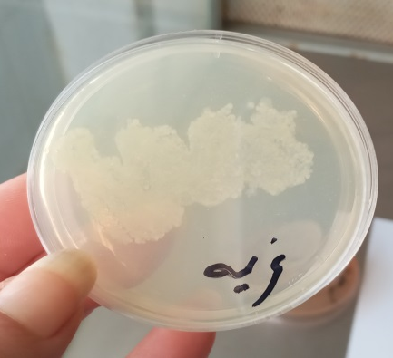
Figure (9): Colonies that appeared on a solid nutrient agar plate.
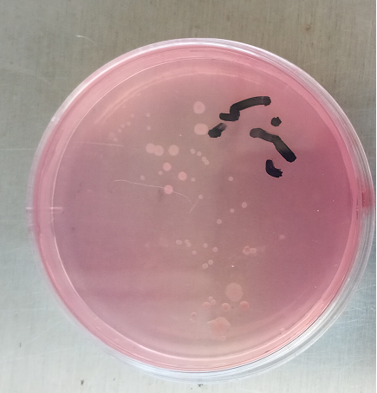
Figure (10): Colonies that appeared on a solid MacConkey agar plate.
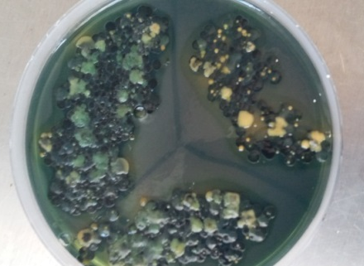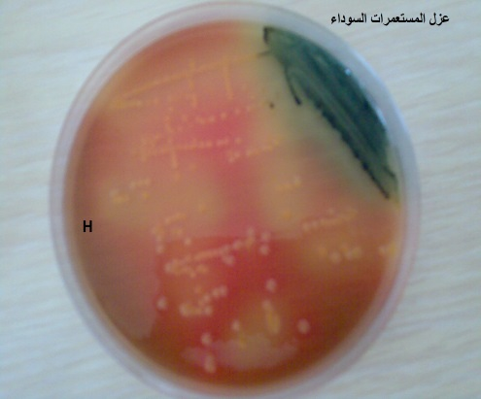
Figure (11): Colonies that appeared on a solid Hecton agar plate.

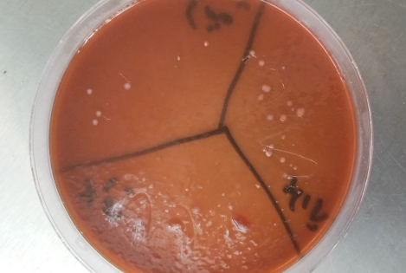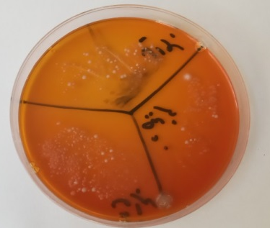
Figure (12): Colonies that appeared on a solid SS agar plate.
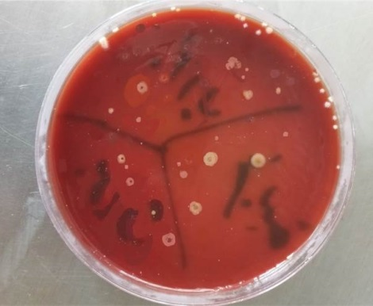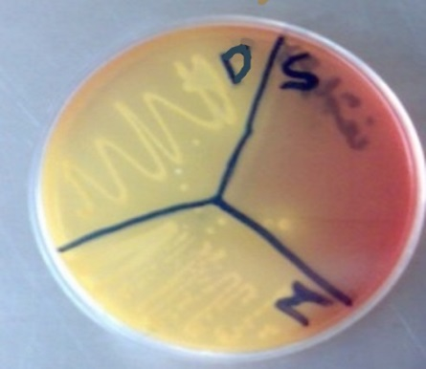
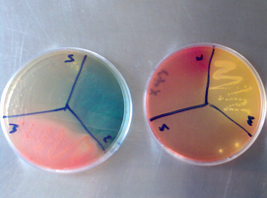
Figure (13): Colonies that appeared on a solid XLD agar plate.

Two (2) to three (3) representative isolates from each group were subjected to Gram staining, motility testing and a battery of biochemical tests including; oxidase, catalase, urease production, motility, manitol fermentation, sucrose fermentation, starch hydrolysis, H2S production and Gelatin test.

Table 3: Summary of biochemical tests
 | Salmonella |  |  | Shigella |  |  | E. coli
 | 1 | 2 | 3 | 1 | 2 | 3 | 1 | 2
Gram stain | - | - | - | - | - | - | - | -
Shape | Rod | Rod | Rod | Slender bacilli | Slender bacilli | Slender bacilli | Small rod | Small rod
Catalase Production | + | + | + | + | + | + | + | +
Oxidase test | - | - | - | - | - | - | - | -
Urease production | - | - | - | - | - | - | - | -
Motility test | + | + | + | - | - | - | + | +
Manitol Fermentation | + | + | + | + | + | + | + | +
Sucrose Fermentation | + | + | + | + | + | + | + | +
Starch hydrolysis | + | + | - | + | + | + | + | +
H2S production | - | - | - | + | + | - | + | +
Gelatin test | - | - | - | + | + | - | + | +
+: Positive, -: negative
Fish are highly nutritious, easily digestible, and low in calories and saturated fat, unlike red meat and poultry. They are among the most important sources of unsaturated fats, specifically long-chain fatty acids, which are harmless and cannot be synthesized by the human body (Bener et al., 2009; Colangelo et al., 2009; Taşbozan & Gökçe, 2017).
The results of the total aerobic plate count showed that The proximity of Tartous Corniche to sewage discharge explains the increased bacterial counts relative to Basira, as there are many organic materials that these microbes use for nutrition (Kumar et al., 2023).
Microbial loads were significantly influenced by environmental conditions, and the fishing season, with higher temperatures promoting bacterial growth during summer (Baixas et al., 2009; Ikape, 2017; Ali et al., 2021). Therefore, fish are kept at a low temperature immediately after caught (Mohammed & Hamid, 2011; Sikorski, 2020). This affects the transport of nutrients into and out of the cell, which in turn reduces cellular metabolic activity and inhibits microbial growth. Consequently, this delays the chemical and physical changes that may occur in the fish due to microbial activity, thus improving their preservation. In good condition for a longer period of time (Kilinc et al., 2007; Álvarez et al., 2008; Foteini and Leblanc et al., 2015). In addition to the effect of the dissolved oxygen level in the water, which microbes need for their functions and the decomposition of organic matter, the type of fish, its health and physiological condition, and the nets used in fishing may all play a role in the presence of microbes. The fish's feeding pattern may also be a factor (Rahman et al., 2010), as these microbes travel to the intestines and reach various tissues via the bloodstream, including fleshy tissue (Sikorski et al., 2020; Zheng et al., 2023).
The isolation of Salmonella, Shigella, and E.coli indicate faecal and environmental pollution (Yagoub, 2009). Salmonella has been considered the causal agent of the largest number of enteric infections in the world (Bell and Kyriakides, 2002). The organism E. coli is recognized as the reliable indicator of faecal contamination in small numbers and in large numbers (Ezeet al., 2011) This was attributed to the heavy load of sewage disposal into the seas which could act as a suitable environment for the growth and survival of the human pathogens. The levels of pathogenic microorganisms detected, although within acceptable limits, highlight the need for ongoing monitoring, especially in areas close to pollution sources.
- Conclusion and Recommendations
Siganus rivulatus collected along the Tartous coast is generally safe for consumption, as microbial levels did not exceed national permissible limits. However, wastewater management must be improved to prevent future contamination. Routine monitoring and stricter environmental regulations are recommended to protect public health and marine biodiversity.

- Disclaimer (Artificial intelligence)
Author hereby declare that NO generative AI technologies such as Large Language Models (ChatGPT, COPILOT, etc.) and text-to-image generators have been used during the writing or editing of this manuscript.

References:
- Al-Sharifi, Aqil (2014). Potential pollution of some heavy metals and some environmental factors of the waters of the Bani Hassan stream in Karbala Governorate, Iraq. Master's thesis, College of Science, University of Babylon, Iraq, 91 pages. https://uokerbala.edu.iq/wpcontent/uploads/2019/12/%D8%B1%D8%B3%D8%A7%D9%84%D8%A9-%D9%85%D8%A7%D8%AC%D8%B3%D8%AA%D9%8A%D8%B1-%D8%B9%D9%82%D9%8A%D9%84%D8%A7%D9%84%D8%B4%D8%B1%D9%8A%D9%81%D9%8A.pdf

- Al-Shiwi, Abdul Salam. (2013). International protection of the aquatic environment from pollution. Scientific Journal of the Colleges of Commerce Sector - Al-Azhar University . (10) 422-536. https://doi.org/10.21608/jsfc.2013.26154

- Ali, A., Ishag I., Al-Shobaki K., Balal D., Jab allah A., Khaled S.and Alkhawaja H. (2021). Microbial contamination in the Tobruk Bay basin. International Journal of Multidisciplinary Sciences and Advanced Technology, Special Issue (1) 663–667. https://www.researchgate.net/publication/350961817_Microbial_contamination_in_the_Tobruk_Bay_basin

- Álvarez, A., García, B., Garrido, M.D. & Hernández, M.D. (2008). The influence of starvation time 451 prior to slaughter on the quality of commercial-sized gilthead seabream (Sparus aurata) during ice 452 storage. Aquaculture, 284. :106–114. https://doi.org/10.1016/j.aquaculture.2008.07.025

- Austin, B. (2006). The bacterial microflora of fish, revised. The scientific world journal, 6(1), 931-945.‏ https://doi.org/10.1100/tsw.2006.181

- Begona, B., C. Craven, and H. An. (1998). Histamine formation in albacore muscle analyzed by AOAC and enzymatic Methods. J. of Food Sci. 63(2):210-214. https://doi.org/10.1111/j.1365-2621.1998.tb15711.x

- Baixas, S., Bover, S., Veciana, M.T. & Vidal, M.C. (2009). Effect of 463 gutting on microbial loads, sensory properties, volatile and biogenic amine contents of European 464 Hake (Merluccius merluccius var. mediterraneus) stored in ice. Journal of Food Protection, 72. 465: 1671- 1676. https://doi.org/10.4315/0362-028x-72.8.1671

- Bener, A.; Al-Ali, M. and Hoffmann, G. F. (2009). Vitamin D Deficiency in Healthy Children in a Sunny Country: Associated Factors. International Journal of Food Sciences, 60: S5, 60-70. https://doi.org/10.1080/09637480802400487

- Beverly, Steve. (2011). Proper fish handling for quality and safety. SPC Fisheries Newsletter #134 - January/April, 29. (3):31-32 . https://www.spc.int/digitallibrary/get/a7ve6

- Cheesbrough, M. (1984). Medical laboratory for tropical countries, 1st edn. Green Britain of the University Press Cambridge, UK. https://books.google.com/books?id=f_XCAAAAMAAJ

- Chong, C. M., Shakir, M. Z., Lai, K. S., Liew, H. J., & Loh, J. Y. (2023). Microbes and fish diseases. In Recent advances in aquaculture microbial technology (pp. 65-102). Academic Press.‏ https://doi.org/10.1016/B978-0-323-90261-8.00009-2

- Colangelo, L. A.; HE, K.; Whooley, M. A.; Daviglus, M. L. and Liu, K. (2009). Higher Dietary Intake of Long-Chain ω-3 Polyunsaturated Fatty Acids Is Inversely Associated with Depressive Symptoms. Nutrition, 25. (10): 1011-1019. https://doi.org/10.1016/j.nut.2008.12.008

- de Bruijn, I., Liu, Y., Wiegertjes, G. F., & Raaijmakers, J. M. (2018). Exploring fish microbial communities to mitigate emerging diseases in aquaculture. FEMS Microbiology Ecology, 94(1), fix161.‏ https://doi.org/10.1093/femsec/fix161

- Dural, M.; Goksu, M.Z.L. and Ozak, A.A. (2007). Investigation of heavy metal levels in economically important fish species captured from the Tuzla Lagoon. Food Chem., 102: 415-421 . https://doi.org/10.1016/j.foodchem.2006.03.001

- Elbaz, Naglaa F. and Mohammad E. Abd Al Fatah. Bacterial diseases outbreaks in some freshwater fish farms in Kafr El-Sheikh, Egypt. Journal of Applied Aquaculture 36 (2022): 1 - 23. https://doi.org/10.1080/10454438.2022.2105673

- Foteini, F; I. Yoshida; and J.C. Leblanc. (2015). Microbiological spoilage and volatiles production of gutted European sea bass stored under air and commercial modified atmosphere package at 2_C .Food Microbiology. 44: 50-53. https://www.sciencedirect.com/science/article/pii/S074000201500057X

- FAO, 2012. The State of World Fisheries and Aquaculture. FAO Fisheries and Aquaculture Management – ​​Food and Agriculture Organization of the United Nations, Rome. http://www.fao.org/docrep/016/i2727e/i2727e.pdf

- Garcia JC, Martinez DT, Alves OL, Leonardo AFG, Barbieri E. (2015). Ecotoxicological effects of carbofuran and oxidized multiwalled carbon nanotubes on the freshwater fish Nile tilapia: Nanotubes enhance pesricide ecotoxicity. Ecotoxicol. Environ. Saf., 111. 131–137. https://doi.org/10.1016/j.ecoenv.2014.10.005

- Ghaly, A. E., Dave, D., Budge, S., & Brooks, M. S. (2010). Fish spoilage mechanisms and preservation techniques. American journal of applied sciences, 7(7), 859. https://doi.org/10.3844/ajassp.2010.859.877

- Huss, H.H., D. Dalsgaard, L. Hansen, H. Ladefoged, A. Pedersen and L. Zittan. (1974). The influence of hygiene in catch handling on the Torage life of iced cod and plaice. J. Food Technol. 9.: 213-221. https://doi.org/10.1111/j.1365-2621.1974.tb01765.x

- Ikape, S. I. (2017). Fish spoilage in the tropics: A review. Octa Journal of Biosciences, 5(2).‏ http://sciencebeingjournal.com/octa-journal-of-biosciences-fish-spoilage-in-the-tropics-a-review/

- Kilinc, B., Cakli, S., Cadun, A., Dincer, T. & Tolasa, S. (2007). Comparison of effects of slurry ice and 559 flake ice pretreatments on the quality of aquacultured sea bream (Sparus aurata) and sea bass 560 (Dicentrarchus labrax) stored at 4 degrees ºC. Food Chemistry, 104.: 1611-1617. https://doi.org/10.1016/j.foodchem.2007.03.002

- Kumar, V., Sehgal, R., & Gupta, R. (2023). Microbes and wastewater treatment. In Development in Wastewater Treatment Research and Processes (pp. 239-255). Elsevier https://doi.org/10.1016/C2020-0-03289-5
‏
- Maria, A. (2019). Shelf life extension and improvement of the nutritional value of fish fillets through osmotic treatment based on the sustainable use of Rosa damascena distillation by-products. Foods. 8: 421. https://doi.org/10.3390/foods8090421

- Medina‐Félix, D., Garibay‐Valdez, E., Vargas‐Albores, F., & Martínez‐Porchas, M. (2023). Fish disease and intestinal microbiota: A close and indivisible relationship. Reviews in Aquaculture, 15(2), 820-839.‏ https://doi.org/10.1111/raq.12762

- Mohammed, I. M. A., & Hamid, S. H. A. (2011). Effect of chilling on microbial load of two fish species (Oreochromis niloticus and Clarias lazera). Food and Nutrition, 1(3), 109-113.‏ https://doi.org/10.5251/ajfn.2011.1.3.109.113

- Oehlenschlager, J. (2014). Seafood quality assessment. In: Boziaris, I.S. (Ed.), Seafood Processing, IFST Advances in Food Science Series. Technology, Quality & Safety Wiley- Blackwell, West Sussex, UK, pp. 361-386. https://doi.org/10.1002/9781118346174.ch14

- Rahman, M. S., Hasan, M., Mahmud, Z. H., & Islam, M. S. (2010). Bacterial load in twelve freshwater fishes of four feeding habits in Bangladesh. Dhaka University Journal of Biological Sciences, 19(2), 145-150.‏ https://doi.org/10.3329/dujbs.v19i2.8956

- Sikorski, Z. E., Kołakowska, A., & Burt, J. R. (2020). Postharvest biochemical and microbial changes. In Seafood (pp. 55-75). CRC Press.‏ https://doi.org/10.1201/9781003068419

- Sikorski, Z. E. (2020). Chilling of fresh fish. In Seafood (pp. 93-109). CRC Press.‏ https://doi.org/10.1201/9781003068419-8

- Slaby, B.M.; R.E. Martin; and G.E Ramsdell (1981). Reproducibility of microbiological counts on frozen cod: A collaborative study. J. Food Sci., 46(3): 716 719. https://doi.org/10.1111/J.1365-2621.1981.TB15333.X

- Sulaiman, Sheem; Hassan, Muhammad. (2017). Physical, chemical, and microbial spoilage of fish (a reference study). Jordanian Journal of Agricultural Sciences, 13 (1): 265-279.https://archives.ju.edu.jo/index.php/jjas/article/view/15304/7460
- Syrian Agricultural Statistical Collection. (2020) Fish production for 2020 and its development at the national level during the period (2011-2020) - Ministry of Agriculture and Agrarian Reform in Syria, Statistical Collections, Chapter 5, Farm Animals and Their Products. https://moaar.gov.sy/index.php?node=5610&cat=5610

- Taşbozan, O., & Gökçe, M. A. (2017). Fatty acids in fish. Fatty acids, 1, 143-159.‏ https://doi.org/10.5772/68048

- Zheng, Y., Zhu, H., Li, Q., & Xu, G. (2023). The effects of different feeding regimes on body composition, gut microbial population, and susceptibility to pathogenic infection in largemouth bass. Microorganisms, 11(5), 1356.‏ https://doi.org/10.3390/microorganisms11051356

