Seaweed Diversity along the Southern Kerala Coast: A Comparative Study from Kovalam and Ernakulam

ABSTRACT
Seaweeds, or marine macroalgae, are primitive, non-flowering photosynthetic organisms that inhabit intertidal and subtidal zones and constitute an important renewable marine resource. This study explored the diversity of seaweeds and the physicochemical characteristics of coastal waters in Kovalam (Hawaii) and Ernakulam (Nayarambalam and Kuzhupilli), Kerala. Eight seaweed samples were collected from rocky intertidal substrata across these locations, with only two species documented from the Ernakulam region. Among the collected specimens, Ulva fasciata Delile, Caulerpa peltata J.V. Lamouroux, and Chaetomorpha antennina Kützing were identified as green algae, while Gracilaria corticata J. Agardh, Hypnea bullata Kundu & Patel, and Asparagopsis taxiformis belonged to the red algae. The remaining two species—Scytosiphon lomentaria J. Agardh and Sargassum wightii (Greville) J. Agardh—were brown algae reported exclusively from Kovalam. Ulva fasciata Delile and Chaetomorpha antennina Kützing were the two green algal species recorded from the Ernakulam coastal waters. Evaluation of seven major physicochemical parameters (pH, total dissolved solids, salinity, temperature, dissolved oxygen, nitrate, and phosphate) revealed slightly alkaline, warm, and saline waters with elevated dissolved solids, conditions favorable for sustaining diverse macroalgal communities.
Key words: Seaweeds, Physio chemical parameters, Kerala, Kovalam, Ernakulam Coastal water

INTRODUCTION
Marine ecosystems rely heavily on seaweeds, which enhance ecosystem structure, support nutrient cycling, and sustain diverse marine life. As macroscopic, multicellular, and benthic marine algae, seaweeds form an essential component of these ecosystems and represent an important renewable natural resource. These organisms are broadly classified into three major groups—Chlorophyceae (green algae), Rhodophyceae (red algae), and Phaeophyceae (brown algae)—based on their characteristic pigmentation and biochemical composition (El-Beltagi et al., 2022). Globally, more than 20,000 species of seaweeds have been identified, highlighting their vast biodiversity and ecological significance. Beyond their ecological role, seaweeds possess substantial economic importance, serving as valuable sources of food, fodder, fertilizers, and raw materials for various industries (Yadav et al., 2015). They serve as important raw materials for various industrial products, including agar, algin, and carrageenan (Manivannan et al., 2008). Along the southwestern coast of India, Kerala hosts approximately 580 km of diverse coastal habitats that provide favourable conditions for seaweed growth and distribution (Mookkan et al., 2015). Within this region, Kovalam stands out as a prominent coastal area where marine biodiversity thrives amidst the challenges of coastal development, reflecting the intricate balance between natural resource utilization and environmental sustainability (Ghosh & Datta, 2012).
MATERIALS AND METHODS
Study area
Seaweed samples were randomly collected during low-tide periods from the coastal waters of Thiruvananthapuram (Latitude: 8.386524⁰, Longitude: 76.975965⁰) and Ernakulam (Latitude: 10.051881⁰, Longitude: 76.202508⁰), representing two ecologically distinct sites along the southwest coast of Kerala. The three selected sites are described below
Kovalam
The Kovalam coast, situated in the Thiruvananthapuram district of southern Kerala, boasts a mixed rocky–sandy shoreline along the Arabian Sea. Geographically positioned at approximately 8.400°N, 76.980°E, this coast experiences a tropical maritime climate characterised by pronounced southwest and northeast monsoons, which significantly influence tidal patterns, wave dynamics, and nutrient influx. The intertidal zone features rocky platforms, tidal pools, and scattered boulders that support diverse seaweed communities and associated marine flora and fauna (Manisseri et al., 2012).
Ernakulam
The Ernakulam coastal region of Kerala forms part of the southwest coast of India and includes approximately 46 km of shoreline within the district. The coastal waters of Nayarambalam and Kuzhupally are situated along the western fringe of Vypin Island in Ernakulam. Nayarambalam is characterized by its direct exposure to the Arabian Sea on the west and its connection to the Veeran Puzha/backwater system on the east. Kuzhupally likewise fronts the Arabian Sea, featuring sandy beach stretches backed by coconut groves and lying in close proximity to lagoonal and backwater channels toward the east. This coastal environment is influenced by a micro-tidal regime typical of this sector of the Kerala coast (Sankar & Ramachandran, 2015).
Seaweed sampling
Seasonal sampling was carried out such that seaweeds from Thiruvananthapuram were collected during the autumn and winter months, whereas samples from Ernakulam were collected exclusively during the winter season. Immediately after collection, the specimens were gently washed with fresh water to remove adhering sand particles, epiphytes, and other impurities, ensuring the structural integrity of the thalli. The cleaned samples were then preserved in 4% formalin solution to maintain their morphological characteristics for subsequent analysis. The taxonomic identification and authentication of the collected specimens were meticulously performed using literature reviews (Sowjanya & Sekhar, 2017; Clayton, 1978; Kundu & Bast, 2021).
Determination of Physico-Chemical Parameters of Coastal Waters
The physicochemical characteristics of the coastal waters, including temperature, salinity, dissolved oxygen (DO), total dissolved solids (TDS), nitrate, and phosphate, were systematically analyzed to assess the environmental quality of the study sites. Temperature and TDS were measured using a calibrated TDS meter, while salinity was determined with the aid of a salinometer. Dissolved oxygen concentrations were estimated following Winkler’s iodometric method (Carvalho et al., 2021), ensuring precise quantification of oxygen levels in the water samples. Furthermore, nitrate and phosphate concentrations were determined using the UV spectrophotometric method and the ascorbic acid (molybdenum blue) method (Dash et al., 2017).

RESULTS AND DISCUSSIONS
During the study period, a total of eight seaweed samples were collected from the rocky substratum in the intertidal zones of Kovalam and Ernakulam coastal waters. Among these, three species—Ulva fasciata Delile, Caulerpa peltata J.V. Lamouroux, and Chaetomorpha antennina Kützing—were identified as green algae. Three species belonged to the red algae, namely Gracilaria corticata J. Agardh, Hypnea bullata Kundu & Patel, and Asparagopsis taxiformis. The remaining two species, Scytosiphon lomentaria J. Agardh and Sargassum wightii (Greville) J. Agardh, were classified as brown algae.
From the Ernakulam coast, two seaweed species were recorded: Ulva fasciata Delile and Chaetomorpha crassa (C. Agardh) Kützing, representing the green algae. All seaweed specimens were taxonomically identified and verified using samples collected from the Kovalam coastal waters. The panoramic view of the collection sites and the identified seaweed species is presented in Figures 1 and 2.
Seven key physicochemical parameters of the Kovalam coastal waters were assessed during the study period. The pH was 8.3, indicating slightly alkaline conditions, while the water temperature measured 32.3 °C. Salinity was recorded at 40‰, and dissolved oxygen, determined using Winkler’s iodometric method, was 4.4753 mL/L. Total dissolved solids (TDS) reached 96,000 ppm, reflecting the high ionic load characteristic of coastal ecosystems. Nitrate and phosphate concentrations were 7.99 mg/L and 0.46 mg/L, respectively. Complementing these observations, seaweed collections from the Ernakulam coastal waters were conducted at two sites—Nayarambalam and Kuzhupilly—where the environmental parameters were similarly documented. At Naryarambalam, the pH was 8.4, the temperature was 33.8 °C, salinity was 32‰, and TDS measured 526 × 10 ppm. At Kuzhupilly, the pH was slightly higher at 8.5, with a temperature of 34 °C, salinity of 33‰, and TDS of 633 × 10 ppm. Together, these measurements provide a comprehensive baseline of the physicochemical conditions prevailing across the sampling regions.
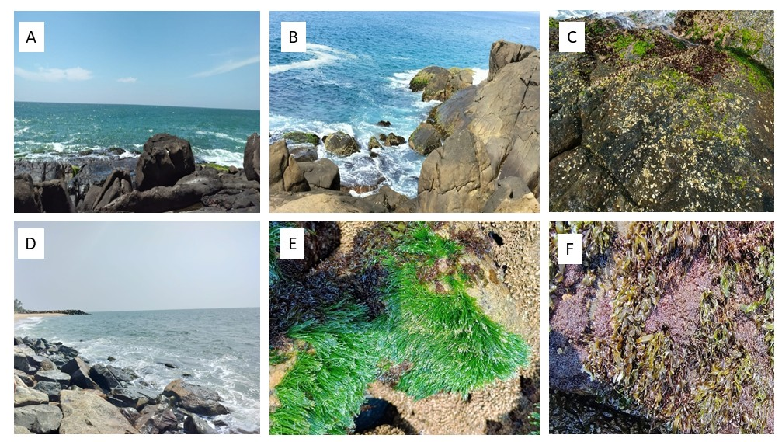
Figure 1: Panoramic view of Sample site
Kovalam (A, B) and Ernakulam Coastal water (D)
C, F- Close view of dense growth of Ulva fasciata on rocks, E- Chaetomorpha growth on rocks
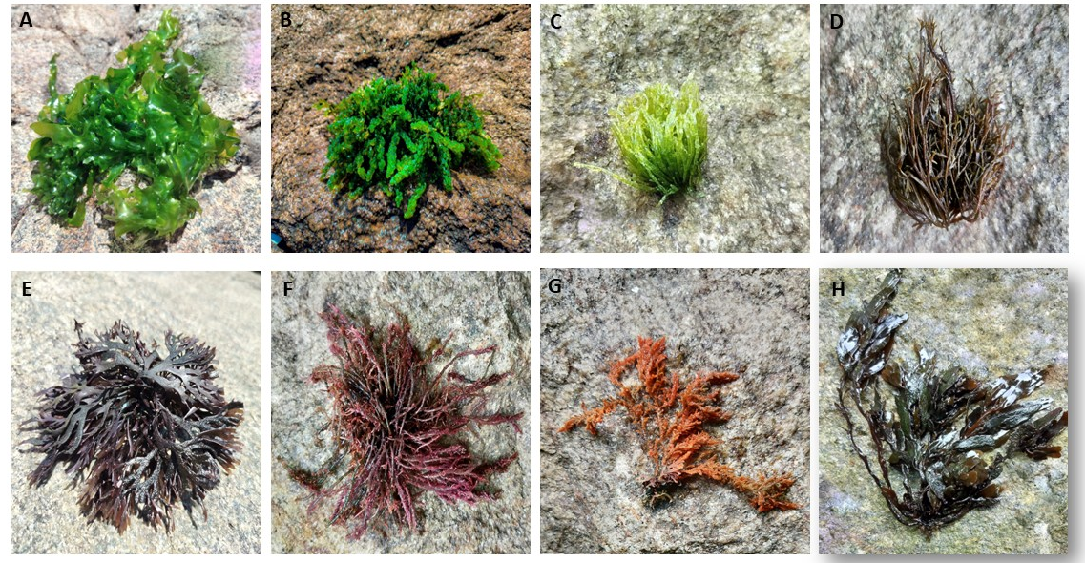

Figure 2. Identified Seaweed Species
A- Ulva fasciata Delile, B- Caulerpa peltata J.V Lamourouk, C- Chaetomorpha antennina Kuetzing, D- Scytosiphon lomentaria J. Agardh, E- Gracilaria corticata J. Agardh,F- Hypnea bullata Kundu & Past, G- Asparagopsis taxifomis Delile, H- Sargassum wightii (Greville) J. Agardh

Morphological description of samples
- Ulva fasciata Delile
Thallus dark-light green in colour, usually 8-50 cm long but can grow even up to 2 m long, 5-20 cm wide at base, leafy, ribbon shaped, mostly gregarious, tufted, lithophilic. Holdfast small, rhizoidal, tufted, firmly attached. Stipe small, foliaceous, simple or branched, up to 2 cm long and 0.8 cm wide. Fronds leafy, deeply divided into several linear blades; blades 2-5 cm wide, almost uniformly flattened in middle portion, surface smooth, membranous, irregularly lobed, gradually tapering towards apex, margins entire to frequently undulate, apex acute to obtuse
- Caulerpa peltata J.V. Lamour
Thallus dark-bright green in colour, rhizomatous, 3-15 cm long, tufted, growing as patches, prostrate, stoloniferous, epilithic. Holdfast rhizoidal, colourless, stout, variable in length, often loosely attached on rocky substrata in intertidal belts. Fronds cornsist of creeping stolons and erect assimilators. Stolon stalked, slender to terete, up to 1.8 mm in diameter, colourless to blackish green in older regions, tufted, branched. Assimilators usually arranged at intervals of 1.4-5 cm long, cylindrical, 2-6 cm long, simple or branched with radially arranged ramuli; ramuli peltate, disc like, smooth, entire, 2-5 mm in diameter; rachis 1.4-2 × 0.5-1 mm
- Chaetomorpha antennina Kuetzing
Thallus dark green in colour, 5-15 cm long, filamentous, brush like, caespitose, tufted, erect, growing gregariously, lithophilic. Holdfast small, rhizoidal, irregularly branched, attached tightly on rocky and muddy substrata in the tidal or intertidal zones. Stipe and fronds undifferentiated, filamentous, differentiated into nodes and internodes, unbranched, uniseriate, cylindrical or barrel shaped with regular nodes and internodes; basal cells long, usually barrel shaped with narrow base; apical cell with acute apices.
- Scytosiphon lomentaria J. Agardh
The fronds are cylindrical, shiny, and olive-brown, remaining unbranched and reaching lengths of up to 400 mm. Each frond arises from a short stalk, with multiple fronds often emerging from a single holdfast. They broaden to 3–10 mm before tapering again toward the tip. The fronds are hollow and commonly exhibit irregular constrictions.
- Gracilaria corticata J. Agardh
Thallus light-dark brownish or yellowish red in colour, flattened, 5-20 cm long, bushy, tufted, cartilaginous, rigid, epilithic. Holdfast small, discoid, up to 5 mm in diameter, firmly attached on rocky substrata in tidal and intertidal areas. Stipe flattened, rigid, 0.4-2 cm long and 1.5-3 mm wide. Fronds cartilaginous, flattened to slightly cylindrical, up to 18 cm long and 1.4-3 mm wide; regularly dichotomously branched with narrow segments; surface usually smooth; margins entire; apex mostly acute to narrowly obtuse, rarely proliferated.
- Hypnea bullata Kundu & Past
It is characterized by a prostrate thallus reaching up to 1.5 cm in height, with a highly anastomosed structure. The axial cell is encircled by periaxial cells of equal or smaller size. Tetrasporangia occur near the base of the branchlets, and lenticular thickenings are present.
G- Asparagopsis taxifomis Delile
Thallus pink to purple red in colour, frondose, bushy, gregarious, brush like, usually 4-20 cm long and 1-3 cm wide, rigid, erect or prostrate, epilithic. Holdfast small, rhizomatous, arising from the creeping stolon’s, attached firmly on calcareous stones and bedrocks in intertidal zones. Stipe uniaxial, erect, cylindrical to terete, variable in size, Fronds cylindrical to terete, up to 15 cm long, usually naked below gradually becoming shortened towards apex, sub-opposite, pinnate, further divided into branchlets in all directions, densely covering the main axis in upper region; apex portion often incurved.
H - Sargassum wightii (Greville) J. Agardh
Thallus dark brown in colour, becomes black after drying, usually 10-30 cm long, bushy, tufted, erect, epilithic. Holdfast discoid, 1-3 mm wide, stout, occasionally calcified, firmly attached on rocky substrata. Stipe stalked, cylindrical to terete, 1-3.6 mm wide, rough, occasionally calcified in older thallus. Fronds well developed, forming bushy appearance, differentiated into primary and secondary branches; primary branches cylindrical-terete, 5-25 cm long and 1.5-5 mm wide, usually glabrous; secondary branches cylindrical or terete, occasionally slightly compressed in upper region, alternately arranged; leaves develop on primary as well as on secondary branches, narrowly oblong-linear or lanceolate, 2-8 × 0.6-1 cm, alternate, stalked or subsessile; stalk up to 2 mm long; base cuneate; surface glabrous or rough, thick; midrib usually inconspicuous; margins entire to wavy or sinuate; apex broadly acute.
CONCLUSION
The present study provides a comprehensive assessment of seaweed diversity and coastal water quality along the Kovalam and Ernakulam shores of Kerala. A total of eight seaweed species representing green, red, and brown algae were documented, with Ulva fasciata and Chaetomorpha antennina occurring frequently across both regions. The physicochemical analyses revealed slightly alkaline, warm, and saline waters with high dissolved solids, conditions that support the growth of diverse macroalgal communities. The environmental parameters recorded at Narayambalam and Kuzhupilly further confirmed comparable coastal characteristics influencing species distribution. Overall, these findings establish a valuable baseline for understanding seaweed biodiversity in these coastal ecosystems and provide essential reference data for future ecological monitoring and biotechnological explorations.
Competing interest declaration
The authors declare that they have no competing interests related to this work.

Reference
- Dash, S., Behera, R. K., Pati, A., Mohapatra, P. K., Sarangi, R. K., Raut, D., & Patnaik, L. (2016). Sea water nutrient analysis methods. In *Water Research and Technology* (pp. 75-89). Bhumi Publishing..
- Carvalho, A., Costa, R., Neves, S., Oliveira, C. M., & Bettencourt da Silva, R. J. N. (2021). Determination of dissolved oxygen in water by the Winkler method: Performance modelling and optimisation for environmental analysis. Microchemical Journal, 165, 106129. https://doi.org/10.1016/j.microc.2021.106129 .
- Clayton, M. N. (1978). Morphological variation and life history in cylindrical forms of Scytosiphon lomentaria (Scytosiphonaceae: Phaeophyta) from southern Australia. Marine Biology, 47(4), 349–357. https://doi.org/10.1007/BF00388926 .
- El-Beltagi, H. S., Mohamed, A. A., Mohamed, H. I., Ramadan, K. M. A., Barqawi, A. A., & Mansour, A. T. (2022). Phytochemical and Potential Properties of Seaweeds and Their Recent Applications: A Review. Marine Drugs, 20(6), 342. https://doi.org/10.3390/md20060342 .
- Ghosh, P. K., & Datta, D. (2012). Coastal tourism and beach sustainability – An assessment of community perceptions in Kovalam, India. Geografia: Malaysian Journal of Society and Space, 8(7), 75–87. http://www.ukm.my/geografia/images/upload/8.geografia-okt%202012-proshanta-english-am.pdf .
- Kundu, P., & Bast, F. (2021). Molecular data reveals two new species of Hypnea (Cystocloniaceae, Rhodophyta) from India: Hypnea indica sp. nov. and Hypnea bullata sp. nov. Botanica Marina, 64(2), 139-148. https://doi.org/10.1515/bot-2020-0069 .
- Manisseri, M. K., Antony, G., & Rao, G. S. (2012). Common Seaweeds and Seagrasses of India Herbarium Vol.1. Central Marine Fisheries Research Institute. http://eprints.cmfri.org.in/id/eprint/8947 .
- Manivannan, K., Thirumaran, G., Karthikai Devi, G., Hemalatha, A., & Anantharaman, P. (2008). Biochemical Composition of Seaweeds from Mandapam Coastal Regions along Southeast Coast of India. American-Eurasian Journal of Botany, 1(2), 32–37. https://www.idosi.org/aejb/1(2)08/6.pdf .
- Mookkan, P., Yadav, S. K., & Murthy, G. V. S. (2015). Distribution and Diversity of Seaweeds at Thikkodi Coast, Kerala, South India. In A. Rajendran & V. Aravindhan (Eds.), Biodiversity Concepts: Aspects and Prospects (pp. 28–51). https://www.researchgate.net/publication/281340000_Distribution_and_Diversity_of_Seaweeds_at_Thikkodi_Coast_Kerala_South_India .
- Ramachandran, A., Enserink, B., & Balchand, A. N. (2005). Coastal regulation zone rules in coastal panchayats (villages) of Kerala, India vis-a` -vis socio-economic impacts from the recently introduced peoples' participatory program for local self-governance and sustainable development. Ocean & Coastal Management, 48(7-8), 632–653. https://doi.org/10.1016/j.ocecoaman.2005.03.011 .
- Sowjanya, I. V., & Sekhar, P. S. R. (2017). Ecology of marine macro algal flora of Visakhapatnam coastal areas, Bay of Bengal, India. Journal of Threatened Taxa, 9(3), 9911–9919. https://doi.org/10.11609/jott.2102.9.3.9911-9919 .
- Yadav, s. K., Mookkan, P., & Murthy, G. V. S. (2015). Distribution, Diversity and Conservation of Seaweeds of Thiruvananthapuram Coast, Kerala (pp. 51–62).

