Original Research Article
DNA barcoding and phylogenetic analysis to characterize biodiversity of fish fauna from lake Kolleru, India

ABSTRACT
The current study was aimed to document the Fish faunal diversity and to estimate genetic divergence using Cytochrome oxidase I (COI) sequence data of fish fauna from lake Kolleru, the only RAMSAR site from Andhra Pradesh, India. A total of 258 specimens representing 45 species, 30 genera, 19 families, 11 orders were collected from five major sampling stations across the lake, i.e. Gundugolanu, Adavikolanu, Gudivakalanka, Kaikaluru and Akividu. Partial COI sequence data of 38 DNA barcodes belonging to 17 species were generated and used to investigate various parameters of genetic diversity including inter and intra-species divergence, haplotype diversity, and phylogenetic analysis using Kimura 2-paramter (K2P) method. All the results suggested that DNA barcoding is an efficient and reliable tool for species identification and to decipher the species boundaries. Most of the studied fish species exhibited threshold K2P sequence divergence for various hierarchical taxa. The haplotype diversity of the fish population was moderate to high which was accompanied by low nucleotide diversity indicates that haplotypes with close genetic relationships. The constructed Neighbor Joining tree with 1000 bootstrap replications was clearly showed species discrimination corresponding to their genera and families. However, presence of anomalous clustering at intraspecies level in two species, Anabas cobojius and Anguilla bicolor, revealed presence of putative cryptic species or erroneous sequence submissions. The current data on existing fish diversity and COI sequence data may serve as reference library that will help ichthyologists, researchers, biodiversity managers and policy makers in effective planning with regard to fishery conservation strategies.
Keywords: Cytochrome oxidase I, Biodiversity, Genetic Divergence, Phylogeny, Lake Kolleru

INTRODUCTION
The increased loss of global inland fish diversity has led to intensified efforts to produce the global census data and incorporating integrative taxonomic procedures that combines morphology with species distributional data and DNA based tools, etc. This will help in obtaining more detailed and accurate assessments of biodiversity both within and between species and also in resolving species delineations. As per the IUCN red list at global level, 17.25% of fishes were kept in threatened category and less than 35% were considered as least concerned, while the status of 44% species was classified as unknown category (IUCN, 2019). Hence, knowledge of the diversity and distribution of fish fauna is essential for design and to implement appropriate conservation strategies. According to FishBase reports (Froese and Pauly, 2023), out of 34900 fish species worldwide, 2609 species are present in India in which 1003 species exclusively belong to freshwater. Among them, 199 species are endemic, 278 species are threatened, and 26 species were exotic species (Froese and Pauly, 2023).
Lake Kolleru is one of the largest freshwater lakes that is connected to the Bay of Bengal via Upputeru tidal channel. This shallow freshwater lake was provided with multiple inlets and plays a vital role as natural sponge during floods, by acting as natural flood balancing reservoir between Godavari and Krishna River deltas, Andhra Pradesh, India. Lake Kolleru found to be highly dynamic and extremely productive ecosystem was impacted largely by seasonal variations. Due to its shallow nature with mean depth of two meters, the actual lake proper was converted into myriads of fish ponds (Irrinki & Irrinki, 2007). This scenario has led to introducing several invasive species that were imported in view of their advantageous characteristics in fish culture practices, thereby, greatly impacting the indigenous fishery composition of the lake (Padmavathi and Srinu, 2017). Hence, the data on current fish diversity and analysis of genetic diversity by applying integrative taxonomic tools is essential.
Compared to nuclear markers, mitochondrial markers have two advantages. First, it is haploid in nature and highly conserved, therefore it is easy to amplify the COI sequence region without cloning it into any other species (Hurst and Jiggins, 2005). Second, its higher evolutionary rates are able to differentiate the closely related species effectively even with short length of nucleotide sequence data (Whitworth et al., 2007). DNA barcoding technology has received significant attention from scientific community as an accurate species identification tool which is based on mitochondrial cytochrome oxidase I (COI) gene (Hebert et al., 2003). Several works reported the success rate of DNA Barcoding in species identification ranged between 93-99% for different taxa including butterflies (Dincă et al., 2021), bivalves (De Araújo et al., 2023), fishes (Padmavathi & Srinu, 2019; Darwin et al., 2020), and birds (Tizard et al., 2019). In recent times, it is also being used for species delimitation (Ward et al., 2005; Srinu et al., 2019) and phylogenetic analysis studies (Bhattacharya et al., 2016). Scientific community is actively involving in contribution DNA barcodes of diverse taxa across the globe. After submission of COI sequence, a thorough scrutiny process conducted by the GenBank database of National Center for Biotechnology Information (NCBI) portal and then the annotation team will assign DNA Barcodes to the voucher specimen (https://www.ncbi.nlm.nih.gov/genbank). This biological nucleotide sequence data across the globe will be shared on daily basis with DNA Data Bank of Japan (DDBJ; www.ddbj.nig.ac.jp), and European Nucleotide Archive (EMBL; www.embl.org). The Fish Barcode of Life campaign (FISH-BOL) was aimed to create a standard reference library for sequence-based identification of fish fauna worldwide (Ward et al., 2009). By using these database sources, it is possible to envisage the genetic diversity and inter relationships among different populations (Becker et al., 2011).
MATERIALS AND METHODS
Fish samples were collected at regular fortnight intervals for a period of two years from January 2017 to December, 2018 at five designated landing stations from the environs of lake Kolleru (16º32’ and 16º47’N and 81º5’ and 81º21’E) viz., A. Gundugolanu B. Adavikolanu C. Gudivakalanka D. Kaikaluru and E. Akividu (Figure 1) in West Godavari and Krishna districts. All the collected specimens were labeled with a distinct code and preserved in 5% Formalin. About 50 mg of pectoral fin base tissue was collected for DNA barcoding analysis and preserved in absolute alcohol and deposited at Departmental Museum, Acharya Nagarjuna University, India. Samples were identified up to the species level using standard taxonomical keys developed by Talwar and Jhingran (1991).
Genomic DNA was isolated using Qiagen DNeasy Tissue kit (Haendiges et al., 2020) followed by amplification of mitochondrial Cytochrome Oxidase I (COI) gene was amplified in Eppendorf Master Cycler (Nexus gradient, 230V) (Eppendorf, Hamburg, Germany) using universal primers i.e., FishF1 (5′-TCA ACC AAC CAC AAA GAC ATT GGC AC-3′) and FishR1 (5′-TAG ACT TCT GGG TGG CCA AAG AAT CA-3′) (Ward et al., 2005). A total of 20μl reaction mixture was prepared with 5μl of PCR Smart Master Mix (2X) (www.thermofisher.com ), 1μl of forward primer (25ng/μl), 1μl of reverse primer (25ng/μl), approximately 1μl of DNA (100 ng/μl) template and 12μl dH₂O. The thermal regime consisted of an initial denaturation at 94°C for 3 min; a) denaturation at 94°C for 45 sec., b) annealing temperature of 50°C for 45 sec. and c) elongation temperature of 72°C for 1 min for 30 cycles of a,b,c steps, and concluded with a final elongation step at 72°C for 7 min followed by a hold at 4°C. The cleaned-up PCR products were sequenced using automated DNA sequencer (ABI systems) by following the BigDye terminator (Rosenblum et al., 1997) method. The raw DNA sequences were edited using BioEdit sequence alignment editor version 7.0.5.2 (Hall, 1999). Sequence alignment was performed using ClustalW analysis tool (Thompson et al., 1997) and deposited in the NCBI-GenBank database using a multi-platform submission program called “Sequin” (www.ncbi.nlm.nih.gov/Sequin/index.html). The Basic Local Alignment Search Tool (BLAST) available on the NCBI website (http://www.ncbi.nih.gov/BLAST/) was used to search for sequence homology. Inter- and intra-species evolutionary divergence was estimated using Kimura’s 2-Parameter (K2P) method (Kimura et al., 1980). Mutation rates, polymorphic sites and haplotypes among the populations were estimated using DnaSP V.5.0 software (Librado and Rozas, 2009). The Neighbor Joining (NJ) tree was constructed to reveal K2P distance values among species of Kolleru using K2P method using MEGA V.7.0 tool (Arizona) (Kumar et al., 2016). To verify the robustness of the internal nodes of NJ tree, bootstrap analysis was carried out using 1000 pseudo replicates and the values were represented as units of base substitutions per site (Saitou and Nei, 1987, Felsenstein, 2000).
RESULTS
The maximum numbers of species were recorded from the order Cypriniformes (31.11%), followed by Siluriformes (22.22%), Anabantiformes (17.78%), and Gobiiformes (6.67%). The orders namely Perciformes, Cichliformes and Anguilliformes represent 2 species each (4.44%) followed by four orders namely Mugiliformes, Osteoglossiformes, Characiformes and Synbranchiformes with one species each (2.22%). Among the 19 families, maximum of six (31.58%) families belong to order Siluriformes, followed by Anabantiformes (3) (15.79%), Perciformes (2) (10.53%) and the remaining eight orders holds one family each (5.26%). Family Cyprinidae with 15 (33%) species is the most abundant group among the 19 families recorded followed by Channidae 5 (11%) and Bagridae 4 (9%) (Figure 2).
A comprehensive check list of the species of fish recorded, the common names, species occurrence at collection sites, IUCN status, risk to humans and their type of usage are presented in Table 1. The results of the current study yielded a total of 45 species belonging to 11 orders, 19 families and 30 genera from five sampling stations of Lake Kolleru viz. Gundugolanu, Adavikolanu, Gudivakalanka, Kaikaluru and Akividu. Conservation status by IUCN of the 45 fish species was presented, out of 45 fish species reported in the present study, 4 (8.88%) species as Vulnerable, 3 (6.66%) species as Near threatened, 36 (79.88%) species as Lower risk, one species (2.22%) listed as Near extension, and one species comes under Data deficient (1.66%) (Table 1).
The frequency of occurrence for each species during pre-monsoon, monsoon, winter and post-monsoon months along with their individual abundance (%) was presented in Table 2. The maximum frequency of occurrence was recorded during Monsoon season (June-September, 41.84%) and the minimum frequency of occurrence was recorded in Pre-monsoon season (April-June, 2.30%).
The genomic DNA was isolated from all the 38 samples following Phenol: Chloroform: Isoamylalcohol method and amplified 650bp partial sequence of Cytochrome oxidase I (COI) gene. After sequencing of amplified products, Sequences with good quality were deposited to NCBI-GenBank database. All the sequences yielded more than 600 bp length DNA which confirmed that no Nuclear originated mitochondrial DNA segments (NUMTs) were amplified (Table 3). Among the 17 species for which COI sequence amplicons were generated in this study, 13 species were reported first time from the state of Andhra Pradesh. The COI partial gene sequences related to two species namely, Anguilla bengalensis and Anabas testudineus were first time contributions to NCBI-GenBank from the lake Kolleru (Table 3). Sequencing results were verified for nearest neighbor species using BlastN tool in NCBI platform that revealed definitive identity matches for consensus sequences of 17 species at the range of 97.8-100% (Table 3). All the species were shown homology with same putative species that belonged to possible nearest geographical regions in accordance with sequence availability except Anguilla bicolor (Accession No. MG675613) and Channa orientalis (Accession No. MG675615) which matched with different species within the same genus Anguilla bengalensis (99.84%) and Channa gachua (99.84%) respectively.
The analysis with DAMBE v7 software revealed that there were 440 polymorphic (segregating) sites with average polymorphic diversity as 0.723. The average number of nucleotide differences (k) is 137.86 with sequence conservation (C) as 0.272 (Figure 3 and Table 4). There are 168 invariable sites (monomorphic bases) with sufficient monomorphic diversity (0.276) among all sequences. Among 608 cumulative bases, there are seven singleton variable (two variants) sites (Positions 35, 177, 191, 243, 251, 257, and 601) with 433 parsimony informative sites (Table 4). A total of 45 haplotypes (h) were formed with a haplotypic diversity (Hd) of 0.989±0.005. The maximum number of haplotypes was found in Pseudeutropius atherinoides (4) (Table 4).
The mean K2P distance within the clusters was found to be 0.048 ± 0.006, with a minimum K2P distance found in Clarias batrachus (0.002) and a maximum distance in Anguilla bicolor (0.624) (Table 5). The mean K2P distance among the clusters was observed is 0.313 ± 0.026, with a minimum K2P distance found in Anabas cobojius (0.284 and a maximum distance found in Anguilla bicolor (0.796) (Table 5).
The major criteria to delineate the species boundaries is that the con-generic divergence should be higher than con-specific divergence (Hubert et al., 2008). In current study the average distance between intra-species and inter-species is nearly 57 times higher. Maximum distance was found between Clarias batrachus and Anabas testudineus (142 folds) whereas minimum distance was found between Anguilla bicolor and Anguilla bengalensis (1.28 folds) (Figure 4).
The neighbor joining tree was constructed using 38 partial sequences belonging to 17 species showed the distinct separate clusters for each species. The exceptions include two species of Anabas viz. Anabas testudineus and Anabas cobojius; two species of Anguilla viz., Anguilla bicolor and Anguilla bengalensis which were clustered with other species of the same genera (Figure 5).
DISCUSSION
The Lake Kolleru is one of the important freshwater lakes and national wetlands of India and is the only RAMSAR site of conservational importance from Andhra Pradesh. Several riverine important edible fishes utilize this wetland as their breeding grounds. The presence of juvenile specimens of almost all the fishes especially the carps in this lake indicates that these fishes use this water body as their spawning grounds. Since this lake was connected distantly with the Bay of Bengal via Upputeru, it was observed that few marine fishes were also found in the lake. Lake Kolleru was found to harbor three species of Near Threatened category, viz. Anguilla bicolor, Anguilla bengalensis, and Piaractus mesopotamicus; and four species of Vulnerable category, viz. Wallago attu, Cyprinus carpio, Oreochromis mossambica, and Channa orientalis.
Species identification and delineating species boundaries based on morphological methods and DNA sequence are nearly concordant (Ward et al., 2005). A total of 45 species were documented from lake Kolleru out of which 38 barcodes were generated belonged to 18 species. All of them were found genetically distinct inferred from COI gene partial sequence data. Chacko et al. (1952) reported 51 species belonged to 9 orders, 21 families and 35 genera from lake Kolleru that reported 4 endangered, 11 vulnerable and 1 rare species. Rao et al. (1987) revealed that there were 62 species belonging to 27 families from lake Kolleru of which many of them had gradually vanished from the lake due to various anthropogenic effects in the last few years (Barman, 2004). Azeez et al. (2011) reported that a total of 63 species belonging to 29 families have been recorded from the lake. Currently, the lake is shown to have diminished diversity of fish fauna compared to previous studies. Seshagiri Rao (1997) emphasized that culturing of exotic species in surrounding ponds and subsequent release of utilized pond waters into lake waters severely impacted the indigenous fish composition of the lake (Parvez et al., 2023). In the current data, the catfishes (Heteropneustes fossilis and Clarias batrachus) dominated across all the sampling stations. In addition, loricariid species (Sucker mouth catfishes, Pterygoplichthys disjunctivus and P. paradilis) was also encountered frequently all over the lake and it is considered as one of the most invasive fish species worldwide (Bate et al., 2025). Pterygoplichthys species recorded first time from the lake and found abundantly across the lake during all seasons due to its tolerance to low dissolved oxygen and supporting armored body. The possible source of entry of this fish into the lake may be via accidental release by aquarium traders into the inlet canals of the lake (Paul et al., 2024).
Order Cypriniformes dominated the fish assemblage structure among the 11 Orders and also dominated across all collection sites of the lake. This may be due to their high adaptive nature. Dominance of Cypriniformes during the present study is in accordance with the findings of Johnson and Arunachalam (2009), Jhonson et al. (2012), Ubharhande and Sonawane (2012), and Verma (2021).
Lake Kolleru is harboring unique fish fauna, despite having substantial economic value and serving as a breeding ground for many species. Approximately 30% species of the lake are uncommon found occasionally, and some of them are rarely found during the sample collection tenure. This may be due to their specific habitat requirements as suggested by Keith (2003). Fish fauna of lake Kolleru are facing a severe threat due to several anthropogenic activities. Habitat loss is the major cause among all followed by pollution due to agriculture run-offs, introduction of exotic species by culturists, urbanization and other anthropological activities (Dar & Dar, 2025).
The consistent water flow via various drain channels into lake Kolleru was noticed in peak level during Monsoon season. This regular water flow will diminish drastically to minimum level by pre-monsoon season that resulted in increased sub-merged vegetation coupled with lowering the dissolved oxygen in lake waters. This may be the reason for maximum species abundance shown by catfishes, Heteropneustes fossilis (0.143) and Mystus cavasius (0.119) which can tolerate even under hypoxia conditions. Alarmingly, the Loricariid catfishes, Pterygoplichthys disjunctivus (0.128) and P. pardalis (0.111) which cause destruction to indigenous fauna with their robustness showed higher levels of abundance throughout the lake. Hence, it is highly recommended to prevent these species from establishing in the lake (Hussan et al., 2021; da Silva et al., 2022).
The constructed Neighbor Joining tree clearly demarcated the species of their respective genera and the congeneric species formed the distinct clade. There is no overlapping across all taxonomical hierarchical stages. The barcode sequence data clearly discriminated all the studied fishes of the lake with apparent phylogenetic signal concomitant with previous studies (Ward et al., 2005, Afrand et al., 2024). All assemblages of conspecific individuals have exhibited 88-100% bootstrap values. The exceptions for similar clustering include two species of the genus Anabas viz. Anabas testudineus and Anabas cobojius; two species of the genus Anguilla viz., Anguilla bicolor and Anguilla bengalensis which were clustered erroneously with other species of the same genus. Sequence data of Anguilla bicolor (KY765586 and KY765587) sourced from Hakim et al. (2020) have pointed out that these sequences were mixed and merged with other studied sequences within the genus. These anomalies may arise due to the presence of mislabeled sequences in the database of other barcoding studies also (Meier et al., 2006). Such dwindling conspecific divergence was also previously reported in A. bicolor that was attributed to geographical isolation and substantial habitat reorganization (Worsham et al., 2017). The higher conspecific divergence may also be due to lack of habitat quality along the migratory path to facilitate genetic exchange and long-term species viability (Elmy et al., 2024).
The minimum intraspecific K2P distance as threshold for species delineation was put forwarded by many workers (Bhattacharjee et al., 2012, Meier et al., 2008) is used in current study to identify species that is high conspecific divergent so as to eliminate the possible mis-identification induced. However, the misidentification can only be detected and eliminated effectively by the combined approach of morphology and distance-based algorithms.
The present study was the first of its kind being conducted to explore biodiversity of fishes in lake Kolleru based on integrative taxonomic approach. In lake Kolleru, this is the first study to employ the DNA barcoding for species distinction and establishing phylogenetic relationships among various orders of lake fish fauna. Further, the establishment of reliable COI barcode database for Kolleru fish fauna may serve as a reference database for accurate identification of fishes that could help ichthyologists, researchers, students, biodiversity managers, and policy makers. The findings of the present study will also set the benchmark for further research on the fish biodiversity studies of lake Kolleru in both morphological and molecular aspects.

REFERENCES
Afrand, M., Sourinejad, I., Shahdadi, A., & Vera, M. (2024). DNA barcoding for identification and discovery of fish species in the protected mangroves of Hormozgan, Iran. Estuaries and Coasts, 47(3), 865-879.
Azeez, P.A., Kumar, S.A., Choudhury, B.C., Sastry, V.N.V.K., Upadhyay, S., Reddy, K.M and Rao, K.K. (2011). Report on the proposal for downsizing the Kolleru Wildlife Sanctuary (+5 to +3 feet contour). Submitted to MoEF, Govt. of India.
Barman, R.P. (2004). The fishes of the kolleru lake, Andhra Pradesh, India with comments on their conservation. Records of the Zoo. Survey of India, 83-89.
Bate, J. M. B., Inog, Y. U. S., Solomon, M. A. K. H., & Pavia Jr, R. T. B. (2025). New Locality Record of the Invasive Pterygoplichthys disjunctivus (Weber, 1991) on RAMSAR-listed Lake Naujan, the Philippines. Philippine Journal of Science, 154(4), 805-809.
Becker, S., Hanner, R., & Steinke, D. (2011). Five years of FISH-BOL: brief status report. Mitochondrial DNA, 22(sup1), 3-9.
Bhattacharjee, M.J., Laskar, B.A., Dhar, B., and Ghosh, S.K. (2012). Identification and re-evaluation of freshwater catfishes through DNA barcoding. PLoS One, 7:e49950
Bhattacharya, M., Sharma, A.R., Patra, B.C., Sharma, G., Seo, E.M., Nam, J.S., Chakraborty, C. and Lee, S.S., (2016). DNA barcoding to fishes: current status and future directions. Mitochondrial DNA Part A, 27(4): 2744-2752.
Chacko, P.I., Abraham J.G., Andal R. (1952). A survey of the flora, fauna and fisheries of Collair lake. Indian Com. Journal, 1952: 8:274-280.
Da Silva, J.C., Reinas, G.C.Z., Agostinho, A.A., and Bialetzki, A. (2022). Chronology of invasion and establishment of Pterygoplichthys ambrosettii (Holmberg 1893), in the upper Paraná River basin. Jr. of Applied Ichth., 38(4): 434-441.
Dar, S. A., & Dar, J. A. (2025). Trade-offs in ecosystem services of a Ramsar wetland due to conversion into aquaculture ponds in the coastal region of Indian peninsula. Ocean & Coastal Management, 269, 107861.
Darwin, C., Pamulapati, P., & Srinu, G. (2020). Taxonomic validation of Areolate grouper, Epinephelus areolatus (Perciformes: Serranidae) along the Nizampatnam coast, India. J Appl Biol Biotechnol, 8(4), 7-15.
De Araújo, A. D., Carvalho, O. D. S., Gava, S. G., & Caldeira, R. L. (2023). DNA barcoding as a valuable tool for delimiting mollusk species of the genus Biomphalaria Preston, 1910 (Gastropoda: Planorbidae). Frontiers in Cellular and Infection Microbiology, 13, 1167787.
Dincă, V., Dapporto, L., Somervuo, P., Vodă, R., Cuvelier, S., Gascoigne-Pees, M., ... & Vila, R. (2021). High resolution DNA barcode library for European butterflies reveals continental patterns of mitochondrial genetic diversity. Communications Biology, 4(1), 315.
Elmy, F.I., Gaspare, L., Mfilinge, P.L and Lusana, J.L. (2024). Genetic structure and demographic history of Anguilla bicolor from Tanzania based on mitochondrial cytochrome oxidase I sequence: Implications for effective management and conservation strategies. Aquatic Conservation: Marine and Freshwater Ecosystems, 34(7): e4225.
Felsenstein, J. (2000) PHYLIP (Phylogeny Inference Package), Department of Genetics, University of Washington, Seattle (distributed by the author).
Froese, R., and Pauly, D. (2023). Fishbase database. World Wide Web Electronic Publications. Available at: http://www.fishbase.org (accessed June 2023).
Haendiges, J., Timme, R., Kastanis, G., and Balkey, M. (2020). Manual DNA Extraction using Qiagen DNeasy Blood and Tissue Kit.
Hakim, A.A., Kamal, M.M., Butet, N.A., & Affandi, R. (2020). Taxonomic status investigation of freshwater eels (Anguilla spp.) based on the molecular marker in seven rivers that flow to Palabuhanratu Bay, Indonesia. In IOP Conference Series: Earth and Environmental Science (Vol. 420, No. 1, p. 012012).
Hall, T. A. (1999, January). BioEdit: a user-friendly biological sequence alignment editor and analysis program for Windows 95/98/NT. In Nucleic acids symposium series (Vol. 41, No. 41, pp. 95-98).
Hebert, P.D.N., Cywinska, A., and Ball, S.L. (2003). Biological identifications through DNA barcodes. Proceedings of the Royal Society of London B: Biological Sciences, 270(1512): 313-321.
Hubert, N., Hanner, R., Holm, E., Mandrak, N., Taylor, E., Burridge, M., Watkinson, D., Dumont, P., Curry, A., Bentzen, P. and Zhang, J. (2008). Identifying Canadian freshwater fishes through DNA barcodes. PLoS one, 3(6): e2490.
Hurst, G. D., & Jiggins, F. M. (2005). Problems with mitochondrial DNA as a marker in population, phylogeographic and phylogenetic studies: the effects of inherited symbionts. Proceedings of the Royal Society B: Biological Sciences, 272(1572), 1525-1534.
Hussan, A., Mandal, R.N., Hoque, F., Sundaray, J.K., Das, A., Chakrabarti, P. P. & Pillai, B. R. (2021). Strategies to control invasion of Sailfin Armoured Catfish, Pterygoplichthys spp. in wastewater-fed aquaculture bheries of East Kolkata Wetland, India. International Journal of Aquatic Biology, 9(3): 187-199.
Irrinki, S. R., & Irrinki, N. L. (2007). Implementing sustainable development in the Lake Kolleru, India. Department of Environmental, Social and Spatial Change (ENSPAC) Roskilde University Denmark 2006-07 (AGRIS FAO report).
IUCN (2019). IUCN Red List of Threatened Species. Version:2. (www.iucnredlist.org). Downloaded on 12 December, 2019.
Jhonson, J. A., Ravi, P., Ramesh, K., Subbarajan, Murthy, R. S. (2012). Fish diversity and assemblage structure in Ken River of Panna landscape, central India. Journal of Threatened Taxa, 4(13): 3161-3172.
Johnson, J. A. and Arunachalam, M. (2009). Diversity, distribution and assemblage structure of fishes in streams of Southern Western Ghats, India. Journal of Threatened Taxa., 1(10): 507 - 513.
Keith, P. (2003). Biology and Ecology of amphidromous gobiidae of the Indo-Pacific and the Caribbean regions. Journal of Fish Biology, 63(4): 831-847.
Kimura M. (1980). A simple method for estimating evolutionary rate of base substitutions through comparative studies of nucleotide sequences. Journal of Molecular Evolution, 16:111-120.
Kumar S., Stecher G., and Tamura K. (2016). MEGA7: Molecular Evolutionary Genetics Analysis version 7.0 for bigger datasets.Molecular Biology and Evolution, 33: 1870-1874.
Librado, P and Rozas, J. (2009). DnaSP v5: a software for comprehensive analysis of DNA polymorphism data. Bioinformatics, 25(11): 1451-1452.
Meier, R., Shiyang, K., Vaidya, G and Ng, P.K. (2006). DNA barcoding and taxonomy in Diptera: a tale of high intraspecific variability and low identification success. Systematic biology, 55(5): 715-728.
Meier, R., Zhang, G and Ali, F. (2008). The use of mean instead of smallest interspecific distances exaggerates the size of the “barcoding gap” and leads to misidentification. Systematic biology, 57(5): 809-813.
Padmavathi, P., & Srinu, G. (2017). Wetlands of India: Biodiversity, ecological services and strategies for conservation. Biodiversity Assessment: Tool for Conservation. Kolhapur, India: Bhumi Publishers, 189-204.
Padmavathi, P., & Srinu, G. (2019). Genetic divergence and phylogenetic analysis of fish fauna from Lake Kolleru based on COI Sequences. Current Trends in Biotechnology and Pharmacy, 13(2), 178-189.
Parvez, M. T., Lucas, M. C., Hossain, M. I., Chaki, N., Mohsin, A. B. M., Sun, J., & Galib, S. M. (2023). Invasive vermiculated sailfin catfish (Pterygoplichthys disjunctivus) has an impact on highly valued native fish species. Biological Invasions, 25(6), 1795-1809.
Paul, P., Gupta, N. K., Mondal, D., Sikary, A., & Aditya, G. (2024). The Sailfin Catfish (Pterygoplichthys spp.) as a non-native aquarium pet: assessment of the potential distribution and public perception. Aquatic Ecology, 58(1), 89-105.
Rao, K.J., Rao, K.V., Rama Raju, T.S, and Rao, K.S. (1987). Studies on the position and prospectus of fisheries of Kolleru lake with special reference to the management of the resource. J. Indian Soc. Coastal Aqric. Res., 5(1): 325-221.
Rosenblum, B.B., Lee, L G., Spurgeon, S. L., Khan, S. H., Menchen, S. M., Heiner, C. R and Chen, S. M. (1997). New dye-labeled terminators for improved DNA sequencing patterns. Nucleic acids research. 25(22): 4500-4504.
Saitou, N and Nei, M. (1987). The neighbor-joining method: a new method for reconstructing phylogenetic trees. Mol. Bio. & Evo, 4(4): 406-425.
Seshagiri Rao, B.V. (1997). Birds and aqua culture with special reference to coastal Andhra Pradesh. Second National Symposium on Applied Ornithology, University of Baroda, pp 19-20.
Srinu, G., Padmavathi, P., & Chatla, D. (2019). Identification and validation of Anabas spp. (Osteichthyes: Anabantidae) through morphology and DNA barcoding from Lake Kolleru, Andhra Pradesh, India. Journal of Coastal Research, 86(SI), 142-148.
Talwar, P. K. and Jhingran, A. G. 1991. Inland Fishes of India and Adjacent Countries. Oxford and IBH Publishing Company, New Delhi, India. 1-2: 1158.
Thompson, J.D., Gibson, T.J., Plewniak, F., Jeanmougin, F and Higgins, D.G. (1997). The CLUSTALX windows interface: flexible strategies for multiple sequence alignment aided by quality analysis tools. NucleicAcidsResearch,25(24):876-882.
Tizard, J., Patel, S., Waugh, J., Tavares, E., Bergmann, T., Gill, B., ... & Millar, C. (2019). DNA barcoding a unique avifauna: an important tool for evolution, systematics and conservation. BMC Evolutionary Biology, 19(1), 52.
Ubharhande, S.B. and Sonawane, S.R. (2012). Study of freshwater fish fauna and water quality at Paintakil dam from Buldhana district, (M.S) India. Journal of Experimental Science, 3 (7): 4-8.
Verma (2021), Ichthyo-faunal diversity of Alwara lake: Threats and conservation status. Intern. J. Zool. Invest, 7(2): 479-485.
Ward, R. D., Hanner, R., & Hebert, P. D. N. (2009). The campaign to DNA barcode all fishes, FISH‐BOL. Journal of fish biology, 74(2), 329-356.
Ward, R. D., Zemlak, T. S., Innes, B. H., Last, P. R and Hebert, P. D.N. (2005). DNA barcoding Australia's fish species. Philosophical Transactions of the Royal Society B: Biological Sciences, 360(1462): 1847-1857.
Whitworth, T. L., Dawson, R. D., Magalon, H., & Baudry, E. (2007). DNA barcoding cannot reliably identify species of the blowfly genus Protocalliphora (Diptera: Calliphoridae). Proceedings of the Royal Society B: Biological Sciences, 274(1619), 1731-1739.
Worsham, M. L., Julius, E. P., Nice, C. C., Diaz, P. H and Huffman, D. G. (2017). Geographic isolation facilitates the evolution of reproductive isolation and morphological divergence. Ecology and Evolution, 7(23): 10278-10288.

Tables and Figures

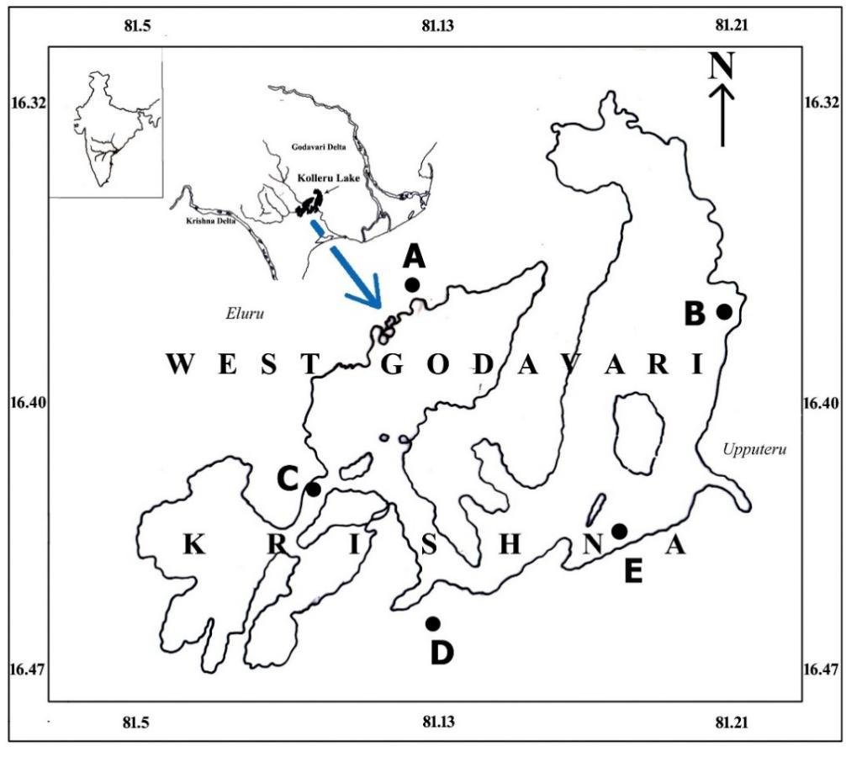
Figure 1. Geographical location of five sampling stations in lake Kolleru A. Gundugolanu B. Adavikolanu C. Gudivakalanka D. Kaikaluru E. Akividu
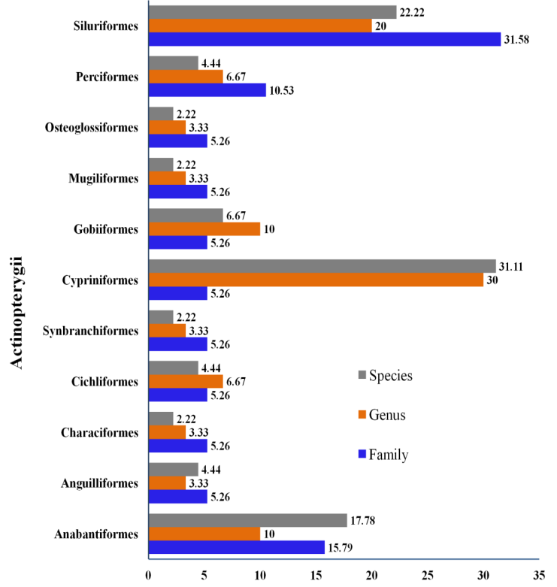
Figure 2. Relative abundance of species, genera, families and orders of fish recorded at sampling stations
Table 1. Fish species, common names, IUCN status, human use and their occurrence in five sampling stations
S.No.. | Order | Family | Species Name | Common Name | Station | IUCN  Status | Human Use
1 | Anabantiformes | Nandidae | Nandus nandus | Gangetic leaf fish | A, B, C, D, E | LC | F, Aq
2 | Anabantiformes | Anabantidae | Anabas testudineus | Climbing Perch | A, B, C, D, E | LC | F, Aq, Ac
3 | Anabantiformes | Anabantidae | Anabas cobojius | Gangetic Koi | A, B, C, D, E | DD | F
4 | Anabantiformes | Channidae | Channa striata | Striped snakehead | A, B, C, D, E | LC | F, Aq, Ac
5 | Anabantiformes | Channidae | Channa punctata | Spotted Snakehead | A, B, C, D, E | LC | F, Aq, Ac, Gf
6 | Anabantiformes | Channidae | Channa marulia | Great Snakehead | A, B, C, D, E | LC | F, Aq, Ac, Gf
7 | Anabantiformes | Channidae | Channa gachua | Dwarf Snakehead, Red seam snakehead | A, B, C, D, E | LC | Aq
8 | Anabantiformes | Channidae | Channa orientalis | Walking snakehead | A, B, C, D, E | VU | F, Aq
9 | Anguilliformes | Anguillidae | Anguilla bicolor | Shortfin eel | A, B, C, D, E | NT | F
10 | Anguilliformes | Anguillidae | Anguilla bengalensis | Indian longfin eel | A, B, C, D, E | NT | F, Ac, Gf
11 | Characiformes | Serrasalmidae | Piaractus mesopotamicus | Small-scaled Pacu | A, B, C, D, E | NT | Ac
12 | Cichliformes | Cichlidae | Etroplus suratensis | Green Chromide | D, E | LC | F, Aq, Ac
13 | Cichliformes | Cichlidae | Oreochromis mossambica | Mozambique tilapia | A, B, C, D, E | VU | F, Ac, Aq, Gf
14 | Cypriniformes | Cyprinidae | Puntius chola | Swamp barb, Chola barb | A, B, C, D, E | LC | F, Aq
15 | Cypriniformes | Cyprinidae | Puntius sarana | Olive barb | A, B, C, D, E | LC | F, Gf, Aq
16 | Cypriniformes | Cyprinidae | Puntius sophore | Pool barb | A, B, C, D, E | LC | Aq
17 | Cypriniformes | Cyprinidae | Osteobrama cotio | Indian Hafo | A, B, C, D, E | LC | F
18 | Cypriniformes | Cyprinidae | Esomus danrica | Flying barb | A, B, C, D, E | LC | F, Aq
19 | Cypriniformes | Cyprinidae | Rasbora daniconius | Black-line Rasbora or Slender rasbora | A, B, C, D, E | LC | F, Aq
20 | Cypriniformes | Cyprinidae | Amblypharyngodon mola | Mola carplet | A, B, C, D, E | LC | F
21 | Cypriniformes | Cyprinidae | Catla catla | Indian carp or Indian major carp | A, B, C, D, E | LC | F, Ac, Gf
22 | Cypriniformes | Cyprinidae | Cirrhinus mrigala | Mrigal carp | A, B, C, D, E | LC | F, Ac
23 | Cypriniformes | Cyprinidae | Labeo bata | Bata or Minor carp | A, B, C, D, E | LC | F, Ac
24 | Cypriniformes | Cyprinidae | Labeo rohita | Rohu or Rui | A, B, C, D, E | LC | F, Ac, Gf
25 | Cypriniformes | Cyprinidae | Labeo calbasu | Orangefin Labeo | A, B, C, D, E | LC | F Ac
26 | Cypriniformes | Cyprinidae | Cyprinus carpio | Common carp | A, B, C, D, E | VU | F, Aq, Ac, Gf
27 | Cypriniformes | Cyprinidae | Laubuka laubuca/ Chela labuca | Indian Glass Barb | A, C, D, E | LC | Aq, Gf
28 | Gobiiformes | Gobiidae | Glossogobius giuris | Tank goby | A, B, C, D, E | LC | F, Aq, Ac
29 | Gobiiformes | Gobiidae | Pseudapocryptes elongatus | False mudskipper | D, E | LC | F
30 | Gobiiformes | Eleotridae | Eleotris fusca | Dusky sleeper | A, B, C, D, E | LC | F, Aq
31 | Mugiliformes | Mugilidae | Mugil cephalus | Flathead grey mullet | A, B, D, E | LC | F, Ac, Gf
32 | Osteoglossiformes | Notopteridae | Notopterus notopterus | Bronze featherback | A, B, C, D, E | LC | F, Aq, Ac
33 | Perciformes | Latidae | Lates calcarifer | Asian sea bass | D, E | LC | F, Aq, Ac, Gf
34 | Perciformes | Ambassidae | Chanda nama | Elongate glassy perchlet | A, B, C, D, E | LC | F, Aq
35 | Siluriformes | Siluridae | Wallago attu | Wallago | A, B, C, D, E | VU | F, Gf
36 | Siluriformes | Bagridae | Mystus gulio | Long-whiskered catfish | A, B, C, D, E | LC | F
37 | Siluriformes | Bagridae | Mystus cavasius | Gangatic mystus | A, B, C, D, E | LC | F
38 | Siluriformes | Bagridae | Mystus vittatus | Striped dwarf catfish | A, B, C, D, E | LC | F, Aq
39 | Siluriformes | Bagridae | Mystus bleekeri | Day's mystus | A, B, C, D, E | LC | F, Aq
40 | Siluriformes | Clariidae | Clarias batrachus | Walking catfish | A, B, C, D, E | LC | F, Aq, Ac
41 | Siluriformes | Heteropneustidae | Heteropneustes fossilis | Asian stinging catfish | A, B, C, D, E | LC | F, Aq, Ac
42 | Siluriformes | Loricariidae | Pterygoplichthys pardalis | Amazon sailfin catfish | A, B, C, D, E | LC | F, Aq
43 | Siluriformes | Loricariidae | Pterygoplichthys disjunctivus | Vermiculated sailfin catfish | A, B, C, D, E | NE | Aq
44 | Siluriformes | Schilbeidae | Pseudeutropius atherinoides | Indian Potasi | A, B, C, D, E | LC | F, Aq
45 | Synbranchiformes | Mastacembelidae | Mastacembelus armatus | Zig-zag eel | A, B, C, D, E | LC | F, Aq
IUCN Status: DD – Data Deficient; EN – Endangered; LC – Least Concern; NE – Not Evaluated; NT – Near Threatened; VU – Vulnerable.
Human Use: C – Commercial; F – Fisheries; Aq – Aquarium; Ss – Scientific study; Sf – Subsistence fisheries; Ac – Aquaculture; Gf – Gamefish; Ukn – Unknown
Stations: A- Gundugolanu; B- Adavikolanu; C- Gudivakalanka; D- Kaikaluru; E- Akividu

Table 2. Frequency of occurrence in different seasons and abundance of fish species
S. No. | Species Name | No. of fish species available in different seasons (Frequency of occurrence) |  |  |  | Abundance (%)
S. No. | Species Name | Monsoon (%) | Post- monsoon (%) | Winter (%) | Pre- monsoon (%) | Abundance (%)
1 | Anguilla bicolor | 44.68 | 29.79 | 23.40 | 2.13 | 0.50
2 | Anguilla bengalensis | 47.06 | 25.00 | 26.47 | 1.47 | 0.73
3 | Notopterus notopterus | 41.63 | 27.76 | 26.53 | 4.08 | 2.62
4 | Laubuka laubuca | 100.00 | 0.00 | 0.00 | 0.00 | 0.09
5 | Esomus danrica | 75.00 | 21.15 | 3.85 | 0.00 | 0.56
6 | Rasbora daniconius | 49.15 | 36.16 | 14.69 | 0.00 | 1.89
7 | Amblypharyngodon mola | 39.62 | 33.02 | 27.36 | 0.00 | 1.13
8 | Cyprinus carpio | 36.82 | 36.07 | 27.11 | 0.00 | 4.30
9 | Puntius chola | 36.74 | 27.16 | 36.10 | 0.00 | 3.35
10 | Puntius sarana | 36.59 | 32.20 | 31.22 | 0.00 | 2.19
11 | Puntius sophore | 34.15 | 31.17 | 26.62 | 8.06 | 6.11
12 | Osteobrama cotio | 45.03 | 39.74 | 15.23 | 0.00 | 1.62
13 | Labeo bata | 47.83 | 31.88 | 20.29 | 0.00 | 0.74
14 | Labeo calbasu | 46.20 | 34.50 | 19.30 | 0.00 | 1.83
15 | Labeo rohita | 35.23 | 34.39 | 29.54 | 0.84 | 5.07
16 | Cirrhinus mrigala | 39.96 | 30.69 | 29.34 | 0.00 | 5.54
17 | Catla catla | 36.68 | 32.80 | 27.87 | 2.65 | 6.07
18 | Mystus bleekeri | 40.65 | 31.61 | 26.45 | 1.29 | 1.66
19 | Mystus cavasius | 40.24 | 24.70 | 23.90 | 11.16 | 2.69
20 | Mystus gulio | 40.56 | 30.77 | 27.27 | 1.40 | 1.53
21 | Mystus vittatus | 37.67 | 25.33 | 27.33 | 9.67 | 3.21
22 | Wallago attu | 35.57 | 35.23 | 29.19 | 0.00 | 3.19
23 | Pseudeutropius atherinoides | 17.65 | 79.41 | 2.94 | 0.00 | 0.36
24 | Clarias batrachus | 31.03 | 33.33 | 27.97 | 7.66 | 2.79
25 | Heteropneustes fossilis | 20.11 | 15.64 | 50.84 | 13.41 | 1.92
26 | Pterygoplichthys pardalis | 30.83 | 27.96 | 30.83 | 10.38 | 6.70
27 | P. disjunctivus | 28.47 | 28.32 | 31.27 | 11.95 | 7.25
28 | Lates calcarifer | 31.58 | 68.42 | 0.00 | 0.00 | 0.20
29 | Chanda nama | 44.33 | 47.42 | 8.25 | 0.00 | 2.08
30 | Etroplus suratensis | 48.48 | 39.39 | 12.12 | 0.00 | 0.35
31 | Oreochromis mossambica | 52.17 | 40.22 | 7.61 | 0.00 | 0.98
32 | Mugil cephalus | 48.89 | 46.67 | 4.44 | 0.00 | 0.48
33 | Glossogobius giuris | 47.71 | 37.61 | 14.68 | 0.00 | 1.17
34 | Pseudapocryptes elongatus | 80.00 | 20.00 | 0.00 | 0.00 | 0.11
35 | Eleotris fusca | 48.08 | 40.38 | 11.54 | 0.00 | 0.56
36 | Channa marulia | 33.33 | 27.27 | 39.39 | 0.00 | 0.71
37 | Channa orientalis | 26.55 | 43.36 | 30.09 | 0.00 | 1.21
38 | Channa punctatus | 33.86 | 36.22 | 29.92 | 0.00 | 2.72
39 | Channa striatus | 36.21 | 33.22 | 30.23 | 0.33 | 3.22
40 | Channa gachua | 34.62 | 32.69 | 32.31 | 0.38 | 2.78
41 | Anabas testudineus | 41.87 | 27.55 | 28.93 | 1.65 | 3.88
42 | Anabas oligolepis | 34.06 | 28.99 | 35.51 | 1.45 | 1.48
43 | Nandus nandus | 35.90 | 16.67 | 38.46 | 8.97 | 0.83
44 | Mastacembelus armatus | 42.61 | 26.09 | 26.96 | 4.35 | 1.23
45 | Piaractus mesopotamicus | 47.22 | 30.56 | 22.22 | 0.00 | 0.39

Table 3. GenBank Accession Numbers of species of lake Kolleru
Order | Family | Species | Collection date | Accession number | Base length | Coordinates | Nearest neighbor species | % identity (Location)
Anguilliformes | Anguillidae | Anguilla bicolor | 20-Sep-17 | MG675613 | 630 bp | 16°39'00.0"N 81°12'36.0"E | Anguilla bengalensis | Kerala (99.84)
Anguilliformes | Anguillidae | Anguilla bicolor | 26-Feb-14 | KP979655 | 625 bp | 16°34'32.5"N 81°20'43.1"E | Anguilla bengalensis | Kerala (100.0)
Anguilliformes | Anguillidae | Anguilla bengalensis | 21-Sep-17 | MG675618 | 630 bp | 16°39'00.0"N 81°12'36.0"E | Anguilla bengalensis | Kenya (99.05)
Anguilliformes | Anguillidae | Anguilla bengalensis | 26-Feb-14 | KR021973 | 608 bp | 16°34'35.0"N 81°20'44.5"E | Anguilla bengalensis | Kenya (100)
Cypriniformes | Cyprinidae | Laubuka laubuca | 21-Sep-17 | MG675624 | 630 bp | 16°39'00.0"N 81°12'36.0"E | Laubuka laubuca | Assam (99.37)
Cypriniformes | Cyprinidae | Laubuka laubuca | 13-Jun-14 | KP939355 | 677 bp | 16°37'28.2"N 81°23'11.0"E | Laubuca fasciata | Not given (99.39)
Cypriniformes | Cyprinidae | Esomus danrica | 21-Sep-17 | MG675623 | 619 bp | 16°39'00.0"N 81°12'36.0"E | Esomus danrica | Nepal (100.0)
Cypriniformes | Cyprinidae | Esomus danrica | 27-Mar-14 | KP939356 | 639 bp | 16°36'43.6"N 81°20'52.1"E | Esomus danrica | Nepal (99.37)
Siluriformes | Bagridae | Mystus bleekeri | 01-Sep-17 | MG675622 | 630 bp | 16°39'00.0"N 81°12'36.0"E | Mystus bleekeri | Tamilnadu (100.0)
Siluriformes | Bagridae | Mystus bleekeri | 07-Feb-14 | KP939357 | 660 bp | 16°35'07.1"N 81°20'46.0"E | Mystus bleekeri | Tamilnadu (97.8)
Siluriformes | Schilbeidae | Pseudeutropius atherinoides | 21-Sep-17 | MG675621 | 630 bp | 16°39'00.0"N 81°12'36.0"E | P. atherinoides | Bangladesh (99.04)
Siluriformes | Schilbeidae | Pseudeutropius atherinoides | 27-Mar-14 | KP939358 | 617 bp | 16°34'37.2"N 81°13'44.8"E | P. atherinoides | Bangladesh (99.51)
Siluriformes | Clariidae | Clarias batrachus | 21-Sep-17 | MG675625 | 630 bp | 16°39'00.0"N 81°12'36.0"E | Clarias batrachus | Karnataka (99.68)
Siluriformes | Clariidae | Clarias batrachus | 29-Mar-14 | KM519157 | 678 bp | 16°35'38.8"N 81°22'41.9"E | Clarias batrachus | Andhra Pradesh (99.23)
Siluriformes | Heteropneustidae | Heteropneustes fossilis | 21-Sep-17 | MG675619 | 630 bp | 16°39'00.0"N 81°12'36.0"E | H.fossilis | Bangladesh (99.84)
Siluriformes | Heteropneustidae | Heteropneustes fossilis | 07-Feb-14 | KR021972 | 627 bp | 16°38'49.6"N 81°17'47.4"E | H. fossilis | Japan (100.0)
Cichliformes | Cichlidae | Etroplus suratensis | 21-Sep-17 | MG675620 | 630 bp | 16°39'00.0"N 81°12'36.0"E | Etroplus suratensis | Kerala (99.68)
Cichliformes | Cichlidae | Etroplus suratensis | 26-Feb-14 | KP939359 | 536 bp | 16°34'27.1"N 81°20'43.4"E | Etroplus suratensis | Kerala (100.0)
Gobiiformes | Gobiidae | Pseudapocryptes elongatus | 20-Sep-17 | MG675611 | 606 bp | 16°39'00.0"N 81°12'36.0"E | P. elongatus | Bangladesh (98.68)
Gobiiformes | Gobiidae | Pseudapocryptes elongatus | 20-Sep-17 | MG675612 | 606bp | 16°39'00.0"N 81°12'36.0"E | P. elongatus | Bangladesh (99.17)
Gobiiformes | Gobiidae | Pseudapocryptes elongatus | 26-Feb-14 | KT124739 | 622 bp | 16°33'51.8"N 81°20'52.1"E | P. elongatus | Bangladesh (98.55)
Gobiiformes | Gobiidae | Pseudapocryptes elongatus | 02-Apr-14 | KT124740 | 487 bp | 16°35'08.5"N 81°20'44.5"E | P. elongatus | Bangladesh (98.76)
Gobiiformes | Eleotridae | Eleotris fusca | 20-Sep-17 | MG675614 | 630 bp | 16°39'00.0"N 81°12'36.0"E | Eleotris fusca | Bangladesh (99.37)
Gobiiformes | Eleotridae | Eleotris fusca | 26-Feb-14 | KP979654 | 616 bp | 16°35'05.6"N 81°20'44.9"E | Eleotris fusca | Bangladesh (99.84)
Anabantiformes | Channidae | Channa orientalis | 20-Sep-17 | MG675615 | 630 bp | 16°39'00.0"N 81°12'36.0"E | Channa gachua | Meghalaya (99.84)
Anabantiformes | Channidae | Channa orientalis | 07-Feb-14 | KP979653 | 613 bp | 16°39'00.4"N 81°17'57.1"E | Channa gachua | Maharashtra (99.84)
Anabantiformes | Channidae | Channa punctatus | 22-May-15 | MG181947 | 622 bp | 16°36'00.0"N 81°15'00.0"E | Channa punctata | India (100.0)
Anabantiformes | Channidae | Channa punctatus | 20-Sep-17 | MG675616 | 630 bp | 16°39'00.0"N 81°12'36.0"E | Channa punctata | Andhra Pradesh (100.0)
Anabantiformes | Channidae | Channa punctatus | 07-Feb-14 | KP979652 | 622 bp | 16°37'28.6"N 81°17'56.0"E | Channa punctata | Andhra Pradesh (100.0)
Anabantiformes | Channidae | Channa striatus | 20-Sep-17 | MG675617 | 630 bp | 16°39'00.0"N 81°12'36.0"E | Channa striata | Germany (99.37)
Anabantiformes | Channidae | Channa striatus | 07-Feb-14 | KP979651 | 421 bp | 16°38'56.4"N 81°17'57.5"E | Channa striata | Bangladesh (100.0)
Anabantiformes | Anabantidae | Anabas testudineus | 09-Jul-18 | MK213550 | 642 bp | 16°37'19.2"N 81°13'17.9"E | Anabas cobojius | Jharkhand (99.53)
Anabantiformes | Anabantidae | Anabas testudineus | 10-Jul-18 | MK213551 | 642 bp | 16°33'00.0"N 81°12'36.0"E | Anabas cobojius | Jharkhand (99.53)
Anabantiformes | Anabantidae | Anabas testudineus | 10-Jul-18 | MK213552 | 642 bp | 16°36'03.0"N 81°22'10.6"E | Anabas cobojius | Jharkhand (99.69)
Anabantiformes | Anabantidae | Anabas cobojius | 10-Jul-18 | MK213553 | 652 bp | 16°33'00.0"N 81°12'36.0"E | Anabas cobojius | Jharkhand (99.85)
Anabantiformes | Anabantidae | Anabas cobojius | 10-Jul-18 | MK213554 | 652 bp | 16°36'03.0"N 81°22'10.6"E | Anabas cobojius | India (99.85)
Characiformes | Serrasalmidae | Piaractus mesopotamicus | 21-Sep-17 | MG675626 | 630 bp | 16°39'00.0"N 81°12'36.0"E | P. brachypomus | Bangladesh (99.68)
Characiformes | Serrasalmidae | Piaractus mesopotamicus | 19-Mar-14 | KM519156 | 675 bp | 16°39'00.0"N 81°28'36.0"E | P. brachypomus | Bangladesh (99.7)

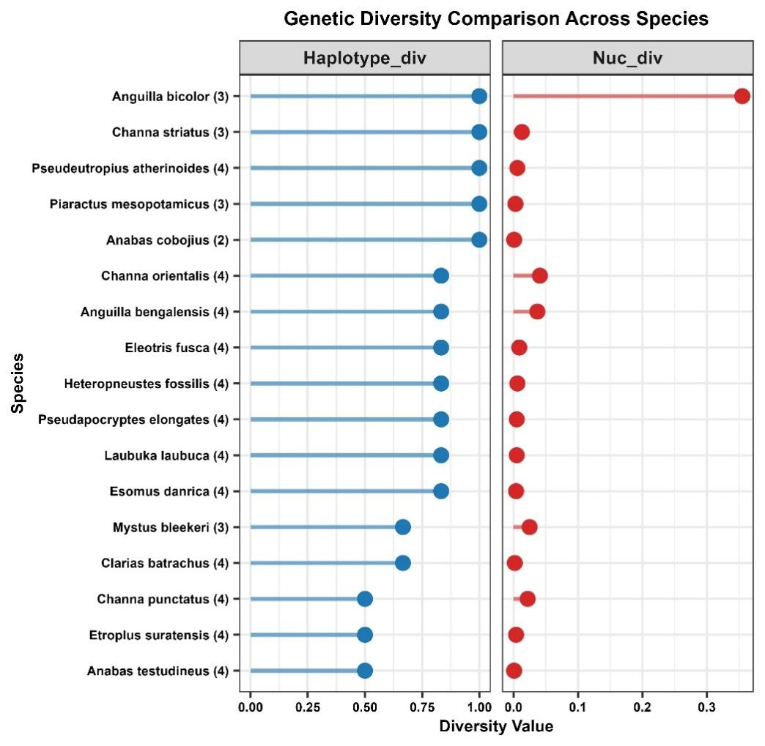
Figure 3. Haplotype and Nucleotide diversity of fish species

Table 4. Segregating sites and Haplotype data of fish species
Species (COI sequences) | No. of Haplotypes | No. of segregating sites
Anguilla bicolor (3) | 3 | 324
Anguilla bengalensis (4) | 3 | 44
Laubuka laubuca (4) | 3 | 5
Esomus danrica (4) | 3 | 4
Mystus bleekeri (3) | 2 | 23
Pseudeutropius atherinoides (4) | 4 | 5
Clarias batrachus (4) | 2 | 2
Heteropneustes fossilis (4) | 3 | 8
Etroplus suratensis (4) | 2 | 5
Pseudapocryptes elongates (4) | 3 | 5
Eleotris fusca (4) | 3 | 11
Channa orientalis (4) | 3 | 41
Channa punctatus (4) | 2 | 27
Channa striatus (3) | 3 | 12
Anabas testudineus (4) | 2 | 2
Anabas cobojius (2) | 2 | 1
Piaractus mesopotamicus (3) | 3 | 3

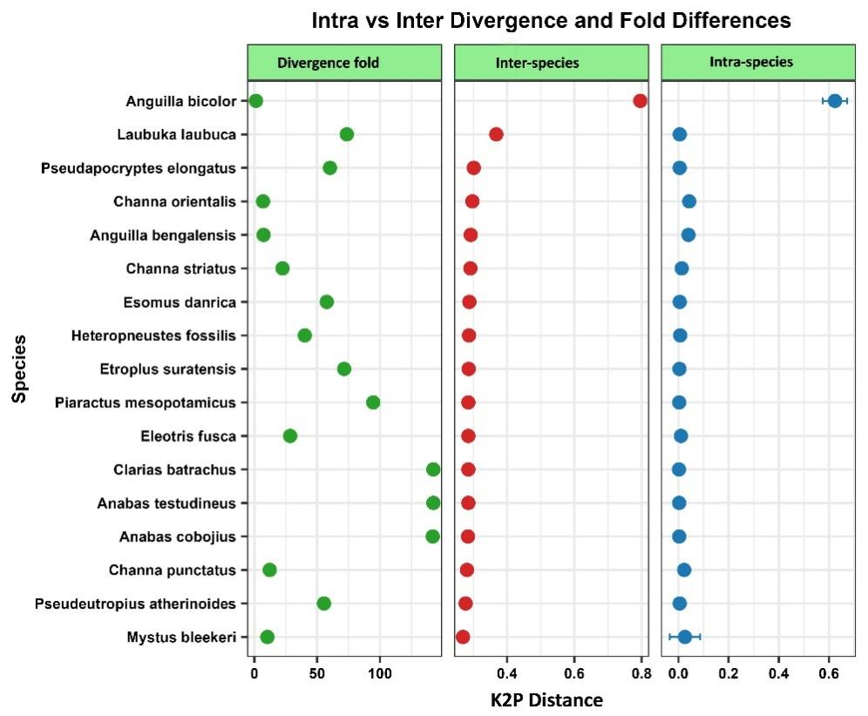
Figure 4. The scatter plot of intraspecific and interspecific genetic distances among the fish species

Table 5. Inter-specific genetic divergence of fish fauna of lake Kolleru
Species |  | 1 | 2 | 3 | 4 | 5 | 6 | 7 | 8 | 9 | 10 | 11 | 12 | 13 | 14 | 15 | 16 | 17
1 | Anguilla bicolor |  | 0.05 | 0.06 | 0.06 | 0.06 | 0.06 | 0.07 | 0.06 | 0.06 | 0.06 | 0.06 | 0.07 | 0.06 | 0.06 | 0.08 | 0.08 | 0.07
2 | Anguilla bengalensis | 0.65 |  | 0.03 | 0.02 | 0.02 | 0.02 | 0.02 | 0.02 | 0.03 | 0.02 | 0.02 | 0.02 | 0.02 | 0.02 | 0.02 | 0.02 | 0.02
3 | Laubuka laubuca | 0.79 | 0.33 |  | 0.03 | 0.03 | 0.03 | 0.03 | 0.03 | 0.02 | 0.03 | 0.03 | 0.03 | 0.03 | 0.03 | 0.03 | 0.03 | 0.03
4 | Esomus danrica | 0.72 | 0.25 | 0.32 |  | 0.02 | 0.02 | 0.02 | 0.02 | 0.02 | 0.03 | 0.02 | 0.02 | 0.02 | 0.02 | 0.03 | 0.03 | 0.02
5 | Mystus bleekeri | 0.70 | 0.24 | 0.33 | 0.23 |  | 0.02 | 0.02 | 0.02 | 0.02 | 0.02 | 0.02 | 0.02 | 0.02 | 0.02 | 0.02 | 0.02 | 0.02
6 | P. atherinoides | 0.74 | 0.24 | 0.32 | 0.21 | 0.15 |  | 0.02 | 0.02 | 0.02 | 0.02 | 0.02 | 0.02 | 0.02 | 0.02 | 0.02 | 0.02 | 0.02
7 | Clarias batrachus | 0.74 | 0.27 | 0.34 | 0.24 | 0.19 | 0.20 |  | 0.02 | 0.02 | 0.02 | 0.03 | 0.02 | 0.02 | 0.02 | 0.02 | 0.02 | 0.02
8 | H. fossilis | 0.70 | 0.27 | 0.32 | 0.22 | 0.19 | 0.19 | 0.17 |  | 0.02 | 0.02 | 0.02 | 0.02 | 0.02 | 0.02 | 0.02 | 0.02 | 0.02
9 | Etroplus suratensis | 0.73 | 0.27 | 0.30 | 0.25 | 0.23 | 0.25 | 0.26 | 0.26 |  | 0.03 | 0.02 | 0.03 | 0.02 | 0.02 | 0.02 | 0.02 | 0.02
10 | P. elongatus | 0.77 | 0.24 | 0.34 | 0.28 | 0.24 | 0.27 | 0.25 | 0.24 | 0.27 |  | 0.03 | 0.03 | 0.02 | 0.03 | 0.02 | 0.02 | 0.02
11 | Eleotris fusca | 0.72 | 0.23 | 0.33 | 0.25 | 0.23 | 0.24 | 0.26 | 0.24 | 0.23 | 0.27 |  | 0.02 | 0.02 | 0.02 | 0.02 | 0.02 | 0.02
12 | Channa orientalis | 0.81 | 0.28 | 0.33 | 0.27 | 0.26 | 0.27 | 0.25 | 0.28 | 0.26 | 0.29 | 0.25 |  | 0.02 | 0.02 | 0.02 | 0.02 | 0.02
13 | Channa punctatus | 0.77 | 0.25 | 0.33 | 0.25 | 0.25 | 0.25 | 0.25 | 0.26 | 0.23 | 0.27 | 0.22 | 0.19 |  | 0.02 | 0.02 | 0.02 | 0.02
14 | Channa striatus | 0.74 | 0.27 | 0.36 | 0.27 | 0.24 | 0.25 | 0.27 | 0.25 | 0.24 | 0.26 | 0.26 | 0.24 | 0.19 |  | 0.02 | 0.02 | 0.02
15 | Anabas testudineus | 0.80 | 0.27 | 0.33 | 0.27 | 0.26 | 0.29 | 0.27 | 0.28 | 0.25 | 0.25 | 0.26 | 0.25 | 0.23 | 0.25 |  | 0.00 | 0.02
16 | Anabas cobojius | 0.80 | 0.27 | 0.33 | 0.27 | 0.26 | 0.29 | 0.27 | 0.28 | 0.25 | 0.25 | 0.26 | 0.25 | 0.23 | 0.25 | 0.00 |  | 0.02
17 | P. mesopotamicus | 0.75 | 0.24 | 0.34 | 0.24 | 0.22 | 0.22 | 0.23 | 0.23 | 0.25 | 0.23 | 0.26 | 0.26 | 0.27 | 0.27 | 0.24 | 0.24
Note: Standard error estimates were shown above the diagonal. Analyses were conducted using the Kimura 2-parameter model (Kimura, 1980). The analysis involved 63 nucleotide sequences. Codon positions included were 1st+2nd+3rd+Noncoding. All positions containing gaps and missing data were eliminated. There was a total of 608 positions in the final dataset
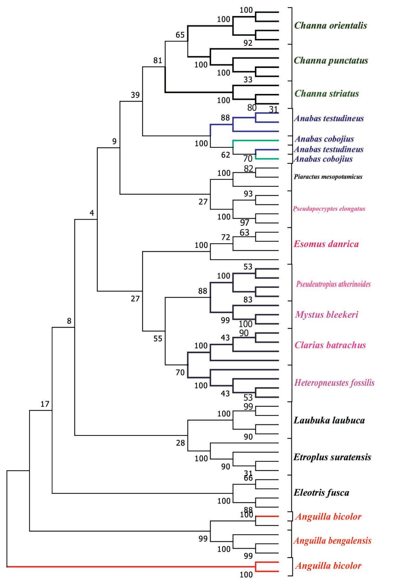
Figure 5. Neighbor-Joining tree of CO1 gene data derived from 63 sequences constructed using K2P distance method.
Note: The numbers at the nodes represents bootstrap values based on 1000 replicates.

